Monday, September 2, 2013

Exploring Further Holliman History in Old Virginia, Part 1
by Glenn N. Holliman
Descendants of Christopher Holyman (d 1691) who reside in Virginia to this Day.....
Recently in this space I wrote of Isaac and Anne Gray Holliman, the anguished story of two persons caught in the racial and cultural divides of 19th Century Virginia. Seeking to know more of our family heritage from Isle of Wight County, Virginia, I have been fortunate enough to meet Holleman cousins of Virginia who have kindly shared family stories, lineages and photographs. For the next several articles, with their permission, I shall be writing a synopsis of this research.
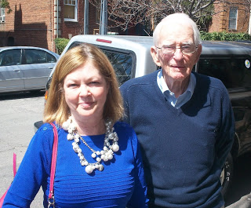

﻿
Recently Susan Holleman Brewer and her father, Joseph Howard Holleman, Jr., both of Richmond, Virginia, kindly shared lunch (pictured above). The conversation deepened my understanding of the family branch that resided and still resides along the Blackwater River near the Mill Swamp in Isle of Wight County and also in Surry County, Virginia.
Susan opened several doors which led to visits with Holleman cousins Caroline Holleman Thomas and Sarah Barlow Wright who both shared their family memorabilia and photographs. Their stories and that of other Hollemans will be published in future articles.

To refresh memories, Christopher Holyman, the fore bearer of most Hollimans in America today, arrived in Virginia in 1650 from Bedfordshire, England, the son of a cordwainer and inn keeper, and by the time of his death in 1691, established a plantation of 1,020 acres in Mill Swamp, Isle of Wight County, Virginia.
﻿
The farm was divided amongst his four sons - Christopher, Jr., Thomas, William and Richard Holyman. Many of their descendants had by the 1800s scattered, for the most part, to the southern and southeastern parts of the United States. The names were altered into various spellings depending on one's literacy (and that of the county register and census taker!) as the centuries progressed.
﻿
Susan and her father, Joseph Howard Holleman, Jr. are descended from the oldest son, Christopher Holyman, Jr. who inherited and/or purchased from his brothers a significant portion of the original 1691 plantation. Although now much reduced in acreage, the farm has remained in their branch of the Holleman line for over 300 years.

Today the land and Federal period 1830 house are owned by William Joseph Holleman of Smithfield, Virginia.

Joseph Howard Holleman, Jr. was born in 1923 on the original farm, then owned by his uncle and aunt Josiah (1851-1937) and Augusta Hannah White Holliman (1859-1941). Joseph Jr.'s father was Joseph Howard Holleman, Sr. (1897-1979) and his mother, Bessie Faircloth (1896-1986) of Southampton County.
﻿
Below, Joseph Howard Holleman, Sr. in his uniform as a Virginia Military Institute cadet in the middle 1910s. This photograph and the one below it are courtesy of Sarah Barlow Wright.
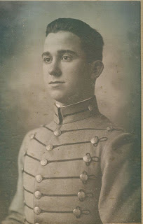

Below, a photograph taken during World War II. The girl is Caroline Holleman Thomas, sister of Joseph, Jr. who is in the Army uniform. Left and right are their parents, Joseph Sr. and Bessie.
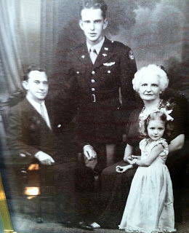
Joseph Holleman, Sr. purchased a Chevrolet dealership in Surry County, Virginia and entered politics. From 1934 until 1948 he represented Surry and Prince George Counties and the City of Hopewell in the Virginia House of Delegates.
﻿
Joseph Sr.'s long time service in the House of Delegates lead to a career opening for his son, Joseph, Jr. who became a decade's long Clerk of the Virginia House. With his vast knowledge of the Virginia legislature, Joseph Jr. wrote a definitive work entitled 'Speakers and Clerks of the Virginia House of Delegates 1776-1976'.
﻿
Joseph, Jr.'s daughter, Susan, pictured in the first photograph, is a law professor at a Richmond college, and continues the family's legacy of serving the legal needs of the Commonwealth of Virginia.
﻿
Next more on the Hollemans who remained in Virginia....

Friday, September 20, 2013

Exploring Further Holliman History in Old Virginia, Part 2
by Glenn N. Holliman
Descendants of Christopher Holyman (d 1691) who reside in Virginia to this Day....
We continue to report on the descendants of Christopher Holyman (1618-1691), who live in the Isle of Wight County and Richmond, Virginia. My thanks to the distant cousins who kindly shared their time and photographs. There will be several more articles on Isle of Wight County, which to most Holymans (and many various spellings) is our American ancestral starting point.
Below, Caroline Holleman Thomas and her husband, Bill, in their Richmond, Virginia home earlier this year. Caroline is the sister of Joseph Howard Holleman, Jr., about whom I wrote in the last post. Both are children of Joseph Howard Holleman, Sr. and Bessie Faircloth Holleman. Bill and Caroline are retired educators.
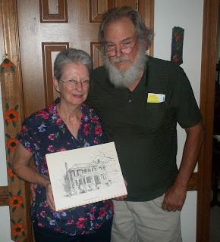
Above, Caroline holds a drawing of the 1830 Holleman House located along the Blackwater River near the Mill Swamp Baptist Church in Isle of Wight, Virginia. Caroline and Bill had their wedding rehearsal dinner by romantic candlelight in the historic home in December 1962. The dinner party was hosted by her Aunt Louise and Uncle Algenon (Nonnie) Holleman.
Most persons in the U.S who bear the Holleman name (and various spellings such as Holliman, Holloman, etc.) trace their linage to this farm adjacent to the Mill Swamp near the Blackwater River in Isle of Wight County, Virginia.
If there be a 'Plymouth Rock' for Hollimans, this is the place although, of course, the brick 1830 home was not built during the 17th Century. Christopher Holyman's original home, most probably a log cabin, would have lasted only 20 to 40 years as a habitable house. Since the 1680s, Hollemans have lived on the same land patented by Christopher Holyman during the reign of King Charles II of England.
Below, this water color is in the possession of Sarah Barlow Wright of Smithfield, a first cousin of Caroline Holleman Thomas. Mrs. Wright has told me that the clapboard building on the right of the painting pre-dates the Federal style home, and was the Holleman home while the 1830 building was being constructed. The out building still stands today, probably of 18th Century construction.
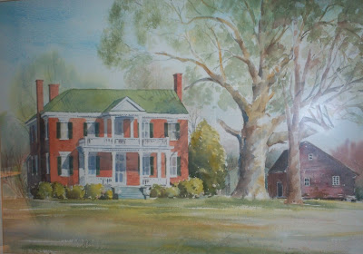
Below, Algenon Holleman who with his wife, Louise, hosted the 1962 rehearsal dinner for their niece, Caroline Holleman, and Bill Thomas. Algenon's son, William Joseph (Billy Joe) Holleman, owns the home today. His son, Joseph (Joey) Holleman, lives in the historic home with his family.

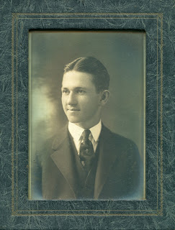

This above photograph is courtesy of Sarah Barlow Wright, whose mother, Gladys Holleman Barlow, grew up in the early 1900s at the Holleman House. We will begin their stories in the next posting.
Next more on the Hollemans of Isle of Wight, Virginia....

