When We Were English, Part XVI
by Glenn N. Holliman
Connecting Cuddington Holymans to Cholesbury Holymans and Tring Holymans
Note: Cousin Jeanette Stewart recently shared in a Holliman chat room information on the Holyman and Weedon (Wedon) families of Hertfordshire, England from the English Origins of New England Families. Before reviewing her excellent research, I had been preparing the article below which echoes and strengthens her findings. In future postings, I will attempt to weave her public work into the growing narrative of the Holymans in Tring and Cuddington, England in the 16th and 17th centuries. My thanks to Jeanette, Joe Parker and all for making available to the larger Holliman, Holleman, Hollimon, etc. families their increasing knowledge of our historic roots.

Last spring my cousin Maxine Wright, a relentless researcher in pursuit of Holliman origins, mailed me the following information of one Richard Wedon, who lived in Botley, a small village near Cholesbury and Tring. As one can read in the first paragraph of this p. 187 of The Register, published 1954, Richard had to pay a fine in 1567 for breaking the head on another man's servant. Hmmm....

Richard must have matured because nine years later, in 1576 he married Jayne Holyman in Cholesbury, near Tring. The information below states that this Jayne Holyman was from 'a yeoman family of good standing in Cuddington', descendents of Bishop John Holyman, whose life we have reviewed in previous blogs.

Several other items leap out at us. Richard and Jayne had a son named James who evidently immigrated to Rhode Island! Did James join a cousin named Ezekiel of Tring in Rhode Island?One remembers that Ezekiel Holyman, an Anabaptist, baptised Roger Williams the founder of Rhode Island!
Notice that Richard Wedon writes a will in 1618 (it is probated in 1624, presumably the year of his death). The will is witnessed by William Holyman. Double click to enlarge.
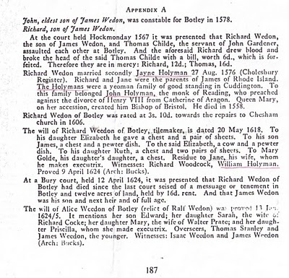
Now the issue grows more complicated. Above we have Jayne Holliman married to Richard Wedon. Below in another section of the Register, we have a John Holyman appearing in marriage in 1593 and dying a few years later. Goodbye to this John who had no children.

However, now William Holyman, the eldest son of another William Holyman, appears again (noticed who witnessed Richard Wedon's will), baptized June 1583 and his sister Priscilla February 1584/5. They have a brother named Ezekiel.

This Ezekiel according to many web sites and those who have researched Baptist Church history is the Ezekiel who sailed to Massachusetts and helped found Rhode Island!

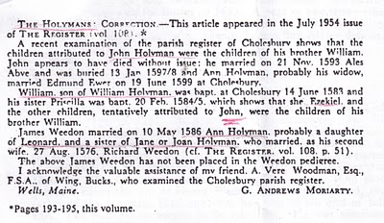
Notice in the next paragraph an Ann Holyman married another Wedon May 1586, and is noted as a probable daughter of Leonard Holyman and a sister of Jane Holyman.

Confusing? Yes, but stay with me. In the next blog, we are going to examine Leonard Holyman and his offspring. In web sites, Leonard is listed as the father of Ezekiel Holyman.

So, two thoughts emerge:

1. Leonard Holyman and other Holymans of Tring and Cholesbury, including Ezekiel, are indeed descendants of Bishop John Holyman of Cuddington.

2. Bishop John Holyman, a devout Roman Catholic, therefore is probably a great or great great uncle or cousin of Ezekiel Holyman, who was religiously antithetical by 180 degrees, to his prominent descendant, an Anabaptist in America! For those interested in religious history this is an amazing journey for a family. One generation burns Protestants at the stake; another helps establish the Baptist Church in Rhode Island.

So are all these interesting Holymans our direct ancestors? Ancestors, most probably yes; direct, we still do not know.

