OUR FAMILY’S COLONIAL ERA
By Glenn N. Holliman

These articles were published at http://hollimanfamilyhistory.blogspot.com/ from 2010 to 2012. Please note research is on-going and persons are encouraged to read of the Holyman ancestors in England to better understand Colonial Virginia.

FRIDAY, APRIL 9, 2010

Our Family's Colonial Era, 1607 - 1775, Part I
The following five colonial history posts are put together from a number of sources including published historical works, internet sites, and from the research of our contributors Dr. Rhodes Holliman, Maxine Wright, Glenda Norris, Ron Holliman, the late Walt Holliman and other family members who came before them. Those who have additional information or ideas for genealogy posts, please let us hear from you. Only by researching, critiquing, and listening to one other can our understanding of the past increase.
"From where did we come" is one of the oldest questions we humans ask. For Hollimans, our American experience began in Jamestown, Virginia where English America was founded by some adventurous colonialists from London in 1607. In this post we begin an on-going series about the first decades of our family in American.
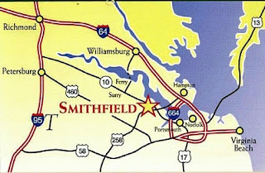By: Glenn N.Holliman
The map right identifies Smithfield,Virginia, where Christopher Holliman, Sr. settled by 1661. Jamestown is not marked but is just south of Williamsburg, where one can catch a ferry to Isle of Wight County on the south side of the James River.
By any measure, the life of Christopher Holliman, Sr. (ca. 1630 - 1691) was one of adventure and economic success. We know he sailed over on a ship that was sponsored by John Coxe of London. Christopher stepped onto American soil in Jamestown, Virginia on May 22, 165o. He was only 19 or 20 years of age when he began his adventure in the "new world."
Christopher Sr.'s first wife was named Anne, last name unknown, and of that union, six children grew to maturity.
There is no other record of Christopher Sr. until 1661, when a deed states that he purchased land near what is now Smithfield, Virginia, across from Jamestown on the south side of the James River. He farmed several hundred acres along Cypress Creek, a tributary of the Pagan, which itself runs into the James River. From this body of water, Christopher, Sr. easily loaded hogsheads of tobacco onto ships which would transport his cash crop to England. He purchased more land along Cypress Swamp in 1668.
He did well economically because in 1684, now in his 50s, he patented a large amount of land from the Royal Governor between the Mill Swamp and the Blackwater River. The Blackwater River is the western boarder of Isle of Wight County. The plantation, as he styled it in his will, was large - 1,020 acres, a large farm for the time and place. When he died in 1691, his will divided the land among his children and his second wife, Mary Gray Holliman.
Where is the exact location of the original site? The deeds, dependent upon landmarks now gone, except for the Swamp and BlackwaterRiver, are unclear. A family friend and professional geographer who also traces his family back to Isle of Wight County, Paul Fly, suggested I look along the border of Surry and Southampton Counties.
In March 2010 my wife, Barb, our oldest granddaughter, Holly, age 4 1/2, and I took a day trip from Richmond, Virginia down Highway 460 past Wakefield, Virginia to the hamlet of Ivor. There we turned east on Proctor Bridge Road, crossed the Blackwater River and made some interesting 'discoveries' that I will share with you next week!
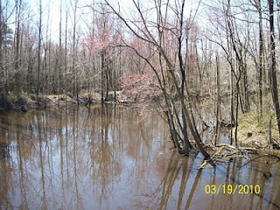
The BlackwaterRiver (pictured right) flows southward into North Carolina. It is deep and wide enough for boats to carry tobacco casts to ships bound for England. Tobacco was the cash crop of Virginia and was the mainstay of its colonial economy. In his 1691 will, Christopher Holliman Sr. records that he had tobacco barns, confirming tobacco too was his financial foundation.

FRIDAY, APRIL 16, 2010

Our Family's Colonial Era, 1607 - 1775, Part II

In Search of Christopher Holliman Sr.'s 17th Century Virginia Plantation
by Glenn N. Holliman
This is the second post of an on-going series of our ancestors. Last March, my wife, Barb, and granddaughter, Holly and I crossed the Blackwater River, the border between Southampton and Isle of Wright Counties, Virginia in search of Christopher Holliman Sr.'s plantation. Our little adventure continues....
We passed picked cotton fields and peanut storage units. Our noses told us that a pig farm, probably the home of future Smithfield Hams, was nearby. After passing Sycamore Corner, we were on Mill Swamp Road. A mile later we saw a decrepit sign which read: Holleman House.
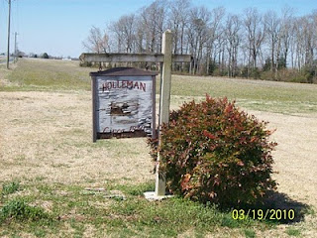Was this it, the remnant of Christopher Sr.'s 17th century plantation? Holliman has been spelled many ways - Holyman, Holleman or Holloman. No one was at home, so we took photographs and left a note. We noticed a family cemetery. The oldest visible stone is of Edward Adolphus Holleman, young son of Wilson and Ann Holleman, b 1810 - d 1819.
We did not expect to discover Christopher's grave. In the 17th, and most of the 18th century, there were no gravestones in the Tidewater area, as they were expensive items at the time. My guess is that his bones rest on this, or an adjacent, property.
Nor did we expect to discover a log cabin that housed the first Hollimans. No cabins from the 1600s survive in the Tidewater region. They burned easily and deteriorated rapidly without paint or protective coatings. It was after 1700 that the red brick plantation homes along the James River were constructed.
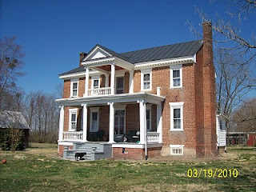Constructed in 1830, this is the Holleman House, located on Mill Swamp Road, Isle of Wight Country, Virginia. This historic Federal period house, with over-sized front doors and saw- tooth cornices, is located on the site of Christopher Holliman, Sr.'s 1,020 acre plantation.
To our amazement, when we visited the Isle of Wight County Museum later that day, we discovered an 1983 book by Helen Haverty King entitled Historic Isle of Wight. The 200 page volume pictures numerous antebellum homes in the county, one being the Holleman home!
The book is available at The Isle of Wight County Museum ($35). On the back cover is an illustrated map showing the location of the Holleman house and many others. 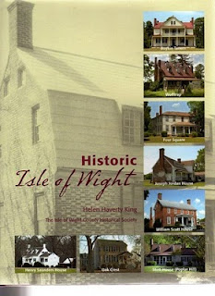
In this volume, one will find confirmation that in 1684 Christopher Holliman, Sr. completed his purchase of 1,020 acres in a corner of Isle of Wight County.
Bordering the family's property were the Atkinsons (whose sons married two of Christopher Sr's. daughters) and the Gwaltneys (who also married future Hollimans). The Gwaltneys became retail sellers of peanuts and hams, and were the founders of the famous Smithfield Ham company. They did well financially, and several of their 19th century mansions are open to visitors in downtown Smithfield today.
Next week, we will continue with our adventure to Colonial Virginia and further explore the history of the Holleman House.

FRIDAY, APRIL 23, 2010

Our Family's Colonial Era, 1607 - 1775, Part III
Confirming the Family Tree
by Glenn N. Holliman
For the past several weeks I have been writing about a trip I took with my wife, and granddaughter, to Isle of Wight County, Virginia. In the last blog we posted a photograph of the Holleman House which was constructed by a distant cousin, Wilson Holleman (1803-1873), a son of Josiah Holleman (1771-1848), who was a son of Jesse Holliman and a veteran of the American Revolution, who was a son of John Holliman, who was a son of Christopher Holliman, Jr., the son of Christopher Holliman, Sr., who patented the land in 1684. Christopher Sr. is my four-year-old granddaughter's 10th great grandfather.
Below is a photo of Wilson Holleman's headstone in the family cemetery located by the main house.
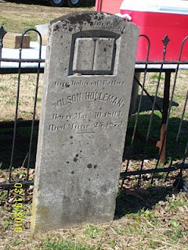
According to current information on our family tree, all in this family cemetery are relatives of Christopher Holliman, Sr., d 1691.
Pictured below is the view from Highway 621, Mill Swamp Road looking back toward the Holleman House on the left, and an older dependency building on the right. The soil is sandy and the ground is flat in the Virginia Tidewater region.
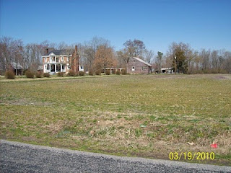Isle of Wight County is only 59 feet above sea level at its highest point. The fertility of the soil was maintained in the 19th century with marl, a local mineral, which helped reclaim the vitality of the soil that was leached by tobacco farming.
Perhaps, as with many early Virginians, the first Holliman generation tilled only a small portion of land for the cash crop tobacco, and utilized the rest for corn, vegetables, wood fuel and range for hogs, poultry and cattle.
The historian, Edmund S. Morgan, reports that in the 1600s and 1700s Virginia, one laborer could handle at most 3 acres of tobacco and three acres of corn. This was the monetary crop and food source for humans, horses and cattle alike. Of course, wild game, still in abundance in the early colonial days, supplemented diets.
As one author of Virginia history notes, “Tobacco chews through soil fertility with ferocity possessed of few other crops. In the absence of fertilizer, it can only be grown on virgin land for four seasons maximum.” Perhaps this first Christopher tilled his acres with the help of children for several years and then moved on to another piece of his land. Future Holliman families would do the same, and as their land was exhausted, they would move south and west into the Deep South, at least until the Civil War and Reconstruction.
Next week we examine the Mill Swamp Cemetery, adjacent to the 1684 plantation, that is the final resting place of 19th and 20th Century cousins.

WEDNESDAY, APRIL 28, 2010

Our Family's Colonial Era, Part IV
Mill Swamp and the Church
by Glenn N. Holliman
For the past three weeks, I have described a journey to our family roots in Isle of Wight County, Virginia. Just down the road from the Holleman House is a church that has become part of the family story.
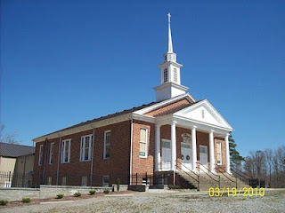The Mill Swamp Baptist Church, Isle of Wight Co., Virginia has been rebuilt many times in nearly 300 years of existence. The church and cemetery are adjacent to land owned by the Holleman's and Gwaltney's. According to cousin Jeanette Holiman Stewart, from 1798 to 1801 Jesse Holleman, Sr. was joint minister of the church with John Gwaltney. Later Jesse Sr., a direct descendant of Christopher Holliman, Sr. pastored the church alone from 1819-1820 when he was 83 years of age.
The first Hollimans were Anglicans, members of the Church of England. Until the American Revolution, there was only one official church in Virginia, and that was the Anglican or as now styled, the Episcopal Church. Our Virginia ancestors did not come to the New World for religious freedom. They came to better themselves economically, and Christopher Holliman, Sr. succeeded.
There were few Episcopal parishes in colonial days. Only one or two in each shire (as the first Virginia counties were called), and many persons felt something missing spiritually in their lives. Into that religious void came the Baptist Church, which gradually spread out of New England into the Middle Atlantic and Southern colonies by the early 1700s. Presbyterians and Methodists soon followed.

Our cousins and contributors, Ron Holliman and Maxine Wright, have pointed out that one Holliman, Ezekiel of Rhode Island, was a founder of the American Baptist Church. Ezekiel Holliman, from the same part of England as Christopher Holliman, Sr., baptised Roger Williams, the founder of Rhode Island and the Baptist Church in America! More on this probable distant cousin in later posts.
One of the first Baptist churches established in southeast Virginia was located adjacent to Holliman and Gwaltney land. The Mill Swamp Baptist Church, founded 1719, was named after the marshy ground and a stream that ran nearby. This church's location proved perfect for baptisms and became the mother church of many others in the Virginia tidewater region.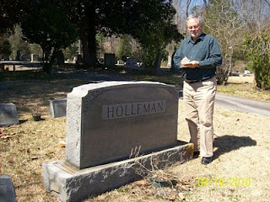In the adjacent cemetery are numerous graves of 19th and 20thcentury Hollemans plus Cofers, Gwaltneys and Atkinsons, all who intermarried in the Holliman family. Photo by Barbara Holliman of Glenn, 2010. A list of those buried in Mill Swamp Baptist Church Cemetery can be found at http://www.iwchs.com/

Yes, there truly is a Mill Swamp near the Blackwater River as noted on the 1684 patent for Christopher Holliman, Sr.
Next week we begin to examine the cash crop, tobacco, which was grown by the Holliman family in the Colonial Era.

FRIDAY, MAY 7, 2010

Our Family's Colonial Era, Part V
Tobacco and Our Family
by Glenn N. Holliman
As noted, our great grandfather Christopher Holliman Sr. acquired much land in Virginia. By the time of his death in 1691, he left 1,020 acres, along the Blackwater River and Mill Swamp (purchase completed 1684), to his four sons.
Christopher Sr. was also well respected in the community. The Thomas Pittman family tree website reports that in 1671 Christopher Sr. was witnessing deeds, and in 1676, joined other leaders in the Isle of Wight community who signed a petition concerning Nathaniel Bacon's ill-fated rebellion against the Royal Government.
There is some information that Sr. may have been in the shipping business, probably with some brothers and later with his son,Richard Holliman. In 1702 Richard Holliman transported enough persons to Virginia to claim over 1,000 acres of land through the Virginia headright system. If one imported, or paid for the importation of an immigrant, the transporter received 50 acres in land per person.
The shipping sketch portrays one of
the fragile sailing ships of the time. Note the
barrels of tobacco being loaded for England.
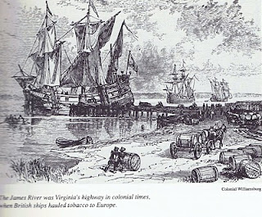
Most assuredly the Holliman family grew tobacco (Christopher Sr.’s will mentions tobacco barns). They probably hauled hogsheads to the river where it was then shipped to England. Tobacco as a commercial crop was first developed by John Rolfe, Pocahontas’s husband, in 1610s.
Thus began an ecological and social alliance with tobacco and slavery; two items that would shape the future of our family and country.
Next week, we will take a break from the 17th century and visit the 20th century through some Holliman World War II veterans. My daughter, Grace, has edited several articles sent in by relatives honoring all Hollimans for their service. In June we will continue our tour of Colonial Virginia and look further back to our Holliman English roots.
Posted by Glenn N. Holliman at 5:33 AM 0 comments

THURSDAY, JUNE 10, 2010

Our Family's Colonial Era, Part VI
Tobacco, Slavery, Democracy and Our Family
by Glenn N. Holliman
If one analyzes the 17th Century Virginia economy carefully, it makes for disturbing reading. The Christopher Hollimans and, of course, the rest of the colony grew a crop (tobacco) that if used normally shortens the lives of most people.
Even King James I wrote during his reign (1603- 1625) a book , called "A Counter Blast to Tobacco" castigating the use of the Indian weed. He was the first but not the last political leader to urge persons to quit the habit. (This same king gave us the King James Version of the Bible which our ancestors read and cherished.)
Of course, until 1776, the Crown's tobacco tax fattened the coffers of the English throne just as cigarette taxes swell the treasuries of the U.S. and the states today.
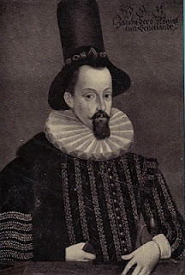
King James I of England models the latest in London hat wear fashion in the early 1600s
Generally, before 1700, this crop was often hoed and harvested by indentured servants from England. However, by the early 1700s, more and more newly imported African laborers tended the weed. These new Americans of a darker skin hue, soon found themselves in ever more secure legal chains on land taken by the English-Americans, usually forcefully, from Native Americans. The Virginia House of Burgesses, composed mainly of wealthier planters, passed laws as early as 1660 declaring that both captured Native American and African-Americans as 'property' who could be held in bondage and sold as human chattel.
Did these first Holliman generations hold slaves, even though holding human chattel was still an ill-formed institution in the late 1600's Virginia? The 1691 will of Christopher Sr. mentions nothing of human property, but one of his grandson’s, Thomas Holliman, does record in his will of 1762 the leaving of five slaves to his various sons. One slave, named Peter, was to be sold and the income produced to be divided amongst some family members. Other relatives began to note slaves, although not more than a few African Americans, in their wills by the early and middle 1700s.
The Christopher Hollimans and their descendants seemed to have been ‘average southerners’, yeoman, land-owning farmers if you will. In 1860 only one out of every four southern heads of households owned slaves. Most of our Alabama Hollimans listed no slaves in census reports of 1860, although kinfolk by marriage did so. Historians report that average number of slaves owned by a southern head of household was four, or roughly that of a family. The gigantic slave plantations of Gone With the Wind are largely fiction, although some such 'human factories' did exist.
Perhaps as with many early Virginians, the first Holliman generation tilled only a small portion of land for tobacco, the cash crop, utilizing the rest for corn, vegetables, wood fuel and range for hogs, poultry and cattle. There were six children who grew to adult hood to assist with the work in this 17th century generation.
For the record, let us note three events in the year 1619 that influenced American history and our family. One, the House of Burgess, a parliament if you will, met for the first time in Jamestown - the first example of representative democracy. Two, that same year a Portuguese transport sold Africans in Virginia who were held as slaves. Three, across the James River, a new settlement was born, the shire, later to be called after a founder's English home, of Isle of Wight County.
So paradoxically democracy and slavery, our nation's birth defect, were introduced the same year in the same colony. To this day our family has been greatly influenced by these events. And across the James River, the shire where Christopher Holliman, Sr. prospered, was founded that same fateful year of 1619!
(For sources used for this article and more information, please refer to Sources and Publications on this blog.)

Tuesday, November 2, 2010

Our Family's Colonial Era - Part VII
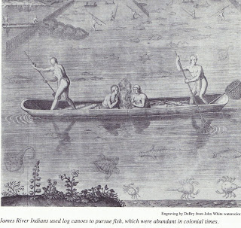
Conflict with Native Americans – A Clash of Cultures
by Glenn N. Holliman
Between April and June, 2010, I published six articles on the Holliman family in 17th Century Colonial America (they can be found in the archive section of this blog). After having published 23 articles on our English past, I now return to the history of the Virginia English colony and the travails our family experienced.

This was truly a new frontier with both opportunity and premature death. Only the brave or foolish ventured from England to Virginia from the early to mid -1600s. Perhaps our pioneering family of Christopher Holliman, Sr. was a mixture of both.
Michael Mallary in his 2004 work, Our Improbable Universe, makes the point that everywhere farmers went taking their technology and culture, the hunter-gatherers melted away before them. “The high population density that could be supported by agriculture depleted game well below the density that hunters (such as American Indians) required” observed this historian.
This then was the societal reality when Christopher C. Holliman, Sr. with his probable sister, Judith, arrived in Virginia in 1650. The frontier required bravery, a tenacious attitude to attack the virgin forests and a strong constitution not to succumb on the voyage or to disease and malnutrition upon arriving. Fortunately this Holliman family had such attributes, although Anne, Christopher's first wife, died in the 1660s. Mary Grey, perhaps the daughter of a member of the House of Burgesses in Jamestown, became Sr’s second wife.
In only a generation or so, soil exhaustion from tobacco cultivation forced families or young farmers to move to virgin land, to push the American frontier ever westward. The quest for land to grow tobacco and later cotton meant more and more Native Americans were displaced. The result was violence as American Indians naturally resisted encroachment on their hunting grounds and villages. The Indian did not go quietly to his cultural demise in Virginia and greater America.

The founding of Jamestown in 1607 meant the English had come to stay. Unlike the earlier 1580s failed Roanoke experience, this time our Anglo fore bearers mustered the necessary resources to establish a permanent colony. The English Diaspora employed superior technology, organization and the financial resources to grasp and hold an expanding piece of the New World.
Perhaps 15,000 to 25,000 Native Americans lived in Southern Virginia in the early 1600s. Benjamin Woolley’s Savage Kingdom records Captain Christopher Newport’s 1607 initial visit up the newly named James River to the site of present day, Richmond. He sighted numerous Indian villages. John Smith’s adventurous tales record numerous Indian settlements and evidence of many warriors. What English people knew as Virginia, Native Americans called Tsenacomoco.
Although there were numerous skirmishes and at least one large assault on early Jamestown as the two cultures brushed and bruised each other, the English were fortunate the central Indian chief was Powhatan. By and large he was an accommodating weroance (chief) who failed to anticipate the ultimate threat of the English invasion.
At his passing, his brother, Opechancanough, already an old man, recognized the Anglo incursion for what it was – a death threat to Indian culture and territory. On the Christian Good Friday in March, 1622, this war chief unleashed a Pearl Harbor on the small colony. By stealth, Indians conducted well-coordinated attacks on plantations and settlements all up and down the James River on both south and north banks. Over 1/3rd of the English colonists were killed in one day – 347 men, women and children. It was a close run thing if the colony could repel the attacks.
While a tactical victory for Native Americans, the attacks were not enough to drive the English into the ocean. Within a year, the colonists struck back and killed over 200 Indians, although Opechancanough escaped. For two decades the frontier was mostly quiet, but in 1644, now almost 100 years old, ever determined Opechancanough struck one last time. Five hundred settlers died, particularly along the York and Pamunkey rivers. (Records indicate several settlers named Holyman already were living in the colony in the 1630s and 40s. We will explore this in later postings.)
This time under a controversial but stubborn royal governor, Sir William Berkeley, the Virginia militia now much stronger and more numerous than warriors the Indians mustered, captured Opechancanough and destroyed most of his forces. The old chief died in captivity in Jamestown, slain by a vengeful guard. Surviving Native Americans were relegated to a piece a land near the fall line, at present day Richmond.

Of course, beyond the settled frontier, other Indians remained as yet only modestly undisturbed by the ever westward moving Europeans. As yet undisturbed….

Next posting more on our Holliman family and their challenges in a new world.

Wednesday, November 17, 2010

Our Family's Colonial Era - Part VIII
by Glenn N. Holliman

In 1635, persons whose last names are similar to Holliman, were living in Virginia. Are they our ancestors? Who were Thomas Holeman (Holman) and Robert Hollman?

Cousins Jeanette Stewart, Joe Parker and Maxine Wright have drawn my attention to the name and landownership of Thomas Holeman who purchased property in 1635 in Martin's Hundred, approximately ten miles south of Jamestown, Virginia. On p. 30 of Nugent's Cavaliers and Pioneers, Patent Book No. 1, Part I is a listing of a purchase of fifty acres of land in James County, adjacent to John Dennett and Capt. John West. The land had belonged to one Thomas Harvey who had died (the death rate was very high in early Virginia).

Is this the Thomas Holyman (Holiman, Holman, etc.) who was baptized September 13, 1612 at St. Mary's, Bedford, Bedfordshire, England? As noted in early posts, Thomas and Ellenora Holliman of Bedford were the parents of a Thomas and three other children with the names of John, Judith and Christopher Holyman, the same names as other persons who lived in Virginia in 1650.

In some recent research at the Library of Virginia in Richmond, I consulted numerous works, seeking to know more of this Thomas. Martha W. McCartney in Virginia Immigrants and Adventurers 1607 - 1635, also writes of Thomas patenting land on August 24, 1635. Ms. McCartney spells his name 'Holman', not 'Holeman'. Likewise, Gary Parks' index of Virginia Land Records records Thomas as a 'Holman'.

Gravestones were not common in Colonial Virginia until the 1700s when the colony began to 'mature' and relatives had the resources to purchase and craftsmen to carve rock. Below is the memorial marker for Alice Holleman of the 19th Century, who lived and is buried on the original plantation of Christopher Holyman Sr. Unfortunately, of course, there are no markers for ancestors who lived in the 1600s and precious few for the 1700s. Weather and time have eroded even stone.
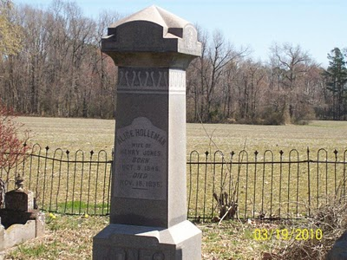
And Who was Robert Holliman?

Then there is twice mention of one Robert Hollman (not Holman or Hollyman) in Virginia Land Records, pages 666 and 674, on the dates of June 1 and March 6, 1635 in Henrico County, Virginia. Henricio is north of Jamestown and now encompasses the city of Richmond. This Robert Hollman owned land adjacent to the 'main' river, that is the James.

Granted spelling was atrocious in Colonial Virginia. The records are hard to read, and last names were spelled in different ways and often inaccurately.

So are Thomas and Robert our Holliman ancestors or some one else's?

If so, at least 15 years before Christopher Holyman Sr., our known ancestor, arrived, were his relatives, perhaps a brother and/or a cousin, already in the Chesapeake region? Did they prepare the way for more Hollimans who arrived in 1650 and later?

Thursday, November 25, 2010

Our Family's Colonial Era - Part IX
by Glenn N. Holliman

More on Thomas Holeman, 1635 Land Owner at Martin's Hundred in Virginia

Martin's Hundred, a real estate development if you will, was named after the Society for Martin's Hundred of London, a land holding group in 1618. This huge settlement was located east of Jamestown and west of Skiffe's (Keith's Creek). It contained 20,000 acres and was a principle settlement site at that time. The website Jamestowne Rediscovery has an excellent summary.

Records indicated 140 or so English lived in the development when in 1622 on Good Friday, a surprise American Indian uprising took the lives of at least 78 of the settlers in Martin's Hundred. The remaining were captured or fled to Jamestown. According to historian Bob Dean in his book The River Where America Began, 347 settlers, more than 1/4th of all the colonists died in that one day massacre.
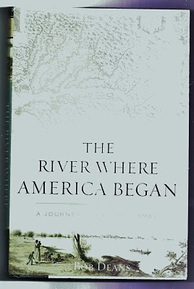
The Virginia colony was in great jeopardy, but struck back violently the next year against the Native Americans. The Crown took control of the dispirited colony from the Virginia Joint Stock Company that had founded Jamestown and had hoped to make a financial fortune.

Slowly the colony recovered, and immigrants arrived again. One being Thomas Holeman who purchased land in Martin's Hundred in 1635. Fifteen years later, Judith and Christopher Holyman, perhaps his siblings, arrived. Judith probably married quickly, and her name is lost to history.

In that same year of 1650, one John Holyman of Southampton, Virginia died leaving a will listing worldly goods but no land. He named a friend as an executor. When did he arrive and were Thomas, Judith and Christopher his siblings, all from Bedford, England?

We know Christopher survived and thrived, dieing in 1691 with an Isle of Wight County farm of 1,020 acres and numerous children. Most of us reading this today are his descendants.

In 1627, approximately 1,500 English persons lived in Virginia, mainly along the James. From 1606 until 1624, the Virginia Company had sent out over 7,000 settlers of whom over 6,000 died! By 1650, the year Christopher Holliman arrived, some 15,000, ten times as many white settlers were present, or about seven times as many Anglos over Native Americans by this time in Virginia. Many of the Indians had been destroyed by European diseases and malnutrition, as well as warfare. The English were living longer thanks to better diet and shelter.

What happened to Thomas? At this writing I know of no research that has surfaced a will or marriage record. He purchased land, and may have died early as did many. Unfortunately James City County records were destroyed when Richmond was burned during the Civil War, and only some land patent records survive to my knowledge. Martin's Hundred ceased to exist as an entity in the early 1700s.

Did Thomas survive long enough to welcome to Virginia other members of his family - assuming John, Judith and Christopher Holyman were his siblings (families often immigrated together or after one had settled and encouraged others to immigrate)? Can we ever know the whole story?

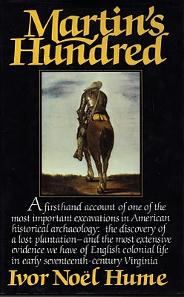
In the 1970s with a grant from the National Geographical Society, archaeologist Ivor Hume, excavated part of Martin's Hundred, now included in the Carter Grove Plantation and incorporated in the Williamsburg Foundation. Much of Hume's 1988 book (pictured above) focuses on the 1622 Good Friday Massacre and the physical remains of that day. The cover of the book shows an English soldier of the time, garbed in armor. It is compelling reading.

Thursday, December 2, 2010

Our Family's Colonial Era - Part X
A Civil War in England and
War with the Dutch in the Chesapeake Bay
by Glenn N. Holliman
Virginia was not immune from the disturbances in England. After the English Civil War, and Charles I losing his crown and head, Oliver Cromwell’s Commonwealth ruled from 1649 to 1660. Robert Berkeley, a long serving royal appointee, was dismissed as governor of Virginia in 1652 when a Commonwealth ship sailed up the James River and demanded Berkeley’s surrender of the colony and his post.
Below Oliver Cromwell, the uncrowned king of England during the Commonwealth Era.
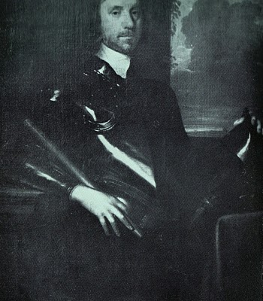
With the restoration of Charles II to the British throne in 1660, Berkeley left his plantation and exile at Green Spring (near present day Williamsburg) and returned to lead from Jamestown, still the capitol.
Violence never was far away from the Hollimans and their farms in what is now Smithfield, Virginia on the Cypress River (a short river which emptied into the Pagan and then into the James) and later the Blackwater Swamp, still in Isle of Wight County. In 1667, a Dutch fleet sailed up the James and burned twenty colonial ships carrying tobacco. Six years later, the persistent Dutch in a continuing trade war with Britain, returned and burned or captured another ten ships.
Did the Holliman’s suffer financial losses as a result of this international war? Did they hear the guns and see the smoke? Undoubtedly the Virginia militia was turned out. Was this long-forgotten naval engagement (and war) the first occasion for Holliman’s to muster in defense of their new country?

Economically the Virginia colony was suffering from a surplus of tobacco, falling commodity prices, restrictive trade laws and increasing taxes. In addition to Dutch and Mercantile wars, the frontier (northern Isle of Wight County was a border) still experienced friction and violence between settlers and Native Americans. If this sounds like 21st Century America, we are reminded that physical and economic security are paramount issues in any community or century.

Next posting, other Hollimans arrive in the Virginia colony....

Friday, December 10, 2010

Our Family's Colonial Era, Part XI
by Glenn N. Holliman

Some 17th Century Holymans - Who Were They?

Most of us reading this blog are descendants from Christopher Holyman (Holliman, etc.) who was born in England, immigrated in 1650 to Jamestown with a person named Judith, presumed to be his sister, both from either Bedford or Tring, England. Judith disappears from the story, but we know Christopher, Sr. died in Isle of Wight County, Virginia in 1691, having prospered as a planter.

In other blogs, I have shared research by others on Thomas Holeman who in 1635 purchased land at Martin's Hundred, south of Jamestown. There was also one Robert Hollman, who in March 1635 owned land in Henrico County, along the James River. Then there is John Holyman who died in Southampton, Virginia in 1650, a possible brother of our Christopher Holyman and the above Thomas Holeman.

There are still more Hollimans!

Beside the descendants of Christopher Holliman, Sr., other Hollimans also were arriving in the New World. Here is a list I have put together so far, and of course, welcome information, additions and clarification.

1653 - Another Judith Holyman and a second Christopher Holyman arrived three years after our Christopher Holyman Sr. and the original Judith Holyman stepped ashore at Jamestown. Most genealogists believe they were relatives, perhaps a son, a daughter or a mother?

1656 - On April 25, 1656 one William Holliman arrived, transported courtesy of Thomas Rolfe. Who was Thomas Rolfe? None other than the son of John Rolfe and his famous wife, Pocahontas, the daughter of Powhatan, chief of the tribes when Jamestown was founded. Well....my goodness....By 1658, William Holliman was a land owner. All this from Nell Nugent, Volume 1, pages 328 and 377, Cavaliers and Pioneers.
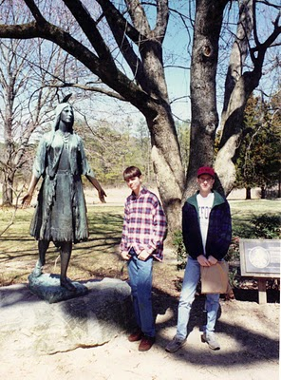Above in this 1994 photograph, my son, Christopher S. Holliman and my nephew, Bryan Payne, pose at Jamestown in front of the statue of Pocahontas. Both are direct descendants from their multi-great grandfather, Christopher Holyman, Sr., who landed at this site in 1650.
1658 - February 26, one John Hollman transported by John Dorrant. A Holliman simply slightly misspelled?

1659 - How about some indentured servants, poor people who bought their passage to Virginia in exchange for years of work? Labor to work tobacco fields was very scarce in the colony. There was Jane Hollyman, unknown family, who on September 10th was ordered to serve her master an extra year at the end of her indenture for running away. This freedom loving female Hollyman had escaped for six months from one William Cox. The county was York, Virginia. Interesting, our Christopher Holliman, Sr. was transported in 1650 by one John Cox. Relationship?

1675 and 1681 - The names of Thomas Hollyman pop up twice, both times in Lancaster County, Virginia as indentured servants. Are they the same person or two named Thomas Hollyman? The second in 1681 is listed as a servant of Lt. Colonel John Carter, ah ha, of the famous Carter family. Later the Carters will cease using indentured servants and instead utilize African slaves. This John Carter will die early eventually leaving the entire family estate to Robert "King" Carter who will become the wealthiest man in Colonial Virginia, acquiring over 300,000 acres and 1,000 slaves. This John Carter got his start in Isle of Wight County in the 1640s, the same country were our direct great grandparents would put down roots.

For citations on Jane and the two Thomas Hollymans, go to the Immigrant Servants Database on the web. Citations in original records are given. A very neat web site where one can cross check numerous family trails.

From whence did these Hollymans come? Bedford or Tring, England? Some other part of the England? Are these distant cousins? Perhaps, probably, perhaps. Joe Parker has identified even more Hollimans who lived in Virginia in the second half of the 17th Century. So there are more stories to tell.

More on Colonial Virginia and the Family of Christopher Holyman, Sr. in the next post....

Monday, December 20, 2010

Our Family's Colonial Era, Part XII
by Glenn N. Holliman

What Can We Learn from the Will of John Holyman?

I am indebted to Joe Parker, a serious Holliman genealogist, for the material below from the Northampton County, Virginia Record Book, Vol. III, 1645 - 1651, page 448. The work is edited by Dr. Howard Mackey and Marlene Alma Hinchley Groves. Opinions and any errors in this article are mine alone.

Below is the will of John Holyman dated May 8, 1650, two weeks before Christopher Holliman Sr. and Judith Holliman arrived in Jamestown, Virginia.

"Memorand That this day ye Last will & Testant' of John Holoman of Northampton County, planter, dec'd was pr'ved:
J'No Hollowman his will & desire is that hie giveth unto Christopher Kirke towe cowes & one heyffor with towe steers & one yearlinge, and towe calves & towe sowes & towe barrowes, and more. towe shutes of clothes & a gun w'th a chest & a cutlace, and my Bedd w'th covinge w'th three sheets. As witness my hand this 8 daye of May 1650./ JNo [ his mark ] Hollowman. Wit: Wm Mortt [Mott?]
JNo Hollowman his Acco'tt the 8th day of Maye 1650/ of what Debtes is oweinge him abroad w'thout any spec. as followeth, witnes' my hand.
Test: Wm Moulte/ JNo [ his mark ] Hollowman"

Translation? John leaves to one Christopher Kirk two cows, a heifer (a cow not yet giving milk), two steers, a yearling, two calves and two pigs (female). The barrows are neutered male pigs. And he leaves more, which we assume are farm tools. Judging from the above John is a small farmer with a modest amount of livestock, typical for a yeoman planter at that time in Virginia's history. Christopher Kirk fathered a line of successful children and grandchildren, and their story may be explored further in colonial records (just Google the name and time).

What else? Two suites of clothes, a gun, a cutlass, a chest and a bed with three sheets. Okay, John could defend himself from wild animals and Native Americans (was John present in 1644 when 500 plus colonists died, a very serious uprising?).
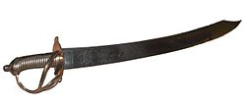Above left a 17th century French cutlass, a curved short sword.

What's missing from this will? Well, number one, every thing is left to a friend and not to a spouse or children (or a brother and sister). If Christopher Sr. and Judith yet had not arrived from England, it is not too surprising that nothing is left to them, if one assumes John is either their father or more likely, their brother. No wife? Women were still scarce in Virginia in 1650, and perhaps this John never married or a spouse may have died.

No mention is made of land? Did John rent land? Possibly unless he had given it away before writing the will, which seems odd. So probably he rented some acres. He was not an indentured servant or he would not have had the livestock. However, he did not have any sheep, so wool or clothe would have been precious. A wife was important for spinning wool and making clothing. Cotton was not yet grown, so clothes, generally all imported, were expensive and highly prized. Hence clothes left to a friend in the will.

No furniture or kitchen items, silverware or other items described. Virginia was not yet a mature or abundant colony. Most English, approximately 15,000 by 1650, were yeoman farmers, struggling to plant Indian corn, some beans and tobacco (as much as possible).

I have searched databases of Northampton County, Virginia and have found no other listing of John Holyman (or similar name) during these times. Northampton is also on the Eastern Shore, the southern most county. Granted this is the entrance to the Chesapeake Bay, but it is some distance by water from Jamestown or Isle of Wight County.

So is John Holyman a possible ancestral uncle? Or as is claimed by one Hollyman web site, the father of Christopher Holyman Sr.?

Let's refresh our memories. Remember these dates and names from my October 14, 2010 posting?

1610 - September 16, one John Holliman baptised. John married a Mary Parrell on July 25, 1641 at St. Mary's Parish, Bedford, England. If this be our John, did Mary make the trip to Virginia with him?

1616 - Thomas Holloman, brother of the above John, baptised at St. Mary's Parish, Bedford on March 20. Is this the Thomas of Martin's Hundred near Jamestown who took land in the 1635? Did this Thomas start the family moving to Virginia when he was only 18 or 19 years old?

1618 - Christopher Hollaman, brother of the above, baptized on September 2. Is this our Christopher Holyman Senior who immigrates to Jamestown in 1650, raises a large family, makes his earthly fortune and dies 1691?! Is this my generation's 8th or 9th great grandfather?

1621 - Judith Holliman, sister of the brothers above, baptised on February 11. Is this the Judith who arrives in Jamestown with a Christopher in 1650 and/or later in 1653?!

Genealogy is not an exact science, and it is so frustrating not to be able to tie these lines of kinship together. My opinion is that this John Holyman is a cousin (and not their father) of Christopher and Judith Holyman who arrived in Virginia at the time of John's death. Evidence and logic - yes. Proof? I have none.

MONDAY, JANUARY 10, 2011

Our Family's Colonial Era, Part XIV
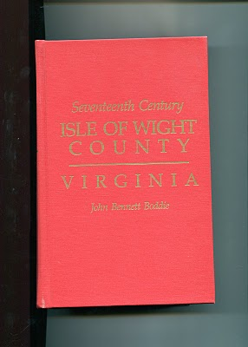by Glenn N. Holliman

The Observations of Historian John Bennett Boddie

In 1938, Virginian historian John Bennett BoddiepublishedSeventeenth Century, Isle of Wight County, Virginia. My 1994 reprint by the Genealogical Publishing Company of Baltimore, Maryland is brimming with abstracts of county records and Boddie'sown history of this part of Virginia in the 1600s. Yes, there are many Holymans,including Christopher Holyman, Sr. and Jr., recorded in this volume, and much to study and upon which to reflect. In the next few postings, I shall pull out and examine some findings that reflect on our family and our country.

Isle of Wight Country had its first English settlers in 1619, one Captain Christopher Lawne responsible for a few pioneers. He represented his fledgling county in the historic first House of Burgess's meeting in 1619. Lawne's settlement floundered, but one Robert Bennett transported 120 settlers to Isle of Wight by 1621.

As I have recorded in earlier posts, the Powhatan Indian Confederacy launched an uprising on Good Friday, March 1622. After the day of murder, only 50 or so English remained in Isle of Wight Country, and 950 so English in the entire colony. English Virginia barely survived, but in recovering the settlers launched all out war on the Native Americans. From 1622 to 1632, annual forays into Indian territory resulted in destruction of many villages and food supplies.

Colonial Virginia was safer for current and future English settlers, and the amount of available land taken by a decade of conquest considerably enlarged frontier borders. TheWarascoyak's tribe of Isle of Wight Country was destroyed in the extensive conflict.

In recording the above, Broddie on pages 84 to 86 notes three important precedents established by the Virginia House of Burgess in that ten year war. I thought them so important to understanding the future of our country, that I record them here.

1624 - Virginia General Assembly required 'that those shall be hurt on service shall be cured at public charge and the lame to be maintained by the county according to his person and quality'.
The care of veterans wounded in combat is enshrined into legislation very early in our history!

1629 - The Assembly gave Plantation commanders the authority and power 'to levy men to fall upon the Indians'. This is the first conscription or 'draft' law in colonial America, a precedent that all future draftees (such as myself in 1968) can appreciate!

1632 - Assembly required that no man shall attend church without carrying firearms or work ground with out arms and a sentinel. In a foreshadowing of the 2nd Amendment to the 1789 U.S. Constitution, later Assembly laws required that white males own a musket, shot and powder. This requirement provided an instant militia and saved money by not requiring a central armory for each county.

More on Colonial Virginia and our family in the next posting....

THURSDAY, JANUARY 20, 2011

Our Family's Colonial Era, Part XV
by Glenn N. Holliman

The New Life of Christopher Holyman, Sr. in 1650

DNA testing and research both come to the same conclusions that the father of the Holliman family in America (Holleman, Hollomon and other variations) is Christopher Holyman, Sr (1618 - 1691), who landed at Jamestown, Virginia on May 22, 1650.

Unfortunately, we know his first wife only by her first name, Anne, and we do not know how and where Christopher lived during his first decade in Virginia. His name first appears in a legal document in 1660 in Isle of Wight County on the west side of the James River. If ThomasHolyman of Martin's Hundred (assuming he was Christopher's brother, a considerable 'if'') who had arrived in 1635 was still alive, no doubt he may have materially assisted this Holyman in his first years in the New World. Sadly Thomas Holyman is lost to history, and we can only speculate.

Imagine the America in which Christopher settled in 1650. Barely 50,000 Europeans were scattered from Boston to Jamestown, hugging the east coast with a fragile toe hold. There was no Charleston (or South or North Carolina), no Baltimore, no Philadelphia (no Pennsylvania) and New Amsterdam (later New York) was a small settlement at the tip of Manhattan surrounded, as were all colonies, by semi-hostile Native Americans. Only 15,000 or so settlers lived in Virginia, and the roads, such as existed, were mud hollows in wet weather.

Jamestown itself was little more than a village of 30 to 50 cabins and a brick church (see below) that also served as the colonial assembly building. Williamsburg did not exist.
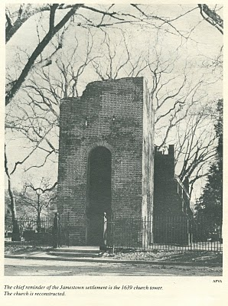
The New World, although blessed with boundless forests, rivers teeming with fish, and savannas ripe with game, was a hostile environment. If one survived the wretched voyage in small ships across the North Atlantic (and on average, one out of four did not), then there was the period of 'seasoning' when immigrants had to face and overcome American diseases such as malaria and yellow fever from Virginia mosquitoes, and the usual small pox and other assorted maladies that took the lives of many. Until settlers established apple groves, there was a lack of vitamin C. Most wells were shallow in the Tidewater with resulting contamination and disease.

In 1650 already enshrined in Virginia law was the requirement that all white men carry muskets when leaving their homes. Powhatan Indians had delivered bloody blows to the encroaching settlements in both 1622 and 1642. In the last encounter, eight years before our Christopher arrived, over 500 Virginia colonists had been slain by Indians. The tension between the two cultures remained real and dangerous.

We know that on January 11, 1661, Christopher and Anne Holymanpatented land along the Cypress River, Isle of Wight County from the founder of Smithfield, Virginia, George Smith. This would be virgin land, not yet exhausted by tobacco. In 1668, Christopher Holyman, this time with a new wife, Mary, would sell the land to Thomas Pittman. Google these names and one will find 'Holyman' and these sales articulated in several web sites.
Several sources besides web sites reveal these early transactions. In addition to Brodie's book I discussed in a previous post, Blanche Adams Chapman's Wills and Administrations of Isle of Wight County, Virginia, 1647 - 1800, Books 1 - 3 contains considerable legal recordings of the Holyman families. Chapman's book (pictured below) is available through Heritage Books, 65 E. Main Street, Westminister, Maryland 21157.

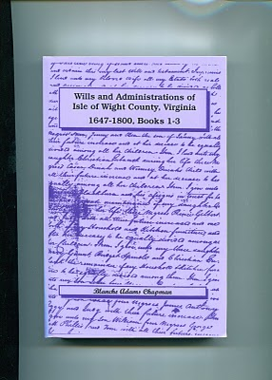

SUNDAY, JANUARY 30, 2011

Our Family's Colonial Era, Part XVI
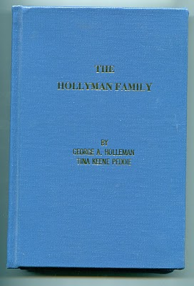
by Glenn N. Holliman

Who Were the Children of ChristopherHolliman, Sr.?

In 1952, George A.Holleman, formerly of Chicago and later Columbus, Mississippi, wrote and published privately a work calledThe Hollyman Family. To my knowledge this work, which was expanded and reprinted by Holliman genealogist TinaPeddie, is the first and still the only comprehensive volume to discuss the founding of our Holliman family and to list hundreds of names of Holliman descendants. It is a monumental piece of research for the pre-internet age. Those of us who are his distant cousins are grateful for this volume, and Tina's work to update it and keep it alive.

The 350 odd page volume is available from Tina Peddie, desabla1@yahoo.com.

In this book George Holleman published, probably for the first time, a list of the children of Christopher Holyman Sr.

They are:

Thomas Holyman - ? to 1734

Christopher Holyman, Jr. - ? to 1731 in Isle of Wight Co.

William Holyman - 1661 - 1704

Richard Holyman - ? to 1711 in Surry Co.

Ann Holyman who married John Atkinson in 1691

Mary Holyman who married James Atkinson (John's brother) in 1691

The genealogists, reports and data I have read seem in agreement that primarily Hollymans, Hollemans, Hollimans, Hollomons, etc. in the United States are descendants of this family. This is not to say that other Hollimans could not have migrated later to other colonies or that other Virginia Holymans, such that have been discussed in other postings, did not leave families also.

However, to my knowledge (and I wish to be corrected if in error), most if and not all Hollimans (and variations) trace their lineage through Christopher Holyman, Sr. Personally, this is my branch, so those of you related to me through grandfathers and great grandfathers are descendants of dear Christopher Sr.

And thank you George A. Holleman for your pioneering work!

THURSDAY, FEBRUARY 10, 2011

Our Family's Colonial Era, Part XVII
by Glenn N. Holliman

Bacon's Rebellion - The Virginia Civil War Before the American Revolution

Some have called it the precursor to the 1776 Revolution, only one hundred years earlier. Actually, my reading of the violence and pain of 1676 Colonial Virginia is more of that of a Civil War. Two factions, one wealthier and in power, and the other less wealthy, less powerful and feeling physically threatened by Native Americans, clashed over taxes and 'homeland' security.

The insurgents, hundreds of white and some Black young men, rallied around Nathaniel Bacon, age 32, a cousin by marriage to the Virginia Royal Governor, and a planter near the Falls that is now Richmond, Virginia. A number of issues led to Bacon's revolt which resulted in brutal attacks on Indian villages, the rousting of the Royal Government and the burning, of all places, Jamestown, the capitol. Many died and many were hung by a recovering Royal authority.
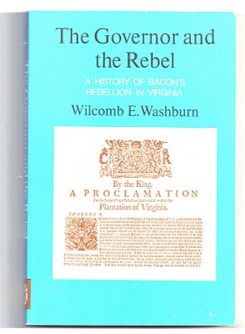
Were Christopher Holyman, Sr., a planter with a thousand acres or so, and his children caught up in these events? Yes, they were. The Holymans had some legitimate grievances, but when push came to shove, they opted to support the Royal Governor, one William Berkeley. For that no Holyman swung by their necks as did 22 rebels in the autumn of 1676, including a few of their neighbors.

Still the standard for understanding Bacon's Rebellion is Wilcomb E. Washburn's 1955 work. It is fair, balanced and points out the issues on both sides.

Numerous historians have provided excellent interpretations of the events of the rebellion such as Alan Taylor's, American Colonies and especially Edmund S. Morgan's American Slavery, American Freedom.
Next Post, the Rebellion and Why the Holyman's were Caught in the Middle....

SUNDAY, FEBRUARY 20, 2011

Our Family's Colonial Era, Part XVIII
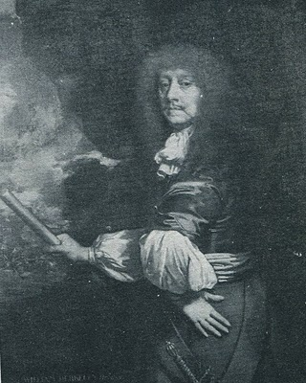
by Glenn N.Holliman

Why the Holyman's were Caught in the Middle of Bacon's Rebellion

The painting at right is Sir William Berkeley (1606 - 1677), a well-educated Englishman appointed by Charles I during the English Civil War to govern the colony of Virginia. He was successful when he arrived in 1642 to defeat the latest Powhatan Indian attacks and usher in a period of peace. Turned out in the early 1650s by the Commonwealth, he returned with the Stuart Restoration. He grew old in the position and became content with loyal assemblymen from a House of Burgess that sat from 1661 to 1676. Bacon's Rebellion resulted in the burning of his capitol, Jamestown, the loss of his post and eventually his recall to London. He died in 1677 before he could defend his actions before the Court.

In the 1671 Surry County, Virginia Record Book, p. 2 is this fascinating insight into our family and the Virginia colony on the eve of a great civil rebellion. It is recorded in George A. Holleman's original history of Hollymans in 1952.

"Att a courte houlden att Southwarke for he County Mar. 5, 1671...Upon complaint of Christo Holiman itt manifestly apearinge that the Coppahunck Indians have kild two hoggs of ye saidHoliman. Itt is ordered that Capt. Pipsicoe within thee months make payment unto ye said Holiman of Six Buck and Six doe well drest Skins & in Case itt doe apeare heere after that any Indian shall Kill any hogg or hogs of ye English that they shall pay for every Hog by them Kild twnety Buck skins."

Well, what to make of this?

1. Surry County, founded from James City County in 1647, lies just north and west of Isle of Wight County.

2. The parish of Southwarke was located across the Isle of Wight County line. The plantation of Christopher Holyman straddled the county lines, and his theft occurred in Surry County. Many Holyman descendants will move into Surry County and from there to Johnston County, North Carolina in the 1700s.

3. The Indians were Quiyoughcohanocks (Cohanocks), allied with the Algonquian Powhatan Confederacy. This tribe had participated in the Good Friday Massacre of 1622 which almost wiped out the Virginia colony.

4. Subsequently, the Virginia House of Burgesses had passed draconian legislation that any Indian who crossed the Blackwater River could be shot on sight! The Holyman plantation was (and parts of it still are) adjacent to Surry County and the Blackwater River.

5. The 1670s saw considerable Indian unrest up and down the eastern seaboard. In 1675 the tension burst into King Phillip's War in New England. Thousands, both white and red, died in the greatest outburst of violence to that date in the English colonies.

6. As in New England, the increasing dissatisfaction with the population increase of the English settlements, let to Indian resistance in Maryland and Virginia. The population of Virginia more than doubled from 15,000 to over 30,000 by the 1670s further encroaching on Indian lands.

7. The theft of hogs from the Holymans was a typical incident between the English and Indians. The English, who went armed and hunted deer for food and hides (a valuable commodity), evidently had little sense they were reducing the caloric intake possibilities of Indians. Indians felt that since whites could enter their hunting lands, and take game, they were entitled to enter English farms and take livestock! Tit for tat one would say.

The Hollimans and other colonialists did not see it that way.

Multiply these incidents by the dozens, add indiscriminate murders by both colonists and Native Americans, mix with land hunger by the English and decrease of hunting land by the Indians, and one has the recipe for another Indian War. In fact a murder of Nathaniel Bacon's overseer near Richmond, Virginia triggered a vigilante response led by Bacon. A peaceful Indian village near the North Carolina border was wiped out, and Indian women and children brutally murdered by Bacon's irregulars.

This was in defiance of Governor William Berkeley, a long serving administrator who wanted to build forts rather than unleash the militia. Those living on the edge of the frontier, presumably including the Holymans, desired immediate offensive action against Native Americans. Although Berkeley was furious with Bacon's actions as he had tried sincerely to maintain the peace, the rugged take-charge, take-no-prisoners attitude of Bacon attracted many colonial adherents.

Bacon also demanded reduction of taxes on tobacco, the money crop for almost all colonialists. Tobacco prices had plummeted in the recent decade due to too many settlers growing too much of Nicotiana tabacum. The English Navigation Act of 1663 forbade the colonists from trading with any nations other than the English. With Dutch and Spanish markets cut off directly from Virginia, there were fewer outlets and competition for the increasing supply of tobacco. Yet while income went down, taxes remained the same.

Something had to give.

Give it did with Bacon's Rebellion, a toxic brew of racial strife, physical fear, land lust and a burdensome tax load. Planters such as the Holyman's had to be sorely tempted to use force to defend the frontier and do something to reduce taxes. Some of the Holyman neighbors did join Bacon, and the result was strife in and around Isle of Wight County.

The Holymans, caught between two forces, remained loyal to the Crown.

TUESDAY, MARCH 1, 2011

Our Family's Colonial Era, Part XIX
by Glenn N. Holliman

The Rebellion Close to the Holyman Plantation

By the fall of 1676 Nathaniel Bacon's revolt had attracted hundreds of adherents, some who took delight in ransacking the homes and plantations of wealthy planters. A few of the rebels were of the planter class themselves, the most visible to history being one William Byrd, whose descendants would prosper financially, leave diaries and a political dynasty. (In the 1700s one Mary Byrd of this family would marry a grandson of Christopher, Sr.)

Other rebels, hundreds of young men in fact, were indentured servants and African-American slaves, an interesting mingling of persons, generally of a less economically prosperous class. The presence of armed Blacks during this period would later result in the House of Burgess passing highly restrictive slave codes in Colonial Virginia. As far as this writer knows this would be the last time that poor whites and Blacks would make common cause against a white power structure in Southern history prior to the Civil War. For the next several hundred years, white racial prejudice would overwhelm the common economic interests these two groups could have shared .

Isle of Wight and neighboring Surry County produced both supporters of Bacon and defenders of Governor Berkeley. Historian John Boddie in his work 17th Century Isle of Wight records numerous conflicts amongst neighbors and the forces of the Crown and the rebellion. A Major Arthur Allen, a prominent Crown supporter, fled his home near the James River, not fifteen miles north east of the Holyman plantation. Constructed in 1665, and still one of the finest examples of 17th Century Jacobian architecture remaining in the western hemisphere, the home was occupied for four months in 1676/77 by William Rookings, other commanders and up to seventy supporters of Bacon.
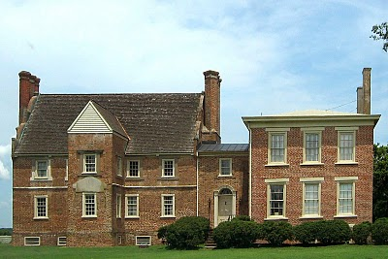
The rebellion collapsed in the late fall of 1676 after Bacon died of dysentery, and his body buried in the York River. Allen recovered the home in 1677 and later sued the occupants of his home for damages. This wealthy neighbor of the Holymans would not doubt be angry that his residence has become known as 'Bacon's Castle' after his nemesis! Today the home is on the National Register of Historic Places, is administered by the Association of the Preservation of Virginia Antiquities and is open to the public. Google Bacon's Castle and view the home and read its history.

Bear in mind, this is one of the few examples of 17th Century brick construction surviving in North America. The Holymans and 99% of other Virginians at the time were living in unpainted wooden structures that in a short time disappeared to natural decay or fire. Virtually no 17th structures remain in Virginia. Bacon's Castle is one of the few.

During your next trip to Jamestown and Williamsburg, do cross west over the James River, visit the museum in Smithfield, the Holleman home near the Mill Swamp Baptist Church in Isle of Wight County and nearby Bacon's Castle.

Next posting, the Empire Strikes Back!

WEDNESDAY, MARCH 9, 2011

Our Family's Colonial Era, Part XX
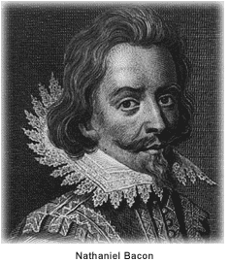
by Glenn N. Holliman

The Empire Strikes Back

With the premature death of Nathaniel Bacon, the rebellion in 1676 in Colonial Virginia began to die for lack of leadership. Royal Governor William Berkeley returned from exile on the eastern shore of Virginia, and began to reek vengeance with a rope. Before King Charles II and his new colonial appointees could stop the aged and angry governor, over 20 rebels went to the gallows.

When news of the rebellion reached London, the King and his council responded dynamically. For the first time in Colonial American history, troops from England entered the colonies to restore law and order and suppress a rebellion against the Royal Government. Over 1,000 British soldiers arrived with new civilian leadership in tow. Berkeley was summarily dismissed, and sent back to England to explain the rebellion and his actions. Before he could appear before Council, he had the good fortune to die of natural causes.

King Charles II, whose government had grown dependent of taxes from Chesapeake tobacco, was furious that Berkeley and his government had 'squeezed' the tobacco planters too tightly. The ability of the Crown to collect taxes had been jeopardized, and the complaints of the planters had best be addressed.

Virginia historian John Boddie reports that over 80 enlisted men and their officers were billeted in homes in Isle of Wight County for up to a year in 1677 and 1678. As in the 1770s in Boston, Massachusetts having civilians board soldiers quickly created stress and a financial burden on the home. Rowdy troops rapidly wore out their welcome. Here in America for the first time were planted the seeds of the 3rd Amendment to the Constitution.

Perhaps the presence of troops encouraged both Christopher Holyman Sr. and Jr. to join seventy or so of their fellow Isle of Wight citizens to sign a 1677 petition begging the pardon of the Royal Government and pledging loyalty to the same.

Again from John Boddie, "We humbly beg and lay hold of His Majesties most gracious Pardon, for as much as we, or some of us, at sometime or the other, since this Horrid Rebellion through fear, force or otherwise, deviated from our duties and allegiance to His Most Sacred Majesty."

This bit of public crawling seems to have moderated some of the anger of the new governor, Herbert Jeffreys, who wanted nothing so much as the planters to return to their fields and generate both tobacco and tax revenues. Our Holymans, caught in the middle of a vicious civil quarrel, survived and continued their lives as farmers along Blackwater River branch known as Middle Swamp.

We can surmise Christopher Jr's birthday as he had to be at least 21 to sign the petition. He now has officially appeared in a public record. In future postings, we will attempt to trace his life.

Next post, More on the Holyman family of Colonial Virginia.....

SUNDAY, MARCH 20, 2011

Our Family's Colonial Era, Part XXI
by Glenn N. Holliman
Were the Holymans Royalists Escaping the English Civil War?
Part I by Robert Holloman
Why did the Holymans come to Virginia at the time they did? A descendant of Christopher Holyman, Sr., Robert Holloman, who holds a B.A. in history from the University of Virginia, recently shared this hypothesis with me. With his permission, I share it with the larger family. This is interesting reading, and points out more research is needed. This is part one of several articles. - Glenn N. Holliman
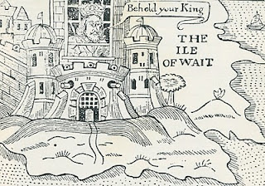
Ironically near the end of the English Civil War in 1648, the English King, Charles the First, was incarcerated by Commonwealth troops on the Isle of Wight, England (not of course Isle of Wight County, Virginia where the Holymans were to live). In this political cartoon Isle of Wight is labeled the Ile of Wait as the leaders of the rebellion, Oliver Cromwell, and others were trying to decide what to do with the defeated King. A court found the King guilty of treason, and he went to the executioner's block (see below).
One approach I have recently been exploring is to investigate whether there is a connection between the events of the English Civil War and the emigration of the Hollimans to Virginia. Bedfordshire, England is an area that gave strong support to Parliament against King Charles. If the Bedford Hollimans were royalist supporters, there may be records of fines they paid since royalists were required to pay to Parliament to either avoid military service or to support Parliament's campaigns.
As John, Thomas, Christopher and even Stephen Holliman of Bedford would have been of age to serve in the military, there may be records that reveal if any had served and in what capacity. The National Archives at Kew has a guide to researchers about records it holds of the English civil war and other potential sources - http://www.nationalarchives.gov.uk/records/research-guides/civil-war-soldiers.htm.
Could John Holliman have been a Royalist Supporter?
John Holliman's emigration to Virginia and his possession of a cutlass as evidenced by his will (1650) intrigues me. As we know, Virginia (and Maryland) remained supportive of royalists through 1651 when Cromwell sent a fleet to suppress Virginia. His representatives replaced the governor, William Berkeley, who had been appointed by Charles in 1641. This is the same William Berkeley who later in his second stint as governor would pardon Christopher Hollyman and his son after Bacon's rebellion in 1676.
I think if John (Holyman who died 1650) had emigrated from England in the 1640's, it could be he was a royalist supporter. Northampton County in Virginia where he died had previously been called Accomac Shire and was renamed Northampton County by the Virginia colony in 1644 to honor Lord Compton, Earl of Northampton, a royalist military leader who died at the battle of Hopton Heath in 1643.
Judith and Christopher Holliman - Royalists or Puritans?
Another interesting question for me is reconciling the multiple Jamestown landing records for Christopher and Judith Holleman. As there are records indicating both Christopher and Judith's arrivals in both 1650 or 1653, to me these two dates represent very different political regimes in the Virginia colony. The unapologetic, royalist era ended in March 1652 when Richard Bennett became governor. He was one of the few Puritans in the Virginia Land Company and also part of a major founding family in Isle of Wight County that over the years recruited hundreds of settlers to Virginia.
While there is strong evidence that the marketing campaigns of the Virginia company and its landholders presenting Virginia as a paradise attracted Englishmen of all persuasions between 1645 and 1670, the change of Governors in 1652 may have resulted in the perception of greater opportunity in Virginia for those who had supported Parliament and Puritans in particular. - Robert Holloman, a multiple great grandson of Christopher Holliman, Sr (d 1691)
The King represented Divine Right rule. Parliament forces fostered representative democracy. The Royalist forces were eventually defeated in battle, the King imprisoned and tried for treason. King Charles I lost his head (see below) and the Commonwealth came into being. In 1660 the monarchy was restored and King Charles II came to the throne. The Stuarts always had troubles with various Parliaments and in 1688, James II was forced from the throne. He fled to France rather than losing his head (literally) as had his father..
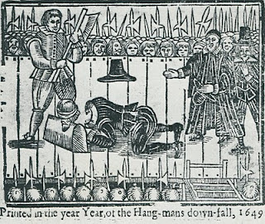
Comment on the above intriguing article by Robert Holloman, distant cousin, is most welcome.....Another article on possible Royalist connections continues in the next posting.

WEDNESDAY, MARCH 30, 2011

Our Family's Colonial Era, Part XXII
This continues a series of articles by cousin Robert Holloman, a B.A. in history from the University of Virginia. In the previous article Robert explored our possible royalist connections in the English Civil War. In this post, he presents information and raises questions on who transported our ancestors to Virginia. Again evidence points one in the direction of Bedfordshire, England as the origin of the Holliman (and various spellings) families in the New World. - Glenn N. Holliman
Who were the Sponsors of the First Virginia Holymans?
by Robert Holloman
In regards to the early settlement of Holymans in Virginia, I have been attempting to track down information on the named sponsors of Judith and Christopher (and William in 1656) Holliman. According to records, these sponsors were John Cos(x), Thos. Wilkinson, John Sherlock and Thomas Rolph (William's sponsor). In May 1650, John Cox received 1,000 acres of land in Northumberland County on the south side of the Rappahannock River, for the transport of twenty persons including two John Coxes, Elizabeth Cox, Xtopher Holleman and Judath Halloman.
Below in the center of this map by Joshua Fry and Peter Jefferson in 1751, one will find Northumberland and Lancaster Counties. Just below the left red line is the Rappahannock River; above are Lancaster and Northumberland Counties. Click on the map to enlarge.
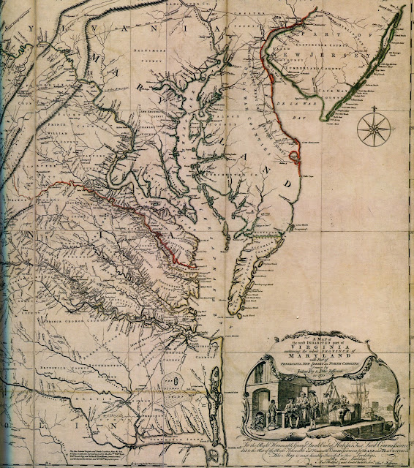

In August 1653, John Sherlock received land in Lancaster County (which was created from Northumberland County in 1652) for the transport of three persons that included Epper a (possible corruption of Christopher?) Holliman, and another grant in November 1653 for the transport of four persons that included both Judith and Christoper Holliman.

A possible connection to both John Cox and Christopher Hollyman is a Vincent Cox who was transported to Virginia as an indentured servant to a Richard Cole on the ship Honor in October 1649. His birth in 1632 can be traced to Bedford. His father was Henry Cox, and he had a younger brother, John Cox but that brother died ten days after birth in 1634 according to Bedfordshire record. In 1653 Cox and Cole legally disputed the end to his term of indenture and that legal fight provides us today the detailed record to trace his passage from England. After winning his release, Vincent Cox settled in Westmoreland County (which was also created from Northumberland County in 1652) and later would receive land in both counties several times in the 1660s.

Both the Wilkinsons and the Coxes are known to have property in Isle of Wight County in the time period of Christopher and Judith's arrivals. The Cox and Wilkinson families later intermarried.

There is a recent 2006 (expanding a 1996) book on the history of the Wilkinsons entitled The Wilkinsons of Isle of Wight, Surry and Sussex Counties and Related Families (including Cox) by Gene Cox Wilkinson and George Carroll Wilkinson. I have recently attempted to contact the authors to see where in England these families had originated and any information on Cox and Wilkinson's activities in the years of Christopher and Judith, but have had not had success as yet.- Robert Holloman
More in the next post concerning possible Royalist connections....

Sunday, April 10, 2011

Our Family's Colonial Era, Part XXIII
Exploring Further Possible Connections Between the English Civil War and the Early Holymans of Virginia
by Robert Holloman
During the past several articles, Robert Holloman, a descendant of Christopher Holyman, Sr., has been exploring connections between participants in the English Civil War and the arrival of the Holymans to Colonial Virginia. In this posting, he proposes additional evidence that suggests the Holymans were sympathetic to Charles I's forces in the fight with Parliament. One remembers Charles I was executed in 1649, and many of his supporters fled the country. Were some who fled the Holymans? - Glenn N. Holliman
My premise that the English Civil War sparked the emigration of Christopher Hollyman (and/or Judith) to Virginia is obviously not original as many families trace some of their American roots to this period. Documenting the Hollyman (Holyman, Holliman, Holloman, etc) migration is challenging. I have scattered notes and quotes about the topic that I continue to try and arrange in manageable order.
One is struck by comments such as in Richard L. Morton's Colonial Virginia, Vol. I, the Tidewater Period 1607 - 1710 (UNC Press, 1960) where on p. 166 is stated: "After Prince Charles's defeat in 1651 at Worcester, 1,610 Royalist prisoners were granted their request to be sent to Virginia." Although Charles's army was predominately Scottish and not English at Worcester, prior to the battle his army had grown by the influx of English royalist supporters as it had moved south into England from Scotland.
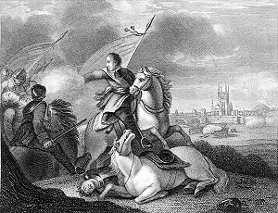
This 19th Century engraving depicts the success of Oliver Cromwell and his forces over the future Charles II at Worcester, England in 1651. After the battle, Prince Charles escaped and hide for a while in an oak tree, since known as the 'Royal Oak'. Cromwell died in 1658 and in 1660, the Stuart family, Charles II, was restored to the throne of England.
Parliament decreed in September 1651 that all prisoners below the rank of Captain were to be sent to the plantations. Prisoners from Chester, Worcester, Liverpool and Shrewsbury were sent to Bristol for transportation to Virginia and Bermuda.
A large number of these left with the annual Virginia fleet in the fall of 1651. This fleet would join with Sir George Ayscue's fleet in Barbados where he was engaged in fighting to subdue Royalist forces that were then controlling the colony.
In December, Ayscue hired 150 prisoners from the fleet to join with his marines for a successful assault on Speight's Town. In January 1652, Barbados submitted to Ayscue as the Virginia fleet continued to Jamestown. The Virginia arrival of the Worcester prisoners is captured in the record of arrival of 270 prisoners from the ship including some of my non-Holliman ancestors, John and Sarah Bridger, who entered the colony as indentured servants. I cannot find any Hollimans on the list but I can not be totally certain because many names are not legible.
I have found other interesting connections between the English Civil War and Christopher Hollyman. One of the first records of Christopher Holyman, Sr in Virginia is his granting of power of attorney to Thomas Pittman in 1660. According to Pittman family websites, Thomas Pittman was a royalist officer who arrived in Virginia in 1649 from Monmouthshire, England. Furthering this connection between the Pittman and Holyman families, his grandson, Thomas Pittman III would later marry Christopher's son William Holliman's widow, Mary Chambers Holliman in 1704.
As my descendants continuously lived in Virginia and North Carolina though my father and mother's generation, through the years I have discovered other members of my families who were Royalist immigrants. For example, Joseph Bridger, who was born in Dursley, Gloucestershire, was a Royalist officer. Joseph Bridger arrived in the mid-1650s and is known to have brought several supporters with him to Virginia. After arrival he would prosper and become one of the leading citizens of Isle of Wight County.
His descendant Sarah Bridger, my 2nd great- great grandmother married my 2nd great-great father Jesse Holloman in 1867. Another descendant of mine, Thomas Carter, Sr, a Royalist arrived in 1650. Charlotte Carter is my 4th great-grandmother.
Although I am skeptical that each story of a royalist emigrant to Virginia between 1645 and 1660 has a basis in fact, I argue that given the dates of Christopher Holyman's arrival in Virginia, that the English Civil War had to have played a prominent roll in the decision to emigrate. Hopefully, with more research, a data trail can shed further light on this proposition. - Robert Holloman

WEDNESDAY, APRIL 20, 2011

Our Family's Colonial Era, Part XXIV
Joe Parker is a diligent researcher of Holliman family history tracing his ancestry back to Christopher Holyman, Sr. He has facts at his finger tips on the family from the early 1600s in Bedford, Bedfordshire to his 21st Century relatives in his home state of Texas. Below, he shares his observations on just who those early Holymans were and what could their relationships be to one another. - Glenn N. Holliman
Christopher, Judith and John Holliman, some Additional Information concerning their Emigration to Virginia
by Joe Parker
The Headrights of Christopher and Judith Holyman
In 1650 when they arrived in Jamestown, both Christopher and Judith Holyman received head rights to acreage in the Virginia Colony. My understanding is that when a man received a head right to any block of land, the wife also has ownership of that tract, by privilege of being married to the man who received the acreage.
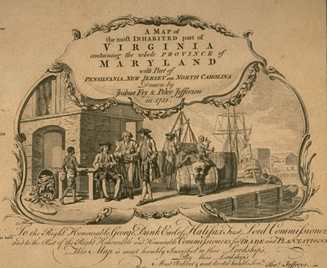
This 1751 work depicts a colonial dock with hogsheads of tobacco on the wharf. West bound from England, the ships would carry English goods and immigrants. East bound from Virginia to England, tobacco in casts would be the item transported.
Why then would - Judith in this case - receive separate notice of receiving such acreage, unless she was possibly recipient of such land as a separate individual? Conclusion, Judith was not the wife of Christopher, but yes, as the Bedfordshire English parish records indicate, more likely was his sister. - Joe Parker
Genealogist Robert W. Baird in his web site Understanding Headrights publishes the following which helps us to grasp more fully some of the reasons our Holymans might have come to the Virginia colony.
"The headright origin is found in the London Company’s “Greate Charter” of 1618:

“That for all persons…which during the next seven years after Midsummer Day 1618 shall go into Virginia with the intent there to inhabite, if they continue there three years or dye after they are shipped there shall be a grant made of fifty acres for every person… which grants shall be made respectively to such persons and their heirs at whose charges the said persons going to inhabite in Virginia shall be transported…”

- There were no restrictions on age or gender. Headrights could be, and often were, children. In fact, many imported indentured servants were teenagers.
- Persons settled in Virginia who subsequently left the colony and returned were sometimes successfully claimed as headrights. A number of patents claimed importation of a specific person “the second time” or the “the third time” (or in one case, a total of six times.) Although this seems contradictory to the spirit of the system, it appears to have been an accepted practice from the very beginning, for several Ancient Planters claimed multiple rights for their own arrivals in Virginia.
- Because there was no system for validating or accounting for headright usage, headrights were often claimed more than once, and persons who had no “intent to inhabit” were used as headrights. More on this later.
Hmmm....much to consider here as we look not just to the mid-1600s, but also the late 1600s and early 1700s and see the Holliman family utilizing the 'headright system'. - GNH

Keeping an Open Mind on just Who was John Holleman
As to John Holleman, who died in 1650 in Northampton County, Virginia, I have an open mind on this individual. The fact that he left no worldly goods to any children should be looked at carefully. He may have divided his fortune with his children (if any) before his death, and this could have left him virtually penniless at death. John left his remaining goods to a friend who would help to settle the estate. Conversely, this John Holleman could have been the husband of Judith, who arrived two weeks after his death in Virginia. Or John could have been her brother, born 1612 in Bedford, Bedfordshire, England.
I am not forming any set opinions until we search more in the Bedfordshire Archives and study additional works. For now, I will return to my review of passenger lists of boats arriving in the Virginia Colony in the 17th and 18th Centuries. - Joe Parker, Texas

Saturday, November 5, 2011

Our Family's Colonial Era, Part XXV
by Glenn N. Holliman
The Will of Christopher Holliman, Sr.
Isle of Wight County, Virginia 1691
Below is Christopher Holyman's (Holliman, Holleman, etc) Virginia will of 1691. This is an easy to read version, but it is authentic and prepared, I believe, by a distant cousin. The original was filed in the Isle of Wight when William and Mary occupied the thrones of England. The colonies were almost a century away from George Washington, another Virginia, becoming President of the United States. Let's examine the will and see what we can learn. (Click on will to enlarge.)
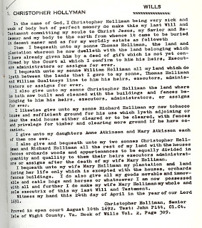
We note first of all a salutation common to English and colonial wills of the time, a statement of faith and belief in Christ Jesus. These faith statements are less common today. Christopher's grave is lost. Until the late 18th century, grave stones were rare in the colonies and virtually none at all in the 1600s Virginia. A family cemetery is now located adjacent to the current 1830s two-story brick Holleman house on the site of the original 1,020 acres that Christopher Holliman, Sr. owned. One suspects this might be the location of the first home, certainly a log house, and family grave sites (Click Archives and visit articles April 2010.)
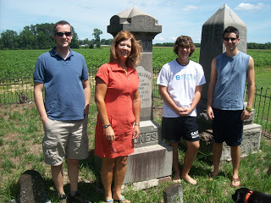
Distant cousins visit at the original Christopher Holyman, Sr. (1618 - 1691) plantation in July 2011. Pictured above at the Holleman farm in Isle of Wight County, Virginia are left to right, Bryan Payne (Tennessee), Alice Holliman Murphy (Texas), and Spenser and Corey Holleman, brothers who live at the original site. This Holleman family cemetery, with the earliest headstones from the first decades of the 1800s, may have been the location of the grave of Christopher Holyman, Sr.
Let's look at the bequests:
Thomas - Christopher had deeded already a plot of land to this son. The number of acres is not mentioned for any of the bequests.
William - This son received that portion of land between Thomas's plantation and the neighbor, William Gualtney (later spelled Gwaltney and of Welsh origin). The Gualtney's in the late 1800s will become merchants, first selling peanuts and later hams. These are now the famous Smithfield Hams of Isle of Wight County. Many of the Queen Anne style homes of downtown Smithfield were constructed from the financial success of the family. Records indicate Holliman daughters married Gualtney's from time to time.
Christopher, Jr. - This first borne son received his cleared land and buildings already constructed.
Richard - The youngest son received land for tobacco growing, timbering and clearing more if he wished. His bequest is the only mention of the principle crop - tobacco - and a bequest of a tobacco barn. Richard continued what became my branch of the family tree as he is my 6th great grandfather. More on him later in my writings.
Next posting, more analysis of this 17th Century family will....

Tuesday, November 15, 2011

Our Family's Colonial Era, Part XXVI
by Glenn N. Holliman
Christopher Holliman, Sr's. Will, a Further Look...
In the last posting, I published the will of my ancestor, Christopher Holliman, Sr., died 1691. Christopher left his two married daughters, Anne and Mary, not land, but one ewe each. That may seem unfair to 21st Century standards, but there were probably mitigating circumstances.
1. When they married their neighbor's sons, the Atkinsons, they married men who were expected to support their wives and children, and were expected to inherit land, just as did the Holliman sons.
2. The Atkinsons may very well have been provided doweries, thus in effect receiving their inheritances upon marriage.
3. Symbolically Anne and Mary both received an ewe, a female sheep. Most clothing worn by families in the 1600s of Colonial Virginia was home spun, that is clothes from the spinning of sheep wool. An ewe could become pregnant, and those produce additional sheep and wool for the family. Cotton would not become a cloth of choice until the invention of the cotton gin in the 1790s in Georgia.
The will left everything else including land to the wife, Mary, during her lifetime. At her passing, two sons (but not all four) received the remainder. Hmmmm....perhaps Christopher Sr. was trying to be fair to all, or perhaps he favored two of his sons, Christopher and Richard, over Thomas and William. Perhaps he had distributed some land earlier to these sons. We will never know.
Mention is made of orchards, an important supplement to the Colonial Virginia diet. Until English persons were able to plant and harvest apples, the lack of fruit and subsequent vitamins had resulted in malnutrician and many early deaths.
Notice no slaves or indentured servants are mentioned in the Holliman will. Although African-American slavery existed in the 1690s in Virginia, and the Assembly was passing more and more draconian slave laws, the great increase in importation of Africans would not occur until after 1700. Tragically by 1790, one out of five Americans (700,000) would be enslaved, an incredible statistic. Virginia and South Carolina had the largest populations of trapped human beings.
Of considerable interest is the importance of the tobacco culture in his will. The cultivation of tobacco, the cash crop, was critical. The volume below by husband and wife historians tells the story of Middlesex county, Virginia during the 17th Century. The Rutmans record that a whole tobacco crop of seeds could be cupped in one hand. These tiny seeds were placed in dirt hills, three to four feet apart. It was not even necessary to clean the land completely; just girdle the trees.
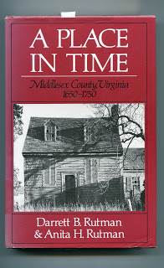

No more equipment was needed than a hoe. One laborer would 'crop' two to three acres which produced 1100 to 1200 pounds of cured tobacco. Corn could be interspersed with the tobacco. After a few years, when the soil was exhausted, the planter moved to new acres, and allowed hogs and cattle to graze on the abandoned land, allowing time and animal mature to re-nourish the soil.
The Rutmans published this cycle of a typical colonial agriculture year (see below and click to enlarge). With very little imagination, we can picture our ancestors working this pattern year after year. Not to be reproduced for commercial purposes.
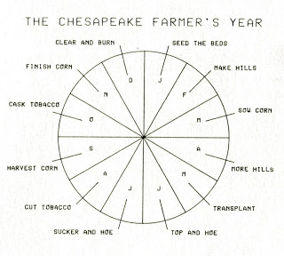
In future postings, we shall follow the fortunes of the Holliman children and their descendants....

Wednesday, July 11, 2012

Our Families Colonial Era, Part XXVII
by Glenn N. Holliman
Richard Holliman (1665? - 1711), a Son of Christopher Holyman, Sr (1618 - 1691)...and the Grandfather of James Grantson Holliman (1750 - 1836)
Christopher Holyman, Sr., the founder of the Holyman family that immigrated from England to Jamestown, Virginia in 1650, had six children, four males and two females. The girls married Atkinson's and the boys carried the family name forward, sometimes spelling it Holliman, Holleman, Holloman, Holyman and other variations depending on the literacy level of the county court clerk at the time!
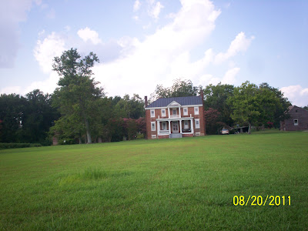
Above the Holleman House in Isle of Wight County, Virginia near the Blackwater River. Built in the 1830s, the home and farm are still owned by descendants of Christopher Holyman, Sr. On this plantation, Richard Holliman grew up. When of age, he sold part of his inheritance to a brother and purchased land in Surry County adjacent to his boyhood home.
Holliman family researcher, Joe Parker, proposes that Richard Holliman, one of Christopher, Sr.'s sons is the grandfather of my 4th great grandfather, James Grantson Holliman. Based on the evidence we have at this date (subject always to additional research and interpretation), I favor Joe's thesis. James Grantson Holliman's father? That would be one of Richard's sons - Samuel Holliman, my 5th great grandfather, and Richard, my generation's 6th great grandfather.
Let's first examine what we know of Richard Holliman, his life and go from there. George Holleman in his 1953 classic volume on the family does not give a birth date for Richard, but lists him as the 4th child born to Christopher and an unknown mother. The third child, William, was born in 1661 and the 5th child, Ann Holyman Atkinson married in 1691. So if Ann were born in the late 1660s or early 1670s, then Richard's birth falls approximately in the mid-1660s, give or take a few years.
Richard would be the first son of Christopher Holyman, Sr. to die in 1711, perhaps in his mid-40s.
Information is available on Richard and his wife, and mother of Samuel, one Margaret Jordan House.
We will look closely at the fascinating Jordan lineage in later posts, a remarkable early Virginia family branch of the Holymans.
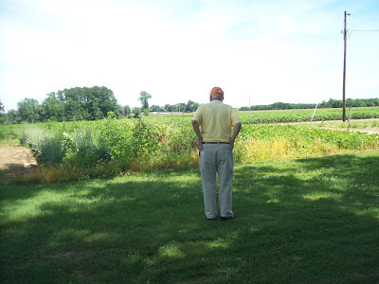
Above, Bishop Holliman (b 1919) surveys some of the land of Isle of Wight plantation founded by Christopher Holyman, Sr (1618-1691) in 2011. Bishop, this writer's father, is a 6th great grandson of Christopher.
From Christopher Holyman, Sr.'s 1691 will, we know Richard inherited land along the Blackwater River in Isle of Wight County. Evidently, he sold some of it to his brother, Thomas.
Richard Hollyman patented 1150 acres of land in Surry County, Virginia in 1696, five years after his father died. The Christopher Holyman, Sr. land was on the border of Isle of Wight and Surry Counties.
Obviously doing well, Richard patented another 1,023 acres on the south side of the main Blackwater River, 25 April 1702. This latter he received for transporting immigrants to Virginia. There is evidence he inflated the numbers in order to secure more acres under the 'head right' system. For every person one 'imported' to Virginia, one received 50 acres outright. (Information found p. 83, Crutchfield, James A. The Grand Adventure. Richmond, Dietz Press, 2005 with contributions by Joe Parker, genealogist.)

