Memories of Irondale, 1925 to 1942, Part I
by H. Bishop Holliman
In November 2010, also 91 years of age, H. Bishop Holliman (pictured below in the red sweater) who lived his childhood and youth at 2300 3rd Avenue North, Irondale, Alabama, returned to look once more at his home town where he grew up in the 1920s and 1930s. These are his memories and photographs. - GNH

Trains, trains, trains…Among my earliest memories of Irondale are the trains that went through the center of town. Four main lines that used five tracks – two for the Alabama Great Southern that ran from Birmingham to Chattanooga on to Washington, DC. One for the Southern that ran from Washington, D.C. to New Orleans and one for the Central of Georgia that connected with the other line that ran from Chicago to Miami. Finally, one for the Seaboard that came from Washington, D.C, through to Birmingham.

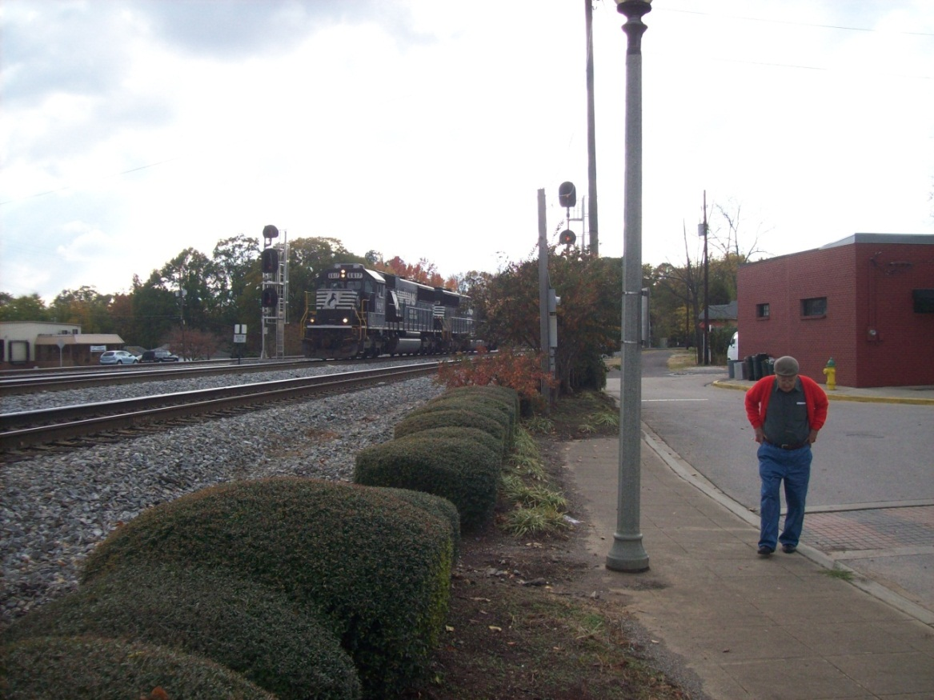
Above the Norfolk Southern freight pulls through Irondale with Bishop Holliman walking beside it in 2010.

Long before ‘rock and roll’, music came on the scene, Irondale already knew how to shake. It seems that a train was barreling through every few minutes – sometimes four at a time. On summer evenings we would try to sit on the front porch to listen on the radio to Major Bowes or Bob Hope. But about 8 o’clock, the Pelican on its way to New Orleans or the Robert E. Lee from Washington and Atlanta, plus a couple of freights, would create so much noise, we had to go inside.

Each day to and from school, to church on Sunday, to the post office and to the baseball diamond, we had to cross those tracks. There were no warning lights and no guard rails to stop us – we crossed the tracks at our peril. You can imagine the anxiety our parents felt every day that we went to school or to other placers, hoping and praying we would get there and back safety. Some did not make it. I remember three deaths that occurred. Usually an older student would lead first graders from school across the tracks in the afternoon. About two thirty each afternoon we would hear the toot of the Seaboard train on its way to Atlanta and we would know then school would soon let out.

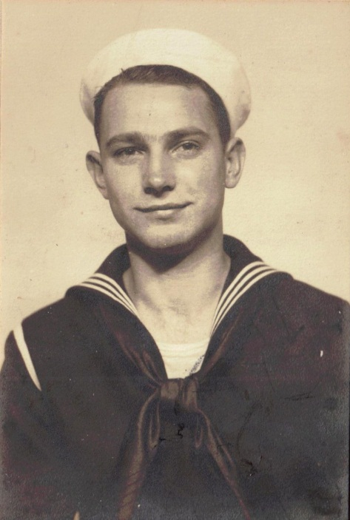

It was the Seaborne Rail Line that took Bishop Holliman, above, to the U.S. Navy in 1941. On December 7, 1941, only three weeks into the Navy, he heard the news at the Norfolk Navy Base that Pearl Harbor had been bombed. Almost four years would pass before he could return to his Irondale family.

As we got older, one of our fondest dreams was to get on one of those fast passenger trains and ride off to some enchanted places we had heard about. Alas, it did not happen for most of us until World War II. I left Birmingham on Friday, November 13, 1941, on the Seaboard’s Cotton State Special for Norfolk, Virginia to spend nearly four years in the Navy.

Incidentally, gates were installed after the war to protect against on- coming trains, and thanks to efforts by my Mother, Pearl Caine Holliman, home delivery of mail was begun before the war ended, thus eliminating a daily rail crossing to the post office for all the folks on the north side of town.

Bishop Holliman’s mother, Pearl Caine Holliman of Irondale, wrote this letter to Congressman Luther Patrick in 1943. In January 1944, home delivery mail service began and residents on the hill were no longer required to cross the rail road tracks to collect daily mail at the post office.
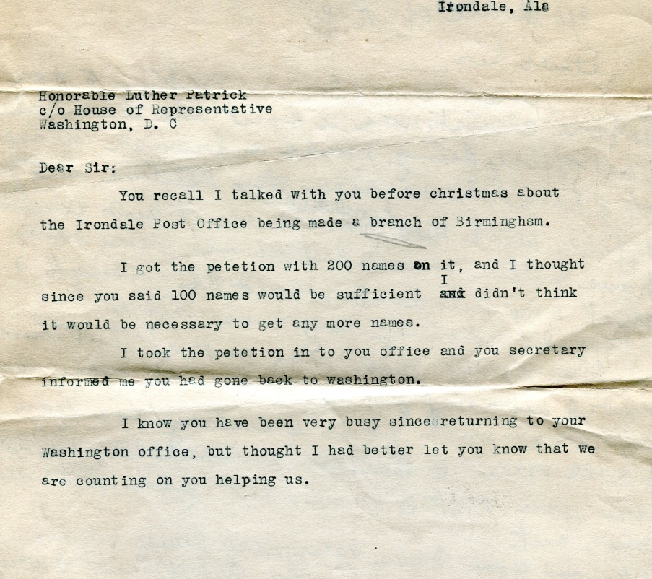

Memories of Irondale, 1925 to 1942, Part II
by H. Bishop Holliman
This is the second article of my father’s memories of growing up in the small suburb of Birmingham, Alabama during the 1920s and 1930s, a time of economic deprivation prior to World War II.

Grocery Stores…I remember the two stores that provided food for Irondale folks in the 1920s and early 1930s. We traded with R.H. Davis and Sons, located on 2nd Avenue North and 19th Street. I remember stopping by the store when I was in the first grade and buying a nickel package of juicy fruit chewing gum and trying to chew it all before I reach home. I did not succeed. And I never did that again.

Our groceries were bought on credit and Daddy (Ulyss S. Holliman, 1884 – 1965) would pay the bill every two weeks. Mr. Davis would give him a little sack of candy each time, and Virginia (Cornelius, 1922 – 2011), Ralph (Holliman, 1924) and I looked forward to that treat. Mr. Davis had a small truck he used to deliver groceries, and it could be used for other purposes, such as taking us once to ‘Blue Hole’.

This was a small swimming hole created from the artesian well that flowed on the west side of town where 30 to 40 years later the East Side Mall was built. ‘Lokey’ was a black man who worked for Mr. Davis. He would come by the house to take grocery orders then he would deliver them later in the day or the next day. We all learned to love Lokey. He was highly regarded by our family, Grandma Caine and Aunt Maud’s family. He always came into the house through the back door, as was the custom of that era.

The other grocery store was J. T. Ramsey and Son, located on south side of town by the Seaboard tracks in a large brick building that was still standing the last time I looked (2010). We never did trade there. I guess because it was farther away from our house. At one time, I don’t remember the year, it opened or closed, the Jane Griffin family (Eloise, Janie, Joyce and Gerry) operated a store on the corner of 1st Avenue South and 20th Street. I remember buying a cap pistol from Mrs. Griffin when I was about eleven years old, for 25 cents!

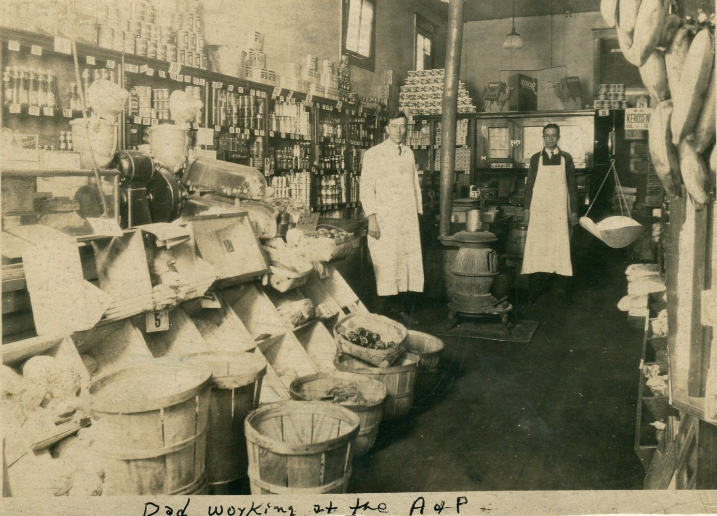

Bishop Holliman’s brother-in-law, right, Charles Ferrell, working at a Birmingham, Alabama A & P grocery of the late 1920s. Charles would graduate from Birmingham-Southern College and Yale Divinity School, be ordained a Methodist minister and in 1935 marry Loudelle Holliman of Irondale. Photo courtesy of Charles H. Ferrell. This store was not unsimilar to the Irondale groceries recorded above.

The chain stores eventually came and Mr. Davis could not compete with Hill grocery Company nor with the A & P. J. T. Ramsey stayed in business much longer. Another grocery opened on 1st Avenue, I am not sure of the year, by Ed Fortenberry. We know he was in business when I went off to war, and I don’t know how long he was there. But Hill’s and A & P, I am sure, soon took all the business from local merchants.

At one time, though, there were two grocery stores there on First Avenue, North. Hill’s was in the same block as the A & P and Fortenberry’s Grocery where the drug store, operated by Dr. Brock and the hardware store owned by Mr. T. C. Burgess. In 1943, Mr. Burgess retired and his store bought by Robert Daly, Sr. (my brother-in-law) and his brother, George Daly.

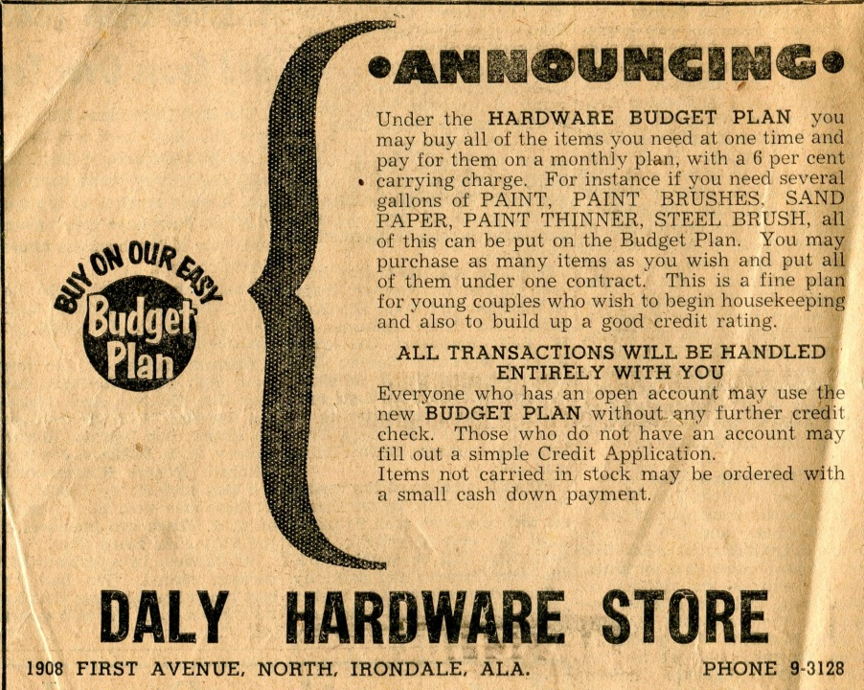

Also in the same block was Bess Fortenberry’s hamburger stand that gained fame as the ‘Whistle Stop Café’. We young boys always bought our baseball equipment each spring from the hardware store and Dr. Brock helped us young men fill out the questionnaire we received from the draft board in 1940 and 1941. Incidentally, the chain grocery stores provided about the only job opportunities available at that time for boys. I worked at Hill’s on Saturdays ‘off and on’ almost to the time I left for the Navy. I was going to Birmingham-Southern at the time and was paid $2.50 for working from seven in the morning until 10 that night. Three cents was withheld for Social Security!

Memories of Irondale, 1925 to 1942, Part III
by H. Bishop Holliman
This is the third article of my father’s memories of growing up in a small suburb of Birmingham, Alabama during the 1920s and 1930s, a time of economic deprivation prior to World War II.
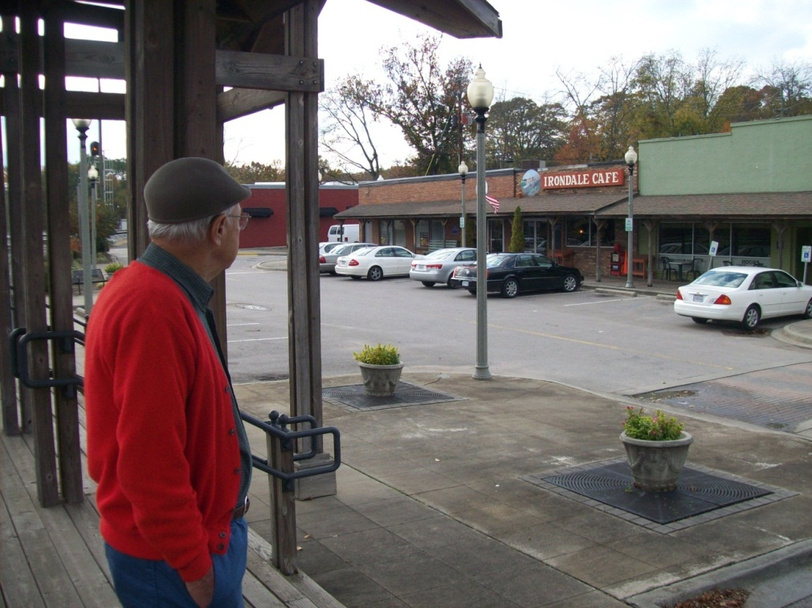

Bishop Holliman surveys 1st Avenue of Irondale, Alabama in November 2010. The café and buildings are still present. Just different names and contemporary automobiles from the days of his childhood. The Model A Fords are gone. His brother-in-law’s Daly Hardware Store closed in 1960.

The Street Car…I can barely remember riding the street car that came into Irondale on 2nd Avenue North. It ran one block to 20th, went down the short hill…past Ina Powell’s barber shop and Mr. Gaddis’ blacksmith shop, turned right on 1st Avenue, North in front of the grocery store, drug store and hardware store. Then back up the slight hill on 19th Street and headed back to town. It must have been 1929 or 1930 that they replaced the street car with the bus. The fare was seven cents.

Riders were given a free transfer from the bus to street cars in Woodlawn for completion of our ride into downtown Birmingham. In Woodlawn we transferred to No. 27 or No. 2 that would take us into town and/or Ensley or West End, all for seven cents!
Add street car info from booklet

Most folks rode street cars/busses in the 1920s and up into the 1930s, and again during World War II. Daddy worked for the street car company (Birmingham Electric Company). The street car ride I remember was to East Lake Park when I was about six years old. We transferred to the First Avenue car going to East Lake where there was an amusement park with a merry-go-round, and several other rides. I think we went two summers. I guess sit was the Depression beginning in 1929 that brought an end to that entertainment. The street car became a big part of my life until I left in 1941. I rode it nearly every day to Birmingham Southern and any time I went to town.

Memories of Irondale, 1925 to 1942, Part IV
by H. Bishop Holliman
This is the fourth article of my father’s memories of growing up in a small suburb of Birmingham, Alabama during the 1920s and 1930s, a time of economic deprivation prior to World War II.

Schools…Irondale schools were among the best in Alabama. I remember all my teachers and events that occurred in each grade. Mr. Houk was principal when I entered in 1927. Later, George S. Millsap was made principal. He was a good teacher but very, very strict, as were all of the teachers. Irondale students competed very well at Shades Cahaba with students from other schools and from families more prosperous than Irondale families. In 1937, the year of my graduation, I was editor-in-chief of the annual and my closest friend, Charles Pugh, who lived a few doors from us on the hill, was president of the senior class and valedictorian. Some other names that come to mind after all these years are Cecil Giddens, Jean LaFurgy, the two Gaylor boys, the Hurtt girls, Sadie Mae Burgess and Corely Odum.

Irondale students were well-behaved at Shades Cahaba, not entirely due to family upbringing, but also to the strict teachers at Irondale. At the end of the school year in 1933 I was double promoted to the 9th grade, which was the senior year of Junior High. There were five of us: Clementine Shurbert, George Sorrell, J.H. Ratliff, Oscar Lee Hurtt and myself. I am the only one of that circle still living. Our teachers in junior high were Mr. Millsap who taught 9th grade algebra, Miss Margaret Hanes, math and science and Mrs. Joe McClendon English and civics. In retrospect, I think skipping the 8th grade was one of the worst things that could have happened to me. Why? Well, it simply took a year out of my life and it put me in high school and college a year younger than my peers. I don’t think I every caught up, as I always felt insecure when with classmates who were a year older. And also I did not get a good foundation in math by being introduced to 9th grade algebra minus 8th grade math.

In 9th grade civics each Friday we read and discussed the Weekly reader, a compilation of current events. On this particular Friday one Student, Clyde Godwin, was reading from the paper an item about President Roosevelt’s visit somewhere. He meant to read, “The President wore a flower in his button hole.” Instead he read, “The President wore a flower in his bottom hole.” Well, the class exploded! Even Mrs. Mac (as we were allowed to call her) lost her dignity and laughed along with us. At that age, now soon becoming 15 I was very conscious of how my hair looked, and to make sure it was combed neatly I put a lot of hair oil on it every day. At graduation in May each member of the class was given a gift of dubious value accompanied by some sort of explanation. For me, the gift was a small can of pure lard with the accompanying verse: “To keep your hair down, we know it is hard, so we give to you this compound lard!”

A sad thing happened soon after school opened again in September, Mr. Millsap, who was only 31 years old, one morning before 8 o’clock wrapped a towel around his head, put a gun up to it and pulled the trigger. His death was a big blow to all of us and was not easy for his current students and the most recent graduating class to get over. Glenn Barrow was made principal and remained in that position until death in the Army in 1943. Photo below.

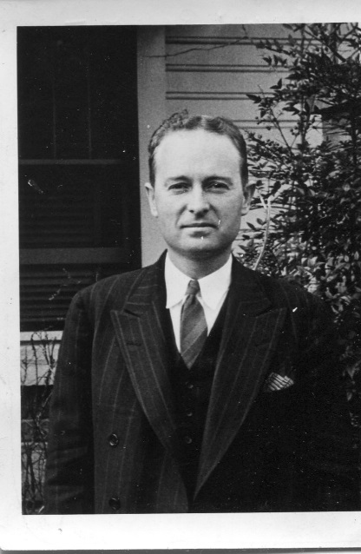

Memories of Irondale, 1925 to 1942, Part V
by H. Bishop Holliman
This is the fifth article of my father’s memories of growing up in the small suburb of Birmingham, Alabama during the 1920s and 1930s, a time of economic deprivation prior to World War II.

The Great Depression…I was too young to remember the beginning of the Depression and the havoc it wrought to so many. In my young mind, times had always been hard and some people had always been without work. Daddy was off from the job just six weeks in the summer of 1933. Many folks we knew were out of work. It was not uncommon for men to come to the house asking for food and/or other forms of help. Some children went to school bare footed. Loudelle and Euhal were still at home. Melton had married in 1932, but he had been living away from home before his marriage and had worked full time. Like us, many folks in Irondale kept chickens or a cow and put in big gardens and managed to get by.

Ulyss S. Holliman of 2300 3rd Avenue, North in Irondale poses in the middle 1920s in his large garden. A native of Fayette, Alabama, Ulyss moved his growing family to this suburb of Birmingham during World War I to take advantage of employment opportunities. Twenty years later, Pearl Caine Holliman, writes her son, Bishop Holliman, promising to save a Sunday chicken for the day he would return home from the war. As with gardens, many in Irondale raised their own chickens. For several years in the 1930s, the Ulyss Hollimans even had a milk cow.

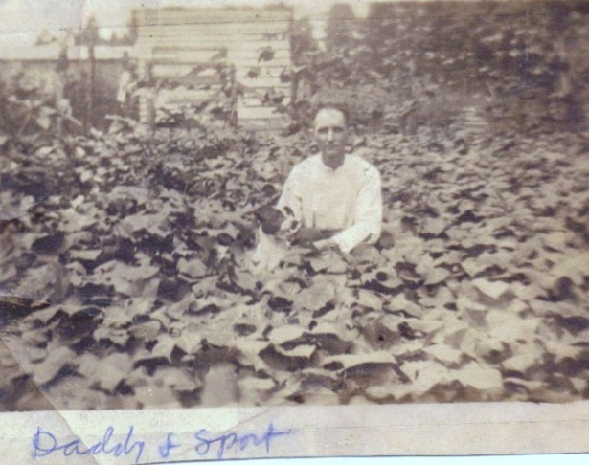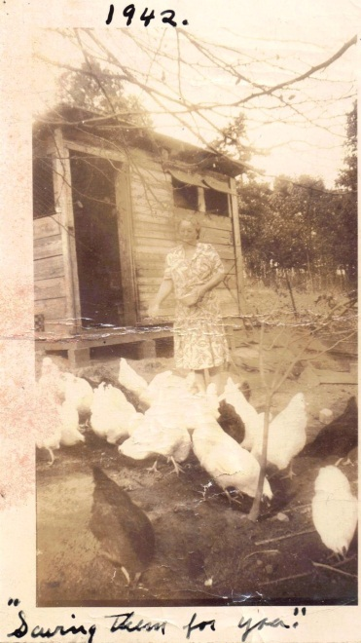

The WPA and other New Deal projects soon provided menial jobs for the unemployed. It was in 1936 the sewer systems were installed and we began to enjoy indoor plumbing. An early New Deal project was the building of sidewalks through most of the town. Though not a New Deal project (as far as I know) the streets were paved during World War II, and I think Frank Williams was mayor at the time.

I have already alluded to the hobos who rode the freight trains during these years----In my mind, hobos had always ridden them. Central heating had not come into vogue so it was still my job each day to bring in coal and kindling for Daddy to start a fire each morning. We had a heater in the middle bed room and later, one in the living room. After the War, they managed to get central gas heat.

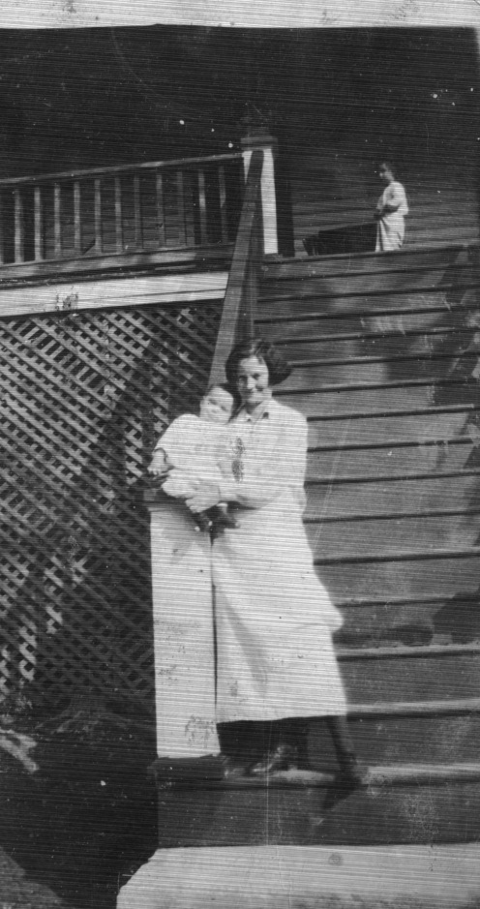
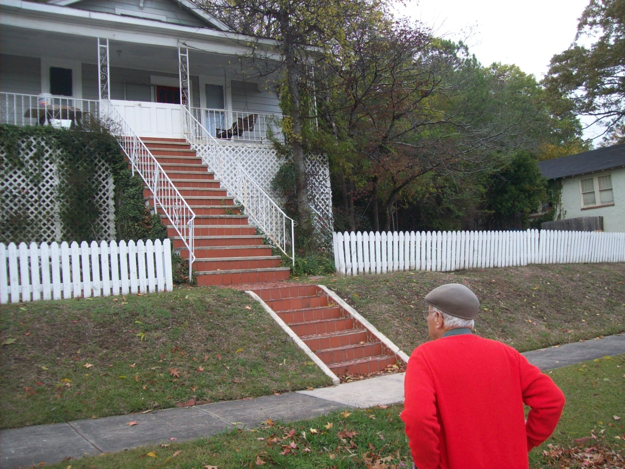

Above left, in 1923, Pearl Caine Holliman, age 37, held her 6th child, Virginia Holliman Cornelius in her arms at the foot of the tall front stairs of her new home she shared with her husband, Ulyss S. Holliman, and family at 2300 3rd Avenue North. At the top of the stairs is her 5th child, Bishop Holliman. On the right in 2010, the same Bishop Holliman views the steps, now all brick, leading to the front porch and his memories of his beloved ‘Mama’.
Each summer Mama would can fruits and vegetables, maybe over 100 jars, as did most housewives. I should note that Vena had married in 1928 and was living next door in the brick house. Robert was manager of the Woodlawn bank and had a good job throughout the Depression, and they were able to take vacations to the beach each summer, a treat denied to most folks in those years.)

Beginning in 1937, I was attending Birmingham Southern College, working in the library on a NYA job, another creation of the New Deal. However, we were still Republican! In 1938, the local GOP sponsored an oratorical contest for “Young Republicans”, and I represented Alabama in the finals in Knoxville, Tennessee and won second prize - $100 - huge sum – enough to pay a semester at college.

Memories of Irondale, 1925 to 1942, Part VI
by H. Bishop Holliman
This is the sixth article of my father’s memories of growing up in the small suburb of Birmingham, Alabama during the 1920s and 1930s, a time of economic deprivation prior to World War II.

Baseball…During the 1930s – at least half – amateur baseball was very popular throughout Jefferson County and most of the small towns fielded a team. The baseball diamond in Irondale lay between the Seaboard and Southern tracks, along First Avenue South. It was a Saturday ritual to attend the games that Irondale played, even if I did have to cross three main line tracks. The whites shared the diamond with blacks. The blacks seldom attended the white games but I often went to see the blacks play.

Some of the players I remember were Hubert Kilgore, Jack Godwin, Jesse Smoke, the two Wilson boys, Alfred McNutt and Click McDanal. All of these fellows were the age of Loudelle and Euhal. Baseball was a big part of our lives during the 1930s. The Birmingham Baron games were broadcast over the radio by Bull Connor, and never missed a game if I could help it. I still remember Melton taking me to my first game at Rickwood field July 5, 1931!

Baseball was not the only recreation for a large family. In the middle 1920s before middle class vacations, a summer treat was to take the family to Grant’s Mill on the east side of Irondale. Here Ulyss Holliman supervises his children in the water, Bishop Holliman front, Euhal, Loudelle Holliman Ferrell and Vena Holliman Daly, behind the boat.
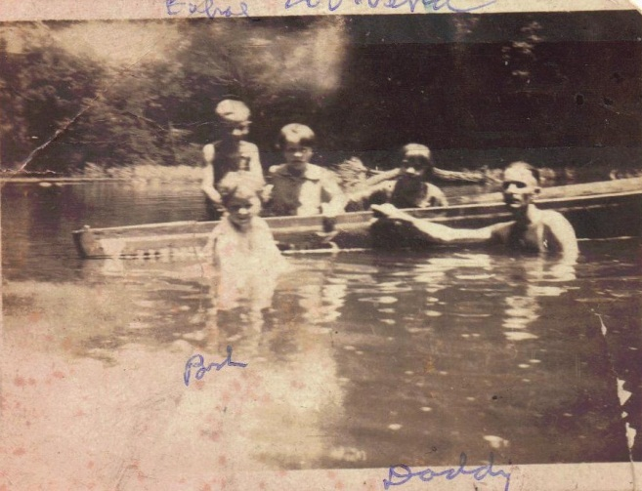

Memories of Irondale, 1925 to 1942, Part VII
by H. Bishop Holliman
This is the seventh article of my father’s memories of growing up in a small suburb of Birmingham, Alabama during the 1920s and 1930s, a time of economic deprivation prior to World War II.
Insert churches

Churches…There were three churches in Irondale as far back as I could remember: the Methodist, Baptist and Presbyterian. At Christmas each one staged a Christmas pageant the Sunday night before Christmas. Every summer the Baptist and Methodist Churches held a revival, and that meant for two weeks we had somewhere to go on the warm summer evenings before there were radios, television and air conditioning.

The revival that stands out in my mind was the one in 1936 at the Methodist Church, conducted by Fred Brown from Bob Jones College. For two weeks the church was filled each night to hear the Word preached by this dynamic preacher. Even folks from the other two churches came to hear him. At the end of the revival put on a watermelon-picnic feast down at the artesian wells where East Side Mall as later built. I have many good memories of church activity up to the time I left in 1941.

Below an outing in Irondale in the late 1930s. Either church or Shades Cahaba friends (probably both). Virginia Holliman Cornelius is 3rd from left and Bishop Holliman on far right.

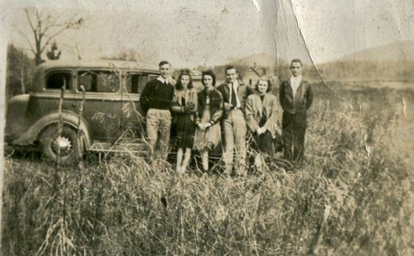

We young people were led by such folks as the Hamiltons, Sherets, Overtons, Grissoms, Glenn Barrow and many others. Most of our social life originated in the church – at Christmas, Halloween, summer outings at Grant’s Mill, where you could go swimming for 20 cents, cook-outs in the fall at the beacon light on Gate City Mountain. We also participated in putting on plays at the school, sponsored by the church in support of some project. One time we bought a pulpit bible with money we raised. Some participants I remember now were: Clementine Sherbet, Mary Virginia Hamilton, Frances McNutt, Jo Helen Leath, Charles Pugh and Louis Overton.
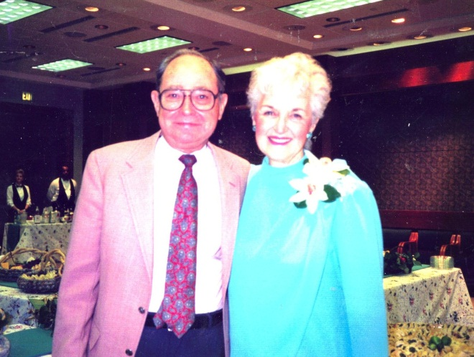
Above Bishop Holliman poses with his sister Virginia Holliman Cornelius (1922 – 2011) at a Birmingham, Alabama reunion in 1985 almost 50 years after the photo by the automobile.

.

Memories of Irondale, 1925 to 1942, Part VIII
by H. Bishop Holliman
This is the eight article of my father’s memories of growing up in the small suburb of Birmingham, Alabama during the 1920s and 1930s, a time of economic deprivation prior to World War II.

The Blizzard of 1940…It was January or thereabouts that snow began to fall, and before it had ended, 14 inches lay on the ground, a very rare occurrence for our part of the South. It began about midnight and at daylight the radio had already come on with the news that schools would not open, nor would the colleges nor would hardly anything else. I don’t remember what Daddy did about going to work. Street cars on some lines had run all night to keep tracks clear. I can’t remember the day of the week it was that all this happened. The hill was frozen over and I guess nearly impossible for cars to get up it. For two weeks the temperature hardly got above freezing, and it dropped to 10 degrees below on the second day.

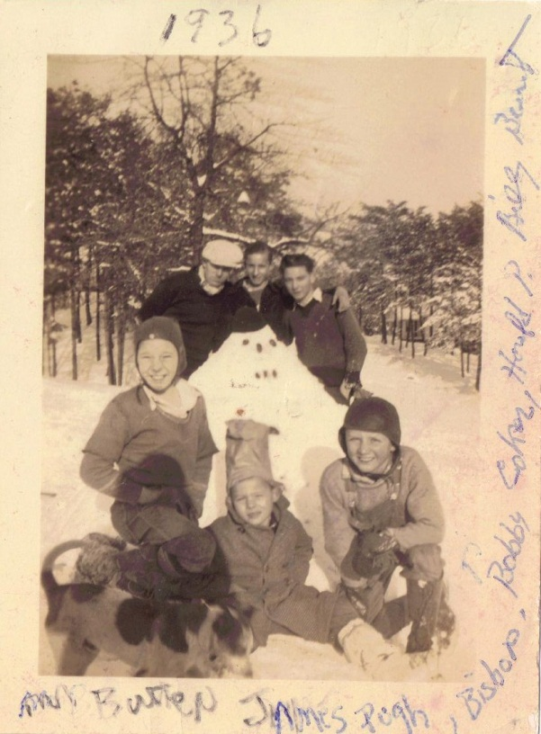
Not the snow of 1940, but above the snow of 1936 on 3rd Avenue, Irondale. Top left to right are The Rev. Stewart Button, James Pugh, Bishop Holliman. Front row are Bobby Coker, Harold Pugh and Billy Bean.

I have forgotten how long it stayed at that mark. Remember, at this time we had no central heat, drinking, cooking, bathing and flushing. Even if they became unthawed, they would refreeze the next night. Each night young folks would gather at the top of the hill above our house, build a fire out of limbs, old tires, etc. and we built sleds out of scrap lumber that somebody furnished and we slide the two blocks downhill. That went on several nights. It was probably the last night of this merriment that the accident happened. A car parked at the bottom of the hill had not pulled all the way into its driveway, leaving part of it in the road, and a sure target for an unguided sled.
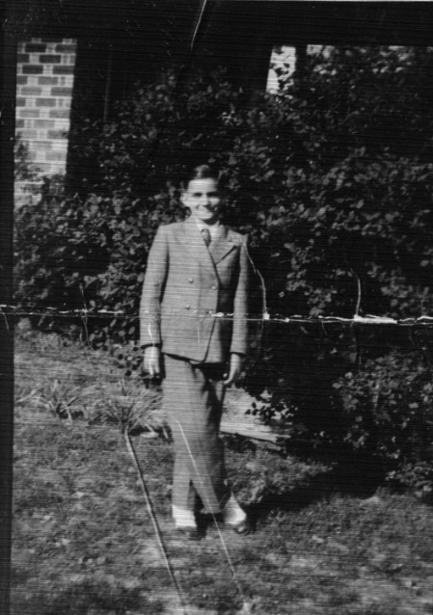

Sans his notorious sled, Young Ralph Holliman, ca 1936, on his front lawn in Irondale. Probably dressed for Easter at the Irondale Methodist Church. Notice his spats!

My brother Ralph was at the front of the sled, followed by Margaret Overton, Jo Helen Leath and myself. You could not steer the sled. It went wherever the ice allowed it to go, and it went right into the back of the parked car! Ralph, who was at the front bore the brunt of the collision, bringing a gash to his head.

Robert Daly, Sr. was on the scene, having been there just to observe the goings on, rushed Ralph to Dr. Odum’s house on the other side of the town. The doctor patched him and sent him on his way. Probably did not charge more than $2 and did not say come back tomorrow. That experience put an end to our sledding. Note Ralph Holliman believes the accident was in the great snow of 1936, not 1940. The two brothers have different memories of the date.

The snow and ice eventually melted, but the blizzard of 1940 stayed with us a long time. That winter as so bad Life magazine ran a cover page in February of the Southern passenger train, The Tennessean, pulling into Washington, D.C., covered with snow and ice, also carrying a story about the frigid winter down south.”

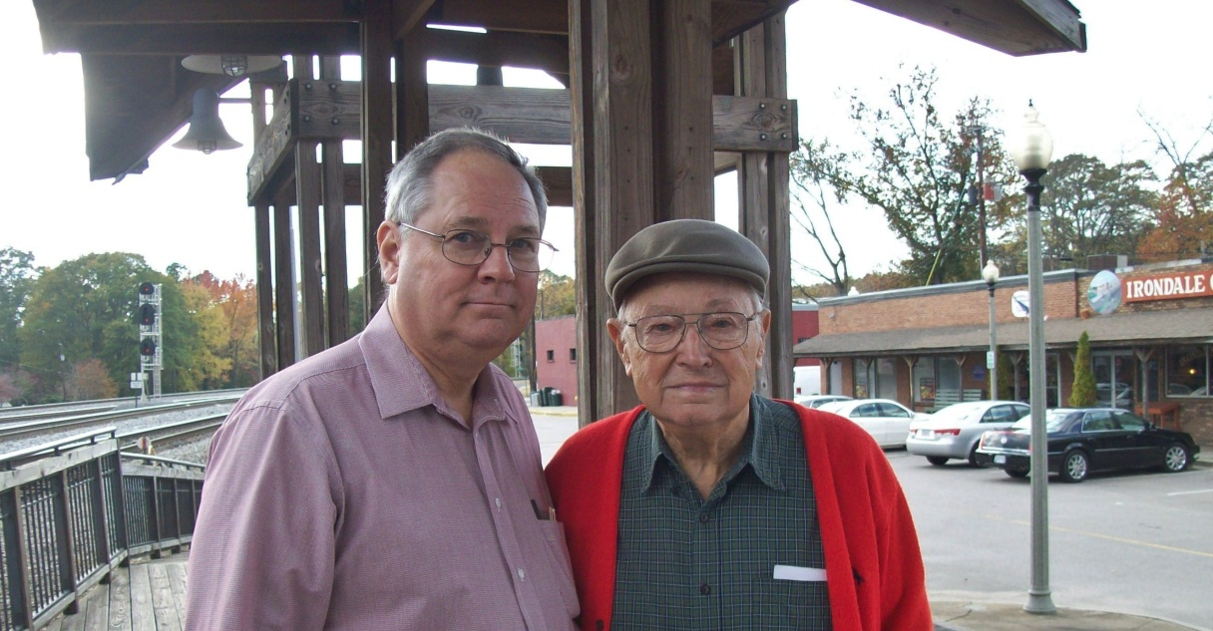

Bishop Holliman, 90, returned to Irondale in November 2010 with his 64 year old son, Glenn N. Holliman to tour the home of his childhood. Bishop named his only son after the Irondale educator, Glenn Barrrow, who died during World War II.

