Thursday, October 27, 2011

The Legacy of Walt Holliman
by Glenn N. Holliman
The Research and Writings of Walter O. Holliman Preserved and Being Shared with a New Generation
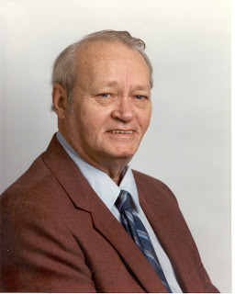

Walter Orien Holliman, pictured above, a meticulous family researcher, passed away November 1, 2003. His birthday was May 5, 1927. Walt's father was Moses Holliman, the son of Warren C. Holliman, the son of Charles Holliman (1795 - 1841 ca), who was the son of James Grantson Holliman (1750-1836), a common grandfather to almost all reading this blog.
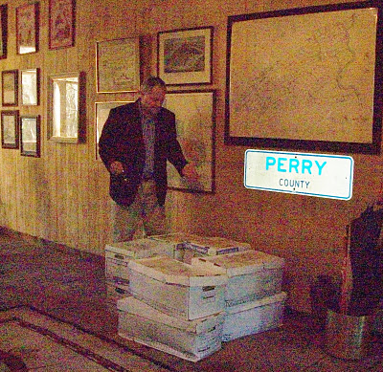
Above, Glenn N. Holliman, distant cousin of Walt Holliman, surveys over 300 pounds of papers and books donated to his Holliman Collection from the children of Walt. The material is housed in a 5,000 volume collection of books and papers in Newport, Pennsylvania (yes, it is in Perry County as the liberated highway sign reveals).
"I walked into my library/barn just as the UPS truck was pulling away to discover this awesome collection of research, manuscripts, raw data and genealogical books. The children of Walt - Lynn, Bryan and Ann - had been in touch with me about preserving the collection. After checking with other children - Debbie and Paul - they decided to pass this invaluable material to my growing family history collection. This is 24 feet of shelf space of important papers and books.
I am honored by their trust. This winter I intend to inventory the collection and begin posting appropriate materials on the web so that other Hollimans and associated families can benefit from the decades of work accomplished by Walt. After my time is over, I intend to pass the collection to a new generation of family members, perhaps in some type of family association or corporation.
While I have not had time to study the materials in depth, there are unpublished manuscripts and meticulous will and land transfer records obviously representing years of work and travel. It is obvious Walt was careful and documented everything he did. His work is an excellent example of a historian who enjoyed his craft.
We are fortunate in our extended family to have this work saved. Others in the family, the late Cecil Holliman and his son, Rhodes Holliman, Ron Holliman, Maxine Wright, Joe Parker, Vonceil Duckworth, Jeanette Holiman Stewart, Glenda Norris and other members of Tina Peddie's chat room have been likewise industrious in saving and preserving our family's history. The story of the Hollimans and our associated families is America's story.
Walt was born in Birmingham, Alabama as was I. A Boy Scout, he enlisted at age 16 in the U.S. Navy serving in World War II as a air gunner. After the war, he graduated from the University of Tennessee and went on to a successful career in mobile home manufacturing and the aviation industry. Tiring of travelling, he settled back in the Birmingham area as a stock and real estate broker. He was a member of Mensa International, the American Legion, the Veterans of Foreign Wars, the Methodist Church and various business associations.
From his last home in Pelham, Alabama, he spent countless hours collecting raw data, saving it and typing thousands of pages of notes and stories on his families.
Our great thanks to the family of Walt for preserving his work and their generosity is sharing it with the larger family. I am happy to report that in the first few weeks of receiving this material, I was able to:
(1) pass along a thick file for review on the Blakeney family to genealogist Glenda Norris, a Blakeney descendant in Alabama,
(2) review Walt's materials on Samuel Holliman (1707 - 1789) with Lynn Holliman (Texas) and Joe Parker (Texas), and together come to consensus, that yes, Samuel is the father of James Grantson Holliman, and
(3) respond quickly to David Jennings of Pickens County, Alabama who sought to know the name of his great, great grandfather. Like Walt, David descends from Warren C. Holliman, son of Charles Holliman, son of James Grantson Holliman."
For information on the Walt Holliman Collection or if you have papers to preserve, please contact yours truly at Glennhistory@gmail.com. Together we can save our history for our children who come after us.

Wednesday, July 25, 2012

Walt O. Holliman Manuscripts
by Glenn N. Holliman
The late Walt O. Holliman (1927 - 2003), a native of Alabama, had an excellent mind and a bent to collect data on family. In the pre-Internet age he did an incredible job of researching his families and those of his wife. In the autumn of 2011, his children shipped me his 20 plus boxes of research. With their permission I have scanned his 55 manuscripts of his related families and now have them ready to email to whomever might have an interest. Our continued thank you to Walt's family for preserving and protecting these documents.
Walt's father was Walt Holliman, the son of Moses Holliman, the son of Warren C. Holliman, the son of Charles Holliman, who was the son of James Grantson Holliman (1750-1836), a common grandfather to many reading this blog.
Some of the manuscripts are in draft, others polished and all footnoted. I can be reached at glennhistory@gmail.com for copies or additional information. If you believe you are related to these families and want to have a look, I am happy to email manuscripts which are in the red color. Additional information on research items can be found in Walt O. Holliman page on the left hand side of the blog.
Below four of Walt's manuscripts - the Alexanders, Beall, Blekeney and Bryan families.
.
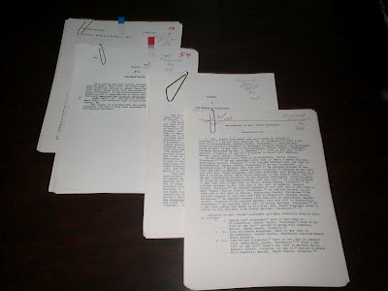
Alexander Family – 80 pages approximately of manuscript and two large binders of research materials of Walt's wife's family from Tennessee. This manuscript has been scanned and can be emailed.

Beall or Bell Family – Approximately 60 pages of manuscript and some 30 pages of research materials; two manuscripts have been scanned and can be emailed.
Blakeney Family – 100 pages of manuscript; these manuscripts (3) have been scanned and can be emailed.
Bryan Family – 20 pages of manuscript, large binders and notebook of research by names of Bryan Family of Tennessee, Mississippi Territory and Pickens Co., Alabama; three manuscripts have seen scanned and can be emailed.

Champion Family - 7 page manuscript of an early Isle of Wight and Surry Co., Virginia family that married into the Beall family; manuscript has been scanned and can be emailed.

Curtis Family – 11 pages of manuscript and research of census records; manuscript scanned and ready for emailing.
Davidson Family plus Index– 101 pages of manuscript plus massive research binders on Walter O. Holliman’s maternal family; manuscript ready for emailing - has Bryan, Champion, Curtis, Egerton, Emerson, Guyton, Hawkins, Judkins, Love, McKnight, Petite, Petway, Smith, Wallace, Whiteaker and other ancestors.
Davies Family – 6 pages manuscript; scanned and ready for emailing.
De Mallpas Family – 2 pages of manuscript; scanned and ready for emailing.
Douglas Family – 2 page manuscript and basically research copies of Scottish newsletters from 1990s; scanned and ready for emailing

Edwards Family – 8 pages approximately of manuscript and research photocopies from Virginia including Surry County; scanned and ready for emailing.
Egerton Family – 40 pages approximately of manuscript– Massive folder full of notes and photcopies; scanned and available for emailing.
Emerson Family -2 pages of manuscript; scanned and ready for emailing.
Fitzhugh Family - 2 pages of manuscript; scanned and ready for emailing.
Fowlehurst Family – 2 pages of manuscript; scanned and ready for emailing.
Gonson Family - 2 pages of manuscript
Graves Family – 30 pages of manuscript and a massive research folder of photocopies and some notes; scanned and ready for emailing.
Gray Family – 6 pages of manuscript and individual folders of research and photocopies of Grays of Virginia, N.C., S.C., KY and Alabama, hundreds of pages; manuscript only scanned and ready for emailing.
Guyton Family – 77 pages of manuscript and two hundred research pages of records, notes and photocopies; manuscript only scanned and ready for emailing.
Hall Family – 3 pages of manuscipt; scanned and ready for emailing.
Hawkins Family – 35 pages approximately of manuscript and several hundred pages of photocopies covering four states; scanned and ready for emailing.
Hendrix Family – 20 pages approximately of manuscript and research photocopies of wills and personal notes, not in order: manuscript scanned and ready for emailing.
Holliman Family – over 200 pages of manuscript, many duplicates. Research is extensive and included in the appendix. This manuscript is available for emailing. Contact Glennhistory@gmail.com.

Howard Family – 20 pages approximately of manuscript and perhaps 50 pages of notes; scanned and ready for emailing.

Judkins Family – 15 pages approximately of manuscript and many research pages of notes; Scanned and ready for emailing.
Love Family – 5 pages of manuscript and research records and photocopies; scanned and ready for emailing.

Mansfield Family – 2 pages of manuscript; scanned and ready for emailing.
Manwaring Family – 2 pages of manuscript; scanned and ready for emailing.
McBee – 2 pages of manuscript and one page of research; scanned and ready for emailing.

McKnight Family – 2 page manuscript of family history; scanned and ready for emailing.
Moore Family – 2 pages of manuscript and a research binder, at least fifty pages of photocopies, many of Surry and Southampton County, Virginia records; scanned and ready for emailing.

Nicholson Family – 3 pages of manuscript and research of Virginia Colonial Abstracts for James City; scanned and ready for emailing.

O’Dell Family – 58 pages of manuscript and a large binder of research material; scanned and ready for emailing.
Oliver Family – 67 pages of manuscript and a large research file; scanned and ready for emailing.

Below a portion of the Walt O. Holliman Collection at the ad hoc Holliman Family History Library, Newport, Pennsylvania

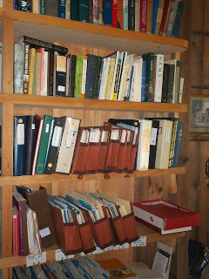
Pearce or Peerce Family – 18 pages of manuscript and a large file of research; scanned and ready for emailing.
Petway Family – 9 page manuscript and Surry County, VA and Granville Co., N.C. research records; scanned and ready for emailing.

Petite Family – 18 pages of manuscript and fifty pages at least of research; scanned and ready for email
Peerce (Pearce) Family - A 12 page manuscript; scanned and ready for emailing
Ridgely Family – 42 pages with duplication of manuscript and over 100 pages of research including Maryland records; scanned and ready for emailing.
Riggan Family – 18 pages of manuscript with massive file on this Monroe, Mississippi family; over 100 pages of photocopies of records from Virginia and Maryland Counties. Many personal notes all in a brown large folder. Manuscript scanned and ready for emailing.
Roberts Family – 49 pages manuscript with a very large file (5 inches); scanned and ready for emailing.
Smith Family – 106 pages of manuscript and research on Jonathan and Henry Smith with photocopies of wills and estates; scanned and ready for emailing.
Spencer Family – 2 pages of manuscript; scanned and ready for emailing.
Sprigg Family – 19 pages of manuscript plus search of Maryland photocopies of records, perhaps 75 pages; scanned and ready for emailing.
Standley Family – 2 pages of manuscript; scanned and ready for emailing.

Thompson Family – 3 pages of manuscript and research notes and census of 1790 in South Carolina; scanned and ready for emailing.
Thornton Family – 2 pages of manuscript; scanned and ready for emailing.
Trelawney Family – 2 pages of manuscript; scanned and ready for emailing.

Wallace Family – 5 pages of manuscript and several research pages including a 1965 history of the family; scanned and ready for emailing.
Walters Family – 20 page manuscript and research photocopies and notes; scanned and ready for emailing.
Williams Family – 3 page manuscript and three research pages of photocopies; scanned and ready for emailing.
Wilmot Family – 3 page manuscript and South Caroline research records including history of state senate; scanned and ready for emailing.
Whitaker Family – 18 page draft manuscript and large binder of notes and materials; scanned and ready for emailing.

Whitten Family, Bible and Wesley Chapel Methodist Church Roles – 59 pages of manuscript and a larger binder of materials plus the Whitten and Wilson Family Bible including the Sunday School Record Book, Wesley Chapel Methodist Church, Fayette County, AL, 1851-1878. Scanned and ready for emailing.
Wilson Family – over 200 pages of manuscripts, many duplicates of this South Carolina and Alabama family. These manuscripts have been scanned and can be emailed.

Again my email is glennhistory@gmail.com if you desire a down load of material!

Thursday, February 2, 2012

A Holliman History by Walter O. Holliman, Part I
by Glenn N. Holliman
What follows are dozens of pages of critical Holliman family research prepared in 1995 and 1996 by the late Walter O. Holliman (1927-2003). In the fall of 2011, his children shipped me his papers and since then I have been indexing and reading his marvelous research and conclusions. In the left column of this post, one will find the Walter O. Holliman manuscripts and research folders of his voluminous work.
With this posting, I begin publishing his interpretation of our family's history. He prepared two documents. The 1995 copy contains his understanding at the time of the first Holyman's in America and takes us into the 20th Century. In his 1996 work, he omits the early Virginia Hollimans and begins with his 4th great grandfather, James Grantson Holliman, again traveling late into the last century. For privacy sake, I cease the history with Walt's parents, uncles and aunts. My introductory comments are in red. Walt's pages are as he prepared them. Click twice and the pages should enlarge.
I know I speak for his children and all who are interested in Holliman history when I say comments and critique are welcome. As Walt himself notes, genealogy is never finished. New information continues to come forth and alter earlier interpretations.
The Title Page - I have omitted his address. The documents are posted with permission of his children. As far as I know he never published this tome. This title page is from 1995.
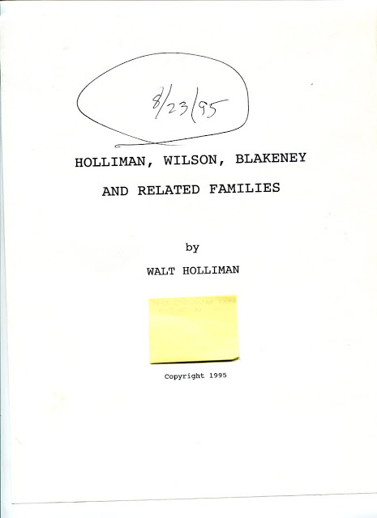

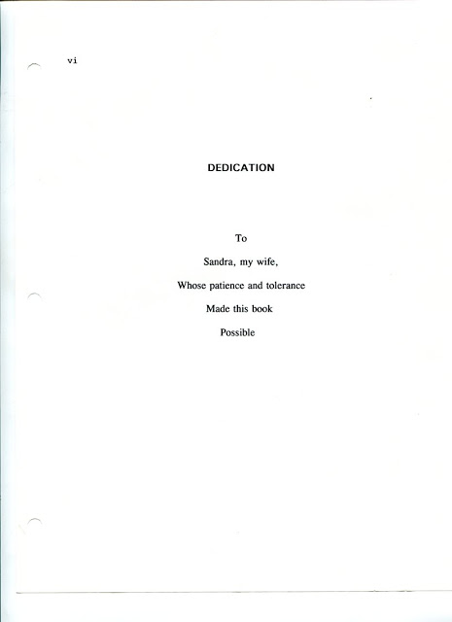
Index - This really is Walt's table of contents. He created manuscripts for all the families listed below, over fifty, and research on another fifty or so! These manuscripts are available, but are not part of the series of posts that will be forthcoming immediately.
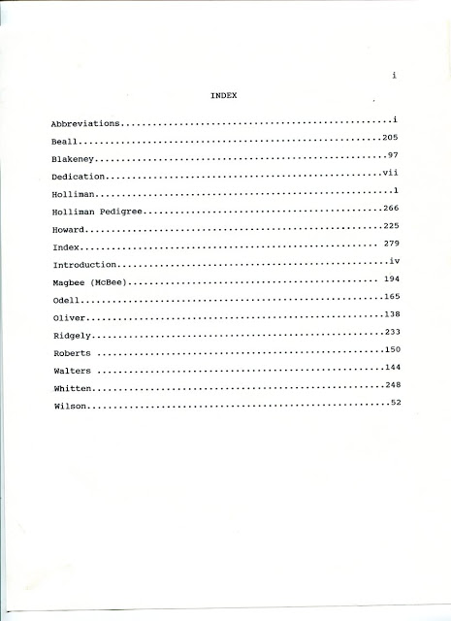
Abbreviations -Walt was meticulous as this listing of abbreviations indicates. He belonged to Mensa International, an organization for persons with a high I.Q. (Well, would we not except that from a Holliman!?)
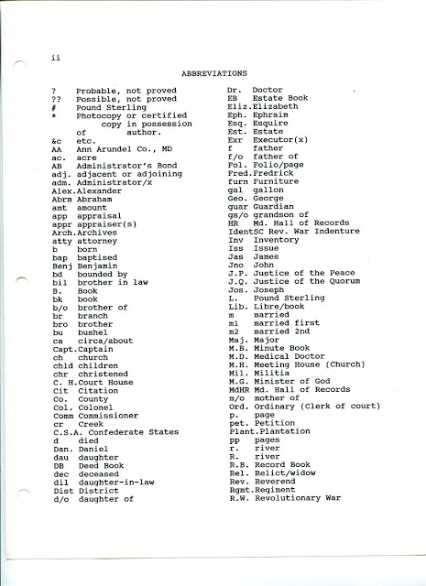
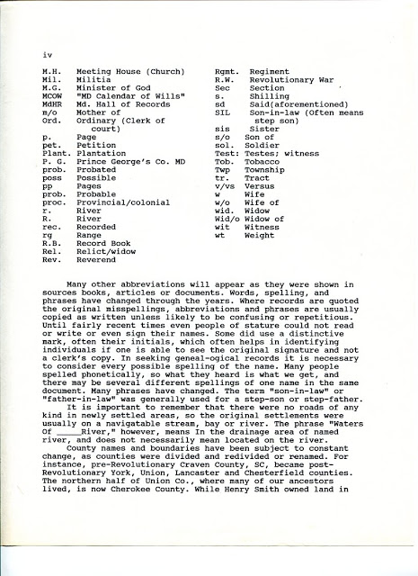
The next page is missing, and it becomes impossible to separate the 1995 and 1996 editions. However, the conversation, slightly truncated, continues below. The pages are not always in order due to Walt's dual publications and evidently additional changes. He provides some very useful commentary on genealogical research.
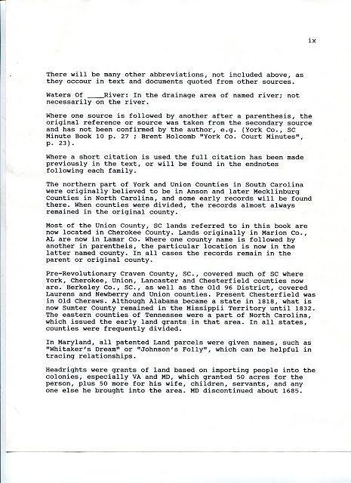
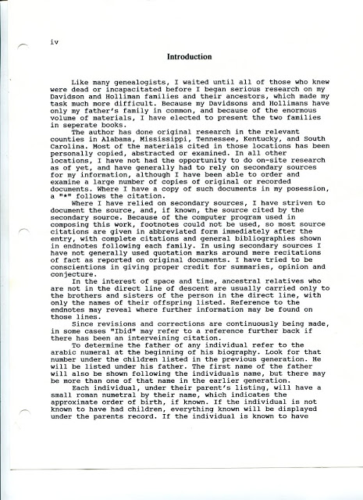
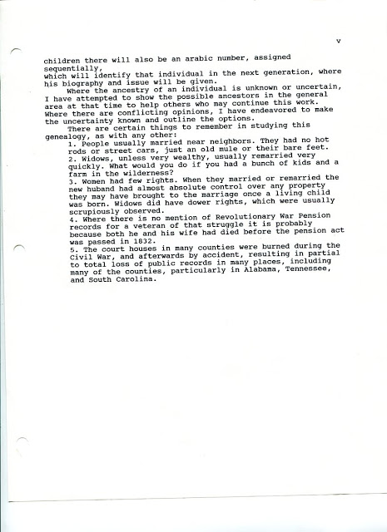

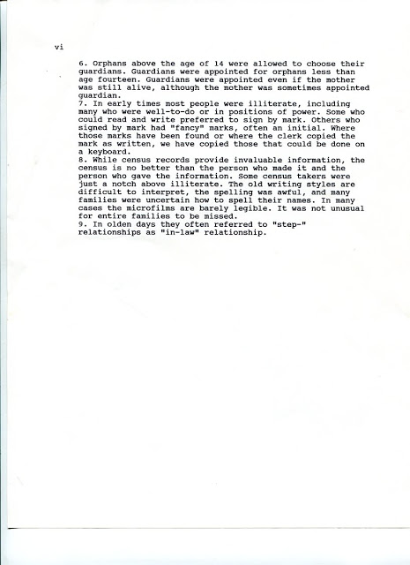
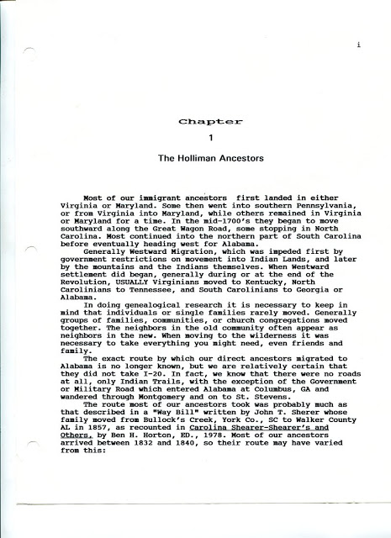

This description of the trek west to Alabama in the 1830s from South Carolina is important. Imagine horses, cows, pigs, hand carts and wagons. Women and children, along with young husbands and fathers, moving through near wilderness pushing ever westward.

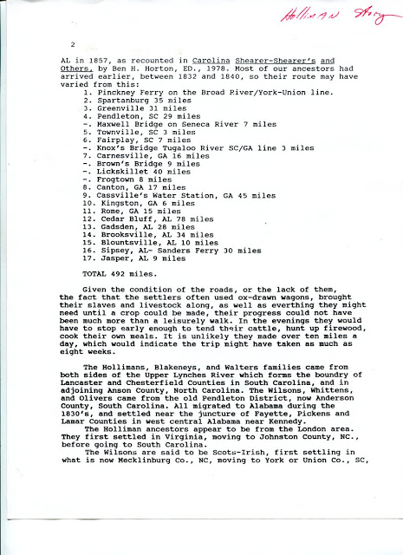

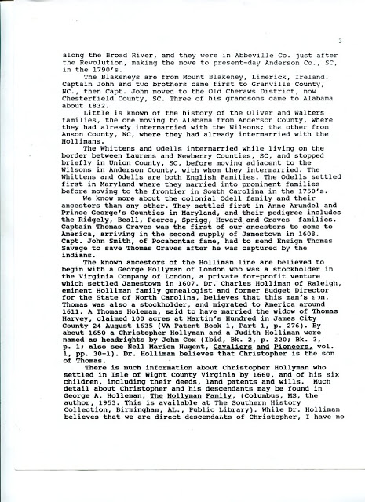
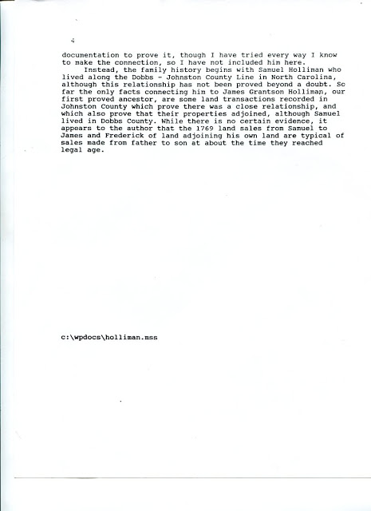
In the next post, we will begin Walt O. Holliman's generation by generation interpretation of our early Holyman history.

Wednesday, February 8, 2012

A Holliman History by Walter O. Holliman, Part II
by Glenn N. Holliman
This is the second in a series of a history of the Holliman family written by Walter O. Holliman in 1995 and edited in 1996.
In the 1995 document with which we begin below, Walt presents a 1990s interpretation of the Holyman family in England. As readers of this blog know, we now have evidence that the American Hollimans emerged from Bedford and Buckinghamshires in the 17th and 16th Centuries.
This first generation provided by Walt is curious, and he hesitated to include it in his work. I have hesitated also, but feel there may be some clues worth exploring now that we have the Internet. He quotes the late Dr. Charles Holliman of North Carolina for a considerable portion of his information of our family's early Virginia history.
Unfortunately Walt was not able to obtain original sources for much of Dr. Holliman's work. For example, information from my research in England does give a hint that Hollimans emerged from London, as early as the 1400s, but the name George Holliman is unknown to me. A Holliman as a member of the London Stock Company?! This startling statement certainly calls for more research.
Also, the Bermuda assertion is curious. There was an amazing amount of slave and tobacco trade between Bermuda and Virginia in the 1600s. While there is evidence of one Richard Holliman, a son of Christopher Holyman, Sr., transporting settlers to Virginia by ship, this writer has not seen as of yet, any evidence of Hollimans living in Bermuda.
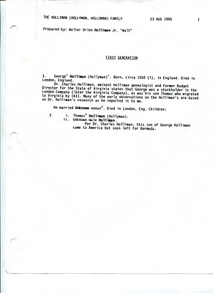
The next page below requires careful review. Walt states Thomas Holliman is the son of George Hollyman, and was a stockholder in the London Company. Cavaliers and Pioneers, p. 30-31 is cited as the source. This requires investigation as this thesis is completely new to this writer.
In the next sentence, Walt records as have others, of one Thomas Holeman, acquiring land in Martin's Hundred in 1635 near Jamestown. The speculation on one Thomas Harvey is the first time I have seen such. Alas, Charles Holliman is quoted in several places but with no annotation.
Item 3 below merges several persons and events, and one cannot be sure if Christopher Holyman is born in Virginia or transported there with his sister. This writer does not accept this page's interpretation as accurate as much more evidence is available today than in the early 1990s. Again, I urge a careful reading of my earlier writings at this blog spot.
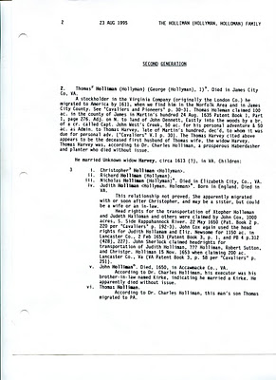
Below, with the next generation, Walt moves to surer ground. His first source is George A. Holleman's 1953 book and some speculation of our English roots. In paragraph 3, Walt again quotes Dr. Charles Holliman on Christopher Holyman's age and gives a Surry County deposition as the source. Hmmmm.... The rest of the page is a valuable listing of Christopher Holyman, Sr.'s legal and land records in Virginia. Here we see Walt produce his solid research with which he will be flooding us in future articles.

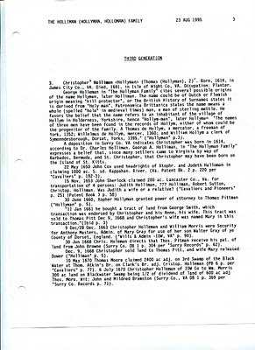

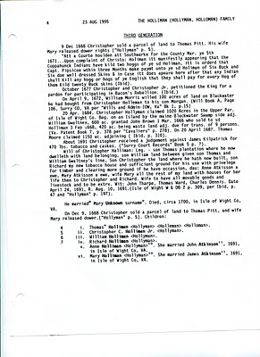
The page below reflects Walt's partial acceptance of Dr. Charles Holliman's thesis that Walt's descent from Christopher Holyman, Sr. is through Thomas Holliman, a son born ca 1655, dying 1734. The information Walt records is valuable, but he is dubious that James Grantson Holliman is through Thomas. Today, several learned Holliman genealogists believe descent from Christopher Sr. is through his son Richard Holliman to his son Samuel Holliman.
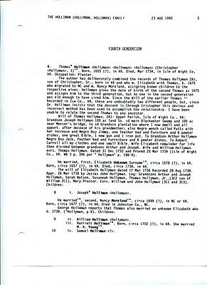

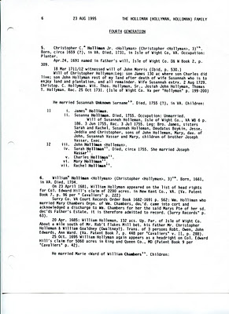
Notice person 18, iv. Samuel Holliman on the page below. This writer believes his descent from Christopher Holyman, Sr. is through Richard to Samuel to James Grantson Holliman. Walt accepts the Samuel thesis himself later in his manuscript.
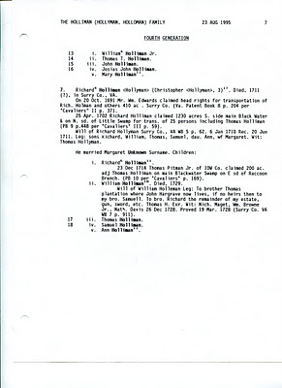
So we tip our hat to both Dr. Charles Holliman and Walt O. Holliman for their work almost two decades or more ago. Now in the Internet age and with access to English archives, the early interpretations have changed considerably, but we still salute their efforts and recognize that genealogy is always a process that requires research and constant critique.

Thursday, February 9, 2012

From the Walter O. Holliman Archives
by Glenn N. Holliman
An Announcement -
My son, Christopher S. Holliman, writes a blog at http://the62mets.blogspot.com/ and, no, it is not about baseball. One of his most recent blogs is a trip to the Crater at the Petersburg, Virginia battlefield where his 3 GGF and 2 GGF fought for the Confederacy. You might check it out. There are some photographs.
And now...
A Special Posting...
Several of you have been studying the page on the Walter O. Holliman Materials, an index of his voluminous research on his families and have asked for information. Below I reproduce six pages of photocopies he made in the early 1990s of Johnston County, North Carolina Holliman land records. This information may or may not be new to serious Holliman family researchers but I am happy to post this and other items as time permits.
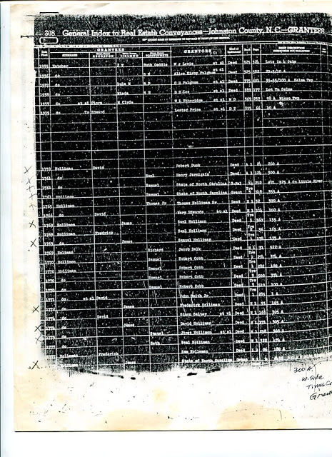

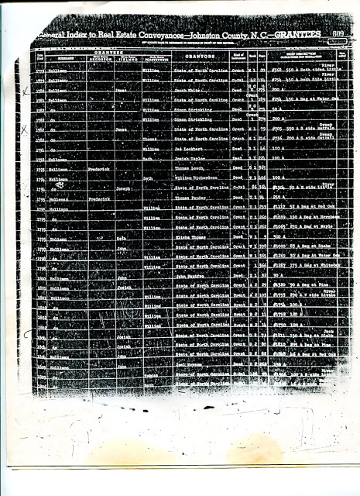

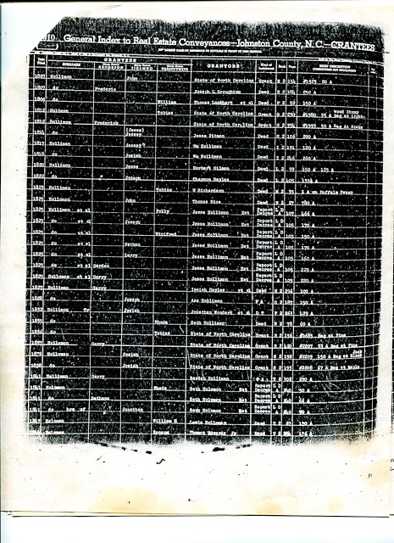

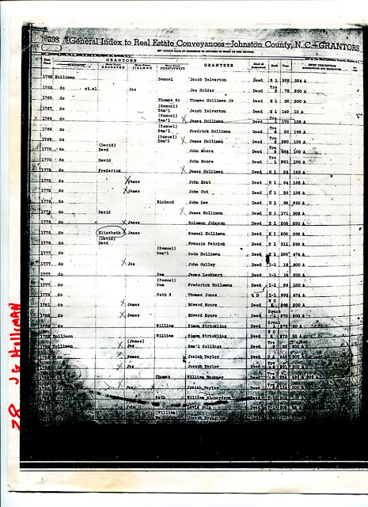

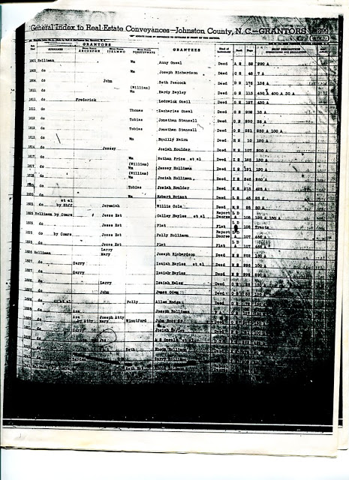

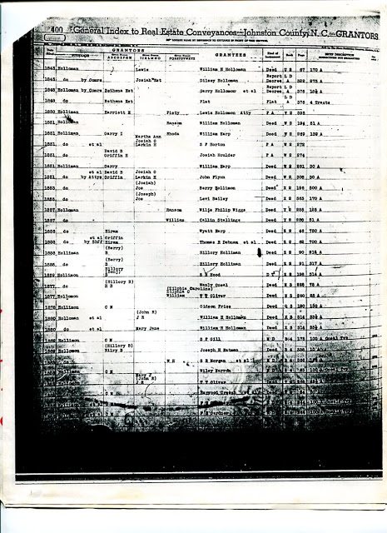
Walt came to believe, as did Dr. Charles Holliman, that Samuel Holliman was the father of my 4 great grandfather, James Grantson Holliman (1750-1836).

Sunday, February 12, 2012

A Holliman History by Walter O. Holliman, Part III
by Glenn N. Holliman
This is the third in a series of a history of the Holliman family written by Walter O. Holliman in 1995 and edited in 1996.
Please refer to previous posts in order to understand the sequencing of these pages. Walt continues sharing his research on the Holliman family that came to Virginia in 1650. The Samuel Holliman below is believed by several serious Holliman genealogists, including this writer, to be the son of Richard Holliman and father of James Grantson Holliman (1750-1836). Walt assigned Samuel to the Thomas Holliman line, and he admitted below his ambiguity over the issue.
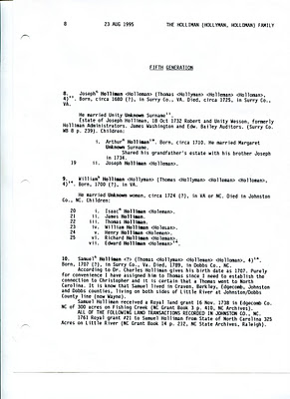

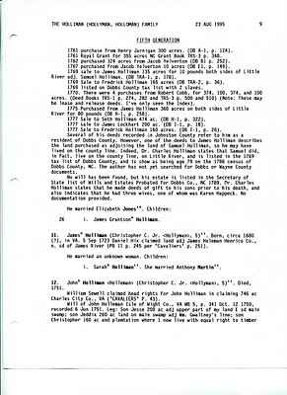

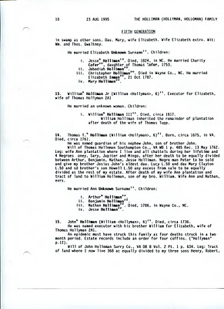

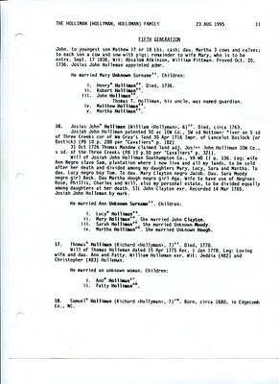

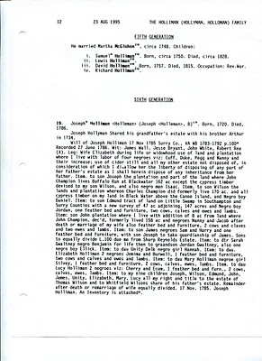

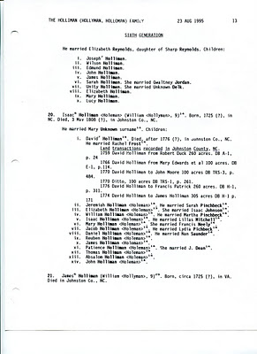

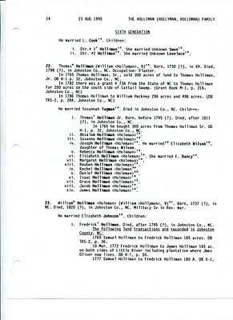

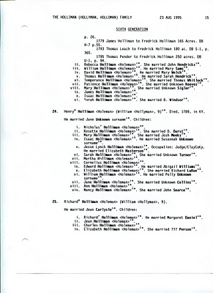
It is hoped the above pages are useful for those who do not have this research. This closes our presentation of Walt's 1995 publication. In the next posting, we shall read of his 1996 conclusions and research beginning with Samuel Holliman (1707-1789), the believed father of James Grantson Holliman.
Obviously, much has happened in family research since Walt typed these words. If you see any errors or material that should be challenged or enlarged, please let us know.

Saturday, February 18, 2012

A Holliman History by Walter O. Holliman, Part IV
by Glenn N. Holliman
This is the fourth in a series of a history of the Holliman family written by Walter O. Holliman (1927 - 2003) in 1995 and reworked by him in 1996.
In this posting of a manuscript written in 1996, Walt labels this chapter as Generation One choosing to begin his Holliman family history with Samuel Holliman (1707-1789). Walt was uneasy about the accuracy of his information on Christopher Holyman, Sr. and other early Hollimans in Virginia. As I have pointed out in early blogs, he had reason be concerned about the veracity of information he had gathered on Holymans in the early to late 1600s.
Some of the material Walt presents below concerning the origins of Hollymans in America has been superceded by new research. However, in this story there could be some tid bits that could yet lead us in new paths of genealogical research.
Walt provides valuable research on Samuel Holliman's real estate dealings in North Carolina. On page three, Walt states one Elizabeth Jones, born Isle of Wight, was a wife of Samuel Holliman. This is the first time I have seen such information and welcome comment on it.
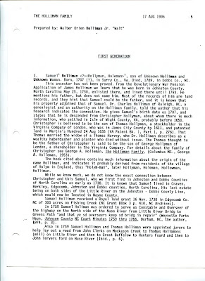

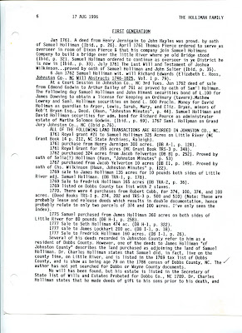

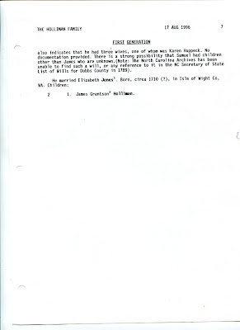
As I have written extensively, I believe the Hollimans emerged from a family in Bedford and Buckingham Shires, England with Christopher Holyman, Sr. (1618-1691) arriving in Jamestown in 1650. My descendant, in my opinion, is through Richard Holyman (1660s ca - 1711), a son of Christopher, Sr., through Samuel Holliman (1707-1789) and on to James Grantson Holliman (1750-1836). Still, it is fascinating to study Walt O. Holliman's manuscript and reflect on what adds to our genealogical picture and challenges our perceptions.
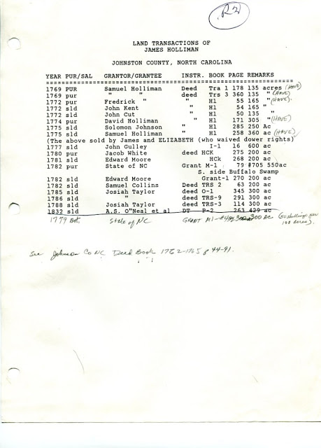
Above in Walt's own handwritting and type is his research on Holliman land sales in Johnston County, North Carolina in the 1700s. This is valuable for those seeking North Carolina roots.

Friday, February 24, 2012

A Holliman History by Walter O. Holliman, Part V
by Glenn N. Holliman
This is the fifth in a series of a history of the Holliman family written by Walter O. Holliman in 1995 and edited in 1996.
In this Second Generation document, Walt shares his research on James Grantson Holliman (1750 - 1836). There is more to be written on this Holliman's Revolutionary War record in which he served in his local Johnston County militia as a young man, but this manuscript does include a copy of his petition seeking a pension for his service. Also included in this material is the story of two of his daughters seeking financial redress for his military years.
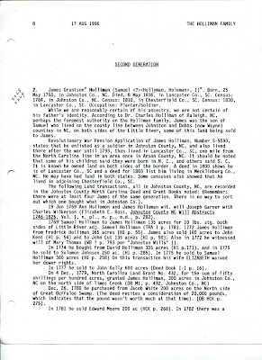

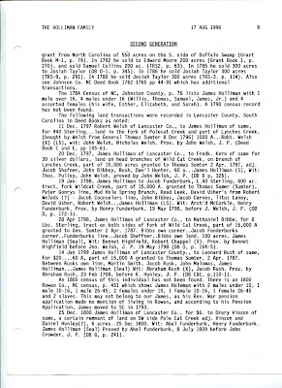

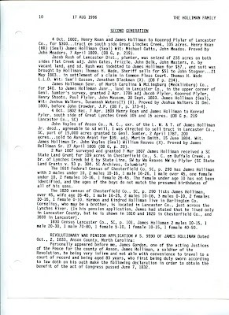

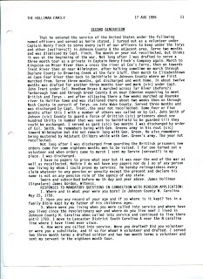

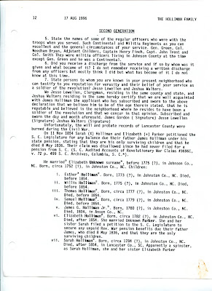

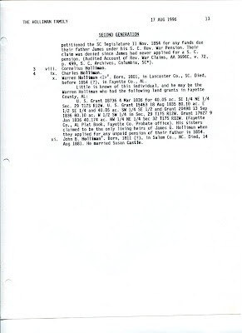
At this writing, Walt was not aware that James' wife was Elizabeth Bryant, evidently from a neighbouring farm, and related to a distinguished family in Johnston County, North Carolina.

Tuesday, February 28, 2012

A Holliman History by Walter O. Holliman, Part VI
by Glenn N. Holliman
This is the sixth in a series of a history of the Holliman family written by Walter O. Holliman in 1995 and edited in 1996.
In this Third Generation as Walt labels his manuscript, his ancestor Cornelius Holliman (1792-1862) leaves the used-up soil of South Carolina, and with a good dose of Alabama fever, he and two of his brothers leave the grave of their father, James Grantson Holliman, and migrate to West Alabama in 1836.
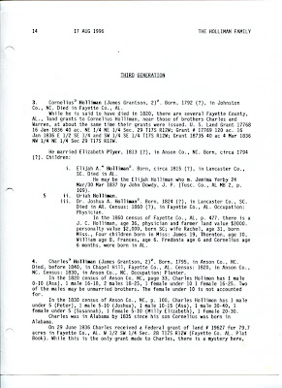

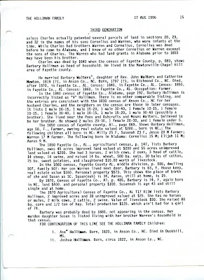

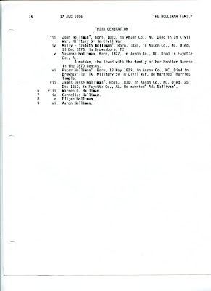
If you have information to add to this narrative, please let us hear from you.

Sunday, March 4, 2012

A Holliman History by Walter O. Holliman, Part VII
by Glenn N. Holliman
This is the seventh in a series of a history of the Holliman family written by Walter O. Holliman in 1995 and edited in 1996.
Walt named this generation as the 'Fourth' and began it with my second great grandfather, Uriah Holliman (1818 - 1862), a successful farmer who enlisted in the CSA in 1861, and along with his son, Charles, died of the measles in Okalona, Mississippi after the Battles of Shiloh and Corinth. A tragic waste that took the Holliman family generations to recover.
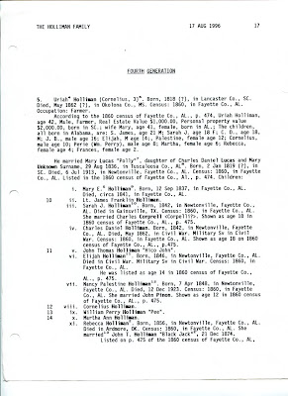

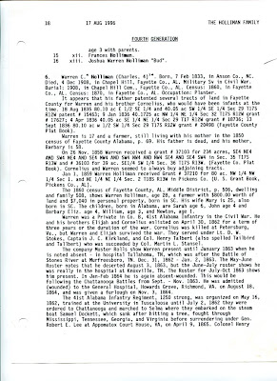

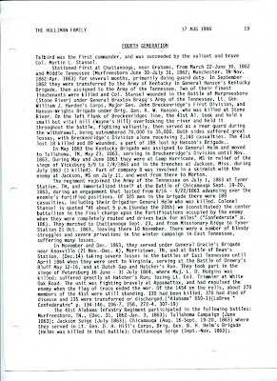

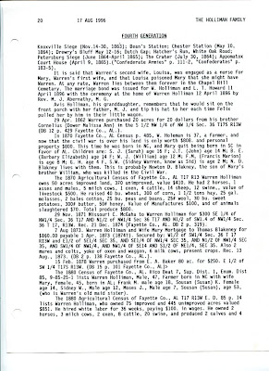

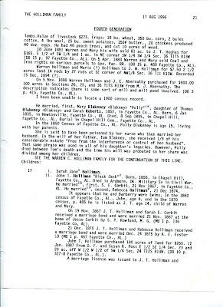

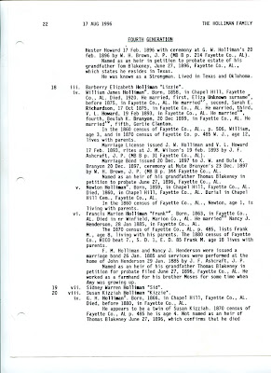

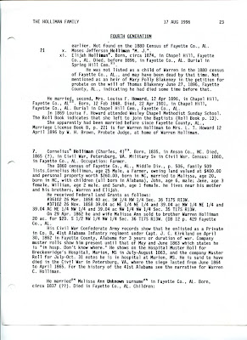

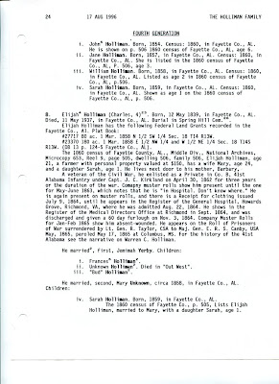

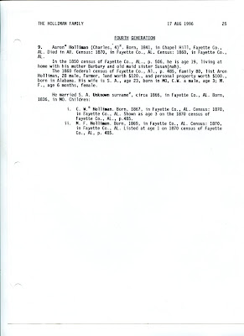
The above represents the extent of information available to Walt in the early 1990s, before the Internet age. Additions and corrections welcome.
Posted by Glenn N. Holliman at 4:42 PM No comments:

Friday, March 9, 2012

A Holliman History by Walter O. Holliman, Part VIII
by Glenn N. Holliman
This is the eighth in a series of a history of the Holliman family written by Walter O. Holliman in 1995 and edited in 1996.
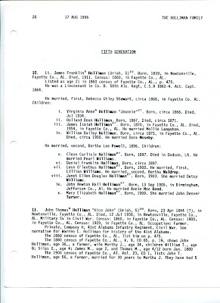

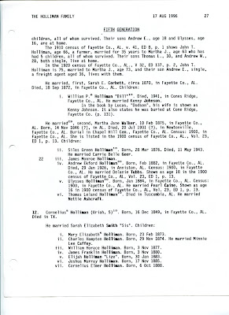

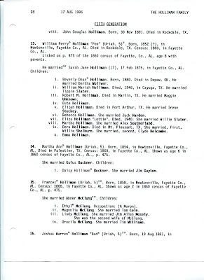

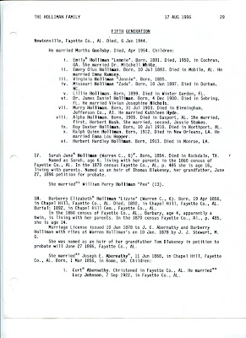

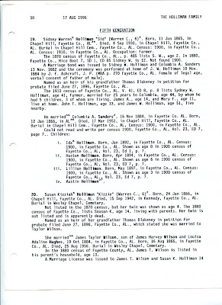

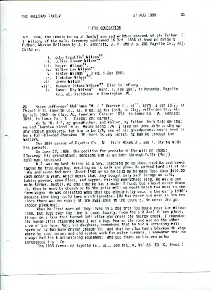

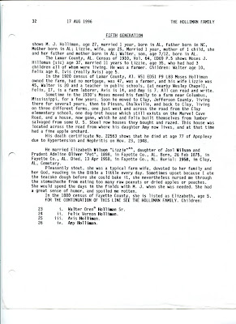
The John Thomas Holliman recorded in these documents is this writer's great grandfather.

Wednesday, March 14, 2012

A Holliman History by Walter O. Holliman, Part IX
by Glenn N. Holliman
This is the ninth and last in a series of a history of the Holliman family written by Walter O. Holliman in 1995 and edited in 1996.
This generation includes Walt's father and mother.
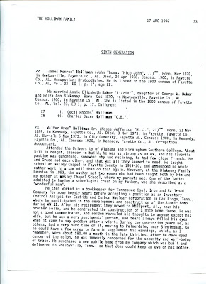

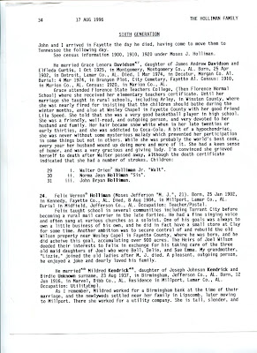

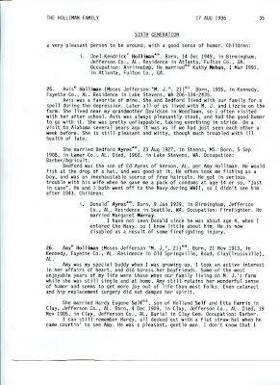

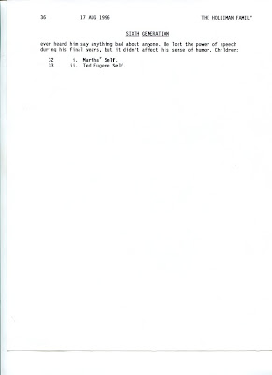
Walter O. Holliman produced dozens of manuscripts of his associated families. Over time, they shall be posted. For our next, blog we will feature the memories of Dr. Rhodes Holliman, another outstanding Holliman historian.

