by Glenn N. Holliman

School Pictures

Sometime after World War II, a tradition started in this country of commercial companies coming to schools and taking photos of the students. Here are a few of the cousins celebrating a return to school this fall.

1990s

First Grace and Chris

And now Patrick!
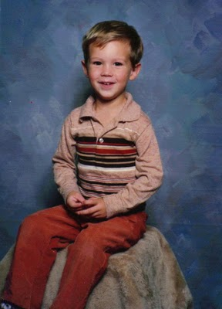
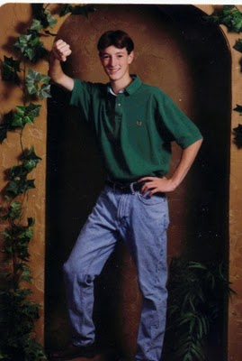

And Jonathan in an ivy arch!
Tomorrow the other four cousins....
Posted by Glenn N. Holliman at 1:09 AM 0 comments
Email ThisBlogThis!Share to TwitterShare to Facebook
Labels: Chris Holliman, Grace Holliman, Jonathan Murphy, Patrick Murphy

Monday, August 30, 2010

Holliman Scrapbook, No. 42
by Glenn N. Holliman

All Dressed Up!
1970s
Here is a formal photo of Alice and Bill, I think before they were married. Bill is behind the mustache.
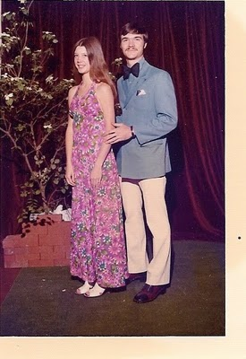

My side of the family could be formal also. This is the backyard in Cookeville, I think in 1975. Lynn, Grace and I look pretty spiffy. Lynn and I were old, about 29 years. Grace was one, and perhaps overly dressed, perhaps.
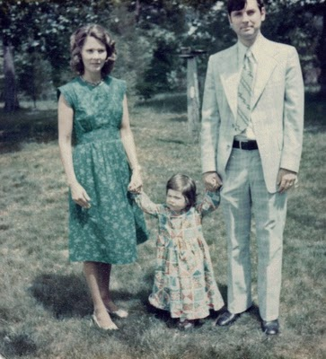
Here is a nice black and white photo of the Paynes with young Bryan. As I look at these archives I am struck how often the back yard in Cookeville was the staging area for so many pictures.
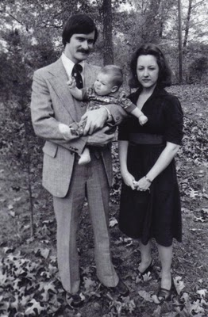
I think we looked rather nice when we were younger. Of course, the ladies have never aged....
Posted by Glenn N. Holliman at 1:53 AM 0 comments
Email ThisBlogThis!Share to TwitterShare to Facebook
Labels: Alice Murphy, Becky Payne, Bill Murphy, Bryan Payne, Glenn Holliman, Grace Holliman, Lynn Holliman Armstrong, Paul Payne

Sunday, August 29, 2010

Holliman Scrapbook, No. 41
by Glenn N. Holliman

The 1975 Great Trip concluded....(whew you say...)
In Spain, we traveled into the mountains and visited an ancient village. Is Becky is looking for ancient artifacts or the car keys?
Below Becky stands on a ruin and photographs the countryside. Pretty dramatic scenery don't you think?
Here we stop for lunch and enjoy figs from a tree.
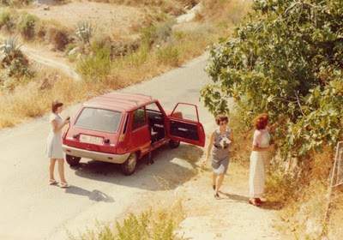
I end with this great picture of the photographer we took along for the trip. Note his the wide tie and wine-red knit bell bottom pants. Truly the 1970s when we were young and thin. Kudos to Mother and Becky for living with me for two weeks. They deserved a lot of credit. Hollimans do dress well for travel.
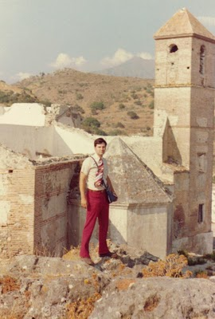
Okay, that's it for a week of some one else's summer vacation...back to other family members tomorrow....
Posted by Glenn N. Holliman at 2:36 AM 0 comments
Email ThisBlogThis!Share to TwitterShare to Facebook
Labels: Arlette, Becky Payne, Glenn Holliman, Granny

Saturday, August 28, 2010

Holliman Scrapbook, No. 40
by Glenn N. Holliman

The Great Trip, now to Spain

It was 1975 and for $700 one could fly to London, Paris and Magala, Spain all travel, hotels and meals paid. Not bad for the time. Here Becky, Mother and Arlette enjoy a repast in Magala. Arlette lived in a mountain village, Mijas, overlooking the Mediterranean near Malaga. Mother looks very stylish.

<
This was a village near Mijas.
This is Becky photographing one means of mountain transportation in Spain in 1975.
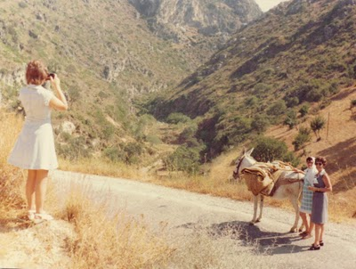
More of Spain tomorrow....
Posted by Glenn N. Holliman at 6:02 AM 0 comments
Email ThisBlogThis!Share to TwitterShare to Facebook
Labels: Arlette, Becky Payne, Granny

Friday, August 27, 2010

Holliman Scrapbook, No. 39
by Glenn N. Holliman

Continuing the Great Trip....On to Paris!
1975

I have posted some earlier photos of Mother and Becky in Paris but here are several more. Perhaps we were there for two days? Not sure.
We attended a service at the Cathedral of Notre Dame. Interestingly in 1996, Barb, while working a capital campaign in France, had an apartment only six blocks from where I took this photo.
Below is a photo of the service. Interesting light is it not?
The Tower and the ladies!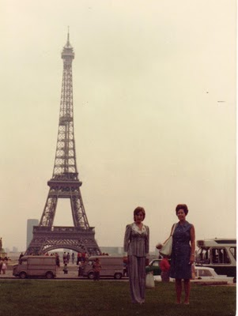
Off to Spain tomorrow.....(well, I could be making you sit through hours of home movies....)
Posted by Glenn N. Holliman at 4:31 AM 0 comments
Email ThisBlogThis!Share to TwitterShare to Facebook
Labels: Becky Payne, Granny

Thursday, August 26, 2010

Holliman Scrapbook, No. 38
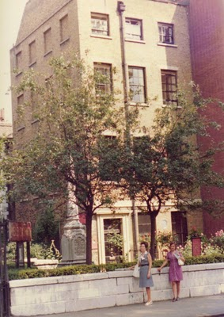
by Glenn N. Holliman

The Great Trip continues...

Mother has deep Methodist roots as a result of a revival meeting in Sutherland, Ashe Co., North Carolina in the 1850s. Her great grandparents, Isaac and Caroline Greer Wilson, left a Baptist heritage and joined a rural Methodist Church. The tradition of Methodism has continued for generations. So while in London in 1975, we visited the home of John Wesley, the founder of Methodism and the adjacent cemetery where so many other Protestant saints lie buried.

To the right is the John Wesley home, chapel and burial place. That's Mother and Becky in front. We had walked all the way from the Tower of London to this location known as Bunhill Fields. All the walking bothered Becky not at all.
Here is an attractive picture of Mother resting by Susanna Wesley's grave.
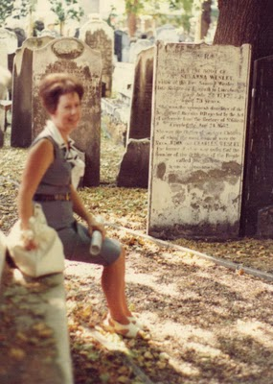
Yes, I was along for the trip also. Most of the time I seemed to wear purple knit bell bottom pants. Like the short, wide tie? You notice, we Hollimans dress formally for vacations. Just a tradition, I suppose, especially when we frequent cemeteries.
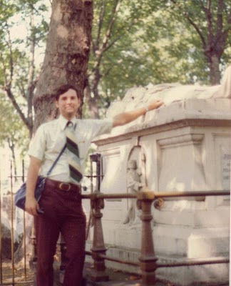
Next posting, we are off to Paris! Still enjoying this travelogue?
Posted by Glenn N. Holliman at 2:32 AM 0 comments
Email ThisBlogThis!Share to TwitterShare to Facebook
Labels: Becky Payne, Glenn Holliman, Granny

Wednesday, August 25, 2010

Holliman Scrapbook, No. 37
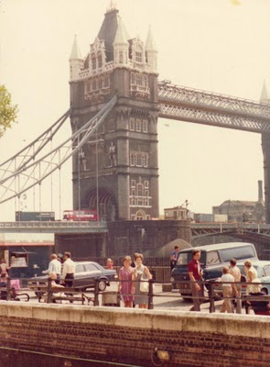
by Glenn N. Holliman

The Great Trip continued....

1975

To the right, you can see Becky and Mother in front of the Tower Bridge in London. This is the site of the medieval Tower of London were so many have lost their heads.

Here the tourists have their picture made with one of the Beefeaters at the Tower, guards in their Elizabethian uniforms. Becky is a bit downcast as she just met an American woman who was wearing an identical dress. No, that is not Allison behind the sun glasses.
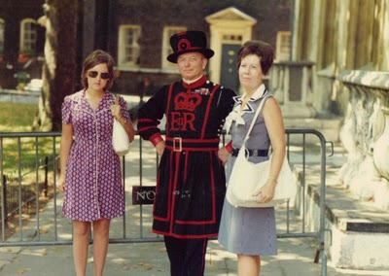
One day we took a tour bus to Stratford on Avon, and went through Shakespeare's home. That is Mother sitting and Becky behind her. The gardens are typically English beautiful. We had good weather the whole trip.
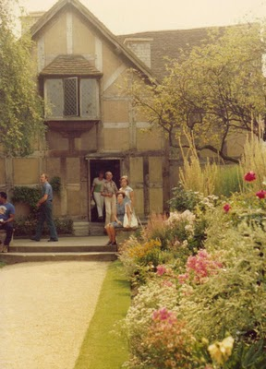
Next posting, a tour of a London cemetery! Yes, you must wait until tomorrow. Sorry....
Posted by Glenn N. Holliman at 6:40 AM 0 comments
Email ThisBlogThis!Share to TwitterShare to Facebook
Labels: Becky Payne, Granny

Tuesday, August 24, 2010

Holliman Scrapbook, No. 36
by Glenn N. Holliman

The Great Trip

1975

Alice and Bill were married in June 1975. Shortly thereafter, Granny, Becky and I took off on a TWA 12 or so day trip to London, Paris and Malaga, Spain. Mother and Becky had never been overseas and Mother wanted to see her pen pal from World War II, Arlette Ifrak, a French lady who after a long personal journey resided in Spain.

Here is that interesting trip broken into several parts, London first. We visited Hyde Park, the major park which was near our hotel. Both Becky and Mother dressed informally all during the expedition.
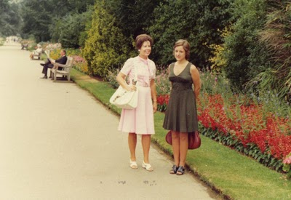
This is No. 10 Downing Street, the home of the British Prime Minister. Believe or not, 35 years ago one could walk up literally to the front door, as we did here.
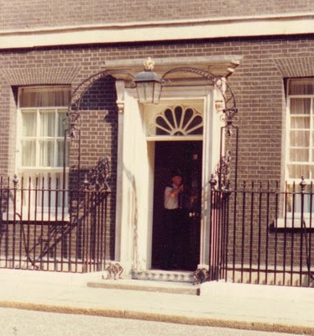
This was the only guard at the entrance of Downing Street. He asked to pose with Mother and Becky so they obliged.
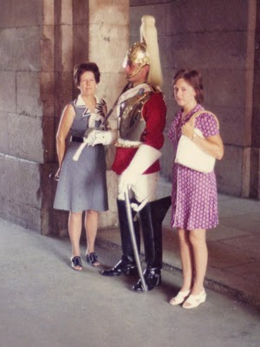
More on this trip tomorrow.....interesting a bit?
Posted by Glenn N. Holliman at 7:47 AM 0 comments
Email ThisBlogThis!Share to TwitterShare to Facebook
Labels: Becky Payne, Granny

Monday, August 23, 2010

Holliman Scrapbook, No. 35
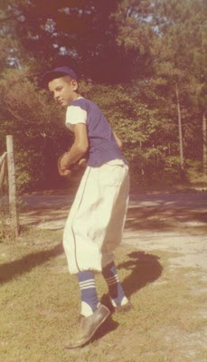
By Glenn N. Holliman

Baseball and the Family

1950s

Yours truly gets ready to pitch in Florence, South Carolina. We lived there from 1958 to 1960, and I played Little League as a pitcher in 1959. I think we lost all our games but had a grand time. This was the uniform of the time - baggy pants and leggings.

1980s

Grace, the left hander, gets ready to swing while Pa Bish catches in Cookeville. She played softball in a girl's league in Bell Buckle for several summers. Grace and I for the past dozen years or more have traveled to Florida to attend Spring Training games, soaking up sun and baseball.
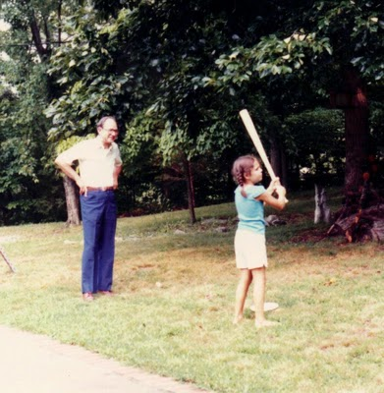

1990s
Mother and I watched a game in the 1990s while visiting Alice and Bill. It was beastly hot that day as the Texas Rangers played. That's me on the right with sunglasses, not Allison.
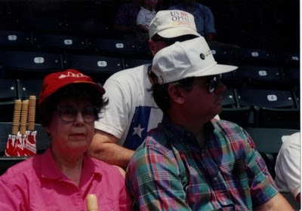
More later....
Posted by Glenn N. Holliman at 1:12 AM 0 comments
Email ThisBlogThis!Share to TwitterShare to Facebook
Labels: Glenn Holliman, Grace Holliman, Granny, Pa Bish

Sunday, August 22, 2010

Holliman Scrapbook, No. 34
by Glenn N. Holliman
Baby Pictures of Allison, Chris, Patrick and Sean (I hope)
(Corrections welcome!)
1980s
Okay, this is not easy because all the photos are not labeled and children look different as infants than they do at say 5 or 6 years of age. I think this is Allison being fed by Granny in Cookeville.
Correct Becky? No, this is Sean!
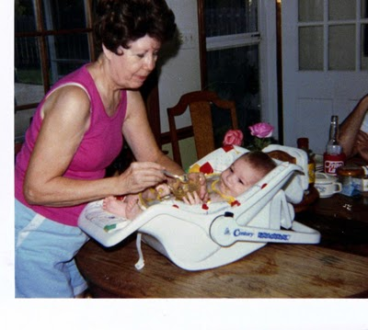Below Erin is holding Patrick or Sean? It is Patrick!
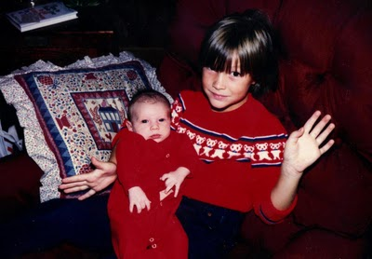

I know this near one year old is Chris. Photo is a bit tinted red, but the smile is big.
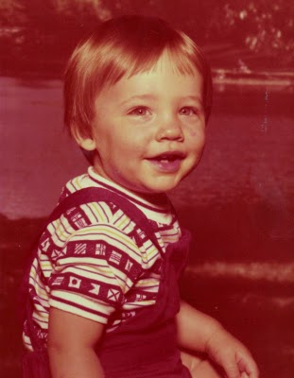
Finally, I think Sean, or is it Patrick, being held by Erin with Jonathan next to them on the couch. Alice, right or wrong? Okay, the pillow is the same but the couch is different. Erin is dressed differently. Oh me, did I slight Patrick? If so we will make it up to him. Nope, it is Patrick.
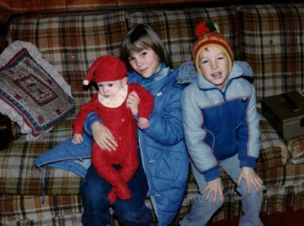
More next posting....Allison, I will be posting your baby photo.
Posted by Glenn N. Holliman at 7:12 AM 0 comments
Email ThisBlogThis!Share to TwitterShare to Facebook
Labels: Erin Hensley, Granny, Jonathan Murphy, Patrick Murphy, Sean Murphy

Friday, August 20, 2010

Holliman Scrapbook, No. 33
by Glenn N. Holliman

Baby Pictures of the first Four Cousins

1974 - Grace and her Grandfather in Cookeville.
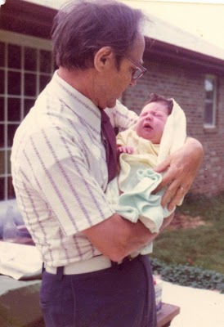
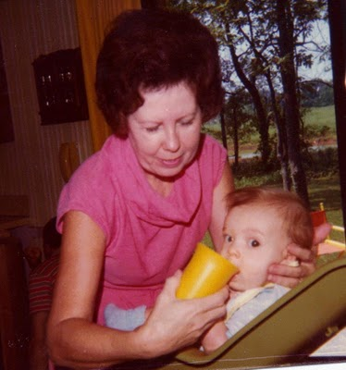
Granny and Bryan in 1977.

Granny, Erin, Jonathan and various four legged creatures in Dallas, Texas1981.
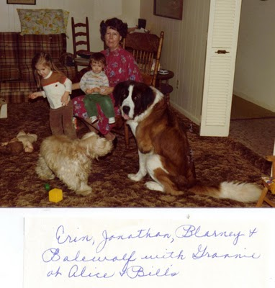
We will cover Chris, Allison, Patrick and Sean a bit later....equal time for all.
Posted by Glenn N. Holliman at 6:17 AM 0 comments
Email ThisBlogThis!Share to TwitterShare to Facebook
Labels: Bryan Payne, Erin Hensley, Grace Holliman, Granny, Jonathan Murphy, Pa Bish

Thursday, August 19, 2010

Holliman Scrapbook, No. 32
by Glenn N. Holliman
Great Moments in Holliman Family History
1970s
This was sort of my he-man time in life, living in Bell Buckle, Tennessee - teaching by day, and farming on the weekends. Below Grace supervises my tractor work. Note my formal fashion statement takes after my father and brother-in-law Paul. Click twice on the photo to look at my plaids.
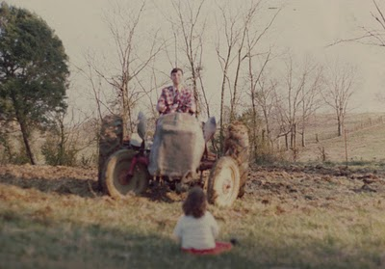
1970
This photo of Granny was taken at a Holliman family reunion in Irondale, Alabama. Over 35 relatives attended. Granny has just been informed by Aunt Edna (background) that the dishwasher has broken down, and she will have to do the dishes by herself by hand.

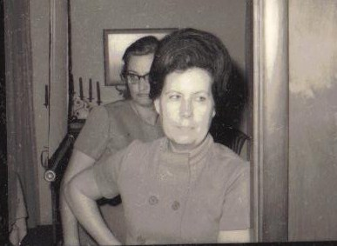
1960s

Unknown to junior members of the family, Pa Bish had some identify problems in the late 1960s, as did many young Americans. He started behaving in interesting fashion (literally, see photo below). He even took to wearing a lamp shade on his head and letting his hair grow out like hippies of the era. That is Granny' shawl he was wearing for this picture.
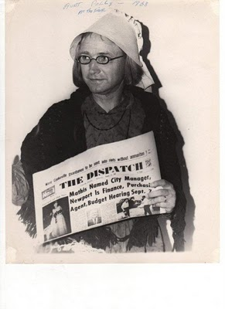My goodness.....
Posted by Glenn N. Holliman at 4:56 AM 0 comments
Email ThisBlogThis!Share to TwitterShare to Facebook
Labels: Aunt Edna, Glenn Holliman, Granny

Wednesday, August 18, 2010

Holliman Scrapbook, No. 31
by Glenn N. Holliman
Houses in Which We Lived
1970s
A bit fuzzy, but this is house in Bowling Green, Kentucky where Paul and Becky lived until from the middle 1970s to the early 1980s, before moving to Cookeville. This shot was made during an earthquake, probably.
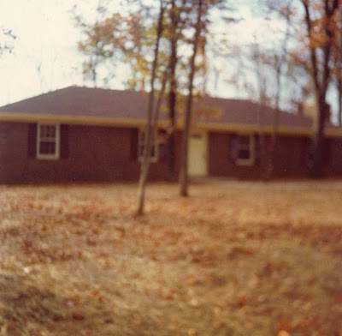
1980s

I found this photo with Granny's writing under it. That is Bill's mother, Mrs. Elizabeth Murphy visiting Erin, Jonathan and Alice in Dallas. The horse is unidentified.
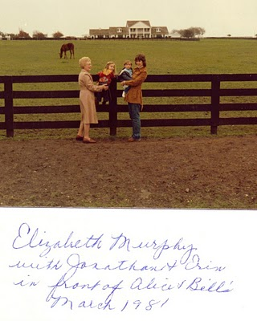
1981

Here Bill and Alice, with Jonathan and Erin, stand in front of another house in Dallas. Bill's career has led the family to moves in Mt. Juliet and Memphis, Tennessee, Topeka, Kansas, Missouri but most often the Dallas, Texas area. Bill is wearing a beard and mustache as part of the Witness Protection Program run by the Texas Rangers. Evidently the house in the photo above was owned already by another family, and the resulting difficulties made it best for Bill to work closer to home for a while. It was during this time that Bill began to fantasize of creating the now popular cheddar cheese and cranberry flavored potato chip. Bill is on the far left in disguise.
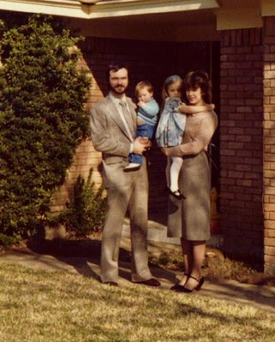
More commentary tomorrow....fair and balanced....
Posted by Glenn N. Holliman at 7:25 AM 0 comments
Email ThisBlogThis!Share to TwitterShare to Facebook
Labels: Alice, Erin Hensley, Jonathan Murphy, Mrs. Murphy

Tuesday, August 17, 2010

Holliman Scrapbook, No. 30
by Glenn N. Holliman

Photos that Caught Us Slightly Off Guard

2000s

Allison and her amazed mother in Cookeville on a spring day. Becky has just spotted the first robin of March and it is circling her head.

1974
Baby Grace takes a bite out of her father's then abundant hair. The red vest was a Christmas present from mother that year.

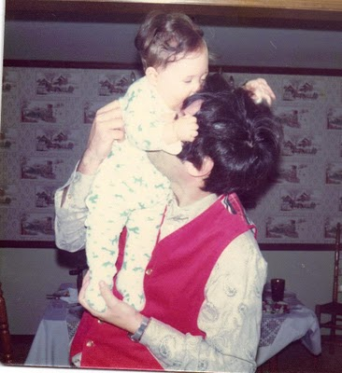

1970s
In the midst of a tea that her Aunt Louise and Becky were enjoying, Alice suddenly remembered an algebra equation required for her test the next day in micro-biological radiation at Tennessee Tech. Before she forgets it, she hurriedly scribbles it on the ever present chalk board Granny always left in the living room next to the piano, where Becky often played Claire de Lune.
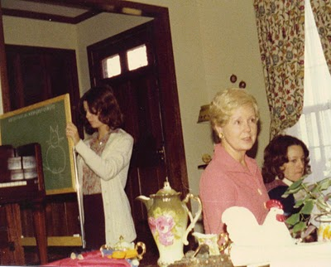
Yes, more tomorrow....
Posted by Glenn N. Holliman at 4:08 AM 0 comments
Email ThisBlogThis!Share to TwitterShare to Facebook
Labels: Alice, Allison, Becky Payne, Glenn Holliman, Grace Holliman,Louise Sherwood

Monday, August 16, 2010

Holliman Scrapbook, No. 29
by Glenn N. Holliman
Photos of the Bell Buckle Alligator Roast

1980s

This one is of Grace, almost nine years old, after unloading on an alligator in our pond in Bell Buckle, Tennessee. Chris is in the foreground and a girl friend of Grace's in the back ground. Yours truly is hauling the critter. ready to plop him into a kettle to make stew.. This was Grace's pig tail and gun-totting era. Sarah Palin has nothing, absolutely nothing, on Grace.
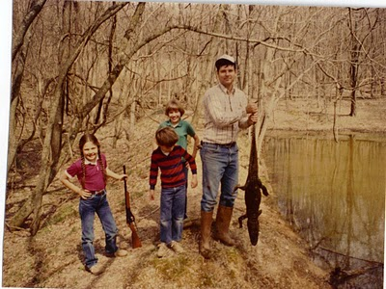

Later Chris and I prepare an old kettle to boil the critter as alligator meat can be tough.
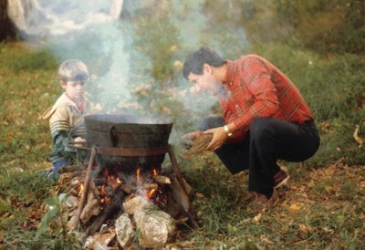Here Chris teaches Bryan how to eat alligator with one's left hand. Bryan had trouble swallowing the exotic treat.
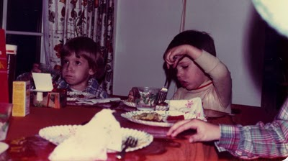
Tomorrow another absolutely true family story....
Posted by Glenn N. Holliman at 3:12 AM 0 comments
Email ThisBlogThis!Share to TwitterShare to Facebook
Labels: Bryan Payne, Chris Holliman, Glenn Holliman, Grace Holliman

Sunday, August 15, 2010

Holliman Scrapbook, No. 28
by Glenn N. Holliman
Lounge Chairs and their Importance in our Family History
1970s
Here we see the suburban man of leisure enjoying his back garden and lounge chair. Pa Bish is dressed as usual for the occasion. He probably had just finished mowing the lawn.
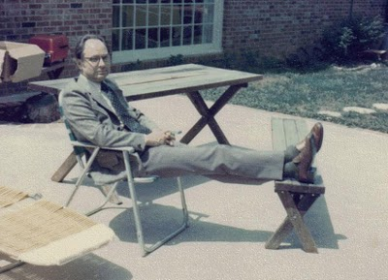
Late 1970s

Bryan takes his ease in Cookeville on his grandparent's back patio, probably worn out from practicing is walking skills.
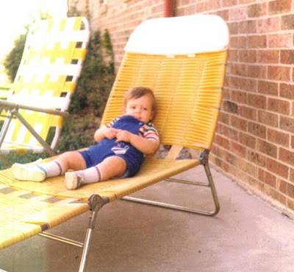
1974 in North Carolina
I think this photo was made while visiting Aunt Vena and her husband at their mountain retreat north of Spartanburg, SC. The brown socks belong to Pa Bish. That's Granny, not Allison, in the sun glasses.
More soon.....
Posted by Glenn N. Holliman at 4:50 AM 0 comments
Email ThisBlogThis!Share to TwitterShare to Facebook
Labels: Bryan Payne, Granny, Pa Bish

Friday, July 30, 2010

Holliman Scrapbook, No. 14
by Glenn N. Holliman
1950s
In the early 1950s, Hopalong Cassidy, Gene Autry and Roy Rogers were the first heroes for the Baby Boomers. We dressed like cowboys, even inLockport, New York where this cow girl points her six shooter at her father, Robert Long, who took this photo of his only child, Barbara Davis Long, all dressed out in western hat and boots. Hmmm....I have seen that look in her eye before.
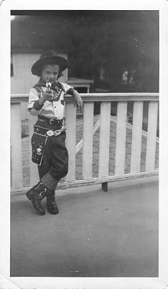

1970s

Styles come and go, and here we have Paul and Becky off to chaperon a college fraternity dance in the middle 1970s. Anyone for plaids?
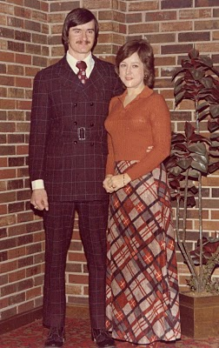

1990s

Why not end with this group photo of the Murphys, 1999. L to R: Jonathan, Erin, Sean, Bill, Alice, Sean and Patrick. Yes, that is an angel dancing on Bill's head!
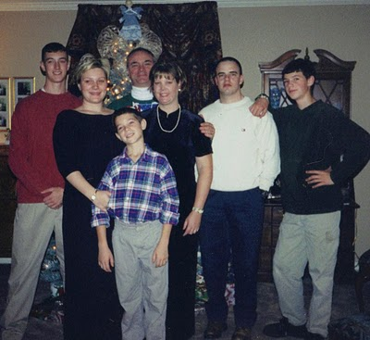
More goodies soon.....from the senior member
Posted by Glenn N. Holliman at 9:45 PM 0 comments
Email ThisBlogThis!Share to TwitterShare to Facebook

Holliman Scrapbook, No. 13
by Glenn N. Holliman
1950s

Yes, that is yours truly kneeling with a rifle in 1955, the 3rd grade, about to shoot some 'bunnies'. Of course these are not the Playboy bunnies of the 1960s but rather a skit for the May Day Exercises at my elementary school, Bernard, on the Old Jonesboro Highway in Johnson City, Tennessee. It was a quaint English holiday, no longer celebrated in America - May Day exercises in elementary school topped off by wrapping a ribbon around a May Pole. A forgotten holiday in American, it was practised in Colonial times and evidently in the mountains of East Tennessee even after World War II.

The girls were to do a 'bunny hop' and then I would rush out and pretend to be Elmer Fudd, the cartoon character, and yell 'Get those wabbits out of my carrot patch' and then 'shoot' them. The American flag has 48 stars. I can no longer remember the names of my female school mates, but they probably remember me (just joking).
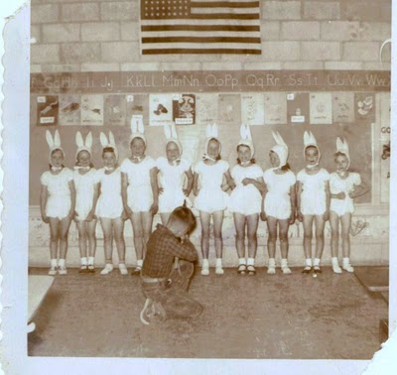
1970s
Aha, this is Becky and Grace, age 2, in Cookeville in 1976. Lynn and I were in England on a holiday, and Mother and Daddy were keeping Grace. Aunt Becky who lived then in Nashville came up to visit. I post this photo in part because of the automobile which had a short lived career. It is an American Motor's Pacer which had a shelf life similar to Ford's 1959 Edsel. Becky and Paul bought one of these futuristic cars, but I remember Becky expressing how disappointed they were with it. Google the Pacer and look at its neat styling. It was an early hatch back.
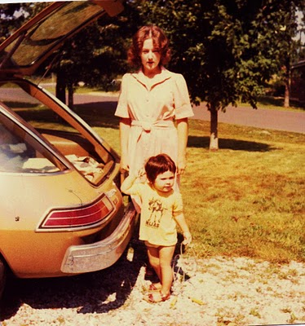

2010s

Let's end today with this neat photo of brother and sister, Erin and Jonathan, taken in Texas in the early 2010s. Our thoughts are with Jonathan in Afghanistan this summer.
More family next posting....
Posted by Glenn N. Holliman at 12:00 PM 0 comments
Email ThisBlogThis!Share to TwitterShare to Facebook

Wednesday, July 28, 2010

Holliman Scrapbook, No. 12
by Glenn N. Holliman
1970s
Here's a photo I had not seen before. It is Christmas 1976, Grace's second with her mother, Lynn, on the right. In the background are Aunt Anne and Uncle Charles (Red) Stansbery. We did not see them often, and now both are deceased. The two met at the Philadelphia Stage Door Canteen in 1943, and married five weeks later. The marriage lasted until Anne's death in 2002. Charles was Granny's only brother.
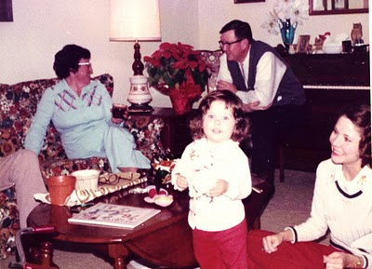
1980s
It is a little known fact but before the Murphys started raising BassetHounds, they grew ducks for the pate market. Here is Bill trying to teach Jonathan how to stuff a duck in 1981.
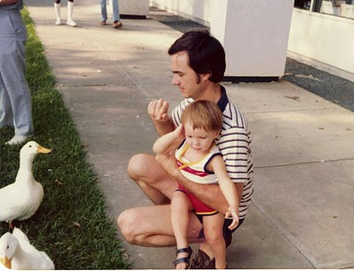

2000s

This photo was new to me; I think Becky sent it, perhaps to highlight the dog, whom I believe was Marley? Forgive me if I have that incorrect. L to R: Bryan, his mother Becky and his sister, Allison. The year is 2001 inCookeville. Oh yes, Becky is holding the dog.
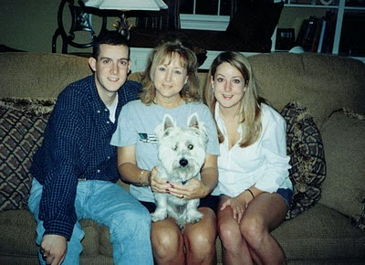
Ah, more goodies from the past with witty comment in the next posting....
Posted by Glenn N. Holliman at 5:46 PM 0 comments
Email ThisBlogThis!Share to TwitterShare to Facebook

Holliman Scrapbook, No. 11
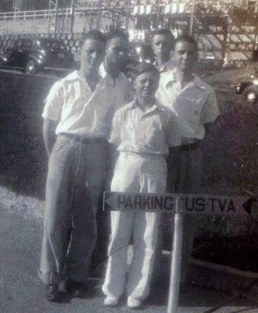
by Glenn N. Holliman

1930s

It was 1938, and young MGM star Mickey Rooney (right in front of photo) was about to go big time with his Andy Hardy movie series with Judy Garland. But for one last summer before his face was familiar to everyone in America, he spent some time with his high school chums on a trip through the Smokey Moutains. Micky stands (he was a short fellow) with his Class of 1937 class president, Bishop Holliman, on the right. Dad, always the engineering type, and his friends were touring the new TVA Norris Dam outside of Knoxville, Tennessee. Dad reports after Mickey went to Hollywood, they lost touch, especially with the war and military service absorbing the nation's attention. (None of this story is exaggerated except perhaps the part of Pa Bish majoring in engineering.)

1970s

I thought long and hard about publishing this photo (below) of Erin drinking some of Pa Bish's dogwood nectar juice. However as this batch was unfermented, I thought it okay to post. She seems to be enjoying the beverage at Granny and Pa Bish's Cookeville, Tennessee home. I think this is 1979. Her father was teaching her how to drink.

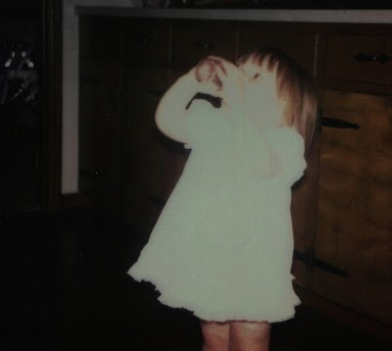
2000s
I thought it time to post a photo of the siblings and spouses for the children to enjoy. We seem like a jolly bunch as we celebrate Becky's 50th birthday in 2003 at our Newport, Pennsylvania home. Paul seems to have dozed off during the excitement. Left to right for the future's sake: Alice, Becky, Paul, Barb, Bill and Glenn remembering he has to buy dinner for everyone later that evening. I don't remember anyone else being present. Did one of the cats take the photo?
Unless I hear from your attorneys, I will continue to post....
Posted by Glenn N. Holliman at 9:28 AM 0 comments
Email ThisBlogThis!Share to TwitterShare to Facebook

Monday, July 26, 2010

Holliman Scrapbook, No. 10
Photos of Aunt Louise
by Glenn N. Holliman

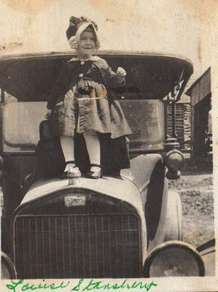

1910s

The little girl bouncing on the hood of a car is none other than my Aunt LouiseStansbery Sherwood, b 1915. Probably this picture was taken around 1918 in upper East Tennessee. Louise was born in Afton, Tennessee to the parents of Charles Stansbery, Sr. andMayme Osborne Stansbery.

Louise's brother, Charles, would be born in 1918 and the last child, Geraldine (aks Granny) entered life in 1923. Our dear Aunt Louise passed away in 2006.
My sister, Becky, carries her middle name.

Can anyone identify the make of the car?

1930s
This picture (below) was taken in Bristol, Tennessee around 1936. The little girl, Aunt Louise, is now second from right, between her cousin Doris Osborne Akers and her mother, Mayme Osborne. Moving right is Granny, probably about 13 years of age and her cousin, Gladys Osborne Adema.
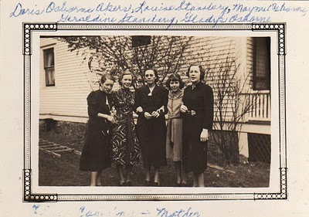
1990s
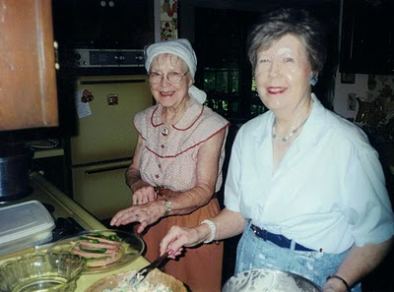Few sisters have been closer than Louise and Geraldine. This photo was taken in 1999 at Granny's home inFairfieldGlade, Tennessee.

In the 1930s,while winning the Miss Tennessee contest, Louise went to work in the local 5 & 10 cents store in Bristol, Tennessee to help support the family. Until Mother married in 1945, Gerry would live with 'Sister'.

They lost their Mother, Mayme Osborne Stansbery, December 3, 1943 who died at only age 47 in Philadelphia. Louise had married Vance Sherwood, and he worked in a war industry in Pennsylvania before serving in the U.S. Army during World War II.

Undoubtedly the eight cousins remember their Great Aunt Louise as a older woman, who died in 2006 in Knoxville, Tennessee. Becky, Alice and I remember a gracious and generous aunt who remains in our hearts.

More nostalgic stories with the next posting....
Posted by Glenn N. Holliman at 2:30 PM 0 comments
Email ThisBlogThis!Share to TwitterShare to Facebook

Sunday, July 25, 2010

Holliman Scrapbook, No. 9
by Glenn N. Holliman
Birthdays Galore!

1950s That is Becky below on her first birthday in 1951. Pam Holliman, Uncle Ralph Holliman's daughter, is on the right. Pam is now a Ph.D. in religion and teaches at a seminary in Chicago. That handsomely turned out young man is stripes is yours truly, obviously trying to emulate my father in stylistic dress. Notice Becky is about to sink her hands into the cake. She knows she has to before I reach out and consume it.
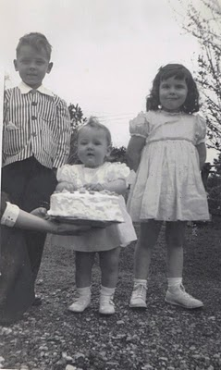

1970s I am not sure if Becky and Paul had married yet. Paul seems a little dubious about the cake, perhaps because Snoopy, the dog in Mother's lap, had just sampled it. Is this 1970? Alice thinks it is 1972 or 73.
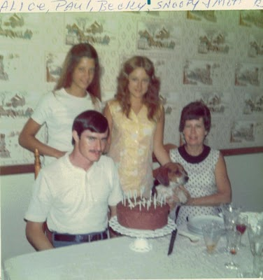
1980s
Now the little tiger between Granny and Pa Bish is none other than Bryan Payne celebrating a birthday in 1981, his fourth. Bryan and Allison had the advantage of living most of the 1980s in Cookeville with their grand parents. Notice all the presents and how large they are! Atta boy, Bryan.
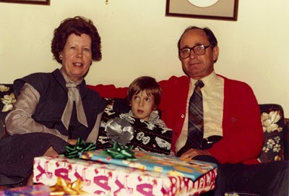
Next posting, more nostalgia with a smile....
Posted by Glenn N. Holliman at 4:30 PM 0 comments
Email ThisBlogThis!Share to TwitterShare to Facebook

Friday, July 23, 2010

Holliman Scrapbook, No. 8
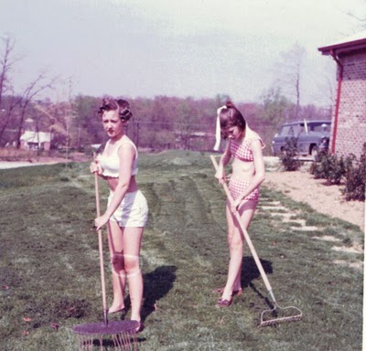by Glenn N. Holliman
(A tongue in cheek posting!)

Our family has lived through both good and bad times. In this decade, it is a recession. In the late 1960s there was great unrest in the nation, and the family in Cookeville felt the ramifications of unsettled times.

Becky and Alice, right, plant corn in the front yard in 1969. It was a tough year with not enough to eat as you can tell by their ribs showing. (What is growing out of Alice's head?)
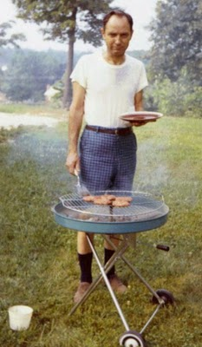
The family suffered the embarrassment of having the electricity disconnected. Daddy (left) was forced to charcoal outside for the girls and mother. You can tell he was not happy about the situation.
(Below) As he was running out of black socks to compliment his Bermuda shorts, neighbors brought the family clothes to wear. Somehow, even in economic distress, Daddy held on to the 1968 Ford Maverick. The large trunk would come in handy when he started running fermented dogwood nectar on the Cumberland Plateau.

I guess the grandchildren will be shocked when they see this photo of their Pa Bish smoking a pipe, but such was socially acceptable in the late 1960s. Granny eventually forced him to stop; complaining that the shavings from the corn cob were littering the den floor.

Yes, that is Aunt Alice wearing 'dog ears'. Being all dressed up, she was probably leaving for a high school prom. Mother must have taken this posed photo before Pa Bish drove her to pick up her date. Pa Bish always insisted on driving her on social occasions that involved young men. Just an old fashioned habit, I suspect.
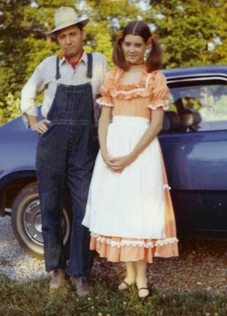
Fortunately two highly skilled son in laws (see below) soon entered the family and taught Daddy how to harvest dogwood nectar and ferment it. Daddy then sold it out of the garage and the Maverick . Not having to collect adult beverage taxes, he soon had the family returning to prosperity. Just as with today's economy, good times gradually returned as Americans began to innovate. Thanks Bill and Paul!
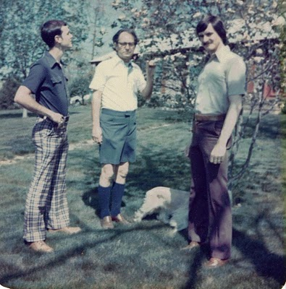Dad, Bill and Paul examining the dogwood crop. Is that a dog behind Paul? Yes, it is Blarney who lived with Alice and Bill for 16 years.

Next post, more whimsical stories of the Holliman family.....by a senior member....
Posted by Glenn N. Holliman at 5:29 PM 2 comments
Email ThisBlogThis!Share to TwitterShare to Facebook

Thursday, July 22, 2010

Holliman Scrapbook, No. 7
by Glenn N. Holliman
1920s
In our blog today, I post 'baby pictures'. Here are a few I have on hand, beginning below with my mother, Geraldine Stansbery Holliman Feick. Mother is 3 years old, so the year is 1926. Her home is in Bristol, Tennessee. Her father, Charles S. Stansbery, Sr. supervises the repair shop of the local Ford dealership. Mayme Osborne Stansbery, her mother, is in poor health and stays home to raise Gerry, Louise Stansbery Sherwood and Charles S. Stansbery, Jr., my mother's older siblings. Mother at age 3 looks a lot like Heidi, one of my grand daughters.

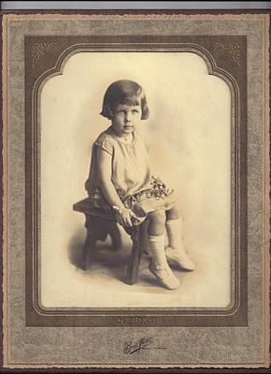

1940s

Yes, here below is my mother's arms is yours truly, Glenn Nelson Holliman. The year must be 1947, and we lived in Birmingham, Alabama. Dad had just started teaching school at Shades Cahaba after graduating from Birmingham-Southern College, majoring in history. Is not mother lovely? Who is that pudgy one year old?
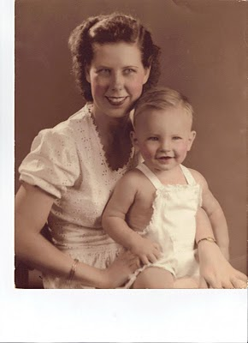
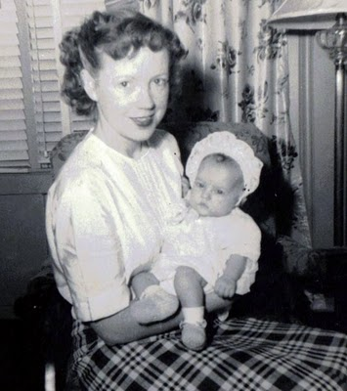

1950s

Rebecca Louise Holliman Payne is held by her Aunt Louise Stansbery Sherwood in this 1950 photograph. When Becky was born we lived in a federal housing project called Elynton Village in Birmingham, Alabama. I am not sure where this photo was taken, but I remember when Becky was born. I went to bed upstairs and woke up downstairs when my sitter told me I had a baby sister. Louise was 35 years old in 1950.

Dad was a school teacher. In the summer of 1950s, we moved to the suburbs in Trussville, Alabama. Upward bound about to enjoy the economic prosperity of the post war boom!

1950s continued....

Below, Alice Lynn Holliman Murphy begins to lift her head for the photographer at age 3 months, 1956. Alice was born in Johnson City, Tennessee where Dad was a field representative for the Social Security Administration. Becky and I were playing at a neighbor's house when Dad called the neighbor to tell her of the birth around 4 pm on a Friday, April the 13th. The neighbor, a Mrs. Testerman, stepped out the back door and yelled at us that we had a baby sister. Indeed we did.
Alice, below, cuts a rug!
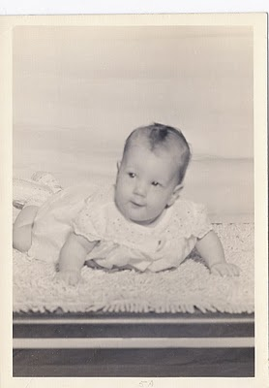

Sorry, no photos have been found of Pa Bish (Bishop Holliman) as a baby.
Posted by Glenn N. Holliman at 3:03 PM 0 comments
Email ThisBlogThis!Share to TwitterShare to Facebook
Labels: Becky Payne, Glenn Holliman, Granny, Louise Sherwood

Tuesday, July 20, 2010

Holliman Scrapbook, No. 6
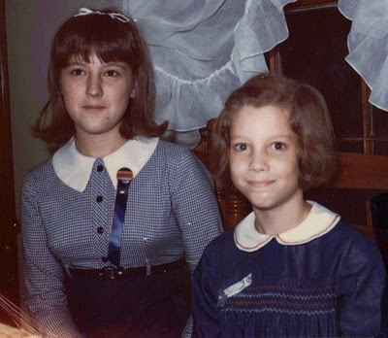
by Glenn N.Holliman

My Sisters

Becky mailed some remarkable pictures of Alice and herself recently. Now do they make sisters any cuter than these two? (right photo) This is a 1966 picture of Becky wearing an Auburn badge and Alice with a home made badge emulating her teenage sister.
Three years later, Alice is a teenager.
This picture (photo below) is outside of the kitchen window on Mt. Vernon Drive. The year is 1969, and Becky is now at Tennessee Tech. This was the year I was in Viet Nam. Is Alice holding a guitar or violin case? Grandchildren, notice there were no back packs in those days and girls carried their books clutched to their chests.

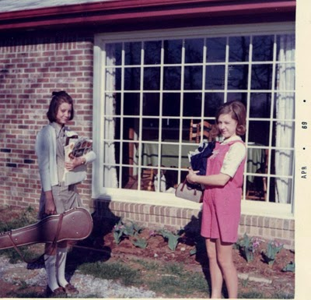
This is was the age of 'flower children' and in the spring of 1970 Alice and Becky were inspecting closely Daddy's tulips in Cookeville. For decades he planted and replanted jonquil and tulip bulbs. Why did I take this photo in black and white and miss the color of the spring flowers? Not too bright, I fear.
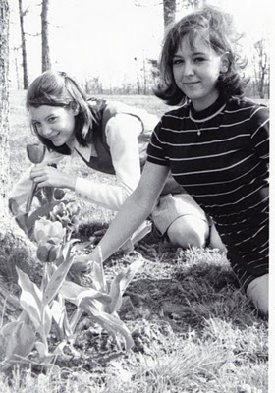
Next posting, more never to be forgotten photos of sibling youth....
Posted by Glenn N. Holliman at 12:20 PM 0 comments
Email ThisBlogThis!Share to TwitterShare to Facebook

Monday, July 19, 2010

Holliman Scrapbook, No. 5
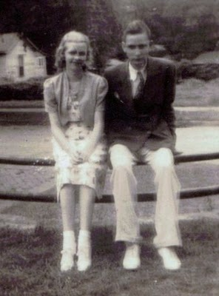by Glenn N. Holliman

As I have reviewed these old photographs, I have been reminded how some fashions change and others remain the same. Both male and female attire have stayed remarkably static for 80 years. Granted mini-skirts (see below) and bell bottom pants prevailed in the late 1960s, but the 1938 female dress style is similar to fashion today.

Remember pictures of how long and full women's dresses were in the 191os? By the late 1920, hem lines were at the knee rather than the ankle.

1930s

My wife and daughter always remark on my
elegant and sure manner concerning fashion and dress. I always tell them it is my father's influence. Above photo we have him at the Montevallo, Alabama Methodist Church Conference in 1938. Obviously he and the pretty blond are taking a break from theology sessions.

What are they sitting on? A fence? Dad looks like he is afraid it will collapse, and perhaps ruin his white pants, white bucks and double-breasted jacket. Perhaps he is uncomfortable sitting so closely to the young lady? Naa....
1970s

Below, my two lovely sisters model in 1970 the mini-skirt. They are standing in front of their Cookeville residence as their father would not let them leave the premises in such attire. At least Alice is wearing white socks.
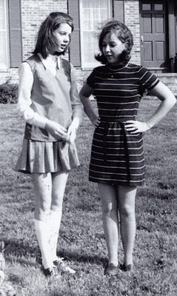
1980s

Uncle Vance Sherwood, below, would rather be discussing University of Tennessee football, but is a good sport to share time with his many great nieces and nephews. L to R: Uncle Vance, Erin, Jonathan, Bryan, Vance's grand daughter, Kate Sherwood, Aunt LouiseStansbery Sherwood, Allison and Patrick on Mother's lap. I think this is 1986. Did I identify everyone correctly? I think this photo is in Knoxville, Tennessee.
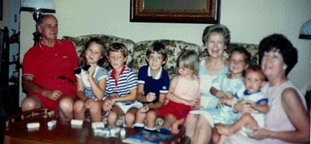
Next posting, another look back at the past with a smile....
Posted by Glenn N. Holliman at 12:10 PM 0 comments
Email ThisBlogThis!Share to TwitterShare to Facebook

Saturday, July 17, 2010

Holliman Scrapbook, No. 4
by Glenn N. Holliman

1940s
I could not resist this photo (below) which I found this week. This is 1941 at a Methodist Youth Assembly in Montgomery, Alabama. Could you imagine teenagers today dressing up formally for a religious retreat? Can you spot Pa Bish? I think he is third from the right, third row in a beige jacket, tie and white shirt, looking away from the camera. He is probably worried about grass stains.

Almost far left, sitting by herself four or five rows back with a Kleenex to her nose, is a brunette in a dark jacket. Is this the girl whom Pa Bishrefused to folk dance with the night before, and she still has not recovered? Click on the photo and it will enlarge.

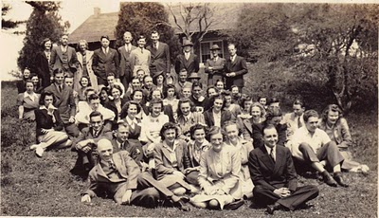
1960s

Alice had Bill email this amazing photo (below) this week. From the summer of 1958 to December 1960, we lived at 1709 Pineland Avenue, Florence, S.C. We went to St. Paul's Methodist Church and undoubtedly this is where we are headed on a Sunday morning, probably Easter 1960. There was almost no grass around this house, only tall pine trees that grew out the sandy soil. Pesky gnats drove us crazy every sweaty summer (this was before air conditioning). A favorite activity in which Becky and I engaged was picking fleas off of Beanie the Beagle.
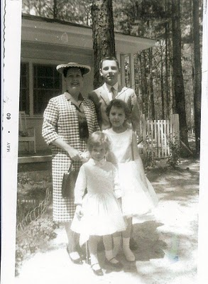
I think Alice is wearing white gloves, and both sisters are in every present white socks. Then again, I am wearing white socks, the male fashion of the time. How do you like my extravagant flat top hair cut. It costs $1.25 v. $1.00 for a regular trim. Oh, I was extravagant, but no expense spared for the elder son. I even had some black shoes with white narrow triangles on the sides.

We were fashion plates, and of course, after Paul Payne entered the family, we soared to even greater splendorous heights. This was the beginning of the Space Age, and Mother's hat no doubt reflects the flying saucer rage of the time. Goes with my hair style.

Whatever happened to crinolines?

1990s
I am trying to always close with the next (no, present generation), the twenty and thirty somethings who are taking over the world and running it. (Below) This is at Grannie's 70th birthday party in Fairfield Glade, Tennessee, November 1993. Patrick, sans teeth, has just belted out 'Happy Birthday Dear Granny" and the rest of the cousins and his siblings stand around in dazed amazement and wonderment, although Grace has just spotted a gravy stain on her brother's shirt.
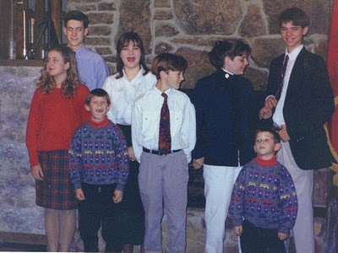
Actually, Chris, far right, carries on the Pa Bish tradition of coat and tie. Jonathan, who also is fascinated by the gravy stain, looks snazzy himself with his neck tie nicely touching his belt. Allison looks away, perhaps enviously toward the adults who are standing at the bar, far left out of the picture. Patrick and Sean are in matching sweaters, probably fromNeiman-Marcus in Dallas where Alice shops regularly. Bryan remains enthralled by Erin's continuation of the birthday song.

Ah yes, more laughter and light nostalgic moments from the senior in the group (not counting Granny and Pa Bish) in the next posting....
Posted by Glenn N. Holliman at 1:51 PM 0 comments
Email ThisBlogThis!Share to TwitterShare to Facebook

Tuesday, July 13, 2010

Holliman Scrapbook, No. 3
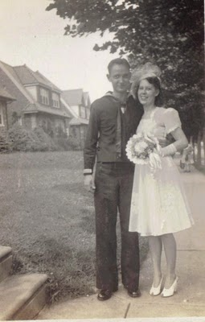by Glenn N. Holliman

1940s
How many of the grandchildren have seen this June 26, 1945 wedding of photograph (right) of Pa Bish and Grannie? Although Geraldine Stansbery had moved in 1944 from Philadelphia to Knoxville, Tennessee, the couple decided to marry in Philadelphia. They had met in Atlantic City, New Jersey in 1942, and after a long correspondence and a few visits, well, it was war time and people had to make decisions in a hurry.

Daddy is in his U.S. Navy uniform as a Seaman 2nd Class Radioman. He had been stationed on destroyers, and often docked in Philadelphia. Mother had moved to Philadelphia from Bristol, Tennessee with her Mother in 1941 to live with her sister, Louise Stansbery Sherwood and her husband, Vance R. Sherwood. Unfortunately, Mother's mother, MaymeOsborne Stansbery died December 3, 1943. My sisters and I never were able to know her.

The war ended in August, 1945, and by that fall the couple had settled in Birmingham, Alabama. Daddy finished college on the G.I. Bill, along with hundreds of thousands of other former servicemen.

1970s
In an effort to forestall criticism from my brother-in-law Bill that I never print unflattering photos (below) of myself, I thought I would include this one of Becky and me in August 1975 on a bridge overlooking the Seine River in Paris. That summer, Mother, Becky and I flew to London, Paris and Malaga, Spain on a TWA tour. I think it cost us each $700 for the 8 or 9 days, including airfare.

I don't know why I look so smug....mugging for the camera which Mother was holding I guess. I had never noticed the litter under the bench until I dropped in this photo into this blog. Please observe how smartly Becky and I are dressed; just typical American tourists. We both were wearing bell bottom pants. Ah, as ever, stylish Hollimans. Yes, that is an ink pen in my shirt pocket in case I ran into any papers to grade. Both Becky and I were teachers in the 1970s. Becky still is and a darn good one.
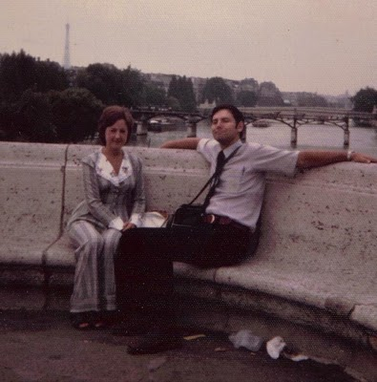

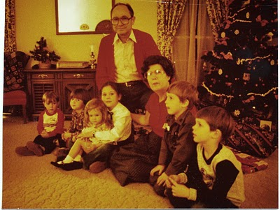1980s
Well, let's end with the children of Alice, Becky and Glenn again. In the photo above, I believe this is 1982. L. to r. are Jonathan, Erin, Allison, Grace, Pa Bish and Grannie, Bryan and Chris. Cookeville at Christmas.
Soon more of those family photos you have forgotten, never seen or never wish to see again!
Posted by Glenn N. Holliman at 12:00 PM 0 comments
Email ThisBlogThis!Share to TwitterShare to Facebook

Sunday, July 11, 2010

Holliman Scrapbook, No. 2
by Glenn N. Holliman
1950s
Alice mailed me some photos yesterday. One below is a 1959 photo at Ocean Drive Beach, South Carolina where we vacationed each summer from 1957 to 1960. Although slightly damaged, we can observe the dress fashions of the 50's. Notice that we are at the beach but Mother, Alice and Becky are all wearing dresses, and pretty ones at that. Were we headed out to a fancy dinner? I am wearing what were called 'Calypso' pants, shorts that fell below the knees that summer. Pretty stylish family!

One summer we took our pet dog, Beanie, a beagle to the beach. We usually rented a cottage or a house on the beach or a block from it. The year we took Beanie, we left him in the cottage as we swam in the ocean. A short time later, Beanie arrived, having tracked us down. He had broken through a screen window and crossed a busy highway to join his family. As Daddy is not taking this photo, perhaps Beanie is behind the camera.
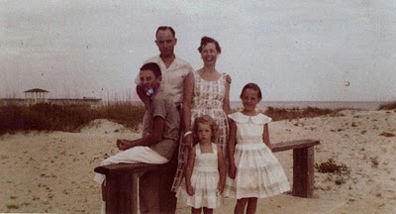
1960s
The photo below was taken in 1967. My wife, Lynn, and I were working in New York City that summer doing day camp work with African-American children in Brooklyn. Daddy, Mother and Alice drove up from Cookeville, Tennessee to see us. As I remember, Becky had flown up a week earlier to spend some time in the city at our apartment in the West 90s in Manhattan. Is Alice sea sick on this Staten Island ferry and is Mother comforting her?
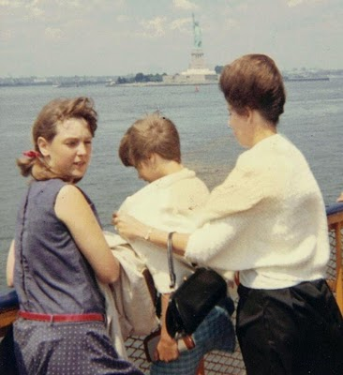

1980s
I thought I would finish this post with an photograph that Erin and Grace's children might enjoy. This is a 1981 photo below with Grannie playing with Allison, Grace in front of the swing, and Erin flying ever higher! This photo was taken at our home in Bell Buckle, Tennessee in the back yard.
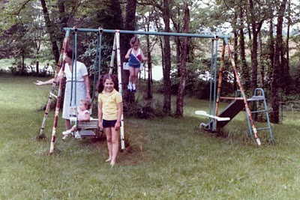
As I have not received any notice from legal solicitors, I will continue to share nostalgia with the immediate family....
Posted by Glenn N. Holliman at 5:17 PM 0 comments
Email ThisBlogThis!Share to TwitterShare to Facebook

Friday, July 9, 2010

Holliman Scrapbook, No. 1
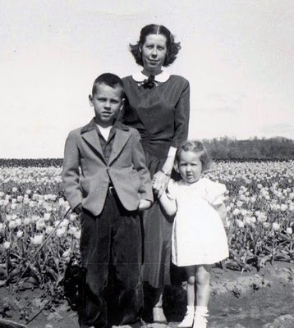
A Photo Scrapbook for Siblings and Descendants of Bishop Holliman and Geraldine Stansbery Holliman Feick
by Glenn N. Holliman

As we are all aware of privacy issues and the openness of the internet, I will only post photos of 'golden oldies' and no one of current young grandchildren.I have marked also no distribution of this blog. If there be any objections to any photo, just shout and I will delete.Your photos welcome. Email to Glennholliman@Embarqmail.com.

As the oldest child of a family created by the marriage of Bishop and Geraldine Stansbery Holliman, June 26, 1945, I wanted to share some memories before I forget them! Perhaps the grandchildren will appreciate them someday. I am having fun composing these blogs and sharing some sense of who we were and who we are.

1950s
Above, Glenn, Mother and Becky are posing in a tulip nursery in East Tennessee in 1953. Becky and I are in our Sunday best and Mother's hair is fighting a windy day in spring time.
As ususal Daddy was taking the photographs with a Kodak box camera. The picture below is from St. Augustine, Florida 1955. We were touring the old Spanish fort on a Sunday morning. We ran into some acquaintances from our Munsey Memorial Methodist Church in Johnson City and Daddy remarked, "We didn't see you in church this morning!"
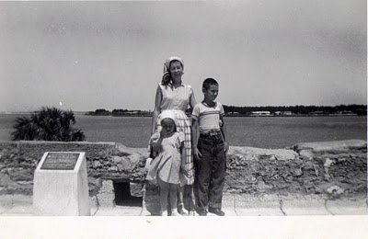
1960s
Below, this must be a classic. I think it is 1963 in our front yard in Gadsden, Alabama. I am holding our new dog, Tiny, who ranks as the most obnoxious pet we ever had. We are off to church on a chilly day in our 1959 Ford Galaxie. Becky is blossoming into a pretty teenager, and Alice is as cute as a pixie. Mother seems to be chewing on her teeth or something. I am sporting a stylish flat top hair style. What are not visible are my white socks. Notice all the ladies are wearing white gloves. I think Daddy was wearing a Fedora, but as usual he was taking the picture.
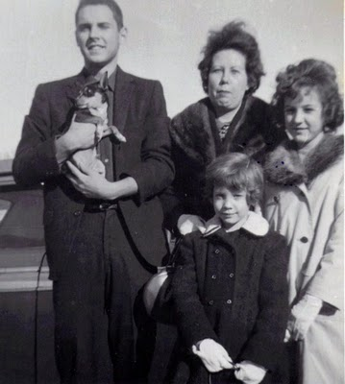
As I scan old photos, I will post some from time to time unless my brother in laws bring legal action....
Posted by Glenn N. Holliman at 4:55 PM 1 comments
Email ThisBlogThis!Share to TwitterShare to Facebook
Home
Subscribe to: Posts (Atom)

Recent Comments

Popular Posts
Holliman Scrapbook, No. 1
A Photo Scrapbook for Siblings and Descendants of Bishop Holliman and Geraldine Stansbery Holliman Feick by Glenn N. Holliman As we are a...
Holliman Scrapbook, No. 371
Scenes of the 1960s by Glenn N. Holliman Alice started school in 1962. A month later the Cuban Missile Crisis occurred, the most fearful...
Holliman Scrapbook, No. 8
by Glenn N. Holliman ( A tongue in cheek posting! ) Our family has lived through both good and bad times. In this decade, it is a recessio...

Holliman Scrapbook

Holliman Family 1957
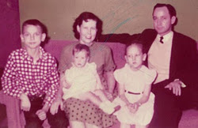
Glenn, Alice, Geraldine, Rebecca & Bishop

Blog Archive
Wat

Tuesday, January 31, 2012

Holliman Scrapbook, No. 552
Scenes of the 1970s
by Glenn N. Holliman
There is no doubt, the first grand child changed the family dramatically. Grace had to wait three years to get her first cousin, but Christmas then on revolved around the new generation. Aunt Becky in December 1974 holds her first niece.
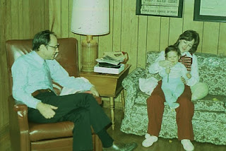

Posted by Glenn N. Holliman at 4:42 AM 0 comments
Email ThisBlogThis!Share to TwitterShare to Facebook
Labels: Becky Payne, Grace Holliman, Pa Bish

Monday, January 30, 2012

Holliman Scrapbook, No. 551
Scenes of the 1970s
by Glenn N. Holliman
The boat dock of Vance and Louise Sherwood in the summer of 1973 along the Tennessee River at their home. Do any Murphy children recognize the young couple by the water?

Posted by Glenn N. Holliman at 5:25 AM 1 comments
Email ThisBlogThis!Share to TwitterShare to Facebook
Labels: Alice Murphy, Bill Murphy

Sunday, January 29, 2012

Holliman Scrapbook, No. 550
Scenes of the 1970s
by Glenn N. Holliman
I produce this one of Pa Bish so that the grand children can see how stylish he dressed in 1973 when we visited his old friend, Paul Propst in Birmingham, Alabama.
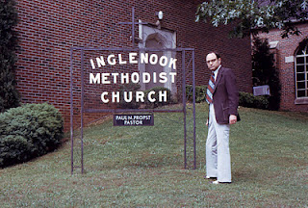

Posted by Glenn N. Holliman at 5:23 AM 0 comments
Email ThisBlogThis!Share to TwitterShare to Facebook
Labels: Pa Bish

Saturday, January 28, 2012

Holliman Scrapbook, No. 549
Scenes of the 1970s
by Glenn N. Holliman
Can anyone identify all the relatives at this 4th of July lunch at the Sherwoods in 1973?
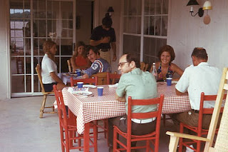

Posted by Glenn N. Holliman at 5:20 AM 1 comments
Email ThisBlogThis!Share to TwitterShare to Facebook
Labels: Lynn Holliman Armstrong, Pa Bish

Friday, January 27, 2012

Holliman Scrapbook, No. 548
Scenes of the 1970s
by Glenn N. Holliman
Here is a neat picture of boating at the Buckeits in North Carolina in 1973. I see Grannie and Alice. Who is the other person. Alice are you driving?

Posted by Glenn N. Holliman at 1:09 AM 1 comments
Email ThisBlogThis!Share to TwitterShare to Facebook
Labels: Alice Murphy, Grannie

Thursday, January 26, 2012

Holliman Scrapbook, No.547
Scenes of the 1970s
by Glenn N. Holliman
Grass mowing in 1970 by a 50 year old Pa Bish in Cookeville.
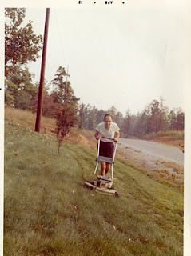

Posted by Glenn N. Holliman at 4:32 AM 0 comments
Email ThisBlogThis!Share to TwitterShare to Facebook
Labels: Pa Bish

Wednesday, January 25, 2012

Holliman Scrapbook, No. 546

Scenes of the 1970s
by Glenn N. Holliman
I think this is summer 1975 during Bill and Alice's first summer of marriage. Pa Bish and Grannie traveled to Georgia to visit while Bill was stationed there. Alice's hair is no longer long.
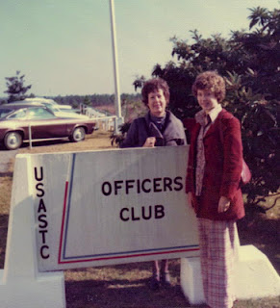

Posted by Glenn N. Holliman at 4:27 AM 1 comments
Email ThisBlogThis!Share to TwitterShare to Facebook
Labels: Alice Murphy, Pa Bish

Tuesday, January 24, 2012

Holliman Scrapbook, No. 545
Scenes of the 1970s
by Glenn N. Holliman
Alice prepares in 1973 to water ski in Saluda, North Carolina. Aunt Vena Daly had married Phil Buckeit who owned a cabin in the mountains. This lake was large enough for Alice, the daring one of the family, to launch out on the water.
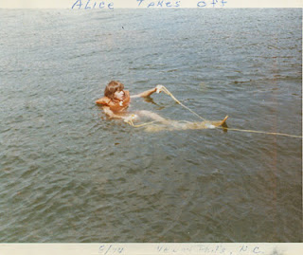

Posted by Glenn N. Holliman at 4:21 AM 0 comments
Email ThisBlogThis!Share to TwitterShare to Facebook
Labels: Alice Murphy

Monday, January 23, 2012

Holliman Scrapbook, No. 544
Scenes of the 1970s
by Glenn N. Holliman
This is August 1972, and Paul is pointing out that Alice is engaging in the Holliman trait of head scratching in public. Becky, unknowingly is participating in the same past time. This Holliman 'tick' developed when we were forced to watch Lawrence Welk shows every Sunday night in the early 1960s.
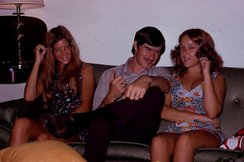

Posted by Glenn N. Holliman at 4:17 AM 2 comments
Email ThisBlogThis!Share to TwitterShare to Facebook
Labels: Alice Murphy, Becky Payne, Paul Payne

Sunday, January 22, 2012

Holliman Scrapbook, No. 543
Scenes of the 1970s
by Glenn N. Holliman
This is 1975 in Cookeville. Alice and Bill are now married, and Alice has a new hairdo. Aunt Becky is enjoying playing with Grace. Alice has a new dog, the white one.
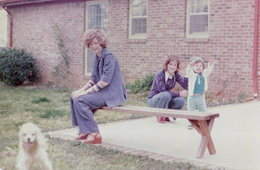

Posted by Glenn N. Holliman at 10:07 AM 0 comments
Email ThisBlogThis!Share to TwitterShare to Facebook
Labels: Becky Payne; Alice Murphy, Grace Holliman

Saturday, January 21, 2012

Holliman Scrapbook, No. 542
Scenes of the 1970s
This photo of Senator Howard Baker and Pa Bish was taken in 1973. The fashions speak of the time, loud clothing. Baker was co-chair of the Senate Watergate Investigation Committee that year. Was he seeking some advice from Bishop Holliman. Perhaps.
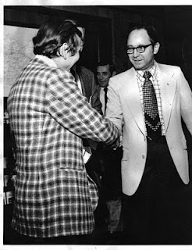
by Glenn N. Holliman
Posted by Glenn N. Holliman at 4:59 AM 0 comments
Email ThisBlogThis!Share to TwitterShare to Facebook
Labels: Pa Bish

Friday, January 20, 2012

Holliman Scrapbook, No. 541
Scenes of the 1970s
by Glenn N. Holliman
Here Bishop Holliman receives a commendation award from Commissioner Ball of the Social Security Administration. About to shake Pa Bish's hand is Elliott Richardson, the Secretary of what was then called the Health, Education and Welfare. This cabinet post is now named Health and Human Services.

In October 1973, then Attorney-General Richardson refused President Richard Nixon's order to fire Archibald Cox, the special prosecutor of the Watergate investigation. Richardson resigned and a 'firestorm' of protest swept the nation. Impeachment resolutions emerged in the House of Representatives and on August 9, 1974, Nixon resigned, the first President to do so.

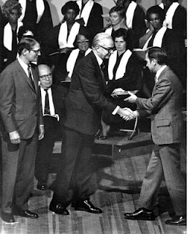

Posted by Glenn N. Holliman at 4:45 AM 0 comments
Email ThisBlogThis!Share to TwitterShare to Facebook
Labels: Pa Bish

Thursday, January 19, 2012

Holliman Scrapbook, No. 540
Scenes of the 1970s
by Glenn N. Holliman
This photo was made of Grannie, Grace and Becky in the fall of 1975 in the front yard in Cookeville, Tennessee. Grace was the first born grand child and until Bryan came along in 1977, Grace was the family star. Here she is bundled up in a blue coat for a fall afternoon walk. She is suffering from too little attention.
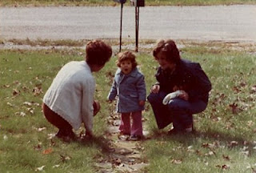

Posted by Glenn N. Holliman at 4:42 AM 0 comments
Email ThisBlogThis!Share to TwitterShare to Facebook
Labels: Becky Payne, Grace Holliman, Grannie

Wednesday, January 18, 2012

Holliman Scrapbook, No. 539
Scenes of the 1970s
by Glenn N. Holliman
This black and white portrait of Bill and Alice was made in 1974, a few months before the wedding. Bill was in the Army hence his short hair cut. Long hair for young men was the style in the early 1970s, along with bell bottom trousers.
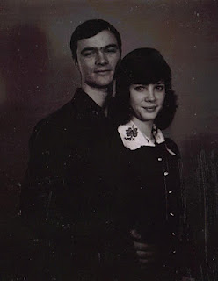

Posted by Glenn N. Holliman at 4:36 AM 2 comments
Email ThisBlogThis!Share to TwitterShare to Facebook
Labels: Alice Murphy, Bill Murphy

Tuesday, January 17, 2012

Holliman Scrapbook, No. 538
Scenes of the 1970s
by Glenn N. Holliman
Here is Grannie in February 1975 at West Palm Beach, Florida. With the house empty of children, Pa Bish and Grannie began traveling.
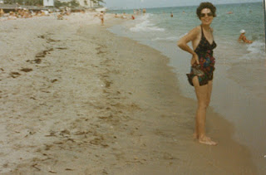

Posted by Glenn N. Holliman at 4:32 AM 0 comments
Email ThisBlogThis!Share to TwitterShare to Facebook
Labels: Grannie

Monday, January 16, 2012

Holliman Scrapbook, No. 537
Scenes of the 1970s
by Glenn N. Holliman
May 28, 1974 Grace A. Holliman was born with a lot of hair on her head. Here she is only a few weeks old being held by her grand father.
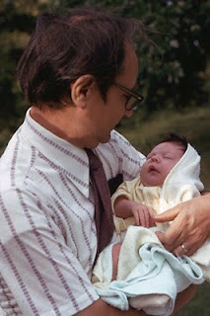

Posted by Glenn N. Holliman at 4:27 AM 0 comments
Email ThisBlogThis!Share to TwitterShare to Facebook
Labels: Grace Holliman, Pa Bish

Sunday, January 15, 2012

Holliman Scrapbook, No. 536
Scenes of the 1970s
by Glenn N. Holliman
Luncheon at the Tennessee River home of Louise and Vance Sherwood. Lynn looks on while Paul tries one of Uncle Vance's hot sauce beef plates.
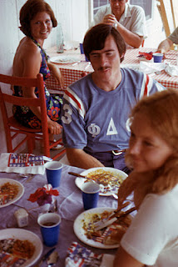

Posted by Glenn N. Holliman at 3:32 PM 0 comments
Email ThisBlogThis!Share to TwitterShare to Facebook
Labels: Becky Payne;Lynn Armstrong, Paul Payne

Saturday, January 14, 2012

Holliman Scrapbook, No. 535
Scenes of the 1970s
by Glenn N. Holliman
A very young couple in 1971 hiding behind a bush in Pa Bish's back yard.
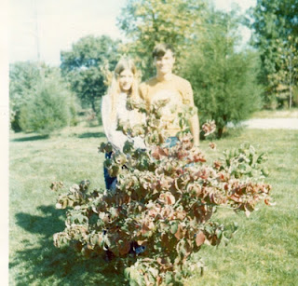

Posted by Glenn N. Holliman at 3:29 PM 0 comments
Email ThisBlogThis!Share to TwitterShare to Facebook
Labels: Alice Murphy, Bill Murphy

Friday, January 13, 2012

Holliman Scrapbook, No. 534
Scenes of the 1970s
by Glenn N. Holliman
The summer of 1973 Alice must have won an award for these plants. What is this vine? Notice the dog ears and pants.
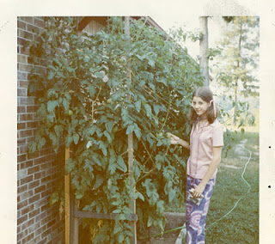

Posted by Glenn N. Holliman at 3:24 PM 2 comments
Email ThisBlogThis!Share to TwitterShare to Facebook
Labels: Alice Murphy

Thursday, January 12, 2012

Holliman Scrapbook, No. 533
Scenes of the 1970s
by Glenn N. Holliman
It is January outside, but in 1973 in the middle of summer Pa Bish and Grannie served lunch on the patio. No screened in porch in those days. The dog's name was Reggie.
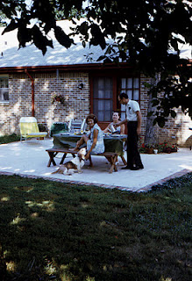

Posted by Glenn N. Holliman at 3:21 PM 0 comments
Email ThisBlogThis!Share to TwitterShare to Facebook
Labels: Grannie, Lynn Holliman Armstrong, Pa Bish

Wednesday, January 11, 2012

Holliman Scrapbook, No. 532
Scenes of the 1970s
by Glenn N. Holliman
This was Christmas in Cookeville 1973. Notice Aunt Louise is sitting as usual in the floor. Uncle Vance Sherwood, perhaps anticipating his nephew's interest in family history, has received a likeness of himself as an American Indian from his favorite brother-in-law.
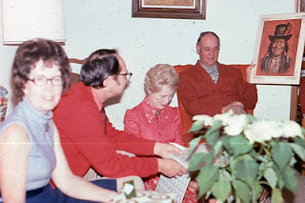

Posted by Glenn N. Holliman at 8:18 AM 0 comments
Email ThisBlogThis!Share to TwitterShare to Facebook
Labels: Aunt Louise, Grannie, Pa Bish, Vance Sherwood

Tuesday, January 10, 2012

Holliman Scrapbook, No. 531
Scenes of the 1970s
by Glenn N. Holliman
Can you spot the great grandparents at this high school football game in Cookeville in 1973? I imagine Alice was a cheerleader at the time. Notice the long hair on the boys. Is that Watson Brown sitting in front of Pa Bish? Color photography had not been invented yet!
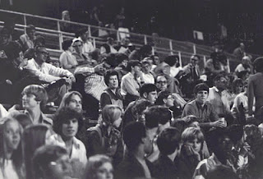

Posted by Glenn N. Holliman at 8:14 AM 1 comments
Email ThisBlogThis!Share to TwitterShare to Facebook
Labels: Grannie, Pa Bish

Monday, January 9, 2012

Holliman Scrapbook, No. 530
Scenes of the 1970s
by Glenn N. Holliman
This photo was taken in 1973 in Birmingham, Alabama. Pa Bish is on the right. The man dressed in dazzlingly white with the flat top is The Rev. Paul Propst, an United Methodist Minister who was a good friend of my father,s in the late 1930s. Most of his grandchildren do not know how active Pa Bish was in the Methodist Church in the late 1930s and early 1940s before he went off to war. Bishop Holliman directed the youth of the North Alabama Conference of the Methodist Church for several years, while attending Birmingham-Southern College.
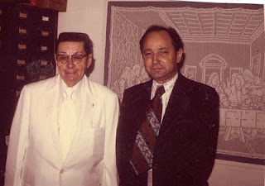
Paul Propst had a middle name, Nelson, which is my middle name. When I was born, Paul gave my father a $100 savings bond. It helped pay for my first quarter at Birmingham-Southern College in 1964. My tuition and expenses that quarter amounted to $500, a princely sum almost half a century ago.
The styles in this photograph are remarkable today. Notice Pa Bish's wide tie, and Paul's, well, immaculate white outfit. Wow....
Posted by Glenn N. Holliman at 5:21 AM 0 comments
Email ThisBlogThis!Share to TwitterShare to Facebook
Labels: Pa Bish, Paul Propst

Sunday, January 8, 2012

Holliman Scrapbook, No. 529
Scenes of the 1970s
by Glenn N. Holliman
This photo is from 1973 of Paul Payne. He and Becky were living in Goodlettsville, Tennessee at the time.
As brother in law's go, Paul has been a generous and welcome host to his many in-laws. Time after time, he and Becky have open their home to a host of relatives. I believe there were 30 present in December 2011. Paul's hair is a bit grayer now, but as Bill and I note, he still has his hair! Thanks Paul for your many years of kind hospitality to the family.
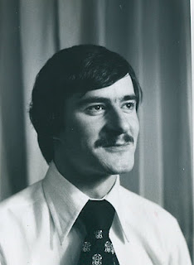

Posted by Glenn N. Holliman at 5:15 AM 0 comments
Email ThisBlogThis!Share to TwitterShare to Facebook
Labels: Paul Payne

Saturday, January 7, 2012

Holliman Scrapbook, No. 528
Scenes of the 1970s
by Glenn N. Holliman
Becky is now married in 1972 and Pa Bish goes out to see his daughter in Kansas where Paul is stationed in the Army. Does Becky look like Allison here, 40 years ago!
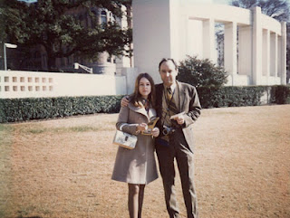

Posted by Glenn N. Holliman at 9:44 AM 1 comments
Email ThisBlogThis!Share to TwitterShare to Facebook
Labels: Becky Payne, Pa Bish

Friday, January 6, 2012

Holliman Scrapbook, No. 527
Scenes of the 1970s
by Glenn N. Holliman
Tis June 1974 and a new Holliman has joined the clan. Grace is held by her grandfather.

Posted by Glenn N. Holliman at 4:41 AM 0 comments
Email ThisBlogThis!Share to TwitterShare to Facebook
Labels: Grace Holliman, Pa Bish

Thursday, January 5, 2012

Holliman Scrapbook, No. 526
Scenes of the 1970s
by Glenn N. Holliman
This is December 1973 with Becky, Paul and Alice's boyfriend named Bill. Where was this picture taken?
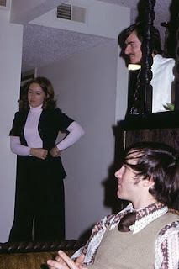

Posted by Glenn N. Holliman at 4:32 AM 2 comments
Email ThisBlogThis!Share to TwitterShare to Facebook
Labels: Becky Payne, Bill Murphy, Paul Payne

Wednesday, January 4, 2012

Holliman Scrapbook, No. 525
Scenes of the 1970s
by Glenn N. Holliman
Grannie walks our dog, Reggie, a bassett hound who stayed with Mother and Daddy while Lynn and I toured Europe in the summer of 1972. Notice the lush garden that Pa Bish grew at the new home on Mt. Vernon Drive in Cookeville, Tennessee. Grannie was all of 48 years old that summer.
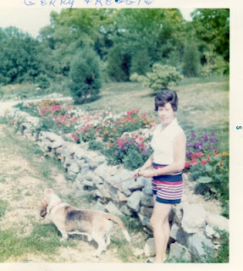
by Glenn N. Holliman
Posted by Glenn N. Holliman at 4:28 AM 0 comments
Email ThisBlogThis!Share to TwitterShare to Facebook
Labels: Grannie

Tuesday, January 3, 2012

Holliman Scrapbook, No. 524
Scenes of the 1970s
by Glenn N. Holliman
Now is it is 1974 and the first grand child is with us. Left to right in Bell Buckle, Tennessee are Pa Bish, Alice, Grannie and little Grace. Grace's parents were teacher and librarian at the Webb School at the time.

Posted by Glenn N. Holliman at 4:57 AM 3 comments
Email ThisBlogThis!Share to TwitterShare to Facebook
Labels: Alice Murphy, Grace, Grannie, Pa Bish

Monday, January 2, 2012

Holliman Scrapbook, No. 523
Scenes of the 1970s
by Glenn N. Holliman
Alice and flowers. Here is the young lady in 1971 in Cookeville in her father's garden by the edge of the road. This was taken, gasp, 41 years ago. I still think of Alice as a kid. Alas....
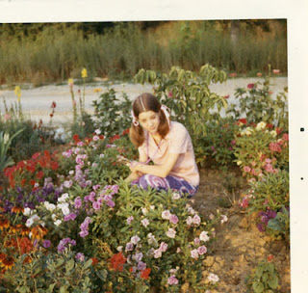

Posted by Glenn N. Holliman at 4:55 AM 0 comments
Email ThisBlogThis!Share to TwitterShare to Facebook
Labels: Alice Murphy

Sunday, January 1, 2012

Holliman Scrapbook, No. 522
Scenes of the 1970s
by Glenn N. Holliman
I don't know if this one of Alice has been posted recently, but here she is at age 17 and what a pretty way to begin the new year of 2012. This was taken 39 (ahem) years ago!
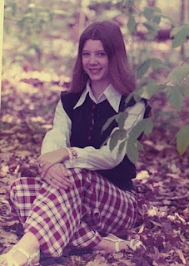

Posted by Glenn N. Holliman at 4:50 AM 1 comments
Email ThisBlogThis!Share to TwitterShare to Facebook
Labels: Alice Murphy
Newer PostsOlder PostsHome
Subscribe to: Posts (Atom)

Recent Comments

Popular Posts
Holliman Scrapbook, No. 1
A Photo Scrapbook for Siblings and Descendants of Bishop Holliman and Geraldine Stansbery Holliman Feick by Glenn N. Holliman As we are a...
Holliman Scrapbook, No. 371
Scenes of the 1960s by Glenn N. Holliman Alice started school in 1962. A month later the Cuban Missile Crisis occurred, the most fearful...
Holliman Scrapbook, No. 8
by Glenn N. Holliman ( A tongue in cheek posting! ) Our family has lived through both good and bad times. In this decade, it is a recessio...

Holliman Scrapbook

Holliman Family 1957
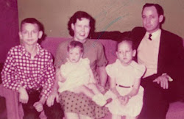
Glenn, Alice, Geraldine, Rebecca & Bishop

Blog Archive

Friday, February 24, 2012

Holliman Scrapbook, No. 576
Scenes of the 1970s
by Glenn N. Holliman
Ah, Bryan at birth, already thinking great thoughts. He was born in Bowling Green, Kentucky.

Posted by Glenn N. Holliman at 10:35 AM 0 comments
Email ThisBlogThis!Share to TwitterShare to Facebook
Labels: Bryan Payne

Thursday, February 23, 2012

Holliman Scrapbook, No. 575
Scenes of the 1970s
by Glenn N. Holliman
Yes, it is the first grand child asserting her vocal cords to her grandmother and aunt in Cookeville, 1976.
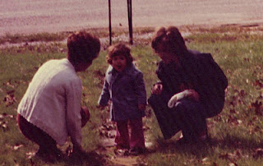

Posted by Glenn N. Holliman at 10:32 AM 0 comments
Email ThisBlogThis!Share to TwitterShare to Facebook
Labels: Becky Payne, Grace Holliman, Grannie

Wednesday, February 22, 2012

Holliman Scrapbook, No. 574
Scenes of the 1970s
by Glenn N. Holliman
1977, the future intellectual sits by the fireplace at his grand parents home in Cookeville. Yes, it is Bryan Payne!
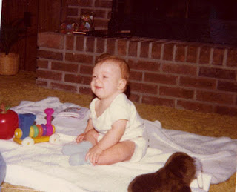

Posted by Glenn N. Holliman at 10:30 AM 1 comments
Email ThisBlogThis!Share to TwitterShare to Facebook
Labels: Bryan Payne

Tuesday, February 21, 2012

Holliman Scrapbook, No. 573
Scenes of the 1970s
by Glenn N. Holliman
Ah, that 3rd grandchild - Erin Murphy Hensley with her grandfather. Where was this photo taken?
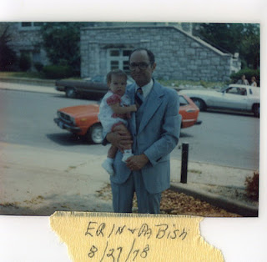

Posted by Glenn N. Holliman at 10:28 AM 1 comments
Email ThisBlogThis!Share to TwitterShare to Facebook
Labels: Erin Hensley, Pa Bish

Monday, February 20, 2012

Holliman Scrapbook, No. 572
Scenes of the 1970s
by Glenn N. Holliman
Here is Grannie in Pompono Beach Florida in 1976. Aunt Louise is on the left and in the center wearing another conservative outfit is Vance Sherwood, Sr. He loved Republican politics and the University of Tennessee football.
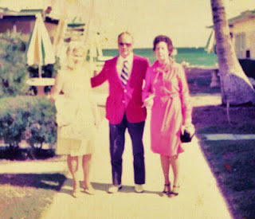

Posted by Glenn N. Holliman at 11:00 AM 0 comments
Email ThisBlogThis!Share to TwitterShare to Facebook
Labels: Grannie, Louise Sherwood, Vance Sherwood

Sunday, February 19, 2012

Holliman Scrapbook, No. 571
Scenes of the 1970s
by Glenn N. Holliman
With the children grown and married, Bishop and Gerry began traveling more. Here they are with brother-in-law Vance Sherwood, Sr. at his Knoxville home along Loudon Lake.
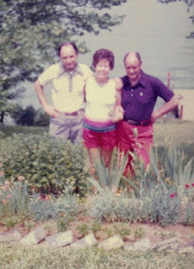

Posted by Glenn N. Holliman at 10:56 AM 0 comments
Email ThisBlogThis!Share to TwitterShare to Facebook
Labels: Gerry Holliman, Pa Bish, Vance Sherwood

Saturday, February 18, 2012

Holliman Scrapbook, No. 570
Scenes of the 1970s
by Glenn N. Holliman
Well, Bryan had to get his Social Security card also in the 1970s. Pa Bish was manager of the Cookeville District Office from late 1964 until his retirement January 1983. Bryan seems puzzled by the camera.
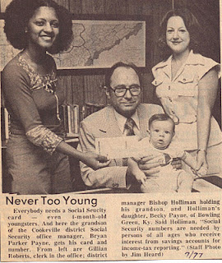

Posted by Glenn N. Holliman at 10:52 AM 0 comments
Email ThisBlogThis!Share to TwitterShare to Facebook
Labels: Becky Payne, Bryan Payne, Pa Bish

Friday, February 17, 2012

Holliman Scrapbook, No. 569
Scenes of the 1970s
by Glenn N. Holliman
I think this is Becky in 1975 but it could be 1973. Love portrait shop of her and the flipped hair do.
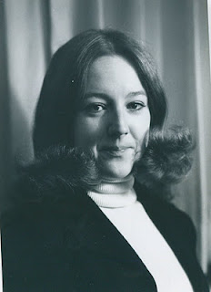

Posted by Glenn N. Holliman at 10:50 AM 0 comments
Email ThisBlogThis!Share to TwitterShare to Facebook
Labels: Becky Payne

Thursday, February 16, 2012

Holliman Scrapbook, No. 568
Scenes of the 1970s
by Glenn N. Holliman
Have I run this one before? It is 1975 where I do not know and Pa Bish plays with Alice's dog. So is that Lynn or Alice in the photo?

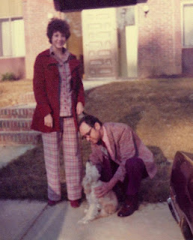
Scenes of the 1970s
by Glenn N. Holliman
Posted by Glenn N. Holliman at 10:46 AM 1 comments
Email ThisBlogThis!Share to TwitterShare to Facebook
Labels: Alice Murphy, Pa Bish

Wednesday, February 15, 2012

Holliman Scrapbook, No. 567
Scenes of the 1970s
by Glenn N. Holliman
Here is Grace in 1975, still the only grand child then and enjoying attention from Aunts Becky an Alice. Grace seems to be growing a daffodil on her nose.
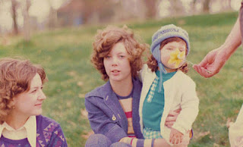

Posted by Glenn N. Holliman at 10:43 AM 0 comments
Email ThisBlogThis!Share to TwitterShare to Facebook
Labels: Becky Payne; Alice Murphy, Grace Holliman

Tuesday, February 14, 2012

Holliman Scrapbook, No. 566
Scenes of the 1970s
by Glenn N. Holliman
Ah, the grandchildren came thick and fast by the last 1970s. Here is Erin, nee Hensley, received that cherish Social Security card being held by her Murphy grandfather, James. That's Alice in the middle with a sheik hair style of the era.
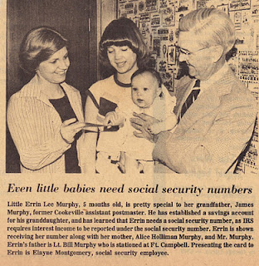

Posted by Glenn N. Holliman at 10:40 AM 0 comments
Email ThisBlogThis!Share to TwitterShare to Facebook
Labels: Alice Murphy, Erin Hensley, James Murphy

Monday, February 13, 2012

Holliman Scrapbook, No. 565
Scenes of the 1970s
by Glenn N. Holliman
We took a lot of photos that summer of 1976 in Cookeville. No, that is not Patrick; it is Bill Murphy with, no not their first born, but the dog Blarnie. Grannie is in the middle and Alice on the right.
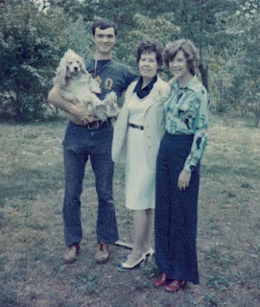

Posted by Glenn N. Holliman at 5:06 AM 0 comments
Email ThisBlogThis!Share to TwitterShare to Facebook
Labels: Alice Murphy, Bill Murphy, Grannie

Sunday, February 12, 2012

Holliman Scrapbook, No. 564
Scenes of the 1970s
by Glenn N. Holliman
Another view of the summer of 76, our nation's 200th anniversary. Grannie is all of 53, Becky 26 and yours truely almost 30 that year.Ah, all that hair and a slim fellow.
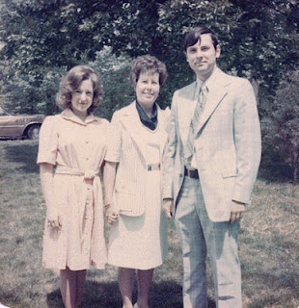

Posted by Glenn N. Holliman at 5:02 AM 0 comments
Email ThisBlogThis!Share to TwitterShare to Facebook
Labels: Becky Payne; Granny, Glenn Holliman

Saturday, February 11, 2012

Holliman Scrapbook, No. 563
Scenes of the 1970s
by Glenn N. Holliman
A bit sun faded, but here we are in the summer of 1976. Yes, left to right is Alice, Grannie, Becky and Pa Bish in Cookeville.
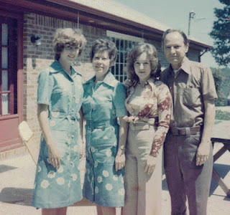

Posted by Glenn N. Holliman at 4:59 AM 0 comments
Email ThisBlogThis!Share to TwitterShare to Facebook
Labels: Becky Payne; Alice Murphy, Grannie, Pa Bish

Friday, February 10, 2012

Holliman Scrapbook, No. 562
Scenes of the 1970s
by Glenn N. Holliman
Tis the summer of 1976 in Cookeville, and Becky, feeling cheerful and jolly, watches Grace and Mrs. Plummer's grand daughter play in the plastic pool on Mt. Vernon Drive. Later Pa Bish would install a screen porch around the patio.
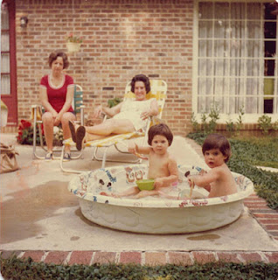

Posted by Glenn N. Holliman at 4:55 AM 0 comments
Email ThisBlogThis!Share to TwitterShare to Facebook
Labels: Becky Payne, Grace Holliman

Thursday, February 9, 2012

Holliman Scrapbook, No. 561
Scenes of the 1970s
by Glenn N. Holliman
I believe the date is spring 1976 and Paul is in the backyard of the home on Mt. Vernon Drive in Cookeville.
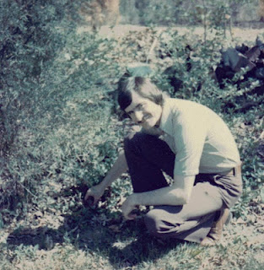

Posted by Glenn N. Holliman at 1:47 AM 0 comments
Email ThisBlogThis!Share to TwitterShare to Facebook
Labels: Paul Payne

Wednesday, February 8, 2012

Holliman Scrapbook, No. 560
Scenes of the 1970s
by Glenn N. Holliman
This is, I think but could be wrong, 1976 at the Sherwoods in Knoxville. Uncle Vance is standing next to Grannie. Cousin Van Sherwood is sitting leaving forward and Pa Bish is on the far right. The woman on the left sitting is Barbara Sherwood, Van's wife, who died a year later of a brain tumor.
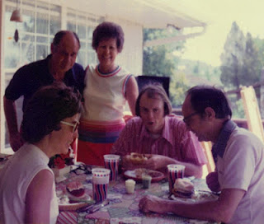

Posted by Glenn N. Holliman at 1:40 AM 0 comments
Email ThisBlogThis!Share to TwitterShare to Facebook
Labels: Barbara Sherwood, Grannie, Pa Bish, Van Sherwood, Vance Sherwood

Tuesday, February 7, 2012

Holliman Scrapbook, No. 559
Scenes of the 1970s
by Glenn N. Holliman
Spring will soon be here, so let's have one from springtime 1976 of Alice, Grannie and Rebecca.
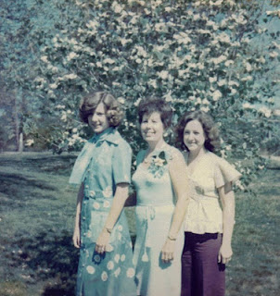

Posted by Glenn N. Holliman at 4:05 AM 0 comments
Email ThisBlogThis!Share to TwitterShare to Facebook
Labels: Becky Payne; Alice Murphy, Grannie

Monday, February 6, 2012

Holliman Scrapbook, No. 558
Scenes of the 1970s
by Glenn N. Holliman
Summer 1976 - Gerald Ford is running to be elected President against Jimmy Carter of Georgia. In the meantime, parents pose in Cookeville, Tennessee in the back yard of their house on Mt. Vernon Drive.
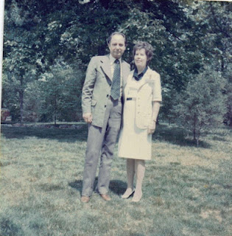

Posted by Glenn N. Holliman at 1:34 AM 0 comments
Email ThisBlogThis!Share to TwitterShare to Facebook
Labels: Grannie, Pa Bish

Sunday, February 5, 2012

Holliman Scrapbook, No. 557
Scenes of the 1970s
by Glenn N. Holliman
Aha, in March 1977, Grace ceased to be the only grandchild. Here Becky holds baby Bryan while a grandfather looks on. Photo taken in Bowling Green, Kentucky where the Paynes lived at the time.
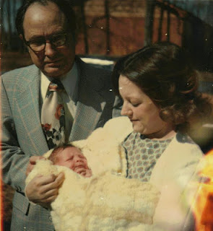

Posted by Glenn N. Holliman at 4:03 AM 1 comments
Email ThisBlogThis!Share to TwitterShare to Facebook
Labels: Becky Payne, Bryan Payne, Pa Bish

Saturday, February 4, 2012

Holliman Scrapbook, No. 556
Scenes of the 1970s
by Glenn N. Holliman
Here in Cookeville in 1977 are Alice and Bill, not yet parents that summer. Grace in the foreground.
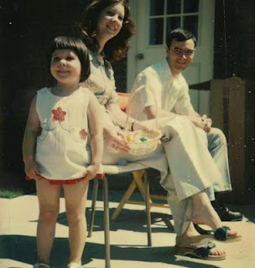

Posted by Glenn N. Holliman at 4:00 AM 0 comments
Email ThisBlogThis!Share to TwitterShare to Facebook
Labels: Alice Murphy, Bill Murphy, Grace Holliman

Friday, February 3, 2012

Holliman Scrapbook, No. 555
Scenes of the 1970s
by Glenn N. Holliman
Another touching picture of Aunt Becky and Grace in 1975. Becky has just told Grace that Pa Bish was leaving his estate entirely to the first grand daughter!
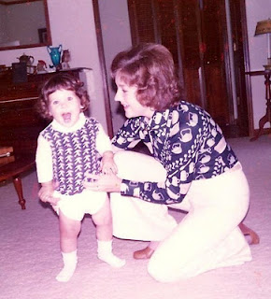

Posted by Glenn N. Holliman at 4:51 AM 0 comments
Email ThisBlogThis!Share to TwitterShare to Facebook
Labels: Becky Payne, Grace Holliman

Thursday, February 2, 2012

Holliman Scrapbook, No. 554
Scenes of the 1970s
by Glenn N. Holliman
This is Grannie's 52 nd birthday party, November 1975. Were we at Becky and Paul's?
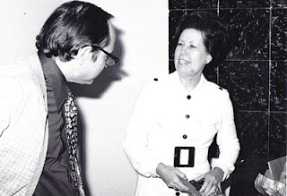

Posted by Glenn N. Holliman at 4:48 AM 1 comments
Email ThisBlogThis!Share to TwitterShare to Facebook
Labels: Grannie, Pa Bish

Wednesday, February 1, 2012

Holliman Scrapbook, No. 553
Scenes of the 1970s
by Glenn N. Holliman
1975, I think, and Grannie has just announced that this has been nice, but now we must go. Does anyone remember where and when this was taken?
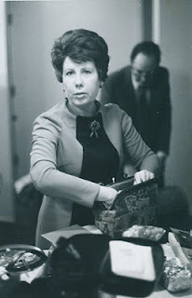

Posted by Glenn N. Holliman at 4:46 AM 1 comments
Email ThisBlogThis!Share to TwitterShare to Facebook
Labels: Grannie, Pa Bish
Newer PostsOlder PostsHome
Subscribe to: Posts (Atom)

Recent Comments

Popular Posts
Holliman Scrapbook, No. 1
A Photo Scrapbook for Siblings and Descendants of Bishop Holliman and Geraldine Stansbery Holliman Feick by Glenn N. Holliman As we are a...
Holliman Scrapbook, No. 371
Scenes of the 1960s by Glenn N. Holliman Alice started school in 1962. A month later the Cuban Missile Crisis occurred, the most fearful...
Holliman Scrapbook, No. 8
by Glenn N. Holliman ( A tongue in cheek posting! ) Our family has lived through both good and bad times. In this decade, it is a recessio...

Holliman Scrapbook

Holliman Family 1957
Glenn, Alice, Geraldine, Rebecca & Bishop

Blog Archive
Watermark template. Powered by Blog

