8/15/14

The Osborne Family Reunion, Washington State, Part 1
by Glenn N. Holliman
The same weekend in July 2014, the Wilson-Greer-Osborne and associated families were gathering in Boone, North Carolina for a family historical forum, Osborne cousins met for an annual event in Skagit County, Washington. These cousins are descendants of William I. Osborne who was born at Sutherland, Ashe County, North Carolina in 1869. He was the oldest child of Richard Franklin 'Frank' (1846-1897) and Nancy Emmaline 'Emma' Wilson Osborne (1850-1919).
Cousin Jeanie Bond, Osborne descendant, and I have been exchanging copy and photographs the past few weeks. This is a two part series - first a bit of history of the family and then scenes from the 2014 reunion. Some of the following pictures are courtesy of Shirley Sorrell, Clinton Getzinger and Dale Wilson, fellow genealogists whom we are fortunate to have to capture family stories. -GNH
Some History of an Osborne Branch in the Pacific Northwest by Jeanie Bond, great, great grand daughter of Isaac and Carolina Greer Wilson
William I. Osborne's mother, Emma, was the oldest child of Isaac and Nancy Greer Wilson. Frank and Emma, who met when Frank and G.W. Osborne took refuge in the Wilson home during the Civil War, raised their family on the Green Valley side of the hill where Isaac Wilson's Cemetery is located in Ashe County, North Carolina. They attended the Sutherland Methodist Church, and what they did not grow, they bought in Trade, Tennessee. William I. Osborne was the oldest of Frank and Emma's children, and many of his grand nieces and nephews still live in the NC/TN area.
My immediate family believes that William was the first of many who migrated out of the North Carolina mountains to the great Northwest. Ashe and surrounding counties were not economically productive enough to support the many offspring of the clans that had pioneered the ridges and valleys in the late 18th and early 19th centuries.

William traveled to Washington State first by himself, but became so homesick that his employer put him on train and sent him home. Then, just a few years later, he went west again, in the company of his sister Martha Jane (Jenny) Osborne Thomas and her young family. This time, he settled permanently in the Skagit Valley where his seven acres of flat land abutting a partially wooded hill pasture must have reminded him of Mountain City, TN, as it did me and my mother when we traveled east in 1991. Later, Roby Frank Hardy Osborne joined his brother William I. Osborne in Sedro-Woolley, Washington.
Below, an advertisement in the Watauga-Democrat of Boone, North Carolina.
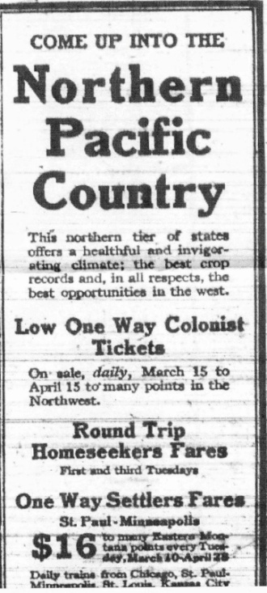
With glowing reports of work and available land, it was not long before there were hundreds of “Tar Heel” families logging the hills, farming the flats and producing children. The phone directory for the “Upper Skagit” and Darrington areas read very much the same as one you might find for Trade, or Boone, or Creston, NC. Stout, Forrester, Riddle, Thomas, Wilson, Dunn, Main and, of course Osborne, can be easily be found in either location.
Below William Isaac Osborne (1869-1953) and his father, Richard Franklin "Frank" Osborn (1846-1897). The photographer is Hodges of Bristol, Tennessee and the photo MAY have been taken on the occasion of William's first trip to the Pacific Northwest about 1888. He looks much younger than 19 and may have gone to the Pacific Northwest at a much younger age. This is the earliest photo of William, and the only known photo of Frank.
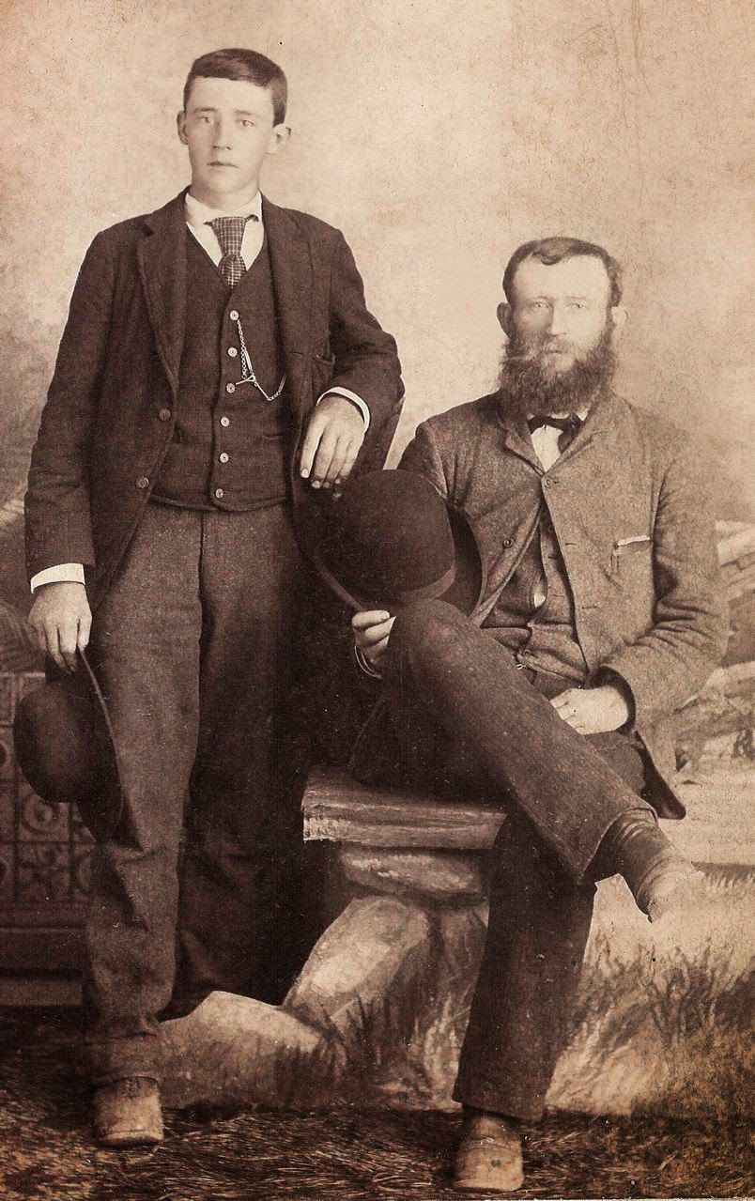

"One sad failing...." The February 4, 1897 Watauga-Democrat ran this article on the death of Richard Frank Osborne, the father of William I. Osborne and many others. Clipping courtesy of Clinton Getzinger, a direct descendant of Frank Osborne.
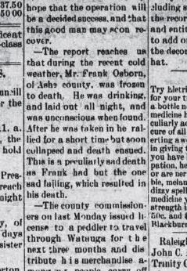

Below are Frank's wife, Emma, their daughter Effie Marilla Osborne
Miller with her children Florence Miller and Victor (Dusty) Osborne
and on the far right is Frank and Emma’s youngest son, Robert Bruce T.
Osborne. They are posed next to Frank and Emma’s home on Brushy Fork
Road, Sutherland, NC ca. 1903.

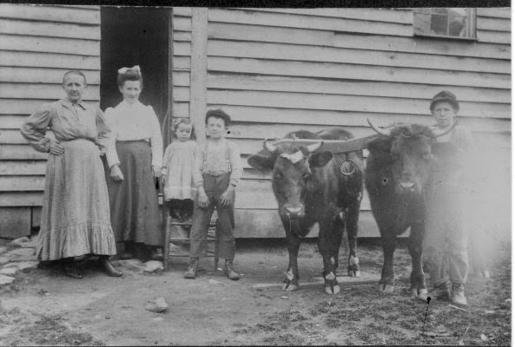
Below right are William I. Osborne (1869-1953) and his wife, Waneta T. Drever Osborne and their children Harry William, Robert Frank, Hattie Blanche and, the child in christening dress is my Uncle Chester Clarence. The photo was taken in Sedro Woolley, Washington by Mrs. Pilcher who purchased the studios of Darius Kinsey.
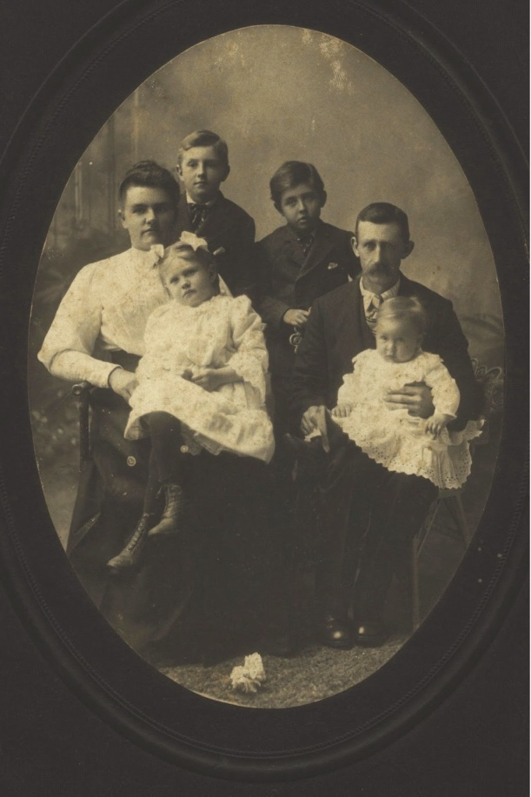
A later photograph below, the family of William and Waneta Osborne at the home of Waneta's parents, 1917 in Washington State. Standing in the back are Chester (1907-1986) and Hattie (1903-1923.) Middle row: Lawrence (1909-1988), Waneta (1879-1923) and William (1869-1953). In front: Helen (1912-1914), Juanita (1917-2009) on her mother's lap, Derward (1916-2014) on his father's lap and Verner (1915-1957). Not pictured are two older boys, Harry (1899-1986) and R. Frank (1901-1986) who were away working and, the only child surviving today, Cecil Mark was not born until 1919.
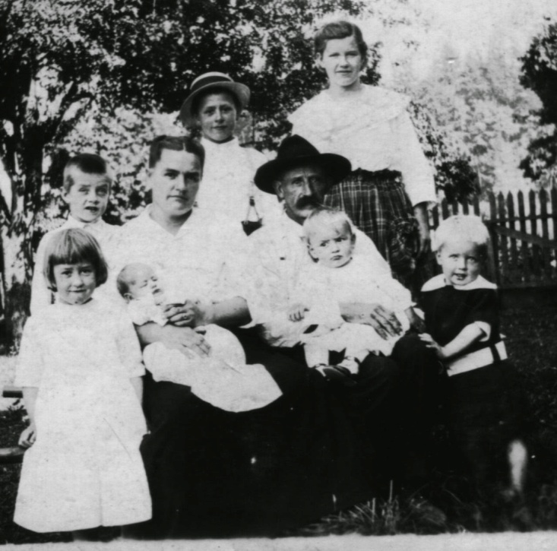
Below, this is a photo of the siblings in 1980, the first one that we specifically took photos by generation. They are, left to right, Cecil Mark, Juanita, Derward, Helen, Lawrence, Chester, R. Frank and Harry. Missing are: Hattie who died in child birth in 1923; Charles who died as an infant, cause unknown, and Verner who died by misadventure in 1957. - Jeanie Bond

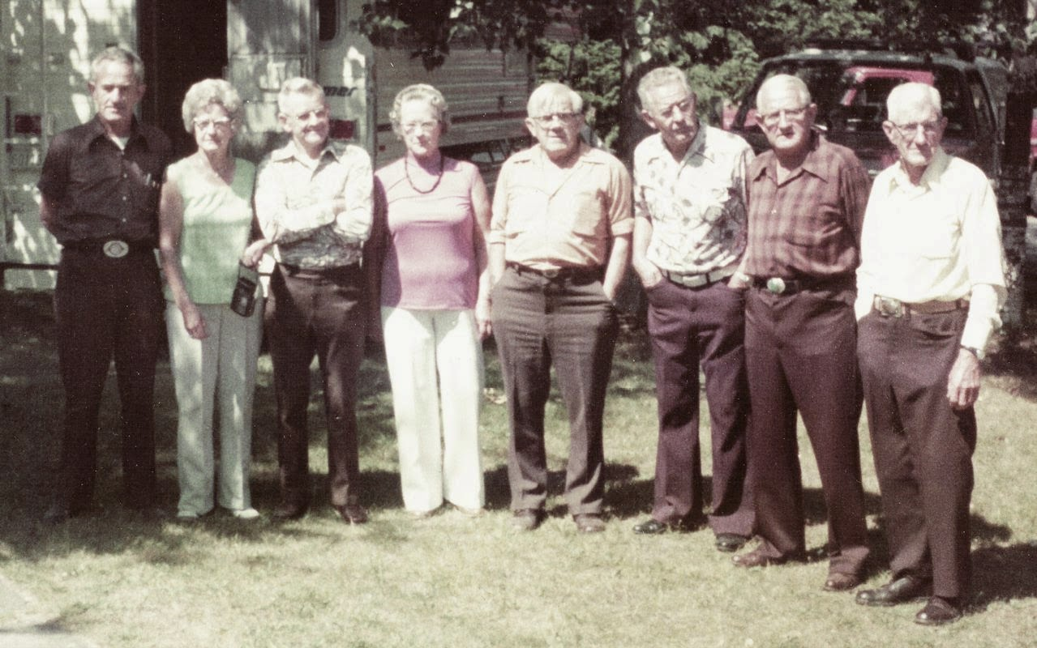
Next posting, photographs from the 2014 Osborne Reunion in Washington State....

All are invited to join in building the family tree at Wilson-Greer-Osborne-Forrester-Donnelly and Associated Families of Western NC at Ancestry.com. Just write to glennhistory@gmail.com for an invitation. Please let me know of any errors, omissions or additions to the above story.

7/27/14

The 2014 Wilson, Greer and Associated Families Forum 1
by Glenn N. Holliman
The weekend of July 18 -20, 2014, cousins, both distant and close, gathered in Boone, North Carolina to share family stories and histories. The first evening, a number of us gathered for a common meal greeting previous acquaitances and new family members. On the morning of July 19, at the community room of the Boone Public Library, we shared histories, watched a power point of the story of the Wilson and Greer families and were both educated and entertained by our common ancestor - John Wilcoxson (1720-abt 1790).
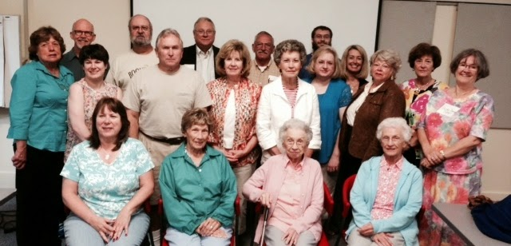
Front row left to right: Connie Burns, Bina Forrester Gray, Shirley F. Marcus and Betty E. Ankers. Second Row: Ann Osborne Dunn, Wendy Hodges, Phil Marcus, Jackie Farrington, Bonnie H. Steelman, Jennifer Bundy, Kathryn Wilson, Linda Donnelly Wilson, Jeanette Suggs and Shirley Sorrell. Back Row: Dr. Greg Adams, Gary Hodges, Glenn Holliman, Johnny R. Greer and Chase Bundy.
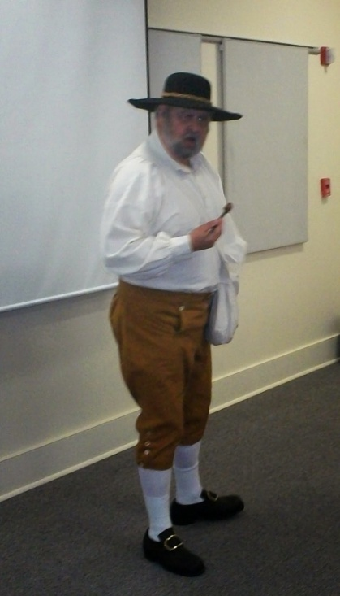
A special treat was the premier presentation by Gary Hodges, a fifth great grandson of John Wilcoxson, who is seen left, dressed in period costume. Gary shared the story of the Pennsylvania Quaker family of Squire and Sara Morgan Boone, who along with their children (including famed frontiersman, Daniel) and in-laws (John Wilcoxson being one) braved the wilderness of western North Carolina and Kentucky in the 1700s. "John' told the story of the siege of Ft. Boonesborough during the American Revolution, where both he and his wife Sarah Boone Wilcoxson, took refuge on occasion.
Below, out of costume, Gary encourages family members to join the Daniel Boone Society and reminded all that we were eligible for membership in both American Revolution and Confederate ancestral organizations. Gary has information and lineages he is happy to share.
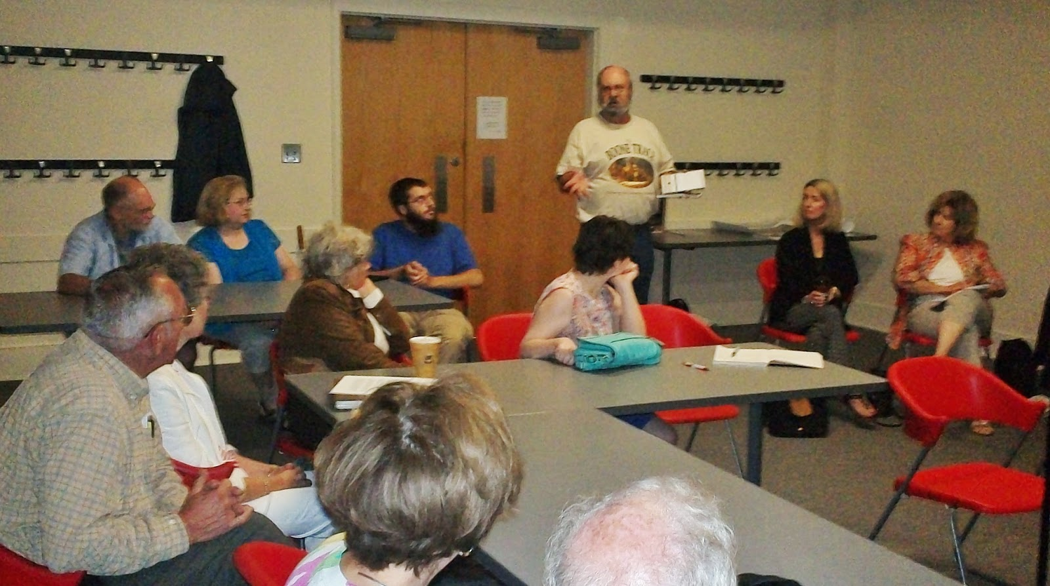
In later articles, we shall be posting additional photographs and lineages of those attending. My thanks to all who attended. For information on Gary Hodges' email address, write me at glennhistory@gmail.com. GNH, seventh great grandson of Squire and Sara Morgan Boone.

Posted by Glenn N. Holliman at 3:33 PM No comments:

7/9/14

From the Scrapbook of Shirley Sorrell 8
by Glenn N. Holliman
Shirley Sorrell, great great grand daughter of Isaac and Caroline Greer Wilson, continues to share photographs she has collected of her parents, grandparents, aunts and uncles and cousins.
Below, a picture in the 1940s of Roger Donnelly, left, followed to the right by Mayme Donnelly. Next moving right is John T. Sutherland and his wife, Mayme's daughter, Rebekah Donnelly Sutherland. The picture was taken at the Mayme Donnelly home in Sutherland, North Carolina.
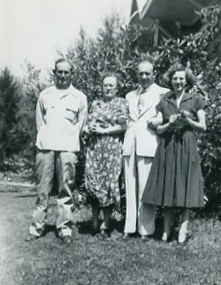

Below, in 1937, in Sutherland, a picture was taken of the oldest children of Bessie and Conley Wilson, who are also the grandchildren of John (1855-1928) and Rebecca Wilson (1862-1952) who is sitting center on the front row.
Back row, left to right are: Bessie's oldest son, Boyd Wilson and his wife, Lexie holding the baby named Gloria. Then Coney's oldest son, Argus and his wife, Grace Wilson holding baby Betty. Finally on the back row is Conley's daughter Marie and husband Don Marsh with baby Shirley Marsh.
In the front, left is Bessie Wilson Wilson holding Boyd's son, Robert. Then Rebecca Wilson Wilson and finally Conley Wilson.
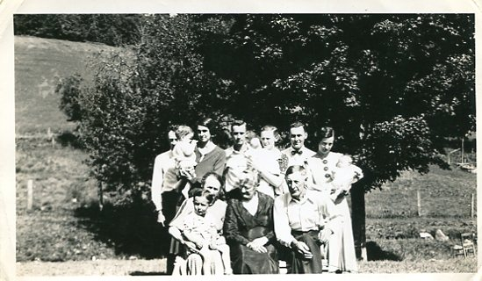

Robert James Wilson was born August 25, 1932 and died of leukemia on August 16, 1950. Gloria Jeanette Wilson entered life on October 5, 1934, William Boyd Wilson March 9, 1936 and Annabel Wilson, July 31, 1938.
Corrections, additions and your own photos, most welcome. GNH

The Families of Frances Wilson Osborne and G.W. Osborne, Jr.
Photographs and Articles on the history of the ancestors and descendants of Frances Wilson Osborne (1851-1940) and George Washington Osborne, Jr. (1846 - 1927)

6/26/14

From the Scrapbook of Shirley Sorrell 7
by Glenn N. Holliman
The sun was shining brightly on a September's day in Wilson Cove in Sutherland, Ashe County, North Carolina in 1935 when this picture of John and Rebecca Wilson Wilson's descendants was taken. Shirley Sorrell has saved this and other photographs and has identified these family members.
Below, the grandchildren of John and Rebecca.
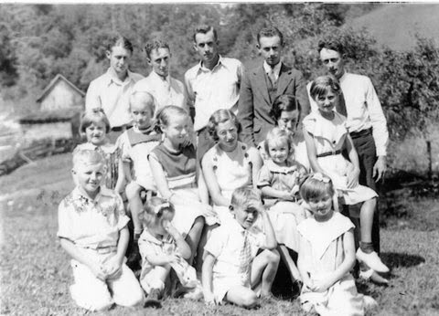

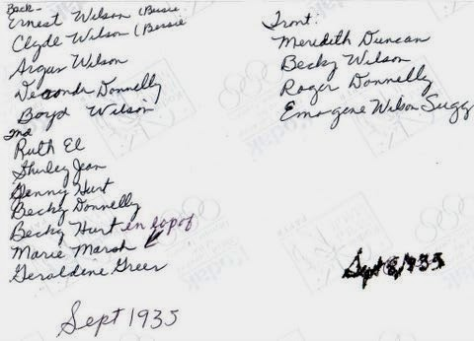
Below are the son-in-laws of John and Rebecca Wilson. Front row, left to right are Earl Donnelly married to Mayme and Shirley Hurt, wed to Ruth. Back row, left to right are Chall Osborne married to Minnie, William Wilson married to Cal, Bower Duncan wed to Margaret (Maggie) and Arlie Wilson whose wife was Bessie.
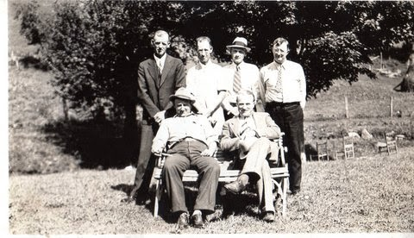
When one analyzes the occupations of the son-in-laws, we begin to see the increasing economic diversity of the North Carolina highlands. Several had moved to medium size cities for employment. Two had become educators. Only one remained a farmer in this generation.
Earl Donnelly was a hardware store salesman. Shirley Hurt was a paint company salesman in Greensboro, NC and did landscaping. Chall Osborne was a farmer in Ashe County although he and Minnie had gone out west to tend sheep. William Wilson married his first cousin Cal. He graduated from Trinity College (now Duke), class of 1914. He served in the U.S. Army and worked for Liggett and Myers Tobacco in Durham from 1920 to 1959. His father was the Methodist missionary to Japan who wrote the Wilson family memoirs of the violent 1860s. Bower Duncan served as a teacher principal and superintendent in Ashe County schools. He attended Appalachian and Wake Forest, served in World War I and as a magistrate for many years.
Arlie Wilson ran a store in Mabel community, and taught in Watauga and Wilkes county schools. He and Bessie later moved in with Rebecca Wilson Wilson to care for her.
In 1935, the U.S. Congress passed the Social Security Act ensuring retirement benefits to older Americans. The descendants of John and Rebecca Wilson Wilson, unlike Rebecca, would be able to live their senior years more independently.
Below, a picnic at the reunion. Shirley Sorrell has identified several of the persons as Deronda Donnelly, Ernest Wilson, Don Wilson, Becky Donnelly and Geraldine Wilson in the middle of the photograph. Additional identifications welcome.
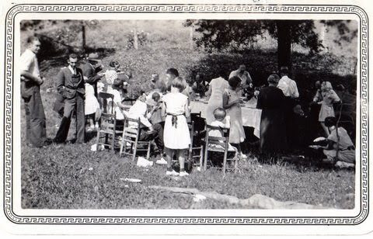
We invite you to rediscover your heritage at a Wilson, Greer, Wilcoxson, Osborne, Forrester, Adams and other families Forum, Saturday, 9:30 am, July 19, 2014 in the community room of the Boone, North Carolina public library. Sunday, July 20th is also the annual Wilson Homecoming at Sutherland United Methodist Church in Ashe County. The Family Forum begins at the Rustica Restaurant, Boone, NC. 6 pm, July 18th. Email glennhistory@gmail.com for reservations, please.
For details and schedule on the above event, contact glennhistory@gmail.com. Isaac and Caroline Greer Wilson are great, great grandparents of this writer.
Posted by Glenn N. Holliman at 7:29 AM No comments:
Labels: Arlie Wilson, Bower Duncan, Chall Osborne, Deronda Donnelly, Don Wilson, Earl Donnelly, Ernest Wilson, grandchildren of John and Rebecca Wilson, Shirley Hurt, Shirley Sorrell, William Wilson

6/11/14

From the Scrapbook of Shirley Sorrell 6
by Glenn N. Holliman
We continue with our series on the Wilson and associated families of Sutherland, North Carolina. Thanks once more to cousin Shirley Sorrell for making available these marvelous photographs from 1935 of the John and Rebecca Wilson family reunion in Sutherland, North Carolina.

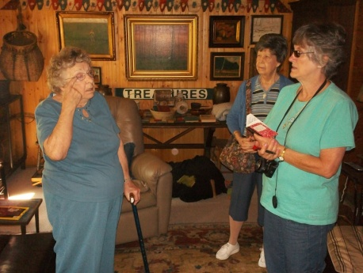
Right, Annie Greer Heaton of Banner Elk, NC with Shirley Sorrell, front right, and Geraldine Stansbery Holliman Feick, back right. This picture was made at our Wilson-Greer family forum in 2012. Another is planned this July 19 and 20, 2014.
In 1935, the United States struggled to escape the Great Depression. Ashe County historian, Arthur Lloyd Fletcher, states that the sheriff reported in 1932 to the County Board of Supervisors that enforcing the property tax law would result in foreclosure of more than half the homes in Ashe county! Such were the economic challenges of our ancestors in those difficult times.
Shirley has identified the ten surviving children below. John Wilson, born 1855, died in 1928. His parents are Isaac (1822-1864) and Caroline Greer Wilson (1828-1911).
The Rebecca and John Wilson Descendants Family Reunion 1935
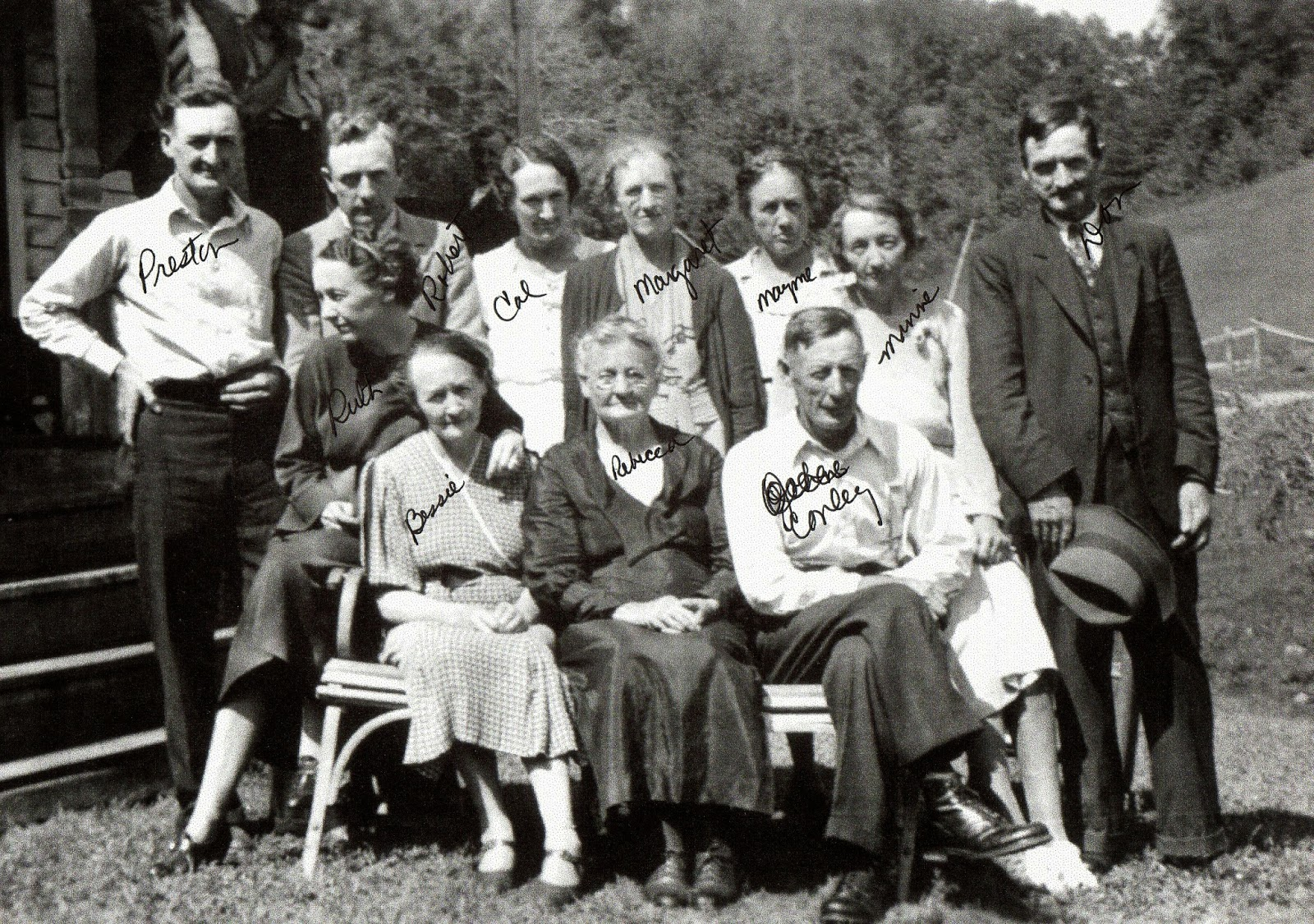
Above, front row in the summer of 1935: Ruth Wilson Hurt (1903-1999) , Bessie Wilson Wilson (1887-1976), Rebecca Wilson Wilson (1862-1954), and Conley Wilson (1882-1957). Back row: Preston (1900-1989), Robert (1906-1987), Cal (1898-1999) , Margaret (1894-1992), Mayme (1892-1975), Minnie (1896-1987) and Don (1890-1975).
Four children died in infancy or childhood, Nora (1881-1887), Edgar (1883-1885), Boyd (1885) and Nancy (1912).

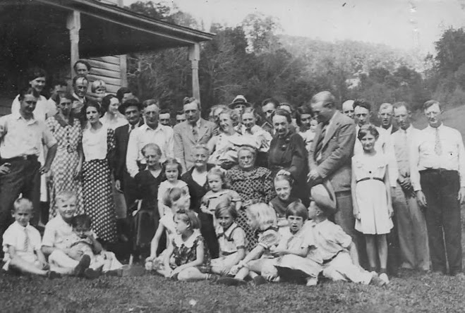
Above, from the same reunion, we have this picture of several generations. Shirley has made it easy for us to identify our ancestors. Below is a numbered photograph and then under it, are numbers and names.
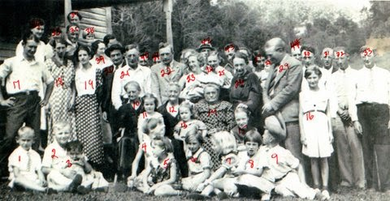
1. Roger Donnelly, son of Mayme Wilson and Earl Donnelly
2. Meridith Duncan, son of Bower and Margaret (Maggie) Wilson Duncan
3. Robert Wilson, son of Boyd and Lexie Wilson
4. Emojean Wilson Suggs, daughter of Ruth Kilby and Preston Wilson
5. Ruthel Wilson Merritt, daughter of Preston Wilson
6. Mary Wilson, daughter of Olive and Oscar Wilson, son of Ellen and Robert Wilson
7. Shirley Hurt Brand, daughter of Ruth Wilson and Shirley Hurt
8. Irene Wilson, daughter of Olive and Oscar Wilson, son of Ellen and Robert Wilson
9. Worth Wilson, son of Olive and Oscar Wilson, son of Ellen and Robert Wilson
10. Alice Wilson, mother to Arlie Wilson, husband of Bessie Wilson
11. Rebecca Wilson Igneizi, only daughter of Cal Wilson and William Wilson
12. Rebecca Wilson Wilson (b 1862), wife to John (1855-1928), sister to Ellen Wilson
13. Rebecca Hurt Johnson, daughter of Ruth Wilson and Shirley Hurt
14. Ellen Wilson Wilson, wife of Robert and sister to Rebecca Wilson Wilson
15. Virginia Hurt Breeden, daughter of Ruth Wilson and Shirley Hurt
16. Geraldine Wilson, daughter of Preston Wilson
17. Ernest Wilson, son of Bessie and Arlie Wilson
18. Olive Kilby Wilson, wife of Oscar Wilson, son of Ellen and Robert Wilson
19. Maude 'Tincey' Williams Wilson, wife of Clyde Wilson
20. Don Wilson, son of John (b 1855)
21. Conley Wilson, son of John (b 1855)
22. Shirley Hurt, husband to Ruth Wilson Hurt
23. Rebecca Donnelly Sutherland, daughter of Mayme Wilson (b 1892) and Earl Donnelly
24. Grace Donnelly Wilson, wife to Argus Wilson, son of Conley
25. Betty Wilson Elmore, daughter to Argus and Grace Wilson (baby in Grace's arms)
26. Ruth Wilson Hurt, daughter of John (b 1855)
27. Lexie Lawrence Wilson, wife to Boyd Wilson, son of Bessie and Arlie Wilson
28.Gloria Wilson Heimburger, daughter of Boyd and Lexie Wilson
29. Shirley Hurt, husband to Ruth Wilson
30. Boyd Wilson, son of Bessie and Arlie Wilson
31. Chall Wilson, husband to Minnie Wilson, daughter of John (b 1855)
32. William Wilson, husband to Cal Wilson
33. Arlie Wilson, husband to Bessie Wilson
34. Ruth Kilby Wilson, wife of Preston Wilson, son of John (b 1855)
35. Clyde Wilson, son of Bessie and Arlie Wilson
36. Oscar Wilson, son of Ellen and Robert Wilson (b 1860)
37. Bessie Wilson, daughter of John (1855)
38. Unidentified blond boy
39. Cal Wilson, daughter of John (1855)
40. Preston Wilson, son of Rebecca and John (1855)
41. Argus Wilson, son of Conley
42. Bower Duncan, husband of Margaret (Maggie) Wilson
43. Deronda Donnelly, son of Mayme Wilson Donnelly
44. Earl Donnelly, husband to Mayme Wilson
45. Shirley Ann Marsh (b 6/15/1935), daughter of Marie Wilson (Conley's daughter) and Don Marsh
If one discovers any discrepancies in the above, please let us know. One of the positive features of a blog is one can go back and change, add or subtract copy.
Next posting yet more reunion photographs from the John Wilson family of Ashe County, North Carolina....
We invite you to rediscover your heritage at a Wilson, Greer, Wilcoxson, Osborne, Forrester, Adams and other families Forum, Saturday, 9:30 am, July 19, 2014 in the community room of the Boone, North Carolina public library. Sunday, July 20th is also the annual Wilson Homecoming at Sutherland United Methodist Church in Ashe County. A Friday evening, 6 pm, July 18th get acquainted dinner will be held at the Boone, NC Rustica Restaurant. For reservations and details, email glennhistory@gmail.com.

Posted by Glenn N. Holliman at 1:34 PM No comments:
Labels: 1935 John Wilson family reunion, John and Rebecca Wilson Wilson families, Shirley Sorrell

5/21/14

Louise Stansbery's Great Adventure, Part 5
by Glenn N. Holliman
Cuba...an Island of Political Unrest....
This concludes a five part series on Louise Stansbery Sherwood's beauty pageant trip to Havana, Cuba from her home in Bristol, Tennessee in 1935....a era gone by....Louise is a grand daughter of G.W. and Frances Wilson Osborne.
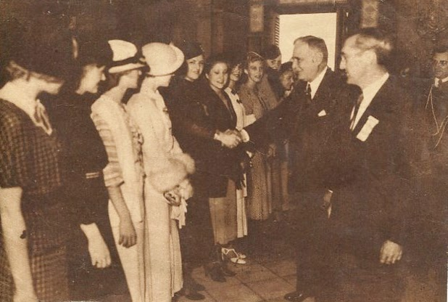Below International Radio Club beauty contestants, one being Louise Stansbery Sherwood (1915-2006), met President Carlos Mendieta of Cuba, December 9, 1935. Two days later Mendieta was forced out of office in yet another turnover of leadership in an unstable nation.
To most 21st Century Americans, Cuba is known as an island controlled by the two Castro brothers who led the 1959 revolution that overthrew a former Cuban army sergeant and quasi-dictator, Fulencio Batista.
Somewhere in the average American's high school memory is knowledge of the 1898 Spanish-American War when Teddy Roosevelt and his Rough Riders, plus the U.S. Navy, expelled the Spanish colonial administration from Cuba. For a few years, the U.S. cast a protectorate over Cuba, before the Cubans began, fitfully, to expeerience governmental independence.
After four centuries of Spanish rule, exercising that sovereignty proved vexing. Cuba was a deeply class ridden society with a few who were very wealthy and the many who were very poor.
Below, Louise Stansbery Sherwood and other beauty pageant young ladies await to shake hands with President Mendieta in the ornate Presidential Palace reception room.
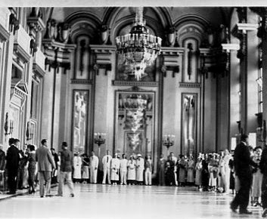

Amazing in the memorabilia of Louise Stansbery was a tourist booklet highlighting the 'charms' of 1935 Cuba. Appearing in the visitor's puff piece was this photograph below of a 'typical' Cuban family. Cuba seethed with political unrest and violence, and studying the picture below suggests why.
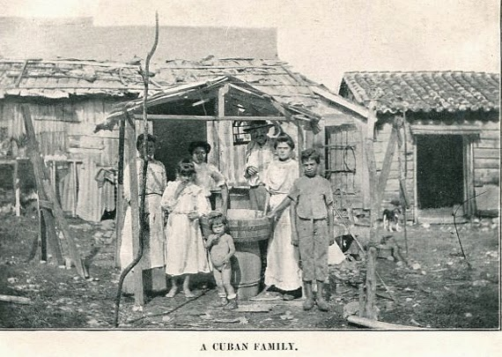
While in Havana, Louise was interviewed on the Havana radio. The next day, she wrote home that the building in which the broadcast had been made, was bombed by would be revolutionaries! Such was the unrest in the culture, that each contestant was issued a police card, see below.
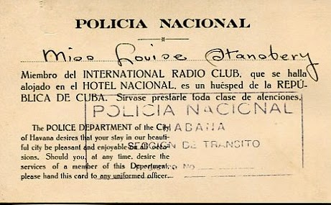

However this being a beauty contest, the International Radio Club had to crown a queen (below left). The winner was not Louise, but the twenty year old girl from Bristol, Tennessee had had the time of her young life as the tickets indicate!

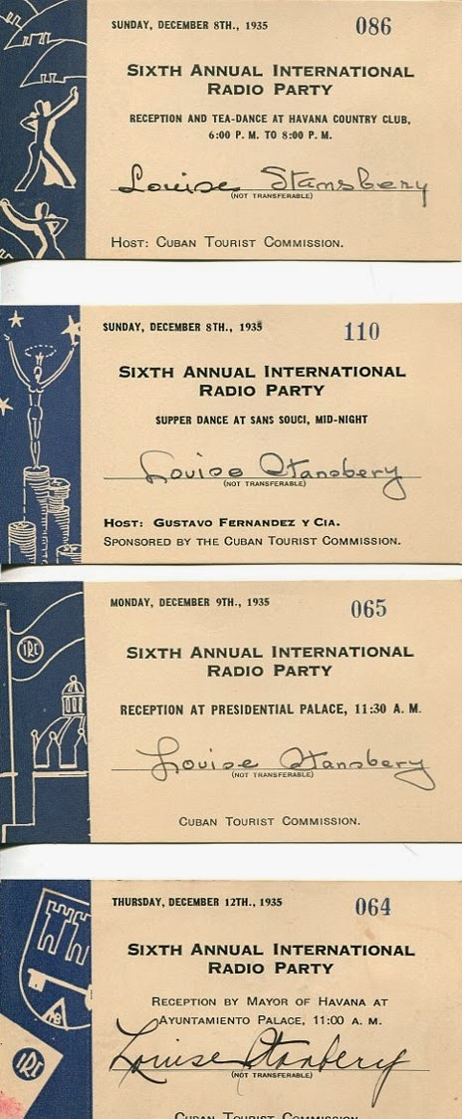
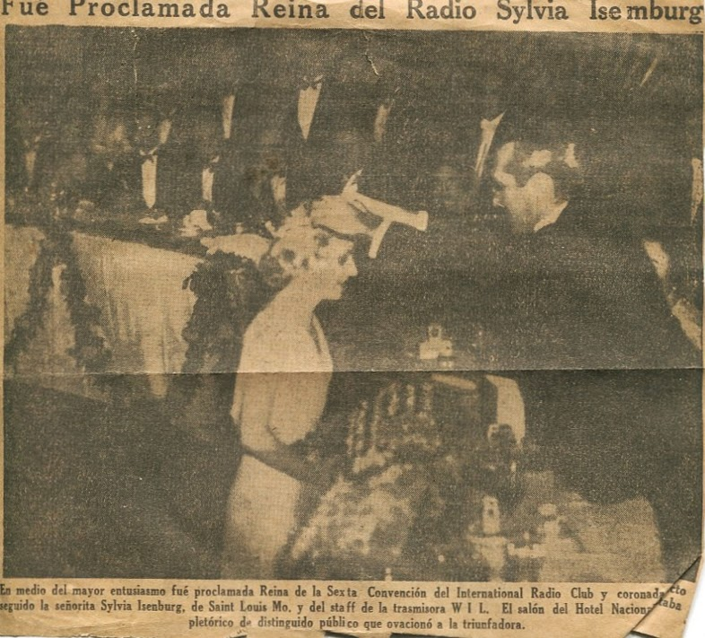 December 12th, the ship sailed back to Florida, and the Havana excursion ended. The next day, the WOPI Bristol, Tennessee party boarded a bus in Miami, and undertook a more than 24 bus ride, with several lay overs, back to East Tennessee. Louise took home wonderful memories and saved numerous mementos of that marvelous week, including, alas, a Greyhouse bus luggage stub, a reentry ticket, if you will, back to reality!
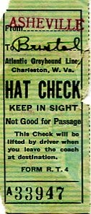
Next posting more reunion photographs from the John and Rebecca Wilson family of Ashe County, North Carolina....
We invite you to rediscover your heritage at a Wilson, Greer, Wilcoxson, Osborne, Forrester, Adams and other families Forum, Saturday, 9 :30 am, July 19, 2014 in the community room of the Boone, North Carolina public library. Sunday, July 20th is also the annual Wilson Homecoming at Sutherland United Methodist Church in Ashe County.
In addition, a detailed family tree of the above families is growing at a MyFamily.com site. For details and schedule on the above event and web site invitation, contact glennhistory@gmail.com. Isaac and Caroline Greer Wilson are great, great grandparents of this writer.

The Families of Frances Wilson Osborne and G.W. Osborne, Jr.
Photographs and Articles on the history of the ancestors and descendants of Frances Wilson Osborne (1851-1940) and George Washington Osborne, Jr. (1846 - 1927)

4/30/14

Louise Stansbery's Great Adventure, Part 4
by Glenn N. Holliman
Louise Stansberry's Great Cuban Adventure of 1935!
Our series continues....
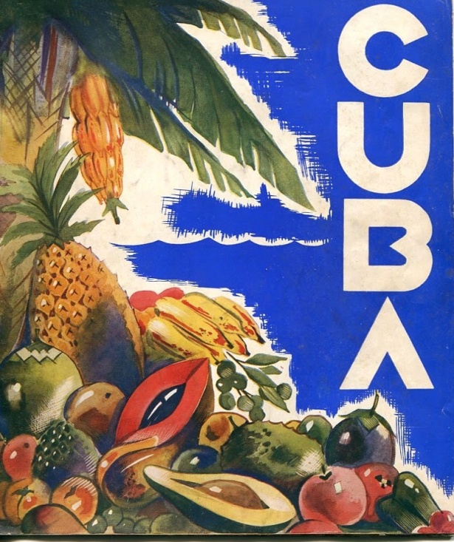
It was the adventure of a lifetime for the 20 year old young lady from Bristol, Tennessee. For a week, she represented WOPI of Bristol in an international beauty contest for the International Radio Club.
Below, Louise Stansbery in 1935.
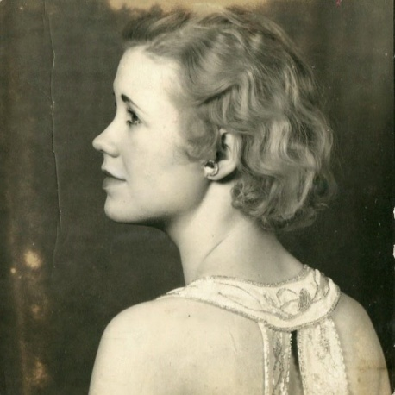
After a busy two days in Miami, the group of 24 'girls', almost all blondes and over 60 convention goers traveled by ship to Havana. A police escort met the group, and with sirens blaring guided them to the convention hotel, the famous National Hotel of Havana.
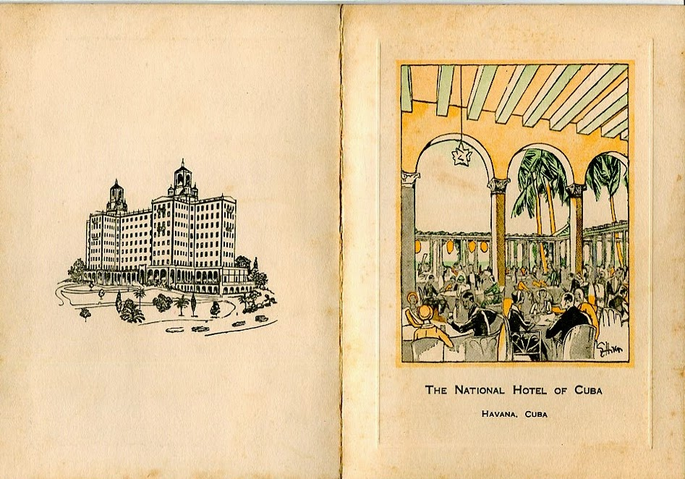
For whirl-wind three days, the young ladies were wined and dined and toured the city
This was a beauty contest after all. In sessions, the ladies were judged on beauty and personality, including a swim suit competition, but a rather modest one as the news picture below illustrates.
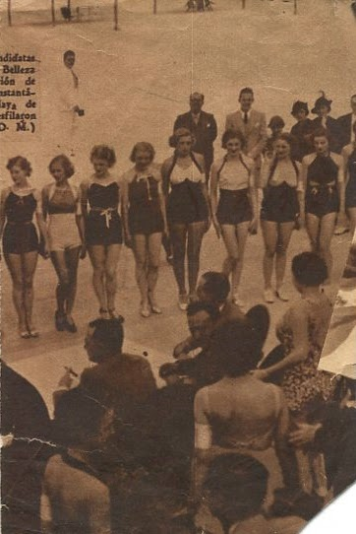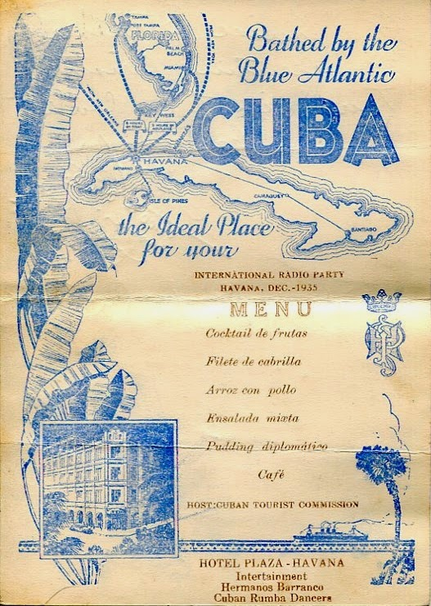
Above, a menu from the Havana Plaza Hotel

With her strong East Tennessee Methodist upbringing, Louise had been taught that intoxicating beverages were sinful. (Her late grandfather, G.W. Osborne, had been ordained a Methodist minister in Sutherland, North Carolina in the 1870s.) Although constantly offered alcoholic beverages on the trip, she must have refused indulging. Note the personal note from one Hayden R. Evans below!
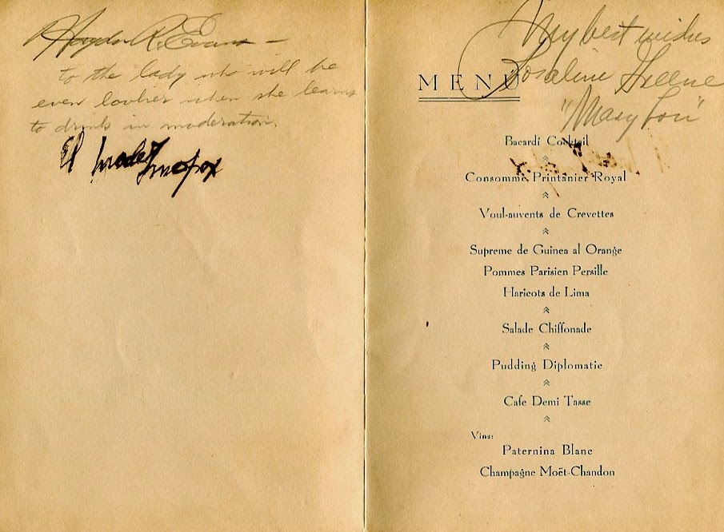

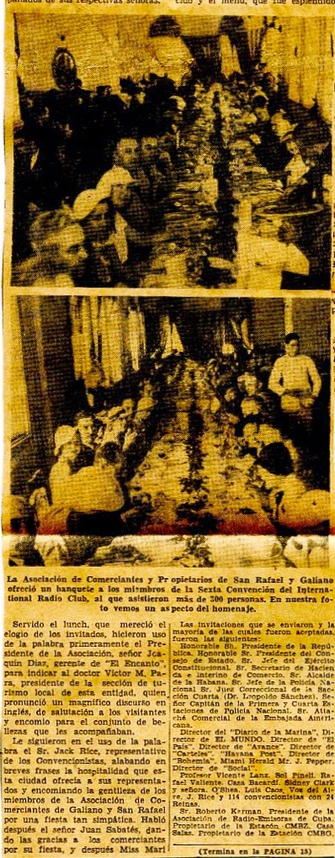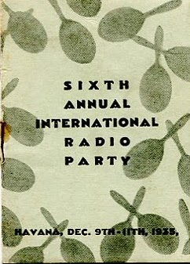Left and right a program and pictures of a luncheon. Newspaper coverage was extensive as the business community of Cuba desired greatly to encourage tourism.

Below, more newspaper coverage from Havana.
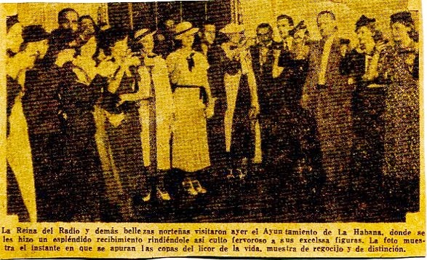
There were parties, there were tours and there were dinners. But behind this life on the high side, Cuba was dealing with poverty and political unrest....and that intruded on their time in Havana...next posting, a rebel bomb and a change of presidents!
We invite you to rediscover your heritage at a Wilson, Greer, Wilcoxson, Osborne, Forrester, Adams and other families Forum, Saturday, 9 :30 am, July 19, 2014 in the community room of the Boone, North Carolina public library. Sunday, July 20th is also the annual Wilson Homecoming at Sutherland United Methodist Church in Ashe County.
In addition, a detailed family tree of the above families is growing at a MyFamily.com site. For details and schedule on the above event and web site, watch this space and/or contact glennhistory@gmail.com. Isaac and Caroline Greer Wilson are great, great grandparents of this writer.

Posted by Glenn N. Holliman at 2:00 AM No comments:
Labels: Bristol, Cuba, Havana, International Radio Club, Louise Stansbery Sherwood, National Hotel of Cuba, Tennessee

4/17/14

Louise Stansbery's Great Adventure, Part 3
by Glenn N. Holliman
It was the greatest adventure of her 20 year old life - Louise Stansbery, daughter of Charles and Mayme Osborne Stansbery of Bristol, Tennessee, off to Florida and Cuba as a beauty pageant contestant in December 1935. This is the third in a series of articles capturing her fantastic trip and the times in which this event occurred.
The headquarters building in Miami, Florida was the stately Columbus Hotel, now long gone but then one of the most prestigious facilities in south Florida. Photographs were taken and a fancy banquet was held by the sponsoring organization, the International Radio Club.
Below in the left photograph, but right in the picture is Louise in a stylish black and white outfit and right photograph, wearing a hat with what appears to be wires (netting?) protruding. Another contestant, left picture, also stylishly outfitted, wears a white overcoat, suggesting an unusual cold wave. Note the 1930s automobile on the right of the picture.
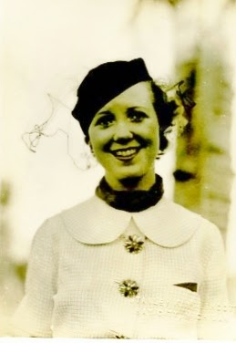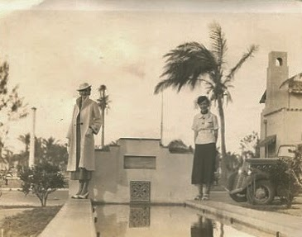

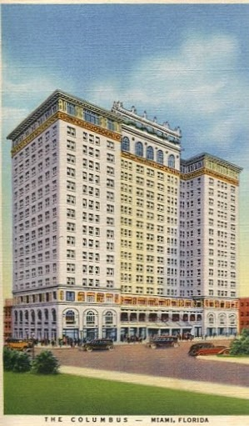Left, the Columbus Hotel, built in 1926 and now replaced on Biscayne Bay, was the headquarters hotel and the site of the opening banquet. As common at the time, Louise collected autographs of those at her table. My mother, Geraldine Stansbery (1923) remembers that famed radio personality of the time, Lowell Thomas, described the pageant contestants as the 24 most beautiful blondes in America!
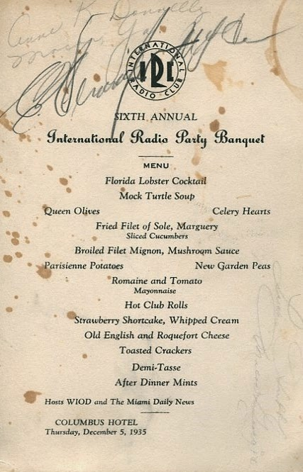
The next day, it was off to Havana, Cuba on the P and O liner, the S.S. Florida for an overnight cruise.
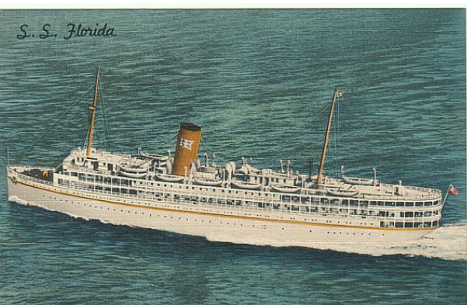
While on board, Louise was asked to pose for news photographers with three other contestants. She is second from the left.
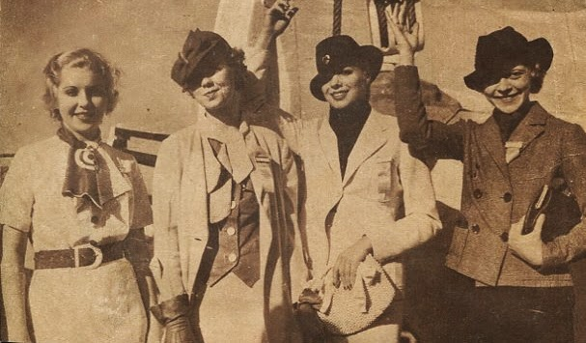
There was the arrival in Cuba, captured in this newspaper photograph of the day. The young ladies were placed in open touring cars and with a police escort driven to their hotel.
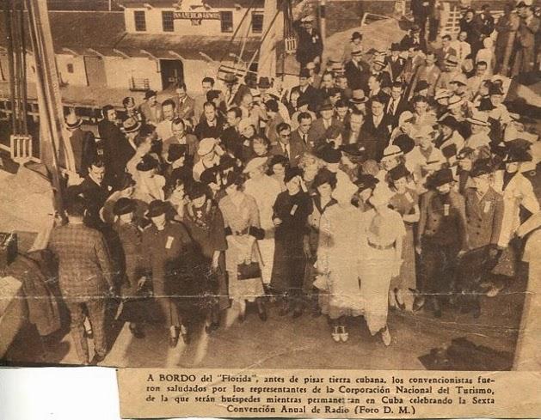
Next posting a whirl wind of tours, dinners and a turbulent political scene....
We invite you to rediscover your heritage at a Wilson, Greer, Wilcoxson, Osborne, Forrester, Adams and other families Forum, Saturday, 9 :30 am, July 19, 2014 in the community room of the Boone, North Carolina public library. Sunday, July 20th is also the annual Wilson Homecoming at Sutherland United Methodist Church in Ashe County.
In addition, a detailed family tree of the above families is growing at a MyFamily.com site. For details and schedule on the above event and web site, watch this space and/or contact glennhistory@gmail.com. Isaac and Caroline Greer Wilson are great, great grandparents of this writer.

Posted by Glenn N. Holliman at 7:42 AM No comments:
Labels: International Radio Club, Louise Stansbery Sherwood, WOPI

4/3/14

Louise Stansbery's Great Adventure, Part 2
by Glenn N. Holliman
Our series on my late Aunt Louise Stansbery Sherwood (1915-2006) continues. She is one of the great grand daughters of Isaac (1822-1864) and Caroline Greer Wilson (1828-1911) of Sutherland, North Carolina. Her grandmother, Frances Wilson Osborne (1851-1940), was one of the children assisting her father in the Ashe County cornfield when he was shot from ambush during the American Civil War in June 1864.
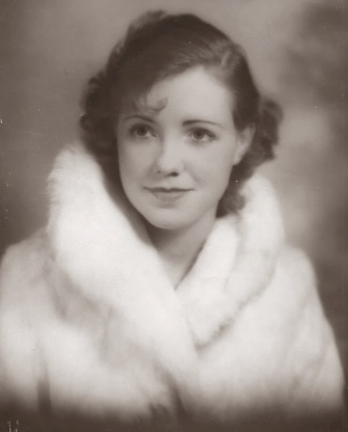Louise Stansbery, age 20, left Bristol, Tennessee in early December 1935, en route to Miami, Florida and then by ship to Havana, Cuba. The International Radio Club was sponsoring a beauty contest, and Louise - Miss Bristol that year - was tapped by WOPI radio to represent the station. WOPI owner W. A. Wilson and others accompanied Louise on this adventure.
They took the bus! Of course commercial flying was in its infancy and expensive. Why not the train? One suspects the bus was cheaper, and Wilson must have been counting his pennies and dimes in those early days of radio.
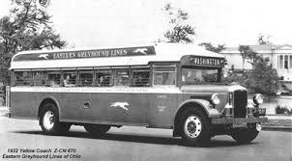
Left, a model 1932 Greyhound bus.
Heading south, one of the first stops was Statesville, North Carolina and Gray's Restaurant. Louise saved the menu, an elegant publication for its time. 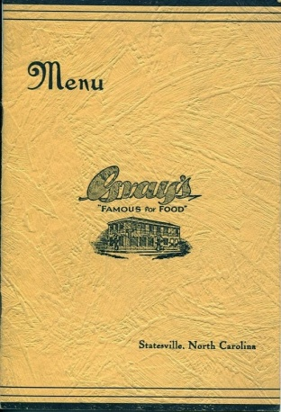
What is remarkable to 21st Century bank accounts is how inexpensive the food was. Steak only 50 cents and sandwiches for a dime. Of course the average annual income for American families in the middle 1930s was approximately $1,500 per year and during those Depression years, many such as my Osborne and Stansbery ancestors, made do with much less.
It is a bit unusual posting a menu, but it captures the cost of an up-scale restaurant of its time...a cup of coffee for 5 cents!
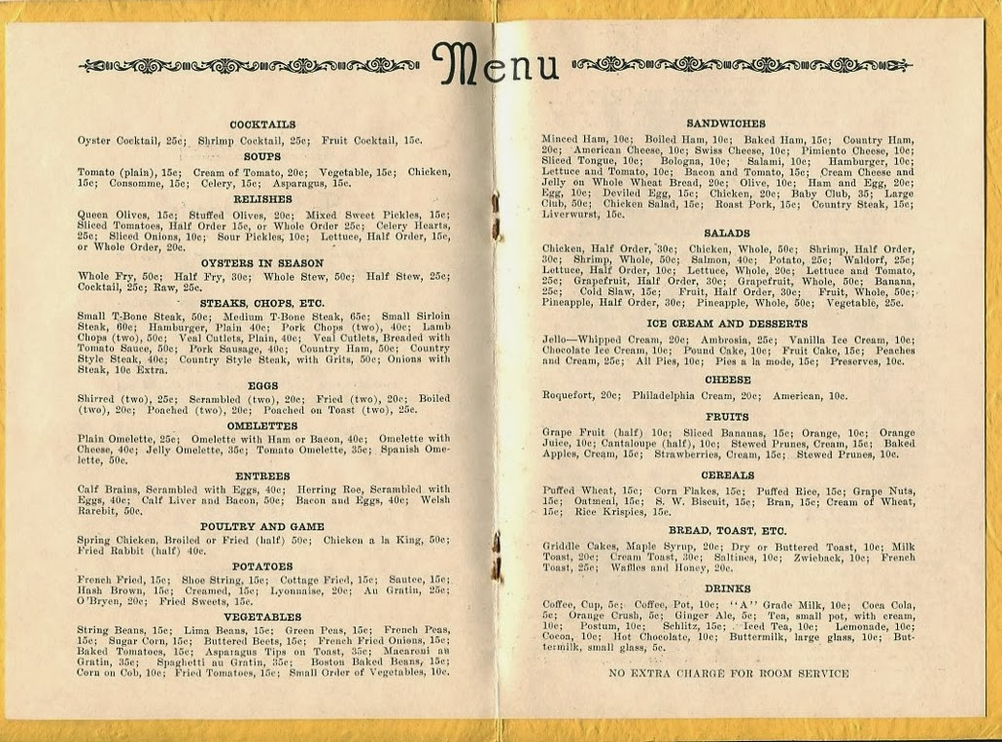
In a quick post card home from Georgia, Louise complained they were running late. That probably explains the railroad timetable contained in her memorabilia. Remarkably, she was assigned a private room for the overnight run from Jacksonville to Miami, Florida. One suspects Mr. Wilson wanted Louise rested and looking refreshed when they arrived in Miami for the first phase of the conference.
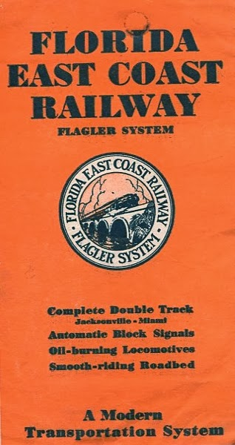
After two days travel, the party arrived in Miami, and quickly, Louise sent a second post card home to her mother, Mayme Osborne Stansbery. Below is Flagler Street, Miami in 1935.
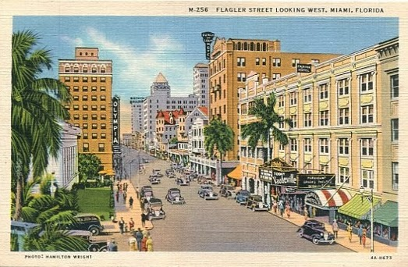
Next Posting, two nights in Miami....one of the belles of Radio in 1935!

The Families of Frances Wilson Osborne and G.W. Osborne, Jr.
Photographs and Articles on the history of the ancestors and descendants of Frances Wilson Osborne (1851-1940) and George Washington Osborne, Jr. (1846 - 1927)

3/17/14

Louise Stansbery's Great Adventure, Part 1
by Glenn N. Holliman
Recently my cousin, Donna Sherwood, passed along to me a large box of memorabilia of my late Aunt Louise Stansbery Sherwood. Donna's husband, Vance R. Sherwood, Jr. is my first cousin. In a container inside the larger box, I found envelopes of photographs and souvenirs from a special period in my aunt's life. It is a delight to share this bit of Americana with the larger family and world.
Frances Louise Stansbery Sherwood (1915-2006) lived a long and gentle life as a housewife in Knoxville, Tennessee. She is a maternal aunt of mine, the grand daughter of G.W. (1847 - 1927) and Frances Wilson Osborne (1851-1940). Although known as Louise throughout her life, the Frances comes from her grandmother and her great, great grandmother, Frances Brown Greer, the Civil War heroine who stood off the Union patrol that were stealing her honey pot. There was even Franklin Brown, the father of Frances Brown.
In 1918, she attended as a child of three the Wilson Reunion held on the Ashe County, North Carolina farm where her great grandfather, Isaac Wilson (1822-1864), had been killed just 55 years earlier near the North Fork of the New River in Sutherland. Again a debt to Shirley Sorrell who identified the children in this picture.
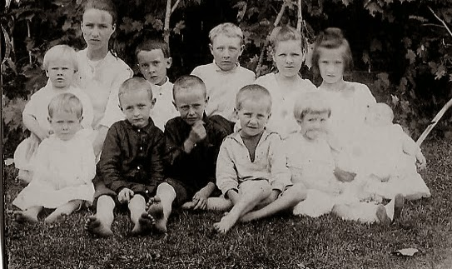Louise is on the front row, far right while an older cousin, behind her, Agnes Wilson, holds Louise's new born brother, Charles Stansbery, Jr.
Left, front row, left to right - Ernest, Clyde and Boyd Wilson, sons of Bessie and Arlie Gaither Wilson; Earl Wilson, son of Conley who is a son of John W. Wilson; Louise and Charles Stansbery, children of Mayme Osborne, the daughter of G.W. and Frances Wilson Osborne.
Back row, left to right - Thomas Earl Donnelly, who died at age 5. He is the son of Mayme and Thomas Earl Donnelly. Marie and Argus Wilson, children of Conley Wilson who is a son of John W. Wilson; Robert Wilson, a son of John W. Wilson (Robert is the only grandchild of Issac and Caroline Greer Wilson in this picture); Dorothy and Agnes Wilson, the daughters of The Rev. William A. Wilson and Mary A. McClellan, who were Methodist missionaries to Japan. Notice that almost all the children are bare footed!

Louise, the daughter of Charles S. and Mayme Torrence Osborne Stansbery (1896-1947), although born in Afton, Tennessee, grew up in Bristol, Tennessee, a mountain or two west of her mother's roots in Sutherland, Ashe County, North Carolina. Louise's parents separated in 1930, and she went to work immediately after high school graduation in 1933 in the depths of the Great Depression. Her jobs were retail clerk at Kress's and later waitress at King's Department Store. Times were very hard for the family, and her small pay check kept her disabled mother, younger sister and brother in groceries. Below, the beauty pageant announcement.

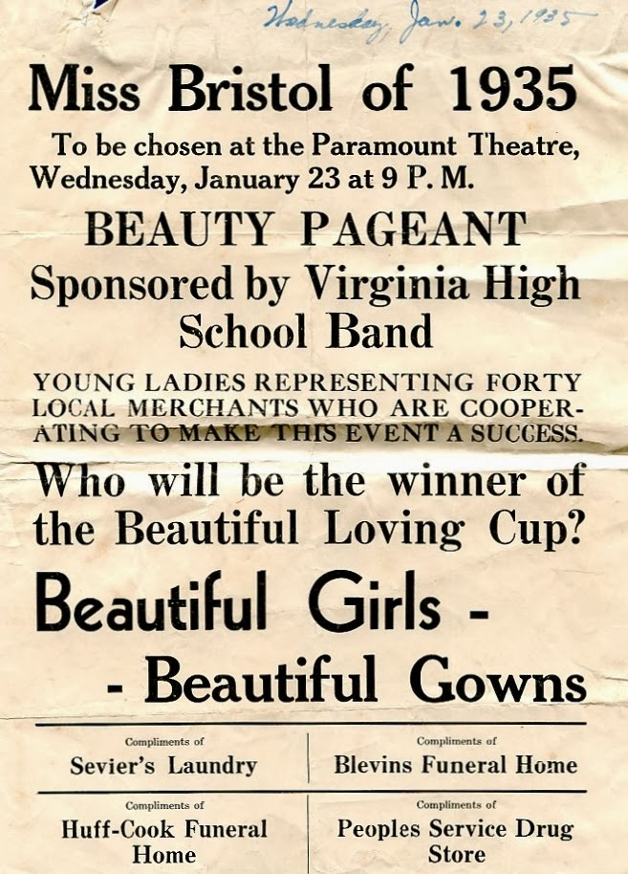

Then in January 1935, her life took a turn that led to a larger world. She had been blessed with good looks and a winning personality. She was encouraged to participate in the Miss Bristol, Tennessee beauty pageant, and she won! There was a preliminary contest on January 23, 1935 and then the finals on January 29. The picture below appeared in the Bristol newspaper.

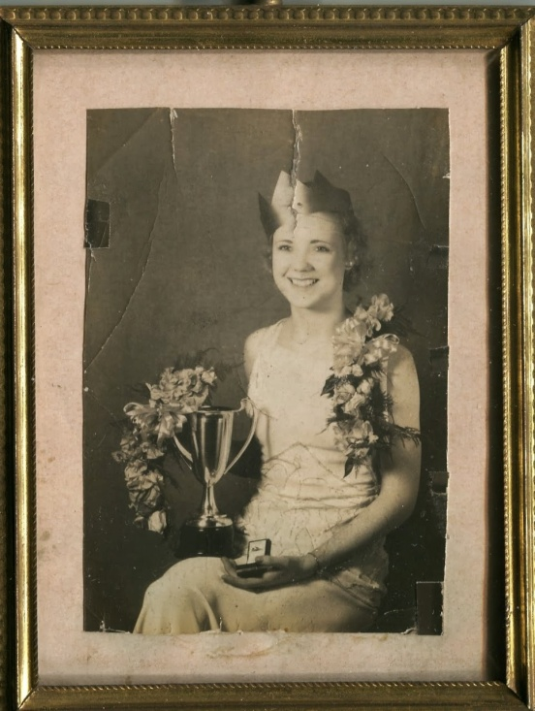

The newspaper clipping of the time states she would vie for Miss United States at Atlantic City. The family has no oral history or memorabilia of such as contest, but she did attract the attention of the local radio station, WOPI that was looking for a beauty contestant for the annual International Radio Club conference. The business gathering in 1935 was to be held in Miami, Florida and Havana, Cuba.
Founded by W. A. Wilson (no relation to our Ashe County family), the station went on the air in 1929, the first air castle between Roanoke, Virginia and Knoxville, Tennessee. Wilson was a good promoter; WOPI stood for 'Watch Our Popularity Grow' according the web site, http://www.wopi.com/history.html. The original format was popular and mountain music. Today WOPI, many owners later, is largely a sports station.

Below, a post card Louise saved of the Cuban trip showing the early WOPI.
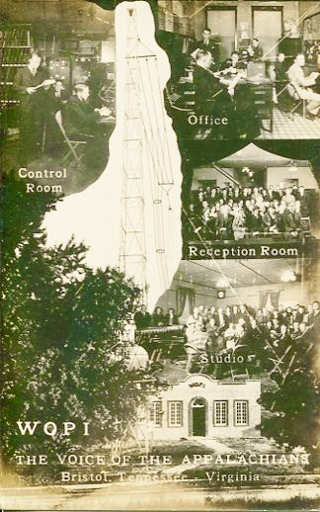
Below, one of the early announcers for WOPI was Tennessee Ernie Ford who was a Stansbery neighbor and fellow member of Bristol's Anderson Street Methodist Church in the 1930s. Ernest sang in the church choir and was a classmate with Louise's brother, Charles. With the popular entertainer from the 1950s and 60s is W.A. Wilson in a photograph from the WOPI web site. Mr. Wilson (1896-1967) and others would accompany Louise to Cuba and back.
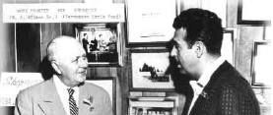

With radio in its infancy, local station owners branded together in the International Radio Club, a trade organization run by one Jack Rice, an entrepreneur of his day. The purpose of the 'club' was to promote radio and the sharing of ideas.
There was an annual convention and in December 1935, that convention was held in both Miami, Florida and Havana, Cuba. Below in Havana in December 1937 is Jack Rice, an aggressive promoter, who dreamed up the idea of a beauty pageant for the IRC as a way to attract attention and capture some publicity.
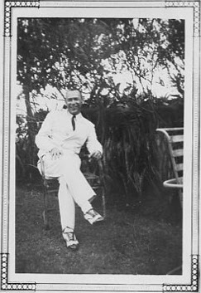
When all said and done, 24 local broadcasters (there were about 65 members that year) tapped 'pageant queens' and paid their expenses to Havana. For Bristol, Tennessee, the participant was the small town dime store clerk, my Aunt Louise, and she embarked on the great adventure of your young and to that date, sheltered life!
Next on to Florida and Cuba!
We invite you to rediscover your heritage at a Wilson, Greer, Wilcoxson, Osborne, Forrester, Adams and other families Forum, Saturday, 9 :30 am, July 19, 2014 in the community room of the Boone, North Carolina public library. Sunday, July 20th is also the annual Wilson Homecoming at Sutherland United Methodist Church in Ashe County. In addition, a detailed family tree of the above families is growing at a MyFamily.com site. For details and schedule on the above event and web site, watch this space and/or contact glennhistory@gmail.com. Isaac and Caroline Greer Wilson are great, great grandparents of this writer.

Posted by Glenn N. Holliman at 2:00 AM No comments:
Labels: 1918 great grandchildren reunion, Frances Brown Greer, Frances Wilson Osborne, Jack Rise, Louise Stansbery Sherwood, NC, Sutherland, W.A. Wilson, WOPI

2/28/14

From the Scrapbook of Shirley Sorrell 5
by Glenn N. Holliman
Continuing our Series of Wilson Photographs....
Several cousins, Shirley Sorrell, Dale Wilson and Kathryn Wilson have made this article possible with their photographs and knowledge of ancestors who were born and for many, lived their lives in the North Fork of the New River in Ashe County, North Carolina. We continue the series with more on John Wilburn Wilson (1855-1928), a son of Isaac (1822-1864) and Caroline Greer Wilson's (1828-1911).
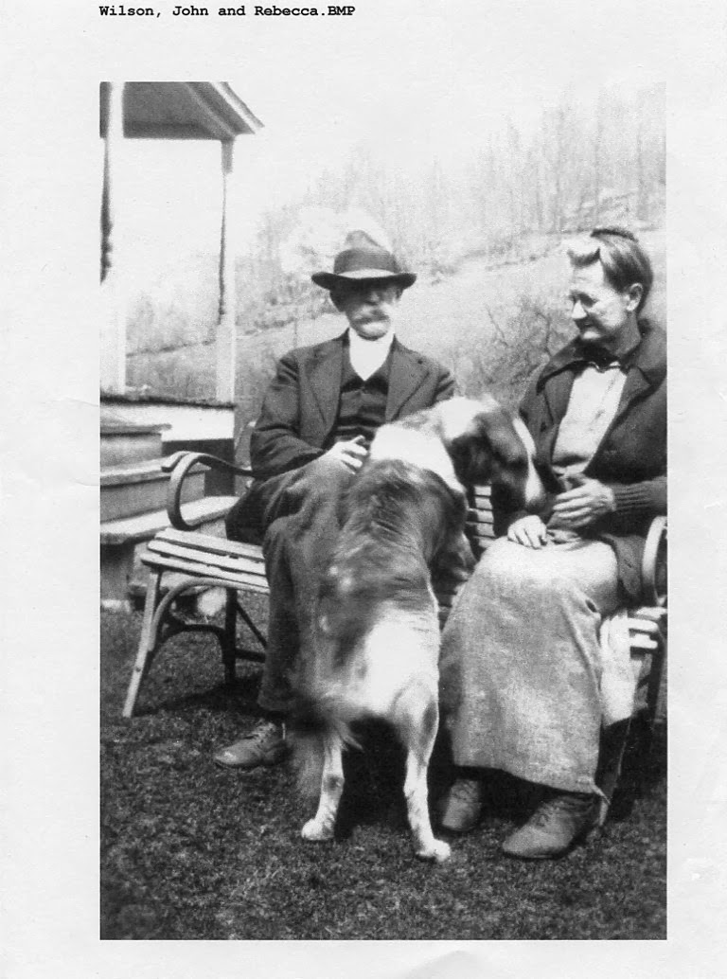
John and Rebecca Wilson Wilson (1862 - 1954) had ten children who lived to maturity, and while some descendants still reside in the Western North Carolina mountains, many have dispersed across the United States.

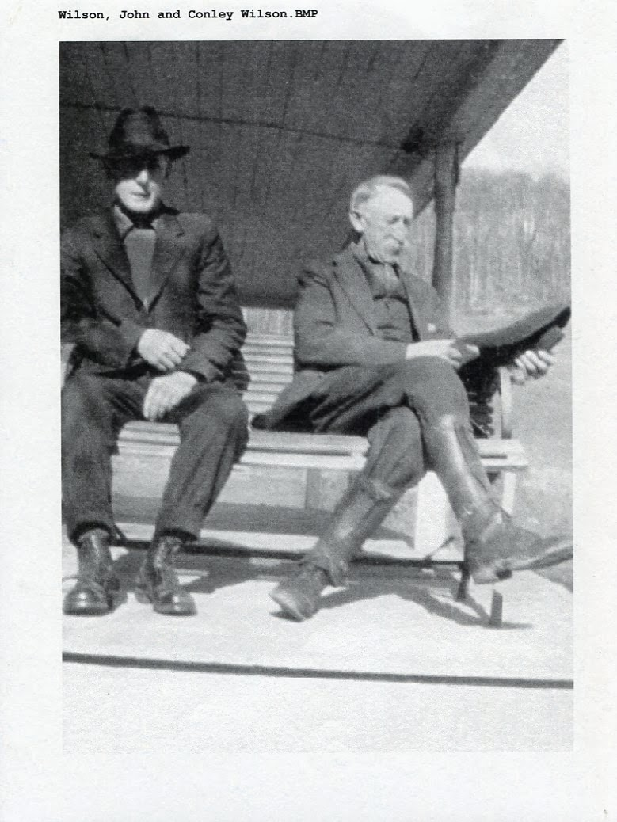
One son of John and Rebecca's was Thomas Conley Wilson, born Feb 18, 1882 and died Dec 9, 1957. He married Verde M. Barlow, (1880 - 1969). Their children are Marie Wilson (1908-2001), Conley Argus Wilson (October 3, 1909 - January 3, 1994) and Thomas Earl Wilson (October 22, 1913 - July 23, 1977). Earl married Neva Howard ( b. Aug 12, 1912).
Conley lived all his life on a farm that was part of the Issac Wilson home place. The house still stands on the right just before Wilson cemetery on Oscar Wilson Road, Sutherland, North Carolina. John and Rebecca, his parents, lived a little further up the road from him. He died of what appeared to be a heart failure in his barn, where his son Argus found him.
Robert Wilson was the last child of John and Rebecca, born June 4, 1906 and died May 18, 1987 and is buried in Guildford Memorial Park in Greensboro, NC. As a young man, he went out west with his nephew, Earl Wilson (son of his brother Conley). Robert was a bachelor for a long time, but later married Imogene (last name unknown) from Galax, Virginia. There were no children from the marriage. The coupled lived in High Point, North Carolina where Robert worked at Sears in Greensboro for years. Imogene worked at Pilot Life Insurance.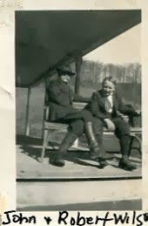
He loved horses but Imogene did not want him spending money on them. So he would buy one, and say it was his nephew's, Clyde Wilson. Clyde was the oldest son of Robert's sister, Bessie Wilson. They did have dogs and cats at home. Clyde Wilson, his wife Tincy and their daughter Kathryn lived in High Point also. Robert ‘s youngest sister, Ruth Wilson Hurt, lived in Greensboro within miles of Robert. Reportedly Imogene and Ruth had their differences and 'fought like cats and dogs'!
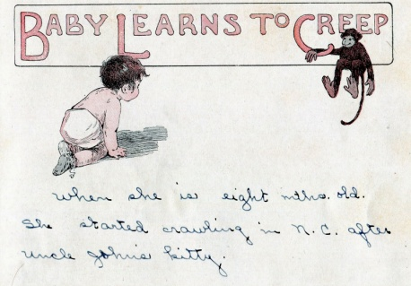
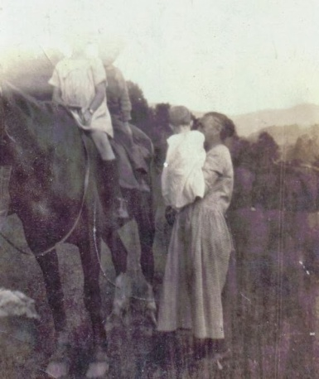Above, recently in my sister's attic I found my mother's (Geraldine Stansbery Holliman Feick, b 1923) baby book kept by her mother, Mayme Osborne Stansbery (1896-1943). They lived in Bristol, Tennessee, and visited John W. Wilson and families in Sutherland in July 1924. According to the above entry my mother first crawled at her great Uncle John's home. The photograph to the right, appears to be my great grandmother, Frances Wilson Oborne (1851-1924) holding my mother while her two siblings, Frances Louise Stansbery Sherwood (1915-2006) and Charles Stansbery (1981-2006) mount a horse in Wilson Cove.
Below are the obituaries concerning John Wilburn Wilson and his death in 1928. This is has become a comprehensive treasure chest of family names and relations. Notice the reference to the bushwhacking in 1864 of Isaac Wilson by Leonard Columbus Wilson, a cousin by marriage. Click on the pages twice and they should enlarge.

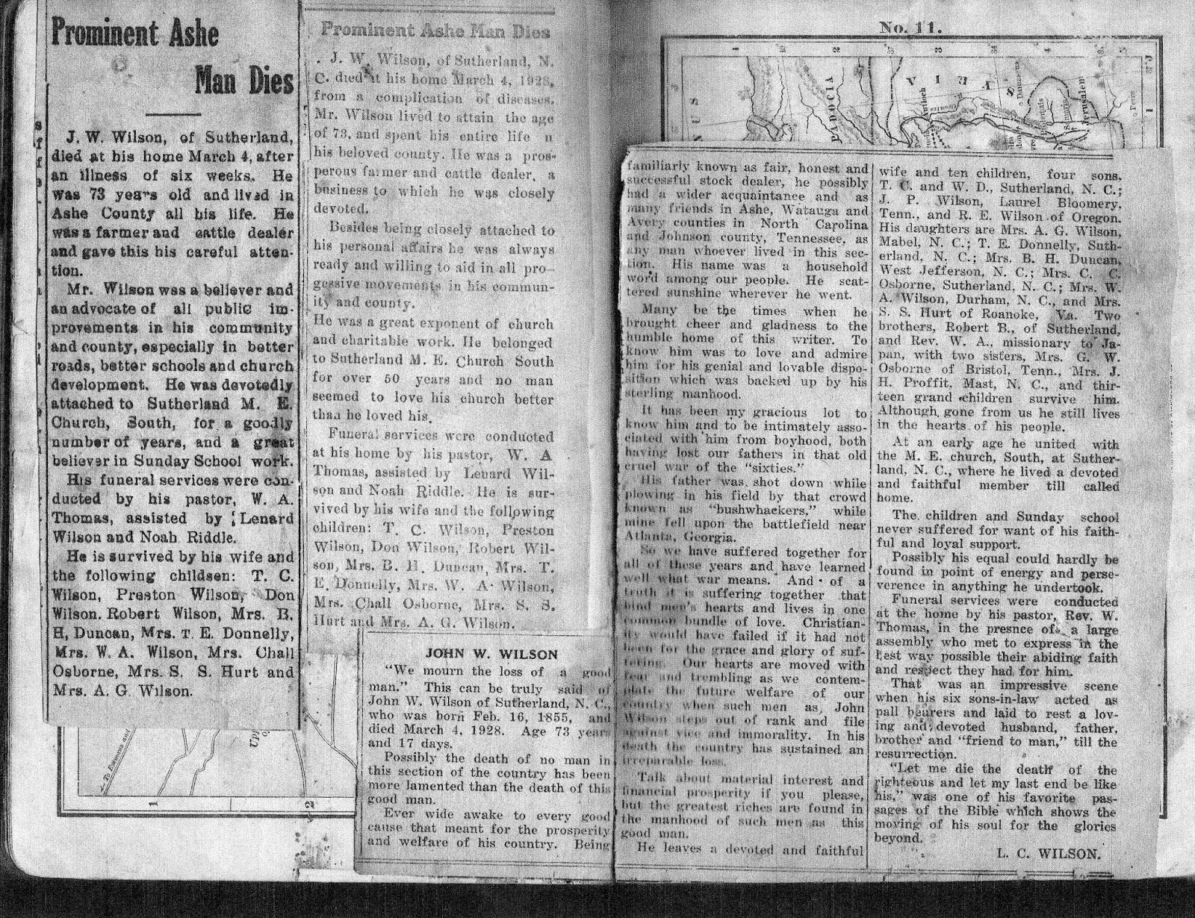

More on our ancestors in the next post....
We invite you to rediscover your heritage at a Wilson, Greer, Wilcoxson, Osborne, Forrester, Adams and other families Forum, Saturday, 9 :30 am, July 19, 2014 in the community room of the Boone, North Carolina public library. Sunday, July 20th is also the annual Wilson Homecoming at Sutherland United Methodist Church in Ashe County. In addition, a detailed family tree of the above families is growing at a MyFamily.com site. For details and schedule on the above event and web site, watch this space and/or contact glennhistory@gmail.com. Isaac and Caroline Greer Wilson are great, great grandparents of this writer.

Posted by Glenn N. Holliman at 3:00 AM No comments:
Labels: Argus Wilson, Bessie Wilson, Caroline & Isaac Wilson, Clyde Wilson, Earl Wilson, Edgar Donnelly, John Wilson, Marie Wilson, Mayme Donnelly, Neva Howard, Rebecca Wilson, Robert Wilson, Shirley Sorrell, Verde Barlow

2/10/14

From the Scrapbook of Shirley Sorrell 4
by Glenn N. Holliman
Continuing our tour of Shirley Sorrell's Family Album....
Our continued thanks to cousin Shirley Sorrell for sharing this magnificent collection of Wilson family photographs of the descendants of Isaac (1822-1864) and Caroline Greer Wilson (1828-1911). These families lived along the North Fork of the New River in Ashe County, North Carolina surrounded by mountains and lush forests.
"The earliest settlers to Ashe County cleared small patches of upland soil and cultivated it by scratching the surface with crude home-made implements. When the cleared patches decreased in productiveness they were said to be 'worn out' and new land was cleared and brought under cultivation. Within one or two seasons the abandoned land became covered with grass, mainly clover and blue grass.
This development tended to increase stock raising but, as a matter of fact, there was not great demand for livestock for many years. Apparently each settler was interested in just enough work stock for his individual use, and cattle, sheep, and hogs were raised to supply the home demand for beef, milk, butter, mutton, and bacon." - p. 208, Ashe County, a History by Arthur Lloyd Fletcher, McFarland Publishers, Jefferson County, North Carolina, 1963 (reprinted 2006).
While limited agricultural land meant that some children of prolific parents such as Wilson descendants had to move west, others remained to engage in age-old subsistence farming. These turn of the 20th Century photographs capture the last generation of an agricultural era now gone. By World War II, most of these farms were uneconomical. Seasonal homes, gated communities, Christmas Tree farms, tourism and work in service industries have replaced the family farm.
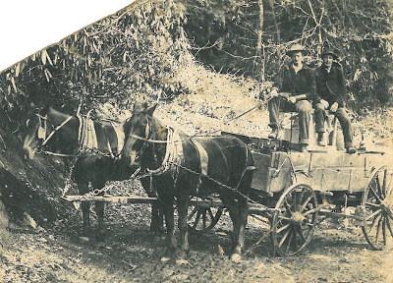
Edgar Osborne and Conley Wilson, ca 1910. Edgar, born 1893, the son of Walter Raleigh and Effie Lewis Osborne, was one of the many who migrated to Oregon. Conley, a son of John and Rebecca Wilson Wilson, elected to stay in North Carolina and farmed until his death in 1957.
"Prior to 1872, all plows hoes, shovels and other implements used in Ashe County were homemade from iron ore taken from the mines of Ashe and forged in Ashe County forges." - p. 208, Fletcher.
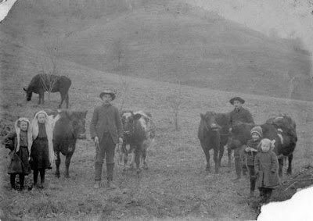

Above, 1907 ca Sutherland, North Carolina Callie, Minnie, John, Don, Preston and Ruth Wilson. John Wilson (1855-1928) and his wife, Rebecca Wilson Wilson (1862-1954), were the parents of ten children who grew to maturity.
"The cutting and shocking of corn was first practiced in 1882...Commercial fertilizer was not used prior to 1891. There were no facilities for soil testing in those days, and Ashe county farmers saw no need for it." - Fletcher, p. 208 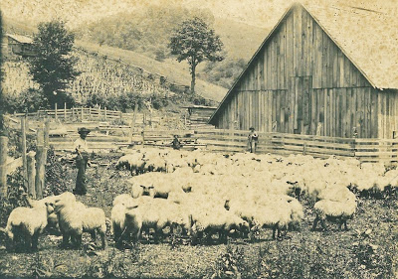
Above and below, herding sheep, Bob (1860-1949) and Ellen Wilson's (1866-1952) farm in Sutherland, North Carolina. Help in identifying these persons most welcome.
"In 1925, it took 10 to 15 acres of corn to feed a team of horse. By 1963 in Ashe County, less than one acre of corn will feed a team of horse for a year." - Fletcher, p. 213
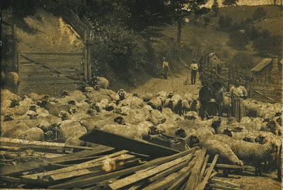
As the 20th Century moved on and mechanism increased "One man, plus the proper machines, could do the work formerly done by ten men or more. There was no farm work waiting for the boys finishing high school...." - Fletcher, p. 216
"The exodus from American farms marked the end of self-sufficiency and an uprooting of families from their heritage. In 1900 40% of the U.S. work force was in agriculture. Today the number is about 2%" - Atlantic Monthly, June 2013

Next posting, more from Shirley Sorrell's scrapbook of family pictures....

