Ulyss and Pearl Caine Holliman and their Descendants
by Glenn N. Holliman
Vena Vivian Hollman Daly Buckheit (1909 - 1990),
the Second Child of Ulyss and Pearl Caine Holliman

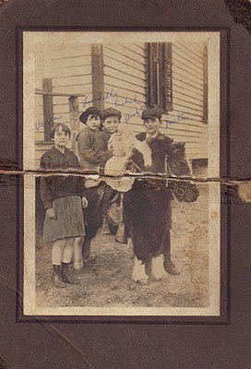

Above left to right are Vena, Loudelle, Euhal, Bishop and Melton Holliman in 1920. The pony may have belonged to Mrs. T.C. Burgess who lived at the bottom of the hill below the Irondale, Alabama house. She had two children, John Hugh and Sadie Mae. Mr. Burgess owned the hardware store that Robert and George Daly purchased in 1944.
Vena was 8 in 1917, when Ulyss and Pearl Holliman moved their four children and themselves to the growing suburb of Irondale, Alabama. The population of Birmingham and its environs were exploding. Founded in the 1870s, Birmingham grew in forty years from 3,086 to 178,816! Jobs were plentiful as the infrastructure of the steel industry and the city grew. Ulyss Holliman, now age 32, with many mouths to feed, left Fayette County and work in the lumber yard, to become a carpenter with the Birmingham Electric Company.
As Birmingham grew horizontally, street car lines pushed to all corners and into the suburbs. Ulyss helped keep the wooden carriages and benches in good repair. Ironically, when Ulyss was born there were no street cars in Birmingham, and when he died in 1965, there were not street cars in Birmingham.
Vena, the oldest daughter helped her mother, Pearl, care for the growing brood, which expanded by three more children after Ulyss found secure employment, and the family settled into new housing in Irondale.
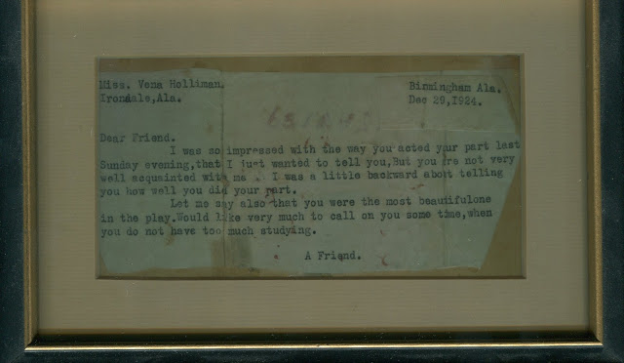
In December 1924, twenty-one year old Robert Daly, grandson of an Irish immigrant who came to Alabama to build railroads, watched Vena in a Christmas pageant in the Irondale Methodist Church. Robert, smitten over the cute 15 year old, sent her the above note and by her 19th birthday in 1928, she became his bride! Below is the newspaper clipping of the happy occasion. Click on the pictures to make them larger.
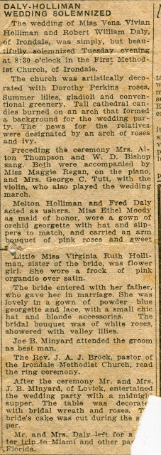
More soon on the Daly family and how they impacted on the life of the three youngest children....
Note: The information and opinions expressed in these family biographies are those of the writer alone. Comments, corrections and additions are most welcome. The purpose of these articles is to capture a period and family in American history and to pass this legacy along to future generations who share the common bond of family. My thanks to Mary Daly Herrin for making these materials available..

Ulyss and Pearl Caine Holliman and their Descendants
by Glenn N. Holliman
Vena and Robert Daly, Sr. and their Influence on the Holliman Family
In the mid 1920s, Robert Daly, Sr. began working for American Traders Bank in Woodlawn, Alabama. Later it became the American National Bank of Birmingham. In addition to being manager of the Woodlawn branch, he would become as a vice president of the larger corporation.

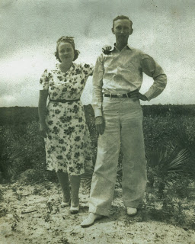
Robert loved to travel and vacation in Florida. Above are Vena and Robert in 1935. Robert was incredibly generous with his time and company to the siblings of Vena. He made himself a beloved figure to the three youngest Holliman children - Bishop, Virginia and Ralph - who often went with the Dalys to Panama City and Daytona Beach, Florida. Both Vena and Robert were tremendous role models for their generation, and later for their many nieces, nephews and grandchildren. After the death of Pearl Caine Holliman in 1955, the center of Holliman gatherings moved to Vena and Robert's 'white house' on the east side of Irondale.
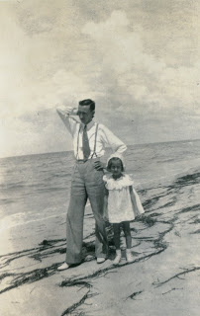
Vena and Robert would have two children, Mary Daly Herrin, born 1932 and Robert Daly, Jr., born 1943. Above is Mary in 1936, age 4 with her father at a Florida beach. They both seem formally dressed for a stroll in the sand! Below in winter 1944, Mary and her young brother, Bob, attempt to enjoy a light snow. In the background is the Daly house built in the early 1930s, adjacent to the Ulyss and Pearl family home at 2300 3rd Avenue, Irondale, Alabama.
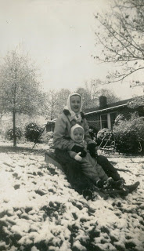

Sadly, Robert, Sr. suffered for years from congestive heart failure and died suddenly at his home in 1959. In the 1960s, Vena served as a sorority house mother at the Universities of Alabama and Mississippi. In 1971, she remarried Phil Buckheit, a successful newspaper publisher from Spartanburg, South Carolina. After he died in 1977, she returned to Birmingham, and lived in a condo on Red Mountain next to her sister, Virginia Holliman Cornelius. Vena died 1990. One of her grand daughters, Iris Daly Williams, recently reminisced that visiting her grandmother in the 1980s was like visiting a queen. Vena had a presence and gracefulness that her family admired and loved, as this nephew can attest.
Next the third child of Ulyss and Pearl Holliman....
Note: The information and opinions expressed in these family biographies are those of the writer alone. Comments, corrections and additions are most welcome. The purpose of these articles is to capture a period and family in American history and to pass this legacy along to future generations who share the common bond of family. My thanks to Mary Daly Herrin for allowing the use of these materials.
ULYSS S. HOLLIMAN FAMILIES

In this post we focus on the Daly and Herrin families:
Vena Holliman (1909-1990) was the first born daughter of Ulyss and Pearl Caine Holliman. In 1928, she married Robert Daly, an up and coming banker in Irondale and Woodlawn. They had two children, Mary Daly Herrin, Irondale and Dr. Robert Daly, Florence, AL.

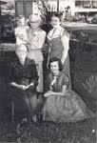
In this photo ca 1954 (clockwise from top):
Clayton Herrin, Pearl Caine Holliman, Vena Holliman Daly, Mary Daly Herrin, Lula Hocutt Caine
In the unpublished memoirs of H. Bishop Holliman, a brother of Vena Daly, we found these observations. Bishop captures a time and place of a family in Alabama in the 1920s and 30s and the generosity of Robert and Vena.
Memories of Robert Daly and Vena Vivian Holliman Daly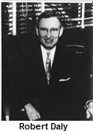
by Bishop Holliman (Written 1983).
Vena Vivian was born December 21, 1909. It was always common knowledge that she, my eldest sister, was exactly ten years older than I. My only memory of Vena being at home in Irondale, Alabama was of her dating Robert Daly. They were married June 12, 1928 at the Irondale Methodist Church. I was 8 years old, but I can recall the event clearly.
Vena attended Shades Cahaba, and since she was only 18 at marriage, she would not have done much work outside of the home. It is my recollection that she and Robert dated for three years. Many times on their dates they would have to tolerate Virginia, Ralph or me. Since Robert had been in the family as far back as we three could remember, we assumed he was there to see us as well as Vena!
‘Going riding’ was the thing to do in those days, so many, many times, one of us or all three, would be with them. I don’t know why they put up with us as they did. They would take us on picnics and fishing trips to the Cahaba River in the summer.
Their honeymoon was spent in Miami, Florida, and believe me, that was a long way from Irondale and not just in mileage. I still recall the excitement of getting post cards from them and having friends know that we had family who could go to Miami!
Robert had built the two brick houses on the hill next to our house, but I believe they lived with the Dalys out on the mountain (the east side of Irondale) the first years of their marriage. In 1929, they took a trip visiting Lake Lure in NC and Mammoth Cave in KY. They took Euhal (a brother of Bishop, 1912-1989) with them.
At the time Robert drove a Packard roadster---with a rumble seat! In 1933, they went to the Chicago World’s Fair taking Loudelle (Loudelle Holliman Ferrell, 1914-1998) with them. Beginning in 1934, a third vacation became standard fare, and for the rest of his life, they always vacationed on the beach.
In 1934, Mary was 3 years old, they began going to Florida on vacations and for some reason they took Virginia and me along. Ralph was considered too young. Virginia was able to babysit with Mary so she was of some value to them. I was of no value, except to go along as a fishing buddy. Virginia and I went with them again in 1935 and 1936. Robert, I suppose, paid all our expenses. We were not old enough to question the source of our support for those trips...they would volunteer to let us go with them and we did - gladly!
In 1931, they were living in one of the brick houses next to us, because that is where they were when Mary was born June 15, 1931 (Mary Daly Herrin). Vena and Robert spoiled Virginia, Ralph and me. We made their home ours, and did not hesitate to impose upon them at any hour – day or night – and we expected to be treated royally by them, and we were. I do not know why they were so good to us, but they were.
Robert Daly had the greatest influence on our young lives, certainly Virginia, Ralph and me. He was born in August 5, 1901, lived about 3 miles from Irondale, had completed whatever schooling was available to him, and I think, had taken a business course. He then started working at the First National Bank in Birmingham, and by the time we were old enough to remember, he was manager of the Woodlawn Branch, the position he held until his death March 12, 1959 of heart disease.
Robert was more than a 'brother' to us. We dearly loved him, all the family did. Even before they were married, he would give us presents, loose change, etc. He was always generous, a very affable person and apparently had great natural ability to deal with people as he did. Even after I was in college I would not hesitate to call on him if I needed help, transportation, etc.
As I got older, nearly every night after being out - working, dating, whatever, I would come by their house and chat. As WWII came closer, we would get in heated discussions about world events. He would agitate me purposely to get me stirred up. Robert never got mad. He was always smiling and would help everyone, I guess, who came to him.
When I left to go into the Navy on November 13, 1941, Robert, along with Mama, Daddy, Virginia and Vena were at the station to see me off. All during the war, Robert would write cheerful, newsy letters to me, and I treasured them and looked forward to them. After the war of course life changed for all of us, and new concerns and priorities came to the front. Life was never the same again, but Robert's influence on our lives remained strong and had a lasting effect.
Bishop Holliman now lives in Avilla, Indiana with his wife, Ellen Cox Holliman.

The Hollimans of Alabama

by Glenn N. Holliman
Alabamians Crossing Paths
During my recent sojourns to my native state of Alabama, I have been staying with my first cousin Mary and her husband Elliot Clayton (E.C.) Herrin. I have known E.C. since his marriage to Mary Daly in 1951. As am I, Mary is a 3 great grandchild of Cornelius Holliman (1792 - 1862) who immigrated to Fayette County, Alabama as a pioneer family from South Carolina in 1836. Mary and E.C. have raised a family of four and now have six grandchildren. After service in the U.S. Navy and graduating from Howard College (now Samford University), E.C. in the 1950s worked as an accountant in the Birmingham steel industry. However, he had an ambition to be an attorney.
Below, the lovely Mary Daly Herrin, the year before her marriage to E.C. Herrin in Irondale, Alabama. Her parents are the late Robert W. Daly, Sr. and Vena Holliman Daly. Mary is the granddaughter of Ulyss and Pearl Caine Holliman, Irondale, Alabama and great grand daughter of John Thomas and Martha Walker Holliman, Fayette, Alabama. Her 7th great grandfather is Christopher Holyman, Sr. (1618 - 1691), the founder of the Holliman families of Virginia and America. On the Daly side of her family are Irish ancestors who engineered railroads in 19th Century Alabama.
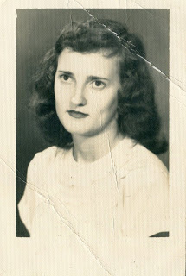
In a punishing schedule, strongly supported by Mary and the family, E.C. Herrin went to law school for years, sometimes three to five nights a week. In 1964, he passed the Alabama Bar and in 1967 became the municipal judge for the city of Helena, Alabama. In 2011, now 81 years old, he continues to hold court for the city twice a month. He is the longest serving municipal judge currently on the bench in Alabama, a distinguished record of service. He may be the longest serving municipal judge in Alabama history!
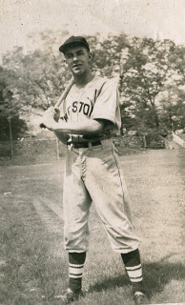
E.C. Herrin has loved sports all his life and played sandlot ball many afternoons as a youngster. Above he is in his high school baseball uniform in the 1940s. A favorite childhood companion was John Thomas Vaughan, another youngster growing up in the Depression in a small town in east central Alabama. Born in 1932, Dr. Tom Vaughan became a outstanding veterinarian and served for 18 years as the 6th Dean of the College of Veterinary Medicine at Auburn. Today, the large animal hospital at the University of Auburn is named after the well-respected and well-known Dr. Vaughan. (photo above)
These Alabamians Crossed Paths!
While these two children played their sandlot games prior to World War II, an old dignified Black man used to stop and watch. After a time, he came to know the boys by name. "Hello, Mr. E.C., Hello, Mr. Tom", he would say in the parlance of the pre-Civil Rights era. And in the societal manner of a different age, the two boys, eight or nine years of age, would respond to the ancient figure, "Hello, George, how are you today?" This happened on numerous occasions.
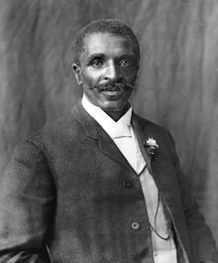
E.C. has never forgotten the kind, older African-American gentleman who died in 1943. Who was the man who befriended these two children? He was the distinguished Alabamian, a former slave who did his scientific work at Tuskegee Institute - none other than the legendary George Washington Carver, who revolutionized agriculture in the South! The above photo of Dr. Carver was taken in 1906.
More in the next post on the Hollimans and Associated families of Alabama....and paths that crossed....

