The Golden Summers, P 8
Insert map of area
“We learned through folks in the building that the railroad depot would be a safe place for us to go, once it was safe to get out on the street, so soon after daylight that’s where we went. There was no chance of getting breakfast as the wind and rain continued in full force, and we knew we had better stay put. So we did.
Insert photo of old depot
All morning long the wind blew and blew and the rain poured and poured. I remember seeing objects such as signs, limbs and other stuff flying through the air. Up in the morning the L & N passenger train that ran between Jacksonville and New Orleans pulled into the station. Its appearance gave us some hope, as we believed if the train could get through maybe the worst was over.
In all the fury, there was no panic and no hysteria throughout our ordeal from the youngest to the oldest. During the morning other refugees came into the building and one told us the gadget that measured the wind’s intensity was rising and that was a a good sign. I remember Melton’s saying that he hoped it reached a thousand!
All during the morning, though, we were concerned about Loudelle and Charles and Euhal and Edna back in Birmingham. There was no way to let them know what was happening to us and that so far we were safe. Loudelle was just about a month from bringing Charles Halford into the world. And Euhal and Edna has been married only a month. So our concerns were not confined to our fate there in the depot. I know now that Mama and Daddy, especially, were carrying a lot of weight on their shoulders that we young ones could not realize.

Around one o’clock the wind seemed to have subsided a little, so Hoyt and Melton dared to go out in search of some food for all of us. Maybe they found some, I don’t remember now from this this distant date. But about mid-afternoon, the wind let up, the sun came out and we all seemed alive again. We piled into the two cars and headed back to Panama City Beach, hoping Daddy’s car would still be there and that our belongings would also.
It was close to dark when we arrived at our destination. Limbs and trees were strewn all along the highway on the way, but thankfully, the houses were still there with all our belongings. The first thing we saw though was Daddy’s car, which had lost some paint due to flying sand. It was still where we left it, but would it start? It did, right off. We immediately packed up, loaded the cars and headed north as the sun sank in the west, glad to be safe and sound and on the way home!
It was a Friday night and we drove all the way to Dothan, Alabama, before stopping to eat and/or finding lodging for the night. We arrived home late Saturday afternoon, happy to be safe with lots to talk about. The next week Daddy called a reporter for the Birmingham morning paper, the Age-Herald, and gave him an account of our experience in the Florida hurricane. His story came out on the front page, listing all our names and what our feelings were about our ordeal.
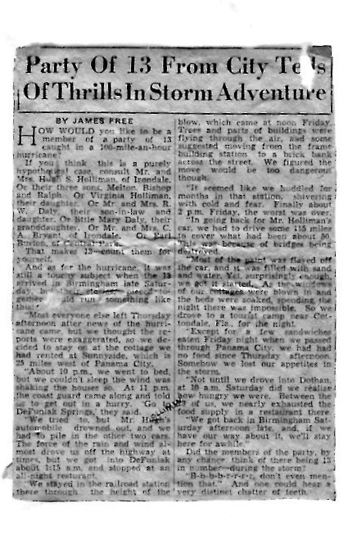
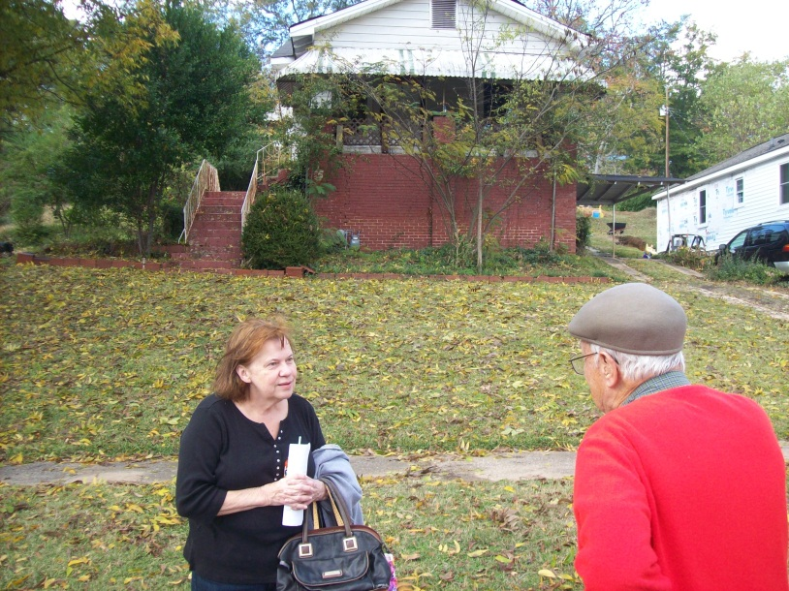
In November 2010, Bishop Holliman, back to camera, visited Irondale again. This photo shows him conversing with the unidentified person who now lives in the house (behind her) on 2nd Avenue where Melton and Ida Hughes Holliman lived in the late 1930s.
Melton and Ida were living in the house across from Grandma Caine (in Irondale, Alabama), just down the hill from us. Ida had an old Underwood typewriter that she let us peck on from time to time. So several days after we returned home I got the bright idea of writing up a history of our experience in Florida and of the storm, typing it all out of her type writer. Truly a hunt and peck system. I have forgotten how long it took me to get the job done.
The title was “The Storm Warnings Were Posted”, and I don’t know how I came up with such a threatening name for my story. Daddy was so impressed with my work he showed it to a Birmingham News reporter, thinking he could make something of my work. Abu alas, nothing ever came of it and the reporter returned it after a few weeks. Today, this great literary production is in possession of my son, Glenn Holliman.
Insert copy of book
So, thus ended my third Golden Summer with the Dalys and Virginia. By next summer, 1937, I had finished Shades Cahaba and was hoping to enter Birmingham Southern College that Fall, also trying to pick up odd jobs. I had reached the age where I would to start paying my way, and that realization posed all sorts of problems for me. My days of romping on the beach were over and done with!!

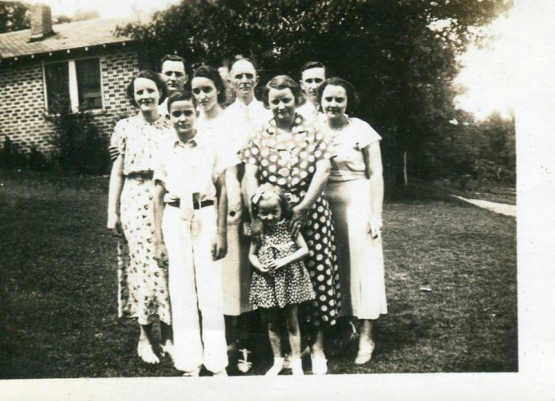
Above are eight of the thirteen family members who were caught in the 1936 hurricane. This photo was taken in 1936 in the yard between the Dalys and Hollimans in Irondale, Alabama, a natural photo spot to catch the afternoon sun. The youngster with the long tie on the front row is Ralph Holliman, about 12 years old. The young girl is Mary Herrin born 1931, with her grandmother’s hands resting on her shoulders. Her grandmother is Pearl Caine Holliman, age approximately 49 in this photo and not wearing glasses at that time.
Back row left to right are Ida Hughes Holliman, her husband Melton Holliman, Virginia Holliman, probably 14 in this photo, Ulyss Holliman and Robert Daly, Sr. just behind his wife, Vena Holliman Daly. Perhaps Bishop Holliman took the photo.

However, Vena, Robert, Mary and Virginia went to Miami the next summer, and Mr. Button returned to Irondale and went with them. Upon their return, I went to Knox-
ville with Mr. B. staying with a church family there, and we climbed Mt. LeConte in the Smokies. Virginia may have gone with them again in 1938 or 1939…I am not sure. Ralph went with them in whatever year it was Virginia did not go, even though he has forgotten it!
In the surf in Florida – left to right – Stewart Button, unidentified, Robert Daly, Mary Daly Herrin, Ralph Holliman and Vena Holliman Daly
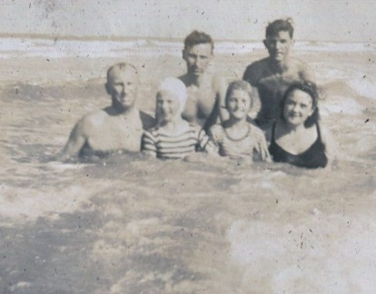
On July 1, 1941, I registered the World War II draft, an event that had lasting consequences for me, as it had on everyone else who registered. At the time, I was working in a New Deal temporary job in Birmingham and at Hill’s grocery Store on Saturday, planning to return to college in September.
The Dalys had been to Daytona that summer for two weeks, and here in August they were going back again! Robert had a very stressful job at the bank and he decided he should spend at least a month away from it, so they took off again. This time I went with them to help drive in case Robert did not feel up to driving all the way. So, I quit both jobs and made my last trip to Florida as a foot loose and fancy free lad.

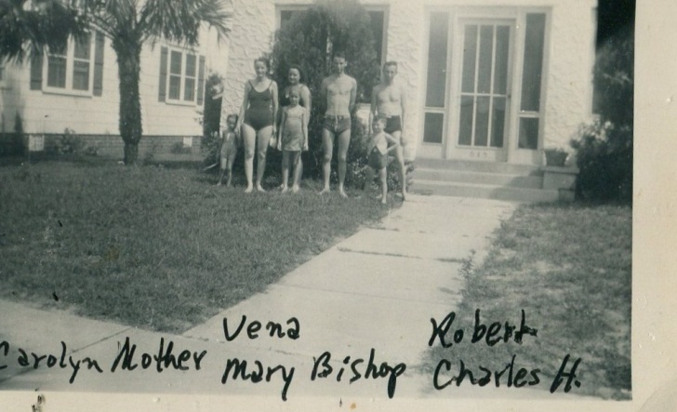
Left to right that late summer in Daytona Beach, Florida: Carolyn and Loudelle Ferrell, Vena and Mary Daly, Bishop Holliman, Robert Daly and Charles Halford Ferrell. Germany had invaded the Soviet Union that June. America was only a few months from being in the growing war.
Robert rented a house similar to the one we had had at Clearwater in 1936. Thus, we were prepared to stay as long as was necessary and allowed by the bank. A few days into our stay, Loudelle, Charles, Halford and Carolyn joined us. I think they were living in Jacksonville, Alabama at the time. So there we were - a big part of the family, enjoying our stay on the beach in the summer of 1941.

But it all ended too soon. Mama wrote to tell me I had received a notice from the draft board to report in, adding that you had better get back home.’ I planned to hitch hike, which was a popular way for college boys to travel in that day. But Loudelle would not hear of that so she pretended that they also had to get home, and that I should ride with them. And so I did.
As soon as I could get there I checked with the draft board and they told me I would probably be drafted that fall – October or November. I had already decided I would join the Navy rather go into the Army, as the first draftees were having a terrible time at Camp Blanding in Florida and I wanted no part of that. I would not sign up thought until I had to.
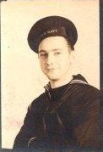
Bishop Holliman, born December 17, 1919 in the U.S. Navy from November 1941 until September 1945.
I also made the decision not to return to Birmingham Southern College that September since it appeared I would not be able to finish the semester – a decision I have wondered ever since if it was a wise one. I learned later that I probably would have been deferred until the end of the term. But all that is hind-sight. I came out of the war unscathed, married a pretty girl from Philadelphia who became the mother of my children, so don’t look back.
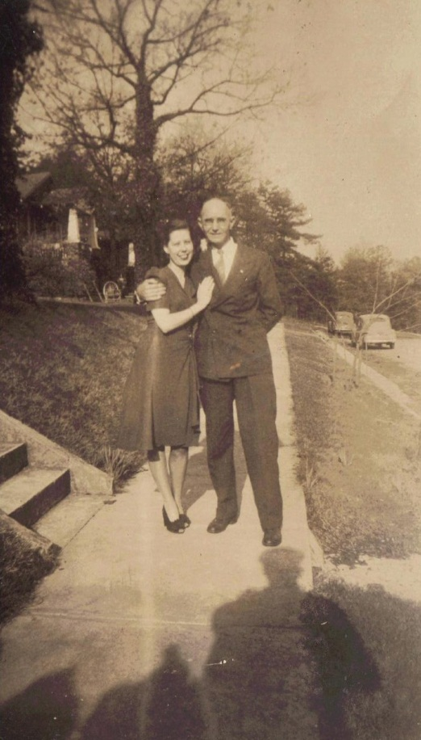
Above, Geraldine Stansbery Holliman, formerly from Philadelphia, visited Irondale, Alabama in February 1945 prior to her marriage to Bishop Holliman. Here Ulyss Holliman in an unusual display of affection has his arm around Gerry!
I don’t recall how long Vena, Robert and Mary remained at Daytona, probably for a month. I had obtained a temporary job at Sloss-Sheffield steel and Iron Company, so I was out of touch with goings on and getting ready to make my exit from home and Birmingham. I had a good friend who worked at S.S. steel and iron, who got me the job. I was paid, I think, 75 cents an hour, more money than I had ever seen. I worked up until the end of October, joining the Navy Friday, November 13, 1941. Mama, Daddy Ralph, Vena and Robert came to the train station to see me off!
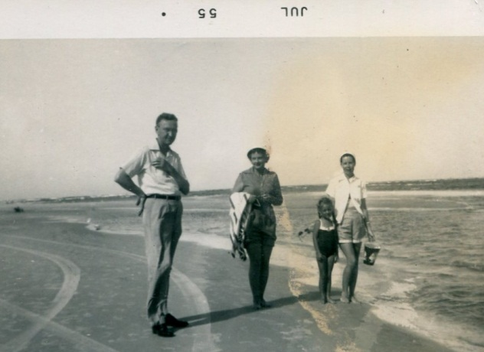
In the summer of 1955, Bishop Holliman took his young family to Daytona Beach, Florida to join his father and the Robert Daly family. Left to right, Robert Daly, Sr., Vena Holliman Daly, Becky Holliman, age 5, and Gerry Stansbery Holliman, age 31.
And so ended my last trip to Florida with the Daly trio. The next time I would be in Florida with them would be July 1955, two months after Mama’s death. We were living in Johnson City, Tennessee and we drove to Ormond Beach to join Vena, Robert, Bobby and Daddy for a week.
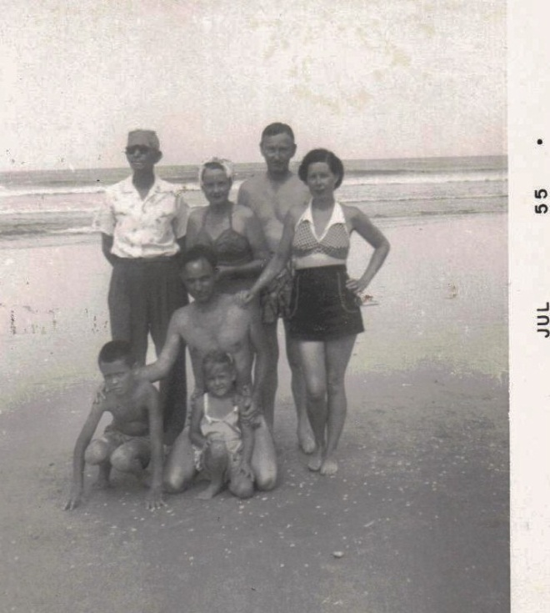
Above in Daytona Beach, Florida in July 1955, two months after Pearl Caine Holliman had died of a heart attack. Back row is Ulyss Holliman, uncharacteristically wearing sun glasses, who had married Pearl in 1906 in Fayette, Alabama. Next to him is his oldest daughter, Vena Holliman Daly and her husband, Robert Daly, Sr. Far right is Bishop’s wife, Geraldine, and front row, Glenn Holliman, age 8, Bishop Holliman, age 35 and Becky Holliman Payne.
Some things I should have remembered….
In 1935 or 1936 Robert got the bug to buy property in Florida and build and operate a ‘tourist court’, as it was called in those days before the coming of the Holiday Inn. He wrote to real estate folks in several places and his interest in such a project may be why we went to Clearwater in 1936.
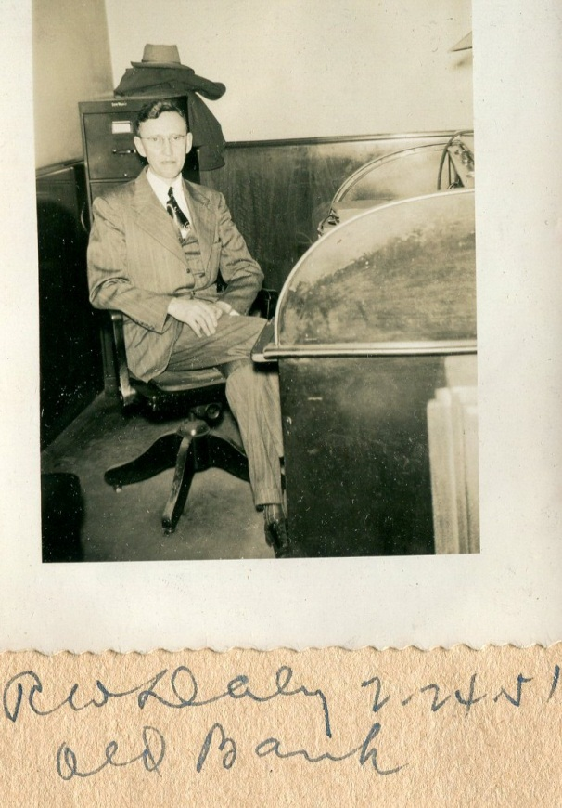
Robert Daly, Sr. sits at his desk in Woodlawn, Alabama prior to the construction of a new facility later that year. Unfortunately at age 50 his health began to fail, and he died of a heart attack in 1959 at his home in Irondale, Alabama.
I guess the stress of his job was worse than anyone could know at the time. His Aunt Alice was opposed to such a move and she told him to take up golf instead. In 1939, he bought three lots on the beach at Daytona…the war come. I was now out of the loop, so I do not know at was going on.

What happened to Mr. Button?
Below in June 1975, Stewart Button and his wife, Hazel, attended the Tennessee wedding of Alice Holliman Murphy (back to camera).
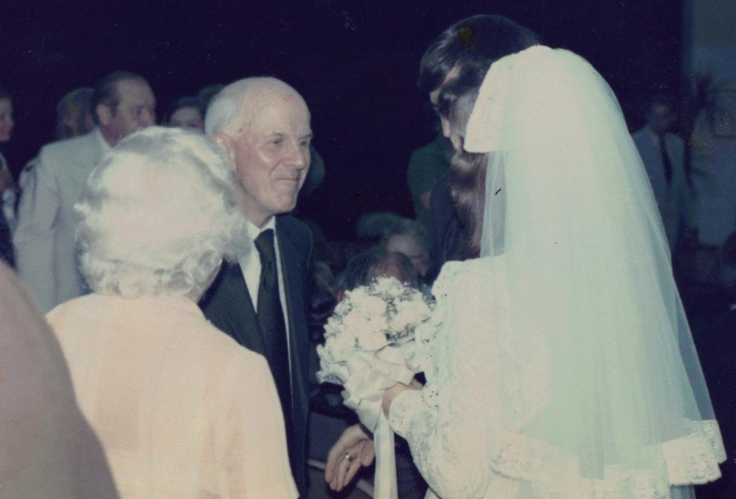
He was still living in Knoxville when I went into the Navy and continued to live there several years. He later moved to Cleveland, Ohio, maybe left the ministry and went into library work. I don’t know if he ever made any more trips with Vena and Robert, but he stayed in touch. Sometime during the 1940s, he married Hazel and was still living in Ohio at the time of Robert’s death in 1959. Later, he returned to Chattanooga, worked in the library and later moved back to Knoxville. Gerry and I visited them in Knoxville a couple of time.
He and Hazel attended Alice’s wedding in 1975. He was always mentally alert, his mind very sharp and he maintained his interest in all the families and folks he used to known in Irondale. I do not know the year of his death. He was a like a member of the family.

In our next post, Bishop Holliman continues his memories with details of the small town of Irondale, Alabama in the 1920s and 1930s.

