Earlier this year, 91 year old Bishop Holliman, the fifth child of Ulyss and Pearl Caine Holliman, penned some nostalgic memories of vacationing with his family in Florida in the middle 1930s. My father mailed copies to numerous of my cousins, but with his permission, I place his words in this space in order to reach a larger audience. Glenn N. Holliman
The Golden Summers of the 1930s, Part I
by H. Bishop Holliman 2011
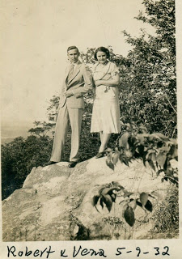
Introduction -
"Several years ago, my great nephew, Clayton Herrin, suggested I
write a few words about trips my siblings and I made to Florida with Clayton's mother, Mary Daly Herrin, and his grandparents,
Robert W. and Vena Holliman Daly in the 1930s. He said he had heard us talk about those times, and he thought it would be good to put in writing that period of history for the benefit of his generation
and those that follow. So that is what I have done - probably more than anyone wants to read. But I have included many other bits of history about the family and events of those years that I think are worth recording. Good reading!"
Above are Robert and Vena Daly, somewhere on a trip other than Florida, and most formally dressed for an outing. In May 1932, Herbert Hoover was in the White House and the Depression was nearing its nadir. The Democrats that summer were about to nominate the governor of New York, Franklin D. Roosevelt, as their presidential candidate. History was about to turn again. GNH
"In the summer of 1934, I was 14 years old and had graduated from the 9th grade at Irondale school. My sister, Virginia was 12, and Ralph, my youngest brother, was 10. Both siblings Euhal and Loudelle were still living at home. My oldest brother, Melton, had been married for two years, and Vena for six. Melton worked in the drug store at Five Points in Birmingham, filling prescriptions; Loudelle at Woolworths and Euhal for Hill Grocery Company. Vena, Robert and their new daughter, Mary, lived next door to us, the Ulyss and Pearl Caine Holliman house, 2300 3rd Avenue on the hill in Irondale, Alabama. Robert had built two brick houses in the early 1930s, and lived in the one closest to our home Daddy had constructed in 1921.
Daddy (Ulyss S. Holliman) worked at the street car company (Birmingham Electric Company) full time, having lost only six weeks of work during the Great Depression in the summer of 1933. Robert was manager of the Woodlawn Bank, a branch of the First National in Birmingham.
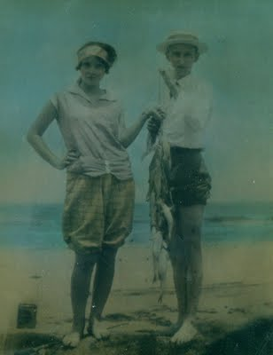
This wonderful 1928 picture of young Vena and Robert showing off their catch of the day was taken in Miami on their honeymoon. The photo hangs in their daughter's home in Irondale, Alabama. There is a startling resemblance between young Robert Sr. and son, Robert Daly, Jr. Vena, all of age 19, is looking very coquettish in the picture. GNH
Vena and Robert had married in June 1928 at the Irondale Methodist Church, and went to Miami on their honeymoon, driving a four-door black Dodge automobile. This was the first of many long trips they would take during the next thirty or so years. Before the start of the next summer - 1929 - Robert had traded for a used Packard roadster with a rumble seat, and they drove to Mammoth Cave, Kentucky and over to the Indian Reservation in North Carolina.
I mention these little incidents to point out that in 1929 and on through the 1930s, during the Depression years, not many people, in fact, only a very few people in Irondale, could afford the luxury of driving Packard automobiles, or taking a vacation. Or enjoying the semblance of a comfortable life like taking long automobile trips without worrying about their next meal.
Fate had smiled kindly on Robert and Vena, and, fortunately for Virginia, Ralph and me, we shared in their good fortune! Not only did they share their goods with we three youngest children, but also with the entire family. Robert had been in the family as long as we could remember. He gave us gifts at Christmas even before they were married, and he continued to shower us with love and affection and presents as long as he lived. I don't know how or why he and Vena put up with us as they did - not only with we three youngest only, but with all the family as needs and opportunities arose."
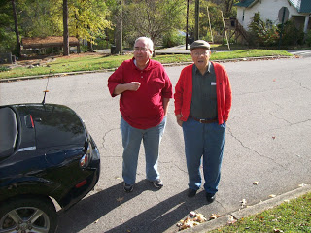
Clayton Herrin, left , who asked his great uncle, Bishop Holliman, right, to prepare some comments on the Dalys and Hollimans in the 1930s. Here the two stand in front of the Ulyss and Pearl Caine Holliman home at 2300 3rd Avenue, Irondale, Alabama in November 2010. In 1956 with their children, Euhal and Edna Holliman moved into the house and lived in it to their passing.
Next: More Reminiscences by Bishop Holliman.... The Golden Summers of the 1930s, Part II
by H. Bishop Holliman 2011
"In the summer of 1929, Daddy (Ulyss Holliman 1884 - 1965) bought an electric cook stove, a rare appliance for that time and place. Up until then Mama (Pearl Caine Holliman 1888 - 1955) had had to cook on a coal stove, which, of course, was an unbearable thing in the summer. But not many folks in Irondale, Alabama enjoyed the luxury of such a thing at that time.
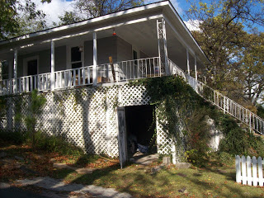
Left, a side view of the Ulyss Holliman house at 2300 3rd Avenue, Irondale, Alabama. Constructed in 1921, the home had six rooms and no indoor plumbing facilities until 1938. This photo was taken in November 2010.
I remember this event so well because the stove was installed while Vena and Robert were on their trip to Kentucky and North Carolina. They took Euhal (1912 - 1989) with them on this trip. He was 17 years old, and I remember his saying when he returned that he sat in the rumble seat and waved to the girls they passed along the way! So Euhal was the first of the family to enjoy a long auto trip with the Dalys. Our time - and Loudelle's - would come later.
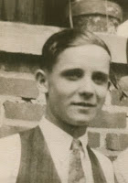
Above Euhal Holliman, ca 1935
By the summer of 1930, the Great Depression was in full sway, though I was too young to understand the implications of any of it. I thought folks had always been unemployed. The freight trains that came through Irondale, which we could plainly see from our front porch, had always carried hobos as far as I knew, so I was not impressed one way or the other by the evidence around me. If Daddy had been out of a job, as so many of our acquaintances were, I am sure I would have been more aware of what was happening.
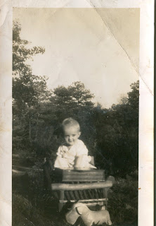
.
Mary Daly was born in June 1931, so they did not go anywhere that summer. At that time, 1931, they were living in the 2nd brick house (the one next to the woods) on our block. I remember Bill Fortenberry on the afternoon of June 15, 1931, who worked for his brother Ed in the local grocery store, saying to me that I was now an 'uncle'. I thought that made me more mature than I was!
Right, Mary Daly Herrin in Irondale, 1932.
I guess the summer of 1932 was much like the previous summer. The Depression had deepened, and the thought of taking a long trip was incomprehensible to most folks. Daddy was still working, and Euhal and Loudelle were working off and on. Radio was a fairly new kid on the block, even though Daddy had bought a Zenith in 1928 for the prodigious sum of $219, a huge amount in those days.
I remember Mama let me stay home from school in 1929 to listen to Herbert Hoover's presidential inauguration. In 1932 we listened to the Democratic Convention and heard the band playing over and over 'Happy Days are Here Again.'
The radio, along with the electric stove, made us among the first folks in Irondale to claim ownership of such modern conveniences."
Next more memories of the 1930s.... The Golden Summers of the 1930s, Part III
by H. Bishop Holliman 2011
"In the summer of 1933 many of FDR's programs were being developed and there was lots of news about the new President and what was happening in Washington. That summer I spent reading the 8th grade history book because I had been double-promoted from the 7th grade to the 9th. Mr. Millsap, the principal, had told me to study that book over the summer, so I did. In September 1933, I entered the 9th grade.
Below in Irondale, Alabama in 1934 are left, Ida Hughes Holliman, wife of Melton, and Loudelle Holliman. In 1935, Loudelle would marry an up and coming young Methodist minister, Charles Ferrell.
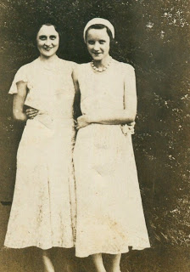
Loudelle was working at F.W. Woolworth Ten Cent Store on 3rd Avenue and 19th Street in Birmingham. She worked six days a week and made, I think, seven dollars a week! Her car fare was 14 cents day. I don't know what she did for lunch. Euhal was working in Hill's grocery store in East Lake, but I do not know how much he was paid.
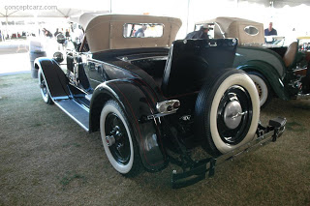
Right, a restored 1926 Packard with rumble seat the type in which Euhal Holliman enjoyed riding when Robert and Vena Holliman Daly took him for a long vacation ride!
By that summer, Robert Daly had sold his Packard Roadster and bought a Model A Ford from Cecil Bunt, who lived on the same street up on the hill. I never did know why he sold the Packard, or felt the need to move down to a lower level. That was not for me to know. The two-door Ford was probably a 1931 model.
Also in 1933, there came into Robert and Vena's life, and also into our family's lives, The Rev. Stewart Button, the new Presbyterian preacher in Irondale, one who was to impact our lives for many years.
Below, Irondale neighbor, Charles Pugh, Bishop Holliman and Stewart Button in front of the Holliman home at 2300 3rd Avenue, ca 1939.
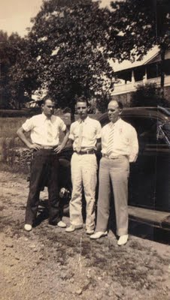
Mr. Button, or 'Button' as Robert Daly called him, was a native of Ireland and had come to the States in the late 1920s, attended Maryville College in Tennessee, a Presbyterian institute. A well educated man, he was about the same age as Robert but as yet unmarried. Robert and Vena took him under their wings, and from then on Mr. Button was like one of the family.
He was in and out of their house constantly, socialized with them and shared many hours of pleasant conversations. Maybe it was the Irish connection that tied them together. Anyway, he became a big part of their lives as long as they lived. Also, he had a great influence on my life as well."
Next, a Return again to the 1930s.... The Golden Summers of the 1930s, Part IV
by H. Bishop Holliman 2011
"In the summer of 1933, the Robert Dalys, The Rev. Stewart Button and the Model A Ford all got together, left Irondale, Alabama and went to the Century of Progress (the World's fair ) in Chicago! Can you imagine anything more unusual than that!!! They left daughter Mary, now two years old, with Robert's sister, Lena and other Daly folks, on their farm, up above where Mary and E.C. Herrin live now (near the new Shades Valley High School in east Irondale).
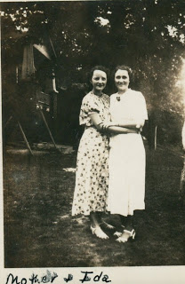
Right, Loudelle Holliman Ferrell and her sister-in-law Ida Holliman in front of the Daly house in Irondale, a new home built by Robert Daly in the early 1930s. The lawn on which Loudelle and Ida are standing was the shared lawn with the Ulyss Holliman home at 2300 3rd Avenue. Dozens of family photos were taken from the 1930s to 1990s at this site.
In addition, they took Loudelle with them! I guess they were gone a week. They must have been on the road a night each way, going and coming. I am sure Robert paid all the expenses for gas and overnight lodging. Maybe Mr. Button paid his hotel bill. Loudelle would not have had any money, and she lost a week's wages because there was no vacation time nor sick leave for hardly any one at that time, and surely not for ten cent store clerks. But this was Loudelle's time to travel with the Dalys!
To say that your relatives had gone to the World's Fair elevated in little Irondale, Alabama our prestige no end - even more so than riding in the rumble seat of the Packard! None of us knew of anyone else who had gone to Chicago, and certainly not to the Fair. It gave us a lot to talk about. Vena and Robert always brought souvenirs back to Virginia, Ralph and me, but I can't recall now what they brought this time. Loudelle picked up lots of pamphlets with coupons to order stuff, and I got on many mailing lists. Below, Vena Holliman Daly in 1934.
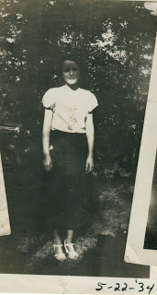
An interesting side bar - to add luster to this 1933 safari, the next summer, 1934, the noted gangster, John Dillinger, was shot and killed by FBI agents outside a Chicago theater. The four from Irondale like to claim that the hotel where they stayed the summer before was just a few blocks from where the Enemy No. One was gunned down! That gave them something to talk about (aside from being asked several times if they saw Sally Rand)!"
More exciting Irondale adventures in next post.... The Golden Summers of the 1930s, Part V
by H. Bishop Holliman 2011
Below, Virginia Holliman Cornelius, Mary Daly Herrin, Vena Holliman Daly, Robert W. Daly, Sr. and H. Bishop Holliman at Fort Walden, Florida, 1934. Stewart Button must have taken the picture.
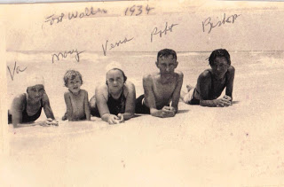
"I have never known why Vena and Robert felt it appropriate to take me along on their trip to Florida in 1934, the first of my 'three Golden Summers'. I can understand why they took Virginia along - Mary was just three years old, so Virginia was needed to baby sit her. But there was no earthly reason why they let me tag along, except out of the goodness of their hearts. Also, Mr. Button was included in this, the first of their many escapades to Florida. I don't recall any conversations that led up to the decision to take me with them.
Almost 5 million Model A Fords were built between 1927 and 1931. As Henry Ford said, one could have it in any color one wanted, as long as it was black! This is a plush model. The 1934 Daly car was more prosaic! GNH
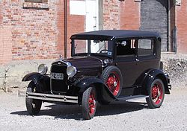
We left Irondale, Alabama on a Monday morning in July at about 3 am, riding in the Model A Ford. I have always remembered how exciting it was to be awakened that early and to head off to Florida, the first time I was to be out of Alabama and to view the ocean. So six of us - three adults, two young teenagers and one three year old - were stacked in the two door car. Our suit cases were slung over the hood on each side and may have even been tied to the fender opposite the driver's side. Remember...there was no such thing as air conditioning, no radio and no trunk to store luggage. Only two-lane roads, no fancy rest stops and very few eating places along the way. By today's standards it was murder! But we did not know any better. We were headed to Florida, and besides, gas was no more than 20 cents a gallon.
Our first stop was in Clanton, Alabama where we had breakfast at the Dixie Cafe on the main street. The cost was $2.50 for the six of us....ham and eggs and all the trimmings. I guess Robert paid for Mr. Button's share. Virginia and I had no money at all. I thought the price of our meal was astronomical, and I recall writing back home and telling Mama and Daddy how much we had already spent. We stopped in Dothan, Alabama to visit a Daly cousin, and we may have had lunch there.
I remember Virginia and I always wanting to visit places we had read about in our Alabama geography and history books, but the adults did not cotton to that idea so we never stopped. Our goal was to reach Panama City. We may have spent the night at a 'tourist court', reaching the ocean the next day; I am not sure now.
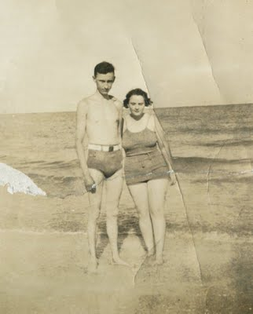
Young Robert Daly and wife, Vena, enjoy the beach in Florida. Their kindness opened up a larger view of the world to younger brothers and sister.
Whatever the day was, I remember how 'awed' I was when I first cast my eyes on the huge body of water that was Panama City Bay. I guess I had seen Lake Purdy, but it was not like that at all! The next day, I was even more 'awed', when we reached the beach at Fort Walton, Florida, a fairly new resort west toward Pensacola. There we settled for the next twelve days in a one-bath cabin, an oil cook stove, no radio. Air conditioning had not been heard of nor television. There were no near-by eating places, no movie houses nor other entertainment. But we were in Florida, and the beach was a couple of miles away, over the bridge that connected the town to the beach, and we thought it was pretty nice."
Next posting, more amazing adventures of a small town American family in the 1930s....
The Golden Summers of the 1930s, Part VI
by H. Bishop Holliman 2011
The Summer of 1934 continued...
"Vena and Robert Daly did all the cooking, cleaning and whatever else had to be done. Looking back now from this distance, you have to wonder how they could have endured such a life style, even just for two weeks. Imagine, sharing the bath with a non relative, cooking for all of us all the time, hot humid weather and no attractions other than the beach and the fishing pier! I don't know how they did it but they did!
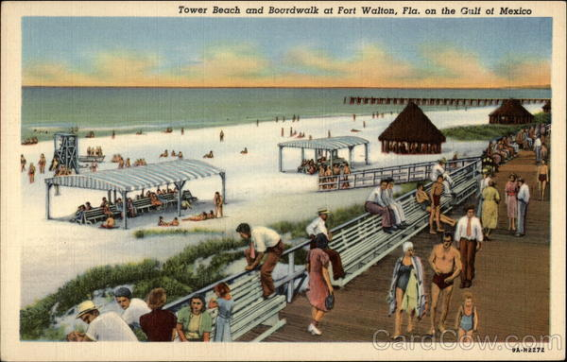
Above, Fort Walden Beach, Florida in the late 1930s or early 1940s when a boardwalk and pier were the attractions, plus of course a beautiful beach and the Gulf of Mexico.
As far as I know, we all got along fine. Virginia and I did as we were told, and I never heard a cross word between Vena, Robert and Mr. Button. We had a nice little cabin (in the terminology of the times). I don't recall the number of bedrooms or other amenities and I have no idea how much it cost - very little, I am sure by today's standards. After our first night's rest, Mary said she slept on a log. We thought that was funny and I wrote home and told them about it!
The luxury cabin of the Daly's and Hollimans in the middle 1930s!
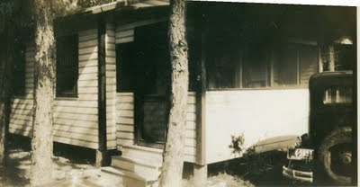
Most of our time at Fort Walton was spent in fishing, and I guess we went in the surf everyday also. The bridge across the bay to the beach was our fishing perch, and we caught more fish than I thought were in the ocean. Fish of all kinds - one afternoon Robert reeled in a stingray, something we had never heard of and we learned it was very poisonous. All of us were captivated by our catch each day, and Robert arranged to 'pickle' some of them in formaldehyde in jars and bring them back home to show off his piscatorial ability. He drove over to Pensacola to get the pickle juice and bottles. For many years after, his pickled fish were stored in his garage up on the Irondale hill. They were still there when I went into the Navy in November 1941.
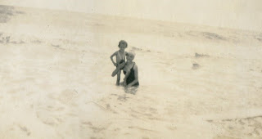
Mary Daly Herrin and her baby sitter and Virginia Holliman Cornelius in Florida.
Such was our first trip to Florida - 1934. We arrived home on a Saturday afternoon, having been gone about 13 days. I remember being startled by how much the grass and the garden had grown during our absence. I am sure we all went to church the next day because we would have wanted to tell everyone we had been to Florida, how many fish we caught, and to show off our tans! We made several pictures - that are still in existence of our beach escapade of 1934. One of Robert fishing in the surf I thought was so good I sent it to the Birmingham News, but they never saw fit to print it."
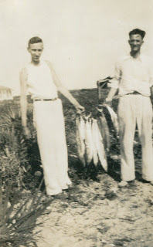
A fine day's worth of Florida fishing - Robert Daly and Stewart Button
Another Golden Summer in the next post....
The Golden Summers of the 1930s, Part VII
by H. Bishop Holliman 2011
The Summer of 1935....
"I had completed my first year of high school at Shades Cahaba and would be 16 the coming December. Still too young to get a job, even if one had been available and even if I had been so inclined to pursue it! Robert always had yard work to do and he gave us loose change...which he always had...for Saturday afternoon chores. Also, one winter I earned some pennies for starting the fire each Sunday in the heater in the Presbyterian church....not enough to pay my way to Florida however.
When the summer of 1935 rolled around, the Dalys began to talk of another trip to the beach, and I guess Virginia and I pressured them to include us in their plans, though I do not remember any of that now. Mr. Button evidently was included also in the planning because he, along with Virginia and me, were in the Model A Ford on a Monday morning in August when we set out again for Florida.
Robert had received some brochures from the Mississippi Gulf that attracted him to that area. Also, Loudelle and Charles had spent their honeymoon at the "The Whitehouse", a luxury hotel in Biloxi in June, so maybe that helped lure him there instead of Florida.
Our first stop was in Tuscaloosa to chat with Glenn Barrow, the young principal of Irondale school was attending classes there, working on another degree. He met us on the corner of the main street of the University and we talked for about 30 minutes. We felt bad that he had to attend classes and were going on a beach holiday. But such was life. He was a fine man, and we were glad to spend time with him.
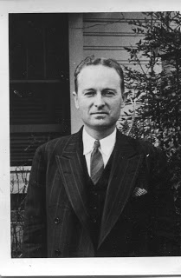
Glenn Barrow, right, served as a teacher and principal. After his death, during the war, Bishop Holliman named his first child in 1946 after this thoughtful educator.
We went on to Mississippi, arriving in Gulf Port about sun down, and were we ever disappointed! We saw immediately that the beaches along that coast did not measure up to those at Fort Walton and other Florida beaches. We spent the night there, but the next morning all of us agreed that we had rather go back to Fort Walton even if it ate up another day of our vacation. So, east went, along the Gulf Coast, through Mobile and Pensacola arriving late that afternoon in Fort Walton, in a cabin close to where were the previous summer. We felt at home there, and content to be back there for the next 10 to 12 days.
Our facilities and daily activities were much like those of the previous summer. Vena and Robert did the cooking. Mr. Button was a 'fun' person, and I guess he helped with dish washing, maybe. Virginia continued to look after Mary, and to this day, I can't think of anything I did except act as a good fishing buddy and surf swimmer. However it was not long before we had company!
Mary Daly Herrin on the beach in Florida.
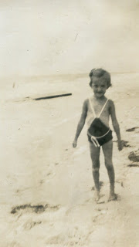
The 1935 tourist court or cabins would not, perhaps, be enticing to the 21st Century generation of Hollimans, Dalys, Herrins, Corneliuses and Ferrells!
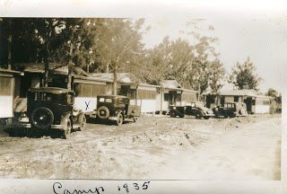
Over the past year we had done such a good job talking up the pleasures of a beach vacation....so much so that Mama and Daddy (Pearl Caine and Ulyss Holliman) decided to join us at Fort Walton for a few days. I don't know how they managed to pull it off...I am sure Daddy had to suffer a loss of wages for a week...but they did it! I have forgotten how long they stayed...less than a week. They brought with them my brothers, Ralph and Euhal and Euhal's girl friend, Anna Grace Bagley. They found a cabin near us and we all enjoyed a few days of fishing and surfing. All of us got along fine. This was Daddy's first real vacation and their first time ever to splurge. Daddy, born 1884 in Fayette, Alabama, was 51 that summer.
Below, Stewart Button and young Bishop Holliman survey their 'catches of the day' at Fort Walton, Florida.
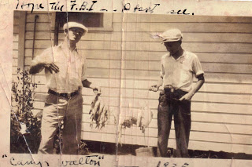
We returned home from Fort Walton on a Saturday in August, the other members having been back for several days. Our stay at the beach had been uneventful after their departure...lots of fishing and swimming. This may seem a mundane thing to mention now, but I remember our lunch on the way back was a sandwich shop in south Alabama. The sandwiches were 20 cents each...a humongous sum, we thought!"
Next posting, the Great Storm of 1936.... The Golden Summers of the 1930s, Part VIII
by H. Bishop Holliman 2011

The Summer of 1936 and the Great Storm....
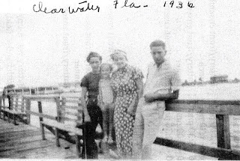
Above along a pier in Clearwater, Florida, 1936, left to right, Virginia Holliman Cornelius, Mary Daly Herrin, Vena Holliman Daly and Bishop Holliman.
"I don't recall now how our 1936 trip came about. Stewart Button had taken a church in Knoxville, Tennessee earlier in the year, but Virginia and I were still available. Ralph, I guess, was still considered too young to go. I would enter my last year of high school that fall, so this would be my last hurrah. That year we went further south, all the way to Clearwater, Florida and points in between. Robert had now acquired a new 1936 black two-door Plymouth, so now we would be travelling in style.
Below a restored 1936 four door Plymouth touring car.
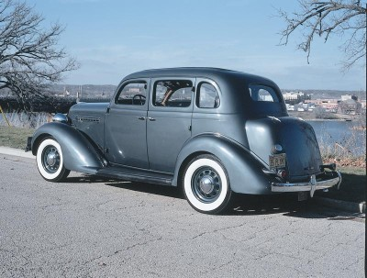
In Clearwater, we did not find the beach as white and sandy as those at Fort Walton and Panama City, so that took some of the shine off our stay there. Instead of a 'tourist cabin', we found a fully furnished home used mainly in the winter by a wealthy owner, so that made our stay more enjoyable. It was a few blocks from the beach and backed up to the bay. I have no idea what the rent was, but I am sure more than we had paid at Fort Walton. One day we drove down to Sarasota and over to St. Petersburg, and another time Robert rented a small boat and he and I went out into the bay to fish and got caught in a squall that came up quickly. We had left Vena, Mary and Virginia home to worry about us.
It had been planned early on that Mama, Daddy and Ralph would drive down to Panama City Beach during our two week stay. Soon Melton and Ida Holliman decided to join them, along with Ida's nephew, Earl Burton. Also, accompanying Mama, Daddy and Ralph would be Hoyt and Vivian Bryant, close family friends of Melton's age, who had lived next door in years past. After a week at Clearwater, we decided we would join them, so we drove up to Panama City, found a cabin where they were and settled down, we thought, for a fun time with friends and family. On the way, we stopped at a resort similar to Silver Springs called Wakulla Springs and took a boat ride."
Next the hurricane comes....
The Golden Summers of the 1930s, Part IX
by H. Bishop Holliman 2011

The Hurricane Approaches...

"Our place at Panama City was on the same street, a few cabins up from where all the others were staying. The highway ran between our place and the beach, a very convenient location. One day all of us were deep-sea fishing and some of us got sick. I don't remember catching many fish, but what I do remember is the hurricane that came up a few days later. It was a defining moment of our 1936 trip to Florida and an event we would remember and talk about the rest of our lives.

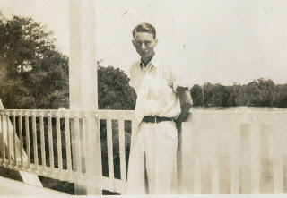
Young Bishop Holliman on vacation in Florida, wearing a white tie?
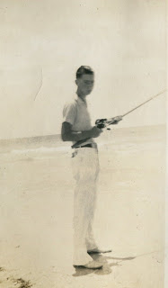
Before the hurricane came ashore, Bishop and other families members fished along the Panama City inlets.
We read in the paper that a strong storm was approaching the Gulf Coast that summer of 1936, but we did not pay much attention to the warning. Remember, we did not have ready access to a radio so the paper was all we had to rely on. The morning of the storm dawned cloudy and very windy. We were not able to stay on the beach due to the stinging sand of Panama City that was whipped up by the raging wind. It went on like that all day, so we sat and waited for nightfall, hoping things would be better tomorrow.
The Holliman Clan and Company remained in their cabin a few doors closer to the beach and across the street from us About 8 o'clock that night we thought we felt the house shake, so Robert Daly, Sr. herded us out to this car, and we sat, thinking the wind would let up soon. I don't know why we felt the car would be a safer place than the house. But about 9 o'clock we noticed a big stir in the house down the street and we wondered what was going on. We soon found out."
Next the escape from the beach!

The Golden Summers of the 1930s, Part X
by H. Bishop Holliman 2011

Off the Beach!
We resume our story told by Bishop Holliman as the Daly-Hollimans huddled, crowded, in their automobiles attempting to ride out the gathering storm of 1936 in Panama City, Florida.

In the photograph taken on another date, Robert W. Daly, Sr., leader of the Daly-Holliman vacations to Florida in the 1930s, walks the beach with his only daughter, Mary Daly Herrin. They look smartly dressed for beach-combing!
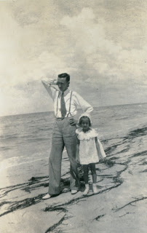
"Immediately, there was a tap on the car window and a man in uniform told us to leave the beach area at once, to drive inland, that the hurricane was ready to strike in full force, that we had to leave now! He spoke with great authority so we did not meander. Robert turned the car around and we headed out, lining up behind Daddy's car (Ulyss Holliman) and Melton's (Holliman), and away we all went!!
We headed inland as the man told us to do.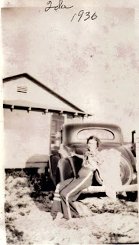
Ida Holliman, Melton Holliman's wife, perches on the Chevrolet coupe that drove part of the family off the beach in 1936.
Mama (Pearl Caine Holliman), Daddy, Ralph (Holliman, the younger brother), and Hoyt and Vivian Bryant were in Daddy's car, a 1933 four door Chevrolet with Holyt driving and leading the way. Right behind them drove Melton in a Chevrolet coupe, with Ida and Earl, and then came Robert, Vena (Holliman Daly), Mary, Virginia (Holliman Cornelius) and me, going we knew not where!
Just a few miles down the beach high way Daddy's car came to a complete stop! I guess all the excitement had caused it to flood out, as we say. Any way, it would not go any farther. What to do on a dark and stormy night, marooned on the side of the Gulf, trying to reach higher, safer and dryer ground? We did the only thing we could do. All those in Daddy's car piled into Robert's car with our party. That meant six adults, two teen-agers and a five year old. And off we went, leaving Daddy's car by itself, there next to the Gulf, at the mercy of the wind, the rain and ocean waves."
The 1933 Chevrolet of Ulyss Holliman stalled in the storm. Below is an advertisement for a two door version. Note the price and that the models are formally dressed, somewhat as were Robert and Mary Daly in the above photograph!
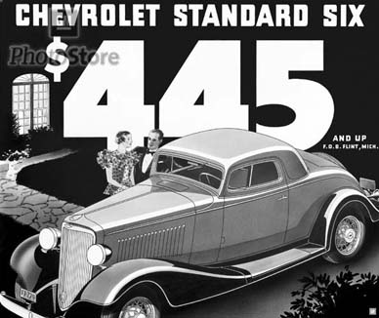
Next the road house of the refugees! The Golden Summers of the 1930s, Part XI
by H. Bishop Holliman 2011
From the web, a site entitled Storm Lifecycle - SOURCE: Wikipedia, 1936 Atlantic hurricane
"A tropical storm was first observed over the southern Bahamas on July 27. It tracked to the west-northwest, and made landfall a short distance south of Everglades City, Florida with winds of 60 mph (95 km/h). After crossing the state, it intensified over the eastern Gulf of Mexico and became a hurricane on July 30. The hurricane continued to strengthen, and hit the western Florida Panhandle with peak winds of 90 mph (145 km/h) on July 31. It weakened rapidly over land, and dissipated over western Alabama on August 1."
The story written by H. Bishop Holliman continues with the Robert Daly, Sr. and Ulyss and Melton Holliman cars carrying a frantic family, now terribly worried by a growing storm of water and wind and a 90 mile an hour hurricane as described in history above. - GNH
"Mama (Pearl Holliman, 1887 - 1955)), Daddy (Ulyss Holliman, 1884 - 1965)), Ralph (Holliman, 1924), Hoyt (Hughes, Ida Hughes Holliman's brother) and Vivian (Hoyt's wife) were in Daddy's car, a 1933 four door Chevrolet with Hoyt driving and leading the way. Right behind them drove Melton (1908 - 1958) with Ida (1910 - 1991) and Earl, and then came Robert (Daly, 1903 - 1959), Vena (Holliman Daly, 1910 - 1990), Mary (Daly Herrin, 1931), Virginia (Holliman Cornelius, 1922 - 2011) and me (Bishop Holliman, 1919), going we knew not where!
Just a few miles down the beach highway, Daddy's car came to a complete stop! I guess all the excitement had caused it to flood out, as we say. Any way, it would not go any farther. What do on a dark and stormy night, marooned on the side of the gulf, trying to reach higher, safer and dryer ground?
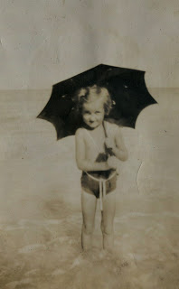
We did the only we could do. All those in Daddy's car piled into Robert's car with our party. That meant six adults, two teen-agers and a five year old. And off we went, leaving Daddy's car by itself, there next to the Gulf, at the mercy of the wind, the rain and ocean waves.
Left, Mary Daly Herrin, five years old in 1936, attempts to shield herself from either the sun or rain in Panama City, Florida.
I don't know how it was decided where we would go and when we would stop, or who decided when. At last, through, we reached DeFuniak Springs, which was inland and northwest of Panama City. Maybe the wind had died down and we felt we had reached a safe haven.
Both cars parked by an all-night honky-tonk, and they let us use the rest room and park up against the building. It must have been close to midnight by this time, and there seemed to be no let-up in the wind and rain. I guess some of us dozed a little, but I am not sure. It seemed the honky-tonk had a lot of customers and men came and went throughout the night, the weather be-damned. I was only 16 but I have often wondered just what kind of place that was."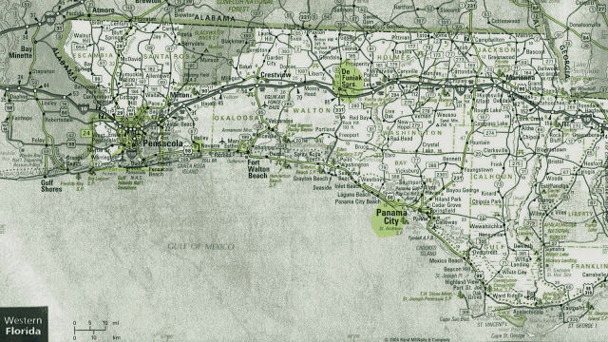
Above, a 2011 Florida road map showing in yellow Panama City and to the north, in yellow, Defuniak, Florida. The Hollimans drove from Panama City to Defuniak to ride out the storm. Unfortunately, they were driving north on the same path as the hurricane. If forecasts had been better in those days, they would have driven east to escape the brunt of the blast.
Next Riding Out the Storm....
The Golden Summers of the 1930s, Part XII
by H. Bishop Holliman 2011
The story of the West Florida hurricane of 1936 continues by H. Bishop Holliman.
“We learned through folks in the building that the railroad depot would be a safe place for us to go, once it was safe to get out on the street, so soon after daylight that’s where we went. There was no chance of getting breakfast as the wind and rain continued in full force, and we knew we had better stay put. So we did.
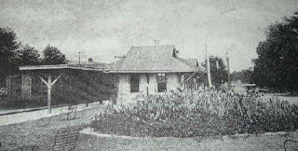
Taken from the Defuniak Springs, Florida history web site is this photograph of the L & N Railroad station where the Holliman family took shelter. Hmmm....it does not look all that substantial as a structure.
All morning long the wind blew and blew and the rain poured and poured. I remember seeing objects such as signs, limbs and other stuff flying through the air. Up in the morning the L & N passenger train that ran between Jacksonville and New Orleans pulled into the station. Its appearance gave us some hope, as we believed if the train could get through maybe the worst was over.
In all the fury, there was no panic and no hysteria throughout our ordeal from the youngest to the oldest. During the morning other refugees came into the building and one told us the gadget that measured the wind’s intensity was rising and that was a good sign. I remember Melton’s saying that he hoped it reached a thousand! (Probably this was a barometer indicating rising pressure; the storm was passing.)
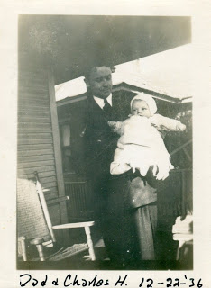
Left, the young minister, Charles Ferrell holds his new son, Charles Halford Ferrell, the second grand child of Ulyss and Pearl Caine Holliman.
All during the morning, though, we were concerned about Loudelle and Charles and Euhal and Edna back in Birmingham. There was no way to let them know what was happening to us and that so far we were safe. Loudelle was just about a month from bringing Charles Halford into the world. And Euhal and Edna has been married only a month. So our concerns were not confined to our fate there in the depot. I know now that Mama and Daddy, especially, were carrying a lot of weight on their shoulders that we young ones could not realize.
Below Edna Westbrook Holliman, age 18, the new bride of Euhal Holliman, the third child and second son of Ulyss and Pearl Caine Holliman. Edna and Euhal waited in Birmingham, worried about the family caught in the Florida storm.

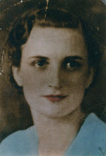
Around one o’clock the wind seemed to have subsided a little, so Hoyt and Melton dared to go out in search of some food for all of us. Maybe they found some, I don’t remember now from this distant date. But about mid-afternoon, the wind let up, the sun came out and we all seemed alive again. We piled into the two cars and headed back to Panama City Beach, hoping Daddy’s car would still be there and that our belongings would also.
It was close to dark when we arrived at our destination. Limbs and trees were strewn all along the highway on the way, but thankfully, the houses were still there with all our belongings. The first thing we saw though was Daddy’s car, which had lost some paint due to flying sand. It was still where we left it, but would it start? It did, right off. We immediately packed up, loaded the cars and headed north as the sun sank in the west, glad to be safe and sound and on the way home!

It was a Friday night and we drove all the way to Dothan, Alabama, before stopping to eat and/or finding lodging for the night. We arrived home late Saturday afternoon, happy to be safe with lots to talk about."
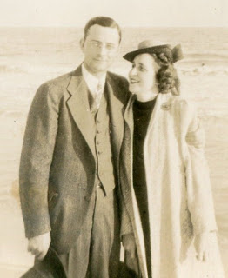
Left, Melton and Ida Holliman were caught in the storm with other members of their family.
Next post, recording the story of the storm in newspaper and in print..... The Golden Summers of the 1930s, Part XIII
by H. Bishop Holliman 2011
From memory written in 2011, 92 year old Bishop Holliman continues his narrative of his summers in the 1930s, 75 years earlier.
"The next week Daddy (Ulyss S. Holliman) called a reporter for the Birmingham morning paper, the Age-Herald, and gave him an account of our experience in the Florida hurricane. His story came out on the front page, listing all our names and what our feelings were about our ordeal."
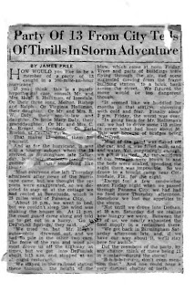
As the faded newspaper is difficult to read, I include this material which seems to be the story prepared by James Free, reporter, before publication. GNH

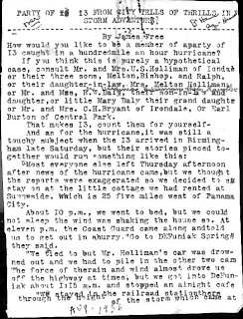

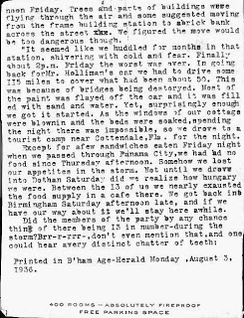

Next post, the 75 page book that young Bishop Holliman wrote and typed in 1936.

The Golden Summers of the 1930s, Part XIV
by H. Bishop Holliman 2011
In late 1936, the 16 year old Bishop Holliman wrote a 'book' on the great hurricane of 1936 that his family had experienced in the pan handle of Florida. In 2011, 91 years old, he wrote the story from memory as I now have pocession of the 75 page tome. In comparing my Father's memories to what he wrote three - quarters of a century earlier, he has remembered well and factually in his senior years. Naturally the 1936 work is much more detailed and includes some danger not included in his 2011 memoirs. Still a fascinating look at an America three-quarters a century ago. - GNH
In November 2010, below my Father, back to camera, visited his boyhood home, Irondale, Alabama again. This photo shows him conversing with the unidentified person who now lives in the house (behind her) on 2nd Avenue where his brother, Melton and his wife, Ida Hughes Holliman, lived in the late 1930s. His 2011 narrative continues....
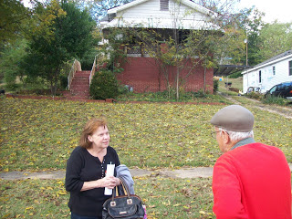
"Melton and Ida were living in the house across from Grandma Lula Caine (in Irondale, Alabama), just down the hill from us. Ida had an old Underwood typewriter that she let us peck on from time to time. So several days after we returned home I got the bright idea of writing up a history of our experience in Florida and of the storm, typing it all out of her type writer. Truly a hunt and peck system. I have forgotten how long it took me to get the job done.

The title was 'The Storm Warnings Were Posted', and I don’t know how I came up with such a threatening name for my story. Daddy was so impressed with my work he showed it to a Birmingham News reporter, thinking he could make something of my work. But alas, nothing ever came of it and the reporter returned it after a few weeks. Today, this great literary production is in possession of my son, Glenn Holliman."
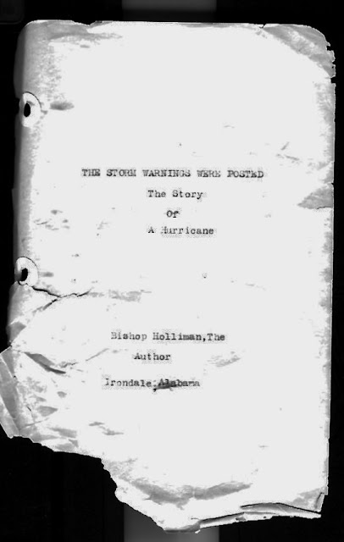
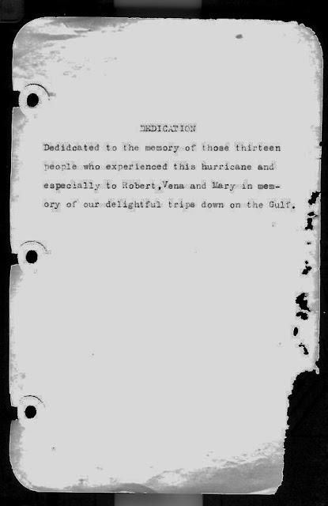
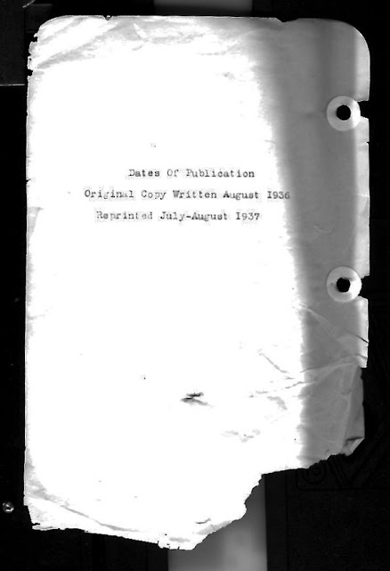

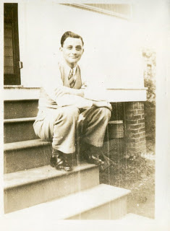
Right, Melton Holliman ca 1938 in a photo perhaps taken on the steps of the house on 2nd Avenue, Irondale, Alabama shown above. By this time in his life, Melton had begun what would be a successful career selling pharmacological medicines.
Next the Golden Summers give way to World War II....
The Golden Summers of the 1930s, Part XV
by H. Bishop Holliman 2011
"So, thus ended my third Golden Summer with the Robert Dalys and my sister, Virginia Holliman Cornelius. By next summer, 1937, I had finished Shades Cahaba and was hoping to enter Birmingham Southern College that Fall, also trying to pick up odd jobs. I had reached the age where I would have to start paying my way, and that realization posed all sorts of problems for me. My days of romping on the beach were over and done with!!"
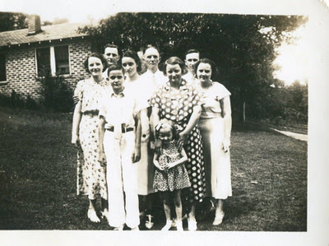
Above are eight of the thirteen family members who were caught in the 1936 hurricane. This photo was taken in 1936 in the yard between the Dalys and Hollimans in Irondale, Alabama, a natural photo spot to catch the afternoon sun.
The youngster with the long tie on the front row is Ralph Holliman, about 12 years old. The young girl is Mary Herrin, born 1931, with her grandmother’s hands resting on her shoulders. Her grandmother is Pearl Caine Holliman, age approximately 49 in this photo and not wearing glasses at that time.
Back row left to right are Ida Hughes Holliman, her husband Melton Holliman, Virginia Holliman, probably 14 in this photo, Ulyss Holliman and Robert Daly, Sr. just behind his wife, Vena Holliman Daly. Perhaps Bishop Holliman took the photo.

As an aside, notice how young Pearl Caine Holliman appears in this picture. In just a few years, she will age noticeably with the advent of World War II and three sons going to war. - GNH

"However, Vena, Robert, Mary and Virginia went to Miami the next summer, and Mr. Stewart Button returned to Irondale and went with them. Upon their return, I went to Knoxville with Mr. B. staying with a church family there, and we climbed Mt. LeConte in the Smokies. Virginia may have gone with them again in 1938 or 1939…I am not sure. My youngest brother, Ralph, went with them in whatever year it was Virginia did not go, even though he has forgotten it!"

In the surf in Florida – left to right – Stewart Button, unidentified, Robert Daly, Mary Daly Herrin, Ralph Holliman and Vena Holliman Daly.
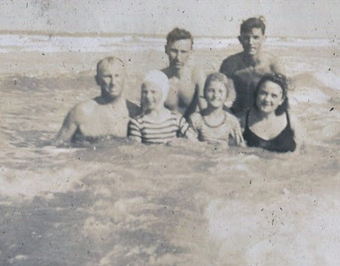
In 1937 Robert Daly, Sr. took the below photo in Miami, Florida of a Pan Am passenger transport, a flying boat which made regular runs to Havana, Cuba and Latin America. This was a massive aircraft for its day, a Sikorsky S-42, all aluminum capable of 150 mph carrying 32 passengers. Range was an amazing 3,000 miles (very lightly loaded), and it still took five days to carry passengers with luggage from Miami to Buenos Aires! - GNH
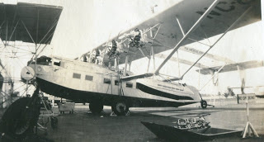

Next, more family memories by Bishop Holliman....
The Golden Summers of the 1930s Give Way to the Turbulent 1940s by H. Bishop Holliman 2011
"On July 1, 1941, I registered for the World War II draft, an event that had lasting consequences for me, as it had on everyone else of my age group. At the time, I was working in a New Deal temporary job in Birmingham, Alabama and at Hill’s Grocery Store on Saturday, planning to return to college in September.
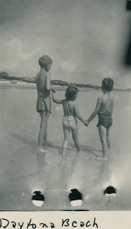

My brother-in-law Robert W. Daly, Sr., his wife - my sister, Vena and my niece, Mary, already had been to Daytona that summer for two weeks, and here in August they were going back again! Robert had a very stressful job at the Woodlawn bank, and he decided he should spend at least a month away from it. So they took off again. This time I went with them to help drive in case Robert did not feel up to driving all the way. So, I quit both jobs and made my last trip to Florida as a foot loose and fancy free lad.
Left, Mary Daly Herrin in the bathing cap supervises her cousins, Carolyn and Charles Ferrell at Daytona Beach, Florida the last summer before America went to war. Photos courtesy of Charles H. Ferrell.
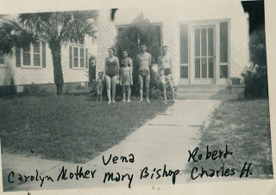
Left to right that late summer in Daytona Beach, Florida: Carolyn and Loudelle Ferrell, Vena and Mary Daly, Bishop Holliman, Robert Daly and Charles Halford Ferrell. Germany invaded the Soviet Union June 22, 1941. America was only a few months from being thrust into the growing war.

Robert rented a house (pictured above) similar to the one we had had at Clearwater, Florida in 1936. Thus, we were prepared to stay as long as allowed by the bank. A few days into our stay, Loudelle, Charles, Halford and Carolyn joined us. I think they were living in Jacksonville, Alabama at the time where Charles was the Methodist pastor. There we were - a big part of the Ulyss and Pearl Holliman family, enjoying our stay on the beach in the summer of 1941.
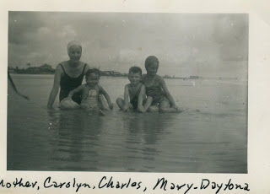
But it all ended too soon. Mama wrote from home in Irondale, Alabama to tell me I had received a notice from the draft board to report, adding that 'you had better get back home'. I planned to hitch hike, which was a popular way for college boys to travel in that day. But Loudelle would not hear of that, so she pretended that they also had to get home, and that I should ride with them. And so I did."
Next posting, the War comes and everything changes....
War Comes and Changes Everything
by Bishop Holliman
Bishop Holliman, a native of Irondale, Alabama, continues his memoirs of the coming of World War II and its impact on his life and family....
"I checked with the draft board, and learned I would probably be inducted that fall – October or November, 1941. I had already decided I would join the Navy rather go into the Army, as the first draftees were having a terrible time at Camp Blanding in Florida and I wanted no part of that. I would not sign up thought until I had to. We still did not know if America would get into the war.

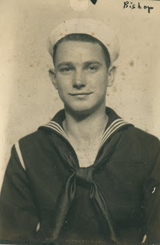
Bishop Holliman, born December 17, 1919, in the U.S. Navy from November 1941 until September 1945.
I also made the decision not to return to Birmingham Southern College that September since it appeared I would not be able to finish the semester – a decision I have wondered ever since if it was a wise one. I learned later that I probably would have been deferred until the end of the term. But all that is hind-sight.

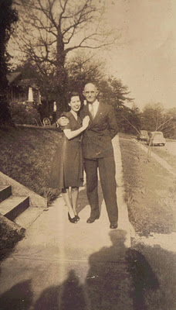
Right, Geraldine Stansbery Holliman, formerly from Philadelphia, visited Irondale, Alabama in February 1945 prior to her marriage to Bishop Holliman in June 1945. Here Ulyss Holliman, in an unusual display of affection, has his arm around Gerry!
I don’t recall how long Vena, Robert and Mary (the Daly family that lived next door to the Hollimans) remained at Daytona, probably for a month. I had obtained a temporary job at Sloss-Sheffield steel and Iron Company, so I was out of touch with goings on and getting ready to make my exit from home and Birmingham. I had a good friend who worked at S.S. Steel and Iron, who got me the job. I was paid, I think, 75 cents an hour, more money than I had ever seen.
I worked up until the end of October, joining the Navy Friday, November 13, 1941. Mama, Daddy Ralph, Vena and Robert came to the train station to see me off!
I came out of the war unscathed, married a pretty girl from Philadelphia who became the mother of my children, so don’t look back."
Next, back to Florida in the 1950s....
The Post War Era and Back to Florida
by Bishop Holliman
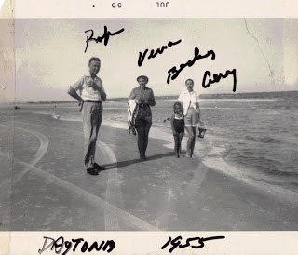
In the summer of 1955, Bishop Holliman took his young family to Daytona Beach, Florida to join his newly widowed father and the Robert Daly family. Left to right, Robert Daly, Sr., Vena Holliman Daly, Becky Holliman, age 5, and Gerry Stansbery Holliman, age 31.
"1941 was my last trip to Florida with the Daly trio until 1955 two months after my mother's death. The simple pre-World War II world of Irondale, Alabama had given way to marriage, children and a career. We were living in Johnson City, Tennessee and we drove to Ormond Beach to join Vena, Robert, Bobby Daly and Daddy, Ulyss S. Holliman, for a week.
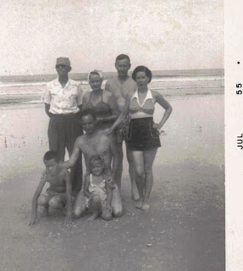

Right in Daytona Beach, Florida in July 1955, two months after Pearl Caine Holliman died of a heart attack. Back row is Ulyss Holliman, uncharacteristically wearing sun glasses, who had married Pearl in 1906 in Fayette, Alabama. Next to him is his oldest daughter, Vena Holliman Daly and her husband, Robert Daly, Sr. Far right is Bishop’s wife, Geraldine, and front row, Glenn Holliman, age 8, Bishop Holliman, age 35 and Becky Holliman Payne.
Some things I should have remembered….
In 1935 or 1936 Robert got the bug to buy property in Florida and build and operate a ‘tourist court’, as it was called in those days before the coming of the Holiday Inn. He wrote to real estate folks in several places and his interest in such a project may be why we went to Clearwater in 1936.
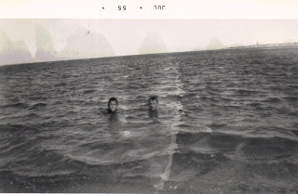
Above two first cousins treading Florida water in 1955. The writer, Glenn Holliman, is on the left and right Robert Daly, Jr., age 11. Bob is now a Ph.D. professor of biology at North Alabama State University, Florence, Alabama.

I guess the stress of his banking job was worse than anyone could know at the time. His Aunt Alice was opposed to such a move and she told him to take up golf instead. In 1939, he bought three lots on the beach at Daytona…the war came and Robert never built his tourist court."
Robert W. Daly, Sr. suffered from congestive heart failure which would take his life in 1959, age 58, a beloved family mentor.

