Tuesday we went up to Holland, Mich. to see the tulips, about 150 miles away. Went through battle Creek and passed the Kellog place. Not many tuluips however. One street like you would see in Europe but not much else, so don't plan on going there. Tomorrow we're going down to Woodburn to see Jeanette. Very sunny and warm here today, Spring is finally here. I guess Glenn and Barb will be leaving soon for their five weeks in England. I talked with Mary Herrin today. She says things are still terrible in Alabama. Ellen is out walking BeBe at the moment. He won't go with me. This all ther news for now. Stay tuned. Dad

All fine here, we had over 6 inches of rain during the storms, thus some local flooding. Power was off for a while, but not problem locally. One county south and east you run into terrible damage. Two small towns totallly blown away with many deaths and many injured. A number of students and faculty/staff here lost everything. They had EF4 and 5 level tornados. Tuscaloosa gets all the news attention but it is just as bad out in the rural areas. It will take years to recover. One problem is that the TVA major power transmission lines were taken down all around the nuclear plant, so most of north Alabama above Birmingham has been out of power. Most areas got power back yesterday or will today. Since we are very close to Wilson and Wheeler dams, we never really lost power. The campus here was hit hard by high winds that knocked out all the main power lines so we were closed for one day. Did discover 3 roof leaks at the house. I operate a local weather station for the Weather folks [NOAA] and I have to report the last 24 hours data every morning @0700. This is also used with my bird banding, especially the hummingbirds, for the US Dept. of the Interior, fish and wildlife service. We have had a lot of rain this spring, much more than usual. We enjoyed the visit by Glenn regarding the WWII letters and other family history. The tornado event last week reminds me of the 1974 tornado disaster. I was living in Athens, Al then and was a member of the rescue squad for the county. I observed 3 tornados, one was an EF5, up close. Helped recover 21 bodies that afternoon in the exact same place as last week. Lots of areas have a dusk to dawn curfew due to looting by the local outlaws. National Guard is out and about with loaded weapons.
Looters need to be shot. Must go to class, final exams start this week. take care Bob Daly
Dr. Robert Daly
Professor of Biology
University of North Alabama
Florence, Al 35630
256-765-4433

From: Ebskip@aol.com [Ebskip@aol.com]
Sent: Monday, May 02, 2011 8:27 PM
To: Daly, Robert W.
Subject: (no subject)
Hello, Dalys! We hope you ar still there. I've been in touch with Mary and she's kept us apprised of some to the things going on. I*t all sounds so terrible it's impossible to relate to what's happening from this distance, but know that we're thinking about you and hoping all is well..... Bishop and Ellen

We hope all goes well with you. Sorry I haven't written you to thank you for letting me ride with you to fayette. I enjoyed our chit-cht along the way. Aren't we glad we went when we did! Glenn has passed the word about the loss of one of your co-workers and I'm sorry to hear about it. I know this is a trying time for all of Alabama
I am reminded of the tornado in 1932 that hit Helena and killed over 300 folks in Alabama. Daddy had not had the model A 1929 Ford long and he had barely learned to drive, but on a Saturday morning we all piled into the Ford, Mama, Daddy, Ralph, Virginia and Euhal and drove to Helena to view the scene. This was an unusaul thing and out of character for a Holliman to be doing. I guess Euhal did someof the driving
Another "out of character " thing we did was go to the scene of the Loveman fire on a cold March Saturday afternoon in 1934. Loudelle was working at Woolworth store across the street from the fire. Radio station WSGN had an announcer on the scene sending out news of the fire and what what was happening. Suddenly Daddy decided we should go down and get as close to the scene as we could so he and I went. He was concerned about Loudelle, as it ;ooled liked for awile the whole downtown section arounf Lovemans might get ablaze. They kept reassuring folks that the Alabama Theater was fireproof and would not burn. I suppose the theater eventually was emptied as so many firetrucks and sirens were beingh heard. Daddy and I were the only two of the family to go down. I suppose Ralph and Virginia were considered too young, Euhal was out of pocket, working I suppose
The Loveman fire eventually resulted in construction of modern building that;s still thewrre, I guess, and soon other stores modernized and improve the whole areaThis is just something I thought about after sitting down here at the computer when it's past my bedtime. Cheers!! Bishop and Elle

Those pictures were made at the Ferrells when they lived in Roanoke, Ala. We went down for a weekend and the big dog belonged to them. I remeber the red jacket. I bought it while I was still teaching, probably 1950 or 1951 and I wore it a long time.
I think the Caines originated in Athens, Georgia, not Athens, Ala. Check with Bobby Prince about this, as I think it was his mother who passed that info on to me many years ago Dad
Yes, we went up on Roan Moutain and I remember those pictures. I'm sure their visit was just two or three days. Where did we sleep? We lived in the stone house on Old Jonesboro highway. Only two bed rooms were usable, as the upstairs was too hot in summer and too cold in winter. We may have a cot upstairs that could be used if there was no other bed. I can not recall though how we accomodated everyone. I'm sure your Mother remembers. I think that was a good experience for Terry and Jerry and all of us at that time. Dad

I was very impressed with Lenwood Holliman and I could tell he came from good stock. Neither of us said anything about our work history, except he knew about Tn Tech and said he'd gone to Vanderbilt
Ron Holliman writes well, and I.m sure he's having lots of troubles. Anne and I stopped to see him once going to Florida but never heard from him after that. I wondered why he was not in our group Saturday.
We are looking for Alice Tuesday .
About Tingley: I never knew that he went to Ft Payne. Virginia Cundy who worked in our office in Gadsden knew him and maybe thatès where she made contact with him.
Stay tuned. Dad April 23, 2011
No, I donèt know anything about William Caine, (great grand father). I donèt recall any conversation with mama or grandma Caine about him--just that he gave the land for the church and was the first person buried there. I always thought it was a mark of distinction to have a distant relative rich enough to give the land and have a church named for him. Something to be proud of!! Dad

You are doing a good job with your writing. I think Uncle Eck may have been more educated than my Daddy and his brother Greene. His wife was a school teacher, I think, and was on the uppity side as I remember Mamma's relationship with her. I don't believe there was ever any further associatiion with her after his death. I don't know how Jim, Cecil's daddy, got his education. Aunt Lizzie was a very refined woman and obviously came from good stock.
Yes, I am doing well. Very cold here and rainy. Becky had told me your were going to Wbb School, so that's good that you still have a connection there. Dad

Leland did not work for the railroad. I think that was Eck, who lived in Pell City, as I remember He died about 1926 or 1927, Never did know much about him. Leland worked for some company out of Bham, maybe Continental Gin, but I'm not sure. He had only one child, Marguerite, a year or two older than me,and i recall Leland or someone reminding us that she was the first Holliman to go to college. She graduated from Athens College which was, or later became Methodist affiliated. It's where Bobby Daly attended. Dad

My first leave was in March 1942 from New Orleans. I rode the L&N train into Bham over a Saturday night, getting into Bham early the next morning. I called Vena and Robert when I got to the station to pick me up. I wanted to surprise Mama and Daddy and get home before they went off to church, which I did. I recall that afternoon that some of the neighborSCAME OUT TO SEE ME, I think Cecil Holliman and wife Ruby. I think I got leave again in late summer, but not again in the spring, I'm sure. Navy boys got more leave trhan army; When our ship returned from a cruise, at least a third of the crew would get leave each time, and when we were shipped to a different ship or station we'd often get leave. I was very lucky in that regard DAD

No, I don't remember the "blow-up" at all. Virginia was already married at that time and living away from home, I suppose. Robert had gotten Virginia a job at the bank, so I don't know what the trouble was.
I don't know what happened to my message. The Bham Electric shop was between 3rd and 5th Aves North, just west of the downtown section, which we passed goiing out to Elyton Village and to Bham Souther. Most of his work was inside the shop where the cars were housed to be worked on and/or adfter their runs. I remember going in to see him once when I was home on leave, and I saw him once from the street car enroute to Bham Southern when he was outside at work. I suppose he repaired interiors, the seats, painted, and put adds in the cars. I don't recall his talking about his work much. As an employee, could ride the street cars without charge; I think the company gave him a book of tickets, which we, of course could not use. After acquiring the Ford in 1931, he drove to and from work alot.
Interstate 65 came right through where the Bham Electric street car barn once stood, so all of that area now is changed and I can't even recognize the place at all.
Back to the 19th Century...A Series of Articles on the Hollimans and Related Families of Fayette County, Alabama

By 1836, several sons of James Grantson Holliman (1750 - 1836) and other associated families had migrated to Fayette County, Alabama from Lancaster, South Carolina. Cornelius (1792 - 1862), Charles (1795 - 1850) and Warren Holliman (1801 - 1876) were part of the westward movement of the American nation and my family in the 19th Century.

Warren would later move on to Arkansas and father many Holliman descendants in that part of the United States. Cornelius, Charles and many of their descendants remained in Fayette County and adjoining counties to this day. Many others went to Mississippi, Louisiana and Texas.

An Excursion into History....
On April 9, 2011, Glenda Norris, a descendant of James Grantson and Cornelius Holliman families, led fifteen of her distant cousins through the cemeteries of her many great grandparents to share their stories. She would be the first to tell you that she stands on the shoulders of her grandfather, Cecil Rhodes Holliman, and his son, her uncle, Dr. Rhodes Holliman. The research about to be shared comes from their hands, also of the late Walt Holliman, a descendant of James Grantson and Charles Holliman, his son.

The first stop of the tour was Charles Daniel Lucas, Jr. burial site. It was unseasonably hot for April (92f) even for the Deep South. But that didn’t slow anyone down. Everyone was more than willing to take a short ‘hike’ into the woods, up a small hill and then a left turn into the forest to view the ‘old Indian burial ground” where Charles Daniel Lucas, Jr. gravesite is located.

Here is a photo of everyone getting ready to make the short hike to see Charles Daniel Lucas’ grave. Left to right are: Jeanette Holiman Stewart (Austin, Texas), Glenn Holliman (Newport, Pennsylvania), Lenwood Holliman (Gordo, Alabama), James Franklin Holliman (Sulligent, Alabama), Bishop Holliman (in cap from Avilla, Indiana), Vonceil Laura Duckworth (Reform, Alabama), Wally and Tommie Holliman (Irondale, Alabama), Faye Gardner (Kennedy, Alabama), Bill Holliman (Horn Lake, Mississippi), Jean Holliman (Irondale, Alabama), Joey Holliman (Florence, Alabama) and Tyler Duckworth (Reform, Alabama and at age 15, the youngest on the trip). Obscured is Robert Holliman and taking the photograph is Norman Holliman (both brothers from Marysville, Tennessee).

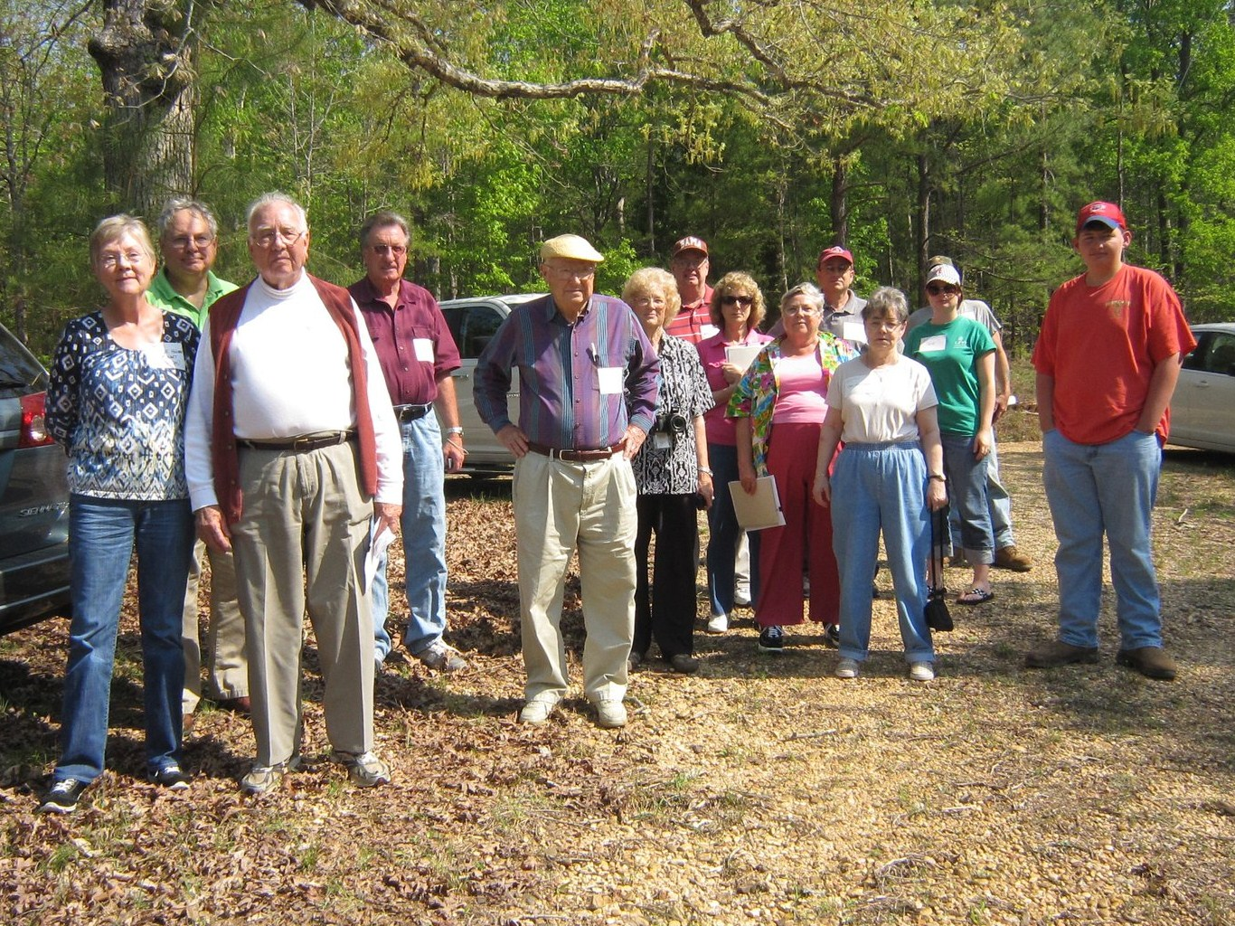
All the above are either descendants of Charles (about 1795 - before 1850) or Cornelius Holliman (1792 - 1862). Of course, all have the DNA of Christopher Holyman, Sr. (1618 - 1691), the Englishman who left Bedford, Bedfordshire and immigrated to Jamestown, Virginia in 1650.

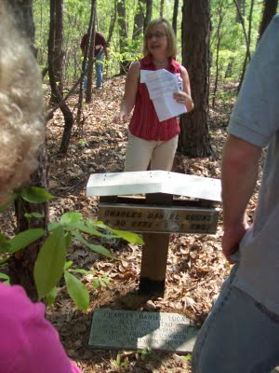

Above, Glenda Norris shares information at the grave site of her 4th great grandfather, Charles Daniel Lucas Jr. whose daughter, Mary 'Polly' Lucas married Uriah Holliman, a son of Cornelius Holliman. Below are her comments which she credits to Rhodes Holliman, her uncle. It was Rhodes who, as a boy in the 1930s, would hike several miles into the piney woods, dodging a few snakes to re-discover the location for the family. Several monuments now mark this spot.

"Charles Daniel Lucas, Jr. was the son of Charles Daniel Lucas, Sr. and “Dorcas” (no last name found). It is believed that the mother of Charles Daniel Lucas could be a Catawba Indian, from the PeeDee River area in Marlboro County, South Carolina. She was only 13 years old when she married Charles Daniel Lucas, Sr. Charles Jr. was born on June 30, 1771 and died May 31, 1853. He was a tailor by trade in South Carolina. Charles Daniel was a traveler and migrated from South Carolina to Alabama before the Holliman brothers. CDLJR first homesteaded 80 acres in Marengo Co., Al. on 10-20-1823 and also 80 more acres in Marengo Co., Al. on 04-15-1824, then on 12-01-1826 he homesteaded 80 acres in Fayette Co., Al., and then on 10-16-1834 he homesteaded 40 acres in Tuscaloosa Co., Al. The homestead in Fayette Co. is almost touching hwy. 171 at the Fayette/Tuscaloosa Co. line, on the East side of the road. The land in Fayette Co. & Tuscaloosa Co. is connected. He was a deacon at the Springhill Church in Tuscaloosa County, it is thought that he and Cornelius were ‘founders’ of this church. He earned his living 'stock dipping' and as a Creek Indian agent. He claimed to be ‘black Dutch’, a term at the time to obscure one's possible Indian ancestry but this has not been proven only speculated. He was a man of large stature (6’4” - 6’6”) and had great strength. It has been passed down through generations that Charles Daniel killed a panther with his bare hands.
His burial site is in southern Fayette County, Newtonville area off of CR100 (Walnut Lane). At one time this land belonged to Charles Daniel Lucas and his home was not far from the burial site. His grave is on a ridge line, over looking a ravine. The site is an Indian burial ground as he chose to be buried with his friends.
Charles Daniel was married to Mary Hasten. They had 10 children together. Family historians suggest that Charles Daniel ‘over disciplined’ one of his grandchildren. It is reported that he struck the child with his cane. This did not go over very well with his family and because of his temper his wife, Mary and the rest of his children left him and moved to the Bluff community. Due to this estrangement Mary Hasten Lucas was buried at the Springhill Cemetery, 20 or so miles north of this pioneer’s resting place.
When Charles Daniel Lucas was born, George III, was sovereign over the American colonies. When Charles Jr. died Franklin Pierce had just become president of the United States, a union on the verge of dissolving."

For additional information on Charles Daniel Lucas, Jr., go to Archives and the February 13 and 26, 2010 editions of this blog. Rhodes Holliman incorporated his own research and that of his father, Cecil Holliman and the late Walt Holliman to create some excellent articles that are available for all to read.

More soon on both our Virginia Colonial past and the Holliman Migrations across the Southern United States from the 17th to the 19th Centuries....Information and your written insights always welcome as we share together.

Hmmm.....when you read the two articles, I want you to feel comfortable that the facts are as correct as we can know them now. Where does Kathy Lucas live? Are there any Lucas’s in the Fayette area to chat with?
A map that could be created for October 15th, would be to have the names of our grand parents labeled next to the church sites. I could do that from here if we could touch up your original map and expand it a bit. My step daughter does design and layout, and we could have a pass out for October (and put on the blog).
I have written the Fayette Civic Center asking for a room with catering space to rent for October 15.
Here is a possible agenda:
9 am – You and I arrive to get the room ready.
9:30 – 10 am – Registration and coffee, name tags
10 am – Welcome, review of the day and introductions (everyone introduces themselves) – Glenda Norris presides
10:20 am – 1st presentation, perhaps by Glenn Holliman on Holyman origins (England, Virginia and the Carolinas)
11 am – Break
11:15 am – Where our Ancestors lived in Fayette County – Robert Holliman, surveyor with map handouts
Where our Ancestors are buried in Fayette County – Glenda with map handout
12 noon – lunch, catered by Lisa’s
1 pm – Sharing time of Memorabilia by those present
1:45 pm – Break
2 pm – What are the Missing Gaps and Challenges in Holliman and Associated Family histories?
3 pm – Summing Up and possible 2012 Meeting?
4 pm – Gather at Norris Plantation in Mt. Vernon for snake hunting (no, no) – visiting time with refreshments, followed by a cookout at 6 pm
Charge folks for the two meals and rental. Ask for volunteers to assist with the cook out.
From: Glenda Norris
Sent: Sunday, April 17, 2011 8:06 AM
To: 'Glenn Holliman'
Subject: RE: Take a Look
I'm sure Kathy Lucas or Tracy and Lola Edwards know more about her and her family. The problem is I can't seem to get Kathy to contact me, her mother was an expert on the Lucas family….there is an ancestry.com Lucas family site. Next time I get an update will see about getting you added so you can view it. Went to Fayette yesterday, no luck on the snake thing…didn't see one snake…but it might be because it has turned 'cool' on us again….we did have 4 mice (dead) in the traps we had placed last week….yuck! :( I drove down to Shepherd Cemetery - hoping someone would be there but to no avail. I want to find out the church history, to find out the different locations. I know of two of the locations and have been to the cemeteries, but there is talk of a third location - Frank seems to think that is where Charles and Barbary Holliman are bkuried. I may try to call later this morning, I know the church is still active and have services on Sunday….and Wednesday…hopefully someone will answer,otherwise I see myself driving to fayette at some point and attending their Sunday morning service. Still nothing on Elizabeth Lucas Rainwater Holliman (Cornelius 2nd wife) -

From: Glenn Holliman [mailto:glennfromyahoo@gmail.com]
Sent: Sunday, April 17, 2011 5:34 AM
To: Glenda Norris
Subject: Re: Take a Look

Hmmm....they were married in South Carolina? Has any one followed the Hastings or Hasten trail? Wonder if that would unlock our knowledge further of the Lucas family.
From: Glenda Norris
Sent: Saturday, April 16, 2011 10:46 PM
To: 'Glenn Holliman'
Subject: RE: Take a Look

Depending on where you look on Mary's name…some spell it Hasten, some spell it Hastings…On Bob Thomas' Ancestry.com site it is spelled Hastings….Charles died several years before Mary…kind of sad that he had distance himself towards his family…

From: Glenn Holliman [mailto:glennhistory@gmail.com]
Sent: Saturday, April 16, 2011 9:04 PM
To: Glenda Norris
Subject: Re: Take a Look

A substantial improvement! Is Mary Hasten spelled correctly or is it Mary Hastings? I will work on type size, etc tomorrow. Hey, we write well together. Glenn

From: Glenda Norris
Sent: Saturday, April 16, 2011 9:38 PM
To: 'Glenn Holliman'
Subject: RE: Take a Look

You might ought to get Grace to look over this…I changed it up a bit…

From: Glenn Holliman [mailto:glennhistory@gmail.com]
Sent: Saturday, April 16, 2011 10:16 AM
To: Norris Glenda; Norris Glenda
Subject: Take a Look

Glenda,

Please take a look at this article which, if you approve, I will post on the blog. This would be the first of at least six plus the map to review our trip and the information shared and gleamed. I also have Vonceil’s materials! Will keep me busy for months.

I did not try to reproduce the Feb. 16 and 26, 2010 articles, but expanded slightly your comments in the hand out and will do so on the others. Please proof read for typos and other needed improvements to the copy. Many photos to add as we go along!

Glenn

