Monday, September 27, 2010

When We Were English, Part XX
by Glenn N. Holliman

Looking for John Holyman in Edward Hollyman's Will of 1617

Just to remind all, the William listed in the last post is the uncle of Ezekiel Holliman, one of the founders of the Baptist Church in Rhode Island and the person who baptized Roger Williams, an architect of American religious liberties. The Edward Hollyman in this post is also Ezekiel's uncle. John Holyman (see Post When we Were English, Part XVII), a brother of William and Edward, is Ezekiel's father.

So here we are knowing Bishop John Holyman (1495 - 1558), devout Roman Catholic who burned Protestants at the stake during the reign of Mary Tudor, is a great uncle or second or so cousin of Ezekiel. Now in all this where is the mysterious John Holyman of Tring (1572 - 1650), believed by many to be the founder of American Hollimans in Virginia?

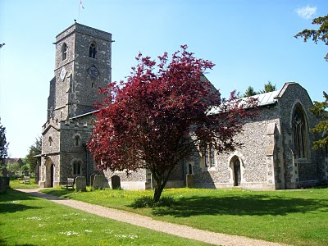The parish church in Aldbury, located a few miles east of Tring, Hertfordshire. Are our relatives buried here also? Photo by Barbara Holliman, 2010.
In the last posting we explored the 1623 will of William Holyman of Tring, son of Leonard Holyman. In this article we reproduce below from the Hertfordshire Archives, the will of Edward Hollyman of Aldbury, brother of William. Aldbury is only a few miles from Tring. Edward lived from 1546 to 1617, and spelled his name with two 'L's. Edward was more prosperous listing furniture and household items to be dispersed as well as land holdings. Note brother William Holyman witnessed this will. As the scanner cannot record the entire will at once, it is divided into two parts. Click twice to enlarge.
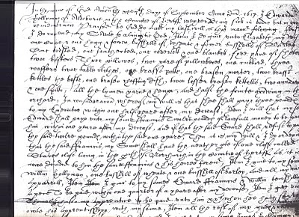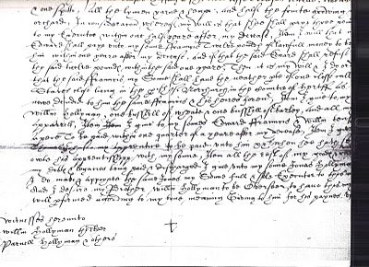
I have not attempted to transcribe this document, but have studied closely the bequests and names. This will seems more difficult to read than William's. A name intrigues, and I remain puzzled over it. Double click the second section and look at the fourth line from the bottom of the will. Beginning in the middle, you will read the words which I transcribe as "I give unto my sons Jonas Hollyman," then words are obscure.

I have pondered and pondered this clause. Is this word John in Latin, Medieval French or 16th century English script? What to do about this? One avenue is to check the Aldbury Church of England register. Remember Thomas Cromwell as of 1538, Henry VIII's chancellor, decreed that all parishes register baptisms, marriages and funerals.

However, I cannot find in Edward's will (as in William's) that he asked to be buried in the parish church lawn. Had Edward joined a non-conformist church (Puritan or even more controversial - the Anabaptists for example) by 1617, as obviously had his nephew Ezekiel? If so, Edward's demise would not be recorded in Anglican Church records.

So I will search the Internet to see what can be found, and if nothing can be found, well, back to the Hertfordshire Archives my next trip to England. A clue, a weak one, but....could this be the not-yet-found John Holyman, d. 1650 in Jamestown, Virginia? I agree, this is a big, huge stretch and even if this name be John, would it also be our John, English founder of our American family....?

Below, is a family memorial in the Aldbury parish. No, not a Hollyman plaque, as it remembers another departed family. This ghastly, but fascinating 17th Century monument, vividly displays that century's view of morbidity. Our ancestors were part of this culture.
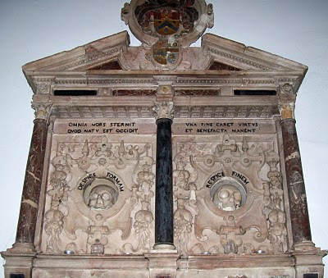Photo 2010 by Barbara Holliman
We are all immigrants from the past...from our families.....
Posted by Glenn N. Holliman at 6:35 AM 1 comment:
Labels: Edward Hollyman, William Hollyman; Jonas Hollyman

Monday, September 20, 2010

When We Were English, Part XIX
by Glenn N. Holliman

The Will of William Holyman (1550 - 1623) of Tring, Part II
Still Looking for John Holyman of Tring....

In the index of wills in the Hertfordshire Archives in Hertford, England, I found and copied the last words of William Holyman, son of Leonard Holyman (1520 - 1573). Bear in mind, I was looking for the John Holyman, the reported ancestor of the American Hollimans. While this will does not disclose our elusive direct ancestor, this document does reveal information on the lives and times of our distant cousins, uncles and aunts when we Hollimans were English. Click twice to enlarge. The document is divided into two parts due to my scanner only taking part at a time.
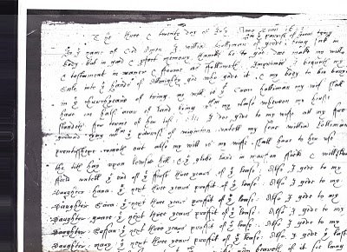
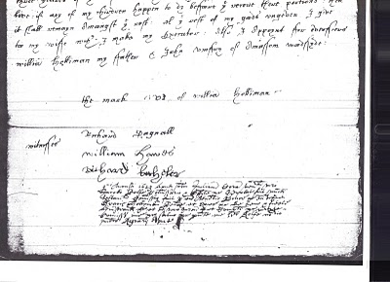What does it say? As no expert, here is my attempt to transcribe the writing form of early 1600s English script.

"The ___ and twentieth day of July Anno Domi 1623 ___ In the Name of God Amen. I, William Holyman of Great (in the parish of Great Tring) being poor in body, but in good and perfect memory, thanks be to God, do make my will and testament in manner and form as followeth,

First, I bequeath my soul into the hands of the Almighty God, who gave it and my body to be buried in the church yard of Tring.

My will is that Grace Holyman, my wife, shall have on half acre of land lying between my house __ for ___ (rest?) of her life. Also I do give to my wife all f___ ___ ___ ___ that ___ of ___. ___ my son William ___ ___ ___ out also my wish is to my wife ___ ___ to her rest the __ hay upon ___ hill; and the glebe land in ma___ field and one of the ___ of the first three years of the field lease. Also I give to my daughter, Hanna, the next ___ years profit of the lease; also I give to my daughter, 'Saiva' or 'Eva', the next three years profit of the ___. Also I give to my daughter, 'Grace' the next ___ profit of ___. I give to my daughter, 'Saffon', the next ___ years profit of the ___. Also I give to my daughter Mary the ___ ___ ___ profit of the ___. Also I give the ___ three ___ of the ___. Unto the ___ my wife ___ ___ if it ___ ___ ___. If any of my children happen to die before they received their portion, then it shall remain amongst the ___. All this ___ of my ___ I give to my wife ___ I make my executor. Also I appoint for administrators (?) William Holyman my father and John Romsy of ___ ___.

The Mark of William Holyman, submitted"

My opinion? Here we have described a yeoman farmer living in Tring, to be buried in Tring and farming fields just outside of Tring. He has few worldly goods other than a lease hold on the land.

And to our disappointment, no son named John Holyman.

So the search for the elusive John Holyman continues....
Posted by Glenn N. Holliman at 12:38 AM No comments:
Labels: Eva, Grace Holyman, Hanna, William Hollyman; Leonard Holyman

Monday, September 13, 2010

When We Were English, Part XVIII
by Glenn N. Holliman

The Will of William Holyman (1550 - 1623), Part I
In the Hertfordshire archives in Hertford, England, one will find several large rooms filled with books, manuscripts microfilm and photographs of local, family and national history. In the short time I was there, the friendly staff pointed me in several directions.

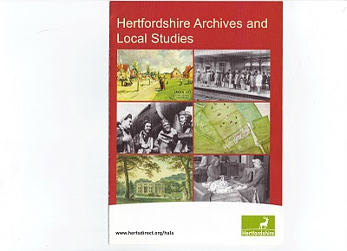This brochure may be of help to those reading this blog. Click twice to enlarge.
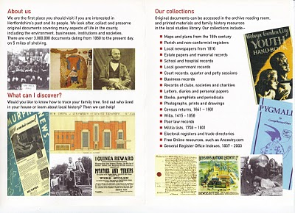

While there I reproduced from microfilm the wills of Edward Holyman and his brother William Holyman. Before I post them and attempt to transcribe, let me share with readers the way our English alphabet looked in the late 16th and early 17th century. (See below)

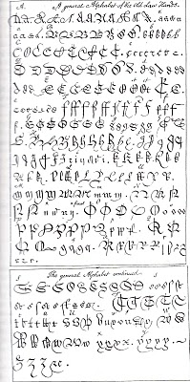

This really is your great grandfather's alphabet! Yes, it is A to Z with several samples for each letter. Some are easy to identify; others are a mystery. It makes interesting reading. Will it get us any closer to the elusive John Holyman (1572 - 1650)?
(Again click the reproduction twice to enlarge.)

In Part II of this article, next posting, we will examine William's 1623 will from Tring.
Posted by Glenn N. Holliman at 1:45 PM No comments:
Labels: William Holyman; Edward Holyman

Tuesday, September 7, 2010

When We Were English, Part XVII
by Glenn N. Holliman

Continuing the Search for John Holyman (1572 - 1650)
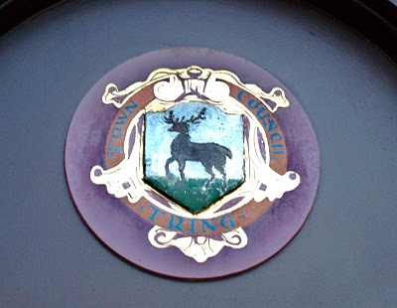Tring, Hertfordshire traces it roots to Anglo-Saxon times, and was located just west of the Danelaw in the 900s. The hamlet is listed in William of Normandy's Doomsday Book. The above is the town logo. (Photo by Barbara Holliman)
I am still looking for that elusive John Holyman who, according to one prominent Holliman genealogical website and the LDS records, was born in Tring, Hertfordshire in 1572. John is the widely reported father of Christopher Holliman, Sr., who is our ancestor of solid record.

We do know a John Holyman did die in Southampton, Virginia in 1650 and left a will which devolved property to a friend, not family. For the past few months, I have been posting information found during an excursion to England seeking Holyman roots and our reported very great grandfather. I continue.

As readers of this web log know, there was a Bishop John Holyman (1495-1558) and an Ezekiel Holyman (1586 - 1659), both religious leaders. One was Roman Catholic and the other a Baptist Protestant. The evidence supports that they are related.

Cousin Jennette Stewart shared by email information that in the English Origins of New England Families, Vol. III, pages 193 - 195, one will find an article by G. Andrews Moriarty entitled 'The Holymans'. In this article Moriarty quotes The Register, an English genealogical publication, that the Holymans were a family of 'substantial yeomen' with branches in Cuddington, Cholesbury and Chesham. The Rt. Rev. John Holyman, Bishop of Bristol from 1554 to 1558 was a member of this family as was one Jayne Holyman (1552 - 1632) and her nephew, Ezekiel Holyman.

From the Latter Day Saints genealogical website, we have the following:

One Leonard Holyman (1520 - 1573) was born in Cholesbury and died in Tring. From the above source we know that Leonard is related to the Cuddington Holymans. I refer all to my post of August 23, 2010, 'When We Were England, Part XV'. Leonard is a contemporary of Bishop John Holyman. Were they brothers or cousins? Cuddington, as the earlier map notes, is an hour or two by horse from Tring and Cholesbury.

Leonard married a Joan (b 1525) also of Cholesbury. They had at least seven children. One was the Jane (Jayne), referred to above, b 1552 in Tring, Cholesbury, died 1636 and is buried in Chesham (near Cholesbury). She married Richard Weedon, as noted in the last posting. One of their sons, James, immigrated to Rhode Island, as did Jayne's nephew, Ezekiel.

Jayne's brother John Holyman (1548 - 1597) was a weaver and had a wife named Ales (Alice). There were a number of children of this marriage, one being Ezekiel Holyman, who would immigrate to New England and help found the Baptist Church in America. Another child, Elsabeth, married into the Weedon family herself.

Two of Leonard's sons, Edward and William, left wills of which I found and made copies while in the Hertfordshire Archives. I will be publishing these wills later and transcribing what I can. There was a third son, John, whose will is below and lifted from the English Origins of New England Families.

The Will of John Holyman (1548 - 1597)
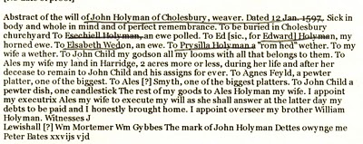

Now John Holyman (d 1597) left a will (abstract above) which does not list a son named John Holyman (remembering we are looking for a John Holyman, b. 1572 in Tring). John (d 1597) does list a godchild, whom he terms John Child. To this godchild, Holyman left his 'looms and all that belongs to them'. His own children received much less, Ezekiel only getting a ewe. Why did he favor the godchild over his natural children? Perhaps John Child had an aptitude for weaving while the others did not? But this John also left John Child his land after his wife's death.

Why favor John Child over one's own children?

Could John Child have taken the last name Holyman from his godfather, John Holyman? Could this John Child be the elusive John Holyman (d 1650 in Virginia)? The dates work. Could this godchild be a natural offspring of John Holyman (d 1597), given perhaps a last name (Child) to obscure a birth out of wedlock? This is only speculation on my part, but the bequests are odd.

So John Holyman (d 1650) is still hidden in history as far as primary sources are concerned, if he be from the Tring area. As cousins Maxine Wright and Joe Parker have revealed, there is evidence John Holyman (d 1650) may have been from twenty-five to thirty miles north in Bedford. If so, why are so many web sites placing him in Tring?

So are the Bedford and Tring area relatives very closely related, perhaps a branch just recently relocated to Bedford from Tring in the late 1500s? Perhaps, somewhere, someplace, some Holyman stated to an authority, "Yes, my family is originally from Tring, before recently moving to Bedford."

I will look further. Thank you for your patience as I attempt to place all this research by several persons and sources in narrative format and on the record. As ever, I am grateful to my distant cousins for their sharing of knowledge and evidence. Opinions expressed and conclusions drawn, as well as errors, are mine alone.

Next posting....looking at the will of William Holyman, a son of John Holyman (d 1597).

