Holleman ~Mill Swamp Rd~ Cemetery
Transcribed by members of the
Grave Site Survey Task Force (GSSTF)
Under the Auspices of
Isle of Wight County Historical Society (IWCHS)
Visited June 12, 2005

A selection of shaving foam, water, or talcum powder was used to improve the legibility of the inscriptions on the older tombstones. Afterwards, a clean water spray was used to remove any residue. GSSTF members were careful not to damage tombstones or artifacts during the transcription process.

Any text within the “[ ]” is a comment about the tombstone inscription, ex., [fs] indicates a footstone inscription. Throughout the transcribing process, an attempt was made to preserve the, ‘look and feel’ of the original inscriptions as regards word spacing, arrangement, and possible misspellings.

Please address your comments/corrections to: albert.b@charter.net or epowellsr@aol.com.

 | Inscription |  |  | Inscription
 | HENRY JONES  Born  Oct. 6, 1826  Died  Jan. 15, 1904  Jones [fs] |  |  | ALICE HOLLEMAN  wife of  HENRY JONES  Born  Oct. 9, 1846  Died  Nov. 18, 1895  JONES
 | Our Beloved Father  WILSON HOLLEMAN  Born May 30, 1805  died June 25, 1873 |  |  | Our Beloved Mother  ANN NICHOLSON  Wife  WILSON HOLLEMAN  Born Jan. 13, 1808  died Sept. 15, 1868  A.N.H. [fs]
 | EDWARD ADOLPHUS  HOLLEMAN  son of  WILSON and ANN HOLLEMAN  Born  Sep. 13, 1810  died  May 21, 1819 |  |  | SARAH NICHOLSON  HOLLEMAN  May 6, 1833  June 26, 1849  S.N.H. [fs]
 | CHARLES BINGLEY  HOLLEMAN  son of  WILSON and ANN HOLLEMAN  Born  Oct. 3, 1834  Died  Oct. 28, 1865  C.B.H. [fs] |  | Note (1) | ALGERNON SIDNEY  HOLLEMAN  Born August 4, 1838  Died  May 22, 1906  At Rest  [illegible footstone]
 | MARTHA JONES  wife of  A. S. HOLLEMAN  Born  Sept. 25, 1838  Died  April 29, 1904  At Rest  M.J.H. [fs] |  |  | ANNIE  Daughter of  ALGERNON & MARTHA  HOLLEMAN  Born Sept. 28, 1880  Died Oct. 12, 1884  Our Darling hath gone  before to greet us  on the blissful shore  Annie [fs]
 | ANNIE  HOLLEMAN JONES  Daughter of  HENRY & ALICE  JONES  Born Apr. 7, 1871  Died June 28, 1871  How many hopes lie  buried here |  |  | Our Babe  [no dates or other info]

Notes:
(1) The following information was copied from old courthouse records … it makes for interesting reading:

ALGERNON SIDNEY HOLLEMAN—was born in Isle of Wight county August 4,1838,a son of Wilson and Ann (Nicholson) Holleman. His mother came to this county in 1827, and died here September 15, 1868; his father died June 25, 1873. The great, great grandfather of Algernon S. was John Holleman, an early and respected settler of Virginia; his great grandfather was Jesse Holleman, a soldier of the Revolution; his grandfather was Josiah Holleman, who served in the war of l812, with captain's commission, for about six months, a portion of the time stationed at Norfolk. Josiah Holleman died March 15, 1848. John E. Holleman, brother of Algernon S. enlisted in the Confederate army in 1861, April; and served until sent to the hospital at Richmond in 1863, where he died July 3, 1863. Algernon S. Holleman was a soldier of the civil war, enlisting as private in Company A. 41st Virginia Infantry, May 15 1861, and in June, 1862, was promoted to lieutenant. He was in active service until wounded in the battle of Spotsylvania. May 12, 1864. He was then sent to the hospital at Richmond, where he lay when the Federal forces entered the city. He was held prisoner about thirty days, and paroled May 18. 1865. In Isle of Wight county, December 21, 1871, he married Martha B. Jones, and their one child, Anna Cassandra, was born September 23. 1880. His wife is a daughter of Robert T. and Lucy Ann (Bell) Jones, and was born in Isle Of Wight County, September 25. 1839. Her father died February 21, 1881, and her mother died December 2, 1882. Mr. A. S. Holleman has a farm of 388 acres, with abundance of marl to make it productive. He has 100 acres devoted to grain, peanuts and fruits. His land lies in Hardy district, where he has been three years judge of elections. Smithfield, Isle of Wight County, Virginia, is his post office address.

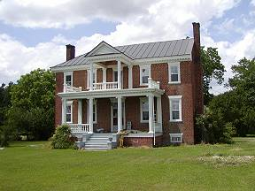 | 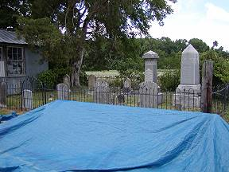
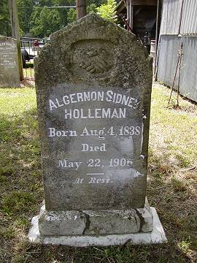 | 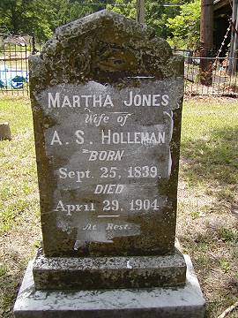
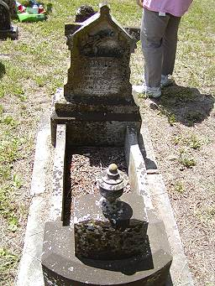 | 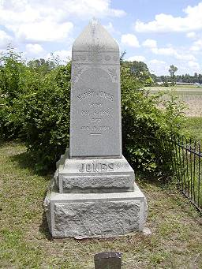
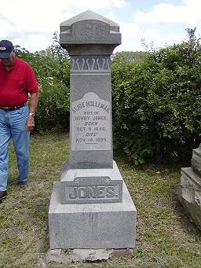 | 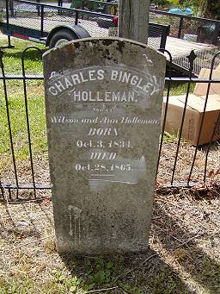
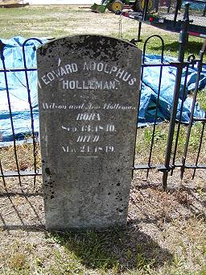 | 