We continue to report on the descendants of Christopher Holyman (1618-1691), who live in the Isle of Wight County and Richmond, Virginia. My thanks to the distant cousins who kindly shared their time and photographs. There will be several more articles on Isle of Wight County, which to most Holymans (and many various spellings) is our American ancestral starting point.
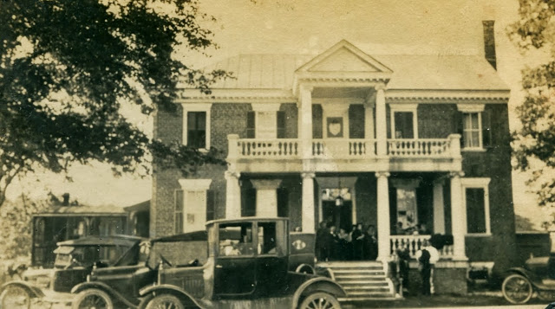
Above, the Holliman House at Mill Swamp, Isle of Wight, Virginia in 1921. A family reunion was being held at the home of Josiah James and Augusta White Benford Holleman. Picture from the collection of Sarah Barlow Wright.

Below, Sarah Barlow Wright in her Isle of Wight, Virginia home with treasured family photographs of her grandparents, Augusta Hannah White Benford Holleman (1859-1941)and Josiah James Holleman (1851-1937). Sarah's grandfather gave the land for the cemetery at the Mill Swamp Baptist Church adjacent to the historic Holleman House in Ivor, adjacent to the Surry County border.
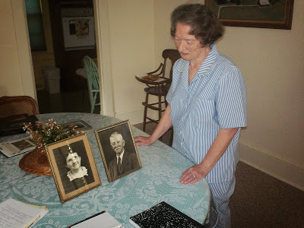
Mrs.Wright taught school for over 35 years, and is now retired. She grew up in Isle of Wight County at the Barlow Farm, five miles north of Smithfield, close to the James River. Her mother, Gladys Hortense Holleman Barlow (1895-1996) was born at the Holleman Farm at Mill Swamp, and later married Gordon Eugene Barlow (1891-1973).

Sarah Wright's lineage in Isle of Wight extends from at least 1661 when Christopher Holyman purchased land from George Smith along the Cypress River. Smithfield, Virginia takes its name from this family.

Below, Augusta Hannah White Benford Holleman. Augusta had two children by a first marriage and three with Josiah J. Holleman. Their children were Gladys Hortense Holleman Barlow (Sarah Wright's mother), Joseph Howard Holleman, Sr. (Caroline Holleman Thomas and Joseph H. Holleman's father written about in earlier posts) and Algernon Hardy Holleman (1902-1963), father of William Joseph Holleman, current owner of the Holleman House.

The lineage for this branch of the Holleman family flows as follows:
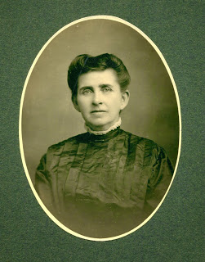

Josiah James Holleman (1851-1937), son of
James Henry Holleman (1819-1858), son of
William H. Holleman (1795-1836), son of
Josiah Holleman (1771-1848), son of
Jesse Holliman, Sr. (1737-1824), son of
John Holleman (1688-1751), son of
Christopher C. Holyman (1660 ca - 1731), son of
Christopher Holyman, Sr. (1618-1691), the immigrant from Bedfordshire, England who arrived in Jamestown, Virginia in 1650.

The 1684 plantation, patented by Christopher Holyman, Sr. eventually descended to Wilson Holleman (1803-1873). Wilson left it to his son, Algernon Sidney Holleman (1838-1906), who died childless. The House and farm then went then to Josiah James Holleman , a first cousin.

Josiah left it to Algernon Hardy Holleman (1902-1963), who passed the property to his son, William Joseph Holliman, who owns the home today. His son, William Joseph Holleman, Jr. now lives on the farm, continuously occupied by Hollemans for almost 350 years.

Next posting, more on the Holleman decendants who have remained in Isle of Wight, Virginia since the Christopher Holyman arrival in Jamestown, Virginia in 1650.

