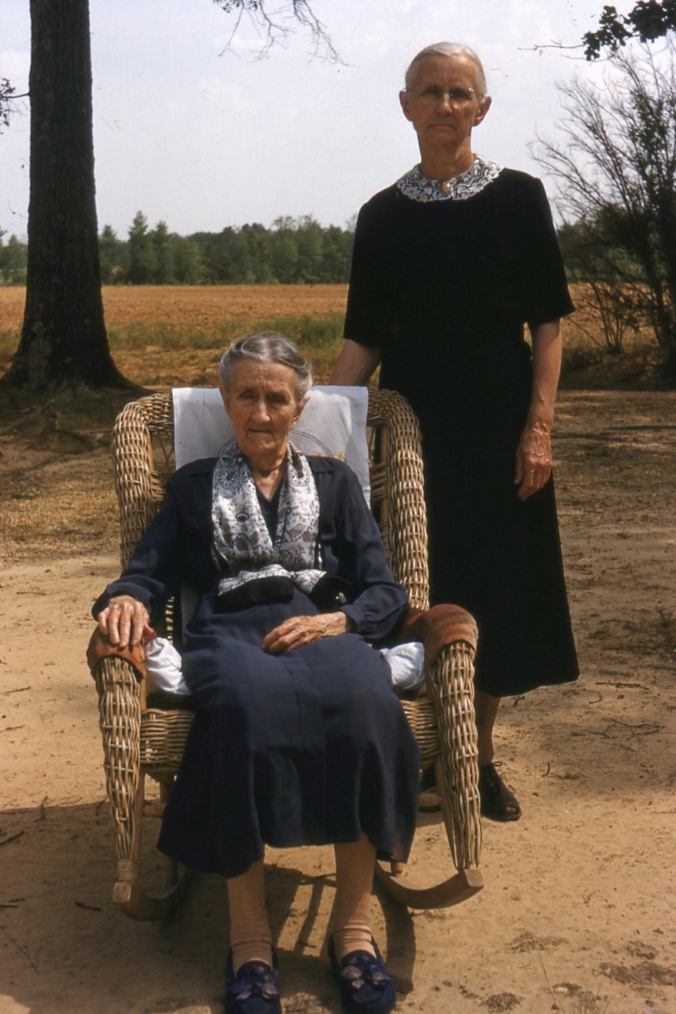
Above 1955 Newtonville, Alabama Belzy Ann Blakeney Baker, 1859-1960 and daughter, Anna Elizabeth Baker Holliman, 1879-1978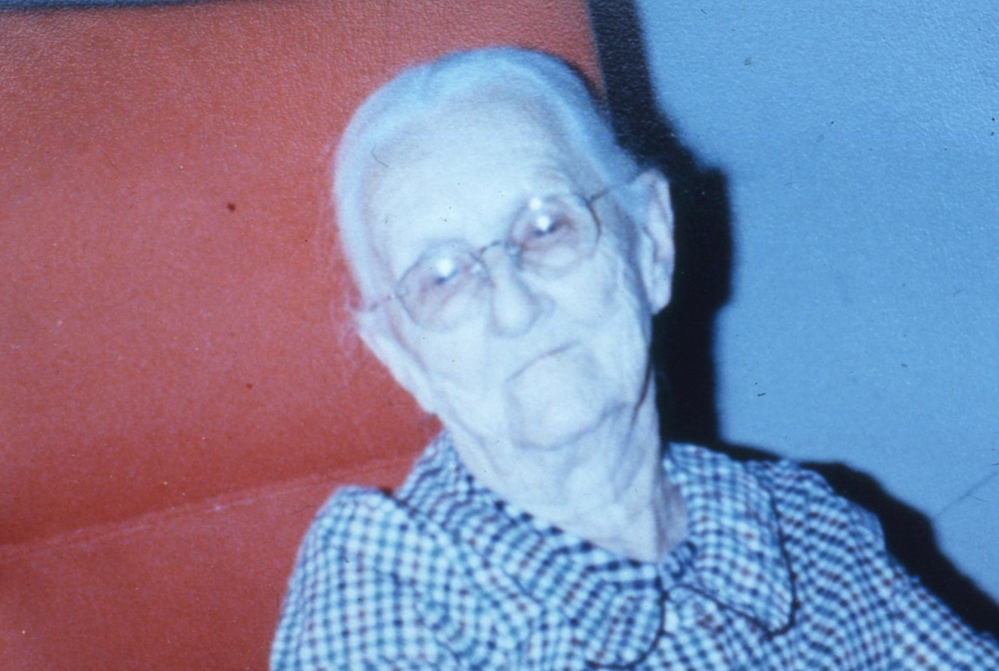
Above 1978 last photo of Elizabeth Baker Holliman.
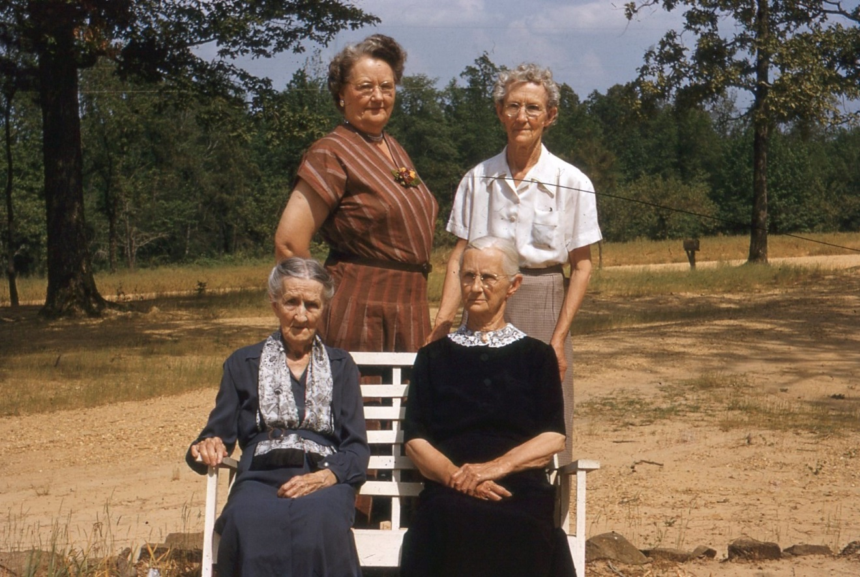
1955 May and Ruth G. Baker above with Belzy Ann and Elizabeth Baker Holliman
Below, May Baker with daughter and children. Ruth, front with Belzy Blakeney Baker.
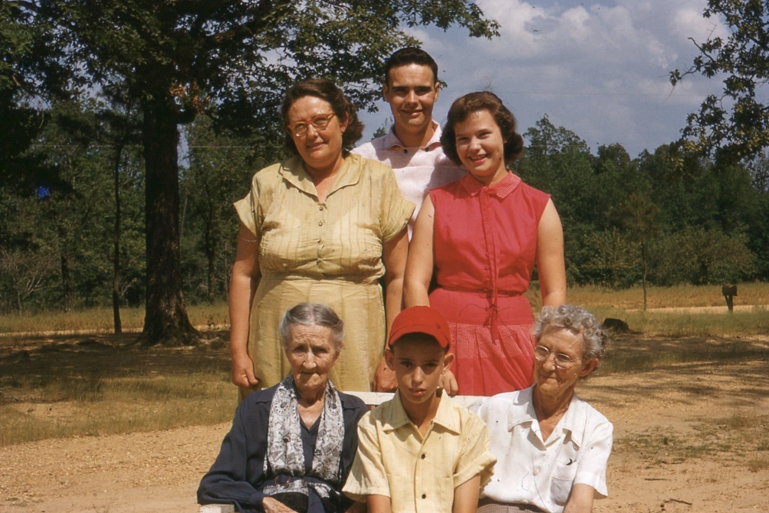

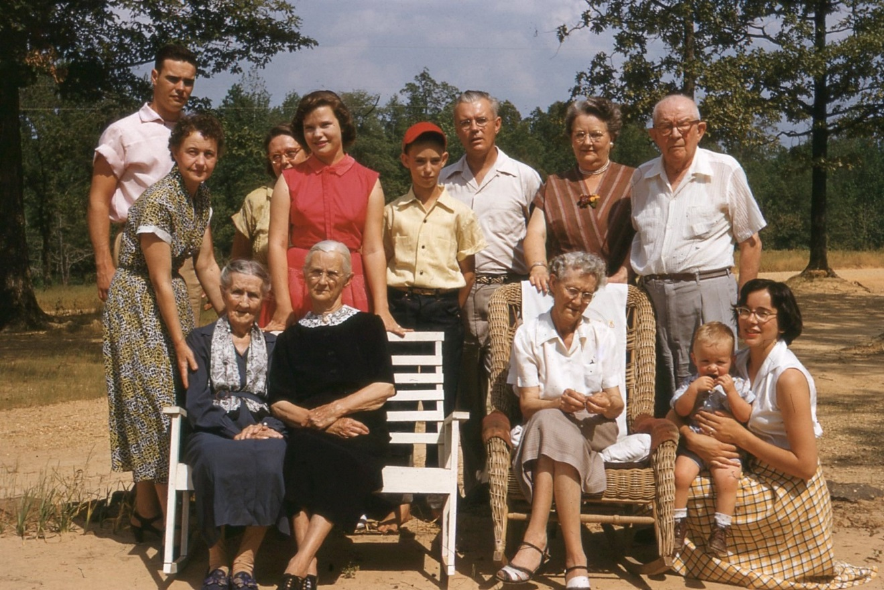
Abve 5 generations ages 17 months, 27, 53, 75, and 95 in May 1955 aat Uncle Eura Carter’s House in Newtonville, Alabama. Cecil R. Holliman in middle back row. Wife, Ruby Burns Holliman, extreme right with hands on Belzy Ann Blakeney Baker. Front row left is Susan Holliman holding Jim Holliman, b. 1953. Rhodes B. Holliman probably took the photo.
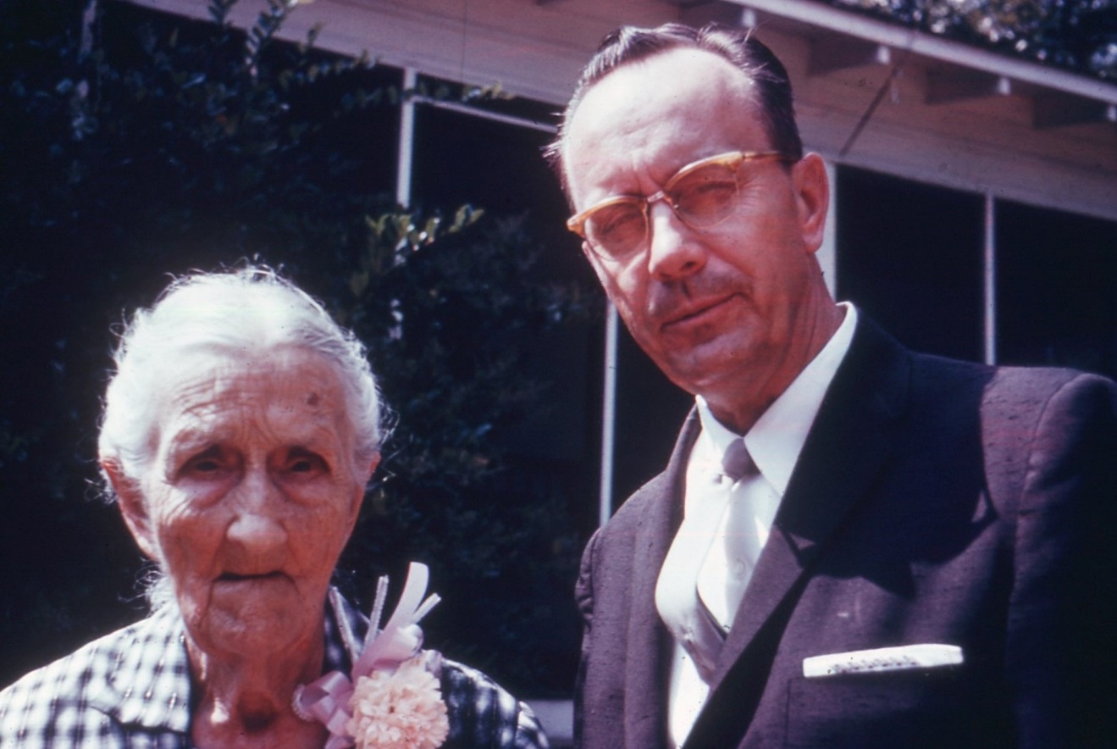
Above Belzy Blakeney Baker and Charles Baker Holliman, 1960

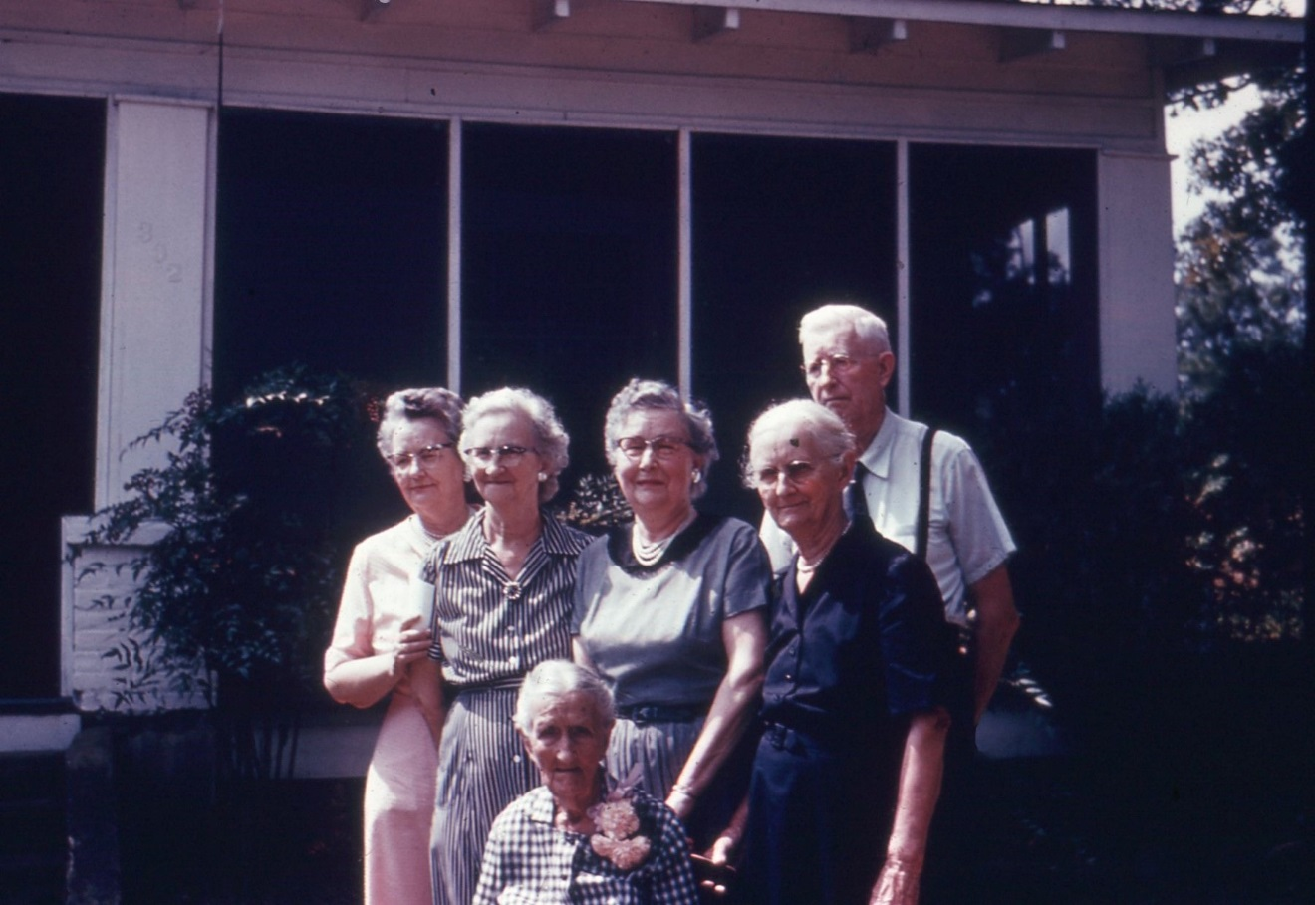
Above Ruth, Motie, Pearl, Elizabeth and Frank Baker with Belzy Ann Blakeney Baker in front. 1960
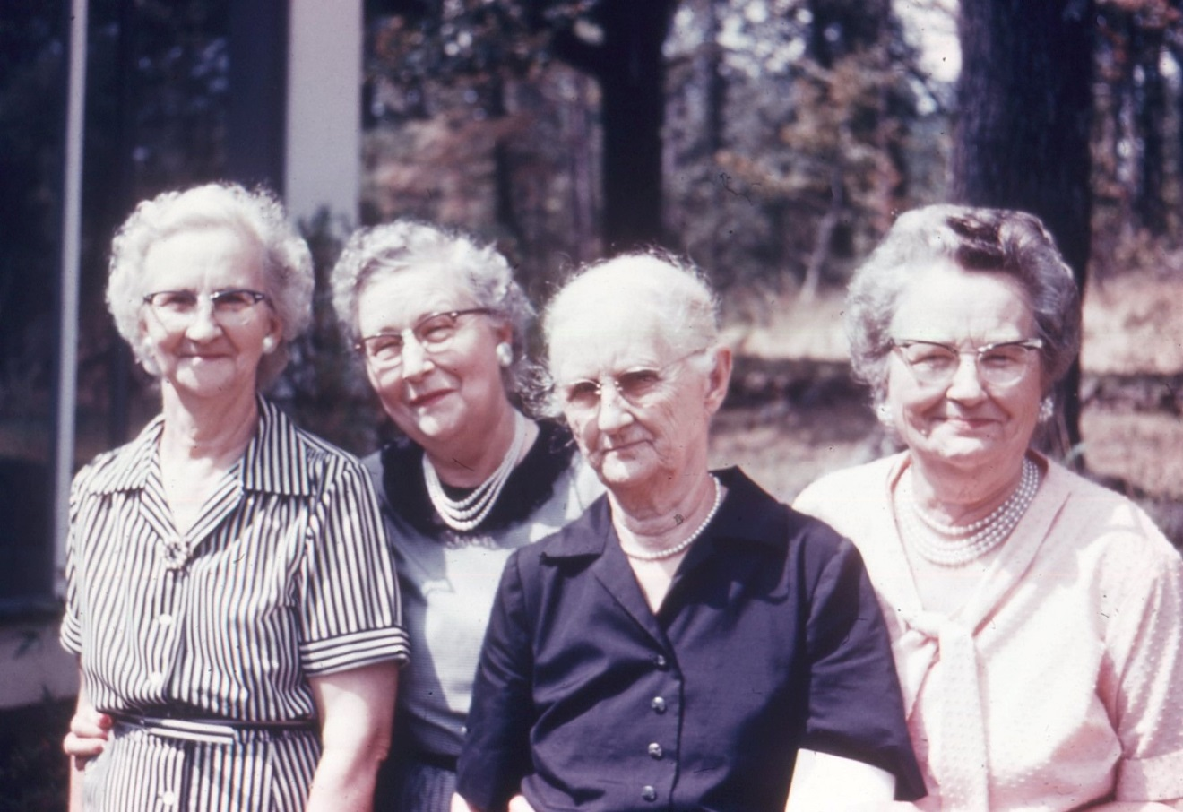

Above, Pearl, Montie, Elizabeth and Ruth, 3 sisters and their mother, Elizabeth Baker. Below Frank Baker all taken in 1960. Below in 1955, Cecil, Jim, Rhodes and Elizabeth standing; Belzy Ann Blakeney Baker sitting.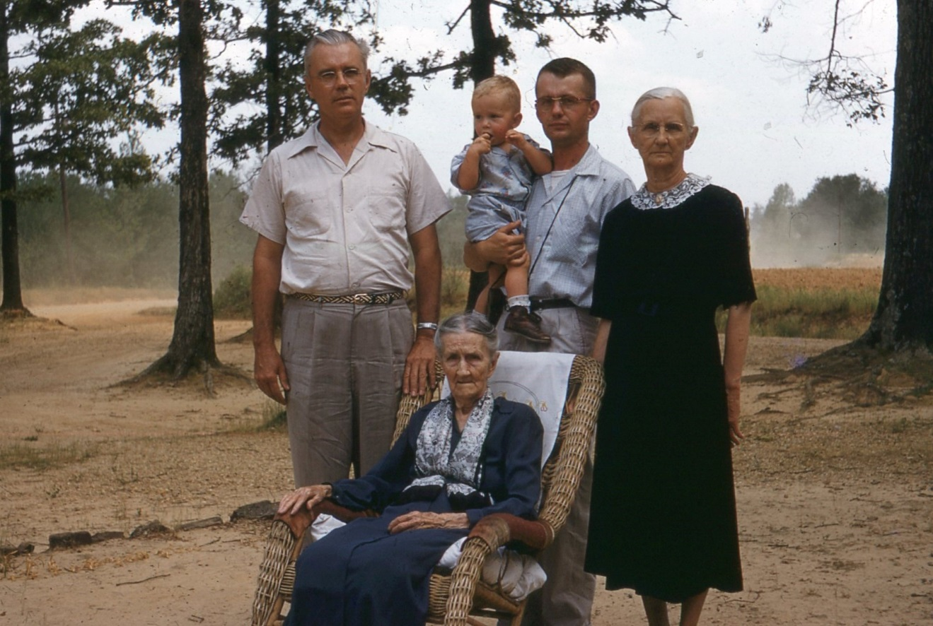

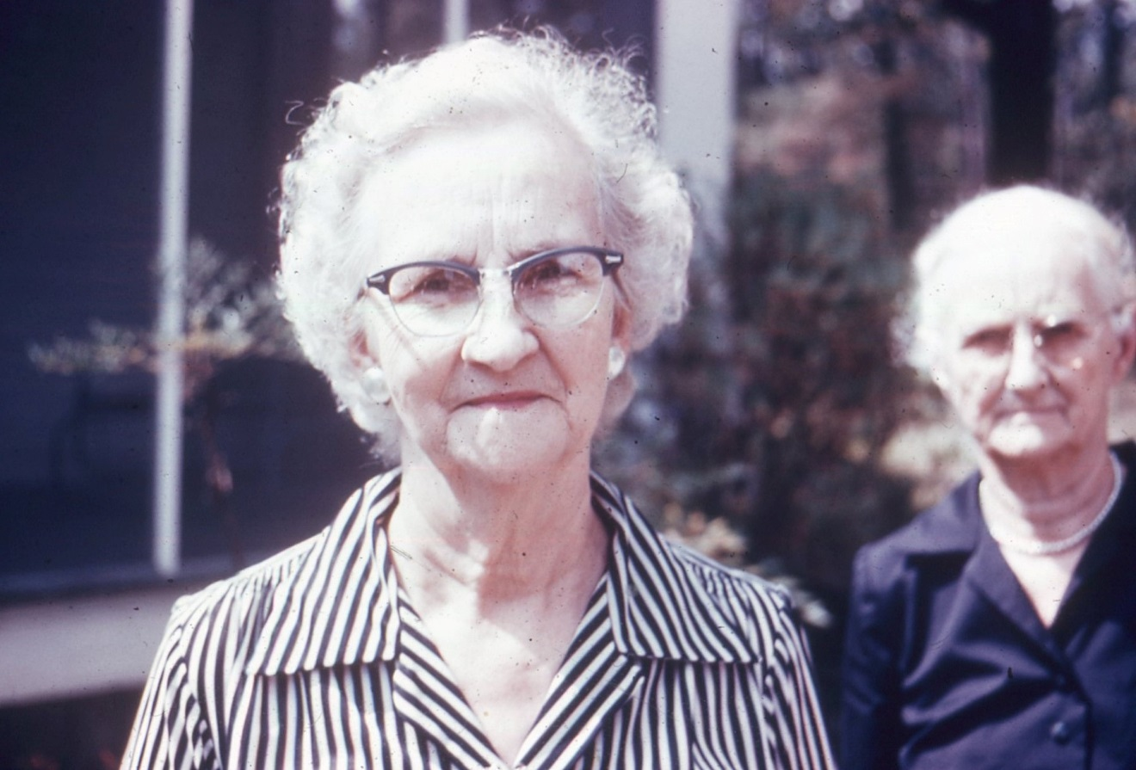

Above, Pearl Baker Gibson 1960. Below Frank, Elizabeth, Belzy Ann and Monte 1960 in Fayette, Alabama, the 100th anniversary of Belzy Ann Blakeney Baker’s birth.
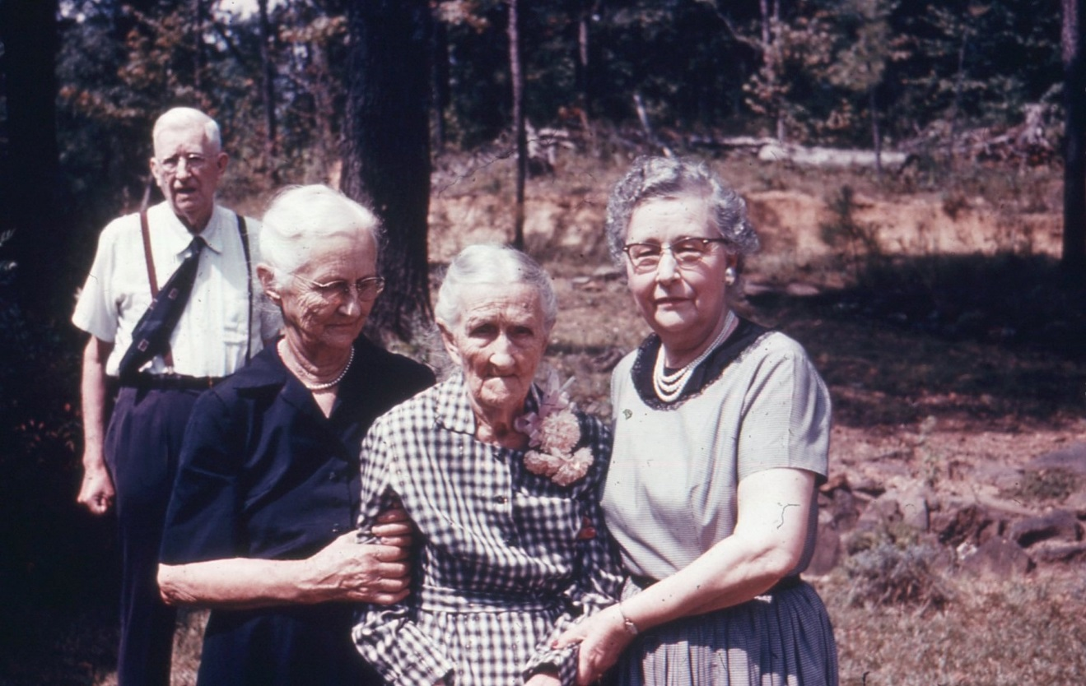

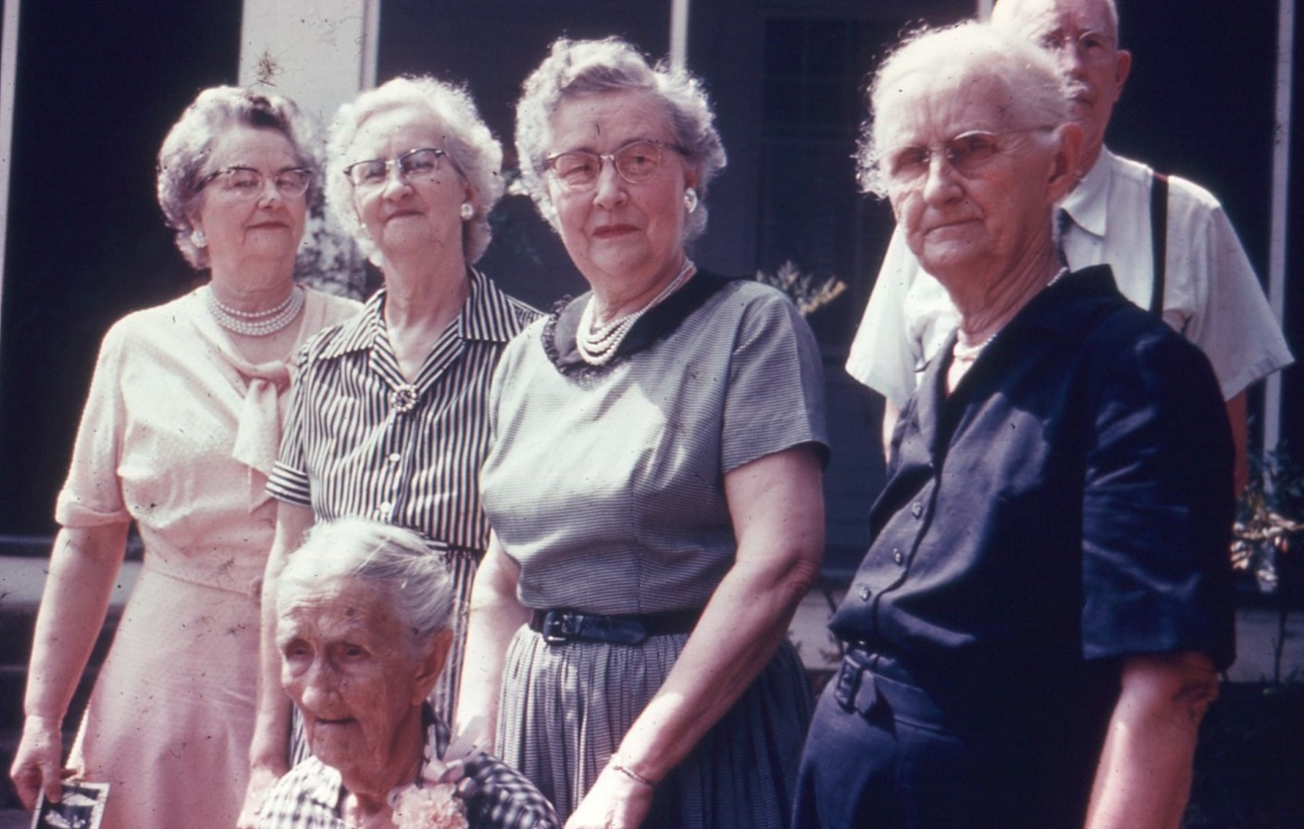
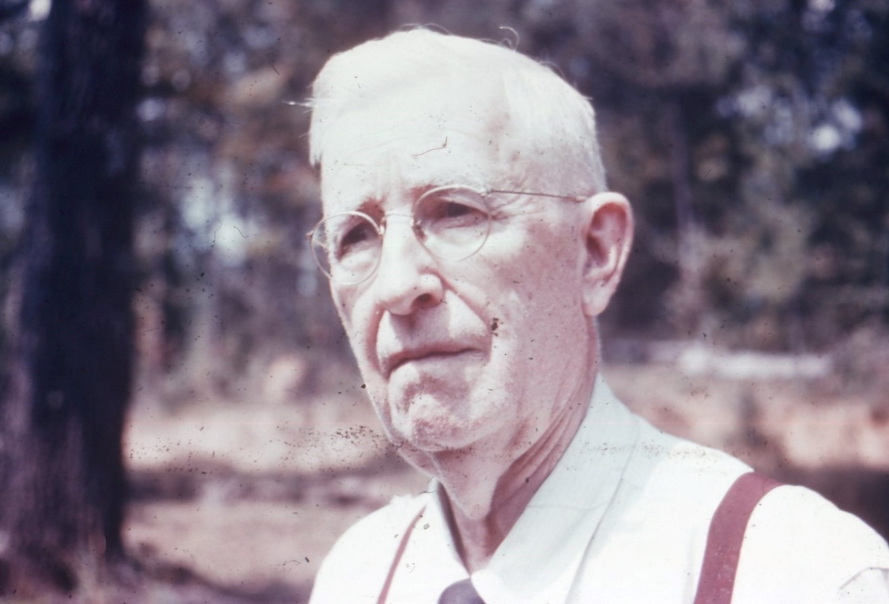
Frank H. Baker, b 1881 in 1960. Below Fayette, AL 1960 with Belzy Ann, age 100.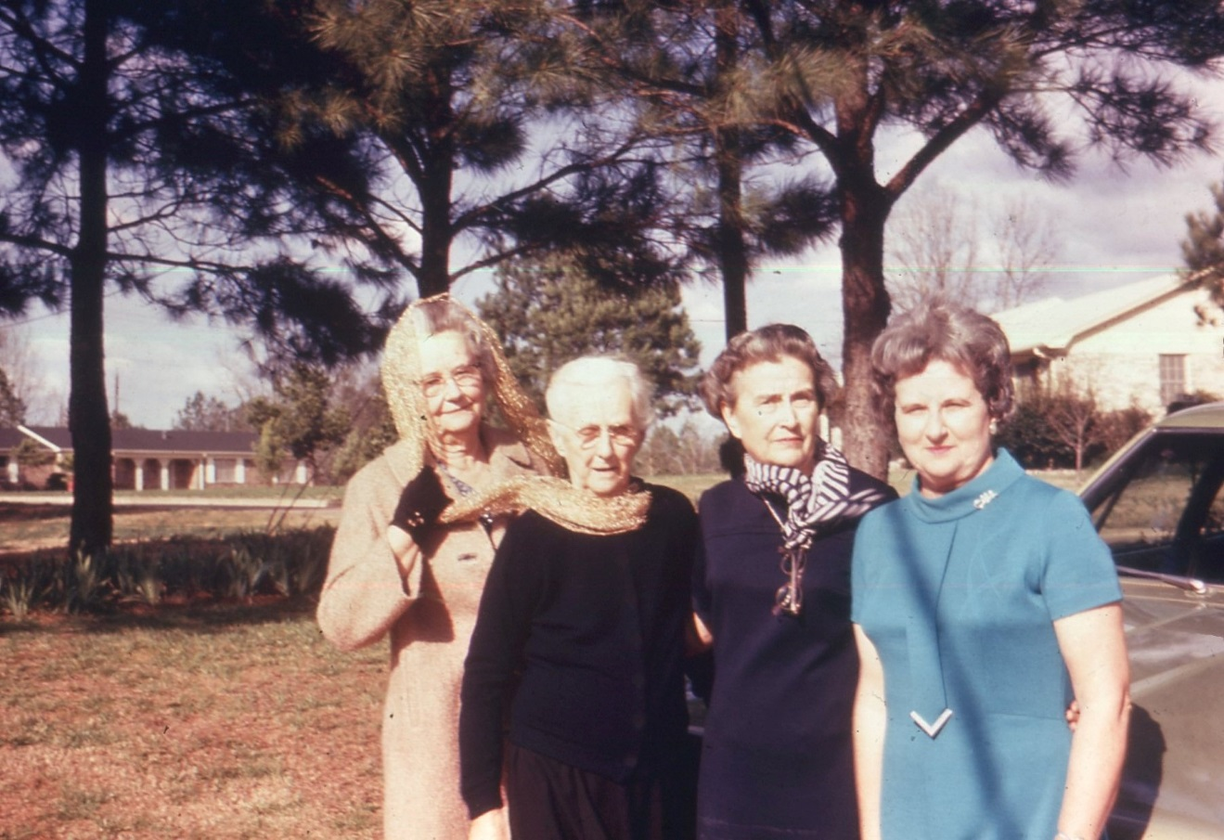
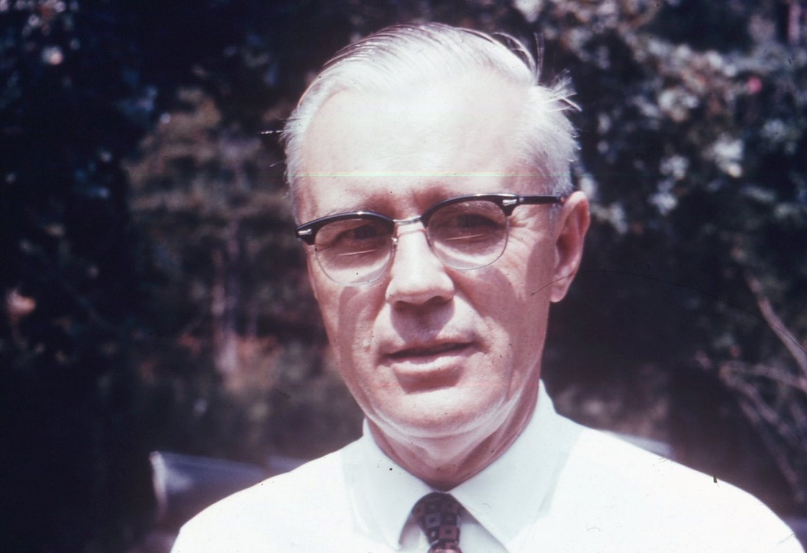
Above Cecil R. Holliman, 1902-1886 in 1960

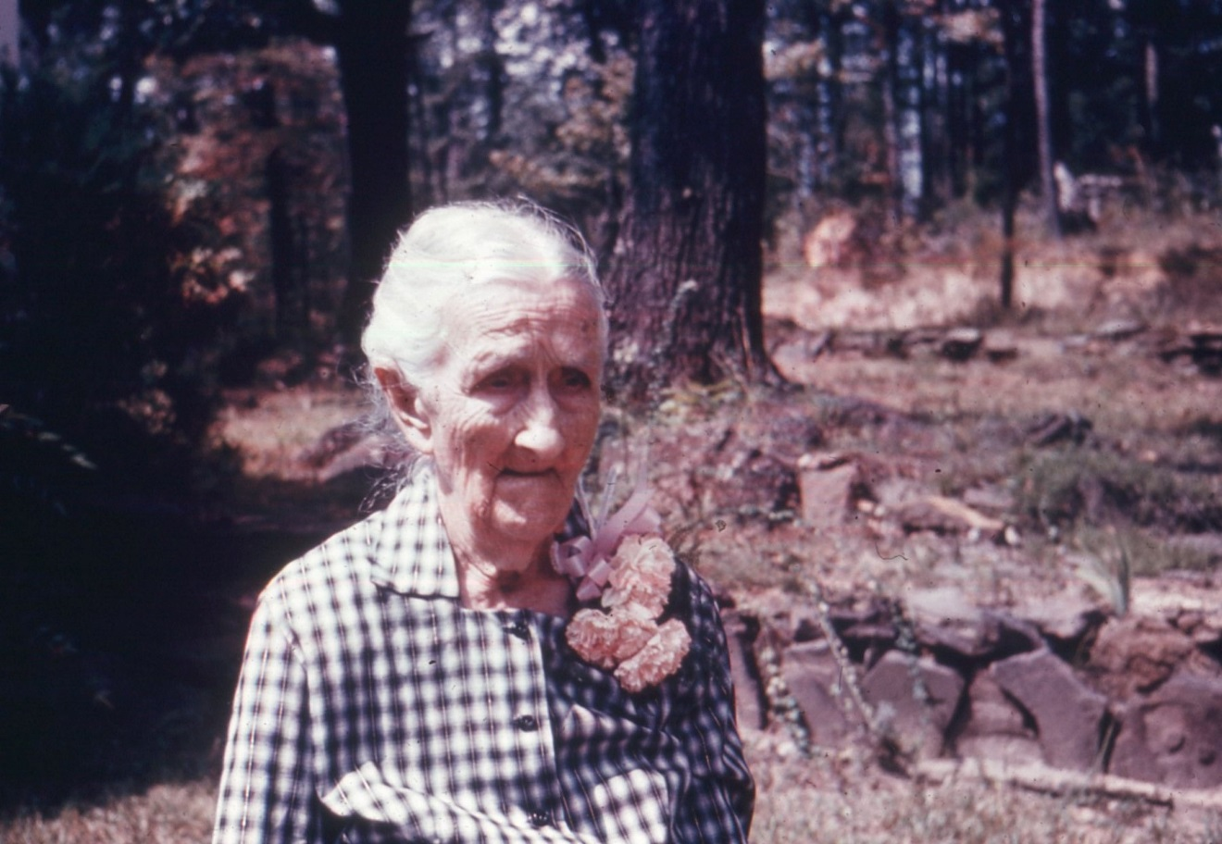
Above Belzy Ann Blakeney Baker, age 100, 1960

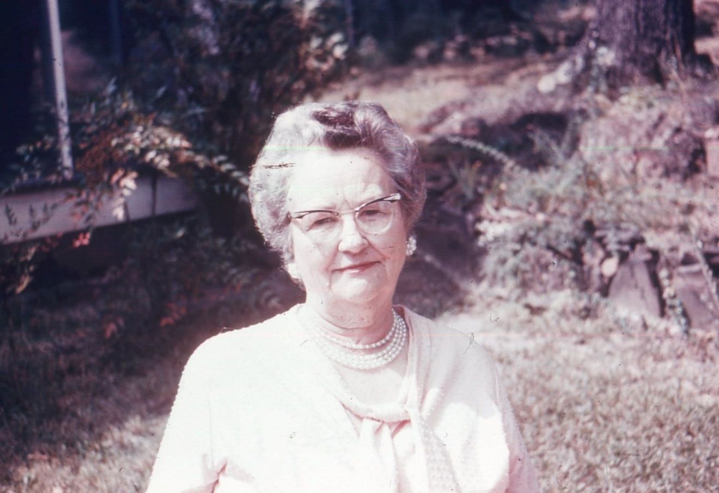
Above Ruth Baker, b 1890 in 1960; below Monte Baker Boshell 1960
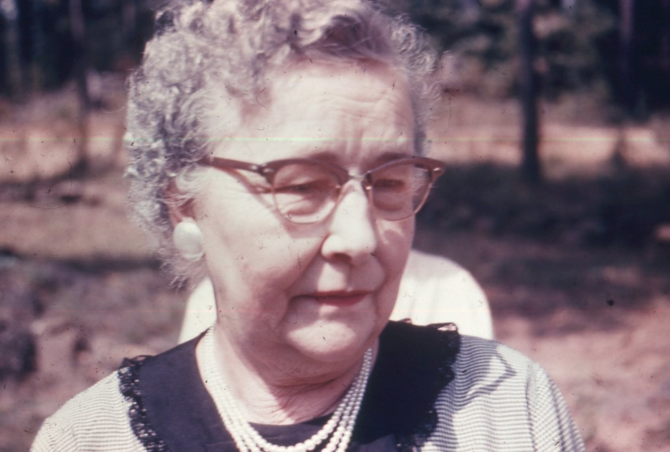

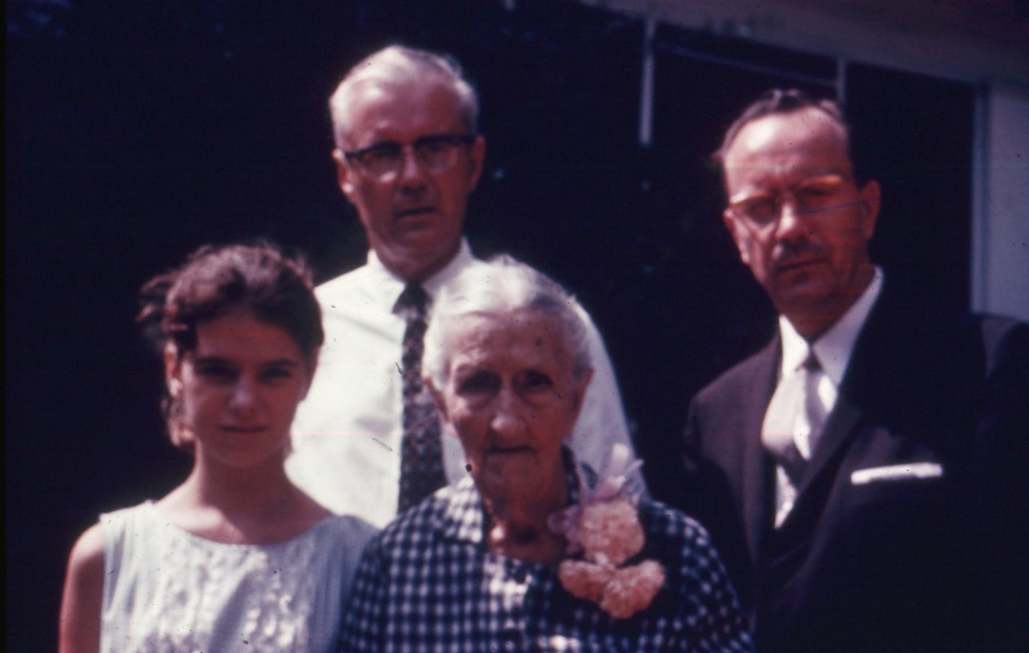
Above, unknown with Belzy Ann Blakeney; behind Cecil R. and Charles Baker 1960

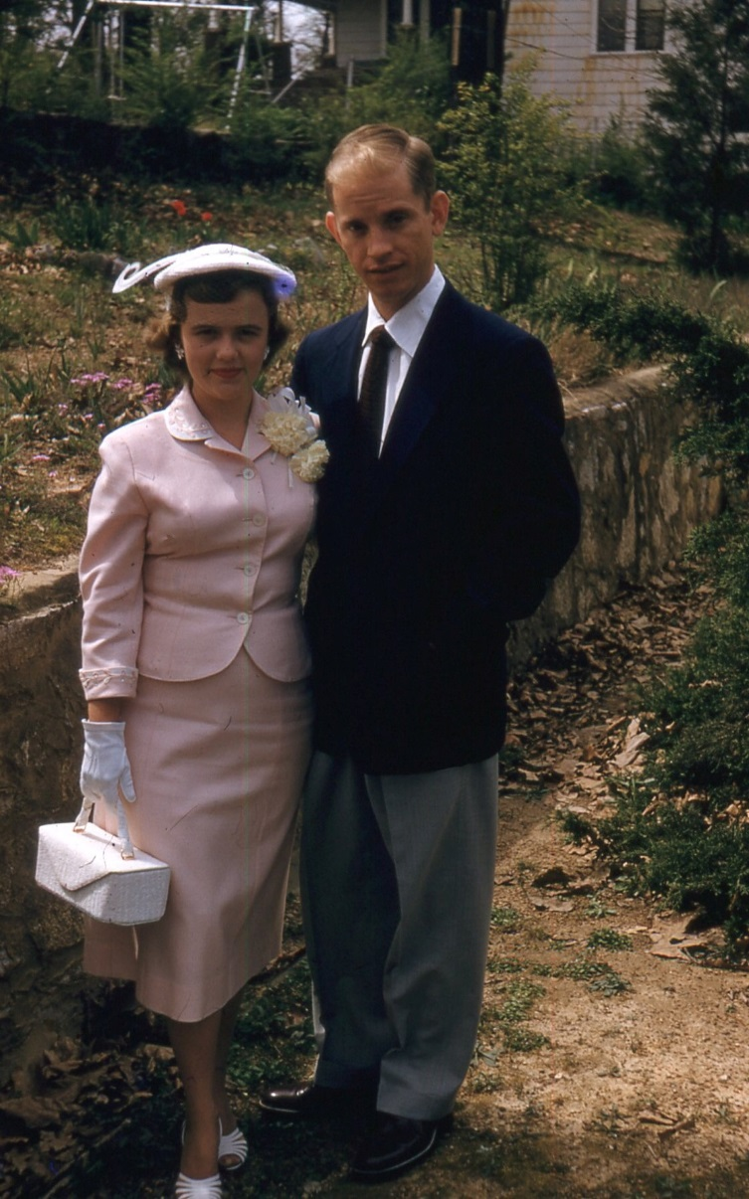
Above and below, Cecile Holliman and Glen Youngblood, Easter 1956
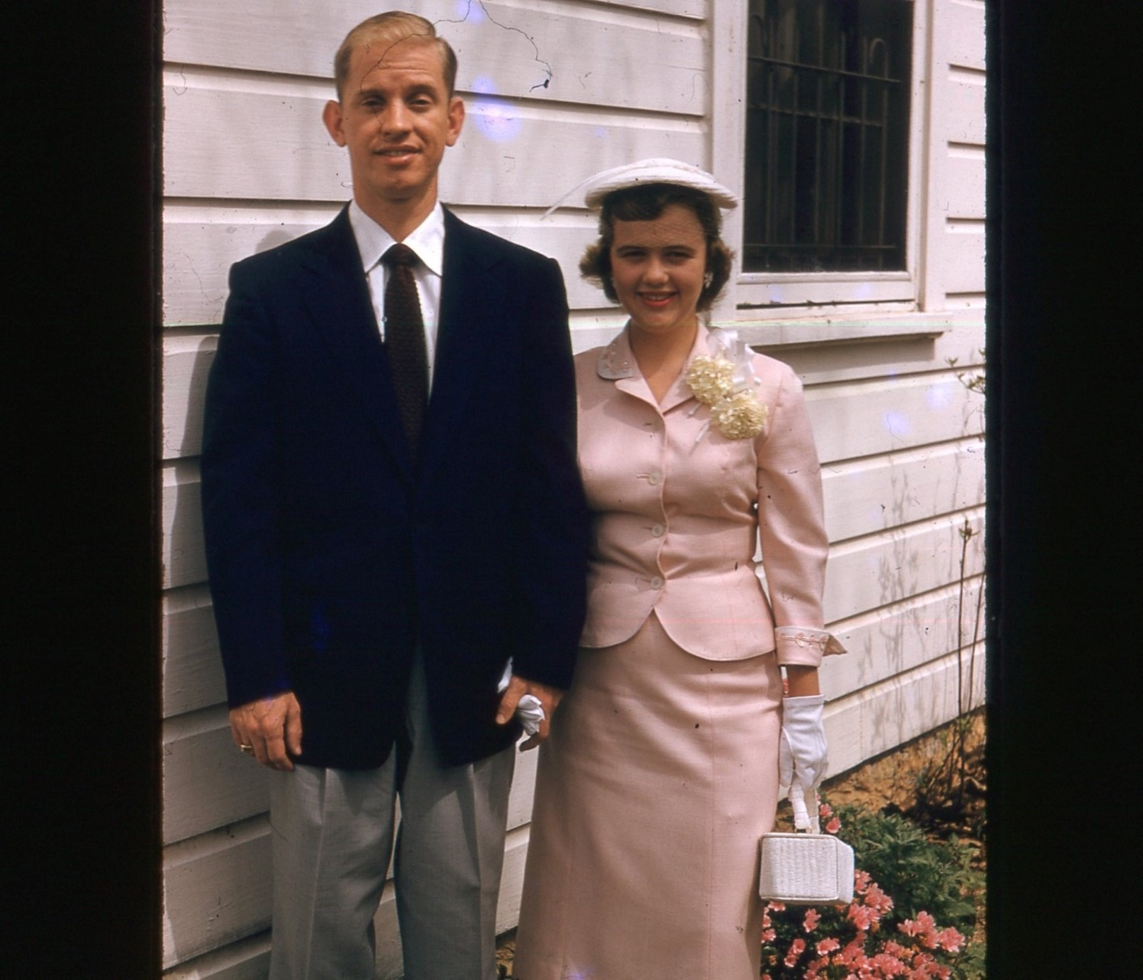

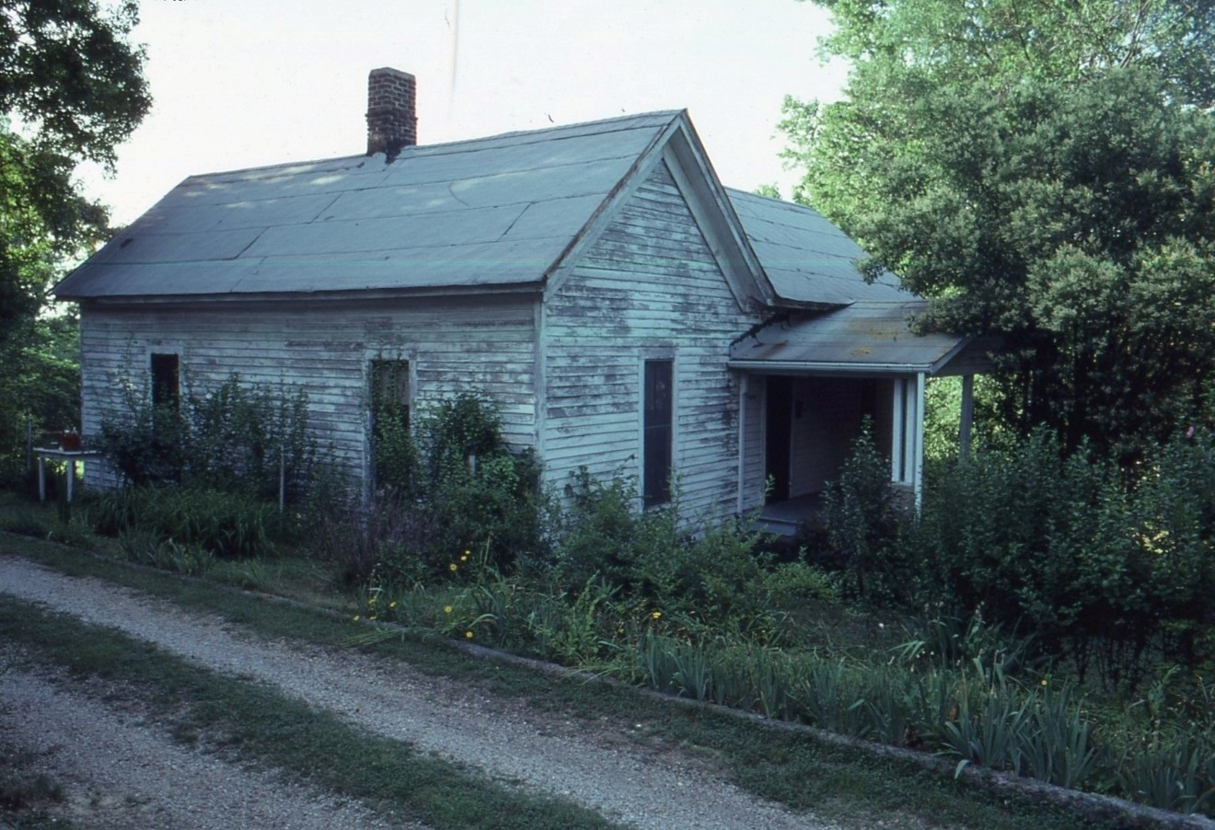
8214 6th Avenue South, home of the Cecil R. Hollimans in 1930s
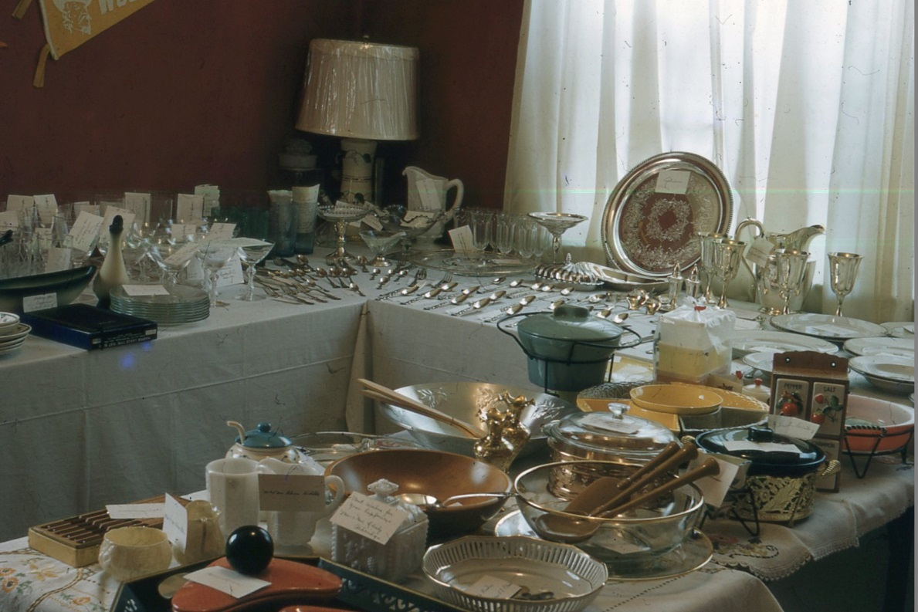
Above Cecile Holliman Youngblood’s 1955 wedding gifts.
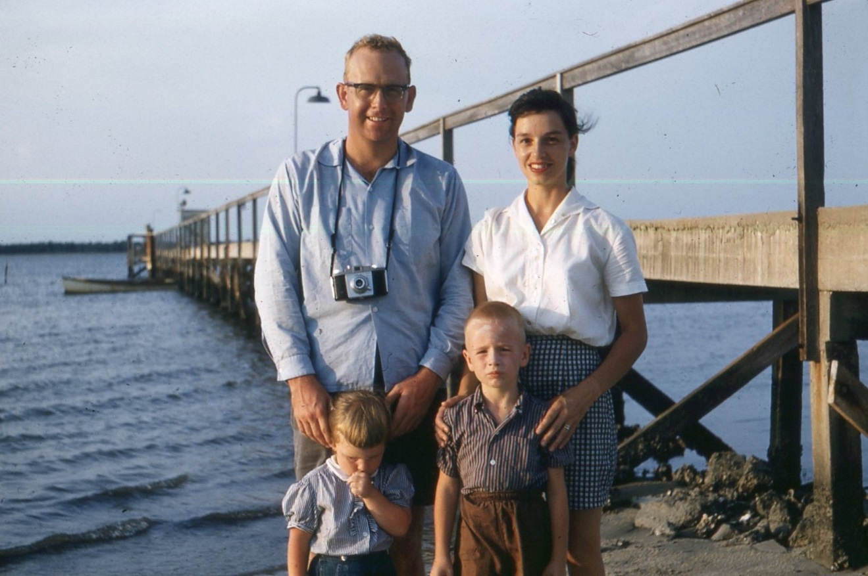
Above Youngbloods 1959 with children. Below Glen and Cecile Youngbood with children and Cecil R. Holliman and Elizabeth Baker Holliman in 1963.
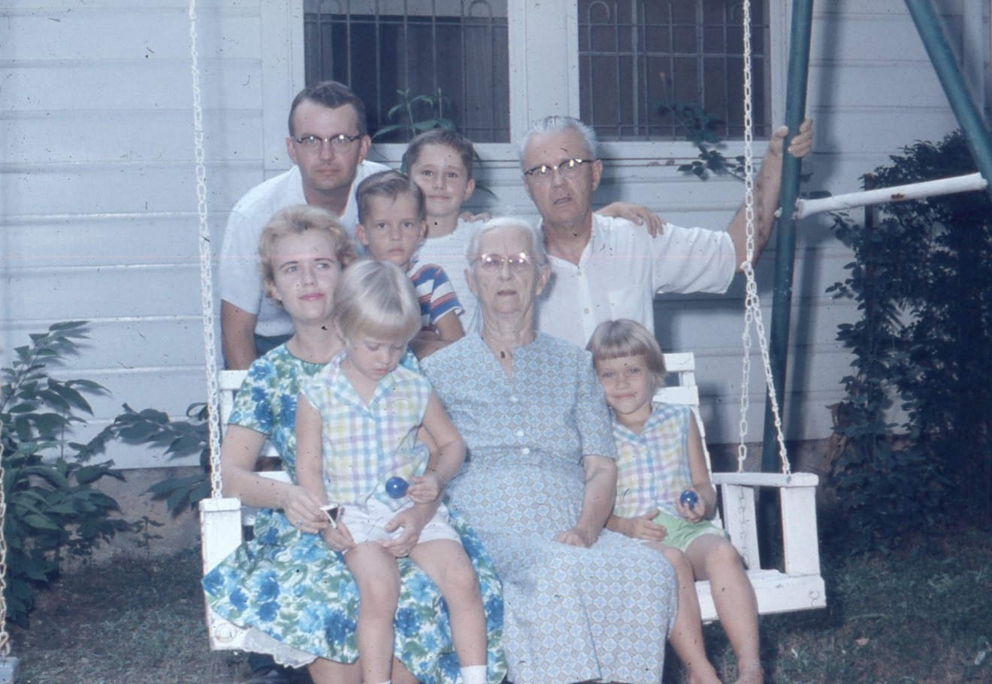

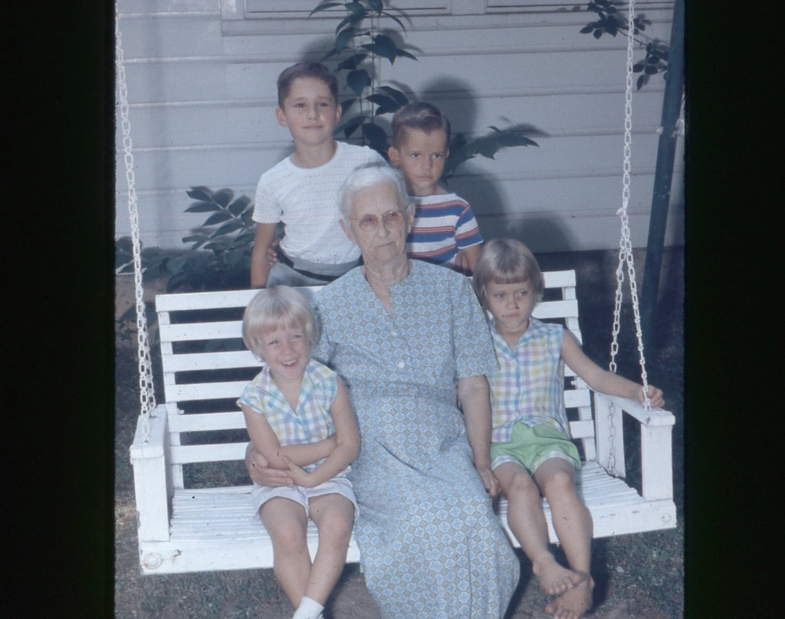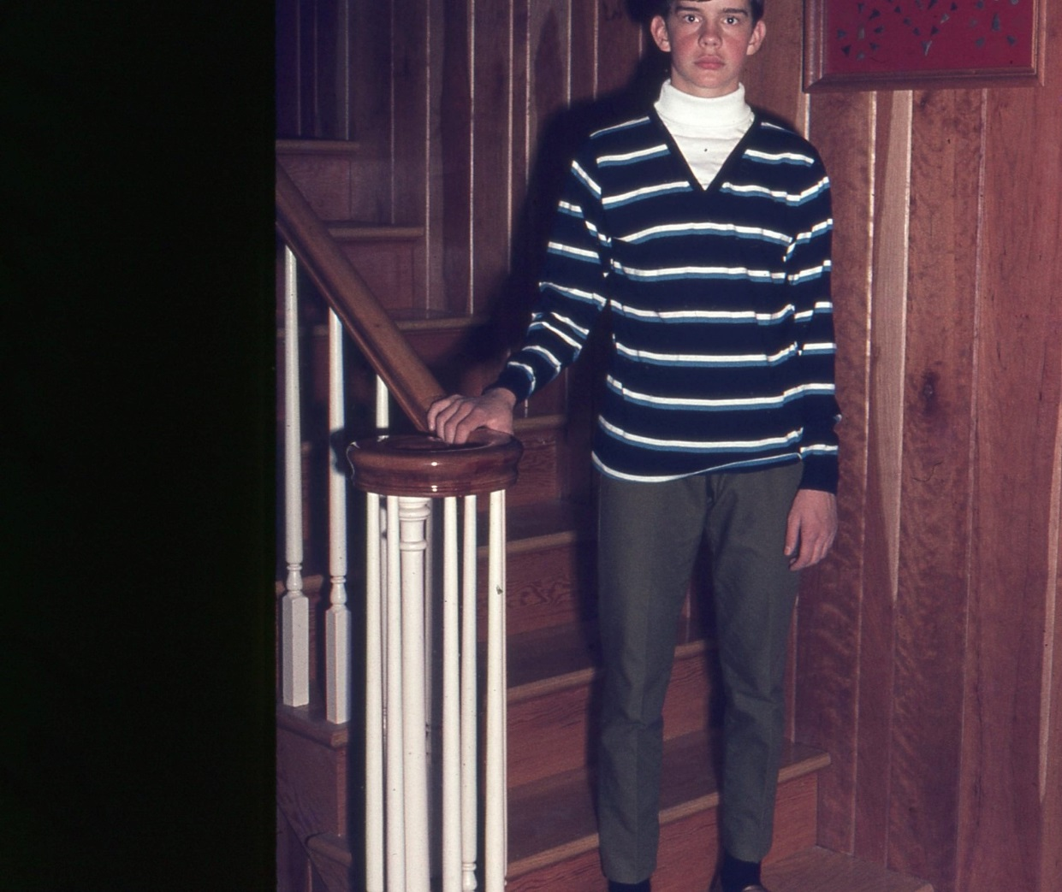
Above 1970, Dan Holliman, son of Rhodes B. Holliman

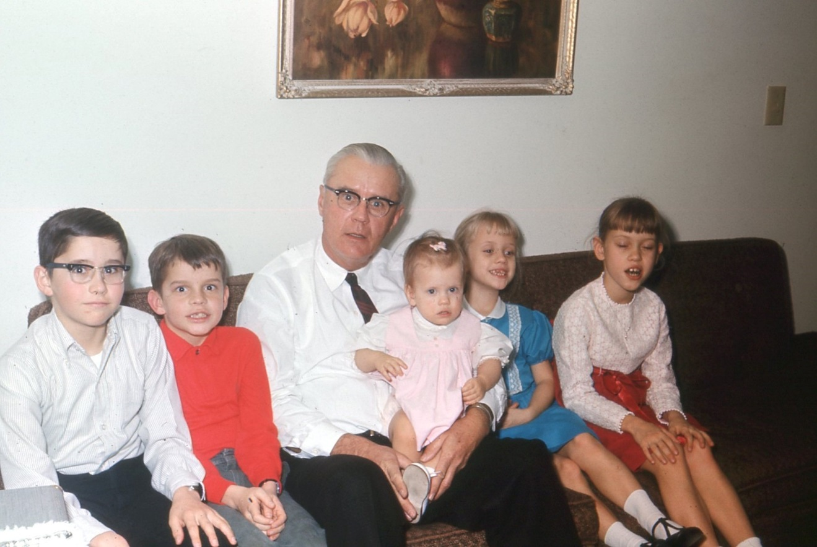
Above Cecil R. Holliman with grandchildren in 1965
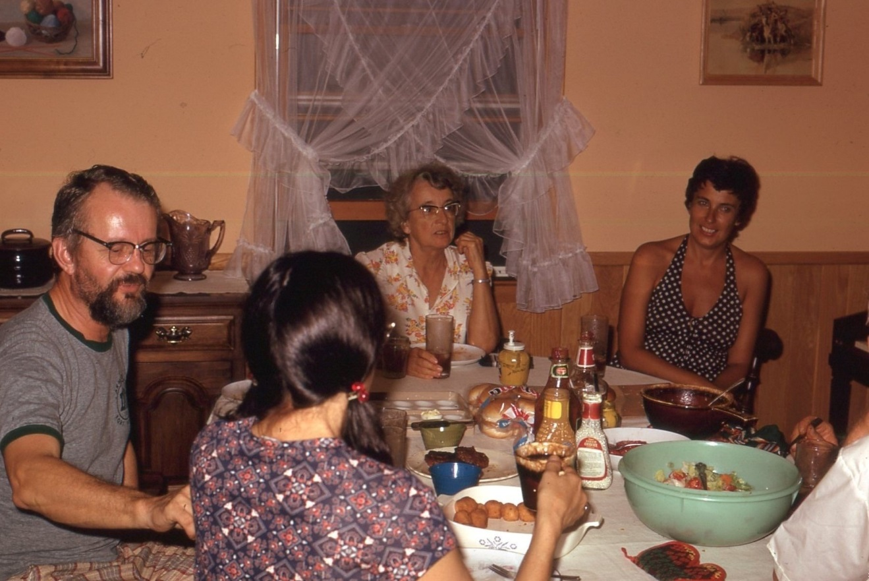
Above 1975 with Cecil Holliman on far left. Wife Mary back to camera.

