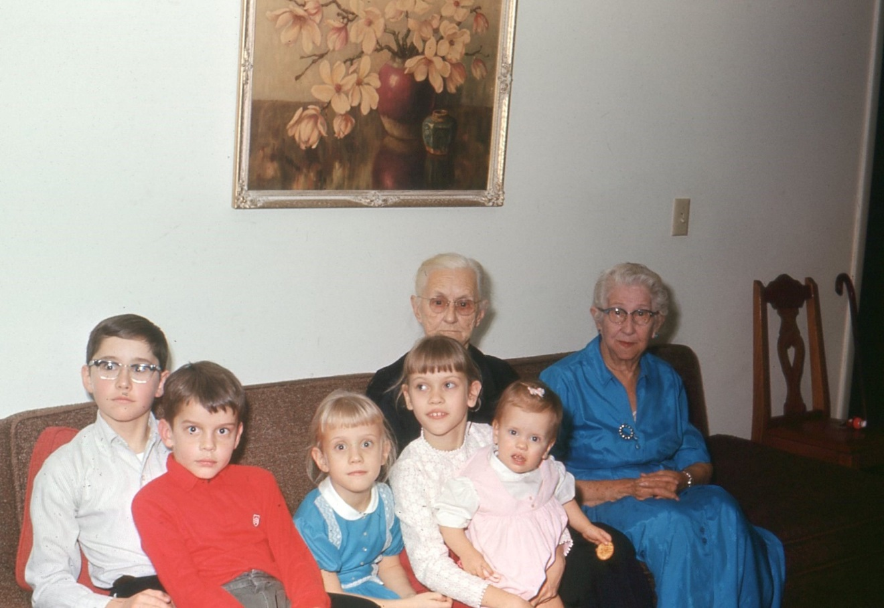
Above Youngblood house in 1965

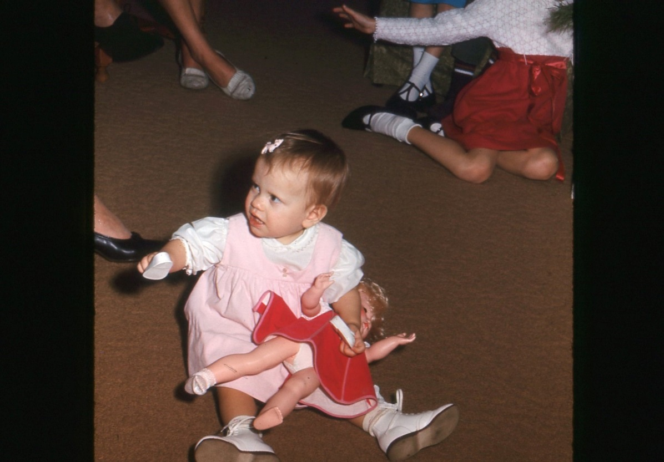
Above Susan Youngblood 1965

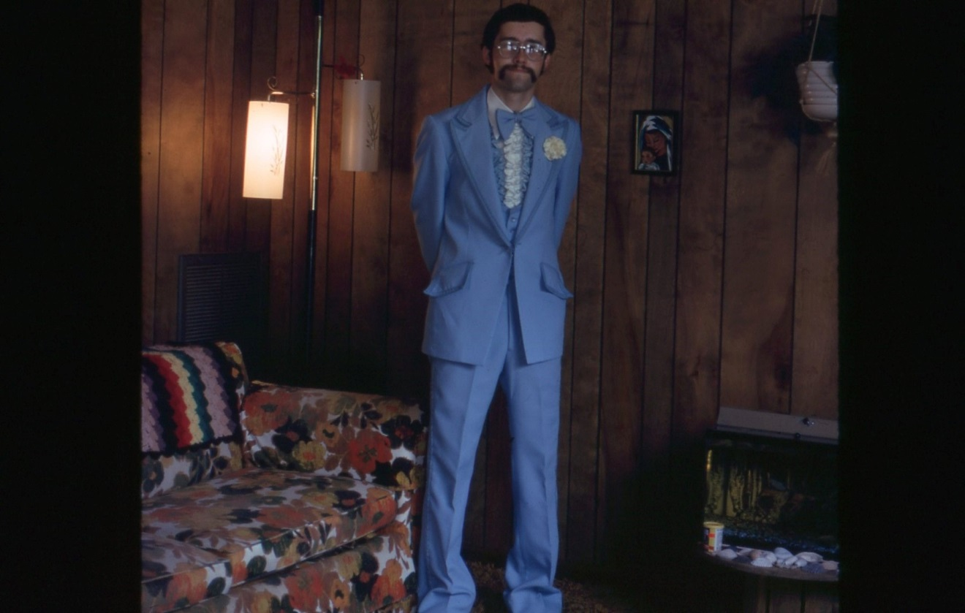
Jim Holliman above in 1976, Durham, NC and below in Melbourne, Florida 1973.
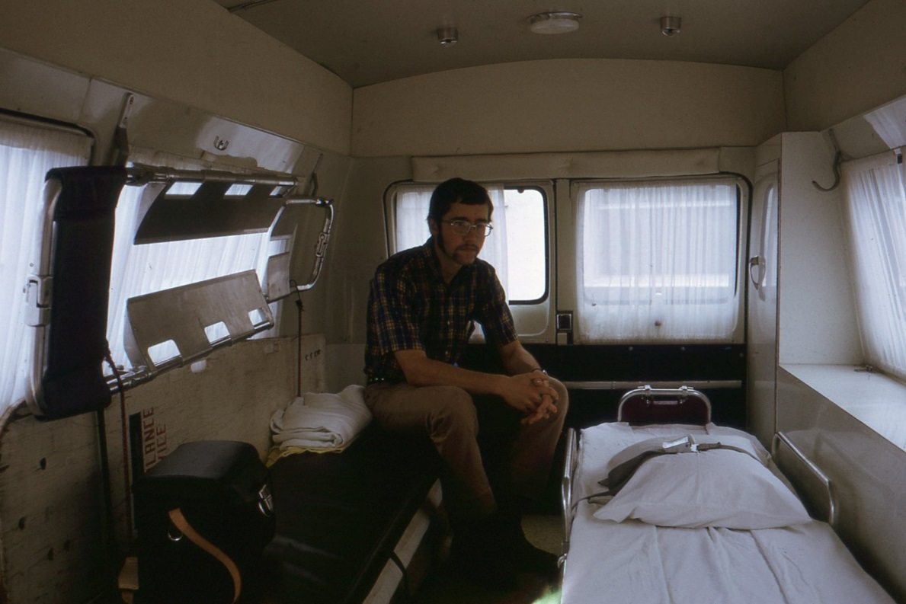

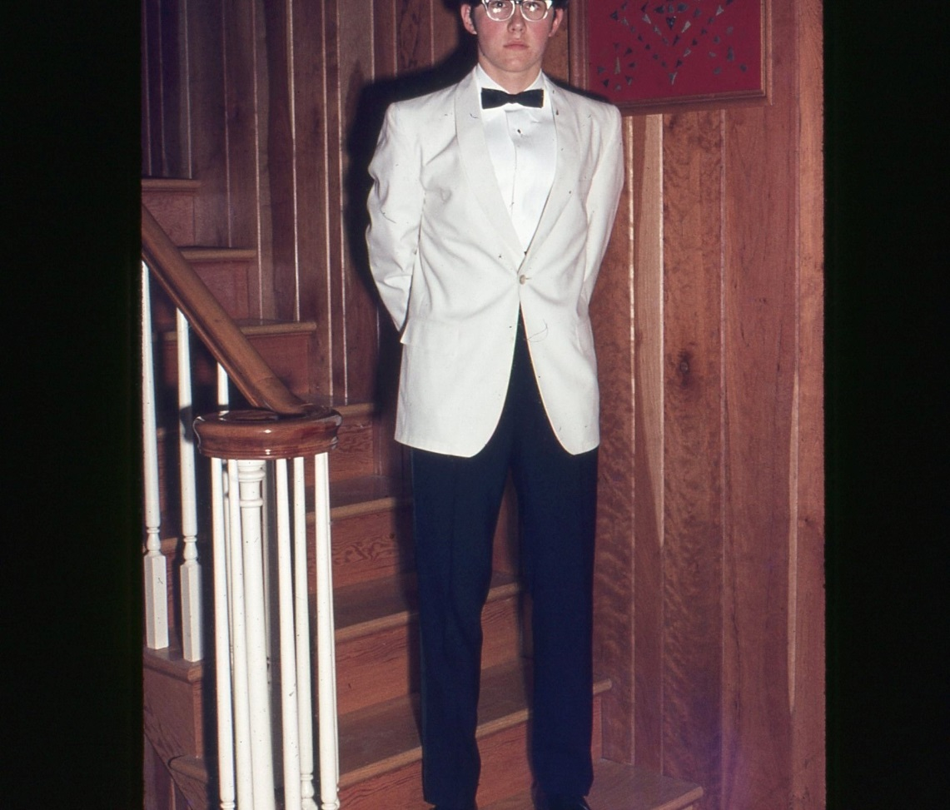
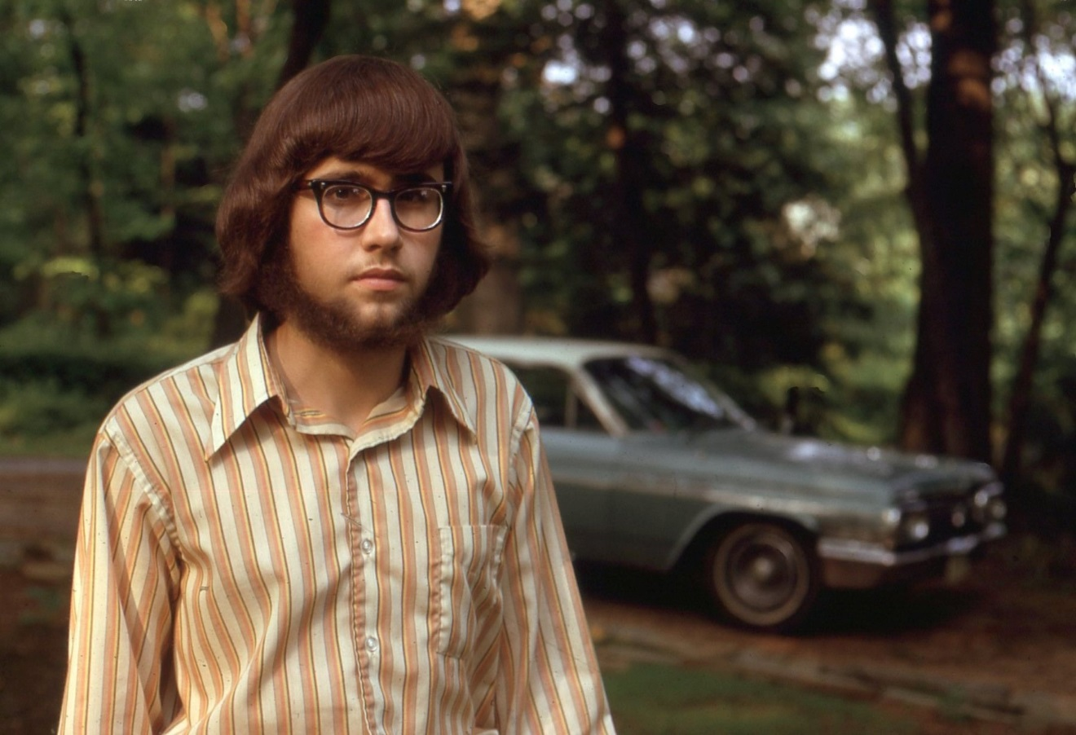
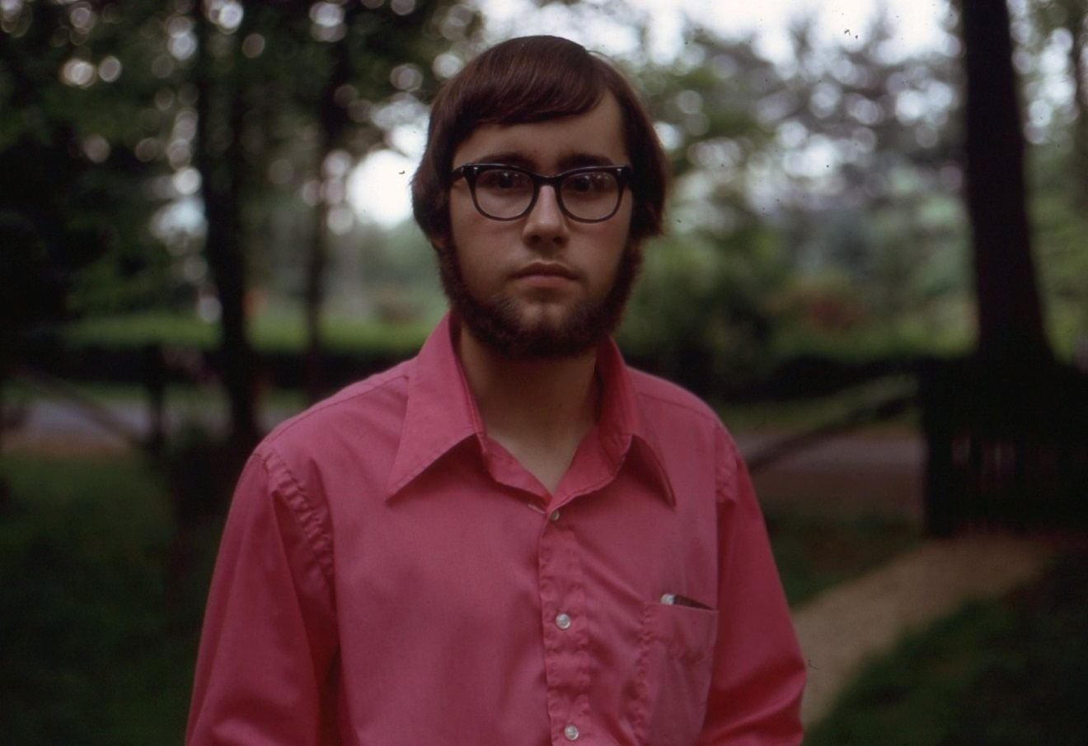
Above three photos of Jim Holliman in 1971; below his grandparents Cecil R. and Ruby Burns Holliman on their 50th wedding anniversary in 1977 in Birmingham, Alabama.

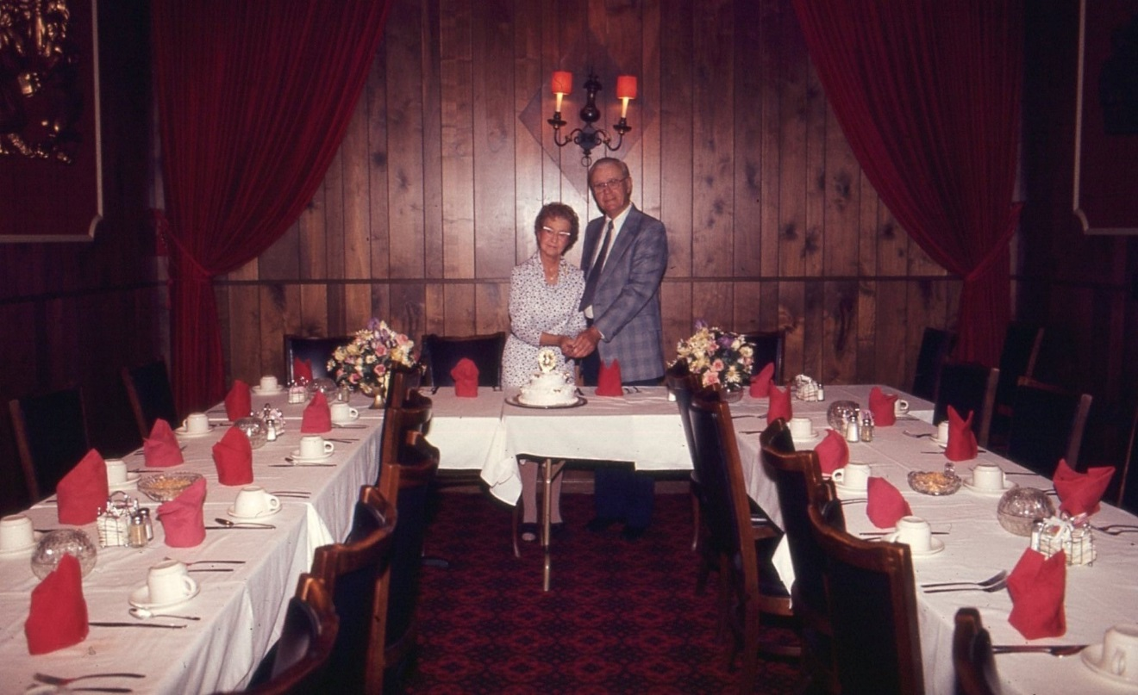

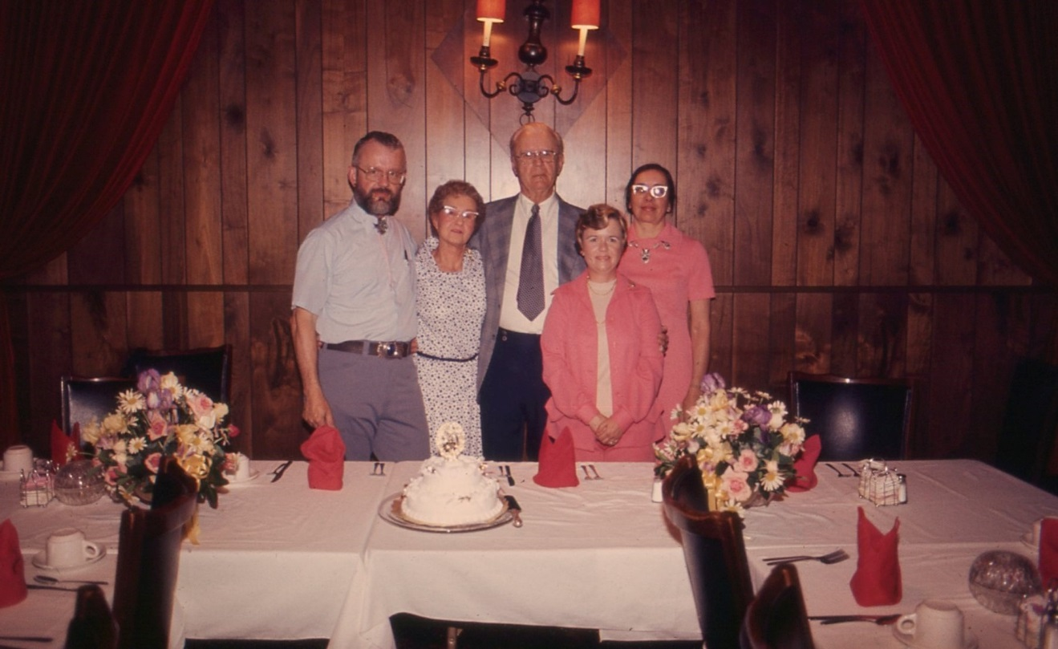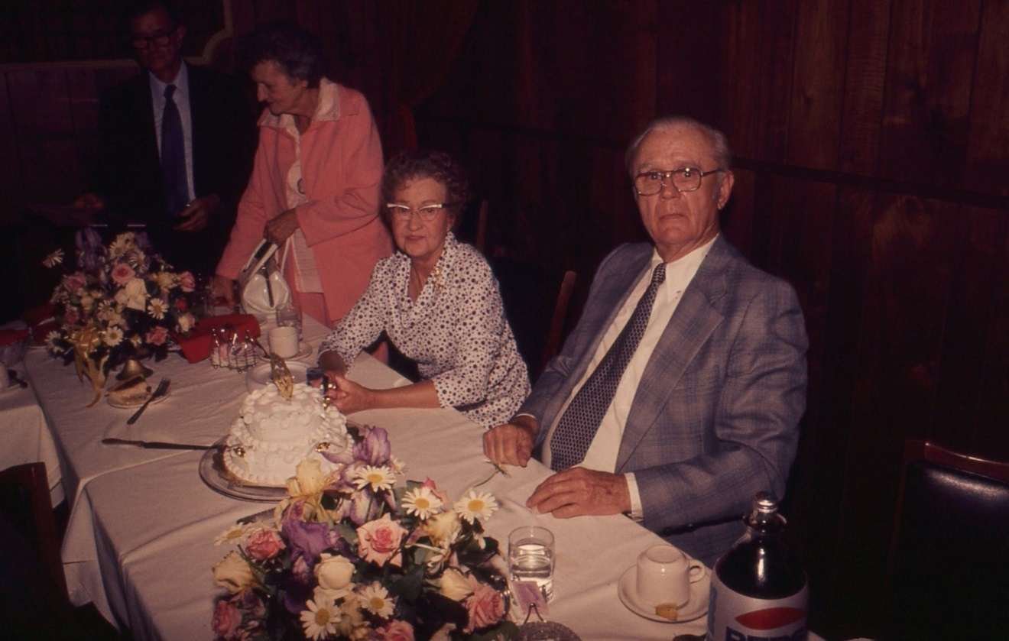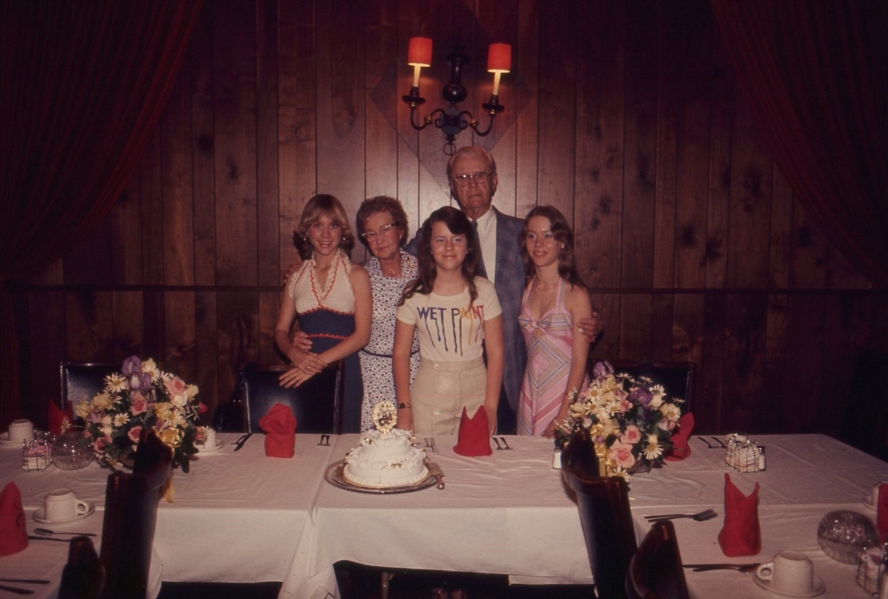
Above 50th Anniversary dinner; below funeral for Elizabeth Baker Holliman in 1978. Pearl and Mae below.
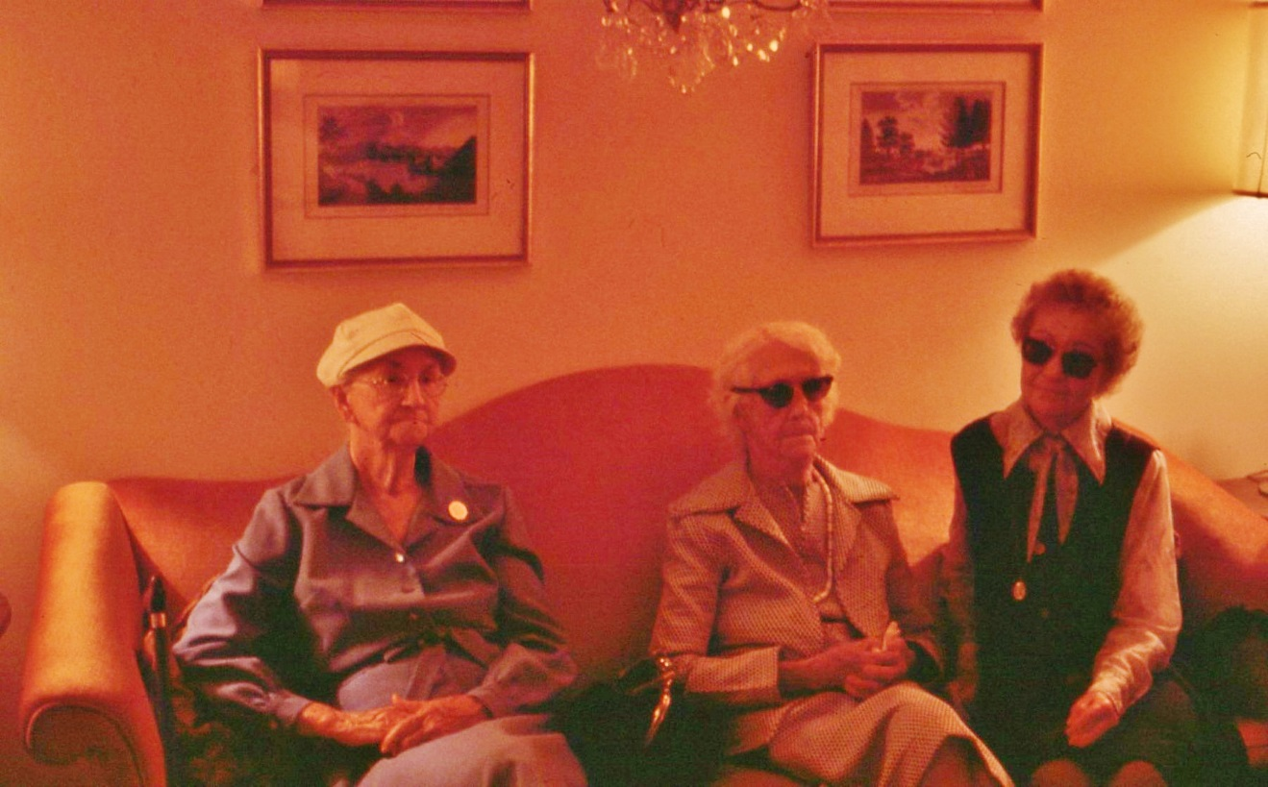

Below funeral of Eula Burns, mother of Ruby Burns Holliman in 1970 in Birmingham, Alabama.
