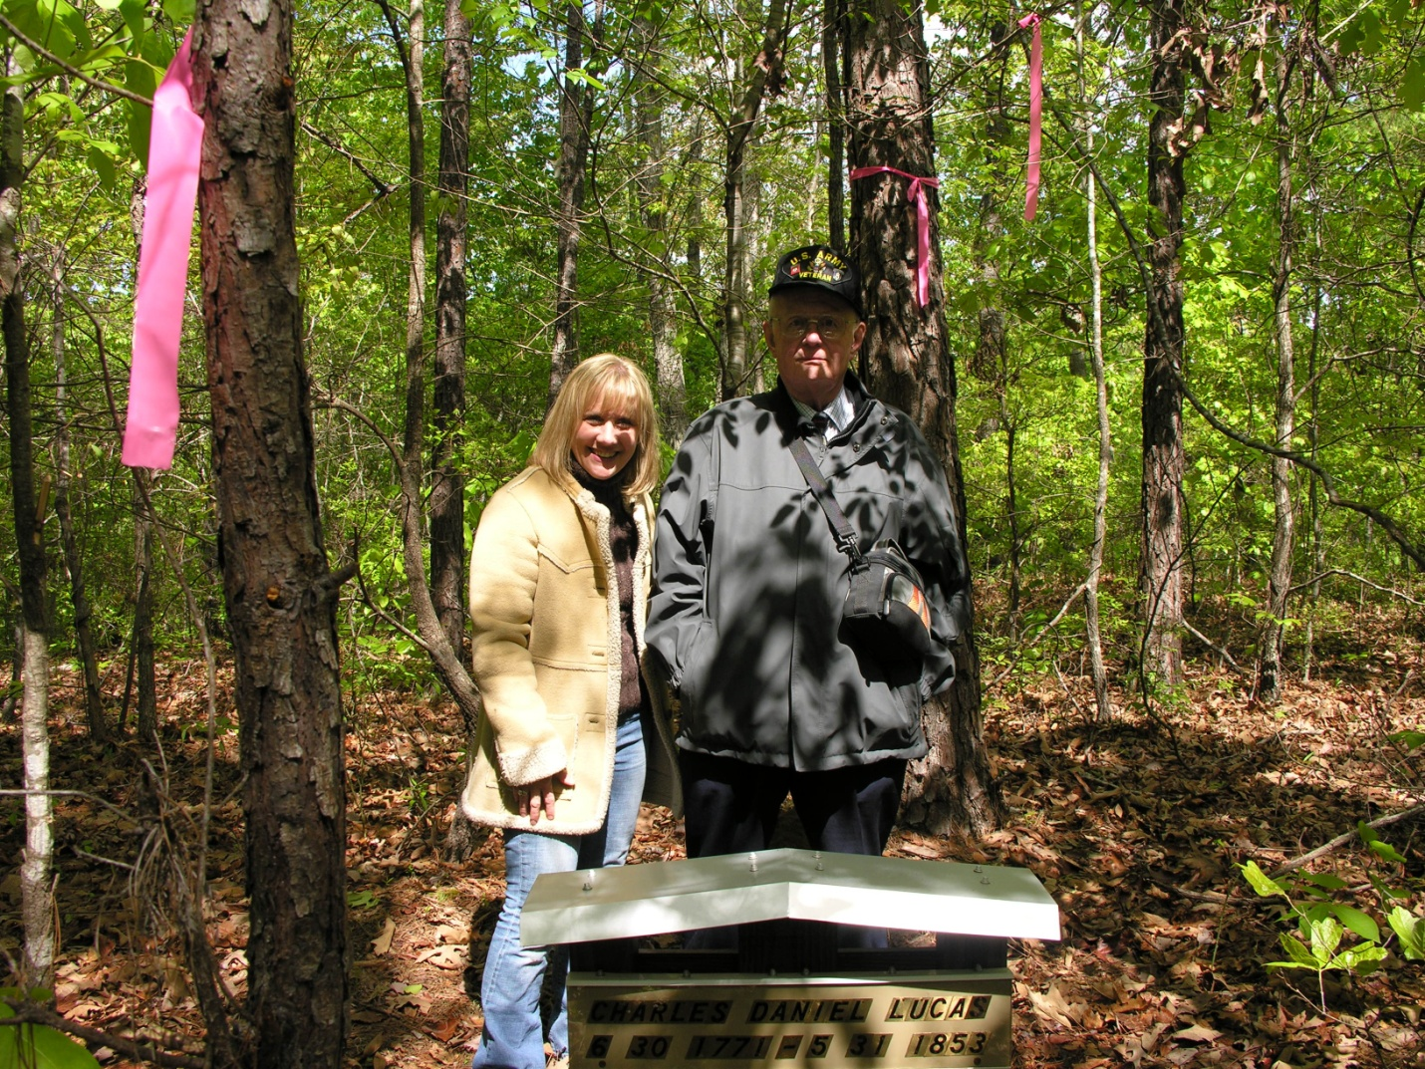
Dr. Rhodes Holliman of Virginia poses with his niece, Glenda Norris of Alabama, at the site of their ancestor Charles Daniel Lucas in Fayette County, Alabama. Rhodes is a retired research biologist from Virginia Tech and an accomplished scholar.
He is the great grandson of John Thomas Holliman, grandson of James Monroe Holliman and son of family historian Cecil Holliman. He has written extensively on the Holliman family and the Civil War. Glenda is an enthusiastic family historian and has conducted several tours of family home sites in Fayette County for her distant cousins. 2007

