A Partial History

of a Holliman Family

by Glenn N. Holliman, October 2011

Introduction
Since early 2010 I have been writing and posting articles on the Internet on the topic of Holliman family history (httt://hollimanfamilyhistory.blogspot.com/). In this publication, I have combined ‘blogs’ on several topics – my branch of the family’s English, Virginia and Fayette County, Alabama ancestors. If Providence grants me additional years, I hope to enlarge this publication with additional episodes in my branch of the Holyman family tree, specifically the years in the Carolinas in the 18th and 19th Centuries and in general to enlarge all sections.
Family history is usually a composite of research by numerous ancestors and family members still living. Such is the case with this compilation. In each ‘chapter’, I have attempted to credit my relatives with their research. There is also an appendix with photographs and biographies of most of the contributors. Interpretations and errors of commission and omission are mine alone.
Genealogy is both art and science. As new research and documents become available, the story may change. Critique and additional information are always welcome. This publication is for educational purposes and not for commercial gain.
I can be reached at Glennhistory@gmail.com and can email photos and materials to you that may be difficult to read in this publication.

The Sections

- A Holyman Family from England to Alabama
- When We Were English
- The Colonial Virginia Experience
- The Fayette County, Alabama Hollimans
- Family Lineage from Christopher Holyman, Sr. to John Thomas Holliman
- Contributors and Sources

SECTION I

A Holyman Family from England to North Alabama

1650 - 2010: 360 Years of American History in one Family

Christopher Holyman, Sr. arrived in Jamestown, Virginia in 1650, along with his sister, Judith. He and his immediate descendants lived approximately a century in Isle of Wight County and adjacent counties. However, around 1740, my direct Holliman descendants from this great grandfather began moving south and west searching for land and increased fortune.

For my line of Hollimans, the chronology is approximately as follows. Of course, sons and daughters were always splitting off and moving to other parts of what is the United States. Many in the late 1700s and early 1800s would move to Tennessee, Georgia and Kentucky. For the most part, my branch of this colonial family would migrate to and through the southern states, although there are exceptions.

Prior to 1650 – The origin of American family is England, with Christopher Holliman, Sr. born 1618 in Bedford, Bedfordshire, England with probable other relatives in Buckinghamshire and Hertfordshire, England. Research to date does not support the reported John Holyman (d 1650) of Tring, England and Southampton, Virginia as the father of Christopher Sr.

The parents of Christopher Sr. appear to be Thomas and Helene Poynard of Bedford. Research in 2011 provides evidence to take the story even further back to a Christopher Hollyman who died in Sherington, Buckinghamshire in 1589, who had a son named Thomas.

The map below traces my Holyman family migrations from Isle of Wight, Virginia to Birmingham, Alabama. Numerals are printed adjacent to each 'stop'. Below the map, the numerals are next to copy about each family historic home. As the map is copied from a history book, out of print, on the westward movement, no part of this map may be used for commercial purposes. Click on the map twice to enlarge. The large red arrows indicate the forced migration of Native Americans from their tribal lands as European - Americans and African -Americans advanced west ward.

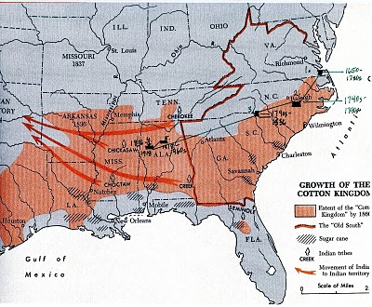

1. 1650 to 1740s - Most of my direct descendants lived in Isle of Wight County and adjoining counties in Virginia. Naturally, many descendants under the names of Holleman, Hollomon, etc. reside in southern Virginia to this day.

2. 1740s to 1790s - Through the parents and relatives of James Grantson Holliman, the Johnston County, North Carolina area became home for my branch of the family.

3. 1790s to 1836 - In the 1790s Anson County, North Carolina and Lancaster County, South Carolina (border counties) became the location of this James Grantson Holliman family.

4. 1836 - 1918 - In 1836, three sons of James Grantson Holliman moved their families to Fayette County, Alabama. The families of Charles and Cornelius Holliman stayed in Alabama and descendants live in the area to this day. Warren Holliman moved with others to Arkansas, and there remain many Hollimans. Others of these extended families moved to Mississippi, Texas, Louisiana and other parts of the southwest and middle Great Plains.

5. 1918 - 1960s - My generation's grandfather, Ulyss S. Holliman (1884 - 1965), a son of John Thomas, grandson of Uriah and great grandson of Cornelius, moved his family from Fayetteville, Alabama to Irondale, Alabama, a suburb of Birmingham in 1917. Several other families migrated to the economic attractions of the 'Magic City' also, including James Monroe Holliman, a brother of Ulyss, and his children. Others of Ulyss' brothers scattered throughout North Alabama; one half-brother, Bill Holliman, remained in Fayette County, dying there in 1940.

1960s to the present - While many of my first cousins remain in the Birmingham and North Alabama region, and 2nd and 3rd cousins in Fayette Country area, many grand and great grandchildren of Ulyss and Pearl Caine Holliman, have relocated across the country living at this writing in Chicago, Boston, Pennsylvania, South Carolina, Texas, Virginia, North Carolina, Tennessee, Alaska, Arizona and other states. As with many American families, advances in education, transportation and career opportunities have led to the dispersion of formally regionally located kinfolk to every part of the country.

The Family of John Holyman through John Thomas Holliman
Recently Holliman family historian Joe Parker has presented a Holliman lineage that differs considerably from one that has been posted on the internet for some time. In light of Mr. Parker's research and documentation, I support his thesis until information otherwise is reported. While this thesis centers on Bedfordshire, England as the origin of the family, I do not believe it rules out Tring, Hertfordshire and Cuddington, Buckhamshire as centers of Holyman family ancestors. My DNA shows me to be a great grandson of Christopher Holyman, Sr.

John Holyman (b 1560) Woburn, Bedfordshire, England (possible, not proved) or

Christopher Hollyman (d 1589) Sherington, Buckinghamshire.
Thomas Holyman (b March 4, 1575/76 in Woburn, Bedfordshire, England (possible, not proved) or Thomas Hollyman (son of Christopher and a school student in Sherington, Buckinghamshire in 1595). Married Henea Poynard, October 23, 1609 at St. Mary’s parish, Bedford, Bedfordshire, England.
Christopher Holliman, Sr. (b 1618, Bedford, England – d 1691, Isle of Wight Co., Virginia);
Richard Holliman (b abt 1665 - 1711), Isle of Wight County, Virginia. Married Margaret House ca. 1700.
Samuel Holliman (b ca 1708 - 1787 ca), died Johnston County, North Carolina. Circumstantial evidence indicates this is the probable father of James Grantson Holliman. Time, place and ruling out others focus our attention on Samuel.
James Grantson Holliman (b 1750, Johnston Co., North Carolina – d 1836, Mecklenburg Co., North Carolina). Wife was Elizabeth Bryant;
Cornelius Holliman (b 1792, Anson Co., North Carolina - d 1862, Fayette Co., Alabama) First wife and mother of Uriah, Mary Elizabeth Plyler (1793-1835);
Uriah Holliman ( b 1817, Lancaster, Co., South Carolina - d 1862, Okolona, Mississippi after the Battle of Corinth). Wife was Mary Polly Lucas (1819-1913);
John Thomas Holliman (b 1844, Fayette Co., Alabama – d 1930, Fayetteville, Alabama). Of the marriage to Sarah Corbett, William Perry Holliman (1871-1941) was the surviving child. Of the marriage to Martha Jane Walker, five sons were born: Silas Green Holliman (1876-1943), James Monroe (1878-1938), Thomas Leland (1880-1970), Andrew Eckford (1882-1926) and Ulysses Selman Holliman (1884-1965).

Section II

When We Were English, Part I

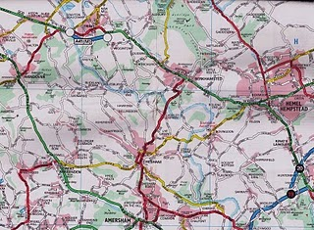
Some First Thoughts on Our English Roots
This map is somewhat dated, but in the upper left hand corner is Tring, Hertfordshire, England. Just to the east of it is the little village of Aldbury and south is Cholesbury. To the west of Hemel Hempstead is Berkhamsted. Toward the lower right hand corner is the tiny village of Chipperfield. In left center is Wendover, and to the west, but not on this map, is Cuddington. London is off the map to the southeast. Holymans and Hollimans lived in these villages and towns from the 1400s through the 1600s according to English records.
I have had the pleasure of traveling to England numerous times in my life. As I have become older, my interest in family history has grown. In 2010, my wife, Barb and I invested a number of days researching Holliman history in an area approximately 25 to 30 miles from the center of London. These towns and villages were Tring, Aldbury, Cholesbury, Cuddington, Chipperfield and Berkhamstead in both Hertfordshire and Buckinghamshire.
In graduate school, (gasp 1970!) I studied history and know that primary evidence is crucial to any research. There is a popular and well-researched Holliman family tree website that lists John Holyman (1572 - 1650) as the direct line of our family, born in Tring, Hertfordshire and died in Southampton, Virginia. Unfortunately, no one has yet shared with me the hard evidence of this birth and death date or the fact that the gentleman ever existed. This does not mean that facts do not exist somewhere; it is just that I have not seen such or discovered it in my research.
Let me quickly say that hard primary evidence exists for our first American Holliman, one Christopher Holliman, Sr, who died in Isle of Wight County, Virginia in 1691. We have his will and many legal records. Evidence exists Christopher and his sister, Judith, are from Bedford, Bedfordshire, England, a strong possibility we shall explore later. For now, let us begin our journey in the Chiltern Hills around Tring, Hertfordshire.
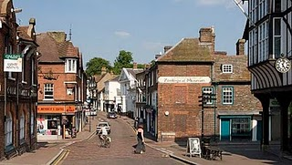
High Street in downtown Tring, Hertfordshire.

Note: Holliman in both England and the U.S.A. is spelled in numerous ways. As literacy and sounds varied in both countries, the surname has been produced in numerous ways such as Holyman, Hollyman, Hollman, Holliman, Holleman, Holloman, Hollomon, etc. As I write of our ancestors in the transition in the 1600s from England to Virginia, I find myself flipping back and forth from Holyman to Holliman.

When We Were English, Part II

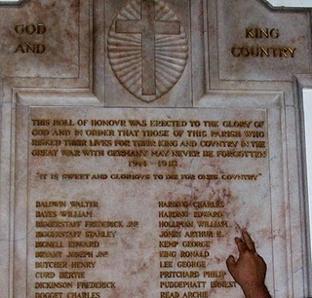With the exception of the historical painting of Elizabeth I below, the other photos in this blog are of memorials to Hollimans and others in St. Paul's parish, Chipperfield, Hertfordshire, approximately 25 miles northwest of Central London.
August 31, 1997, my wife, Barb, and I assembled for the baptism for our godson, Joseph Jeffries, at St. Paul's Anglican parish in Chipperfield, Hertfordshire, England. What should have been a day of joy, instead was a sad morning. Princess Dianna, formerly Princess of Wales, and her boyfriend, Dody Fahad, had died in the early hours in a Paris car crash.
The priest, a lady of whose gender there were only a few at that time in all the England Church, prayed for the repose of the departed souls as she attempted to turn the congregation’s attention to the welcoming of Joseph into the Christian family. Ironically, Diana’s car had smashed itself to a compressed block of metal, plastic and human flesh in a tunnel just a block from where Barb worked the year before at the capital campaign for the American Cathedral in France.

With these conflicting thoughts tumbling through our heads, we ventured to gaze around the lovely neo-gothic nave. Good grief! The walls were covered with war memorial plaques in memory of Hollimans and other villagers! Had we stumbled on to the ancestral home of the Holliman clan? Much evidence indicates that yes, the English Hollimans (or Holleman, Hollyman, Hollomon, etc.) did establish themselves or at least some of the family in Hertfordshire, England around the villages of Chipperfield and Tring, located 30 or so miles northwest of London proper. Other villages with Hollymans were Berkhamsted, Aldbury, Cholesbury, Haddenham and Cuddington.

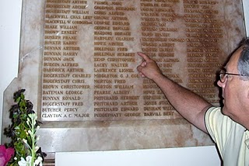

It is obvious from these memorials that in the last two World Wars, numerous Holliman kinsmen mustered with their English regiments, and sadly all did not return.

Until 2010, most of our American genealogical trees began with one John Holyman, allegedly born 1572 in Tring, Hertfordshire. This was during the reign (and rule) of that magnificent Tudor queen, Elizabeth I. Anglicanism had replaced the Roman Catholic faith in the land, helped along by several burnings at stakes of recalcitrant Catholics and not a few Spanish Jesuits who sought to return England to the Old Faith. The friction between Spain and England, exacerbated by privateers Drake and Raleigh, eventually led to the sailing of the Spanish Armada of 1588.

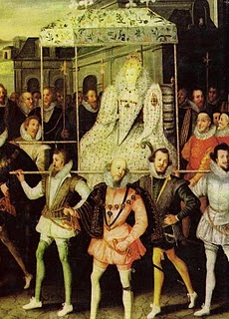

This is Robert Peale's painting of Queen Elizabeth being carried by her devoted courtiers.
Elizabeth called out the able bodied men of England to repel the invader if the embryonic English fleet was not able to do so. One wonders if our Holymen kinsmen did not muster on a village green with pike in hand? Evidence discovered in 2011 indicates that at least one Christopher Hollyman, served in Sherington, Buckinghamshire as a Guard of the Queen.

When We Were English, Part III

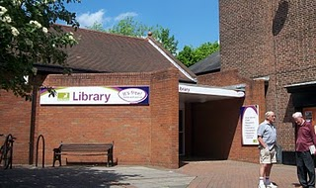

A Holyman in the Late Middle Ages
In the local history section of the Tring, Hertfordshire library (photo with patrons in front) there is a book entitled A History of Tring by Sheila Richards, a denizen of the area. Published in 1974 by the Tring Urban Council in Hertfordshire, it contains many stories, family names and records. While pursuing this work I found on page 53 the following information that was translated from middle English.
From the Court Rolls of the Manor of Tring - Courts 28 May, 18 June and 9 July 1444 (yes, 1444, not 1944!)
"Plaint Continued: the plaint between William Holyman, defendant, and Richard Brame of Chedyngdon, plaintiff, in a plea of trespass, is continued by order."

Observations?

1. Holymans had surnames by the 1400s as did most English by this century.
2. Holymans lived in Tring two centuries before American founder, Christopher Holliman, sailed for Virginia in 1650.
3. This complaint of trespass may have involved a stray animal or William planting a crop on Brame's leasehold. Everyone leased from the Lord of the Manor or shared the common fields surrounding Tring. This lack of personal land is what attracted many of our ancestors to America.
4. As the complaint was continued to another day, perhaps it was settled out of court (just as most legal complaints are today).
There is another mention of William on page 54. He is listed as a juror to decide a leasehold inheritance on shared common town lands known as Goldfield and Bulbourne crofts surrounding Tring.
Observations on this entry?
1. Whatever William's issue in the trespass complaint, it did not keep the judge from appointing him to a jury that summer.
2. Although English common law was in its infancy, the jury system was working, wills were common and so were lawsuits in England by the 1400s.
3. To be appointed to a jury is a compliment indicating some standing in the community.
There was nothing else in this book on William Holyman. Thomas Cromwell, Henry VIII's chancellor, in 1538 required all churches to keep parish records on baptisms, marriages and deaths. Too late for this 15th century William. So where to look? Manorial Court records? Yes. And where are they? At the Public Record Office in Kew, near London. Did this William have a will? Here is an English government web site to explore: http://www.nationalarchives.gov.uk/.
The Middle Ages were Ending
What was happening in our England of 1444 when this possible Holyman ancestor was having legal troubles?
A weak king, Henry VI (photo below) occupied the throne from the first year of his life 1422 until deposed in 1461. He would have made an excellent monk, but was a poor king. He is the only English sovereign to have been crowned in both England and France. His mind was unbalanced, and when a protector stepped in to serve the crown, a civil war broke out. The Houses of Lancaster and York began fighting the War of the Roses.
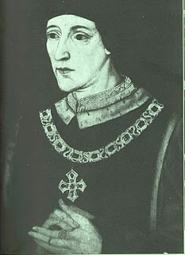
France and England were near the end of their Hundred Years War. Henry's father, Henry V, had conquered a considerable portion of France during his short reign. However, the French reclaimed almost all of their land during Henry VI's time on the throne.
This was the period when the charismatic Joan of Arc (her photo below) revitalized the French army. The English nobles, not at all pleased by such a turn of events, burned her at the stake as a witch. Remember, this was the Middle Ages, and burnings would continue even in the English colony of New York until the 1700s. Nasty way to shuffle off one's mortal coil.
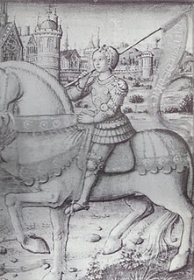

Above, Joan of Arc of France

When We Were English, Part IV

The Turbulent Life of The Rt. Rev. John Holyman, First Installment
The small village of Cuddington, Buckinghamshire, England is approximately 12 miles from Tring, Hertfordshire, the believed homesite of John Holyman (1572 - 1650). Another John Holyman, The Rt. Rev. John Holyman, lived earlier during the eventful times of the Tudor kings and queens. This earlier John played a role in attempting to forestall the Protestant Reformation in England. While we do not know his lineage, time, place and name suggest we American Hollimans carry some of his family DNA. An ancestral cousin or uncle? I would say the odds favor such, and perhaps some day we can connect all the dots.
It was while researching Holymans in the Tring Library, I came upon the incredible news that a Holyman farm existed in nearby Cuddington, and that Bishop John Holyman had been born there. Cousin Maxine Wright of Arkansas had emailed a blurb on this John Holyman several months earlier alerting me to the existence of this particular Holliman. Within the hour, my wife and I drove to the village and indeed visited the Holyman farm, met the present owner, and the next day interviewed one of the village historians, Miss Peggy Cattell. We spent several hours with Miss Cattell and her sister, Nancy, collecting information and papers.
What follows is the first portion of a paper presented in 2005 to the local historical society by Miss Peggy Cattell (photo below) which we reproduce with her permission.
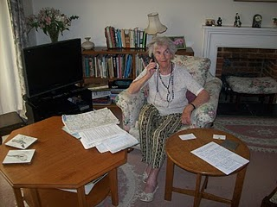
"They Lived In Cuddington"
" It was in 1495 that John Holyman was born. Records don't give any further information about his life in Cuddington, other than that he was born here but the family home was probably a manor house in the field near to the present Holyman's Farmhouse."
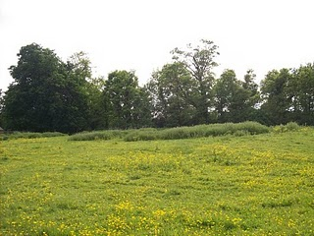On the site of this grassy knole on the west side of Cuddington stood the manor house of the Holyman family in the 15, 16 and 17th centuries. Today this field stands fallow for sheep pasture on still existing farm land.
"Another and more accurate assumption can be made that he must have been baptised in Cuddington Church, in the font which we still use. The font goes back well before his day. We know that the font was moved into its present position in the south aisle from the north aisle in the later part of the nineteenth century."
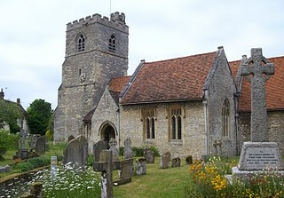

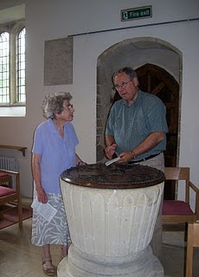
The photo above top is the exterior of the Cuddington parish. The above lower photo is of the baptismal font which is over 500 years old. Miss Nancy Cattell is on the left, and the author on the right taking notes. Photos by Barbara Holliman.
"We can say for certain that his parents brought him through the present north doorway, and from the list of vicars we can assume that the incumbent of that time - William Burtone, priest from 1494 to 1511 - must have performed the baptism."
When We Were English, Part V

The Turbulent Life of The Right Rev. John Holyman, Installment 2
Below we continue the paper of The Rt. Rev. John Holyman that Miss Peggy Cattell presented in 2005 to the Cuddington Historical Society, Buckinghamshire, England.
"John went to school in Winchester (a prestigious school, second only to Eaton), probably at the age of eleven and developed into a fine scholar. From there he entered New College, Oxford and was awarded the Bachelor of Divinity in 1526. For a short time he was rector in Colerne (in Ireland) but this did not suit him. He turned to Oxford, this time to Exeter College, where he acquired a Doctor of Divinity degree.

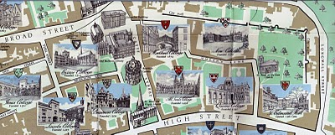New College, top right on the above map, is just inside the Old City Wall in Oxford. Not so new, New College was founded in 1379. Center left of the map is Exeter College, a bit older founded in 1314.
"After this second time at Oxford, Dr. Holyman became a monk at St. Mary's Abbey, Reading."
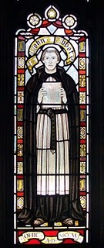This stained glass window at the Bristol, England Cathedral is of the founder of the abbey which later became the Cathedral where The Rt. Rev. John Holyman presided from 1554 - 1558. Brother John Holyman, when a monk, would have worn a habit such as above and had tonsured hair. Photo by Barbara Holliman.
"By this time, he was known as a brilliant scholar, a man of great piety and most eloquent preacher - fine qualities but not ones to blaze his name over the country, but this was soon to come. "
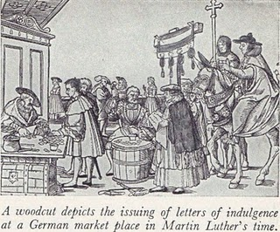"The age in which he was living was one of great religious upheaval. Up to 1517 all of Europe belonged to the Roman Catholic Church owing allegiance to the Pope. In Germany, Martin Luther spoke out again the selling of indulgences - that is people being offered the chance to buy themselves absolution from their sins. Luther believed that only through faith in Jesus Christ could sins be absolved. His concerns spread and a wide rift developed in the church. Those who protested again the Pope and Roman Catholic Church came to be known as Protestants."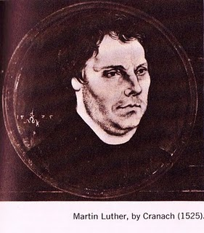
"Holyman's abbot became concerned at what he described as this Lutheran Heresy spreading to England and he sent his best preacher up to London to speak against these thoughts at St. Paul's Cross. And so Holyman was thrust into the centre of this important conflict!" (Speaking at St. Paul's Cross in the 1500s would be today's equivalent of appearing on all the major television news channels and having a Facebook page.)

When We Were English, Part VI

The Turbulent Life of The Rt. Rev. John Holyman, Installment 3
Historian Nancy Cattell continues her paper on Cuddington, Buckingshire resident John Holyman.
"While in London Brother John embroiled himself in not just Reformation issues but also the marriage crisis of King Henry VIII (1591 - 1547). Henry had decided that he must ask the Pope to grant him a divorce from his first wife, Catherine of Aragon. He claimed that because she had been his brother's widow he should not have been given the dispensation to marry her. This 'sin' was smoting him."
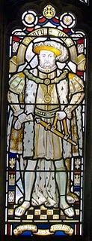This likeness of King Henry VIII is in the Cathedral at Bristol, England, the Cathedral from which Bishop John Holyman presided 1554 to 1558. Photo by Barbara Holliman.
"This after 20 years of marriage, but of course the real reasons for his desire for a divorce were (a) that Catherine had not provided him the son he wanted and (b) much more important - he had fallen desperately in love with Ann Boleyn and wanted to marry her." Catherine’s picture is below.
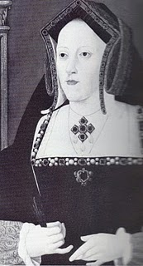
"The Pope refused Henry's request and good Catholic that he was Brother Holyman started preaching in favour of the validity of the marriage to Catherine. This was a very courageous act or if you like, a very foolhardy one for Henry did not approve of criticism."
Anne Boleyn, the mother of Queen Elizabeth I.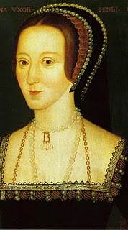.
"Holyman must have made a discreet move from London otherwise he would surely have lost his head - one book I read told me that his abbot did and certainly the Abbey was dissolved during Thomas Cromwell's 'displacement'. "
"As we know when the Pope refused to grant the divorce, Henry cut the Church in England off from the Roman Catholic Church and thus the Church of England came into being. Henry declared himself the head of the Church and so obtained his divorce from his new Archbishop Thomas Cranmer."
"Brother John Holyman left London and sought refuge in Long Handborough, near Woodstock where he became the rector (and kept his head and kept it down)."
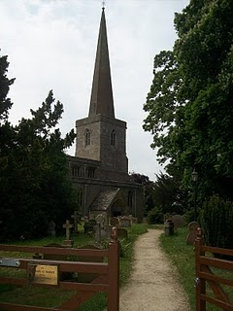
The parish church in Long Handbourgh stands today between Oxford and the historic town of Woodstock, the home of Blenin Palace and the birthplace of Sir Winston Churchill.

When We Were English, Part VII

The Turbulent Life of The Rt. Rev. John Holyman, Installment 4
During the last years of Henry VIII and the reign of the boy king, Edward VI, our John Holyman served as priest at Long Handbrough, near Oxford, and later vicar at Wing, near Tring, Hertfordshire.
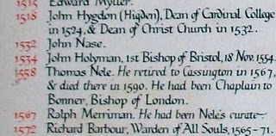
The name John Holyman appears (above) on this list of rectors who have served the parish in Handborough. This roster hangs on the church wall. There is an error; John Holyman was the second, not first Bishop of Bristol.

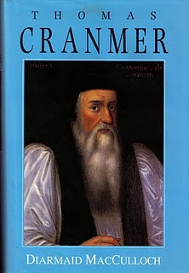
The photo of the book of Archbishop Thomas Cranmer is the latest in many excellent works on this pivotal priest during the Reformation. Some of the activities of our Bishop of Bristol are recorded in Diarmaid MacCulloch's biography which was published Yale University Press in 1996.
During the English Reformation, out went certain Roman traditions and services and in came a more simplistic style of worship and church decorations. English, not Latin, became the language of the pulpit and altar. Cranmer wrote the first Anglican Church prayer books, the model and language which survives even into the 21st century in the American Episcopal Church.
How did this strongly Roman Catholic John Holyman retain his priesthood and parishes in all this change? Discretion must have been his middle name.
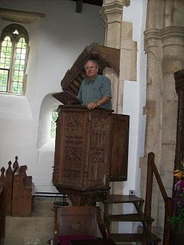
However, one of his distant descendants practices an indiscretion, standing in the 15th century pulpit where John Holyman preached in the 1540s in Long Handborough. Photo by Barbara Holliman, wife of the bogus preacher.

When We Were English, Part VIII

The Turbulent Life of The Rt. Rev. John Holyman, Installment 5

The life of John Holyman reached a climax during the reign of Queen Mary Tudor, or 'Bloody Mary' as she was termed by Protestants. Nancy Cattell of Cuddington, Buckinghamshire, England concludes her story of this distant ancestor.

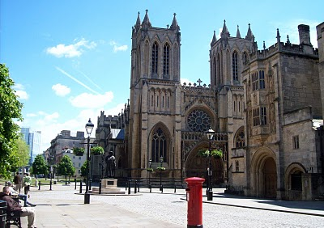

The west entrance to the Bristol Cathedral with a quintessential Royal Post Box in foreground. From 1554 to 1558 The Rt. Rev. John Holyman occupied this Episcopate. Photo by Glenn Holliman
"Upon the accession of the Catholic Mary, daughter of Catherine of Aragon, John Holyman was appointed Bishop of Bristol, obviously as a reward for his support of her mother. Once again Holyman was into the limelight for now the Protestants who had supported Kings Henry VIII and Edward VI were to be tried. Bishop Holyman was included in the commission that tried Latimer, Bishop of Worchester and Ridley, Bishop of London. They were found guilty of heresy. In 1554, Holyman also participated in the disputation of Archbishop of Canterbury, Thomas Cranmer."
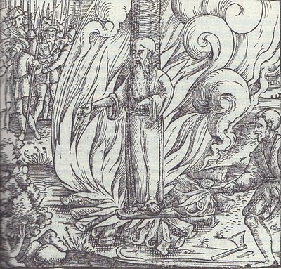
All three Protestant bishops were burned at the stake at Canditch in Oxford for their 'heresy'. The above woodcut is of Cranmer's death from the famous Fox's Book of Martyrs. In Bristol from 1554 - 1558, five more Protestants found martyrdom as 'candles' for Protestantism. In fairness to The Rt. Rev. John Holyman, he is reported to have opposed such actions, but they did occur during his episcopate.
"In 1558, Mary died and was succeeded by the Protestant Elizabeth. So once again the tables were turned and the Catholics were now put on trial. Bishop John Holyman avoided a violent death, as he died of natural causes a month after the accession of Queen Elizabeth I. His burial took place at Handborough Church."
"I am so amazed that anyone born in the 16th century in what must have been at that time the most obscure of little villages should have produced a man who was at the centre of all the important happenings of that tumultuous time." - Nancy Cattell, Cuddington, Buckinghamshire, UK 2005

Paul Bushe, the first Bishop of Bristol received an ornate tomb with effigy (photo next of the Bushe tomb at the Cathedral sanctuary).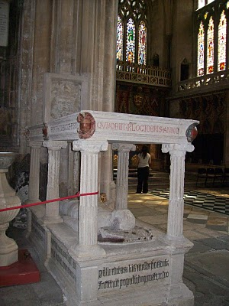

But the second bishop, much more controversial and in disrepute at his death, lies buried in Long Handborough in his former parish church. John Holyman's remains lie under or near this 16th century memorial (photo below) in the small village parish near Oxford. Photos by Barbara Holliman.

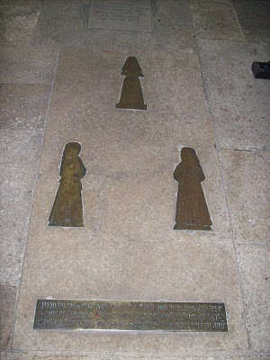

When We Were English, Part IX

Bishop John Holyman's Will, 1558

During my 2010 visit to the village of Cuddington, Buckinghamshire, England, this photograph (below) was taken of Mrs. Caroline Stonham and myself in the back garden of her 17th Century thatch cottage.

What is remarkable about this cottage is that it rests on the Holyman farm, and Holymans used to live in the residence in this photograph!

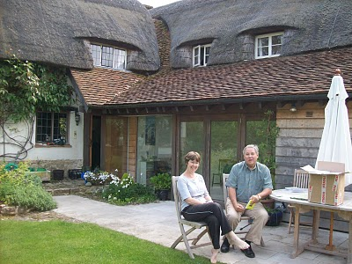
In a previous chapter, I dropped in a photograph of the location of the old 'manor' house where 16th century Holymans lived, approximately 200 yards from where Caroline and I are sitting.

We are reviewing Holyman papers she has collected in the twenty years she has lived on the farm. She is a geography teacher and has a keen appreciation of the history of her home. She kindly shared of her research and gatherings with me, allowing my wife to photograph the many documents. With her permission, I now share them with you.

One of the papers we reviewed follows. It is the 1558 will of Bishop John Holyman. It is a transcription but it does contain a bit of Shakespeare era English. Being celibate, John had no children, but he did have servants whom he remembered and he left funds to colleges and the parish where he is interred. Notice he left funds to pray for the repose of his soul. For one who had been a monk, and had taken a vow of poverty, he left a sizable estate although no land. But he was a bishop which was the top of the ecclesiastical hierarchy.

Page 1
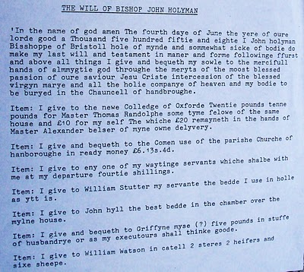

Page 2
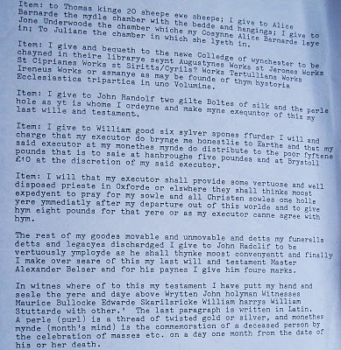

When We Were English, Part X
Continuing the Search for our Ancestors in England

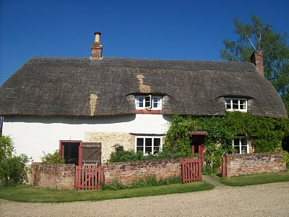In the above 17th century thatch cottage lived great nieces and nephews of The Rt. Rev. John Holyman who was born on this farm in 1495. Numerous legal papers and research tell of the family. What follows are copies of research from Caroline Stonham, current proprietor of the Holyman Farm in Cuddington, Buckinghamshire.
Page 1
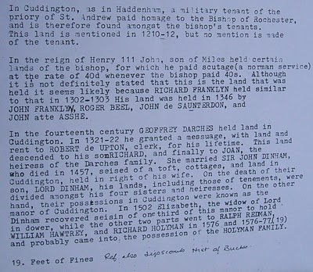
Page 2
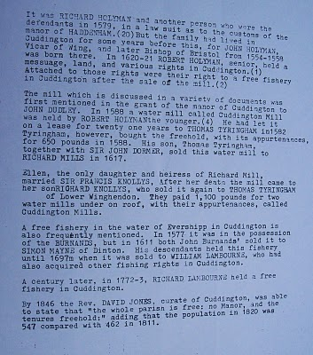These documents may be of use to any Hollimans who research our English roots....unfortunately the names of John Holyman (1572? - 1650) and Christopher Holliman (1618 - 1691) have not appeared in documents from the Holyman Farm.
However after research in 2011 in England, my eye is directed to Thomas Tyringham in the story above. A prominent Tyringham family lived a few miles from Sherington, Buckinghamshire, the home of a prominent Christopher Holyman in the 1580s. Is this a connection tying the Cuddington Holymans to the Sherington Holymans and hence to our Christopher Holliman (1618 – 1691)? Tantalizing, is it not?

When We Were English, Part XI

More on the Holyman Farm, Cuddington, Buckinghamshire, England

In the past few posts, I have been sharing information and photographs of a Holyman farm, described in some English sources as a former 15th century manor house. In the photo below is a contemporary plaque attached to one of the barns, now a residence. This sign celebrates the name of the farm and its most famous namesake, Brother John Holyman (1495 - 1558), a monk and later the Rt. Rev. John Holyman of Bristol. Photo by Barbara Holliman

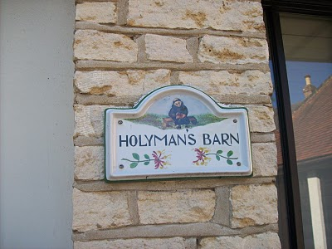

Below from “The Monuments of Buckinghamshire” is a description of the 17th century thatched Holyman cottage that we have featured in previous posts.
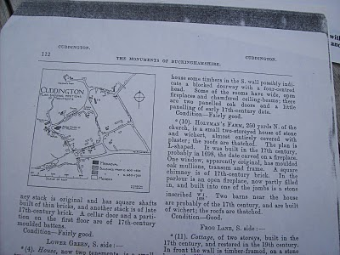

The current owner of Holyman Farm, Mrs. Caroline Stonham, has prepared the following family tree of the Holyman family and others that lived on the property. Perhaps it is of some use to those studying deeply into our English past. Through it one may be able to connect the family to our other English ancestors reportedly from Tring and/or Bedford. Where there are no last names, insert Holyman. Photos by Barbara Holliman.
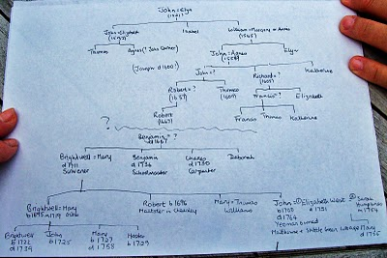

When We Were English, Part XII

The Holyman Farm of Cuddington has Secrets to Reveal
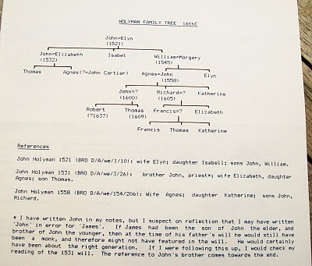
Above is a typed family tree of the Holyman farm prepared by its present owner, Caroline Stonham.

Below is a wing of the 1698 thatched cottage on the Holyman Farm.
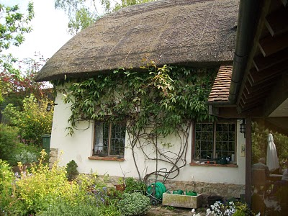

When We Were English, Part XIII

Leaving the Lovely Village of Cuddington

Below a photograph of sheep grazing on a Chiltern hillside near Cuddington, Buckinghamshire. This pastoral scene is typical of the landscape around Tring, Cholesbury, Aldbury and Berkhamstead where the name Holyman pops up in parish registers and legal documents in the 15th, 16th and 17th Centuries.
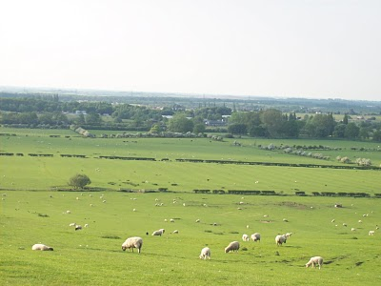

The folk of Cuddington, including Peggy Cattell and Caroline Stonham, were kind and generous with their information on the Holyman family. Below is Nancy Cattell who showed us around the parish church and village. Notice the thatch cottage on the right. It dates to the 1500s.
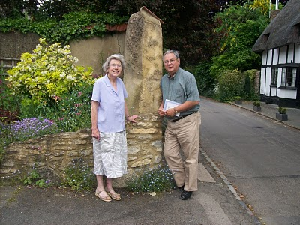

Below is a diagram of a typical small farmers thatch cottage of earlier centuries.

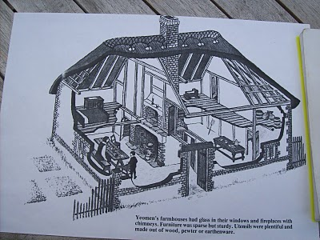

When We Were English, Part XIV

A Family Tree from Cuddington

An email by cousin Betty in the Tina Peddie chat room asking more about the family tree from the farm sent me deeper into my research papers. I reviewed again scattered papers from Lipscomb's “A History of the County of Buckinghamshire, Vs. 1 & 2” photocopied from Miss Peggy Catell's collection of genealogical materials.

Then I pulled out from other historical records (listed below) of Holyman material and have created a time line, which I hope will be of some benefit someday to someone. I then compared this time line to the family tree of Caroline Stonham's (see When We Were English, Part XII). This can be confusing so do not feel one has to memorize the article.

Let's begin with this photo below from 1965 supplied by Mrs. Stonham, current owner of the Holyman Farm. This picture shows a working farm 45 years ago. The thatch cottage is the same one I have been posting, constructed during the time of William and Mary, 1689. The farmer in front wears a typical English sweater and cap. Notice the stone fence. Quintessential England!

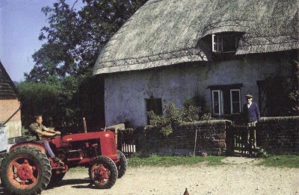
Below, a Time Line of the Holyman Farm using the Buckinghamshire History, the 1522 Certificate of Musters in Cuddington, the 1555 Manorial Survey and the HolymanFamily Tree prepared by Carolyn Stonham of Cuddington

1495 - The Rt. Rev. John Holyman born at the manor. His father was John Holyman (d 1521) married to Elyn in the Stonham family tree.

1511 - A Richard Hollyman receives receipts on behalf of the Priory of Rochester which was at that time still 'lord of the manor'. No mention is made of a Richard Holyman in the Stonhamtree. As noted in the Manorial Survey of 1555, the farm had been divided and Richard probably was a brother or uncle of Bishop John Holyman.

1522 - The Certificate of Musters from Buckinghamshire in 1522 (Aylesbury, 1973), p. 72 listed the villagers of Cuddington for tax purposes. The following Holymans were listed as holders of land:

John Holliman (deceased that year and father of Bishop Holyman)

John (James) Holiman Jr. (as son of the above who d 1521)

William Holiman (a son of the above who d 1521)

Ellin Holiman (wife of John (d 1521) and mother of James and William)

Thomas Holiman, son of John (James) Holiman, Jr.

1527 - A John (James) Hollyman took over the 'farm' of Cuddingtonfrom the Priory for a lease of 30 years. This would be a son of John (d 1521). This John (James) had a brother named William who married Margery or Annis. William died in 1545. William and John, according to Stonham, were brothers of Bishop John Holyman. Stonham believes the records reads "James" not John Holyman as is printed in her Holyman family tree.

1531 - John (James) dies in 1531 and wills the lease and 'bedding' to his son Thomas Hollyman. This John makes provision in his will for the repair of the Cuddington bridge. This is in agreement with the Stonham family tree showing a John (James) Holyman, married to Elizabeth dying in 1532 (when the will was probated or by the old calendar).

1539 - Henry VIII dissolves all monasteries and nunneries, and this king takes legal possession of the Farm. Thomas Hollyman, 'farmer' of Cuddington now leases from the king and no longer the Priory of Rochester. The Stonham document does not list the date of Thomas' death unfortunately or any further children, but we do have Thomas still listed in a 1555 manorial survey.

1542 - Thomas made a profit of over 20 pounds from the farm.

1545 - Elizabeth Holyman of Cuddington in her will wrote (as normal in those days), "I bequeath my soulle to the great mercye of all mightie God and to his mother Marie and all the saints in hevyne." (Remember at this time in England, almost all were Roman Catholics and the Anglican Church was just emerging from the Reformation in Europe.) According to Stonham, Elizabeth was Thomas's mother.

1545 - William Holyman of Cuddington leaves a bequest in his will to mend and repair the bryg waye (by way or road) in the village. (It was common for individual charity to maintain roads in the 16th century.) As noted above, Stonham agrees with this death date. Again William was a brother of Bishop Holyman.

1530s - The Rev. John Holyman writes two books in Latin – “A Treatise against the teaching of Martin Luther” and “A Defence of the Marriage of Queen Catherine with King Henry VIII”. The works do not survive, but his politically explosive books resulted in a new title for John. He was now 'an enemy to the King's cause'. Not good for the Holyman family!!

Fr. John is thought to have retired to the Farm at Cuddington and stayed until he was appointed to the vicarage of Wing in 1546. Later he would be vicar at Handborough prior to becoming Bishop of Bristol. According to Stonham, this elder John would be staying with his nephews - Thomas, the son of John and Elizabeth and John, a son of William who died in 1545. This younger John dies in 1558, ironically the same year as his famous uncle.

1554 - 1558 - John Holyman appointed Roman Catholic bishop of Bristol by Cardinal Pole under Queen Mary Tudor. Bishop Holyman involved in the trials for four of the five bishops executed for heresy during 'Bloody Mary's' reign: Cranmer, Latiner, Ridley and Hooper.

1555 - A Manorial Survey from the Public Record Office in London listed Thomas Holyman as the holder of manor from Queen Mary Tudor which included all houses, lands, a water mill and four acres of pasture land. His nephew, John Holyman, son of the late William Hollyman also held considerable lands as a copy holder.

1574 - Richard Hollyman, the younger, of Cuddington initiated a legal suit against Richard Beake over the custom of bedripp or an extra harvest duty. (Yes, people have quarreled always about taxes. Notice this is Richard the Younger.) According to Stonham, this Richard would be a great nephew of Bishop Holyman. This Richard died in 1605 considerably outliving his father, John (d 1558) who was the son of William (d 1545), who was the son of John (d 1521). This Richard was then a great, great nephew of Bishop Holyman.

1582 – Richard Hollyman leases land, and later sells it to Thomas Tyringham and his son. Although the name of Christopher Hollyman is not mentioned, the Tyringhams would become major land owners near a Christopher Hollyman’s late 1500s home in Sherington, Buckinghamshire. Is this the connection tying the Cuddington Hollymans to the Virginia Holymans in the middle 1600s?!

1600s - Manor remains crown land until reign of James I.

1689 - Thatched cottage (see above) built. Date is on fireplace mantel in main room of the house.

1700s - The Farm evidently stayed in the Holyman family (according to Stonham) until at least the late 1700s.

1900 - Approximately around the turn of the century, the last Holyman dies in poverty in Cuddington.

So what to make of the above?

While this family tree and supporting evidence appears firm, one of the above Holymans, perhaps one of Bishop John Holyman's two brothers - John (James) and William had a male offspring who moved at some point to Tring and Cholesbury. Unfortunately Caroline Stonham does not take the family tree out of Cuddington.

Below a map of the Holyman Farm in the 1500s.

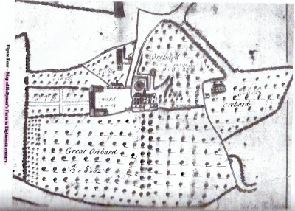

When We Were English, Part XV

Making Sense of Our Cloudy and Confusing English Past
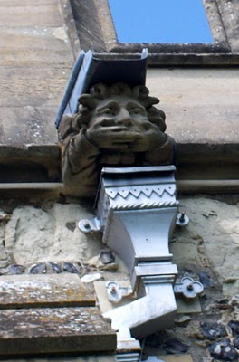This gargoyle on the parish church at Tring, Hertfordshire, England represents the challenges to discover our Holliman roots. The 'past', this gargoyle, seemingly does not wish to tell us what we long to hear....who are our ancestors? Photos by Barbara Holliman

Indeed, research provided by cousins Maxine Wright and Joe Parker is moving the focus of our search from Tring to Bedford, Bedfordshire, England, approximately 35 miles to the north.

In the meantime, I continue to share some findings in Buckinghamshire and Hertfordshire, about 25 to 30 miles northwest of London. Below is a map of the villages where Holymans lived in the 16th and early 17 centuries: Cuddington, Tring, Cholesbury, Berkhamstead and Aldbury. They are shadowed in a yellow marker.

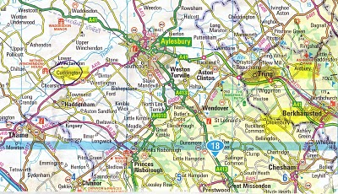

The gargoyle at the top of this posting is from the Tring parish in the photo below.
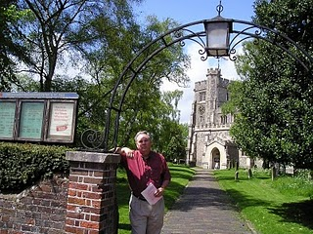
In the photo above, I stand in front of the Tring, Hertfordshire parish church, which has been reconstructed several times since its 11th Century founding. The present structure was erected in 1470. In this sacred space in England some of our distant ancestors probably worshiped and their remains may linger in the ground behind me.
After visiting the Tring parish church a first time in 2005, my wife and I stepped down the block to visit a charity shop (seeking yet more royal coronation ware, a vice of mine). The kind clerk showed us the local telephone book. Yes, seven or eight Hollimans were listed in the local exchange. Hmm… Later we motored to a pub for roast lamb and red wine (and I remember little more of that day!).

When We Were English, Part XVI
Connecting Cuddington Holymans to Cholesbury Holymans and Tring Holymans

Cousin Jeanette Holiman Stewart shared information on the Holyman and Weedon (Wedon) families of Hertfordshire, England from the “English Origins of New England Families”. Before reviewing her excellent research, I had been preparing the article below which echoes and strengthens her findings. I attempt to weave her public work into the growing narrative of the Holymans in Tring and Cuddington, England in the 16th and 17th centuries. My thanks to Jeanette, Joe Parker and all for making available to the larger Holliman, Holleman, Hollimon, etc. families their increasing knowledge of our historic roots.

Earlier another cousin, Maxine Wright, a relentless researcher in pursuit of Holliman origins, had mailed me the following information of one Richard Wedon or Weedon, who lived in Botley, a small village near Cholesbury and Tring. As one can read in the first paragraph of this p. 187 of “The Register”, published 1954, Richard had to pay a fine in 1567 for breaking the head on another man's servant. Hmmm....

Richard must have matured because nine years later, in 1576 he married Jayne Holyman in Cholesbury, near Tring. The information below states that this Jayne Holyman was from 'a yeoman family of good standing in Cuddington', descendants of Bishop John Holyman, whose life we have reviewed in previous blogs.

Several other items leap out at us. Richard and Jayne had a son named James who evidently immigrated to Rhode Island! Did James join a cousin named Ezekiel of Tring in Rhode Island? One remembers that Ezekiel Holyman, an Anabaptist, baptised Roger Williams the founder of Rhode Island!
Notice that Richard Wedon writes a will in 1618 (it is probated in 1624, presumably the year of his death). The will is witnessed by William Holyman.
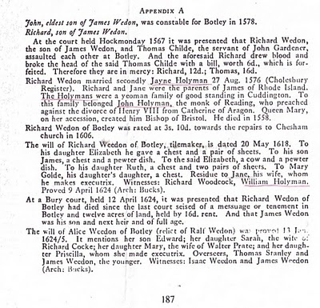
Now the issue grows more complicated. Above we have Jayne Holliman married to Richard Wedon. Below in another section of “The Register”, we have a John Holyman appearing in marriage in 1593 and dying a few years later. Goodbye to this John who had no children.

However, now William Holyman, the eldest son of another William Holyman, appears again (noticed who witnessed Richard Wedon's will), baptized June 1583 and his sister Priscilla February 1584/5. They have a brother named Ezekiel.

This Ezekiel, according to many web sites and those who have researched Baptist Church history, is the Ezekiel who sailed to Massachusetts and helped found Rhode Island!

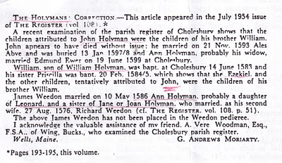

Notice in the next paragraph an Ann Holyman married another Wedon May 1586, and is noted as a probable daughter of Leonard Holyman and a sister of Jane Holyman.

Confusing? Yes, but stay with me. In the next blog, we are going to examine Leonard Holyman and his offspring. In web sites, Leonard is listed as the father of Ezekiel Holyman.

So, two thoughts emerge:

1. Leonard Holyman and other Holymans of Tring and Cholesbury, including Ezekiel, are indeed descendants of Bishop John Holyman of Cuddington.

2. Bishop John Holyman, a devout Roman Catholic, therefore is probably a great or great great uncle or cousin of Ezekiel Holyman, who was religiously antithetical by 180 degrees, to his prominent descendant, an Anabaptist in America! For those interested in religious history this is an amazing family!! One generation burns Protestants at the stake; another helps establish the Baptist Church in Rhode Island.

So are all these interesting Holymans our direct ancestors? Ancestors, most probably yes; direct, more work to do.

When We Were English, Part XVII

Continuing the Search for John Holyman (1572 - 1650)

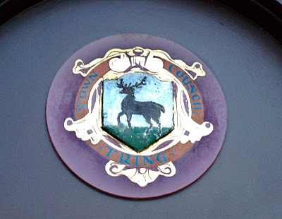Tring, Hertfordshire traces it roots to Anglo-Saxon times, and was located just west of the Danelaw in the 900s. The hamlet is listed in William of Normandy's Doomsday Book. The above is the town logo.(Photo by Barbara Holliman)
I am still looking for that elusive John Holyman who, according to one prominent Holliman genealogical website and the LDS records, was born in Tring, Hertfordshire in 1572. John is the widely reported father of Christopher Holliman, Sr., who is our ancestor of solid record.

We do know a John Holyman did die in Southampton, Virginia in 1650 and left a will which devolved property to a friend, not family. For the past few months, I have been posting information found during an excursion to England seeking Holyman roots and our reported very great grandfather. I continue.

As readers of this web log know, there was a Bishop John Holyman (1495-1558) and an Ezekiel Holyman (1586 - 1659), both religious leaders. One was Roman Catholic and the other a Baptist Protestant. The evidence supports that they are related.

Cousin Jeanette Holiman Stewart shared by email information that in the “English Origins of New England Families, Vol. III”, pages 193 - 195, one will find an article by G. Andrews Moriarty entitled 'The Holymans'. In this article Moriarty quotes “The Register”, an English genealogical publication, that the Holymans were a family of 'substantial yeomen' with branches in Cuddington, Cholesbury and Chesham. The Rt. Rev. John Holyman, Bishop of Bristol from 1554 to 1558 was a member of this family as was one Jayne Holyman (1552 - 1632) and her nephew, Ezekiel Holyman.

From the Latter Day Saints genealogical website, we have the following:

One Leonard Holyman (1520 - 1573) was born in Cholesbury and died in Tring. From the above source we know that Leonard is related to the Cuddington Holymans. I refer all to my post 'When We Were England, Part XV'. Leonard is a contemporary of Bishop John Holyman. Were they brothers or cousins? Cuddington, as the earlier map notes, is an hour or two by horse from Tring and Cholesbury.

Leonard married a Joan (b 1525) also of Cholesbury. They had at least seven children. One was the Jane (Jayne), referred to above, b 1552 in Tring, Cholesbury, died 1636 and is buried in Chesham (near Cholesbury). She married Richard Weedon, as noted in the last posting. One of their sons, James, immigrated to Rhode Island, as did Jayne's nephew, Ezekiel.

Jayne's brother, John Holyman (1548 - 1597), was a weaver and had a wife named Ales (Alice). There were a number of children of this marriage, one being Ezekiel Holyman, who would immigrate to New England and help found the Baptist Church in America. Another child, Elsabeth, married into the Weedon family herself.

Two of Leonard's sons, Edward and William, left wills of which I found and made copies while in the Hertfordshire Archives. There was a third son, John, whose will is below and lifted from the “English Origins of New England Families”.

The Will of John Holyman (1548 - 1597)
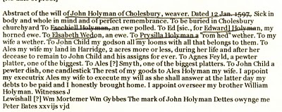

Now John Holyman (d 1597) left a will (abstract above) which does not list a son named John Holyman (remembering we are looking for a possible John Holyman, b. 1572 in Tring). John (d 1597) does list a godchild, whom he terms John Child. To this godchild, Holyman left his 'looms and all that belongs to them'. His own children received much less, Ezekiel only getting a ewe. Why did he favor the godchild over his natural children? Perhaps John Child had an aptitude for weaving while the others did not? But this John also left John Child his land after his wife's death.

Why favor John Child over one's own children?

Could John Child have taken the last name Holyman from his godfather, John Holyman? Could this John Child be the elusive John Holyman (d 1650 in Virginia)? The dates work. Could this godchild be a natural offspring of John Holyman (d 1597), given perhaps a last name (Child) to obscure a birth out of wedlock? This is only speculation on my part, but the bequests are odd.

So John Holyman (d 1650) is still hidden in history as far as primary sources are concerned, if he be from the Tring area if he existed at all. As cousins Maxine Wright and Joe Parker have revealed, there is evidence John Holyman (d 1650) may have been from twenty-five to thirty miles north in Bedford. If so, why are so many web sites placing him in Tring?

When We Were English, Part XVIII

The Will of William Holyman (1550 - 1623), Part I

In the Hertfordshire archives in Hertford, England, one will find several large rooms filled with books, manuscripts microfilm and photographs of local, family and national history. In the short time I was there, the friendly staff pointed me in several directions.

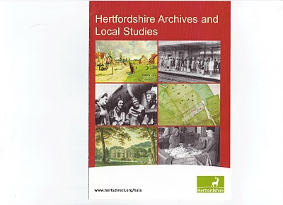

This brochure may be of help to those reading this blog.
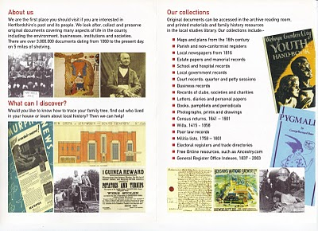
While there I reproduced from microfilm the wills of Edward Holyman and his brother William Holyman. Before I post them and attempt to transcribe, let me share with readers the way our English alphabet looked in the late 16th and early 17th century. (See below)

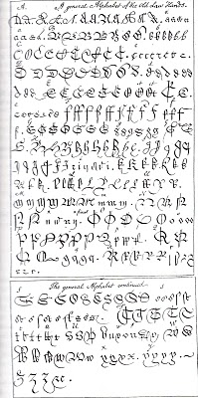
This really is your great grandfather's alphabet! Yes, it is A to Z with several samples for each letter. Some are easy to identify; others are a mystery. It makes interesting reading.

When We Were English, Part XIX

The Will of William Holyman (1550 - 1623) of Tring, Part II

In the index of wills in the Hertfordshire Archives in Hertford, England, I found and copied the last words of William Holyman, son of Leonard Holyman (1520 - 1573). Bear in mind, I was looking for the John Holyman, the reported ancestor of the American Hollimans. While this will does not disclose our elusive direct ancestor, this document does reveal information on the lives and times of our distant cousins, uncles and aunts when we Hollimans were English. The document is divided into two parts due to my scanner only taking a section at a time.
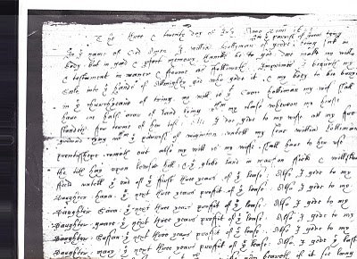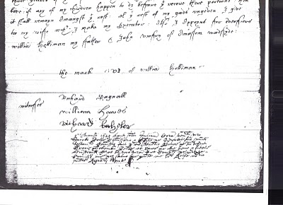

What does it say? As no expert, here is my attempt to transcribe the writing form of early 1600s English script.

"The ___ and twentieth day of July Anno Domi 1623 ___ In the Name of God Amen. I, William Holyman of Great (in the parish of Great Tring) being poor in body, but in good and perfect memory, thanks be to God, do make my will and testament in manner and form as followeth,

First, I bequeath my soul into the hands of the Almighty God, who gave it and my body to be buried in the church yard of Tring.

My will is that Grace Holyman, my wife, shall have on half acre of land lying between my house __ for ___ (rest?) of her life. Also I do give to my wife all f___ ___ ___ ___ that ___ of ___. ___ my son William ___ ___ ___ out also my wish is to my wife ___ ___ to her rest the __ hay upon ___ hill; and the glebe land in ma___ field and one of the ___ of the first three years of the field lease. Also I give to my daughter, Hanna, the next ___ years profit of the lease; also I give to my daughter, 'Saiva' or 'Eva', the next three years profit of the ___. Also I give to my daughter, 'Grace' the next ___ profit of ___. I give to my daughter, 'Saffon', the next ___ years profit of the ___. Also I give to my daughter Mary the ___ ___ ___ profit of the ___. Also I give the ___ three ___ of the ___. Unto the ___ my wife ___ ___ if it ___ ___ ___. If any of my children happen to die before they received their portion, then it shall remain amongst the ___. All this ___ of my ___ I give to my wife ___ I make my executor. Also I appoint for administrators (?) William Holyman my father and John Romsy of ___ ___.

The Mark of William Holyman, submitted"

My opinion? Here we have described a yeoman farmer living in Tring, to be buried in Tring and farming fields just outside of Tring. He has few worldly goods other than a lease hold on the land.

When We Were English, Part XX

Looking for John Holyman in Edward Hollyman's Will of 1617

Just to remind all, the William listed in the last post is the uncle of Ezekiel Holliman, one of the founders of the Baptist Church in Rhode Island and the person who baptized Roger Williams, an architect of American religious liberties.

The Edward Hollyman in this post is also Ezekiel's uncle. John Holyman (see Post When We Were English, Part XVII), a brother of William and Edward, is Ezekiel's father.

So here we are knowing Bishop John Holyman (1495 - 1558), devout Roman Catholic who burned Protestants at the stake during the reign of Mary Tudor, is a great uncle or second or so cousin of Ezekiel. Now in all this where is the mysterious John Holyman of Tring (1572 - 1650), stated by one prominent Holyman web site to be the founder of American Hollimans in Virginia?

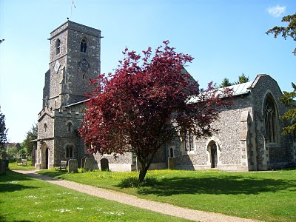The parish church in Aldbury, located a few miles east of Tring, Hertfordshire. Are our relatives buried here also? Photo by Barbara Holliman, 2010.

In the last posting we explored the 1623 will of William Holyman of Tring, son of Leonard Holyman. In this article we reproduce below from the Hertfordshire Archives, the will of Edward Hollyman of Aldbury, brother of William. Aldbury is only a few miles from Tring. Edward lived from 1546 to 1617, and spelled his name with two 'L's. Edward was more prosperous listing furniture and household items to be dispersed as well as land holdings. Note brother William Holyman witnessed this will. As the scanner cannot record the entire will at once, it is divided into two parts.
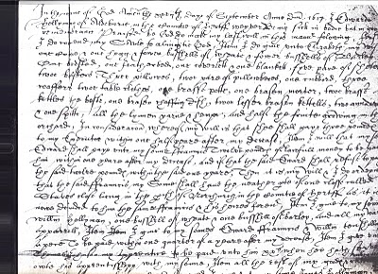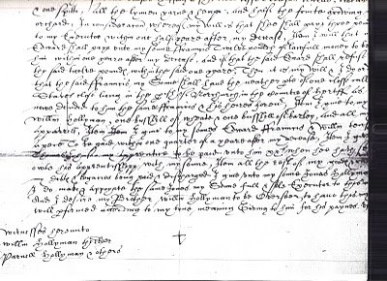

I have not attempted to transcribe this document, but have studied closely the bequests and names. This will seems more difficult to read than William's. A name intrigues, and I remain puzzled over it. Look closely at the second section and notice the fourth line from the bottom of the will. Beginning in the middle, you will read the words which I transcribe as "I give unto my sons Jonas Hollyman," then words are obscure.

I have pondered and pondered this clause. Is this word John in Latin, Medieval French or 16th century English script? What to do about this? One avenue is to check the Aldbury Church of England register. Remember Thomas Cromwell as of 1538, Henry VIII's chancellor, decreed that all parishes register baptisms, marriages and funerals.

However, I cannot find in Edward's will (as in William's) that he asked to be buried in the parish church lawn. Had Edward joined a non-conformist church (Puritan or even more controversial – the Anabaptists for example) by 1617, as obviously had his nephew Ezekiel? If so, Edward's demise would not be recorded in Anglican Church records.

So I will search the Internet to see what can be found, and if nothing can be found, well, back to the Hertfordshire Archives my next trip to England. A clue, a weak one, but....could this be the not-yet-found John Holyman, d. 1650 in Jamestown, Virginia?

I agree, this is a big, huge stretch and even if this name be John, would it also be our John, English founder of our American family....?

Below, is a family memorial in the Aldbury parish. No, not a Hollyman plaque, as it remembers another departed family. This ghastly, but fascinating 17th Century monument, vividly displays that century's view of morbidity. Our ancestors were part of this culture.

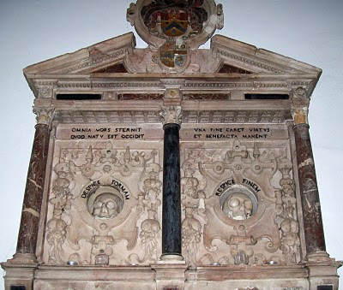Photo 2010 by Barbara Holliman
We are all immigrants from the past...from our families.....

When We Were English, Part XXI
Weddings and Witches
In the Hertfordshire Archives is a book entitled “Hertfordshire Parish Registers” by Phillomore's, 1907, 3 volumes. Of course out of print, and I had precious few hours to review it. It is on my list to revisit someday. However, I did find several weddings of Holyman females to local males. For the record, they are listed below.

By the way, the first two marriages were from yet another village, just a few miles also from Tring - Berkhamstead. Below is a view of its High Street in 2010.
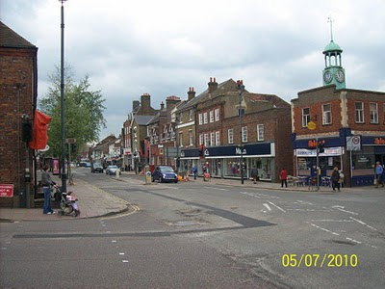

The Berkhamstead Marriages:

Franncys Hadden to Margery Hollyman on 6 May 1601.

Henry Lawrence to Jane Hollyman (Holeman) on 7 February 1638.

Here are two Tring marriages in the same publication:

William Hollyman to Grace Neelie on 20 July 1607 (This is the son of William of Tring whose will we reviewed in When We Were English, Part XIX).

Goff Babylong to Anna Holliman on 7 May 1634

My on-site research failed to turn up the mysterious John Holyman, possibily born in Tring, but I did find a host of very interesting Holymans who impacted English and American religious history. Sometimes it is not what one finds in genealogical research, it is also what one does not find. And sometimes, one may feel bewitched and frustrated not to collect more information. That leads me to my closing historical tidbit you may enjoy.

While reading in the Tring library the 1940 work by Arthur MacDonald, “That Tring Air”, I found that the year 1596 must have been very stressful to our ancestors. They must have observed the following outbreak of, well, witchcraft in their own community!!

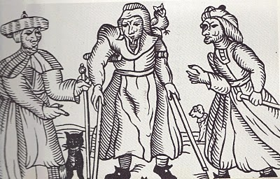
Above a 16th century drawing of three English witches. Rather ugly creatures. Note the black cat.
That year in Tring, one Alice Crutch 'bewitched one Hugh Walden who languished and died'. Nor did the episode of nefarious deeds end there. Another woman, named Elizabeth, put a curse on Thomas Grace's valuable horse and it died!!

For their witchery, these two ladies were 'suspended by neck until dead'!

As I first wrote this article on the Hallowed Eve, think on all the quaint customs of England and Europe that passed through our families to our New World, which we celebrate to this day!

When We Were English, Part XXII

Are the Holymans from Bedford, rather than Tring?

On the map below, one can see Bedford within the red circle almost due north of London. Tring (unnamed) is located at the red dot just northeast of London. Click on map to enlarge.
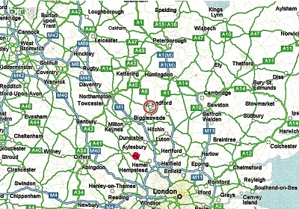

As readers of these articles know, I have spent many chapters expounding on research of our Holyman (Holliman, Holleman, Holloman, etc.) origins. In the late 1990s, a Holyman family tree was posted on the Internet, and many of us took it as gospel. This site, still posted, lists one John Holyman (1572 - 1650) of Tring, Hertfordshire as the English father of our Holliman families in America.

A John Holyman really did die in 1650 in Virginia, as recorded by Virginia records.
However, a continuing search of Internet archives, family trees, research by others, and my own exploration in the Hertfordshire Archives has failed to turn up this elusive character in Tring or surrounding villages, although we have found an abundance of Holymans with some fascinating biographies. I believe they are our relations in some form or fashion.

However, this begs the question concerning John Holyman - have we been looking in the wrong places?

Alas, thanks to research by cousins Maxine Wright, Joe Parker and others, an interesting parish register has turned up in Bedford, Bedfordshire, England. The parish is St. Mary's, now a redundant facility administered by a trust. Bedford is located approximately 50 miles north of London, and about 25 miles or so from Tring. (See map above) The following information is taken directly from the parish register, and can be found in RootsWeb and LDS internet files.

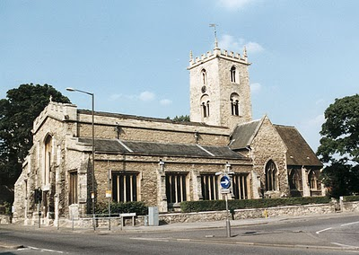St. Mary's parish church, although closed, still stands just south of the River Great Ouse in Bedford. A few blocks away are the Bedfordshire and Luton Archives.

For those of you cognizant of the names of early Virginia Hollimans, these Bedford names are nothing less than amazing. Remember our Christopher Holyman, Sr. arrived 1650 (the same year a John Holyman died) along with a woman named Judith, believed to be his mother or sister. Another Christopher Holliman and another Judith arrived in 1653. Our Christopher Sr. was first married to a woman (our great grandmother!) named Mary.

Be aware, according to colonial records, a Thomas was already in Virginia at Martin's Hundred, one of America's first real estate developments (so to speak).

Now look at these names from the parish registers of Bedford!

1609 - This Thomas Hollyman married Helena Poynard on Oct. 23, however at St. Peter’s in Bedford, not St. Mary’s. Their children are listed below.

1610 - September 16, one John Holliman baptized at St. Mary’s. BINGO! Is this our elusive John, a reputed American founder of our family who died in South Hampton, Virginia in 1650? John married a Mary Parrell on July 25, 1641.

1612 - On September 13, Ellenora Holliman baptised.

1613 - On November 14, Joan Holliman baptised.

1616 - Thomas Holloman baptised on March 20. Is this the Thomas of Martin's Hundred near Jamestown who took land in the 1630s?

1618 - Christopher Hollaman baptisted on September 2. Is this our Christopher Holyman Senior who immigrated to Jamestown in 1650, raises a large family, makes his earthly fortune and dies 1691?! Is this my generation's 7th great grandfather? The date and names strongly suggest this is so.

1621 - Judith Holliman baptised on February 11. Is this the Judith who arrives in Jamestown with Christopher in 1650 or later in 1653?!

1623 - On May 14, Eleanor Hollyman baptised at St. Mary's. (Her sister, the first Eleanor had died earlier.)

1625 - Stephen Holloman baptised on December 24.

1628 - Mary Holiman baptised on September 13.

So the question is begged - have we found the Holyman family that settled in Isle of Wight, Virginia in the early 1650s?

If we have, then Thomas and Helena Poynard of Bedford, Bedfordshire are our English fore parents, and not a John Holyman of Tring (who may never existed).

I will leave you here to ponder on the above, and to allow me time to gather further notes 'to push this envelope'. Again, this research belongs to Maxine, Joe and someone who entered the above in LDS records. My continuing thanks to them. If I have omitted others, please allow me to correct the record and give credit where credit is due.

This Holyman history gets more and more interesting....(if you are addicted to family history!)

When We Were English, Part XXIII
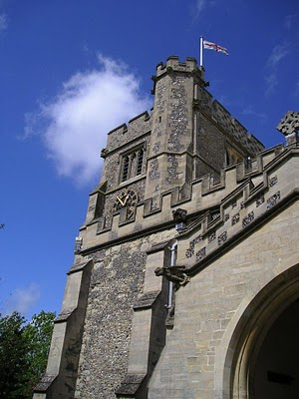

Before We Leave England (for a while anyway)

In this space, it is time to return to the Holliman story in the North American Colonial period, the 17th century when our ancestors arrived in Virginia. Before doing so, I want to sum up my findings (responsibility for errors and incorrect interpretations are mine) and suggest where more work is needed. (Above the parish church of St. Peter's and St. Paul's in Tring, Hertfordshire.) Photo 2010 by Barbara Holliman.

Findings

1. I have not found evidence that John Holyman (1572 - 1650) who died in Virginia is our great grandfather, nor have I found information that this elusive, but widely reported fore bearer of our family name, is from the Tring, Hertfordshire area. Or for that matter, even existed. This person is recorded in a widespread web site as the 'founder' of the American Hollimans, and the father of Christopher Holyman, Sr. (1630 ca - 1691). I doubt it.

2. In and around the Tring area were many Holymans in the 15th to 17th centuries, some such as Ezekiel Holliman who immigrated to Massachusetts and helped found the American Baptist Church. Another Holyman was the Roman Catholic Bishop of Bristol (1495 - 1558) during the reign of Queen Mary Tutor. The 'manor' farm of The Rt. Rev. John Holyman still exists in Cuddington, Buckinghamshire and can be visited. I think it probable that these persons are distant cousins and great uncles and aunts.

3. Research by Joe Parker, Maxine Wright and others (LDS records i.e.) reveals that a Holyman family lived not far from Tring in Bedford, Bedfordshire in the late 1500s and 1600s. As I expounded in my last posting, these names - John, Thomas, Christopher and Judith - are the names that show up in recorded records in Virginia from 1630s to 1650s. I join Joe and Maxine in believing it highly probable this is our 'Founding Family'.

4. DNA testing conducted through Tina Peddie's good offices revealed I and others are descendants of Christopher Holyman, Sr. (D 1691) of Virginia who emigrated from England in 1650 with his probable sister, Judith.

Work to be Done

1. Continue to research the Tring records in the 16th and 17th centuries looking for this John Holyman. There are more files and registers to explore.

2. Dig deeper into the family history of the Thomas Holyman family of Bedford. This can be done on-line and on-site at the Bedford-Luton Archives. I have plans to visit these archives in the spring of 2011, Good Lord willing. I note an LDS record lists Thomas Holyman's father as a John Holyman. As a wealth of information was found in the Hertfordshire Archives and Tring library, I strongly suspect a richness of material awaits a Holliman researcher in Bedford and at the National Archives in Kew (a suburb of London).

3. Establish relationships with Holyman's in Bedford and Tring and kindly ask for DNA testing.

4. Explore what ties exist between Bedford Holymans and Tring Hollimans. Geographically speaking, these communities are only twenty five to thirty miles apart, but in the 1500s, this was a two day walk. It is possible (probable?) that a Holyman from Tring moved to the Bedford area in the 1400s or 1500s and established a family.

5. Do not ignore other Holymans in England in the 17th century. Jeanette Holiman Stewart notes Holymans lived in the early 1600s in Worchestershire, England. As with all genealogical research, be open minded and willing to change interpretations based on the evidence and critical inquiry.

To Summarize

Whether Tring or Bedford, the Holliman line is English, no ifs, ands or buts. Our great grand parents brought to Virginia the customs and culture of England - its forms of government, justice, religion and social mores. Of course, this culture was modified in a new environment that was, ironically, both hostile and welcoming.

To know from whence you come, study the history of England - it is our story. The Stuart, Tutor and Plantagenets - these are the monarchs of our family. The Normans, the Vikings, the Angles and Saxons, the Romans and Celts - these peoples too are part of our DNA, our genetic code, our human family.

ADD NEW 2011 information on England

Section III

THE HOLYMAN FAMILY – THE COLONIAL VIRGINIA EXPERIENCE

Our Family's Colonial Era, 1607 - 1775, Part I

The following colonial history posts were put together from a number of sources including published historical works, internet sites, and from the research of our contributors Dr. Rhodes Holliman, Joe Parker, Jeanette Holiman Stewart, Robert Holloman, Maxine Wright, Glenda Norris, Ron Holliman, the late Walt Holliman and other family members who came before them. Those who have additional information or ideas for genealogy posts, please let us hear from you. Only by researching, critiquing, and listening to one other can our understanding of the past increase.
"From where did we come" is one of the oldest questions we humans ask. For Hollimans, our American experience began in Jamestown, Virginia where English America was founded by some adventurous colonialists from London in 1607. In this post we begin an on-going series about the first decades of our family in American.
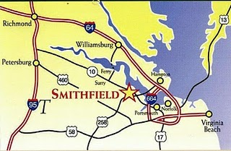
The map right identifies Smithfield, Virginia, where Christopher Holliman, Sr. settled by 1661. Jamestown is not marked but is just south of Williamsburg, where one can catch a ferry to Isle of Wight County on the south side of the James River.
By any measure, the life of Christopher Holliman, Sr. (1618 - 1691) was one of adventure and economic success. We know he sailed over on a ship that was sponsored by John Coxe of London and stepped onto American soil in Jamestown, Virginia on May 22, 165o. He was probably 32 years of age when he began his adventure in the "new world."
Christopher Sr.'s first wife was named Anne, last name unknown, and of that union, six children grew to maturity. Two girls married into the Atkinson family, a neighboring planter. The four sons, to my knowledge, would send the name Holliman (spelled in numerous ways) into the American continent.
There is no other record of Christopher Sr. until 1661, when a deed states that he purchased land near what is now Smithfield, Virginia, across from Jamestown on the south side of the James River. He farmed several hundred acres along Cypress Creek, a tributary of the Pagan, which itself runs into the James River. From this body of water, Christopher, Sr. easily loaded hogsheads of tobacco onto ships which would transport his cash crop to England. He purchased more land along Cypress Swamp in 1668.
He did well economically because in 1684, now in his 60s, he patented a large amount of land from the Royal Governor between the Mill Swamp and the Blackwater River. The Blackwater River is the western boarder of Isle of Wight County. The plantation, as he styled it in his will, was large - 1,020 acres, a large farm for the time and place. When he died in 1691, his will divided the land among his children and his second wife, Mary Gray Holliman.
Where is the exact location of the original site? The deeds, dependent upon landmarks now gone, except for the Swamp and Blackwater River, are unclear. A family friend and professional geographer who also traces his family back to Isle of Wight County, Paul Fly, suggested I look along the border of Surry and Southampton Counties.
In March 2010 my wife, Barb, our oldest granddaughter, Holly, age 4 1/2, and I took a day trip from Richmond, Virginia down Highway 460 past Wakefield, Virginia to the hamlet of Ivor. There we turned east on Proctor Bridge Road, crossed the Blackwater River and made some interesting 'discoveries' that I now share with you!
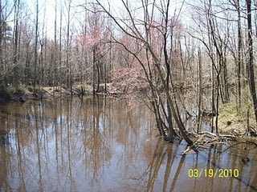
The Blackwater River (pictured above) flows southward into North Carolina. It is deep and wide enough for boats to carry tobacco casts to ships bound for England. Tobacco was the cash crop of Virginia and was the mainstay of its colonial economy. In his 1691 will, Christopher Holliman Sr. records that he had tobacco barns, confirming tobacco too was his financial foundation. As the Blackwater flows south into North Carolina, was this the liquid highway that took my branch of the family to new lands in the early 1700s?

Our Family's Colonial Era, 1607 - 1775, Part II

In Search of Christopher Holliman Sr.'s 17th Century Virginia Plantation
This is the second post of an on-going series of our ancestors. In 2010, my wife, Barb, and granddaughter, Holly, and I crossed the Blackwater River, the border between Southampton and Isle of Wright Counties, Virginia in search of Christopher Holliman Sr.'s plantation. Our little adventure continues....
We passed picked cotton fields and peanut storage units. Our noses told us that a pig farm, probably the home of future Smithfield Hams, was nearby. After passing Sycamore Corner, we were on Mill Swamp Road. A mile later we saw a decrepit sign which read: Holleman House.
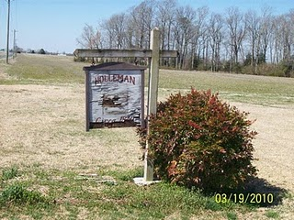Was this it, the remnant of Christopher Sr.'s 17th century plantation? Holliman has been spelled many ways - Holyman, Holleman or Holloman. No one was at home, so we took photographs and left a note. We noticed a family cemetery. The oldest visible stone is of Edward Adolphus Holleman, young son of Wilson and Ann Holleman, b 1810 - d 1819.
We did not expect to discover Christopher's grave. In the 17th, and most of the 18th century, there were no gravestones in the Tidewater area, as they were expensive items at the time. My guess is that his bones rest on this, or an adjacent, property.
Nor did we expect to discover a log cabin that housed the first Hollimans. No cabins from the 1600s survive in the Tidewater region. They burned easily and deteriorated rapidly without paint or protective coatings. It was after 1700 that the red brick plantation homes along the James River were constructed.
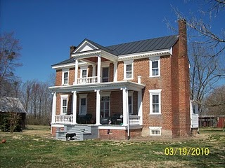Constructed in 1830, this is the Holleman House, located on Mill Swamp Road, Isle of Wight Country, Virginia. This historic Federal period house, with over-sized front doors and saw- tooth cornices, is located on the site of Christopher Holliman, Sr.'s 1,020 acre plantation.
To our amazement, when we visited the Isle of Wight County Museum later that day, we discovered an 1983 book by Helen Haverty King entitled “Historic Isle of Wight”. The 200 page volume pictures numerous antebellum homes in the county, one being the Holleman home!
The book is available at the Isle of Wight County Museum ($35). On the back cover is an illustrated map showing the location of the Holleman House.

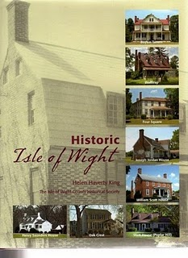
In this volume, one will find confirmation that in 1684 Christopher Holliman, Sr. completed his purchase of 1,020 acres in a corner of Isle of Wight County.
Bordering the family's property were the Atkinsons (whose sons married two of Christopher Sr's. daughters) and the Gwaltneys (who also married future Hollimans). The Gwaltneys became retail sellers of peanuts and hams, and were the founders of the famous Smithfield Ham company. They did well financially, and several of their 19th century mansions are open to visitors in downtown Smithfield today.

Our Family's Colonial Era, 1607 - 1775, Part III

Confirming the Family Tree
In the last blog we posted a photograph of the Holleman House which was constructed by a distant cousin, Wilson Holleman (1803-1873), a son of Josiah Holleman (1771-1848), who was a son of Jesse Holliman and a veteran of the American Revolution, who was a son of John Holliman, who was a son of Christopher Holliman, Jr., the son of Christopher Holliman, Sr., who patented the land in 1684. Christopher Sr. is granddaughters’ 9th great grandfather.
Below is a photo of Wilson Holleman's headstone in the family cemetery located by the main house.
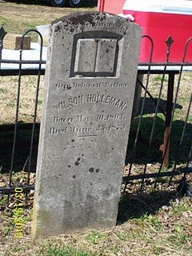
According to current information on our family tree, all in this family cemetery are relatives and descendants of Christopher Holliman, Sr., d 1691.
Pictured below is the view from Highway 621, Mill Swamp Road looking back toward the Holleman House on the left, and an older dependency building on the right. The soil is sandy and the ground is flat in the Virginia Tidewater region.
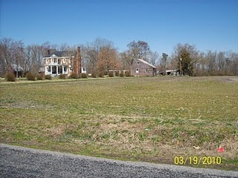Isle of Wight County is only 59 feet above sea level at its highest point. The fertility of the soil was maintained in the 19th century with marl, a local mineral, which helped reclaim the vitality of the soil that was leached by tobacco farming.
Perhaps, as with many early Virginians, the first Holliman generation tilled only a small portion of land for the cash crop tobacco, and utilized the rest for corn, vegetables, wood fuel and range for hogs, poultry and cattle.
The historian, Edmund S. Morgan, reports that in the 1600s and 1700s Virginia, one laborer could handle at most 3 acres of tobacco and three acres of corn. This was the monetary crop and food source for humans, horses and cattle alike. Of course, wild game, still in abundance in the early colonial days, supplemented diets.
As one author of Virginia history notes, “Tobacco chews through soil fertility with ferocity possessed of few other crops. In the absence of fertilizer, it can only be grown on virgin land for four seasons maximum.” Perhaps this first Christopher tilled his acres with the help of children for several years and then moved on to another piece of his land. Future Holliman families would do the same, and as their land was exhausted, they would move south and west into the Deep South, at least until the Civil War and Reconstruction.

Our Family's Colonial Era, Part IV

Mill Swamp and the Church
For the past chapters, I have described a journey to our family roots in Isle of Wight County, Virginia. Just down the road from the Holleman House is a church that is part of the family story.
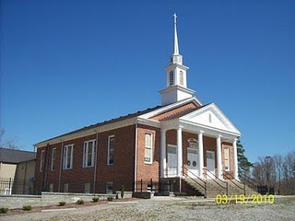The Mill Swamp Baptist Church, Isle of Wight Co., Virginia has been rebuilt many times in nearly 300 years of existence. The church and cemetery are adjacent to land owned by the Holleman's and Gwaltney's. According to cousin Jeanette Holiman Stewart, from 1798 to 1801 Jesse Holleman, Sr. was joint minister of the church with John Gwaltney. Later Jesse Sr., a direct descendant of Christopher Holliman, Sr. pastored the church alone from 1819-1820 when he was 83 years of age.
The first Hollimans were Anglicans, members of the Church of England. Until the American Revolution, there was only one official church in Virginia, and that was the Anglican or as now styled, the Episcopal Church. Our Virginia ancestors did not come to the New World for religious freedom. They came to better themselves economically, and Christopher Holliman, Sr. succeeded.
There were few Episcopal parishes in colonial days. Only one or two in each shire (as the first Virginia counties were called), and many persons felt something missing spiritually in their lives. Into that religious void came the Baptist Church, which gradually spread out of New England into the Middle Atlantic and Southern colonies by the early 1700s. Presbyterians and Methodists soon followed.

Our cousins and contributors, Ron Holliman and Maxine Wright, have pointed out that one Holliman, Ezekiel of Rhode Island, was a founder of the American Baptist Church. Ezekiel Holliman, from the same part of England as Christopher Holliman, Sr., baptised Roger Williams, the founder of Rhode Island and the Baptist Church in America!
One of the first Baptist churches established in southeast Virginia was located adjacent to Holliman and Gwaltney land. The Mill Swamp Baptist Church, founded 1719, was named after the marshy ground and a stream that ran nearby. This church's location proved perfect for baptisms and became the mother church of many others in the Virginia tidewater region.
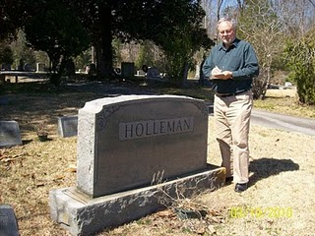In the adjacent cemetery are numerous graves of 19th and 20th century Hollemans plus Cofers, Gwaltneys and Atkinsons, all who intermarried in the Holliman family. Photo by Barbara Holliman of Glenn, 2010.
A list of those buried in Mill Swamp Baptist Church Cemetery can be found at http://www.iwchs.com/ .

Yes, there truly is a Mill Swamp near the Blackwater River as noted on the 1684 patent for Christopher Holliman, Sr.

Our Family's Colonial Era, Part V

Tobacco and Our Family
As noted, our great grandfather Christopher Holliman Sr. acquired much land in Virginia. By the time of his death in 1691, he left 1,020 acres, along the Blackwater River and Mill Swamp (purchase completed 1684), to his four sons.
Christopher Sr. was also well respected in the community. The Thomas Pittman family tree website reports that in 1671 Christopher Sr. was witnessing deeds, and in 1676, joined other leaders in the Isle of Wight community who signed a petition concerning Nathaniel Bacon's ill-fated rebellion against the Royal Government.
There is some information that Sr. may have been in the shipping business, probably with some brothers and later with his son, Richard Holliman. In 1702 Richard Holliman transported enough persons to Virginia to claim over 1,000 acres of land through the Virginia head right system. If one imported, or paid for the importation of an immigrant, the transporter received 50 acres in land per person. The latest research indicates Richard Holliman is my generation’s 6th great grandfather (my branch of the Holyman tree, that is).
The shipping sketch portrays one of
the fragile sailing ships of the time. Note the
barrels of tobacco being loaded for England.
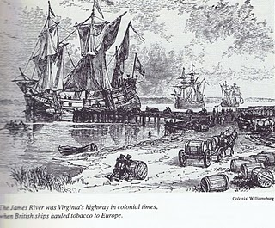
Most assuredly the Holliman family grew tobacco (Christopher Sr.’s will mentions tobacco barns). They probably hauled hogsheads to the river where it was then shipped to England. Tobacco as a commercial crop was first developed by John Rolfe, Pocahontas’s husband, in 1610s.
Thus began an ecological and social alliance with tobacco and later slavery; two items that would shape the future of our family and country.

Our Family's Colonial Era, Part VI

Tobacco, Slavery, Democracy and Our Family
If one analyzes the 17th Century Virginia economy carefully, it makes for disturbing reading. The Christopher Hollimans and, of course, the rest of the colony grew a crop (tobacco) that if used normally shortens the lives of most people.
Even King James I wrote during his reign (1603- 1625) a book called "A Counter Blast to Tobacco" castigating the use of the Indian weed. He was the first but not the last political leader to urge persons to quit the habit. (This same king gave us the King James Version of the Bible which our ancestors read and cherished.)
Of course, until 1776, the Crown's tobacco tax fattened the coffers of the English government just as cigarette taxes swell the treasuries of the U.S. and the states today.
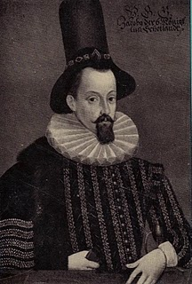
King James I of England models the latest in London hat wear fashion in the early 1600s
Generally, before 1700, this crop was hoed and harvested by family members and indentured servants from England. However, by the early 1700s, more and more newly imported African laborers tended the weed. These new Americans of a darker skin hue, soon found themselves in ever more secure legal chains on land taken by the English-Americans, usually forcefully, from Native Americans. The Virginia House of Burgesses, composed mainly of wealthier planters, passed laws as early as 1660 declaring that both captured Native American and African-Americans as 'property' who could be held in bondage and sold as human chattel.
Did these first Holliman generations hold slaves, even though owning human beings was still an ill-formed institution in the late 1600's Virginia? The 1691 will of Christopher Sr. mentions nothing of human property, but one of his grandson’s, Thomas Holliman, does record in his will of 1762 the leaving of five slaves to his various sons. One slave, named Peter, was to be sold and the income produced to be divided amongst some family members. Other Holliman relatives began to note slaves, although not more than a few African Americans, in their wills by the early and middle 1700s.
The Christopher Hollimans and their descendants seemed to have been ‘average southerners’, yeoman, land-owning farmers if you will. In 1860 only one out of every four southern heads-of-households owned slaves. Most of our Alabama Hollimans listed no slaves in census reports of 1860, although kinfolk by marriage did so. Historians report that average number of slaves owned by a southern head of household was four, or roughly that of a family. The gigantic slave plantations of Gone With the Wind are largely fiction, although some such 'human factories' did exist. The larger planters, men of wealth, controlled the politics of the time and region.
Perhaps as with many early Virginians, the first Holliman generation tilled only a small portion of land for tobacco, the cash crop, utilizing the rest for corn, vegetables, wood fuel and range for hogs, poultry and cattle. There were six children who grew to adult hood to assist with the work in this 17th century generation.
For the record, let us note three events in the year 1619 that influenced American history and our family. One, the House of Burgess, a parliament if you will, met for the first time in Jamestown - the first example of representative democracy in the colonies. Two, that same year a Portuguese transport sold Africans in Virginia who were held as slaves. Three, across the James River, a new settlement was born, the shire, later to be called after a founder's English home, of Isle of Wight County.
So paradoxically democracy and slavery, our nation's birth defect, were introduced the same year in the same colony. To this day our family has been greatly influenced by these events. And across the James River, the shire, where Christopher Holliman, Sr. prospered, was founded that same fateful year of 1619!
(For sources used for this article and more information, please refer to Sources and Publications on this blog.)

Our Family's Colonial Era - Part VII

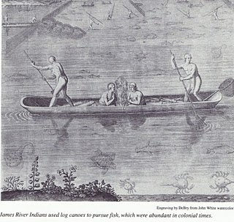
Conflict with Native Americans – A Clash of Cultures
This was truly a new frontier with both opportunity and premature death. Only the brave or foolish ventured from England to Virginia from the early to mid -1600s. Perhaps our pioneering family of Christopher Holliman, Sr. was a mixture of both.
Michael Mallary in his 2004 work, “Our Improbable Universe”, makes the point that everywhere farmers emigrated taking their technology and culture, the hunter-gatherers melted away before them. “The high population density that could be supported by agriculture depleted game well below the density that hunters (such as American Indians) required” observed this historian.
This then was the societal reality when Christopher C. Holliman, Sr. with his probable sister, Judith, arrived in Virginia in 1650. The frontier required bravery, a tenacious attitude to attack the virgin forests and a strong constitution not to succumb on the voyage or to disease and malnutrition upon arriving. Fortunately this Holliman family had such attributes, although Anne, Christopher's first wife, died in the 1660s. Mary Grey, perhaps the daughter of a member of the House of Burgesses in Jamestown, became Sr.’s second wife.
In only a generation or so, soil exhaustion from tobacco cultivation forced families or young farmers to move to virgin land, to push the American frontier ever westward. The quest for land to grow tobacco and later cotton meant more and more Native Americans were displaced. The result was violence as American Indians naturally resisted encroachment on their hunting grounds and village fields of maize and beans.

The Indian did not go quietly to his cultural demise in Virginia and greater America. This displacement is one of the shames of American history.

The founding of Jamestown in 1607 meant the English had come to stay. Unlike the earlier 1580s failed Roanoke experience, this time our Anglo fore bearers mustered the necessary resources to establish a permanent colony. The English Diaspora employed superior technology, organization and the financial resources to grasp and hold an expanding piece of the New World.
Perhaps 15,000 to 25,000 Native Americans lived in Southern Virginia in the early 1600s. Benjamin Woolley’s “Savage Kingdom” records Captain Christopher Newport’s 1607 initial visit up the newly named James River to the site of present day, Richmond. He cited numerous Indian villages. John Smith’s adventurous tales record numerous Indian settlements and evidence of many warriors. What English people knew as Virginia, Native Americans called Tsenacomoco.
Although there were numerous skirmishes and at least one large assault on early Jamestown as the two cultures brushed and bruised each other, the early English were fortunate the central Indian chief was Powhatan. By and large he was an accommodating weroance (chief) who failed to anticipate the ultimate threat of the English invasion.
At his passing, his brother, Opechancanough, already an old man, recognized the Anglo incursion for what it was – a death threat to Indian culture and territory. On the Christian Good Friday in March, 1622, this war chief unleashed a Pearl Harbor on the small colony. By stealth, Indians conducted well-coordinated attacks on plantations and settlements all up and down the James River on both south and north banks. Over 1/3rd of the English colonists were killed in one day – 347 men, women and children. It was a close run thing if the colony could repel the attacks.
While a tactical victory for Native Americans, the attacks were not enough to drive the English into the ocean. Within a year, the colonists struck back and killed over 200 Indians, although Opechancanough escaped. For two decades the frontier was mostly quiet, but in 1644, now almost 100 years old, ever determined Opechancanough struck one last time. Five hundred settlers died, particularly along the York and Pamunkey rivers. (Records indicate several settlers named Holyman already were living in the colony in the 1630s and 40s. They may have been cousins or brothers of Christopher Holyman, Sr.)
This time under a controversial but stubborn royal governor, Sir William Berkeley, the Virginia militia now much stronger and more numerous than warriors the Indians mustered, captured Opechancanough and destroyed most of his forces. The old chief died in captivity in Jamestown, slain by a vengeful guard. Surviving Native Americans were relegated to a piece a land near the fall line, at present day Richmond.

Of course, beyond the settled frontier, other Indians remained as yet only modestly disturbed by the ever westward moving Europeans. As yet undisturbed…although disease and cultural change arrived before the physical presence of pioneers.

Our Family's Colonial Era - Part VIII

In 1635, persons whose last names are similar to Holliman, were living in Virginia. Are they our ancestors? Who were Thomas Holeman
(Holman) and Robert Hollman?

Cousins Jeanette Stewart, Joe Parker and Maxine Wright have drawn my attention to the name and landownership of Thomas Holeman who purchased property in 1635 in Martin's Hundred, approximately ten miles south of Jamestown, Virginia. On p. 30 of Nugent's “Cavaliers and Pioneers, Patent Book No. 1, Part I” is a listing of a purchase of fifty acres of land in James County, adjacent to John Dennett and Capt. John West. The land had belonged to one Thomas Harvey who had died (the death rate was very high in early Virginia).

Is this the Thomas Holyman (Holiman, Holman, etc.) who was baptized September 13, 1612 at St. Mary's, Bedford,Bedfordshire, England? As noted in early posts, Thomas and Ellenora Holliman of Bedford were the parents of a Thomas and three other children with the names of John, Judith and Christopher Holyman, the same names as other persons who lived in Virginia in 1650.

In research at the Library of Virginia in Richmond, I consulted numerous works seeking to know more of this Thomas. Martha W. McCartney in “Virginia Immigrants and Adventurers 1607 – 1635”, also writes of Thomas patenting land on August 24, 1635. Ms. McCartney spells his name 'Holman', not 'Holeman'. Likewise, Gary Parks' index of “Virginia Land Records” records Thomas as a 'Holman'.

Gravestones were not common in Colonial Virginia until the 1700s when the colony began to 'mature' and relatives had the resources to purchase and craftsmen to carve rock. Below is the memorial marker for Alice Holleman of the 19th Century, who lived and is buried on the original plantation of Christopher Holyman Sr. Unfortunately, of course, there are no markers for ancestors who lived in the 1600s and precious few for the 1700s. Weather and time have eroded even stone.
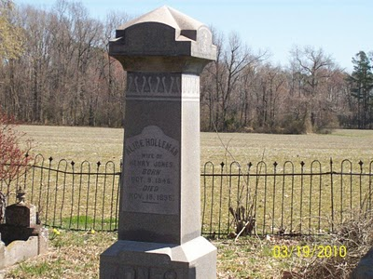
And Who was Robert Holliman?

Then there is twice mention of one Robert Hollman (not Holman or Hollyman) in “Virginia Land Records”, pages 666 and 674, on the dates of June 1 and March 6, 1635 in Henrico County, Virginia. Henricio is north of Jamestown and now encompasses the city of Richmond. This Robert Hollman owned land adjacent to the 'main' river, that is the James.

Granted spelling was atrocious in Colonial Virginia. The records are hard to read, and last names were spelled in different ways and often inaccurately.

So are Thomas and Robert our Holliman ancestors or some one else's?
If so, at least 15 years before Christopher Holyman, Sr., our known ancestor, arrived, were his relatives, perhaps a brother and/or a cousin, already in the Chesapeake region? Did they prepare the way for more Hollimans who arrived in 1650 and later?

Our Family's Colonial Era - Part IX

More on Thomas Holeman, 1635 Land Owner at Martin's Hundred in Virginia

Martin's Hundred, a real estate development if you will, was named after the Society for Martin's Hundred of London, a land holding group in 1618. This huge settlement was located east of Jamestown and west of Skiffe's (Keith's Creek). It contained 20,000 acres and was a principle settlement site at that time. The website Jamestowne Rediscovery has an excellent summary.

Records indicated 140 or so English lived in the development when in 1622 on Good Friday, a surprise American Indian uprising took the lives of at least 78 of the settlers in Martin's Hundred. The remaining were captured or fled to Jamestown. According to historian Bob Dean in his book “The River Where America Began”, 347 settlers, more than 1/4th of all the colonists died in that one day massacre.
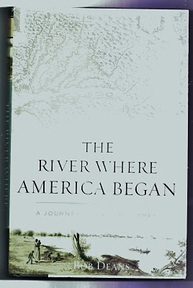
The Virginia colony was in great jeopardy, but struck back violently the next year against the Native Americans. The Crown took control of the dispirited colony from the Virginia Joint Stock Company that had founded Jamestown and had hoped to make a financial fortune.

Slowly the colony recovered, and immigrants arrived again. One being Thomas Holeman who purchased land in Martin's Hundred in 1635. Fifteen years later, Judith and Christopher Holyman, perhaps his siblings, perhaps not, arrived. Judith probably married quickly, and her name is lost to history.

In that same year of 1650, one John Holyman of Southampton, Virginia died leaving a will listing worldly goods but no land. He named a friend as an executor. When did he arrive and were Thomas, Judith and Christopher his siblings, all from Bedford, England?

We know Christopher survived and thrived, dying in 1691 with an Isle of Wight County farm of 1,020 acres and numerous children. Most of us reading this today are his descendants.

In 1627, approximately 1,500 English persons lived in Virginia, mainly along the James. From 1606 until 1624, the Virginia Company had sent out over 7,000 settlers of whom over 6,000 died! By 1650, the year Christopher Holliman arrived, some 15,000, ten times as many white settlers were present, or about seven times as many Anglos over Native Americans by this time in Virginia. Many of the Indians had been destroyed by European diseases and malnutrition, as well as warfare. The English were living longer thanks to better diet and shelter.

What happened to Thomas? At this writing I know of no research that has surfaced a will or marriage record. He purchased land, and may have died early as did many. Unfortunately James City County records were destroyed when Richmond was burned during the Civil War, and only some land patent records survive to my knowledge. Martin's Hundred ceased to exist as an entity in the early 1700s.

Did Thomas survive long enough to welcome to Virginia other members of his family - assuming John, Judith and Christopher Holyman were his siblings (families often immigrated together or after one had settled and encouraged others to immigrate)? Can we ever know the whole story?

In the 1970s with a grant from the National Geographical Society, archaeologist Ivor Hume, excavated part of Martin's Hundred, now included in the Carter Grove Plantation and incorporated in the Williamsburg Foundation. Much of Hume's 1988 book (pictured above) focuses on the 1622 Good Friday Massacre and the physical remains of that day. The cover of the book shows an English soldier of the time, garbed in armor. It is compelling reading.

ADD BOOK COvER

Our Family's Colonial Era - Part X

A Civil War in England and
War with the Dutch in the Chesapeake Bay
Virginia was not immune from the disturbances in England. After the English Civil War, and Charles I losing his crown and head, Oliver Cromwell’s Commonwealth ruled from 1649 to 1660. Robert Berkeley, a long serving royal appointee, was dismissed as governor of Virginia in 1652 when a Commonwealth ship sailed up the James River and demanded Berkeley’s surrender of the colony and his post.
Below Oliver Cromwell, the uncrowned king of England during the Commonwealth Era.
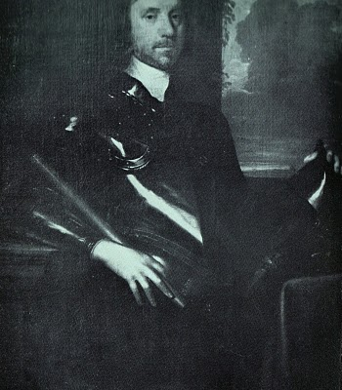
With the restoration of Charles II to the British throne in 1660, Berkeley left his plantation and exile at Green Spring (near present day Williamsburg) and returned to lead from Jamestown, still the capitol.
Violence never was far away from the Hollimans and their farms in what is now Smithfield, Virginia on the Cypress River (a short river which emptied into the Pagan and then into the James) and later the Blackwater Swamp, still in Isle of Wight County. In 1667, a Dutch fleet sailed up the James and burned twenty colonial ships carrying tobacco. Six years later, the persistent Dutch in a continuing trade war with Britain, returned and burned or captured another ten ships.
Did the Holliman’s suffer financial losses as a result of this international war? Did they hear the guns and see the smoke? Undoubtedly the Virginia militia was turned out. Was this long-forgotten naval engagement (and war) the first occasion for Holliman’s to muster in defense of their new country?

Economically the Virginia colony was suffering from a surplus of tobacco, falling commodity prices, restrictive trade laws and increasing taxes. In addition to Dutch and Mercantile wars, the frontier (northern Isle of Wight County was a border) still experienced friction and violence between settlers and Native Americans. If this sounds like 21st Century America, we are reminded that physical and economic security are paramount issues in any community or century.

Our Family's Colonial Era, Part XI

Some 17th Century Holymans - Who Were They?

Most of us reading this blog are descendants from Christopher Holyman (Holliman, etc.) who was born in England, immigrated in 1650 to Jamestown with a person named Judith, presumed to be his sister, both from probably either Bedford or Buckinghamshire, England. Judith disappears from the story, but we know Christopher, Sr. died in Isle of Wight County, Virginia in 1691, having prospered as a planter.

In previous articles, I have shared research by others on Thomas Holeman who in 1635 purchased land at Martin's Hundred, south of Jamestown. There was also one Robert Hollman, who in March 1635 owned land in Henrico County, along the James River. Then there is John Holyman who died in Southampton, Virginia in 1650, a possible brother of our Christopher Holyman and the above Thomas Holeman. Possible.

There are still more Hollimans!

Beside the descendants of Christopher Holliman, Sr., other Hollimans also were arriving in the New World. Here is a list I have put together so far, and of course, welcome information, additions and clarification.

1653 - Another Judith Holyman and a second Christopher Holyman arrived three years after our Christopher Holyman Sr. and the original Judith Holyman stepped ashore at Jamestown. Most genealogists believe they were relatives, perhaps a son, a daughter or a mother? This record in Virginia archives still perplexes me.

1656 - On April 25, 1656 one William Holliman arrived, transported courtesy of Thomas Rolfe. Who was Thomas Rolfe? None other than the son of John Rolfe and his famous wife, Pocahontas, the daughter of Powhatan, chief of the tribes when Jamestown was founded. Well....my goodness....By 1658, William Holliman was a land owner. All this from Nell Nugent, Volume 1, pages 328 and 377, “Cavaliers and Pioneers”.
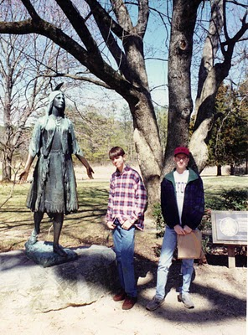Above in this 1994 photograph, my son, Christopher S .Holliman and nephew, Bryan Payne, pose at Jamestown in front of the statue of Pocahontas. Both are direct descendants from their multi-great grandfather, Christopher Holyman, Sr., who landed at this site in 1650. Did Pocahontas’ son Thomas transport another of their ancestors?
1658 - February 26, one John Hollman transported by John Dorrant. A Holliman simply slightly misspelled?

1659 - How about some indentured servants, poor people who bought their passage to Virginia in exchange for years of work? Labor to work tobacco fields was very scarce in the colony. There was Jane Hollyman, unknown family, who on September 10th was ordered to serve her master an extra year at the end of her indenture for running away. This freedom loving female Hollyman had escaped for six months from one William Cox. The county was York, Virginia. Interesting, our Christopher Holliman, Sr. was transported in 1650 by one John Cox. Relationship?

1675 and 1681 - The names of Thomas Hollyman pop up twice, both times in Lancaster County, Virginia as indentured servants. Are they the same person or two named Thomas Hollyman? The second in 1681 is listed as a servant of Lt. Colonel John Carter, ah ha, of the famous Carter family. Later the Carters will cease using indentured servants and instead utilize African slaves. This John Carter will die early eventually leaving the entire family estate to Robert "King" Carter who will become the wealthiest man in Colonial Virginia, acquiring over 300,000 acres and 1,000 slaves. This John Carter got his start in Isle of Wight County in the 1640s, the same country were our direct great grandparents would put down roots.

For citations on Jane and the two Thomas Hollymans, go to the Immigrant Servants Database on the web. Citations in original records are given. A very neat web site where one can cross check numerous family trails.

From whence did these Hollymans come? Bedford or Tring area, England? Some other part of the England? Worcestershire for example? Are these distant cousins? Perhaps, probably, perhaps. Joe Parker has identified even more Hollimans who lived in Virginia in the second half of the 17th Century. So there are more stories to tell.

Our Family's Colonial Era, Part XII

What Can We Learn from the Will of John Holyman?

I am indebted to Joe Parker, a serious Holliman genealogist, for the material below from the “Northampton County, Virginia Record Book, Vol. III, 1645 – 1651”, page 448. The work is edited by Dr. Howard Mackey and Marlene Alma Hinchley Groves. Opinions and any errors in this article are mine alone.

Below is the will of John Holyman dated May 8, 1650, two weeks before Christopher Holliman Sr. and Judith Holliman arrived in Jamestown, Virginia.
"Memorand That this day ye Last will & Testant' of JohnHoloman of Northampton County, planter, dec'd was pr'ved:
J'No Hollowman his will & desire is that hie giveth unto Christopher Kirke towe cowes & one heyffor with towe steers & one yearlinge, and towe calves & towe sowes & towe barrowes, and more. towe shutes of clothes & a gun w'th a chest & a cutlace, and my Bedd w'th covinge w'th three sheets. As witness my hand this 8 daye of May 1650./ JNo [ his mark ] Hollowman. Wit: Wm Mortt [Mott?]
JNo Hollowman his Acco'tt the 8th day of Maye 1650/ of what Debtes is oweinge him abroad w'thout any spec. as followeth, witnes' my hand.
Test: Wm Moulte/ JNo [ his mark ] Hollowman"
Translation? John leaves to one Christopher Kirk two cows, a heifer (a cow not yet giving milk), two steers, a yearling, two calves and two pigs (female). The barrows are neutered male pigs. And he leaves more, which we assume are farm tools. Judging from the above John is a small farmer with a modest amount of livestock, typical for a yeoman planter at that time in Virginia's history. Christopher Kirk fathered a line of successful children and grandchildren, and their story may be explored further in colonial records (just Google the name and time).
What else? Two suites of clothes, a gun, a cutlass, a chest and a bed with three sheets. Okay, John could defend himself from wild animals and Native Americans (was John present in 1644 when 500 plus colonists died, a very serious uprising?).
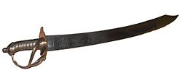
Above a 17th century French cutlass, a curved short sword.
What's missing from this will? Well, number one, everything is left to a friend and not to a spouse or children (or a brother and sister). As Christopher Sr. and Judith yet had not arrived from England, it is not too surprising that nothing is left to them, if one assumes John is either their father or more likely, their brother. No wife? Women were still scarce in Virginia in 1650, and perhaps this John never married or a spouse may have died.
No mention is made of land? Did John rent land? Possibly unless he had given it away before writing the will, which seems odd. So probably he rented some acres. He was not an indentured servant or he would not have had the livestock. However, he did not have any sheep, so wool or clothes would have been precious. A wife was important for spinning wool and making clothing. Cotton was not yet grown, so clothes, generally all imported, were expensive and highly prized. Hence clothes left to a friend in the will.
No furniture or kitchen items, silverware or other items described. Virginia was not yet a mature or abundant colony. Most English, approximately 15,000 by 1650, were yeoman farmers, struggling to plant Indian corn, some beans and tobacco (as much as possible).
I have searched databases of Northampton County, Virginia and have found no other listing of John Holyman (or similar name) during these times. Northampton is also on the Eastern Shore, the southern most county. Granted this is the entrance to the Chesapeake Bay, but it is some distance by water from Jamestown or Isle of Wight County.
So is John Holyman a possible ancestral uncle? Or as is claimed by one Hollyman web site, the father of Christopher Holyman Sr.?
Let's refresh our memories.
1610 - September 16, one John Holliman baptised. John married a Mary Parrell on July 25, 1641 at St. Mary's Parish, Bedford, England. If this be our John, did Mary make the trip to Virginia with him?

1616 - Thomas Holloman, brother of the above John, baptised at St. Mary's Parish, Bedford on March 20. Is this the Thomas of Martin's Hundred near Jamestown who took land in the 1635? Did this Thomas start the family moving to Virginia when he was only 18 or 19 years old?

1618 - Christopher Hollaman, brother of the above, baptized on September 2. Is this our Christopher Holyman Senior who immigrates to Jamestown in 1650, raises a large family, makes his earthly fortune and dies 1691?! Is this my generation's 7th great grandfather? (My personal opinion is, yes.)

1621 - Judith Holliman, sister of the brothers above, baptised on February 11. Is this the Judith who arrives in Jamestown with a Christopher in 1650 and/or later in 1653?!

Genealogy is not an exact science, and it is so frustrating not to be able to tie these lines of kinship together. My opinion is that this John Holyman is a relative (and not the father) of Christopher and Judith Holyman who arrived in Virginia at the time of John's death. Evidence and logic - yes. Proof? I have none.

Our Family's Colonial Era, Part XIII has been modified and appears earlier in this document describing the movement of the Holliman family from Virginia to the Carolinas to Alabama.

Our Family's Colonial Era, Part XIV

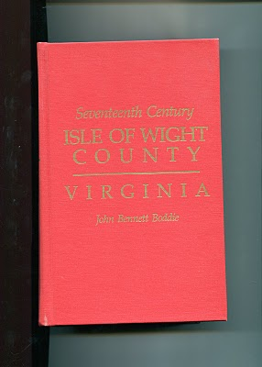

The Observations of Historian John Bennett Boddie

In 1938, Virginian historian John Bennett Boddie published “Seventeenth Century, Isle of Wight County, Virginia”. My 1994 reprint by the Genealogical Publishing Company of Baltimore, Maryland is brimming with abstracts of county records and Boddie's own history of this part of Virginia in the 1600s. Yes, there are many Holymans, including Christopher Holyman, Sr. and Jr., recorded in this volume, and much to study and upon which to reflect. In the next few postings, I shall pull out and examine some findings that reflect on our family and our country.

Isle of Wight Country had its first English settlers in 1619, one Captain Christopher Lawne responsible for a few pioneers. He represented his fledgling county in the historic first House of Burgess's meeting in 1619. Lawne's settlement floundered, but one Robert Bennett transported 120 settlers to Isle of Wight by 1621.

As I have recorded in earlier posts, the Powhatan Indian Confederacy launched an uprising on Good Friday, March 1622. After the day of murder, only 50 or so English remained in Isle of Wight Country, and 950 so English in the entire colony. English Virginia barely survived, but in recovering the settlers launched all out war on the Native Americans. From 1622 to 1632, annual forays into Indian territory resulted in destruction of many villages and food supplies.

Colonial Virginia was safer for current and future English settlers, and the amount of available land taken by a decade of conquest considerably enlarged frontier borders. The Warascoyak's tribe of Isle of Wight Country was destroyed in the extensive conflict.

In recording the above, Broddie on pages 84 to 86 notes three important precedents established by the Virginia House of Burgess in that ten year war. I thought them so important to understanding the future of our country, that I record them here.

1624 - Virginia General Assembly required 'that those shall be hurt on service shall be cured at public charge and the lame to be maintained by the county according to his person and quality'. The care of veterans wounded in combat is enshrined into legislation very early in our history!

1629 - The Assembly gave Plantation commanders the authority and power 'to levy men to fall upon the Indians'. This is the first conscription or 'draft' law in colonial America, a precedent that all future draftees (such as myself in 1968) can appreciate!

1632 - Assembly required that no man shall attend church without carrying firearms or work ground without arms and a sentinel. In a foreshadowing of the 2nd Amendment to the 1789 U.S. Constitution, later Assembly laws required that white males own a musket, shot and powder. This requirement provided an instant militia and saved money by not requiring a central armory or standing army for each county.

Our Family's Colonial Era, Part XV

The New Life of Christopher Holyman, Sr. in 1650

DNA testing and research both come to the same conclusions that the father of the Holliman family in America (Holleman, Hollomon and other variations) is Christopher Holyman, Sr (1618 - 1691), who landed at Jamestown, Virginia on May 22, 1650.

Unfortunately, we know his first wife only by her first name, Anne, and we do not know how and where Christopher lived during his first decade in Virginia. His name first appears in a legal document in 1660 in Isle of Wight County on the west side of the James River. If Thomas Holyman of Martin's Hundred (assuming he was Christopher's brother, a considerable 'if'') who had arrived in 1635 was still alive, no doubt he may have materially assisted this Holyman in his first years in the New World. Sadly Thomas Holyman is lost to history, and we can only speculate.

Imagine the America in which Christopher settled in 1650. Barely 50,000 Europeans were scattered from Boston to Jamestown, hugging the east coast with a fragile toe hold. There was no Charleston (or South or North Carolina), no Baltimore, no Philadelphia (no Pennsylvania) and New Amsterdam (later New York) was a small settlement at the tip of Manhattan surrounded, as were all colonies, by semi-hostile Native Americans. Only 15,000 or so settlers lived in Virginia, and the roads, such as existed, were mud hollows in wet weather.

Jamestown itself was little more than a village of 30 to 50 cabins and a brick church (see below) that also served as the colonial assembly building. Williamsburg did not exist.
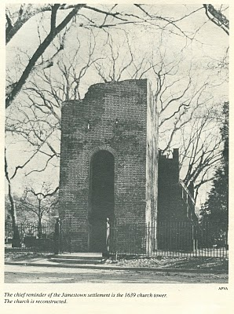
The New World, although blessed with boundless forests, rivers teeming with fish, and savannas ripe with game, was a hostile environment. If one survived the wretched voyage in small ships across the North Atlantic (and on average, one out of four did not), then there was the period of 'seasoning' when immigrants had to face and overcome American diseases such as malaria and yellow fever from Virginia mosquitoes, and the usual small pox and other assorted maladies that took the lives of many. Until settlers established apple groves, there was a lack of vitamin C. Most wells were shallow in the Tidewater with resulting contamination and disease.

In 1650 already enshrined in Virginia law was the requirement that all white men carry muskets when leaving their homes. Powhatan Indians had delivered bloody blows to the encroaching settlements in both 1622 and 1642. In the last encounter, eight years before our Christopher arrived, over 500 Virginia colonists had been slain by Indians. The tension between the two cultures remained real and dangerous.

We know that on January 11, 1661, Christopher and Anne Holyman patented land along the Cypress River, Isle of Wight County from the founder of Smithfield, Virginia, George Smith. This would be virgin land, not yet exhausted by tobacco. In 1668, Christopher Holyman, this time with a new wife, Mary, would sell the land to Thomas Pittman. Google these names and one will find 'Holyman' and these sales articulated in several web sites.
Several sources besides web sites reveal these early transactions. In addition to Brodie's book I discussed in a previous post, Blanche Adams Chapman's “Wills and Administrations of Isle of Wight County, Virginia, 1647 - 1800, Books 1 – 3” contains considerable legal recordings of the Holyman families. Chapman's book (pictured below) is available through Heritage Books, 65 E. Main Street, Westminister, Maryland 21157.

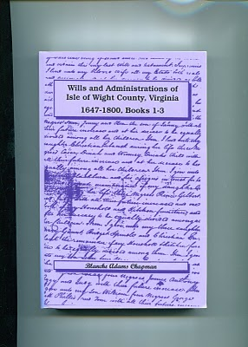

Our Family's Colonial Era, Part XVI

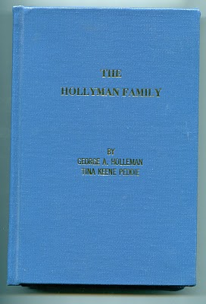

Who Were the Children of Christopher Holliman, Sr.?

In 1952, George A. Holleman, formerly of Chicago and later Columbus, Mississippi, wrote and published privately a work called “The Hollyman Family”. To my knowledge this work, which was expanded and reprinted by Holliman genealogist Tina Peddie, is the first and still the only comprehensive volume to discuss the founding of our Holliman family and to list hundreds of names of Holliman descendants. It is a monumental piece of research for the pre-internet age. Those of us who are his distant cousins are grateful for this volume, and Tina's work to update it and keep it alive.

The 350 odd page volume is available from Tina Peddie, desabla1@yahoo.com.

In this book George Holleman published, probably for the first time, a list of the children of Christopher Holyman Sr.

They are:

Thomas Holyman - ? to 1734

Christopher Holyman, Jr. - ? to 1731 in Isle of Wight Co.

William Holyman - 1661 - 1704

Richard Holyman - ? to 1711 in Surry Co.

Ann Holyman who married John Atkinson in 1691

Mary Holyman who married James Atkinson (John's brother) in 1691

The genealogists, reports and data I have read seem in agreement that primarily Hollymans, Hollemans, Hollimans, Hollomons, etc. in the United States are descendants of this family. This is not to say that other Hollimans could not have migrated later to other colonies or that other Virginia Holymans, such that have been discussed in other postings, did not leave families also.

However, to my knowledge (and I wish to be corrected if in error), most if and not all Hollimans (and variations) trace their lineage through Christopher Holyman, Sr. Personally, this is my branch, so those of you related to me through grandfathers and great grandfathers are descendants of dear Christopher Sr.

And thank you George A. Holleman for your pioneering work!

Our Family's Colonial Era, Part XVII

Bacon's Rebellion - The Virginia Civil War before the American Revolution

Some have called it the precursor to the 1776 Revolution, only one hundred years earlier. Actually, my reading of the violence and pain of 1676 Colonial Virginia is more of that of a Civil War. Two factions, one wealthier and in power, and the other less wealthy, less powerful and feeling physically threatened by Native Americans, clashed over taxes and 'homeland' security.

The insurgents, hundreds of white and some Black young men, rallied around Nathaniel Bacon, age 32, a cousin by marriage to the Virginia Royal Governor, and a planter near the Falls that is now Richmond, Virginia. A number of issues led to Bacon's revolt which resulted in brutal attacks on Indian villages, the rousting of the Royal Government and the burning, of all places, Jamestown, the capitol. Many died and many were hung by a recovering Royal authority.
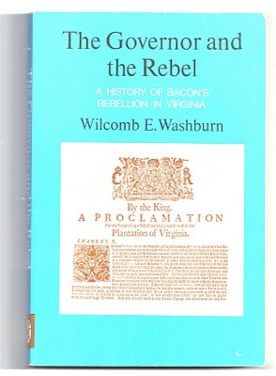
Were Christopher Holyman, Sr., a planter with a thousand acres or so, and his children caught up in these events? Yes, they were. The Holymans had some legitimate grievances, but when push came to shove, they opted to support the Royal Governor, one William Berkeley. For that no Holyman swung by their necks as did 22 rebels in the autumn of 1676, including a few of their neighbors.

Still the standard for understanding Bacon's Rebellion is Wilcomb E. Washburn's 1955 work. It is fair, balanced and points out the issues on both sides.

Numerous historians have provided excellent interpretations of the events of the rebellion such as Alan Taylor's, “American Colonies” and especially Edmund S. Morgan's “American Slavery, American Freedom”.

Our Family's Colonial Era, Part XVIII
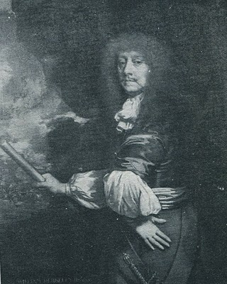

Why the Holyman's were Caught in the Middle of Bacon's Rebellion

The painting is Sir William Berkeley (1606 - 1677), a well-educated Englishman appointed by Charles I during the English Civil War to govern the colony of Virginia. He was successful when he arrived in 1642 to defeat the latest Powhatan Indian attacks and ushered in a period of peace. Turned out of office in the early 1650s by the Commonwealth, he returned with the Stuart Restoration. He grew old in the position and became content with loyal assemblymen from a House of Burgess that sat from 1661 to 1676. Bacon's Rebellion resulted in the burning of his capitol, Jamestown, the loss of his post and eventually his recall to London. He died in 1677 before he could defend his actions before the Court.

In the 1671 “Surry County, Virginia Record Book”, p. 2 is a fascinating insight into our family and the Virginia colony on the eve of a great civil rebellion. It is recorded in George A. Holleman's original history of Hollymans in 1952.

"Att a courte houlden att Southwarke for the County Mar. 5, 1671...Upon complaint of Christo Holiman itt manifestly apearinge that the Coppahunck Indians have kild two hoggs of ye said Holiman. Itt is ordered that Capt. Pipsicoe within thee months make payment unto ye said Holiman of Six Buck and Six doe well drest Skins & in Case itt doe apeare heere after that any Indian shall Kill anyhogg or hogs of ye English that they shall pay for every Hog by them Kild twnety Buck skins."

Well, what to make of this?

1. Surry County, founded from James City County in 1647, lies just north and west of Isle of Wight County.

2. The parish of Southwarke was located across the Isle of Wight County line. The plantation of Christopher Holyman straddled the county lines, and his theft occurred in Surry County. Many Holyman descendants will move into Surry County and from there to Johnston County, North Carolina in the 1700s.

3. The Indians were Quiyoughcohanocks (Cohanocks), allied with the Algonquian Powhatan Confederacy. This tribe had participated in the Good Friday Massacre of 1622 which almost wiped out the Virginia colony.

4. Subsequently, the Virginia House of Burgesses had passed draconian legislation that any Indian who crossed the Blackwater River could be shot on sight! The Holyman plantation was (and parts of it still are) adjacent to Surry County and the Blackwater River.

5. The 1670s saw considerable Indian unrest up and down the eastern seaboard. In 1675 the tension burst into King Phillip's War in New England. Thousands, both white and red, died in the greatest outburst of violence to that date in the English colonies.

6. As in New England, the increasing dissatisfaction with the population increase of the English settlements, led to Indian resistance in Maryland and Virginia. The population of Virginia more than doubled from 15,000 to over 30,000 by the 1670s further encroaching on Indian lands.

7. The theft of hogs from the Holymans was a typical incident between the English and Indians. The English, who went armed and hunted deer for food and hides (a valuable commodity), evidently had little sense they were reducing the caloric intake possibilities of Indians. Indians felt that since whites could enter their hunting lands, and take game, they were entitled to enter English farms and take livestock! Tit for tat one would say.
The Hollimans and other colonialists did not see it that way.

Multiply these incidents by the dozens, add indiscriminate murders by both colonists and Native Americans, mix with land hunger by the English and decrease of hunting land by the Indians, and one has the recipe for another Indian War. In fact a murder of Nathaniel Bacon's overseer near Richmond, Virginia triggered a vigilante response led by Bacon. A peaceful Indian village near the North Carolina border was wiped out, and Indian women and children brutally murdered by Bacon's irregulars.

This was in defiance of Governor William Berkeley, a long serving administrator who wanted to build forts rather than unleash the militia. Those living on the edge of the frontier, presumably including the Holymans, desired immediate offensive action against Native Americans. Although Berkeley was furious with Bacon's actions as he had tried sincerely to maintain the peace, the rugged take-charge, take-no-prisoners attitude of Bacon attracted many colonial adherents. The actor John Wayne could have played Bacon in a Hollywood movie!

Bacon also demanded reduction of taxes on tobacco, the money crop for almost all colonialists. Tobacco prices had plummeted in the recent decade due to too many settlers growing too much of Nicotiana tabacum. The English Navigation Act of 1663 forbade the colonists from trading with any nations other than the English. With Dutch and Spanish markets cut off directly from Virginia, there were fewer outlets and competition for the increasing supply of tobacco. Yet while income went down, taxes remained the same.

Something had to give.

Our Family's Colonial Era, Part XIX

The Rebellion Close to the Holyman Plantation

The Holymans, caught between two forces, remained loyal to the Crown.

By the fall of 1676 Nathaniel Bacon's revolt had attracted hundreds of adherents, some who took delight in ransacking the homes and plantations of wealthy planters. A few of the rebels were of the planter class themselves, the most visible to history being one William Byrd, whose descendants would prosper financially, leave diaries and a political dynasty. (In the 1700s one Mary Byrd of this family would marry a grandson of Christopher, Sr.)

Other rebels, hundreds of young men in fact, were indentured servants and African-American slaves, an interesting mingling of persons, generally of a less economically prosperous class. The presence of armed Blacks during this period would later result in the House of Burgess passing highly restrictive slave codes in Colonial Virginia. As far as this writer knows this would be the last time that poor whites and Blacks would make common cause against a white power structure in Southern history prior to the Civil War. For the next several hundred years, white racial prejudice would overwhelm the common economic interests these two groups could have shared .

Isle of Wight and neighboring Surry County produced both supporters of Bacon and defenders of Governor Berkeley. Historian John Boddie in his work “17th Century Isle of Wight” records numerous conflicts amongst neighbors and the forces of the Crown and the rebellion. A Major Arthur Allen, a prominent Crown supporter, fled his home near the James River, not fifteen miles north east of the Holyman plantation. Constructed in 1665, and still one of the finest examples of 17th Century Jacobian architecture remaining in the western hemisphere, the home was occupied for four months in 1676/77 by William Rookings, other commanders and up to seventy supporters of Bacon.
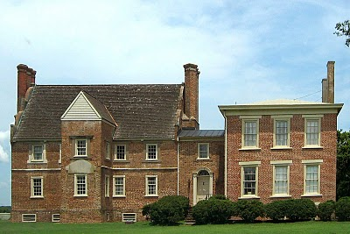
The rebellion collapsed in the late fall of 1676 after Bacon died of dysentery, and his body buried in the York River. Allen recovered the home in 1677 and later sued the occupants of his home for damages. This wealthy neighbor of the Holymans would no doubt be angry that his residence has become known as 'Bacon's Castle' after his nemesis! Today the home is on the National Register of Historic Places, is administered by the Association of the Preservation of Virginia Antiquities and is open to the public. Google Bacon's Castle and view the home and read its history.

Bare in mind, this is one of the few examples of 17th Century brick construction surviving in North America. The Holymans and 99% of other Virginians at the time were living in unpainted wooden structures that in a short time disappeared to natural decay or fire. Virtually no 17th structures remain in Virginia. Bacon's Castle is one of the few.

During your next trip to Jamestown and Williamsburg, do cross west over the James River, visit the museum in Smithfield, the Holleman home near the Mill Swamp Baptist Church in Isle of Wight County and nearby Bacon's Castle.

Our Family's Colonial Era, Part XX
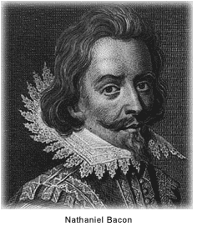

The Empire Strikes Back

With the premature death of Nathaniel Bacon, the rebellion in 1676 in Colonial Virginia began to die for lack of leadership. Royal Governor William Berkeley returned from exile on the eastern shore of Virginia, and began to deliver vengeance with a rope. Before King Charles II and his new colonial appointees could stop the aged and angry governor, over 20 rebels went to the gallows.

When news of the rebellion reached London, the King and his council responded dynamically. For the first time in Colonial American history, troops from England entered the colonies to restore law and order and suppress a rebellion against the Royal Government. Over 1,000 British soldiers arrived with new civilian leadership in tow. Berkeley was summarily dismissed, and sent back to England to explain the rebellion and his actions. Before he could appear before Council, he had the good fortune to die of natural causes.

King Charles II, whose government had grown dependent of taxes from Chesapeake tobacco, was furious that Berkeley and his government had 'squeezed' the tobacco planters too tightly. The ability of the Crown to collect taxes had been jeopardized, and the complaints of the planters had best be addressed.

Virginia historian John Boddie reports that over 80 enlisted men and their officers were billeted in homes in Isle of Wight County for up to a year in 1677 and 1678. As in the 1770s in Boston, Massachusetts having civilians board soldiers quickly created stress and a financial burden on the home. Rowdy, forging troops rapidly wore out their welcome. Here in America for the first time were planted the seeds of the 3rd Amendment to the Constitution.

Perhaps the presence of troops encouraged both Christopher Holyman Sr. and Jr. to join seventy or so of their fellow Isle of Wight citizens to sign a 1677 petition begging the pardon of the Royal Government and pledging loyalty to the same.

Again from John Boddie, "We humbly beg and lay hold of His Majesties most gracious Pardon, for as much as we, or some of us, at some time or the other, since this Horrid Rebellion through fear, force or otherwise, deviated from our duties and allegiance to His Most Sacred Majesty."

This bit of public crawling seems to have moderated some of the anger of the new governor, Herbert Jeffreys, who wanted nothing so much as the planters to return to their fields and generate both tobacco and tax revenues. Our Holymans, caught in the middle of a vicious civil quarrel, survived and continued their lives as farmers along Blackwater River branch known as Middle Swamp.

We can surmise Christopher Jr.'s birthday as he had to be at least 21 to sign the petition. He now officially appeared in a public record. In future postings, we will attempt to trace his life.

Our Family's Colonial Era, Part XXI

Were the Holymans Royalists Escaping the English Civil War?

Part I by Robert Holloman
Why did the Holymans come to Virginia at the time they did? A descendant of Christopher Holyman, Sr., Robert Holloman, who holds a B.A. in history from the University of Virginia, recently shared this hypothesis with me. With his permission, I share it with the larger family. This is interesting reading, and points out more research is needed. This is part one of several articles. - Glenn N. Holliman
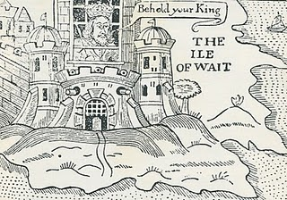
Ironically near the end of the English Civil War in 1648, the English King, Charles the First, was incarcerated by Commonwealth troops on the Isle of Wight, England (not of course Isle of Wight County, Virginia where the Holymans were to live). In this political cartoon Isle of Wight is labeled the Ile of Wait as the leaders of the rebellion, Oliver Cromwell, and others were trying to decide what to do with the defeated King. A court found the King guilty of treason, and he went to the executioner's block (see below).
One approach I have recently been exploring is to investigate whether there is a connection between the events of the English Civil War and the emigration of the Hollimans to Virginia. Bedfordshire, England is an area that gave strong support to Parliament against King Charles. If the Bedford Hollimans were royalist supporters, there may be records of fines they paid since royalists were required to pay to Parliament to either avoid military service or to support Parliament's campaigns.
As John, Thomas, Christopher and even Stephen Holliman of Bedford would have been of age to serve in the military, there may be records that reveal if any had served and in what capacity. The National Archives at Kew has a guide to researchers about records it holds of the English civil war and other potential sources - http://www.nationalarchives.gov.uk/records/research-guides/civil-war-soldiers.htm.
Could John Holliman have been a Royalist Supporter?
John Holliman's emigration to Virginia and his possession of a cutlass as evidenced by his will (1650) intrigues me. As we know, Virginia (and Maryland) remained supportive of royalists through 1651 when Cromwell sent a fleet to suppress Virginia. His representatives replaced the governor, William Berkeley, who had been appointed by Charles in 1641. This is the same William Berkeley who later in his second stint as governor would pardon Christopher Hollyman and his son after Bacon's rebellion in 1676.
I think if John (Holyman who died 1650) had emigrated from England in the 1640's, it could be he was a royalist supporter. Northampton County in Virginia where he died had previously been called Accomac Shire and was renamed Northampton County by the Virginia colony in 1644 to honor Lord Compton, Earl of Northampton, a royalist military leader who died at the battle of Hopton Heath in 1643.
Judith and Christopher Holliman - Royalists or Puritans?
Another interesting question for me is reconciling the multiple Jamestown landing records for Christopher and Judith Holleman. As there are records indicating both Christopher and Judith's arrivals in both 1650 or 1653, to me these two dates represent very different political regimes in the Virginia colony. The unapologetic, royalist era ended in March 1652 when Richard Bennett became governor. He was one of the few Puritans in the Virginia Land Company and also part of a major founding family in Isle of Wight County that over the years recruited hundreds of settlers to Virginia.
While there is strong evidence that the marketing campaigns of the Virginia company and its landholders presenting Virginia as a paradise attracted Englishmen of all persuasions between 1645 and 1670, the change of Governors in 1652 may have resulted in the perception of greater opportunity in Virginia for those who had supported Parliament and Puritans in particular. - Robert Holloman, a multiple great grandson of Christopher Holliman, Sr (d 1691)
The King represented Divine Right rule. Parliament forces fostered representative democracy. The Royalist forces were eventually defeated in battle, the King imprisoned and tried for treason. King Charles I lost his head (see below) and the Commonwealth came into being. In 1660 the monarchy was restored and King Charles II came to the throne. The Stuarts always had troubles with various Parliaments and in 1688, James II was forced from the throne. He fled to France rather than losing his head (literally) as had his father.

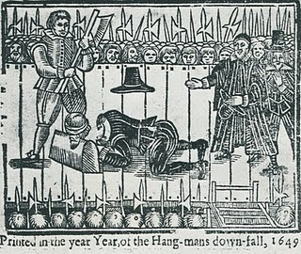

Our Family's Colonial Era, Part XXII

This continues a series of articles by cousin Robert Holloman, a B.A. in history from the University of Virginia. In the previous article Robert explored our possible royalist connections in the English Civil War. In this post, he presents information and raises questions on who transported our ancestors to Virginia. Again evidence points one in the direction of Bedfordshire, England as the origin of the Holliman (and various spellings) families in the New World. - Glenn N. Holliman
Who were the Sponsors of the First Virginia Holymans?

by Robert Holloman
In regards to the early settlement of Holymans in Virginia, I have been attempting to track down information on the named sponsors of Judith and Christopher (and William in 1656) Holliman. According to records, these sponsors were John Cos(x), Thos. Wilkinson, John Sherlock and Thomas Rolph (William's sponsor). In May 1650, John Cox received 1,000 acres of land in Northumberland County on the south side of the Rappahannock River, for the transport of twenty persons including two John Coxes, Elizabeth Cox, Xtopher Holleman and Judath Halloman.
Below in the center of this map by Joshua Fry and Peter Jefferson in 1751, one will find Northumberland and Lancaster Counties. Just below the left red line is the Rappahannock River; above are Lancaster and Northumberland Counties.
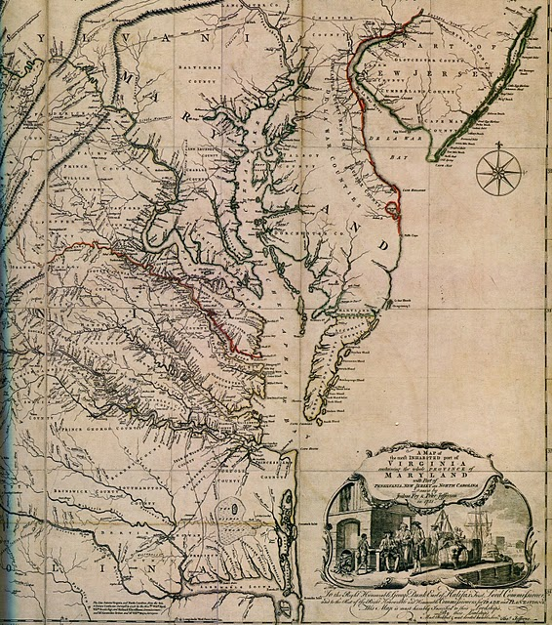

In August 1653, John Sherlock received land in Lancaster County (which was created from Northumberland County in 1652) for the transport of three persons that included Epper a (possible corruption of Christopher?) Holliman, and another grant in November 1653 for the transport of four persons that included both Judith and Christoper Holliman.

A possible connection to both John Cox and Christopher Hollyman is a Vincent Cox who was transported to Virginia as an indentured servant to a Richard Cole on the ship Honor in October 1649. His birth in 1632 can be traced to Bedford. His father was Henry Cox, and he had a younger brother, John Cox but that brother died ten days after birth in 1634 according to Bedfordshire record. In 1653 Cox and Cole legally disputed the end to his term of indenture and that legal fight provides us today the detailed record to trace his passage from England. After winning his release, Vincent Cox settled in Westmoreland County (which was also created from Northumberland County in 1652) and later would receive land in both counties several times in the 1660s.

Both the Wilkinsons and the Coxes are known to have property in Isle of Wight County in the time period of Christopher and Judith's arrivals. The Cox and Wilkinson families later intermarried.

There is a recent 2006 (expanding a 1996) book on the history of the Wilkinsons entitled “The Wilkinsons of Isle of Wight, Surry and Sussex Counties and Related Families” (including Cox) by Gene Cox Wilkinson and George Carroll Wilkinson. I have recently attempted to contact the authors to see where in England these families had originated and any information on Cox and Wilkinson's activities in the years of Christopher and Judith, but have had not had success as yet.- Robert Holloman

Our Family's Colonial Era, Part XXIII

Exploring Further Possible Connections Between the English Civil War and the Early Holymans of Virginia
by Robert Holloman
During the past several articles, Robert Holloman, a descendant of Christopher Holyman, Sr., has been exploring relationships between participants in the English Civil War and the arrival of the Holymans to Colonial Virginia. In this posting, he proposes additional evidence that suggests the Holymans were sympathetic to Charles I's forces in the fight with Parliament. One remembers Charles I was executed in 1649, and many of his supporters fled the country. Were some who fled the Holymans? - Glenn N. Holliman
My premise that the English Civil War sparked the emigration of Christopher Hollyman (and/or Judith) to Virginia is obviously not original as many families trace some of their American roots to this period. Documenting the Hollyman (Holyman, Holliman, Holloman, etc) migration is challenging. I have scattered notes and quotes about the topic that I continue to try and arrange in manageable order.
One is struck by comments such as in Richard L. Morton's “Colonial Virginia, Vol. I, the Tidewater Period 1607 – 1710” (UNC Press, 1960) where on p. 166 is stated:
"After Prince Charles's defeat in 1651 at Worcester, 1,610 Royalist prisoners were granted their request to be sent to Virginia." Although Charles's army was predominately Scottish and not English at Worcester, prior to the battle his army had grown by the influx of English royalist supporters as it had moved south into England from Scotland.
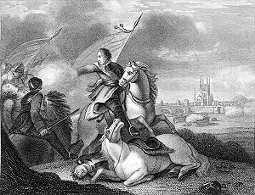
This 19th Century engraving depicts the success of Oliver Cromwell and his forces over the future Charles II at Worcester, England in 1651. After the battle, Prince Charles escaped and hid for a while in an oak tree, since known as the 'Royal Oak'. Cromwell died in 1658 and in 1660, the Stuart family, Charles II, was restored to the throne of England.
Parliament decreed in September 1651 that all prisoners below the rank of Captain were to be sent to the plantations. Prisoners from Chester, Worcester, Liverpool and Shrewsbury were sent to Bristol for transportation to Virginia and Bermuda.
A large number of these left with the annual Virginia fleet in the fall of 1651. This fleet would join with Sir George Ayscue's fleet in Barbados where he was engaged in fighting to subdue Royalist forces that were then controlling the colony.
In December, Ayscue hired 150 prisoners from the fleet to join with his marines for a successful assault on Speight's Town. In January 1652, Barbados submitted to Ayscue as the Virginia fleet continued to Jamestown. The Virginia arrival of the Worcester prisoners is captured in the record of arrival of 270 prisoners from the ship including some of my non-Holliman ancestors, John and Sarah Bridger, who entered the colony as indentured servants. I cannot find any Hollimans on the list but I cannot be totally certain because many names are not legible.
I have found other interesting connections between the English Civil War and Christopher Hollyman. One of the first records of Christopher Holyman, Sr. in Virginia is his granting of power of attorney to Thomas Pittman in 1660. According to Pittman family websites, Thomas Pittman was a royalist officer who arrived in Virginia in 1649 from Monmouthshire, England. Furthering this connection between the Pittman and Holyman families, his grandson, Thomas Pittman III would later marry Christopher's son William Holliman's widow, Mary Chambers Holliman in 1704.
As my descendants continuously lived in Virginia and North Carolina though my father and mother's generation, through the years I have discovered other members of my families who were Royalist immigrants. For example, Joseph Bridger, who was born in Dursley, Gloucestershire, was a Royalist officer. Joseph Bridger arrived in the mid-1650s and is known to have brought several supporters with him to Virginia. After arrival he would prosper and become one of the leading citizens of Isle of Wight County.
His descendant Sarah Bridger, my 2nd great- great grandmother married my 2nd great-great father Jesse Holloman in 1867. Another descendant of mine, Thomas Carter, Sr, a Royalist arrived in 1650. Charlotte Carter is my 4th great-grandmother.
Although I am skeptical that each story of a royalist emigrant to Virginia between 1645 and 1660 has a basis in fact, I argue that given the dates of Christopher Holyman's arrival in Virginia, that the English Civil War had to have played a prominent roll in the decision to emigrate. Hopefully, with more research, a data trail can shed further light on this proposition. - Robert Holloman

Our Family's Colonial Era, Part XXIV
Joe Parker is a diligent researcher of Holliman family history tracing his ancestry back to Christopher Holyman, Sr. He has facts at his finger tips on the family from the early 1600s in Bedford, Bedfordshire to his 21st Century relatives in his home state of Texas. Below, he shares his observations on just who those early Holymans were and what could their relationships be to one another. - Glenn N. Holliman
Christopher, Judith and John Holliman, some Additional Information concerning their Emigration to Virginia
by Joe Parker
The Headrights of Christopher and Judith Holyman
In 1650 when they arrived in Jamestown, both Christopher and Judith Holyman received head rights to acreage in the Virginia Colony. My understanding is that when a man received a head right to any block of land, the wife also has ownership of that tract, by privilege of being married to the man who received the acreage.
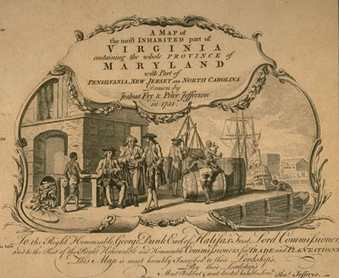
This 1751 work depicts a colonial dock with hogsheads of tobacco on the wharf. West bound from England, the ships would carry English goods and immigrants. East bound from Virginia to England, tobacco in casts would be the item transported.

Why then would - Judith in this case - receive separate notice of receiving such acreage, unless she was possibly recipient of such land as a separate individual? Conclusion, Judith was not the wife of Christopher, but yes, as the Bedfordshire English parish records indicate, more likely was his sister. - Joe Parker
Genealogist Robert W. Baird in his web site Understanding Headrights publishes the following which helps us to grasp more fully some of the reasons our Holymans might have come to the Virginia colony.
"The headright origin is found in the London Company’s “Greate Charter” of 1618:

“That for all persons…which during the next seven years after Midsummer Day 1618 shall go into Virginia with the intent there to inhabite, if they continue there three years or dye after they are shipped there shall be a grant made of fifty acres for every person… which grants shall be made respectively to such persons and their heirs at whose charges the said persons going to inhabite in Virginia shall be transported…”

- There were no restrictions on age or gender. Headrights could be, and often were, children. In fact, many imported indentured servants were teenagers.
- Persons settled in Virginia who subsequently left the colony and returned were sometimes successfully claimed as headrights. A number of patents claimed importation of a specific person “the second time” or the “the third time” (or in one case, a total of six times.) Although this seems contradictory to the spirit of the system, it appears to have been an accepted practice from the very beginning, for several Ancient Planters claimed multiple rights for their own arrivals in Virginia.
- Because there was no system for validating or accounting for headright usage, headrights were often claimed more than once, and persons who had no “intent to inhabit” were used as headrights. More on this later.

Hmmm....much to consider here as we look not just to the mid-1600s, but also the late 1600s and early 1700s and see the Holliman family utilizing the 'headright system'. - GNH

Keeping an Open Mind on just Who was John Holleman
As to John Holleman, who died in 1650 in Northampton County, Virginia, I have an open mind on this individual. The fact that he left no worldly goods to any children should be looked at carefully. He may have divided his fortune with his children (if any) before his death, and this could have left him virtually penniless at death. John left his remaining goods to a friend who would help to settle the estate. Conversely, this John Holleman could have been the husband of Judith, who arrived two weeks after his death in Virginia. Or John could have been her brother, born 1612 in Bedford, Bedfordshire, England.
I am not forming any set opinions until we search more in the Bedfordshire Archives and study additional works. For now, I will return to my review of passenger lists of boats arriving in the Virginia Colony in the 17th and 18th Centuries. - Joe Parker, Texas

Section IV

The Hollimans of fayette county, Alabama

ACKNOWLEDGEMENTS
While we have tried to tip our hat to cousins as articles are presented, we cannot reproduce the works that follow without a more extensive word of appreciation. Family histories are put together with work and support from many people. My daughter, Grace Holliman, and I are pleased to collect writings, photos and memoirs of others and share them with a growing extended family. In the following articles, we present the writings of our cousin Dr. Rhodes Holliman, Dublin, Virginia, on Fayette County ancestors Mary Polly Lucas Holliman, James Franklin Holliman and John Thomas Holliman.
Rhodes notes that he is building on the work of others; specifically from the research of his father, Cecil Rhodes Holliman and a distant cousin, Walter Orien Holliman. A great deal of what we know of the John Thomas Holliman siblings and recent ancestors comes from the work of these men.
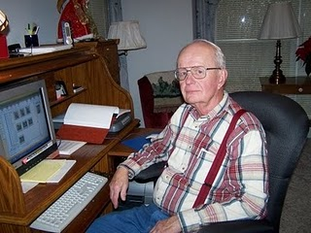
Rhodes Holliman at home in Dublin, VA
Walter Orien Holliman, a meticulous family researcher, passed away in 2003. Walt's father was Moses Holliman, who was the son of Warren C. Holliman, who was the son of Charles Holliman, who was the son of James Grantson Holliman (1750-1836), a common grandfather to almost all reading this blog.

Mary Polly Lucas Holliman, 1819 – 1913
In 21 years of married life, Mary Polly and Uriah Holliman would produce 13 children – seven boys and six girls. Polly could hitch up a mule to a plow and till the soil as well as any man. While maintaining her farm, she became the only source of medical assistance in her community. Often she had to travel many miles by mule to help those in need.
A COMPASSIONATE HEROINE

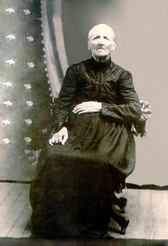The Story of Mary Polly Lucas Holliman (pictured here in 1913) by Dr. Rhodes Holliman, originally published in Southern Times Magazine of Tuscaloosa and West Alabama, Issue no. 125.
The daughter of Charles Daniel Lucas and Mary Hastings was born in South Carolina on January 2, 1819. She died at Vernon, Alabama on July 5, 1913. She married Uriah Holliman in Tuscaloosa County on August 29, 1836 and together they had 13 children. She is buried in Springhill Baptist Cemetery in Bluff, Alabama.
Very little has been published on the privations suffered by southern farm housewives who were widowed by their husband’s deaths in the Civil War. The following story is a documented history of one such woman, this writer’s great-great grandmother, who lived 94 years in poverty by our current standards, yet became the post-war heroine of her backwoods county in northwest Alabama.
Mary Polly Lucas Holliman of Marlboro County, South Carolina was the daughter of Charles Daniel Lucas, born in South Carolina on July 30, 1771. Charles Lucas died in Newtonville, Alabama on May 31, 1853. Her mother was Mary Hastings, born in South Carolina on September 10, 1786 and died in Fayette County, Alabama on January 21, 1867. Charles Daniel Lucas and Mary had 10 children.
Charles was reputed to be a large man (6’4” to 6’6”) and had great strength. Mary Polly loved to tell the story of how he killed a panther with his bare hands. He was also a man of hot temper and a disciplinary tyrant, but that is another story. He was a tailor by trade and after moving to Alabama, a Federal Indian Agent and stock dipper. Charles Daniel is buried in an Indian burial ground on top of a wood hill about seven miles south of Fayette, Alabama.
This writer can remember that graveyard from my childhood (1930s), but it was accessible only by a long hike with a guide over cultivated fields and forests, several miles from the nearest road. Charles Daniel and Mary came to the Newtonville, Alabama community in the 1830s, and purchased land patents from the government.
Mary Polly Lucas married Uriah Holliman in Tuscaloosa County on August 29, 1836. The marriage was performed by the Rev. John Walters, M.G. Uriah Holliman was born in Lancaster County, South Carolina on July 6, 1816 and died at Okolona, Mississippi on May 8, 1862 while in the service of the Confederate Army.
He was the son of Cornelius Holliman, born in Lancaster County, South Carolina on September 25, 1792. Cornelius married Elizabeth Plyler in 1813. She was born in South Carolina in the late 1700s, and died in Fayette County in 1838. She is buried in as tack-rock grave at the Springhill Cemetery in northern Tuscaloosa County, near Moore’s Bridge, just off Route 171. They had five children. He is buried at Old Blooming Grove Cemetery in eastern Lamar County, Alabama. As a veteran of the War of 1812, a memorial stone has been placed in that cemetery to his memory.
Over a period of several years, Uriah obtained a total of 320 acres of government patent homestead land in northwest Fayette County and developed a large, productive farm. It would prove essential to feed his rapidly expanding brood. In 21 years of married life, Mary Polly and Uriah would produce 13 children. All reached adult life except the first, Mary, who lived four years. With medical assistance unavailable and the remoteness of their farm, Mary Polly delivered all of her own children, which gave her valuable experience for events to come.
As the clouds of the Civil war appeared, five of her family joined the Confederate Army: her husband, Uriah at age of 46, and sons, James Franklin, Charles Daniel, John Thomas and Elijah. Her daughter, Sarah Jane, married an Italian immigrant who volunteered as a Confederate soldier.
Only two of her military family would survive the war: her sons Lt. James Franklin Holliman, Company B, 58th Alabama Infantry Regiment, and Pvt. John Thomas Holliman, Company H, 41st Alabama Infantry Regiment. James Franklin is buried in the Holliman-Steward cemetery south of Bluff, Alabama and John Thomas, this writer’s great grandfather, is buried at Caine’s Ridge Cemetery just south of Fayette, Alabama.

The photo below is of Norman S. Holliman of Tennessee taken by the gravesite of his great, great grandmother, Mary Polly Lucas Holliman in Bluff, Alabama. She is a grandmother of many of us reading this story.
A native of Rockdale, Texas, Norman is the son of the late August Harold Holliman, who is the son of Cornelius Elmer, who is the son of Cornelius Holliman, who is the eighth child of Uriah and Polly Lucas Holliman. A genealogy of Uriah and Mary Polly's offspring is listed at the end of this article.
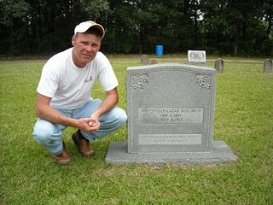
Dr. Rhodes Holliman’s article continues…
In May of 1862, Mary Polly in her home in Fayette Co., Alabama heard from some source, that her husband Uriah and son, Charles Daniel, were sick in Okolona, Mississippi, where a very congested camp had been established after the retreat from Corinth (Battle of Shiloh). They were trapped in an epidemic of measles and pneumonia that enveloped the camp. She hitched up the mule to a wagon and traveled the primitive dirt roads and trails to Okolona, a distance in excess of 70 miles to attempt to care for her sick husband and son. Uriah died on May 8, 1862, and Charles Daniel died on May 12, 1862.
She stayed long enough to bury her husband and son, and then drove the wagon back to the home place near Bluff, while suffering the ravages of measles contracted while acting as caregiver to her family. Their graves are among the many ‘unknowns’ in the Okolona Confederate Cemetery. She remained in desperate condition while convalescing at home. One can only imagine the tragedy what would have occurred if she had died, orphaning seven children at home between the ages of 14 and two. She survived this frightening ordeal to become one of the great, compassionate, pioneer ladies of northwestern Fayette County.
In 1865, when James Franklin and John Thomas returned from the war, Mary Polly had nine of her 13 children at home for a short time. James and John, at ages 26 and 21, would soon be married and moving out to start their own families. The remaining children: females aged 17, 11, nine and seven, and boys aged 16, 13 and fiver, were the ‘work force’ on which May Polly depended to handle all the many chores inherent in sustaining a successful farm. She could hitch up a mule to a plow and till the soil as well as any man. As her brood began to mature over the next 12 years, she saw two boys and two girls marry local sweethearts and move away to Texas, the new frontier for patent land. Another daughter would marry a Holliman cousin and move to Oklahoma, leaving only one daughter and one son to assist in maintaining the farm.
As children abandoned the old homestead for ‘greener pastures’, Mary Polly developed a vocational interest that would endear her to the population of northwest Fayette county and enhance the qualities of her character that are engraved on her grave stone: “Pioneer Strength – Integrity – Human Kindness!”
Professional medical services were virtually unknown in post-war Fayette County so, while maintaining her farm, she became the only source of medical assistance in her community as an herb doctor, caregiver and midwife to many of her neighbors. As her reputation of competency spread, her medical ‘practice’ spread geographically. She would accept appeals for help from all over the area, then saddle up a mule and ride out to provide services.
She charged $5 for midwife services, which included prenatal checkups, moving in to the expectant mother’s home and performing the delivery, staying for a week or more of postnatal care of mother and infant, plus cooking for the family, doing the washing and cleaning the house. If ever a grave stone spoke the truth to the memory of the one interred, it is her stone. One of God’s great compassionate mothers is at rest in Springhill Baptist Cemetery in Bluff Community, Fayette County, Alabama.
Mary Polly finished her days at the home of her youngest son, Joshua Warren Holliman (1860-1944) in Vernon Alabama, Lamar County. This writer had the privilege of talking to Joshua in the 1930s and hunting on his farm as a boy. One of the last recollections that Joshua had of his mother comes from our family archives. She was ‘sitting in a rocking chair on the front porch of an old dog-trot house, smoking a corn cob pipe, dipping snuff and nipping from a quart of Four Roses whiskey that was sitting on the floor beside her chair!” What a unique way to remember a lady whose life-long work ethic brought comfort and support to so many.
There are many tales to tell about Mary Polly Lucas Holliman and her large family. There is a separate, exciting story about each one of them. There are very few cemeteries in Fayette County where you can’t find one or more Hollimans descended from Mary Polly. Her descendants spread out over Mississippi, Oklahoma, Texas and Alabama.

The Children of Uriah Holliman and Mary Polly Lucas Holliman
1. Mary Elizabeth Holliman, born Sept. 12th, 1837, died Oct. 9th, 1841.
2. James Franklin Holliman, born Jan. 28th, 1839, died 13 May, 1911. 1st Lt., Co. B, 58th Alabama Infantry Regt., captured at Missionary Ridge, TN, on Nov. 25th, 1863. Spent the remainder of the War in Johnson's Island Prison Camp for Confederate Officers, in Erie, Ohio. He was released on June 13th, 1865. He returned to Fayette County to become a teacher and farmer. He married Rebecca Utley Stewart on July 2nd, 1865. They had 4 children (3 boys and a girl). Rebecca died and JFH married one of his former students, Bertha Lee Powell. The had 5 children (3 boys and 2 girls). JFH and both wives are buried at the Holliman-Stewart Cemetery, Bluff, AL.
3, Sarah Jane Holliman, born Oct. 3, 1840 in Fayette County, died Oct. 15, 1915, buried at Cottonwood Cemetery, 6 miles east of Eustace, Texas. She married Charles Stephen Coppell in Fayette County on July 13th, 1864.
4. Charles Daniel Holliman, born May 6th, 1842, died May 12, 1862 of diseases mentioned above while in the Confederate Army. Burial probably in the Confederate Cemetery, Okolona, MS.
5. John Thomas Holliman, born April 23, 1844, died July 12th 1930 in Fayette County. Burial at Caine’s Ridge Cemetery, 4 miles south of Fayette, AL, on Route 159. Was known as "Hico John" to distinguish him from 2 others of the same name in the county. Married (1) Sarah Corbett: one child, William Perry. She died in childbirth. Married (2) Martha Jane Walker: 5 sons. JTH was a Pvt. in Company H. 41st Alabama Infantry Regr., CSA. He surrendered at Petersburg, VA, on Feb. 15th, 1865, near starvation. He took the oath and was paroled to a farmer in Indianapolis, Indiana, where he worked until the fall of 1865 and then walked home to Fayette County, AL.
6. Elijah Holliman, born April 16th, 1846, died July 10th, 1864, from typhoid while serving in the Confederate Army. He was a Pvt. in Company I of the 56th Alabama Partisan Rangers. He died in a Confederate Hospital near Lagrange, GA and his buried in Confederate Cemetery under gravestone that reads E. Holman.
7. Nancy Palestine Holliman, born April 7th, 1848, died Dec. 12th, 1923. Married John Pinion: no issue. She is buried near her mother, Mary Polly, in Springhill Cemetery near Bluff, AL.
8. Cornelius Holliman, born Dec. 16th, 1849, in Fayette County. Married Sarah Elizabeth Smith at Fayette. Moved to Rockdale, Milam County, Texas. Buried Texas Eagle Cemetery.
9. William Perry Holliman, born March 29th, 1852, in Fayette County. Married Sarah Holliman, a distant cousin and daughter of Warren C. Holliman and Mary Blakeney of Newtonville, AL. Moved to Rockdale, Milam County, Texas. Resided near Cameron, Texas.
10. Martha Ann Holliman, born June 27th, 1854, married Rufus Buckner. Resided near Alvord, Texas.
11. Rebecca Drucilla Holliman, born March 4th, 1856. Married John Thomas Holliman, cousin, and son of Warren C. Holliman and Mary Blakeney of Newtonville, AL. Moved to Ardmore, OK. He was called "Black John" due to the color of his hair and to distinguish him from two other John T’s living Fayette County at the same time.
12. Emily Frances Holliman, born March 14th, 1858 in Fayette Co. Married (1) Abner McClung in Fayette County. Moved to Eustace, Texas, where she had relatives and there married Joe Reynolds.
13. Joshua Warren Holliman, born Aug. 26th, 1860, died Jan. 6th, 1944. Married Martha Goulsby, resided in Vernon, Lamar County, AL, until his death. Buried in Vernon. His mother, Mary Polly Lucas Holliman, died at his home in 1913.

The Confederate Soldier Who Became a Teacher

We focus on one of Mary Polly Holliman's sons, James Franklin, who survived the Civil War and returned home to become a school teacher. Unfortunately for Polly and her remaining children, her husband, Uriah, and two other sons, Charles Daniel and Elijah, died while serving in the Confederate Army. Imagine the heartache and worry of Polly both during and after the devastating war.
Our continued thanks to cousin Rhodes Holliman for his permission to share these amazing stories and photographs of our ancestors.
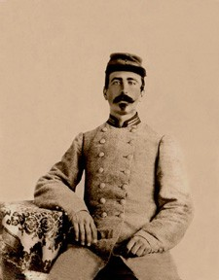
The photo is James Franklin Holliman in his Confederate uniform, ca. 1862.
A SOUTHERN FARM BOY AND A GALLANT LOVER
by Dr. Rhodes B. Holliman, his great great nephew. First published in Southern Times, Magazine of Tuscaloosa and West Alabama, Issue 130.
James Franklin Holliman was the second of 13 children born to Uriah Holliman and Mary Polly Lucas Holliman. She delivered her entire brood by herself, 7 boys and 6 girls. James was born in Tuscaloosa County, Alabama, on January 28th, 1839, but Uriah soon moved the family north into Fayette County, AL, where he obtained Federal homestead land for farming.
When the clouds of War covered the South, a wave of patriotic enthusiasm swept over the family and the father, Uriah, now 46 years old, 4 of his 7 sons, and one son-in-law joined the Confederate Army. The War would exact a heavy toll on this family: of the 6 who enlisted, only 3 would survive.
James enlisted for a year as a private in the 9th Alabama Battalion, Company B, in Fayette, Alabama, in September, 1861. In the following spring, the 9th Battalion proceeded to Corinth, MS, and was engaged at Shiloh and Farmington. At Blackland, MS, the Battalion lost about 20 killed and wounded and disease took its toll at Shiloh, Corinth and Okolona, MS. Among those dying at Okolona was James’ father, Uriah (May 8, 1862), and a brother, Charles Daniel (May 12, 1862).
James reenlisted in the 9th Battalion in September, 1862, as a 1st Lieut., and was sent to Mobile, AL, remaining there until April, 1863. At that time, the Battalion proceeded to Tullahoma, TN, and was placed in Gen. Henry D. Clayton’s Brigade. This set the stage for the carnage that would follow in the area around Chattanooga, TN. The 9th was in several small engagements, especially at Hoover’s Gap. In July, 1863, at Tullahoma, 2 additional companies were attached and the 58th Alabama Infantry Regiment was formed. The 58th was in the thick of the fighting at the Battle of Chickamauga in September 19 - 20. On the 19th, the 58th captured 4 pieces of artillery, and on the 20th, in a suicidal charge, they broke the enemy line with the loss of 148 out of 254 men. A few weeks later in November, the 58th was consolidated with the 32nd Alabama and the field officers of the 58th were retained.
The consolidated Regiment had 400 present at Missionary Ridge on Nov. 25th, 1863, but lost 250 in casualties and prisoners. Lieut. James F. Holliman was captured on November 25th. He was shipped to a military prison in Louisville, KY, and thence to the infamous prison for Confederate officers at Johnson’s Island, Lake Erie, near Sandusky, Ohio. There he remained until he was paroled and took the Oath of Allegiance on June 13th, 1865. He was then described as being 26 years of age, dark completion, dark hair, gray eyes, 5 feet, 9 inches tall.
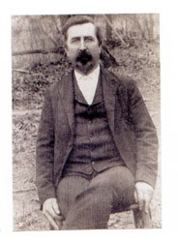
James Franklin Holliman, ca 1909
He (James Franklin Holliman) returned to Bluff Community in Fayette County, Alabama, to resume farming and became the local school teacher. He had a large number of relatives on his class rolls including his brothers and sisters. He married Rebecca Utley Stewart, his wartime sweetheart, on July 2nd, 1865.
Her birth date remains in contention. Her ornate grave marker says: "Nov. 26, 1829". Other sources of family information say: "Oct. 6, 1839", but it is generally conceded that Rebecca was older than James - if her grave marker is correct, she was 10 years older. This disparity in their ages would be unusual for that era and place. Men of that time usually married women who were younger.
A love letter written by him at some time during the War is reputed to be his proposal of marriage. It shows a remarkable expression of sensitivity considering that it was composed by a self-taught, back-woods, farm boy whose parents and siblings were mostly illiterate.
“Miss, for the first time I undertake the pleasant task of addressing you by letter with feelings that you can better imagine than I can describe; to attempt to describe the feelings that pervaded my bosom the last time I had the pleasure of your company would be useless. They would baffel (sic) all descriptions; neither could I at that time, owing to the intensity of my feelings, express them, but my pen obeys the impuls (sic) of my heart, and I can with pleasure in this way communicate (sic) my thoughts and the tender sentiments of my soul to her I love, to her I adore.
It affords me unaffected pleasure to hold correspondence with one so pure, so inicent (sic), so lovely, and you will reseive (sic) thes (sic) lines as a token of the love of one whos (sic) heart you posess (sic), one who from the first moment in which he beheld you has neverceast (sic) to love you with all the tenderness that the human heart is capable of feeling. I, who never can enjoy life except in your society; what would all the world be to me without you to share its pleasures, a caotic (sic) nothing.
Often does my imagination fly to where you are and hover around you and fancy that I see your beautiful form and the angel like beauty and simplicity that is continually beaming from your face. O (sic) when shall my fondest hopes of hapiness (sic) be realized ? When shall I press you to my heart, and call you mine, my one, my lovely. Then would I in the language of the poets, be content and blest whenever I hear the voice of her I love.
Love, that word is full of meaning to me. Could I express that devotion of heart and soul, that enables both lover and love, that undying impulse of attachment that rules my breast; that union of thought, feeling and existence, by which two persons are bound together, that lasts for life and never knows ending; but language fails, and I alone can fel (sic), and you can realize the extent of what cant (sic) be expressed lovely girl. These are of one who will ever remain your faithful lover.”
Rebecca (“Becca”) bore him 4 children: 3 boys and a girl. She died on November 2nd, 1883. An exhaustive search for a picture of her has yielded nothing.
He remained single until he was 57 years old (1896) whereupon he married a former student, Bertha Lee Powell, who was 18 years old! She bore him 5 children: 3 boys, 2 girls. He was 67 years old when his last child was born. He died on May 13, 1911. Bertha Lee assumed the role of head of household and reared her brood to be responsible and productive citizens.
In James' Last Will and Testament dated September 16, 1910, he bequeathed 40 acres of farm land to each of his children by Rebecca and Bertha Lee and he appointed Bertha Lee as his executrix and guardian of his children. He bequeathed to her 20 acres of choice land and all of his personal property.
His cause of death, as listed on the Alabama Death Certificate, was "softing of the brain." The duration of his terminal illness was listed as "8 months." The accuracy of medical diagnostics in rural Fayette County in 1911 was profoundly primitive!

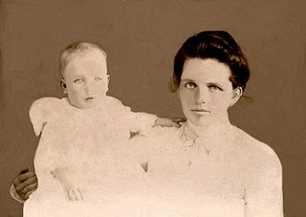The above photo is of Bertha Lee Powell Holliman.
and her third child, Janet, b 1903 and who passed away in 2002. Bertha Lee died March 21, 1948. Photo courtesy of Dr. Holliman.
The last of Bertha's children to die was Janet, who, in 2002, had survived for 99 years and 10 months. He, both wives, and a number of his offspring and in-laws are buried in the Holliman-Stewart Cemetery just south of the Bluff Community in northern Fayette County, AL. The ruins of his old homestead have been recently discovered just south of the family cemetery and isolated from any current or historic road bed.

John Thomas Holliman, A Survivor and Casualty of the Civil War

In this article, Dr. Rhodes Holliman examines the Civil War life of another one of the sons of Uriah and Mary Polly Lucas Holliman. Many of you reading this are descendants of John Thomas Holliman (1844-1930). Others will recognize John Thomas as a distant cousin, a great grandson of James Grantson Holliman (1750-1836).

Whatever your relation, this life of John Thomas captures the pathos and violence of war, and its difficult aftermath. Note the sad reality as John Thomas assembled with his regiment in Tuscaloosa, only one week after his father and brother died following the Battle of Corinth, Mississippi.

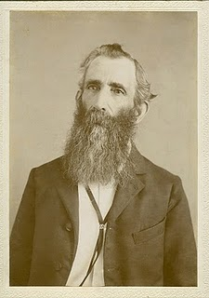UNBEARABLE ENDURANCE
by Dr. Rhodes B. Holliman of Dublin, Virginia. This article first appeared in Southern Times, Magazine of Tuscaloosa and West Alabama,
Issue No. 124.
John Thomas Holliman, ca 1900
John Thomas Holliman was born on April 23, 1844, in Fayette County, Alabama. He was the fifth child of 13 of Uriah Holliman and Mary Polly Lucas Holliman. In his family, two of his older brothers and his father joined the Confederate Army plus a younger brother and a brother-in-law. Of these volunteers, only two would survive the War: John Thomas and his oldest brother, Lt. James Franklin Holliman of the 58th Alabama Infantry. His was a poor, backwoods, farming family who never owned slaves but who stood ready to defend their homeland.
We will never know the motivation that drove John Thomas, his father and 3 brothers to join the Confederate Army. Peer pressure, community pressure, the excitement of travel away from the farm, a patriotic resolve to defend the homeland and their way of life, a distorted view of what combat would really be like and no idea of the privations that lay ahead could have influenced their decisions. John Thomas and his siblings had never been more than 25 miles away from home.
The fallacious idea that war would be fun and exciting and would be over in a few weeks pervaded the minds of so many volunteers of that time in both Union and Confederate armies. The Holliman boys were basically illiterate, and they had no background in the study of history and the horrors of war. As far as we know, James Franklin Holliman was the only member of this family group who could read or write.
At age 18, John Thomas joined Company H of the 41st Alabama Infantry Volunteers as a Private in April, 1862, in the town of Fayette. He would never be promoted. The 41st was made up of volunteers from Tuscaloosa, Greene, Fayette, Perry and Pickens counties, with Fayette County enlisting the most men in Companies B (88), H (132), and I (110). This was 26 % of the 1284 volunteers in the 41st from all counties.
The 41st was assembled in Tuscaloosa, AL, on May 16, 1862, to begin training. The sudden crowding of these men who were accustomed to living on isolated farms remote from individuals with contagious disease, and the subsequent exposure to polluted water, poor rations and unsanitary conditions of camp life, created an environment for an epidemic (measles, typhoid, pneumonia). There was no effort made to quarantine contagious individuals because the microbial source of infection was not discovered until the work of Pasteur and Koch in the late 1800s.
From May through July there were many deaths due to disease so that the first engagement at Chattanooga, TN, in August, 1862, found only 700 men fit for duty. John Thomas fought skirmishes along the Tennessee River in the fall and was hotly engaged in the carnage of Stones River (Murfreesboro, TN, campaign) in early January, 1863. Thereafter, the 41st was deployed along The Army of Tennessee Defense Line at Manchester, Allisona, Tullahoma and McMinnville with frequent skirmishes through the spring of 1863.
In an effort to reinforce troops in the Mississippi Campaign, on May 23rd, the 41st was transferred by rail to Chattanooga, Atlanta, Montgomery and Mobile, Meridian and Jackson. Arriving too late to be of help at Vicksburg, the 41st was outstanding in the Second Battle for Jackson, MS. After a month long rest, the 41st retraced its steps to Chattanooga. John Thomas was yet to face the blood bath at Chickamauga on Sept. 20th and the following siege of Chattanooga.
The 41st left their positions on Missionary Ridge on November 19th and marched to Tyner’s Station to join Gen. Gracie’s brigade for the assault to retake Knoxville. Little did they anticipate that Union forces would overrun Missionary Ridge on November 25th whereupon John’s brother, Lt. James Franklin, was captured and imprisoned for the remainder of the War in the Confederate Officer prison camp on Johnson’s Island in Lake Erie near Sandusky, Ohio.
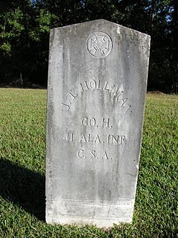
Photo courtesy of Glenda Norris, a great, great grand daughter. Grave is located at Caine's Ridge Baptist Cemetery, Fayette County, Alabama.
Dr. Rhodes Holliman continues…
John Thomas was now without shoes or winter clothing and the severe winter of 1863 - 1864 was closing in. The 41st Infantry Regiment marched from Tyner’s Station to Knoxville, a distance of over 100 miles.
The attack on the Union fortifications at Knoxville was a catastrophe forcing the 41st to retreat toward Bean’s Station over icy ground in freezing rain and snow. At this point John Thomas had no blanket, coat or shoes. He was leaving bloody tracks with every step. A battle at Bean’s Station on December 14th left the 41st with about 350 men and officers: about 1/3rd the original enlistment. Winter encampment was made at Morristown, TN, and the Regiment marched into Bristol, VA, in April of 1864. They soon marched north to Abingdon where they boarded a train on April 16th for Richmond.
Their next campaign began at Drewry’s Bluff on the James River south of Richmond: an effort to prevent Union gunboats from sailing up to the Confederate capitol. The victory at Drewry’s Bluff would become “the finest hour” for the 41st AL. On June 17th, the 41st moved into the trenches at Petersburg for the exhausting 9 month siege to follow. John Thomas would endure the unrelenting rifle and artillery fire until February 1865.
No words can describe the carnage of events in the trenches at Petersburg. During this time he would see two of his cousins from Co. B seriously wounded and one killed. He participated in the effort to bury his cousin from the trenches of Gracie’s Brigade but was thwarted by Union sniper fire. He and 2 other cousins dragged the body at night to the Confederate burial ground in Old Blanford Cemetery near the spot of the Crater Explosion and finally accomplished their mission while dodging Union rifle fire.
On February. 15th, 1865, John Thomas was near death from starvation and exposure in a frozen wasteland. He still did not have shoes, a coat or blanket. He and two of his Company buddies, Sgt. Miles Bobo and Pvt. John Anders South, pooled their money ($17 Confederate) and bought a pone of cornbread being peddled by a free black woman in the trenches. They ate it, put up a white flag on a ramrod and walked over into the Union lines. The Federal Archives state that John Thomas was sent to Washington, D.C., given the oath of allegiance, and then sent to Holly Springs, Mississippi, to await discharge. This statement is correct for Bobo and South but John Thomas’ fate was totally different. This writer is in possession of a note written by a post-war confidant of John Thomas that reads:
“In Co. H - 41 Ala at Petersburg Va. On Feb 15 1865 about dark - went over to Union. John South, Miles Bobo. Carried Gard (sic) House that night - Asked by officers to disclose conditions and were carried from post to post disclosing conditions in Conf. (Gracies Army) Was in U S Army about 1 week. Was then sent to Washington and took Oath - was sent to Baltimore Md - then throug (sic)Pa to Indianapolis Ind & stayed in Inda (sic) about 6 mo - war closed.”

John Thomas was furloughed, really indentured, to a farmer in Indiana and he promised to stay and “make a crop”. Good to his word, he stayed until the fall of 1865. He had earned enough to purchase new shoes and, to limit the wear, he tied the shoelaces together, slung them over his shoulder and, to quote his exact words, “came on home.” He walked cross country, alone and barefoot, about 600 miles to his home in Fayette County in west Alabama!
John Thomas did not receive a single furlough during his 3 ½ years of service. He hated the War and frequently declared it was “a rich man’s war and a poor man’s fight.” He was held in contempt by some of his neighbors for the remainder of his life for his surrender.
His brother, Lt. James Franklin, after release from Johnson’s Island Prison in June, 1865, opened a one room school in the northwest part of the county and enrolled 8 grades of children and adults. John Thomas, at age 21, tried schooling for about a week but quickly withdrew. After his experiences of the previous 3 ½ years, school was not for him.
His first marriage in 1867 produced 3 children, only one of whom, a son, lived to maturity. His wife died in 1872 from “childbed fever” (septicemia) giving birth to their third child, a stillborn infant. He married again in 1875 and produced 5 sons. He was a profound victim of post war traumatic stress and his countenance and personality reflected this condition until his death on July 12th, 1930, from prostate cancer, at age 86.
He had been subjected to unspeakable visions of death and hardship. He was denied a veteran’s pension in his old age and died in poverty. He is buried next to his second wife in Caine’s Ridge Primitive Baptist Cemetery on State Route 159 just south of Fayette, AL. From his 6 sons, there are 6 branches of the Holliman family who have enjoyed life because their ancestor was prudent enough to recognize when death was imminent and the mission was doomed to failure.
The 41st AL went on to fight at Hatcher’s Run and the retreat to Appomattox where 98 of the original 1,284 stood ready to answer the final roll call.
In reading the campaign history of the 41st Alabama, one recognizes the futility of the endless marching and the confusion of battle plans created primarily by lack of communication between combat units. It will never cease to be amazing the endurance and sacrifice of the individual soldier.

The Sons of John Thomas and Martha Jane Walker Holliman
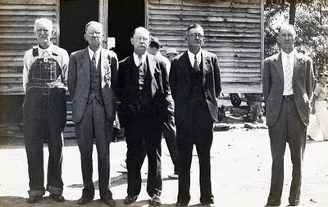
Gathering for a Fayette County reunion in 1934, several years after their parents died are, left to right, Bill, Green, James Monroe, Leland and Ulysses. The vacant spot is for Eckford Holliman, who died in 1926.
The photo was taken May 1934 by Cecil Rhodes Holliman with an old bellows Kodak on 120 film. Rhodes Holliman, his son remembers the photo and observes the following:
I remember the sense of necessity that pervaded the crowd to get this historic family photo. It was made at the annual Holliman reunion and ‘eating on the grounds’. With Eck dead, everyone wanted to preserve the remaining family image. I used to play under this old church while services were in progress. I'm surprised that the building didn't collapse while full of people. The ferruginous rock pilings did not have any mortar! The building was literally balanced on these pilings! Uncle Bill’s son, Grady, played the guitar to accompany the singing. This is where I fell in love with the hymn, "Just a Little Talk with Jesus".

I remember an over-weight lady whose name was Cousin Maggie Thornton. She came to the reunion in a wagon pulled by a team of mules. She had an old steamer trunk full of food: pies, fried chicken, potato salad, you name it. She was famous for her cooking. I think that she was a spinster. She was distantly related -- collateral family. I think that she is buried at Caine’s Ridge.

Uncle Bill could walk to church; his old shack was across the road and a little south, back in the woods. I think that his house site still shows on the USGS Topo maps.
Bishop Holliman (b 1919), a son of Ulyss, was also present at this reunion, and remembers Maggie Thornton. Ulyss, Euhal and Bishop drove from Irondale (a suburb of Birmingham) to Fayette for the day, a major drive in 1934.
One of the sons above, Jim Monroe Holliman, an attorney, and his wife Anna Elizabeth Baker, had two sons who grew to maturity: Cecil Rhodes and Charles Baker Holliman. Ulyss, far right, and his wife, Pearl Caine, had seven children: Melton, Vena Holliman Daly, Euhal, Loudelle Holliman Ferrell, Bishop, Virginia Holliman Cornelius and Ralph Holliman.

ADD MAP OF FAYETTE COUNTY HERE

The Hollimans of Alabama
Back to the 19th Century...A Series of Articles on the Hollimans and Related Families of Fayette County, Alabama
By 1836, several sons of James Grantson Holliman (1750 - 1836) and other associated families had migrated to Fayette County, Alabama from Lancaster, South Carolina. Cornelius (1792 - 1862), Charles (1795 - 1850) and Warren Holliman (1801 - 1876) were part of the westward movement of the American nation and my family in the 19th Century.
Warren would later move on to Arkansas and father many Holliman descendants in that part of the United States. Cornelius, Charles and many of their descendants remained in Fayette and adjoining counties. Many others went to Mississippi, Louisiana and Texas.
An Excursion into History....
On April 9, 2011, Glenda Norris, a descendant of James Grantson and Cornelius Holliman families, led fifteen of her distant cousins through the cemeteries of her many great grandparents to share their stories. She would be the first to tell you that she stands on the shoulders of her grandfather, Cecil Rhodes Holliman, and his son, her uncle, Dr. Rhodes Holliman. The research about to be shared comes from their hands and also of the late Walt Holliman, a descendant of James Grantson and Charles Holliman, his son.
Glenda Norris reports:
"The first stop of the tour was Charles Daniel Lucas, Jr. burial site. It was unseasonably hot for April (92f) even for the Deep South. But that didn’t slow anyone down. Everyone was more than willing to take a short ‘hike’ into the woods, up a small hill and then a left turn into the forest to view the ‘old Indian burial ground” where Charles Daniel Lucas, Jr. gravesite is located.

Here is a photo of everyone getting ready to make the walk. Left to right are: Jeanette Holiman Stewart (Austin, Texas), Glenn Holliman (Newport, Pennsylvania), Lenwood Holliman (Gordo, Alabama), James Franklin Holliman (Sulligent, Alabama), Bishop Holliman (in cap from Avilla, Indiana and the oldest at 91), Laura Vonceil Duckworth (Reform, Alabama), Wally and Tommie Holliman (Irondale, Alabama), Faye Gardner (Kennedy, Alabama), Bill Holliman (Horn Lake, Mississippi), Jean Holliman (Irondale, Alabama), Joey Holliman (Florence, Alabama) and Tyler Duckworth (Tuscaloosa, Alabama and at age 15, the youngest on the trip). Obscured is Robert Holliman and taking the photograph is Norman Holliman (both brothers from Marysville, Tennessee)."

ADD PHOTO HERE OF GROUP

All the above are either descendants of Charles (about 1795 - before 1850) or Cornelius Holliman (1792 - 1862). Of course, all have the DNA of Christopher Holyman, Sr. (1618 - 1691), the Englishman who left Bedford, Bedfordshire and immigrated to Jamestown, Virginia in 1650.
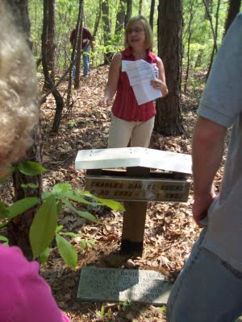
Above, Glenda Norris shares information at the grave site of her 4th great grandfather, Charles Daniel Lucas Jr. whose daughter, Mary 'Polly' Lucas married Uriah Holliman, a son of Cornelius Holliman. Below, Glenda points out a Creek Indian burial site. Charles Daniel Lucas, Jr. was a Federal Indian agent and may have been the son of a Catawba Indian mother named Dorcas from South Carolina. When he died, he requested to be buried with his Native American friends. His wish was granted and he lies today sharing the sandy soil with first Alabamians.
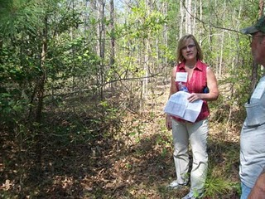

Glenda Norris stands beside of some disturbed ground where grave robbers in the 1870s sought Indian artifacts. Glenda (b 1959), is the daughter of Cecile Eugenia Holliman Youngblood (b 1937), who is the daughter of Cecil Rhodes Holliman, (1902 – 1986), who is the son of James Monroe Holliman (1878 – 1938) who is the son of John Thomas Holliman (1844 – 1930) who is the son of Uriah and Mary Polly Lucas Holliman. Rhodes (b 1928) is the son of Cecil Holliman, the grandson of James Monroe Holliman, and great grandson of John Thomas Holliman.

The Grandfather and Father of Mary Polly Lucas Holliman
Source: Genealogy of the Dodson, Lucas, Pyles, Rochester and Allied Families by: S. Emmett Lucas, Jr. Privately printed 1959, Birmingham, Alabama.
There seems to be no information concerning the Lucas family prior to these great grandfathers. Emmett Lucas speculates the family may have been Welsh in origin and from Pennsylvania.
Charles Lucas, Sr. b before 1755; d ca 1805-1810. Wife: Dorcas, b before 1755; d ca. 1805-1819. Lived in Marlboro County, South Carolina, known as a tailor.
Charles Daniel Lucas, son of Charles Lucas, Sr., b 6/30/1771; d 5/31/1853. Wife Mary Hastings, b9/10/1786; d 1/21/1867.

Below are continued observations by Holliman family historian, Glenda Norris. She credits much of her knowledge to Dr. Rhodes Holliman, her uncle. It was Rhodes who, as a boy in the 1930s, would hike several miles into the piney woods, dodging more than a few snakes to re-discover the location for the family. Several monuments now mark this spot.

"Charles Daniel Lucas, Jr. was the son of Charles Daniel Lucas, Sr. and 'Dorcas' (no last name has been found). It is believed that the mother of Charles Daniel Lucas, Jr. could be a Catawba Indian from the Pee Dee River area in Marlboro County, South Carolina. She was only 13 years old when she married Charles Daniel Lucas, Sr., a tailor. Their son, Charles Jr., was born on June 30, 1771 and died May 31, 1853."

Mary Polly Lucas, was the daughter of Charles Daniel Lucas (1778- 1853) and Mary Hastings (9/10/1786 - 1/21/1867), all originally from South Carolina. Polly Lucas became the wife of Uriah Holliman on 8/29/1836 in Tuscaloosa, AL.

Charles Lucas Sr. (1755 - 1810?) was the grandfather of Polly Lucas. Charles was probably a tailor who lived in Marlboro County, South Carolina along the Pee Dee River near the North Carolina line. Charles Daniel Lucas (1771-1853) stood six-foot-four and according to Polly, he once killed a panther with his bare hands. In 1819 Charles Daniel moved his family from South Carolina to the new state of Alabama (just as the Holliman family did in 1836).
Rhodes Holliman, a great great great grandson of Charles Daniel, reports that Charles had a fierce temper yet managed to serve as a deacon in the 1830s at the Springhill Baptist Church near Moore’s Bridge, Fayette County. Family lore states that Charles Daniel hit one of his sons causing his wife, Mary Hastings Lucas, to move herself and children from Newtonville to the Bluff Community northwest of Fayette.
Charles Daniel died in 1853 after having served as a Federal Indian agent. He is buried in an Indian burial site seven miles from Fayette toward Newtonville. In death, as in life, Charles Daniel Lucas was not completely at peace. In 1870 grave robbers attempted to disinter him but were scared off in the process.
Charles Daniel’s wife, Mary, is buried in an unmarked grave at the Springhill Baptist Church Cemetery in Fayette Co., along with their daughter, Mary Polly Lucas Holliman, and John Thomas Holliman’s first wife, Sarah E. Corbett.”

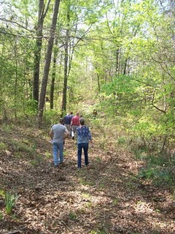
Above, on April 9, 2011, Holliman and Lucas descendants take the trail to the Lucas and Indian graves which are located several hundred yards through the woods off County Road 100 in south Fayette County.
"Charles Daniel Lucas, Jr. was a traveler and migrated from South Carolina to Alabama before the Holliman brothers. His first homestead was in Marengo County, Alabama where he purchased 80 acres on October 20, 1823 and then 80 more the next spring. Two years later, he established a homestead in Fayette County, and still ambitious, 40 acres on October 16, 1834 in Tuscaloosa County.
The Fayette and Tuscaloosa properties were connected, almost touching Highway 171 on its east side. He was a deacon at the Spring Hill Baptist Church in Tuscaloosa County. A monument at the church celebrates him and Cornelius Holliman, a son-in-law, as ‘founders’ of this church.
Charles Jr. earned his living 'stock dipping' and as a Federal Indian agent. Newtonville, Alabama straddled the line between the territory of the Chickasaw (north) and the Choctaw (south). By 1836, all these land claims were extinguished. In a dreadful and, even in that day, controversial act, most of the Native Americans remaining were removed to Indian Territory (present day Oklahoma).
With the dispersal of the tribes, the Federal government sold the land to immigrant families from the south east U.S. - the Hollimans, Lucases and other associated families.
Charles Lucas, Jr. claimed to be ‘black Dutch’, a term at the time to obscure one's possible Indian ancestry but this has not been proven, only speculated.
His burial site is in southern Fayette County, Newtonville area off of County Road 100 (Walnut Lane). At one time this land belonged to Charles Jr. and his home was not far from the burial site. His grave is on a ridge line, over looking a ravine. The site is an Indian burial ground as he chose to be buried with his friends."
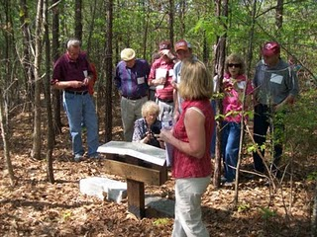
Glenda Norris, foreground, provides information at the internment site and memorials to Charles Daniel Lucas, Jr. The site contains numerous Choctaw or Chickasaw Indian burials, disturbed in an earlier century by grave robbers.
"Charles Daniel Jr. was married to Mary Hasten (in some places spelled Hastings). They had 10 children together. Family historians suggest that Charles Daniel ‘over disciplined’ one of his children with his cane. This did not go over very well with his family and because of his temper, his wife, Mary and the rest of his children left him and moved to the Bluff community. Due to this estrangement Mary Hasten Lucas was buried at the Spring Hill Cemetery, 20 or so miles north of this pioneer’s resting place."

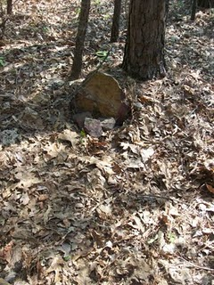
This original stone marker stands on the burial site of Charles Daniel Lucas, Jr., pioneer and Indian agent, who helped open Northwest Alabama to Anglo and African American settlement in the early 19th Century.
When Charles Daniel Lucas, Jr. was born, George III, was sovereign over the American colonies. When Charles Jr. died, Franklin Pierce had just become president of the United States, a union on the verge of dissolving."

Some of the general information for these postings comes from Robert Scott Davis's book, Tracing your Alabama Past (University of Mississippi Press, 2003).

The Hollimans of Alabama
Back to the 19th Century...A Series of Articles on the Hollimans and Related Families of Fayette County, Alabama
We continue our series of the April 9, 2011 tour of Holliman sites in Fayette County, Alabama led by Glenda Norris, descendant of Christopher Holyman, Sr (1618 - 1691).
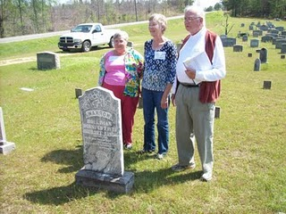
Above at the Chapel Hill Cemetery near Newtonville, Alabama are from left to right: Faye Gardner (Reform, Alabama), Jeanette Holiman Stewart (Austin, Texas) and Lenwood Holliman (Gordo, Alabama). In this April 9, 2011 photograph, they stand behind the grave of Civil War veteran Warren Holliman (1833 - 1908), a son of Charles Holliman (1795 - 1852), of whom the three are descended. Warren is misspelled Warron on his tombstone.
Warren Holliman's story...
In 1836, numerous children accompanied the three brothers, Cornelius, Charles and Warren Holliman, on their journey from the North Carolina/South Carolina border to Fayette County. One of the children of Charles Holliman and wife, Barberry (sometimes Barbara) Walters, was their son, Warren, age 3 at the time. According to U.S. Census records Fayette County had a population of over 3,000 in 1830, and would more than double in size to over 6,000 in 1840 as immigrates moved west to the yet untitled soil of Alabama.
Warren married Mary Polly Blakeney, the daughter of Thomas and Sarah Kemp (or Roberts?) Blakeney. Thomas (1800 - 1892) was a son of William Blakeney and a grandson of Capt. John Blekeney (1732 - 1832). The Blakeneys had migrated to Alabama from Chesterfield, South Carolina. Warren and Polly would have 11 children, 3 girls and 8 boys which helped entrench the Holliman name in the area.
Warren's generation came of age as the American Union dissolved and Civil War engulfed our ancestors. Warren and his two brothers, Cornelius and Elijah, and cousins (including my great grandfather, John Thomas Holliman) joined with other Fayette Countians in enlisting in the 41st Alabama Infantry Regiment. Warren was known as the 'strong man' of the county. He could pick up a bale of cotton (500 pounds) and walk with it!
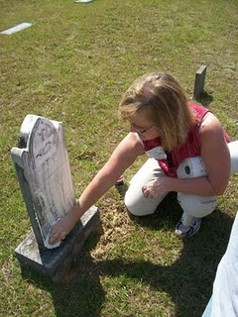

Glenda Norris uses a genealogical technique she learned from Rhodes Holliman, the application of shaving cream to faded tombstones, to reveal hidden names and dates. This is Warren Holliman's gravesite.
Below, Warren Holliman (1833 - 1908), a Civil War Veteran of the 41st Alabama Infantry Regiment
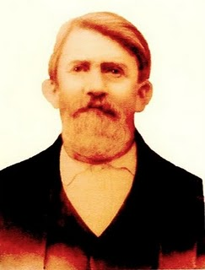
Warren Holliman (1833 - 1908) took a .58 mini-ball to the arm on August 17, 1864 during the siege of Petersburg, Virginia, knocking him out of the Civil War. At age 29, he signed up for the conflict with his relatives and neighbors with the 41st Confederate Alabama Infantry. This storied regiment was at Stones River, Chattanooga, Knoxville, Richmond and Petersburg before surrendering with General Robert E. Lee at Appomattox, Virginia in April 1865. After three months in a Richmond hospital, Warren was sent home in November 1864, his war effectively over. Photo and information from the extensive files of Dr. Rhodes Holliman, family historian, and Vonceil Duckworth, descendant of Cornelius Holliman.
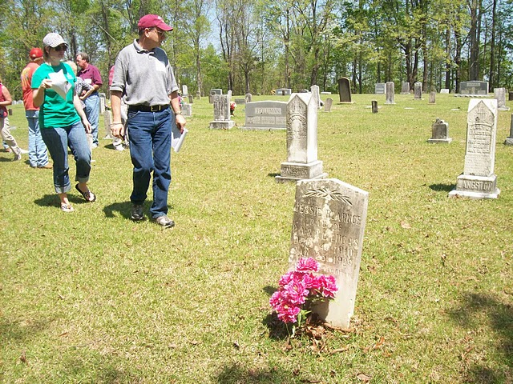

Above on a warm, sunny April day, 2011, Bill and his daughter, Joey Holliman, look for Holliman grave stones at Chapel Hill Cemetery in Fayette County, Alabama. Warren Holliman and his two wives are buried at Chapel Hill (see previous article). Bill Holliman, a multi-great nephew of Warren, is a 3rd great grandson of Cornelius Holliman (1792 - 1862).
Now living in Mississippi, Bill grew up in Irondale, Alabama, a grandson of Ulyss (1884 - 1965) and Pearl Caine Holliman (1887 - 1955), who migrated from Fayette County to Jefferson County in 1917 to take advantage of employment opportunities in the Birmingham area. This migration from rural Alabama communities to metropolitan areas accelerated during the World War I era. Today, descendants such as Joey and Bill return to Fayette, Lamar and Tuscaloosa Counties to discover family roots and stories.

add new blogs here

The Contributors and the Sources

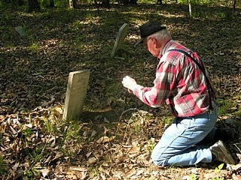
Pictured here is Dr. Rhodes Holliman, Dublin, Virginia, photographing a family grave marker in Fayette County, Alabama. Rhodes is a retired research biologist from Virginia Tech and an accomplished scholar. He is the great grandson of John Thomas Holliman, grandson of James Monroe Holliman and son of Cecil Holliman. He has written extensively on the Holliman family and the Civil War.

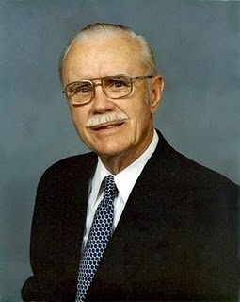
Cecil Holliman (1902 - 1986) was a distinguished attorney in Birmingham, Alabama who researched and recorded a great deal of Holliman family history. He is the father of Dr. Rhodes Holliman and the grandfather of Glenda Norris.
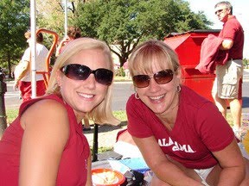
Glenda Norris, Alabaster, Alabama, is the great, great grand daughter of John Thomas Holliman. Rhodes Holliman is her uncle. Her daughter, Michelle, is on the right of the photo.
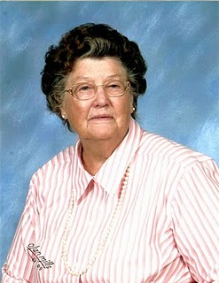Alison Maxine Roach Jones Wright, Mountain Home, Arkansas, is the daughter of Mamie Holliman and Howard Roach. She was born in Tipton County, Tennessee and is a great, great, great grand daughter of James Grantson Holliman. James Grantson Holliman (b 25 May 1750 - died 7 May 1836) was the father of three brothers - Cornelius, Warren and Charles - who migrated from South Carolina to Fayette County, Alabama in 1836. Maxine is descended from Charles (b abt 1818 - d abt 1842-45) and Barbara Holliman. Both Asa Holliman and Elijah Holliman were two of their sons, and both are Maxine's great grandfathers and Civil War veterans. Maxine's grand parents were first cousins: Charles Marion Holliman, son of Asa and Mary Elizabeth Holliman, daughter of Elijah Holliman. Her mother, Mamie, is the daughter of Charles and Mary Holliman. She continues to research 18th and 17 century Holliman family history for her many cousins.
Ron Holliman, Dothan, Alabama is a great grandson of John Thomas Holliman. Green Holliman is his grandfather. Ron is a Federal Program Director with the Southeast Alabama Regional Planning Development Commission (SEARP). (Photo pending)
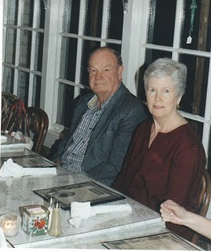
Above, Joe and Gladys Parker, Houston, Texas have a DNA test to prove that one of Joe's great grandfathers is Christopher Holliman, Sr. (d 1691) in Isle of Wight Co., VA. Both Joe and Gladys are accomplished genealogists with several books of 300 pages or more ready to publish. Joe has studied closely the Holloman branches of our Colonial Virginia family, and has, with the help of others, put together an outstanding history of his family branch from North Carolina in the 1700s to Texas of the 21st Century. He is generously sharing his information with the larger family.
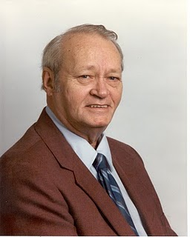

Walter Orien Holliman, a meticulous family researcher, passed away November 1, 2003. His birthday was May 5, 1927. Walt's father was Moses Holliman, the son of Warren C. Holliman, the son of Charles Holliman, who was the son of James Grantson Holliman (1750-1836), a common grandfather to almost all reading this blog. Walt's son, Bryan Holliman, carries on the family history tradition in his branch of the family tree.
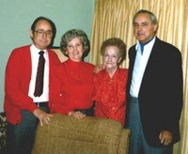
In this 1970s photograph contributor Ralph Holliman is far right. Standing to the left of Ralph are his aunt, Vista Caine Humber Gump, his niece Mary Daly Herrin and brother, Bishop Holliman. Ralph is retired as vice president of operations of American Bakeries. He and his late wife, Motie, had two girls, Pam Holliman, a Ph.D. and professor at Garrett-Evangelical Seminary in Chicago and Kathy Holliman of Philadelphia, a gifted writer of science articles, and mother of Rachel Harbour. Ralph lives in Gulf Shores, Alabama with his wife, Laura.
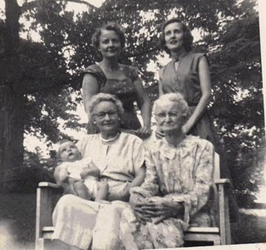
Clayton Herrin, Irondale, Alabama, is the first born of E.C. and Mary Daly Herrin, also of Irondale and is the baby in the 1953 photo. Mary, top right, is the daughter of Robert and Vena Holliman Daly. Vena, top left was the first born daughter of Ulysses and Pearl Caine Holliman (1888-1955), holding baby Clayton. Lula Hocutt Caine (1861 - 1957), bottom right, lost her father, Manassas Hocutt, in the Battle of Stones River, Murfreesboro, Tennessee, January 1863, and never remembered him. Clayton has contributed photos and memories of his mother's side of the family and has helped organize several family reunions.
Norman Stephens Holliman of Maryville, Tennessee was raised in Rockdale, Texas. He is the great, great grandson of Polly Lucas Holliman and is pictured here by her Alabama tombstone.
Below Robert R. Holloman of Rye, NY poses at sunset with his wife, Karen. Robert, a graduate of the University of Virginia in history, is a descendant of Christopher Hollyman, Sr. (d 1691). A grandson of Christopher, Christopher Charles, moved to northern North Carolina in the 1700's. A branch of the family has remained there (Bertie and Hertford Counties) for genereations. George Holleman in his history of the Hollyman family confused Richard Hollyman's son Samuel of Edgecome County (#3D4 in George's book) with a son of Christopher Charles, son of Samuel Hollamon (not listed) who married Martha McGlohan. Samuel and Martha were the parents of Samuel Holloman (#4D5) who served in the Hertford County militia during the Revolutionary War (Captain Perry's company) but not Lewis (#4D6, David (4D7 and Richard (#4D8).
Robert's father, Robert A. Holloman III married Lydia Jane Moore of Hertford County. He entered the military during the Korean War and made it a career, retiring with the rank of Brigadier General. Today, he lives near Atlanta, Georgia.
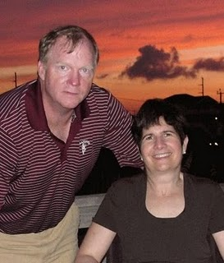
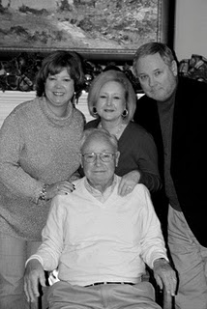
Bishop Holliman is a grandson of John Thomas Holliman, and lives in Avilla, Indiana. His father was Ulysses (b 1884 - d 1965) and his mother, Pearl Caine Holliman (b 1888 - d 1955), both born in Fayette County, Alabama. This photo was taken on his 90th birthday, December 2009 surrounded by his three children, from left - Alice Lynn Holliman Murphy of Trophy Club, Texas, Rebecca Louise Holliman Payne of Cookeville, Tennessee and Glenn Nelson Holliman, Newport, Pennsylvania.

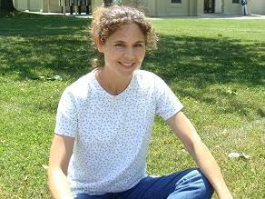

Grace Holliman, Virginia, is the daughter of Glenn Holliman, granddaughter of Bishop Holliman, great granddaughter of Ulysses, and great, great grand daughter of John Thomas Holliman. She helps edit this Weblog and provides continuous technical advice. You may visit her own blog at:http://www.life2seriously.com/.

Glenn Holliman is a resident now of Newport, Pennsylvania. A native of Alabama, he and his wife, Barbara, founded Holliman Associates, a fundraising firm in the 1980s. They sold the firm in 2005, and Glenn is now a retired vice president of the New York based Episcopal Church Foundation. He and Barb are authors of several works on capital campaigns and planned giving. Holding an M.A. in American history from the University of Tennessee, Glenn taught history at the Webb School, Bell Buckle, Tennessee and served as the head of a day school in South Carolina earlier in his career. He is a Vietnam War veteran having served with the 1st Infantry Division. His great grandfather is John Thomas Holliman. One of his greatest joys is gathering information on the family and American history and sharing it with the extended family.

add jeanette holiman stewart

Holliman Records, A History of Some Official Documents
by Glenn N. Holliman
I have accumulated numerous legal abstracts on the Holyman, Holliman, Holleman, Holiman and associated spellings and families. Additions always welcome and corrections, also. My email is glennhistory@gmail.com . Perhaps these notes will be of some assistance to others.

The 'Holliman' Name
by Glenn N. Holliman
The Name Holyman and its Spelling Varieties
Recently I was perusing Archives.com, a subscription service, and clicked on Family History. Lo and behold, the site revealed the numbers of Holliman (and other various spellings) households in the U.S. and the states in which persons of this spelling reside. Here is what I found.
Holliman
This is the 4,999 (not 5,000 mind you) most popular name in America, and there are all of 1,350 households in the country with this name. Frankly, that is a tiny portion of perhaps 75 to 100 million or so residences in these United States. This confirmed my 'feeling' that there were not many of us out there.
Where do Hollimans live? As those of us who follow these things are generally from the southeast, and as Holymans entered North American in Jamestown, Virginia, the vast majority of us still live in the south and southwest. Here is a partial ranking of those of us who in Colonial times adopted an 'i' and dropped the 'y'.
Georgia - 15.3%
Mississippi - 14.4%
Alabama - 11% (my state of origin)
Arkansas - 9.1%
Texas - 8.4%
Tennessee - 5.4%
Oklahoma - 4.4%
Illinois - 2.7%
North Carolina - 2.4%
Virginia - 2.4%
South Carolina - only 1%
Hmmm....So the Hollimans left Virginia, settled for a while in North Carolina in the 1700s,and generally kept moving southwest to the states of the Old Confederacy. We did not go much further west than Texas and Oklahoma (California has all of 2% of the Hollimans). One group did go north to Illinois, perhaps African-American Hollimans who live in the Chicago area, part of the migration between the world wars?
No one of this spelling live in Maine, the Dakotas, Idaho, Wyoming, Nevada or Arizona.
Holloman
Let's try a variation on the name, Holloman. A bit more common - this spelling is 3,350 on the list or about 2,240 households in the entire country. What a difference a vowel makes! Again a very predominant Southern name.
North Carolina - 23.5%
Virginia - 11.6%
Texas - 7.1%
Georgia - 6.7%
South Carolina - 5.8%
Florida - 4.6%
Mississippi - 3.3%
Alabama - 3.1%
Tennessee 2.1%
Whoo...those descendants of Christopher Holyman, Sr (d 1691) who stayed in Virginia and migrated to North Carolina (and put down roots) tended to spell their name with an 'o' not an 'i'.
Holleman
This spelling, fairly common in Isle of Wight County, Virginia a ranks 10,490 as the most common in America; pretty low. There are about 1,350 families in America with this spelling.
Texas - 21%
North Carolina - 18%
Illinois - 5.1%
Tennessee - 4.8%
California - 4.6%
Michigan - 4.3%
Georgia - 4%
Mississippi and Okolahoma - 3.5% each
Virginia 3.3% or only 43 residences
Were a number of these Hollemans African-Americans who moved to Chicago and Detroit between the world wars? Perhaps the descendants of slaves from the deep south? Perhaps?
Hollimon
Opps...this spelling is the 30,255 most popular, pretty low in the name 'market'. There are only 260 residences of cousins who use an 'o', instead of the 'a' in the last syllable. And where do you live? No surprise, again the deep South.
Mississippi - 19.8%
Texas 12.1%
Georgia - 11.3%
Alabama - 7.4%
and so on....
Granted in the Colonial times and in early censuses (dare I say this) our ancestors and those dealing with official records may have lacked certain 'spelling skills' which has led to our various spellings. Whatever happened to Holyman and Hollyman, the names that show up in England and early Colonial records?
Hollyman
Strangely, the spellings of Holyman and Hollyman have disappeared (almost). Only 75 residences in the entire U.S. are labeled 'Hollyman'.
Illinois - 15.6%
Missouri - 15.6%
California - 15.6%
Does this suggest a later migration to the Colonies from another family? Virtually none by this name live in the Deep South as do the known descendants of Christopher Holyman, Sr. (or Hollyman).
Holyman
This is the spelling one will find in 16th and 17th wills in England, and yet in all the United States, only three residences have this spelling. One person each in Missouri, West Virginia and Pennsylvania.

In the next post, Warren Holliman's historic war service with the 41st Alabama Infantry Regiment....

Web Sites for your Own Family Research
There are a number of places to look for additional Holliman family information. One of the most informative, a group chat room, is run by Tina Peddie, a descendant of Christopher Holliman, Sr. One has to ask permission to join. You can find this site at: HOLLYMAN@yahoogroups.com.
Ron Holliman suggests a look at www.poefamilyresearch.net/Holliman/ for lineage information. This site also covers the descendants of Warren Holliman who moved to Arkansas in 1840 after four years in Fayette Co., Alabama.

Roots Web, a service of http://www.ancestry.com/ has some free web sites. Drill down and discover the inputted names of hundreds of Hollimans. Beware not all published internet material is accurate.
A very comprehensive service can be found at http://www.cyndislist.com/. Another great place to discover family is at the Church of the Latter Day Saints (Mormons) site: http://www.familysearch.org/.
For those interested in Isle of Wight County, Virginia, the home of Christopher Holliman, Sr. (d 1691) look to http://myvirginiagenealogy.com/. Also check out http://www.iwchs.com/, the internet home of the Isle of Wight Historical Society. Details of cemeteries are included and an excellent history of the county.
Published Works that have been Helpful Researching Holliman History
The beginning for any Holliman historian is the now classic The Hollyman Family published privately by George Holleman in 1952. While it has some errors and the research is dated, it is still a must have work for the serious Holliman genealogist. The work is available also through The Apple Manor Press, Markham, Virginia. Their web site is http://www.yesterbooks.com/. Tina Peddie (see above) has some copies for sale also with an update addendum.
If one wants detail and a list of wills and deeds, look for John Bennett Boddie's 1938 work, Seventeenth Century Isle of Wight County, Virginia. It has been reprinted by Genealogical Publishing Co., Inc of Baltimore, Maryland. The land purchases of Christopher Holliman, Sr. and his children are listed. For the very serious researcher, Blanche Adams Chapman's Wills and Administrations of Isle of Wight County, Virginia, 1647-1800, Books 1-3, first published in 1938 (evidently a good year of local history publications), has been reprinted. Look to Heritage Books, Westminister, MD for reprints.
Boddie turned out several works on Colonial Virginia, one beingSouthside Virginia Families, Pacific Coast Publishers, Redwood City, California 1955. In this work he describes many land purchases by Hollimans and Hollomans in the 18th and 19th Centuries.
Martha W. McCartney's Virginia Immigrants and Adventurers, 1607 - 1635 contains snipits of information on those brave souls who ventured to Jamestown in its earliest years. Information on one Thomas Holman (Holeman) is found on p. 396 of the 2007 reprint from Genealogical Publishing, Baltimore, Maryland.

Another Genealogical Publishing work is Early Virginia Families Along the James River. In Volume III by Louise Pledge Heath Foley of this 2007 reprint is (p. 56) a statement that William Hollyman arrived in James City County April 25, 1656. Other Hollymans can be found in both Volumes II and III, including rent rolls.

Also from Genealogical Publishing is Geroge Cabell Greer's very helpful Early Virginia Immigrants, 1623 - 1666 which lists the names of many Hollymans. This is a 1982 reprint of the 1912 edition and contains 25,000 names.

Charles Hughes Hamlin's They Went Thataway, multivolume, has a page on one Joseph Holliman of 1770 Surrey County. Hollimans (Hollemans) spilled over from Isle of Wight County, Virginia to Surrey County by the early 1700s. Again by Genealogical Publishing in Baltimore, 1985 reprint.

Helping to understand the early Colonial Virginia experience is James A. Crutchfield's The Grand Adventure, a Year by Year History. Look for Dietz Press, Richmond, Virginia, published 2005.

There are several indexes that provide the names of Hollimans. The Virginia Marriage Records, compiled from the Virginia Magazine of History and Biogrpahy, the William and Mary Quarterly and Tyler's Quarterly, indexed by Elizabeth Petty Bently and published in 1982 by Genealogical Press is a good place to start. Judith McChan in 1993, same publisher and same publications, did an index entitled Virginia Will Records and while containing Surrey County, it omits Isle of Wight County. In that same genre, Gary Parks indexed Virginia Land Records in 1982. Holliman names can be found in all these works.

Marriages of Some Virginia Residents, 1607 - 1800 by Dorothy Ford Wulfeck, three volumes again by Genealoical Press of Baltimore (2003) lists even more Hollomans and Hollmans. And one will find Hollomans in Virginia Tax Records, again by Genealogical Publishing (1983).

Of course, Nugent's Cavaliers and Pioneers remains a standard work for listings of early residents of Virginia. Her one will find Christopher Holyman and his probable sister, Judith.
Don't overlook published historical works to give tone and texture to any family history. I have been studying some recent publications that are page turners and tell the story of Jamestown and the James River. Benjamin Wolley's Savage Kingdom, The True Story of Jamestown, 1607 and the Settlement of America(HarperCollins 2007) describes the first years at Jamestown, a close run thing. In 1609, survivors were sailing into the Chesapeake when a resupply ship and new colonists chanced to meet them, and convinced the discouraged settlers to turn around and try again.
The River Where America Began, A Journey Along the James (Rowman & Littlefield, 2007) by Bob Deans is a beautifully written tome. This work describes how British, African and Native American cultures collided and 'in a twisted paradox, the seeds of democracy and slavery were sown side by side."
American Slavery, American Freedom, The Ordeal of Colonial Virginia by Edmund S. Morgan was first published in 1976. It won the prestigious Francis Parkman prize and has been reprinted by Norton, 2005.
The still standard work on Bacon's Rebellion is The Governor and the Rebel by Wilcomb E. Washburn. First published in 1957, Washburn presented a balanced and well-researched document on the first American rebellion against governmental authority.
For an understanding of Martin's Hundred, the settlement site of some first Hollimans in Jamestown, Virginia, look for a used copy ofMartin's Hundred by Ivor Noel Hume (Alfred E. Knoph, 1988). It is a detective story of one of the most savage Indian uprisings in American History. In a surprise attack in 1622 Native Americans came close to destroying the Virginia colony. Over 1/3rd of the colonists were killed. Fortunately for our DNA, Hollimans had not yet arrived in Jamestown.
A Religious History of the American People by Sydney E. Ahlstrom (Yale, 1972) is a 1,100 page plus volume filled with more religious information than most of us will ever want to know. However, the book does mention our distant cousin Ezikeil Holliman and information on the Anglican and Baptist Churches in Colonial Virginia. There were Quakers, gasp, in the Royal Colony of Virginia in the late 1600s much to the chagrin of the governors and House of Burgess. Later Thomas Jefferson and his insistence on religious freedom in Virginia set the standard for toleration throughout the new United States.
Plain Folk of the Old South is a southern classic, first published in 1949. Historian Frank L. Owsley could have been writing about the Holliman families in North Carolina and Alabama prior to the Civil War. His thesis is that most white southerners were yeoman farmers owning no slaves, and that only a very few planters experienced the Gone with the Wind affluence. As my great grandfather, John Thomas Holliman, said, as reported by Rhodes Holliman, 'It was a rich man's war and a poor man's fight'. Author Owsley would have seconded this statement.
Works Helpful to Understanding our English Roots
Virginia Gleamings in England, again reprinted by Genealogical Publishing of Baltimore, Maryland, 1980, contains that fascinating tidbit of William Holliman of Tring continuing a lease on the Tring parsonage in the 1600s. Lothrop Withington is the author.
The First Elizabeth by Carolly Erickson reads more like a novel than biography. An excellent work that enables one to understand Queen Elizabeth I (1533 - 1603). First published 1983 by MacMillan.
Antonia Fraser is one of the most popular historians writing today. Her The Six Wives of Henry VIII is written from a woman's point of view, and Henry does not come off so well. Written in 1992 and published by Weidenfeld & Nicolson, London.
A valuable tome on Tring, Hertfordshire history is Sheila Richards, A History of Tring, published 1974 by the Tring Urban Council. Contains information on William Holyman in 1444.
Home
Subscribe to: Posts (Atom)
Home

NOTES TAKEN AT LIBRARY OF VIRGINIA, NOVEMBER 2010

McCartney, Martha W. Virginia Immigrants and Adventurers, 1607 – 1635, 2007. Baltimore, Genealogical Publication, 2007.

P. 39/40 – Gift of God arrived January 1619 at Skiff’s Creek and Grove Creek to College Creek. Founded Martin’s Hundred which broke up in 1630s.
P. 396 – Thomas Holman on 8/24/1635 patented for 100 acres in Martin’s Hundred.

Foly, Louise Pledge Heath. Early Virginia families Along the James River, Vol. III. Baltimore, Clearfield Genealogical Publications, 2007.
P 56 – Wm Hollyman, deed of 300 acres to Thomas Rolfe, 300 acres, gent., James City Co. along Wallingford River. 25 Apr. 1656. Transported.
Rent Rolls of Surry Co. 1704
P 156 – Richard Holliman, 480 acres
Mary Hollyman, 290 acres
Thomas Holloman, 450 acres
Ibid., Vol. II.
P. 17 – 1635, Thomas Rolfe, b 1615, sone of Pocahonas and John Rolfe, ret. To claim inheritance.
P. 24 – 1656, John Washington, George Washington’s great grand father arrived in Virginia.

P. 43 – In 1729, North Carolina and South Carolina officially divided. Population of Virginia that year was 114,000.

P 76 – 4 Nov 1685 Charles City Co. Transport William Sewell – trans. Of 15 pers: John Holliman – transported.

Crutchfield, James A. The Grand Adventure. Richmond, Dietz Press, 2005.
P. 83 – 25 Apr, 1702 – Richard Holliman, 1230 acres on S Side of Blackwater, transport of 25 persons. Including Anne and her child, Thomas Holliman.

Greer, George Cabell. Early Virginia Immigrants, 1623 – 1666. Baltimore, Genealogical Publishing Co., 1982 reprint of 1912 edition. Contains 25,000 names.
P. 164 – 1650, Holeman, Xtop by John Cox
P. 164 – 1653, Holliman ___ by John Sheerlock, Lancaster Co.

P. 164 – 1653, Judith Holliman by Sheerlock

P. 164 – 1656, Wm. Holliman by Tho. Rolfe, Gent., James City Co.

P. 165 – 1653, Christop. Hollman by Sheerlock
P. 165 – 1653, Hollman, Judith by John Cox of Lancaster Co.
P. 165 – 1650, Holloman, Judith by Tho Wilkinson _____ Co.
P. 165 – 1638, Holman, Wm by John Bats and John Davis, Charles River Co.
P. 165 – Holman, Robert by Elizabeth Grayne, Charles City Co.

Hamlin, Charles Hughes. They Went That Away. Baltimore, 3 Vols, Baltimore, Genealogical Publishing, 1964 – 1966. Reprinted 1985 as one volume.
P. 10, Vol 2 – Nov. 2, 1770, Joseph Holleman of Southwark Parish, Surry Co. for 65 pds land on S. side Main Blackwate4r Swamp, Surry – 340 acres next to Hart Champion. Benjamin and Elizabeth Chapion moved to Halifax Co., NC.

Coldham, Peter Wilson. The Complete Book of Emigrants 1607 – 1660. Baltimore, Genealogical Publishing, 1987. - on my to read list.
Elliott, Katherine B. Emigration to Other States from Southside Virginia, 2 Vols. Easley, SC, Southern Historical Press, 1966. Reprinted 1983.
Tyler’s Genealogies of Virginia Families – I found no Hollimans in this work.

Boddie, John Bennett. Southside Virginia Families, Vol. 1. Redwood City, CA, Pacific Coast Publisher, 1955.

P. 128 – 1770, Nov. 2; Joseph Holloman purchases Benjamin Champion’s Surry County land.
P. 197 – 1801, June 28; born Ely Holliman, son of Jeremiah Holliman and Anna Hart Fort, daughter of Henry Hart, Halifax City, North Carolina.
Ibid, Vol. 2
P. 24 – April 6, 1769; Anselm Bailey’s Surrry Co. will witnessed by William and Josoph Holloman. Baily had purchased land from Joseph Holleman near Tarapum Swamp.
P. 27/28 – William Holliman m. to Rebecca Barham, d. of James (b. abt 1730). Will prob. Southampton Co. June 9, 1792, filed Feb. 24, 1791.
P. 85 Nov. 3, 1783: Charity Coffer, daughter of Thomas Coffer, married Jesse Holleman.

Bantly, Elizabeth Petty. Virginia Marriage Records.Baltimore, Genealogy Publishing, 1982. This is a completion of information from The Virginia Magazine of History and Biography, The William and Mary Querterly and Tyler’s Quarterly. Ms. Bantly indexed the material.
P. 158 – Dec 15, 1758; Cumberland Co. bonds – Anthony Martin and Sarah Holliman, dau. Of James Holliman.
P. 263 – April 21, 1823; M. Bonds of Greensville Col, VA 1809 – 1827 – Elizabeth Holloman of Northampton Co., NC consents to Martha Maria (Holloman) m. Joseph M.S. Rogers.
P. 574 – December, 1778; Joseph Holliman consents to daughter _____ m. Moreland Delk, Surry Co.
P. 571 – December 25, 1777; Anne Hollman, d. of Arthur Hollman m. Samuel Crocker, Surry Co.
P. 574 – April 28, 1778; James Holliman and Sarah Gwathney, d. of Thomas Gwathney. Joseph Holliman gives consent for his son, Surry Co.

McChan, Judith. Virginia Will Records. Baltimore, Genealogical Publishing, 1993. Indexed from the Virginia Magazine of History and Biography, the William and Mary Quarterly, and the Tyler’s Quarterly.
Statement that Surry Co. has wills of John Holloman and Mary Holleman and a guardian bond for Holleman, Wills from 1730 to 1739 in ‘deplorable shape’ and are not published. Nothing else on Holliman in this volume.

Parks, Gary. Virginia Land Records. Baltimore, Genealogical Publishing, 1982. Again indexed from The Virginia Magazine for History and Biography, The William and Mary Quarterly, and Tyler’s Quarterly.
P. 76 – Goochland County Deeds and Wills – April 10, 1739; Will of Henry Holman, wife Mary, son Nathaniel, Cousin James, son of brother James Holman.
P. 206 – August 24, 1635; Thomas Holman, 100 acres in James County in Martins Hundred adjouning on the north side of John Bennett.
P. 601 – undated deed from Charles City County of Sarah Hollom Woodward, daughter of Robert Hollom.
P. 666 – June 1, 1635; Land patent in Henrico Co. Robert Hollman held land next to James Place.
P. 674 – March 6, 1635; Robert Hollman, land in Henrico Co. VA along the main river.

Walfeck, Dorothy Ford. Marriages of Some Virginia Residents, 1607 – 1800. Baltimore, Genealogical Publishing, 2003.

P. 296 – April 28, 1778; Moreland (?) Delk m, d. of Joseph Holliman, Surry County.
P. 297 – Unlisted and dated; Anne Hollman m. Samuel Crocker
P. 298 – Undated; Charity Holloman m. Jordan Wekiford

Virginia Tax Records. Baltimore, Genealogical Publishing, 1983.
P. 419 – Surry County Quit Rent Rolls –
1704; Richard Holloman, 480 acres
1704; Tho. Holloman, 450 acres

P. 426 – Isle of Wight Tax Rolls
1704, Christopher Hollyman, 400 acres
P. 419 – 1704, Mary Hollyman – 290 acres
P. 33/34 – 1804; John Holeman Jr. and Sr. voted in Cumberland Co.
P. 215 – March 10, 1747, King William Parish, JKames Holeman paid taxes
P. 477 – 1704; James Holeman paid taxes on 150 acres in James City County
P. 427 – 1704, Isle of Wight County, Thomas Holyman, 150 acres

McCartney, Martha W. Virginia Immigrants and Adverturers, 1607 – 1675.
August 24, 1635: Thomas Holman, patent for 100 acres Martins Hundred

Nugent. Cavaliers and Pioneers, Vol. 1.
P. 328 – April 25, 1656; Wim. Holliman transported by Thomas Rolfe
P. 201 – No date; Judith Holloman transport. By Thomas Wilkinson; she came with Alice Newman and Alice Thomas.
P. 192 – May 23, 1650; Christ. Holleman and Judith Hollman and Ellis Newan
P. 377 –Aug 9, 1658; Wm. Hollman transported by Martin Palmer
P. 386 – Feb. 26, 1658; John Hollman transpt. By John Dorrant
P. 77 – May 10, 1670; C. Holleman had land on 3rd Swamp of Blackwater river adjacent to Thomas Moore and Thomas Atkinson. Moore purchased 2,400 acres.

Notes taken at the Edgecombe Library, Tarboro, NC, April 26, 2011 by Glenn N. Holliman

First two entries are on Surry County, Virginia
MacDonald, Edgar and Slatten, Richard. Surry County Virginia Tithables 1668 – 1703.
P. 4 – Xtopher Holliman, 01, Lawnes Creek, 1668.
P. 176 – William Holliman and John Procter June 2; Lawnes Creek, June 10, 1703.
P. 39 – 1679, William Hollyman (near this name is Wm. Gualtny and Thomas Pittman Jr.
P 45 – Lawnes Creek named after Capt. Christopher Lawne who settled in 1619. Parish began at mouth of Hogg Island Creek along the James River to branches of Chippokes Creek. Surry Co. created in 1652 out of James City Co. Lawnes Creek Parish faded into history. Parishes of Southwark and Lawne’s Creek divided by the Blackwater River.
p. 17 – 1673 – Xpher Hollyman, 1 thithable in Surry Co.
P 21 – Xpher Hollyman along Lawnes Creek in 1674.
P 171 – Richard Hollyman and Thomas Pittman, Jr. 1702, pd tithable at Lawnes Creek. Also, William Holliman.
P. 154 – William Hollyman pd. tithable for Lawnes Creek.

Boddie, John B. Colonial Surry. Baltimore, Genealogical Publishing Company, 1966 (reprint from 1948).
P. 214 – VA Quit Rent Rolls for Surry County, 1704 – Richard Holliman, 480 acres; Thomas Holliman – 450; Mary Holliman – 290.
P. 218 – Jan. 25, 1778 – Holliman, James and Sarah Gwathney, dau. Thomas Gwathney. Jospeh Holliman consents for son and Thomas Gwathney for dau.
P 223 – Joseph Holleman, Sr. 10 white, 13 black head of families of Surry Census 1782. Joseph Holleman, Jr., 4 white, 5 black, head of family.
P. 156 – A fort was established early on the Blackwater for defense against the Indians for on March 1675, the House provided that the Fort on the Blackwater River in Surry shall have 729 pounds of shot and 180 pounds of powder.
P. 157 – Surry County was well settled up to the Blackwater River by 1700. October 1705 House passed a measure which provided that ‘on account of the inconvenience of the inhabitants of Prince and Surry, Isle of Wight and Nansemond by reason of uncertainty of the bounds of the said counties on the South side of the Blackwater Swamp, it ordered that the surveyors of the counties, before Dec. 25, 1706 shall survey and laybout the Blackwater Swamp and that the line agreed upon shall afterwards be the dividing line of each country backwards as far as this Government extends.”
P. 179 – Surry Land Grants, south of the Blackwater in what is now Sussex County- John Hollyman, 1724 – 78 acres; Thomas Holleman, 1714 – 220 acres.
P.187 – Xpher, Hollyman, 1 tithable in Surry Co., 1674 on Lawnes Creek Parish.

Clark, Murtie June Clark. Colonial Soldiers of the South, 1732 – 1774. Baltimore, Genealogical Publishing Co., 1983.
P. 662: Under Captain Aqueler Suggs’ Company were David and Thomas Holleman; Muster Roll of Edgecombe County Militia, NC in the 1750s.
P. 806: Under Johnston Co., NC militia commanded by Capt Simon Turner prior to 1770, Soloman Holloman.
p. 794: Under Johnston Co., regiment, Col. Samuel Smith and Capt. Benjin Hardy was David Hollyman; Col. Samuel Smith.
P. 722: Serjeant William Holliman of Capt. John Sallius’s Co. under regiment of Col. William Eaton, Granville Co., NC, Oct. 8, 1754.
P. 673: Absalom Holliman under Capt. Solomon Alston’s company, muster roll of Edgecombe C. militia, NC 1750s.

North Carolina Heads of Families at the First Census of the US taken in the Year 1790 (I have listed only a few; more work required. See below for Johnston Co. names in 1790 census.)
James Holliman, Hillsborough District, Wake County, p. 105: 1 white male over 16, 2 free male whites under 16, 3 free female whites. No slaves. Wake Co. was created in part from Johnston Co.
Isham Holliman, Halifax district, Edgecombe C o, 1 male, 3 males under 16, 4 females and 5 slaves
Jesse Holliman, same location, 1 male, 3 males under 16 and 3 white females. No slaves.
Many Hollomans in Edenton District, Hertford Co. with heads of families begin Samuel, Silva, Aaron, David (all spelled Holomon). Plus John Holoman and Cornelius Holoman and Christopher Holomon.

Fleming, Monika S. Edgecombe County along the Tar River. Charleston, SC, Arcadia, 2003.
P 12 – The Tuscarora War resulted in displacing most of the natives and opening the way for Europeans to migrate inland and settle along the rivers and creeks by the late 1720s.
Before 1730 no more than 20 families lived along the river in what was part of Bertie Co. and is now Edgecombe Co. – Neuse River. Colonial Records of NC listed 65 individuals in arrears of Quit Rents in Edgecombe Precinct in March 1732.
P 13 – 14: Edgecombe established in 1741. Available land soon attracted more settlers from southern Virginia as well as those coming upriver from the coast. Pop. influx up to over 10,000. Hundreds arrived and purchased land near the Tar River or its tributaries.

Edgecombe Co, NC Marriage Bonds. Genealogical Society of Utah, 1938.
Isham Holloman to Sarah Wiggins, Oct. 29, 1799 witnessed by David Forechard and J.H. Hall.

Haun, Wyenette Parks. Edgecombe Co, NC County Court Minutes, 1744 – 1762. Durham, NC, Privately Printed, 1985.
Court held at Enfield on Feb. 19, 1744. A deed of sale from John Rodgers to Saml. Holliman. No indication of where or size.
Court held on Aug 20, 1745 at Enfield. A deed of sale from Robert Council to Henry Turner was proved by the oath of Saml. Holliman.
P. 19 at same court, Saml. Holliman records his mark viz: a Swallow Fork in the left Ear & a Crop in the Right Ear.
Nov. 1745, Samuel Holliman serves on the grand jury.
May 1746 – A deed of sale from Richard Sessums to Wm. Reynolds was proved by the oath of Saml. Holliman.
P. 39 Edgecombe Court, August 1746, Thos. Hollyman some action not recorded;
P. 43 Hollyman ads Popoucoutry ----Judgemt.
P. 146 – Absalom Holleman and others to work on Parsimon Branch to Evan’s Road. Dec. 1760.

Bradley, Dr. Stephen E. Edgecombe County, North Carolina Deeds, Vol. 3: 1778 – 1786. Abstracted 1996.
173-(495) State Grant No. 45 to John Proctor. 1 Jul 1779 - 460 acres on the south side of Tyoncokey Swamp, joining sd Proctor, Arthur Williams, Holliman’s Branch, William Proctor. Nov. Ct 1779. Edward Hall CC.
124 –(441) State Grant No 5 to William Proctor. 10 Dec. 1778 - 230 acres on the east side of Holliman’s Great Branch. Aug Ct 1779. Edward Hall CC.
358 – (126) John (x) Proctor of Edgcombe Co to Absalom Williams of same. 22 May 1780. (no amount) 260 acres which was part of a State Grant to John Proctor, on the south side of Tyancokey Swamp on Hollomon’s Branch, joining Arthur Williams. William Proctor. Feb Ct 7182. Edward Hall CC.

Bradley, Ibid. Vol. 1 1759 - 1768
55-(85) Moses Hare Jr of Edgecombe Co to James Gray of Surry Co VA. 1 Feb 1760 - 300 Pds. 150 acres where sd Moses Hare now lives and which sd Hare had purchased from Samuel Holliman 11 Apr 1753 on the south side of Tar River, joining the river, John Cohoon, Walnut Creek; also 360 acres which Samuel Holliman conveyed to sd Mose Hare 8 Jan 1756, joining sd Moses Hare on the south side of Tar River…Jun Ct 1760. Jas Hall CC.
947 (407) Moses Hare of Hertford Co. to Jesse Hare. 14 Dec. 1765. 5 pd VA. 120 acres, joining Saml Hollomon, Wm Hawyood, Jesse hare, Isaac Wilson, Oct Ct 1766. Jas Hall CC. It appears that a Samuel Holloman still owned land in Edgecombe Co. in 1766.
Edgecombe County Will Abstracts 1732 – 1792
187 – Will of Robert Hilliard April 13, 1743 in May Ct 1751, witnessed by Saml. Holliman, Willm Sergener, Bnj. B. Boykin.
246 – Will of Richard Lee, Sr. April 1, 1756; May ct. 1756. Witnessed by Absalom Holliman, James Permenter and William Fokes. Gave 100 acres of land on Conentny Creek to son.

The North Carolina, Quarterly Journal of Genealogy, Vol. 3, Sept. 1955
P. 66 – Charles R. Holloman, co-author of The Story of Kinston and Lenoir County. Nathan Holloman settled in 1778 in Grantham section of Wayne County, when he came down from Southampton Co., Virginia. Was 3 G Uncle of Charles Holloman. Near Cox’s Mill on south side of Neuse River about ten miles from Goldsboro in the direction of Mt. Olive.
Charles R. Holloman, B.S., LL.B. compiled a Cross Index to Deeds for Johnston Co. 1746 to 1759, Dobbs Co and Lenoir Co. He co-authored a book with Talmadge C. Johnson (Raleigh: Edwards and Broughton Co, 1954).

Hofmann, Margaret M. Abstracts of Deeds, Edgecombe Precinct, Edgecombe Co., NC, 1732 – 1758. Weldon, NC, The Roanoke News, 1976. NC.
P. 360 Samuel Holleman of Onslow Co., Blacksmith to John Wall of Edge. Co., planter 19 Aug 1740, 4 pounds, 10 shillings current money of Va. 300 acres on the north side of Fishing Creek, joining James Cotton and the creek as by patent to the sd. Holleman. Wit: Elias Forte, Thomas Pittman. Nov. Ct. 1740 J. Edwards D.C. Ct. I think this is the first legal document of a Samuel Holliman, 1740. Note he is from Onslow Co., NC.
P. 416 – Samuel Hollyman, Arthur Bryan on Aug 1741 wit sale by James Bynum to Robert Surjoyner of Edge Co. 100 acres on south side of Marratock River.
P. 398 – Samuel Holliman of Duplin Co. to Moses Hare of Edge Co. 8 Jan. 1756 360 acres on s. side of Tar River, joining the sd Hare, John Jameson, a small branch of Walnut Creek, the River and Cahoon’s former land. Feb. Ct 1756. Now we have a Samuel Holliman of Duplin Co., 16 years later. Is this the same person moving from Onslow to Edgecombe to Duplin to finally Johnston Co.?
P. 61 – Abraham Odom and wife Sebell of Edge. Co to John Sumner of Chowan Co. Feb. 1746. Ct.
P. 139 – Samuel Holliman of Edge. Co. to Elisha Battle of Nansemond Co., VA 17 Aug 1747 for 50 pounds current money of VA 400 acres joining George Pollock, a grant to sd Holliman, 6 May 1742. Wit: Jacob Sumner, Joseph Sumner. Reg. Edge. Co., Aug Ct 1747. R. Forster C.Ct. This is the Old Plantation, Battle House Property today restored. This abstract proves Samuel Holliman sold the Battles the land in 1747.
P. 158 - Samuel Holliman and Elizabeth, his wife of Edge. Co. to Mathew Joyer of Isle of Wight Co., VA. 19 May 1747 245 pounds current money of VA. 210 acres on Cypress swamp, joining Whitmill, Daniel McDaniel, Thomas Turner and the swamp. Wit: Joseph Sumner, Joseph Boykin. Reg. Edge Co. Aug Ct. 1747. R. Forster C.Ct. Note Samuel’s wife in 1747 is Elizabeth. This may be my generation’s 5thGGM!
P. 202 - Samuel Holliman witnessed with John Faulk May Ct 1748, sale of land by John Cahoon of Edge Co to Jacob Stricklen of Edge Co. 150 acres on the south side of the Tarr River on the mouth of Saddle Camp branch.
P. 498 - Thomas Holliman and Samuel Holliman on June 18 1750 witness sale of 350 acres on south side of Tar River by Phillip Alston to William Williams.
Can this Samuel Holliman, who is largely buying and selling land in Edgecombe Co. in the 1740s and 1750s be the father James Grantson Holliman, born 1750 in Johnston Co.? James Grantson Holliman could have stated in the 1830s the wrong county in which he was born. Was this Samuel Holliman buying and selling land in the 1740s and 1750s in Edgecomb Co., the same Samuel who purchased and sold land in Johnston Co. in the 1760s, a days ride by horse?
P. 524 – Thomas Bryant of Edge Co to William Bryant of Northampton Co. 22 Aug 1750 200 acres on the south side of Tar River, joining Captain Thomas Bryant, Indian old field, a reedy slash, Ozboon Jeffreys and the rive as by patent. Wit: John Murphree, Samuel Holliman. Aug. Ct 1750. B. Wynns C.Ct. Note, we have in 1750 the Hollimans and Bryan(t)s living next to each other in Edgecombe Co. Is this the same family that will live near each other in Johnston Co., and result in the marriage of James Grantson Holliman to Elizabeth Bryan?
P. 255 – Samuel Hollomon of Edge Co. to Thomas Hill of Edge. Co. 19 May 1752 200 acres on the north side of Fishing Creek, joining Haw Branch and James Cane. May ct. 1752.
P. 366 – Samuel Holliman wit with Joshua Elin on Feb. 1753 ct. sale of 100 acres on the north side of Tyancokey swamp of John Newton to John Elkin.
P. 423 Samuel Hollamon of Edge. Co. to Elisha Battle of Edge. Co. 12 Dec. 1752 the same land as mentioned in a deed from the sd. Hollaman to the sd. Battle 17 Aug. 1747, but Elizabeth wife of the sd. Samuel did not relinquish her downer as by patent to the sd. Hollaman 1 May 1742. Wit: Joseph Sumner, John Rogers. Reg. Edge. Co. May Ct. 1753 Bejamin Wynn C. Ct. A problem with this sale. Why did Elizabeth not release her dower?
P. 500 – Samuel Hollaman of Edge. Co. Sells to Moses hare, the younger of Chowan Co. 11 Apr. 1753 85 pounds lawful money of VA. 150 acres on the south side of Tar River. Whereon the sd. Samuel now lives and which he bought of John and Mary Faulk 8 Oct. 1747 and is part of a grant to John Cohoon. Dated 8 July 1739. Wit: John Streater, James Ruffin. Reg. Edge. Co. Nov. ct. 1753. Benjamin Wynns C.Ct.
P. 502 - I, Samuel Hollaman of Edge. Co. am firmly bound to Moses Hare, the younger of Chowan Co. 11 Apr 1753 in the sum of 500 pounds the condition of the obligation is such that the sd. Samuel for 85 pounds currency money of Va. Hath sold 150 acres to the sd. Moses and 400 acres for 15 pounds current money of Va. Wit: John Streater, James Ruffin.
P. 150 - On April 12, 1743 Samuel Holliman witnessed sale of 400 acres on south side of a pond of Robert Hilliard to William Surginer.
P. 335 - Samuel Holliman and Robert Hatcher wit. Benjamin Blunt of Isle of Wight, VA to Daniel Harris on 8 Dec. 1744 290 acres on north side of Fishing Creek.
p. 328 – Robert Hatcher of Edge Co. to Thomas Holliman of Edge. Co. 19 Feb. 1744 30 pounds of current money of VA. 200 acres on the south side of Toyanchkey swamp, joining William Oshields. Will William Pugh, John Sikes, Feb. Ct. 1744.
P. 341 - John Rogers of Edge. Co. to Samuel Holliman of Edge. Co., blacksmith 2 Oct. 1744 66 acres on the north side of Fishing Creek, Feb. Ct. 1744. Here we have Samuel Holliman identified as a blacksmith for the second time.
P. 407 - Samuel Holliman and James Pyrant wit. Robert Council to Henry Turner 100 acres joining Thomas Whitmill, Cattail Marsh. Aug. Ct. 1745.
P. 481 - Richards Sessumns of Edg. to William Reynolds 29 March 1746 90 acres. Wit. by Samuel Holliman.
P.108 - Thomas Holliman (co. not identified) to Benjamin Hart 24 Feb. 1756 200 acres, a plantation on the south side of Tyanquoque swamp, joining Captain Samuel Ruffin and the swamp. Wit: David Hart, Richard Braswell. Nov. Ct. 1756.
P. 257 - Thomas Holliman, Jarratt Stevens and Edward Moore wit. Rowland Stinson of Edge Co. selling to Samuel Deloch, 22 May 1755 , 225 acres near Tyancokey Swamp.
P. 498 - Thomas along with Samuel Holliman witness sale of land on 18 June 1750 in Edge. Ct. Ct. Aug. 1750.

Watson, Joseph, Estate Records of Edgecombe County, North Carolina 1730 – 1820. Rocky Mount, NC 1970.
Will of Isham Holliman Nov. 1811 by Sarah Holliman. Widow is Sarah Hollomon.
A Jesse Hollimon died Sept. 2, 1796, inventory taken by Penny Hollimon. This Jesse and Penny lived in Johnston Co., I believe!
Samuel Holliman in 1744 held two real estate ‘estate’ sales for the court.

APRIL 27, 2011 HERITAGE CENTER IN SMITHFIELD, JOHNSTON COUNTY, NORTH CAROLINA by Glenn N. Holliman

1784-1787 Johnston County Census
Eight Holliman families:
James - 1 male, ages 21 – 60, 4 females under 21, no slaves This I believe to be James Grantson Holliman
Fred – 1 male, 2 female, 1 slave
John – 1 male, 2 female – either under 21 or over 60, no slaves
Samuel- one male over 60 Is this James Grantson Holliman’s father? Note, no David Holliman now lives in Johnston Co. Has he moved to Georgia? Is this the Samuel Holliman who bought and sold land in Edgecombe Co. in the 1740s and 1750s?
Samuel, Jr. – one male 21 – 60, 2 females under 21 or over 60
Seth – one male and one female
Thomas – 2 between 21 – 60; 6 under 21, 1 female, 2 slaves
William – 1 21 – 60, 3 under 21 or over 60, 6 female

1790 Johnston Co., NC Census
Only John, Seth, William and Frederick Holliman are listed. No James in this county! Has he moved to Anson Co. by 1790? Samuel has died?
In 1800 Johnston Co. Census, Hollomon is the spelling for Frederick, John, Josiah, Seth, Tobias and William. 1810 Census one has Jesse Hollemon, Federick and Frederick, Sr., Tobias and William Hollomon. In 1820 the spelling is Holliman for Frederick, Hardy, Jess, John, Josiah, Prudence and Seth Holliman.

Johnston County, NC Abstracts: Deed Books, 1764 – 1791
On March 8, 1768, James and Frederick Holliman witness a sale of land by John Nairn to Arthur Bailey.
1769, Frederick Holliman purchases land between his land and James Holliman’s. Adj. to Samuel Holliman.
1782, Aug. 21 James Holliman, Jo Co, planter to Samuel Collings, 200 acres. Wit: Lewis Bryant and Nathan Gulley.
Jan. 23, 1783 James Holliman and G. Warren witness sale of land by Isham Rogers to John Bruer.
May 19, 1787, James Holliman wit sale of land by John Price to William Richardson.
Jan. 27, 1783 – Nathan Gully and Jas. Holliman sell to Jas. Holder 250 acres NS of Great Buffelow near Bryan’s.
Feb. 24, 1783 - Jas Holliman and Frederick Holliman witness sale of land by Jams Price to Dixon Price.
Sept. 10, 1782 - Jas. Holliman and Lewis Bryant witness sale of land by John Bruer to Benjamin Wilkinson.
April 2, 1783 – James Holliman witnesses with Lewis sale of land by Jethrow Woodward to George White.
178 (date missing), Feb. 19 - James Hollimon, Jo Co to Josiah Taylor on the SS Great Buffalow sw, being part of a larger tract granted to sd Hollimon from the state office for 550 a Beg. Wit Elisha Woodard and Charles Pope. No ct. date. Believed 1780s.
July 22, 1761 – Granville to Samuel Hollimon, Jo Co, 10 ster, 355 acres vacant land in Jo Co on Little riv…A Samuel Holliman patents land from the Granvilles! Is this the Samuel Holliman of Edgecombe Co. who may have moved to Johnston Co.? It is now 1761, and Samuel seems to have wonderlust!
April 24 1769 - Samuel Holliman, Dobbs Co, planter to James Hollimon, Jo Co planter 135 acres in Jo Co on BS of Little riv being part of a larger tract granted formerly granted to Henry Jernigan by deed from Granville. Dobbs Co. disappeared and became part of Johnston Co.

Ingmire, Frances T. Johnston County, NC Marriage Records, 1767 – 1867. Athens, GA, Iberian Publishing Co., 1993.
In marriage records from 1767 to 1867, I do not find James Holliman. Hmm….did he marry before 1767 or in a different county? January 8, 1768, Richard Holleman m. Apstil Bryan.

Meldrum, Charlotte. Johnston County NC Marriages, 1764 – 1867 . Westminister, MY, Family Line Publications, 1994. Printed from microfilm in NC Dept of Archives and History.
P. 1 Samuel Collins to Martha Nowel, Sep 15, 1778. Bondsmen Samuel Collins and James Holliman.
P. 2 – James Halliman to Elizabeth Bryan 16 Apr 1772. Bssm (Bondsman) James Halliman and Charles Jones. James Grantson Holliman m. an Elizabeth Bryan. Note, one of the bondsmen was a James Holliman. Who is this James Holliman?
P. 9 - William Holleman bondsman for Augnelia Nairr to ? Baily, Nov. 15, 1782.
P. 17 - Joseph Holliman to Nancy Niarn 5 Nov 1791. Bdsm John Holder.
P. 18 – Tobias Holliman to Prudence Holder 29 May 1793. Bdsm Hardy Parker.
P. 2 – William Watson to Elizabeth Tanner 20 Oct 1763. Bdsm James Watson, Henry Rains and David Holleman.
P. 2 – Richard Holleman to Asptie Bryan 8 Jan. 1768. Bdsm Richard Holleman and David Holleman.
The Cat Tail River is north of the Buffalo and Little River in Johnston Co. Go north from Smithfield, NC, up Highway 96 and cross all three.

Haun, Wyenette Parks. Johnston County, NC Land Warrants, Surveys & Miscellaneous Land Papers, 1737 – 1899. Durham, NC 1993
Copied Bryan and Holliman land records between the Cat Tails and Buffalo.
Weynette Parks Haun also did Abstracts of Johnson Co. deed books from 1759 to 1771. Unfortunately, deed books beginning in the year 1746, year of formation , to 1759, destroyed in a fire.
Needham Bryan did get a patent on Sep 27, 1745. Gail Bryan on Oct 13, 1756.
#68, a-1:124….Henry Jernigan to Saml. Halliman, planter, Jo Co 300 acres on BS of Little Riv. Wit: Will Nairn and John Hailes. No date.
#176, B-1: 301…Saml. Halliman wit with John Stevens sale of land of Ambrus Blackburn to John Richardson, 350 acres on BS of Littl Riv. May 1, 1762.
#178, B-1: 306…29 April 1762, Sam. Halliman and John Stevens wit. Sale of land by Ambrus Blackburn to James Downing again on BS of little riv.
#138 B-1: 217…David Halliman proved in April. Ct 1762 sale of land by Richard Baley to John Kent.
#156 B-1:252…Samuel Holliman of Jo. Co, valkin?, Vulkin? To Jacob Yelverton 342 acres on BS Little Riv on Jernigain’s line. Wit by John Hinnard and Celia Halliman. Proved in April. Ct 1762 by Celia Halliman. Who is Celia? Yet in Edgecombe Co. in the 1740s, a Samuel had a wife named Elizabeth. Same Samuel but different wife? Has Elizabeth died?
#15, A-1:24…23 July 1759…Robert Duck, Dobbs Co to David Holliman, Jo Co. 260 acres on NS Great Buffelow, sw part of survey granted to Wm. Boykin by Granvil Deed 8 Nov 1756.
#74 A-1: 135…24 Nov 1760. Henry Jernigan sold to John Hales 300 acres. Wit by William Narn and Saml. Holliman.
#239, Tr-1:14…17 Jan. 1763. Saml. Holliman and John Salter wit John Hayles sale of land to Charles Wilkinson.
#283, Tr-1:61…16 March 1763. Saml. Holliman wit with John Salter and Tho. Whitley to George Witley sale of land to John Gardner.
#403, Tr-1:171 (date is 1768). Joseph Garner will witnessed by Jospeh H. Garner, Saml. Holliman, Charles Wilkinson and James Holliman. Could Saml. Holliman, this Samuel Holliman, be the father of James Grantson Holliman, and the birthdate of James Grantson (1750) be incorrect by a few years too young? James had to be 21 to be a witness? Does his birthday need to be changed to 1747 and his birthplace to Edgecombe Co.?
#409, Tr-1:5: 24 April 1769 Samuel Holliman, Dobbs Co. planter to James Holliman, Jo. Co. Planter 135 acres in Jo Co & on BS Little Riv being part of a larger tract granted formerly to Henry Jernigan by Deed from Granville…bet Samuel Holliman and Charles Wilkinson…Wit: Edmond Godwin, Elias George
#495, Tr-1:101…1 March 1770 Robert Cobb, Cumberland Co, merchant to Samuel Holliman, Jo Co, Planter 374 acres on BS little riv, formerly granted to James Downing by Granville 1 Jan 1763.
#510 Tr-109: 31 March 1770 Robert Cobb to Samuel Holliman, Jo Co, planter 100 acres on BS little Riv being land & plantation whereon Samuel Holliman now lives on being part of a larger tract granted to Ambrose Blackburn by Granville.
#565 D-1:45: 15 Oct 1763 John Salter and Samuel Holliman wit sale by John Hayles to Charles Wilkerson.
#244, GTr-1:20 17 Jan 1763…John Salter, J Co. Planter to John Hailes 400 acres on BS Great Buffaloe Swamp…Wit Saml. Holliman, Charles Wilkinson
#487, Tr-1:88…6 Jan 1770 David Holliman Jo Co to John Moore 100 acres on NS little rive .

Ross, Elizabeth E. Kinfolks of Johnston Co., Abstracts of Deeds, 1759 – 1825, Vol. 1. Clayton, NC
BS means both sides. SS, South side…
P. 4 - Jan. 19, 1769, James Holliman, Saml. Holliman and Charles Wilkinson wit will of Joseph Garner Sr.
Deed Bk H-1, 39…25 May 1772 James Hollimon and John Hinnant wit. sale of land by Jacob Yelventon to Sharrack Yelventon.
258 15 Nov 1775 – James Hallimon of Jo Co to Samuel Hallimon Jo Co 336 ac. BS Little River part of a grant to Robert Bryan by Granville, adj. Boykin, James Hallimon & Solomon Johnson…Elisabeth Hollimon w/o sd James Hollimon surrenders her right of dower & thirds… Wit: David Hollimon, Solomon Johnson…signed James Hollimon and Elisabeth Hollimon. This is an important deed. Robert Bryan received a patent from Granville. By surrendering her dower right, Elizabeth is stating Robert Bryan is her father! My generation’s 5thGGF! Also, we have Samuel and James combined yet again in a legal exercise providing more fuel to the idea that James is the son of Samuel. The dates work.
322. 27 Feb. 1777 Samuel Holliman of Jo. Co. to Seth Holliman Jo. Co. for GW and Aff. To my son…100 ac BS Little River, being part of a tract granted to Ambros Blackbkurn adj…tract granted to James Dowing by Granville, adj Thomas Faulk and Jacob Yelventon…Wit: Jas Holliman, Elizabeth signed Sam. Holliman. More evidence that Samuel Holliman (this Samuel Holliman) is father of James Grantson Holliman. Samuel has given to son Seth for good will and affection 100 acres. Samuel have have been in ill health. 1777 is his last legal document we have.
191 1 Dec. 1777 John Kent of Edgecombe Co to John Lockhart Jo Co in Jo Co BS Little River being part of tract granted to Henry Connacan by Granville…being the plant. Bought of James & Fredrick Holliman…
302 13 May 1780 Isac Ferel of Jo Co to Edward More of Nash Co 300 ac. In JoCo NS Neus River, SS Cattail, Sw. adj. Tho Hollimon, upper end of Hollimons Mill pond…granted to Isac Ferrell Dec. 1778…Wit: Phil Thomas, Jas Holliman.
149 2 Aug 1766 Samuel Holliman of Craven Co SC to Jacob Yelverton JNo Co 10 ac between Little River and Great Bukffellow, part of granted to Holliman 22 July 1761 by Granville…signed Saml Hollimon Ja. Ct 1767.
28 32 (sic) July 1777 Samuel Holleman of Jo Co to John Holleman Jo Co for L & GW to my son, a negro girl Hannah ca. 6/7 years. Wit: Charles Wiklinson, Benca Wilkenson, signed Sam Holleman Nov. Ct 1777.
302 8 Dec 1795 John Hollimon of Jo Co to Lewis Grice 82 ac. As by Indefeasable Est. of Inheritance in fee simple…Wit: Stephen Giles, Sarah Giles, signed John Hollimon May Ct 1796.
160 10 Nov 1802, John Hollimon wit sale of negro man, Jesse, ca 30/40 years by Thomas Kirby to Jesse Kirby.
114 13 Oct 1766 Mary Edwards and others to David Holliman, Jo Co 100 ac NS Little River. Wit: Absalom Holliman
295 121 Aug 1771 John Moore Sr to John Moore Jr…..wit: Absalom Hollimon
Deed Book Transcript #3, Deed books.
1 7 Nov 1786…Simon Strickland sold to Zacharias O’Neal land on BS Little River. Near Fred Hollimon. And purchased from William Hollimon….Wit: Fred Hollimon

Johnson Co, NC Court Martial Minutes 1761 – 1779
David Holliman was a captain in the NC militia Oct 1768 along with Needham and William Bryan. Earlier date, Oct 1767. Served through 1772.
William Hollimon and Thomas Hollimon were absent at the Genl Muster and fined 20 shillings. Nov 1778.
No will found for Samuel Holliman in Johnston Co. Did find one for Frederick Hollomon, 25 Oct. 1823. Left 10 slaves to Patsy, daughter of Seth Hollomon.

Ulyss and Pearl Caine Holliman Descendants

Christmas in Alabama 1946
A Gathering of the Children and Grandchildren of Ulyss and Pearl Caine Holliman

World War II was over and the soldiers, sailors and airmen had come home to new families and careers. At Christmas time 1946, my Grandmother Pearl Caine Holliman, employed a photographer to come and photograph her family using the new invention of flash bulbs. All her children and their spouses were home, again, for the holidays at 2300 3rd avenue, Irondale, Alabama.

Three of her sons (Melton, Bishop and Ralph) and one son-in-law,(Walter Cornelius) had served over seas during the war. Her fourth son, Euhal, was ordered to a pre-induction physical, but due to his age and number of dependents, he was never called. The other two son in laws - Robert Daly and Charles Ferrell were over age. During the war and in the two years after, all seven children of Ulyss and Pearl became parents, three for the second, third or fourth times (Vena and Robert Daly, Loudelle and Charles Ferrell and Euhal and Edna), and four (Melton and Ida, Bishop and Gerry, and Virginia and Walter Cornelius, and Ralph and Motie) for the first time!

The Baby Boomer Generation was underway, and would not cease for this family until 1956. Bishop, Virginia and Ralph all married during the war. Two of these three marriages would end in divorce decades later. The four marriages made in times prior to World War II survived until the death of the first spouse.

While many of my cousins have grown up enjoying and wondering about this photograph, many of the second cousins have not seen or studied it. Here it is along with commentary of the family. Any errors are mine alone; corrections and clarifications always welcome. There is another photograph made in 1950 which I am saving for another occasion.

Pause and reflect this Christmas season how joyful Ulyss and Pearl were to have this large family, safe and secure, around them that year as the world recovered from war. Imagine that this was happening in other Holliman and related families all across the nation. (Click twice and the picture will enlarge.)
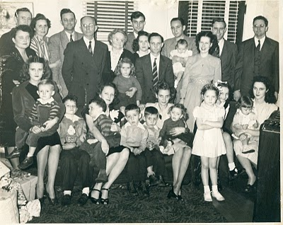Front row, left to right: Mary Daly holding her three year old brother, Robert W. Daly, Jr., Charles Halford Ferrell, next to his mother,Loudelle Holliman Ferrell who is holding John Melton Ferrell. Next are Euhal and Edna's twin boys, Jerry and Terry, and then Edna holding Jean Holliman. Standing tall is Pati (Hairston), Melton and Ida's daughter, and peeking behind her is Carolyn Ferrell (Tatum). Finally on the front row is Virginia Holliman Cornelius holding her first daughter, Nancy Carol Cornelius (Morton).

Back row, left to right. Vena Holliman Daly stands in front of her husband, Robert Daly, the parents of Mary and Bob. The Dalys married in 1928. Next Ida has her arm around Melton Holliman, her husband since 1932. The parents and grandparents of this large family are next - Ulyss and Pearl Caine Holliman, married in 1906, when Ulyss was 22 and Pearl 18. They are 62 and 58 years old respectively when this picture was taken.

Grandmother Holliman has her arm around Anne Holliman (Phillips), eldest daughter of Euhal and Edna. Euhal in the stripped tie stands next to his daughter, and just behind him is Motie, the wife of Ralph (tallest in back row). Their first daughter, Pamela, will be born in 1947.

Holding the four month old baby boy on the back row is my father, Bishop Holliman, and next to that baby (yours truly) and smiling broadly is my mother, Geraldine Stansbery Holliman.
Behind Gerry is Walter Cornelius, Virginia's husband, and at the far right, looking distinguished as always, is The Rev. Charles Ferrell, husband of Loudelle since 1935.

Twelve cousins are pictured in this December 1946 gathering. MaryDaly (Herrin) was the first born in 1931; the last born was my sister, Alice Holliman (Murphy) in 1956. Altogether, there would be 19 great grandchildren. Sadly, Grandmother Holliman who died in May 1955 did not live to hold all of them. She dearly loved her family.

Merry Christmas to all of us still living who were present that day and to the additional cousins, children, grand children and great grand children who have come after us! And a grateful and loving remembrance of those who were present in 1946 but who have left the family in this life. God Bless Us Everyone!!!

A Veterans' Day Salute
by Glenn N. Holliman
U.S. Army, Vietnam 1969
A Thank You to our Veterans

I suspect our family members have been represented in our country's battles from Colonial Chesapeake to the 21st Century Middle Eastern Wars. As it is impossible to list all of them in any kind of complete listing, I will let my nephew, Capt. Jonathan Murphy, USA, take the salute for all who been on active duty, the Reserves or National Guard. Jonathan is on duty somewhere in Afghanistan, his second tour in four years. His family waits for him in the States.

For a time he was Captain of the Guard at the Tomb of the Unknown Soldier in Washington, DC. Below are two photographs - one of Jonathan leading his platoon up the steps of the Memorial and the second of him walking the Guard. For those of us who have stood on guard in other fields and seas, including my father, uncles, nephews and cousins, we express our appreciation to him and all relatives who have gone before him.
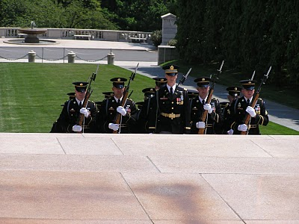
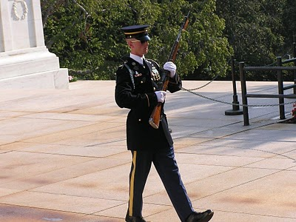
Among his ancestors are family members who served in the French and Indian War, Revolution, War of 1812, Civil War, World War II, Viet Nam, the Cold War and recent Middle East conflicts. One great grandfather, Luke Stansbery (1750 - 1848), was held as a prisoner of war of the British in Charleston, SC 1780 during the American Revolution.

