Holliman Family History
Photographs and articles regarding the ancestors and descendants of Christopher Holliman, Sr. (d 1691 Isle of Wight County, Virginia)
- Home
- The Contributers and the Sources
- Holliman Records, A History of Some Official Docum...
- Family Lineages

John Thomas Holliman House
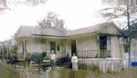

Popular Posts
- 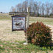
Our Family's Colonial Era, 1607 - 1775, Part II
In Search of Christopher Holliman Sr.'s 17th Century Virginia Plantation by Glenn N. Holliman This is the second post of an on-going ser...
- 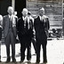
Welcome Family!
Important Notice: Since composing this article in February 2010, additional research has failed to identify John Holyman (1572 - 1650) of ...
Our Family's Colonial Era, Part VI
Tobacco, Slavery, Democracy and Our Family by Glenn N. Holliman If one analyzes the 17th Century Virginia economy carefully, it makes for ...

Blog Archive

Subscribe
Posts
All Comments

Labels
A. Eckford Holliman AlabamaAlice Holleman Alice HollimanAnn Boleyn Ann Holyman Anna Holyman Anne Holyman August Holliman Barb Holliman Bill Holliman Bishop Holliman Bishop John Holyman Blackwater RiverBob Hollyman-Mawson Bob Hollyman-MawsonJimmy Holliman Bryan Payne Bryan PayneChristopher Holliman Jr.Caroline Stonham Cecil Holliman Charles Daniel Lucas Charles HollimanCharles Lucas Sr. Christopher Holliman Christopher Holliman Jr.Christopher Holliman Sr.Christopher HolymanCorey Holleman Cornelius Holliman Cuddington David Jennings Dr. Sidney A. HollemanE.C. Herrin Edward HollymanEdward Holyman Elijah Holliman Elizabeth HolymanEva Ezekiel Holliman Faye Gardner Faye Gartner FayetteGeorge A. Holleman George Washington Carver Gladys Parker Glenda NorrisGlenda Norris Jeanette Stewart Glenn Holliman Grace Holyman Gwaltney HannaHelena Poynard Henry VIIIHerrin Hollyman Holyman Farm James Franklin Holliman James Grantson Holliman James Monroe Holliman Jane Hollyman Jayne Holyman Jean HollimanJeanette Stewart Jesse Holloman Jim Maule Jimmy Holliman Joe Parker Joey Holliman John Holliman John Holyman John Thomas Holliman John Thomas Hollyman Jonathan MurphyJoseph Bridger Jr. Judith Holman Judith HolymanKing Henry VIII Lenwood Holliman Leonard HolymanLuke Stansbery Lynn HollimanMargaret Holliman Martha Jane Holliman Martha Jane Walker Holliman Mary Daly HerrinMary Hasten Lucas Mary Holyman Mary Polly Lucas Holliman Maxine WrightMelissa Anthony Caine MurphyNancy Cattell Nathanel BaconNorman Holliman Oliver Cromwell Palestine HollimanPaul Bushe Peggy Cattell Peter Smith Polly Lucas Queen Catherine Raiford BrandonRalph Holliman Rhodes Holliman Richard HollymanRichard Holyman Robert Daly Robert Holliman Robert Hollman Ron Holliman Samuel Walker Scott Norris Shelia Brandon Silas Green HollimanSr. The Family of Ulyss and Pearl Caine Holliman 1946 Thomas CoxThomas Cranmer Thomas Cromwell Thomas HolemanThomas Holliman Thomas Hollyman Thomas HolmanThomas Holyman Thomas Holyman of Leigh Thomas Leland Holliman Thomas Pittman Tom Vaughan Tommie Holliman Allen Tring Ulysses Selma Holliman Uriah HollimanVena Holliman Vonceil Duckworth Wally Allen Walt Holliman Walt O. HollimanWarren Holliman Weedon family William Bailey HollimanWilliam Berkeley William E. Caine William HollimanWilliam HollymanWilliam Hollyman; Jonas Hollyman William Hollyman; Leonard Holyman William Holyman; Edward HolymanWilson Holleman WWII

FRIDAY, FEBRUARY 26, 2010

Mary Polly Lucas Part I

ACKNOWLEDGEMENTS
Family histories are put together with work and support from many people. My daughter, Grace, and I are pleased to collect writings, photos and memoirs of others and share them with a growing extended family. In this posting we present the writings of our cousin Dr. Rhodes Holliman, Dublin, Virginia, on Mary Polly Lucas Holliman, John Thomas Holliman and James Franklin Holliman.
Rhodes notes that he is building on the work of others; specifically from the research of his father, Cecil Rhodes Holliman and a distant cousin, Walter Orien Holliman. A great deal of what we know of the John Thomas Holliman siblings, and recent ancestors, comes from the work of these men.
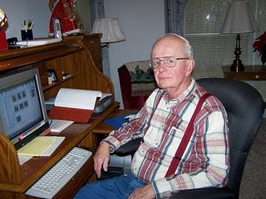
Rhodes Holliman
at home in Dublin, VA
Walter Orien Holliman, a meticulous family researcher, passed away in 2003. Walt's father was Moses Holliman, who was the son of Warren C. Holliman, who was the son of Charles Holliman, who was the son of James Grantson Holliman (1750-1836), a common grandfather to almost all reading this blog.
Another cousin with whom we have been in contact is Ron Hollimanof Dothan, Alabama. For several decades he has researched theHolliman tree and has amassed considerable information. He is a grandson of Greene Holliman, a son of John Thomas and Martha JaneHolliman. We look forward to his contributions in future blog posts.
Glenda Norris of Alabaster, Alabama, a great great granddaughter of John Thomas Holliman, is preparing an article on Samuel Taylor Walker. Walker is the father of Martha Jane Walker Holliman, her great great grandmother, and wife of John Thomas.
We look forward to continuing contact and compiling memorabilia from other members of the extended family.
Feature Story: Mary Polly Lucas Holliman
In 21 years of married life, Mary Polly and Uriah Holliman would produce 13 children – seven boys and six girls. Polly could hitch up a mule to a plow and till the soil as well as any man. While maintaining her farm, she became the only source of medical assistance in her community. Often she had to travel many miles by mule to help those in need.
A COMPASSIONATE HEROINE
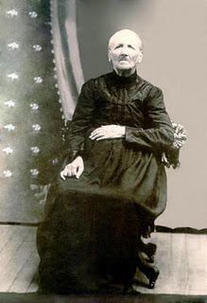Part I – The Story of Mary Polly LucasHolliman (pictured here in 1913)
By Dr. Rhodes Holliman, originally published in Southern Times Magazine of Tuscaloosa and West Alabama, issue no. 125.
The daughter of Charles Daniel Lucas and Mary Hastings (see Blog vol. 1) was born in South Carolina on January 2, 1819. She died at Vernon, Alabama on July 5, 1913. She married Uriah Holliman in Tuscaloosa County on August 29, 1836 and together they had 13 children, all delivered by herself. She is buried inSpringhill Baptist Cemetery, in Bluff, Alabama.
Very little has been published on the privations suffered by southern farm housewives who were widowed by their husband’s deaths in the Civil War. The following story is a documented history of one such woman, this writer’s great-great grandmother, who lived 94 years in poverty by our current standards, yet became the post-war heroine of her backwoods county in northwest Alabama.
Mary Polly Lucas Holliman of Marlboro County, South Carolina, as noted was the daughter of Charles Daniel Lucas, born in South Carolina on July 30, 1771. Charles Lucas died in Newtonville, Alabama on May 31, 1853. Her mother was Mary Hastings, born in South Carolina on September 10, 1786 and died in Fayette County, Alabama on January 21, 1867. Charles Daniel Lucas and Mary had 10 children.
Charles was reputed to be a large man (6’4” to 6’6”) and had great strength. May Polly loved to tell the story of how he killed a panther with his bare hands. He was also a man of hot temper and a disciplinary tyrant, but that is another story. He was a tailor by trade and after moving to Alabama, a Federal Indian Agent and stock dipper. Charles Daniel was buried in an Indian burial ground on top of a wood hill about seven miles south of Fayette, Alabama.
This writer can remember that graveyard from my childhood (1930s), but it was accessible only by a long hike with a guide over cultivated fields and forests, several miles from the nearest road. Charles Daniel and Mary came to the Newtonville, Alabama community in the 1830s, and purchased land patents from the government.
Mary Polly Lucas married Uriah Holliman in Tuscaloosa County on August 29, 1836. The marriage was performed by the Rev. John Walters, M.G. Uriah Holliman was born in Lancaster County, South Carolina on July 6, 1816 and died at Okolona, Mississippi on May 8, 1862 while in the service of the Confederate Army.
He was the son of Cornelius Holliman, born in Lancaster County, South Carolina on September 25, 1792. Cornelius married ElizabethPlyler in 1813. She was born in South Carolina in the late 1700s, and died in Fayette County in 1838. She is buried in as tack-rock grave at the Springhill Cemetery in northern Tuscaloosa County, near Moore’s Bridge, just off Route 171. They had five children. He is buried at Old Blooming Grove Cemetery in eastern Lamar County, Alabama. As a veteran of the War of 1812, a memorial stone has been placed in that cemetery to his memory.
Over a period of several years, Uriah obtained a total of 320 acres of government patent homestead land in northwest Fayette County and developed a large, productive farm. It would prove essential to feed his rapidly expanding brood. In 21 years of married life, Mary Polly and Uriah would produce 13 children. All reached adult life except the first, Mary, who lived four years. With medial assistance unavailable and the remoteness of their farm, Mary Polly delivered all of her own children, which gave her valuable experience for events to come.
As the clouds of the Civil war appeared, five of her family joined the Confederate Army: her husband, Uriah at age of 46, and sons, James Franklin, Charles Daniel, John Thomas and Elijah. Her daughter, Sarah Jane, married an Italian immigrant who volunteered as a Confederate soldier.
Only two of her military family would survive the war: her sons Lt. James Franklin Holliman, Company B, 58th Alabama Infantry Regiment, and Pvt. John Thomas Holliman, Company H, 41st Alabama Infantry Regiment. James Franklin is buried in theHolliman-Steward cemetery south of Bluff, Alabama and John Thomas, this writer’s great grandfather, is buried at Caine’s Ridge Cemetery just south of Fayette, Alabama.
End of Part I.
In our next post, Polly loses a husband and works desperately to survive the War and economic hard times.
The Grandfather and Father of Mary Polly Lucas Holliman
Source: Genealogy of the Dodson, Lucas, Pyles, Rochester and Allied Families
By: S. Emmett Lucas, Jr. Privately printed 1959, Birmingham, Alabama.
There seems to be no information concerning the Lucas family prior to these great grandfathers. Emmett Lucas speculates the family may have been Welsh in origin and from Pennsylvania.
Charles Lucas, Sr. b before 1755; d ca 1805-1810. Wife: Dorcas, b before 1755; d ca. 1805-1819. Lived in Marlboro Co., SC, known as a tailor.
Charles Daniel Lucas, son of Charles Lucas, Sr., b 6/30/1771; d 5/31/1853. Wife Mary Hastings, b 9/10/1786; d 1/21/1867.
Posted by Glenn N. Holliman at 6:00 AM 0 comments
Labels: Polly Lucas, Rhodes Holliman

FRIDAY, FEBRUARY 19, 2010

Blog Launch and Newsletter Vol 2
Last week the Holliman Family History Newsletter, Vol 1 was emailed to many family members in a Word document. While this method was well received, my daughter has talked me into posting family history on the Internet in a blog format. Many of you know I am not computer savvy, yet I have discovered there are quite few advantages to blogging:
- Pictures are easy to upload and view
- Previous information and photos are automatically archived for future reference
- You can visit this blog at your leisure and easily access it on the Internet
- Websites of interest and other blogs, such as the one Grace Hollimanwrites, can be easily linked to this site
Please bear with me as I discover the ins and outs of blogging. No doubt there will be a few glitches along the way. This blog is a work in progress. Your comments, questions, and any information you have on family history is most welcome here.
Glenn N. Holliman, Compiler
In this post we focus on the Daly and Herrin families:
Vena Holliman (1909-1990) was the first born daughter of Ulyss and Pearl Caine Holliman. In 1928, she married Robert Daly, an up and coming banker in Irondale and Woodlawn. They had two children, Mary Daly Herrin, Irondale and Dr. Robert Daly, Florence, AL.

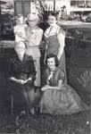
In this photo ca 1954 (clockwise from top):
Clayton Herrin, Pearl Caine Holliman, VenaHolliman Daly, Mary Daly Herrin, Lula HocuttCaine
In the unpublished memoirs of H. Bishop Holliman, a brother of Vena Daly, we found these observations. Bishop captures a time and place of a family in Alabama in the 1920s and 30s and the generosity of Robert and Vena.
Memories of Robert Daly and Vena Vivian Holliman Daly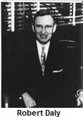
by Bishop Holliman (Written 1983).
Vena Vivian was born December 21, 1909. It was always common knowledge that she, my eldest sister, was exactly ten years older than I. My only memory of Vena being at home inIrondale, Alabama was of her dating RobertDaly. They were married June 12, 1928 at theIrondale Methodist Church. I was 8 years old, but I can recall the event clearly.
Vena attended Shades Cahaba, and since she was only 18 at marriage, she would not have done much work outside of the home. It is my recollection that she and Robert dated for three years. Many times on their dates they would have to tolerate Virginia, Ralph or me. Since Robert had been in the family as far back as we three could remember, we assumed he was there to see us as well as Vena!
‘Going riding’ was the thing to do in those days, so many, many times, one of us or all three, would be with them. I don’t know why they put up with us as they did. They would take us on picnics and fishing trips to the Cahaba River in the summer.
Their honeymoon was spent in Miami, Florida, and believe me, that was a long way from Irondale and not just in mileage. I still recall the excitement of getting post cards from them and having friends know that we had family who could go to Miami!
Robert had built the two brick houses on the hill next to our house, but I believe they lived with the Dalys out on the mountain (the east side of Irondale) the first years of their marriage. In 1929, they took a trip visiting Lake Lure in NC and Mammoth Cave in KY. They tookEuhal (a brother of Bishop, 1912-1989) with them.
At the time Robert drove a Packard roadster---with a rumble seat! In 1933, they went to the Chicago World’s Fair taking Loudelle(Loudelle Holliman Ferrell, 1914-1998) with them. Beginning in 1934, a third vacation became standard fare, and for the rest of his life, they always vacationed on the beach.
In 1934, Mary was 3 years old, they began going to Florida on vacations and for some reason they took Virginia and me along. Ralph was considered too young. Virginia was able to babysit with Mary so she was of some value to them. I was of no value, except to go along as a fishing buddy. Virginia and I went with them again in 1935 and 1936. Robert, I suppose, paid all our expenses. We were not old enough to question the source of our support for those trips...they would volunteer to let us go with them and we did - gladly!
In 1931, they were living in one of the brick houses next to us, because that is where they were when Mary was born June 15, 1931 (Mary Daly Herrin). Vena and Robert spoiled Virginia, Ralph and me. We made their home ours, and did not hesitate to impose upon them at any hour – day or night – and we expected to be treated royally by them, and we were. I do not know why they were so good to us, but they were.
Robert Daly had the greatest influence on our young lives, certainly Virginia, Ralph and me. He was born in August 5, 1901, lived about 3 miles from Irondale, had completed whatever schooling was available to him, and I think, had taken a business course. He then started working at the First National Bank in Birmingham, and by the time we were old enough to remember, he was manager of theWoodlawn Branch, the position he held until his death March 12, 1959 of heart disease.
Robert was more than a 'brother' to us. We dearly loved him, all the family did. Even before they were married, he would give us presents, loose change, etc. He was always generous, a very affable person and apparently had great natural ability to deal with people as he did. Even after I was in college I would not hesitate to call on him if I needed help, transportation, etc.
As I got older, nearly every night after being out - working, dating, whatever, I would come by their house and chat. As WWII came closer, we would get in heated discussions about world events. He would agitate me purposely to get me stirred up. Robert never got mad. He was always smiling and would help everyone, I guess, who came to him.
When I left to go into the Navy on November 13, 1941, Robert, along with Mama, Daddy, Virginia and Vena were at the station to see me off. All during the war, Robert would write cheerful, newsy letters to me, and I treasured them and looked forward to them. After the war of course life changed for all of us, and new concerns and priorities came to the front. Life was never the same again, but Robert's influence on our lives remained strong and had a lasting effect.
Bishop Holliman now lives in Avilla, Indiana with his wife, Ellen CoxHolliman.

Posted by Glenn N. Holliman at 8:10 AM 0 comments
Labels: Bishop Holliman, Herrin, Robert Daly, Vena Holliman

SATURDAY, FEBRUARY 13, 2010

Welcome Family!
Important Notice:

Since composing this article in February 2010, additional research has failed to identify John Holyman (1572 - 1650) of Tring as the father of Christopher Holyman, Sr., the believed first generation of Hollimans in America. My interpretation at this time is that Christopher Holyman, Sr. was born in Bedford, Bedfordshire, England in 1618. We have data that he arrived in Virginia in 1650 and died in 1691.(Written on January 7, 2011.)

This is the story of the Christopher Holyman families from Jamestown, Virginia to the present day. All family members, and those who have married into this family, are invited to join in the exploration.
Through this blog we plan to include interesting facts, family trees, lore, geographical information and first hand memories. This blog is a work in progress. Your comments, insights, corrections, articles, photographs, diaries and old letters are most welcome. In this format we plan to hand off our past, and present, to the future.
Glenn N. Holliman, Complier
Grace A. Hollilman, Editor
Family Lineage
What follows is a baseline genealogy of the Holliman paternal family tree through the life of John Thomas Holliman of Fayette County, Alabama and his sons. John Thomas is the father of six sons (photo below). Most of the persons receiving this email are descendents of two of the sons: James Monroe Holliman and Ulysses (usually spelled and pronounced Ulyss) Selman Holliman.
Jim Monroe Holliman, an attorney, and his wife Anna Elizabeth Baker, had two sons who grew to maturity: Cecil Rhodes and Charles Baker Holliman. Ulyss and his wife, Pearl Caine, had seven children: Melton, Vena Holliman Daly, Euhal, Loudelle Holliman Ferrell, Bishop, Virginia Holliman Cornelius and Ralph Holliman.
All the above, and most of you reading this, are descended from an immigrant from a Bedford, England with probable cousins in theTring, Hertfordshire, area northwest of central London.
Christopher Holliman (b 1618 Bedford, England – d 1691, Isle of Wight Co., Virginia)
Christopher Holliman, Jr. (b 1659, Jamestown, Virginia – d 1731, Isle of Wight Co., Virginia)
Since this publication, the next three grandfathers as our direct line is under review. Jesse Holliman does not appear to be in the James Grantson Holliman lineage.(January 7, 2011)
John Holliman (b 1684 - d 1751, Isle of Wight Co, Virginia)
Jesse Holliman (b 1711?, Isle of Wight Co., Virginia - d 1812, Johnston Co., North Carolina)
James Grantson Holliman (b 1750, Johnston Co., North Carolina – d 1836, Mecklenburg Co., North Carolina). Wife was Elizabeth Bryant.
Cornelius Holliman (b 1792, Anson Co., North Carolina - d 1862, Fayette Co., Alabama) First wife and mother of Uriah, Mary ElizabethPlyler (1793-1835).
Uriah Holliman ( b 1817, Lancaster, Co., South Carolina - d 1862,Okolona, Mississippi after the Battle of Corinth). Wife was Mary Polly Lucas (1819-1913).
John Thomas Holliman (b 1844, Fayette Co., Alabama – d 1930,Fayetteville, Alabama)
Of the marriage to Sarah Corbett, William Perry Holliman (1871-1941) was the surviving child. Of the marriage to Martha Jane Walker, five sons were born: Silas Green Holliman (1876-1943), James Monroe (1878-1938), Thomas Leland (1880-1970), Andrew Eckford (1882-1926) and Ulysses Selman Holliman (1884-1965).
Sons of John Thomas and Martha Jane Walker Holliman
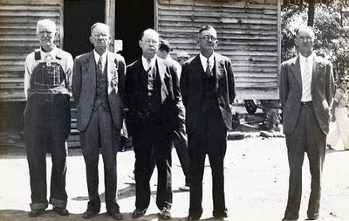

Left to right are: Bill, Green, James Monroe, Leland and Ulysses. The vacant spot is for Eckford who died in 1926.
The photo was taken at Fayette Co., Alabama May 1934 by Cecil Rhodes Holliman with an old bellows Kodak on 120 film. RhodesHolliman, his son remembers the photo and observes the following:
I remember the sense of necessity that pervaded the crowd to get this historic family photo. It was made at the annual Hollimanreunion and ‘eating on the grounds’. With Eck dead, everyone wanted to preserve the remaining family image. I used to play under this old church while services were in progress. I'm surprised that the building didn't collapse while full of people. The ferruginous rock pilings did not have any mortar! The building was literally balanced on these pilings! Uncle Bill’s son, Grady, played the guitar to accompany the singing. This is where I fell in love with the hymn, "Just a Little Talk with Jesus". I remember an over-weight lady whose name was Cousin Maggie Thornton. She came to the reunion in a wagon pulled by a team of mules. She had an old steamer trunk full of food: pies, fried chicken, potato salad, you name it. She was famous for her cooking. I think that she was a spinster. She was distantly related -- collateral family. I think that she is buried atCaine’s Ridge. Uncle Bill could walk to church; his old shack was across the road and a little south, back in the woods. I think that his house site still shows on the USGS Topo maps.
Bishop Holliman (b 1919), a son of Ulyss, was also present at this reunion, and remembers Maggie Thornton. Ulyss, Euhal and Bishop drove from Irondale (a suburb of Birmingham) to Fayette for the day, a major drive in 1934.
Mary Polly Lucas Holliman (1819-1913)
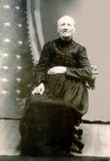
The Story of Her Father and Grandfather
Contributions from Glenda Norris, Rhodes Holliman and S. Emmett Lucas, Jr. Prepared by Glenn Holliman
Mary Polly Lucas, was the daughter of Charles Daniel Lucas (1778- 1853) and Mary Hastings (9/10/1786 - 1/21/1867), all originally from South Carolina. Polly Lucas became the wife of Uriah Hollimanon 8/29/1836 in Tuscaloosa, AL. Uriah and Polly had many children, one being John Thomas Holliman, the direct ancestor of most persons reading this information.
Charles Lucas Sr. (1755 - 1810?) was the grandfather of Polly Lucas. Charles was probably a tailor who lived in Marlboro County, SC, along the Pee Dee River near the North Carolina line. Glenda Norris reports that Charles was married to Dorcus (maiden name unknown) who is thought to have been an American Indian. One of their sons was Charles Daniel Lucas, Polly’s father.
Charles Daniel Lucas (1771-1853) stood six-foot-four and according to Polly, he once killed a panther with his bare hands. In 1819 Charles Daniel moved his family from South Carolina to the new state of Alabama (just as the Holliman family did in 1836).
Rhodes Holliman, a great great great grandson of Charles Daniel, reports that Charles had a fierce temper yet managed to serve as a deacon in the 1830s at the Springhill Baptist Church near Moore’s Bridge, Fayette County. Family lore states that Charles Daniel hit one of his sons causing his wife, Mary Hastings Lucas, to move herself and children from Newtonville to the Bluff Community northwest of Fayette.
Charles Daniel died in 1853 after having served as a Federal Indian agent. He is buried in an Indian burial site seven miles from Fayette toward Newtonville. In death, as in life, Charles Daniel Lucas was not completely at peace. In 1870 grave robbers attempted to disinter him but were scared off in the process.
Charles Daniel’s wife, Mary, is buried in an unmarked grave at theSpringhill Baptist Church Cemetery in Fayette Co., along with their daughter, Mary Polly Lucas Holliman, and John Thomas Holliman’s first wife, Sarah E. Corbett.
In the picture below Glenda Norris (Alabaster, AL) and her uncle, Dr. Rhodes Holliman (Dublin, VA), visit the gravesite of Charles Daniel Lucas in Fayette Co., AL near Newtonville in 2007

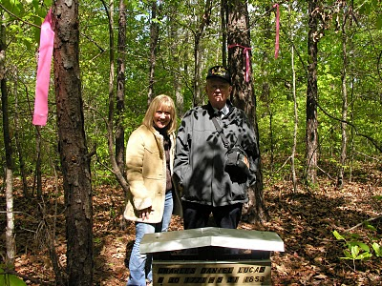

Glenda (b 1959), is the daughter of Cecile Eugenia HollimanYoungblood (b 1937), who is the daughter of Cecil Rhodes Holliman, (1902 – 1986), who is the son of James Monroe Holliman (1878 – 1938) who is the son of John Thomas Holliman (1844 – 1930) who is the son of Uriah and Mary Polly Lucas Holliman. Rhodes (b 1928) is the son of Cecil Holliman, the grandson of James Monroe Holliman, and great grandson of John Thomas Holliman.
Posted by Glenn N. Holliman at 1:39 PM 3 comments
Labels: A. Eckford Holliman, Charles Daniel Lucas, Charles Lucas Sr.,Glenda Norris, James Monroe Holliman, Polly Lucas, Rhodes Holliman,Silas Green Holliman, Thomas Leland Holliman, Ulysses Selma Holliman
Home

FRIDAY, MARCH 26, 2010

The Confederate Soldier Who Became a Teacher
In this post we focus on another of Mary Polly Holliman's sons, James Franklin, who survived the Civil War and returned home to become a school teacher. Unfortunately for Polly and her remaining children, her husband, Uriah, and two other sons, Charles Daniel and Elijah, died while serving in the Confederate Army. Imagine the heartache and worry of Polly both during and after the devastating war.
Our continued thanks to cousin Rhodes Holliman for his permission to share these amazing stories and photographs of our ancestors.
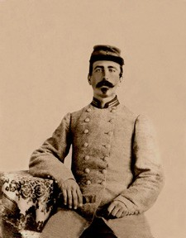
The photo is James Franklin Holliman in his Confederate uniform, ca. 1863.
A SOUTHERN FARM BOYAND A GALLANT LOVER
by Dr. Rhodes B. Holliman of Dublin, Virginia,
his great great nephew. First published in Southern Times, Magazine of Tuscaloosa and West Alabama, Issue 130.
James Franklin Holliman was the second of 13 children born to Uriah Holliman and Mary Polly Lucas Holliman. She delivered her entire brood by herself, 7 boys and 6 girls. James was born in Tuscaloosa County, Alabama, on January 28th, 1839, but Uriah soon moved the family north into Fayette County, AL, where he obtained Federal homestead land for farming.
When the clouds of War covered the South, a wave of patriotic enthusiasm swept over the family and the father, Uriah, now 46 years old, 4 of his 7 sons, and one son-in-law joined the Confederate Army. The War would exact a heavy toll on this family: of the 6 who enlisted, only 3 would survive.
James enlisted for a year as a private in the 9th Alabama Battalion, Company B, in Fayette, Alabama, in September, 1861. In the following spring, the 9th Battalion proceeded to Corinth, MS, and was engaged at Shiloh and Farmington. At Blackland, MS, the Battalion lost about 20 killed and wounded and disease took its toll at Shiloh, Corinth and Okolona, MS. Among those dying at Okolona was James’ father, Uriah (May 8, 1862), and a brother, Charles Daniel (May 12, 1862).
James reenlisted in the 9th Battalion in September, 1862, as a 1st Lieut., and was sent to Mobile, AL, remaining there until April, 1863. At that time, the Battalion proceeded to Tullahoma, TN, and was placed in Gen. Henry D. Clayton’s Brigade. This set the stage for the carnage that would follow in the area around Chattanooga, TN. The 9th was in several small engagements, especially at Hoover’s Gap. In July, 1863, at Tullahoma, 2 additional companies were attached and the 58th Alabama Infantry Regiment was formed. The 58th was in the thick of the fighting at the Battle of Chickamauga in September 19 - 20. On the 19th, the 58th captured 4 pieces of artillery, and on the 20th, in a suicidal charge, they broke the enemy line with the loss of 148 out of 254 men. A few weeks later in November, the 58th was consolidated with the 32nd Alabama and the field officers of the 58th were retained.
The consolidated Regiment had 400 present at Missionary Ridge on Nov. 25th, 1863, but lost 250 in casualties and prisoners. Lieut. James F. Holliman was captured on November 25th. He was shipped to a military prison in Louisville, KY, and thence to the infamous prison for Confederate officers at Johnson’s Island, Lake Erie, near Sandusky, Ohio. There he remained until he was paroled and took the Oath of Allegiance on June 13th, 1865. He was then described as being 26 years of age, dark completion, dark hair, gray eyes, 5 feet, 9 inches tall.
In our next weblog, we share the second half of James Franklin's life along with a beautiful love letter sent to his fiancée, Rebecca.
Posted by Glenn N. Holliman at 6:40 AM 0 comments
Labels: James Franklin Holliman, Polly Lucas, Rhodes Holliman

FRIDAY, MARCH 19, 2010

John Thomas Holliman, A Survivor and Casualty of the Civil War

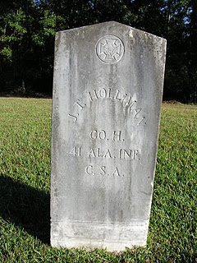
In the previous posting, John Thomas enlisted in the Confederate Army and engaged in a number of battles. As the fall of 1863 approaches, he has been in the Army for a year and a half and has had no leave or furlough. The Union Armies of Grant and Sherman have pushed deep into the South, and Lee has been repulsed at Gettysburg. The Southern cause has become desperate.
Photo courtesy of Glenda Norris, a great, great grand daughter. Grave is located at Caine's Ridge Baptist Cemetery, Fayette County, Alabama.
UNBEARABLE ENDURANCE, Part II
by Dr. Rhodes B. Holliman of Dublin, Virginia.
This article first appeared in Southern Times, Magazine of Tuscaloosa and West Alabama, issue No. 124.
John Thomas was now without shoes or winter clothing and the severe winter of 1863 - 1864 was closing in. The 41st Infantry Regiment marched from Tyner’s Station to Knoxville, a distance of over 100 miles.
The attack on the Union fortifications at Knoxville was a catastrophe forcing the 41st to retreat toward Bean’s Station over icy ground in freezing rain and snow. At this point John Thomas had no blanket, coat or shoes. He was leaving bloody tracks with every step. A battle at Bean’s Station on December 14th left the 41st with about 350 men and officers: about 1/3rd the original enlistment. Winter encampment was made at Morristown, TN, and the Regiment marched into Bristol, VA, in April of 1864. They soon marched north to Abingdon where they boarded a train on April 16th for Richmond.
Their next campaign began at Drewry’s Bluff on the James River south of Richmond: an effort to prevent Union gunboats from sailing up to the Confederate capitol. The victory at Drewry’s Bluff would become “the finest hour” for the 41st AL. On June 17th, the 41st moved into the trenches at Petersburg for the exhausting 9 month siege to follow. John Thomas would endure the unrelenting rifle and artillery fire until Feb. 1865.
No words can describe the carnage of events in the trenches at Petersburg. During this time he would see two of his cousins from Co.B seriously wounded and one killed. He participated in the effort to bury his cousin from the trenches of Gracie’s Brigade but was thwarted by Union sniper fire. He and 2 other cousins dragged the body at night to the Confederate burial ground in Old Blanford Cemetery near the spot of the Crater Explosion and finally accomplished their mission while dodging Union rifle fire.
On February. 15th, 1865, John Thomas was near death from starvation and exposure in a frozen wasteland. He still did not have shoes, a coat or blanket. He and two of his Company buddies, Sgt. Miles Bobo and Pvt. John Anders South, pooled their money ($17 Confederate) and bought a pone of cornbread being peddled by a free black woman in the trenches. They ate it, put up a white flag on a ramrod and walked over into the Union lines. The Federal Archives state that John Thomas was sent to Washington, D.C., given the oath of allegiance , and then sent to Holly Springs, Mississippi, to await discharge. This statement is correct for Bobo and South but John Thomas’ fate was totally different. This writer is in possession of a note written by a post-war confidant of John Thomas that reads:
“In Co. H - 41 Ala at Petersburg Va. On Feb 15 1865 about dark - went over to Union. John South, Miles Bobo. Carried Gard (sic) House that night - Asked by officers to disclose conditions and were carried from post to post disclosing conditions in Conf. (Gracies Army) Was in U S Army about 1 week. Was then sent to Washington and took Oath - was sent to Baltimore Md - then throug (sic)Pa to Indianapolis Ind & stayed in Inda (sic) about 6 mo - war closed.”

John Thomas was furloughed, really indentured, to a farmer in Indiana and he promised to stay and “make a crop”. Good to his word, he stayed until the fall of 1865. He had earned enough to purchase new shoes and, to limit the wear, he tied the shoelaces together, slung them over his shoulder and, to quote his exact words, “came on home.” He walked cross country, alone and barefoot, about 600 miles to his home in Fayette County in west Alabama!
John Thomas did not receive a single furlough during his 3 ½ years of service. He hated the War and frequently declared it was “a rich man’s war and a poor man’s fight.” He was held in contempt by some of his neighbors for the remainder of his life for his surrender.
His brother, Lt. James Franklin, after release from Johnson’s Island Prison in June, 1865, opened a one room school in the northwest part of the county and enrolled 8 grades of children and adults. John Thomas, at age 21, tried schooling for about a week but quickly withdrew. After his experiences of the previous 3 ½ years, school was not for him.
His first marriage in 1867 produced 3 children, only one of whom, a son, lived to maturity. His wife died in 1872 from “childbed fever” (septicemia) giving birth to their third child, a stillborn infant. He married again in 1875 and produced 5 sons. He was a profound victim of post war traumatic stress and his countenance and personality reflected this condition until his death on July 12th, 1930, from prostate cancer, at age 86.
He had been subjected to unspeakable visions of death and hardship. He was denied a veteran’s pension in his old age and died in poverty. He is buried next to his second wife in Caine’s Ridge Primitive Baptist Cemetery on State Route 159 just south of Fayette, AL. From his 6 sons, there are 6 branches of the Holliman family who have enjoyed life because their ancestor was prudent enough to recognize when death was imminent and the mission was doomed to failure.
The 41st AL went on to fight at Hatcher’s Run and the retreat to Appomattox where 98 of the original 1,284 stood ready to answer the final roll call.
In reading the campaign history of the 41st Alabama, one recognizes the futility of the endless marching and the confusion of battle plans created primarily by lack of communication between combat units. It will never cease to be amazing that logistics and tactics could coordinate and the endurance and sacrifice of the individual soldier was beyond comprehension.
Posted by Glenn N. Holliman at 11:02 AM 0 comments
Labels: John Thomas Holliman, Rhodes Holliman

FRIDAY, MARCH 12, 2010

John Thomas Holliman, A Survivor and Casualty of the Civil War

In this posting, Dr. Rhodes Holliman examines the Civil War life of one of the sons of Uriah and Mary Polly Lucas Holliman. Many of you reading this are descendants of John Thomas Holliman (1844-1930). Others will recognize John Thomas as a distant cousin, a great grandson of James Grantson Holliman (1750-1836).

Whatever your relation, this life of John Thomas captures the pathos and violence of war, and its difficult aftermath. Note the sad reality as John Thomas assembled with his regiment in Tuscaloosa only one week after his father and brother died following the Battle of Corinth, Mississippi.

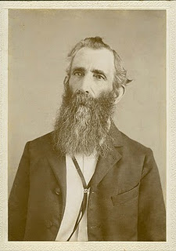UNBEARABLE ENDURANCE, Part I
by Dr. Rhodes B. Holliman of Dublin, Virginia.
This article first appeared inSouthern Times, Magazine of Tuscaloosa and West Alabama, issue No. 124.
(John Thomas Holliman, ca 1900)
John Thomas Holliman was born on April 23, 1844, in Fayette County, Alabama. He was the fifth child of 13 of Uriah Holliman and Mary Polly Lucas Holliman. In his family, two of his older brothers and his father joined the Confederate Army plus a younger brother and a brother-in-law. Of these volunteers, only two would survive the War: John Thomas and his oldest brother, Lt. James Franklin Holliman of the 58th Alabama Infantry. His was a poor, backwoods, farming family who never owned slaves but who stood ready to defend their homeland.
We will never know the motivation that drove John Thomas, his father and 3 brothers to join the Confederate Army. Peer pressure, community pressure, the excitement of travel away from the farm, a patriotic resolve to defend the homeland and their way of life, a distorted view of what combat would really be like and no idea of the privations that lay ahead could have influenced their decisions. John Thomas and his siblings had never been more than 25 miles away from home.
The fallacious idea that war would be fun and exciting and would be over in a few weeks pervaded the minds of so many volunteers of that time in both Union and Confederate armies. The Holliman boys were basically illiterate, and they had no background in the study of history and the horrors of war. As far as we know, James Franklin Holliman was the only member of this family group who could read or write.
At age 18, John Thomas joined Company H of the 41st Alabama Infantry Volunteers as a Private in April, 1862, in the town of Fayette. He would never be promoted. The 41st was made up of volunteers from Tuscaloosa, Greene, Fayette, Perry and Pickens counties, with Fayette County enlisting the most men in Companies B (88), H (132), and I (110). This was 26 % of the 1284 volunteers in the 41st from all counties.
The 41st was assembled in Tuscaloosa, AL, on May 16, 1862, to begin training. The sudden crowding of these men who were accustomed to living on isolated farms remote from individuals with contagious disease, and the subsequent exposure to polluted water, poor rations and unsanitary conditions of camp life, created an environment for an epidemic (measles, typhoid, pneumonia). There was no effort made to quarantine contagious individuals because the microbial source of infection was not discovered until the work of Pasteur and Koch in the late 1800s.
From May through July there were many deaths due to disease so that the first engagement at Chattanooga, TN, in August, 1862, found only 700 men fit for duty. John Thomas fought skirmishes along the Tennessee River in the fall and was hotly engaged in the carnage of Stones River (Murfreesboro, TN, campaign) in early January, 1863. Thereafter, the 41st was deployed along The Army of Tennessee Defense Line at Manchester, Allisona, Tullahoma and McMinnville with frequent skirmishes through the spring of 1863.
In an effort to reinforce troops in the Mississippi Campaign, on May 23 rd, the 41st was transferred by rail to Chattanooga, Atlanta, Montgomery and Mobile, Meridian and Jackson. Arriving too late to be of help at Vicksburg, the 41st was outstanding in the Second Battle for Jackson, MS. After a month long rest, the 41st retraced its steps to Chattanooga. John Thomas was yet to face the blood bath at Chickamauga on Sept. 20th and the following siege of Chattanooga.
The 41st left their positions on Missionary Ridge on November 19th and marched to Tyner’s Station to join Gen. Gracie’s brigade for the assault to retake Knoxville. Little did they anticipate that Union forces would overrun Missionary Ridge on November 25th whereupon John’s brother, Lt. James Franklin, was captured and imprisoned for the remainder of the War in the Confederate Officer prison camp on Johnson’s Island in Lake Erie near Sandusky,Ohio.
Part II of the war travail of John Thomas Holliman continues with the next posting.
Posted by Glenn N. Holliman at 8:10 AM 0 comments
Labels: John Thomas Holliman, Rhodes Holliman

SATURDAY, MARCH 6, 2010

Mary Polly Lucas Holliman Part II

Since our February 26, 2010 post we have heard from many members of our extended family. Much thanks to all for writing and passing along new information and photographs about Holliman family history. Your contributions are encouraged and welcome.
The photo below is of Norman S. Holliman of Tennessee taken by the gravesite of his great, great grandmother, Mary Polly Lucas Holliman in Bluff, Alabama. She is a grandmother of almost all reading this story.
A native of Rockdale, Texas, Norman is the son of the late August Harold Holliman, who is the son of Cornelius Elmer, who is the son of Cornelius Holliman, who is the eighth child of Uriah and Polly Lucas Holliman. A genealogy of Uriah and Mary Polly's offspring is listed at the end of this post and has been added to the Family Lineage Page (on the left on this blog).
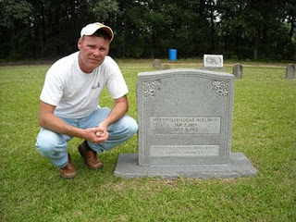Feature Story:
Part II –A Compassionate Heroine: The Story of Mary Polly Lucas Holliman
By Dr. Rhodes Holliman, originally published in Southern Times Magazine of Tuscaloosa and West Alabama, issue no. 125.
In May of 1862, Mary Polly in her home in Fayette Co., Alabama heard from some source, that her husband Uriah and son, Charles Daniel, were sick in Okolona, Mississippi, where a very congested camp had been established after the retreat from Corinth (Battle of Shiloh). They were trapped in an epidemic of measles and pneumonia that enveloped the camp. She hitched up the mule to a wagon and traveled the primitive dirt roads and trails to Okolona, a distance in excess of 70 miles to attempt to care for her sick husband and son. Uriah died on May 8, 1862, and Charles Daniel died on May 12, 1862.
She stayed long enough to bury her husband and son, and then drove the wagon back to the home place near Bluff, while suffering the ravages of measles contracted while acting as caregiver to her family. Their graves are among the many ‘unknowns’ in the Okolona Confederate Cemetery. She remained in desperate condition while convalescing at home. One can only imagine the tragedy what would have occurred if she had died, orphaning seven children at home between the ages of 14 and two. She survived this frightening ordeal to become one of the great, compassionate, pioneer ladies of northwestern Fayette County.
In 1865, when James Franklin and John Thomas returned from the war, Mary Polly had nine of her 13 children at home for a short time. James and John, at ages 26 and 21, would soon be married and moving out to start their own families. The remaining children: females aged 17, 11, nine and seven, and boys aged 16, 13 and fiver, were the ‘work force’ on which May Polly depended to handle all the many chores inherent in sustaining a successful farm. She could hitch up a mule to a plow and till the soil as well as any man. As her brood began to mature over the next 12 years, she saw two boys and two girls marry local sweethearts and move away to Texas, the new frontier for patent land. Another daughter would marry a Holliman cousin and move to Oklahoma, leaving only one daughter and one son to assist in maintaining the farm.
As children abandoned the old homestead for ‘greener pastures’, Mary Polly developed a vocational interest that would endear her to the population of northwest Fayette county and enhance the qualities of her character that are engraved on her grave stone: “Pioneer Strength – Integrity – Human Kindness!”
Professional medical services were virtually unknown in post-war Fayette County so, while maintaining her farm, she became the only source of medical assistance in her community as an herb doctor, caregiver and midwife to many of her neighbors. As her reputation of competency spread, her medical ‘practice’ spread geographically. She would accept appeals for help from all over the area, then saddle up a mule and ride out to provide services.
She charged $5 for midwife services, which included prenatal checkups, moving in to the expectant mother’s home and performing the delivery, staying for a week or more of postnatal care of mother and infant, plus cooking for the family, doing the washing and cleaning the house. If ever a grave stone spoke the truth to the memory of the one interred, it is her stone. One of he God’s great compassionate mothers is at rest in Springhill Baptist Cemetery in Bluff Community, Fayette County, Alabama.
Mary Polly finished her days at the home of her youngest son, Joshua Warren Holliman (1860-1944) in Vernon Alabama, Lamar County. This writer had the privilege of talking to Joshua in the 1930s and hunting on his farm as a boy. One of the last recollections that Joshua had of his mother comes from our family archives. She was ‘sitting in a rocking chair on the front porch of an old dog-trot house, smoking a corn cob pipe, dipping snuff and nipping from a quart of Four Roses whiskey that was sitting on the floor beside her chair!” What a unique way to remember a lady whose life-long work ethic brought comfort and support to so many.
There are many tales to tell about Mary Polly Lucas Holliman and her large family. There is a separate, exciting story about each one of them. There are very few cemeteries in Fayette County where you can’t find one or more Hollimans descended from Mary Polly. Her descendants spread out over Mississippi, Oklahoma, Texas and Alabama.
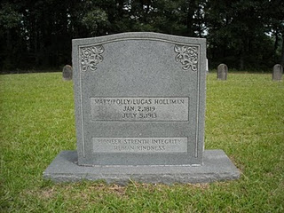

Tombstone of Mary Polly Lucas Holliman
(photo courtsey of Norman Holliman)
In our next post, Dr. Rhodes Holliman continues his story of the Holliman family with a two part biography of John Thomas Holliman (1844-1930).
The Children of Uriah Holliman and Mary Polly Lucas Holliman
compiled by Dr. Rhodes Holliman
1. Mary Elizabeth Holliman, born Sept. 12th, 1837, died Oct. 9th, 1841.
2. James Franklin Holliman, born Jan. 28th, 1839, died 13 May, 1911. 1st Lt., Co. B, 58th Alabama Infantry Regt., captured at Missionary Ridge, TN, on Nov. 25th, 1863. Spent the remainder of the War in Johnson's Island Prison Camp for Confederate Officers, in Erie, Ohio. He was released on June 13th, 1865. He returned to Fayette County to become a teacher and farmer. He married Rebecca Utley Stewart on July 2nd, 1865. They had 4 children (3 boys and a girl). Rebecca died and JFH married one of his former students, Bertha Lee Powell. The had 5 children (3 boys and 2 girls). JFH and both wives are buried at the Holliman-Stewart Cemetery, Bluff, AL.
3, Sarah Jane Holliman, born Oct. 3, 1840 in Fayette County, died Oct. 15, 1915, buried at Cottonwood Cemetery, 6 miles east of Eustace, Texas. She married Charles Stephen Coppell in Fayette County on July 13th, 1864.
4. Charles Daniel Holliman, born May 6th, 1842, died May 12, 1862 of diseases mentioned above while in the Confederate Army. Burial probably in the Confederate Cemetery, Okolona, MS.
5. John Thomas Holliman, born April 23, 1844, died July 12th 1930 in Fayette County. Burial at Caine’s Ridge Cemetery, 4 miles south of Fayette, AL, on Route 159. Was known as "Hico John" to distinguish him from 2 others of the same name in the county. Married (1) Sarah Corbett: one child, William Perry. She died in childbirth. Married (2) Martha Jane Walker: 5 sons. JTH was a Pvt. in Company H. 41st Alabama Infantry Regr., CSA. He surrendered at Petersburg, VA, on Feb. 15th, 1865, near starvation. He took the oath and was paroled to a farmer in Indianapolis, Indiana, where he worked until the fall of 1865 and then walked home to Fayette County, AL.
6. Elijah Holliman, born April 16th, 1846, died July 10th, 1864, from typhoid while serving in the Confederate Army. He was a Pvt. in Company I of the 56th Alabama Partisan Rangers. He died in a Confederate Hospital near Lagrange, GA and his buried in Confederate Cemetery under gravestone that reads E. Holman.
7. Nancy Palestine Holliman, born April 7th, 1848, died Dec. 12th, 1923. Married John Pinion: no issue. She is buried near her mother, Mary Polly, in Springhill Cemetery near Bluff, AL.
8. Cornelius Holliman, born Dec. 16th, 1849, in Fayette County. Married Sarah Elizabeth Smith at Fayette. Moved to Rockdale, Milam County, Texas. Buried Texas Eagle Cemetery. This is Norman S. Holliman's great grandfather.
9. William Perry Holliman, born March 29th, 1852, in Fayette County. Married Sarah Holliman, a distant cousin and daughter of Warren C. Holliman and Mary Blakeney of Newtonville, AL. Moved to Rockdale, Milam County, Texas. Resided near Cameron, Texas.
10. Martha Ann Holliman, born June 27th, 1854, married Rufus Buckner. Resided near Alvord, Texas.
11. Rebecca Drucilla Holliman, born March 4th, 1856. Married John Thomas Holliman, cousin, and son of Warren C. Holliman and Mary Blakeney of Newtonville, AL. Moved to Ardmore, OK. He was called "Black John" due to the color of his hair and to distinguish him from two other John Ts living Fayette County at the same time.
12. Emily Frances Holliman, born March 14th, 1858 in Fayette Co. Married (1) Abner McClung in Fayette County. Moved to Eustace, Texas, where she had relatives and there married Joe Reynolds.
13. Joshua Warren Holliman, born Aug. 26th, 1860, died Jan. 6th, 1944. Married Martha Goulsby, resided in Vernon, Lamar County, AL, until his death. Buried in Vernon. His mother, Mary Polly Lucas Holliman, died at his home in 1913.

Posted by Glenn N. Holliman at 8:00 AM 0 comments
Labels: Norman Holliman, Polly Lucas, Rhodes Holliman, Uriah Holliman
Home
Subscribe to: Posts (Atom)

WEDNESDAY, APRIL 28, 2010

Our Family's Colonial Era, Part IV
Mill Swamp and the Church
by Glenn N. Holliman
For the past three weeks, I have described a journey to our family roots in Isle of Wight County, Virginia. Just down the road from theHolleman House is a church that has become part of the family story.
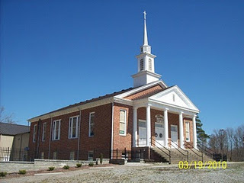The Mill Swamp Baptist Church, Isle of Wight Co., Virginia has been rebuilt many times in nearly 300 years of existence. The church and cemetery are adjacent to land owned by the Holleman's andGwaltney's. According to cousin Jeanette Holiman Stewart, from 1798 to 1801 Jesse Holleman, Sr. was joint minister of the church with John Gwaltney. Later Jesse Sr., a direct descendant of Christopher Holliman, Sr. pastored the church alone from 1819-1820 when he was 83 years of age.
The first Hollimans were Anglicans, members of the Church of England. Until the American Revolution, there was only one official church in Virginia, and that was the Anglican or as now styled, the Episcopal Church. Our Virginia ancestors did not come to the New World for religious freedom. They came to better themselves economically, and Christopher Holliman, Sr. succeeded.
There were few Episcopal parishes in colonial days. Only one or two in each shire (as the first Virginia counties were called), and many persons felt something missing spiritually in their lives. Into that religious void came the Baptist Church, which gradually spread out of New England into the Middle Atlantic and Southern colonies by the early 1700s. Presbyterians and Methodists soon followed.

Our cousins and contributors, Ron Holliman and Maxine Wright, have pointed out that one Holliman, Ezekiel of Rhode Island, was a founder of the American Baptist Church. Ezekiel Holliman, from the same part of England as Christopher Holliman, Sr., baptised Roger Williams, the founder of Rhode Island and the Baptist Church in America! More on this probable distant cousin in later posts.
One of the first Baptist churches established in southeast Virginia was located adjacent to Holliman and Gwaltney land. The Mill Swamp Baptist Church, founded 1719, was named after the marshy ground and a stream that ran nearby. This church's location proved perfect for baptisms and became the mother church of many others in the Virginia tidewater region.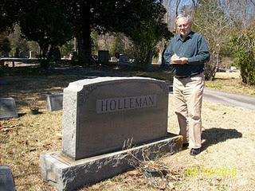In the adjacent cemetery are numerous graves of 19th and 20thcentury Hollemans plus Cofers, Gwaltneys and Atkinsons, all who intermarried in the Holliman family. Photo by Barbara Holliman of Glenn, 2010. A list of those buried in Mill Swamp Baptist Church Cemetery can be found at http://www.iwchs.com/

Yes, there truly is a Mill Swamp near the Blackwater River as noted on the 1684 patent for Christopher Holliman, Sr.
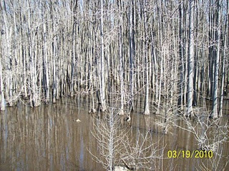
Next week we begin to examine the cash crop, tobacco, which was grown by theHollimanfamily in the Colonial Era.
Posted by Glenn N. Holliman at 5:01 PM 0 comments
Labels: Ezekiel Holliman, Gwaltney, Maxine Wright, Ron Holliman

FRIDAY, APRIL 23, 2010

Our Family's Colonial Era, 1607 - 1775, Part III
Confirming the Family Tree
by Glenn N. Holliman
For the past several weeks I have been writing about a trip I took with my wife, and granddaughter, to Isle of Wight County, Virginia. In the last blog we posted a photograph of the Holleman House which was constructed by a distant cousin, Wilson Holleman (1803-1873), a son of Josiah Holleman (1771-1848), who was a son of Jesse Holliman and a veteran of the American Revolution, who was a son of John Holliman, who was a son of Christopher Holliman, Jr., the son of Christopher Holliman, Sr., who patented the land in 1684. Christopher Sr. is my four-year-old granddaughter's 10th great grandfather.
Below is a photo of Wilson Holleman's headstone in the family cemetery located by the main house.
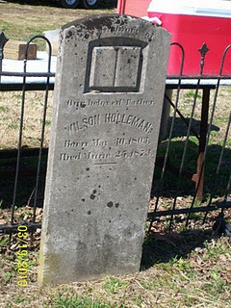
According to current information on our family tree, all in this family cemetery are relatives of Christopher Holliman, Sr., d 1691.
Pictured below is the view from Highway 621, Mill Swamp Road looking back toward the Holleman House on the left, and an older dependency building on the right. The soil is sandy and the ground is flat in the Virginia Tidewater region.
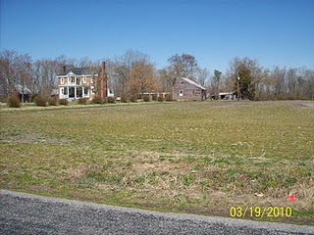Isle of Wight County is only 59 feet above sea level at its highest point. The fertility of the soil was maintained in the 19th century with marl, a local mineral, which helped reclaim the vitality of the soil that was leached by tobacco farming.
Perhaps, as with many early Virginians, the first Holliman generation tilled only a small portion of land for the cash crop tobacco, and utilized the rest for corn, vegetables, wood fuel and range for hogs, poultry and cattle.
The historian, Edmund S. Morgan, reports that in the 1600s and 1700s Virginia, one laborer could handle at most 3 acres of tobacco and three acres of corn. This was the monetary crop and food source for humans, horses and cattle alike. Of course, wild game, still in abundance in the early colonial days, supplemented diets.
As one author of Virginia history notes, “Tobacco chews through soil fertility with ferocity possessed of few other crops. In the absence of fertilizer, it can only be grown on virgin land for four seasons maximum.” Perhaps this first Christopher tilled his acres with the help of children for several years and then moved on to another piece of his land. Future Holliman families would do the same, and as their land was exhausted, they would move south and west into the Deep South, at least until the Civil War and Reconstruction.
Next week we examine the Mill Swamp Cemetery, adjacent to the 1684 plantation, that is the final resting place of 19th and 20th Century cousins.
Posted by Glenn N. Holliman at 3:05 PM 0 comments
Labels: Christopher Holliman Sr., John Holliman, Wilson Holleman

FRIDAY, APRIL 16, 2010

Our Family's Colonial Era, 1607 - 1775, Part II

In Search of Christopher Holliman Sr.'s 17th Century Virginia Plantation
by Glenn N. Holliman
This is the second post of an on-going series of our ancestors. Last March, my wife, Barb, and granddaughter, Holly and I crossed the Blackwater River, the border between Southampton and Isle of Wright Counties, Virginia in search of Christopher Holliman Sr.'s plantation. Our little adventure continues....
We passed picked cotton fields and peanut storage units. Our noses told us that a pig farm, probably the home of future Smithfield Hams, was nearby. After passing Sycamore Corner, we were on Mill Swamp Road. A mile later we saw a decrepit sign which read: Holleman House.
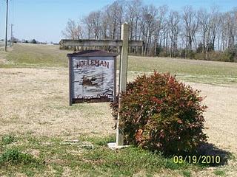Was this it, the remnant of Christopher Sr.'s 17th century plantation? Holliman has been spelled many ways - Holyman, Holleman or Holloman. No one was at home, so we took photographs and left a note. We noticed a family cemetery. The oldest visible stone is of Edward Adolphus Holleman, young son of Wilson and Ann Holleman, b 1810 - d 1819.
We did not expect to discover Christopher's grave. In the 17th, and most of the 18th century, there were no gravestones in the Tidewater area, as they were expensive items at the time. My guess is that his bones rest on this, or an adjacent, property.
Nor did we expect to discover a log cabin that housed the first Hollimans. No cabins from the 1600s survive in the Tidewater region. They burned easily and deteriorated rapidly without paint or protective coatings. It was after 1700 that the red brick plantation homes along the James River were constructed.
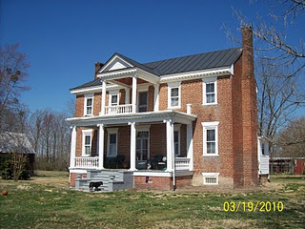Constructed in 1830, this is the Holleman House, located on Mill Swamp Road, Isle of Wight Country, Virginia. This historic Federal period house, with over-sized front doors and saw- tooth cornices, is located on the site of Christopher Holliman, Sr.'s 1,020 acre plantation.
To our amazement, when we visited the Isle of Wight County Museum later that day, we discovered an 1983 book by Helen Haverty King entitled Historic Isle of Wight. The 200 page volume pictures numerous antebellum homes in the county, one being the Holleman home!
The book is available at The Isle of Wight County Museum ($35). On the back cover is an illustrated map showing the location of the Holleman house and many others. 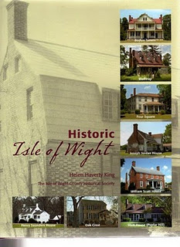
In this volume, one will find confirmation that in 1684 Christopher Holliman, Sr. completed his purchase of 1,020 acres in a corner of Isle of Wight County.
Bordering the family's property were the Atkinsons (whose sons married two of Christopher Sr's. daughters) and the Gwaltneys (who also married future Hollimans). The Gwaltneys became retail sellers of peanuts and hams, and were the founders of the famous Smithfield Ham company. They did well financially, and several of their 19th century mansions are open to visitors in downtown Smithfield today.
Next week, we will continue with our adventure to Colonial Virginia and further explore the history of the Holleman House.
Posted by Glenn N. Holliman at 7:00 AM 0 comments
Labels: Christopher Holliman Sr., Wilson Holleman

FRIDAY, APRIL 9, 2010

Our Family's Colonial Era, 1607 - 1775, Part I
The following five colonial history posts are put together from a number of sources including published historical works, internetsites, and from the research of our contributors Dr. RhodesHolliman, Maxine Wright, Glenda Norris, Ron Holliman, the late Walt Holliman and other family members who came before them.Those who have additional information or ideas for genealogy posts, please let us hear from you. Only by researching, critiquing, and listening to one other can our understanding of the past increase.
"From where did we come" is one of the oldest questions we humans ask. For Hollimans, our American experience began in Jamestown, Virginia where English America was founded by some adventurous colonialists from London in 1607. In this post we begin an on-going series about the first decades of our family in American.
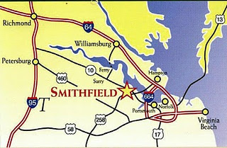By: Glenn N.Holliman
The map right identifiesSmithfield,Virginia, where ChristopherHolliman, Sr. settled by 1661. Jamestown is not marked but is just south of Williamsburg, where one can catch a ferry to Isle of Wight County on the south side of the James River.
By any measure, the life of Christopher Holliman, Sr. (ca. 1630 - 1691) was one of adventure and economic success. We know he sailed over on a ship that was sponsored by John Coxe of London. Christopher stepped onto American soil in Jamestown, Virginia on May 22, 165o. He was only 19 or 20 years of age when he began his adventure in the "new world."
Christopher Sr.'s first wife was named Anne, last name unknown, and of that union, six children grew to maturity. Those of us reading this are descended from their eldest, Christopher, Jr. (You can review the "lineage" page at the top of this blog to refresh your memory.)
There is no other record of Christopher Sr. until 1661, when a deed states that he purchased land near what is now Smithfield, Virginia, across from Jamestown on the south side of the James River. He farmed several hundred acres along Cypress Creek, a tributary of the Pagan, which itself runs into the James River. From this body of water, Christopher, Sr. easily loaded hogsheads of tobacco onto ships which would transport his cash crop to England. He purchased more land along Cypress Swamp in 1668.
He did well economically because in 1684, now in his 50s, he patented a large amount of land from the Royal Governor between the Mill Swamp and the Blackwater River. The Blackwater River is the western boarder of Isle of Wight County. The plantation, as he styled it in his will, was large - 1,020 acres, a large farm for the time and place. When he died in 1691, his will divided the land among his children and his second wife, Mary Gray Holliman.
Where is the exact location of the original site? The deeds, dependent upon landmarks now gone, except for the Swamp and BlackwaterRiver, are unclear. A family friend and professional geographer who also traces his family back to Isle of Wight County, Paul Fly, suggested I look along the border of Surry and Southampton Counties.
In March 2010 my wife, Barb, our oldest granddaughter, Holly, age 4 1/2, and I took a day trip from Richmond, Virginia down Highway 460 past Wakefield, Virginia to the hamlet of Ivor. There we turned east on Proctor Bridge Road, crossed the Blackwater River and made some interesting 'discoveries' that I will share with you next week!
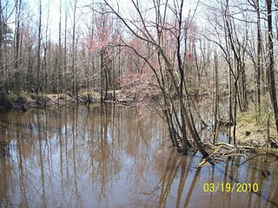
The BlackwaterRiver (pictured right) flows southward into North Carolina. It is deep and wide enough for boats to carry tobacco casts to ships bound for England. Tobacco was the cash crop of Virginia and was the mainstay of its colonial economy. In his 1691 will, Christopher Holliman Sr. records that he had tobacco barns, confirming tobacco too was his financial foundation.
Posted by Glenn N. Holliman at 6:50 AM 2 comments
Labels: Blackwater River, Christopher Holliman, Sr.

FRIDAY, APRIL 2, 2010

The Confederate Soldier Who Became a Teacher, Part II
This is the second part of Rhodes Holliman's story of James FranklinHolliman (photo below, ca. 1900). James Franklin returned from the Civil War and devoted himself to school teaching and educating a new generation. He also fathered nine children with two wives. Scattered throughout western and northern Alabama are many descendants of this dynamic ancestor!
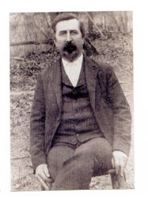
A SOUTHERN FARM BOY
AND A GALLANT LOVER
by Dr. Rhodes B. Holliman of Dublin, Virginia,
his great great nephew. First published in Southern Times, Magazine of Tuscaloosa and West Alabama, Issue 130.
He (James Franklin Holliman) returned to Bluff Community in Fayette County, AL, to resume farming and became the local school teacher. He had a large number of relatives on his class rolls including his brothers and sisters. He married Rebecca Utley Stewart, his wartime sweetheart, on July 2nd, 1865.
Her birth date remains in contention. Her ornate grave marker says: "Nov. 26, 1829". Other sources of family information say: "Oct. 6, 1839", but it is generally conceded that Rebecca was older than James - if her grave marker is correct, she was 10 years older. This disparity in their ages would be unusual for that era and place. men of that time usually married women who were younger.
A love letter written by him at some time during the War is reputed to be his proposal of marriage. It shows a remarkable expression of sensitivity considering that it was composed by a self-taught, back-woods, farm boy whose parents and siblings were mostly illiterate.
“Miss, for the first time I undertake the pleasant task of addressing you by letter with feelings that you can better imagine than I can describe; to attempt to describe the feelings that pervaded my bosom the last time I had the pleasure of your company would be useless. They would baffel (sic) all descriptions; neither could I at that time, owing to the intensity of my feelings, express them, but my pen obeys the impuls (sic) of my heart, and I can with pleasure in this way communicate (sic) my thoughts and the tender sentiments of my soul to her I love, to her I adore.
It affords me unaffected pleasure to hold correspondence with one so pure, so inicent (sic), so lovely, and you will reseive (sic) thes (sic) lines as a token of the love of one whos (sic) heart you posess (sic), one who from the first moment in which he beheld you has neverceast (sic) to love you with all the tenderness that the human heart is capable of feeling. I, who never can enjoy life except in your society; what would all the world be to me without you to share its pleasures, a caotic (sic) nothing.
Often does my imagination fly to where you are and hover around you and fancy that I see your beautiful form and the angel like beauty and simplicity that is continually beaming from your face. O (sic) when shall my fondest hopes of hapiness (sic) be realized ? When shall I press you to my heart, and call you mine, my one, my lovely. Then would I in the language of the poets, be content andblest whenever I hear the voice of her I love.
Love, that word is full of meaning to me. Could I express that devotion of heart and soul, that enables both lover and love, that undying impulse of attachment that rules my breast; that union of thought, feeling and existence, by which two persons are bound together, that lasts for life and never knows ending; but language fails, and I alone can fel (sic), and you can realize the extent of what cant (sic) be expressed lovely girl. These are of one who will ever remain your faithful lover.”
Rebecca (“Becca”) bore him 4 children: 3 boys and a girl. She died on November 2nd, 1883. An exhaustive search for a picture of her has yielded nothing.
He remained single until he was 57 years old (1896) whereupon he married a former student, Bertha Lee Powell, who was 18 years old! She bore him 5 children: 3 boys, 2 girls. He was 67 years old when his last child was born. He died on May 13,1911. Bertha Lee assumed the roll of head of household and reared her brood to be responsible and productive citizens.
In James' Last Will and Testament dated September 16, 1910, he bequeathed 40 acres of farm land to each of his children by Rebeccaand Bertha Lee and he appointed Bertha Lee as his executrix and guardian of his children. He bequeathed to her 20 acres of choice land all of his personal property.
His cause of death, as listed on the Alabama Death Certificate, was "softing of the brain." The duration of his terminal illness was listed as "8 months." The accuracy of medical diagnostics in rural Fayette County in 1911 was profoundly primitive!
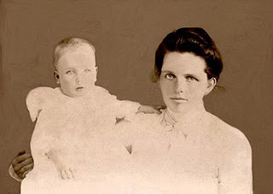The above photo is of Bertha Lee Powell Holliman and her third child, Janet, b 1903 and who passed away in 2002. Bertha Lee died March 21, 1948. Photos on this post courtesy of Dr. Holliman.
The last of Bertha's children to die was Janet, who, in 2002, had survived for 99 years and 10 months. He, both wives, and a number of his offspring and in-laws are buried in the Holliman-Stewart Cemetery just south of the Bluff Community in northern Fayette County, AL. The ruins of his old homestead have been recently discovered just south of the family cemetery and isolated from any current or historic road bed.
Posted by Glenn N. Holliman at 6:00 AM 0 comments
Labels: James Franklin Holliman, Rhodes Holliman
Home
Subscribe to: Posts (Atom)

FRIDAY, MAY 28, 2010

A Salute to our Family's World War II Veterans: Part III
Never, never, never believe any war will be smooth and easy, or that anyone who embarks on the strange voyage can measure the tides and hurricanes he will encounter. –Sir Winston Churchill
This week my father writes about his father’s experience in the Navy during WWII. ---Grace
Bishop Holliman and His War
(1941 Seaman's Photo Right)
by Glenn N. Holliman
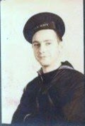
In July 1943, the German Army and Italy, its companion in the war, were reeling on both the Russian and Mediterranean fronts. The protracted battle of Stalingrad resulted in the Nazi's loss of an entire Army and many divisions of their reluctant allies. North Africa had fallen to Montgomery and Eisenhower's desert armies by May 1943.
Not yet strong enough to invade France, the British and American leaders next turned their expanding forces to the major island of Sicily, Italian soil. A victory in Sicily might knock Italy out of the war and force Germany to engage on a new front.
Into this maelstrom of war sailed a small destroyer, the USS Butler, approximately 1,600 tons in size. Working at his forward duty station, copying code from distant radio signals, was a young man from Irondale, Alabama - Bishop Holliman, age 23. After a year and half in the Navy, he was about to receive a baptism of fire.
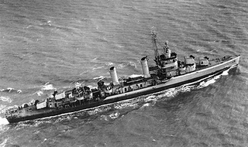
The USS Butler was at sea in 1943. Launched in 1942 in Philadelphia, its top speed was 34 knots. It came loaded with torpedoes, depth charges, four 5-inch guns and anti-aircraft batteries.
The Butler (DD636) was a fighting ship. After the invasion of Sicily, she escorted Royal Navy carriers before returning to New York, where Bishop Holliman was transferred to the USS Barker. In the Pacific in 1945, a Japanese kamikaze detonated a bomb under the Butler that killed nine crewmen. The ship survived, but was decommissioned in the fall of 1945 after only three years of service. But the taxpayers received more than enough value from this gallant lady.
Putting out from Algiers to convoy Allied troop ships to the invasion, the Captain spoke over ship's loudspeaker: "There will be no giving up or thoughts of abandoning ship. We will fight to the very last." Feeling fear and determination, the crew suffered horrible seasickness as the Butler plowed through atrocious weather while escorting American soldiers to battle.
And fight this tiny U.S. ship did, first through air raids as she approached Sicily that July 8th. The next day, the ship shelled German tanks and shore positions at the Gela beachhead, allowing General George Patton's 1st Infantry Division to advance inland with fewer casualties. A few days later, the Butler exchanged fire with German shore batteries at Palermo. The Luftwaffe once again attacked and damaged sister ships.
All the time, Bishop remained at his post relaying coded messages to the bridge. For the young man from Alabama, the continuing war became a blur of convoy duty and several crossings of the North Atlantic and into the Mediterranean. On June 6, 1944, Bishop was at his duty station on his destroyer, now the USS Barker, as she passed through the Straits of Gibraltar. There he intercepted BBC signals announcing the invasion of Normandy. He thought that now at last this long war might soon be over.
No doubt he was comforted by the letters he was receiving from a young southern girl, temporarily located in Pennsylvania, whom he had met while on liberty in 1942. A chance meeting at Atlantic City, New Jersey had led to correspondence, visits while in port, and finally, on June 26, 1945, a wedding in Philadelphia.
The war ended and Bishop and his new bride, Geraldine Stansbery, originally of Bristol, Tennessee, began married life together in Birmingham, Alabama. Three children, eight grandchildren and, to date, seven great- grandchildren have blessed their lives.
Next week we conclude our WWII/Memorial Day tributes with a D-Day article I wrote during a visit to Normandy, France on June 4, 2004. ---Grace
Posted by Glenn N. Holliman at 5:34 AM 0 comments
Labels: Bishop Holliman

FRIDAY, MAY 21, 2010

A Salute of our Family's World War II Veterans: Part 2
"If there must be trouble let it be in my day, that my child may have peace."
– Thomas Paine
Our second account is a personal one. My great uncle, RalphHolliman, was kind enough to take the time to write about his experience during the war. His description of life on a troop transport ship is an image I will not soon forget. - Grace
World War II: My Story
by Ralph Holliman
(photo: Ralph Holliman 1944)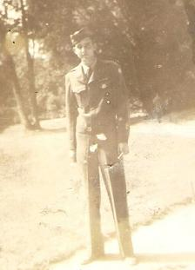
First of all, I want to say that I never shot at, nor was I shot at by anyone while in the service. I am not a hero. Having said that, I will try to give a short history of my two and a half years in the service to our country.
In late January, 1943, I visited the draft board to see where my name was listed and when I might be called up. They always kept a list posted in the window. Naturally, when I found my name , I learned that I would be the very next person to be called. So in March 1943, five months short of my 19th birthday, I found myself at Fort McClellan in Anniston, AL. (On the 21st of February, Motie Chism and I were married). After a few days at Fort McClellan, I was moved to Fort McPherson in Atlanta. After a couple of weeks of physical, mental and other examinations, I was on a train to an unknown destination. To my happy surprise, I realized we were heading south and to the Tides Hotel, Miami Beach, FL. I was assigned to the Air Corps (later called Air Force).
While at Miami, we had basic training: learning how to shoot a gun, calisthenics, getting up at dawn and learning to say, "Yes, Sir" and salute. After a couple of months there, I was sent to Denver, Colorado for further training. En route to Denver, our train stopped in Birmingham but I was not allowed to get off or call Motie or Mama and Daddy. Army rules. After Denver, I was sent to Sacramento, California with the idea that I would end up in the Pacific. As it turned out, I was put on a troop train and traveled across the country to Newark, New Jersey. (If you want a thrill, spend more than a week on a troop train with no air conditioner.)
After Newark, in October, I was on a troop ship headed for Europe. One thing that I learned quickly was to not volunteer for anything in the Army. I learned this when they asked for volunteers to stand watch on the ship’s gun turrets while crossing the Atlantic, four hours on and eight hours off. With no knowledge of what to do while on duty, it was fortunate that we did not encounter a submarine. On duty during the winter at three o’clock in the morning in the North Atlantic is not my idea of a cruise.
With several thousand soldiers on board, our living standards left a lot to be desired. Our sleeping quarters were stacked four or five high. When eating, we stood at a long table, and when the ship changed directions, our trays would slide down the table and would come back to us when the ship righted. The weather and seas were not smooth and a lot of men would get sick. The line to the latrine was always long. After a visit to the latrine, you would usually get back in line because you knew that by the time you could get in you probably would need it.
Twenty-one days later, we landed at the Firth of Clyde, Scotland. After that I was stationed in Bournemouth, England on the English Channel until D-Day. On D-Day I was stationed in Oxford and later was moved to Creil, France, about thirty-five miles north of Paris. At that time I was in the 326th Ferrying Squadron of the 9th Air Force. The 9th Air Force had the fighting planes (P47 and P51) and the 8th Air Force had the heavy bombers (B17 & B24).
While at Creil, (I was a Staff Sergeant by this time), the Germans decided to make a final thrust at the Battle of the Bulge. Due to the shortage of Army infantrymen to meet this thrust, they began calling men from the Air Force who were under the rank of S/Sgt. so I missed this action. The war finally ended and I was in Paris on V-E day. You can imagine what an experience that was.
In the summer of 1945 after V-E Day, I moved about from place to place - Germany, Belgium and ended up in Marseilles, France on my way to the Philippines through the Suez Canal. President Truman authorized dropping the atomic bomb on Japan and the war was over. I came home on the ship that was scheduled for the Pacific. In October, 1945, I landed at Newport News, Virginia and received a forty-five day furlough. While at home, I had enough points to be discharged.
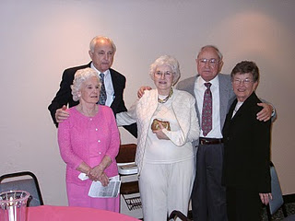In 2002, Ralph (back left), his wife, Motie - the girl he married at age 18 in 1943, his sister, Virginia Holliman Cornelius and his brother, Bishop Hollimanand wife, Ellen, gathered to celebrate Virginia's 80th birthday in Texas.
As I look back over that time of my life, I realize how fortunate I was to survive the experience without the suffering that so many of my fellow soldiers endured. It is my hope that someday the leaders of this world will find a better way to solve their differences than sacrificing the lives of so many people and that there will be peace in this world.
Next week, we tell the story of Ralph's brother, BishopHolliman, my grandfather who served in the U.S. Navy during World War II. - Grace
Posted by Glenn N. Holliman at 6:00 AM 0 comments
Labels: Ralph Holliman, WWII

FRIDAY, MAY 14, 2010

A Salute to Our Family's World War II Veterans, Part I
Duty is the most sublime word in our language. Do your duty in all things. You cannot do more. You should never wish to do less. ---Robert E. Lee
World War II, 1939-1945, was a time of horrible destruction, hatred and sadness. Young men, with the support of women, were asked to leave their homes to fight an aggressive enemy on foreign land. They went to Europe, Africa, and the Pacific, places they had only heard of, or read about, in school books. These soldiers witnessed the atrocities of modern warfare, yet, upon their return home, were able to build the foundation for the superpower nation we live in today.
In his book, Tom Brokaw aptly describes the men and women of the WW II era, "… it is, I believe, the greatest generation any society has ever produced."
Over the next four weeks we take time, and the Weblog space, to pay tribute to some of the WWII Veterans in our family, and to the veterans of every great generation.
- Grace Holliman
A Soldier's Duty
by Norman Holliman
My father, August Harold Holliman, was born in Burleson County, Texas, September 27, 1923 and passed away March 11, 1991, much too young. My mother was born November 2, 1928 in Maryville, Tennessee and survives him.
Dad enlisted in the Army on May 19, 1944 at Fort Sam Houston in Texas. He was sent to the front lines in France and Germany where he was in the Battle of the Bulge (December 1944-January 1945). He reported that, in some places, he had to walk in thigh-high snow in sub zero conditions.
One evening my father was on guard duty. When he finished his watch, he went to the campfire to get his replacement. The soldier who was to replace my father said, "The hell with them, let them come and get us.” Instead of going to the CO (commanding officer), my dad pulled his replacement’s shift in that unbearable snow and almost lost his feet to frostbite.
When I asked my dad why he didn't do something about the soldier’s reply he said, "I knew what he was going through. He was having a hard time dealing with the circumstances.” My father was humble like that; of course he was a Holliman!
When my father got to the hospital in England, his feet where black with frostbite. The good nurses rubbed his feet nonstop with alcohol, relieving each other periodically. My dad made it home and was medically discharged from the Army on August 2, 1945 with a Purple Heart and the European – African – Middle Eastern Campaign Medal. My father was a rifleman in his service to his country.
Later in his life, my dad was the Post Commander at the local VFW inRockdale, TX. I hope any child who has a father who is, or was, a veteran of any war can admire him as much as I admire my father!
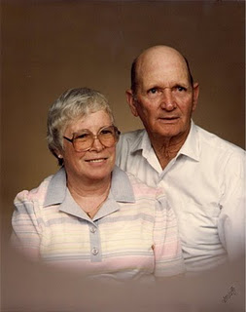
Right, a photo of August Harold Holliman and wife, Betty. They married June 25, 1957.
Next week, we highlight the war service of a distant cousin of Norman's, William RalphHolliman. Norman and Ralph, who is the youngest son of Ulyssand Pearl CaineHolliman, share a great grandfather, John GrantsonHolliman (1850-1836), who fought North Carolina Tories and the British Army in 1780 during the American Revolution. Additional information on Norman and Ralph can be found in our Contributor's page.
Posted by Glenn N. Holliman at 5:30 AM 0 comments
Labels: August Holliman, Norman Holliman, WWII

FRIDAY, MAY 7, 2010

Our Family's Colonial Era, Part V
Tobacco and Our Family
by Glenn N. Holliman
As noted, our great grandfather Christopher Holliman Sr. acquired much land in Virginia. By the time of his death in 1691, he left 1,020 acres, along the Blackwater River and Mill Swamp (purchase completed 1684), to his four sons.
Christopher Sr. was also well respected in the community. The Thomas Pittman family tree website reports that in 1671 Christopher Sr. was witnessing deeds, and in 1676, joined other leaders in the Isle of Wight community who signed a petition concerning Nathaniel Bacon's ill-fated rebellion against the Royal Government.
There is some information that Sr. may have been in the shipping business, probably with some brothers and later with his son,Richard Holliman. In 1702 Richard Holliman transported enough persons to Virginia to claim over 1,000 acres of land through the Virginia headright system. If one imported, or paid for the importation of an immigrant, the transporter received 50 acres in land per person.
The shipping sketch portrays one of
the fragile sailing ships of the time. Note the
barrels of tobacco being loaded for England.
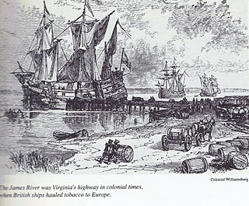
Most assuredly the Holliman family grew tobacco (Christopher Sr.’s will mentions tobacco barns). They probably hauled hogsheads to the river where it was then shipped to England. Tobacco as a commercial crop was first developed by John Rolfe, Pocahontas’s husband, in 1610s.
Thus began an ecological and social alliance with tobacco and slavery; two items that would shape the future of our family and country.
Next week, we will take a break from the 17th century and visit the 20th century through some Holliman World War II veterans. My daughter, Grace, has edited several articles sent in by relatives honoring all Hollimans for their service. In June we will continue our tour of Colonial Virginia and look further back to our Holliman English roots.
Posted by Glenn N. Holliman at 5:33 AM 0 comments
Labels: Christopher Holliman Sr., Thomas Holliman
Home
Subscribe to: Posts (Atom)

MONDAY, JUNE 28, 2010

When We Were English, Part IV
The Turbulent Life of The Rt. Rev. John Holyman, First Installment
by Glenn N. Holliman
The small village of Cuddington, Buckinghamshire, England is approximately 12 miles from Tring, Hertfordshire, the believed homesite of John Holyman (1572 - 1650). Another John Holyman, The Rt. Rev. John Holyman, lived earlier during the eventful times of the Tudor kings and queens. This earlier John played a role in attempting to forestall the Protestant Reformation in England. While we do not know his lineage, time, place and name suggest we American Hollimans carry some of his DNA. A ancestral cousin or uncle? I would say the odds favor such, and perhaps some day we can connect all the dots.
It was while researching Holymans in the Tring Library, I came upon the incredible news that a Holyman farm existed in nearby Cuddington, and that Bishop John Holyman had been born there. Cousin Maxine Wright of Arkansas had emailed a blurb on this John Holyman several months earlier alerting me to the existence of this particular Holliman. Within the hour, my wife and I drove to the village and indeed visited the Holyman farm, met the present owner, and the next day interviewed one of the village historians, Miss Peggy Cattell. We spent several hours with Miss Cattell and her sister, Nancy, collecting information and papers.
What follows is the first portion of a paper presented in 2005 to the local historical by Miss Peggy Cattell (photo below right) which we reproduce with her permission.
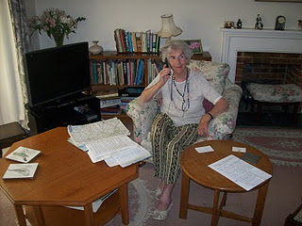
"They Lived In Cuddington"
" It was in 1495 that John Holyman was born. Records don't give any further information about his life in Cuddington, other than that he was born here but the family home was probably a manor house in the field near to the present Holyman's Farmhouse."
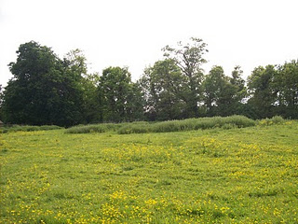On the site of this grassy knole on the west side of Cuddington stood the manor house of the Holyman family in the 15, 16 and 17th centuries. Today this field stands fallow on still existing farm land.
"Another and more accurate assumption can be made that he must have been baptised in Cuddington Church, in the font which we still use. The font goes back well before his day. We know that the font was moved into its present position in the south aisle from the north aisle in the later part of the nineteenth century."
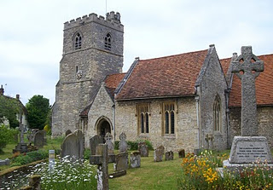
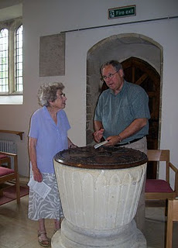
The photo above right is the exterior of the Cuddington parish. The above left photo is of the baptismal font which is over 500 years old. Miss Nancy Cattell is on the left, and the author on the right taking notes. Photos by Barbara Holliman.
"We can say for certain that his parents brought him through the present north doorway, and from the list of vicars we can assume that the incumbent of that time - William Burtone, priest from 1494 to 1511 - must have performed the baptism."
In the next post, we continue our study of the turbulent life of Bishop John Holyman....
Posted by Glenn N. Holliman at 10:26 AM 0 comments
Labels: Bishop John Holyman, Maxine Wright

FRIDAY, JUNE 25, 2010

When We Were English, Part III
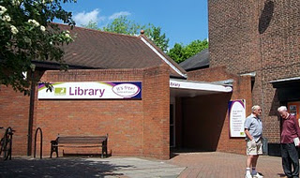A Holyman in the Late Middle Ages
by Glenn N. Holliman
In the local history section of the Tring, Hertfordshire library (photo to the left with patrons in front) there is a book entitledA History of Tring by Sheila Richards, a denizen of the area. Published in 1974 by the Tring Urban Council in Hertfordshire, it contains many stories, family names and records. While recently pursuing this work I found on page 53 the following information that was translated from middle English.
From the Court Rolls of the Manor of Tring - Courts 28 May, 18 June and 9 July 1444 (yes, 1444, not 1944!)
"Plaint Continued: the plaint between William Holyman, defendant, and Richard Brame of Chedyngdon, plaintiff, in a pleas of trespass, is continued by order."
Observations?
1. Holymans had surnames by the 1400s as did most English by this century.
2. Holymans lived in Tring two centuries before American founder, Christopher Holliman, sailed for Virginia in 1650.
3. This complaint of trespass may have involved a stray animal or William planting a crop on Brame's leasehold. Everyone leased from the Lord of the Manor or shared the common fields surrounding Tring. This lack of personal land is what attracted many of our ancestors to America.
4. As the complaint was continued to another day, perhaps it was settled out of court (just as most legal complaints are today).
There is another mention of William on page 54. He is listed as a juror to decide a leasehold inheritance on shared common town lands known as Goldfield and Bulbourne crofts surrounding Tring.
Observations on this entry?
1. Whatever William's issue in the trespass complaint, it did not keep the judge from appointing him to a jury that summer.
2. Although English common law was in its infancy, the jury system was working, wills were common and so were lawsuits in England by the 1400s.
3. To be appointed to a jury is a compliment indicating some standing in the community. Hats off to our William Holyman. I hope he is one of our great grandfathers. At least he lives in the community which we believe saw the birth to Christopher Holliman, Sr.
Unfortunately, I have found no further records on this William YET. Nothing else in this book on him. Thomas Cromwell, Henry VIII's chancellor, in 1538 required all churches to keep parish records on baptisms, marriages and deaths. Too late for this 15th century William. So where to look? Manorial Court records? Yes. And where are they? Alas, at the Public Record Office in Kew, near London. Did this William have a will? Here is an English government web site to explore: http://www.nationalarchives.gov.uk/.
The Middle Ages were Ending
What was happening in our England of 1444 when this possible Holyman ancestor was having legal troubles?
A weak king, Henry VI (photo below) occupied the throne from the first year of his life 1422 until deposed in 1461. He would have made an excellent monk, but was a poor king. He is the only English sovereign to have been crowned in both England and France. His mind was unbalanced and when a protector stepped in to serve the crown, a civil war broke out. The Houses of Lancaster and York began fighting the War of the Roses.
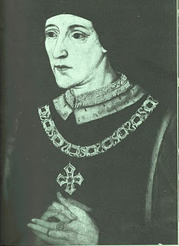
France and England were near the end of their Hundred Years War. Henry's father, Henry V, had conquered a considerable portion of France during his short reign. However, the French reclaimed almost all of their land during Henry VI's time on the throne.
This was the period when the charismatic Joan of Arc (her photo below) revitalized the French army. The English nobles, not at all pleased by such a turn of events, burned her at the stake as a witch. Remember, this was the Middle Ages, and burnings would continue even in the English colony of New York until the 1700s. Nasty way to shuffle off one's mortal coil.
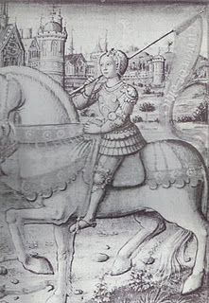
Next post, more adventures with our Holyman ancestors....
Posted by Glenn N. Holliman at 3:33 PM 0 comments

MONDAY, JUNE 21, 2010

When We Were English, Part II
by Glenn N. Holliman
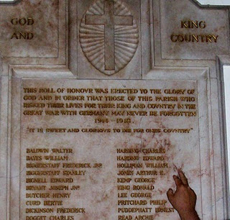With the exception of the historical painting of Elizabeth I below, the other photos in this blog are of memorials to Hollimans and others in St. Paul's parish, Chipperfield, Hertfordshire, approximately 25 miles northwest of Central London.
August 31, 1997, my wife, Barb, and I assembled for the baptism for our godson, Joseph Jeffries, at St. Paul's Anglican parish inChipperfield, Hertfordshire, England. What should have been a day of joy, instead was a sad morning. Princess Dianna, formerly Princess of Wales, and her boyfriend, Dody Fahad, had died in the early hours in a Paris car crash.
The priest, a lady of whose gender there were only a few at that time in all the England Church, prayed for the repose of the departed souls as she attempted to turn the congregation’s attention to the welcoming of Joseph into the Christian family. Ironically, Diana’s car had smashed itself to a compressed block of metal, plastic and human flesh in a tunnel just a block from where Barb worked the year before at the capital campaign for the American Cathedral in France.
With these conflicting thoughts tumbling through our heads, we ventured to gaze around the lovely neo-gothic nave. Good grief! The walls were covered with war memorial plaques in memory of Hollimans and other villagers! Had we stumbled on to the ancestral home of the Holliman clan? Much evidence indicates that yes, the English Hollimans (or Holleman, Hollyman, Hollomon, etc.) did establish themselves or at least some of the family in Hertfordshire, England around the villages of Chipperfield and Tring, located 30 or so miles northwest of London proper. Other villages with Hollymans were Berkhamsted, Aldbury, Cholesbury and Cuddington.
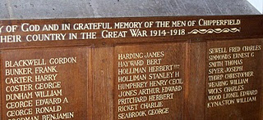
Most of our American genealogical trees begin with one John Holyman, born 1572 in Tring, Hertfordshire. This was during the reign (and rule) of that magnificent Tudor queen, Elizabeth I. Anglicanism had replaced the Roman Catholic faith in the land, helped along by several burnings at stakes of recalcitrant Catholics and not a few Spanish Jesuits who sought to return England to the Old Faith. The friction between Spain and England, exacerbated by privateers Drake and Raleigh, eventually led to the sailing of the Spanish Armada of 1588.
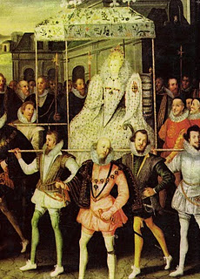This is Robert Peale's painting of Queen Elizabeth being carried by her devoted courtiers.
Elizabeth called out the able bodied men of England to repel the invader if the embryonic English fleet was not able to do so. One wonders if John Holyman and our kinsmen did not muster on a village green with pike in hand?
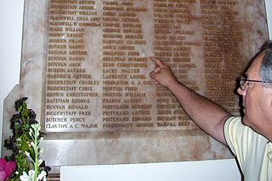
It is obvious from these memorials that in the last two World Wars, numerous Holliman kinsmen mustered with their English regiments, and sadly all did not return.
More on the English Holliman's in the next posting!
Posted by Glenn N. Holliman at 8:00 AM 0 comments

THURSDAY, JUNE 17, 2010

Yes, Christopher Holliman Still Lives In Virginia!
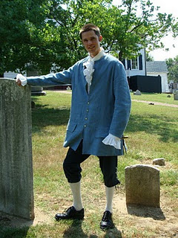by Christopher S. Holliman
At right is Christopher Holliman (b 1978), a 9th great grandson of Christopher Holliman, Sr. (d 1691) dressed in his Colonial reenactment costume at St. John's Episcopal Church, Richmond, Virginia. Chris gives tours to visitors at this historic site on Saturdays and Sundays during the summer months.
St. John's Church is a National Historic Landmark in recognition of it being the site where Patrick Henry gave his famous "Liberty or Death" speech. With such men as George Washington and Thomas Jefferson in the audience, St. John's Church was, for a few days in March 1775, the center of the American Revolution. Visitors come to reconnect with this historical moment, and I'm lucky to be one of the people that they may meet while they are here.
A typical day here includes giving tours to school groups, walking tourists around the cemetery and church, and generally interpreting history for them. My favorite part of the job is meeting people that come from all over the world and care deeply about history.
On Sunday afternoons in the summer we provide a reenactment of Patrick Henry's speech at the church. Costumed actors perform the various roles of the famous patriots. We pack the church for each performance, and the energy in the room is absolutely electric. It's like watching history come to life.
So, if you are traveling in Virginia this vacation season, stop by Richmond and meet both Patrick Henry and me, Christopher Holliman, a relative of those who read this Weblog. For information on and directions to this Colonial history site, visithttp://www.historicstjohnschurch.org/. Hope to see you soon! "
When not providing historical interpretations, Chris is a librarian with the Henrico County Library system. His three-year-old daughter, Camille, is a 10th, possibly 11th generation American (if we count John Holyman, d 1650 as the first generation). Yes, Chris is the brother of Grace Holliman, and son of Glenn Holliman, who prepare this blog.
Posted by Glenn N. Holliman at 3:49 PM 0 comments
Labels: Christopher Holliman

WEDNESDAY, JUNE 16, 2010

When We Were English, Part I
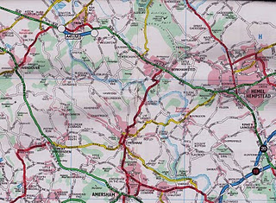
Some First Thoughts on Our English Roots
by Glenn N. Holliman
This map is somewhat dated, but in the upper left hand corner is Tring, Hertforshire, England. Just to the east of it is the little village of Aldbury and south is Cholesbury. To the west of Hemel Hempstead is Berkhamsted. Toward the lower right hand corner is the tiny village of Chipperfield. In left center is Wendover, and to the west, but not on this map, is Cuddington. London is off the map to the southeast. There is evidence that Holymans and Hollimans lived in these villages and towns.
I have had the pleasure of traveling to England numerous times in my life. As I have become older, my interest in family history has grown. Recently, my wife and I invested a number of days researching Holliman history in an area approximately 25 to 30 miles from the center of London. These towns and villages were Tring, Aldbury, Cholesbury, Cuddington, Chipperfield and Berkhamstead in both Hertfordshire and Buckinghamshire.
In graduate school, (gasp 40 years ago!) I studied history and know that primary evidence is crucial to any research. There is a popular and evidently well-researched Holliman family tree website that lists John Holyman (1572 - 1650) as the direct line of our family, born in Tring, Hertfordshire and died in Southampton, Virginia. Unfortunately, no one has yet shared with me the hard evidence of this birth and death date or the fact that the gentleman ever existed. This does not mean that facts do not exist somewhere; it is just that I have not seen such or discovered it in my research.
Let me quickly say that hard primary evidence exists for our first American Holliman, one Christopher Holliman, Sr, who died in Isle of Wight County, Virginia in 1691. We have his will and many legal records. Unfortunately his birth place and date are still a matter of conjecture.
You might want to review the map above because in our next post we will explore our English roots. Internet sites suggest this is not the only part of England where Hollimans may have lived in the 17th century, but I'll begin our journey in the Chiltern Hills around Tring. More on this subject soon.
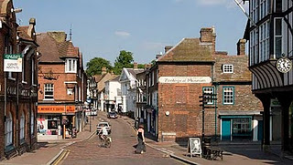High Street in downtown Tring, Hertfordshire, a town over 1,000 years old.
Posted by Glenn N. Holliman at 7:00 AM 0 comments

THURSDAY, JUNE 10, 2010

Our Family's Colonial Era, Part VI
Tobacco, Slavery, Democracy and Our Family
by Glenn N. Holliman
If one analyzes the 17th Century Virginia economy carefully, it makes for disturbing reading. The Christopher Hollimans and, of course, the rest of the colony grew a crop (tobacco) that if used normally shortens the lives of most people.
Even King James I wrote during his reign (1603- 1625) a book , called "A Counter Blast to Tobacco" castigating the use of the Indian weed. He was the first but not the last political leader to urge persons to quit the habit. (This same king gave us the King James Version of the Bible which our ancestors read and cherished.)
Of course, until 1776, the Crown's tobacco tax fattened the coffers of the English throne just as cigarette taxes swell the treasuries of the U.S. and the states today.
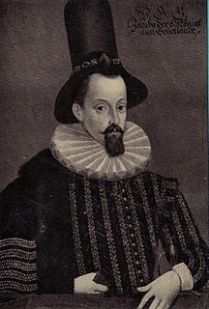
King James I of England models the latest in London hat wear fashion in the early 1600s
Generally, before 1700, this crop was often hoed and harvested by indentured servants from England. However, by the early 1700s, more and more newly imported African laborers tended the weed. These new Americans of a darker skin hue, soon found themselves in ever more secure legal chains on land taken by the English-Americans, usually forcefully, from Native Americans. The Virginia House of Burgesses, composed mainly of wealthier planters, passed laws as early as 1660 declaring that both captured Native American and African-Americans as 'property' who could be held in bondage and sold as human chattel.
Did these first Holliman generations hold slaves, even though holding human chattel was still an ill-formed institution in the late 1600's Virginia? The 1691 will of Christopher Sr. mentions nothing of human property, but one of his grandson’s, Thomas Holliman, does record in his will of 1762 the leaving of five slaves to his various sons. One slave, named Peter, was to be sold and the income produced to be divided amongst some family members. Other relatives began to note slaves, although not more than a few African Americans, in their wills by the early and middle 1700s.
The Christopher Hollimans and their descendants seemed to have been ‘average southerners’, yeoman, land-owning farmers if you will. In 1860 only one out of every four southern heads of households owned slaves. Most of our Alabama Hollimans listed no slaves in census reports of 1860, although kinfolk by marriage did so. Historians report that average number of slaves owned by a southern head of household was four, or roughly that of a family. The gigantic slave plantations of Gone With the Wind are largely fiction, although some such 'human factories' did exist.
Perhaps as with many early Virginians, the first Holliman generation tilled only a small portion of land for tobacco, the cash crop, utilizing the rest for corn, vegetables, wood fuel and range for hogs, poultry and cattle. There were six children who grew to adult hood to assist with the work in this 17th century generation.
For the record, let us note three events in the year 1619 that influenced American history and our family. One, the House of Burgess, a parliament if you will, met for the first time in Jamestown - the first example of representative democracy. Two, that same year a Portuguese transport sold Africans in Virginia who were held as slaves. Three, across the James River, a new settlement was born, the shire, later to be called after a founder's English home, of Isle of Wight County.
So paradoxically democracy and slavery, our nation's birth defect, were introduced the same year in the same colony. To this day our family has been greatly influenced by these events. And across the James River, the shire where Christopher Holliman, Sr. prospered, was founded that same fateful year of 1619!
(For sources used for this article and more information, please refer to Sources and Publications on this blog.)
Posted by Glenn N. Holliman at 3:10 PM 0 comments

FRIDAY, JUNE 4, 2010

D-Day Tribute
An American Goes to Normandy
By Grace Holliman
Excerpt from an article published in the Herald-Citizen, Cookeville, Tennessee, on June 6, 2004
(soldiers walking the beach at Normandy, 2004)

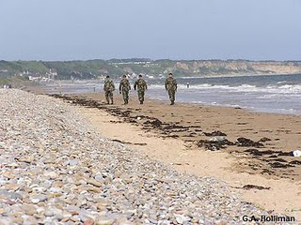“I hear you are going to be in Normandy during the first week of June,” my grandfather, Bishop (Pa-Bish) Holliman wrote to me in an email. “I’m sure I’ve told you where I was on D-Day, 1944. I was on the Barker (a Navy destroyer) and we were coming through the Straits of Gibraltar.”
“I was on watch that morning,” Pa-Bish’s email continued, “in the radio shack and I heard over the BBC that the invasion had occurred. Needless to say, I was glad to be where I was at the time. I realized that it was largely by the luck of the draw, or what letter of the alphabet your name began with, that most of us were where we were at any time during the war. If we made it through the war unscathed, we were just plain lucky.”
Not everyone was as lucky as my grandfather.
It is June 2, 2004 and Allies have once again invaded Normandy. This time it is with cameras, re-enactors, portable pavilions and folding chairs. My husband, father, stepmother and I are just four of the hundreds of people who are watching the military and media from all over the western world prepare for the 60th Anniversary of D-Day.
Today the American Cemetery, located along the coast of Omaha Beach, is full of activity. Gardeners are finishing up last minute weed-eating, mowing and pruning. Cut grass is being collected and loaded into carts pulled by lawn tractors. The 3rd Armor Division is drilling for the ceremonies that will take place in less than four days.
Three young French girls run up to two U.S. soldiers with paper and pen. I watched as the enlisted men sign their names.
“I bet you didn’t plan on being a celebrity,” I say to one of the men.
“Yeah, it is kind of weird,” he said, a bit embarrassed after realizing that I was an American. “But being here sure beats where we are stationed in Germany.”
It appears that the French are pleased to see the Allies return. Flowers and flags, primarily of American, British, and Canadian nationalities, are on poles in window boxes and strung across streets in banners.
Ste-Mere-Eglise, a town that became a drop zone for the 82nd and 101st Airborne Divisions, is brimming with tourists and trucks loaded with grandstand equipment. Locals sit in front of cafes amused with the lighting and sound gear that is being set up on their church lawn.
Pointe-du-Hoc, the dividing cliff between Omaha and Utah beaches, is swarming with men and women dressed in WWII uniforms. Re-enactors of American, British and German origin mingle with civilian-clothed tourists and active duty troops. Occasionally it is difficult to distinguish the re-enactors from the real servicemen.
Before leaving the American Cemetery, my family and I stroll around through the rows and rows of bright white crosses and stars. We can hear the ocean crashing along the coastline with sporadic interruptions from the buzz of weed-eater motors.
A few members of the media are practicing camera angles and interviewing veterans. I watch as military personnel from the U.S., England, and France walk along the path between the graves and the ocean. They are here to commemorate D-Day together.
“You are going to have to give your grandfather a phone call when you get home and tell him about your trip,” my father stated as our group slowly walked back to the memorial entrance.
“Absolutely,” I said as my mind raced ahead to packing bags, plane tickets, and returning to work on Monday. “It has been an amazing trip.”
Glancing back at the rows of white, it occurred to me that the men buried here never had the chance to become grandfathers.
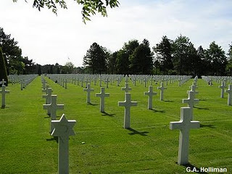American Cemetery in Normandy, France
Next week, Glenn returns to 17th Century Virginia and continue to uncover that first generation of Hollimans and their challenges in a new land.
Posted by Glenn N. Holliman at 8:00 AM 1 comments
Home
Subscribe to: Posts (Atom)

WEDNESDAY, JULY 28, 2010

When We Were English, Part XI
by Glenn N. Holliman
More on the Holyman Farm, Cuddington, Buckinghamshire, England

In the past few posts, I have been sharing information and photographs of a Holyman farm, described in some English sources as a former 15th century manor house. In the photobelow is a contemporary plaque attached to one of the barms, now a residence. This sign celebrates the name of the farm and its most famous namesake, Brother John Holyman (1495 - 1558), a monk and later the Rt. Rev. John Holyman of Bristol. Photo by Barbara Holliman
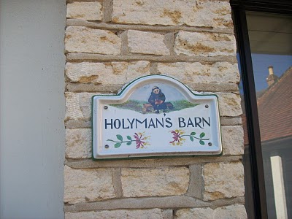
Below from The Monuments of Buckinghamshire is a description of the 17th century thatched cottage that we have featured in previous posts (see archives). Click twice and the manuscript will enlarge.
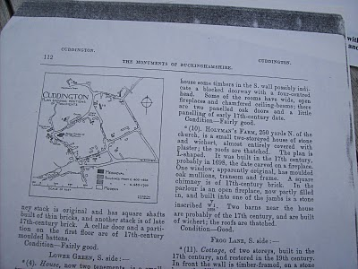
The current owner of Holyman Farm, Mrs. Caroline Stonham, has prepared the following family tree of the Holyman family and others that lived on the property. Perhaps it is of some use to those studying deeply into our English past. Through it one may be able to connect the family to our other English ancestors reportedly from Tring and/or Bedford. Where there are no last names, insert Holyman.Again, click twice and the document will enlarge. Photos by Barbara Holliman
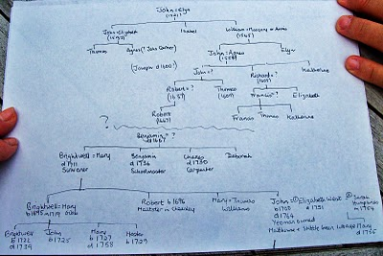
Next posting, more research on our English roots....
Posted by Glenn N. Holliman at 4:29 PM 0 comments
Labels: Bishop John Holyman, Caroline Stonham

FRIDAY, JULY 23, 2010

When We Were English, Part X
by Glenn N. Holliman
Continuing the Search for our Ancestors in England
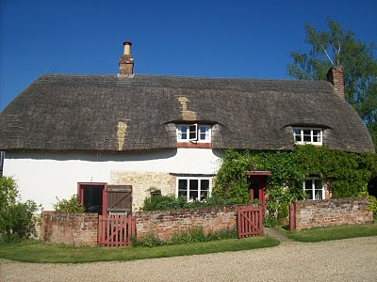In the above 17th century thatch cottage lived great nieces and nephews of The Rt. Rev. John Holyman who was born on this farm in 1495. Numerous legal papers and research tell of the family. Beloware copies of research from Caroline Stonham, current proprietor of the Holyman Farm in Cuddington, Buckinghamshire. Click on the documents to enlarge them.
Page 1
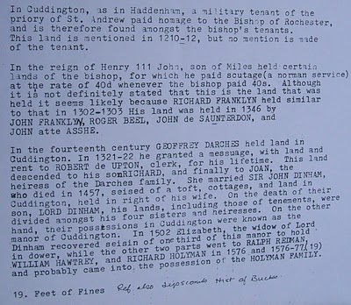
Page 2
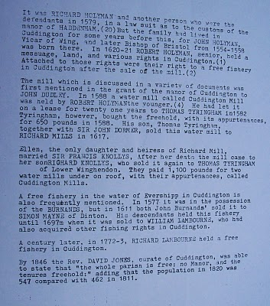These documents may be of use to any Hollimans who research our English roots....unfortunately the names of JohnHolyman (1572 - 1650) and Christopher Holliman (1631? - 1691) have not appeared in documents from the Holyman Farm. The search continues for our direct ancestors....
Posted by Glenn N. Holliman at 4:45 PM 0 comments
Labels: Bishop John Holyman, Caroline Stonham, Cuddington

WEDNESDAY, JULY 21, 2010

When We Were English, Part IX
by Glenn N. Holliman
Bishop John Holyman's Will, 1558

In my recent postings, I have been chronicling the life and times of The Rt. Rev. John Holyman, probably a distant uncle of our Hollimanfamily. During my recent visit to the village of Cuddington,Buckinghamshire, England, this photograph (below) was taken of Mrs. Caroline Stonham and myself in the back garden of her 17thcentury thatch cottage.

What is remarkable about this cottage is that it rests on theHolyman farm, and Holymans used to live in the residence in this photograph!
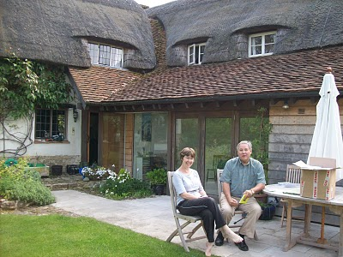
In an earlier posting, I dropped in a photograph of the location of the old 'manor' house where 16th century Holymans lived, approximately 200 yards from where Caroline and I are sitting.
We are reviewing Holyman papers she has collected in the twenty years she has lived on the farm. She is a geography teacher and has a keen appreciation of the history of her home. She kindly shared of her research and gatherings with me, allowing my wife to photograph the many documents. With her permission, I now share them with you.

One of the papers we reviewed is below. It is the 1558 will of Bishop John Holyman. It is a transcription but it does contain a bit of Shakespeare era English. Being celibate, John had no children, but he did have servants whom he remembered and he left funds to colleges and the parish where he is interred. Notice he left funds to pray for the repose of his soul. For one who had been a monk, and had taken a vow of poverty, he left a sizable estate although no land.
If one places the cursor over the document and clicks, the will should enlarge for easier reading.
Page 1
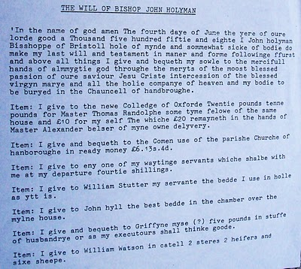
Page 2
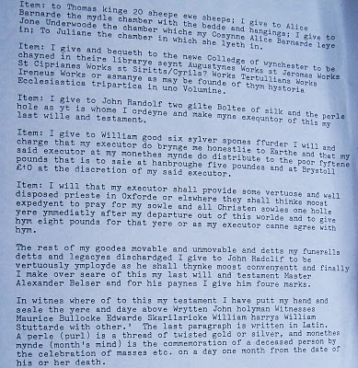
This will was transcribed under the direction of Bob Hollyman-Mawson of Wales, for whom we all are indebted.
Next posting, more on the Holyman farm and family documents in Cuddington, Buckinghamshire, England....
Posted by Glenn N. Holliman at 4:58 PM 0 comments
Labels: Bishop John Holyman, Bob Hollyman-Mawson, Caroline Stonham,Glenn Holliman

TUESDAY, JULY 20, 2010

When We Were English, Part VIII
by Glenn N. Holliman

The Turbulent Life of The Rt. Rev. John Holyman, Installment 5

The life of John Holyman reached a climax during the reign of Queen Mary Tudor, or 'Bloody Mary' as she was termed by Protestants. Nancy Cattell of Cuddington, Buckinghamshire, England concludes her story of this distant ancestor.

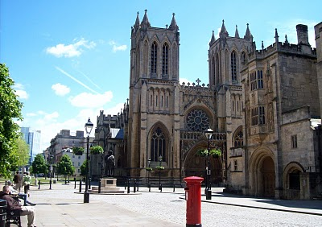The west entrance to the Bristol Cathedral with a quintessential Royal Post Box in foreground. From 1554 to 1558 The Rt. Rev. John Holyman occupied this Episcopate.Photo by Glenn Holliman
"Upon the accession of the Catholic Mary, daughter of Catherine ofAragon, John Holyman was appointed Bishop of Bristol, obviously as a reward for his support of her mother. Once again Holyman was into the limelight for now the Protestants who had supported Kings Henry VIII and Edward VI were to be tried. Bishop Holyman was included in the commission that tried Latimer, Bishop of Worchester and Ridley, Bishop of London. They were found guilty of heresy. In 1554,Holyman also participated in the disputation of Archbishop of Canterbury, Thomas Cranmer."
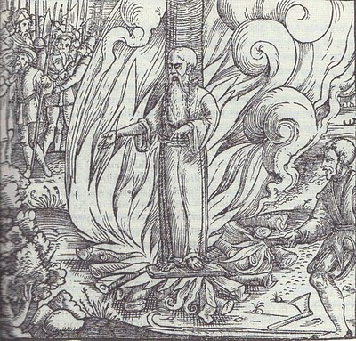
All three Protestant bishops were burned at the stake at Canditch in Oxford for their 'heresy'. The above woodcut is of Cranmer's death from the famous Fox's Book of Martyrs. In Bristol from 1554 - 1558, five more Protestants found martyrdom as 'candles' for Protestantism. In fairness to The Rt. Rev. John Holyman, he is reported to have opposed such actions, but they did occur during his episcopate.
"In 1558, Mary died and was succeeded by the Protestant Elizabeth. So once again the tables were turned and the Catholics were now put on trial. Bishop John Holyman avoided a violent death, as he died of natural causes a month after the accession of Queen Elizabeth I. His burial took place at Hanborough Church."
"I am so amazed that anyone born in the 16th century in what must have been at that time the most obscure of little villages should have produced a man who was at the centre of all the important happenings of that tumultuous time." - Nancy Cattell, Cuddington,Buckinghamshire, UK 2005
Paul Bushe, the first Bishop of Bristol received an ornate tomb with effigy (photo below of Cathedral sanctuary).
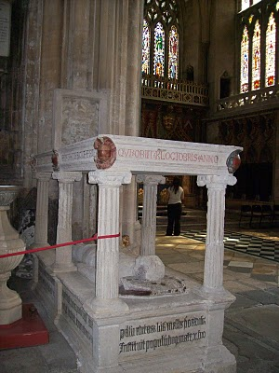

But the second bishop, much more controversial and in disrepute at his death, lies buried in LongHandborough in his former parish church. John Holyman's remains lie under or near this 16th century memorial (photo below) in the small village parish near Oxford.Photos by Barbara Holliman
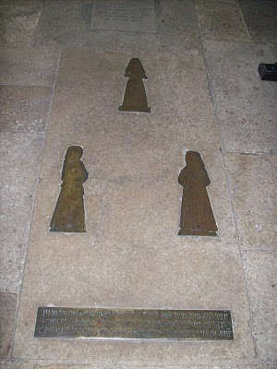

Next post, a visit to the Holymanfarm inCuddington,Buckinghamshire....
Posted by Glenn N. Holliman at 9:59 PM 0 comments
Labels: Bishop John Holyman, Paul Bushe, Thomas Cranmer

SATURDAY, JULY 10, 2010

When We Were English, Part VII
The Turbulent Life of The Rt. Rev. John Holyman, Installment 4
by Glenn N. Holliman
During the last years of Henry VIII and the reign of the boy king, Edward VI, our John Holyman served as priest at Long Handborough, near Oxford, and later vicar at Wing, near Tring, Hertfordshire.
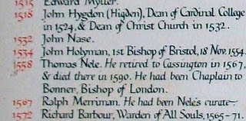
The name John Holyman appears (above) on this list of rectors who have served the parish in Handborough. This roster hangs on the church wall. There is an error; John Holyman was the second, not first Bishop of Bristol.
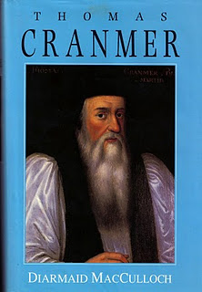
The photo of the book to theleft of Archbishop Thomas Cranmer is the latest in many excellent works on this pivotal priest during the Reformation. Some of the activities of our Bishop of Bristol are recorded in Diarmaid MacCulloch's biography which was published Yale University Press in 1996.

During the English Reformation, out went certain Roman traditions and services and in came a more simplist style of worship and church decorations. English, not Latin, became the language of the pulpit and altar. Cranmer wrote the first Anglican Church prayer books, the model and language which survives even into the 21st century in the American Episcopal Church.
<p&~~special_remove!#~~gt;how did="" john="" holyman="" retain="" his="" priesthood="" and="" parishes="" in="" all="" this="" change="" which="" he="">Discretion must have been his middle name.
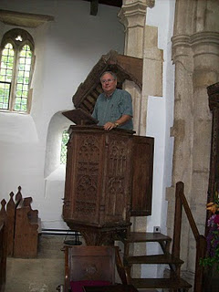

However, one of his distant descendants practices an indiscretion, standing in the 15th century pulpit where John Holyman preached in the 1540s in Long Handborough. Photo by Barbara Holliman, wife of the bogus preacher.
Next posting, we continue with the paper on ancestor John Holyman (1495 - 1558) presented by Peggy Cattell of Cuddington, Buckinghamshire, England.
</p&~~special_remove!#~~gt;how>
Posted by Glenn N. Holliman at 10:46 AM 0 comments
Labels: Thomas Cranmer

FRIDAY, JULY 9, 2010

When We Were English, Part VI
The Turbulent Life of The Rt. Rev. JohnHolyman, Installment 3
by Glenn N. Holliman
Historian Nancy Cattell continues her paper on Cuddington,Buckingshire resident John Holyman.
"While in London Brother John embroiled himself in not just Reformation issues but also the marriage crisis of King Henry VIII (1581 - 1547). Henry had decided that must ask the Pope to grant him a divorce from his first wife, Catherine of Aragon. He claimed that because she had been his brother's widow he should not have been given the dispensation to marry her. This 'sin' was smoting him."
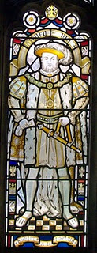This likeness of King Henry VIII is in the Cathedral at Bristol, England, the Cathedral from which Bishop John Holyman presided 1554 to 1558. Photo by Barbara Holliman.
"This after 20 years of marriage, but of course the real reasons for his desire for a divorce were (a) that Catherine had not provided him the son he wanted and (b) much more important - he had fallen desperately in love with Ann Boleyn and wanted to marry her."
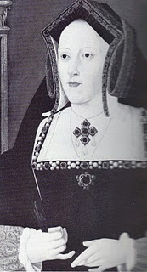"The Pope refused Henry's request and good Catholic that he was Brother Holyman started preaching in favour of the validity of the marriage to Catherine (photo right). This was a very courageous act or if you like, a very foolhardy one for Henry did not approve of criticism."
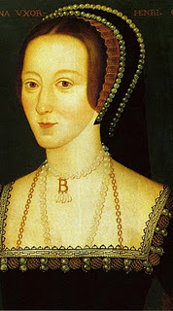Catherine is the mother of Queen Mary Tudor.
"Holyman must have made a discreet move from London otherwise he would surely have lost his head - one book I read told me that his abbot did and certainly the Abbey was dissolved during Thomas Cromwell's 'displacement'. "
Anne Boyleyn, the mother of Queen Elizabeth I, photo left.
"As we know when the Pope refused to grant the divorce, Henry cut the Church in England off from the Roman Catholic Church and thus the Church of England came into being. Henry declared himself the head of the Church and so obtained his divorce from his new Archbishop Thomas Cranmer."
"Brother John Holyman left London and sought refuge in LongHandborough, near Woodstock where he became the rector (and kept his head and kept it down)."
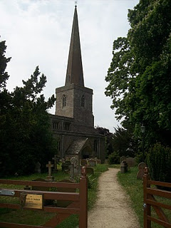
The parish church in Long Handbourgh stands today between Oxford and the historic town of Woodstock, the home of BleninPalace and the birthplace of Sir Winston Churchill.
Next posting, more on the career of Bishop JohnHolyman....
Posted by Glenn N. Holliman at 1:14 PM 0 comments
Labels: Bishop John Holyman, King Henry VIII, Nancy Cattell

SUNDAY, JULY 4, 2010

When We Were English, Part V
The Turbulent Life of The Right Rev. John Holyman, Installment 2
by Glenn N. Holliman
Below we continue the paper of John Holyman that Miss Peggy Cattell presented in 2005 to the Cuddington Historical Society, Buckinghamshire, England.
"John went to school in Winchester (a prestigious school, second only to Eaton), probably at the age of eleven and developed into a fine scholar. From there he entered New College, Oxford and was awarded the Bachelor of Divinity in 1526. For a short time he was rector in Colerne (in Ireland) but this did not suit him. He turned to Oxford, this time to Exeter College, where he acquired a Doctor of Divinity degree.
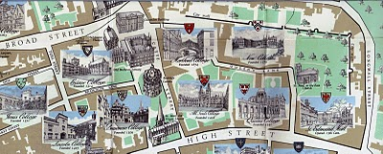New College, top right on the above map, is just inside the Old City Wall in Oxford. Not so new, New College was founded in 1379. Center left of the map is Exeter College, a bit older founded in 1314.
"After this second time at Oxford, Dr. Holyman became a monk at St. Mary's Abbey, Reading."
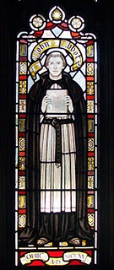This stained glass window at the Bristol, England Cathedral is of the founder of the abbey which later became the Cathedral where The Rt. Rev. John Holyman presided from 1554 - 1558. Brother John Holyman, when a monk, would have worn a habit such as above and had tonsured hair. Photo by Barbara Holliman.
"By this time, he was known as a brilliant scholar, a man of great piety and most eloquent preacher - fine qualities but not ones to blaze his name over the country, but this was soon to come. "
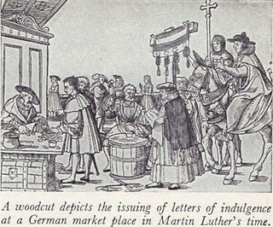"The age in which he was living was one of great religious upheaval. Up to 1517 all of Europe belonged to the Roman Catholic Church owing allegiance to the Pope. In Germany, Martin Luther spoke out again the selling of indulgences - that is people being offered the chance to buy themselves absolution from their sins. Luther believed that only through faith in Jesus Christ could sins be absolved. His concerns spread and a wide rift developed in the church. Those who protested again the Pope and Roman Catholic Church came to be known as Protestants."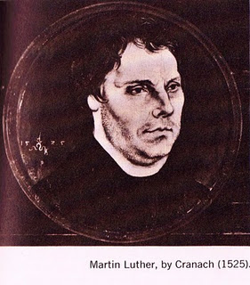

" Holyman's abbot became concerned at what he described as this Lutheran Heresy spreading to England and he sent his best preacher up to London to speak against these thoughts at St. Paul's Cross. And so Holyman was thrust into the centre of this important conflict!" (Speaking at St. Paul's Cross in the 1500s would be today's equivalent of appearing on all the major television news channels.)
In the next posting, the Reformation and a Royal divorce engulf King Henry VIII, his Queens Catherine and Ann Boleyn, Cardinal Thomas Wolsey, Sir Thomas More and our own Brother John Holyman.
Posted by Glenn N. Holliman at 11:00 AM 0 comments
Labels: Ann Boleyn, Henry VIII, John Holyman, Queen Catherine
Home
Subscribe to: Posts (Atom)

WEDNESDAY, AUGUST 25, 2010

When We Were English, Part XVI
by Glenn N. Holliman
Connecting Cuddington Holymans to Cholesbury Holymans and Tring Holymans
Note: Cousin Jeanette Stewart recently shared in a Holliman chat room information on the Holyman and Weedon (Wedon) families of Hertfordshire, England from the English Origins of New England Families. Before reviewing her excellent research, I had been preparing the article below which echoes and strengthens her findings. In future postings, I will attempt to weave her public work into the growing narrative of the Holymans in Tring and Cuddington, England in the 16th and 17th centuries. My thanks to Jeanette, Joe Parker and all for making available to the larger Holliman, Holleman, Hollimon, etc. families their increasing knowledge of our historic roots.

Last spring my cousin Maxine Wright, a relentless researcher in pursuit of Holliman origins, mailed me the following information of one Richard Wedon, who lived in Botley, a small village near Cholesbury and Tring. As one can read in the first paragraph of this p. 187 of The Register, published 1954, Richard had to pay a fine in 1567 for breaking the head on another man's servant. Hmmm....

Richard must have matured because nine years later, in 1576 he married Jayne Holyman in Cholesbury, near Tring. The information below states that this Jayne Holyman was from 'a yeoman family of good standing in Cuddington', descendents of Bishop John Holyman, whose life we have reviewed in previous blogs.

Several other items leap out at us. Richard and Jayne had a son named James who evidently immigrated to Rhode Island! Did James join a cousin named Ezekiel of Tring in Rhode Island?One remembers that Ezekiel Holyman, an Anabaptist, baptised Roger Williams the founder of Rhode Island!
Notice that Richard Wedon writes a will in 1618 (it is probated in 1624, presumably the year of his death). The will is witnessed by William Holyman. Double click to enlarge.
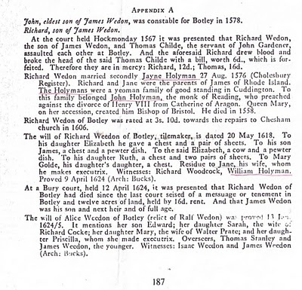
Now the issue grows more complicated. Above we have Jayne Holliman married to Richard Wedon. Below in another section of the Register, we have a John Holyman appearing in marriage in 1593 and dying a few years later. Goodbye to this John who had no children.

However, now William Holyman, the eldest son of another William Holyman, appears again (noticed who witnessed Richard Wedon's will), baptized June 1583 and his sister Priscilla February 1584/5. They have a brother named Ezekiel.

This Ezekiel according to many web sites and those who have researched Baptist Church history is the Ezekiel who sailed to Massachusetts and helped found Rhode Island!

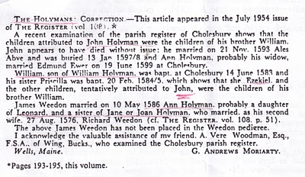
Notice in the next paragraph an Ann Holyman married another Wedon May 1586, and is noted as a probable daughter of Leonard Holyman and a sister of Jane Holyman.

Confusing? Yes, but stay with me. In the next blog, we are going to examine Leonard Holyman and his offspring. In web sites, Leonard is listed as the father of Ezekiel Holyman.

So, two thoughts emerge:

1. Leonard Holyman and other Holymans of Tring and Cholesbury, including Ezekiel, are indeed descendants of Bishop John Holyman of Cuddington.

2. Bishop John Holyman, a devout Roman Catholic, therefore is probably a great or great great uncle or cousin of Ezekiel Holyman, who was religiously antithetical by 180 degrees, to his prominent descendant, an Anabaptist in America! For those interested in religious history this is an amazing journey for a family. One generation burns Protestants at the stake; another helps establish the Baptist Church in Rhode Island.

So are all these interesting Holymans our direct ancestors?Ancestors, most probably yes; direct, we still do not know.

The elusive John Holyman, who died in Virginia in 1650 and is named in various web sites as the father of Christopher Holliman, Sr. (whom we know is the father of the American Hollimans), still has not appeared in the Tring records many of us have researched.

More in the next posting on resolving this mystery. Is our Christopher Sr. really from Bedford, Bedfordshire, another 30 miles or so up the road from Tring? Stayed tuned for more research....
Posted by Glenn N. Holliman at 2:20 AM
Labels: Ezekiel Holliman, Jayne Holyman, Jeanette Stewart, Joe Parker,Leonard Holyman, Maxine Wright, William Hollyman

0 comments:

Post a Comment
Newer PostOlder PostHome
Subscribe to: Post Comments (Atom)
- The Contributers and the Sources
- Holliman Records, A History of Some Official Docum...
- Family Lineages

John Thomas Holliman House

Popular Posts
Our Family's Colonial Era, 1607 - 1775, Part II
In Search of Christopher Holliman Sr.'s 17th Century Virginia Plantation by Glenn N. Holliman This is the second post of an on-going ser...
Welcome Family!
Important Notice: Since composing this article in February 2010, additional research has failed to identify John Holyman (1572 - 1650) of ...
Our Family's Colonial Era, Part VI
Tobacco, Slavery, Democracy and Our Family by Glenn N. Holliman If one analyzes the 17th Century Virginia economy carefully, it makes for ...

Blog Archive

Subscribe
Posts
All Comments

Labels
A. Eckford Holliman AlabamaAlice Holleman Alice HollimanAnn Boleyn Ann Holyman Anna Holyman Anne Holyman August Holliman Barb Holliman Bill Holliman Bishop Holliman Bishop John Holyman Blackwater RiverBob Hollyman-Mawson Bob Hollyman-MawsonJimmy Holliman Bryan Payne Bryan PayneChristopher Holliman Jr.Caroline Stonham Cecil Holliman Charles Daniel Lucas Charles HollimanCharles Lucas Sr. Christopher Holliman Christopher Holliman Jr.Christopher Holliman Sr.Christopher HolymanCorey Holleman Cornelius Holliman Cuddington David Jennings Dr. Sidney A. HollemanE.C. Herrin Edward HollymanEdward Holyman Elijah Holliman Elizabeth HolymanEva Ezekiel Holliman Faye Gardner Faye Gartner FayetteGeorge A. Holleman George Washington Carver Gladys Parker Glenda NorrisGlenda Norris Jeanette Stewart Glenn Holliman Grace Holyman Gwaltney HannaHelena Poynard Henry VIIIHerrin Hollyman Holyman Farm James Franklin Holliman James Grantson Holliman James Monroe Holliman Jane Hollyman Jayne Holyman Jean HollimanJeanette Stewart Jesse Holloman Jim Maule Jimmy Holliman Joe Parker Joey Holliman John Holliman John Holyman John Thomas Holliman John Thomas Hollyman Jonathan MurphyJoseph Bridger Jr. Judith Holman Judith HolymanKing Henry VIII Lenwood Holliman Leonard HolymanLuke Stansbery Lynn HollimanMargaret Holliman Martha Jane Holliman Martha Jane Walker Holliman Mary Daly HerrinMary Hasten Lucas Mary Holyman Mary Polly Lucas Holliman Maxine WrightMelissa Anthony Caine MurphyNancy Cattell Nathanel BaconNorman Holliman Oliver Cromwell Palestine HollimanPaul Bushe Peggy Cattell Peter Smith Polly Lucas Queen Catherine Raiford BrandonRalph Holliman Rhodes Holliman Richard HollymanRichard Holyman Robert Daly Robert Holliman Robert Hollman Ron Holliman Samuel Walker Scott Norris Shelia Brandon Silas Green HollimanSr. The Family of Ulyss and Pearl Caine Holliman 1946 Thomas CoxThomas Cranmer Thomas Cromwell Thomas HolemanThomas Holliman Thomas Hollyman Thomas HolmanThomas Holyman Thomas Holyman of Leigh Thomas Leland Holliman Thomas Pittman Tom Vaughan Tommie Holliman Allen Tring Ulysses Selma Holliman Uriah HollimanVena Holliman Vonceil Duckworth Wally Allen Walt Holliman Walt O. HollimanWarren Holliman Weedon family William Bailey HollimanWilliam Berkeley William E. Caine William HollimanWilliam HollymanWilliam Hollyman; Jonas Hollyman William Hollyman; Leonard Holyman William Holyman; Edward HolymanWilson Holleman WWII

MONDAY, SEPTEMBER 27, 2010

When We Were English, Part XX
by Glenn N. Holliman

Looking for John Holyman in Edward Hollyman's Will of 1617

Just to remind all, the William listed in the last post is the uncle of Ezekiel Holliman, one of the founders of the Baptist Church in Rhode Island and the person who baptized Roger Williams, an architect of American religious liberties. The Edward Hollyman in this post is also Ezekiel's uncle. John Holyman (see Post When we Were English, Part XVII), a brother of William and Edward, is Ezekiel's father.

So here we are knowing Bishop John Holyman (1495 - 1558), devout Roman Catholic who burned Protestants at the stake during the reign of Mary Tudor, is a great uncle or second or so cousin of Ezekiel. Now in all this where is the mysterious John Holyman ofTring (1572 - 1650), believed by many to be the founder of AmericanHollimans in Virginia?

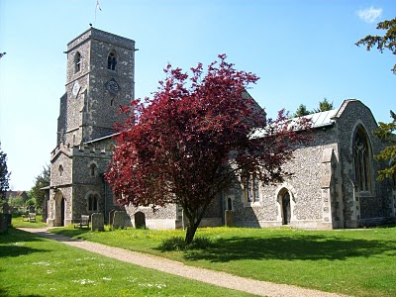The parish church in Aldbury, located a few miles east of Tring,Hertfordshire. Are our relatives buried here also? Photo by BarbaraHolliman, 2010.
In the last posting we explored the 1623 will of William Holyman ofTring, son of Leonard Holyman. In this article we reproduce below from the Hertfordshire Archives, the will of Edward Hollyman ofAldbury, brother of William. Aldbury is only a few miles from Tring. Edward lived from 1546 to 1617, and spelled his name with two 'L's. Edward was more prosperous listing furniture and household items to be dispersed as well as land holdings. Note brother William Holymanwitnessed this will. As the scanner cannot record the entire will at once, it is divided into two parts. Click twice to enlarge.
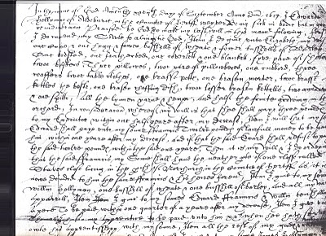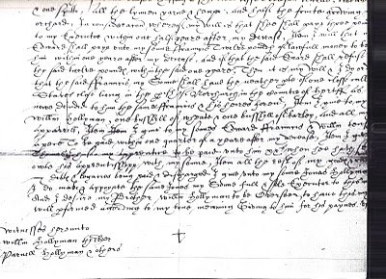
I have not attempted to transcribe this document, but have studied closely the bequests and names. This will seems more difficult to read than William's. A name intrigues, and I remain puzzled over it. Double click the second section and look at the fourth line from the bottom of the will. Beginning in the middle, you will read the words which I transcribe as "I give unto my sons Jonas Hollyman," then words are obscure.

I have pondered and pondered this clause. Is this word John in Latin, Medieval French or 16th century English script? What to do about this? One avenue is to check the Aldbury Church of England register. Remember Thomas Cromwell as of 1538, Henry VIII's chancellor, decreed that all parishes register baptisms, marriages and funerals.

However, I cannot find in Edward's will (as in William's) that he asked to be buried in the parish church lawn. Had Edward joined a non-conformist church (Puritan or even more controversial - theAnabaptists for example) by 1617, as obviously had his nephew Ezekiel? If so, Edward's demise would not be recorded in Anglican Church records.

So I will search the Internet to see what can be found, and if nothing can be found, well, back to the Hertfordshire Archives my next trip to England. A clue, a weak one, but....could this be the not-yet-found John Holyman, d. 1650 in Jamestown, Virginia? I agree, this is a big, huge stretch and even if this name be John, would it also be our John, English founder of our American family....?

Below, is a family memorial in the Aldbury parish. No, not aHollyman plaque, as it remembers another departed family. This ghastly, but fascinating 17th Century monument, vividly displays that century's view of morbidity. Our ancestors were part of this culture.
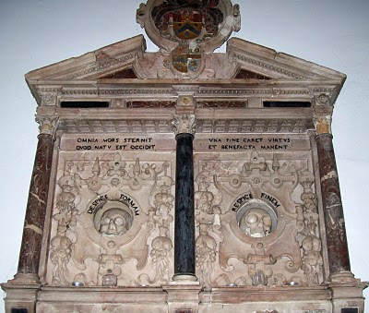Photo 2010 by Barbara Holliman
We are all immigrants from the past...from our families.....
Posted by Glenn N. Holliman at 6:35 AM 1 comments
Labels: Edward Hollyman, William Hollyman; Jonas Hollyman

MONDAY, SEPTEMBER 20, 2010

When We Were English, Part XIX
by Glenn N. Holliman

The Will of William Holyman (1550 - 1623) of Tring, Part II
Still Looking for John Holyman of Tring....

In the index of wills in the Hertfordshire Archives in Hertford, England, I found and copied the last words of William Holyman, son of Leonard Holyman (1520 - 1573). Bear in mind, I was looking for the John Holyman, the reported ancestor of the American Hollimans. While this will does not disclose our elusive direct ancestor, this document does reveal information on the lives and times of our distant cousins, uncles and aunts when we Hollimans were English.Click twice to enlarge. The document is divided into two parts due to my scanner only taking part at a time.
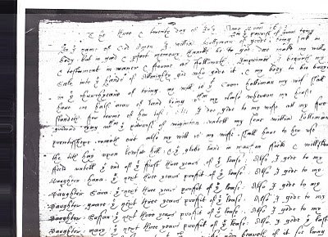
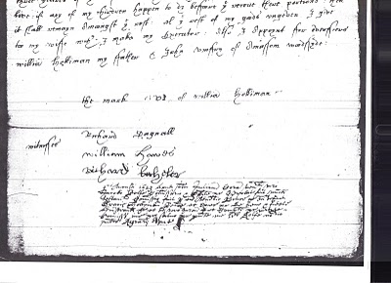What does it say? As no expert, here is my attempt to transcribe the writing form of early 1600s English script.

"The ___ and twentieth day of July Anno Domi 1623 ___ In the Name of God Amen. I, William Holyman of Great (in the parish of Great Tring) being poor in body, but in good and perfect memory, thanks be to God, do make my will and testament in manner and form as followeth,

First, I bequeath my soul into the hands of the Almighty God, who gave it and my body to be buried in the church yard of Tring.

My will is that Grace Holyman, my wife, shall have on half acre of land lying between my house __ for ___ (rest?) of her life. Also I do give to my wife all f___ ___ ___ ___ that ___ of ___. ___ my son William ___ ___ ___ out also my wish is to my wife ___ ___ to her rest the __ hay upon ___ hill; and the glebe land in ma___ field and one of the ___ of the first three years of the field lease. Also I give to my daughter, Hanna, the next ___ years profit of the lease; also I give to my daughter, 'Saiva' or 'Eva', the next three years profit of the ___. Also I give to my daughter, 'Grace' the next ___ profit of ___. I give to my daughter, 'Saffon', the next ___ years profit of the ___. Also I give to my daughter Mary the ___ ___ ___ profit of the ___. Also I give the ___ three ___ of the ___. Unto the ___ my wife ___ ___ if it ___ ___ ___. If any of my children happen to die before they received their portion, then it shall remain amongst the ___. All this ___ of my ___ I give to my wife ___ I make my executor. Also I appoint for administrators (?) William Holyman my father and JohnRomsy of ___ ___.

The Mark of William Holyman, submitted"

My opinion? Here we have described a yeoman farmer living in Tring, to be buried in Tring and farming fields just outside of Tring. He has few worldly goods other than a lease hold on the land.

And to our disappointment, no son named John Holyman.

So the search for the elusive John Holyman continues....
Posted by Glenn N. Holliman at 12:38 AM 0 comments
Labels: Eva, Grace Holyman, Hanna, William Hollyman; Leonard Holyman

MONDAY, SEPTEMBER 13, 2010

When We Were English, Part XVIII
by Glenn N. Holliman

The Will of William Holyman (1550 - 1623), Part I
In the Hertfordshire archives in Hertford, England, one will find several large rooms filled with books, manuscripts microfilm and photographs of local, family and national history. In the short time I was there, the friendly staff pointed me in several directions.

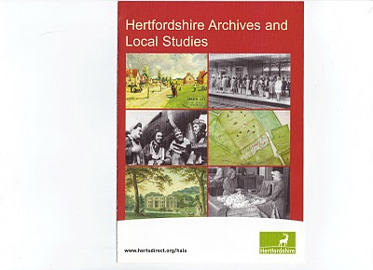This brochure may be of help to those reading this blog. Click twice to enlarge.
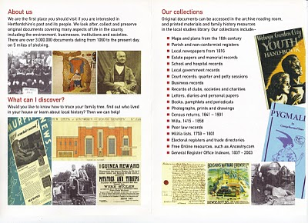

While there I reproduced from microfilm the wills of EdwardHolyman and his brother William Holyman. Before I post them and attempt to transcribe, let me share with readers the way our English alphabet looked in the late 16th and early 17th century. (See below)

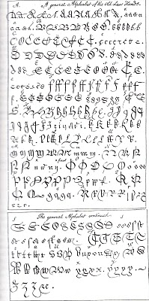

This really is your great grandfather's alphabet! Yes, it is A to Z with several samples for each letter. Some are easy to identify; others are a mystery. It makes interesting reading. Will it get us any closer to the elusive JohnHolyman (1572 - 1650)?
(Again click the reproduction twice to enlarge.)

In Part II of this article, next posting, we will examine William's 1623 will fromTring.
Posted by Glenn N. Holliman at 1:45 PM 0 comments
Labels: William Holyman; Edward Holyman

TUESDAY, SEPTEMBER 7, 2010

When We Were English, Part XVII
by Glenn N. Holliman

Continuing the Search for John Holyman (1572 - 1650)
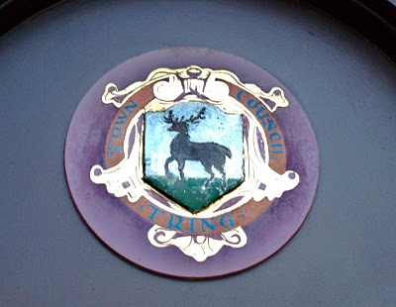Tring, Hertfordshire traces it roots to Anglo-Saxon times, and was located just west of the Danelaw in the 900s. The hamlet is listed in William of Normandy's Doomsday Book. The above is the town logo.(Photo by Barbara Holliman)
I am still looking for that elusive John Holyman who, according to one prominent Holliman genealogical website and the LDS records, was born in Tring, Hertfordshire in 1572. John is the widely reported father of Christopher Holliman, Sr., who is our ancestor of solid record.

We do know a John Holyman did die in Southampton, Virginia in 1650 and left a will which devolved property to a friend, not family. For the past few months, I have been posting information found during an excursion to England seeking Holyman roots and our reported very great grandfather. I continue.

As readers of this web log know, there was a Bishop John Holyman(1495-1558) and an Ezekiel Holyman (1586 - 1659), both religious leaders. One was Roman Catholic and the other a Baptist Protestant. The evidence supports that they are related.

Cousin Jennette Stewart shared by email information that in theEnglish Origins of New England Families, Vol. III, pages 193 - 195, one will find an article by G. Andrews Moriarty entitled 'TheHolymans'. In this article Moriarty quotes The Register, an English genealogical publication, that the Holymans were a family of 'substantial yeomen' with branches in Cuddington, Cholesbury andChesham. The Rt. Rev. John Holyman, Bishop of Bristol from 1554 to 1558 was a member of this family as was one Jayne Holyman(1552 - 1632) and her nephew, Ezekiel Holyman.

From the Latter Day Saints genealogical website, we have the following:

One Leonard Holyman (1520 - 1573) was born in Cholesbury and died in Tring. From the above source we know that Leonard is related to the Cuddington Holymans. I refer all to my post of August 23, 2010, 'When We Were England, Part XV'. Leonard is a contemporary of Bishop John Holyman. Were they brothers or cousins? Cuddington, as the earlier map notes, is an hour or two by horse from Tring andCholesbury.

Leonard married a Joan (b 1525) also of Cholesbury. They had at least seven children. One was the Jane (Jayne), referred to above, b 1552 in Tring, Cholesbury, died 1636 and is buried in Chesham (nearCholesbury). She married Richard Weedon, as noted in the last posting. One of their sons, James, immigrated to Rhode Island, as did Jayne's nephew, Ezekiel.

Jayne's brother John Holyman (1548 - 1597) was a weaver and had a wife named Ales (Alice). There were a number of children of this marriage, one being Ezekiel Holyman, who would immigrate to New England and help found the Baptist Church in America. Another child,Elsabeth, married into the Weedon family herself.

Two of Leonard's sons, Edward and William, left wills of which I found and made copies while in the Hertfordshire Archives. I will be publishing these wills later and transcribing what I can. There was a third son, John, whose will is below and lifted from the English Origins of New England Families.

The Will of John Holyman (1548 - 1597)
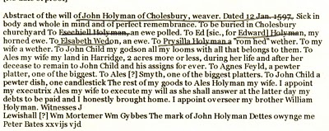

Now John Holyman (d 1597) left a will (abstract above) which does not list a son named John Holyman (remembering we are looking for a John Holyman, b. 1572 in Tring). John (d 1597) does list a godchild, whom he terms John Child. To this godchild, Holymanleft his 'looms and all that belongs to them'. His own children received much less, Ezekiel only getting a ewe. Why did he favor the godchild over his natural children? Perhaps John Child had an aptitude for weaving while the others did not? But this John also left John Child his land after his wife's death.

Why favor John Child over one's own children?

Could John Child have taken the last name Holyman from his godfather, John Holyman? Could this John Child be the elusive JohnHolyman (d 1650 in Virginia)? The dates work. Could this godchild be a natural offspring of John Holyman (d 1597), given perhaps a last name (Child) to obscure a birth out of wedlock? This is only speculation on my part, but the bequests are odd.

So John Holyman (d 1650) is still hidden in history as far as primary sources are concerned, if he be from the Tring area. As cousins Maxine Wright and Joe Parker have revealed, there is evidence JohnHolyman (d 1650) may have been from twenty-five to thirty miles north in Bedford. If so, why are so many web sites placing him inTring?

So are the Bedford and Tring area relatives very closely related, perhaps a branch just recently relocated to Bedford from Tring in the late 1500s? Perhaps, somewhere, someplace, some Holyman stated to an authority, "Yes, my family is originally from Tring, before recently moving to Bedford."

I will look further. Thank you for your patience as I attempt to place all this research by several persons and sources in narrative format and on the record. As ever, I am grateful to my distant cousins for their sharing of knowledge and evidence. Opinions expressed and conclusions drawn, as well as errors, are mine alone.

Next posting....looking at the will of William Holyman, a son of John Holyman (d 1597).
Posted by Glenn N. Holliman at 1:25 PM 0 comments
Labels: Christopher Holliman Sr., Edward Holyman, Ezekiel Holliman,Jeanette Stewart, Joe Parker, John Holyman, Leonard Holyman, Maxine Wright, Weedon family, William Hollyman
Home
Subscribe to: Posts (Atom)

TUESDAY, OCTOBER 26, 2010

When We Were English, Part XXIII
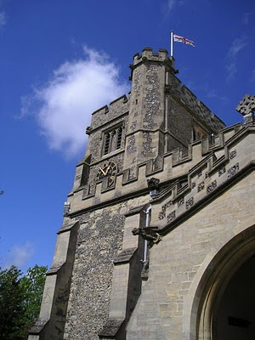by Glenn N. Holliman

Before We Leave England (for a while anyway)

As readers of this blog know, I have been writing of English Holymans (aka Holliman, Holloman, Holleman, etc.) for the past twenty-three articles, often from my research on-site in the Tring, Hertfordshire area. These articles owe much to the work of others who 'plowed ground' before me.

In this space, it is time to return to the Holliman story in the North American Colonial period, the 17th century when our ancestors arrived in Virginia. Before doing so, I want to sum up my findings (responsibility for errors and incorrect interpretations are mine) and suggest where more work is needed. (Above the parish church of St. Peter's and St. Paul's in Tring, Hertfordshire. Photo 2010 by Barbara Holliman.)

Findings

1. I have not found evidence that John Holyman (1572 - 1650) who died in Virginia is our great grandfather, nor have I found information that this elusive, but widely reported fore bearer of our family name, is from the Tring, Hertfordshire area. This person is recorded in a widespread web site as the 'founder' of the American Hollimans, and the father of Christopher Holyman, Sr. (1630 ca - 1691).

2. In and around the Tring area were many Holymans in the 15th to 17th centuries, some such as Ezekiel Holliman who immigrated to Massacusetts and helped found the American Baptist Church. Another Holyman was the Roman Catholic Bishop of Bristol (1495 - 1558) during the reign of Queen Mary Tutor. The 'manor' farm of The Rt. Rev. John Holyman still exists in Cuddington, Buckinghamshire and can be visited. I think it probable that these persons are distant cousins and great uncles and aunts.

3. Research by Joe Parker, Maxine Wright and others (LDS records i.e.) reveals that a Holyman family lived not far from Tring in Bedford, Bedfordshire in the late 1500s and 1600s. As I expounded in my last posting, these names - John, Thomas, Christopher and Judith - are the names that show up in recorded records in Virginia from 1630s to 1650s. I join Joe and Maxine in believing it highly probable this is our 'Founding Family'.

4. DNA testing conducted through Tina Peddie's good offices this summer revealed I and others are descendants of Christopher Holyman, Sr. (D 1691) of Virginia who immigrated from England in 1650 with his probable sister, Judith.

Work to be Done

1. Continue to research the Tring records in the 16th and 17th centuries looking for this John Holyman. There are more files and registers to explore.

2. Dig deeper into the family history of the Thomas Holyman family of Bedford (this Thomas was born in 1576). This can be done on-line and on-site at the Bedford-Luton Archives. I have plans to visit these archives in the spring of 2011, Good Lord willing. I note an LDS record lists Thomas Holyman's father as a John Holyman. As a wealth of information was found in the Hertfordshire Archives and Tring library, I strongly suspect a richness of material awaits a Holliman researcher in Bedford and at the National Archives in Kew (a suburb of London).

3. Establish relationships with Holyman's in Bedford and Tring and kindly ask for DNA testing.

4. Explore what ties exist between Bedford Holymans and Tring Hollimans. Geographically speaking, these communities are only twenty five to thirty miles apart, but in the 1500s, this was a two day walk. It is possible (probable?) that a Holyman from Tring moved to Bedford in the 1400s or 1500s and established a family.

5. Do not ignore other Holymans in England in the 17th century. A recent researcher on the Tina Peddie Hollyman chat room noted a Christopher Holyman was born in the early 1600s in Worchestershire, England. As with all genealogical research, be open minded and willing to change interpretations based on the evidence and critical inquiry.

To Summarize

Whether Tring or Bedford, the Holliman line is English, no ifs, ands or buts. Our great grand parents brought to Virginia the customs and culture of England - its forms of government, justice, religion and social mores. Of course, this culture was modified in a new environment that was, ironically, both hostile and welcoming.

To know from whence you come, study the history of England - it is our story. The Stuart, Tutor and Plantagenets - these are the monarchs of our family. The Normans, the Vikings, the Angles and Saxons, the Romans and Celts - these peoples too are part of our DNA, our genetic code, our human family.

Next posting, this story returns to Colonial America and the founding of a new nation.
Posted by Glenn N. Holliman at 1:31 AM
Labels: Bishop John Holyman, Christopher Holliman Sr., John Holyman,Thomas Holliman

0 comments:

Post a Comment
Newer PostOlder PostHome
Subscribe to: Post Comments (Atom)

THURSDAY, NOVEMBER 25, 2010

Our Family's Colonial Era - Part IX
by Glenn N. Holliman

More on Thomas Holeman, 1635 Land Owner at Martin's Hundred in Virginia

Martin's Hundred, a real estate development if you will, was named after the Society for Martin's Hundred of London, a land holding group in 1618. This huge settlement was located east of Jamestown and west of Skiffe's (Keith's Creek). It contained 20,000 acres and was a principle settlement site at that time. The websiteJamestowne Rediscovery has an excellent summary.

Records indicated 140 or so English lived in the development when in 1622 on Good Friday, a surprise American Indian uprising took the lives of at least 78 of the settlers in Martin's Hundred. The remaining were captured or fled to Jamestown. According to historian Bob Dean in his book The River Where America Began, 347 settlers, more than 1/4th of all the colonists died in that one day massacre.
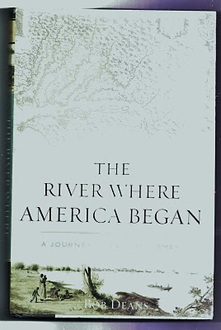
The Virginia colony was in great jeopardy, but struck back violently the next year against the Native Americans. The Crown took control of the dispirited colony from the Virginia Joint Stock Company that had founded Jamestown and had hoped to make a financial fortune.

Slowly the colony recovered, and immigrants arrived again. One beingThomas Holeman who purchased land in Martin's Hundred in 1635. Fifteen years later, Judith andChristopher Holyman, perhaps his siblings, arrived. Judith probably married quickly, and her name is lost to history.

In that same year of 1650, one John Holyman of Southampton, Virginia died leaving a will listing worldly goods but no land. He named a friend as an executor. When did he arrive and were Thomas, Judith and Christopher his siblings, all from Bedford, England?

We know Christopher survived and thrived, dieing in 1691 with an Isle of Wight County farm of 1,020 acres and numerous children. Most of us reading this today are his descendants.

In 1627, approximately 1,500 English persons lived in Virginia, mainly along the James. From 1606 until 1624, the Virginia Company had sent out over 7,000 settlers of whom over 6,000 died! By 1650, the year Christopher Hollimanarrived, some 15,000, ten times as many white settlers were present, or about seven times as many Anglos over Native Americans by this time in Virginia. Many of the Indians had been destroyed by European diseases and malnutrition, as well as warfare. The English were living longer thanks to better diet and shelter.

What happened to Thomas? At this writing I know of no research that has surfaced a will or marriage record. He purchased land, and may have died early as did many. Unfortunately James City County records were destroyed when Richmond was burned during the Civil War, and only some land patent records survive to my knowledge. Martin's Hundred ceased to exist as an entity in the early 1700s.

Did Thomas survive long enough to welcome to Virginia other members of his family - assuming John, Judith and Christopher Holyman were his siblings (families often immigrated together or after one had settled and encouraged others to immigrate)? Can we ever know the whole story?

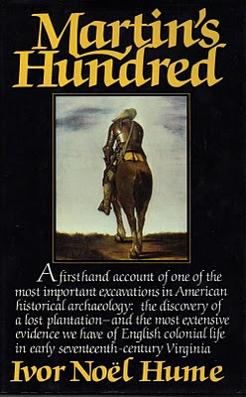
In the 1970s with a grant from the National Geographical Society, archaeologist Ivor Hume, excavated part of Martin's Hundred, now included in the Carter Grove Plantation and incorporated in theWilliamsburg Foundation. Much of Hume's 1988 book (pictured above) focuses on the 1622 Good Friday Massacre and the physical remains of that day. The cover of the book shows an English soldier of the time, garbed in armor. It is compelling reading.

More in the next posting on our Colonial past....
Posted by Glenn N. Holliman at 4:02 AM 0 comments
Labels: Christopher Holliman Sr., Judith Holyman, Thomas Holeman

WEDNESDAY, NOVEMBER 17, 2010

Our Family's Colonial Era - Part VIII
by Glenn N. Holliman

In 1635, persons whose last names are similar to Holliman, were living in Virginia. Are they our ancestors? Who were Thomas Holeman (Holman) and Robert Hollman?

Cousins Jeanette Stewart, Joe Parker and Maxine Wright have drawn my attention to the name and landownership ofThomas Holeman who purchased property in 1635 in Martin's Hundred, approximately ten miles south of Jamestown, Virginia. On p. 30 of Nugent's Cavaliers and Pioneers, Patent Book No. 1, Part I is a listing of a purchase of fifty acres of land in James County, adjacent to JohnDennett and Capt. John West. The land had belonged to one Thomas Harvey who had died (the death rate was very high in early Virginia).

Is this the Thomas Holyman (Holiman, Holman, etc.) who was baptized September 13, 1612 at St. Mary's, Bedford,Bedfordshire, England? As noted in early posts, Thomas andEllenora Holliman of Bedford were the parents of a Thomas and three other children with the names of John, Judith and Christopher Holyman, the same names as other persons who lived in Virginia in 1650.

In some recent research at the Library of Virginia in Richmond, I consulted numerous works, seeking to know more of this Thomas. Martha W. McCartney in Virginia Immigrants and Adventurers 1607 - 1635, also writes of Thomas patenting land on August 24, 1635. Ms. McCartney spells his name 'Holman', not 'Holeman'. Likewise, Gary Parks' index of Virginia Land Records records Thomas as a 'Holman'.

Gravestones were not common in Colonial Virginia until the 1700s when the colony began to 'mature' and relatives had the resources to purchase and craftsmen to carve rock. Below is the memorial marker for Alice Holleman of the 19th Century, who lived and is buried on the original plantation of Christopher Holyman Sr. Unfortunately, of course, there are no markers for ancestors who lived in the 1600s and precious few for the 1700s. Weather and time have eroded even stone.
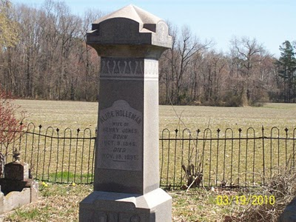
And Who was Robert Holliman?

Then there is twice mention of one Robert Hollman (not Holman or Hollyman) in Virginia Land Records, pages 666 and 674, on the dates of June 1 and March 6, 1635 in Henrico County, Virginia. Henricio is north of Jamestown and now encompasses the city of Richmond. This Robert Hollman owned land adjacent to the 'main' river, that is the James.

Granted spelling was atrocious in Colonial Virginia. The records are hard to read, and last names were spelled in different ways and often inaccurately.

So are Thomas and Robert our Holliman ancestors or some one else's?
If so, at least 15 years before Christopher Holyman Sr., our known ancestor, arrived, were his relatives, perhaps a brother and/or a cousin, already in the Chesapeake region? Did they prepare the way for more Hollimans who arrived in 1650 and later?

More in our next posting....as ever your knowledge and research, most welcome.

Posted by Glenn N. Holliman at 3:25 PM 0 comments
Labels: Alice Holleman, Christopher Holliman Sr., Robert Hollman,Thomas Holeman

THURSDAY, NOVEMBER 11, 2010

A Veterans' Day Salute
by Glenn N. Holliman
U.S. Army, Vietnam 1969
A Thank You to our Veterans

I suspect our family members have been represented in our country's battles from Colonial Chesapeake to the 21st Century Middle Eastern Wars. As it is impossible to list all of them in any kind of complete listing, I will let my nephew, Capt. Jonathan Murphy, USA, take the salute for all who been on active duty, the Reserves or National Guard. Jonathan is on duty somewhere in Afghanistan, his second tour in four years. His family waits for him in the States.

For a time he was Captain of the Guard at the Tomb of the Unknown Soldier in Washington, DC. Below are two photographs - one of Jonathan leading his platoon up the steps of the Memorial and the second of him walking the Guard. For those of us who have stood on guard in other fields and seas, including my father, uncles, nephews and cousins, we express our appreciation to him and all relatives who have gone before him.
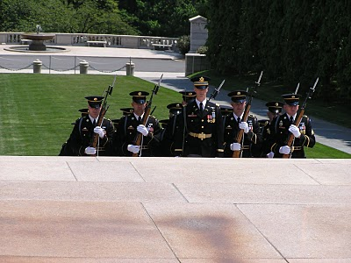
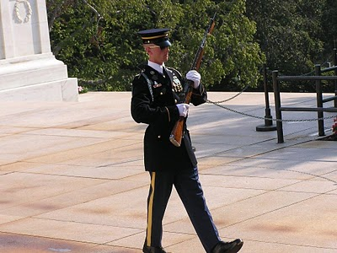
Among his ancestors are family members who served in the French and Indian War, Revolution, War of 1812, Civil War, World War II, Viet Nam, the Cold War and recent Middle East conflicts. One great grandfather, Luke Stansbery (1750 - 1848), was held as a prisoner of war of the British in Charleston, SC 1780 during the American Revolution.

Back to Colonial America with the next post....
Posted by Glenn N. Holliman at 3:18 AM 1 comments
Labels: Christopher Holliman Sr., Jonathan Murphy, Luke Stansbery

TUESDAY, NOVEMBER 2, 2010

Our Family's Colonial Era - Part VII
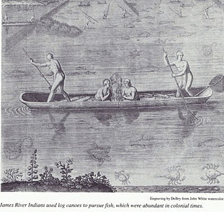
Conflict with Native Americans – A Clash of Cultures
by Glenn N.Holliman
Between April and June, 2010, I published six articles on theHollimanfamily in 17thCentury Colonial America (they can be found in the archive section of this blog). After having published 23 articles on our English past, I now return to the history of the Virginia English colony and the travails our family experienced.

This was truly a new frontier with both opportunity and premature death. Only the brave or foolish ventured from England to Virginia from the early to mid -1600s. Perhaps our pioneering family of Christopher Holliman, Sr. was a mixture of both.
Michael Mallary in his 2004 work, Our Improbable Universe, makes the point that everywhere farmers went taking their technology and culture, the hunter-gatherers melted away before them. “The high population density that could be supported by agriculture depleted game well below the density that hunters (such as American Indians) required” observed this historian.
This then was the societal reality when Christopher C. Holliman, Sr. with his probable sister, Judith, arrived in Virginia in 1650. The frontier required bravery, a tenacious attitude to attack the virgin forests and a strong constitution not to succumb on the voyage or to disease and malnutrition upon arriving. Fortunately this Hollimanfamily had such attributes, although Anne, Christopher's first wife, died in the 1660s. Mary Grey, perhaps the daughter of a member of the House of Burgesses in Jamestown, became Sr’s second wife.
In only a generation or so, soil exhaustion from tobacco cultivation forced families or young farmers to move to virgin land, to push the American frontier ever westward. The quest for land to grow tobacco and later cotton meant more and more Native Americans were displaced. The result was violence as American Indians naturally resisted encroachment on their hunting grounds and villages. The Indian did not go quietly to his cultural demise in Virginia and greater America.

The founding of Jamestown in 1607 meant the English had come to stay. Unlike the earlier 1580s failed Roanoke experience, this time our Anglo fore bearers mustered the necessary resources to establish a permanent colony. The English Diaspora employed superior technology, organization and the financial resources to grasp and hold an expanding piece of the New World.
Perhaps 15,000 to 25,000 Native Americans lived in Southern Virginia in the early 1600s. Benjamin Woolley’s Savage Kingdomrecords Captain Christopher Newport’s 1607 initial visit up the newly named James River to the site of present day, Richmond. He sighted numerous Indian villages. John Smith’s adventurous tales record numerous Indian settlements and evidence of many warriors. What English people knew as Virginia, Native Americans calledTsenacomoco.
Although there were numerous skirmishes and at least one large assault on early Jamestown as the two cultures brushed and bruised each other, the English were fortunate the central Indian chief was Powhatan. By and large he was an accommodating weroance (chief) who failed to anticipate the ultimate threat of the English invasion.
At his passing, his brother, Opechancanough, already an old man, recognized the Anglo incursion for what it was – a death threat to Indian culture and territory. On the Christian Good Friday in March, 1622, this war chief unleashed a Pearl Harbor on the small colony. By stealth, Indians conducted well-coordinated attacks on plantations and settlements all up and down the James River on both south and north banks. Over 1/3rd of the English colonists were killed in one day – 347 men, women and children. It was a close run thing if the colony could repel the attacks.
While a tactical victory for Native Americans, the attacks were not enough to drive the English into the ocean. Within a year, the colonists struck back and killed over 200 Indians, althoughOpechancanough escaped. For two decades the frontier was mostly quiet, but in 1644, now almost 100 years old, ever determinedOpechancanough struck one last time. Five hundred settlers died, particularly along the York and Pamunkey rivers. (Records indicate several settlers named Holyman already were living in the colony in the 1630s and 40s. We will explore this in later postings.)
This time under a controversial but stubborn royal governor, Sir William Berkeley, the Virginia militia now much stronger and more numerous than warriors the Indians mustered, capturedOpechancanough and destroyed most of his forces. The old chief died in captivity in Jamestown, slain by a vengeful guard. Surviving Native Americans were relegated to a piece a land near the fall line, at present day Richmond.

Of course, beyond the settled frontier, other Indians remained as yet only modestly undisturbed by the ever westward moving Europeans. As yet undisturbed….

Next posting more on our Holliman family and their challenges in a new world.
Posted by Glenn N. Holliman at 6:00 AM 1 comments
Labels: Christopher Holliman Sr., Judith Holyman, William Berkeley
Home
Subscribe to: Posts (Atom)

THURSDAY, DECEMBER 30, 2010

Our Family's Colonial Era, Part XIII
by Glenn N. Holliman

A Holyman Family from Isle of Wight, Virginia to North Alabama
A Closing Observations as the Old Year Slips Away....

1650 - 2010: 360 Years of American History in one Family

Christopher Holyman, Sr. arrived in Jamestown, Virginia in 1650. He and his immediate descendants lived approximately a century in Isle of Wight County and adjacent counties. However, around 1740, my direct Holliman descendants from this multiple great grandfather began moving south and west searching for land and increased fortune.

For my line of Hollimans, the chronology is approximately this, and of course, sons and daughters were always splitting off and moving to other parts of what is the United States. Many in the late 1700s and early 1800s would move to Tennessee and Kentucky. For the most part, my branch of this colonial family would migrate to the southern states, although there are exceptions.

Prior to 1650 - Origin of American family is England, with Christopher Holliman, Sr. born 1618 in Bedford, Bedfordshire, England with possible other relatives in Tring, Hertfordshire, England.
Research to date does not support the reported John Holyman (d 1650) of Tring, England and Southampton, Virginia as the father of Christopher Sr. The parents of Christopher Sr. appear to be Thomas (b 1576) and Helene Poynard of Bedford.

The map below traces my Holyman family migrations from Isle of Wight, Virginia to Birmingham, Alabama. Numerals are printed adjacent to each 'stop' . Below the map, the numerals are next to copy about each family historic home. As the map is copied from a history book on the westward movement, no part of this map may be used for commercial purposes. Click on the map twice to enlarge. The large red arrows indicate the forced migration of Native Americans from their tribal lands as European - Americans and African -Americans advanced westwardly.
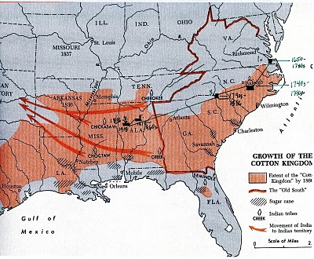

1. 1650 to 1740s - Most of my direct descendants lived in Isle of Wight County and adjoining counties in Virginia. Naturally, many descendants under the names of Holleman, Hollomon, etc. reside in southern Virginia to this day.

2. 1740s to 1790s - Through the parents and relatives of JamesGrantson Holliman, the Johnston County, North Carolina area became home for my branch of the family.

3. 1790s to 1836 - In the 1790s Anson County, North Carolina and Lancaster County, South Carolina (border counties) became the location of this James Grantson Holliman family.

4. 1836 - 1918 - In 1836, three sons of James Grantson Hollimanmoved their families to Fayette County, Alabama. The families of Charles and Cornelius Holliman stayed in Alabama and descendants live in the area to this day. Warren Holliman moved with others to Arkansas, and there remain many Hollimans. Others of these extended families moved to Mississippi, Texas, Louisiana and other parts of the southwest and middle Great Plains.

5. 1918 - 1960s - My generation's grandfather, Ulyss S. Holliman(1884 - 1965), a son of John Thomas, grandson of Uriah and great grandson of Cornelius, moved his family from Fayetteville, Alabama to Irondale, Alabama, a suburb of Birmingham. Several other families migrated to the economic attractions of the 'Magic City' also, including James Monroe Holliman, a brother of Ulyss, and his children. Others of Ulyss' brothers scattered throughout North Alabama; one Bill Holliman, remained in Fayette County, dieing there in 1940.

1960s to the present - While many of my first cousins remain in the Birmingham and North Alabama region, and 2nd and 3rd cousins in Fayette Country area, many grand and great grand children of Ulyssand Pearl Caine Holliman, have relocated across the country living in Chicago, Boston, Pennsylvania, South Carolina, Texas, Virginia, North Carolina, Tennessee, Alaska, Arizona and other states. As with many families, advances in education, transportation and career opportunities have led to the dispersion of formally regionally located kinfolk to every part of the country.

Next Posting, a close examination of life in Isle of Wight County in the 17th Century, and its influence on our family today....
Posted by Glenn N. Holliman at 12:33 PM 1 comments
Labels: Charles Holliman, Christopher Holliman Sr., Cornelius Holliman,James Grantson Holliman, James Monroe Holliman, Ulysses Selma Holliman, Uriah Holliman, Warren Holliman

FRIDAY, DECEMBER 24, 2010

Ulyss and Pearl Caine Holliman Descendants
by Glenn N. Holliman

Christmas in Alabama 1946
A Gathering of the Children and Grandchildren of Ulyss and Pearl Caine Holliman

World War II was over and the soldiers, sailors and airmen had come home to new families and careers. At Christmas time 1946, my Grandmother Pearl Caine Holliman, employed a photographer to come and photograph her family using the new invention of flash bulbs. All her children and their spouses were home, again, for the holidays at 2300 3rd avenue, Irondale, Alabama.

Three of her sons (Melton, Bishop and Ralph) and one son-in-law,(Walter Cornelius) had served over seas during the war. Her fourth son, Euhal, was ordered to a pre-induction physical, but due to his age and number of dependents, he was never called. The other two son in laws - Robert Daly and Charles Ferrell were over age. During the war and in the two years after, all seven children of Ulyss and Pearl became parents, three for the second, third or fourth times (Vena and Robert Daly, Loudelle and Charles Ferrell and Euhal and Edna), and four (Melton and Ida, Bishop and Gerry, and Virginia and Walter Cornelius, and Ralph and Motie) for the first time!

The Baby Boomer Generation was underway, and would not cease for this family until 1956. Bishop, Virginia and Ralph all married during the war. Two of these three marriages would end in divorce decades later. The four marriages made in times prior to World War II survived until the death of the first spouse.

While many of my cousins have grown up enjoying and wondering about this photograph, many of the second cousins have not seen or studied it. Here it is along with commentary of the family. Any errors are mine alone; corrections and clarifications always welcome. There is another photograph made in 1950 which I am saving for another occasion.

Pause and reflect this Christmas season how joyful Ulyss and Pearl were to have this large family, safe and secure, around them that year as the world recovered from war. Imagine that this was happening in other Holliman and related families all across the nation. (Click twice and the picture will enlarge.)
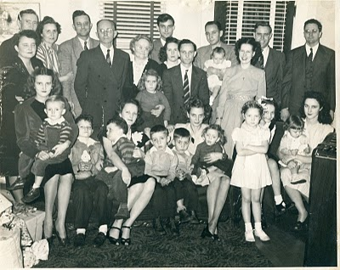Front row, left to right: Mary Daly holding her three year old brother, Robert W. Daly, Jr., Charles Halford Ferrell, next to his mother,Loudelle Holliman Ferrell who is holding John Melton Ferrell. Next are Euhal and Edna's twin boys, Jerry and Terry, and then Edna holding Jean Holliman. Standing tall is Pati (Hairston), Melton and Ida's daughter, and peeking behind her is Carolyn Ferrell (Tatum). Finally on the front row is Virginia Holliman Cornelius holding her first daughter, Nancy Carol Cornelius (Morton).

Back row, left to right. Vena Holliman Daly stands in front of her husband, Robert Daly, the parents of Mary and Bob. The Dalysmarried in 1928. Next Ida has her arm around Melton Holliman, her husband since 1932. The parents and grandparents of this large family are next - Ulyss and Pearl Caine Holliman, married in 1906, when Ulyss was 22 and Pearl 18. They are 62 and 58 years old respectively when this picture was taken.

Grandmother Holliman has her arm around Anne Holliman (Phillips), eldest daughter of Euhal and Edna. Euhal in the stripped tie stands next to his daughter, and just behind him is Motie, the wife of Ralph (tallest in back row). Their first daughter, Pamela, will be born in 1947.

Holding the four month old baby boy on the back row is my father, Bishop Holliman, and next to that baby (yours truly) and smiling broadly is my mother, Geraldine Stansbery Holliman.
Behind Gerry is Walter Cornelius, Virginia's husband, and at the far right, looking distinguished as always, is The Rev. Charles Ferrell, husband of Loudelle since 1935.

Twelve cousins are pictured in this December 1946 gathering. MaryDaly (Herrin) was the first born in 1931; the last born was my sister, Alice Holliman (Murphy) in 1956. Altogether, there would be 19 great grandchildren. Sadly, Grandmother Holliman who died in May 1955 did not live to hold all of them. She dearly loved her family.

Merry Christmas to all of us still living who were present that day and to the additional cousins, children, grand children and great grand children who have come after us! And a grateful and loving remembrance of those who were present in 1946 but who have left the family in this life. God Bless Us Everyone!!!
Posted by Glenn N. Holliman at 2:03 AM 0 comments
Labels: The Family of Ulyss and Pearl Caine Holliman 1946

MONDAY, DECEMBER 20, 2010

Our Family's Colonial Era, Part XII
by Glenn N. Holliman

What Can We Learn from the Will of John Holyman?
I am indebted to Joe Parker, a serious Holliman genealogist, for the material below from the Northampton County, Virginia Record Book, Vol. III, 1645 - 1651, page 448. The work is edited by Dr. HowardMackey and Marlene Alma Hinchley Groves. Opinions and any errors in this article are mine alone.

Below is the will of John Holyman dated May 8, 1650, two weeks before Christopher Holliman Sr. and Judith Holliman arrived in Jamestown, Virginia.
"Memorand That this day ye Last will & Testant' of JohnHoloman of Northampton County, planter, dec'd waspr'ved:
J'No Hollowman his will & desire is that hie giveth unto Christopher Kirke towe cowes & one heyffor with towesteers & one yearlinge, and towe calves & towe sowes & towebarrowes, and more. towe shutes of clothes & a gun w'th a chest & a cutlace, and my Bedd w'th covinge w'th three sheets. As witness my hand this 8 daye of May 1650./ JNo [ his mark ] Hollowman. Wit: Wm Mortt [Mott?]
JNo Hollowman his Acco'tt the 8th day of Maye 1650/ of what Debtes is oweinge him abroad w'thout any spec. asfolloweth, witnes' my hand.
Test: Wm Moulte/ JNo [ his mark ] Hollowman"
Translation? John leaves to one Christopher Kirk two cows, a heifer (a cow not yet giving milk), two steers, a yearling, two calves and two pigs (female). The barrows are neutered male pigs. And he leaves more, which we assume are farm tools. Judging from the above John is a small farmer with a modest amount of livestock, typical for a yeoman planter at that time in Virginia's history. Christopher Kirk fathered a line of successful children and grandchildren, and their story may be explored further in colonial records (just Google the name and time).
What else? Two suites of clothes, a gun, a cutlass, a chest and a bed with three sheets. Okay, John could defend himself from wild animals and Native Americans (was John present in 1644 when 500 plus colonists died, a very serious uprising?).
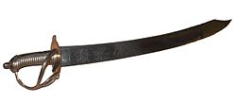Above left a 17th century French cutlass, a curved short sword.

What's missing from this will? Well, number one, every thing is left to a friend and not to a spouse or children (or a brother and sister). If Christopher Sr. and Judith yet had not arrived from England, it is not too surprising that nothing is left to them, if one assumes John is either their father or more likely, their brother. No wife? Women were still scarce in Virginia in 1650, and perhaps this John never married or a spouse may have died.
No mention is made of land? Did John rent land? Possibly unless he had given it away before writing the will, which seems odd. So probably he rented some acres. He was not an indentured servant or he would not have had the livestock. However, he did not have any sheep, so wool or clothe would have been precious. A wife was important for spinning wool and making clothing. Cotton was not yet grown, so clothes, generally all imported, were expensive and highly prized. Hence clothes left to a friend in the will.
No furniture or kitchen items, silverware or other items described. Virginia was not yet a mature or abundant colony. Most English, approximately 15,000 by 1650, were yeoman farmers, struggling to plant Indian corn, some beans and tobacco (as much as possible).
I have searched databases of Northampton County, Virginia and have found no other listing of John Holyman (or similar name) during these times. Northampton is also on the Eastern Shore, the southern most county. Granted this is the entrance to the Chesapeake Bay, but it is some distance by water from Jamestown or Isle of Wight County.
So is John Holyman a possible ancestral uncle? Or as is claimed by one Hollyman web site, the father of Christopher Holyman Sr.?
Let's refresh our memories. Remember these dates and names from my October 14, 2010 posting?
1610 - September 16, one John Holliman baptised. John married a Mary Parrell on July 25, 1641 at St. Mary's Parish, Bedford, England.If this be our John, did Mary make the trip to Virginia with him?

1616 - Thomas Holloman, brother of the above John, baptised at St. Mary's Parish, Bedford on March 20. Is this the Thomas of Martin's Hundred near Jamestown who took land in the 1635? Did this Thomas start the family moving to Virginia when he was only 18 or 19 years old?

1618 - Christopher Hollaman, brother of the above, baptized on September 2. Is this our Christopher Holyman Senior who immigrates to Jamestown in 1650, raises a large family, makes his earthly fortune and dies 1691?! Is this my generation's 8th or 9th great grandfather?

1621 - Judith Holliman, sister of the brothers above, baptised on February 11. Is this the Judith who arrives in Jamestown with a Christopher in 1650 and/or later in 1653?!

Genealogy is not an exact science, and it is so frustrating not to be able to tie these lines of kinship together. My opinion is that this John Holyman is a brother (an not their father) of Christopher and Judith Holyman who arrived in Virginia at the time of John's death. Evidence and logic - yes. Proof? I have none.

Next posting, we shall look at the Holliman migrations across the Southern English Colonies and United States.

Posted by Glenn N. Holliman at 2:35 PM 0 comments
Labels: Christopher Holliman Sr., John Holyman, Judith Holyman

FRIDAY, DECEMBER 10, 2010

Our Family's Colonial Era, Part XI
by Glenn N. Holliman

Some 17th Century Holymans - Who Were They?

Most of us reading this blog are descendants from Christopher Holyman (Holliman, etc.) who was born in England, immigrated in 1650 to Jamestown with a person named Judith, presumed to be his sister, both from either Bedford or Tring, England. Judith disappears from the story, but we know Christopher, Sr. died in Isle of Wight County, Virginia in 1691, having prospered as a planter.

In other blogs, I have shared research by others on ThomasHoleman who in 1635 purchased land at Martin's Hundred, south of Jamestown. There was also one Robert Hollman, who in March 1635 owned land in Henrico County, along the James River. Then there is John Holyman who died in Southampton, Virginia in 1650, a possible brother of our Christopher Holyman and the above Thomas Holeman.

There are still more Hollimans!

Beside the descendants of Christopher Holliman, Sr., otherHollimans also were arriving in the New World. Here is a list I have put together so far, and of course, welcome information, additions and clarification.

1653 - Another Judith Holyman and a secondChristopher Holyman arrived three years after our Christopher Holyman Sr. and the original Judith Holyman stepped ashore at Jamestown. Most genealogists believe they were relatives, perhaps a son, a daughter or a mother?

1656 - On April 25, 1656 one William Holliman arrived, transported courtesy of Thomas Rolfe. Who was Thomas Rolfe? None other than the son of John Rolfe and his famous wife, Pocahontas, the daughter of Powhatan, chief of the tribes when Jamestown was founded. Well....my goodness....By 1658, William Holliman was a land owner. All this from Nell Nugent, Volume 1, pages 328 and 377,Cavaliers and Pioneers.
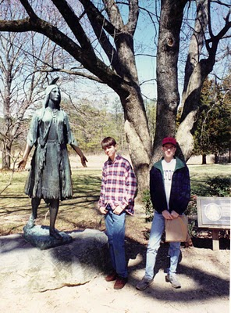Above in this 1994 photograph, my son, Christopher S.Holliman and my nephew, Bryan Payne, pose at Jamestown in front of the statue of Pocahontas. Both are direct descendants from their multi-great grandfather, Christopher Holyman, Sr., who landed at this site in 1650.
1658 - February 26, one John Hollman transported by John Dorrant. A Holliman simply slightly misspelled?

1659 - How about some indentured servants, poor people who bought their passage to Virginia in exchange for years of work? Labor to work tobacco fields was very scarce in the colony. There was Jane Hollyman, unknown family, who on September 10th was ordered to serve her master an extra year at the end of her indenture for running away. This freedom loving female Hollyman had escaped for six months from one William Cox. The county was York, Virginia. Interesting, our Christopher Holliman, Sr. was transported in 1650 by one John Cox. Relationship?

1675 and 1681 - The names of Thomas Hollyman pop up twice, both times in Lancaster County, Virginia as indentured servants. Are they the same person or two named Thomas Hollyman? The second in 1681 is listed as a servant of Lt. Colonel John Carter, ah ha, of the famous Carter family. Later the Carters will cease using indentured servants and instead utilize African slaves. This John Carter will die early eventually leaving the entire family estate to Robert "King" Carter who will become the wealthiest man in Colonial Virginia, acquiring over 300,000 acres and 1,000 slaves. This John Carter got his start in Isle of Wight County in the 1640s, the same country were our direct great grandparents would put down roots.

For citations on Jane and the two Thomas Hollymans, go to the Immigrant Servants Database on the web. Citations in original records are given. A very neat web site where one can cross check numerous family trails.

From whence did these Hollymans come? Bedford or Tring, England? Some other part of the England? Are these distant cousins? Perhaps, probably, perhaps. Joe Parker has identified even more Hollimans who lived in Virginia in the second half of the 17th Century. So there are more stories to tell.

More on Colonial Virginia and the Family of Christopher Holyman, Sr. in the next post....

Posted by Glenn N. Holliman at 4:59 AM 0 comments
Labels: Bryan Payne, Christopher Holliman, Jane Hollyman, John Thomas Hollyman, William Holliman

THURSDAY, DECEMBER 2, 2010

Our Family's Colonial Era - Part X
A Civil War in England and
War with the Dutch in the Chesapeake Bay
by Glenn N. Holliman
Virginia was not immune from the disturbances in England. After the English Civil War, and Charles I losing his crown and head, Oliver Cromwell’s Commonwealth ruled from 1649 to 1660. Robert Berkeley, a long serving royal appointee, was dismissed as governor of Virginia in 1652 when a Commonwealth ship sailed up the James River and demanded Berkeley’s surrender of the colony and his post.
Below Oliver Cromwell, the uncrowned king of England during the Commonwealth Era.
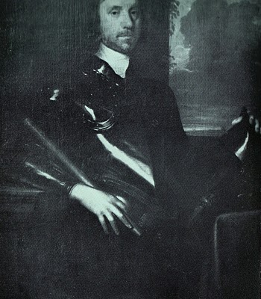
With the restoration of Charles II to the British throne in 1660, Berkeley left his plantation and exile at Green Spring (near present day Williamsburg) and returned to lead from Jamestown, still the capitol.
Violence never was far away from the Hollimans and their farms in what is now Smithfield, Virginia on the Cypress River (a short river which emptied into the Pagan and then into the James) and later the Blackwater Swamp, still in Isle of Wight County. In 1667, a Dutch fleet sailed up the James and burned twenty colonial ships carrying tobacco. Six years later, the persistent Dutch in a continuing trade war with Britain, returned and burned or captured another ten ships.
Did the Holliman’s suffer financial losses as a result of this international war? Did they hear the guns and see the smoke? Undoubtedly the Virginia militia was turned out. Was this long-forgotten naval engagement (and war) the first occasion for Holliman’s to muster in defense of their new country?

Economically the Virginia colony was suffering from a surplus of tobacco, falling commodity prices, restrictive trade laws and increasing taxes. In addition to Dutch and Mercantile wars, the frontier (northern Isle of Wight County was a border) still experienced friction and violence between settlers and Native Americans. If this sounds like 21st Century America, we are reminded that physical and economic security are paramount issues in any community or century.

Next posting, other Hollimans arrive in the Virginia colony....
Posted by Glenn N. Holliman at 12:20 AM 0 comments
Labels: Oliver Cromwell
Home
Subscribe to: Posts (Atom)

SUNDAY, JANUARY 30, 2011

Our Family's Colonial Era, Part XVI
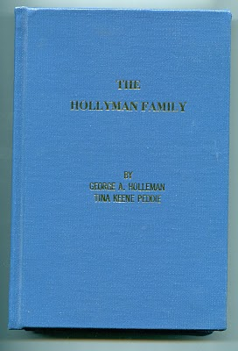
by Glenn N. Holliman

Who Were the Children of ChristopherHolliman, Sr.?

In 1952, George A.Holleman, formerly of Chicago and later Columbus, Mississippi, wrote and published privately a work calledThe Hollyman Family. To my knowledge this work, which was expanded and reprinted by Holliman genealogist TinaPeddie, is the first and still the only comprehensive volume to discuss the founding of our Holliman family and to list hundreds of names of Holliman descendants. It is a monumental piece of research for the pre-internet age. Those of us who are his distant cousins are grateful for this volume, and Tina's work to update it and keep it alive.

The 350 odd page volume is available from Tina Peddie, desabla1@yahoo.com.

In this book George Holleman published, probably for the first time, a list of the children of Christopher Holyman Sr.

They are:

Thomas Holyman - ? to 1734

Christopher Holyman, Jr. - ? to 1731 in Isle of Wight Co.

William Holyman - 1661 - 1704

Richard Holyman - ? to 1711 in Surry Co.

Ann Holyman who married John Atkinson in 1691

Mary Holyman who married James Atkinson (John's brother) in 1691

The genealogists, reports and data I have read seem in agreement that primarily Hollymans, Hollemans, Hollimans, Hollomons, etc. in the United States are descendants of this family. This is not to say that other Hollimans could not have migrated later to other colonies or that other Virginia Holymans, such that have been discussed in other postings, did not leave families also.

However, to my knowledge (and I wish to be corrected if in error), most if and not all Hollimans (and variations) trace their lineage through Christopher Holyman, Sr. Personally, this is my branch, so those of you related to me through grandfathers and great grandfathers are descendants of dear Christopher Sr.

And thank you George A. Holleman for your pioneering work!
Posted by Glenn N. Holliman at 4:25 AM 3 comments
Labels: Ann Holyman, Christopher Holyman, George A. Holleman, Jr.,Mary Holyman, Richard Holyman, Thomas Holyman

THURSDAY, JANUARY 20, 2011

Our Family's Colonial Era, Part XV
by Glenn N. Holliman

The New Life of Christopher Holyman, Sr. in 1650

DNA testing and research both come to the same conclusions that the father of the Holliman family in America (Holleman, Hollomon and other variations) is Christopher Holyman, Sr (1618 - 1691), who landed at Jamestown, Virginia on May 22, 1650.

Unfortunately, we know his first wife only by her first name, Anne, and we do not know how and where Christopher lived during his first decade in Virginia. His name first appears in a legal document in 1660 in Isle of Wight County on the west side of the James River. If ThomasHolyman of Martin's Hundred (assuming he was Christopher's brother, a considerable 'if'') who had arrived in 1635 was still alive, no doubt he may have materially assisted this Holyman in his first years in the New World. Sadly Thomas Holyman is lost to history, and we can only speculate.

Imagine the America in which Christopher settled in 1650. Barely 50,000 Europeans were scattered from Boston to Jamestown, hugging the east coast with a fragile toe hold. There was no Charleston (or South or North Carolina), no Baltimore, no Philadelphia (no Pennsylvania) and New Amsterdam (later New York) was a small settlement at the tip of Manhattan surrounded, as were all colonies, by semi-hostile Native Americans. Only 15,000 or so settlers lived in Virginia, and the roads, such as existed, were mud hollows in wet weather.

Jamestown itself was little more than a village of 30 to 50 cabins and a brick church (see below) that also served as the colonial assembly building. Williamsburg did not exist.
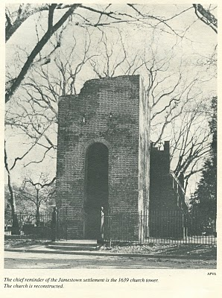
The New World, although blessed with boundless forests, rivers teeming with fish, and savannas ripe with game, was a hostile environment. If one survived the wretched voyage in small ships across the North Atlantic (and on average, one out of four did not), then there was the period of 'seasoning' when immigrants had to face and overcome American diseases such as malaria and yellow fever from Virginia mosquitoes, and the usual small pox and other assorted maladies that took the lives of many. Until settlers established apple groves, there was a lack of vitamin C. Most wells were shallow in the Tidewater with resulting contamination and disease.

In 1650 already enshrined in Virginia law was the requirement that all white men carry muskets when leaving their homes. Powhatan Indians had delivered bloody blows to the encroaching settlements in both 1622 and 1642. In the last encounter, eight years before our Christopher arrived, over 500 Virginia colonists had been slain by Indians. The tension between the two cultures remained real and dangerous.

We know that on January 11, 1661, Christopher and Anne Holymanpatented land along the Cypress River, Isle of Wight County from the founder of Smithfield, Virginia, George Smith. This would be virgin land, not yet exhausted by tobacco. In 1668, Christopher Holyman, this time with a new wife, Mary, would sell the land to Thomas Pittman. Google these names and one will find 'Holyman' and these sales articulated in several web sites.
Several sources besides web sites reveal these early transactions. In addition to Brodie's book I discussed in a previous post, Blanche Adams Chapman's Wills and Administrations of Isle of Wight County, Virginia, 1647 - 1800, Books 1 - 3 contains considerable legal recordings of the Holyman families. Chapman's book (pictured below) is available through Heritage Books, 65 E. Main Street, Westminister, Maryland 21157.
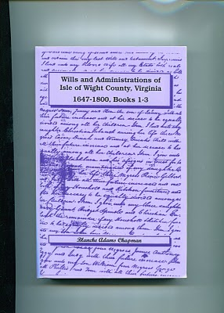
The Story of Christopher Holliman, Sr. continues with the Next Post....
Posted by Glenn N. Holliman at 11:46 AM 0 comments
Labels: Anne Holyman, Christopher Holliman Sr., Mary Holyman

MONDAY, JANUARY 10, 2011

Our Family's Colonial Era, Part XIV
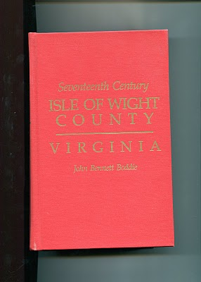by Glenn N. Holliman

The Observations of Historian John Bennett Boddie

In 1938, Virginian historian John Bennett BoddiepublishedSeventeenth Century, Isle of Wight County, Virginia. My 1994 reprint by the Genealogical Publishing Company of Baltimore, Maryland is brimming with abstracts of county records and Boddie'sown history of this part of Virginia in the 1600s. Yes, there are many Holymans,including Christopher Holyman, Sr. and Jr., recorded in this volume, and much to study and upon which to reflect. In the next few postings, I shall pull out and examine some findings that reflect on our family and our country.

Isle of Wight Country had its first English settlers in 1619, one Captain Christopher Lawne responsible for a few pioneers. He represented his fledgling county in the historic first House of Burgess's meeting in 1619. Lawne's settlement floundered, but one Robert Bennett transported 120 settlers to Isle of Wight by 1621.

As I have recorded in earlier posts, the Powhatan Indian Confederacy launched an uprising on Good Friday, March 1622. After the day of murder, only 50 or so English remained in Isle of Wight Country, and 950 so English in the entire colony. English Virginia barely survived, but in recovering the settlers launched all out war on the Native Americans. From 1622 to 1632, annual forays into Indian territory resulted in destruction of many villages and food supplies.

Colonial Virginia was safer for current and future English settlers, and the amount of available land taken by a decade of conquest considerably enlarged frontier borders. TheWarascoyak's tribe of Isle of Wight Country was destroyed in the extensive conflict.

In recording the above, Broddie on pages 84 to 86 notes three important precedents established by the Virginia House of Burgess in that ten year war. I thought them so important to understanding the future of our country, that I record them here.

1624 - Virginia General Assembly required 'that those shall be hurt on service shall be cured at public charge and the lame to be maintained by the county according to his person and quality'.
The care of veterans wounded in combat is enshrined into legislation very early in our history!

1629 - The Assembly gave Plantation commanders the authority and power 'to levy men to fall upon the Indians'. This is the first conscription or 'draft' law in colonial America, a precedent that all future draftees (such as myself in 1968) can appreciate!

1632 - Assembly required that no man shall attend church without carrying firearms or work ground with out arms and a sentinel. In a foreshadowing of the 2nd Amendment to the 1789 U.S. Constitution, later Assembly laws required that white males own a musket, shot and powder. This requirement provided an instant militia and saved money by not requiring a central armory for each county.

More on Colonial Virginia and our family in the next posting....
Posted by Glenn N. Holliman at 1:36 AM 1 comments
Labels: Christopher Holliman, Christopher Holliman Sr., Jr.
Home
Subscribe to: Posts (Atom)

SUNDAY, FEBRUARY 20, 2011

Our Family's Colonial Era, Part XVIII
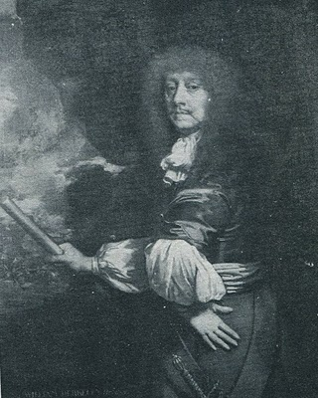
by Glenn N.Holliman

Why theHolyman'swere Caught in the Middle of Bacon's Rebellion

The painting at right is Sir William Berkeley (1606 - 1677), a well-educated Englishman appointed by Charles I during the English Civil War to govern the colony of Virginia. He was successful when he arrived in 1642 to defeat the latest Powhatan Indian attacks and usher in a period of peace. Turned out in the early 1650s by the Commonwealth, he returned with the Stuart Restoration. He grew old in the position and became content with loyal assemblymen from a House of Burgess that sat from 1661 to 1676. Bacon's Rebellion resulted in the burning of his capitol, Jamestown, the loss of his post and eventually his recall to London. He died in 1677 before he could defend his actions before the Court.

In the 1671 Surry County, Virginia Record Book, p. 2 is this fascinating insight into our family and the Virginia colony on the eve of a great civil rebellion. It is recorded in George A. Holleman'soriginal history of Hollymans in 1952.

"Att a courte houlden att Southwarke for he County Mar. 5, 1671...Upon complaint of Christo Holiman itt manifestlyapearinge that the Coppahunck Indians have kild two hoggs of ye saidHoliman. Itt is ordered that Capt. Pipsicoe within thee months make payment unto ye said Holiman of Six Buck and Six doe well drestSkins & in Case itt doe apeare heere after that any Indian shall Kill anyhogg or hogs of ye English that they shall pay for every Hog by themKild twnety Buck skins."

Well, what to make of this?

1. Surry County, founded from James City County in 1647, lies just north and west of Isle of Wight County.

2. The parish of Southwarke was located across the Isle of Wight County line. The plantation of Christopher Holyman straddled the county lines, and his theft occurred in Surry County. Many Holymandescendants will move into Surry County and from there to Johnston County, North Carolina in the 1700s.

3. The Indians were Quiyoughcohanocks (Cohanocks), allied with the Algonquian Powhatan Confederacy. This tribe had participated in the Good Friday Massacre of 1622 which almost wiped out the Virginia colony.

4. Subsequently, the Virginia House of Burgesses had passed draconian legislation that any Indian who crossed the BlackwaterRiver could be shot on sight! The Holyman plantation was (and parts of it still are) adjacent to Surry County and the Blackwater River.

5. The 1670s saw considerable Indian unrest up and down the eastern seaboard. In 1675 the tension burst into King Phillip's War in New England. Thousands, both white and red, died in the greatest outburst of violence to that date in the English colonies.

6. As in New England, the increasing dissatisfaction with the population increase of the English settlements, let to Indian resistance in Maryland and Virginia. The population of Virginia more than doubled from 15,000 to over 30,000 by the 1670s further encroaching on Indian lands.

7. The theft of hogs from the Holymans was a typical incident between the English and Indians. The English, who went armed and hunted deer for food and hides (a valuable commodity), evidently had little sense they were reducing the caloric intake possibilities of Indians. Indians felt that since whites could enter their hunting lands, and take game, they were entitled to enter English farms and take livestock! Tit for tat one would say.
The Hollimans and other colonialists did not see it that way.

Multiply these incidents by the dozens, add indiscriminate murders by both colonists and Native Americans, mix with land hunger by the English and decrease of hunting land by the Indians, and one has the recipe for another Indian War. In fact a murder of Nathaniel Bacon's overseer near Richmond, Virginia triggered a vigilante response led by Bacon. A peaceful Indian village near the North Carolina border was wiped out, and Indian women and children brutally murdered by Bacon's irregulars.

This was in defiance of Governor William Berkeley, a long serving administrator who wanted to build forts rather than unleash the militia. Those living on the edge of the frontier, presumably including the Holymans, desired immediate offensive action against Native Americans. Although Berkeley was furious with Bacon's actions as he had tried sincerely to maintain the peace, the rugged take-charge, take-no-prisoners attitude of Bacon attracted many colonial adherents.

Bacon also demanded reduction of taxes on tobacco, the money crop for almost all colonialists. Tobacco prices had plummeted in the recent decade due to too many settlers growing too much ofNicotiana tabacum. The English Navigation Act of 1663 forbade the colonists from trading with any nations other than the English. With Dutch and Spanish markets cut off directly from Virginia, there were fewer outlets and competition for the increasing supply of tobacco. Yet while income went down, taxes remained the same.

Something had to give.

Give it did with Bacon's Rebellion, a toxic brew of racial strife, physical fear, land lust and a burdensome tax load. Planters such as the Holyman's had to be sorely tempted to use force to defend the frontier and do something to reduce taxes. Some of the Holymanneighbors did join Bacon, and the result was strife in and around Isle of Wight County.

The Holymans, caught between two forces, remained loyal to the Crown.
Posted by Glenn N. Holliman at 1:52 AM 0 comments
Labels: Christopher Holliman Sr., William Berkeley

THURSDAY, FEBRUARY 10, 2011

Our Family's Colonial Era, Part XVII
by Glenn N. Holliman

Bacon's Rebellion - The Virginia Civil War Before the American Revolution

Some have called it the precursor to the 1776 Revolution, only one hundred years earlier. Actually, my reading of the violence and pain of 1676 Colonial Virginia is more of that of a Civil War. Two factions, one wealthier and in power, and the other less wealthy, less powerful and feeling physically threatened by Native Americans, clashed over taxes and 'homeland' security.

The insurgents, hundreds of white and some Black young men, rallied around Nathaniel Bacon, age 32, a cousin by marriage to the Virginia Royal Governor, and a planter near the Falls that is now Richmond, Virginia. A number of issues led to Bacon's revolt which resulted in brutal attacks on Indian villages, the rousting of the Royal Government and the burning, of all places, Jamestown, the capitol. Many died and many were hung by a recovering Royal authority.
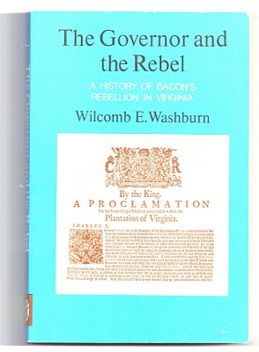
Were Christopher Holyman, Sr., a planter with a thousand acres or so, and his children caught up in these events? Yes, they were. The Holymans had some legitimate grievances, but when push came to shove, they opted to support the Royal Governor, one William Berkeley. For that no Holyman swung by their necks as did 22 rebels in the autumn of 1676, including a few of their neighbors.

Still the standard for understanding Bacon's Rebellion is Wilcomb E. Washburn's 1955 work. It is fair, balanced and points out the issues on both sides.

Numerous historians have provided excellent interpretations of the events of the rebellion such as Alan Taylor's, American Coloniesand especially Edmund S. Morgan's American Slavery, American Freedom.
Next Post, the Rebellion and Why the Holyman's were Caught in the Middle....
Posted by Glenn N. Holliman at 11:21 AM 0 comments
Labels: Christopher Holliman Sr., Nathanel Bacon
Home
Subscribe to: Posts (Atom)

WEDNESDAY, MARCH 30, 2011

Our Family's Colonial Era, Part XXII
This continues a series of articles by cousin Robert Holloman, a B.A. in history from the University of Virginia. In the previous article Robert explored our possible royalist connections in the English Civil War. In this post, he presents information and raises questions on who transported our ancestors to Virginia. Again evidence points one in the direction of Bedfordshire, England as the origin of the Holliman (and various spellings) families in the New World. - Glenn N. Holliman
Who were the Sponsors of the First Virginia Holymans?
by Robert Holloman
In regards to the early settlement of Holymans in Virginia, I have been attempting to track down information on the named sponsors of Judith and Christopher (and William in 1656) Holliman. According to records, these sponsors were John Cos(x), Thos. Wilkinson, John Sherlock and Thomas Rolph (William's sponsor). In May 1650, John Cox received 1,000 acres of land in Northumberland County on the south side of the Rappahannock River, for the transport of twenty persons including two John Coxes, Elizabeth Cox, Xtopher Holleman and Judath Halloman.
Below in the center of this map by Joshua Fry and Peter Jefferson in 1751, one will find Northumberland and Lancaster Counties. Just below the left red line is the Rappahannock River; above are Lancaster and Northumberland Counties. Click on the map to enlarge.
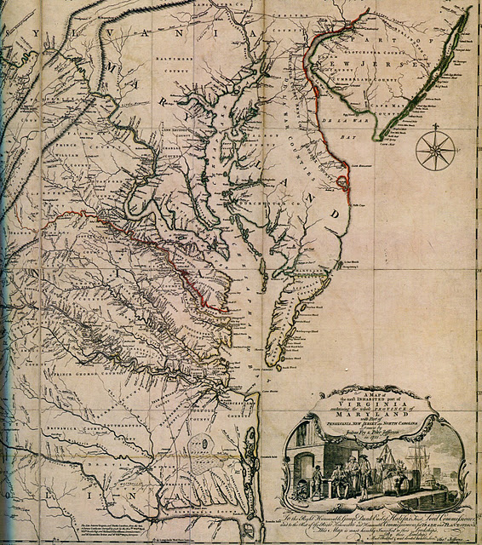

In August 1653, John Sherlock received land in Lancaster County (which was created from Northumberland County in 1652) for the transport of three persons that included Epper a (possible corruption of Christopher?) Holliman, and another grant in November 1653 for the transport of four persons that included both Judith and Christoper Holliman.

A possible connection to both John Cox and Christopher Hollyman is a Vincent Cox who was transported to Virginia as an indentured servant to a Richard Cole on the ship Honor in October 1649. His birth in 1632 can be traced to Bedford. His father was Henry Cox, and he had a younger brother, John Cox but that brother died ten days after birth in 1634 according to Bedfordshire record. In 1653 Cox and Cole legally disputed the end to his term of indenture and that legal fight provides us today the detailed record to trace his passage from England. After winning his release, Vincent Cox settled in Westmoreland County (which was also created from Northumberland County in 1652) and later would receive land in both counties several times in the 1660s.

Both the Wilkinsons and the Coxes are known to have property in Isle of Wight County in the time period of Christopher and Judith's arrivals. The Cox and Wilkinson families later intermarried.

There is a recent 2006 (expanding a 1996) book on the history of the Wilkinsons entitled The Wilkinsons of Isle of Wight, Surry and Sussex Counties and Related Families (including Cox) by Gene Cox Wilkinson and George Carroll Wilkinson. I have recently attempted to contact the authors to see where in England these families had originated and any information on Cox and Wilkinson's activities in the years of Christopher and Judith, but have had not had success as yet.- Robert Holloman
More in the next post concerning possible Royalist connections....

Posted by Glenn N. Holliman at 9:32 AM 0 comments
Labels: Christopher Holliman Sr., Judith Holyman, William Holliman

SUNDAY, MARCH 20, 2011

Our Family's Colonial Era, Part XXI
by Glenn N. Holliman
Were the Holymans Royalists Escaping the English Civil War?
Part I by Robert Holloman
Why did the Holymans come to Virginia at the time they did? A descendant of Christopher Holyman, Sr., Robert Holloman, who holds a B.A. in history from the University of Virginia, recently shared this hypothesis with me. With his permission, I share it with the larger family. This is interesting reading, and points out more research is needed. This is part one of several articles. - Glenn N. Holliman
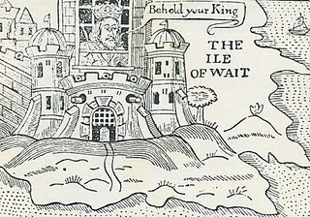
Ironically near the end of the English Civil War in 1648, the English King, Charles the First, was incarcerated by Commonwealth troops on the Isle of Wight, England (not of course Isle of Wight County, Virginia where the Holymans were to live). In this political cartoon Isle of Wight is labeled the Ile of Wait as the leaders of the rebellion, Oliver Cromwell, and others were trying to decide what to do with the defeated King. A court found the King guilty of treason, and he went to the executioner's block (see below).
One approach I have recently been exploring is to investigatewhether there is a connection between the events of the English Civil War and the emigration of the Hollimans to Virginia. Bedfordshire, England is an area that gave strong support to Parliament against King Charles. If the Bedford Hollimans were royalist supporters, there may be records of fines they paid since royalists were required to pay to Parliament to either avoid military service or to support Parliament's campaigns.
As John, Thomas, Christopher and even Stephen Holliman of Bedford would have been of age to serve in the military, there may be records that reveal if any had served and in what capacity. The National Archives at Kew has a guide to researchers about records it holds of the English civil war and other potential sources - http://www.nationalarchives.gov.uk/records/research-guides/civil-war-soldiers.htm.
Could John Holliman have been a Royalist Supporter?
John Holliman's emigration to Virginia and his possession of a cutlass as evidenced by his will (1650) intrigues me. As we know, Virginia (and Maryland) remained supportive of royalists through 1651 when Cromwell sent a fleet to suppress Virginia. His representatives replaced the governor, William Berkeley, who had been appointed by Charles in 1641. This is the same William Berkeley who later in his second stint as governor would pardon Christopher Hollyman and his son after Bacon's rebellion in 1676.
I think if John (Holyman who died 1650) had emigrated from England in the 1640's, it could be he was a royalist supporter. Northampton County in Virginia where he died had previously been called Accomac Shire and was renamed Northampton County by the Virginia colony in 1644 to honor Lord Compton, Earl of Northampton, a royalist military leader who died at the battle of Hopton Heath in 1643.
Judith and Christopher Holliman - Royalists or Puritans?
Another interesting question for me is reconciling the multiple Jamestown landing records for Christopher and Judith Holleman. As there are records indicating both Christopher and Judith's arrivals in both 1650 or 1653, to me these two dates represent very different political regimes in the Virginia colony. The unapologetic, royalist era ended in March 1652 when Richard Bennett became governor. He was one of the few Puritans in the Virginia Land Company and also part of a major founding family in Isle of Wight County that over the years recruited hundreds of settlers to Virginia.
While there is strong evidence that the marketing campaigns of the Virginia company and its landholders presenting Virginia as a paradise attracted Englishmen of all persuasions between 1645 and 1670, the change of Governors in 1652 may have resulted in the perception of greater opportunity in Virginia for those who had supported Parliament and Puritans in particular. - Robert Holloman, a multiple great grandson of Christopher Holliman, Sr (d 1691)
The King represented Divine Right rule. Parliament forces fostered representative democracy. The Royalist forces were eventually defeated in battle, the King imprisoned and tried for treason. King Charles I lost his head (see below) and the Commonwealth came into being. In 1660 the monarchy was restored and King Charles II came to the throne. The Stuarts always had troubles with various Parliaments and in 1688, James II was forced from the throne. He fled to France rather than losing his head (literally) as had his father..
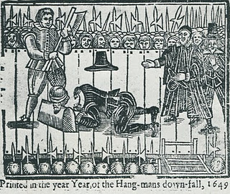
Comment on the above intriguing article by Robert Holloman, distant cousin, is most welcome.....Another article on possible Royalist connections continues in the next posting.
Posted by Glenn N. Holliman at 2:36 PM 1 comments
Labels: Christopher Holliman Sr.

WEDNESDAY, MARCH 9, 2011

Our Family's Colonial Era, Part XX
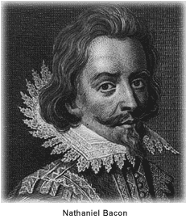
by Glenn N. Holliman

The Empire Strikes Back

With the premature death of Nathaniel Bacon, the rebellion in 1676 in Colonial Virginia began to die for lack of leadership. Royal Governor William Berkeley returned from exile on the eastern shore of Virginia, and began to reek vengeance with a rope. Before King Charles II and his new colonial appointees could stop the aged and angry governor, over 20 rebels went to the gallows.

When news of the rebellion reached London, the King and his council responded dynamically. For the first time in Colonial American history, troops from England entered the colonies to restore law and order and suppress a rebellion against the Royal Government. Over 1,000 British soldiers arrived with new civilian leadership in tow. Berkeley was summarily dismissed, and sent back to England to explain the rebellion and his actions. Before he could appear before Council, he had the good fortune to die of natural causes.

King Charles II, whose government had grown dependent of taxes from Chesapeake tobacco, was furious that Berkeley and his government had 'squeezed' the tobacco planters too tightly. The ability of the Crown to collect taxes had been jeopardized, and the complaints of the planters had best be addressed.

Virginia historian John Boddie reports that over 80 enlisted men and their officers were billeted in homes in Isle of Wight County for up to a year in 1677 and 1678. As in the 1770s in Boston, Massachusetts having civilians board soldiers quickly created stress and a financial burden on the home. Rowdy troops rapidly wore out their welcome. Here in America for the first time were planted the seeds of the 3rd Amendment to the Constitution.

Perhaps the presence of troops encouraged both Christpher Holyman Sr. and Jr. to join seventy or so of their fellow Isle of Wight citizens to sign a 1677 petition begging the pardon of the Royal Government and pledging loyalty to the same.

Again from John Boddie, "We humbly beg and lay hold of His Majesties most gracious Pardon, for as much as we, or some of us, at sometime or the other, since this Horrid Rebellion through fear, force or otherwise, deviated from our duties and allegiance to His Most Sacred Majesty."

This bit of public crawling seems to have moderated some of the anger of the new governor, Herbert Jeffreys, who wanted nothing so much as the planters to return to their fields and generate both tobacco and tax revenues. Our Holymans, caught in the middle of a vicious civil quarrel, survived and continued their lives as farmers along Blackwater River branch known as Middle Swamp.

We can surmise Christopher Jr's birthday as he had to be at least 21 to sign the petition. He now has officially appeared in a public record. In future postings, we will attempt to trace his life.

Next post, More on the Holyman family of Colonial Virginia.....
Posted by Glenn N. Holliman at 6:59 AM 0 comments
Labels: Christopher Holliman Jr., Christopher Holliman Sr.

TUESDAY, MARCH 1, 2011

Our Family's Colonial Era, Part XIX
by Glenn N. Holliman

The Rebellion Close to the Holyman Plantation

By the fall of 1676 Nathaniel Bacon's revolt had attracted hundreds of adherents, some who took delight in ransacking the homes and plantations of wealthy planters. A few of the rebels were of the planter class themselves, the most visible to history being one William Byrd, whose descendants would prosper financially, leave diaries and a political dynasty. (In the 1700s one Mary Byrd of this family would marry a grandson of Christopher, Sr.)

Other rebels, hundreds of young men in fact, were indentured servants and African-American slaves, an interesting mingling of persons, generally of a less economically prosperous class. The presence of armed Blacks during this period would later result in the House of Burgess passing highly restrictive slave codes in Colonial Virginia. As far as this writer knows this would be the last time that poor whites and Blacks would make common cause against a white power structure in Southern history prior to the Civil War. For the next several hundred years, white racial prejudice would overwhelm the common economic interests these two groups could have shared .

Isle of Wight and neighboring Surry County produced both supporters of Bacon and defenders of Governor Berkeley. Historian John Boddie in his work 17th Century Isle of Wight records numerous conflicts amongst neighbors and the forces of the Crown and the rebellion. A Major Arthur Allen, a prominent Crown supporter, fled his home near the James River, not fifteen miles north east of theHolyman plantation. Constructed in 1665, and still one of the finest examples of 17th Century Jacobian architecture remaining in the western hemisphere, the home was occupied for four months in 1676/77 by William Rookings, other commanders and up to seventy supporters of Bacon.
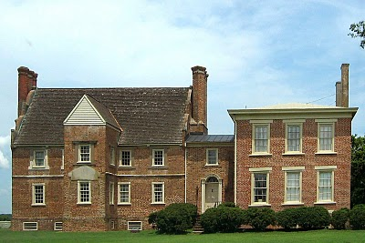
The rebellion collapsed in the late fall of 1676 after Bacon died of dysentery, and his body buried in the York River. Allen recovered the home in 1677 and later sued the occupants of his home for damages. This wealthy neighbor of the Holymans would not doubt be angry that his residence has become known as 'Bacon's Castle' after his nemesis! Today the home is on the National Register of Historic Places, is administered by the Association of the Preservation of Virginia Antiquities and is open to the public. Google Bacon's Castle and view the home and read its history.

Bare in mind, this is one of the few examples of 17th Century brick construction surviving in North America. The Holymans and 99% of other Virginians at the time were living in unpainted wooden structures that in a short time disappeared to natural decay or fire. Virtually no 17th structures remain in Virginia. Bacon's Castle is one of the few.

During your next trip to Jamestown and Williamsburg, do cross west over the James River, visit the museum in Smithfield, the Holleman home near the Mill Swamp Baptist Church in Isle of Wight County and nearby Bacon's Castle.

Next posting, the Empire Strikes Back!

Posted by Glenn N. Holliman at 5:41 AM 0 comments
Labels: Christopher Holliman Sr.
- by Glenn N. Holliman This is the second post of an on-going ser...

MONDAY, APRIL 25, 2011

The Hollimans of Alabama
by Glenn N. Holliman

Back to the 19th Century...A Series of Articles on the Hollimans and Related Families of Fayette County, Alabama
Below are observations by Holliman family historian, Glenda Norris. She credits much of her knowledge to Dr. Rhodes Holliman, her uncle. It was Rhodes who, as a boy in the 1930s, would hike several miles into the piney woods, dodging more than a few snakes to re-discover the location for the family. Several monuments now mark this spot.

Glenda Norris reports:
"Charles Daniel Lucas, Jr. was the son of Charles Daniel Lucas, Sr. and 'Dorcas' (no last name has been found). It is believed that the mother of Charles Daniel Lucas, Jr. could be a Catawba Indian from the Pee Dee River area in Marlboro County, South Carolina. She was only 13 years old when she married Charles Daniel Lucas, Sr., a tailor. Their son, Charles Jr., was born on June 30, 1771 and died May 31, 1853."

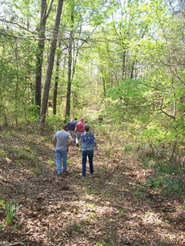
Above, on April 9, 2011, Holliman and Lucas descendants take the trail to the Lucas and Indian graves which are located several hundred yards through the woods off County Road 100 in south Fayette County.
"Charles Daniel Lucas, Jr. was a traveler and migrated from South Carolina to Alabama before the Holliman brothers. His first homestead was in Marengo County, Alabama where he purchased 80 acres on October 20, 1823 and then 80 more the next spring. Two years later, he established a homestead in Fayette County, and still ambitious, 40 acres on October 16, 1834 in Tuscaloosa County.
The Fayette and Tuscaloosa properties were connected, almost touching Highway 171 on its east side. He was a deacon at the Spring Hill Baptist Church in Tuscaloosa County. A monument at the church celebrates he and Cornelius Holliman, a son-in-law, as ‘founders’ of this church.
Charles Jr. earned his living 'stock dipping' and as a Federal Indian agent. Newtonville, Alabama straddled the line between the territory of the Chickasaw (north) and the Choctaw (south). By 1836, all these land claims were extinguished. In a dreadful and, even in that day, controversial act, most of the Native Americans remaining were removed to Indian Territory (present day Oklahoma).
With the dispersal of the tribes, the Federal government sold the land to immigrant families from the south east U.S. - the Hollimans, Lucases and other associated families.
Charles Lucas, Jr. claimed to be ‘black Dutch’, a term at the time to obscure one's possible Indian ancestry but this has not been proven, only speculated. He was a man of large stature (6’4” - 6’6”) and had great strength. It has been passed down through generations that Charles Daniel killed a panther with his bare hands.
His burial site is in southern Fayette County, Newtonville area off of County Road 100 (Walnut Lane). At one time this land belonged to Charles Jr. and his home was not far from the burial site. His grave is on a ridge line, over looking a ravine. The site is an Indian burial ground as he chose to be buried with his friends."
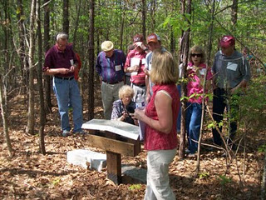
Glenda Norris, foreground, provides information at the internment site and memorials to Charles Daniel Lucas, Jr. The site contains numerous Choctaw or Chickasaw Indian burials, disturbed in an earlier century by grave robbers.
"Charles Daniel Jr. was married to Mary Hasten (in some places spelled Hastings). They had 10 children together. Family historians suggest that Charles Daniel ‘over disciplined’ one of his children with his cane. This did not go over very well with his family and because of his temper, his wife, Mary and the rest of his children left him and moved to the Bluff community. Due to this estrangement Mary Hasten Lucas was buried at the Spring Hill Cemetery, 20 or so miles north of this pioneer’s resting place."

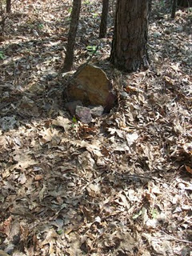
This original stone marker stands on the burial site of Charles Daniel Lucas, Jr., pioneer and Indian agent, who helped open Northwest Alabama to Anglo and African American settlement in the early 19th Century.
When Charles Daniel Lucas, Jr. was born, George III, was sovereign over the American colonies. When Charles Jr. died, Franklin Pierce had just become president of the United States, a union on the verge of dissolving."

For additional information on Charles Daniel Lucas, Jr., go to Archives and the February 13 and 26, 2010 editions of this blog. Rhodes Holliman incorporated his own research and that of his father, Cecil Holliman and the late Walt Holliman to create some excellent articles that are available for all to read. Some of the general information for these postings comes also from Robert Scott Davis's book, "Tracing your Alabama Past" (University of Mississippi Press, 2003).

More soon on the Holliman migrations across the Southern United States from the 17th to the 19th Centuries....Information and your written insights always welcome as we share together.
Posted by Glenn N. Holliman at 7:25 AM 0 comments
Labels: Charles Daniel Lucas, Glenda Norris, Mary Hasten Lucas

WEDNESDAY, APRIL 20, 2011

Our Family's Colonial Era, Part XXIV
Joe Parker is a diligent researcher of Holliman family history tracing his ancestry back to Christopher Holyman, Sr. He has facts at his finger tips on the family from the early 1600s in Bedford, Bedfordshire to his 21st Century relatives in his home state of Texas. Below, he shares his observations on just who those early Holymans were and what could their relationships be to one another. - Glenn N. Holliman
Christopher, Judith and John Holliman, some Additional Information concerning their Emigration to Virginia
by Joe Parker
The Headrights of Christopher and Judith Holyman
In 1650 when they arrived in Jamestown, both Christopher and Judith Holyman received head rights to acreage in the Virginia Colony. My understanding is that when a man received a head right to any block of land, the wife also has ownership of that tract, by privilege of being married to the man who received the acreage.
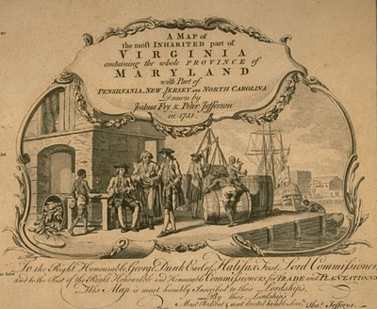
This 1751 work depicts a colonial dock with hogsheads of tobacco on the wharf. West bound from England, the ships would carry English goods and immigrants. East bound from Virginia to England, tobacco in casts would be the item transported.
Why then would - Judith in this case - receive separate notice of receiving such acreage, unless she was possibly recipient of such land as a separate individual? Conclusion, Judith was not the wife of Christopher, but yes, as the Bedfordshire English parish records indicate, more likely was his sister. - Joe Parker
Genealogist Robert W. Baird in his web site Understanding Headrights publishes the following which helps us to grasp more fully some of the reasons our Holymans might have come to the Virginia colony.
"The headright origin is found in the London Company’s “Greate Charter” of 1618:

“That for all persons…which during the next seven years after Midsummer Day 1618 shall go into Virginia with the intent there to inhabite, if they continue there three years or dye after they are shipped there shall be a grant made of fifty acres for every person… which grants shall be made respectively to such persons and their heirs at whose charges the said persons going to inhabite in Virginia shall be transported…”

- There were no restrictions on age or gender. Headrights could be, and often were, children. In fact, many imported indentured servants were teenagers.
- Persons settled in Virginia who subsequently left the colony and returned were sometimes successfully claimed as headrights. A number of patents claimed importation of a specific person “the second time” or the “the third time” (or in one case, a total of six times.) Although this seems contradictory to the spirit of the system, it appears to have been an accepted practice from the very beginning, for several Ancient Planters claimed multiple rights for their own arrivals in Virginia.
- Because there was no system for validating or accounting for headright usage, headrights were often claimed more than once, and persons who had no “intent to inhabit” were used as headrights. More on this later.
Hmmm....much to consider here as we look not just to the mid-1600s, but also the late 1600s and early 1700s and see the Holliman family utilizing the 'headright system'. - GNH

Keeping an Open Mind on just Who was John Holleman
As to John Holleman, who died in 1650 in Northampton County, Virginia, I have an open mind on this individual. The fact that he left no worldly goods to any children should be looked at carefully. He may have divided his fortune with his children (if any) before his death, and this could have left him virtually penniless at death. John left his remaining goods to a friend who would help to settle the estate. Conversely, this John Holleman could have been the husband of Judith, who arrived two weeks after his death in Virginia. Or John could have been her brother, born 1612 in Bedford, Bedfordshire, England.
I am not forming any set opinions until we search more in the Bedfordshire Archives and study additional works. For now, I will return to my review of passenger lists of boats arriving in the Virginia Colony in the 17th and 18th Centuries. - Joe Parker, Texas
Posted by Glenn N. Holliman at 9:13 AM 0 comments
Labels: Christopher Holliman Sr., John Holyman, Judith Holyman

MONDAY, APRIL 18, 2011

The Hollimans of Alabama
by Glenn N. Holliman
Back to the 19th Century...A Series of Articles on the Hollimans and Related Families of Fayette County, Alabama
By 1836, several sons of James Grantson Holliman (1750 - 1836) and other associated families had migrated to Fayette County, Alabama from Lancaster, South Carolina. Cornelius (1792 - 1862), Charles (1795 - 1850) and Warren Holliman (1801 - 1876) were part of the westward movement of the American nation and my family in the 19th Century.
Warren would later move on to Arkansas and father many Holliman descendants in that part of the United States. Cornelius, Charles and many of their descendants remained in Fayette and adjoining counties. Many others went to Mississippi, Louisiana and Texas.
An Excursion into History....
On April 9, 2011, Glenda Norris, a descendant of James Grantson and Cornelius Holliman families, led fifteen of her distant cousins through the cemeteries of her many great grandparents to share their stories. She would be the first to tell you that she stands on the shoulders of her grandfather, Cecil Rhodes Holliman, and his son, her uncle, Dr. Rhodes Holliman. The research about to be shared comes from their hands and also of the late Walt Holliman, a descendant of James Grantson and Charles Holliman, his son.
Glenda Norris reports:
"The first stop of the tour was Charles Daniel Lucas, Jr. burial site. It was unseasonably hot for April (92f) even for the Deep South. But that didn’t slow anyone down. Everyone was more than willing to take a short ‘hike’ into the woods, up a small hill and then a left turn into the forest to view the ‘old Indian burial ground” where Charles Daniel Lucas, Jr. gravesite is located.

Here is a photo of everyone getting ready to make the walk. Left to right are: Jeanette Holiman Stewart (Austin, Texas), Glenn Holliman (Newport, Pennsylvania), Lenwood Holliman (Gordo, Alabama), James Franklin Holliman (Sulligent, Alabama), Bishop Holliman (in cap from Avilla, Indiana and the oldest at 91), Laura Vonceil Duckworth (Reform, Alabama), Wally and Tommie Holliman (Irondale, Alabama), Faye Gardner (Kennedy, Alabama), Bill Holliman (Horn Lake, Mississippi), Jean Holliman (Irondale, Alabama), Joey Holliman (Florence, Alabama) and Tyler Duckworth (Tuscaloosa, Alabama and at age 15, the youngest on the trip). Obscured is Robert Holliman and taking the photograph is Norman Holliman (both brothers from Marysville, Tennessee)."
All the above are either descendants of Charles (about 1795 - before 1850) or Cornelius Holliman (1792 - 1862). Of course, all have the DNA of Christopher Holyman, Sr. (1618 - 1691), the Englishman who left Bedford, Bedfordshire and immigrated to Jamestown, Virginia in 1650.
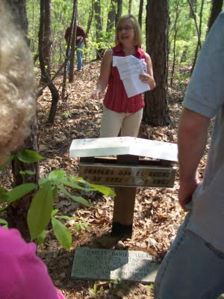
Above, Glenda Norris shares information at the grave site of her 4th great grandfather, Charles Daniel Lucas Jr. whose daughter,Mary 'Polly' Lucas married Uriah Holliman, a son ofCornelius Holliman. Below, Glenda points out a Creek Indian burial site. Charles Daniel Lucas, Jr. was a Federal Indian agent and may have been the son of a Catawba Indian mother from South Carolina. When he died, he requested to be buried with his Native American friends. His wish was granted and he lies today sharing the sandy soil with first Alabamians.
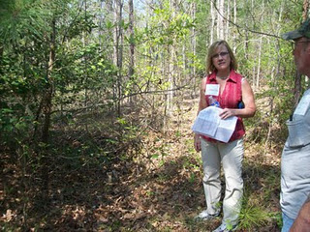
Next post on Fayette County, Glenda provides detailed information on the Lucas family....
Posted by Glenn N. Holliman at 7:14 AM 0 comments
Labels: Bishop Holliman, Charles Daniel Lucas, Glenda Norris

SUNDAY, APRIL 10, 2011

Our Family's Colonial Era, Part XXIII
Exploring Further Possible Connections Between the English Civil War and the Early Holymans of Virginia
by Robert Holloman
During the past several articles, Robert Holloman, a descendant of Christopher Holyman, Sr., has been exploring connections between participants in the English Civil War and the arrival of the Holymans to Colonial Virginia. In this posting, he proposes additional evidence that suggests the Holymans were sympathetic to Charles I's forces in the fight with Parliament. One remembers Charles I was executed in 1649, and many of his supporters fled the country. Were some who fled the Holymans? - Glenn N. Holliman
My premise that the English Civil War sparked the emigration of Christopher Hollyman (and/or Judith) to Virginia is obviously not original as many families trace some of their American roots to this period. Documenting the Hollyman (Holyman, Holliman, Holloman, etc) migration is challenging. I have scattered notes and quotes about the topic that I continue to try and arrange in manageable order.
One is struck by comments such as in Richard L. Morton's Colonial Virginia, Vol. I, the Tidewater Period 1607 - 1710 (UNC Press, 1960) where on p. 166 is stated: "After Prince Charles's defeat in 1651 at Worcester, 1,610 Royalist prisoners were granted their request to be sent to Virginia." Although Charles's army was predominately Scottish and not English at Worcester, prior to the battle his army had grown by the influx of English royalist supporters as it had moved south into England from Scotland.
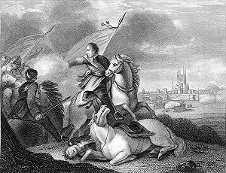
This 19th Century engraving depicts the success of Oliver Cromwell and his forces over the future Charles II at Worcester, England in 1651. After the battle, Prince Charles escaped and hide for a while in an oak tree, since known as the 'Royal Oak'. Cromwell died in 1658 and in 1660, the Stuart family, Charles II, was restored to the throne of England.
Parliament decreed in September 1651 that all prisoners below the rank of Captain were to be sent to the plantations. Prisoners from Chester, Worcester, Liverpool and Shrewsbury were sent to Bristol for transportation to Virginia and Bermuda.
A large number of these left with the annual Virginia fleet in the fall of 1651. This fleet would join with Sir George Ayscue's fleet in Barbados where he was engaged in fighting to subdue Royalist forces that were then controlling the colony.
In December, Ayscue hired 150 prisoners from the fleet to join with his marines for a successful assault on Speight's Town. In January 1652, Barbados submitted to Ayscue as the Virginia fleet continued to Jamestown. The Virginia arrival of the Worcester prisoners is captured in the record of arrival of 270 prisoners from the ship including some of my non-Holliman ancestors, John and Sarah Bridger, who entered the colony as indentured servants. I cannot find any Hollimans on the list but I can not be totally certain because many names are not legible.
I have found other interesting connections between the English Civil War and Christopher Hollyman. One of the first records of Christopher Holyman, Sr in Virginia is his granting of power of attorney to Thomas Pittman in 1660. According to Pittman family websites, Thomas Pittman was a royalist officer who arrived in Virginia in 1649 from Monmouthshire, England. Furthering this connection between the Pittman and Holyman families, his grandson, Thomas Pittman III would later marry Christopher's son William Holliman's widow, Mary Chambers Holliman in 1704.
As my descendants continuously lived in Virginia and North Carolina though my father and mother's generation, through the years I have discovered other members of my families who were Royalist immigrants. For example, Joseph Bridger, who was born in Dursley, Gloucestershire, was a Royalist officer. Joseph Bridger arrived in the mid-1650s and is known to have brought several supporters with him to Virginia. After arrival he would prosper and become one of the leading citizens of Isle of Wight County.
His descendant Sarah Bridger, my 2nd great- great grandmother married my 2nd great-great father Jesse Holloman in 1867. Another descendant of mine, Thomas Carter, Sr, a Royalist arrived in 1650. Charlotte Carter is my 4th great-grandmother.
Although I am skeptical that each story of a royalist emigrant to Virginia between 1645 and 1660 has a basis in fact, I argue that given the dates of Christopher Holyman's arrival in Virginia, that the English Civil War had to have played a prominent roll in the decision to emigrate. Hopefully, with more research, a data trail can shed further light on this proposition. - Robert Holloman
Posted by Glenn N. Holliman at 1:12 AM 2 comments
Labels: Christopher Holliman Sr., Jesse Holloman, Joseph Bridger,Thomas Pittman
Home
Subscribe to: Posts (Atom)

TUESDAY, MAY 31, 2011

The Hollimans of Alabama
By Glenn N. Holliman
Back to the 19th Century...A Series of Articles on the Hollimans and Related Families of Fayette County, Alabama
April 9, 2011 distant cousins from six states gathered in Fayette County, Alabama to discover and rediscover ancestral grave sites. The picture below was taken at Caine's Ridge Baptist Church cemetery where lie John Thomas and Martha Jane Walker Holliman and members of the associated family of Caine.
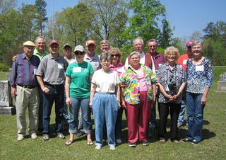
Left to right, Bishop Holliman (Indiana), Glenn Holliman(Pennsylvania), Bill Holliman (Mississippi), Robert Holliman(Tennessee), Joey Holliman (Alabama), Norman Holliman(Tennessee), Wally Allen, Jean Holliman, Tommie Holliman Allen, Faye Gardner, Lenwood Holliman, James Franklin (Frank) Holliman, Vonceil Duckworth, Tyler Duckworth(all from Alabama) and Jeanette Holiman Stewart (Texas). The photograph was taken by Glenda Norris, organizer of the excursion.
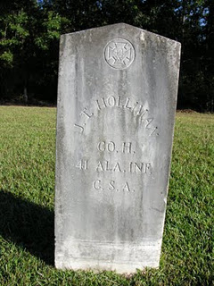
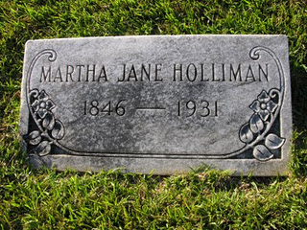
The earthly remains ofJohn Thomas andMartha Jane Walker Holliman lie side by side at Caine's Ridge, a few miles south of their former home in Fayette. The story of John Thomas Holliman is told in its sad glory by one of his great grandson's Rhodes Holliman in this blog, February and March 2010. Please go to the Archives function and to seek the articles.
More next posting on the Holliman and their associated families in Fayette County, Alabama.
Plan now to attend the Holliman and Associated Families Genealogical Round Table at the Fayette County, Alabama Civic Center, 10 am to 3 pm, Saturday, October 15, 2011. For information and reservations for lunch, contact Glenda Norris at gnorris@bcbsal.org or Glenn Holliman at Glennhistory@gmail.com. Sessions to include Tracing the Holymans from England to Alabama, Holliman Farm Sites in Fayette County and sharing of information on Associated Families. All invited!
Posted by Glenn N. Holliman at 9:13 AM 0 comments
Labels: John Thomas Holliman, Martha Jane Holliman

MONDAY, MAY 23, 2011

The Hollimans of Alabama
by Glenn N. Holliman
Back to the 19th Century...A Series of Articles on the Hollimans and Related Families of Fayette County, Alabama

Below, H. Bishop Holliman, great grandson of Samuel T. Walker, and Glenda Norris, 3 great grand daughter of Samuel, stand at his grave at Pilgrim's Rest Church in Fayette County, Alabama. Glenda led a tour on April 9, 2011 of Holliman and associated family cemetery sites. Glenda and two cousins, Normanand Robert Holliman, are attempting to have installed a Confederate tombstone marking the incredible military service of this family ancestor. Samuel (1820 - 1900) was one of the 7,000 or so troops left in Lee's army when he surrendered at Appomattox!
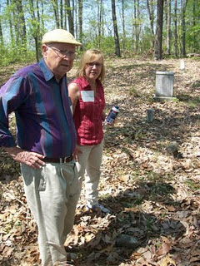
The late Cecil Rhodes Holliman (1901 - 1980) has written extensively on the Walker family and in later postings the history of the Walkers and especially Samuel will be explored. One of Samuel Walker's daughter's, Martha Jane, married John Thomas Holliman (1844 - 1930), a grandson of Cornelius Holliman and son of Uriah Holliman (1820 - 1862). John Thomas and Martha Janes Holliman had five children, one being Glenda's great grandfather, James Monroe Holliman. Another child was Ulyss Holliman (1884 - 1965), the father of Bishop Holliman, above.
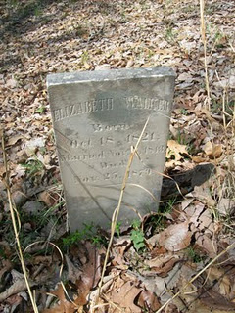
Located near Samuel's resting place at Pilgrim's Rest is his wife,Elizabeth Walker (1821 - 1879), mother of Martha Jane Walker Holliman.
More next week on the Hollimans and associated families....
Plan now to attend the Holliman and Associated Families Genealogical Round Table at the Fayette County, Alabama Civic Center, 10 am to 3 pm, Saturday, October 15, 2011. Sessions on the Holymans from England to Alabama, Holliman sites in Fayette County, Alabama, and general sharing of Associated Families material. All invited! For information and reservations for lunch, contact Glenda Norris at gnorris@bcbsal.org or Glenn Holliman at Glennhistory@gmail.com.
Posted by Glenn N. Holliman at 7:28 AM 0 comments
Labels: Bishop Holliman, Glenda Norris, Norman Holliman, Robert Holliman, Samuel Walker

MONDAY, MAY 16, 2011

The Hollimans of Alabama

by Glenn N. Holliman
Alabamians Crossing Paths
During my recent sojourns to my native state of Alabama, I have been staying with my first cousin Mary and her husband Elliot Clayton (E.C.) Herrin. I have known E.C. since his marriage toMary Daly in 1951. As am I, Mary is a 3 great grand child ofCornelius Holliman (1792 - 1862) who immigrated to Fayette County, Alabama as a pioneer family from South Carolina in 1836. Mary and E.C. have raised a family of four and now have six grandchildren. After service in the U.S. Navy and graduating from Howard College (now Samford University), E.C. in the 1950s worked as an accountant in the Birmingham steel industry. However, he had an ambition to be an attorney.
Below, the lovely Mary Daly Herrin, the year before her marriage to E.C. Herrin in Irondale, Alabama. Her parents are the lateRobert W. Daly, Sr. and Vena Holliman Daly. Mary is the grand daughter of Ulyss and Pearl Caine Holliman, Irondale, Alabama and great grand daughter of John Thomas and Martha Walker Holliman, Fayette, Alabama. Her 7th great grandfather is Christopher Holyman, Sr. (1618 - 1691), the founder of the Holliman families of Virginia and America. On the Daly side of her family are Irish ancestors who engineered railroads in 19th Century Alabama.
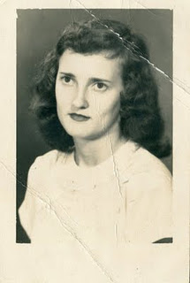
In a punishing schedule, strongly supported by Mary and the family, E.C. Herrin went to law school for years, sometimes three to five nights a week. In 1964, he passed the Alabama Bar and in 1967 became the municipal judge for the city of Helena, Alabama. In 2011, now 81 years old, he continues to hold court for the city twice a month. He is the longest serving municipal judge currently on the bench in Alabama, a distinguished record of service. He may be the longest serving municipal judge in Alabama history!
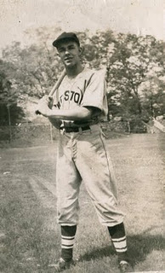
E.C. Herrin has loved sports all his life and played sandlot ball many afternoons as a youngster. Above he is in his high school baseball uniform in the 1940s. A favorite childhood companion was John Thomas Vaughan, another youngster growing up in the Depression in a small town in east central Alabama. Born in 1932, Dr. Tom Vaughan became a outstanding veterinarian and served for 18 years as the 6th Dean of the College of Veterinary Medicine at Auburn. Today, the large animal hospital at the University of Auburn is named after the well-respected and well-known Dr. Vaughan. (photo above)
These Alabamians Crossed Paths!
While these two children played their sandlot games prior to World War II, an old dignified Black man used to stop and watch. After a time, he came to know the boys by name. "Hello, Mr. E.C., Hello, Mr. Tom", he would say in the parlance of the pre-Civil Rights era. And in the societal manner of a different age, the two boys, eight or nine years of age, would respond to the ancient figure, "Hello, George, how are you today?" This happened on numerous occasions.
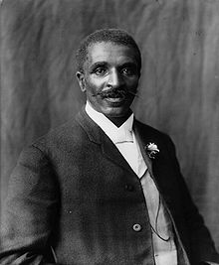
E.C. has never forgotten the kind, older African-American gentleman who died in 1943. Who was the man who befriended these two children? He was the distinguished Alabamian, a former slave who did his scientific work at Tuskegee Institute - none other than the legendary George Washington Carver, who revolutionized agriculture in the South! The above photo of Dr. Carver was taken in 1906.
More in the next post on the Hollimans and Associated families of Alabama....and paths that crossed....
Plan now to attend the Holliman and Associated Families Genealogical Round Table at the Fayette County, Alabama Civic Center, 10 am to 3 pm, Saturday, October 15, 2011. For information and reservations for lunch, contact Glenda Norris at gnorris@bcbsal.org or Glenn Holliman at Glennhistory@gmail.com. Sessions to include Tracing the Holymans from England to Alabama, Holliman Farm Sites in Fayette County and sharing of information on Associated Families. All invited!
Posted by Glenn N. Holliman at 3:09 AM 0 comments
Labels: E.C. Herrin, George Washington Carver, Mary Daly Herrin, Tom Vaughan

MONDAY, MAY 9, 2011

The Hollimans of Alabama
by Glenn N. Holliman
Back to the 19th Century...A Series of Articles on the Hollimans and Related Families of Fayette County, Alabama
Warren Holliman (1833 - 1908), A Civil War Veteran of the 41st Alabama Infantry Regiment
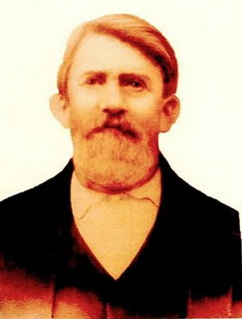
Above Warren Holliman (1833 - 1908) took a .58 mini-ball to the arm on August 17, 1864 during the siege of Petersburg, Virginia, knocking him out of the Civil War. At age 29, he signed up for the conflict with his relatives and neighbors with the 41st Confederate Alabama Infantry. This storied regiment was at Stones River, Chattanooga, Knoxville, Richmond and Petersburg before surrendering with General Robert E. Lee at Appomattox, Virginia in April 1865. After three months in a Richmond hospital, Warren was sent home in November 1864, his war effectively over. Photo and information from the extensive files of Dr. Rhodes Holliman, family historian, and Vonceil Duckworth, descendant ofCornelius Holliman. More on Warren and his military adventures in later posts.
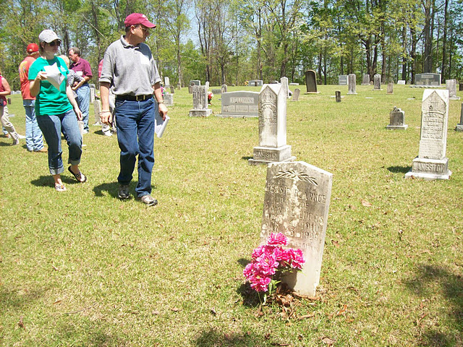
Above on a warm, sunny April day, 2011, Bill and his daughter,Joey Holliman, look for Holliman grave stones at Chapel Hill Cemetery in Fayette County, Alabama. Warren Holliman and his two wives are buried at Chapel Hill (see previous article). Bill Holliman, a multi-great nephew of Warren, is a 3rd great grandson of Cornelius Holliman (1792 - 1862).
Now living in Mississippi, Bill grew up in Irondale, Alabama, a grandson of Ulyss (1884 - 1965) and Pearl Caine Holliman (1887 - 1955), who migrated from Fayette County to Jefferson County in 1917 to take advantage of employment opportunities in the Birmingham area. This migration from rural Alabama communities to metropolitan areas accelerated during the World War I era. Today, descendants such as Joey and Bill return to Fayette, Lamar and Tuscaloosa Counties to discover family roots and stories.
More soon on the Fayette County family tour led by Glenda Norris, a 4th great grand daughter of Cornelius Holliman.
Plan now to attend the Holliman and Associated Families Genealogical Round Table at the Fayette County, Alabama Civic Center, 10 am to 3 pm, Saturday, October 15, 2011. For information and reservations for lunch, contact Glenda Norris at gnorris@bcbsal.org or Glenn Holliman at Glennhistory@gmail.com.
Posted by Glenn N. Holliman at 1:57 AM 0 comments
Labels: Bill Holliman, Cornelius Holliman, Joey Holliman, Rhodes Holliman, Vonceil Duckworth, Warren Holliman

THURSDAY, MAY 5, 2011

The 'Holliman' Name
by Glenn N. Holliman
The Name Holyman and its Spelling Varieties
Recently I was perusing Archives.com, a subscription service, and clicked on Family History. Lo and behold, the site revealed the numbers of Holliman (and other various spellings) households in the U.S. and the states in which persons of this spelling reside. Here is what I found.
Holliman
This is the 4,999 (not 5,000 mind you) most popular name in America, and there are all of 1,350 households in the country with this name. Frankly, that is a tiny portion of perhaps 75 to 100 million or so residences in these United States. This confirmed my 'feeling' that there were not many of us out there.
Where do Hollimans live? As those of us who follow these things are generally from the southeast, and as Holymans entered North American in Jamestown, Virginia, the vast majority of us still live in the south and southwest. Here is a partial ranking of those of us who in Colonial times adopted an 'i' and dropped the 'y'.
Georgia - 15.3%
Mississippi - 14.4%
Alabama - 11% (my state of origin)
Arkansas - 9.1%
Texas - 8.4%
Tennessee - 5.4%
Oklahoma - 4.4%
Illinois - 2.7%
North Carolina - 2.4%
Virginia - 2.4%
South Carolina - only 1%
Hmmm....So the Hollimans left Virginia, settled for a while in North Carolina in the 1700s,and generally kept moving southwest to the states of the Old Confederacy. We did not go much further west than Texas and Oklahoma (California has all of 2% of the Hollimans). One group did go north to Illinois, perhaps African-American Hollimans who live in the Chicago area, part of the migration between the world wars?
No one of this spelling live in Maine, the Dakotas, Idaho, Wyoming, Nevada or Arizona.
Holloman
Let's try a variation on the name, Holloman. A bit more common - this spelling is 3,350 on the list or about 2,240 households in the entire country. What a difference a vowel makes! Again a very predominant Southern name.
North Carolina - 23.5%
Virginia - 11.6%
Texas - 7.1%
Georgia - 6.7%
South Carolina - 5.8%
Florida - 4.6%
Mississippi - 3.3%
Alabama - 3.1%
Tennessee 2.1%
Whoo...those descendants of Christopher Holyman, Sr (d 1691) who stayed in Virginia and migrated to North Carolina (and put down roots) tended to spell their name with an 'o' not an 'i'.
Holleman
This spelling, fairly common in Isle of Wight County, Virginia a ranks 10,490 as the most common in America; pretty low. There are about 1,350 families in America with this spelling.
Texas - 21%
North Carolina - 18%
Illinois - 5.1%
Tennessee - 4.8%
California - 4.6%
Michigan - 4.3%
Georgia - 4%
Mississippi and Okolahoma - 3.5% each
Virginia 3.3% or only 43 residences
Were a number of these Hollemans African-Americans who moved to Chicago and Detroit between the world wars? Perhaps the descendants of slaves from the deep south? Perhaps?
Hollimon
Opps...this spelling is the 30,255 most popular, pretty low in the name 'market'. There are only 260 residences of cousins who use an 'o', instead of the 'a' in the last syllable. And where do you live? No surprise, again the deep South.
Mississippi - 19.8%
Texas 12.1%
Georgia - 11.3%
Alabama - 7.4%
and so on....
Granted in the Colonial times and in early censuses (dare I say this) our ancestors and those dealing with official records may have lacked certain 'spelling skills' which has led to our various spellings. Whatever happened to Holyman and Hollyman, the names that show up in England and early Colonial records?
Hollyman
Strangely, the spellings of Holyman and Hollyman have disappeared (almost). Only 75 residences in the entire U.S. are labeled 'Hollyman'.
Illinois - 15.6%
Missouri - 15.6%
California - 15.6%
Does this suggest a later migration to the Colonies from another family? Virtually none by this name live in the Deep South as do the known descendants of Christopher Holyman, Sr. (or Hollyman).
Holyman
This is the spelling one will find in 16th and 17th wills in England, and yet in all the United States, only three residences have this spelling. One person each in Missouri, West Virginia and Pennsylvania.
Next post, back to the 19th Century....
So if you are descended from the three brothers, Charles, Warren and Cornelius Holliman, who immigrated to Alabama in 1836 from the Carolinas, you may wish to attend a Holliman Family Round Table at the Fayette County, Alabama Civic Center, October 15, 2011, 10 a.m. to 3 p.m. To reserve lunch, contact Glenda Norris at gnorris@bcbsal.org or Glenn Holliman at Glennhistory@gmail.com.
Posted by Glenn N. Holliman at 6:51 AM 0 comments
Labels: Hollyman

MONDAY, MAY 2, 2011

The Hollimans of Alabama
by Glenn N. Holliman
Back to the 19th Century...A Series of Articles on the Hollimans and Related Families of Fayette County, Alabama
We continue our series of the April 9, 2011 tour of Holliman sites in Fayette County, Alabama led by Glenda Norris, descendant ofChristopher Holyman, Sr (1618 - 1691).
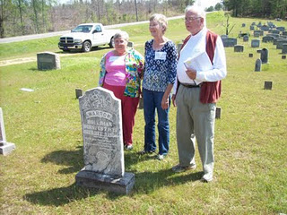
Above at the Chapel Hill Cemetery near Newtonville, Alabama are from left to right: Faye Gardner (Reform, Alabama), Jeanette Holiman Stewart (Austin, Texas) and Lenwood Holliman (Gordo, Alabama). In this April 9, 2011 photograph, they stand behind the grave of Civil War veteran Warren Holliman (1833 - 1908), a son of Charles Holliman (1795 - 1852), of whom the three are descended. Warren is misspelled Warron on his tombstone.
Warren Holliman's story...
In 1836, numerous children accompanied the three brothers, Cornelius, Charles and Warren Holliman, on their journey from the North Carolina/South Carolina border to Fayette County. One of the children of Charles Holliman and wife, Barberry (sometimes Barbara) Walters, was their son, Warren, age 3 at the time.
According to U.S. Census records Fayette County had a population of over 3,000 in 1830, and would more than double in size to over 6,000 in 1840 as immigrates moved west to the yet untitled soil of Alabama.
Warren married Mary Polly Blakeney, the daughter of Thomas and Sarah Kemp (or Roberts?) Blakeney. Thomas (1800 - 1892) was a son of William Blakeney and a grandson of Capt. John Blekeney (1732 - 1832). The Blakeneys had migrated to Alabama from Chesterfield, South Carolina. Warren and Polly would have 11 children, 3 girls and 8 boys which helped entrench the Holliman name in the area.
Warren's generation came of age as the American Union dissolved and Civil War engulfed our ancestors. Warren and his two brothers, Cornelius and Elijah, and cousins (including my great grandfather, John Thomas Holliman) joined with other Fayette Countians in enlisting in the 41st Alabama Infantry Regiment. Warren was known as the 'strong man' of the county. He could pick up a bale of cotton (500 pounds) and walk with it!
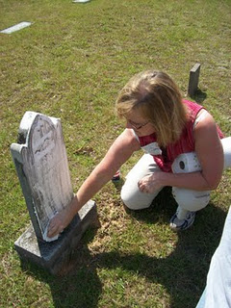
Glenda Norris uses a genealogical technique she learned from Rhodes Holliman, the application of shaving cream to faded tombstones, to reveal hidden names and dates. This is Warren Holliman's grave site.
In the next post, Warren Holliman's historic war service with the 41st Alabama Infantry Regiment....
Posted by Glenn N. Holliman at 1:25 AM 1 comments
Labels: Faye Gardner, Glenda Norris Jeanette Stewart, Lenwood Holliman,Warren Holliman
Home
Subscribe to: Posts (Atom)

TUESDAY, JUNE 28, 2011

The Hollimans of Alabama
by Glenn N. Holliman
Back to the 19th Century...A Series of Articles on the Hollimans and Related Families of Fayette County, Alabama

Visiting the Grave site of James Franklin Holliman, An Officer and a Teacher
Below the 21st Century James Franklin Holliman stands by the grave of his great grandfather, James Franklin (1839 - 1908) and his great grandmother, Bertha Lee Holliman. James Franklin Holliman's first wife, Rebecca Stewart, the one to whom he wrote a series of letters during the Civil War, lies on the other side of his grave. The location is the Steward-Holliman Cemetery near the Bluff community.
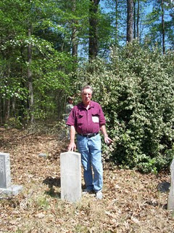
Below Robert Holliman, a great great grandson of Uriah and Polly Lucas Holliman clears brush near the grave site of his great, great uncle, James Franklin Holliman at the Stewart-Holliman Cemetery.
Lt. James Franklin Holliman of the Alabama 58th Regiment, Co. B, was captured at Missionary Ridge, Tennessee. After incarceration for two years at the infamous Johnson's Island in Lake Erie, Ohio, on June 13, 1865, he was released, and walked home to Alabama, At home he did some thing even more heroic - he started a school in his own community and devoted his life to educating the citizens of northern Fayette County. The school was located a few miles from his grave site in the Bluff community. This information courtesy ofRhodes Holliman.
More on this Cemetery in the next post....
Plan now to attend the Holliman and Associated Families Genealogical Round Table at the Fayette County, Alabama Civic Center, 10 am to 3 pm, Saturday, October 15, 2011. For information and reservations for lunch, contact Glenda Norris at gnorris@bcbsal.org or Glenn Holliman at Glennhistory@gmail.com. Sessions to include Tracing the Holymans from England to Alabama, Holliman Farm Sites in Fayette County and sharing of information on Associated Families. All invited!
Posted by Glenn N. Holliman at 2:40 PM 0 comments
Labels: James Franklin Holliman, Robert Holliman

TUESDAY, JUNE 21, 2011

The Hollimans of Alabama
by Glenn N. Holliman
Back to the 19th Century...A Series of Articles on the Hollimans and Related Families of Fayette County, Alabama
Nancy Palestine Holliman, one of the thirteen children of Uriahand Polly Lucas Holliman, is buried at Springhill Cemetery in the Bluff Community of Fayette County, Alabama near her mother, Mary Polly Lucas Holliman. Athough her name is listed as Holliman on the stone, Nancy Palestine is reported by Rhodes Holliman to have been married to John Pinion, but they had no children.
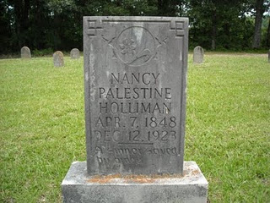
Below, J. Frank Holliman, a second great grandson of Uriah and Polly Lucas Holliman, tells the tale of the winter time burial of his great aunt, Palestine, at the Bluff community, Spring Hill Cemetery. His great grandfather and other relatives dug the grave on a cold, stormy night in 1923.
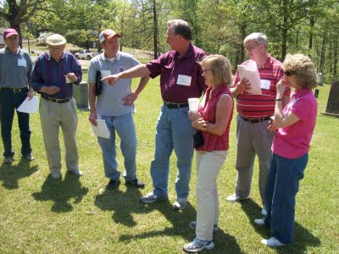
Left to right are Bill Holliman, Bishop Holliman, Norman Holliman, James Franklin (Frank) Holliman, Glenda Norris, Wally and Tommie Holliman Allen. Frank Holliman, who still lives on and near the land farmed by Uriah Holliman prior to the Civil War, is most familiar with Holliman ancestors in the northern part of Fayette County and southern part of Lamar County, Alabama. This excursion to north central Alabama on April 9, 2011 was organized by Uriah and Polly Lucas Holliman's 3rd great grand daughter, Glenda Norris.
More next post on the Hollimans of Fayette County....
Plan now to attend the Holliman and Associated Families Genealogical Round Table at the Fayette County, Alabama Civic Center, 10 am to 3 pm, Saturday, October 15, 2011. For information and reservations for lunch, contact Glenda Norris at gnorris@bcbsal.org or Glenn Holliman at Glennhistory@gmail.com. Sessions to include Tracing the Holymans from England to Alabama, Holliman Farm Sites in Fayette County and sharing of information on Associated Families. All invited!
Posted by Glenn N. Holliman at 2:40 PM 0 comments
Labels: James Franklin Holliman, Norman Holliman, Palestine Holliman,Tommie Holliman Allen

TUESDAY, JUNE 14, 2011

The Hollimans of Alabama
by Glenn N. Holliman
Back to the 19th Century...A Series of Articles on the Hollimans and Related Families of Fayette County, Alabama
Spring Hill Cemetery in Bluff, Alabama is the final resting place of a pioneer ancestor who made the trek from the Carolinas to Alabama in 1836, raised a large family, survived the Civil War although losing a husband and two sons, farmed, midwifed and lived to be 94 years old. Family lore has her enjoying her 'flowers' - her 'Four Roses' - deep into her final years.
"Mary Polly Lucas Holliman, January 2, 1819 - July 5, 1913, Pioneer Strength, Integrity, Human Kindness"
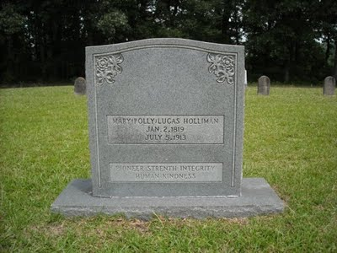
Even thought 'strenth' may be mis-spelled, this grave stone speaks eloquently of the wife of Uriah Holliman, 1817 - 1862. As Dr.Rhodes Holliman, a great, great grandson has written (see Archives of this blog, March 2010 and copy below), Polly buried a husband and son (Charles Daniel Holliman) at Okalona, Mississippi after the Battle of Shiloh in 1862. Sick herself, she rode home, raised the children remaining and lived to the age of 94. During the decades after the war she served as a mid-wife, delivering many of her own grandchildren.
"In 21 years of married life, Mary Polly and Uriah would produce 13 children - seven boys and six girls. She could hitch up a mule to a plow and till the soil as well as any man. While maintaining her farm, she became the only source of medical assistance in her community as a herb doctor, caregiver, and midwife to many of her neighbors. She would accept appeals for help from all over the area, saddle up a mule and ride out to provide services." - Dr. Rhodes Holliman
Below family members, four of whom are direct descendants of Polly Lucas Holliman, gaze over the Spring Hill Cemetery in the Bluff community of Fayette, County. Left to right: Wally Allen, Jean Holliman, Tommie Holliman Allen, Bill Holliman, Bishop Holliman (great grandson of Polly Lucas) and Jeanette Holiman Stewart. Bishop Holliman,b 1919, is a first cousin of Rhodes Holliman's father, Cecil Rhodes Holliman (1903 - 1982).
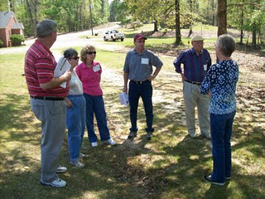
On that early April day in 2011, when sixteen Holliman descendants traveled through Fayette County, the trees were leafing out in pastel green. One noticed that the soil of Fayette County could not decide if it wanted to be red clay or sandy stone and rock. Both pine and oak thrive in the ravines and on the ridges adjacent to the Sipsey River that flows north to south through the county. Swamps cover many areas near the river bottoms. From this soil our 19th Century ancestors harvested cotton, corn and lumber. Hogs and cattle grazed in the woods and pastures. Below the ground, coal emerged, and today oil and gas flow deep from the Alabama earth.
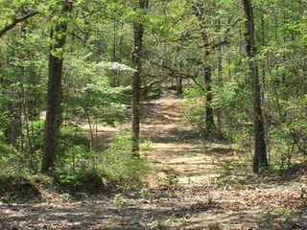
Above, a dirt road winds off from the Bluff cemetery
Next more posts on the Hollimans of Alabama....
Plan now to attend the Holliman and Associated Families Genealogical Round Table at the Fayette County, Alabama Civic Center, 10 am to 3 pm, Saturday, October 15, 2011. For information and reservations for lunch, contact Glenda Norris at gnorris@bcbsal.org or Glenn Holliman at Glennhistory@gmail.com. Sessions to include Tracing the Holymans from England to Alabama, Holliman Farm Sites in Fayette County and sharing of information on Associated Families. All invited!
Posted by Glenn N. Holliman at 1:24 AM 0 comments
Labels: Bill Holliman, Bishop Holliman, Jean Holliman, Jeanette Stewart,Mary Polly Lucas Holliman, Rhodes Holliman, Tommie Holliman Allen,Wally Allen

TUESDAY, JUNE 7, 2011

The Hollimans of Alabama
by Glenn N. Holliman
Back to the 19th Century...A Series of Articles on the Hollimans and Related Families of Fayette County, Alabama

The Visit to Caine's Ridge, a Family Excursion in 2011
Lecturing on family history near the burial sites of this paternal and maternal grandparents is 91 year old H. Bishop Holliman (in purple shirt with cap). As a boy he used to visit John Thomas andMartha Jane Walker Holliman, his paternal grandparents at their last home near the Fayette train depot. One of his memories is sitting on their porch on the south side of town watching the trains come into town.
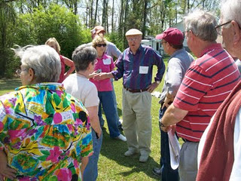
Below in a photograph taken in either 1928 or 1929 are John Thomas and Martha Jane Walker Holliman standing in front of their home in Fayette. John would died in 1930 and Martha Jane in 1931. The young man sitting on the porch in a white shirt and tie on the far right is 10 year old Bishop Holliman!
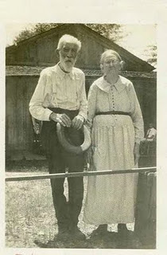

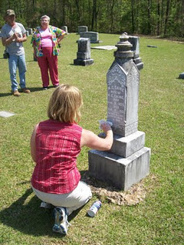
Cleaning the Caine monument is Glenda Norris using shaving cream. When gently scrapped off, the cream reveals difficult to read letters. Glenda credits her Uncle Rhodes Holliman for the process. In the background are Robert Holliman and Faye Gardner.
Bishop Holliman's father was Ulyss Holliman (1884 - 1965) who grew up in Fayette, married Pearl Caine (1887 - 1955) in 1906, and removed to Jefferson County, Alabama in 1917 in search of increased income for his growing family. Pearl Caine's grandparents, William Ellison and Melissa Anthony Caine, lie buried under the gravestone above. It was Pearl's grandfather who gave the land for the church.
The journey to explore Holliman and their families continues in the next post....
Plan now to attend the Holliman and Associated Families Genealogical Round Table at the Fayette County, Alabama Civic Center, 10 am to 3 pm, Saturday, October 15, 2011. For information and reservations for lunch, contact Glenda Norris at gnorris@bcbsal.org or Glenn Holliman at Glennhistory@gmail.com. Sessions to include Tracing the Holymans from England to Alabama, Holliman Farm Sites in Fayette County and sharing of information on Associated Families. All invited!
Posted by Glenn N. Holliman at 9:36 AM 0 comments
Labels: Bishop Holliman, Glenda Norris, John Thomas Holliman, Martha Jane Walker Holliman, Melissa Anthony Caine, William E. Caine
Home
Subscribe to: Posts (Atom)

MONDAY, JULY 25, 2011

The Hollimans of Alabama
by Glenn N . Holliman
Back to the 19th Century...A Series of Articles on the Hollimans and Related Families of Fayette County, Alabama
Below Norman Holliman photographs his distant cousin, Glenda Norris, at the head stone of a common great grandfather, Cornelius Holliman, 1792 - 1862. Cornelius is buried in the Old Blooming Grove Cemetery in the Bluff community of Fayette County. It was wretched year for the Holliman family. A son and grandson of Cornelius, Uriah and Charles Daniel Holliman, died in May of 1862 after the Battle of Shiloh. Now in the autumn of that tragic year of 1862, Cornelius, passed away from natural causes. Born in North Carolina, he rests in Alabama soil.
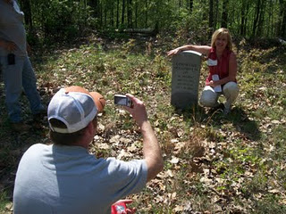

Below members of the Holliman excursion view graves at Old Blooming Grove Cemetery. It was early spring, the trees were leafing out and the brush and weeds were still few and low to the ground.
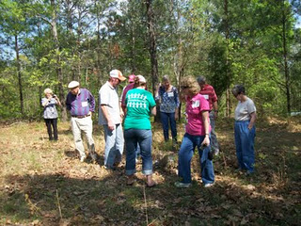
Here Bishop Holliman, b 1919, and great, great grandson ofCornelius, stands with his son, Glenn N. Holliman, b 1946 at the headstone of the pioneer who left the Carolinas and by horse and wagon in 1836 crossed Georgia and much of Alabama to reach the ravine and river bottom country of Fayette County. One hundred and twenty-five years later, some of his many descendants paid homage to his courage and energy and those of his brothers,Charles and Warren, and their wives and children who treked west with them.
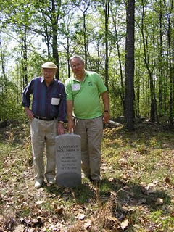Plan now to attend the Holliman and Associated Families Genealogical Round Table at the Fayette County, Alabama Civic Center, 10 am to 3 pm, Saturday, October 15, 2011. For information and reservations for lunch, contact Glenda Norris at gnorris@bcbsal.org or Glenn Holliman at Glennhistory@gmail.com. Sessions to include Tracing the Holymans from England to Alabama, Holliman Farm Sites in Fayette County and sharing of information on Associated Families. All invited also to the 5:30 pm to 9 pm social at the Rose House Inn in Fayette, Friday, October 14, 2011!

Posted by Glenn N. Holliman at 5:58 AM 0 comments
Labels: Bishop Holliman, Glenda Norris, Glenn Holliman, Norman Holliman

WEDNESDAY, JULY 20, 2011

The Hollimans of Alabama
by Glenn N. Holliman
Back to the 19th Century...A Series of Articles on the Hollimans and Related Families of Fayette County, Alabama
One of the more unusual stops on our April 9th, 2011 excursion was a visit to memorial for some Hollimans who fought in the Civil War. While not a burial spot, a well-meaning distant cousin ordered and set up near the William Bailey Holliman home a series of memorial stones honoring James Franklin Holliman, John Thomas Holliman, Uriah Holliman and Elijah Holliman.
Future generations, please be aware many of the dates are incorrect and some facts are wrong on the stones.
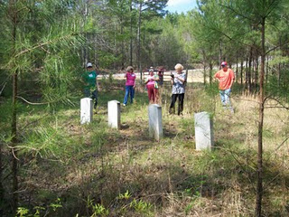
Surveying the memorial stones are left to right, Joey Holliman, Tommie Holliman Allen, Faye Gardner, Jeanette Holliman and Tyler Duckworth. A front view of the stones reveals an old barn in a collapsed state in the background. Pictured below are Bill Holliman and Robert Holliman.
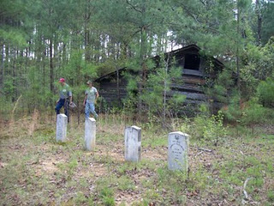

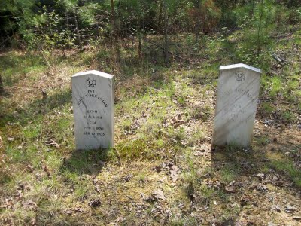
The date on John T. Holliman's stone is incorrect. He died in 1930. While these are not grave sites, one notes that several of these persons did not come home. Elijah Holliman died not at Petersburg, Virginia, but rather at La Grange, Georgia of typhoid fever. He is buried there having served with the 56th Alabama Partisan Rangers. Uriah Holliman died in Okalona, Mississippi along with his son, Charles Daniel Holliman.
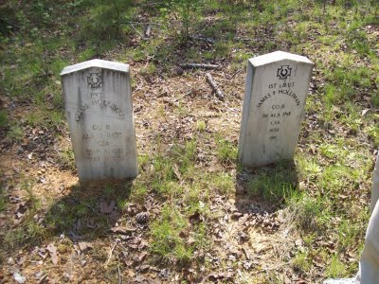
James F. Holliman is NOT buried in this plot but in the Stewart-Holliman Cemetery.
Uriah Holliman was born on July 6, 1816, in Lancaster County, SC. He married Mary "Polly" Lucas in
Tuscaloosa County, AL on Aug. 31, 1836. Performing the ceremony was the Rev. John Walters. Mary was 17 years old. The couple later settled southwest of Bluff in Fayette County, where government land records show that Uriah received patents for more than 320 acres in the late 1850s. Uriah joined the Confederate Army in 1861 at the age of 45! He was Pvt. Uriah H. Holliman, Co. B of the 9th Alabama
Battalion of Volunteers, 26th Regiment, CSA.
He died of measles and pneumonia at Okolona, Chickasaw County, MS, on May 8, 1862, attended by his wife until death. Their son,Charles Daniel Holliman, same military unit, same place, died on May 12, 1862, of the same diseases. Their grave sites are unknown but probably in the Confederate Cemetery in Okolona, MS. Fayette County, Alabama. - Information provided by Dr. Rhodes Holliman, great, great grandson of Uriah Holliman.
I leave this blog up as a caution to those who stumble on the stones near Bluff, Alabama sometime in the future. They are not accurate.
Plan now to attend the Holliman and Associated Families Genealogical Round Table at the Fayette County, Alabama Civic Center, 10 am to 3 pm, Saturday, October 15, 2011. For information and reservations for lunch, contact Glenda Norris at gnorris@bcbsal.org or Glenn Holliman at Glennhistory@gmail.com. Sessions to include Tracing the Holymans from England to Alabama, Holliman Farm Sites in Fayette County and sharing of information on Associated Families. All invited!
More Holliman sites of Fayette County in the next post.
Posted by Glenn N. Holliman at 4:29 AM 0 comments
Labels: Elijah Holliman, James Franklin Holliman, John Thomas Holliman,Uriah Holliman

SATURDAY, JULY 16, 2011

The Hollimans of Alabama
by Glenn N. Holliman
Back to the 19th Century...A Series of Articles on the Hollimans and Related Families of Fayette County, Alabama
Frank Holliman shares information with Bill Holliman, left, and Bill's Uncle Bishop Holliman at the Holliman-Stewart Cemetery in the Bluff Community of Fayette County, Alabama.
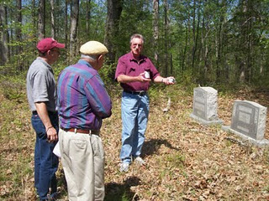
Pictured is the gravestone of Frank Holliman's grandfather, William Bailey Holliman, a son of James Franklin Holliman and Rebecca Stewart Holliman.
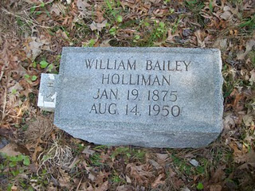

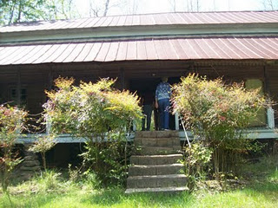
Right, located near the Holliman-Stewart Cemetery is the old home of William Baily Holliman, a classic early 19th Century 'dog-trot'. The name originated as the family dogs would sleep or trot through the opening between the two sides of the cabin. Generally one side was built to hold the kitchen with its wood stove (not comfortable in the summer) and the living rooms on the other side. Of course, no running water, central heat or air, or electricity. Those were the good ole days?
Plan now to attend the Holliman and Associated Families Genealogical Round Table at the Fayette County, Alabama Civic Center, 10 am to 3 pm, Saturday, October 15, 2011. For information and reservations for lunch, contact Glenda Norris at gnorris@bcbsal.org or Glenn Holliman at Glennhistory@gmail.com. Sessions to include Tracing the Holymans from England to Alabama, Holliman Farm Sites in Fayette County and sharing of information on Associated Families. All invited!
Posted by Glenn N. Holliman at 6:08 AM 0 comments
Labels: Bill Holliman, Bishop Holliman, James Franklin Holliman, William Bailey Holliman

WEDNESDAY, JULY 6, 2011

The Hollimans of Alabama
by Glenn N. Holliman
Back to the 19th Century...A Series of Articles on the Hollimans and Related Families of Fayette County, Alabama

More on the Civil War Veteran who became a School Teacher
Below on April 9, 2011, Holliman descendant Faye Gardner snaps photographs of Holliman and Stewart grave sites while Robert Holliman and his brother, Norman (not visible) work at removing vines and bushes from covered grave sites of Hollimans and Stewarts near Bluff, Alabama.

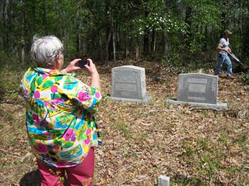
Below, Glenda Norris stands by the memorial stone for Daniel F. Holliman, son of James Franklin and Bertha Lee Holliman - Oct 20, 1895 - May 27, 1897. Lt. James Franklin Holliman is a great, great uncle of hers.
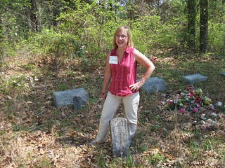
Below, James Franklin Holliman in the early 1900s. This Civil War veteran dedicated his life to school teaching after the violence of his military service from 1861 - 1865. Photo from the collection ofDr. Rhodes Holliman, a great nephew of James Franklin.
More on the Hollimans of Fayette County, Alabama, next post....
Posted by Glenn N. Holliman at 2:41 PM 0 comments
Labels: Faye Gartner, Glenda Norris
Home
Subscribe to: Posts (Atom)

MONDAY, AUGUST 29, 2011

When We Were English, Part XXVIII
ARE WE WORCESTERSHIRE HOLLIMANS?
by Glenn N. Holliman

Cousin Jeanette Holiman Stewart pointed out in 2010 that there were numerous Hollymans living in Worcestershire, England in the 1500 and 1600s, according to the International Genealogical Index. Could one of these Holymans be the origin of our Christopher Holyman, Sr., founder of the American family?

Could one be Thomas or John Holiman who lived in Virginia in 1636 and 1650 respectively? Or other Hollymans who appeared in the 1650s and 1660s?

Worcester is located 40 miles or so east by northeast from our cottage near Stow in the Wold, so we took a day and motored over to the Family Heritage Centre there.

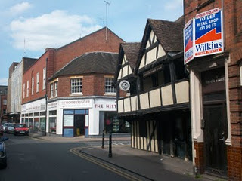
Above on the corner of this Worcester photograph stands the Heritage Centre of Worcestershire which holds many family records. We spent several hours exploring the files and local histories. Unfortunately the parish records were not indexed as in Bedfordshire, which means one must go through reams of microfilm, time which we did not have on this trip. Yes, there is more investigation to do in Worcester, but we found considerable Holyman information which I share in the next post.

The Tutor building in the foreground (above) is one of the oldest structures in the shire, dating back to the 1400s. Did some of our ancestors enjoy a pint of ale in that former inn, now preserved in a historical trust?

Oh, yes, many Hollimans lived in Worcestershire in previous centuries! They left many wills. Would we find evidence that this area, 80 or so miles west of Buckingham and Bedford Shires, could be the origin of the American Hollimans, or at least some of them?

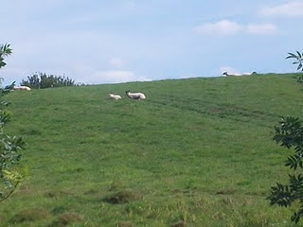

Just a few miles from the centre of Worcester, one encounters a countryside still providing pasture of the sheep. Wool was and is a source of wealth for the English farmer. This particular pastoral scene (photo above) is in Leigh, Worcestershire. Many Holymans lived in and around this village in the 1500s.

My search of the various archives of England made very evident to me that groups of Holyman families lived in several parts of the country in the 15th to 17th Centuries. From where did they originate and why were they scattered?
Distant cousin Jim Maule of Philadelphia, Pennsylvania shared a theory with me recently as to why there are several locations where obviously dozens of Holymans lived. He believes the 14th Century Black Death and the decrease in available labour led many persons to move about the country, financially bettering themselves. Hence pockets of Holymans in several parts of England. Makes sense.

Next post, a listing of Holymans found in Worcestershire - they left many wills!

Posted by Glenn N. Holliman at 6:23 AM 0 comments
Labels: Jim Maule

TUESDAY, AUGUST 23, 2011

When We Were English, Part XXVII
A LOOK DEEP INTO THE BEDFORDSHIRE ARCHIVES
by Glenn N. Holliman

Last June, with the help of Bedfordshire family historian, Peter Smith (photo below), we explored the Bedfordshire, England Archives.

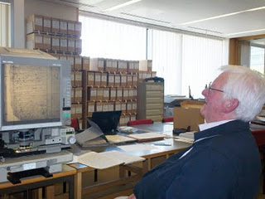

In addition to our reading microfilm of 17th Century parish records, the archivists (see photo below) open the files of the almost 400 year old Bishop’s Transcripts (copies held by the dioceses of parish records).

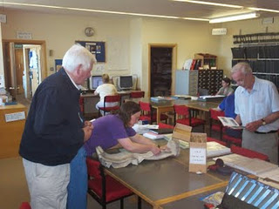

I held the transcripts and viewed the names of Christopher andJudith Holyman (see below), born in 1618 and 1621. The father’s name is given as Thomas.

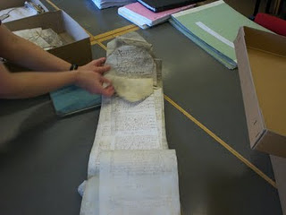

If there be any question about the authenticity of these two persons, that is put to rest.
Is this then truly the Christopher who sailed to Jamestown and inhabited the Isle of Wight County? Were there other Christopher’s in England at this time? Can we find more evidence to support the Bedford thesis or disprove it?

Can we find the birthplace of Thomas Holyman who married in 1609 and sired Christopher Holyman, born 1618? When did this Thomas die and where? The parish records do not tell us, yet.

Are there other places and archives in England to investigate?

Let’s keep looking….

Posted by Glenn N. Holliman at 6:09 AM 0 comments
Labels: Christopher Holliman Sr., Judith Holyman, Thomas Holyman

THURSDAY, AUGUST 18, 2011

When We Were English, Part XXVI
ARE WE WOBURN, BEDFORDSHIRE HOLLIMANS?
by Glenn Holliman

Woburn is the home of the Dukes of Bedford, whose families have occupied the Abby property there since the 1500s when Henry VIII dissolved the monasteries. For centuries the village was a staging station for travelers moving north and south from and to London, approximately 40 miles to the south. The town today was rebuilt after a fire in the early 1700s, and retains a Georgian architectural look as viewed in the photograph below.

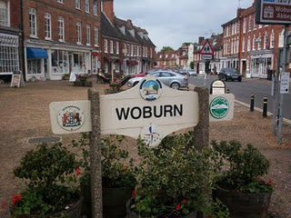

The name Holman concerns me. In other shires, Holyman is plainly written, as it is in Bedford St. Mary’s parish records. One grants handwriting is often a guess as many of the parish clerks were near illiterate in the late 1500s and letter formation had not yet finalized as it is in today’s English script.

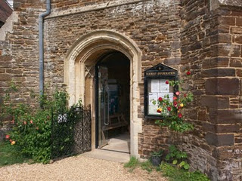

Photographed below is an index of Woburn parish records located in the Heritage Centre (pictured above - the former parish church which is now the museum and Centre). Beginning in 1538, Henry VIII’s chancellor, Thomas Cromwell, required all churches to record all baptisms, marriages and burials. This Cromwell helped convict Anne Boleyn of treason that led to her beheading. Later Chancellor Cromwell lost his own head to Henry’s bad temper!

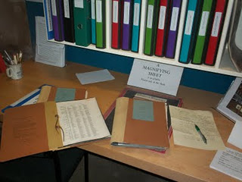

In these Woburn records (pictured above), one will find a host of Holmans and Hollmans but that middle vowel is always missing, no ‘i’, ‘e’ , ‘o’ or ‘y’. Hmmm….There are numerous families whose head of households were named Robert, John, William and Thomas. There is even one Judith Holman, baptized February 16, 1609, daughter of Kath Holman and Henry Dally….hmmmm….born evidently out of wedlock.
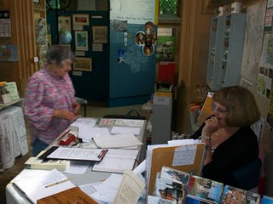
Above, as is common in England, kindly volunteers and staff do all they can to assist Americans in their search for English ancestors.

Yes, there is a Thomas Holman, son of Jn Holman, baptized March 4, 1576, but nary a Christopher born, married or died in Woburn between 1567 and 1670. But if Thomas moved to Bedford, married and had his children, one would not expect to discover such in Woburn. So Woburn cannot be ruled out totally even though the name does not quite match.

Let’s go back to Bedford and search some more.

Posted by Glenn N. Holliman at 1:18 AM 0 comments
Labels: Judith Holman, Thomas Cromwell, Thomas Holman

SATURDAY, AUGUST 13, 2011

When We Were English, Part XXV
Are We Bedfordshire Holymans?
by Glenn N. Holliman
According to parish records, Thomas Holiman (Holyman) of Bedford, who may or may not have been born fifteen or so miles south in Woburn, married at St. Peter’s Church in Bedford in 1609 toHelenara Poynard. Roger Smith suggests the name Helena might be Eleanor, and Poynard, which is not yet found in other Bedford records, may be P’nard or Peynard. Spellings were not yet ‘settled’ nor is the handwriting of parish administrators always legible.

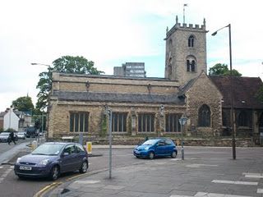
St. Mary's parish is today an archaeological trust facility, and has long since ceased to be a place of Anglican worship. The building and cemetery stand on a busy street corner, two blocks from the river and across the street from Bedford College. Imagine if you will four hundred years ago, no automobiles, only muddy streets, horse carts and the Holyman couple having their children baptised in this parish. How many of them now reside in the cemetery? We don't know.

Again according to parish records, this couple had the following children, all baptized at St. Mary’s Church in south Bedford, two blocks from the River Great Ouse (a wonderful name!).

John, b 1610 (was he named after a grandfather?)

Eleanor, b and d 1612 (may have been named after her mother)

Joan, b 1613

Thomas, b 1616 (named after his father)

Christopher, b 1618 (the believed to be emigrant to Jamestown, Virginia in 1650)

Judith, b 1621 (the believed to be emigrant to Jamestown, Virginia in 1650)

Eleanor, b 1625 (named after her mother and deceased sister)

Stephen, b 1625

Mary, b 1628

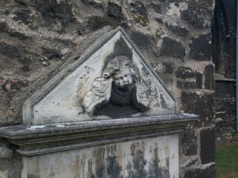

Tombstones were rare in 17th Century England (as in Virginia). This one of a grieving angel in St. Mary's grave yard, is only from the 1800s. Coal smoke and pollution have worn away the stone carving. The cemetery, like the church, is abandoned but the lawn is kept up and the grass mowed. Do our 8th great grandfather, Thomas, and his wife lie in these grounds?

As discussed in earlier articles, a John Holiman died in Virginia in 1650, and a Thomas Holiman (or Holman) took possession of land at Martin’s Hundred, Virginia in 1636. Are John and Thomas from this same family, and is this the encouragement that led to Christopher and Judith to leave for Jamestown, Virginia?

Encouragement Christopher and Judith undoubtedly had, but the 1636 Thomas in Virginia is most probably not the off spring of Thomas who married in Bedford in 1609. Parish records indicate aThomas Holiman married in 1639 at St. Paul’s, Bedford, and my guess this is the second son of the 1609 marriage. Tragically, a son Matthew, died was buried at St. Paul's in 1640.

Next posting….a visit to Woburn and the Heritage Center there.
Posted by Glenn N. Holliman at 4:25 AM 0 comments
Labels: Christopher Holliman Sr., Judith Holyman, Thomas Hollyman

MONDAY, AUGUST 8, 2011

When We Were English, Part XXIV
Back to England for More Research!
by Glenn N. Holliman
As I have written in earlier posts, in the spring of 2010, my wife and I did considerable research on the Holyman family in the Tring, Hertfordshire and Cuddington, Buckinghamshire areas of England. The two villages are approximately a dozen or so miles apart, and in the 15th to 17th Centuries contained families named Holliman (Hollyman, etc.)

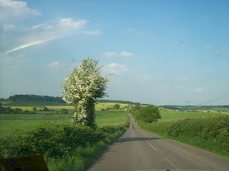

A highway leads from Cuddington, Buckinghamshire through the English countryside. The Rt. Rev. John Holyman and other Holymans were born in Buckingham, Bedfordshire and Hertfordshire in the 1400s and 1500s. More and more evidence suggests these persons are the ancestors of the Virginia Hollimans of the 17th Century.

As described several of these Holymans became prominent; one The Rt. Rev. John Holyman (1495 – 1558) was the Roman Catholic Bishop of Bristol, England and was caught up in the English Counter Reformation. Another Holyman, Ezekiel, a great nephew of Bishop Holyman, ironically helped found the Baptist Church in Rhode Island.

Additional research by cousins in the States in 2010 revealed parish records of St. Mary’s in Bedford, Bedfordshire, England that registered a Holliman family that in the early 1600s gave birth to children named, among others, Christopher (b 1618) and Judith ( b 1621)). Two persons with these names migrated to Jamestown, Virginia in 1650.

Judith disappears to history (probably married to one of the surplus males in the colony) and Christopher to marry, have six children and prosper financially. He left a plantation of 1,020 acres at his death in 1691, and is credited with being the founder of all the Hollimans and various spellings in the now United States.

And So to Bedfordshire
So in the spring of 2011, my wife and I sailed to England to research further the Holliman family (with its various spellings). In addition to American cousins doing considerable research, we have been assisted by a family researcher in Bedfordshire, one Peter Smith, seen below in the photo with the author in May 2011. We are reviewing materials over lunch at the Swan Hotel in Bedford, Bedfordshire, north of London.

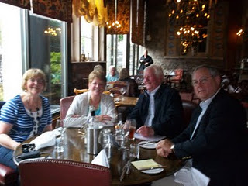
In May 2011, two couples met at the historic Swan Hotel in Bedford, Bedfordshire, England to review genealogical materials pertinent to the Holyman family. John Bunyan, author of Pilgrim's Progress, lunched here in the middle 1600s. Left to right are Maureen Smith, Barbara Holliman, my wife, Peter Smith, a family historian and member of the local genealogical society, and yours truly. One can observe that not all family history research and sharing occurs in a musty archives. More of that later.
Peter had not found (nor did I) Holymans in Bedford before the 1609 marriage of Thomas Holyman, and the subsequent birth of his children. Peter, in his research, however, had found a John Holman born 1560 in Woburn, Bedfordshire, approximately 15 miles south of Bedford and 15 miles north of Tring, Hertfordshire. This John married early – 1575, but no wife is named.
While young, it may have been a required marriage as one Thomas Holiman was born in Woburn in 1576. Two other children are recorded of that marriage – Robert, b 1581 and Joan, 1586, both born in Woburn. Hmmm…..interesting. Could this Thomas be Christopher Holyman, Sr.’s father? Some believe this Woburn, Bedfordshire Thomas is an ancestor of ours.
Next posting in Woburn, Bedfordshire....
Posted by Glenn N. Holliman at 2:57 AM 0 comments
Labels: Barb Holliman, Christopher Holyman, Judith Holyman, Peter Smith, Thomas Holyman

FRIDAY, AUGUST 5, 2011

The Hollimans of Alabama
by Glenn N. Holliman
Back to the 19th Century...A Series of Articles on the Hollimans and Related Families of Fayette County, Alabama
This is my last post on the April 9, 2011 Fayette County, Alabama excursion organized by my second cousin, Glenda Norris. Working with information from her Uncle Rhodes and Grandfather Cecil Rhodes Holliman, Glenda scheduled the day, and even did a 'test drive' before leading 15 of her distant cousins on a trip through family history. Below in the Tuscaloosa County, Spring Hill Baptist Church Cemetery, Glenda in the background cleans a tombstone while her husband, Scott, and Norman Holliman look on. Robert Holliman in the foreground takes photos.
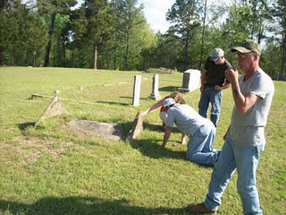
In this cemetery is the unmarked grave of my generation's third great grandmother, Elizabeth Holliman, wife of Cornelius. They led their family by horse and wagon in 1836 from Lancaster County, South Carolina near the North Carolina line through George to west Alabama. Here on recently released Indian land, the family purchased land and began farming. Two brothers, Warren and Charles Holliman, made the trek also, although Warren moved on in a few years to Arkansas to put down roots and establish the Holliman name there. In the photo below, 91 year old H. Bishop Holliman, who visited Fayette County for the first time in the 1920s (He was born in Irondale, Alabama in the 1919) explores the cemetery.
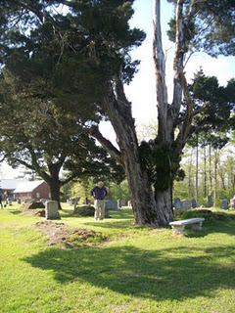
Several earthen grave sites dot the Spring Hill Cemetery. In one of these resting places, may be the remains of Elizabeth Plyler Holliman, pioneer Mother and Grandmother
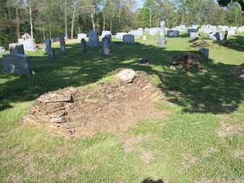
Next post, we return to study earlier Hollimans in England....
Plan now to attend the Holliman and Associated Families Genealogical Round Table at the Fayette County, Alabama Civic Center, 10 am to 3 pm, Saturday, October 15, 2011. For information and reservations for lunch, contact Glenda Norris at gnorris@bcbsal.org or Glenn Holliman at Glennhistory@gmail.com. Sessions to include Tracing the Holymans from England to Alabama, Holliman Farm Sites in Fayette County and sharing of information on Associated Families. All invited including the social at 5:30 pm, Rose House Inn in Fayette on Friday evening, October 14th. Y'all come!
Posted by Glenn N. Holliman at 12:59 PM 0 comments
Labels: Bishop Holliman, Glenda Norris, Norman Holliman, Robert Hollman, Scott Norris

MONDAY, AUGUST 1, 2011

The Hollimans of Alabama
by Glenn N. Holliman
Back to the 19th Century...A Series of Articles on the Hollimans and Related Families of Fayette County, Alabama
Actually this article is about a Baptist Church just south of Fayette County and Newtonville. Spring Hill Baptist Church is located just over the Tuscaloosa County line. The memorial stone below in front of the church honors to of my generations's three great grandfathers -Charles Daniel Lucas and Cornelius Holliman. Their graves were visited on April 9, 2011 by some of their descendants.
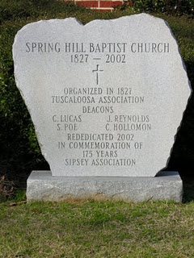
Below the church with the memorial stone in front.
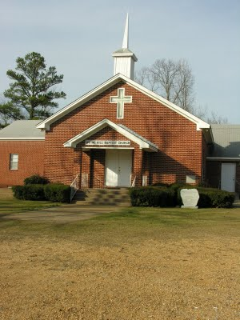
As we know, Charles Daniel Lucas is buried several miles away in an Indian grave site. Cornelius is at peace twenty or so miles north at Old Blooming Grove in the Bluff Community. Glenda Norris believes Cornelius's wife, Elizabeth Plyler, is buried inside the gates of the Spring Hill Cemetery. However, her grave is lost.
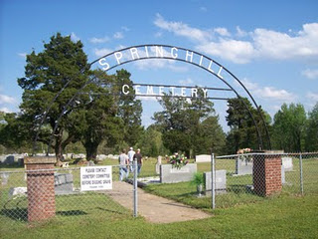
Next post, more graves in Spring Hill....
Plan now to attend the Holliman and Associated Families Genealogical Round Table at the Fayette County, Alabama Civic Center, 10 am to 3 pm, Saturday, October 15, 2011. For information and reservations for lunch, contact Glenda Norris at gnorris@bcbsal.org or Glenn Holliman at Glennhistory@gmail.com. Sessions to include Tracing the Holymans from England to Alabama, Holliman Farm Sites in Fayette County and sharing of information on Associated Families. All invited, including the 5:30 pm - 9 pm social at the Rose House Inn, Fayette, Friday, October 14th.

Posted by Glenn N. Holliman at 1:39 AM 0 comments
Labels: Charles Daniel Lucas, Cornelius Holliman, Glenda Norris

Home TUESDAY, SEPTEMBER 27, 2011

When We Were English, Part XXXII
A Treasure Found - the Will of Christopher Holyman, 1589! by Glenn N. Holliman
I could not look at all of the Holliman wills in the Buckinghamshire Archives, but three that seemed to match time, place and name, I explored closely. Now I am not talking about microfilm.
The actual wills were hand carried to me by a lady garbed in a white coat, much like a physician. She placed three 'ancient' parchments in front of me on a pillow so bindings would not break, and then (gasp) with my uncovered but clean fingers, I turned the pages and held in my 21st Century hands a will signed in 1589 by Christopher Holyman!!!

Was I holding a document signed by my 9th great grandfather???? Could this be the grandfather of Christopher Holyman, Sr. (1618 – 1691) of Isle of Wight, Virginia? Let me tell you what I found and what it may, repeat, may mean.
Click twice and the document should enlarge. I have yellowed the names, the first one being Christopher Hollyman! Note Thomas Hollyman is the second child.
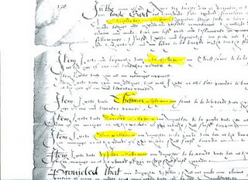

1. This Christopher Hollyman lived in Sherington, Buckinghamshire.

2. He had children, whose names I make out to be:

A. John
B. Thomas, a minor in 1589
C. Dorothy (?), a minor
D. Ellin, a minor
E. (?) lloy, a minor
F. Ami, a minor
The wife’s name was Margaret. He appointed his brother, Thomas Hollyman, as executor. Were these persons my 9th great grandmother and a very great uncle?
Yes, for 4 pounds, 20 pence (about $7) I asked for a copy of the will. It did not reproduce well but here is part of it above. But there was the signature by an English Christopher Hollyman – chills down my back at this point at this point. Darn, I forgot to film the document, I was so excited.

So I race to the Sherington, Buckinghamshire parish records to ascertain the baptism records, marriage and burial records of this Hollyman family. Tragedy!! No parish records from Sherington UNTIL 1603. Curses, no way to find out the birth dates of the children.

What next?
Posted by Glenn N. Holliman at 8:32 AM 0 comments
Labels: Christopher Holyman, Margaret Holliman

SUNDAY, SEPTEMBER 18, 2011

When We Were English, Part XXXI
ARE WE BUCKINGHAMSHIRE HOLLIMANS?
by Glenn N. Holliman
As one recalls in 2010, I began my research in Hertfordshire before discovering the Holyman 15th Century farm in Cuddington, Buckinghamshire. So in June 2011, after exploring the Shire Archives in Bedford and Worcester, with the help of family historian, Peter Smith, delved into the Aylesbury, Buckinghamshire Archives.
And there, I found treasure!
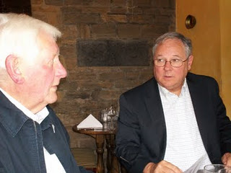
Family history 'detective' Peter Smith and the writer discuss findings over lunch.
A look at the Buckinghamshire Probate Records wills index revealed a plethora of Holliman names. Unfortunately, the wills are not printed out but must be viewed in the original one at a time. Here are their names. Note the ones from Cuddington, the home of the former Holyman Farm and manor house.
1521 – John Holyman, Cuddington. (see articles posted August 15, 2010 for all Cuddington names)
1525 – Joan Holyman, Chesham, Leicester.
1525 – John Holyman, Chesham.
1525 – William Holyman, Chesham.
1533 – John Holyman, husbandman, Cuddington.
1545 – William Holyman, husbandman, Cuddington.
1547 – Elizabeth Holyman, Cuddington.
1557 – William Holliman, husbandman, Cuddington (estate valued at 18 pounds).
1558 – John Holyma(n), husbandman, Cuddington.
1573 – Leonard Holyman, weaver, Cholesbury. (see article posted September 7, 2010 for Leonard Holyman)
1589 – Christopher Hollyman, Sherington, testator. (Yes, my eyes doubled, nay tripled, in size when I spotted this one!)
1598 – John Holyman, weaver, Cholesbury.
1600 – John Holyman, husbandman, Cuddington
1603 – Francis Holliman, yeoman, Cuddington.
1607 – Richard Holyman, labourer, Haddenham.
1618 – John Holeman, shoemaker, Newport Pagnell.
1623 – Thomas Holliman, the elder, yeoman, Cuddington.
1624 – Joseph Hollyman, Haddenham.
1638 – Roberet Hollyman, yeoman, Cuddington.
1648 – Richard Holyman, yeoman, Haddenham.
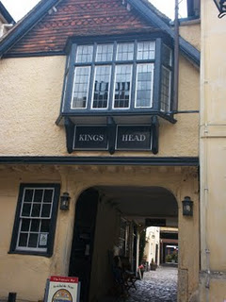
Several blocks from the Aylesburg Archives is the Kings Head Pub, one of the few ever listed in England's National Trust. Henry VIII and Anne Boylen spent the night here on at least one occasion. Whilst in the Archive's the wives of Peter Smith and Glenn Holliman retired for a repast here (after some shopping on High Street!)
Next Post - following up on Christopher Holyman (1589)!
Plan now to attend the Holliman and Associated Families Genealogical Round Table at the Fayette County, Alabama Civic Center, 10 am to 3 pm, Saturday, October 15, 2011. For information and reservations for lunch, contact Glenda Norris at gnorris@bcbsal.org or Glenn Holliman at Glennhistory@gmail.com. Sessions to include Tracing the Holymans from England to Alabama, Holliman Farm Sites in Fayette County and sharing of information on Associated Families. All invited, including the 5:30 pm - 9 pm social at the Rose House Inn, Fayette, Friday, October 14th.

Posted by Glenn N. Holliman at 6:29 AM 0 comments
Labels: Christopher Holyman

SATURDAY, SEPTEMBER 10, 2011

When We Were English, Part XXX
Some More Names and Thoughts on Worcester Holymans
by Glenn N. Holliman
From the Calendar of Wills and Administrations of the Consistory Court of the Bishop of Worchester, 1661 – 1699, we have more names of Holymans who wrote wills. In Bedfordshire, there are few wills of Holymans; in Worcestershire during the same time period, many. Strange. The archivist in Bedford told me only about 5% of the population in that shire wrote wills in the 1600s. More did so in Worcester.

1672, Aug. 21, John Hollyman, Bromsgrove.
1687, May 9 – Hugh Hollyman, Leigh.
1691, Aug. 7, Thomas Holliman, Bromsgrove.

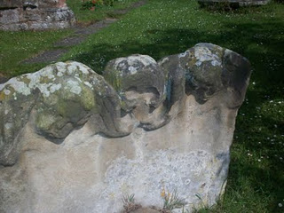
At the Leigh St. Edburga parish from a 1700s tombstone, these eroded figures of two children and grisly skull remind us that young people died often before reaching adulthood.
As my research time was limited, I cannot say that a Judith and Christopher Holyman or other Virginia Holymans did not come from Worcester. Additional hours must be dedicated to reading the microfilm of each will (looking for names) and parish records, as no parish index exists for Worcestershire (sigh…). Only then will be able to rule out or welcome Worcestershire as the ancestral home of at least some of the Hollimans. So much more work to be done.

BUT no name of Christopher or Judith leaped out as such as surfaced in Bedford, England. So for now, I still favor the Bedford Holymans as the origin of our Virginia family.

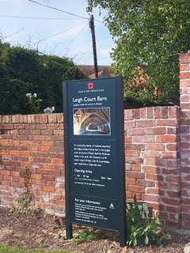
Adjacent to St. Edburga parish is the medieval tithe barn, now maintained by English Heritage. Members of the community were required to support the church (and the civil functions it carried out) through a 10% 'tax' on their harvest. Hence the need for a parish barn to hold the 'tithe'.
A closing thought – the Severn River runs south from Worcester into the Bristol Channel. Bristol, we are told by historians, was the chief port for English relocating to the American colonies. So if one wanted to immigrate to America, Worcestershire would be a convenient location from which to begin an odyssey to the New World.

Therefore as a note of interest, as Christopher and Judith Holyman were transported to Virginia in 1650 sponsored by a man named John Cox, I found this recording in “The Complete Book of Emigrants, 1607-1660” by Peter Wilson Coldham, Baltimore, Genealogical Publishing, 1987:

“April 9, 1650 – Sir Henry Chicheley to be released and allowed to pass to Virginia on the usual security . Pass also for Thomas Cox and Robert Pigge to go to Virginia.” Hmm....

Next a visit to the Buckinghamshire Archives, still searching for the ancestors of Christopher Holyman, Sr. (1618 - 1691)....
Posted by Glenn N. Holliman at 11:23 AM 0 comments
Labels: Thomas Cox, Thomas Holliman

MONDAY, SEPTEMBER 5, 2011

When We Were English, Part XXIX
A Look at the Holymans of Worcestershire
by Glenn N. Holliman

During my visit to the Worcestershire Archives I explored several volumes. My first was Wills and Administrations , Volume 1, 1451 – 1600 by the Worcestershire Historical Society, 1904. These names are indexed for wills as follows. Unfortunately transcripts of the wills have not been published thus requiring, eventually, a look at all the wills to build a family tree.

Spellings of towns vary as certain names were spelled by sound.

1541 – Richard Holyman, Sturbridge.
1553 – Thomas Holyman, the Elder, Lye. (Leigh).
1558 – Elizabeth Holyman, Lyghe (Leigh).
1575 – Hufrey Holyma(n), Blakesall, Wolverley.
1582 – Thomas Holyman(n), Woluley (Wolverley), a M. bond to Alice Stower.
1593 – Thomas Holliman, husbandman, Lyghe (Leigh).
1596, Nov. 23 –William Holliman, victualer, St. Peter’s, Worcester.
1597, Feb. 13 – Thomas Holliman, husbandman, Leigh.

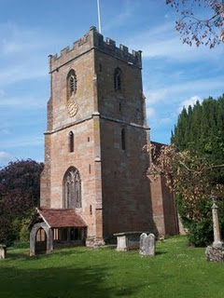
The parish church of St. Edburga at Leigh, Worcestershire. Holymans must lie in the church cemetery.

Then from Wills and Administrations, Probate Registry of Worcester, 1601 – 1652, one finds:

1607 – Roger Hollyman, labourer, Kidderminister.
1608 – Thomas Holliman, husbandman, Leigh.
1610 – John Holliman, Purshullgreene.
1611 – Humfrey Holleymon, yeoman, Wolverley.
1614 – Ann Hollyman, widow, Leigh.
1627 – Samuel Hollyman, Wolverly.
1629 – Francis Holliman, Chadisley (Chaddesley) Corbertt, a scythesmith left a total of 82 pounds (A sizeable sum in the 17thCentury. A scythesmith was a metalworker.)
1642 – Richard Hollyman, yeoman, Leigh.

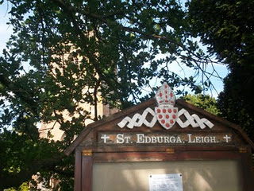

Next post, a few more Hollyman names and some thoughts....

Posted by Glenn N. Holliman at 1:11 AM 0 comments
Labels: Thomas Holyman of Leigh
Home
Subscribe to: Posts (Atom)

THURSDAY, OCTOBER 27, 2011

The Legacy of Walt Holliman
by Glenn N. Holliman
The Research and Writings of Walter O. Holliman Preserved and Being Shared with a New Generation
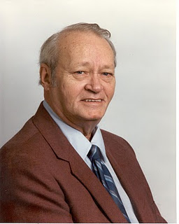

Walter Orien Holliman, pictured above, a meticulous family researcher, passed away November 1, 2003. His birthday was May 5, 1927. Walt's father was Moses Holliman, the son of Warren C. Holliman, the son of Charles Holliman (1795 - 1841 ca), who was the son of James Grantson Holliman (1750-1836), a common grandfather to almost all reading this blog.
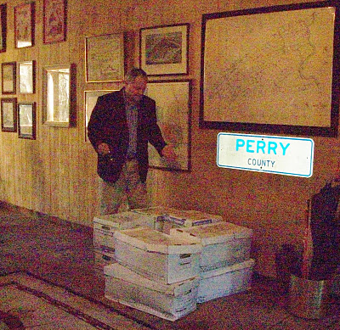
Above, Glenn N. Holliman, distant cousin of Walt Holliman, surveys over 300 pounds of papers and books donated to his Holliman Collection from the children of Walt. The material is housed in a 5,000 volume collection of books and papers in Newport, Pennsylvania (yes, it is in Perry County as the liberated highway sign reveals).
"I walked into my library/barn just as the UPS truck was pulling away to discover this awesome collection of research, manuscripts, raw data and genealogical books. The children of Walt - Lynn, Bryan and Ann - had been in touch with me about preserving the collection. After checking with other children - Debbie and Paul - they decided to pass this invaluable material to my growing family history collection. This is 24 feet of shelf space of important papers and books.
I am honored by their trust. This winter I intend to inventory the collection and begin posting appropriate materials on the web so that other Hollimans and associated families can benefit from the decades of work accomplished by Walt. After my time is over, I intend to pass the collection to a new generation of family members, perhaps in some type of family association or corporation.
While I have not had time to study the materials in depth, there are unpublished manuscripts and meticulous will and land transfer records obviously representing years of work and travel. It is obvious Walt was careful and documented everything he did. His work is an excellent example of a historian who enjoyed his craft.
We are fortunate in our extended family to have this work saved. Others in the family, the late Cecil Holliman and his son, Rhodes Holliman, Ron Holliman, Maxine Wright, Joe Parker, Vonceil Duckworth, Jeanette Holiman Stewart, Glenda Norris and other members of Tina Peddie's chat room have been likewise industrious in saving and preserving our family's history. The story of the Hollimans and our associated families is America's story.
Walt was born in Birmingham, Alabama as was I. A Boy Scout, he enlisted at age 16 in the U.S. Navy serving in World War II as a air gunner. After the war, he graduated from the University of Tennessee and went on to a successful career in mobile home manufacturing and the aviation industry. Tiring of travelling, he settled back in the Birmingham area as a stock and real estate broker. He was a member of Mensa International, the American Legion, the Veterans of Foreign Wars, the Methodist Church and various business associations.
From his last home in Pelham, Alabama, he spent countless hours collecting raw data, saving it and typing thousands of pages of notes and stories on his families.
Our great thanks to the family of Walt for preserving his work and their generosity is sharing it with the larger family. I am happy to report that in the first few weeks of receiving this material, I was able to:
(1) pass along a thick file for review on the Blakeney family to genealogist Glenda Norris, a Blakeney descendant in Alabama,
(2) review Walt's materials on Samuel Holliman (1707 - 1789) with Lynn Holliman (Texas) and Joe Parker (Texas), and together come to consensus, that yes, Samuel is the father of James Grantson Holliman, and
(3) respond quickly to David Jennings of Pickens County, Alabama who sought to know the name of his great, great grandfather. Like Walt, David descends from Warren C. Holliman, son of Charles Holliman, son of James Grantson Holliman."
For information on the Walt Holliman Collection or if you have papers to preserve, please contact yours truly at Glennhistory@gmail.com. Together we can save our history for our children who come after us.

Posted by Glenn N. Holliman at 7:35 AM 0 comments
Labels: Cecil Holliman, Glenda Norris Jeanette Stewart, Glenn Holliman,Joe Parker, Rhodes Holliman, Vonceil Duckworth, Walt Holliman

WEDNESDAY, OCTOBER 19, 2011

When We Were English, Part XXXV
A Cuddington, Buckinghamshire Connection? Maybe So
by Glenn N. Holliman
8. In the 1580s, Robert Holyman of Cuddington had real estate dealings with Thomas Tyringham, whose home was in the near village of Nether Winchendon, Buckinghamshire, and may have had family in Tyringham near Sherington. (See article posted July 28, 2010) Could a Robert Holyman relative be our Christopher Hollyman of 1589 in Sherington? Could this be the tie to the Cuddington Holymans, approximately 30 miles south of Sherington?

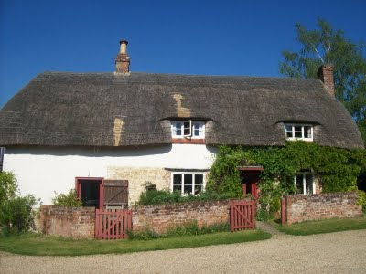
The pub at Cuddington, Buckinghamshire, only a few blocks from the former Holyman farm, sports a thatched roof, a not uncommon architectural feature in English villages.
A scenario can be constructed that Christopher Holyman, Sr. who died Isle of Wight, Virginia in 1691, was the son of Thomas Hollyman, probably born in Sherington, Buckinghamshire who by 1609 was earning a living in Bedford, Bedfordshire and married that year at St. Peter’s parish.

And this Thomas, a second son who inherited some assets, but not family property, from Christopher Holyman (will of 1589) of Sherington, is the same Thomas Hollyman who went to grammar school in Lathbury, Buckinghamshire in 1595.

And while more research is needed, this 1589 Christopher Hollyman of Sherington may have moved to the area from the central part of Buckinghamshire, the Cuddington, Tring or Cholesbury area, perhaps being born sometime from 1520 to 1550. Perhaps!

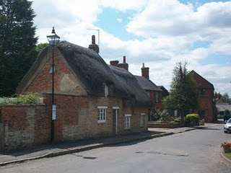
Thatched roofs in Sherington, Buckinghamshire. Did Holymans centuries past sleep and live under threshes?
Now who then is the Christopher 1589’s father?!!! Are we on the edge of taking the family tree another one hundred years or so back in time, to the time when The Rt. Rev. John Holyman, Counter-Reformation Bishop, was born in 1495 in Cuddington, Buckinghamshire? (See blog article of September 2010.)
Notwithstanding the significant number of Holliman families in Worcestershire, is this Christopher Hollyman of Sherington, Buckinghamshire the grandfather of the Christopher Holyman who sailed to Virginia in 1650? Have we found my generation’s 9th great grandfather?

And indeed, are we a few more bits of research from tying the Cuddington/Tring Holymans to the Sherington and Bedford Holymans? Are we pushing the family history back to the 1400s!

Posted by Glenn N. Holliman at 1:35 AM 0 comments
Labels: Christopher Holyman, Richard Holyman

TUESDAY, OCTOBER 11, 2011

When We Were English, Part XXXIV
Have We Found the English Family of Christopher Holyman, Sr. of Virginia? by Glenn N. Holliman
Let’s play family history detective. Here are the facts and what can be deduced.
1. Christopher, according to family historian Peter Smith of Bedfordshire, was an uncommon first name in the 1500s and 1600s, so locating the name in 1589 is important. In all my research, I have not found it ANY WHERE ELSE in England attached to the surname Holyman or one of its various spellings, except, of course, for the 1618 birth of Christopher Holyman in Bedford.
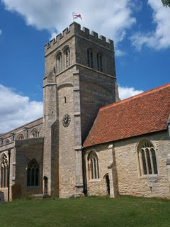
The parish church in Sherington, Buckinghamshire is named after St. Laud of France. It is just possible that my generation's 9th great grandfather, Christopher Holyman's dust, may be embedded in the grounds surrounding this 19th Century restoration.
First names are often repeated from one generation to another. Thomas of 1589 and 1595, is he the same Thomas Hollyman who marries in Bedford, Bedfordshire at St. Peter’s in 1609?

3. And the Christopher Holyman born in Bedford in 1618 to Thomas, is he a grandson and named after the 1589 Christopher of Sherington, Buckinghamshire?

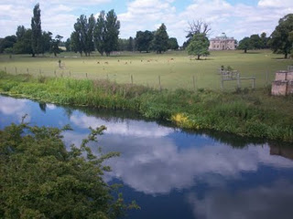
The Great River Ouse (yes, that is the name of this lazy 'river') flows from Sherington to Bedford. Here the stream meanders past Tyringham House, a great county estate a few miles west of Sherington. Yes, the river flows west for a bit and then turns north and finally east, moving through Bedford and eventually to the North Sea.
4. Sherington is upriver on the Great River Ouse which flows through Bedford, two blocks from St. Mary’s parish where Christopher Holyman, b. 1618, was baptized. Sherington is approximately 12 walking miles from Bedford. Hmmmm.....

5. We can find no records of Holymans in Sherington parish records after 1602 (and no records exist prior to 1603, except 1576 and no Hollymans that year).

6. No records exist in Bedford, Bedfordshire prior to 1609 on Hollymans.

7. No records exist in Bedford recording the death of Christopher Holyman, b. 1618, or his sister, Judith, b 1621, in Bedford. (Of course not if they died in Virginia!)
The clues point to a connection....
Posted by Glenn N. Holliman at 1:35 AM 0 comments
Labels: Christopher Holliman Sr., Christopher Holyman

TUESDAY, OCTOBER 4, 2011

When We Were English, Part XXXIII
ARE WE FROM SHERINGTON, NEAR MILTON KEYNES, BUCKINGHAMSHIRE? by Glenn N. Holliman
On a tip from Buckinghamshire family historian Peter Smith, I ventured in June 2011 to the local history section of the Milton Keynes library, about 15 miles north of Aylesbury, Buckinghamshire. Hopefully there I would find the missing parish records of Sherington, Buckinghamshire, looking as I was for more information on Christopher Holyman (d 1589).
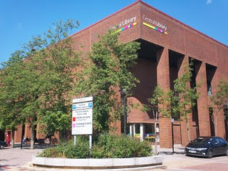
The modern library and local history room in Milton Keynes is located a 1960s planned development section featuring plenty of parking, retangle office, brick store blocks and urban boredom.
Milton Keynes is a medieval market town that received a planning make over in the 1960s. Now a ‘planned community’ of round-abouts and rectangular business plazas, several blocks in length, it does feature plenty of parking even if there be a dreary sameness to its governmental and commercial centre. Charm, there is none.
Alas, the parish records I sought were still ‘missing’ and after several hours of squinting at microfilm of 17th Century wills, baptisms and burials from 1603 to 1720, I came up with precious few clues on the Holyman family. However, sometimes it is not what one finds, but what one does not find. Evidently, the Holyman family, citizens of Sherington in the late 1500s, did not live there in the 1600s after this 1589 Christopher’s death.
So where did the children go? To Bedford twelve or so miles away and a thriving community in the early 1600s especially if one be a second son, such as Thomas Holyman?
Well, as I was about to leave (my parking was expiring), I glanced at the shelf of local parish publications. My eye caught a title – “Fiefs and Fields of a Buckinghamshire Village” by A.C. Chibnall. The work was published in 1965 by Cambridge University Press of Cambridge. I flipped to the index, not expecting to find anything, when, lo and behold, up popped the names Christopher Holyman andThomas Holyman!
On page 178 of the work, I find this: “Two leading inhabitants (of Sherington) Edward Ardes and Christopher Hollyman, visited the bishop in 1575 in Buckden to lodge a complaint on rector Henry Barlow, a dissolute fellow.”
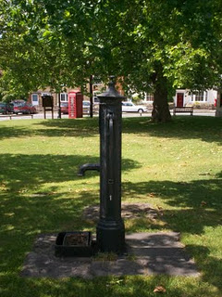
Ye ole village pump stands even today on the small village green in Sherington. The now disappearing British Telephone red box is in the background, and across the street, a closed facility labeled, I think ironically given our family history, the Virginia Store!
Another page over on 179, the author reports Christopher Hollyman serving in Queen Elizabeth’s guard and leasing the rectory for 50 pounds annum. This Christopher Hollyman (p. 188) died in 1589 after securing more land from his ‘good friend Richard Ardes’ (probable son of Edward Ardes).
Remember in his 1589 will, Christopher Hollyman records a second son, a minor, named Thomas Hollyman. Well, on pages 193 and 194 of Chibnall’s tome, we are told of a grammar school, 6 or 7 miles from Sherington in Lathbury. One of the 14 boys listed as attending in 1596 was a Thomas Hollyman! This would make him the right age to be married in 1609 twelve miles away in Bedford!
The circumstantial evidence is building that we have found the father and grandfather of Christopher Holyman, Sr. (1618 - 1691)....
Posted by Glenn N. Holliman at 1:33 AM 0 comments
Labels: Christopher Holyman, Thomas Holyman
Home

Subscribe to: Posts (Atom) SUNDAY, NOVEMBER 27, 2011

The Louisiana Hollemans
by Glenn N. Holliman
The Family of Sidney Anthony Holleman, Jr.,Well Written and Neatly Bound
Last spring on a tip from Joe Parker, ace Holliman family historian, I discovered a volume of family history by a distant cousin in Texas, one Dr. Sidney Anthony Holleman, Jr. By email I contacted Dr. Holleman and after covering printing and mailing costs, a 197 page tome on the Hollemans (or Holyman, Holliman, Holiman, etc.) arrived.
It is a handsome book, well bound and paperback, but certain to last in one's library for generations to come. Dr. Holleman researched the work, obviously for years, and published it in 2004. While later research has eclipsed some thoughts on our English roots, Sidney calmly and carefully moves his branch of the family from Christopher Holyman, Sr. (1618 - 1691 and Isle of Wight, Virginia eventually to Texas, the state he claims as his birthplace.
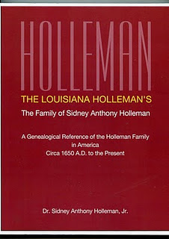
His Hollemans, as have most branches of our family, followed the southern migration across the southland from Virginia to North Carolina to Georgia and by the Civil War to Louisana. There the family became Roman Catholic and strengthened itself with some Acadian DNA. By the turn of the last century, the family had GTT - Gone to Texas! There Sid's parents raised him and where he has raised his own family.
If there is an 'e' as the second vowel in your Holliman name, you will want to obtain this book. Respecting Dr. Holleman's privacy, if you wish to contact him, send me an email and I will put him in touch with you.
Even if you don't have an 'e' in your name, you will appreciate the time, effort and family lore that has gone into this work.
Posted by Glenn N. Holliman at 4:47 AM 0 comments
Labels: Dr. Sidney A. Holleman

TUESDAY, NOVEMBER 15, 2011

Our Family's Colonial Era, Part XXVI
by Glenn N. Holliman
Christopher Holliman, Sr's. Will, a Further Look...
In the last posting, I published the will of my ancestor, Christopher Holliman, Sr., died 1691. Christopher left his two married daughters, Anne and Mary, not land, but one ewe each. That may seem unfair to 21st Century standards, but there were probably mitigating circumstances.
1. When they married their neighbor's sons, the Atkinsons, they married men who were expected to support their wives and children, and were expected to inherit land, just as did the Holliman sons.
2. The Atkinsons may very well have been provided doweries, thus in effect receiving their inheritances upon marriage.
3. Symbolically Anne and Mary both received an ewe, a female sheep. Most clothing worn by families in the 1600s of Colonial Virginia was home spun, that is clothes from the spinning of sheep wool. An ewe could become pregnant, and those produce additional sheep and wool for the family. Cotton would not become a cloth of choice until the invention of the cotton gin in the 1790s in Georgia.
The will left everything else including land to the wife, Mary, during her lifetime. At her passing, two sons (but not all four) received the remainder. Hmmmm....perhaps Christopher Sr. was trying to be fair to all, or perhaps he favored two of his sons, Christopher and Richard, over Thomas and William. Perhaps he had distributed some land earlier to these sons. We will never know.
Mention is made of orchards, an important supplement to the Colonial Virginia diet. Until English persons were able to plant and harvest apples, the lack of fruit and subsequent vitamins had resulted in malnutrician and many early deaths.
Notice no slaves or indentured servants are mentioned in the Holliman will. Although African-American slavery existed in the 1690s in Virginia, and the Assembly was passing more and more draconian slave laws, the great increase in importation of Africans would not occur until after 1700. Tragically by 1790, one out of five Americans (700,000) would be enslaved, an incredible statistic. Virginia and South Carolina had the largest populations of trapped human beings.
Of considerable interest is the importance of the tobacco culture in his will. The cultivation of tobacco, the cash crop, was critical. The volume below by husband and wife historians tells the story of Middlesex county, Virginia during the 17th Century. The Rutmans record that a whole tobacco crop of seeds could be cupped in one hand. These tiny seeds were placed in dirt hills, three to four feet apart. It was not even necessary to clean the land completely; just girdle the trees.
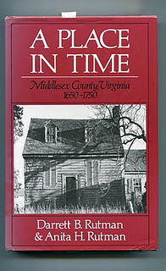

No more equipment was needed than a hoe. One laborer would 'crop' two to three acres which produced 1100 to 1200 pounds of cured tobacco. Corn could be interspersed with the tobacco. After a few years, when the soil was exhausted, the planter moved to new acres, and allowed hogs and cattle to graze on the abandoned land, allowing time and animal mature to re-nourish the soil.
The Rutmans published this cycle of a typical colonial agriculture year (see below and click to enlarge). With very little imagination, we can picture our ancestors working this pattern year after year. Not to be reproduced for commercial purposes.
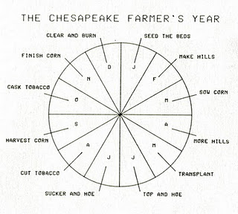
In future postings, we shall follow the fortunes of the Holliman children and their descendants....
Posted by Glenn N. Holliman at 1:07 AM 1 comments
Labels: Christopher Holliman Sr.

SATURDAY, NOVEMBER 5, 2011

Our Family's Colonial Era, Part XXV
by Glenn N. Holliman
The Will of Christopher Holliman, Sr.
Isle of Wight County, Virginia 1691
Below is Christopher Holyman's (Holliman, Holleman, etc) Virginia will of 1691. This is an easy to read version, but it is authentic and prepared, I believe, by a distant cousin. The original was filed in the Isle of Wight when William and Mary occupied the thrones of England. The colonies were almost a century away from George Washington, another Virginia, becoming President of the United States. Let's examine the will and see what we can learn. (Click on will to enlarge.)
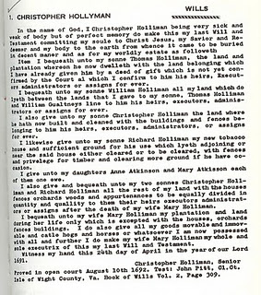
We note first of all a salutation common to English and colonial wills of the time, a statement of faith and belief in Christ Jesus. These faith statements are less common today. Christopher's grave is lost. Until the late 18th century, grave stones were rare in the colonies and virtually none at all in the 1600s Virginia. A family cemetery is now located adjacent to the current 1830s two-story brick Holleman house on the site of the original 1,020 acres that Christopher Holliman, Sr. owned. One suspects this might be the location of the first home, certainly a log house, and family grave sites (Click Archives and visit articles April 2010.)
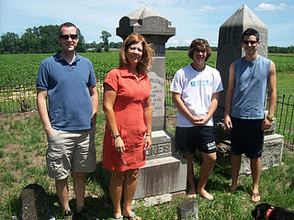
Distant cousins visit at the original Christopher Holyman, Sr. (1618 - 1691) plantation in July 2011. Pictured above at the Holleman farm in Isle of Wight County, Virginia are left to right, Bryan Payne (Tennessee), Alice Holliman Murphy (Texas), and Spenser and Corey Holleman, brothers who live at the original site. This Holleman family cemetery, with the earliest headstones from the first decades of the 1800s, may have been the location of the grave of Christopher Holyman, Sr.
Let's look at the bequests:
Thomas - Christopher had deeded already a plot of land to this son. The number of acres is not mentioned for any of the bequests.
William - This son received that portion of land between Thomas's plantation and the neighbor, William Gualtney (later spelled Gwaltney and of Welsh origin). The Gualtney's in the late 1800s will become merchants, first selling peanuts and later hams. These are now the famous Smithfield Hams of Isle of Wight County. Many of the Queen Anne style homes of downtown Smithfield were constructed from the financial success of the family. Records indicate Holliman daughters married Gualtney's from time to time.
Christopher, Jr. - This first borne son received his cleared land and buildings already constructed.
Richard - The youngest son received land for tobacco growing, timbering and clearing more if he wished. His bequest is the only mention of the principle crop - tobacco - and a bequest of a tobacco barn. Richard continued what became my branch of the family tree as he is my 6th great grandfather. More on him later in my writings.
Next posting, more analysis of this 17th Century family will....
Posted by Glenn N. Holliman at 1:35 AM 0 comments
Labels: Alice Holliman, Bryan PayneChristopher Holliman Jr., Christopher Holliman Sr., Corey Holleman, Murphy, Richard Holyman, Thomas Holliman, William Holliman
Home
Subscribe to: Posts (Atom)

SATURDAY, DECEMBER 31, 2011

SATURDAY, DECEMBER 31, 2011

A Gathering of Hollimans, Part IV
by Glenn N. Holliman
This is the fourth in a series of articles concerning the October 14/15, 2011 family seminar held in Fayette, Alabama, the ancestral location of many Hollimans living today.
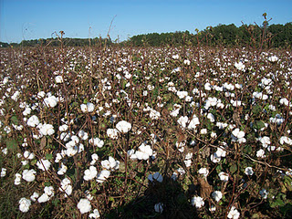
On the outskirts of Fayette last October were many cotton fields (above) waiting for the harvest. This crop was important to Southern Holliman families for several centuries. The farm land in the Sipsy River bottoms and the the timber and minerals of the ridge and ravine topography of the area have provided income to generations of Hollimans in that part of west Alabama.
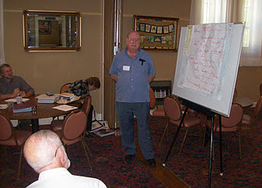
Above at the Fayette, Alabama seminar for Holliman descendants, Raiford Brandon, Bill Holliman and Vonceil Duckworth took notes while Joe Parker (above) shared his many insights in the Holliman family.
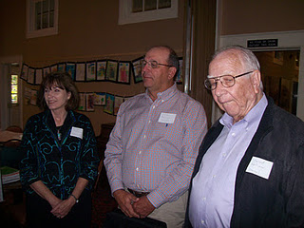
The gathering did not lack for educational expertise. In addition to Kathleen and Jimmy Holliman (above left), a professor at Auburn, was Lenwood Holliman (above right) of Lamar County, Alabama, a retired superintendent of schools. Both Lenwood and Jimmy descend through Charles Holliman, a son of James Grantson Holliman.
The Hollimans attending, sans spouses, were left to right front row: Jeanette Holiman Stewart, Vonceil Duckworth, Lenwood Holliman, Glenda Norris(number 12), Jimmy Holliman, Raiford Brandon andDavid Jennings. Back row: James Franklin Holliman, Glenn Holliman, Bill Holliman, Joe Parker and Lynn Holliman.

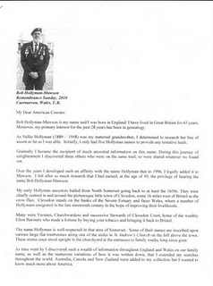

Sending greetings to Alabama from Caernarvon, Wales in Great Britain was cousin Bob Hollyman-Mawson (left) who forwarded some of his humerous findings on Holyman behaviors in Nottingham, England in the 1500s. His article, which generated chuckles, was distributed at the seminar.
Finally after a presentation on our English heritage to the Fayette group, an accumulation of my articles on English Holymans, was distributed (see below). If anyone would like a copy of Bob Hollyman-Mawson's article and/or mine, I am happy to email. My email address isGlennhistory@gmail.com.
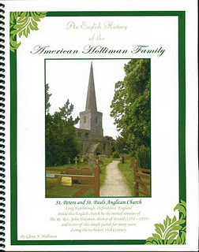
This publication describes my adventures during 2010 and 2011 in the search of the Holliman families of England before our ancestors became Americans. The parish church on the cover is Long Hanborough, Oxfordshire, England where a very great uncle of the America Hollimans was born in 1495. This uncle became The Rt. Rev. John Holyman, appointed a bishop during the turbulent reign of Queen Mary Tudor.
One cannot close our visit to Fayette, Alabama without a word of thanks to the Rose Hill Inn for their generous hospitality, the staff at the Fayette County Civic Center who worked on a Saturday for us, and my genealogical partner and second cousin, Glenda Norris who donated great time and energy to insuring the Holliman Round Table event would occur.
And much thanks to those who came so far and shared knowledge and asked good questions as we all sought to know better our ancestral roots.
Next postings, more on Alabama Hollimans before we return to Merry Ole England and Wales in search of our Medieval and Renaissance roots.
Posted by Glenn N. Holliman at 5:15 AM 0 comments
Labels: Bill Holliman, Bob Hollyman-MawsonJimmy Holliman, Lenwood Holliman, Raiford Brandon, Vonceil Duckworth

SATURDAY, DECEMBER 24, 2011

A Gathering of Hollimans, Part III
by Glenn N. Holliman
This is the third in a series of articles concerning the October 14/15, 2011 family seminar held in Fayette, Alabama, the ancestral location of many Hollimans living today.
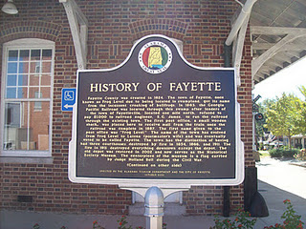
At the Georgia-Pacific Railroad Depot in Fayette stands a historical sign. The Depot is now a visitor’s center and museum where in the 1880s the rail road reached Fayette. In 1917, this writer's grandfather and grandmother rode this train with their four children to start life over in Irondale, Alabama, a blue collar suburb of Birmingham. There Ulyssand Pearl Caine Holliman increased their family by three more children (one my father b. 1919 H. Bishop Holliman). Their movement during World War I foreshadowed the disapra that the Holliman families and tens of millions of American families would experience from the middle to the end of the 20th Century.
On October 15, 2011, seminar and round table discussions were held at the Fayetteville Civic Center. Some of those attending were below left to right, David Jennings and his uncle Bill Holliman, both of Picken’s County, Alabama. Later, after consulting the papers of the lateWalt O. Holliman, it was determined they are descendants of Charles Holliman (1795 – 1841 ca), one of the three brothers who immigrated to west Alabama in 1836 from South Carolina. Bill is a retired college music professor.

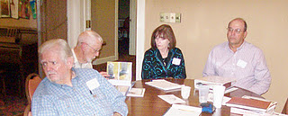

Above, same photo on the right, from the Selma, Alabama area were Jimmy and Kathleen Holliman. Jimmy is a descendant also of Charles Holliman, and is a professor with the University of Auburn Agricultural Extension Service.

Keeping notes at the meeting was Jeanette Holiman Stewart of Texas, below. Jeanette has entered over 10,000 Holliman names in her database! Behind Jeanette,left, is Frank Holliman who still retains some of the original land settled by the pioneering Holliman families in Fayette County.

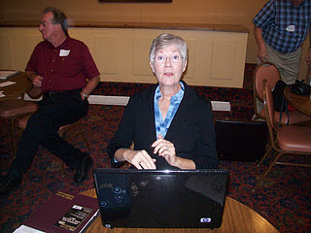

Below, Joe Parker flanked on his left by Lynn Hollimandelivers a point during the discussions. Joe provided information on the Holliman lines from Christopher Sr. (1618 – 1691) to the present. His knowledge of the various Holliman branches through their Southern migrations is encyclopedic in scope.

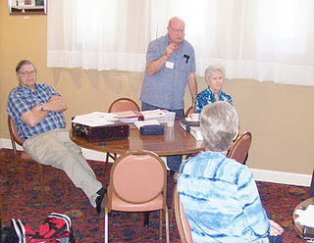

At the meeting, we remembered many Holliman pioneers, both living and deceased who could not be present. Undoubtedly this is only a partial list, and I apologize for not having information to include all. Additions to this Holliman (and all its spellings) Hall of Fame are welcome.
Recognized were Maxine Wright of Arkansas and Dr. Rhodes Holliman of Virginia. Both descend from James Grantson Holliman and have accomplished through the decades a mountain of research. Dr. Sidney Arthur Holleman’s 2003 publication of his branch of the family (Texas) was praised also. Ron Holliman of Dothan, Alabama, a descendant of James Grantson and John Thomas Holliman, also has compiled significant records but due to business and family could not be with us.
Among those whose earthly journeys are over and recognized as contributing significantly to our knowledge of this American family are Cecil Rhodes Holliman, Glenda Norris’s grandfather, Walt O. Holliman, also late of Alabama, whose research has been preserved by his children, and Dr. Charles Holliman, late of North Carolina whose work lives on the writings of others.
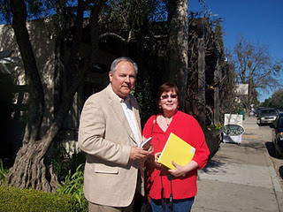
Above Glenn Holliman and Tina Peddie in February 2011 near her home in California. In addition to being an accomplished genealogist, Tina conducts searches for adopted children seeking biological parents.
Tina Peddie’s establishment of the Hollyman Internet chat room in 1999 has been instrumental in the sharing of family information and networking of various Holliman researchers. Her contributions from her home in California also include the re-publication, with the just deceased at age 93, Dr. Jeremiah Holliman, of the George E. Holleman 1953 ground breaking genealogical book on the family. Her achievements and George E. Holliman's tome, the first known publication concerning the family, were recognized with appreciation.

Next posting, more on the Holliman Alabama seminar....

Posted by Glenn N. Holliman at 4:38 AM 0 comments
Labels: Alabama, Bill Holliman, David Jennings, Fayette, Jeanette Stewart, Jimmy Holliman

SATURDAY, DECEMBER 17, 2011

A Gathering of Hollimans, Part II
by Glenn N. Holliman
In mid-October 2011, a dozen descendants of Christopher Holyman, Sr. (1618 - 1691),born an Englishman and died a Virginian, gathered in Fayette, Alabama for a seminar on the family. In 1836 three Holliman brothers arrived in Fayette County in West Alabama. Today their descendants live in Fayette, adjacent counties and states, and literally all over the country. In these articles we look at Fayette and also family, some living and some passed on.
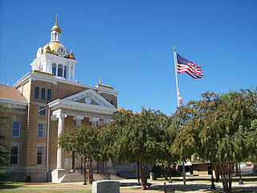

Above, Fayette County’s legal system and records resides in its one hundred year old gold domed court house. A fire in 1911 destroyed much of the down town taking many early records with it.
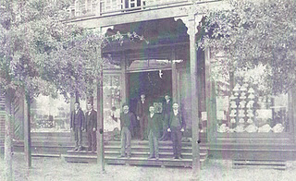

Above and far left James Monroe Holliman, Glenda Norris’ great grandfather, stands in front of Harkin’s Store which was destroyed by the 1911 disastrous fire that swept through the west Alabama community. Later, James became a successful attorney in Birmingham, Alabama (1878 - 1938).
Today, (below) the front street across from the Court House reflects the gentle pace of life during a Friday afternoon in autumn.
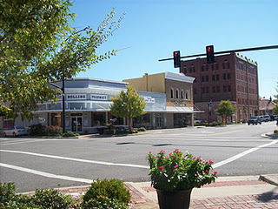

Below, James Franklin Holliman (right) inspects the materials Raiford Brandon (left) brought to the Fayette Round Table. Frank is a descendent of Cornelius Holliman and Raiford of Charles Holliman. All present were descended from Christopher Holyman, Sr. (1618 – 1691) and his son, Richard Holyman (1660c – 1711) with the exception of Joe Parker, who descended fromChristopher Holyman, Sr. through a different son; that being Christopher Holyman, Jr.
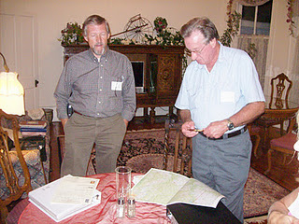

Below, two blocks from the Court House is the old train depot which survived the 1911 disastrous fire, now a community museum and visitor’s center. Just a few blocks away stood the home ofJohn Thomas Holliman (1844 – 1930), the great grandfather of Glenn Holliman and great, great grandfather of Glenda Norris.
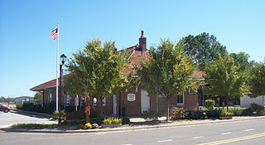

Below, holding the bridle of his horse, John Thomas Holliman, and Martha Jane Walker Holliman (1845 – 1931), his wife, stand in the 1920s in front of their Fayette home, only four blocks from the County Court House and close to the depot. The house is now gone.
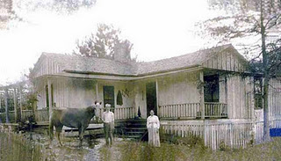

Like almost all Alabama white men and his male relatives of that era and age, John Thomas Holliman was a Confederate veteran. He fought at Stone’s River in the West and the Petersburg, Virginia Crater in the East. Martha Jane’s father, Samuel Walker (1822 – 1900) also of Fayette County, was one of the remaining 7,000 who surrendered with Robert E. Lee at Appomattox. (A fascinating article on John Thomas Holliman by Dr. Rhodes Holliman, grandson of James Monroe Holliman, can be found in the Archives, March 2010.)

Next posting, more views and news of the Alabama Round Table....
Posted by Glenn N. Holliman at 9:35 AM 0 comments
Labels: Charles Holliman, Cornelius Holliman, Martha Jane Walker Holliman, Rhodes Holliman, Richard Holyman

SATURDAY, DECEMBER 10, 2011

A Gathering of Hollimans, Part I
by Glenn N. Holliman

In the small community of Fayette, Alabama on October 14 and 15, 2011, a dozen blood-related Hollimans, all descended from Christopher Holyman, Sr. (1618 – 1691), gathered to share research and pose questions as to their common lineage.
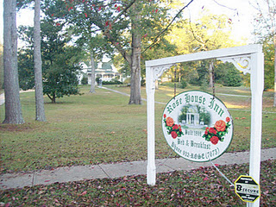
Those who came overnight lodged at the Rose House Inn(above) in Fayette, a quiet community, forty or so miles west of Birmingham and the same distance north of Tuscaloosa. It was in this frontier county that three Holliman brothers, Warren, Charles and Corneliussettled in 1836, emigrating from South Carolina. All three were sons of James Grantson Holliman (1750 – 1836). Warren and his family moved on to Arkansas. Charles, Cornelius and hundreds of their descendants stayed in Fayette and surrounding counties.

Not wasting a moment, Joe Parker (left below) and Lynn Holliman (right) immediately upon arriving began sharing information on the front porch of the Inn’s guest house. Both had driven from Texas, and planned to travel further east on family vacations and research. Joe had prepared a software disk of Hollimans (and various spellings) and their locations in the United States.
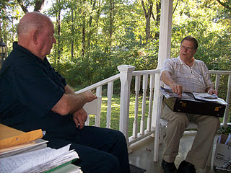
During the evening, Joe, Lynn and yours truly examined papers on James Grantson Holliman from the Walt O. Holliman collection recently donated by his children for review by other family members.
With combined research and the work done by Walt in previous decades, we concluded that the evidence is overwhelming that Samuel Holliman (1707c - 1789), a grandson of Christopher Holyman, Sr. (1618 - 1691), must be the father of James Grantson. The name of James Grantson Holliman's father has bedeviled family historians for decades.
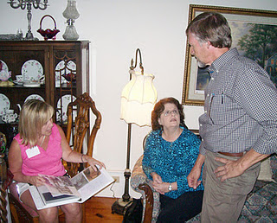
On the Friday evening, a reception was held and, those of us who knew each other only by email, began to share stories in person. Above seminar organizer Glenda Norris, (left in pink) of the Birmingham, Alabama suburbs, reviews a family history prepared by Raiford Brandon (right) and his wife,Shelia (in blue).
The Brandons had traveled from their home near Hattiesburg, Mississippi. Raiford’s family tree not only is connected to England through his Holliman roots, but also has branches leading to members of the Tudor Royal Court of the 1500s.
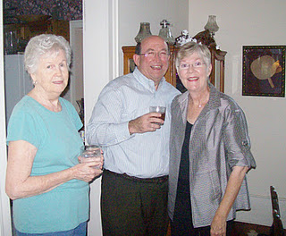
Also traveling from Texas to Alabama were Gladys Parker,above left, and Jim and Jeanette Holiman Stewart, all of the Lone Star state, representing some of the many family members that continued west from the Deep South. Gladys,Joe Parker’s better half, is a serious genealogist herself.

Next Posting, more on the Round Table and a look at Hollimans in Fayette County, Alabama
Posted by Glenn N. Holliman at 1:14 AM 1 comments
Labels: Gladys Parker, Glenda Norris Jeanette Stewart, Joe Parker, Lynn Holliman, Raiford Brandon, Shelia Brandon, Walt O. Holliman
Home
Subscribe to: Posts (Atom)

TUESDAY, JANUARY 31, 2012
Some Notes on a West Alabama Family by Laura Vonceil Duckworth, Reform, Alabama.
In this final article of a series of postings by Laura Vonceil Duckworth of Reform, Alabama, she writes a tribute to her late mother, whose words reflect the respectful wisdom of the family-oriented culture of the Deep South. Both are descendants of Christopher Holyman, Sr. (1618 - 1691).
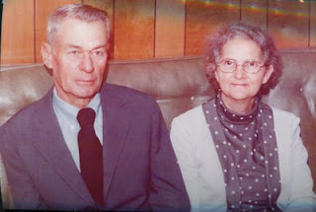
Right, Mamie Lou Clemmons and Dewey Bonner in the 1970s
My mother, Mamie Lou Clemmons, a descendant of Hollimans, had a great influence on my life. She always was at home taking care of seven brats. Very few times was a switch used, but she used her soft voice for corrections, teaching us that it was wrong to talk about others.

West Alabama Wisdom from Mamie Lou Clemmons

- ‘If you can't say anything good about other people, it is best not to say anything.

- Never take anything for granted.

- Always give a helping hand when you can, as you never know when you might need help.

- Learn and use your mistakes when you have children of your own.

- Always tell the truth and then you don’t get into trouble because your daddy has checked the mileage of the old car.

- Other people will look at you and know what kind of parents you have by the way you act.

- Your education can never be taken away.’

Mom’s parents passed away while she was still a teenager. She dropped out of school in the ninth grade, and she married at the age of nineteen. Dewey D. Bonner was fourteen years older, but he provided well for her. He always said she was different from any of the other women he had dated.

Never in my life did I hear my mother utter a curse word. One of the most wonderful things I ever heard her say was, 'The greatest thing I get out of life is helping others.' What a tribute to leave behind.

She passed away on January 13, 1984 in Birmingham, Alabama from complications of acute leukemia. She had been diagnosed two weeks before while in a hospital in Columbus, Mississippi. She had a heart attack the day she left that hospital and a stroke the same night. What a defeat.
Or was it? She longed to see her husband whom had passed away May 16, 1979. I say she was received with open arms.”

Soon another reminiscence of West Alabama by Dr. Rhodes Holliman, a prominent Holliman family historian....

Posted by Glenn N. Holliman at 1:06 PM 0 comments
Labels: Mamie Lue Clemmons Bonner, Virgil Bonner

SATURDAY, JANUARY 21, 2012
Some Notes on a West Alabama Family by Laura Vonceil Duckworth, Reform, Alabama.
This is the third article in a series of four postings on the family and ancestors of Laura Vonceil Duckworth, a descendant of Christopher Holyman (1618 - 1691) of Isle of Wight, Virginia.
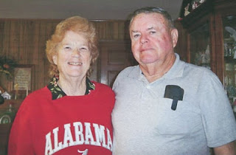
Wearing a shirt seen all over Alabama every autumn is Vonceil Bonner Duckworth with her husband of almost 50 years, Lonnie Morris Duckworth.
" I married Lonnie Morris Duckworth on 14 December 1962. Our children are – Kenneth Morris Duckworth (7 February 1964) and Michael Keith Duckworth (19 November 1967).
My siblings are as follows:
Dewey Max Bonner married Dorothy Faye Holliman, daughter of Kenneth Holliman, son of Frank and Kesta Howard Holliman in June 1958. Their children are Wanda Faye Bonner Hicks (13 May 1960), Franklin Max Bonner (12 April 1964), Camelia ‘Millie’ Diane Bonner Elkins (15 September 1961) and Jeffrey Dale Bonner 8 December 1965)."
Shelby Marie Bonner married Allen Wilson McDaniel. They have one child, Allen Mitchell McDaniel.

Johnnie Bonner married Charles Babb, and their children are: Steven Gregory Babb, Kristen Michelle Babb Hill.
Jimmy Keith Bonner’s two children are Amanda McDaniel Sullivan and Brandon Keith Bonner.

Clayton Gregory Bonner married Linda Ann Junkin Bonner (now divorced). Their children are Jason Gregory Bonner and Lezlee Ann Bonner.

Frances Marilyn Bonner married Jimmy Donald Elmore. Their children are: Jacy Elmore, Jared Donald Elmore and Jala Dawn Elmore.
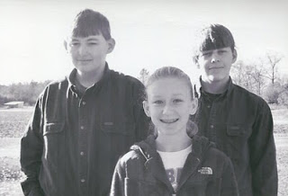
Above, Tyler and Tim, twins, and their cousin, Lauren Duckworth

Tyler, Tim and Lauren Duckworth are our grandchildren. The twins are the children of our son Kenneth Morris Duckworth and Judy Renee Gray Duckworth, now divorced. Lauren is the daughter of son Keith and Amy Duckworth. Through their Holliman line, these grandchildren can trace their lineage all the way back to the Tutor age in England."

Next posting, some timeless wisdom from a Lamar County, Alabama sage - Vonceil's mother!

Posted by Glenn N. Holliman at 1:38 PM 0 comments
Labels: Vonceil Duckworth

FRIDAY, JANUARY 13, 2012
Some Notes on a West Alabama Family by Laura Vonceil Duckworth, Reform, Alabama.
This is second in a series of four postings on the family and ancestors of Laura Vonceil Duckworth, a descendant of Christopher Holyman (1618 - 1691) of Isle of Wight, Virginia.

"My ancestor, Charles Holliman migrated to Fayette County, Alabama with his two brothers, Warren and Cornelius, from the family home in Lancaster, South Carolina of their father, James Grantson Holliman (1850 – 1836) in 1836.

Elijah’s Civil War record would take pages to tell. For now, I continue to share my family tree below with several photographs. My great grandmother, his second wife, Permelia Gibson Holliman, was the 6th child of Tillman Gibson of Fayette, Alabama.

My grandmother, Laura Jannie Holliman (29 August 1873 – 6 December 1936) married Virgil Constantine Clemmons, son of Woodson Clemmons and Rebecca Reece Clemmons. Jannie is buried at Bethlehem Baptist Church Cemetery, Reform, Alabama, Pickens County along with her husband. These are my grandparents, Jannie and Virgil Clemmons. Their photographs are below.
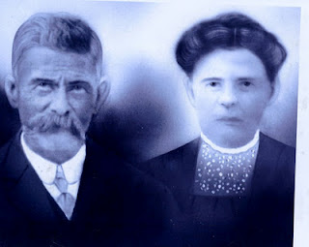

Their children are Melinda Elizabeth ‘Lizabeth’ Clemmons (1893 – 1895), William Edward Clemmons, Thomas Tillman Clemmons, Elvin Elijah Clemmons, Charlie Dennis Clemmons, Minnie Lee Clemmons and Mamie Lou Clemmons.

On July 12, 1935, the extended family gathered in Lamar County, Alabama for Elijah Holliman’s 96th birthday. He was the oldest Confederate veteran in his county when he died May 11, 1937.
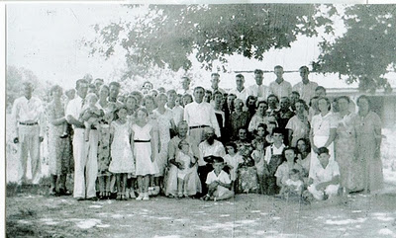
Above the family of Elijah Holliman, center for his birthday in Reform, Alabama in 1935. Assistance is sought from his family to identify persons in the photo above. Please contact glennhistory@gmail.com, a close family member or leave a comment below.
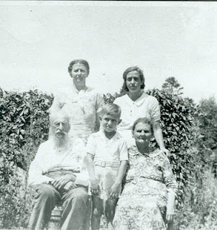
Above at the 1935 reunion are front row left to right, Elijah Holliman, his great, great grandson, Sonny Cunningham and Mary Elizabeth Shaw, Elijah's daughter by his first wife, Mary Shaw. Back row, left to right are grand daughter, Pattie Holliman Whaley and great granddaughter Mary Sue Whaley Cunningham.
One of the children of Virgil and Jannie Holliman Clemmons was my mother, Mamie Lou Clemmons (14 August 1918 – 13 January 1984) who married my father, Dewey Delmer Bonner on 29 December 1937.
Their seven children were Dewey Max Bonner (13 June 1939), Laura Vonceil Bonner Duckworth (18 December 1941), Shelby Marie Bonner McDaniel (13 June 1944), Johnnie Mae Bonner Babb (20 January 1946), Jimmy Keith Bonner (25 November 1950), Clayton Gregory Bonner (5 November 1953), and Frances Marilyn Bonner Elmore (12 March 1956)."

Next week, another posting of Vonceil Duckworth's family tree....
Posted by Glenn N. Holliman at 11:40 AM 0 comments
Labels: Elijah Holliman, Vonceil Duckworth

FRIDAY, JANUARY 6, 2012
Some Notes on a West Alabama Familyby Laura Vonceil Duckworth, Reform, Alabama.

One of the joys of exploring family history is learning from 2nd, 3rd and 4th cousins of great uncles and aunts who lived in different times and places. Laura Vonceil Duckworth of Pickens County, Alabama and I visited twice in 2011 and have traded emails about descendants of James Grantson Holliman (1750 - 1836), our common 4 GGF.
What follows below is in no way comprehensive of Elijah Holliman's Civil War struggles but does allow us to begin to know of his life and offspring. Our thanks to Vonceil for this glimpse of her family and their lives in West Alabama. Any errors in these articles belong to me, and I welcome additions and corrections. - GNH

“My great grandfather was the famed Civil War veteran Elijah Holliman, born on 12 July 1839 in Newtonville, Fayette County, Alabama. He was the son of Charles and Barbara Walters Holliman who emigrated from South Carolina in 1836.

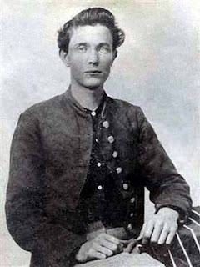
Elijah Holliman in his Confederate uniform during the Civil War
Elijah married three times. His first marriage was to Mary Shaw of whom three children were born: Sarah Melissa Holliman, Mary Elizabeth Holliman and Peter Aaron Holliman.

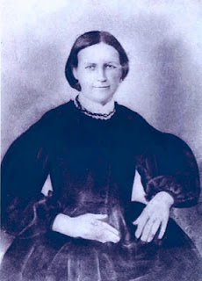
Mary Shaw Holliman
His second marriage was to Permelia Gibson ( 1834-1873). She is my great grandmother. From this union there were two children: William Green Holliman and Laura Jane (Jannie) Holliman, my grandmother. Unfortunately I do not have a photograph of Permelia or even know where she is buried.
Elijah’s third wife (photo below) was Malinda Elmina Levisa Jane Johnson, born December 23, 1846 and died September 12, 1926. She is buried in Springhill Southern Baptist Cemetery, five miles west of Millport, Alabama next to Elijah.
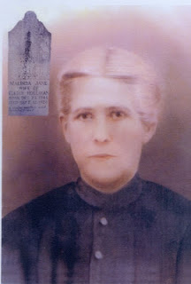

Next posting more on Vonceil Duckworth's Holliman ancestors....

Posted by Glenn N. Holliman at 10:44 AM 0 comments
Labels: Elijah Holliman, Malinda Elmina Levisa Jane Johnson Holliman,Mary Shaw Holliman, Permelia Gibson Holliman, Vonceil Duckworth
Newer PostsOlder PostsHome
Subscribe to: Posts (Atom)

SUNDAY, FEBRUARY 12, 2012

A Holliman History by Walter O. Holliman, Part III
by Glenn N. Holliman
This is the third in a series of a history of the Holliman family written by Walter O. Holliman in 1995 and edited in 1996.
Please refer to previous posts in order to understand the sequencing of these pages. Walt continues sharing his research on the Holliman family that came to Virginia in 1650. The Samuel Holliman below is believed by several serious Holliman genealogists, including this writer, to be the son of Richard Holliman and father of James Grantson Holliman (1750-1836). Walt assigned Samuel to the Thomas Holliman line, and he admitted below his ambiguity over the issue.
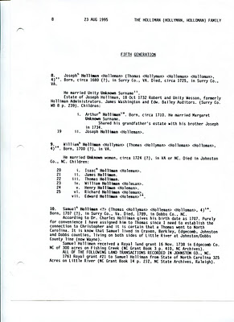

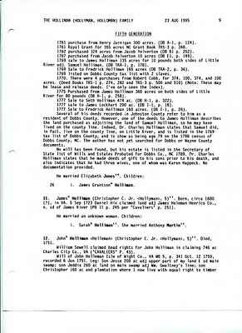

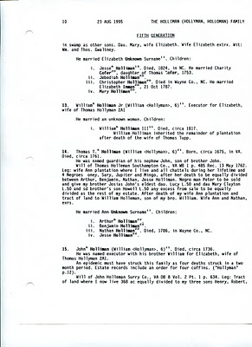

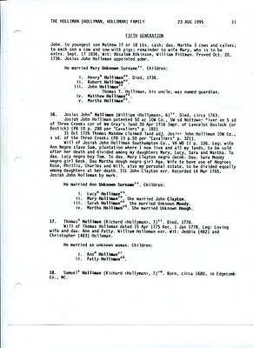

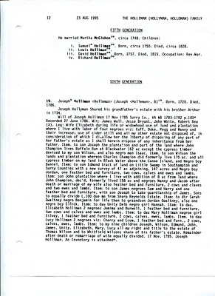

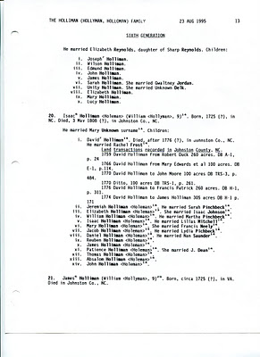

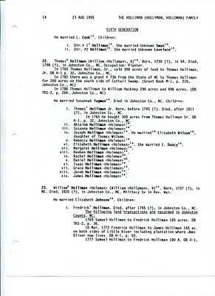

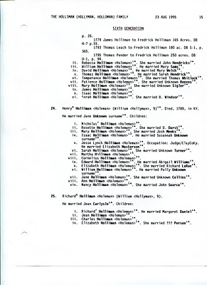
It is hoped the above pages are useful for those who do not have this research. This closes our presentation of Walt's 1995 publication. In the next posting, we shall read of his 1996 conclusions and research beginning with Samuel Holliman (1707-1789), the believed father of James Grantson Holliman.
Obviously, much has happened in family research since Walt typed these words. If you see any errors or material that should be challenged or enlarged, please let us know.
Posted by Glenn N. Holliman at 3:44 PM 0 comments
Labels: Richard Hollyman, Samuel Holliman

THURSDAY, FEBRUARY 9, 2012

From the Walter O. Holliman Archives
by Glenn N. Holliman
An Announcement -
My son, Christopher S. Holliman, writes a blog at http://the62mets.blogspot.com/ and, no, it is not about baseball. One of his most recent blogs is a trip to the Crater at the Petersburg, Virginia battlefield where his 3 GGF and 2 GGF fought for the Confederacy. You might check it out. There are some photographs.
And now...
A Special Posting...
Several of you have been studying the page on the Walter O. Holliman Materials, an index of his voluminous research on his families and have asked for information. Below I reproduce six pages of photocopies he made in the early 1990s of Johnston County, North Carolina Holliman land records. This information may or may not be new to serious Holliman family researchers but I am happy to post this and other items as time permits.
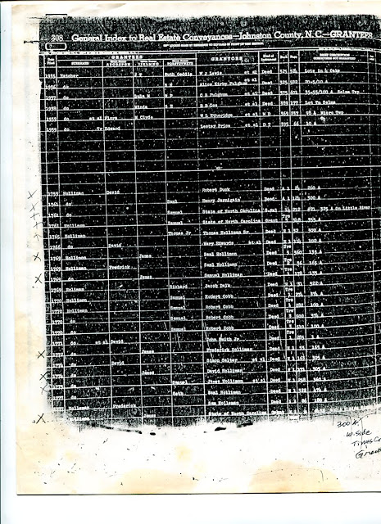

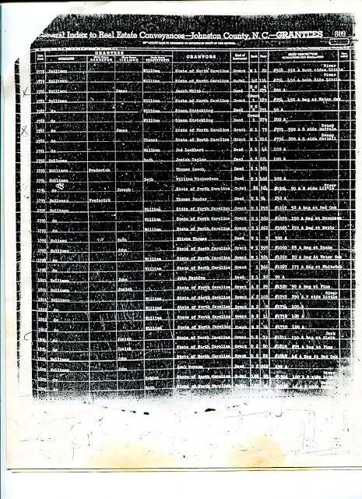

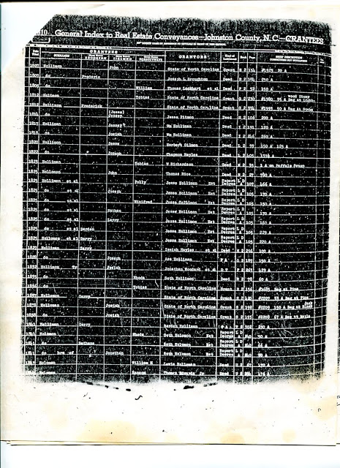

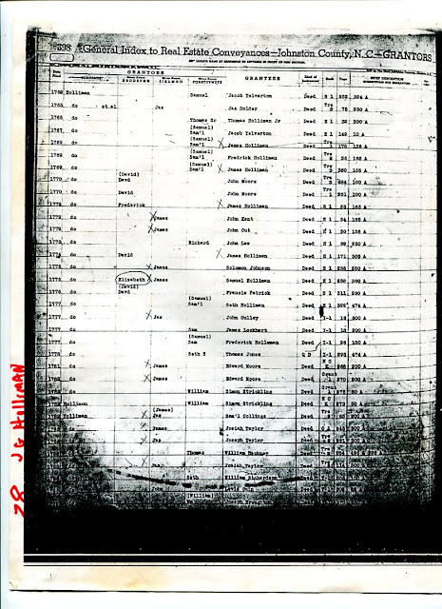

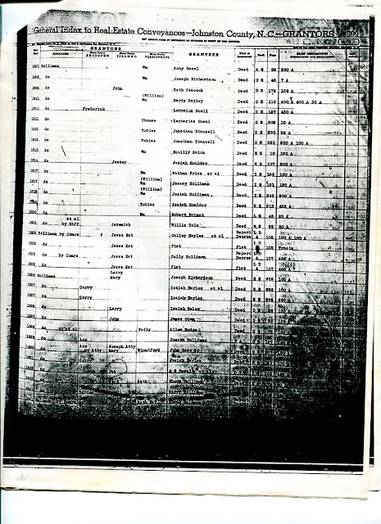

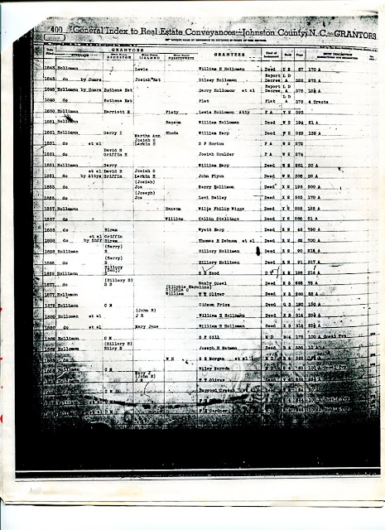
Walt came to believe, as did Dr. Charles Holliman, that Samuel Holliman was the father of my 4 great grandfather, James Grantson Holliman (1750-1836).
Posted by Glenn N. Holliman at 4:48 AM 0 comments
Labels: Charles Holliman, James Grantson Holliman, Samuel Holliman,Walt O. Holliman

WEDNESDAY, FEBRUARY 8, 2012

A Holliman History by Walter O. Holliman, Part II
by Glenn N. Holliman
This is the second in a series of a history of the Holliman family written by Walter O. Holliman in 1995 and edited in 1996.
In the 1995 document with which we begin below, Walt presents a 1990s interpretation of the Holyman family in England. As readers of this blog know, we now have evidence that the American Hollimans emerged from Bedford and Buckinghamshires in the 17th and 16th Centuries.
This first generation provided by Walt is curious, and he hesitated to include it in his work. I have hesitated also, but feel there may be some clues worth exploring now that we have the Internet. He quotes the late Dr. Charles Holliman of North Carolina for a considerable portion of his information of our family's early Virginia history.
Unfortunately Walt was not able to obtain original sources for much of Dr. Holliman's work. For example, information from my research in England does give a hint that Hollimans emerged from London, as early as the 1400s, but the name George Holliman is unknown to me. A Holliman as a member of the London Stock Company?! This startling statement certainly calls for more research.
Also, the Bermuda assertion is curious. There was an amazing amount of slave and tobacco trade between Bermuda and Virginia in the 1600s. While there is evidence of one Richard Holliman, a son of Christopher Holyman, Sr., transporting settlers to Virginia by ship, this writer has not seen as of yet, any evidence of Hollimans living in Bermuda.
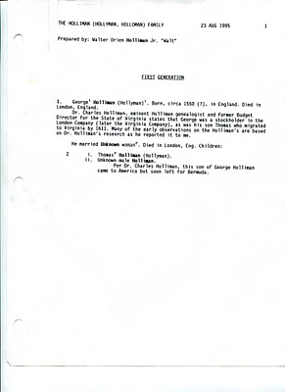
The next page below requires careful review. Walt states Thomas Holliman is the son of George Hollyman, and was a stockholder in the London Company. Cavaliers and Pioneers, p. 30-31 is cited as the source. This requires investigation as this thesis is completely new to this writer.
In the next sentence, Walt records as have others, of one Thomas Holeman, acquiring land in Martin's Hundred in 1635 near Jamestown. The speculation on one Thomas Harvey is the first time I have seen such. Alas, Charles Holliman is quoted in several places but with no annotation.
Item 3 below merges several persons and events, and one cannot be sure if Christopher Holyman is born in Virginia or transported there with his sister. This writer does not accept this page's interpretation as accurate as much more evidence is available today than in the early 1990s. Again, I urge a careful reading of my earlier writings at this blog spot.
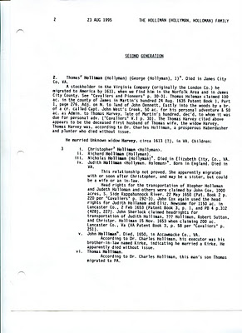
Below, with the next generation, Walt moves to surer ground. His first source is George A. Holleman's 1953 book and some speculation of our English roots. In paragraph 3, Walt again quotes Dr. Charles Holliman on Christopher Holyman's age and gives a Surry County deposition as the source. Hmmmm.... The rest of the page is a valuable listing of Christopher Holyman, Sr.'s legal and land records in Virginia. Here we see Walt produce his solid research with which he will be flooding us in future articles.

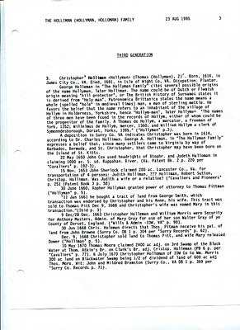

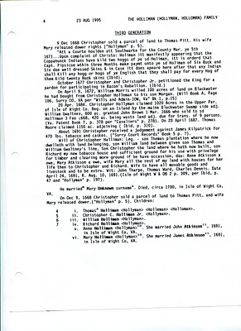
The page below reflects Walt's partial acceptance of Dr. Charles Holliman's thesis that Walt's descent from Christopher Holyman, Sr. is through Thomas Holliman, a son born ca 1655, dying 1734. The information Walt records is valuable, but he is dubious that James Grantson Holliman is through Thomas. Today, several learned Holliman genealogists believe descent from Christopher Sr. is through his son Richard Holliman to his son Samuel Holliman.
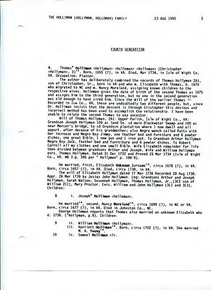

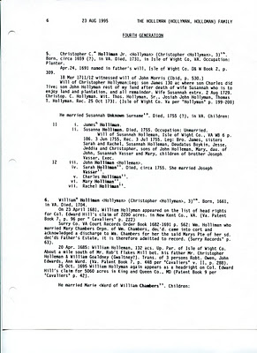
Notice person 18, iv. Samuel Holliman on the page below. This writer believes his descent from Christopher Holyman, Sr. is through Richard to Samuel to James Grantson Holliman. Walt accepts the Samuel thesis himself later in his manuscript.
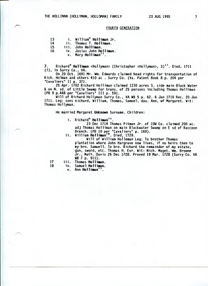
So we tip our hat to both Dr. Charles Holliman and Walt O. Holliman for their work almost two decades or more ago. Now in the Internet age and with access to English archives, the early interpretations have changed considerably, but we still salute their efforts and recognize that genealogy is always a process that requires research and constant critique.
Next posting, we continue Walt's Holliman history....
Posted by Glenn N. Holliman at 1:34 AM 0 comments
Labels: Christopher Holliman Sr., Walter O. Holliman

THURSDAY, FEBRUARY 2, 2012

A Holliman History by Walter O. Holliman, Part I
by Glenn N. Holliman
What follows are dozens of pages of critical Holliman family research prepared in 1995 and 1996 by the late Walter O. Holliman (1927-2003). In the fall of 2011, his children shipped me his papers and since then I have been indexing and reading his marvelous research and conclusions. In the left column of this post, one will find the Walter O. Holliman manuscripts and research folders of his voluminous work.
With this posting, I begin publishing his interpretation of our family's history. He prepared two documents. The 1995 copy contains his understanding at the time of the first Holyman's in America and takes us into the 20th Century. In his 1996 work, he omits the early Virginia Hollimans and begins with his 4th great grandfather, James Grantson Holliman, again traveling late into the last century. For privacy sake, I cease the history with Walt's parents, uncles and aunts. My introductory comments are in red. Walt's pages are as he prepared them. Click twice and the pages should enlarge.
I know I speak for his children and all who are interested in Holliman history when I say comments and critique are welcome. As Walt himself notes, genealogy is never finished. New information continues to come forth and alter earlier interpretations.
The Title Page - I have omitted his address. The documents are posted with permission of his children. As far as I know he never published this tome. This title page is from 1995.
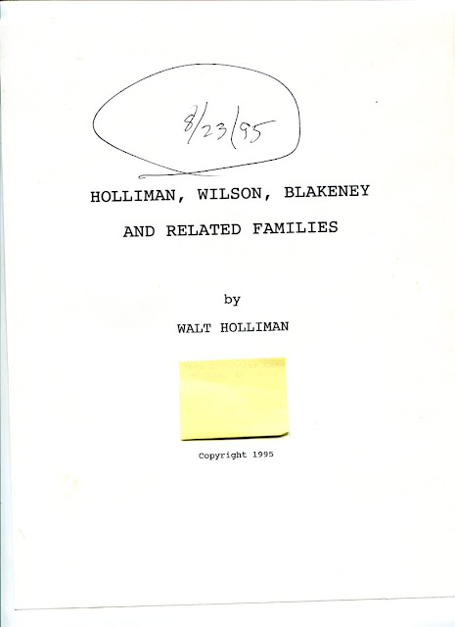

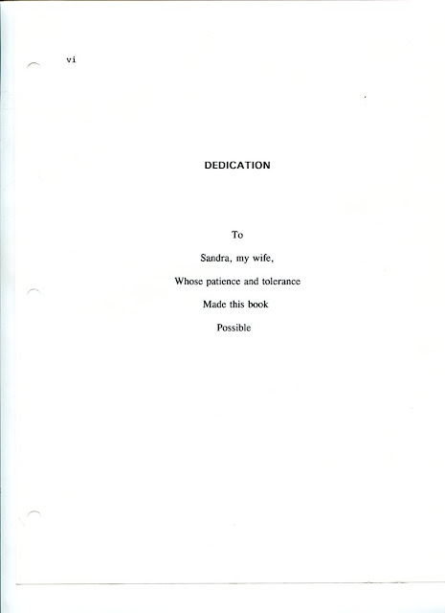
Index - This really is Walt's table of contents. He created manuscripts for all the families listed below, over fifty, and research on another fifty or so! These manuscripts are available, but are not part of the series of posts that will be forthcoming immediately.
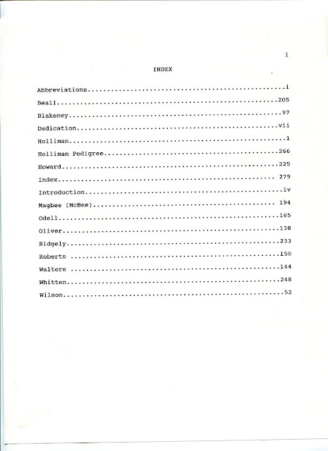
Abbreviations -Walt was meticulous as this listing of abbreviations indicates. He belonged to Mensa International, an organization for persons with a high I.Q. (Well, would we not except that from a Holliman!?)
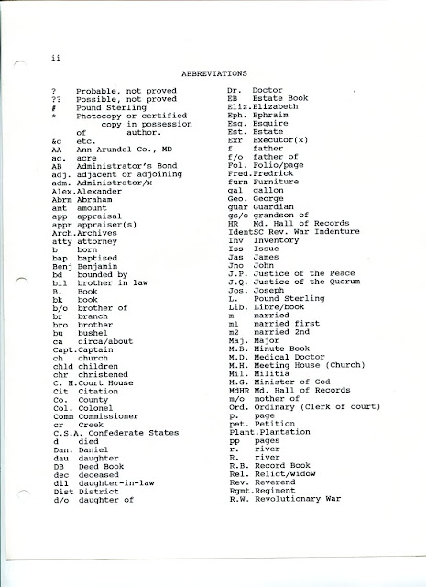
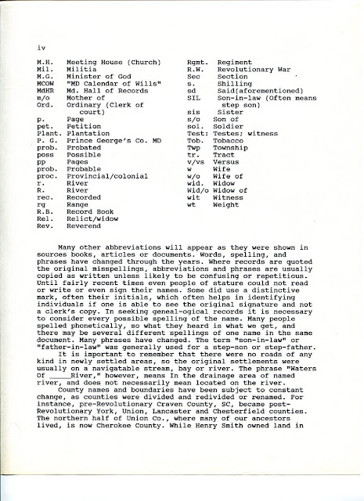
The next page is missing, and it becomes impossible to separate the 1995 and 1996 editions. However, the conversation, slightly truncated, continues below. The pages are not always in order due to Walt's dual publications and evidently additional changes. He provides some very useful commentary on genealogical research.
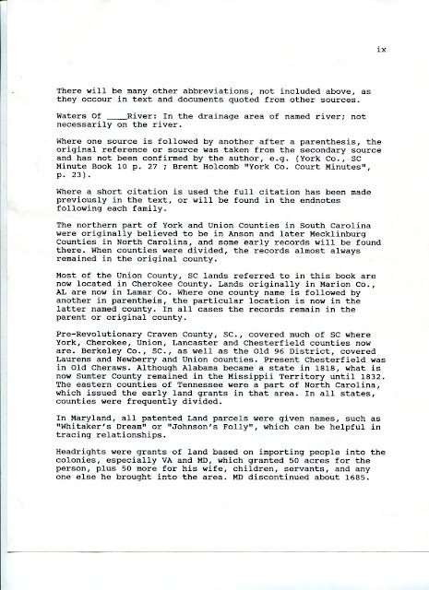
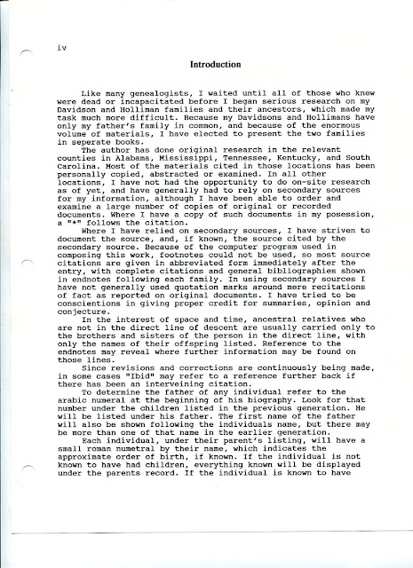
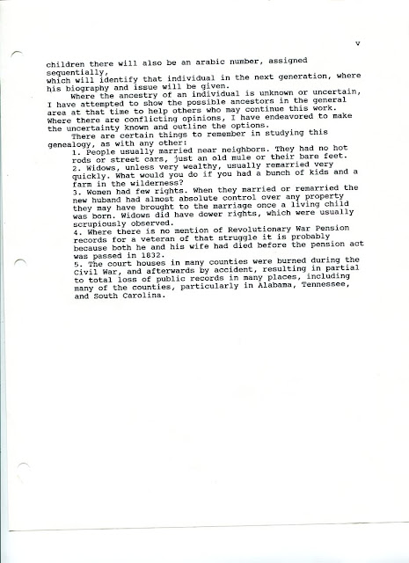

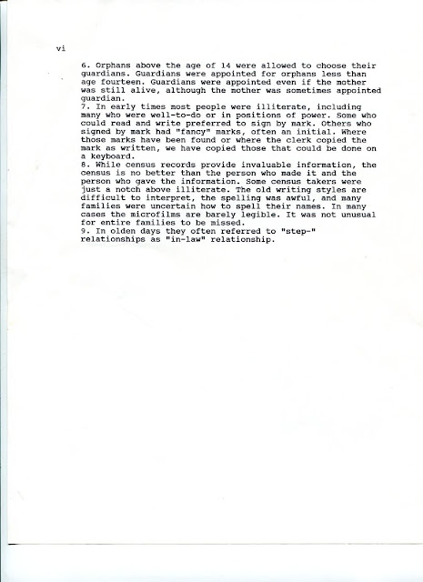
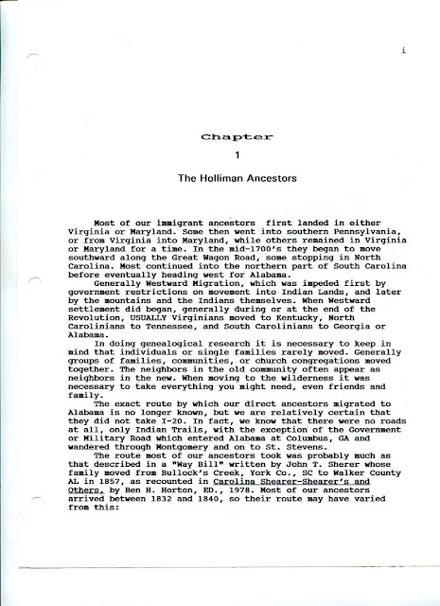

This description of the trek west to Alabama in the 1830s from South Carolina is important. Imagine horses, cows, pigs, hand carts and wagons. Women and children, along with young husbands and fathers, moving through near wilderness pushing ever westward.

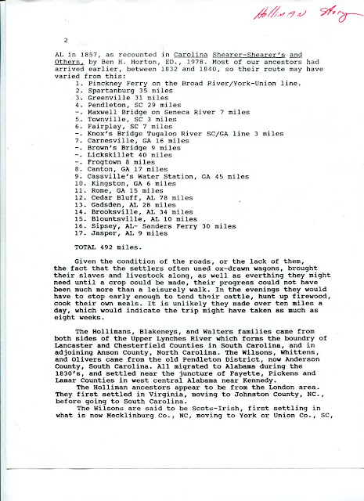

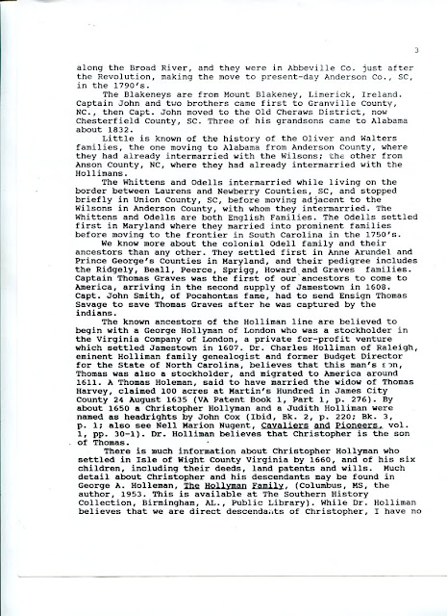
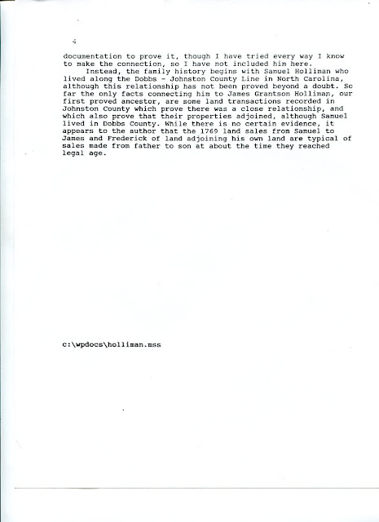
In the next post, we will begin Walt O. Holliman's generation by generation interpretation of our early Holyman history.
Posted by Glenn N. Holliman at 12:16 PM 0 comments
Labels: Walt O. Holliman
Newer PostsOlder PostsHome
Subscribe to: Posts (Atom)

Holliman Family History
Photographs and articles regarding the ancestors and descendants of Christopher Holliman, Sr. (d 1691 Isle of Wight County, Virginia)
- Home
- The Contributers and the Sources
- Holliman Records, A History of Some Official Docum...
- Family Lineages
- The Walter O. Holliman Manuscripts and Research Ma...

John Thomas Holliman House
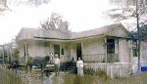

Popular Posts
- 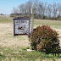
Our Family's Colonial Era, 1607 - 1775, Part II
In Search of Christopher Holliman Sr.'s 17th Century Virginia Plantation by Glenn N. Holliman This is the second post of an on-going ser...
- 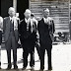
Welcome Family!
Important Notice: Since composing this article in February 2010, additional research has failed to identify John Holyman (1572 - 1650) of ...
Our Family's Colonial Era, Part VI
Tobacco, Slavery, Democracy and Our Family by Glenn N. Holliman If one analyzes the 17th Century Virginia economy carefully, it makes for ...

Blog Archive

Subscribe
Posts
Comments

Labels
A. Eckford Holliman AlabamaAlice Holleman Alice HollimanAnn Boleyn Ann Holyman Anna Holyman Anne Holyman August Holliman Barb Holliman Bill Holliman Bishop Holliman Bishop John Holyman Blackwater RiverBob Hollyman-Mawson Bob Hollyman-MawsonJimmy Holliman Bryan Payne Bryan PayneChristopher Holliman Jr.Caroline Stonham Cecil Holliman Charles Daniel Lucas Charles HollimanCharles Lucas Sr. Christopher Holliman Christopher Holliman Jr.Christopher Holliman Sr.Christopher HolymanCorey Holleman Cornelius Holliman Cuddington David Jennings Dr. Sidney A. HollemanE.C. Herrin Edward HollymanEdward Holyman Elijah Holliman Elizabeth HolymanEva Ezekiel Holliman Faye Gardner Faye Gartner FayetteGeorge A. Holleman George Washington Carver Gladys Parker Glenda NorrisGlenda Norris Jeanette Stewart Glenn Holliman Grace Holyman Gwaltney HannaHelena Poynard Henry VIIIHerrin Hollyman Holyman Farm James Franklin Holliman James Grantson Holliman James Monroe Holliman Jane Hollyman Jayne Holyman Jean HollimanJeanette Stewart Jesse Holloman Jim Maule Jimmy Holliman Joe Parker Joey Holliman John Holliman John Holyman John Thomas Holliman John Thomas Hollyman Jonathan MurphyJoseph Bridger Jr. Judith Holman Judith HolymanKing Henry VIII Lenwood Holliman Leonard HolymanLuke Stansbery Lynn HollimanMalinda Elmina Levisa Jane Johnson Holliman Mamie Lue Clemmons Bonner Margaret Holliman Martha Jane HollimanMartha Jane Walker HollimanMary Daly Herrin Mary Hasten Lucas Mary Holyman Mary Polly Lucas Holliman Mary Shaw Holliman Maxine WrightMelissa Anthony Caine MurphyNancy Cattell Nathanel BaconNorman Holliman Oliver Cromwell Palestine HollimanPaul Bushe Peggy CattellPermelia Gibson Holliman Peter Smith Polly Lucas Queen Catherine Raiford BrandonRalph Holliman Rhodes Holliman Richard Hollyman Richard Holyman Robert Daly Robert Holliman Robert Hollman Ron Holliman Samuel HollimanSamuel Walker Scott NorrisShelia Brandon Silas Green Holliman Sr. The Family of Ulyss and Pearl Caine Holliman 1946 Thomas Cox Thomas Cranmer Thomas CromwellThomas Holeman Thomas Holliman Thomas HollymanThomas Holman Thomas Holyman Thomas Holyman of Leigh Thomas Leland HollimanThomas Pittman Tom VaughanTommie Holliman Allen TringUlysses Selma HollimanUriah Holliman Vena Holliman Virgil BonnerVonceil Duckworth Wally Allen Walt Holliman Walt O. Holliman Walter O. HollimanWarren Holliman Weedon family William Bailey HollimanWilliam Berkeley William E. Caine William HollimanWilliam HollymanWilliam Hollyman; Jonas Hollyman William Hollyman; Leonard Holyman William Holyman; Edward HolymanWilson Holleman WWII

SATURDAY, FEBRUARY 18, 2012

A Holliman History by Walter O. Holliman, Part IV
by Glenn N. Holliman
This is the fourth in a series of a history of the Holliman family written by Walter O. Holliman (1927 - 2003) in 1995 and reworked by him in 1996.
In this posting of a manuscript written in 1996, Walt labels this chapter as Generation One choosing to begin his Holliman family history with Samuel Holliman (1707-1789). Walt was uneasy about the accuracy of his information on Christopher Holyman, Sr. and other early Hollimans in Virginia. As I have pointed out in early blogs, he had reason be concerned about the veracity of information he had gathered on Holymans in the early to late 1600s.
Some of the material Walt presents below concerning the origins of Hollymans in America has been superceded by new research. However, in this story there could be some tid bits that could yet lead us in new paths of genealogical research.
Walt provides valuable research on Samuel Holliman's real estate dealings in North Carolina. On page three, Walt states one Elizabeth Jones, born Isle of Wight, was a wife of Samuel Holliman. This is the first time I have seen such information and welcome comment on it.
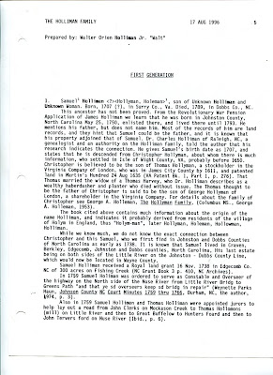

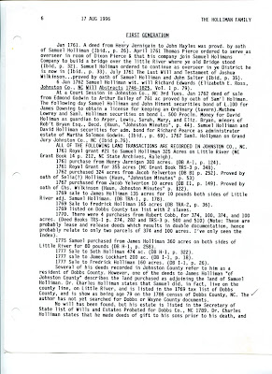

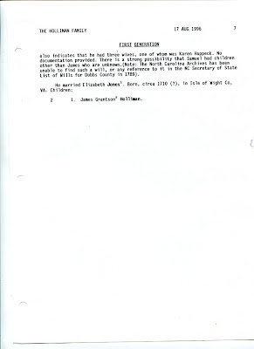
As I have written extensively, I believe the Hollimans emerged from a family in Bedford and Buckingham Shires, England with Christopher Holyman, Sr. (1618-1691) arriving in Jamestown in 1650. My descendant, in my opinion, is through Richard Holyman (1660s ca - 1711), a son of Christopher, Sr., through Samuel Holliman (1707-1789) and on to James Grantson Holliman (1750-1836). Still, it is fascinating to study Walt O. Holliman's manuscript and reflect on what adds to our genealogical picture and challenges our perceptions.
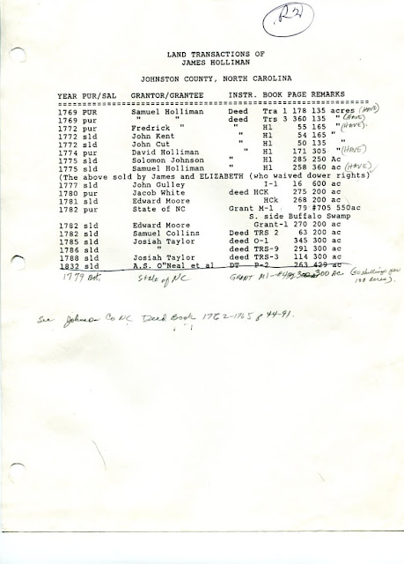
Above in Walt's own handwritting and type is his research on Holliman land sales in Johnston County, North Carolina in the 1700s. This is valuable for those seeking North Carolina roots.
Posted by Glenn N. Holliman at 2:24 PM
Labels: Richard Holyman, Samuel Holliman, Walter O. Holliman

0 comments:

Post a Comment
Older PostHome
Subscribe to: Post Comments (Atom)

