A Gathering of Hollimans
by Glenn N. Holliman
In the small community of Fayette, Alabama on October 14 and 15, 2011, a dozen blood-related Hollimans, all descended from Christopher Holyman, Sr. (1618 – 1691), gathered to share research and pose questions as to their common lineage.
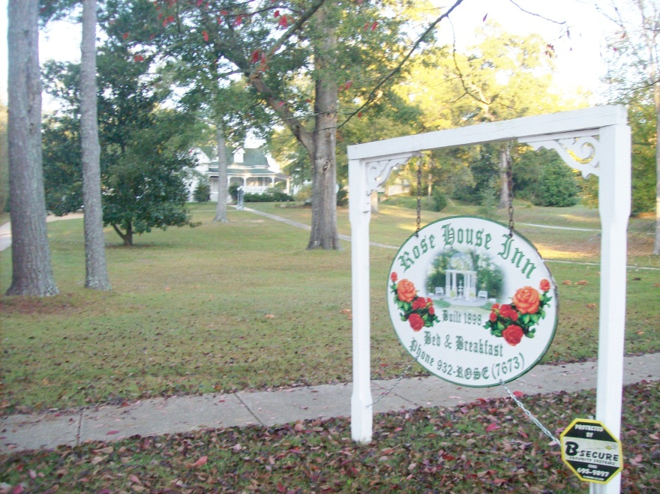
Those who came overnight lodged at the Rose House Inn in Fayette, a quiet community of three or four thousand persons, forty or so miles west of Birmingham and the same distance north of Tuscaloosa. It was in this frontier county that three Holliman brothers, Warren, Charles and Cornelius settled in 1836, emigrating from South Carolina. All three were sons of James Grantson Holliman (1750 – 1836). Warren and his family moved on to Arkansas. Charles, Cornelius and hundreds of their descendants stayed in Fayette and surrounding counties.
Not wasting a moment, Joe Parker (left below) and Lynn Holliman (right) immediately began sharing information on the front porch of the Inn’s guest house. Both had just driven from Texas, and planned to travel further east on family vacations and research.

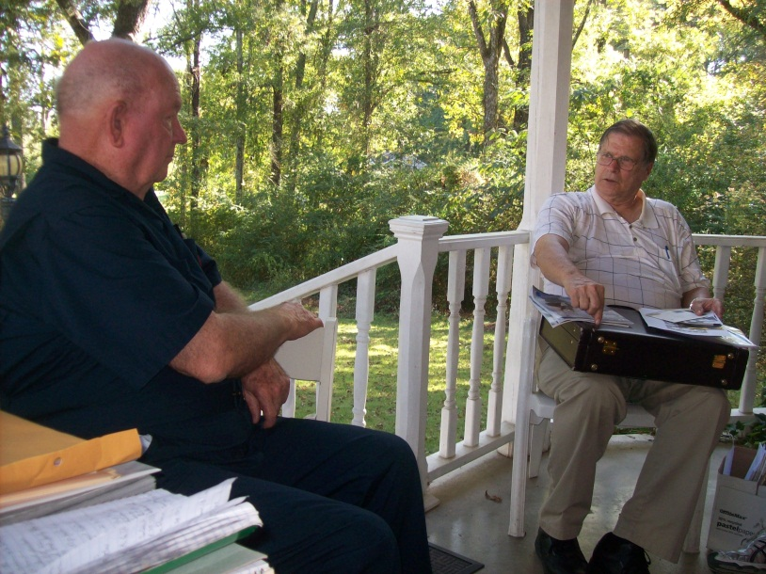
On the Friday evening, a reception was held and those of us who knew other only by email began to share stories in person. Below seminar organizer Glenda Norris, (left in pink) of the Birmingham, Alabama suburbs, reviews a family history prepared by Raiford Brandon (right) and his wife, Shelia (in blue). They had traveled from their home near Hattiesburg, Mississippi. Raiford’s family tree not only is connected to England through his Holliman roots, but also has branches leading to members of the Tudor Royal Court of the 1500s.
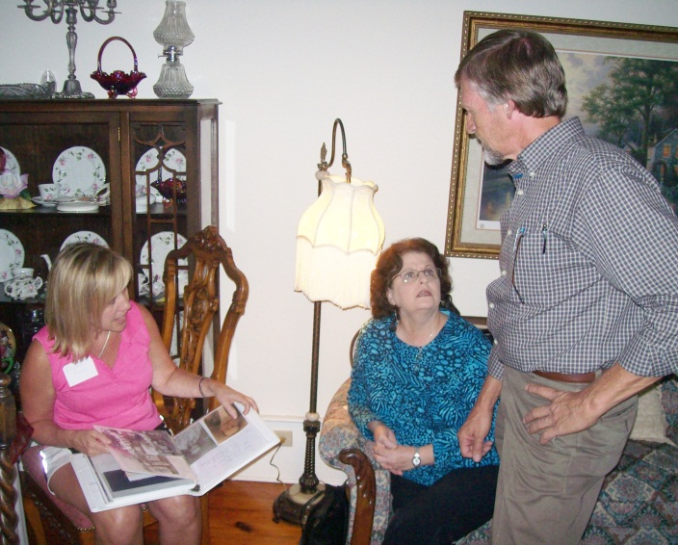

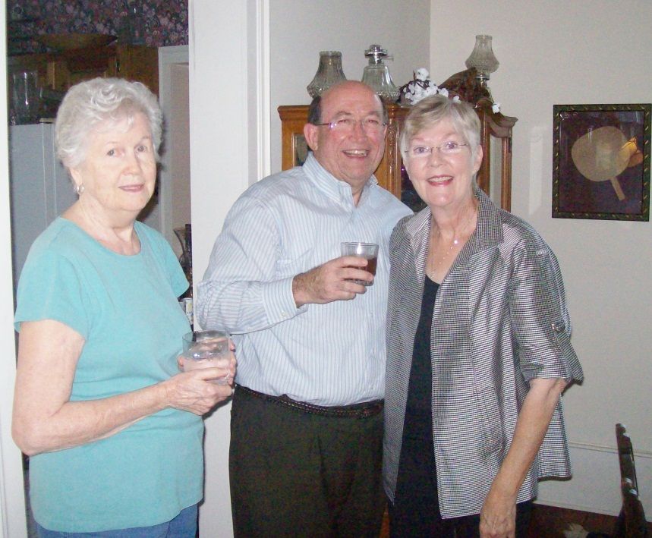 Also traveling from Texas to Alabama were Gladys Parker, left, and Jim and Jeanette Holiman Stewart, all of the Lone Star state, representing some of the many family members that continued west from the Deep South. Gladys, Joe Parker’s better half, is a serious genealogist herself.
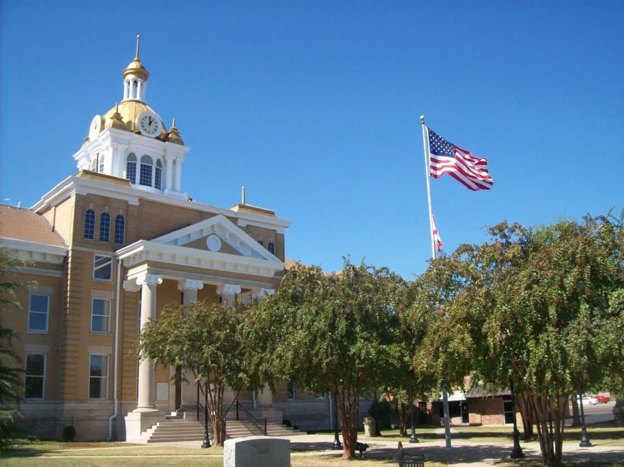
Fayette County’s legal system and records resides in its one hundred year old gold domed court house. A fire in 1911 destroyed much of the town.
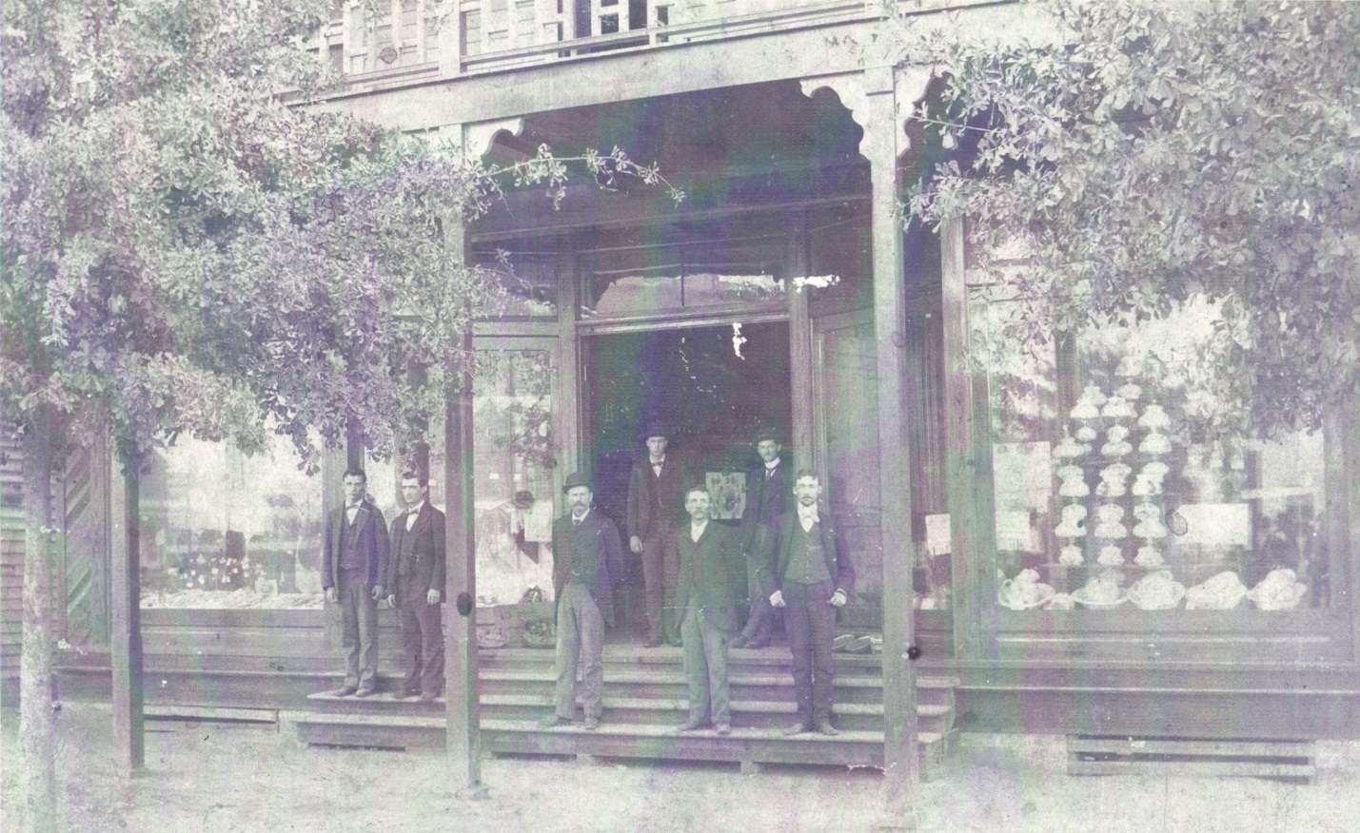
Above and far left James Monroe Holliman, Glenda Norris’ great grandfather, stands in front of Harkin’s Store which was destroyed by the 1911 disastrous fire that swept through the west Alabama community. Today, (below) the front street across from the Court House reflects the gentle pace of life during a Friday afternoon in autumn.
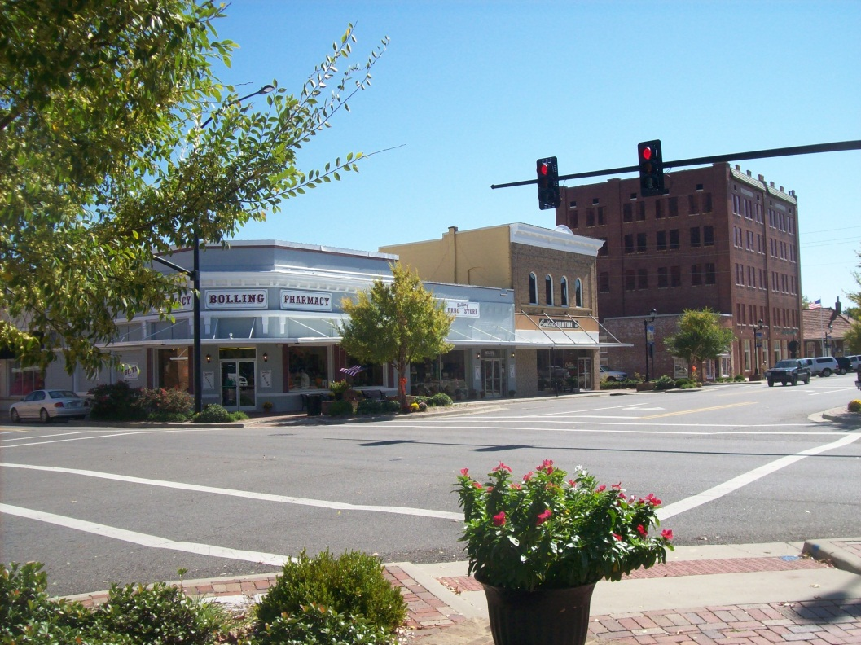
Below, James Franklin Holliman inspects the materials Raiford Brandon brought. Frank is a descendent of Cornelius Holliman and Raiford of Charles Holliman. All present were descended from Christopher Holyman, Sr. (1618 – 1691) and his son, Richard Holyman (1660ca – 1711) with the exception of Joe Parker, who descended from Christopher Holyman, Sr. through a different son; that being Christopher Holyman, Jr.
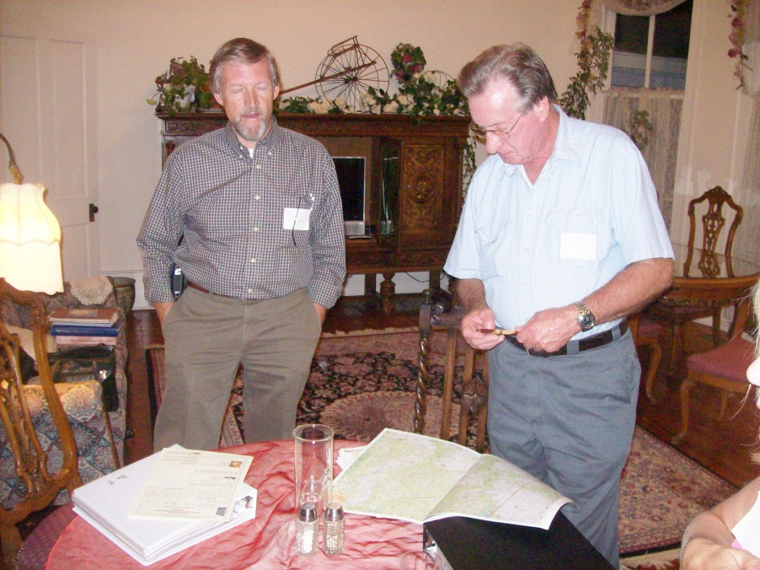
Below, two blocks from the Court House is the old train depot, now a community museum and visitor’s center. Just two blocks away stood the home of John Thomas Holliman (1844 – 1930), the great grandfather of Glenn Holliman and great, great grandfather of Glenda Norris.
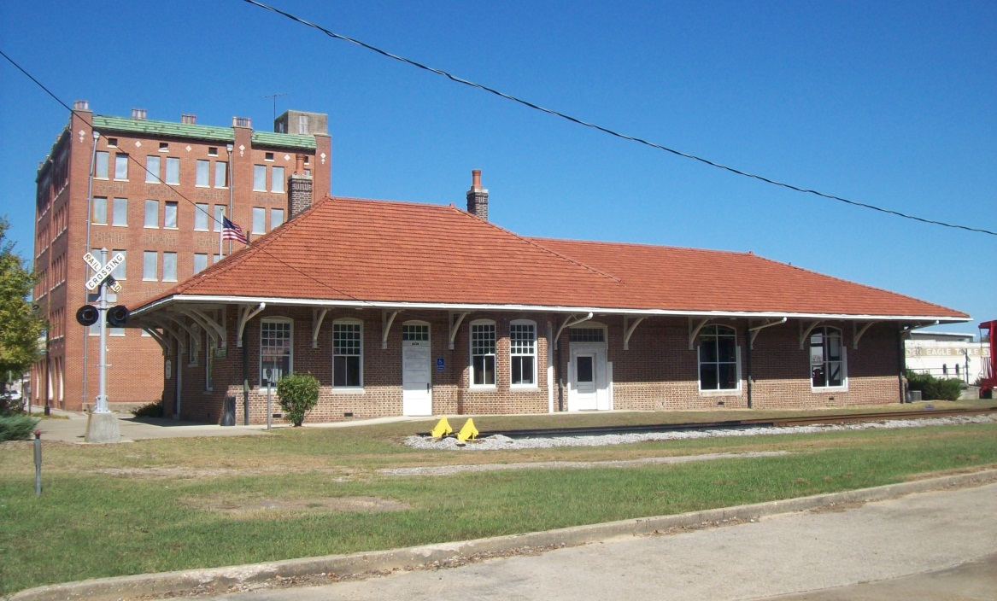
Below, holding the bridle of his horse, John Thomas Holliman, and Martha Jane Walker Holliman (1845 – 1931), his wife, stand in the 1920s in front of their home, only four blocks from the County Court House and close to the depot. The house is now gone. Like almost all Alabama men and male relatives of that era and age, he was a Confederate veteran. He fought at Stone’s River in the West and the Petersburg, Virginia Crater in the East. Martha Jane’s father, Samuel Walker (1822 – 1900) also of Fayette County, was one of the remaining 7,000 who surrendered with Robert E. Lee at Appomattox.
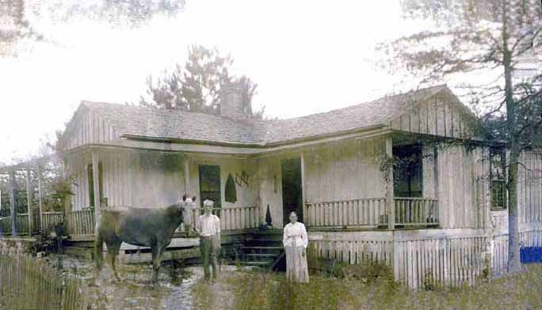

Seminar and round table discussions were held at the Fayetteville Civic Center. Some of those attending were left to right, David Jennings and his uncle Bill Holliman, both of Picken’s County. Later after consulting the papers of the late Walt Holliman, it was determined they are descendants of Charles Holliman (1795 – 1841 ca), one of the three brothers who immigrated to west Alabama in 1836. Bill is a retired college music professor.
Right same photo, from the Selma, Alabama area were Jimmy and Kathleen Holliman. Jimmy is a descendent of Charles Holliman, and is a professor with the University of Auburn Agricultural Extension Service.
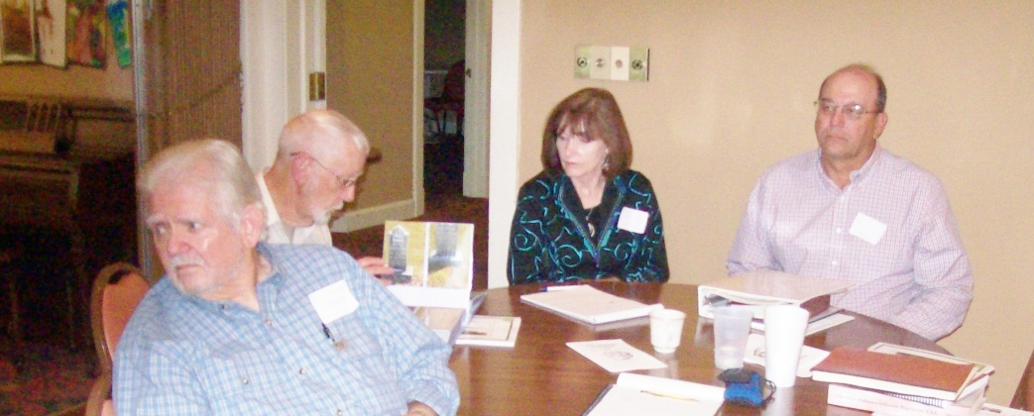
Keeping notes at the meeting was Jeanette Holiman Stewart, below. Jeanette has entered over 10,000 Holliman names in her database!
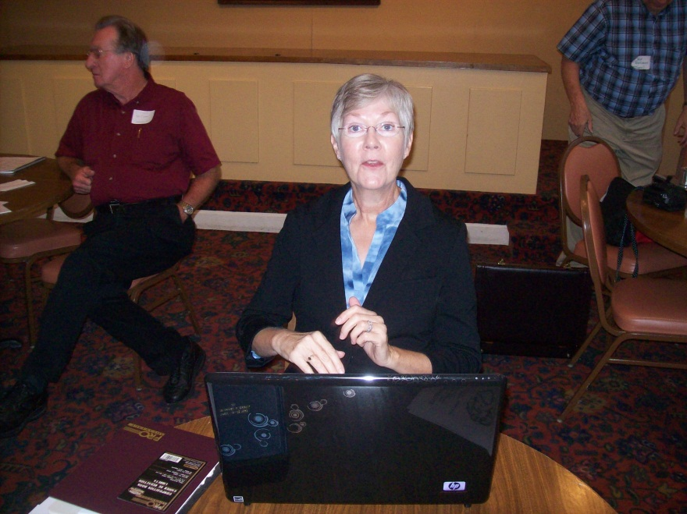

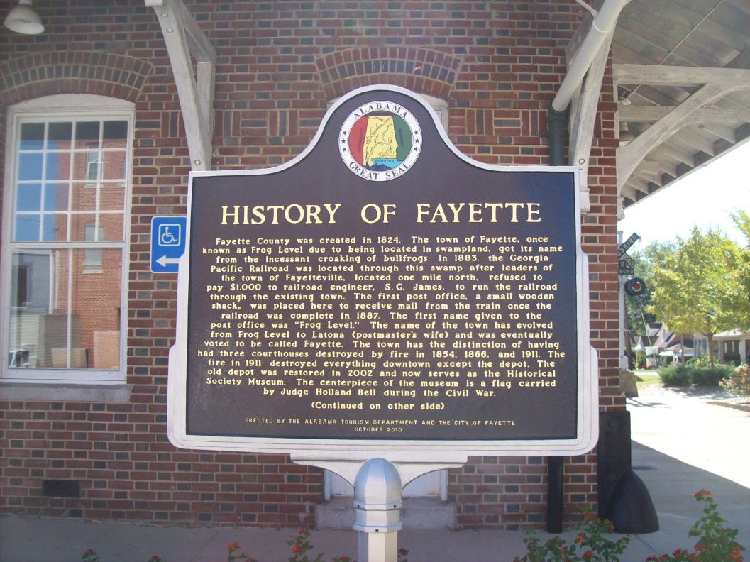
At the Georgia-Pacific Railroad Depot in Fayette stands a history of Fayette. The Depot is now a visitor’s center and museum. Below, Joe Parker flanked on his left by Lynn Holliman delivers a point during the discussions.

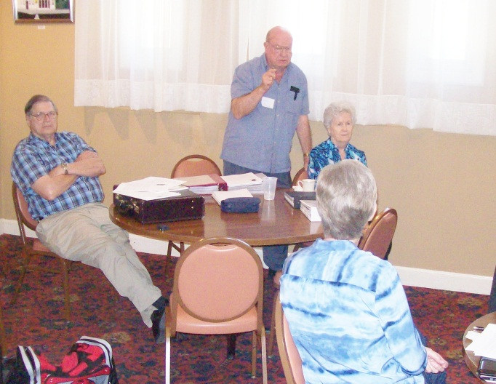 Joe Parker, standing, provided information on the Holliman lines from Christopher Sr. (1618 – 1691) to the present. Joe’s knowledge of the various Holliman branches through their Southern migrations is encyclopedia in scope.
The Holliman families (and its various spellings) have been blessed with numerous genealogists through the 20th Century, several living who could not be present at Alabama for this gathering. Two in particular were recognized – Maxine Wright of Arkansas and Dr. Rhodes Holliman of Virginia. Both descend from James Grantson Holliman and have accomplished through the decades a mountain of research. Dr. Sidney Arthur Holleman’s 2003 publication of his branch of the family (Texas) was noted also.
Among those whose earthly journeys are over and recognized as contributing significantly to our knowledge of this American family are Cecil Rhodes Holliman, Glenda Norris’s grandfather, Walt O. Holliman whose research has been preserved by his children and Dr. Charles Holliman, late of North Carolina who work lives on the writings of others.
Tina Peddie’s establishment of the Hollyman Internet chat room 1999 has been instrumental in the sharing of family information and networking of various Holliman researchers. Her contributions from her home in California also include the re-publication of the George E. Holleman 1953 ground breaking genealogical book on the family. Her achievements were recognized with appreciation.
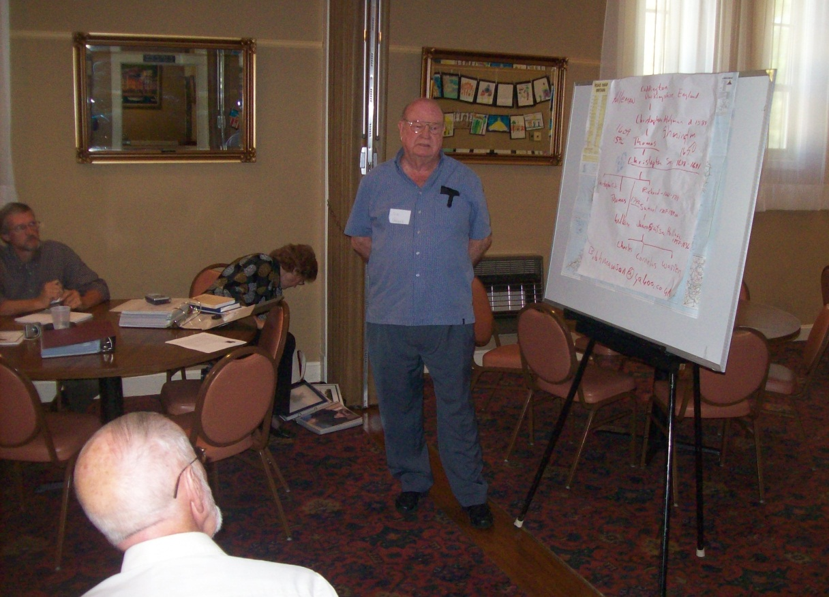
Raiford Brandon, Bill Holliman and Vonceil Duckworth take notes while Joe Parker (above) shares his many insights in the Holliman family.

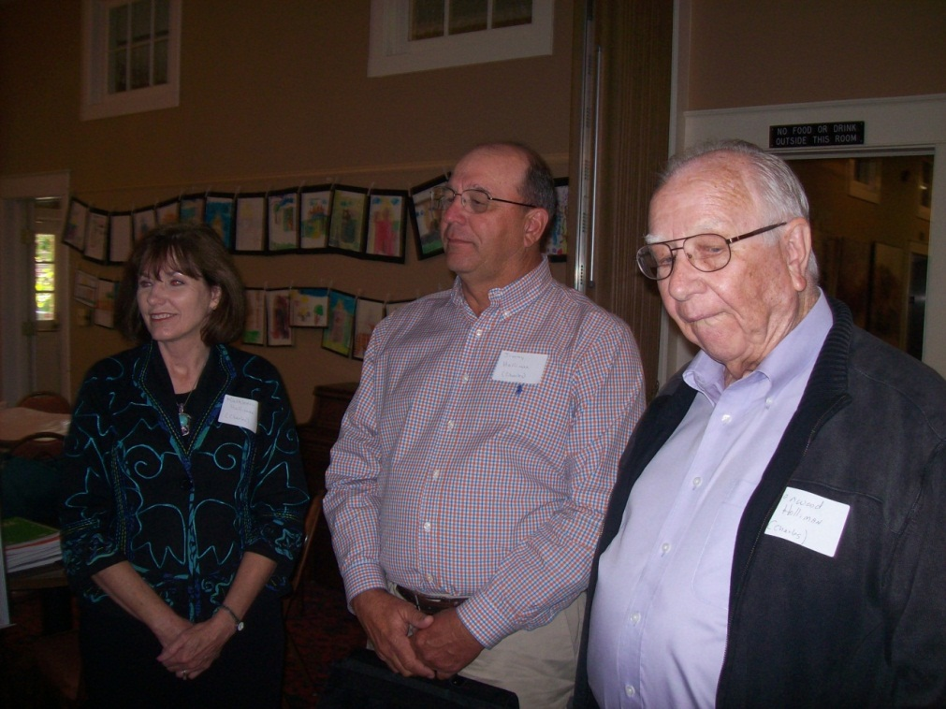
The gathering did not lack for educational expertise. In addition to Kathleen and Jimmy Holliman (left), a professor at Auburn, was Lenwood Holliman (right) of Lamar County, Alabama, a retired superintendent of schools. Both Lenwood and Jimmy descend through Charles Holliman.

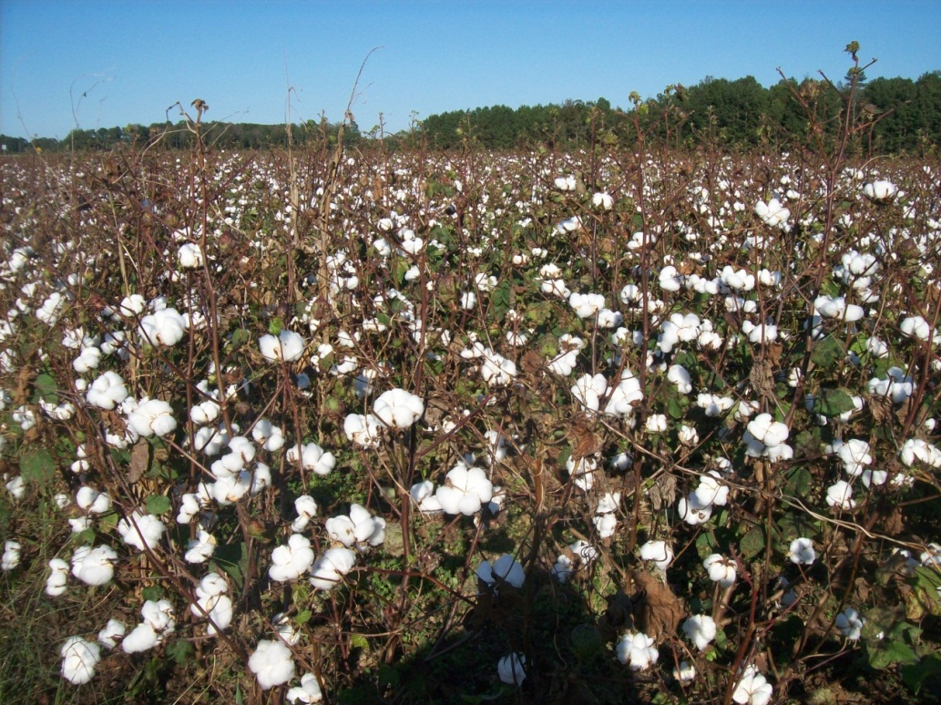
On the outskirts of Fayette are many cotton fields, a crop important to Southern Holliman families for centuries. In October when the seminar was being held, these fields were being harvested. The timber and mineral rights of the ridge and ravine topography of the area have provided income to generations of Hollimans.

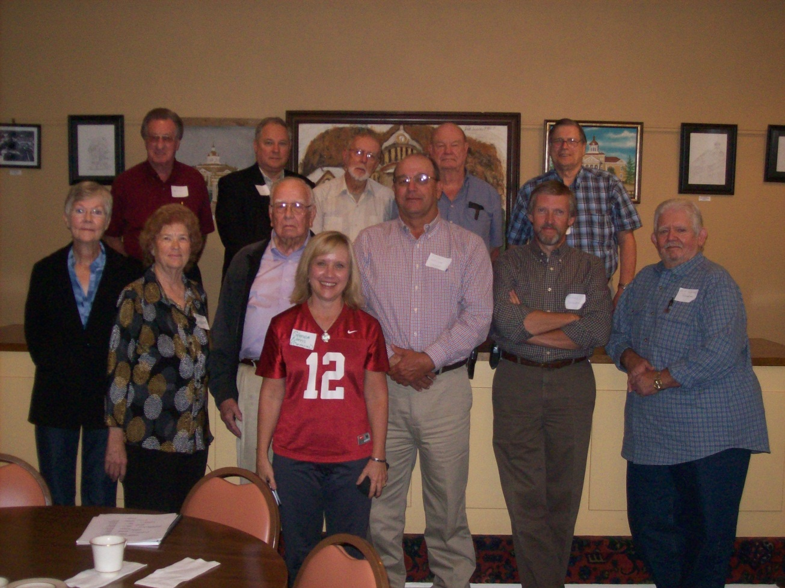
The Hollimans attending were left to right front row: Jeanette Holiman Stewart, Vonceil Duckworth, Lenwood Holliman, Glenda Norris (number 12), Jimmy Holliman, Raiford Brandon and David Jennings. Back row: James Franklin Holliman, Glenn Holliman, Bill Holliman, Joe Porter and Lynn Holliman.
Sending greetings from Caernarvon, Wales in Great Britain was Bob Hollyman-Mawson who forwarded some of his humerous findings on Holyman behaviors in Nottingham, England in the 1500s.

Below, wearing what he calls his ‘Dixie’ hat is Bob in his hometown in Wales, arriving to pick up yours truly in November. Notice Bob’s red car is festooned with Southern U.S. symbols. Ironically, unaware that many of his distant cousins lived in the southern United States, he has for years been an avid historian of the American Civil War and quite caught up in the romance of the old Confederacy.
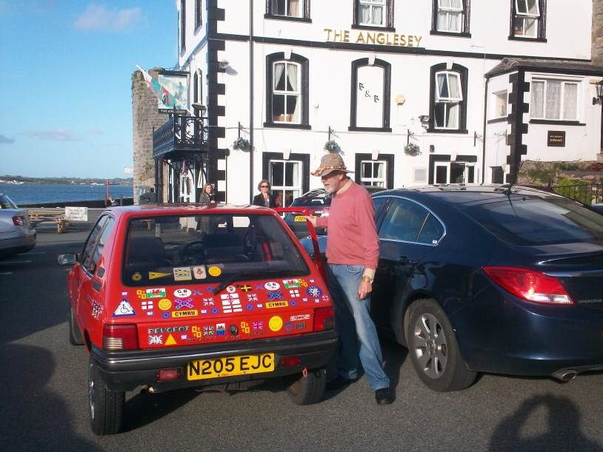

Finally after a presentation on our English heritage to the Fayette group, an accumulation of my articles on English Holymans was distributed. If anyone would like a copy, I am happy to email. My email address is Glennhistory@gmail.com.

Next posting, latest Holyman findings from England….

