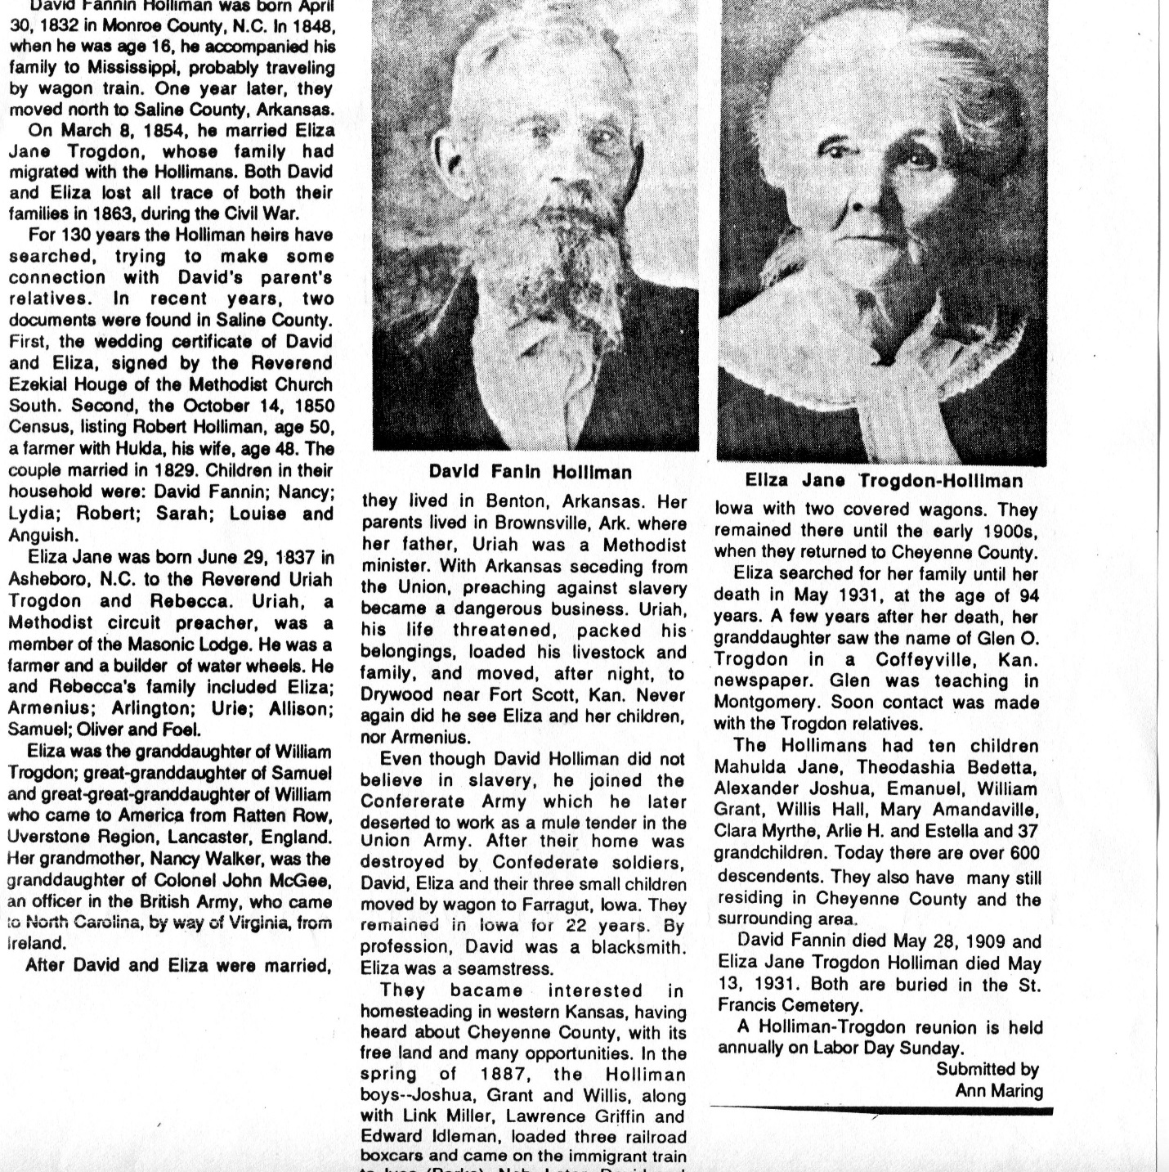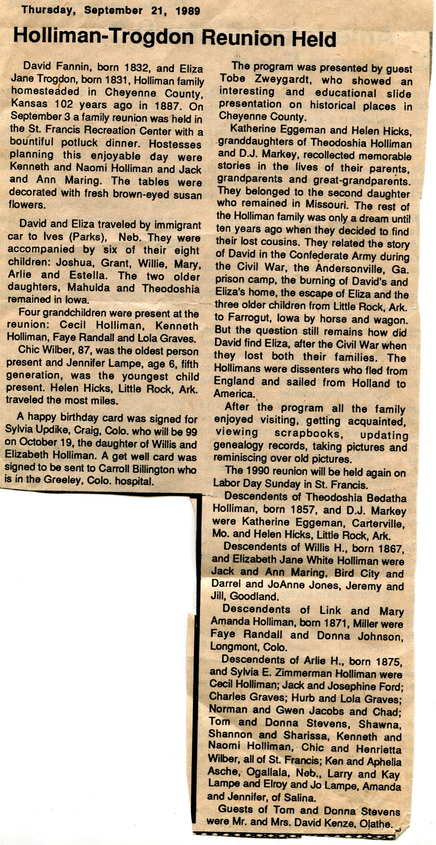 Glenn,
Eliza Jane Trogdon Holliman, born June 29, 1837, in Asheboro, Randolph County, North Carolina, is my Great Grandmother. The picture was taken in about 1925 near St. Francis, Kansas, on the Holliman family farm. The men were her sons, including William Grant Holliman, born 1865 probably in Drakesville, Iowa, after the family fled Arkansas. Grant was my Grand Father who resided in Iowa in 1925. Arlie was the Grand Father of Donald Arlie Holliman, my 2nd cousin in Bird City, Kansas, who matches my DNA at the 37 marker point, so we know we are descendants of Eliza and David Holliman.
On 23andMe, I match cousins with Betty in Florida, so I may be kin yet!!

