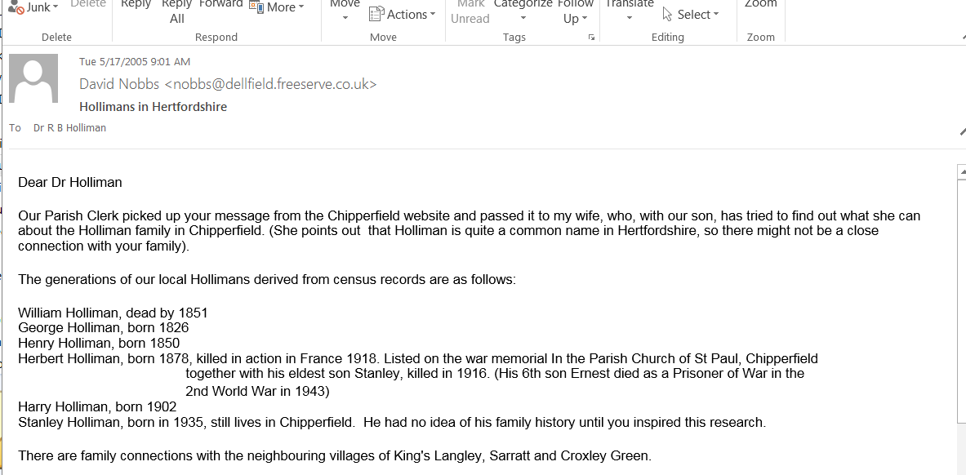There are family connections with the neighbouring villages of King's Langley, Sarratt and Croxley Green.

We will try and help further if you are able to send more details of your forbears, e.g. full name,date of birth, place of birth,dates of emigration etc. We cannot promise results, but our son will do his best for you.

Yours sincerely

David Nobbs, Chipperfield Parish Council.

