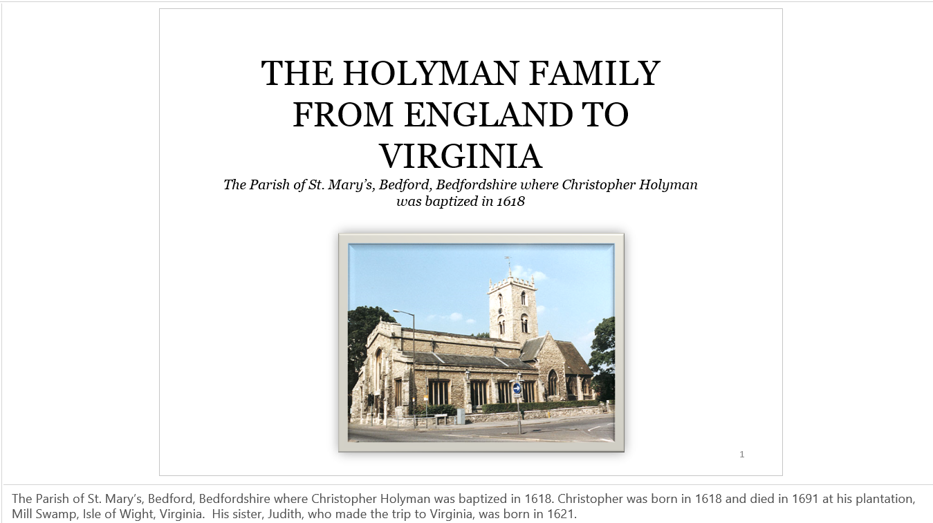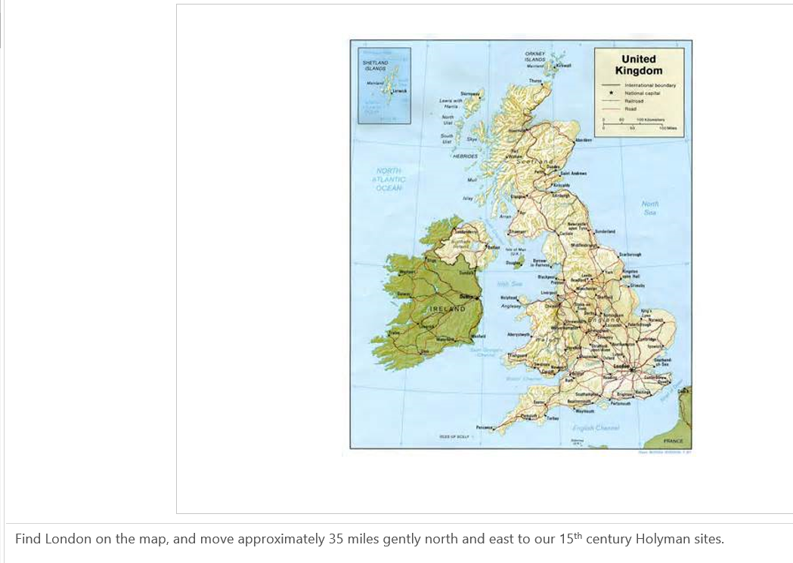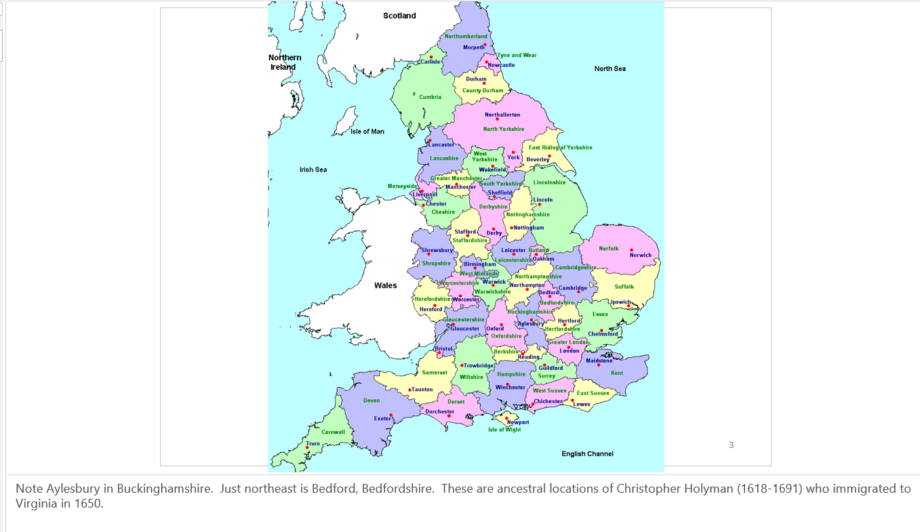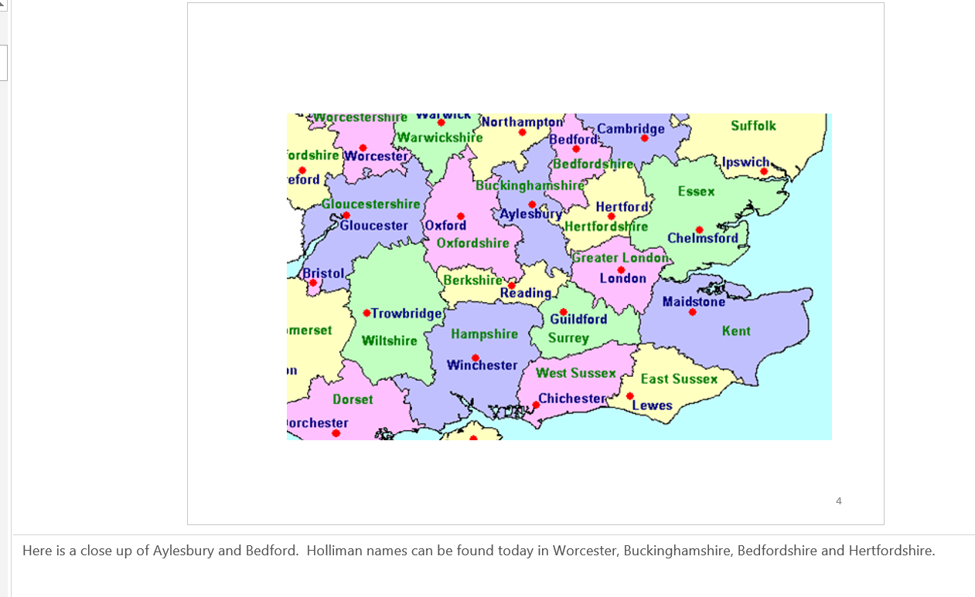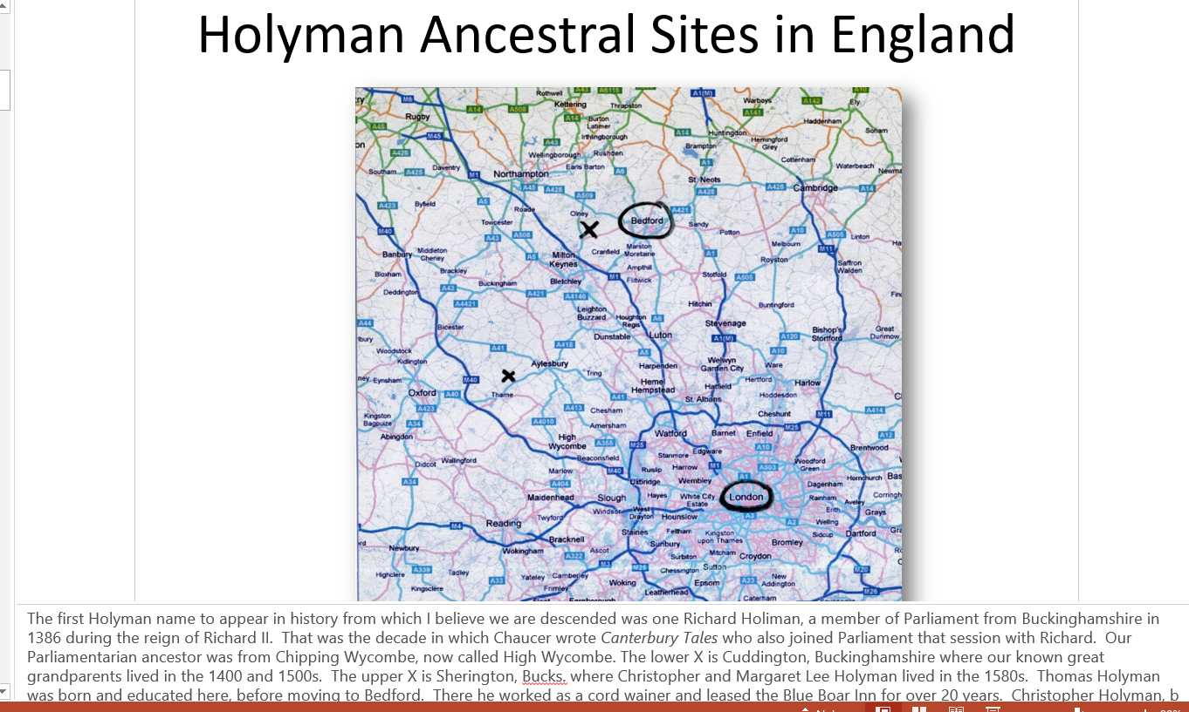There he worked as a cord wainer and leased the Blue Boar Inn for over 20 years. Christopher Holyman, b 1618, was born there.
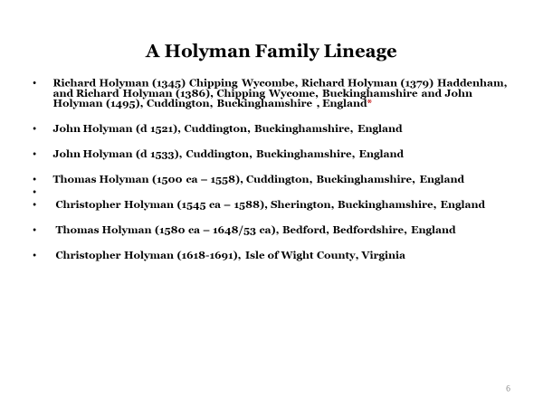Mix this together, stir for several thousand years and one becomes British. Sail to the New World, add yet more cultures and races, plus several hundred additional years and one becomes an American.” – Glenn N. Holliman 2012
* Indicates speculation only

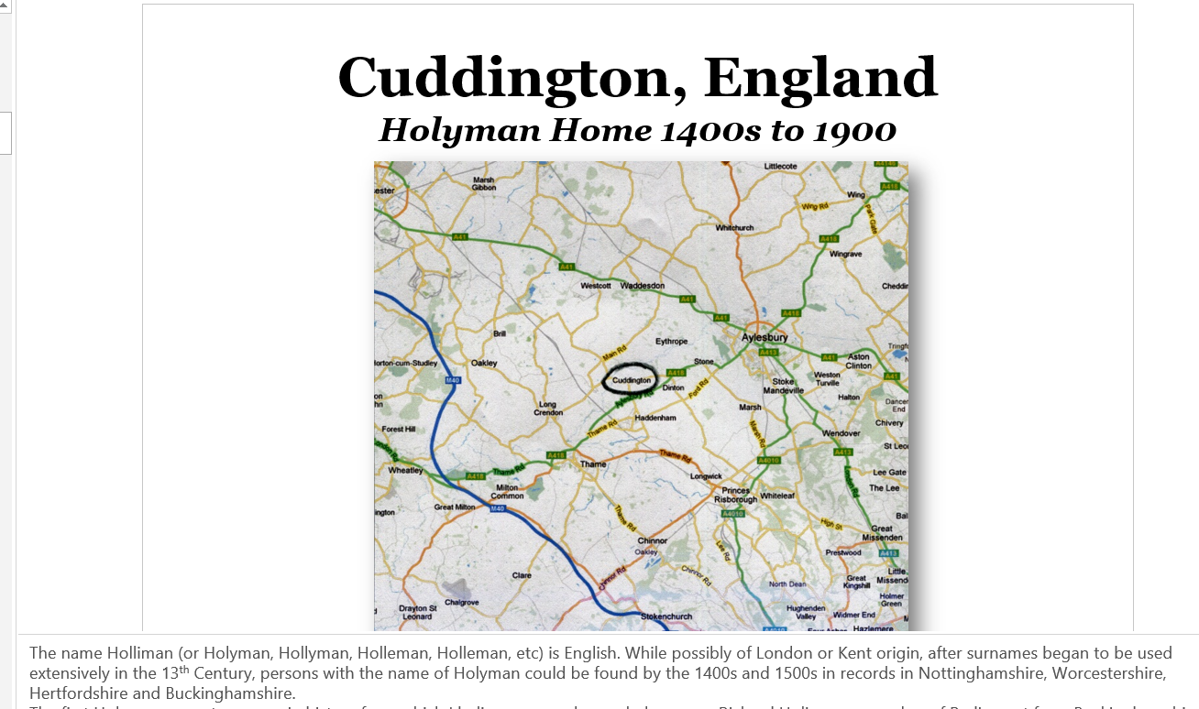The name Holliman (or Holyman, Hollyman, Holleman, Holleman, etc) is English. While possibly of London or Kent origin, after surnames began to be used extensively in the 13th Century, persons with the name of Holyman could be found by the 1400s and 1500s in records in Nottinghamshire, Worcestershire, Hertfordshire and Buckinghamshire.
The first Holyman name to appear in history from which I believe we are descended was one Richard Holiman, a member of Parliament from Buckinghamshire in 1386 during the reign of Richard II. That was the decade in which Chaucer wrote Canterbury Tales who also joined Parliament that session with Richard. Our Parliamentarian ancestor was from Chipping Wycombe, now called High Wycombe. The city is located at an M-40 exit some 30 miles from central London, a 20th Century super highway that connects the capitol city with Birmingham.

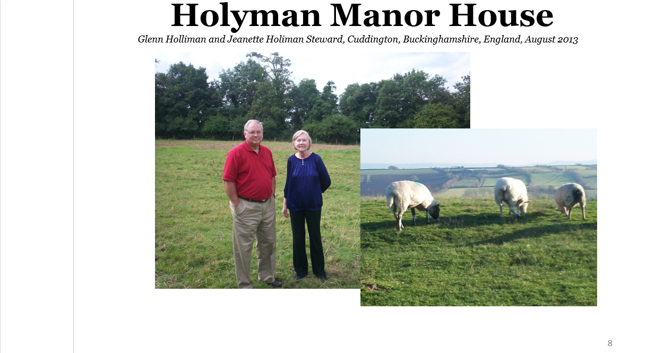 Glenn Holliman and Jeanette Holiman Stewart stand on location of original Holyman manor house. The sheep graze on a nearby hill overlooking the Cuddington valley in Buckinghamshire. These first Holymans were on the rise economically and socially. Richard Holyman had been a member of Parliament. What happened to the family between this date and our next listing of Holymans, I have not yet fully explored. The family was no doubt multiplying as several Holyman branches in Cuddington are recorded at the beginning the 16th Century.

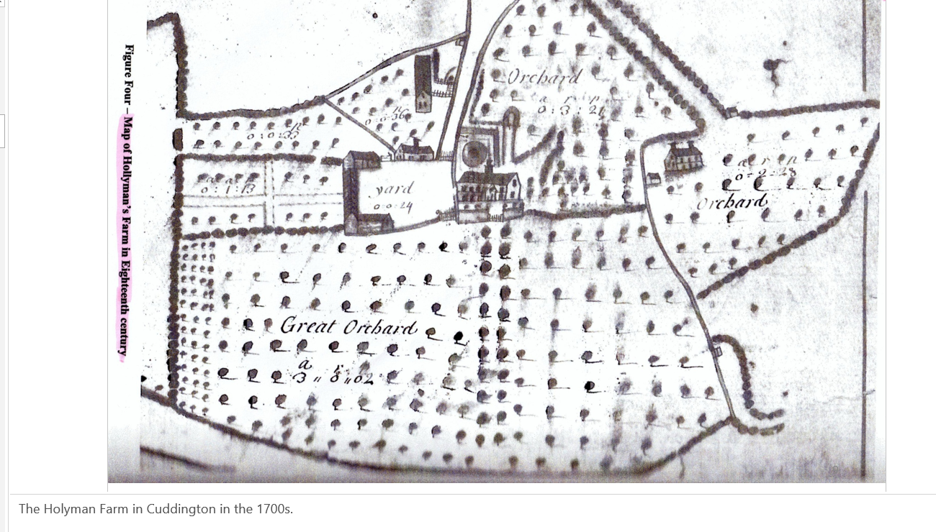 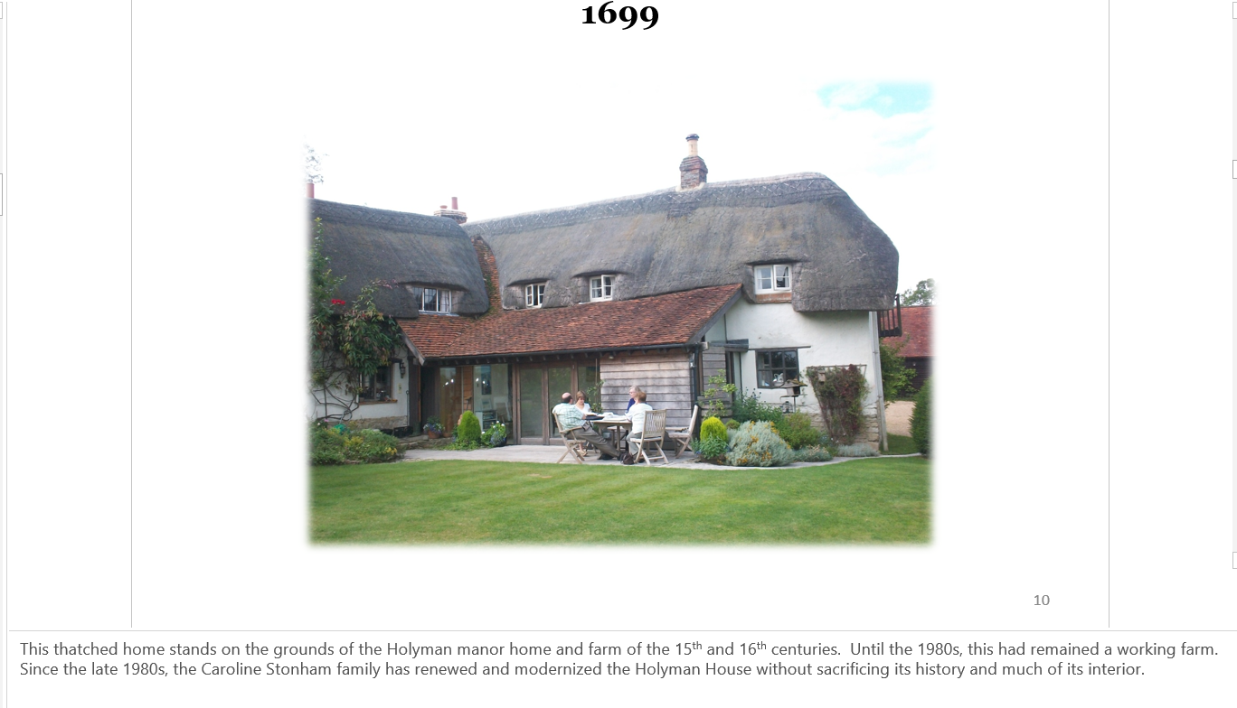 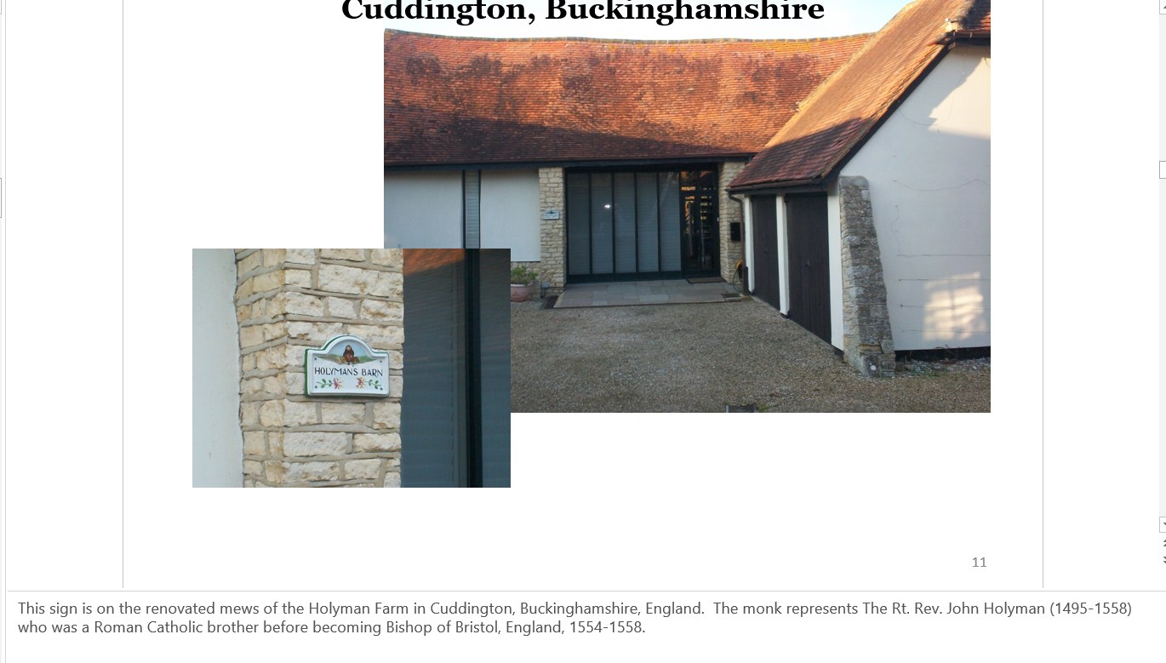 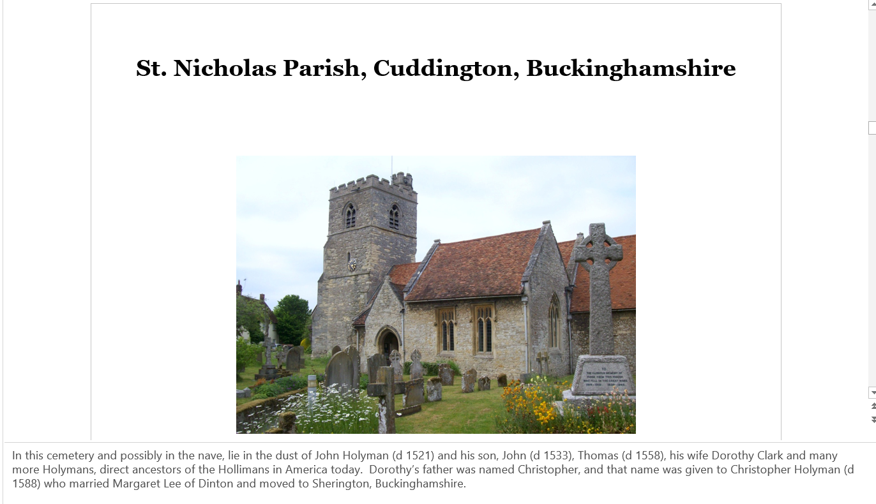 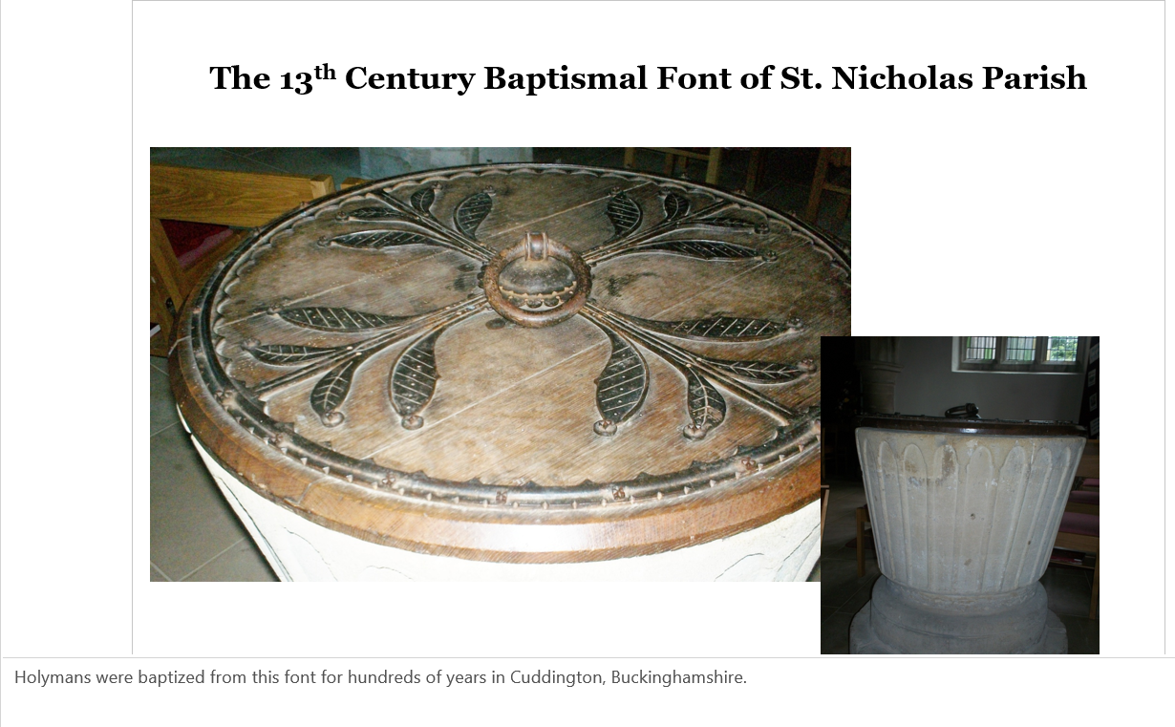 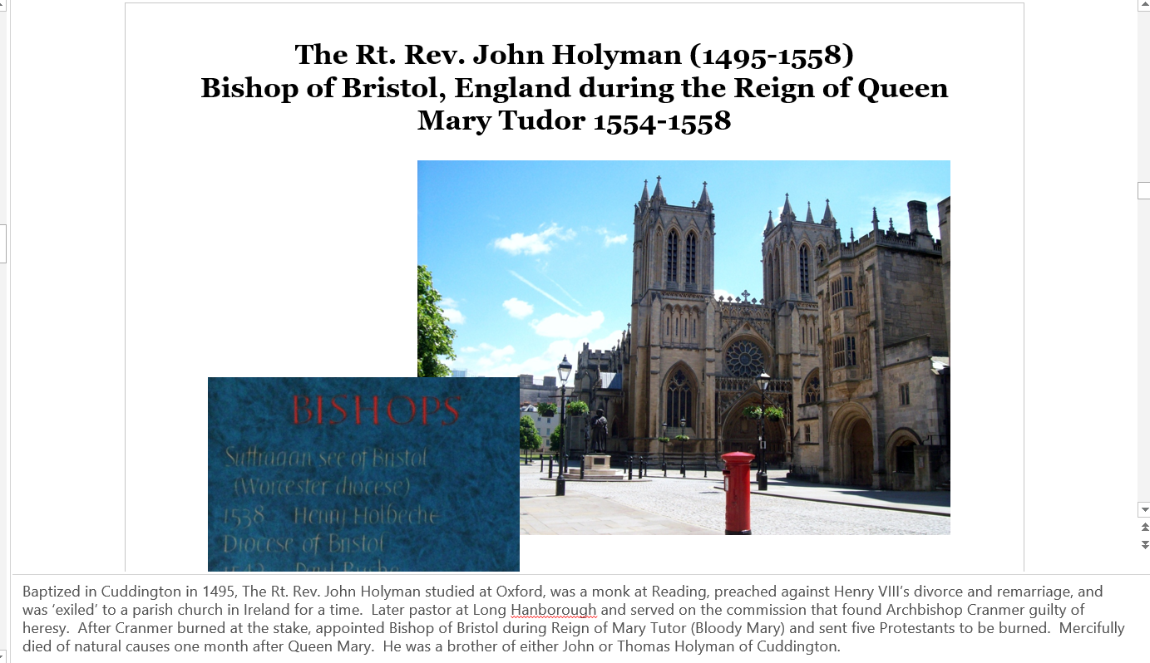 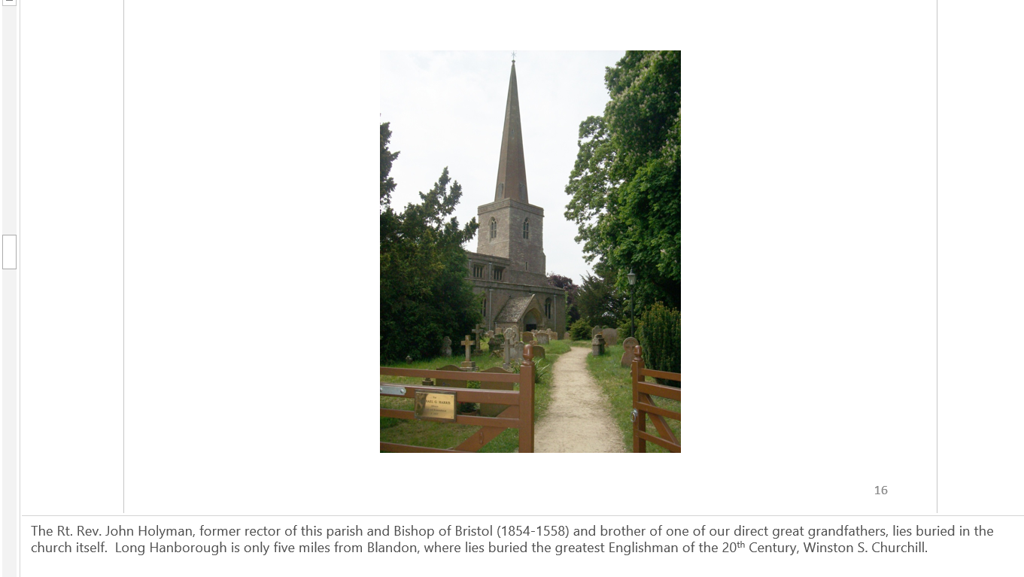 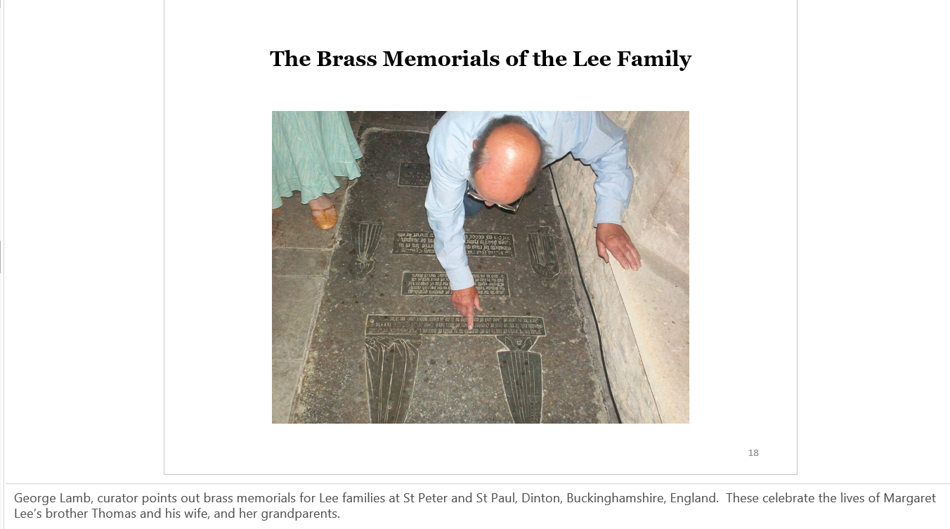 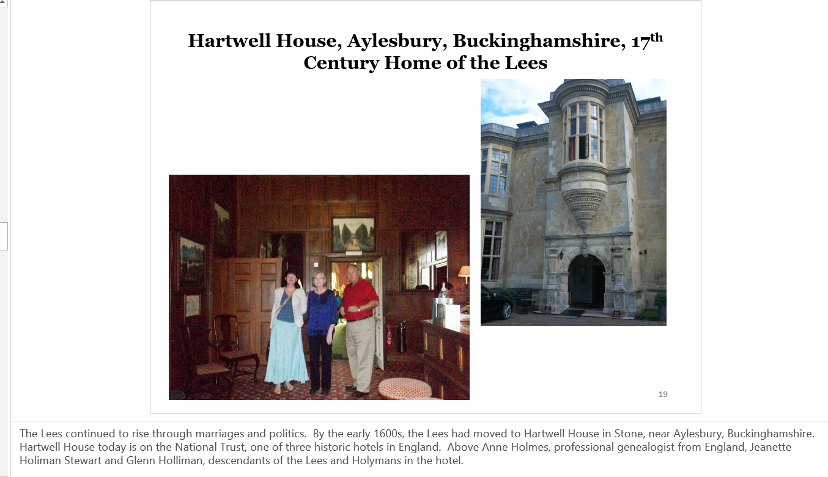 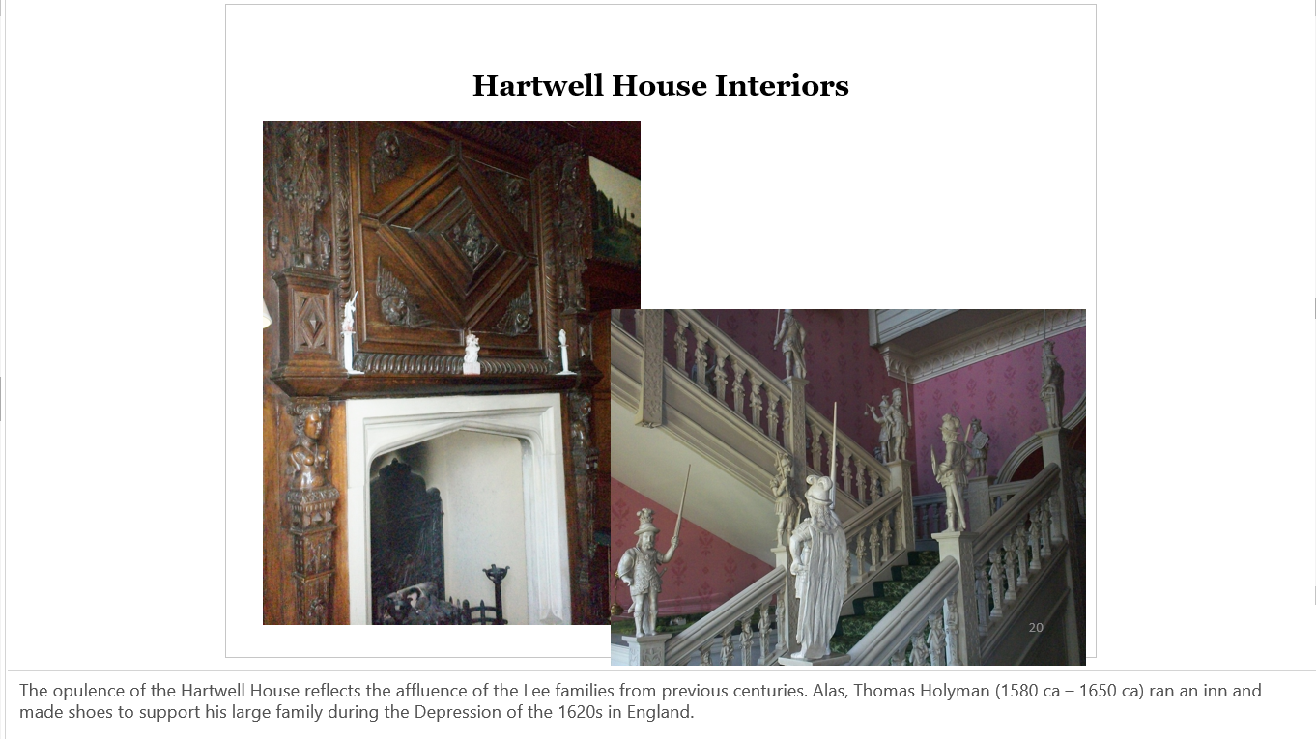 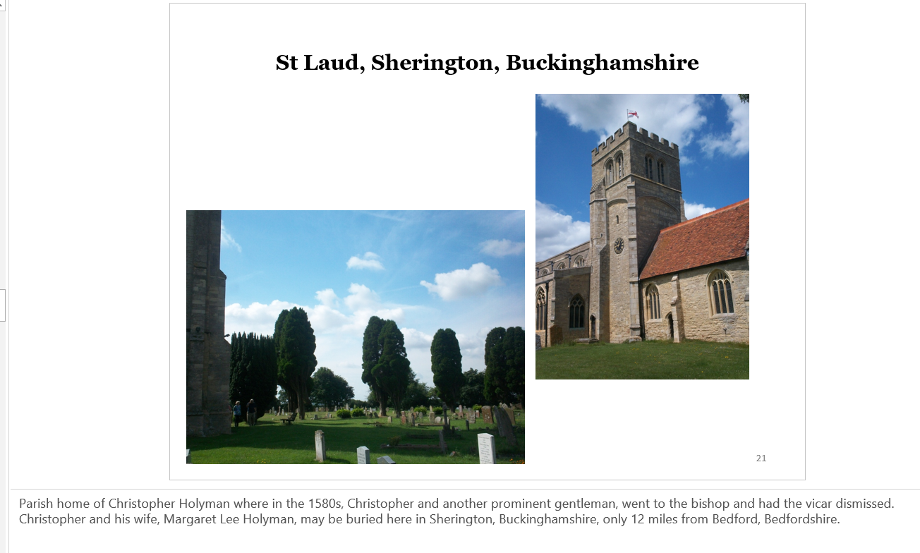 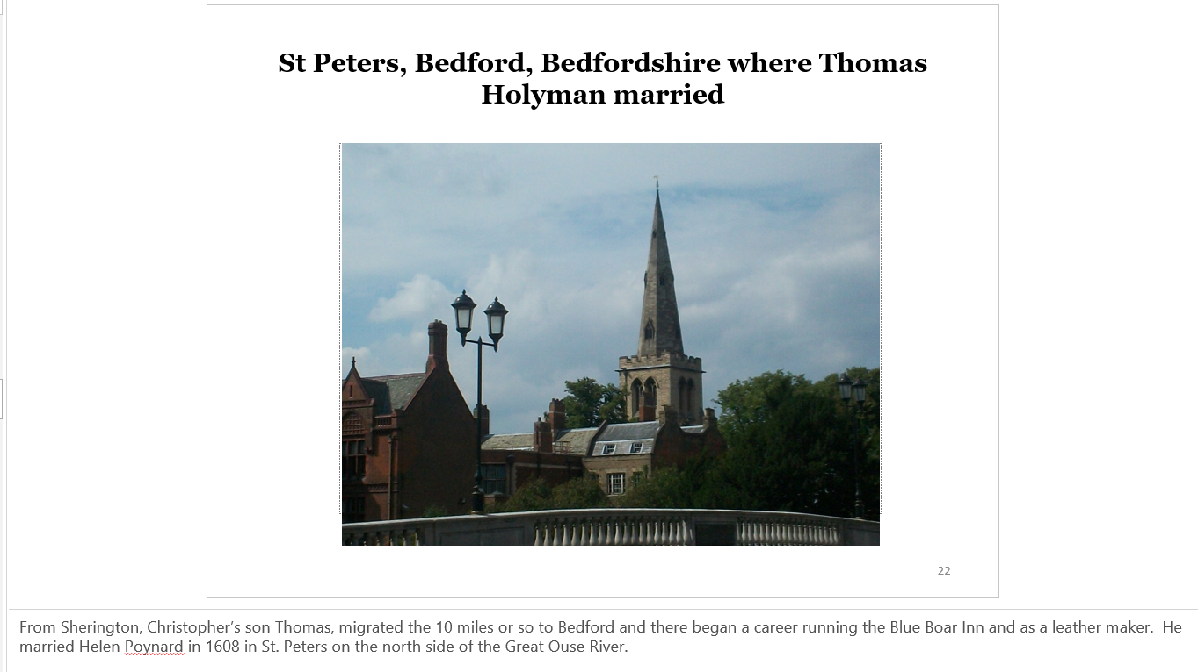 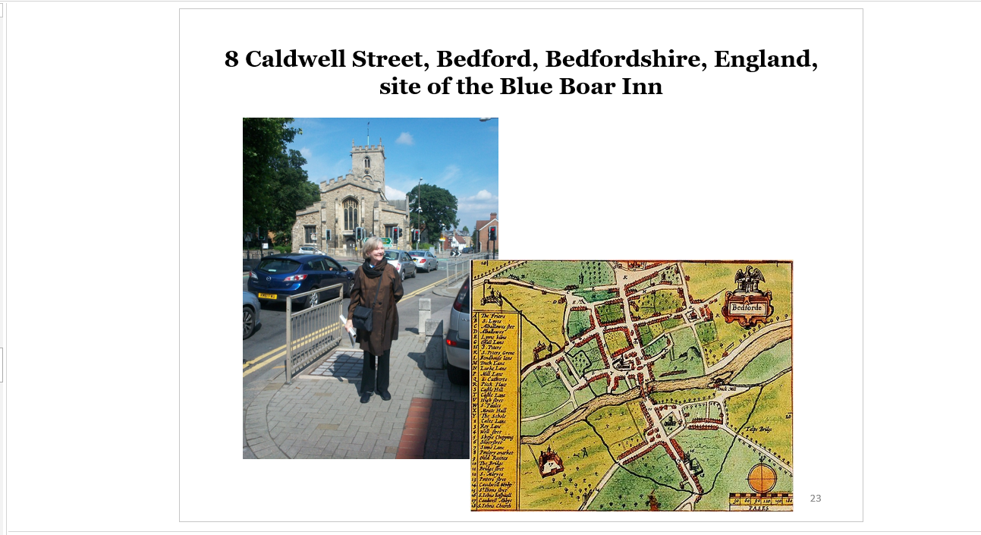 Burial records state Eleanor Holyman was buried in the church yard in 1653 of St. Mary’s above, a person believed to be the wife of Thomas. Here Jeanette Holiman Stewart stands at the site where Christopher Holyman was born and must have worked in his father’s inn and leather shop while growing up. At age 32, Christopher and sister Judith migrated to Jamestown, Virginia.
Thomas and Eleanor’s second son was named Christopher and born in 1618. In my opinion this is the Christopher Holyman (1618-1691) who arrived in Jamestown, Virginia in 1650 with his sister, Judith, born 1621, also in Bedford and baptized at St. Mary’s parish astride the Great Ouse River.
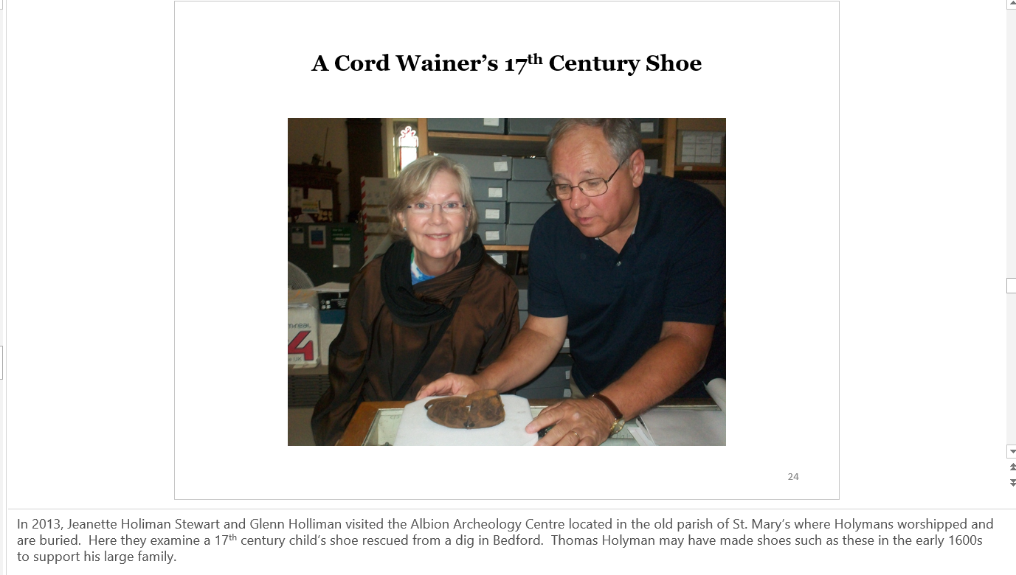 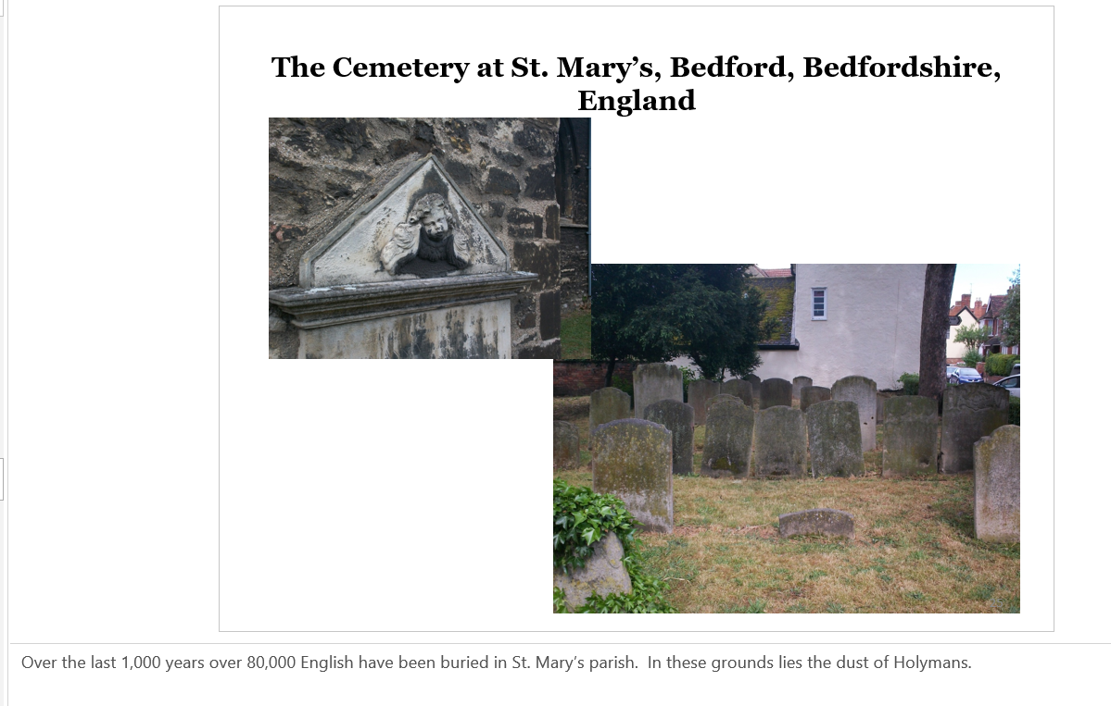 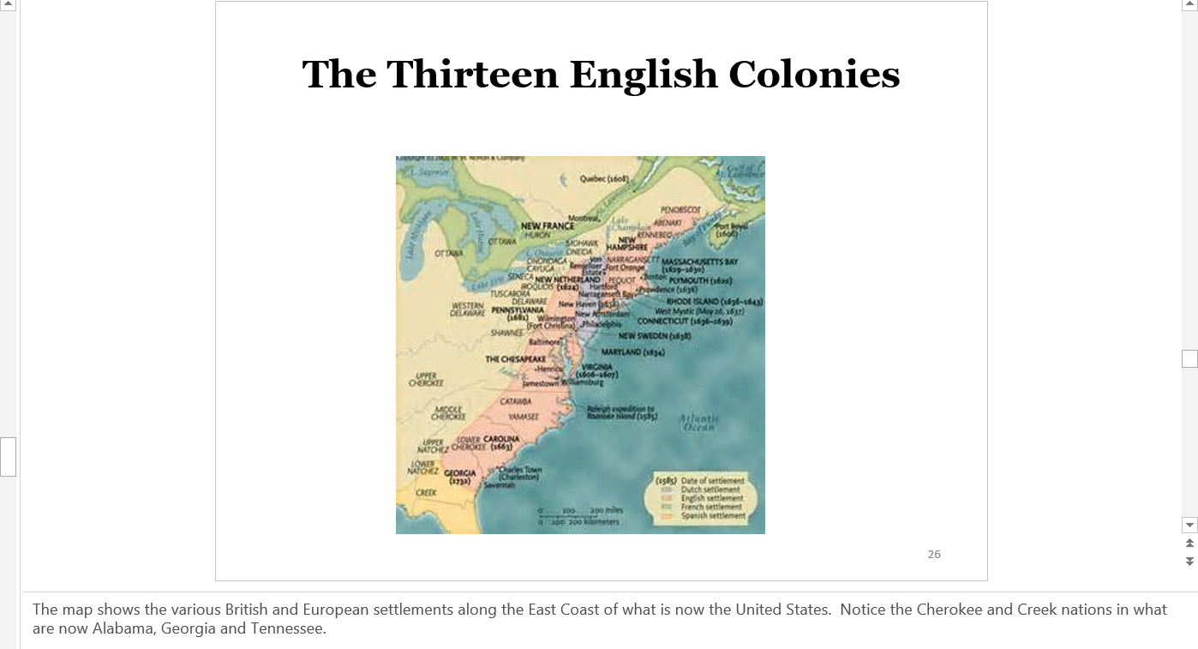 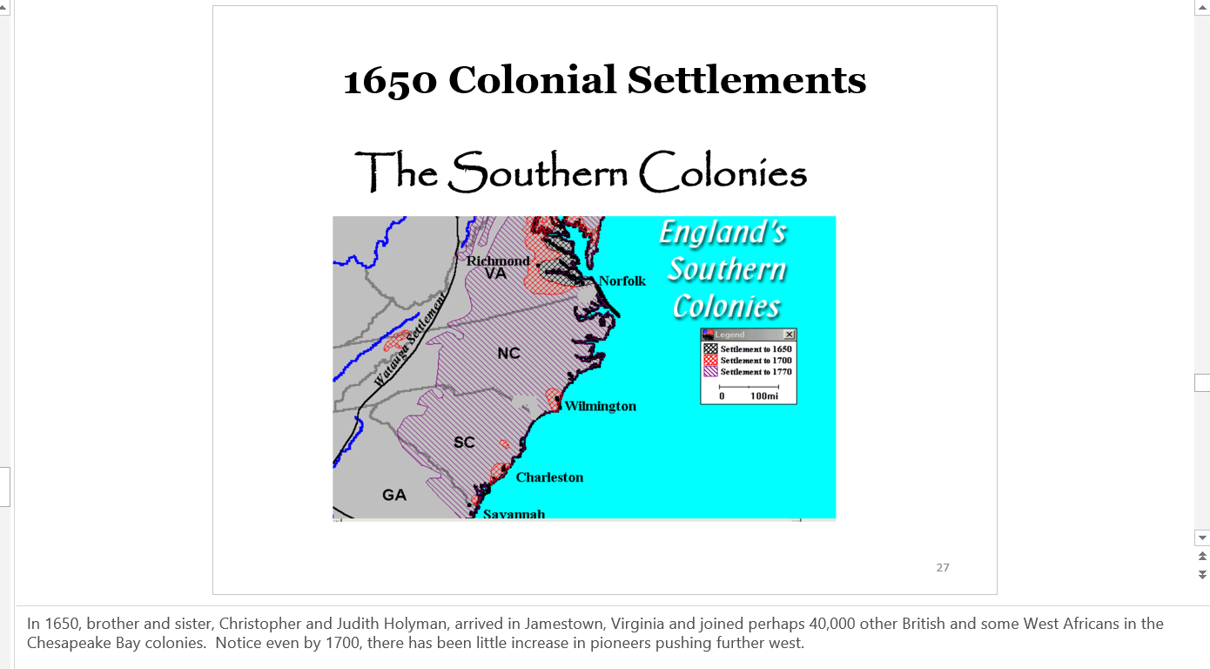 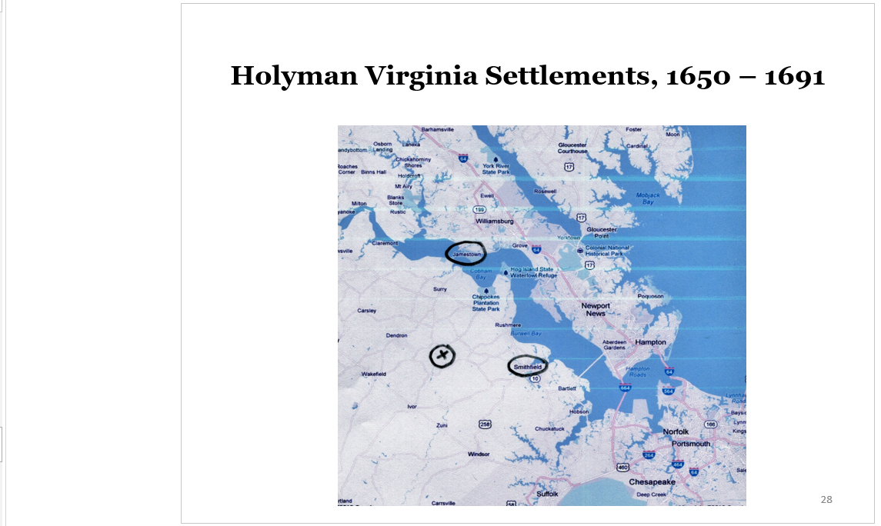 Christopher and his sister Judith Holyman arrived in 1650 in Jamestown, Virginia. By 1661, Christopher owned land near what is now Smithfield along the Cypress River. By the 1680s, he had patented property along the Blackwater River in an area called Mill Swamp (X marks the spot), Isle of Wight County. He died there in 1691 and is in unmarked grave. The Holleman family still owns a portion of the original plantation.
Christopher had two daughters who married Atkinsons and four sons. Descendants of the sons remain in the area today, and others joined in the western march, generally through the Carolinas (but not always) and some arriving in Texas prior to the Civil War. Even day, despite the diaspora of the 20th Century, Hollimans and associated names, still live largely in the southeast and southwest United States.
