HOLLYMAN MORMON LIST FOR LONDON: PART I

WITH NAME VARIATIONS FROM 1551-1875

Comments in brackets and church titles with places amended where necessary inclusive of appropriate grammatical apostrophes.

INDEX OF 44 LONDON PARISH CHURCHES

1 All Hallows’ Church on the Wall

2 All Souls’ Church, Langham Place, St Marylbone

3 St Andrew’s Church, Holborn

4 St Andrew’s Church, St Marylbone

5 St Anne’s Church, Blackfriars

6 St Anne’s Church, Soho, Westminster

7 St Augustine’s Church, Watling Street

8 St Bartholomew the Great’s Church, Smithfield

9 St Botolph’s Church, Aldgate

10 St Botolph’s Church, Bishopsgate

11 St Bride’s Church, Fleet Street

12 St Clement Danes’ Church, Strand, Westminster

13 St Dunstan’s Church, Stepney

14 St George’s in the East Church, Stepney

15 St Giles’s Church, Camberwell

16 St Giles’s Church, Cripplegate

17 St Gregory’s Church by St Paul’s

18 St James’s Church, Clerkenwell, Finsbury, Islington

19 St James’s Church, Piccadilly, Westminster

20 St James’s Church, Sussex Gardens, Paddington

21 St John the Evangelist’s Church, Lambeth

22 St John’s Church, Horsley Downs, Bermondsey

23 St Katherine’s Church by the Tower

24 St Katherine’s Church, Creechurch

25 St Leonard’s Church, Shoreditch

26 St Luke’s Church, Chelsea

27 St Luke’s Church, Old Street, Finsbury, Islington

28 St Margaret’s Church, Westminster

29 St Martin’s in the Fields Church, Trafalgar Square, Westminster

30 St Mary Maftelon’s Church, Whitechapel

31 St Mary’s Church, Lambeth

32 St Mary’s Church, Marylbone Road, St Marylbone

33 St Mary’s Church, Putney

34 St Matthew’s Church, Bethnal Green

35 St Michael’s Church, Bassishaw

36 St Michael’s Church, Cornhill

37 St Nicholas Cole’s Abbey Church, Queen Victoria Street

38 St Olave’s Church, Southwark

39 Old Street Church, St Pancras, Camden

40 St Paul’s Church, Bunhill Row, Finsbury, Islington

41 St Peter, Paul’s Wharf Church

42 St Sepulchre’s Church, Newgate, Holborn

43 St Stephen’s Church, Walbrook

44 St Thomas’s Charterhouse Church, Finsbury, Islington

bpt: baptised xd: christened =: married

1 ALL HALLOWS’ CHURCH ON THE WALL

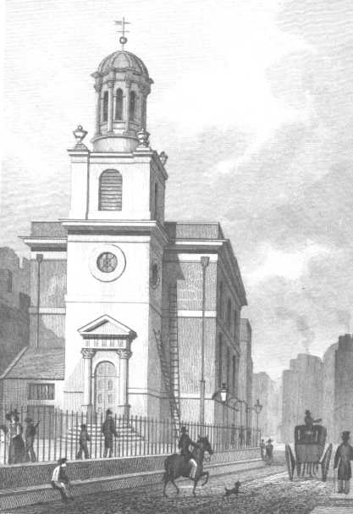

All Hallows’ Church

[Adjacent to the Old City London Wall, Broad Street.]

HOLLYMAN, Ann = JOHNSON, Thomas

2 ALL SOULS’ CHURCH, LANGHAM PLACE, ST MARYLBONE

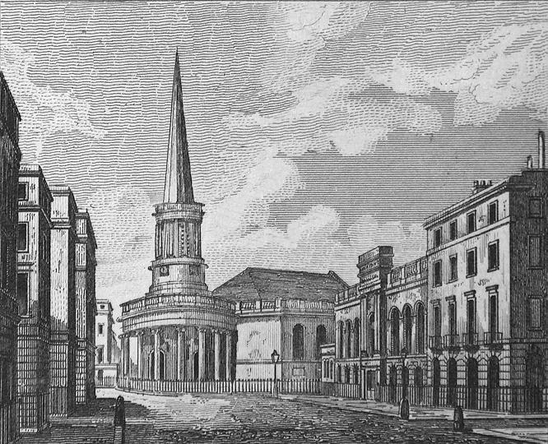

All Souls’ Church, St Marylbone

[At the north end of Regent Street All Souls’, consecrated in 1824, was designed by John Nash, Architect, who designed the Royal Brighton Pavilion.]

HOLLIMAN, Edwin, son of Thomas & Hannah, xd 20 Dec 1831
HOLLYMAN, Sarah Ann = PICKERING, David, 27 Jun 1870

3 ST ANDREW’S CHURCH, HOLBORN

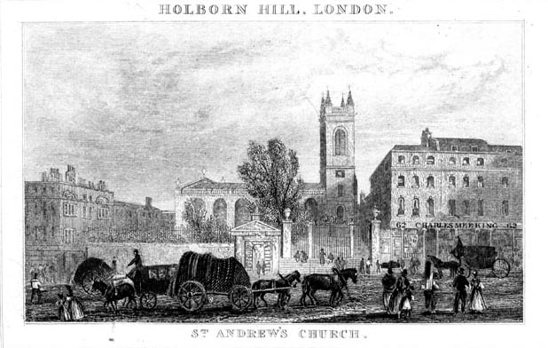

St Andrew’s Church, Holborn

[Rebuilt by Christopher Wren, Architect, and again after being bombed in 1941.]

HOLLYMAN, Joseph, son of Thomas & Sarah, xd 1 Nov 1758
HOLLIMAN, Elizabeth, dau of Thomas & Ann, xd 28 Feb 1769
HOLLIMAN, Sarah, dau of Thomas & Ann, xd 30 Jan 1772
HOLLYMAN, Sarah = JOHNSON, James, 17 Jun 1774
HOLLIMAN, Catherine, dau of Thomas & Ann, xd 1 Mar 1775
HOLLYMAN, John, son of John & Elizabeth, xd 20 Jun 1784
HOLLIMAN, John, son of William & Jane, xd 16 Jun 1793
HOLLIMAN, Charles, son of John & Jane, xd 18 Jan 1808

4 ST ANDREW’S CHURCH, ST MARYLBONE

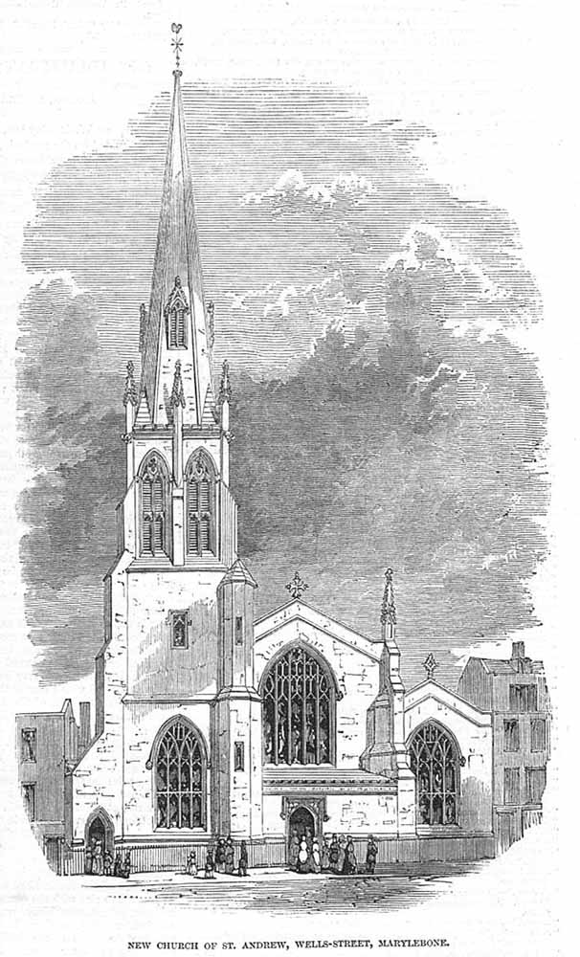

St Andrew’s Church, St Marylbone

HOLLIMAN, Sarah = WARD, Thomas, 18 Feb 1862

5 ST ANNE’S CHURCH, BLACKFRIARS

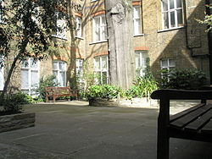

St Anne’s Churchyard, Blackfriars

[This church, a Puritan stronghold, was destroyed by the Great Fire of London in 1666 and never rebuilt; however, the site upon which it stood is now called St Anne’s Churchyard and currently in use.]

HOLLIMAN, John, son of Daniel & Ann, xd 1 Mar 1786

6 ST ANNE’S CHURCH, SOHO, WESTMINSTER

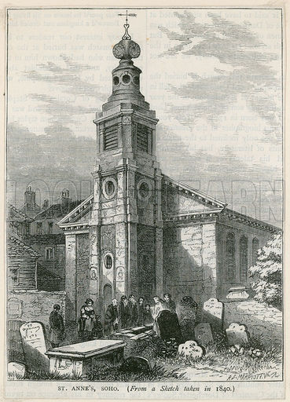

St Anne’s Church, Soho

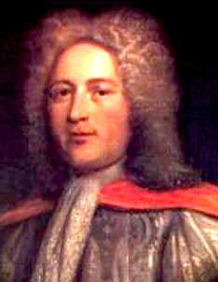

William Croft

[William Croft (1674-1727), the church’s first organist, composed the “St Anne” tune to the hymn, “O God, Our Help in Ages Past”, written by Isaac Watts (1674-1748), Christian Minister and in addition Prince William Henry, brother of King George III, was baptised here.]

O GOD, OUR HELP IN AGES PAST

First four quatrain stanzas by Isaac Watts:

O GOD, OUR HELP IN AGES PAST,
OUR HOPE FOR YEARS TO COME,
OUR SHELTER FROM THE STORMY BLAST,
AND OUR ETERNAL HOME:

UNDER THE SHADOW OF THY THRONE,
THY SAINTS HAVE DWELT SECURE;
SUFFICIENT IS THINE ARM ALONE,
AND OUR DEFENCE IS SURE.

BEFORE THE HILLS IN ORDER STOOD,
OR EARTH RECEIVED HER FRAME,
FROM EVERLASTING THOU ART GOD,
TO ENDLESS YEARS THE SAME.

A THOUSAND AGES IN THY SIGHT
ARE LIKE AN EVENING GONE;
SHORT AS THE WATCH THAT ENDS THE NIGHT
BEFORE THE RISING SUN.

Westminster Abbey - Oh God Our Help in Ages Past - YouTube
HOLLYMAN, Withers = LEWIS, Ann – Union (union of marriage), 28 Aug 1743
HOLLIMAN, Margaret = PARTRIDGE, Joseph, 18 Apr 1802
HOLLIMAN, Charlotte = GOTT, James, 29 Jan 1844

7 ST AUGUSTINE’S CHURCH, WATLING STREET

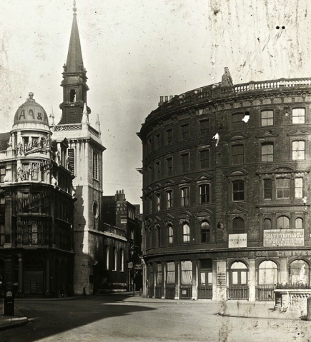

St Augustine’s Church: 1921

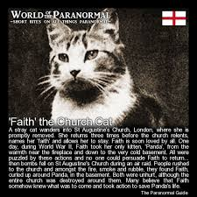

Faith the Church Cat: Feline War Heroine

[Rebuilt to Wren’s designs after being destroyed during the Great Fire in 1666 it was destroyed again by bombing in 1941 and never reconstructed except for its tower, which became part of the new choir school for St Paul’s Cathedral.]

BHM: no personal knowledge of the author’s identity:

FAITH THE CHURCH CAT

“The church cat named Faith became quite well known after the air raid which destroyed St Augustine’s. Days before she was seen moving her kitten, Panda, to a basement area. Despite being brought back several times, Faith insisted on returning Panda to her refuge.

On the morning after the air raid the rector searched through the dangerous ruins for the missing animals and eventually found Faith, surrounded by smouldering rubble and debris but still guarding the kitten in the spot she had selected three days earlier.

The story of her premonition and rescue eventually reached Maria Dickin, founder of the People’s Dispensary for Sick Animals, and for her courage and devotion Faith was awarded a specially-made silver medal.

Her death in 1948 was reported on four continents.”

Tom Jones - What's New Pussycat - YouTube

DAD'S ARMY: full theme song, unheard lyrics - YouTube
HOLLYMAN, (female) = PORTER, M., 1723

8 ST BARTHOLOMEW THE GREAT’S CHURCH, SMITHFIELD

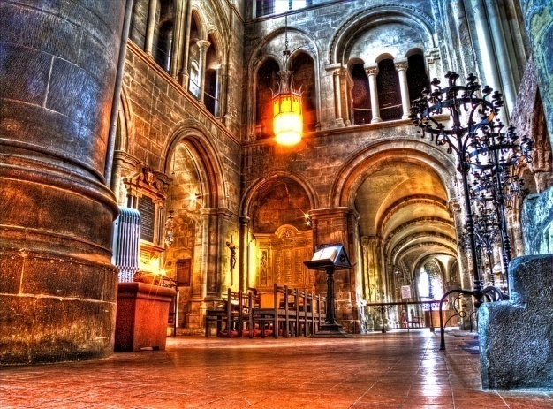

Interior of St Bartholomew’s Church

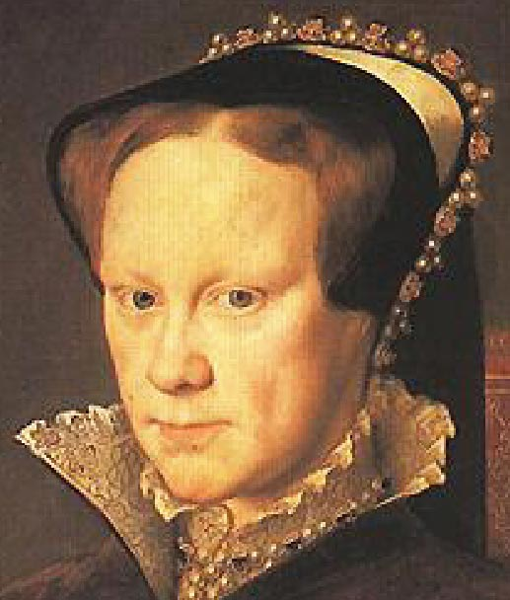

Queen Mary I: Mary Tudor, Bloody Mary

[St Bart’s, London’s oldest surviving church founded in 1123, has been the location of notable film and television dramas such as “Four Weddings and a Funeral”, “Robin Hood: Prince of Thieves”, “Shakespeare in Love” and “The Other Boleyn Girl”.

And Smithfield was the site of 66 martyrs out of about 300 burned nationally at the stake, later called the “Marian Burnings”, during the five-year reign of terror of Bloody Mary (1516-1558), who reigned England and Ireland from 1553.

And the cowled ghost of theAnglo-Saxon Monk Rahere is said to haunt this place, appearing through the closed vestry door on 1st July at 7 am every year; then gradually fading away.

In addition, further folklore has indicated many a sighting of the spirit of an elderly lady slowly ambling around the church smelling delightfully of fragrant flowers before suddenly vanishing into thin air.]

HOLLIMAN, Ann = DAVIDGE, James, 17 Sep 1786

9 ST BOTOLPH’S CHURCH, ALDGATE

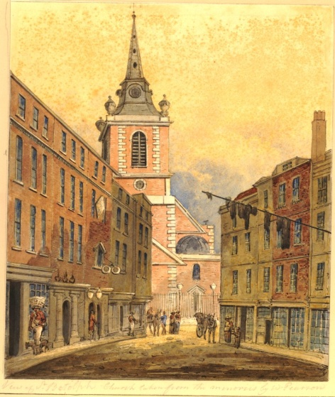

St Botolph’s Church, Aldgate

[At a junction with Houndsditch.]

[HOLLYMANCIS, Garrot, son of Daniell & Jane, (or Joane Mason), xd Oct 1628

Ancestry.com states that a Daniell Hollymancis = Rachell DIPON at London and My Heritage records indicate that ..., daughter of Daniell HOLLIJMANCES or HOLLYMANCIS, xd 1630, died 1631, and that Mary HOLLIJMANCES or HOLLYMANCIS, xd 1630, died 1631; so Mary was likely the issue of Daniell and Jane or Joane.]

10 ST BOTOLPH’S CHURCH, BISHOPSGATE

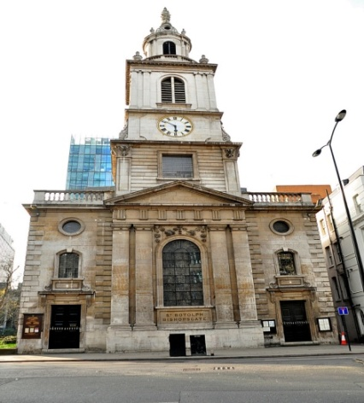

St Botolph’s Church, Bishopsgate

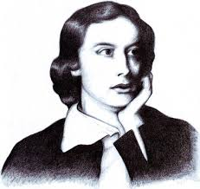

John Keats

[It was rebuilt between 1724-29 and John Keats (1795-1821), English Romantic Poet, was baptised at its font.]

ODE TO A NIGHTINGALE

First two quintet stanzas by John Keats:

MY HEART ACHES, AND A DROWSY NUMBNESS PAINS
MY SENSE, AS THOUGH OF HEMLOCK I HAVE DRUNK,
OR EMPTIED SOME DULL OPIATE TO THE DRAINS
ONE MINUTE PAST, AND LETHE-WARDS HAD SUNK:
‘TIS NOT THROUGH ENVY OF THY HAPPY LOT,

BUT BEING TOO HAPPY IN THINE HAPPINESS,
THAT THOU, LIGHT-WINGED DRYAD OF THE TREES,
IN SOME MELODIOUS PLOT
OF BEECHEN GREEN, AND SHADOWS NUMBERLESS,
SINGEST OF SUMMER IN FULL-THROATED EASE

Ode To A Nightingale-John Keats,read by Robert Donat - YouTube
HOLLYMAN, Mary = TYTFORD, John, 1 Jul 1611
HOLLYMAN, Ann, dau of Francis & Ann, xd 10 Oct 1623
HOLLYMAN, Elizabeth = DAINES, Robert, 9 Dec 1630
HOLLYMAN, Thomas = CARTER, Jane, 3 Aug 1825
HOLLYMAN, Frances, dau of Thomas & Jane, xd 29 Oct 1826
HOLLYMAN, Richard, son of Thomas & Jane, xd 1 Jun 1828
HOLLYMAN, Jane, dau of Thomas & Jane, xd 18 Sep 1829
HOLLYMAN, Sarah = ELLARD, John Andrew, 3 May 1830
HOLLYMAN, James, son of Thomas & Jane, xd 26 Jun 1831
HOLLYMAN, Emma, dau of Thomas & Jane, xd 30 Aug 1833
HOLLYMAN, Thomas, son of Thomas & Jane, xd 23 Aug 1835
HOLLYMAN, Elizabeth, dau of Thomas & Jane, xd 18 Aug 1837
HOLLYMAN, George, son of Thomas & Jane, xd 15 Sep 1839

11 ST BRIDE’S CHURCH, FLEET STREET

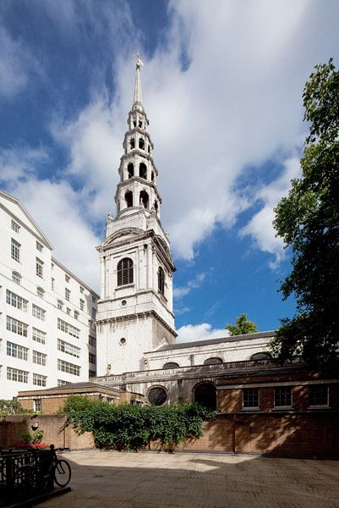

St Bride’s Church, Fleet Street

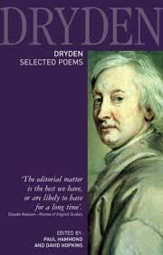

John Dryden

[John Dryden (1631-1700), Playwright and the first English Poet Laureate, was a parishioner at St Bride’s and Samuel Pepys (1633-1703), Member of Parliament, Naval Administrator and Diarist, was baptised here.]

ABSALOM AND ACHITOPHEL

First two quintet stanzas by John Dryden:

IN PIOUS TIMES, ERE PRIEST-CRAFT DID BEGIN,
BEFORE POLYGAMY WAS MADE A SIN;
WHEN MAN, ON MANY, MULTIPLI’D HIS KIND,
ERE ONE TO ONE WAS CURSEDLY CONFIN’D:
WHEN NATURE PROMPTED, AND NO LAW DENI’D

PROMISCUOUS USE OF CONCUBINE AND BRIDE;
THEN, ISRAEL’S MONARCH, AFTER HEAVEN’S OWN HEART,
HIS VIGOROUS WARMTH DID VARIOUSLY IMPART
TO WIVES AND SLAVES: AND, WIDE AS HIS COMMAND,
SCATTER’D HIS MAKER’S IMAGE THROUGH THE LAND.

HOLLIMAN, Thomas, son of Henry & Margaret, xd 8 Jul 1632
HOLLIMAN, Mary, dau of Henry & Mary, xd 23 Jul 1643
HOLLIMAN, Ann, dau of Henry & May, xd 11 Aug 1650
HOLLIMAN, Mary, dau of Albartus & Susanna, xd 4 Apr 1708

12 ST CLEMENT DANES CHURCH, STRAND, WESTMINSTER

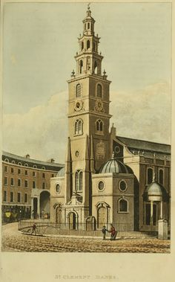

St Clement Danes’ Church: 1814

[St Clement Danes’, situated outside the Royal Courts of Justice, was apparently so named due to Westminster’s prior connections with Danish colonisation during the 9th century and as they had invaded England across the sea from Scandinavia in their Viking longboats, it is not surprising that St Clement is the patron saint of mariners.

The nursery rhyme “Oranges and Lemons” is said to refer to St Clement’s Church, which rings the tune with its bells three times a day.]

Oranges and Lemons Nursery Rhyme - YouTube
ORANGES AND LEMONS
SAY THE BELLS OF ST CLEMENT’S

YOU OWE ME FIVE FARTHINGS
SAY THE BELLS OF ST MARTIN’S

WHEN WILL YOU PAY ME?
SAY THE BELLS OF OLD BAYLEY

WHEN I GROW RICH
SAY THE BELLS OF SHOREDITCH

WHEN WILL THAT BE?
SAY THE BELLS OF STEPNEY

I DO NOT KNOW
SAY THE GREAT BELLS OF BOW

HERE COMES A CANDLE TO LIGHT YOU TO BED
AND HERE COMES A CHOPPER TO CHOP OFF YOUR HEAD!

[It is nationally recognised in England that anyone born within the sound of Bow bells at the Church of St Mary and Holy Trinity, Stafford, Bow, otherwise known as Bow Church, is a true Cockney.]

Lets All Go Down The Strand - From The Top Theatre Company ...

Moreover the Reverend William Webb Ellis, rector of this church, is cautiously credited with inventing rugby football at Rugby School, Warwickshire, in 1823, and St Clement’s holds the immensely proud role of being the Central Church of the Royal Air Force in Great Britain.]

HOLLYMAN, Stephen, son of Stephen & Elizabeth, xd 16 May 1744
HOLLYMAN, Sarah Jane, dau of Richard & Jane, xd 11 Aug 1858
HOLLYMAN, Robert John, son of Robert & Emily Sara, xd 16 Jul 1872
HOLLYMAN, Thomas Henry, son of Robert & Emily Sarah, xd 18 Dec 1873
HOLLYMAN, Walter Lionel, son of Robert & Emily Sarah, xd 15 Dec 1874
HOLLYMAN, Alfred Ernest, son of Robert & Emily Sarah, xd 14 Dec 1875

13 ST DUNSTAN’S CHURCH, STEPNEY

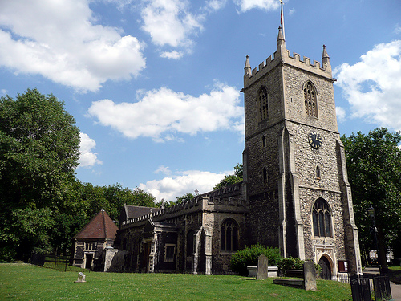

St Dunstan’s Church, Stepney

[Lord Darnley, the eldest brother of the husband of Mary, Queen of Scots, (1542-1587), was buried here aged twelve.]

HOLLYMAN, William = BURMAN, Jane, 18 May 1590
HOLLIMAN, Elizabeth = BECK, William, 25 Sep 1718
HOLLYMAN, William, son of Thomas & Susann, xd 5 Apr 1719

14 ST GEORGE’S IN THE EAST CHURCH, STEPNEY

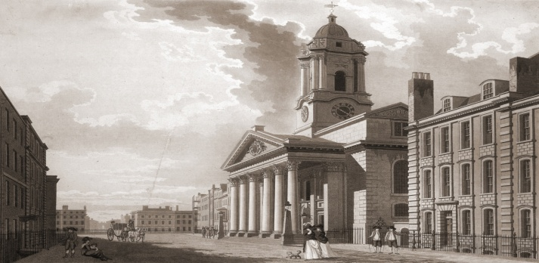

St George’s Church, Stepney: 1787

[During the 1850s the Bishop of London appointed a lecturer for St George’s of Low Church status, of which the High Church incumbent rector and curate did not approve. Protests by pompous, snobbish parishioners ensued who blew loud horns and made high-pitched pussy- mewing noises. And furthermore some men of this congregation entered the church with barking dogs and wearing hats whilst they smoked their pipes, and rubbish was flung onto the altar. As a result St George’s was closed in 1859 until the poor, unfortunate lecturer resigned.]

HOLLIMAN, Tho’s, son of Daniel & Ann, xd 1 Apr 1778

15 ST GILES’S CHURCH, CAMBERWELL

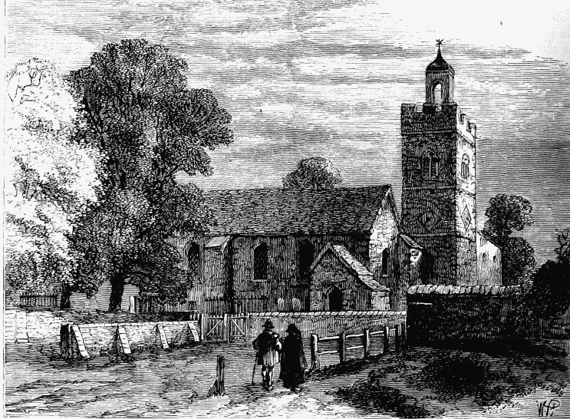

Old St Giles’s Church, Camberwell, in 1750

[John Ruskin, Watercolourist & Writer(1819-1900), designed the East Window.]

HOLLYMAN, William = THOMPSON, Elizabeth, 29 Oct 1815
HOLLYMAN, Elizabeth Frances, dau of William & Elizabeth, 28 Feb 1819
HOLLYMAN, George, son of William & Elizabeth, xd 6 Aug 1820
HOLLYMAN, William, son of William & Elizabeth, xd 18 Jul 1824
HOLLYMAN, Henry, son of William & Elizabeth, xd 7 May 1826
HOLLYMAN, Sarah, dau of William & Elizabeth, xd 7 May 1826

16 ST GILES’S CHURCH, CRIPPLEGATE

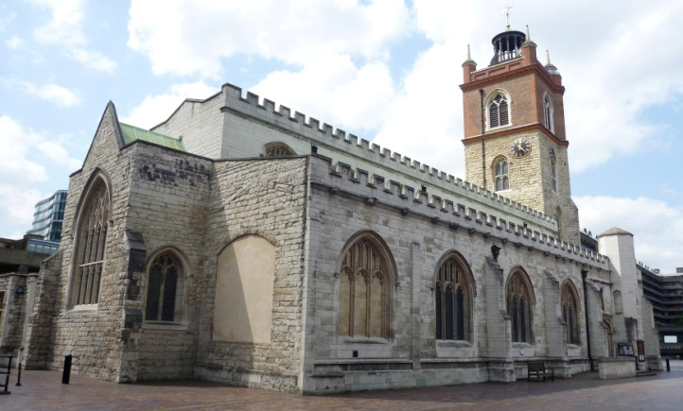

St Giles’s Church, Cripplegate

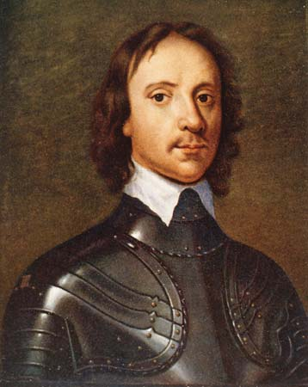

Oliver Cromwell

[John Foxe, author of “The Book of Martyrs” published in 1563, was buried here in 1587 as was Captain Sir Martin Frobisher (ca 1535/39-1594), who commanded a naval squadron during the Battle of the Spanish Armada in 1588.

Furthermore Nathaniel Eaton, Christened at St Giles’s in 1610 and who died in 1674, was the first Schoolmaster of Harvard College, Cambridge, Mass.

And in addition Oliver Cromwell, “Old Ironsides” (1599-1658), Independent Puritan Roundhead Lord Protector of England, married there in 1620.

John Milton born 1608 and author of ‘Paradise Lost’, was buried at this church in 1674, John Bunyon (1628-1688), author of ‘Pilgrim’s Progress’, was a parishioner and Daniel Defoe (1660-1731) who wrote ‘Robinson Crusoe’ died in this parish.]

HOLLYMAN, Amy = MOTHAM, Thomas, 10 May 1650
HOLLYMAN, Ruth = SPOONER, Peter, 14 Dec 1677/99
HOLLYMAN, John, son of John & Rebecca, xd 1 Jul 1829

17 ST GREGORY’S CHURCH BY ST PAUL’S

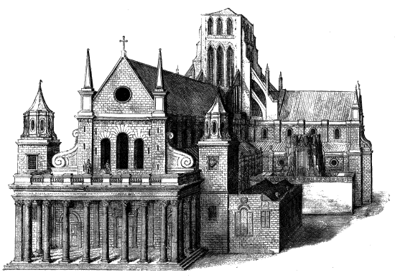

St Gregory’s Church in front with Old St Paul’s Cathedral in the background (rear view)

[St Gregory’s was situated against the south-west tower of Old St Paul’s Cathedral and Inigo Jones (1573-1652), the famous architect who was renovating the cathedral, wanted to demolish the church but the House of Lords denied his request. Nevertheless it was destroyed during the Great Fire of London in 1666 and never rebuilt.

In 1010 the body of St Edmund was brought to the church from St Edmund’s Abbey, Bury, Suffolk for protection because of destructive, merciless raids by the Danes. It was returned intact three years later.

St Edmund the Martyr (841-869), Anglo-Saxon King of East Anglia from ca 855, was killed by “The Great Heathen Army”, the Vikings, apparently under the orders of the two sons of Ragnar: Ivar the Boneless and Ubba, because Edmund, first Patron Saint of England before St George, was said to have refused to deny the existence of Jesus Christ.]

HOLLYMAN, Amie = LAMBORNE, Edward, 11 Feb 1582/83
HOLLIMAN, Francis = WESTBIE, Margaret, 11 May 1609

18 ST JAMES’S CHURCH, CLERKENWELL, FINSBURY, ISLINGTON

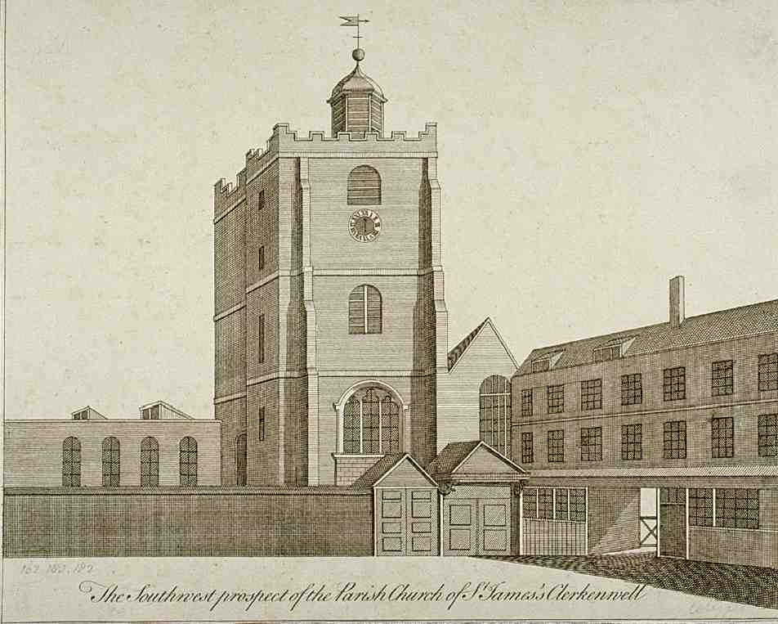

Old St James’s Church, Clerkenwell, c 1750

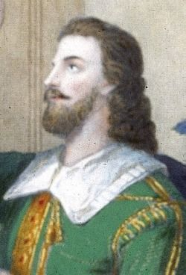

Thomas Rolfe

[The image depicting Old St James’s Church, 1540-1788, depicts a low building to the left of the tower which used to be the former church nave for the nuns of the Benedictine Nunnery of St Mary, c 1100-1539, until King Henry the VIII’s Dissolution of the Monasteries. And in 1623 the tower collapsed twice but was restored; then it was replaced by a new church in 1792 which is presently in use.

It was at St James’s Church that Thomas Rolfe (1615-1680), Colonist, Tobacco Planter and Lieutenant in Virginia reputedly married Elizabeth Washington in 1632 who in 1633 gave birth to an only daughter, Anne, but Elizabeth is said to have died not long after childbirth; then Thomas, according to some sources, returned to Jamestown after leaving Anne under the guardianship of relatives in England; then he married again to Jane Poythress.

This has been disputed because some American descendants of a Thomas Rolfe have said it was another Thomas Rolfe not in any way related to them who married Elizabeth at St James’s, and furthermore added that the other English Thomas had sired five children with his wife and were still living in England after 1642. I have no primary evidence which supports either opinion.

Although he is recognised in some circles as the first successful exporter of cultivated Virginia tobacco outside America, Thomas is more notable for who his parents were: John Rolfe, Tobacco Planter (1585-1622), and Pocahontas (1595-1617). Also his great-uncle was the Indian chief Opechancanough.

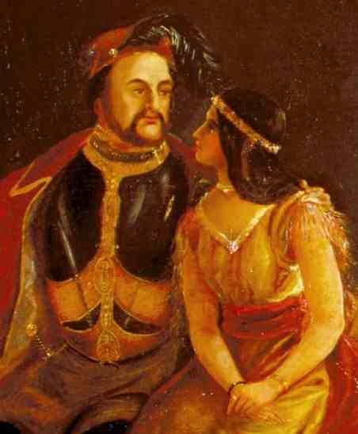

John Rolfe and Pocahontas

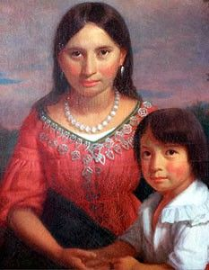

Pocahontas with her son, Thomas Rolfe

Pocahontas, also known as Matoaka and Amonute, was one of the daughters of Chief Powhatan, otherwise called Wahunsenacawh, paramount leader of his powerful confederacy and his wife, Nonoma Winanuske Matatiske.

After apparently saving Captain John Smith’s life (see St Sepulchre’s Church, Newgate, Holborn) she was kidnapped in 1613 by an English sea captain, held captive for ransom; then eventually released after having likely been raped many times by the crew who probably viewed her as a sub-human specimen of the lowest order below English “civilised” society; yet above the value of a horse, to be dillied and dallied with to satiate their delinquent lustful desires.

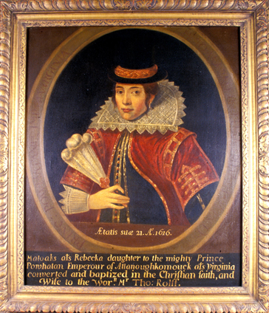

Rebecca Rolfe

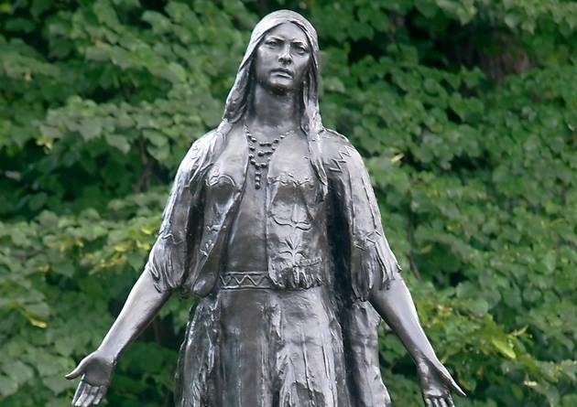

Statue of Pocahontas at Gravesend

After converting to Christianity she was baptised in the name of Rebecca and married John Rolfe at Jamestown in 1614; then in 1616 John and Rebecca Rolfe sailed to England where she was presented to King James I and his wife Queen Anne of Denmark at the Royal Court, being respectfully honoured as an Indian “civilised savage” princess: daughter of Virginia’s most powerful emperor.

Following much adulatory reverence by the population of London, Pocahontas afterwards set sail with her husband back to Jamestown but she sadly died within a day or two and was buried either in St George’s Church chancel or graveyard at Gravesend, Kent on the Thames aged only about 22.

There is no visible marker of her exact place of rest except for a magnificent bronze statue in commemorative remembrance of her which was presented to the town by a group of philanthropicVirginians.

There is also a similar one at Jamestown and over 340 years later, in 1958, the Bishop of Rochester lyrically referred to Pocahontas as “Princess Dancing Sunbeam”.

2016 commemorated the 400th anniversary of Pocahontas’s death.

Thomas, being very seriously ill and not well enough to travel, was put ashore in Plymouth, Devon and placed in the care of Sir Lewis Stuckley who later handed him over to Henry Rolfe, Thomas’s uncle.

And so it came to pass that father and son were never to meet each other again.

Two of Pocahontas’s descendants were Edith Bolling (1872-1961), First Lady of Woodrow Wilson (1856-1924), 28th US President (1913-1921), and Nancy Davis (Anne Frances Robbins) (1921-2016), First Lady of Ronald Reagan (1911-2004), 40th US President (1981-1989).]

HOLLIMAN, Elizabeth = HUTTON, Samuell, 9 Jul 1691* (see Middlesex IGI)

The City of London has been a county since the 12th century.

And as it expanded over the centuries it came to envelop most of the county of Middlesex in the south east in addition to small areas of other neighbouring counties which are also now part of Greater London.

This is the reason why I have transferred Clerkenwell from the Middlesex IGI to the London IGIs as Finsbury, Islington is already listed in the latter.

19 ST JAMES’S CHURCH, PICCADILLY, WESTMINSTER

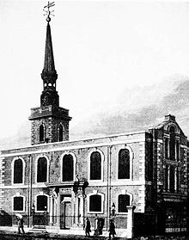

St James’s Church, Piccadilly, 1815

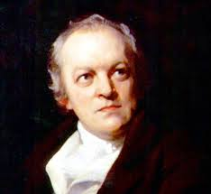

William Blake

It's A Long Way To Tipperary Sung By John McCormack - YouTube
[William Blake (1757-1827), Poet, Painter and Printmaker, was baptised here during the year of his birth, and “Milton” was one of his poems. The preface to this work included another poem, the lines of which became the lyrics for the hymn “Jerusalem”.]:

First four quatrains by William Blake:

AND DID THOSE FEET IN ANCIENT TIME,
WALK UPON ENGLAND’S MOUNTAINS GREEN:
AND WAS THE HOLY LAMB OF GOD,
ON ENGLAND’S PLEASANT PASTURES SEEN!

AND DID THE COUNTENANCE DIVINE,
SHINE FORTH UPON OUR CLOUDED HILLS?
AND WAS JERUSALEM BUILDED HERE,
AMONG THESE DARK SATANIC MILLS?

BRING ME MY BOW OF BURNING GOLD;
BRING ME MY ARROWS OF DESIRE:
BRING ME MY SPEAR: O CLOUDS UNFOLD!
BRING ME MY CHARIOT OF FIRE!

I WILL NOT CEASE FROM MENTAL FIGHT,
NOR SHALL MY SWORD SLEEP IN MY HAND:
TILL WE HAVE BUILT JERUSALEM,
IN ENGLAND’S GREEN AND PLEASANT LAND

And Did Those Feet In Ancient Times - Inspirational Hymns - YouTube
[Robert Graves (1895-1985), Poet, Novelist and Old Carthusian, married Nancy Nicholson (1899-1977), Painter and Fabric designer, at St James’s Church in 1918 and George Mallory (1886-1924), Everest Mountaineer, was the best man.

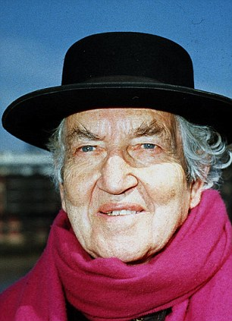

Robert Graves

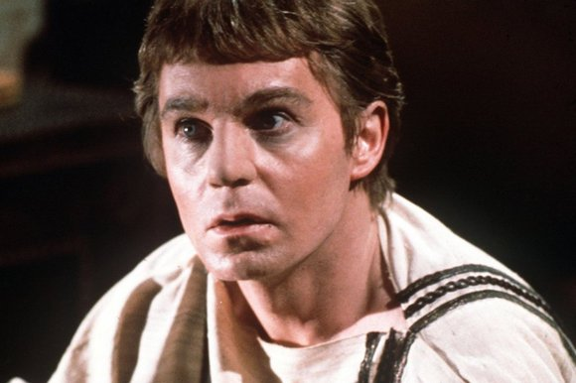

Derek Jacobi as Claudius

An open-minded feminist, Nancy set up regular open market stalls and gave fellow women useful advice on female contraception which was illegal at the time. And whether she was bisexual or not she welcomed Laura Riding (1901-1991), American Poet and Novelist, to live in her home for about eight years whilst they shared Robert between them in a cosy ménage a trois.

But Nancy, with four children in tow, eventually got jealous of Robert’s affections for Laura and felt neglected. They later divorced and many years later, in 1976, Nancy held an exhibition at the Victoria and Albert Museum.

Graves wrote an historical novel called “I, Claudius” which was published in 1935 and made into a popular television series during the 1970s starring Derek Jacobi in the title role together with other famous thespians such as John Hurt, Siân Phillips and Brian Blessed which earned many BAFTAs.

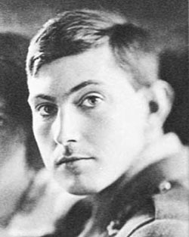

George Mallory

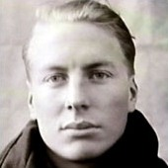

Andrew Irvine

Mallory is remembered for his tragic participation in the British Mount Everest Expedition of 1924 in Tibet, together with Andrew “Sandy” Irvine. They both climbed up the North Face and disappeared on the North-East Ridge after descending cloud obscured any further sight of them; so speculators cannot presently be sure whether they reached the summit of their courageous quest.

The well-preserved body of George, aged 37 when he fell, together with his snow-goggles and wallet, was found by searchers 75 years later in 1999. But Sandy Irvine and his camera with possible film evidence remains missing.]

HOLLIMAN, Daniel = KELLICK, Elizabeth, 22 Nov 1773
HOLLIMAN, Mary = SMITH, Walter, 28 Feb 1830

20 ST JAMES’S CHURCH, SUSSEX GARDENS, PADDINGTON

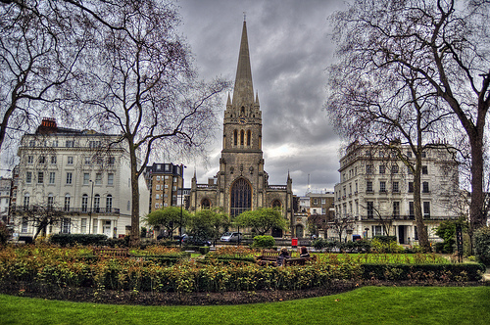

St James’s Church, Paddington

HOLLIMAN, William = VISTIRIN, Elizabeth, 11 May 1857

21 ST JOHN THE EVANGELIST’S CHURCH, LAMBETH

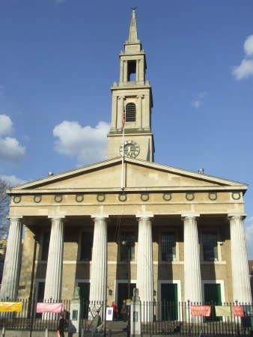

St John the Evangelist’s Church, Lambeth

The Lambeth Walk - YouTube

HOLLYMAN, Eliza, dau of James & Ann, bpt 18 May 1834
22 ST JOHN’S CHURCH, HORSLEYDOWNS, BERMONDSEY

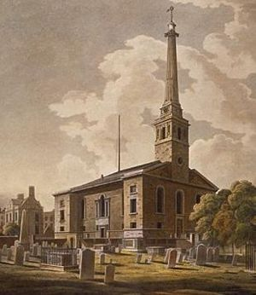

St John’s Church, Bermondsey

[Damaged by bomb during London Blitz in 1940 and closed in 1968.]

HOLLYMAN, James Robert, son of William & Elizabeth, xd 19 Apr 1818
HOLLYMAN, William, son of William & Elizabeth, xd 19 Apr 1818

23 ST KATHERINE’S CHURCH BYTHE TOWER

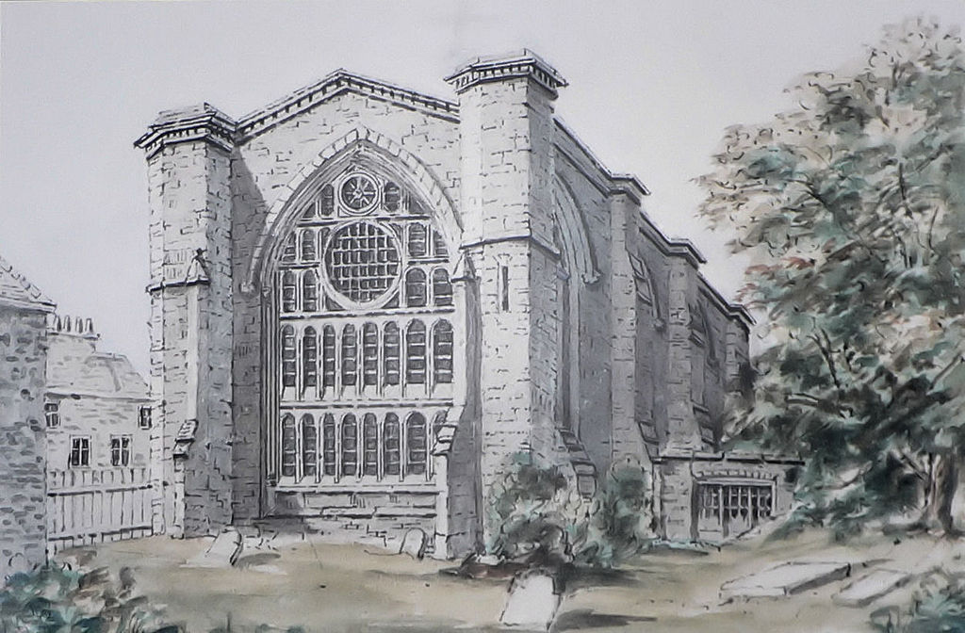

St Katherine’s Church by the Tower

HOLLIMAN, Ursula = HARRISON, Thomas, 5 Dec 1691* [Could be St K Creechurch]
HOLLYMAN, Thomas = BARRES, Susannah, 27 Mar 1713
HOLLYMAN, Susannah = WIMBUSH, Thomas, 15 May 1733

24 ST KATHERINE’S CHURCH, CREECHURCH

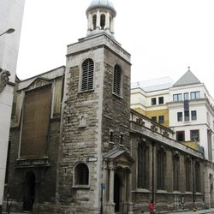

St Katherine’s Church, Creechurch

[Hans Holbein the Younger (1497-1543), 16th century German Northern Renaissance Portraitist of much renown who painted King Henry VIII (1491-1547), the future King Edward VI (1537-1553, and Sir Thomas More (1478-1535), is reputed to have been buried in this church.

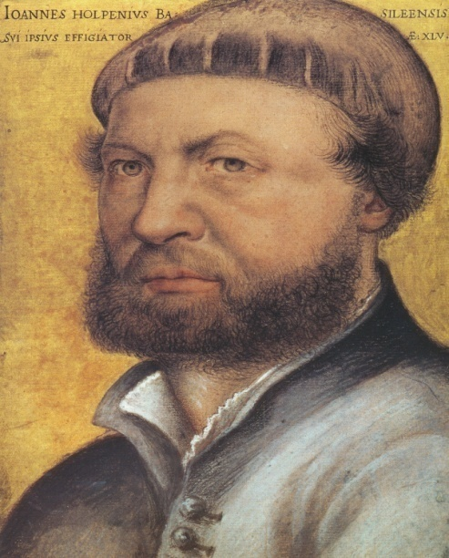

Hans Holbein the Younger

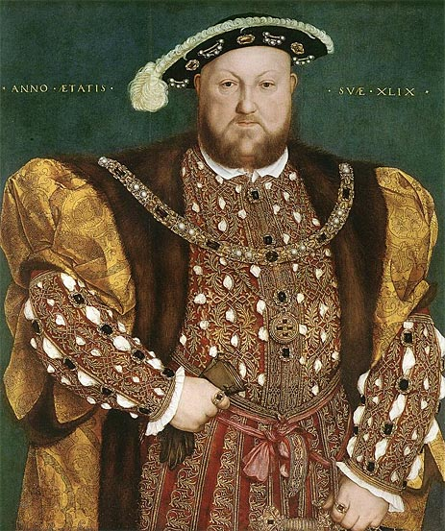

King Henry VIII by Holbein

Moreover the composers Henry Purcell, 1659-1695, and George Frideric Handel, 1685-1759, played the organ here.]

HOLLIMAN, Ursula = HARRISON, Thomas, 5 Dec 1691* [Could be St K By The Tower]
HOLLIMAN, Thomas = GARDINER, Lidia, 3 Feb 1712/13
HOLLYMAN, Lydde, dau of Thomas & Lydde, xd 9 May 1714
HOLLIMAN, Jacob, son of Thomas & Lidia, xd 31 Feb 1716/17
HOLLIMAN, Thomas, son of Thomas & Lidia, xd 16 Aug 1719
HOLLIMAN, Martha, dau of Thomas, xd 23 Jun 1721
HOLLYMAN, Esther, dau of Thomas & Lydia, xd 29 Apr 1723

25 ST LEONARD’S CHURCH, SHOREDITCH

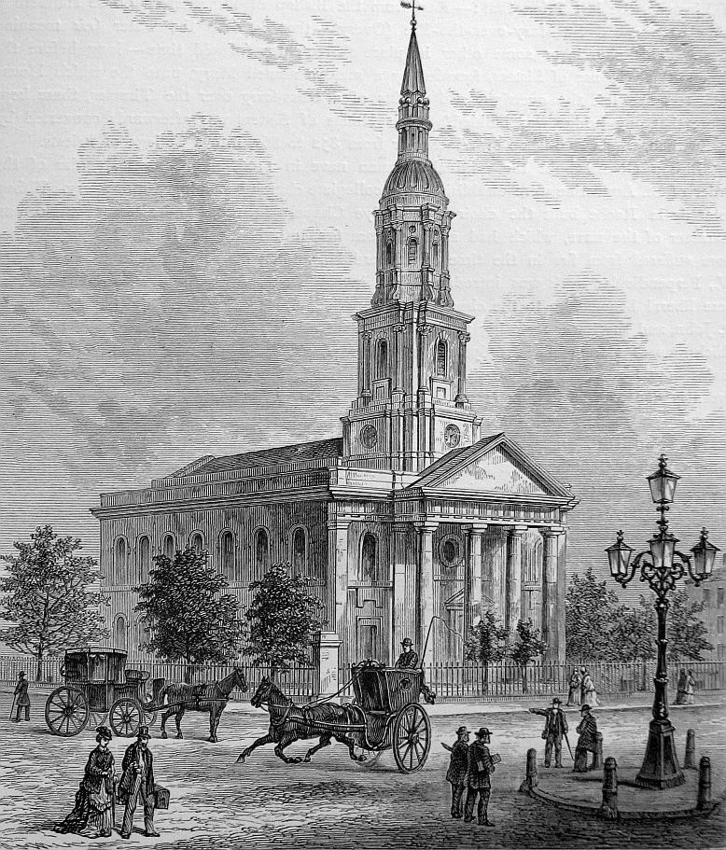

St Leonard’s Church, Shoreditch

[Several Elizabethan actors are buried here, some of them from the nearby Curtain Theatre which was the first playhouse in England and St Leonard’s, Shoreditch is mentioned in the English nursery rhyme “Oranges and Lemons”.]

HOLLYMAN, Richard = MILLS, Sarah, 24 Feb 1829
HOLLYMAN, Thomas, son of Richard & Sarah, xd 13 Jan 1830
HOLLYMAN, William, son of Richard & Sarah, bpt 2 Nov 1831
HOLLYMAN, James = MILLS, Frances, 28 Mar 1833
HOLLYMAN, Richard, son of Richard & Sarah, xd 27 Dec 1833
HOLLYMAN, George, son of Richard & Sarah, xd 18 Jan 1836
HOLLYMAN, Henry, son of Richard & Sarah, xd 3 Jan 1838
HOLLYMAN, Alfred, son of Richard & Sarah, xd 11 Jun 1842
HOLLYMAN, Joseph, son of Richard & Sarah, xd 27 Nov 1850

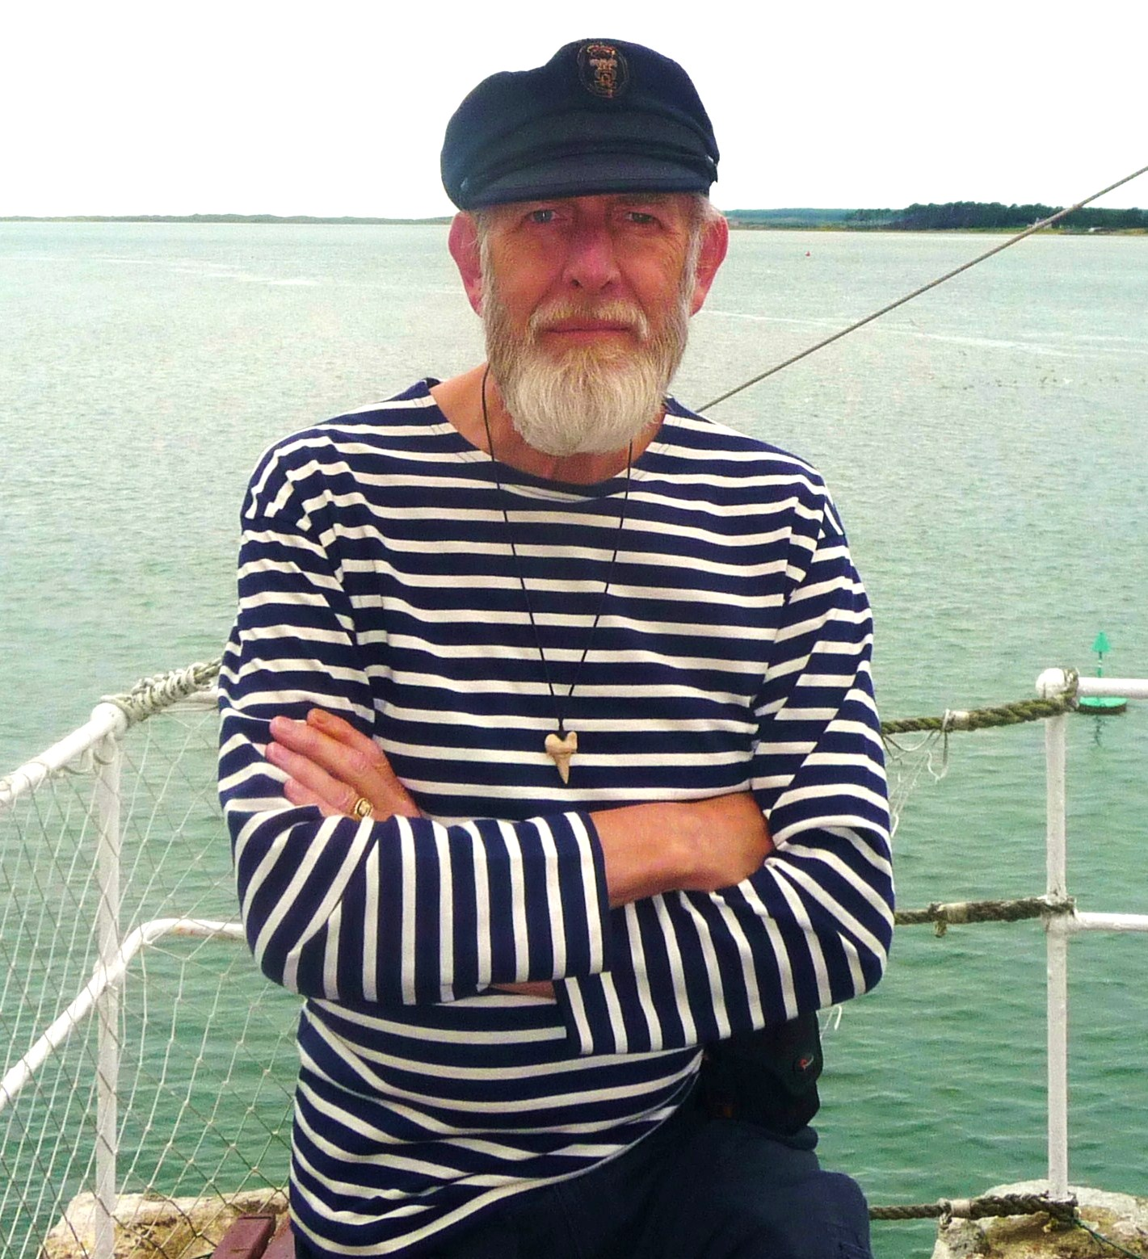

BOB HOLLYMAN-MAWSON

BA (Hons) Linguistics and the English Language, Cert-TEFL
Bangor, North Wales, Great Britain

2017

