HOLLYMAN MORMON LIST FOR LONDON: PART 2

26 ST LUKE’S CHURCH, CHELSEA

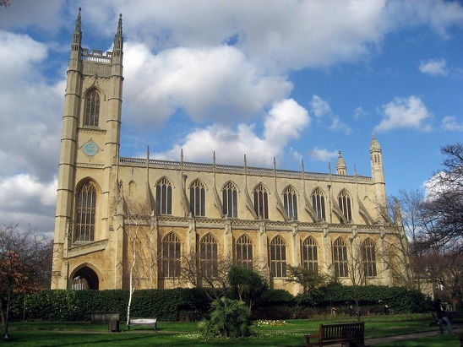

St Luke’s Church, Chelsea

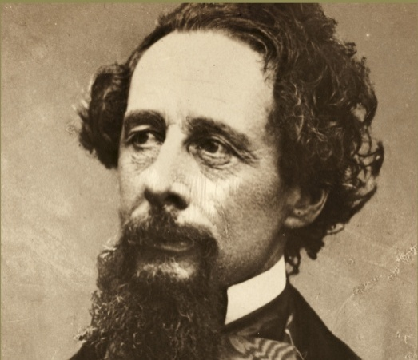

Charles Dickens

[Charles Dickens (1812 - 1870) was married here in 1836 a few days after his first published instalment which was entitled “Pickwick Papers”, and in that same year the Rector of St Luke’s was the father of Charles Kingsley (1819 -1875), author of “The Water-Babies”.]

HOLLYMAN, Simon, son of Francis, xd 19 Jun 1629
HOLLYMAN, John, son of William & Elizabeth, xd 22 Jan 1754
HOLLYMAN, Richard, son of William & Elizabeth, xd 16 Aug 1757
HOLLIMAN, John = SHARP, Mary Ann, 24 Mar 1867
HOLLIMAN, Elizabeth = HARTNELL, James, 25 Dec 1874

27 ST LUKE’S CHURCH, OLD STREET, FINSBURY, ISLINGTON

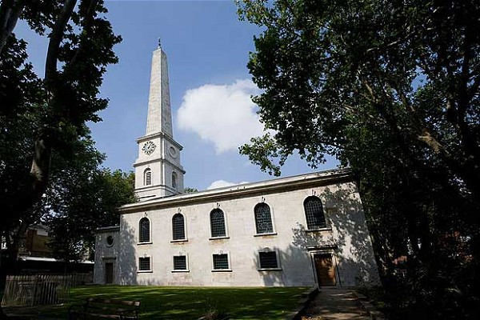

St Luke’s Church, Old Street, Finsbury

[After falling into decrepit ruin due to ever worsening subsidence St Luke’s was subsequently closed in 1964, later deconsecrated, and architecturally converted into a concert hall for the London Symphony Orchestra where since then international entertainers of worldwide renown have performed such as Elton John, Bruce Springsteen, Paul Simon and Van Morrison.]

HOLLYMAN, Thomas = JONES, Jane, 25 Jul 1742
HOLLYMAN, Richard, son of Richard & Mary, xd 5 Jan 1757
HOLLYMAN, John, son of Richard & Mary, xd 25 Jan 1761

28 ST MARGARET’S CHURCH, WESTMINSTER

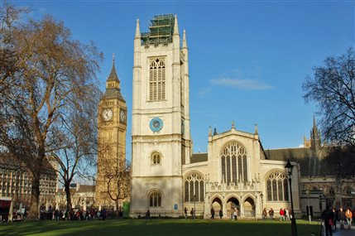

St Margaret’s Church, Westminster

[Situated within the grounds of Westminster Abbey on Parliament Square adjacent to the tower of Big Ben and the Houses of Parliament, St Margaret’s is the parish church of the House of Commons and its rector is always the Canon of Westminster Abbey.

Significant burials took place here such as those of Caxton, Raleigh and Blake.

William Caxton (ca 1422- ca 1491), Merchant, Printer and Writer, was Britain’s first professional printer whose expertise in considerably standardising the English language was linguistically immeasurable to such an extent that he expanded its written vocabulary to great measure via his meticulous studious investigations into regional accents and dialects which resulted in many printed works of much renown.

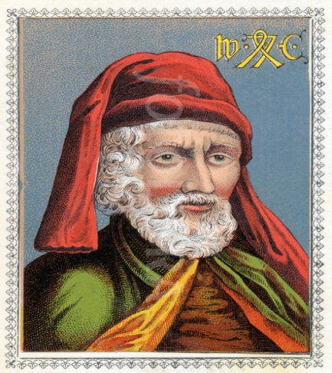

William Caxton

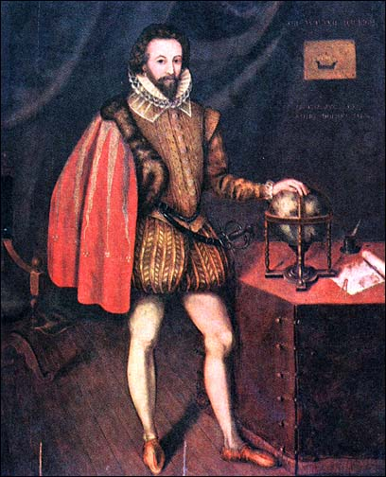

Sir Walter Raleigh

Sir Walter Raleigh (1552/54 - 1618), Writer, Soldier and Explorer, popularised tobacco in England and was granted a royal patent to explore Virginia where he was influential in colonisation.

Raleigh later searched modern day Guyana and Venezuela for the rumoured “City of Gold”: “El Dorado”. But he never found it and as a result of his men sacking a Spanish outpost there without his permission whilst there was at that time a peace treaty between England and Spain, he was arrested and beheaded on the orders of King James I. His bearded, decapitated head was presented to his widow who apparently kept it in a large velvet bag; then after she died it was taken to St Margaret’s Church and placed in the tomb with his headless corpse.

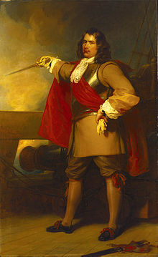

General at Sea Robert Blake

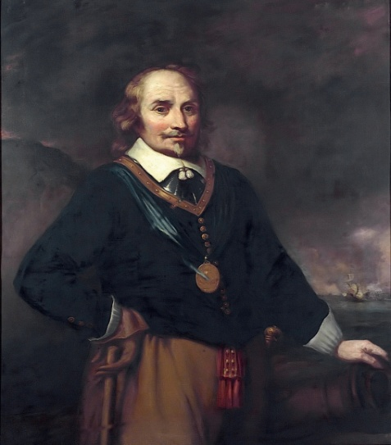

Admiral Maarten Harpertzoon Tromp

Robert Blake (1598 - 1657), MP and Military Commander, fought bravely for the Parliamentarian New Model Army as a captain, lieutenant colonel and colonel during the English Civil War at the Sieges of Bristol (1643), Lyme Regis, Dorset (1644), Taunton, Somerset (1645) and Dunster, Somerset (1645).

In 1649 Blake was appointed General at Sea, a combined role of an admiral and naval commissioner in the Commonwealth Navy; then he set about expanding his small, ineffective English fleet to over a hundred armed vessels which became a powerful maritime force.

He also created official rules and regulations, courts-martial and innovative tactics for blockading enemy shipping wherever they were moored as well as for shore landings.

So as a result of his successful achievements in this role he was appointed Lord Warden of the Cinque Ports in 1656.

During the First Anglo-Dutch War in the early 1650s Robert fought sea battles and skirmishes against Admiral Maarten Harpertzoon Tromp (1598 -1653) of the United Provinces of the Netherlands; then when Tromp was killed at the Battle of Schevingen, the war ended until the Second Anglo-Dutch War: (1665 -1667).

Furthermore, as a result of his later successful actions in the Anglo-Spanish War (1654), Cromwell presented him with a valuable diamond ring.

General Robert Blake passed away from old wounds within sight of Plymouth after returning from Cadiz, Spain and was buried with honours at Westminster Abbey in the presence of the Lord Protector, Oliver Cromwell (1599 - 1658), and his Council of State after a lavish state funeral. But after the restoration of King Charles II (1630 - 1685) his body was unceremoniously exhumed in 1661 and disposed of at St Margaret’s Churchyard in a commoners’ grave.

Amongst various society weddings which have taken place at this church were:

1655: Samuel Pepys (1633 - 1703) and Elisabeth de St Michel (1640 -1669).

1908: Winston Churchill (1874 - 1965) and Clementine Hozier (1885 - 1977).

1920: Harold Macmillan (1894 - 1986) and Lady Dorothy Cavendish (1900 -1966).

1993: David Armstrong-Jones, Viscount Linley (1961 -) and the Honourable
Serena Stanhope (1970 -).

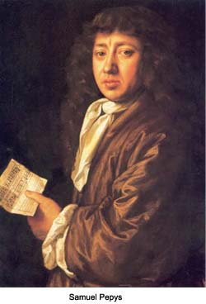

Samuel Pepys

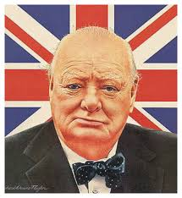

Winston Churchill

During the Great War (1914 - 1918) this church was the venue for a sermon provided by Edward Lyttelton, Headmaster of Eton College in Berkshire near Windsor, and the subject of his controversial lecture to the congregation was about loving your enemy.

He stated, in effect, that if the Allied nations were to force Axis Germany to sign a peace treaty after the war, it should be a morally fair one and not acrimonious. This led to much dissent by many protestors who, singing “Rule Britannia”, intimidated the headmaster to such an extent that after the service had ended he fearfully departed by way of an exit door at the rear of the church.

Rule Britannia - Last Night of the Proms 2009 - YouTube
The hostilities between the Allies and Germany ended the First World War at the 11th hour of the 11th day of the 11th month on 11th November 1918 with the signing of the Armistice of Compiègne in a French railway carriage; then the Treaty of Versailles was signed by them at the Paris Peace Conference in 1919.

The “Big Three” Allied leaders at the conference were US President Woodrow Wilson, British Prime Minister David Lloyd George, and French Prime Minister Georges Clémenceau of France.

As a result the German authorities on behalf of their nation was unconditionally forced to accept responsibility for war guilt on behalf of itself and its axis allies, and pay financial reparations for war damage equivalent in 2016 to US $442 billion or UK £284 billion in addition to military restrictions of extreme severity.

Marshal Foch, Clémenceau and others Frenchmen were determined to take revenge on Germany and used their influence at the conference to make it economically suffer to a questionable degree which caused that country great hardship, and it was one of the major catalysts which eventually brought Hitler to power during the 1930s.]

HOLLIMAN, John = BAREFOTE, Elizabeth, 11 Feb 1584/85
HOLLYMAN, John = RICHARDSON, Agnes, 8 Apr 1594
HOLLYMAN, Henry, son of Thomas, xd 24 Aug 1621
HOLLIMAN, Ann, dau of Thomas, xd Sep 1624
HOLLYMAN, Anthony, son of Thomas, xd Oct 1627
HOLLIMAN, Henry, son of Thomas, xd 15 May 1629
HOLLYMAN, Eleanor, dau of Thomas, xd 15 Oct 1633
HOLLYMAN, Thomas, son of Thomas, xd 7 Jul 1636

29 ST MARTIN’S IN THE FIELDS CHURCH, TRAFALGAR SQUARE,
WESTMINSTER

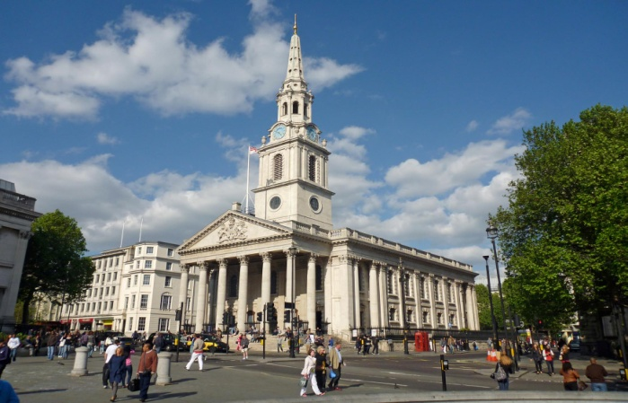

St Martin’s in the Fields Church, Trafalgar Square

[Buried at this church are:

Jack Sheppard (1702 -1724), Thief and Jail Breaker. Hanged at Tyburn Tree Gallows aged about 22.

Tyburn tree was not an actual tree but a wooden construction of a horizonal triangle supported by three legs called “the three-legged mare”.

And especially made for mass executions twenty-three men and one woman were simultaneously hanged from it in 1649; then Oliver Cromwell was later exhumed and his corpse suspended from it as well.

It became known as “God’s Tribunal”.

Louis-François Roubilac (1702/1705 - 1762), French Sculptor who was described by Margaret Whinney, Art Historian, as “probably the most accomplished sculptor ever to work in England”.

Thomas Chippendale (1718 - 1779), Cabinet Maker, Furniture Designer and Publisher.

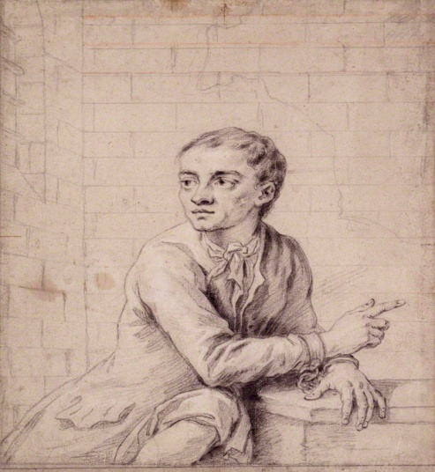

Jack Sheppard

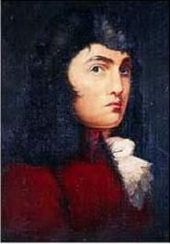

Thomas Chippendale

St Martin’s is the parish church for the Royal Family, 10 Downing Street, and until 1964 the Admiralty.]

HOLLYMAN, Humfredus = BUGGEY, Anna, 17 Sep 1620
HOLLIMAN, Humphredus = WILKINS, Elizabetha, 9 Feb 1623/24
HOLLYMAN, John, son of Henry & Bridget, xd 14 Mar 1627/28
HOLLIMAN, Henry, son of Henry & Bridget, xd 5 Oct 1628
HOLLIMAN, Thomas, son of Mariae, xd 26 Dec 1641
HOLLIMAN, Elizabeth = HAYWOOD, Henric, 20 Jul 1643

HOLLYMAN, Thomas, son of Thomas & Ann, xd 31 Jan 1792
HOLLYMAN, John = STURGESS, Sarah, 26 Sep 1833
HOLLIMAN, William Henry, son of William & Georgina, xd 12 May 1872
HOLLIMAN, Albert Theodore, son of William & Georgina, xd 26 Jan 1873
HOLLIMAN, Ann, dau of William & Georgina, xd 26 Jan 1873
HOLLIMAN, Georgina Marian, dau of William & Georgina Isabel, xd 7 Feb 1875

30 ST MARY MATFELON’S CHURCH, WHITECHAPEL

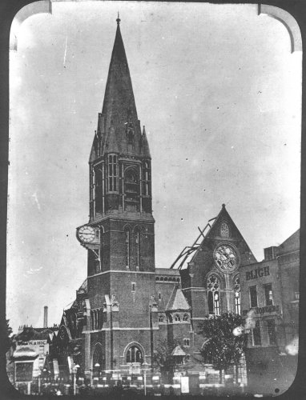

St Mary Maftelon’s Church, Whitechapel, after the fire there in1880

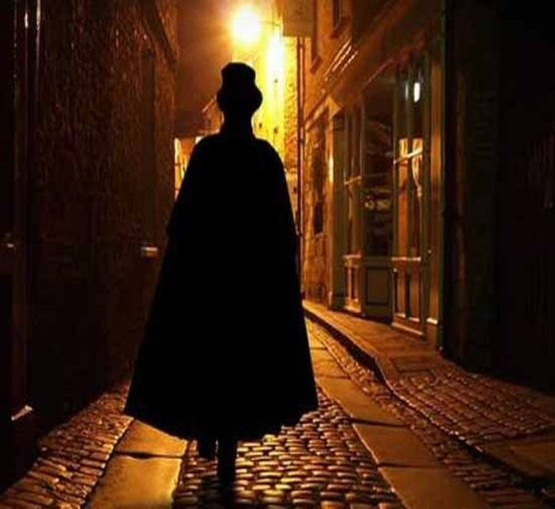

Jack the Ripper

[After severe war damage in 1941 this church commemorating Mary Matfelon, Maftelon, Matselon or Mastelon was demolished in 1952 and converted into a garden.

But the churchyard is still there which contains the body of Richard Brandon, the Royal Mint Ragman, who beheaded King Charles I in 1649.

The former slums of Whitechapel in the East End of London is nationally notorious as the former hunting ground of the dastardly serial killer “Jack the Ripper” during the late 1800s, who committed his atrocious surgical crimes against prostitutes with a sharp knife during London’s smog-laden nights in narrow dark alleyways.

There were at least five victims attributed to Jack who were linked together as a result of their similar horrific injuries, which are too appalling to discuss here, and to this day there have been countless theories as to who committed these dreadful crimes but there has never been enough proof to accuse any of the prime suspects which include a member of the royal family and a surgeon.]

HOLLIMAN, John, son of Francis & Anne, xd 25 Jul 1636
HOLLIMAN, William, son of Francis & Anne, xd 25 Jul 1636
HOLLIMAN, Hannah, dau of Francis & Anne, xd 17 Sep 1637
HOLLIMAN, Francis, son of Francis & Anne, xd 13 Feb 1639/40

31 ST MARY’S CHURCH, LAMBETH

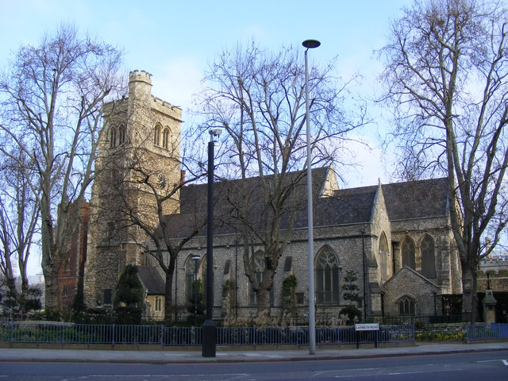

St Mary’s Church, Lambeth

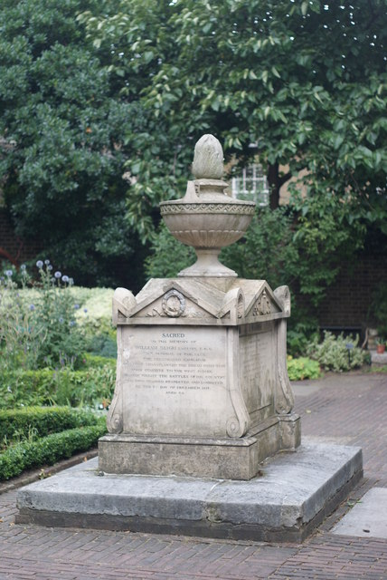

William Bligh’s Family Tombstone

[William Bligh (1754 - 1817), Vice Admiral of the Blue and Governor of New South Wales, Australia is buried beneath his family memorial in St Mary’s deconsecrated churchyard next to Lambeth Palace adjacent to the River Thames, now called Garden Museum.

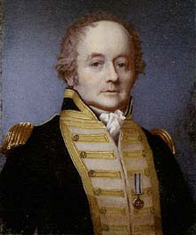

William Bligh

American Seagoing Replica of HMS Bounty

In 1787 Lieutenant Bligh was ship’s commander of HMS Bounty which sailed to the Pacific Ocean in that year on an important botanical mission to collect breadfruit plants for British colonial possessions to grow in the West Indies.

During this sometimes perilous voyage he promoted Acting-Lieutenant Fletcher Christian to be the new Sailing Master after demoting the previous one, and after ten arduous frustrating months of sailing without sight of any woman from the crow’s nest they moored offshore in 1788 at Otaheite (Tahiti), Polynesia.

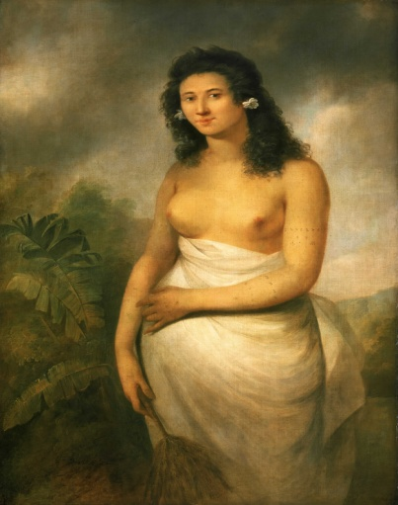

Tahitian Woman circa 1777

Tahitian Woman circa 2016

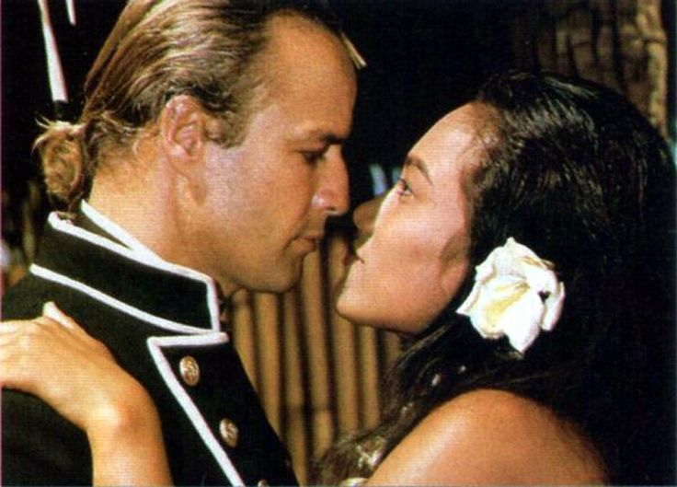

Fletcher Christian (Marlon Brando) and Maimiti (Tarita Teripala): 1962

The Bounty’s mariners, who were unwisely allowed to live ashore for the next five months, must have thought they had arrived at a “Garden of Eden” paradise beyond their wildest dreams for these wanton, beautiful, tanned topless temptresses will have enticingly welcomed these wide-eyed lusty matelots with garlands of heady fragrant flora and flirtingly offered themselves willingly for dalliances of carefree love as was their affectionate and natural custom.

This resulted in many sailors going native including Christian, who fell in love with Princess Maimiti whom he married at a festive wedding.

HMS Bounty subsequently set sail from Tahiti in April 1789 with a very disgruntled and sullen crew together with a thousand breadfruit plants, seriously psychologically affected by being deprived of the many enjoyable delights they had had the pleasure of experiencing whilst they lived on that idyllic island.

Then after sailing for about one thousand three hundred nautical miles a mutiny took place on board during which the mutineers took over the vessel in a bloodless coup led by Christian and forced the defiant commander into the ship’s open boat with 18 officers and men loyal to him and cast them adrift.

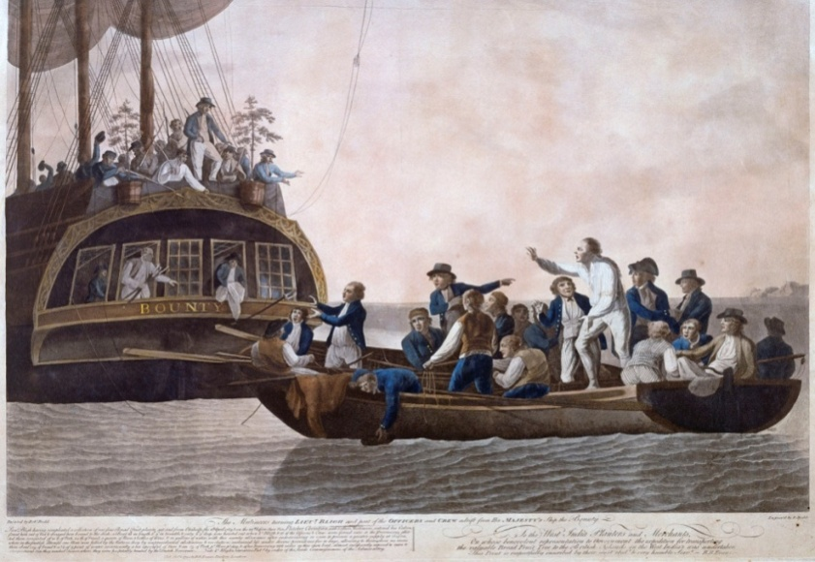

The Mutiny on the Bounty: 1789

And as a result of his strict discipline and remarkable navigational skills Lieutenant William Bligh sailed an incredible three thousand five hundred miles over the ocean for some 47 days and successfully reached the safety of the harbour at Coupang, Timor, a Dutch island settlement adjacent to Indonesia, with the loss of only one man to savages on an island en route.

However only 12 of the hardiest seafarers including Bligh recovered from their considerable ordeal and were transported back to England where the Admiralty took urgent steps to send the Royal Navy to seek out and apprehend the perpetrators of this heinous crime for which they would be sentenced and hanged as common criminals.

The hunt was now on.

Tahiti

Christian meanwhile, now the ship’s commander, went back to Tahiti via the island of Tubai, where the ship’s company had failed to settle after 3 months, to provision the Bounty with large stocks of victuals and livestock together with other vital items essential for survival before permanently sailing off into the sunset.

And sixteen men who decided to remain ashore were later discovered by the Royal Navy, although some of these were not mutineers at all but those who could not sail with Bligh because there was not enough room left in the boat.

Accompanying their captain and Maimiti on their final journey in September 1789 across the sea of no return were eight mutineers and eighteen Tahitians: eleven females which the males needed for mating, one with a baby, and six men as Christian sought safe refuge at one of the uninhabited islands within the vast expanse of the South Pacific Oceania continent before the navy had a viable opportunity to catch up with them.

It was a race against time.

Pitcairn Island

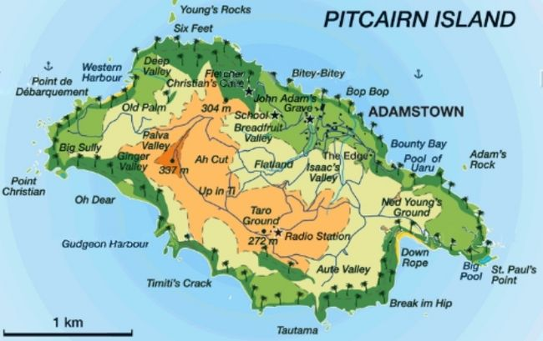

Pitcairn Island Map

And so it came to pass that after an initial fruitless zig-zag voyage of discovery they fortunately came across the sub-tropical volcanic rocks of Pitcairn Island, only two miles in length by one mile in width, as they majestically and metaphorically rose with the sunrise from a mystical misty morning, which had been misplaced on the Admiralty charts by many nautical miles.

In January 1790 HMS Bounty was set on fire and sunk to prevent any escape by islanders, as well as to avoid detection, and its wreck was later discovered by a diver in 1957 at what is now called Bounty Bay.

Christian either died of natural causes or was killed in 1793 during a violent conflict between the mutineers and the Tahitian men, the latter of whom were treated as slave labour by their white master Christians.

Then the surviving islanders, now mostly young women and numbering about forty, were accidentally discovered by the American sealer Topaz in 1808.

And during the 1850s the Reverend William Henry Holman, a Royal Navy Chaplain on HMS Portland, was sent to Pitcairn as a spiritual leader. Holman became very unpopular with the islanders due to his vile authoritarian personality and fanatical, martinet religious fervour.

The capital of Pitcairn Island is Adamstown, named after John (Jack) Adams (1767-1829), the last surviving mutineer who has the only known grave.

And today the population of Pitkerners numbers only about 50, most of them proudly descending from Fletcher Christian and others of his contemporary crew as well as 18th century Polynesian Tahitian men and women.]

HOLLYMAN, Emma, dau of John & Elizabeth, xd 11 Mar 1832

32 ST MARY’S CHURCH, MARYLBONE ROAD, ST MARYLBONE

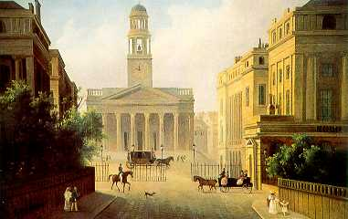

St Mary’s Church, St Marylbone: 1827

HOLLIMAN, Sarah = JORDAN, John, 27 Feb 1689/90
HOLLYMAN, Mary = BOURNE, John, 5 Oct 1785
HOLLYMAN, Alice Amelia, dau of James & Annie, xd 2 Nov 1862

33 ST MARY’S CHURCH, PUTNEY

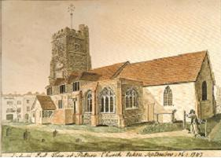

St Mary’s Church, Putney: 1797

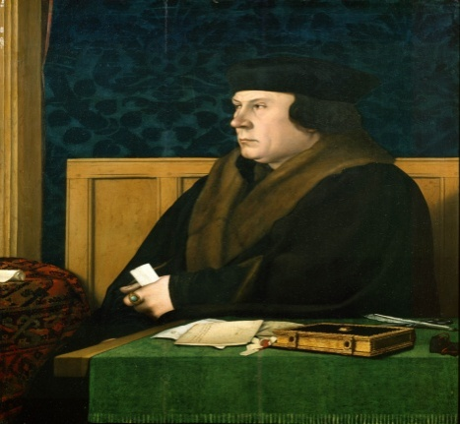

Thomas Cromwell

[Thomas Cromwell (1485 - 1540), Chancellor of England (1533 - 1540), was born in Putney, and the annual Oxford and Cambridge University Boat Race, which began in 1829, begins at Putney and ends at Mortlake.]

HOLLIMAN, George, son of Edward & Anne, xd 14 Aug 1803

34 ST MATTHEW’S CHURCH, BETHNAL GREEN

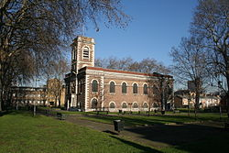

St Matthew’s Church, Bethnal Green

HOLLYMAN, Thomas = SIBLEY, Sarah, 6 Jul 1858

35 ST MICHAEL’S CHURCH, BASSISHAW

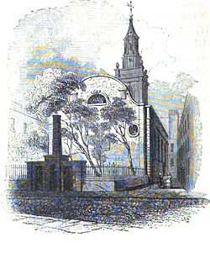
St Michael’s Church, Bassishaw

[Demolished in 1900 and now site of the Barbican Centre.]

HOLLYMAN, Johane = WYLDE, Thomas, 27 Sep 1551
HOLLYMAN, Elezabeth, dau of Rychard, xd 17 Jan 1563/64
HOLLYMAN, Lyonell, son of Rychard, xd 13 Aug 1564
HOLLYMAN, Margery, dau of Rychard, xd 30 Nov 1567
HOLLYMAN, Edward, son of Richard, xd 26 Dec 1568
HOLLYMAN, Robart, son of Rychard, xd 15 Oct 1570
HOLLIMAN, Sarah, dau of Richard, xd 13 Jan 1572/73

36 ST MICHAEL’S CHURCH, CORNHILL

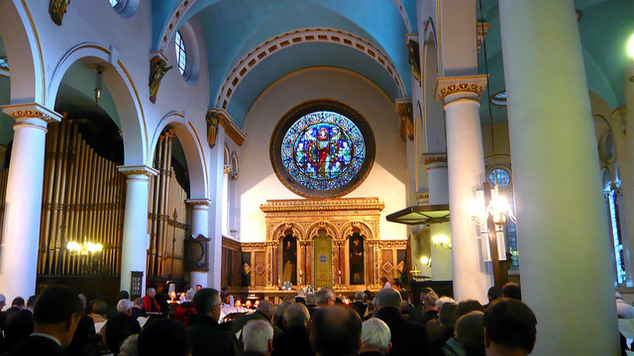

Interior of St Michael’s Church, Cornhill

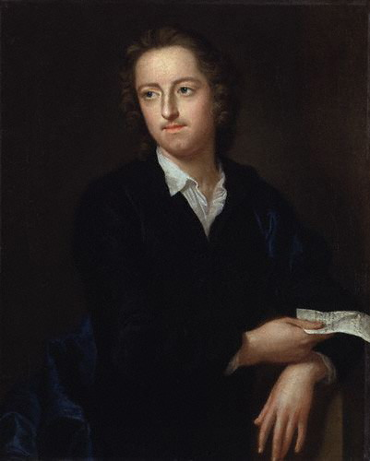

Thomas Gray

[Thomas Gray (1716 - 1771), Poet who wrote “Elegy Written in a Country Churchyard”, was born at his mother’s milliner’s shop next to the church and was baptised there: he became a dedicated parishioner.]

ELEGY WRITEN IN A COUNTRY CHURCHYARD

The first four stanzas by Thomas Grey:

THE CURFEW TOLLS THE KNELL OF PARTING DAY,
THE LOWING HERD WIND SLOWLY O’ER THE LEA,
THE PLOWMAN HOMEWARD PLODS HIS WEARY WAY.
AND LEAVES THE WORLD TO DARKNESS AND TO ME.

NOW FADES THE GLIMM’RING LANDSCAPE ON THE SIGHT,
AND ALL THE AIR A SOLEMN STILLNESS HOLDS,
SAVE WHERE THE BEETLE WHEELS HI S DRONING FLIGHT,
AND DROWSY TINKLINGS LULL THE DISTANT FOLDS;

SAVE THAT FROM YONDER IVY-MANTLED TOW’R
THE MOPING OWL DOES TO THE MOON COMPLAIN
OF SUCH, AS WAND’RING NEAR HER SECRET BOW’R.
MOLEST HER ANCIENT SOLITARY REIGN.

BENEATH THOSE RUGGED ELMS, THAT YEW-TREES SHADE,
WHERE HEAVES THE TURF IN MANY A MOULD’RING HEAP,
EACH IN HIS NARROW CELL FOR EVER LAID,
THE RUDE FOREFATHERS OF THE HAMLET SLEEP.

"Elegy Written in a Country Churchyard" poem Thomas Gray 1716 ...
HOLLIMAN, Mary = ALLIN, Anthony, 7 Aug 1628
HOLLYMAN, Robert, son of Robert & Hester, xd 24 Mar 1700/01

37 ST NICHOLAS COLE’S ABBEY CHURCH , QUEEN VICTORIA ST

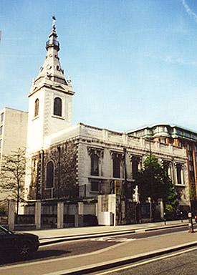

St Nicholas Cole’s Abbey Church

[The original church was destroyed in the Great Fire of London in 1666 and rebuilt by Sir Christopher Wren who built St Paul’s Cathedral. It was heavily damaged during the London Blitz in 1941 and restored 20 years later.]

HOLLYMAN, John = DOSSET, Anne, 13 Jul 1654

38 ST OLAVE’S CHURCH, SOUTHWARK

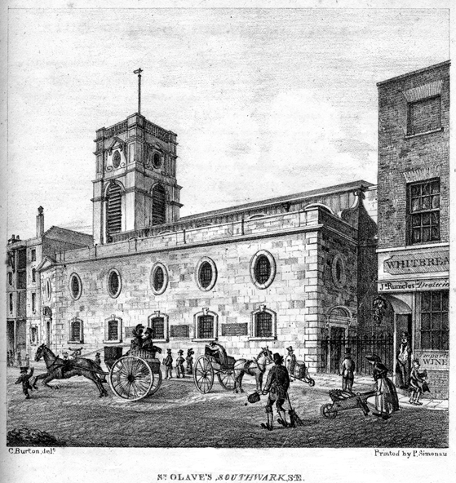

St Olave’s Church, Southwark

[A Docklands church near Fenchurch Street, St Olave’s was demolished during the 20th century and was the burial place of Samuel Pepys.]

HOLLYMAN, Anne, dau of Thomas & Mary, xd 10 Nov 1692
HOLLYMAN, Mary, dau of Thomas & Mary, xd 3 Aug 1696
HOLLIMAN, Susanna, dau of William & Elizabeth, xd 30 Dec 1697
HOLLIMAN, William, son of William & Elizabeth, xd 8 May 1700
HOLLYMAN, Elizabeth, dau of William & Elizabeth, xd 10 Jun 1702
HOLLYMAN, John, son of William & Elizabeth, xd 8 Nov 1713
HOLLYMAN, Henry, son of William & Elizabeth, xd 29 Jan 1715/16
HOLLYMAN, Hannah, dau of Henry & Mary, xd 10 Nov 1717
HOLLYMAN, William, son of William & Elizabeth, xd 29 Dec 1717
HOLLYMAN, Henry, son of Henry & Mary, xd 20 Jan 1718/19
HOLLYMAN, Elizabeth, dau of William & Elizabeth, xd 8 Nov 1719
HOLLYMAN, Hannah, dau of William & Elizabeth, xd 16 Jan 1721/22
HOLLYMAN, Elizabeth, dau of John & Elizabeth, xd 27 Apr 1783

39 OLD STREET CHURCH, ST PANCRAS, CAMDEN

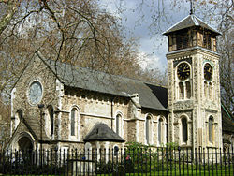

Old Street Church, St Pancras

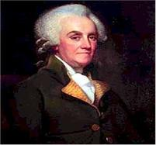

William Franklin

[Old Church is considered to be one of the oldest sites of Christian worship in England and Old St Pancras Churchyard contains the mortal remains amongst others of the following three individuals:

Francis Blyth (ca 1705 - 1772), Carmelite Friar and Catholic Priest.

Chevalier d’Eon (1728 - 1810), French Diplomat, Transgender Spy and Fencer.

William Franklin (c1730 - 1813), 13th and last Colonial Governor of New Jersey under King George III and Loyalist son of Patriot Benjamin Franklin (1706 -1790), a Founding Father of the United States and 6th President of Pennsylvania.]

HOLLYMAN, Joseph James, son of James & Ann, xd 26 Dec 1836
HOLLIMAN, Eliza = TANNER, George Selman, 1 Mar 1857
HOLLIMAN, Frederick = GREEN, Ellen, 18 Apr 1865
HOLLIMAN, John William, son of William & Elizabeth, 26 Jun 1865
HOLLIMAN, Rosetta Hannah, dau of William & Elizabeth, 26 Jun 1865

40 ST PAUL’S CHURCH, BUNHILL ROW, FINSBURY, ISLINGTON

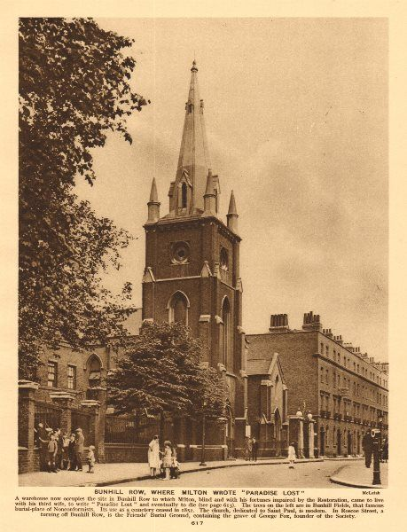

St Paul’s Church, Bunhill Row, Finsbury: 1926

Abu Hamza al-Masri

[It was at Bunhill Row that John Milton wrote “Paradise Lost”, a poem which he published in 1667.

And at Finsbury Park Mosque Egyptian Muslim cleric Abu Hamza al-Masri, otherwise known as Abu Hamza, used to be the imam.

A former nightclub bouncer Abu Hamza was nicknamed “Hookey” by the British tabloid press because he used a hook like Captain Hook in J.M. Barrie’s children’s novel ‘Peter Pan’ as he had lost both hands as well as an eye as a probable result of an explosion in either Afghanistan or Pakistan.

As a result of inciting militant Islamic fundamentalism and racial hatred, as well as organising and planning to kill many kuffars (derogatory term for infidels) in the West and America in particular, he was extradited from Britain to the USA and sentenced to life imprisonment without parole in January 2015.]

HOLLYMAN, Edward = BARTLETT, Mary, 13 Apr 1858

41 ST PETER, PAUL’S WHARF CHURCH

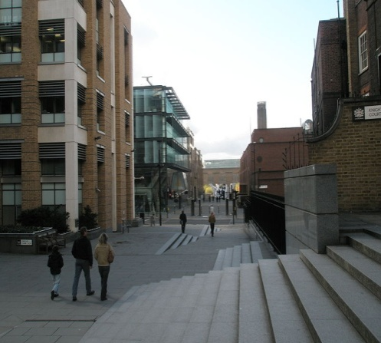

Current site of St Peter, Paul’s Church

[Destroyed by the Great Fire of London in 1666 it was later amalgamated with St Benet Paul’s Wharf Church which Wren designed to be rebuilt after that also was destroyed.

St Benet Paul’s is the official church of the College of Arms in addition to London’s Welsh church which conducts its services in that language.]

HOLLYMAN, John, son of Thomas & Ann, xd 11 Mar 1792

42 ST SEPULCHRE’S CHURCH, NEWGATE, HOLBORN

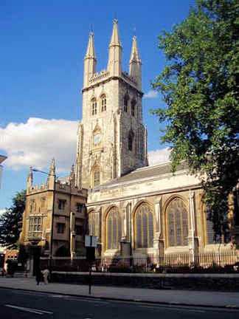

St Sepulchre’s Church, Newgate

[This parish church, the largest in London, was situated close to Newgate Prison next to the Old Bailey, the Central Criminal Court, where an underground passageway used to be used for convenient access between the two places.

It is mentioned in the Oranges and Lemons nursery rhyme: “When will you pay me? Say the bells of Old Bailey” and during the reign of Queen Mary I John Rogers (1507 - 1554), Preacher, Vicar of St Sepulchre’s, Royal Chaplain, Reader of St Paul’s Cathedral and Bible translator, was the first English Protestant martyr to be condemned at the beginning of her reign. A married man with children including a baby they helped to give him courage as they watched in horror with their mother as he burned at the stake for heresy at Smithfield.

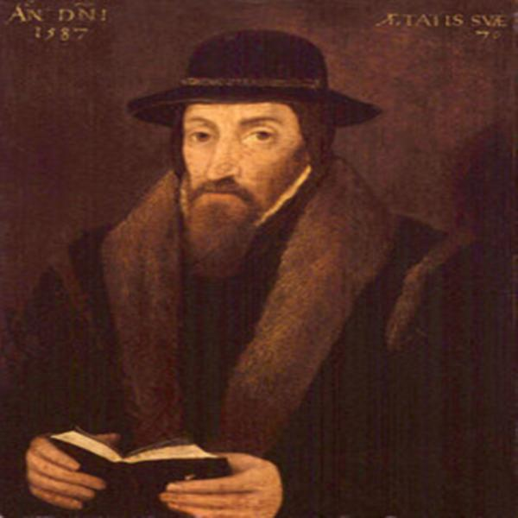

John Foxe

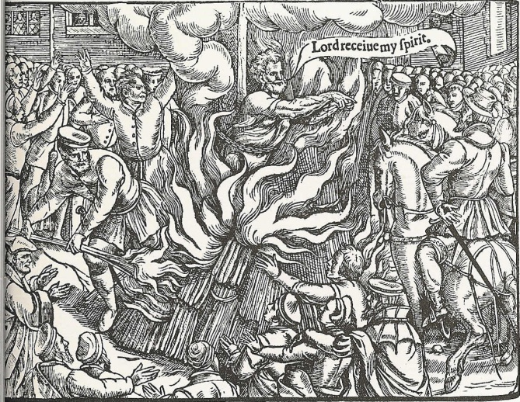

Execution of John Rogers

But there is a twist to this tale which one might call rough justice.

John Foxe (1516 - 1587), Cleric and Lutheran Protestant during the time of King Henry VIII, was firmly against burning accused and sentenced heretics no matter what their religious persuasion.

Wishing to save the life of Joan of Kent, an Anabaptist, he intervened with Rogers on her behalf in the hope that her sentence of burning would not be carried out as he had influence on authorities in high places of government.

Rogers adamantly refused Foxe’s earnest request and told him he absolutely supported the burning of heretics, adding that this particular method of execution was “sufficiently mild” for those who committed heresy.

After a wealthy parishioner had donated £50 to St Sepulchre’s with a request for the church to buy an “Execution Bell”, at about midnight the night before any prisoners were to be sent to the gallows this large hand bell would be double tolled twelve times by a Bellman, the Church’s Sexton, outside the condemned cell at Newgate, after which he would recite the following unpleasant verse:

ALL YOU THAT IN THE CONDEMNED HOLD DO LIE,
PREPARE YOU, FOR TOMORROW YOU SHALL DIE;
WATCH ALL, AND PRAY, THE HOUR IS DRAWING NEAR
THAY YOU BEFORE THE ALMIGHTY MUST APPEAR;

EXAMINE WELL YOURSELVES, IN TIME REPENT,
THAT YOU MAY NOT TO ETERNAL FLAMES BE SENT.
AND WHEN ST SEPULCHRE’S BELL TOMORROW TOLLS,
THE LORD HAVE MERCY ON YOUR SOULS.

PAST TWELVE O’CLOCK!

This bell now has pride of place within an elegant display cabinet at the church.

In addition to tolling the time the big bell out of the twelve in the campanile of St Sepulchre’s was pealed by a campanologist to announce the executions every time the prison carts slowly passed the church on their way to Tyburn Tree Gallows near the present-day Marble Arch, the popular public hanging venue three miles away.

And due to the thousands of mostly noisy, gawping plebeians lining the route who many times prevented their egress it could take up to three hours for the petrified prisoners to reach their final destination of destiny.

The Bowl Inn alehouse at St Giles was a regular stopping-off point for these prison carts as the drivers could take a well-earned break from driving their horses and carts during which grateful convicts were supplied with as much spirits and wine they could drink in attempts to stupefy their consciousnesses.

Buried at St Sepulchre’s Church is John Smith (ca 1580 - 1631): Admiral of New England, Governor of Virginia Colony, Jamestown (1608 - 1609), Soldier, Explorer and Author.

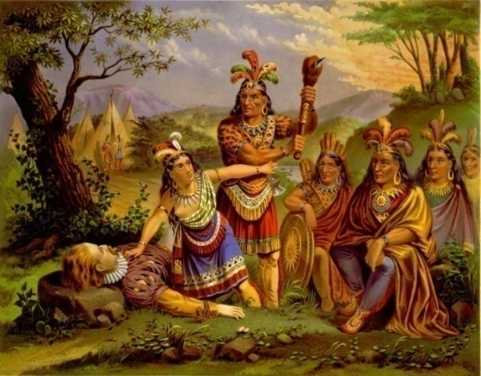

Pocahontas saving the life of John Smith

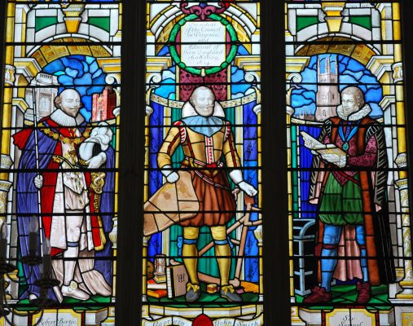

Stained Glass Window of John Smith

Smith, whilst looking for food along the banks of the River Chickahominy in 1607, was captured by Indians and taken to Werowocomoco, the primary village of the Powhatan Confederacy.

He later related that Chief Powhatan ordered his warriors to kill him and that Pocahontas, one of the chief’s daughters aged about 11, suddenly flung herself across his body to protect him whilst begging for mercy which saved his life.

Smith was buried underneath the south aisle of the church in 1633 where a large, impressive, stained-glass window set in one of the walls depicts him in revered commemoration of his abundant lifetime achievements on behalf of Great Britain, its colonies and dependencies.

(see St James’s Church, Clerkenwell, Finsbury for details of Pocahontas’s life)

Also Sir Henry Wood, 1869 - 1944, Orchestra Conductor.

He was notable for conducting annual promenade concerts at London’s Royal Albert Hall which continues to this day with much national flag-waving and singing of patriotic hymns and songs.]

HOLLYMAN, Sarah, dau of Thomas & Sarah, xd 6 Mar 1759
HOLLYMAN, Elizabeth, dau of John & Elizabeth, xd 17 Oct 1787
HOLLIMAN, James Joseph, son of John & Elizabeth, xd 28 Jan 1788

43 ST STEPHEN’S CHURCH, WALBROOK

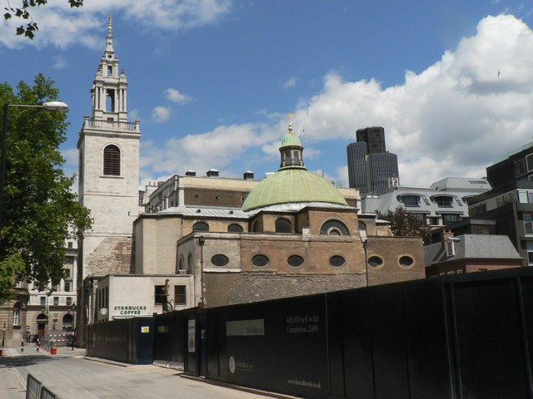

St Stephen’s Church, Walbrook

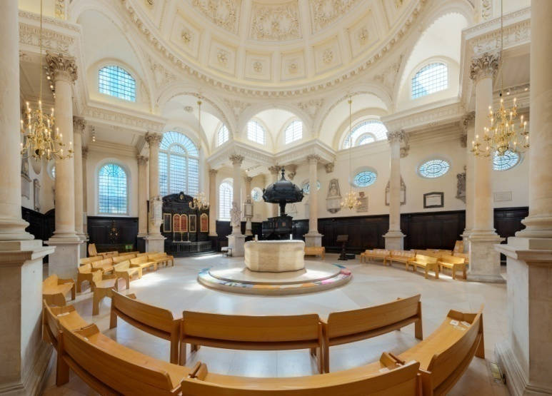

Henry Moore’s Stone Altar

[Henry Moore (1898 - 1986), Sculptor, was commissioned to design and erect a large, gleaming, white stone altar in the centre of this church during the 1980s.

Lady Sarah Armstrong-Jones married Daniel Chatto at St Stephen’s in 1994.

She is the only daughter of the late Sir Anthony Armstrong-Jones (1930 - 2017), 1st Earl of Snowdon and Constable of Caernarvon Castle and Princess Margaret Rose (1930 - 2002), Countess of Snowdon and the late younger sister of Queen Elizabeth II (1926 -), wife of Prince Philip, Duke of Edinburgh (1921-).]

HOLLIMAN, Alice, dau of Robert, xd 21 Sep 1601
HOLLYMAN, Richard, son of Robert, xd 1 Sep 1602

44 ST THOMAS’S CHARTERHOUSE CHURCH, FINSBURY,
ISLINGTON

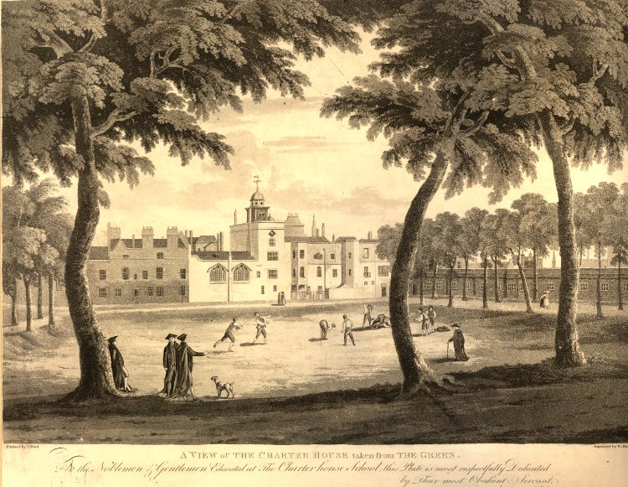

Charter House, Finsbury: 1813

[Thomas Sutton, a wealthy philanthropic entrepreneur, made provision in his 1611 will for an almshouse and a school for boys to be established and as a consequence buildings in Finsbury, Smithfield were purchased with St Thomas’s Church and converted to Charterhouse School, named after the former Carthusian Monastery or Priory which used to stand on this site.

Founded in 1371 it was dissolved during Henry’s dissolution in 1537 but the monks challenged his authority and as a result, eleven of them were arrested.

The prior was hanged, drawn and quartered at Tyburn, and nine of his monks were starved to death in their cells at Newgate Prison. As for the tenth monk who survived that ordeal he was taken to Tower Hill three years later and executed.

Therefore Charterhouse schoolboys, both past and present, have proudly called themselves Carthusians.

Smithfield, situated mostly within the parish of St Sepulchre, has quite a colourful history in addition to the Marian Martyrs who met their end there.

Sir William Wallace, Knight, was one of the main leaders of the Scots who fought during the Wars of Scottish Independence. After winning the Battle of Stirling Bridge against the English in 1297 he was defeated at the Battle of Falkirk in 1298 and went on the run until he was captured eight years later in 1305 by his Scottish enemies and handed over to King Edward I.

After being found guilty at Westminster Hall of treason and for committing atrocities against civilians “sparing neither age nor sex, monk nor nun”, he was “stripped naked and dragged through the city at the heels of a horse to the Elms at Smithfield” where he was half hanged and whilst still alive, “emasculated”, drawn by being “eviscerated and his bowels burned before him, beheaded; then cut into four parts. Then his severed head, dipped in tar, was placed on a pike atop London Bridge” and “his limbs were displayed separately in Newcastle, Berwick, Stirling and Perth.”

Wallace was the subject of the Academy Award-winning film “Braveheart” (1995), Mel Gibson acting in the title role.

Geoffrey Chaucer (1343-1400), Author of “The Canterbury Tales” and King’s Clerk, supervised preparations here for famous jousting tournaments which attracted contestants and visitors from all over Europe to enjoy the pageantry.

And it was at Smithfield Market that Sir William Walworth, Lord Mayor of London, killed Wat Tyler, leader of the Peasants’ Revolt, in 1381in front of King Richard II.

On 17 November 1558 yet even more Protestant heretics were tied to the Smithfield stakes ready for burning. And as the faggots were about to be lit a Royal Herald suddenly appeared, who officially announced that Queen Mary I had just died that day and that those who were about to meet their maker were to be immediately released without harm.

Moreover, at that time, coin-forgers and swindlers were boiled to death in large vats of oil.

Smithfield fortunately escaped much of the Great Fire of London which stopped by the “Fortune of War Tavern” at the junction of Giltspur Street and Cock Lane where the statue of the Golden Boy of Pye Corner is located”.

During the late 1600s many Smithfield residents emigrated to Providence, Rhode Island where they founded the town of Smithfield.

In 1864 the school governors agreed to move the school to Deanery Farm Estate near Godalming; so the original school was subsequently sold and it moved to Surrey in 1872.

Since then it has expanded considerably and allows the enrolment of Carthusian schoolgirls.

All the first year students visit the Old Charterhouse for classes twice a quarter as an introduction and nowadays Charterhouse School is one of the most prestigious public boarding schools in Britain which is equivalent to the eight American Ivy League colleges and universities of Brown, Columbia, Cornell, Dartmouth, Harvard, Pennsylvania, Princeton and Yale.

Hundreds of famous Old Carthusians have graduated through its doors, and here are just four of them:

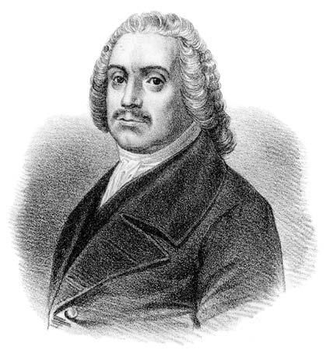

Roger Williams

Roger Williams (ca 1603-1683): Religious Dissenter, Chief Officer of Providence and Warwick (1644 - 1647), Founder of Rhode Island, President of the Colony of Rhode Island and Providence Plantations (1654 - 1657), Puritan, Theologian, Preacher and Baptist.
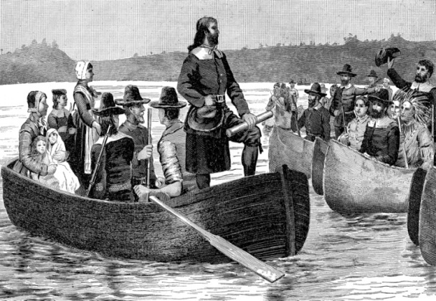

Roger Williams Returning from England with his First Royal Land Charter: 1644

Williams named and began the Colony of Providence Plantations in 1636 and as he believed in the separation of church and state, as well as freedom of religion for any creed, it soon became a safe haven for Baptists, Jews and Quakers.

Ezekiel Holliman (ca 1587 - 1659), Layman Pastor, Anabaptist and Baptist, was from Tring, Hertfordshire in England where his father William Hollliman was a Churchwarden with Ezekiel’s mother Alice.

In 1638 or 1639 Holliman baptised Williams by means of immersion; then Williams baptised Holliman together with about ten others, and those initial significant acts by Ezekiel Holliman and Roger Williams as co-founders created the First Baptist Church in America which continues to thrive to this day.]

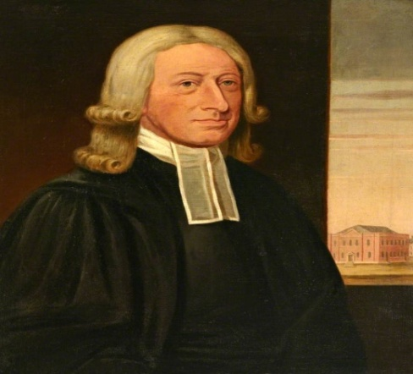

John Wesley

John Wesley (1703-1791), Anglican Minister and Theologian, who together with two others founded the evangelical movement called Methodism.

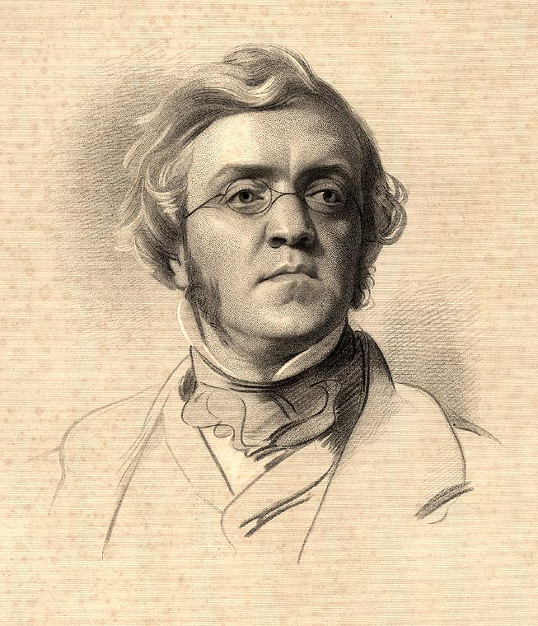

William Makepeace Thackeray

William Makepiece Thackeray (1811-1863), Novelist who wrote Vanity Fair and The History of Henry Esmond.

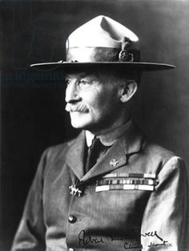

Robert Stephenson Smyth Baden-Powell

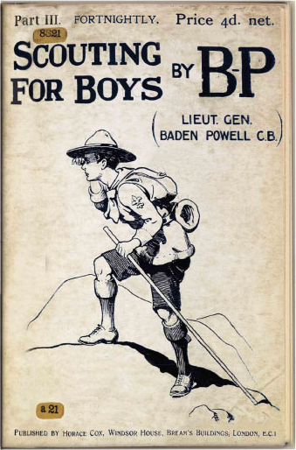

Scouting for Boys

Lord Robert Baden Powell (1857-1941), Lieutenant General, 1st Baron Baden-Powell, OM, GCMG, GCVO, KCB, DL, Writer and Founder of the Boy Scout Movement who liked to be called B-P by his friends and scouts the world over.

After service in India Colonel Baden-Powell was posted to South Africa in 1899 during the Second Boer War where he took command of the town of Mafeking, the capital of Bechuanaland, which he successfully defended whilst under siege for 217 days until a relief force arrived.

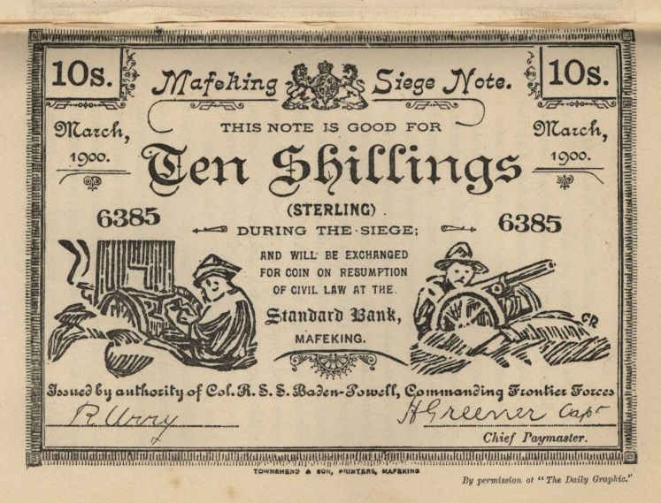

Mafeking Siege Note: March 1900

For his clever, unorthodox military tactics and later founding of the Boy Scouts movement he became an international hero.]

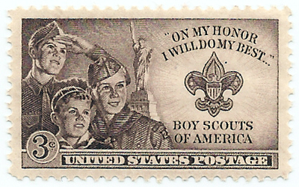

Boy Scouts of America

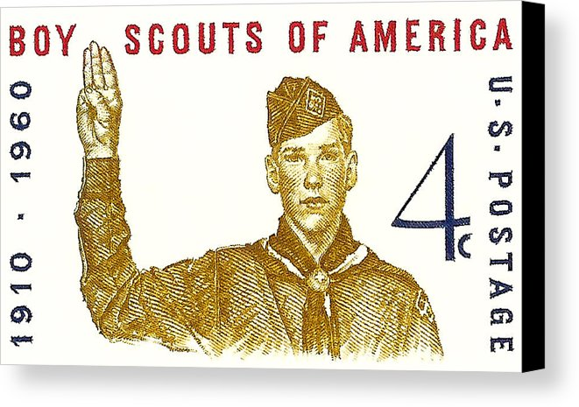

50th Anniversary of Boy Scouts in America

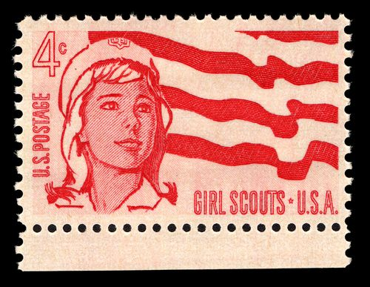

Girl Scouts of America

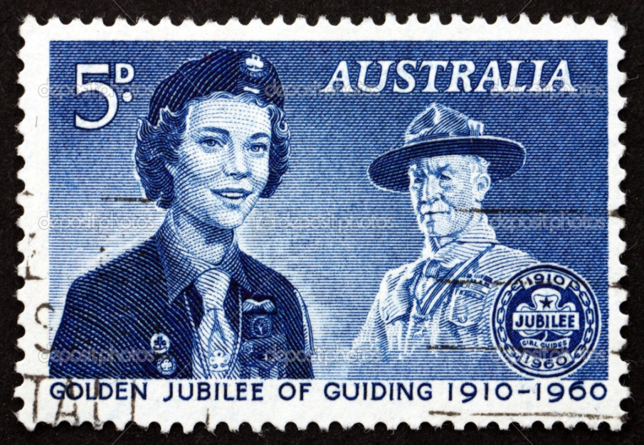

50th Anniversary of Girl Guides: Australia 1960

THE SCOUT LAW

A SCOUT’S HONOUR IS TO BE TRUSTED.

A SCOUT IS LOYAL TO THE QUEEN, HIS COUNTRY, HIS SCOUTERS, HIS PARENTS, HIS EMPLOYERS, AND TO THOSE UNDER HIM.

A SCOUT’S DUTY IS TO BE USEFUL AND TO HELP OTHERS.

A SCOUT IS A FRIEND TO ALL, AND A BROTHER TO EVERY OTHER SCOUT, NO MATTER TO WHAT COUNTRY, CLASS, OR CREED, THE OTHER MAY BELONG.

A SCOUT IS COURTEOUS.

A SCOUT IS A FRIEND TO ANIMALS.

A SCOUT OBEYS ORDERS OF HIS PARENTS, PATROL LEADER, OR SCOUTMASTER, WITHOUT QUESTION.

A SCOUT SMILES AND WHISTLES UNDER ALL DIFFICULTIES.

A SCOUT IS THRIFTY.

A SCOUT IS CLEAN IN THOUGHT, WORD, AND DEED.

THE SCOUT PROMISE

ON MY HONOUR I PROMISE THAT I WILL DO MY BEST –

TO DO MY DUTY TO GOD, AND THE QUEEN,

TO HELP OTHER PEOPLE AT ALL TIMES,

TO OBEY THE SCOUT LAW.

HOLLIMAN, George = COOPER, ... Mary

Maybe It's Because I'm A Londoner - YouTube

ACKNOWLEDGEMENT OF REFERENCES

A History of the Baptists: Chapter XXI – The Origin of the American Baptist Churches

Ancestry.com

Mormon CJCLDS , Salt Lake City, Utah, USA

Dipon - Ancestry.com.au

My Heritage

Spitalfields Life

The Lost City of London

www.artexpert.com

www.bigstrawberry.com

www.commons.wikipedia.org

www.depositphotos.com

www.landonlives.org

www.lookandlearn.com

www.pinterest.com

Robert Havell, British Museum

Wikipedia. The Free Encyclopedia

My other Mormon searches of the other London parishes are incomplete.

ETERNAL FATHER - The Naval Hymn - YouTube

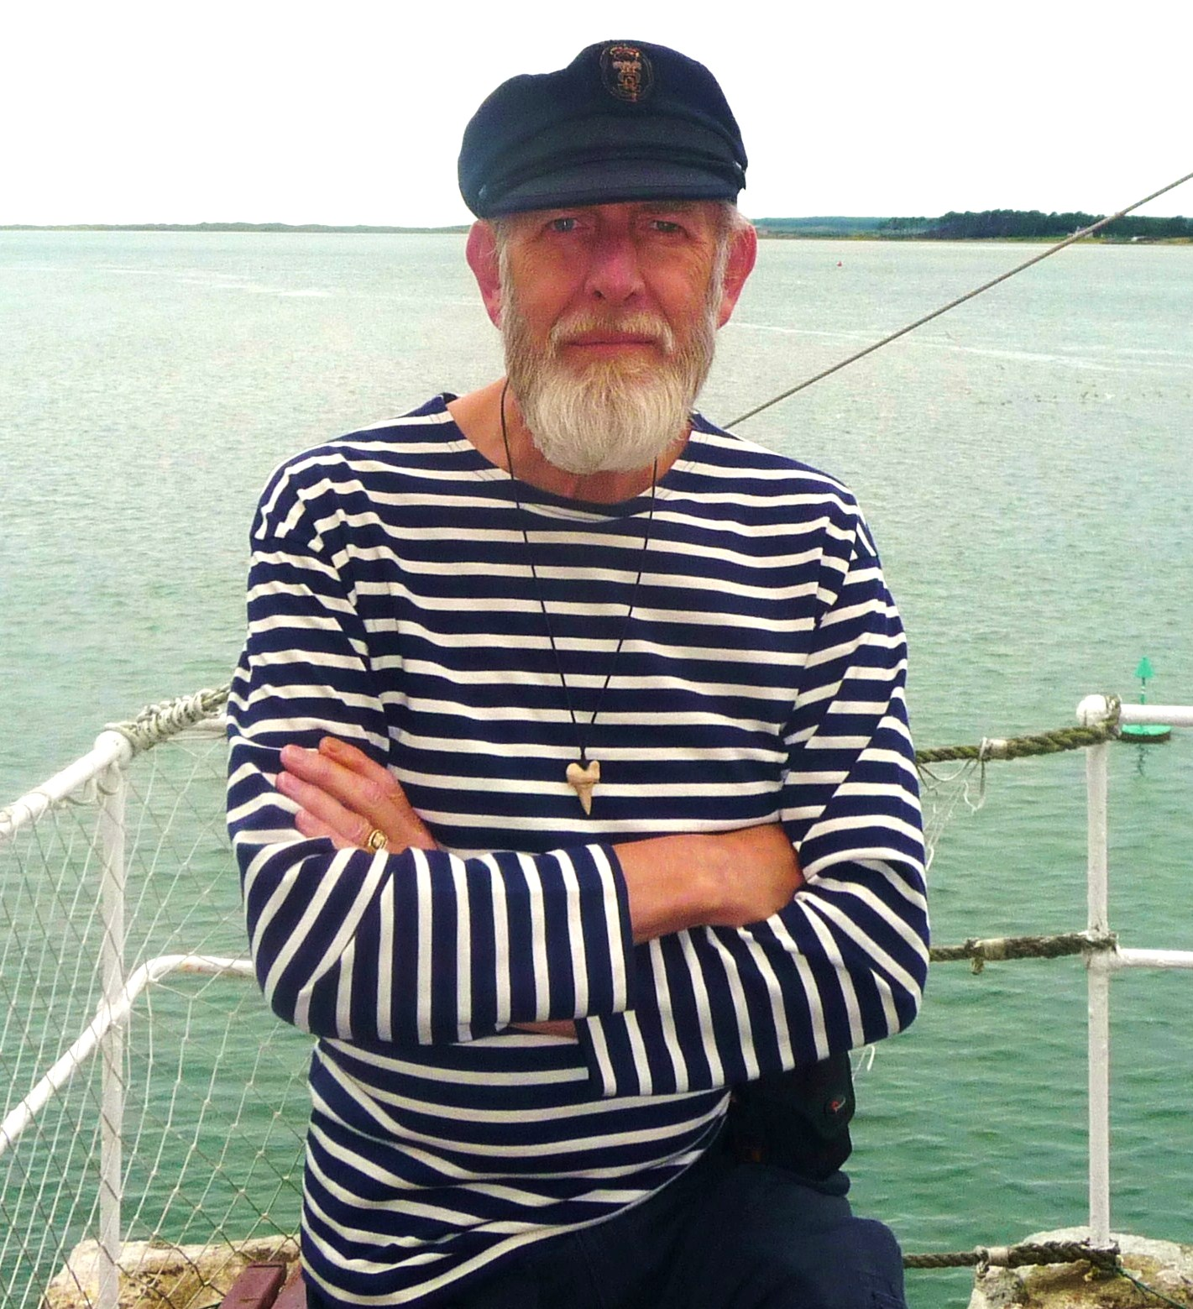

BOB HOLLYMAN-MAWSON

BA (Hons) Linguistics and the English Language, Cert-TEFL
Bangor, North Wales, Great Britain

2017

