SATURDAY, SEPTEMBER 22, 2012

From the Galaxy of Holliman Cousins, Part I
by Glenn N. Holliman
An Isle of Wight, Virginia Story....
Below, Glenn Holliman, left and Sandi Royal, right, both descendants of Isle of Wight, Virginia first families, compare notes over lunch in July 2012. Sandi, a CPA, contacted me through this blog several months ago seeking more information on her Holliman ancestors.
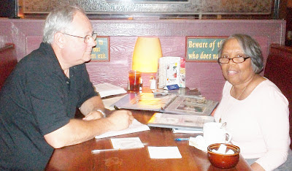
Sandi Royal's great grandfather is Isaac Henry Holliman, born approximately 1824 and died before 1900 in Isle of Wight, County, Virginia. He was born a slave, and his racial makeup was of mixed African and European American heritage. His father and mother are not known, not usual for a time of extreme racial prejudice and no official listing of births yet being recorded by the State.
A recent DNA test did not test positive for an Isaac male descendant being in the Christopher Holyman, Sr. (d 1691) line although future testing may yield different results. The surname does substantiate that Isaac took his name from a Holliman family, undoubtedly his 'owner' in the first half of the 19th Century. We do not know who that family is, yet.
Sandi's great grandmother is one Ann Gray, who according to family tradition, was white. Their first of numerous children were born in 1871. The U.S. Census of 1880 records Isaac as being 56 years old and Ann, 37. She would die sometime in the 1930s and is buried with Isaac in Winsor, Virginia. There is uncertainty as to who her parents are although there are at least two options being reviewed. One strong possibility has been suggested by descendant Joshua Holliman, that being that William and Matelida Gray of Isle of Wight were her parents.
Isaac Holliman's descendants tell the remarkable and horrific story of an 1860s couple fleeing from her parents, hiding and living in the Virginia woods to escape an irate father. This couple, evidently much in love, broke not only racist social taboos of the time, but also rigid Virginia law. Yet, under the most trying circumstances imaginable in 19th Century America, the marriage succeeded, and numerous descendants of this remarkable couple prosper today in a freer society and country.
Each year in Suffolk, Virginia, this extended Holliman family gathers, enjoy several meals of regional foods and share the amazing story of a former slave who ran off with a young woman believed to be a slave owner's daughter.
Sandi and distant cousin, Tammy Hunt, have told me this story and with their permission, I share it with the larger family. There is more research to be done to grasp further the details of this stirring saga. Hopefully, we can publish more later. I am grateful to Sandi and Tammy for contacting this site and telling this American story. Cousin Jeanette Stewart also contributed with her usual diligent research.
In the Story of Family, one finds the Story of America....

SUNDAY, MAY 26, 2013

Isaac Holliman - A Story of the Old South, Part I
by Glenn N. Holliman
Last year in this space, Sandi Royal of Virginia, told the family story of her great great grandparents, one a former slave and one a slave owner's daughter, who defied the severe mores of the 1800s, eloped, married and against social odds raised a family. In the 21st Century descendants of this couple, Isaac and Ann Gray Holliman, gather regularly in southeast Virginia to celebrate their history and family. In October 2012, my son, Christopher S. Holliman, and I joined several of these descendants to explore our shared history in Isle of Wight County, Virginia.
This is a story of people connected by history and family....
As the tobacco and later cotton culture of the southern colonies and later states took hold in the 18th and 19th Centuries, some Holliman families, descendants of Christopher Holyman (who died in 1691 without owning other human beings), purchased slaves. We know this because in their Wills, these Hollemans (of various spellings) devolved persons in bondage to their off-spring.
Due to the lack of legally recording early births in Virginia, we have an incomplete understanding of family relations, especially so among African-Americans, most of whom were held as slaves. In addition, marriage was not legally recognized or recorded for slaves. Indeed part of the special horror of southern slavery was that husbands were sold away from wives and children, and children from their parents.
As generations passed these African-Americans who had lost their language, their religions and their very names, adopted European names and melded the remains of their past with the emerging culture of a new United States. Persons held in bondage took the names of the slave owners, and hence today, especially in southeastern Virginia, one will find numerous African-American Hollimans who have gone on to prosper in the New World.
Which leads us into the story of Isaac and Ann Gray Holliman....
Below, soy bean fields and autumn wild flowers on the original farm of Christopher Holyman, who came to Virginia in 1650 from Bedford, Bedfordshire, England and farmed in Isle of Wight, Virginia until his death in 1691.
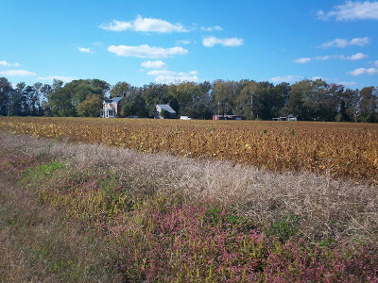
Below some descendants of Isaac Holliman and Ann Gray on an autumn tour in southeastern Virginia to explore ancestral sites. Right to left are Cyndi Barnett, Tammy Hunt, Doris Knox and Robert Royal, husband of Sandi Royal. This photo was taken October 2012 on a bridge overlooking the Blackwater River in Isle of Wight County, Virginia, the area where Isaac and Ann Gray Holliman lived after the Civil War. The original Christopher Holyman plantation was established along the Blackwater River and Mill Swamp bordering Surry County. Hollemans today of African and English descent still live in these first settlements of what became the United States.
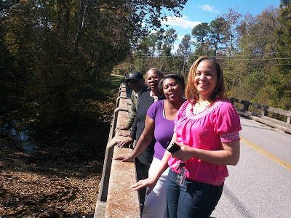

Next posting, more of the amazing story of Isaac and Ann Holliman and their American legacy....

THURSDAY, JUNE 6, 2013

Isaac Holliman - A Story of the Old South, Part II
by Glenn N. Holliman
A Holyman Family with Deep Roots in Virginia....
We continue the fascinating story of the family and descendants of Isaac and Ann Gray Holliman....
Below, left to right, Doris Knox, Tammy Hunt, Cyndi Barnett and Sandi Royal visit Holliman graves at Chapel Grove Cemetery, Windsor, Virginia. All in this photograph, both living and those who have gone before, are descendants of Isaac Holliman, a former slave who had 12 children with Ann Gray, who by family tradition was a daughter of a slave owner.
Isaac did have a son Robert W., probably born in or around 1851 by an earlier relationship with a woman named Matilda. Tammy Hunt is descended from these first parents.
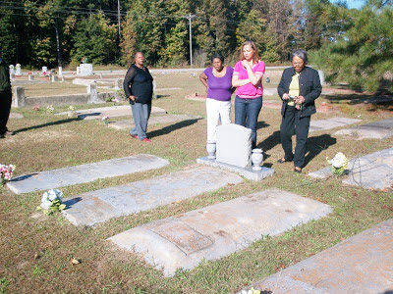
According to family records, the girls of Isaac and Anne were Anne Lou,Joanna, Luzerne, Monil J. and Rosanna. The boys were Isaac T.,James H., Jeremiah P., John H., Joseph, P., Joshua, and Nonnie J.
Who was Isaac Holliman? The 1880 census states an Isaac Holliman of Isle of Wight, Virginia was born in 1824 and had a wife named Ann. Her birthday is in uncertain, born perhaps in 1832, 1845 or 1852.

According to Sandi Royal, Isaac may or may not have been the offspring of his owner, whose name was Holliman. DNA testing to this date has been inconclusive as to whether Isaac and his offspring are genetically related to the descendants of Christopher Holyman (d 1691). However, there is no doubt that the two families are historically related by time, place and circumstance.

The name of the white Holliman family that held Isaac in bondage is not known with certainty although Mrs. Royal has an opinion based on careful reading of George Holleman's 1953 history of the family (reprinted by Tina Peddie and available for sale).

Isaac did adopt the name Holliman, and after having fathered one child, at some point in his life 'jumped the broomstick' (married) a woman named Ann Gray, evidently during the Civil War. Family tradition records Ann who died in 1930 as 'being the white grandmother' and tales abound of Ann being a slave owner's daughter. The couple literally 'ran into the woods' to escape Ann's angry parents.

The document below, found by Hollyman historian Jeanette Holiman Stewart, was issued October 8,1866 at Fortress Monroe, Virginia. The letter requests for Isaac Holliman, his wife, Ann, and son Robert transportation back to Nansemond County (an extinct county which bordered Isle of Wight County). The three are identified as 'freed people' who, as were tens of thousands of former bonds people, displaced by the upheavals and destruction of slavery during the Civil War.
Note Isaac's age is listed as 47 and Ann as 21 (which would make her born in 1845) and the stepson of Ann, Robert, is 15. This Federal document suggests Isaac and Ann were only recently married, given her young age (if accurate) and the lack of children listed.
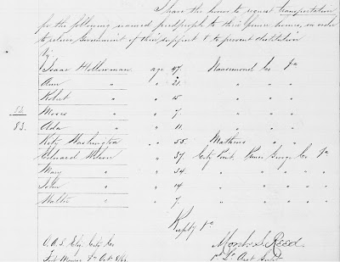

Next article more on this couple who defied the laws of their time to marry and found a family in post-Civil War Virginia. And who was Ann Gray?

Holliman Family History
Photographs and articles regarding the ancestors and descendants of Christopher Holliman, Sr. (d 1691 Isle of Wight County, Virginia)

THURSDAY, JUNE 27, 2013

Isaac Holliman - A Story of the Old South, Part III
by Glenn N. Holliman
Who were Ann Gray Holliman's Parents?
The oral family tradition is compelling and dramatic. Perhaps during the Civil War, a man held in bondage, one Isaac Holliman, ran away with a white woman, Ann Gray, evidently half his age. Her parents were furious, and the couple escaped their outrage by hiding in the forests or swamps of southeast Virginia.
Below the Chapel Grove United Church of Christ in Windsor, Virginia where Isaac and Ann Holliman may be buried. Many of their descendants rest here.
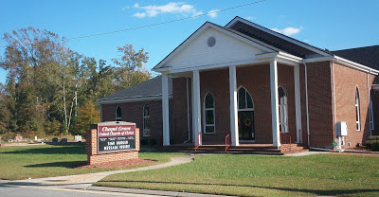
Who was Ann Gray? Who were her parents and where did this family live? Oral tradition places both Ann and Isaac as natives of Isle of Wight County, Virginia. Grays and Holymans were both early settlers of Isle of Wight, and their ancestors live near each other even today.
We have some hints but only a very few....
In a published Isle of Wight will, one Ann Gray is recorded as a granddaughter of Josiah Holleman who died in 1847. Josiah Holleman had a son named Wilson Holleman. The will also lists a daughter, Virginia Gray and another grand daughter, Virginia Gray, the same name.
In the Census of 1860, a family is listed in Smithfield, Isle of Wight, of William Gray, age 40, Matilda, age 34 and among the children, one Ann, age 13. Is this the same Ann Gray recorded in Josiah's 1847 will? Is this the Ann Gray who will marry Isaac Holliman? She could be as the age almost works, but, it is difficult to be certain. As descendant Nonnie Holliman notes, this Ann is no longer with the Gray family in the 1870 Census.
As noted in the last posting, one Isaac Holliman, age 47, and Ann, age 21, and a minor, Isaac's son Robert, age 15 by a first liaison, are recorded in U.S. Freedman records in 1866. This Ann is close to the age recorded in the 1860 Federal Census in the William Gray family.
This couple, with increasing numbers of children, appear in every Federal census until Isaac's death before 1900. Isaac and Ann are recorded as mulatto, that is of mixed African and European DNA. These several censuses place the couple as living in Windsor, Isle of Wight County, Virginia which is located near the original Christopher Holyman plantation founded in the 1680s.
So here we are....
1. The above Pre-Civil War records may or may not identify Ann Gray's parents and grandfather. Circumstantial evidence is there. Is it enough? It is hoped that more records can be discovered to verify parentage beyond a reasonable doubt.
2. Federal censuses identify Isaac as mulatto which begs the question - was he the biological son of a white man named Holyman, Holleman or Holliman? After all Isaac took the name Holliman from the family that owned both him and perhaps his mother.
3. DNA testing done to date has not yet tied the European Hollimans to the African American Hollimans. DNA from a male, directly descended from Isaac through males only, is needed to test the thesis that Isaac is descended from Christopher Holyman, 1618-1691.
4. To my knowledge no one has approached any Gray descendants for DNA testing. Research could be done to locate persons who have Gray ancestors in Isle of Wight County. (For DNA testing cousin Tina Peddie can provide assistance; see information below in blue.)
5. The evidence we do have is remarkable - oral tradition that Ann was the 'white grandmother', the Freedman's record of 1866 and the Federal Census records that place the family in Windsor, Isle of Wight, near the historic homes of the Grays and Hollemans.
Isaac and Ann Gray Holliman left a legacy of children and later descendants who proudly claim this remarkable couple as their 'founding family'. From time to time, descendants gather in southeastern Virginia to celebrate their heritage and the blessings of being American. Sandi Royal and others have published a book on the descendants of Isaac and Ann Gray Holliman. For information on future reunions and this publication, Mrs. Royal can be contacted through this writer atglennhistory@gmail.com.

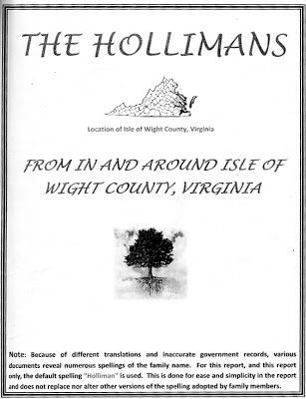

In the Autumn of 2012, Holliman descendants on an afternoon of discovery visited the Mill Swamp Baptist Church Cemetery in Isle of Wight, County, Virginia to learn more about our shared history and possible ancestors. Below, left to right are Christopher S. Holliman (the writer's son), Doris Knox, Cyndi Barnett, Tammy Hunt, Glenn Holliman (the writer) and Sandi Royal.

The gravestone, pictured above, is a memorial to several Isle of Wight County 20th Century descendants of Christopher Holyman (1618-1691), of whom recent members generously gave the land for the cemetery. More will be written on this branch of the Holleman family in future posts.
Research work remains to be accomplished to verify if our Holliman families are genetically related. However, it is very appropriate to state that we are related by time, place and the tides of history, and that we share in the American story!
I am grateful to the above descendants and others of Isaac and Ann Gray Holliman who have written and told me this intriguing story and encouraging additional research. Any errors in these posts are mine alone, and I would be grateful for any additional information and/or corrections.
Next posting....more on Isle of Wight Hollemans....

SUNDAY, MARCH 2, 2014

Exploring further Holleman History in Old Virginia, Part 9
By Glenn N. Holliman
The Conflicted Society....Hollemans in the Antebellum Age of Virginia
This continues our series of articles on Josiah Holleman (1771-1848) and his two sons, Joel (1799-1844) and Wilson (1803-1873), descendants of Christopher Holyman (1618-1691) who lived in Isle of Wight County, Virginia. It was Wilson Holleman who constructed the Federal Period red brick home in 1830 on what remained of the original farm of Christopher Holyman. Josiah was the son of Jesse (1735-1825) and Charity Cofer Holleman (1748-1810). We will be posting an article on Jesse by cousin Allen Holleman in the near future.
On 10 January 1791, Josiah Holleman married Nancy Clark (1769-1844) of Southampton County, Virginia. According to Ancestry.com records, they had ten children, a not uncommon number for couples prior to the 20th Century.
Historian Helen Haverty King records in her history of Isle of Wight many references to Josiah's service to his community. Below is a chronology.
1818 - Jailer for Isle of Wight

1821 - Appointed school commissioner. There were ten commissioners in this early attempt to further public education, one for each military district in the county. In addition, he and Exum Eley were overseers of the poor in the Broadwater District, now the southern part of the Hardy District.
1821 - 1829 - Member Virginia House of Delegates
1823 - 1845 - Commissioner of Isle of Wight

1846-47 - Sheriff of Isle of Wight
1848 - Josiah died 15 March, Isle of Wight County, Virginia

The Divided Nation ....
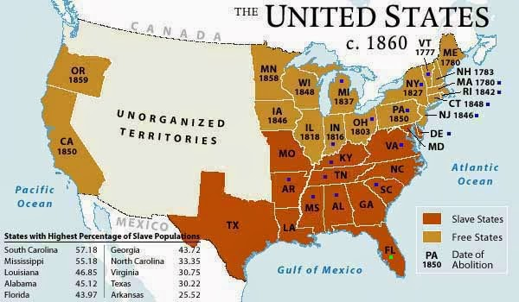
In 1780 Pennsylvania became the first state to outlaw slavery by gradual emancipation. By 1847, there were no slaves in the state. As a member of the PA Heritage Foundation board of directors, I had the thrill this past month of viewing the actual legal document in the PA Archives.
Seeking to know more of these early 19th Century Hollemans last December 2013, I ventured into the Library of Virginia in downtown Richmond. The building is modern, the staff helpful, the records amazing and the parking is free. I was given a folder with the original records, including writs signed by Josiah Holleman - "Guide to the Isle of Wight County (VA) Free Negro and Slave Records, 1785-1861. Barcode number: 1186868." The Library of Virginia can be found at http://www.lva.virginia.gov/.
It was in this folder that stories of a strange culture revealed itself further. Isle of Wight County, Virginia in the Antebellum period was struggling to maintain a system of human bondage.
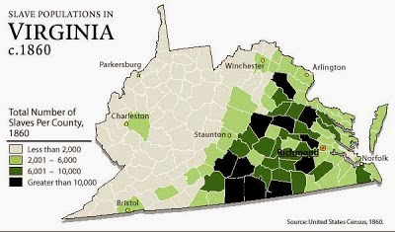
Just a glance at this map indicates why the western counties of the 1860 Virginia withdrew and were recognized in 1863 as the new State of West Virginia. There were many fewer persons held in bondage in the western mountains.
Yet within this system were not only slaves but a significant percentage of 'persons of color' who were not 'owned' by other human beings, but were as free as the laws at that time grudgingly allowed! According to 1860 Federal Census records in Virginia (including West Virginia), approximately 65% of the population was white, 31% slave and 4% free persons of color! If just the current state of Virginia is counted in 1860, over 10% of the population were free persons of color.
Virginia, perhaps in a burst of revolutionary fervor, had in 1782 allowed for the emancipation of blacks from bondage by their owners as long as the freed slaves would not become wards of the state, i.e. too old or sick to care for themselves.
One finds in the Isle of Wight records numerous writs of slave owners freeing slaves. In fact in 1832, Josiah Holleman, owner of fourteen slaves in 1830 and an elected official who authorized the return of runaways and the paying of night patrols to keep slaves from roaming, freed one Isaac Holleman! Why? We do not yet know and may never know. He did not free his other slaves. For additional information on the life of Isaac and Ann Gray Holliman, the reader is directed the June 27, 2013 posting.
Several printed emancipation documents in the Isle of Wight collection read as follows:
"Fully persuaded that freedom is the natural right of all mankind and that it is my duty to do unto others as I would be done in the like situation, and (this is a fill-in-the-blank line) having under my care a negro girl, Jane, now in her minority, age 13 years, whom I do hereby emancipate and set free, after she shall obtain lawful age..."
Holding this 'domestic' system together required stringent laws of race and servitude, and a never ceasing vigilance on the part of the law enforcement establishment. We can see the stresses in this environment in the documents I was studying.

While a jailer in 1818, public records reveal Josiah Holleman detained one James alias David Thomson, a runaway slave. Numerous writs in this folder in my hands were signed by Josiah and others eluded to the fact that runaway slaves were an on-going issue in Antebellum times.
The public records concerning the maintaining of the slave economy in Isle of Wight are deeply troubling to 21st Century concepts of human dignity and freedom. One poignant paper described a woman of color, writing from the Chickasaw Nation in Mississippi in 1832, pleading for Isle of Wight authorities to reissue papers stating she had been a free person before being stolen by a slave catcher and sold into bondage in the deep South! Shades of the current movie, Twelve Years a Slave!
Later, in 1842, Commissioner Josiah Holleman directed the county court clerk to replace papers, destroyed by fire, to an indentured servant, Beaver Jack Wilson, stating he had been free since birth.
What then were the contradictory thoughts of Josiah Holleman as he exercised his legal responsibilities, owned slaves, emancipated a slave himself and lived in a community with numerous free families of color? How could Isle of Wight County, Virginia exist partially free and partially slave? We know the end of the story; it is called the American Civil War.
It is beyond the scope of this simple article to review slavery in Virginia and the South, but I have chosen several of my favorite books on the subject to suggest for further reading. More on the Hollemans and a conflicted society in our next posting.
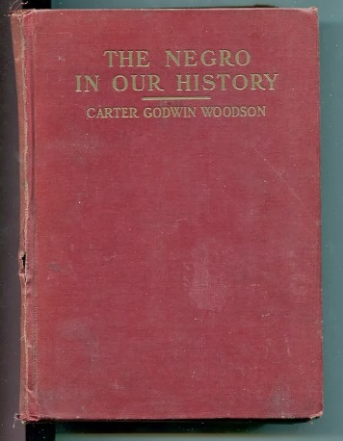
Right, Dr. Carter Woodson's ground breaking work was first published in 1922. My volume is a 7th edition. His work long has been superseded by contemporary writings but the book remains the most important, serious early work of African-Americans in North America.
Below, first published in 1929, 'Life and Labor' was a serious and some what benevolent look at slavery in Antebellum times. U.B. Phillips has long been eclipsed in scholarship by others who differed significantly with his 'soft' interpretation of human bondage in the South.
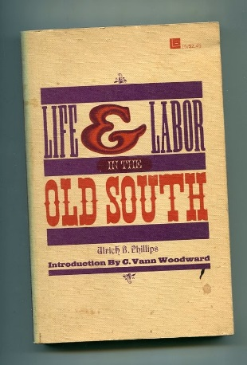
Kenneth M. Stampp's 'The Peculiar Institution' published in 1956 presented an antidote to U.B. Phillip's and ushered in the Civil Rights era interpretations of the horrors of American slavery, a thesis that stands to this day.
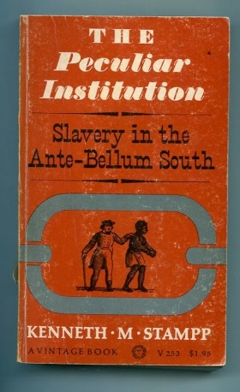

John Hope Franklin is the current dean of African-American historians. All was not well on the plantation as the Isle of Wight papers and 'Runaway Slaves' attests in this heavily documented work published in 1999. Franklin's histories are well-worth reading for content and clarity. His classic 'From Slavery to Freedom', first published in 1947 and revised numerous time is still a standard work.
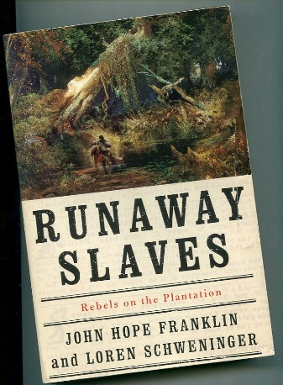
Below, a more recent work, 2006, by Francois Furstenberg focuses on the founding father's conflicted feelings about slavery. George Washington is generally remembered for freeing his Mt. Vernon slaves at his death in 1799. Actually his will stated his slaves were to be freed after his wife's death. Martha did not wait for her possible premature death to be administered by an restless slave. She emancipated her slaves under Virginia law two years after the Founding Father's death!
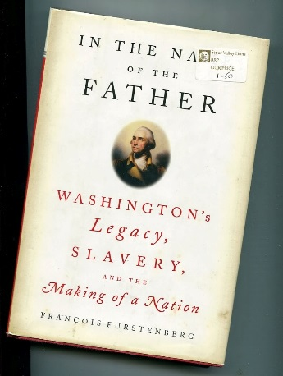

Have questions about Holliman family history? You are invited to join the Hollyman Email List at Hollyman-Subscribe@yahoogroups.com and the Hollyman Family Facebook Page located on Facebook at "Hollyman Family". Post your questions and perhaps one of the dozens Holyman cousins on the list will have an answer. For more information contact Tina Peddie at desabla1@yahoo.com, the list and Facebook manager for Hollyman (and all our various spellings!).

From the research of Susan White, April 2016

Question – Could Franky be the mother of Isaac Holliman, who is listed in the census as of mixed race?

William H. Holleman’s slaves on 1830 census n=18
Males
36-54 | 1
24-35 | 2
10-23 | 2
Under 10 | 5

Females
36-54 | 3
10-24 | 1
24-35 | 1
Under 10 | 3

William H. Holleman’s slaves on 1 March 1834 n=17 (one slave less; presumed dead)
Males
Value in $ | Name | Age designation | Who hired to
500 | Phaggins (Faggins) | Negro man | Dr. Butler(Robert), who lived in Smithfield
450 | Jacob | boy | Josh. Holleman
400 | Isaac | boy | Thomas Woodley (lived at Foursquare)
300 | Wyatt | boy | Dr. Bulter
300 | George |  | Edwin White, Surry Co., lived at Swans Point
225 | Hartwell
200 | Solomon | man | Ben. Jones(Lived at Wolftrap
125 | Mike
100 | Edward |  | Edwin White

Females
Value in $ | Name | Age designation | Who hired to
300 | Franky |  | And 2 children to Mary Holleman
200 | Michel | girl
150 | Sylvia | girl | Robert Brown
150 | Keziah |  | Edwin White
100 | Dilcey/blind for keeping |  | And 2 children to Mary Holleman
75 | Annica | woman | _____Battin
75 | Adeline
40 | Mariah

