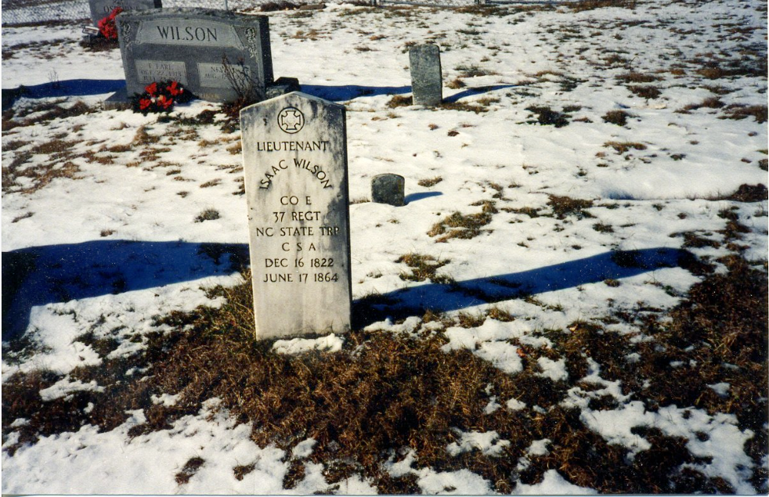Granny Caroline
This is my ggg-grandma Caroline Nancy Greer Wilson 10 Dec 1828 - 08 Sep 1911. She was born at Elk Township, Ashe Co., NC to Jesse Greer, Jr. 1806-1892 and Frances Brown Greer 1810-1905. Caroline's husband was Lt. Isaac Wilson. Her children were: Nancy Emmaline Wilson Osborne 1850-1919, Frances Caroline Wilson Osborne 1851-1940, Polly Jane Wilson Proffitt 1852-1937, John Wilborn Wilson 1855-1928, Martha Evaline Wilson Forrester 1857-1904, Robert Boyd Wilson 1860-1949, William Albert Pinkney Wilson 1861-1951, and Sarah Marilla Wilson Osborne 1866-1882. Photo is courtesy of Cousin Jeanie. Granny Caroline was known for being VERY outspoken. Her granddaughter Maggie remembered her making cakes that looked like gold on the inside and having a cow named Rose. When Caroline went to milk the cow Maggie would sneak in the house and take a slice of the cake.
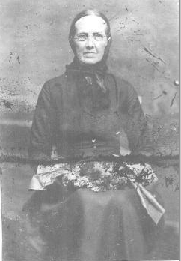Wilson-Isaac_183580353.jpg

http://www.picturetrail.com/sfx/album/view/286030

Lt. Isaac Wilson
Isaac Wilson was the son of Hiram Wilson 1787-1879, and Nancy Smith Wilson 1793-1859. In 1849, he married Caroline Nancy Greer. While home on furlough from his regiment, he was bushwhacked. This is the photo that I first became familiar with as being Isaac. He looks to be between 20-30, and he has some sort of military scarf around his neck. Photo is courtesy of Cousin Dale. 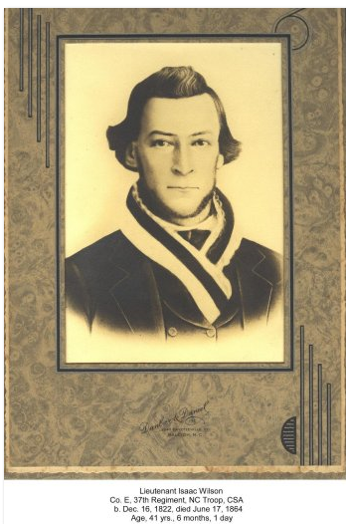Field_Wilson-Isaac_shot-here_183935110.jpg

http://www.picturetrail.com/sfx/album/view/12505635

Where Isaac Wilson Was Shot
Standing in this field is William Albert Pinckney Wilson 20 December 1861 - 18 February 1951. He was the son of Isaac Wilson 16 December 1822 - 17 June 1864 and Caroline Nancy Greer Wilson 10 December 1828 - 08 September 1911. According to Uncle Will Wilson he was standing right on the spot where his father Isaac fell and later died on his farm in North Fork Township, Ashe County, NC. 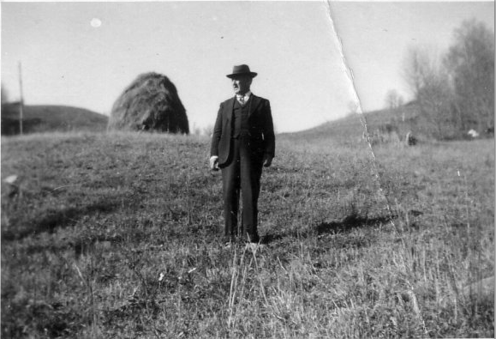
http://www.picturetrail.com/sfx/album/view/12505635

William Isaac Osborne Family
Waneta Dreyer Osborne holding Hattie, with Harry standing behind her; William Isaac holding Chester with Robert Franklin standing behind him. Photo courtesy of Cousin Dale. Note: Someone mislabeled the photo as the Robert Wilson family. 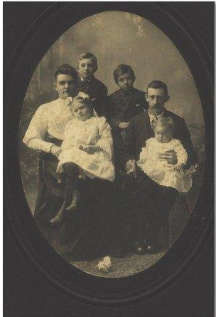
Osborne-Frank_William_183931144.jpg

http://www.picturetrail.com/sfx/album/view/12505635

William Osborne & Frank Osborne
William Isaac Osborne 27 March 1869 - 14 May 1953 is standing by his father Richard Franklin "Frank" Osborne 23 August 1846 - 27 January 1897. Frank Osborne was the son of Alvin Osborne 13 March 1821 - 8 June 1850 and Sarah Thomas 13 April 1823 - 27 September 1903. Alvin Osborne was the s/o Stephen Osborne 1801-1892 and Mary Vanover 1800-1892. Frank Osborne was a strict teacher who had a vineyard in Ashe County. 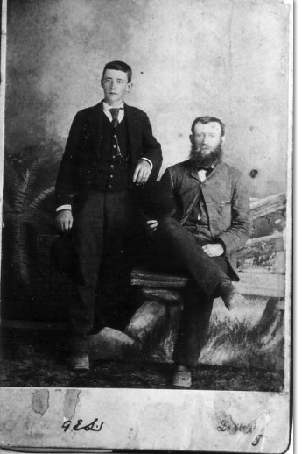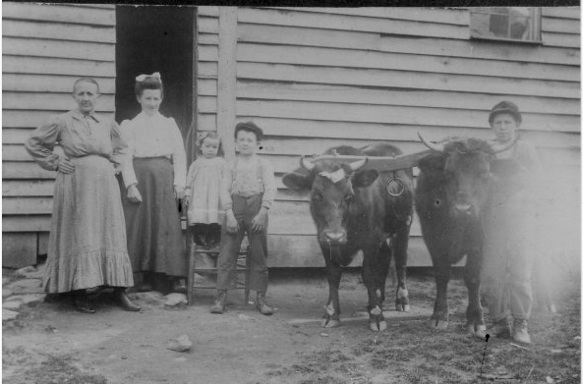
http://www.picturetrail.com/sfx/album/view/12505635

Aunt Emma Osborne
Here are Aunt Nancy Emmaline "Emma" Wilson Osborne 1850-1919, Effie Marilla Osborne Miller 1884-1964, Florence Miller Price 1904-1990, Victor "Dusty" Miller 1902-1950, Bruce Osborne 1893-1964. Emma was the daughter of Isaac Wilson 1822-1864, and Caroline Nancy Greer Wilson 1828-1911. Bruce was Emma's son, and the other two children were Effie's. Aunt Emma must have been very proud of her cattle, because I have another photo of her with them.
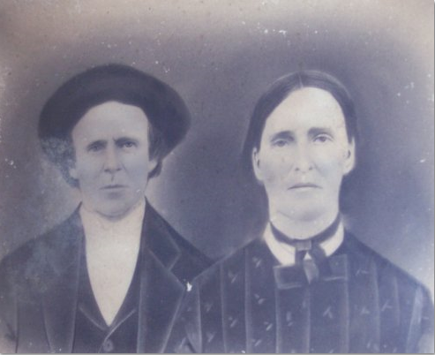
Wilson_Isaac_Caroline_331117113.jpg

http://www.picturetrail.com/sfx/album/view/14292588
Isaac and Caroline Wilson
This charcoal portrait of Lt. Isaac 1822-1864 and Caroline Nancy Greer Wilson 1828-1911 originally hung in Uncle John Wilson's home in Ashe County. Courtesy of the Donnelly Family.
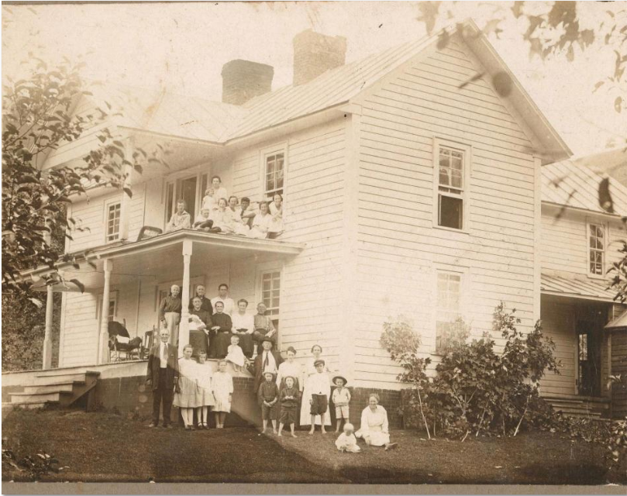
From:Steg1846@aol.com
Date:Fri, 27 Oct 2000 23:31:23 EDT
Subject:Hello
To:rademajr@yahoo.com

Dear Rob:

I haven't seen you online in a very long time. You have probably been
very busy.

Lately I have been in contact with a cousin named Shirley Sorrell. She
has a 1918 photo that has your ancestor Frankie Wilson Osborne sitting on the
porch. Supposedly she sent it out today. I will attach the file of how
it looks.

Clinton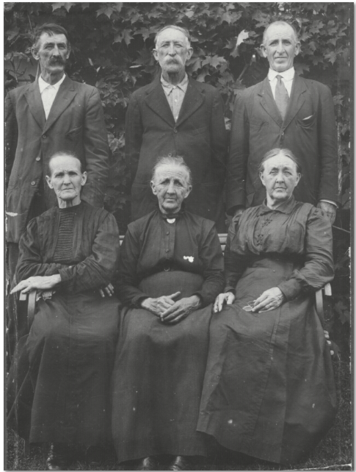
fff71d4e_jpg_orig.jpg
Andrew Jackson Forrester 1866-1938 and Martha Evaline Wilson Forrester 1857-1904 were my 2nd great-grandparents. Andrew was born near Shouns Crossroads in Johnson Co, TN and was the son of Elizabeth Forrester 1837-1915. Martha was the daughter of Lt. Isaac and Caroline Nancy Greer Wilson of Ashe Co., NC. She was born at Sutherland, Ashe Co., NC.

fff505ef.jpg
Nancy Emmaline Osborne 1850-1919, g-daughter Florence Miller 1904-1994, and daughter Effie Marilla Osborne Miller 1884-1964. Emmaline was the oldest child of Lt. Isaac and Caroline Greer Wilson. Emmaline lived at Green Valley, Ashe Co.

ffea6743_jpg_orig.jpg
These are the six surviving children (of seven) of Lt. Isaac and Caroline Nancy Greer Wilson:
Standing L to R: Robert Boyd Wilson 1860-1949, John Wilborn Wilson 1855-1928, Rev. William Albert Pinkney Wilson 1861-1951;
Seated: Mary Jane Wilson Proffitt 1852-1937, Nancy Emaline Wilson Osborne 1850-1919, and Frances Caroline Wilson Osborne 1851-1940s.

fff71d85_jpg_orig.jpg
Caroline Nancy Greer Wilson 1828-1911 was my third great-grandmother. She was the daughter of Jesse Greer, Jr 1806-1892 and Frances Brown Greer 1810-1905.

