Jamaican ginger

From Wikipedia, the free encyclopedia
Jump to: navigation, search
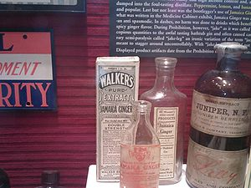
Bottles of "Jamaica Ginger"
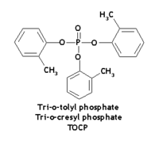
TOCP was the neurotoxin responsible for the paralysis associated with "Jake Walk"
Jamaican Ginger Extract (known in the United States by the slang name Jake) was an early 20th century patent medicine that provided a convenient way to bypass Prohibition laws, since it contained between 70-80% ethanol by weight.
Jake was not itself dangerous, but the U.S. Treasury Department, which administered the Prohibition laws, recognized its potential as an illicit alcohol source and required changes in the solids content of jake to discourage drinking. The minimum requirement of ginger solids per cubic centimeter of alcohol resulted in a fluid that was extremely bitter and difficult to drink. Occasionally, Department of Agriculture inspectors would test shipments of Jake by boiling the solution and weighing the remaining solid residue. In an effort to trick regulators, bootleggers replaced the ginger solids with a small amount of ginger and either castor oil or molasses.
A pair of amateur chemists and bootleggers, Harry Gross and Max Reisman, worked to develop an alternative adulterant that would pass the tests, but still be somewhat palatable. They settled on a plasticizer, tri-o-tolyl phosphate (also known as tri-ortho cresyl phosphate, TOCP, or Tricresyl phosphate), that was able to pass the Treasury Department's tests but preserved jake's drinkability. TOCP was originally thought to be non-toxic; however, it was later determined to be a neurotoxin that causes axonal damage to the nerve cells in the nervous system of human beings, especially those located in the spinal cord. The resulting type of paralysis is now referred to as organophosphate-induced delayed neuropathy (OPIDN).
In 1930, large numbers of jake users began to lose the use of their hands and feet. Some victims could walk, but they had no control over the muscles which would normally have enabled them to point their toes upward. Therefore, they would raise their feet high with the toes flopping downward, which would touch the pavement first followed by their heels. The toe first, heel second pattern made a distinctive “tap-click, tap-click" sound as they walked. This very peculiar gait became known as the jake walk and those afflicted were said to have jake leg, jake foot, or jake paralysis. Additionally, the calves of the legs would soften and hang down and the muscles between the thumbs and fingers would atrophy.
Within a few months, the TOCP adulterated jake was identified as the cause of the paralysis and the contaminated jake was recovered, but it was too late for many victims. Some users recovered full or partial use of their limbs, but for most, the loss was permanent. The total number of victims was never accurately determined, but is frequently quoted as between 30,000 and 50,000. Many victims were migrants to the United States and most were poor with little political or social influence. The victims received very little assistance, and aside from being the subject of a few blues songs recorded in the early 1930s (e.g. "Jake Walk Papa" by Asa Martin and "Jake Leg Blues" by the Mississippi Sheiks), they were almost completely forgotten.

