Dear Frank:

I have found a document that refutes information we have always believed about Lt. JFH. Attached is a copy of the original. I have tried to transcribe the substance of the document as follows:

"Holliman, James F. Present address: Fayette R.F.D No.2 (rural free delivery)
Born on 28th Jan. 1839 in the county of Tuscaloosa
at the State of Alabama; first entered the service as Private 0n Sept., 1961
at Fayette County Ala in the 9th Ala Bat Co. B and continued until
after the Battle of Shilo (sic) 1862

Consolidated ?? Leutenant (sic) on Sept 1862
in the 17 Ala Regt Inft Co B and continued until Nov 3rd 1863 captured
& remained in Prison Johnson Island Ohio untill (sic) 13 June 1865 & paroled."

This gives us the unit in which he enlisted as a private and refutes the notion that he was a Lt. in the 58th Ala. Inf. Regt. Maybe the 17th Ala. Infantry Regt. was combined later with the 58th. I'll try to check this.

This document was probably prepared by the equivalent of a "census taker" in 1907, just 4 - 5 years before JFH's death. It is interesting however, and the information inscribed here must have come directly from JFH.

I am doing more research, beginning today, to publish 3 articles in CIVIL WAR TIMES. I'm working on 3 biographical summaries of Lt. JFH, Pvt. John Thomas Holliman and my great-great-grandpa, 3rd Sgt. William Blakeney, Co. B, 41st Ala. Inf. Regt. He died in Charleston, TN, of pneumonia in the fall of 1863, and I have never found his grave. If these articles are accepted for publication, I will write 3 more on my great grand uncles, sons of Charles: Warren, Elijah and Cornelius. Cornelius was KIA at Petersburg. The other two were wounded there and survived. Warren is buried at Chapel Hill in Newtonville; Elijah at Springhill near Millport. We think that Cornelius was buried among the "Unknowns" in Old Blanford Cemetery at Petersburg. There are about 8000 "Unknowns " there ! John Thomas helped bury him at night to avoid snipers !

I'll forward this around to those who might be interested. Bishop Holliman and I will be down to see you in the spring, God willing. Bishop is the grandson of John Thomas, and is patriarch in our line of the family. He is WW-2 Navy, destroyer duty killing German submarines. He is a very spry 82 ! My best, Doc

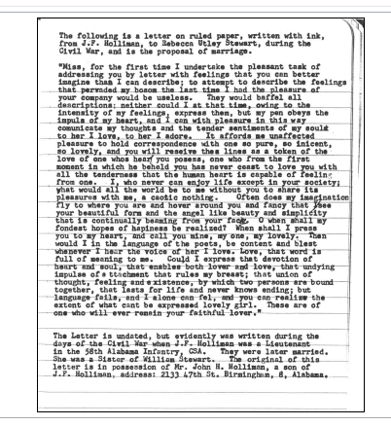
Dear Glenn and Bishop:

Here is a type copy of the original letter from Lt. James Franklin Holliman to Rebecca Utley Stewart. My Dad copied this text from an ink script letter. The original owner of the letter was John H. Holliman, the youngest son of James and Rebecca. John is long dead and I don't know who inherited all of the Civil War correspondence that John owned. This is beautiful prose from a Bluff, Alabama farm boy to his sweetheart ! We Hollimans have a reputation for being red hot lovers ! James and Rebecca lie side-by-side in the Holliman-Stewart Cemetery just south of Bluff, AL. I'll send you photos.

My best, Rhodes
Yes: this was probably the last communication from Lt. James Franklin. It confirms the shakeup in regimental command of the several units that ultimately became the 32nd and 58th Alabama Infantry Regiments. James Franklin was a Commander of Company B in the 58 Ala. Infantry Regiment when they were captured at the Battle of Missionary Ridge (TN) on Nov. 25th, 1863. He was shipped to Louisville, KY and ultimately confined by the Yankees at the Confederate Officer prison camp at Johnson’s Island in Lake Erie near Sandusky, Ohio. He was paroled on June 13th, 1865 and walked home to Fayette County. He died on May 13th, 1911, shortly after writing this letter. The attending doctor diagnosed his cause of death as “softening of the brain”. It could have been Falciparum malaria. Medical diagnostics in Fayette County in 1911 were pretty primitive. Johnson’s Island is currently under excavation by archeologists and a Google search should find a Web Site regarding discoveries of remains of that prison camp.

The Commanding Officer of John Thomas’ outfit, Company H. of the 41st Alabama (Capt. Holland M. Bell) was captured in the retreat from Petersburg and sent to Johnson’s Island. This was about April 1st, 1865. Holland Bell lived to be 104 and I had a conversation with him on the front steps of the Fayette County Courthouse about 1937. Holland Bell was the Probate Judge of Fayette County for a long time and a fine photo hang on the wall in the corridor just opposite the door of the current Probate Judge’s office (Fayette County Courthouse). These notes by Dr. R. B. Holliman, age 83, July 5th, 2011.
Back to the 19th Century...A Series of Articles on the Hollimans and Related Families of Fayette County, Alabama

Visiting the Grave site of James Franklin Holliman, An Officer and a Teacher

Below the 21st Century James Franklin Holliman stands by the grave of his grandfather, James Franklin (18 - 1908) and his great grandmother, Bertha Lee Holliman. James Franklin Holliman's first wife, the one to whom he wrote a series of letters during the Civil War, lies on the other side of his grave. The location is the Steward-Holliman Cemetery near the Bluff community.

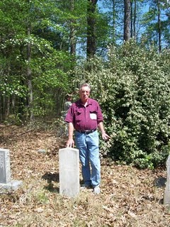

Below Robert Holliman, a great great grandson of Uriah and Polly Lucas Holliman clears brush near the grave site of his great, great uncle, James Franklin Holliman at the Stewart-Holliman Cemetery.

Lt. James Franklin Holliman of the Alabama 58th Regiment was captured at the Battle of Lookout Mountain, Tennessee. After incarceration for two years, he walked home to Alabama and did some thing even more heroic - he started a school in his own community and devoted his life to educating the citizens of northern Fayette County. The school was located a few miles from his grave site in the Bluff community.

More on this Cemetery in the next post....

Plan now to attend the Holliman and Associated Families Genealogical Round Table at the Fayette County, Alabama Civic Center, 10 am to 3 pm, Saturday, October 15, 2011. For information and reservations for lunch, contact Glenda Norris at gnorris@bcbsal.org or Glenn Holliman at Glennhistory@gmail.com. Sessions to include Tracing the Holymans from England to Alabama, Holliman Farm Sites in Fayette County and sharing of information on Associated Families. All invited!

GALLERY Faces of an Era

A SOUTHERN FARM BOY
AND A GALLANT LOVER

Submitted by Dr. Rhodes B. Holliman of Dublin, Virginia,
his great great nephew.

James Franklin Holliman was the second of 13 children born to Uriah Holliman and Mary Polly Lucas Holliman. She delivered her entire brood by herself, 7 boys and 6 girls. James was born in Tuscaloosa County, Alabama, on January 28th, 1839, but Uriah soon moved the family north into Fayette County, AL, where he obtained Federal homestead land for farming.

When the clouds of War covered the South, a wave of patriotic enthusiasm swept over the family and the father, Uriah, now 46 years old, 4 of his 7 sons, and one son-in-law joined the Confederate Army. The War would exact a heavy toll on this family: of the 6 who enlisted, only 3 would survive.

James enlisted for a year as a Private in the 9th Alabama Battalion, Company B, in Fayette, Alabama, in September, 1861. In the following spring, the 9th Battalion proceeded to Corinth, MS, and was engaged at Shiloh and Farmington. At Blackland, MS, the Battalion lost about 20 killed and wounded and disease took its toll at Shiloh, Corinth and Okolona, MS. Among those dying at Okolona was James’ father, Uriah (May 8, 1862), and a brother, Charles Daniel (May 12, 1862).

James reenlisted in the 9th Battalion in September, 1862, as a 1st Lieut., and was sent to Mobile, AL, remaining there until April, 1963. At that time, the Battalion proceeded to Tullahoma, TN, and was placed in Gen. Henry D. Clayton’s Brigade. This set the stage for the carnage that would follow in the area around Chattanooga, TN. The 9th was in several small engagements, especially at Hoover’s Gap. In July, 1863, at Tullahoma, 2 additional companies were attached and the 58th Alabama Infantry Regiment was formed. The 58th was in the thick of the fighting at the Battle of Chickamauga in September 19 - 20. On the 19th, the 58th captured 4 pieces of artillery, and on the 20th, in a suicidal charge, they broke the enemy line with the loss of 148 out of 254 men. A few weeks later in November, the 58th was consolidated with the 32nd Alabama and the field officers of the 58th were retained.

The consolidated Regiment had 400 present at Missionary Ridge on Nov. 25th, 1863, but lost 250 in casualties and prisoners. Lieut. James F. Holliman was captured on November 25th. He was shipped to a military prison in Louisville, KY, and thence to the infamous prison for Confederate officers at Johnson’s Island, Lake Erie, near Sandusky, Ohio. There he remained until he was paroled and took the Oath of Allegiance on June 13th, 1865. He was then described as being 26 years of age, dark complection, dark hair, gray eyes, 5 feet, 9 inches tall.

He returned to Bluff Community in Fayette County, AL, to resume farming and became the local school teacher. He had a large number of relatives on his class rolls including his brothers and sisters. He married Rebecca Utley Stewart, his wartime sweetheart, on July 2nd, 1865. A love letter written by him at some time during the War is reputed to be his proposal of marriage. It shows a remarkable expression of sensitivity considering that it was composed by a self-taught, back-woods, farm boy whose parents and siblings were mostly illiterate.

“Miss, for the first time I undertake the pleasant task of addressing you by letter
with feelings that you can better imagine than I can describe; to attempt to
describe the feelings that pervaded my bosom the last time I had the pleasure of
your company would be useless. They would baffel (sic) all descriptions; neither
could I at that time, owing to the intensity of my feelings, express them, but my
pen obeys the impuls (sic) of my heart, and I can with pleasure in this way
comunicate (sic) my thoughts and the tender sentiments of my soul to her I love,
to her I adore. It affords me unaffected pleasure to hold correspondence with one
so pure, so inicent (sic), so lovely, and you will reseive (sic) thes (sic) lines as a
token of the love of one whos (sic) heart you posess (sic), one who from the first
moment in which he beheld you has never ceast (sic) to love you with all the
tenderness that the human heart is capable of feeling. I, who never can enjoy life
except in your society; what would all the world be to me without you to share
its pleasures, a caotic (sic) nothing. Often does my imagination fly to where you are
and hover around you and fancy that I see your beautiful form and the angel like
beauty and simplicity that is continually beaming from your face. O (sic) when
shall my fondest hopes of hapiness (sic) be realized ? When shall I press you to
my heart, and call you mine, my one, my lovely. Then would I in the language
of the poets, be content and blest whenever I hear the voice of her I love. Love,
that word is full of meaning to me. Could I express that devotion of heart and
soul, that enables both lover and love, that undying impulse of attachment that
rules my breast; that union of thought, feeling and existence, by which two
persons are bound together, that lasts for life and never knows ending; but
language fails, and I alone can fel (sic), and you can realize the extent of what
cant (sic) be expressed lovely girl. These are of one who will ever remain your
faithful lover.”

Rebecca (“Becca”) bore him 4 children: 3 boys and a girl. She died on November 2nd, 1883. He remained single until he was 57 years old (1896) whereupon he married a former student, Bertha Lee Powell, who was 18 years old. She bore him 5 children: 3 boys, 2 girls. He was 67 years old when his last child was born. He died on May 13, 1911. He, both wives, and a number of his offspring and in-laws are buried in the Holliman-Stewart Cemetery just south of the Bluff Community in northern Fayette County, AL. The ruins of his old homestead have been recently discovered.

NAME: James Franklin Holliman
DATES: 1839 to 1911
ALLEGIANCE: Confederate
HIGHEST RANK: First Lieutenant
UNIT: 58th Alabama Infantry Regiment
SERVICE RECORD: Enlisted as a Private in the 9th Alabama Battalion, Company B, for one year. Participated in the Mississippi Campaign (Shiloh, Farmington and Blackland). He reenlisted in September, 1862, as a First Lieutenant, and was transferred to Mobile, AL. In April, 1863, the 9th proceeded to Tullahoma, TN. They had several engagements, especially Hoover’s Gap. In July, 1863, two additional companies were attached to the 9th and the 58th Alabama was formed. In winning the campaign at Chickamauga, GA, they took great loses. The 58th moved to Missionary Ridge, TN, and were overwhelmed on November 25th, 1863. Lt. Holliman was captured and spent the remainder of the War in Johnson’s Island Prison, Lake Erie, Ohio. He was paroled on June 13th, 1865.
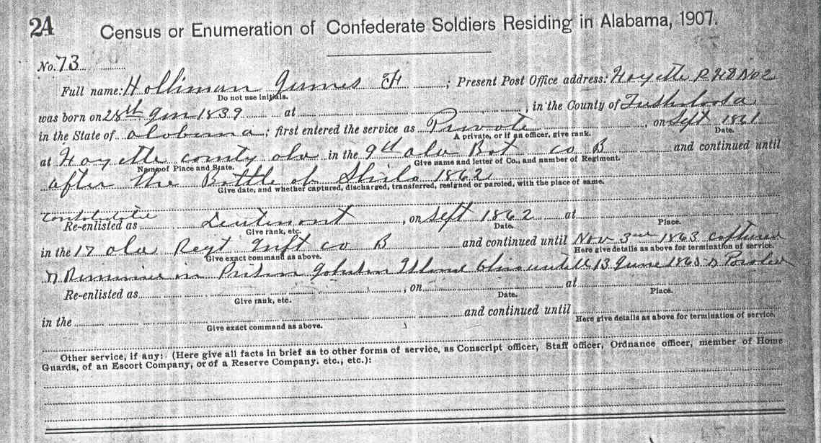 Lieut. James Franklin Holliman, Company B, 58 Alabama Infantry Regiment, CSA. He joined the Confederate Army in 1862 as a Private to serve one year. He reenlisted in 1863 and was promoted to First Lieutenant. He was captured at Missionary Ridge in the battle for Chattanooga on November 25, 1863, and was confined to the notorious prison camp for Confederate officers at Johnson’s Island in Lake Erie, Ohio. He was released on June 13, 1865, and returned to Bluff in Fayette County, Alabama where he was a school teacher and farmer. His class rolls are in my possession and he had many relatives in his classes, among them his second wife. He married his war time sweetheart, Rebecca Utley Stewart, and they had 4 children (3 boys and a girl). She was born Oct. 6, 1839 and died on November 2, 1883. In 1886, he married one of his former students, Bertha Lee Powell. He was 57 and she was 18 ! They had 5 children (3 boys, 2 girls). James Franklin was born January 29, 1839, and died May 13, 1911. He and his two wives are buried in the Holliman-Stewart Cemetery just south of the Bluff community in Fayette County, Alabama. Several of his children and in-laws are buried there.

James Franklin was the son of Uriah Holliman and Mary Polly Lucas. Uriah and 4 of his sons served the Confederacy (John Thomas, James Franklin, Elijah and Charles Daniel). Uriah, Charles Daniel and Elijah died in service.

Dear Glenn:
Here is a copy of the census of Civil War veterans living in Fayette County, AL, in 1907. James Franklin Holliman, brother of John Thomas, was captured at Missionary Ridge, TN, and sent to the infamous Yankee prison camp for CSA officers, Johnsons Island in Lake Erie, Ohio. I think that he was released in June or July of 1865. I'll confirm this. I have many stories about him and I have his proposal of marriage in a love letter to Rebecca Utley Stewart at Bluff, AL. I'll send you a snailmail copy of his proposal. He was a smooth talking son-of-a-gun ! You'll get a kick out of this !
Now we do photos. My best, Rhodes

The old dog-trot house just down the road from the Holliman-Stewart Cemetery was built and occupied by William Bailey Holliman, a son of Lt. James Franklin Holliman and first wife, Rebecca Utley Stewart. Wm. Bailey is buried in the same cemetery, just down the line from JFH. It was Wm. Bailey’s son, Silas, that murdered that Bobo fellow in 1953.

On the new monument at Springhill Church, the name “S. Poe” is Simon Poe, one of the first settlers in the Newtonville community (about 1825). You can find his name on many Land Patents on the Newtonville map. Poe’s grave sits back from the State Route 171 just south of Newtonville. It is a lone grave with a Revolutionary
War headstone.

Per my Uncle Rhodes, sent on 1/8/2011….

