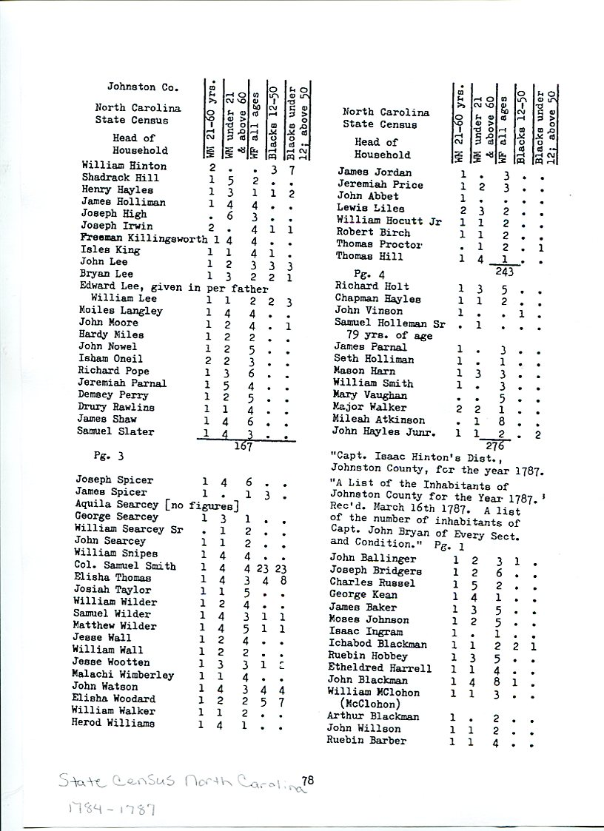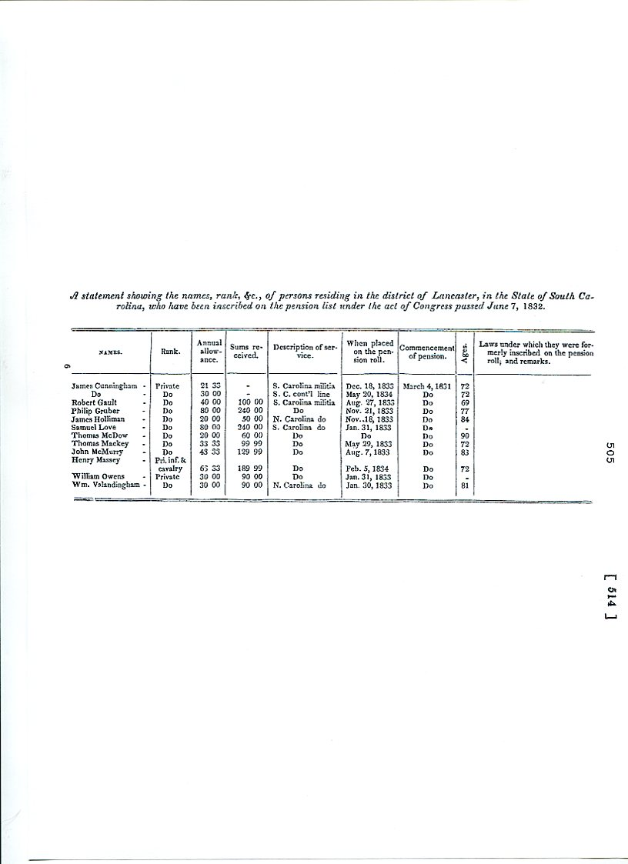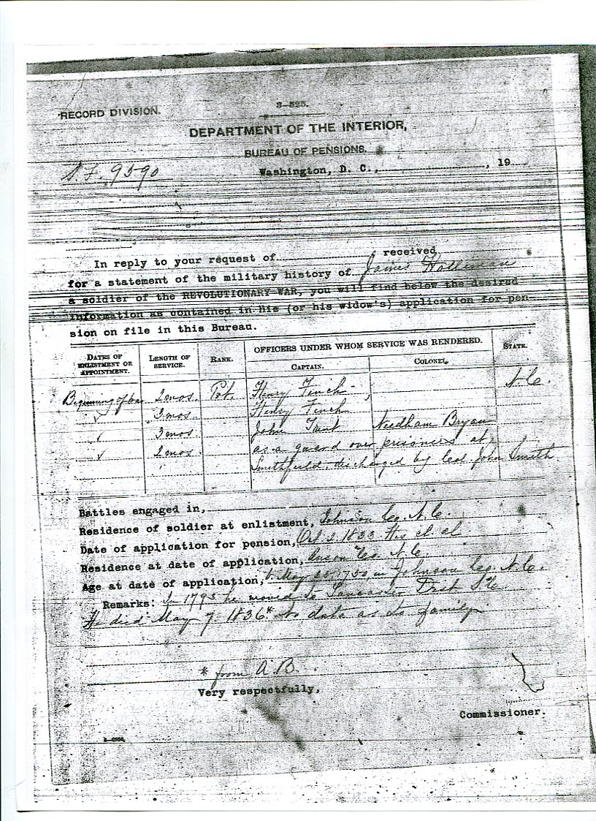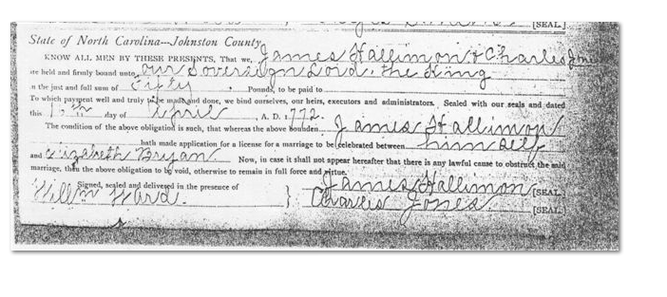Dear Ken:

I have researched my father's notes and confirmed the following children and dates for offspring of James G. Holliman and Elizabeth Bryan.

1. Esther: b. 1777 in Johnson, NC
2. Willis: b. 1775 in Johnson, NC
3. Thomas: b. 1777 in Johnson, NC
4. Samuel: b. 1779 in Johnson, NC
5. James G., Jr.: b. 1780 in Johnson, NC
6. Elizabeth: b. 1782 in Johnson, NC
7. Sarah: b. 1784 in Johnson, NC
8. Cornelius: b. 25 Sept. 1792
9. Charles: b. 1795 in Anson County, NC
10. Warren: b. 1801 in Lancaster, SC.

Cornelius, Charles and Warren were the 3 brothers who came on horseback in 1832 to explore the territory of Newtonville, Fayette County, AL. They camped out thru the winter on 1832-'33, went home to SC and moved their families to Newtonville in 1836. I have a map of the land patents subscribed to them following their arrival in AL. I'll look up the website where you can find these maps and patents. I have walked over all the land that was awarded to them. It had formerly been Creek Indian land. The last Indians were forced out about 1832, going to the Indian Territory which is now eastern OK.

Yor cousin, Doc
