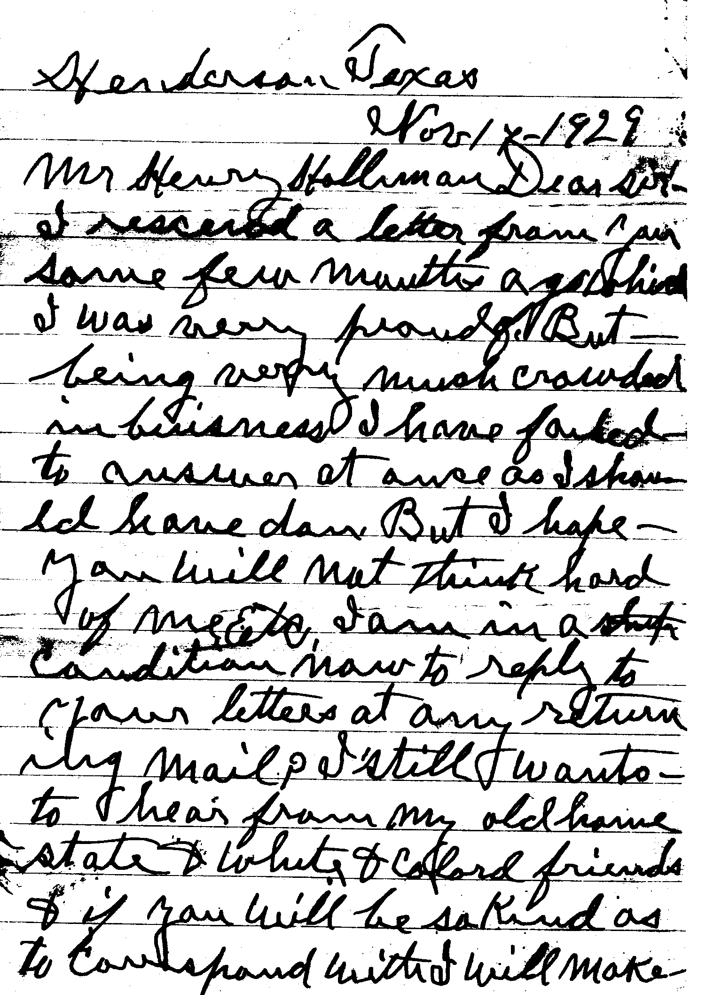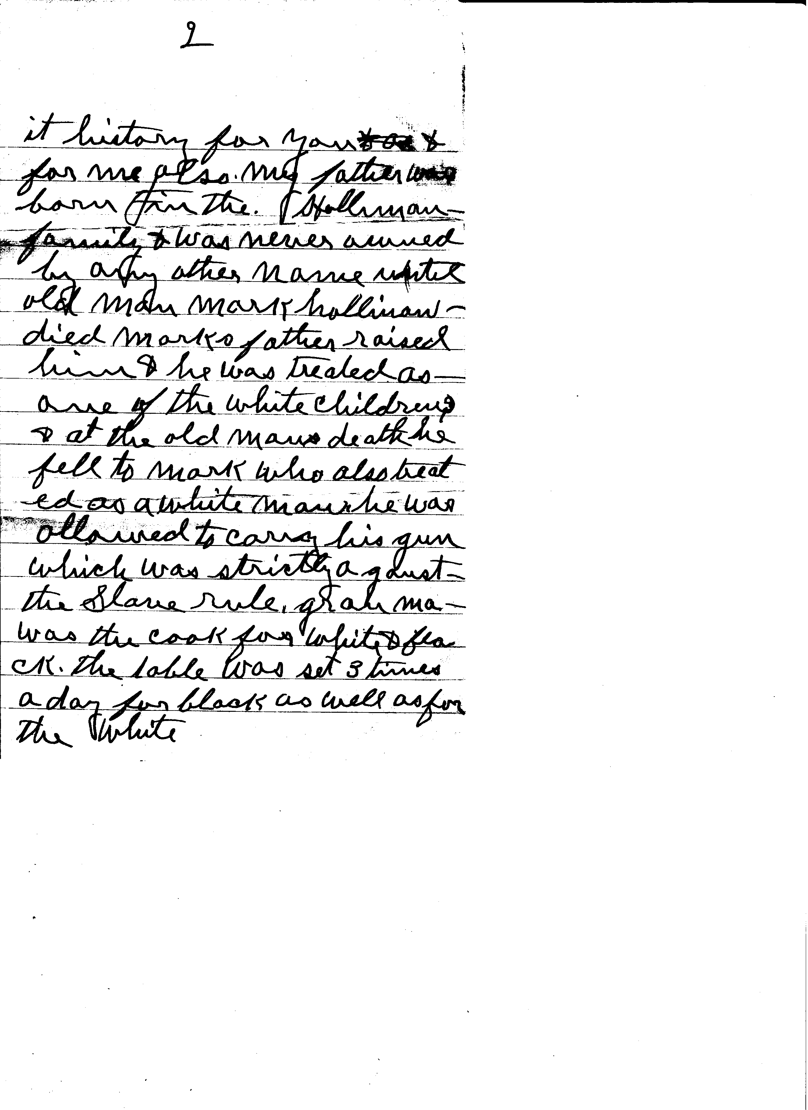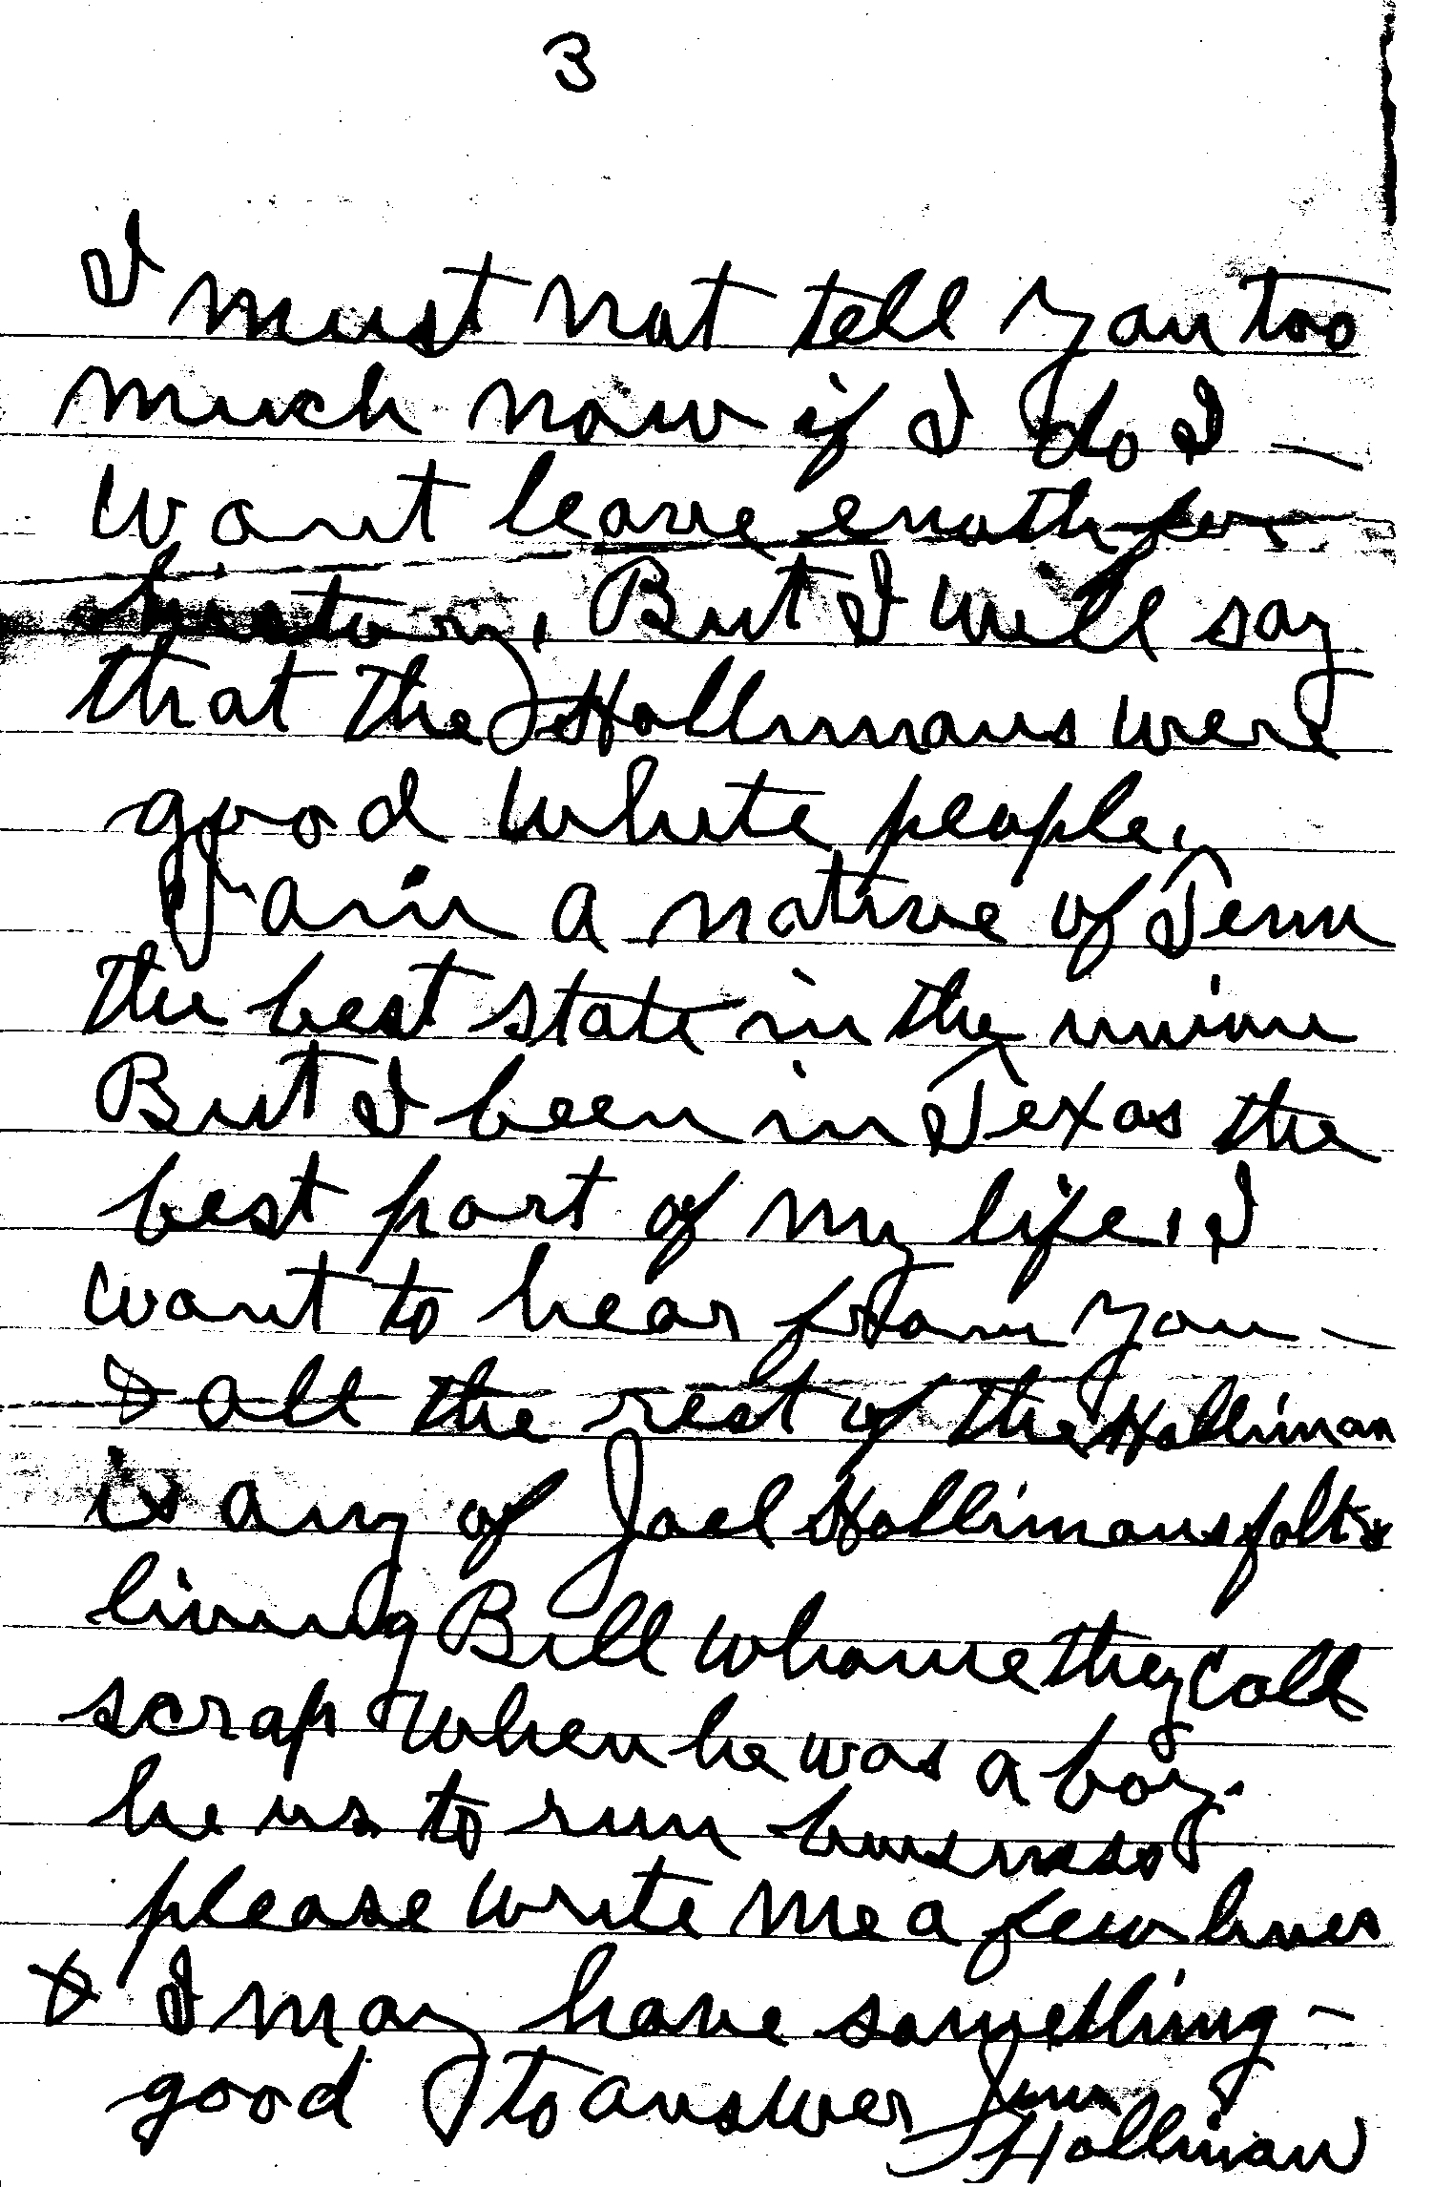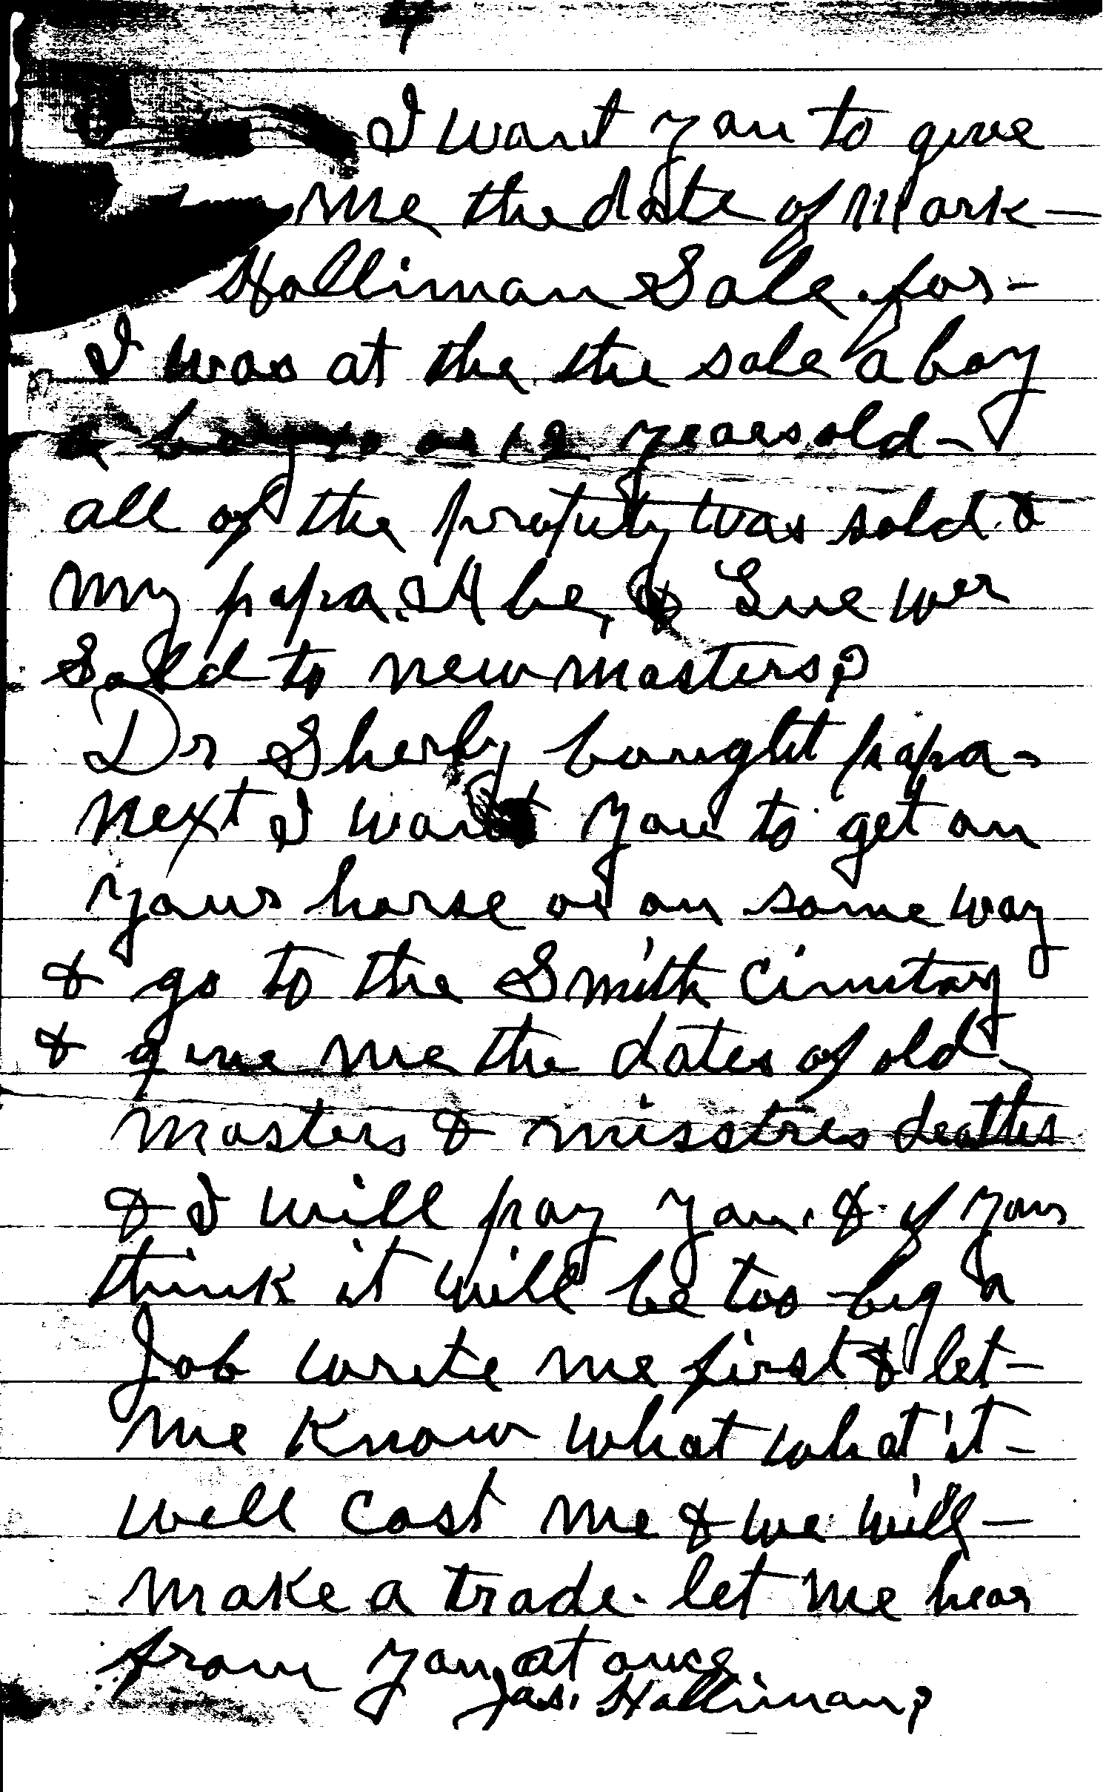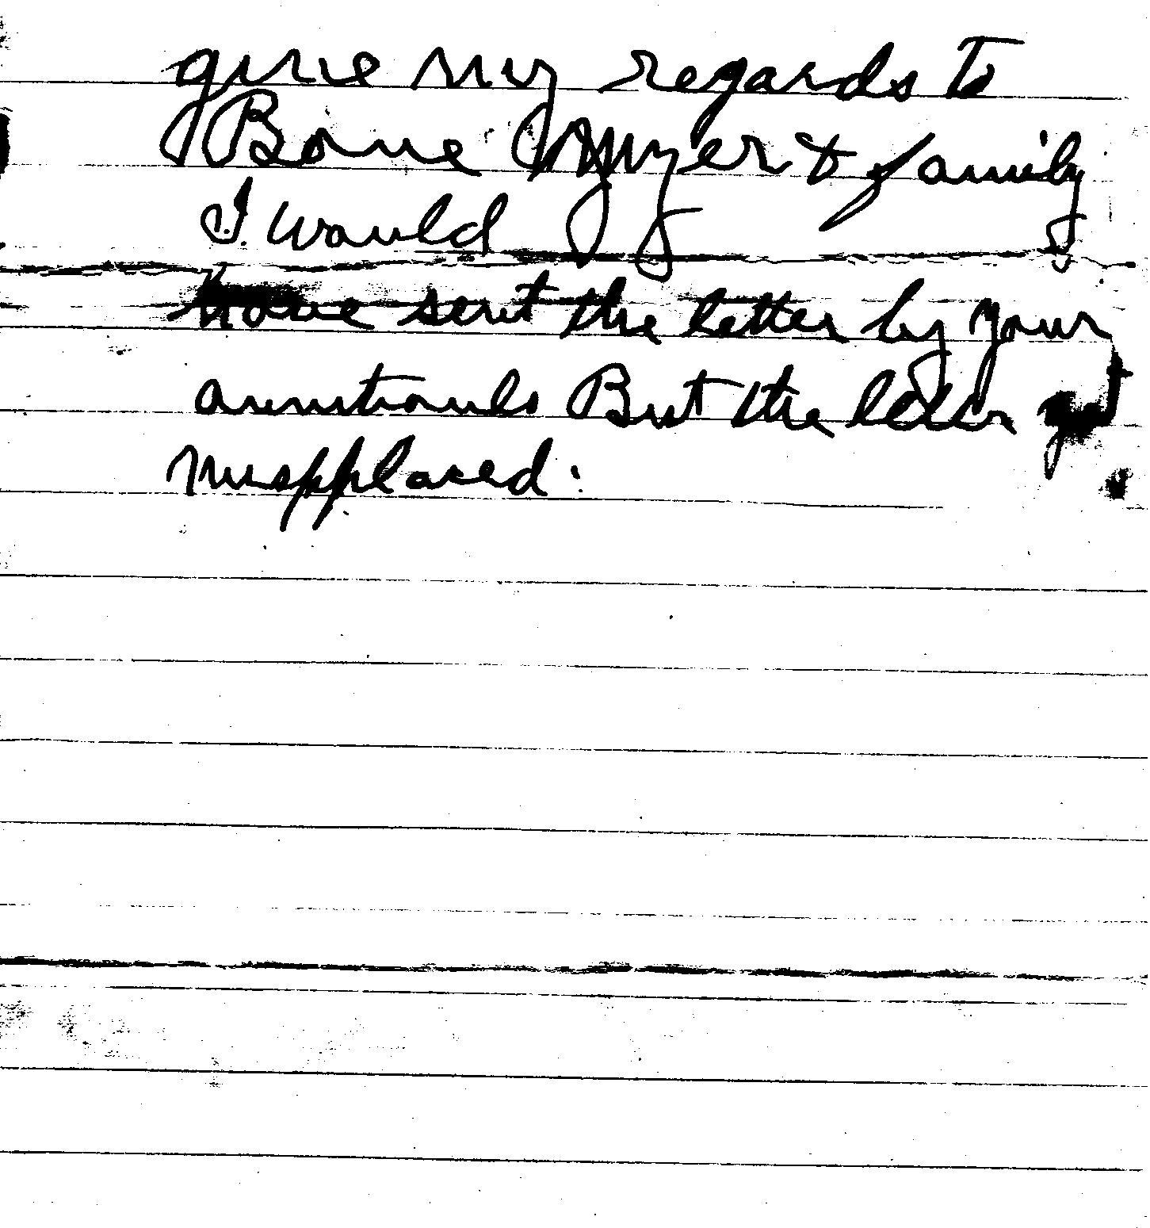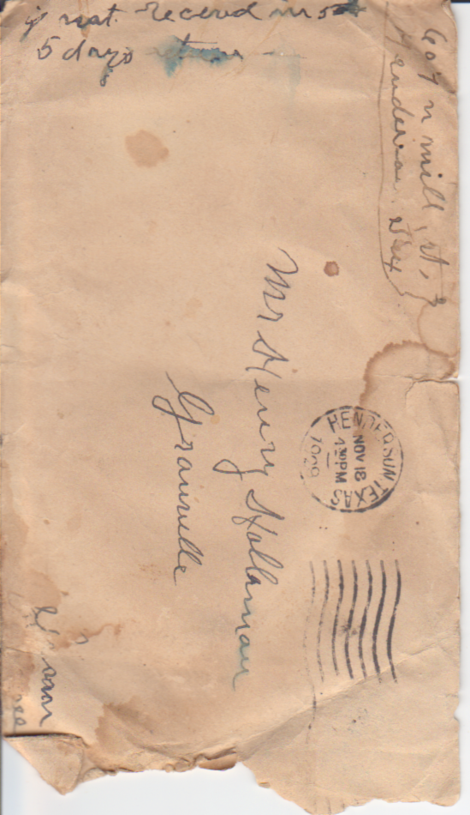Henderson, Texas
Nov 17, 1929 ¹

Mr Henry Holliman ²
Dear Sir

I received a letter from you some few months ago which I was very proud (to get). But being very much crowded in business I have failed to answer at once as I should have done. But I hope you will not think hard of me ____. I am in a condition now to reply to your letters at any returning mail. I still want to hear from my old home state and white and colored friends and if you will be so kind as to correspond with I will make

Page 2
it history for you and for me also. My father was born in the Holliman³ family and was never owned by any other name until old man Mark Holliman died. Mark’s father raised him and he was treated as one of the white children and at the old man’s death he fell to Mark who also treated as a white man. He was allowed to carry his gun which was strictly against the Slave rule. Grandma was the cook for the white and black. The table was set 3 times a day for black as well as for the white.

Page 3
I must not tell you too much now if I do I won’t leave enough for history. But I will say that the Hollimans were good white people. I am a native of Tenn the best state in the union. But I have been in Texas the best part of my life. I want to hear from you and all the rest of the Holliman. Is any of Joel Holliman’s folks living? Bill whose they call scrap. When he was a boy he ___ to run _______. Please write me a few lines and I may have something good to answer. James Holliman

Page 4
I want you to give me the date of Mark Holliman Sale for I was at the sale a boy as 12 years old. All of the property was sold and my papa Abe and Sue were sold to new masters. Dr Sherly⁴ bought papa. Next I want you to get on your horse or in some way and go to the Smith Cemetery and give me the dates of old masters and mistresses deaths and I will pay you and if you think it will be too big a job write me first and let me know what it will cost me and will make a trade. Let me hear from you at once. James Holliman

Page 5
Give my regards to Bone Myer⁷ and family. I would have sent this letter by your _____ but the letter got misplaced.

- James Holliman (author) would have abt 89 years old in 1929.
- Henry Samuel Holleman, 1872-1946, was son of John W. Holleman, 1834-1887, and grandson of Mark Holleman, 1767-1852
- His father was born in the Holliman family – William Holleman, 1740-1815. William was the father of Mark Holleman, 1767-1852
- Joel Holleman, 1842-1887, son of Joel Holleman, 1811-1860, grandson of John Holleman, 1761-? John was the son of William Holleman and brother of Mark Holleman.
- Joel Holleman had a son, William Holleman, 1837-? Maybe the “Bill they call scrap”.
- Dr Sherly – Dr John Shirley was the husband of Louisa Holleman, daughter of Mark and Hannah Holleman.
- Bone Myer – Philip Napoleon Bonaparte Meyers, 1846-1935, son of John and Julian Holleman Meyers. Julian Holleman, 1822-1868, was the daughter of Mark Holleman.

