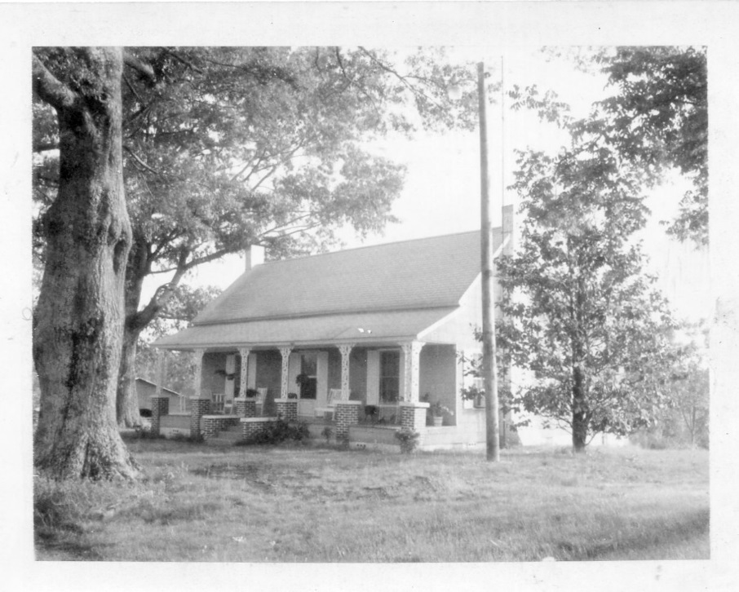
Belk, Alabama home of Janet Holliman Williams

