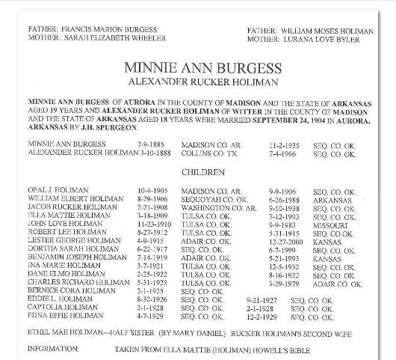
----- Original Message -----

From: sandy
To: Jean Reese
Sent: Sunday, June 25, 2006 7:26 AM
Subject: Re: Our HOLLIMAN pedigree:

I looked in our book that is an index to NC wills. Here is what I found. The following have wills at the NC ARchives:

Wm. Holliman, Johnston County, NC, 1819 WB 1/301

Arthur Holliman, Northampton County, NC, 1796, WB 2/137

James Holleman, Anson County, NC, 1804, WB 2/64

I think I can get copies of these wills at our local Public Library. We asked them to purchase microfilm of NC wills and they did. I'm just not sure they have them for all the counties. I'll check on Monday. If not, I have a friend who goes to the Archives fairly often and she will get us copies. Even if these don't appear to be your line I would order the wills. You never know what they might say. Sandy
Hi,
My name is Jean Reese. My mother is the last living child of Alexander Rucker Holiman. Her mother died when she was a young child, her father gave her away and she knows little about her Holiman ancestry. If you should have an Alexander Rucker and Minnie Holiman who had 16 children in your files, I would love to have some of the information. They lived all of My Mother's life in Oklahoma or Missouri. She believes that she has ancestors buried in Collin County, Texas and also in the state of Arkansas. She remembers hearing talk of Garland and Yell Counties. This probably doesn't make a lot of sense but if any these places or people are in your file, would love to hear from you. My Mother is OLD and just now wondering about her Ancestry.
Thanks for your consideration.
Jean Reese

From: Doc Holliman
To: Jean Reese
Sent: Tuesday, June 20, 2006 10:18 PM
Subject: Re: Holiman Research

I am a retired physician, teacher, medical missionary, age 78. I have been the repository of Holliman info and photos for the last 10 years. My late father, Cecil Rhodes Holliman, Esq., died in 1986 and willed me all his genealogy notes. I come from a patriarchy of 16 generations of Hollimans beginning with a John Holliman, born in Tring, England, in 1572. His son, Christopher C., landed in the Jamestown Colony on 22 May 1650, making us a "First Family of Virginia" ! You belong in this line somewhere. I'll try to figure it out. Cornelius was my 3-great grandpa. Cornelius --- Uriah (died in the C.W.) --- John Thomas (Co. H, 41st Alabama Inf. Regt., CSA) --- James Monroe --- Cecil Rhodes --- me. Cornelius' son, Elijah Alexander, would be my 3-great uncle. It sounds as if you have had an exciting life. I cannot think of anything greater to inherit than what your Father left you. I eagerly await hearing from you.

You forgot your email address. My email address is mwreese@verizon.net I can't send you manuscripts without it. Your brother in Christ, May the Love of Christ rest upon you.
Jean V. Reese

Rhodes Burns Holliman, Ph.D., M.D. (ret.) docholliman@adelphia.net
----- Original Message -----

From: Jean Reese
To: Doc Holliman
Sent: Tuesday, June 20, 2006 10:56 PM
Subject: Re: Holiman Research

Dear Dr. Holiman,
My ground address is:
Jean Reese
458 Marcus Drive
Lewisville, Texas 75057
I am the second daughter of Bernice Holiman Vanderheiden Ramey. She is the last living child (of 17 kids) of Alexander Rucker Holiman. I was with her last week and she is sad that there is nobody left to give information on her family. If you would be so kind as to copy and send me anything that you have, I shall gladly pay you for your time, labor, shipping, or other.
Thank you so much.
Curious tho!!!! Where do you fit into the Holiman Family?
Thank you for anything that you can supply.
Gratefully Yours
Jean Vanderheiden Reese
----- Original Message -----

From: Doc Holliman
To: Jean Reese ; landonramsey@sbcglobal.net
Sent: Tuesday, June 20, 2006 8:32 PM
Subject: Re: Holiman Research

I have a wealth of information on Elijah Alexander Holliman and his descendants. Too much to copy to the Web. If I could get Ms. Reese' postal address, I will send her Xerox copies. Hope this note comes through.

Dr. Rhodes B. Holliman docholliman@adelphia.net
5684 Howell Drive, Dublin, VA 24084

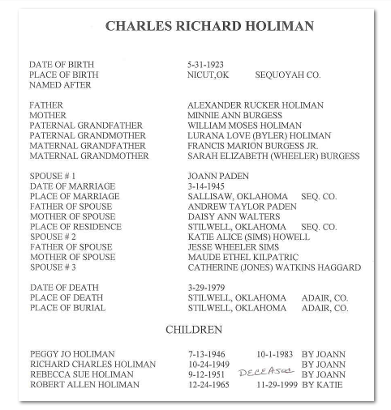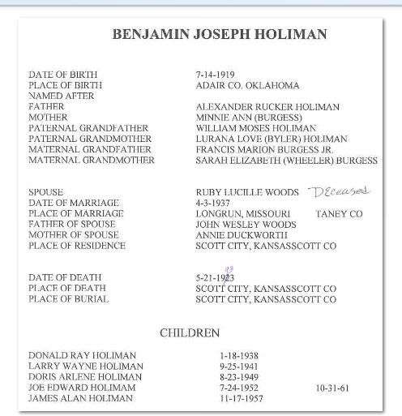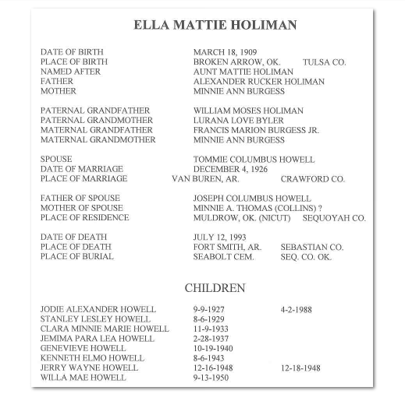THIRD CHILD OF BENNETT AND LILLIE VANDERHEIDEN JAMES WILLIAM VANDERHEIDEN, DOB, Dec. 5, 1906-DOD: March 15, 1995
B orn at Yoestown, AR., Died at Stilwell OK. Hospital;Buried,Stilwell, OK. City Cemetery
MARRIED
March 12, 1939, Honey Hill Church, ADAIR COUNTY, OK.
BERNICE CORA HOLIMAN, DOB Feb. 1, 1925, Sequoyah County OK.
CHILDREN:
1. Cleatis Irene Vanderheiden, dob, Jan 10, 1940 Vanderheiden Mountain, Adair County, OK. Married: John Christopher, dob, Aug. 9, 1938: Married Summer of 1966.
A. Shawn Dale Christopher, dob: Nov. 24, 1972
a. Hope Alexanderia, dob, Nov 26, 1996-- Daughter of Shawn Dale Christopher
& Tanya______.
2. Loretta Jean Vanderheiden, dob, Jan 1, 1943, Sallisaw, Oklahoma, Married: Murry Wayne Reese, dob Aug. 29, 1932, Cherokee County, OK.
NO CHILDREN
3. Rosa Lee Vanderheiden, dob, May 6, 1946, Adair County OK. Married Cleburne Workman, dob Dec. 27, 1942
NO CHILDREN
4. Sylvia Ann Vanderheiden, dob, Feb. 28, 1953 Married: (1) Lynn Feathers, (2) Don Holland, (3) Marvin Ashwill, (4) Jimmy Ward Liles
A. Terrance Lee (Weaver,biological) Feathers, Ashwill, (legally adopted by Marvin Ashwill) dob, Aug. 5, 1971 Married: (1)_______. (2)Shauna----, (3) Diane Wright
NO CHILDREN
B: Marvin Bryant Ashwill, do, Jan 9, 1974 Never Married
a. Alex Hunter Ashwill, dob, Jan. 13, 1994-- Son of Marvin Bryant &Mesina
SmithC. Geffory Keith Ashwill, dob, October 13, 1976-- Married: Ashley______
a. Cody Scott Ashwill, dob, May 2, 2000
5. Harold Dean Vanderheiden, dob, Mar. 15, 1956, Adair Co. OK. Married Corrina Harris, dob, Adair County, OK. Aug 18, 1956
A. Jonathan Ray Vanderheiden, dob, July 30, 1974, Tahlequah, OK. Married, Heidi Buchmann, dob, Dec. 18, 1973-Governors, NY
a. Nathan Cole Vanderheiden, dob March 4, 1997-Ft. Smith, AR.
b. Erika Nicole, dob, June 20, 2000-Ft. Smith, AR.
B. James William Vanderheiden, dob, October 14, 1979--Married in 2005 Adair County, OK. Stacy_________
C. Jerrod Kegan Vanderheiden, dob, October 16, 1986
Cornelius & Elizabeth
Elijah Alexander Holliman & Jermima Yerby
William Moses Holliman & Laurana Love Byler
Alexander Rucker Holiman & Minnie A Burrgess

This is info that I just found. I received an email from a Jean Reese asking for help for her mother is the last living daughter of Alexander Rucker & Minnie....do you have any more on this....I will send you the email I received from her....O by the way this Saturday Tillman Howe Holiman is having a dedication ceremony for the new CSA Burial Headstone here. I plan on being there and taking pictures if you are interested....

James Grantson
Warren & Millie
Tillman Howe Holiman
William Joshua Holiman
Louis Calvin Holiman
Mary Estelle Holiman - mother
Mike Ramsey - ME

take care Cuz, hope is still going great at church for you, hang in there....

Mike Ramsey
Dear Doc,
FIRST: What did you learn at the Doctor today. I do hope it was good news.
Second, Sandy could not get the Wills at her library but has them on order from the NC Archives. she said that as a resident she could order them COD and if I ordered them I would have to fill out forms, pay in advance and it would take longer for them to arrive. so all 3 are on order.
Third, I got the information that you mailed last week. Much of it is identical to what is in The Garland County Book so somebody had to have furnished them with the information.
Fourth, I have been on a quest for 20+ year trying to locate the grave of Elija in Collin county in chambers Cemetery which does not exist. there is a Chamberville town with a Cemetery by the same name but it is not there or if so it was never recorded. In looking at where Elija lived in the 1880 Census, I question that he would have been taken that far for burial. My Mom and I started this search many years ago when my dad was living and healthy. He has been dead for 11 years and was total care for 9 years before that so I know it has been at least 20 years and probably more like 25.
The people acknowledged within this book as being the contributors are: Mrs. Ed. Truesdale, Galena KS; Cecil Holiman, Birmingham, AL.; Lois Holloman Wooldridge, Hot Springs, AR.; Chester Bullock, Magnolia AR.; and Mrs. WH Byrd, Sheridan, Ar. The only name that sounds familiar to me is Mrs. Ed Truesdale but if it is the one that I knew as a child, she is a very old woman now living in NY.
Thanks so much for the maps and the data.
I trust that you got good news or at least not BAD.
God Speed,
JVR
Dear Dr. Holiman,
My ground address is:
Jean Reese
458 Marcus Drive
Lewisville, Texas 75057
I am the second daughter of Bernice Holiman Vanderheiden Ramey. She is the last living child (of 17 kids) of Alexander Rucker Holiman. I was with her last week and she is sad that there is nobody left to give information on her family. If you would be so kind as to copy and send me anything that you have, I shall gladly pay you for your time, labor, shipping, or other.
Thank you so much.
Curious tho!!!! Where do you fit into the Holiman Family?
Thank you for anything that you can supply.
Gratefully Yours
Jean Vanderheiden Reese
----- Original Message -----

From: Doc Holliman
To: Jean Reese ; landonramsey@sbcglobal.net
Sent: Tuesday, June 20, 2006 8:32 PM
Subject: Re: Holiman Research

I have a wealth of information on Elijah Alexander Holliman and his descendants. Too much to copy to the Web. If I could get Ms. Reese' postal address, I will send her Xerox copies. Hope this note comes through.

Dr. Rhodes B. Holliman docholliman@adelphia.net
5684 Howell Drive, Dublin, VA 24084

----- Original Message -----

From: Jean Reese
To: landonramsey@sbcglobal.net
Sent: Monday, June 19, 2006 11:41 PM
Subject: Holiman Research

Hi,
My name is Jean Reese. My mother is the last living child of Alexander Rucker Holiman. Her mother died when she was a young child, her father gave her away and she knows little about her Holiman ancestry. If you should have an Alexander Rucker and Minnie Holiman who had 16 children in your files, I would love to have some of the information. They lived all of My Mother's life in Oklahoma or Missouri. She believes that she has ancestors buried in Collin County, Texas and also in the state of Arkansas. She remembers hearing talk of Garland and Yell Counties. This probably doesn't make a lot of sense but if any these places or people are in your file, would love to hear from you. My Mother is OLD and just now wondering about her Ancestry.
Thanks for your consideration.
Jean Reese
Dear Doc,
Thanks so much for the pictures and also for the forthcoming documents. As strange as this may sound, you do look so much like my own Dad.
I do not have ANY pictures of my Maternal Ancestors. I met Alexander once and of course his wife died when Mom was young. I know that Mom has a picture of her Mother but don't know that I have ever seen one of her Father. I know that they always talked about him being red headed but the one time that I saw him, I do not remember much of his appearances. In my Senior year in college (1963) I took Mom to Branson, Mo. to see him and his second wife. That was the first time that Mom had seen him since about 1936.
Since your Father spent so much time researching this family, I have more questions. Did he acquire land transactions, marriage license but most importantly did he acquire a copy of James Graston's application for War pension? If not, I think I will order a copy of that. Do you know why he was declared a war hero? So many questions?
I must say your dad was a Handsome Guy that fits the image that one has of his Profession.
You and your wife must be proud of both of your sons. I think it is awesome that one has been around the world performing surgeries. How many grand children do you have and are they near you?
I know that you can probably diagnose your own symptoms but let us pray that you are wrong on this. Is RA a genetic issue? I am not going to keep you any longer because I will only pose more questions. Mom's Ancestry is just not something that is known to us since she was abandoned at age ten and then married my Dad at a young 14. She always identified closely with my Paternal Grandparents since that is about the only thing she has memory of. she and Daddy lived with them the first two years of their marriage and then when Mom and Dad got their own home, Grammy and Pappy lived with them. they both died when I was quiet young so I never had Grandparents. The only reason that I know as much about the Holiman ancestry as I do is because it is written about in a book written in 1978 by Garland County, AR Genealogy Society. Even within that text there are a lot of unanswered questions. There are some group & individual pictures within this book and they identify some of the people. I really know so little that it is not something about which I can converse. Now my paternal family, I can discuss back to the 1600's. I have their history very well documented. I have been to both Germany and the Netherlands researching that line. Fascinating Hobby.
I do hope that you have a good week end and Trust In God to take those aches AWAY
Thank you so much for all of your information.
Good speed!!!!
JVR

----- Original Message -----

From: Doc Holliman
To: Jean V Reese
Sent: Friday, June 23, 2006 4:05 PM
Subject: Ready to ship

Dear Jean:

My wife just came in with the Xerox copies of dad's typescript notes on Elijah Alexander Holliman. There are 8 pages. On page 7 you will find Alexander Rucker and off spring. Your mother is mentioned therein.

Dad did an awesome job during his 60 years of family research. He died at age 83 in 1986 (prostate CA with hepatic-pancreas metastasis). His last photo is attached (Cecil Rhodes Holliman, Esq.) Had he lived, he would have been 104 last Sunday on Father's Day ! I would be interested in your thoughts after the document arrives. A recent photo of me at my computer is attached.

If you have any old photos of your ancestral line, I sure would appreciate a scan.

My younger son with RA is a board certified Internist. Both of my boys are physicians. I'll send you the website for finding the older son who is a world-famous trauma surgeon and ER specialist.

I just about convinced that I have RA and Raynaud's syndrome. Will find out on Monday. Do a Google search on "Raynaud's syndrome".

I'll get the documents off to you tomorrow.

Your brother in Christ, Doc
Dear Doc. I do not believe that the Garland County Book is still available. If you would be interested in reading it in it's entirety, I would be happy to mail you my copy and let you look through it. It is about an inch thick and has about 30 pages devoted to the Holiman Family. Yes, my Mom was born in 1925 and had 3 children by the time she was 21. Being the second child, Mom is only 17 years older than I am.
I have found that people are totally interested and consumed by genealogy or have no interest at all. I really wish that we could get all of the work that you and your father have done on the web. Wouldn't that be great. We have my paternal lineage online. Just google Vanderheiden or Vinkenvleugel and you will find a lot of information.
There is a picture in The Garland County book that looks so much like you, I would love to know if he had those startling blue eyes that you and my Dad had.
What ship did Christopher and John sail on from England to the US. I really want to order the ship manifest.
If you have not definitely decided to pass all of your data on to someone, I would be very interested in having it and would see to it that it continues beyond my generation. I know that is bold but I feel that my genealogy data is the most valuable thing that I have because so many people have spent so much time and effort on reconstructing it.
My husband, who is 75 was in the Korean Conflict and spent his time at Ft. Bragg with one of the airborne divisions. He is a retired federal Agent and then again retired from Dallas County's District attorney. He started a white collar crime division for Dallas County under Henry Wade who was the DA when John Kennedy was assinated. His career was much more exciting than mine. I spent 30+ years in education as a teacher, a Speech Pathologist, Administration and a Psychologist. Now we are retired and do little besides Genealogy tho I had lost my zeal for a year or so. The bug bit again and we are back at it. My husband is Cherokee Indian and we both graduated with our BA's from Northeastern university in Tahlequah, OK. Then I did my post graduate work at Texas Woman's University. I guess I am a perennial student because I will still pick up a course if it catches my interest.
I'm looking at a class that will be offered in the fall "Counseling the Survivor". I may just audit it because I don't care for all of the papers that go with acquiring credit that I do not need.
I do hope that somebody can find a way to treat whatever is causing you all of the pain. You can't give up now.
Here is a picture of my birth family that was taken after the death of my Dad. Now why Bill decided to use this one, I'll never understand since we do have better ones.
http://www.vanderheidenhistory.com/PhotoVdh02Holiman.htm
We Would love to have some of that Rain that everyone else is getting. We have not had significant rain in about 18 months so it is a full time job to keep the lawn and garden watered. If we weren't such outside people, I would say let's get rid of this place and find a town house where there is nothing to keep. Yes, we could hire a lawn service but they would never please my husband and probably wouldn't please me. We spend two days every week just grooming and of course we water every day. If it doesn't rain this fall, we will not have water with which to water. we are about two blocks from the edge of the water of Lake Lewisville but it is going down so fast that it will be just down to the river soon.

Thank you so much for all that you are sharing and I do trust and Pray that your Physician Friend will be able to give you something to relieve the pain.
God Speed
JVR
----- Original Message -----

From: Doc Holliman
To: Jean V Reese
Sent: Saturday, June 24, 2006 6:30 PM
Subject: Stuff to discuss:

Dear Jean:

I've let myself get really depressed over this infernal pain so I took a 7.5 mg Hydrocodone and decided I'll work in spite of whatever is killing me !!!! I've printed all of your correspondence and I will address several of the more important issues. Like you said, there is so much to do and so little time. So here goes !!!!

Your mother is a HOLLIMAN, not a HOLIMAN ! The Holiman descendants began in Arkansas when Warren Holliman (son of James Grantson) changed the spelling of the surname. The descendants of the other two brothers, Cornelius and Charles, still spell it HOLLIMAN. However, muster rolls of the many Hollimans in the Civil War are misspelled. I have records of 77 Hollimans who who fought for the CSA ! My 10th great grandfather, Christopher C. Holliman, Sr., was recorded as "Xtoph Holman" by the ship's scribe when he disembarked at Jamestown on 22 May 1650. Your mother belongs in the direct line from this man. We will have to figure out how many "great" granddaughters she is removed from Christopher. I'm going over to Jamestown this year to check records in the National Park Service library there.

Your mother is only 3 years older than me. I was born on 28 Feb. 1928. My records show she was born on 1 Feb. 1925.

I am scanning the original military record of James Grantson and I will put a copy to you in the mail on Monday. This is the original hand script of a J.P. who took down his testimony. He wasn't any particular "hero" of the Revolutuion. The script is pretty clear and testifies to his service record and his signature is neat and bold. He was in and out of the Army several times. The original document is in the U.S. Archives. My dad got a photocopy in 1964.

Texas is full of Hollimans that descended from the children of my great-great grandma, Mary Polly Lucas Holliman, wife of Uriah who was a son of Cornelius. Mary Polly had 13 kids, all delivered by herself. Uriah died in the C.W. from pneumonia-measles at age 46. I'll send you a biography and photo of her. Of her 13 kids, over half migrated to Texas after the War. I've got several biographical sketches and photos of Holliman ancestors that you might enjoy

Neither of my sons (ages 51 and 53) have a burning interest in genealogy. My grandchildren, 2 boys, two girls, don't have the urge either. I may leave all my stuff and dad's stuff to a niece who has shown some interest. Each of my sons had a boy and girl who are adults now. One grandson is married. He is a computer engineer from the University of Pittsburgh who is now in Edinburgh, Scotland, working with their Astronomy Dept. in translating digital signals from orbiting telescopes. His work is far beyond my comprehension.

I need to send you the Fayette County, Alabama, map website for checking original land patents in the 1830s and 1840s. There is some fabulous documentation of the early parcels homesteaded by Cornelius, Charles and Warren. There are several Fayette County websites that you need to check. I've added lots of photos and documents to these sites. I'll send these to you after this letter. Is the 1978 Garland County Genealogy Society book still available ??

RA is genetically linked. It contributed to my mom's death and my younger son was diagnosed last year. My sons are from my first marriage that lasted 28 years until the bra-burning liberation movement took over ! ! I was single for some time during the 1970s into the 1980s. I've been married to a sweet and wonderful lady for 17+ years and have nursed her through ovarian cancer chemotherapy and surgery, and total knee replacement. We are a devoted couple. I am a Deacon in the Christian Church-Disciples of Christ and have represented our church at the International Assembly of the Christian Church-DOC, last July in Portland, Oregon, and at the State Assembly the first of this month at Lynchburg, Virginia. I sing in our Senior Choir, our Men's Chorus and my newly organized quartet for old Southern Gospel music. Religious music has been my life.

I served in the Army during the Korean War. I finished up that service in the design, development and testing of radiological, chemical and biological weapons. I have had a wild and wooly life !!!!

I'll cut this off for now and pick up on to finding those websites promised above. I'll also be sending some random photo scans later. I'm going to finish scanning James Grantson's military record first so that I can get it in the mail by Monday. We are having severe rain and lightning after a hot, dry summer start. We had 2 inches last night and are threatened with 3 inches tonight !

Love in Christ, Doc
Dear Doc,
Thank you so much for the information that you have sent. It is truly fascinating because my Mother thought that her family settled originally in Arkansas. Seeing this just stirs up the desire to learn more and more. I'm sure that the DAR would love to know where James Granston's burial site is. Sometimes, one just cannot find them and it is that simple. I have been looking for one on my paternal family for years. I even know where and when she died, I also know that she was a Devout Catholic therefore there is reason to think that she would have been buried in a Catholic Cemetery and there are not that many of those in that part of WI. for the time frame. I have not given up, but have slowed the pace of searching.
I do hope that you have someone who is as interested in Family History as both you and your Father have apparently been. It would be so sad to see the documentation stop when you can no longer do it. If I had a child, my one wish would be that they would have the same zeal and love for Family History as I have.
Again, I am grateful to you for being willing to share your information. I look forward to getting more and you are a wise one to send it a few pages at the time.
God Speed
Jean V. Reese
----- Original Message -----

From: Doc Holliman
To: Jean V Reese
Sent: Wednesday, June 21, 2006 1:55 PM
Subject: The Holliman boys:

I sent the original of this to a niece who is getting interested in Holliman, Walker and Blakeney genealogy. Thus, the personalized parts. I have saved it to share with others who might be interested.

For the sake of not over-challenging your memory, I will send several manuscripts in abbreviated form over the next few days. Next week I will Xerox a magnificent volume done by our distant cousin, Walt Holliman, who died in Hoover, AL, three years ago. In losing him, we lost the finest Holliman-Blakeney genealogist who ever lived. He smoked himself to death. I do not keep all of the following in my memory and my memory is fading rapidly with age. Also I do not type ! I do all this as a hunt-and-pecker but have written many books this way. Thus, it takes me much longer to produce a page.

We will begin with James Grantson Holliman, Revolutionary War hero, of Anson County, NC. (your 5-great grandpa). He was born on 25 May 1750, in Johnson, NC, and died on 7 May 1836, early 86 years old. He married Elizabeth Bryant and they had 10 children. You will get a complete list of these children in Walt's tome. Don't know where James Grantson is buried. Wish we did. Probably in Chesterfield County, SC, from whence his progeny migrated to AL and MS. Looks like they abandoned SC at the time of his death (1836). The DAR would be delighted to put a big monument on his grave. You should concentrate on the 3 youngest boys who came to Fayette County to prospect for land in 1832, camped over winter with Indians, went home to SC and moved their families to Newtonville, Fayette County, about 1836. to wit:

1. Cornelius, born 25 Sept. 1792 (your 4-great grandpa) died in Lamar County and buried at Old Blooming Grove Cemetery (I have a pic of his new memorial grave marker.) He married Elizabeth Plyler and had 5 children) She died and is buried at Springhill Cemetery in northern Tuscaloosa County) She is buried under one of several rock-stacked graves. I have a pic. He then married a widow, Elizabeth Rainwater. No children by her. Don't confuse this "Springhill Cem." with the one where Mary Polly is buried. There are many "Springhill Cemeteries" in AL.

2. Charles, born ca. 1795, in Anson County, NC. He married Barbara ("Barbary") Walters and they had 11 children. He died somewhere around Newtonville, Fayette County, about 1841, leaving Barbary to raise all those kids. His and her grave sites are unknown. I've burned a lot of shoe leather looking for them with Walt back in 1999 and 2001. Walt's line came from Charles-Barbary. They were your 5-great uncle and aunt.

3. Warren, born ca. 1801, in Lancaster County, SC. He married Millie Walters. About 1840, Warren headed up a wagon train in Newtonville and moved over near Hot Springs, AR. I know less about his progeny than any other line. He changed the spelling to "Holiman". Many descendants still live in Arkansas & TN, and I keep up with a few. I may have a pic of Warren and Millie soon. Have found a source in AR. Somewhere I have a pic of their grave site in AR.. They would be your 5-great uncle and aunt.

Now, try to absorb some of this document. Soon I will start with Cornelius >>> Uriah and that huge family. That is our direct line. After I get through talking about their 13 children, I'll step back and follow the line of Charles and Barbary (collateral) to their 11 kids. We will see several Warrens, Elijahs, John Thomases (at least 3 !) and replication of other names. Hollimans have the bad habit of naming their kids after their ancestors !

I may have another document or two stored on a CD that I can ship after I send this. I'll look now. This is about all I can do mentally in one session. There is so much to learn and so little time !

Learn it this way: James Grantson Holliman to his 3 sons (Alabama migrants): Cornelius, Charles and Warren.

What a handsome couple!!!!!!!! I still wonder how both you and my Dad could have such piercing blue eyes?
Somewhere along the way James used the name Granston because as I think I told you, a paternal genealogy buddy is the President of Ashville, NC Genealogy Society and she found him as James Granston. She is going to check and see if she can find a will for him in NC. I anxiously await the Elijah Information.
If Adobe Photoshop-7 is complex, I need to stay away from it. I have adobe photo shop but think it is level 1 and it gives me fits sometimes.
I am so glad that you have a lovely wife to share the later years of your life and she is a beautiful lady.
I am so happy to hear that you are feeling better and anxious for church. Gospel music is my favorite of all music, so sing one just for me.
You are so kind, just wish that we could meet in real life.
Thanks for all of the goodies. I really enjoyed the biography of Mary Polly. She must have been a very tough lady. I'll see if I still have the information that my VDH relative from Ashville sent me using James Granston's full name.
May God Bless you and keep you strong for a lot of years to come.
JVR
----- Original Message -----

From: Doc Holliman
To: Jean V Reese
Sent: Saturday, June 24, 2006 9:23 PM
Subject: Update

Dear Jean:

I finished scanning the James G. military history files. My copy was purchased from U.S. Archives in 1964 and was a poor copy to start with. It is on legal size paper so I had to cut and paste because my scanner can't handle anything bigger than 8 1/2 X 11. Your copy is enhanced, thus readable. If you can't read it, just tell me and I will type a transcription. It was a script copy made in 1834 so it is embellished with the hand writing of those times. I can read all of it so it would be easy for me to transcribe.

Incidentally, James never mentioned his middle name in all the documents concerning him. I don't know where "Grantson" came from ! I remember my dad using that name and I don't know where he got it. If dad used it, you can believe it !

Your copy of Elijah Alexander was picked up by the mail carrier this morning. I'll drop the James G. document on Monday in the P.O. enroute to see my physician buddy.

I'm a big fan of Adobe Photoshop-7: a graphics and photo program of ultimate complexity. I took two night classes about 2 years ago at the local college to learn the basics. I got a pirated CD from a buddy. Otherwise, it could have cost $900 ! You will be seeing some Holliman collages that I have assembled with this program.

Attached is a pic of me and my wife. I feel a little better and am looking forward to church tomorrow.

Your brother in Christ, Doc
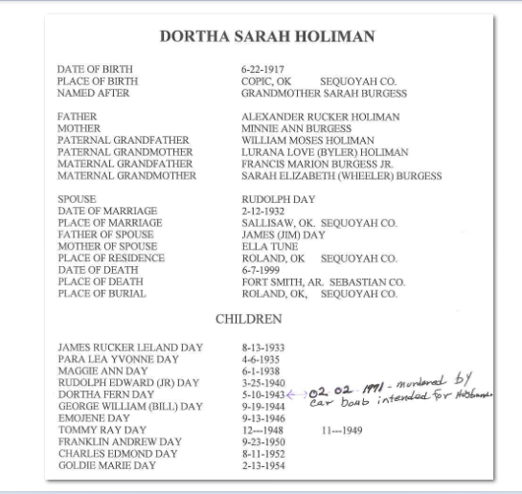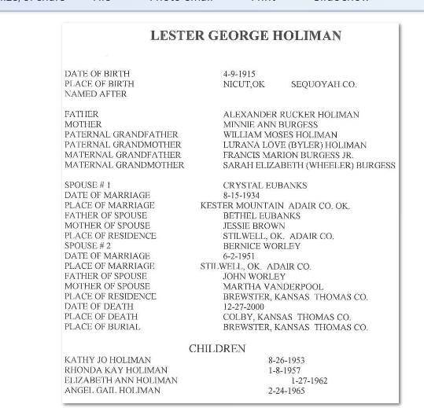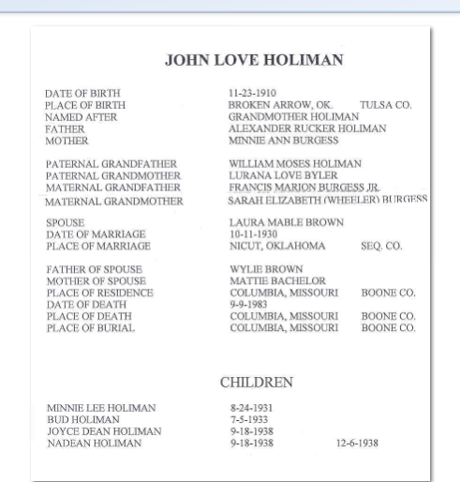Dear doc,
Sorry to hear that you are not well. I've just found you. How much do I owe you for the materials that you will be sending? Also, I need your ground address.
I do hope that your physician colleague can get the hurts gone and that you have a lot more healthy and happy years. That is sad that your son of 52 has RA. We have a very good RA physician here in Dallas, so if your son doesn't find adequate medical care, I know a very good Dr. His bedside manner has something to be desired but he sure appears to know his business.
All of you will be in our prayers and yes, I do think prayer works.
Keep trusting God that you will be able to at least get all of these medical things in remission
May god Bless YOU and Yours.
JVR
----- Original Message -----

From: Doc Holliman
To: Jean V Reese
Sent: Thursday, June 22, 2006 7:41 PM
Subject: Re: The Holliman boys:

Dear Jean:

I asked my wife to copy (Xerox) my dad's original type script notes on Elijah Alexander Holliman and descendants. She will copy tomorrow and I should get everything off in the mail by Monday.

I see my physician colleague next Monday. I've got symptoms of something going bad. The last time I felt like this I had a major heart attack ! I think that I have developed acute rheumatoid arthritis. Everything hurts ! My mother was crippled with RA (she died at 77), and my younger son (age 52) has been diagnosed. We'll see. I'll keep in touch. In Christ, Doc

----- Original Message -----

From: Jean Reese
To: Doc Holliman
Sent: Thursday, June 22, 2006 7:22 PM
Subject: Re: The Holliman boys:

Dear Doc,
Thank you so much for the information that you have sent. It is truly fascinating because my Mother thought that her family settled originally in Arkansas. Seeing this just stirs up the desire to learn more and more. I'm sure that the DAR would love to know where James Granston's burial site is. Sometimes, one just cannot find them and it is that simple. I have been looking for one on my paternal family for years. I even know where and when she died, I also know that she was a Devout Catholic therefore there is reason to think that she would have been buried in a Catholic Cemetery and there are not that many of those in that part of WI. for the time frame. I have not given up, but have slowed the pace of searching.
I do hope that you have someone who is as interested in Family History as both you and your Father have apparently been. It would be so sad to see the documentation stop when you can no longer do it. If I had a child, my one wish would be that they would have the same zeal and love for Family History as I have.
Again, I am grateful to you for being willing to share your information. I look forward to getting more and you are a wise one to send it a few pages at the time.
God Speed
Jean V. Reese

Dear Doc,
I received James's Military records. they are so interesting. I just cannot imagine a pension of twenty Dollars. At the same time, I have to ask myself if he was really in need of that or just entitled. He had servants to spare to perform his duty. I would love to take a stroll back into life at that time.
I'm wondering if you are well or is you are flooded since I've not heard a word from you. I hope neither but hope you are enjoying your days.
Thanks many times over for the information that you have shared.
God Speed,
JVR

