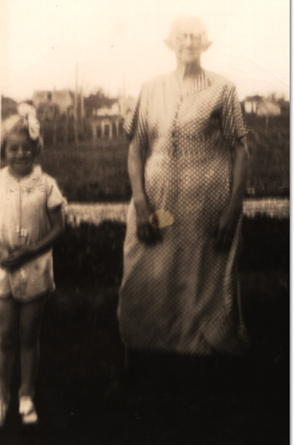From: Doran818@aol.com
Date: Sat, 2 Sep 2000 18:54:36 EDT
Subject: Re: Emma Wilson Osborne
To: Steg1846@aol.com

Dear Clinton,

I have a note in Nancy Emmaline’s file that says she came to Washington in 1901, but I don’t have a source for that information. According to Mom, her grandmother came to Washington with her youngest son Bruce when he got out of the Army in 1918. My mother (born in 1919) would have been too young to have this as a personal memory; it would have been something she was told, probably by her father or Harry’s wife, Mae. Until this very day, I thought I had access to a later day photo of Nancy Emmaline, but unless we have her death date entirely wrong, I have been mistaken. I’ll send you the photo anyway. (including it as part of this e-mail to save uploading time) It pictures an elderly woman (obviously a Wilson—big ears, big nose) and my cousin Betty Jean. Betty Jean appears to be about 10 years old in this photo so that would date the occasion at 1934.
This could be Frankah Wilson Osborne... She did not die until 1940. The photo (a very poor photo) belonged to Betty’s dad, Harry. The fact that there is no note on the photo is also a pretty good indicator that this is not Nancy Emmaline. If this was a photo of Harry’s Grandmother, it would have been framed or something. I didn’t cut Betty out of the photo, the original photo was taken this way.
With temporary custody of Harry’s old albums, I have several photos of the families of two of the Milam boys (William and Carl.) Do you want copies?
[Unable to display image]
I just returned from a kayak/camping trip in the Winchelsea Islands, off the east coast of Vancouver Island—what a beautiful place it was.
I hope your summer has been good.
Forgive the slightly naughty joke I’m sending you.
Love Jeanie

