by Glenn N. Holliman

The same weekend in July 2014, the Wilson-Greer-Osborne and associated families were gathering in Boone, North Carolina for a family historical forum, Osborne cousins met for an annual event in Skagit County, Washington. These cousins are descendants of Osbornes who migrated out of the North Carolina mountains to the great northwest. Ashe and surrounding counties were mountainous, and not economically productive enough to support the many offspring of the clans that had pioneered the ridges and valleys in the late 18th and early 19th centuries. So off to the great Northwest! GNH

We are indebted to cousin Jeannie Bond for these photos, permission to use them and the identifications.
The Annual Osborne-Dreyer Family Picnic, July 2014 by Jeanie Bond

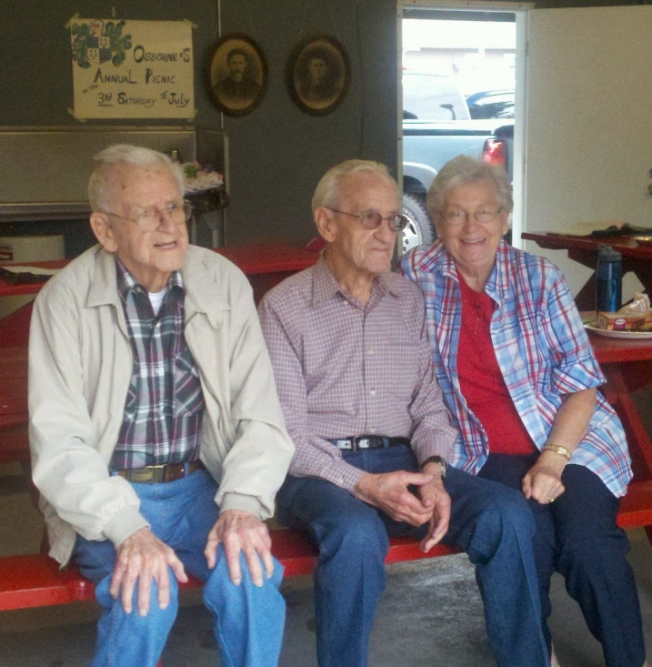

Generation #1 - On the far left is Derward H. Osborne, who sadly died about a week after this picture was taken. Next is C. Mark Osborne, b. 1919 in Skagit County. He, along with his wife Juanita Brown-Bass Osborne, beside him, have a home in Texarkana, Texas. Note the pictures on the wall behind them. These are the parents - William L. Osborne (1869-1953) and Waneta T. Drever Osborne (1979-1923). All their children were born in Skagit County.

William L. Osborne was the son of _____ and grandson of _______.

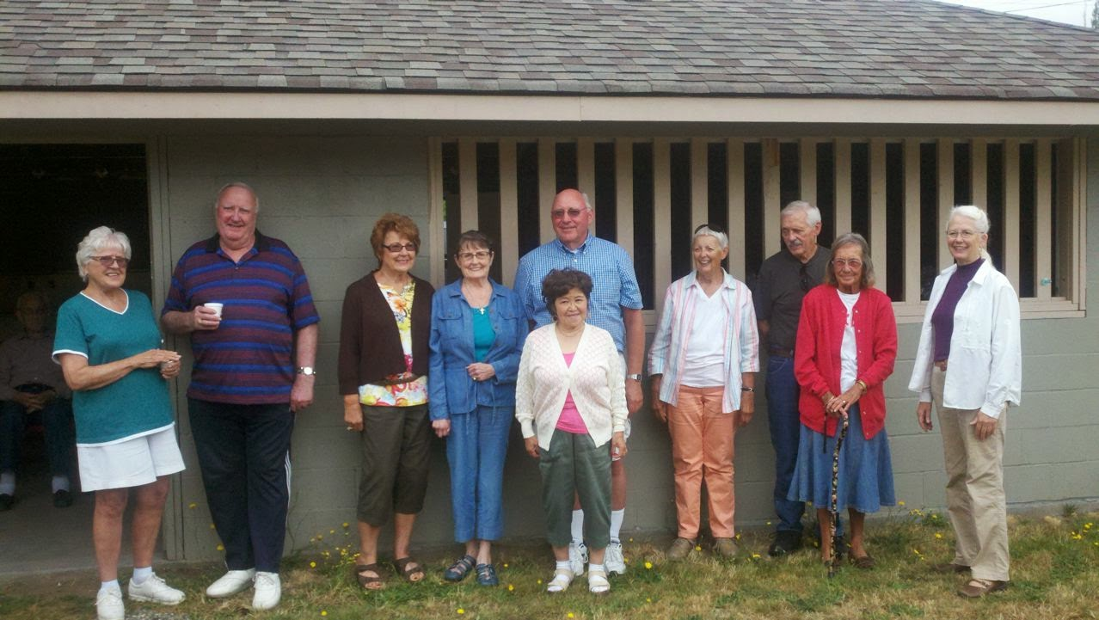Above, the next generation, some of the grandchildren, are represented left to right in order of the birth of their parents: Pat Mosher, Bill Osborne, Shirley O'Neill, Dee Grenville, Wayne Osborne and his wife Tokiko in front; Peggy Van Allen, Steve Doran and wife Sonja and last, Jeanie Bond, a family genealogist.

Sedro Woolley, which is in Skagit County, Washington lies along I-5 between Seattle and the Canadian border. Victoria and Vancouver, British Columbia lie just to the north of Bellingham.
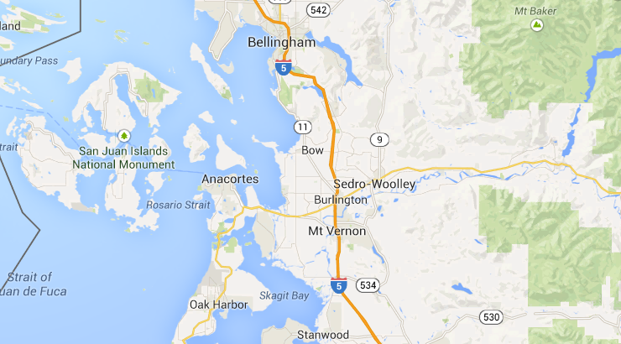

Below, several of the great grandchildren of William and Waneta Osborne, left to right, are Kevin Osborne, Darla Crookshank, Gary Osborne, Gail Wilson, Tadashi Osborne, Cindi Osborne, Steve Vav Allen and Lynn Salter.

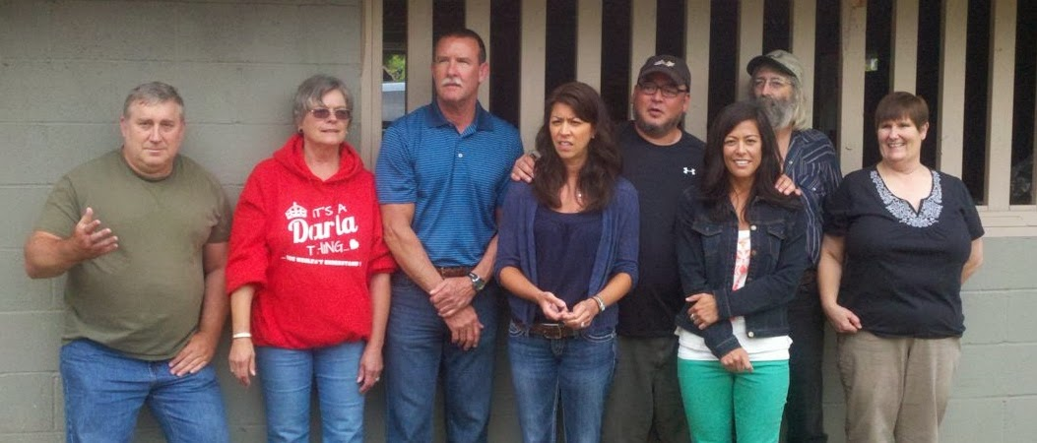

Below, are a few of the great, great grandchildren of William and Waneta Osborne: Aidan, Sarah, Torrin, Ava, Jarret, Teagan, Jimmy, Jason, Brent, Elizabeth. Missing from the photo, but present was Jason's wife, Abra.
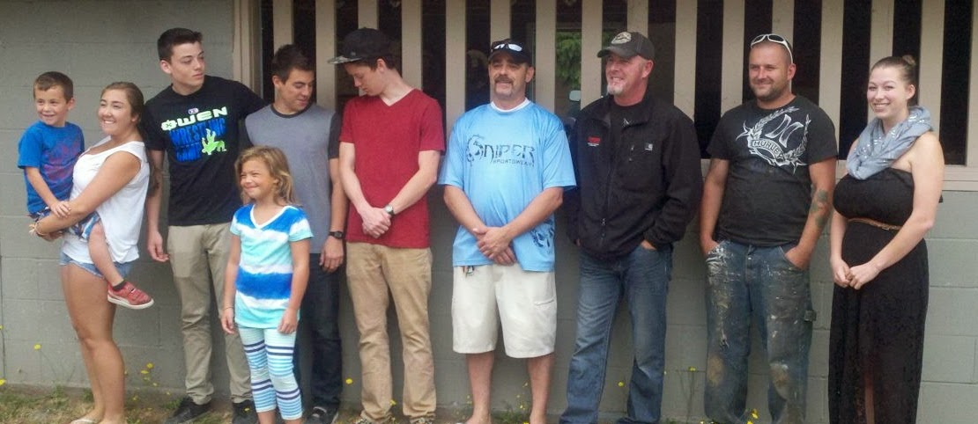

Below left, left to right, the latest generation, are the great, great, great grandchildren of William and Waneta Osborne: Laura, Hailey, Hannah who is holding Madeline.
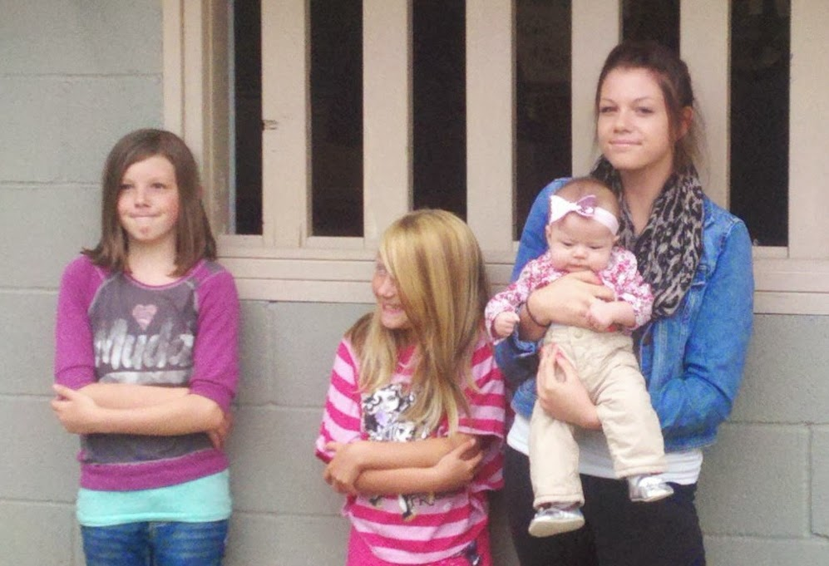

The Osborne plot at Union Cemetery, Sedro Woolley, Washington - Every year on the day of the family picnic, Kevin Osborne puts and (and later takes up, these flags at the site of each Osborne or Dreyer burial. Each flag has several photos and a little history of the individual. Kevin is the family history heir apparent. Way in the background, just barely visible is the 'pink flag' marking the final resting places for Kevin's father, Jerry Osborne, and his grand parents Lawrence and Eunice Osborne. - Jeanie Bond

