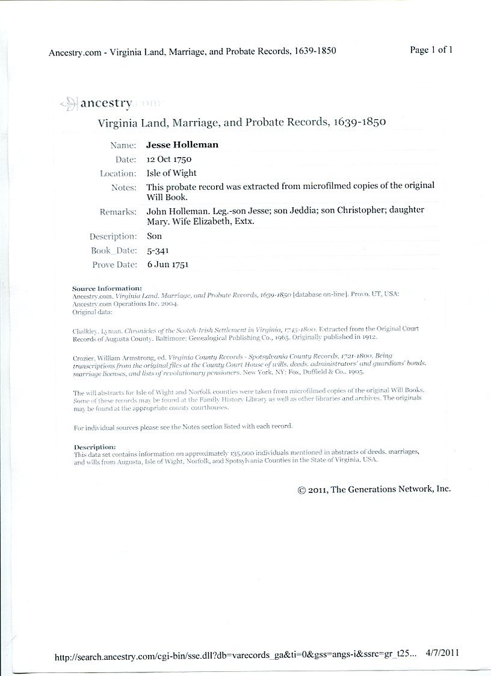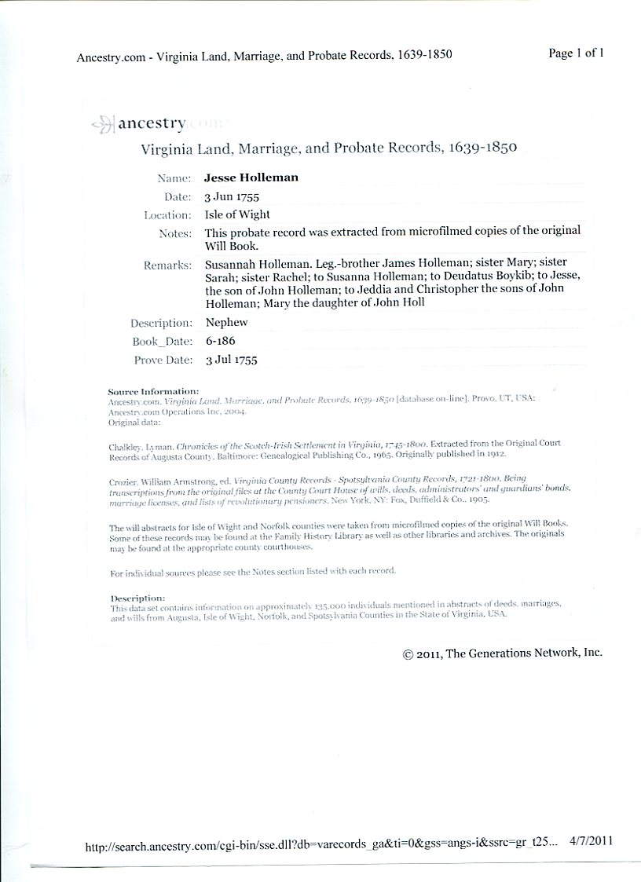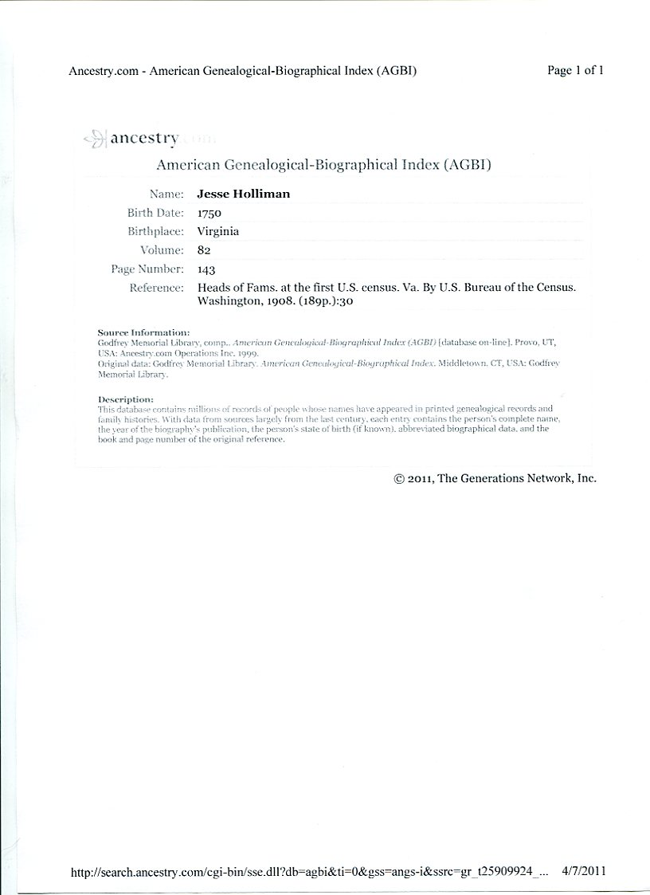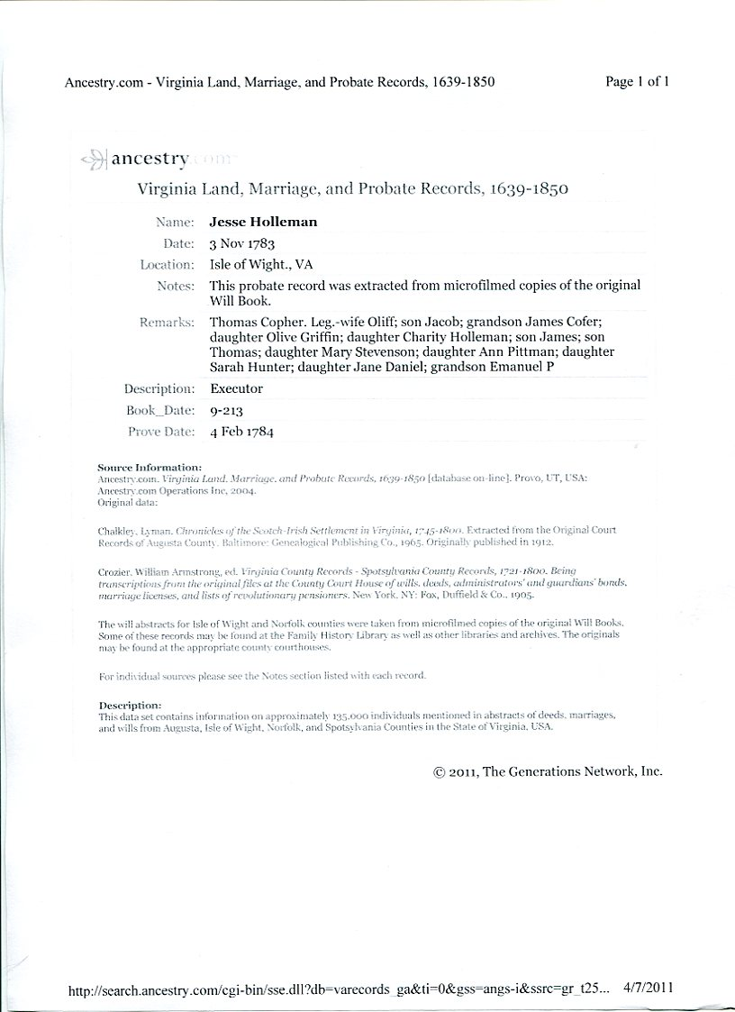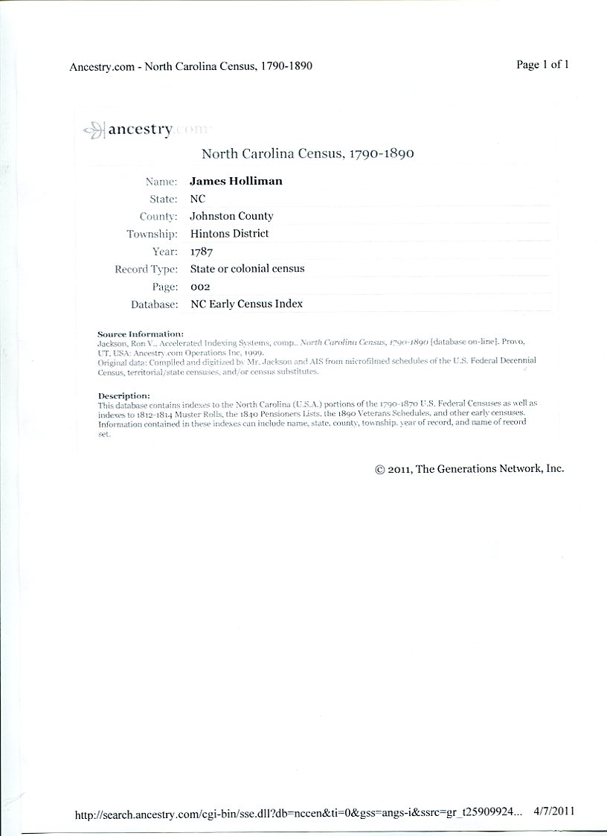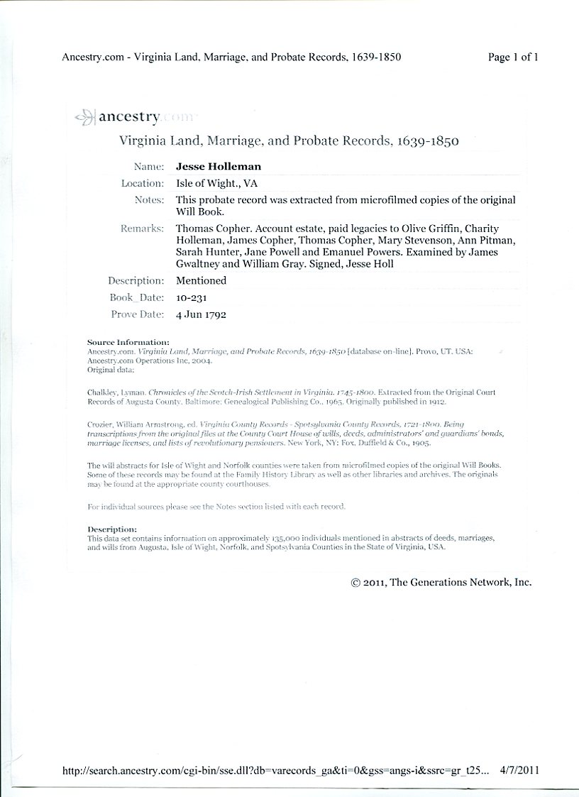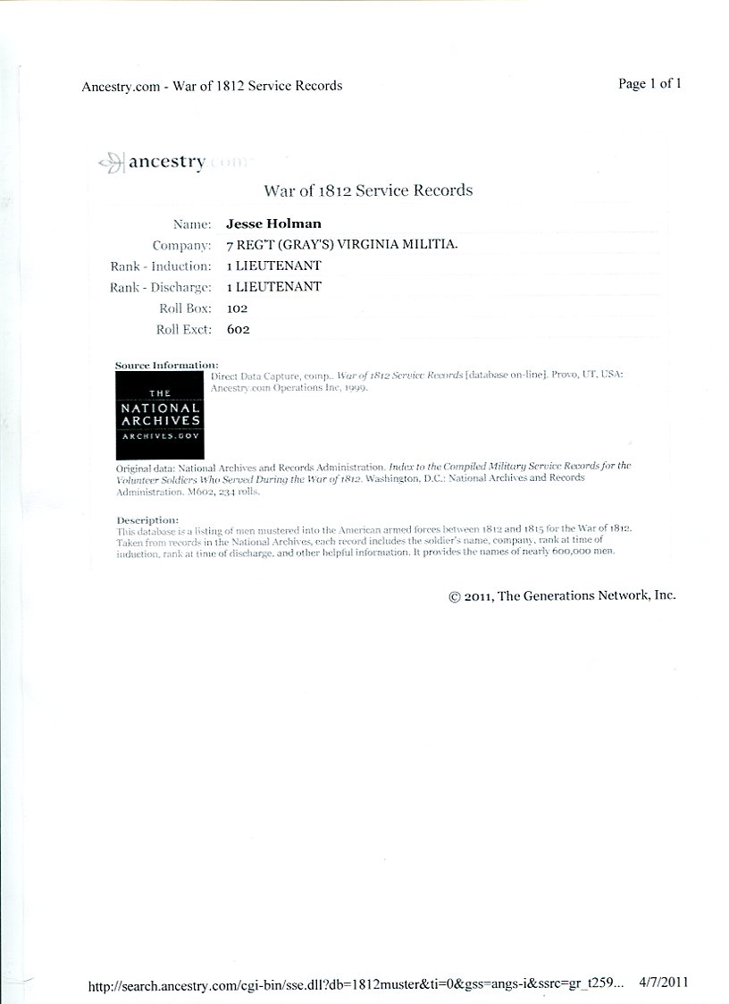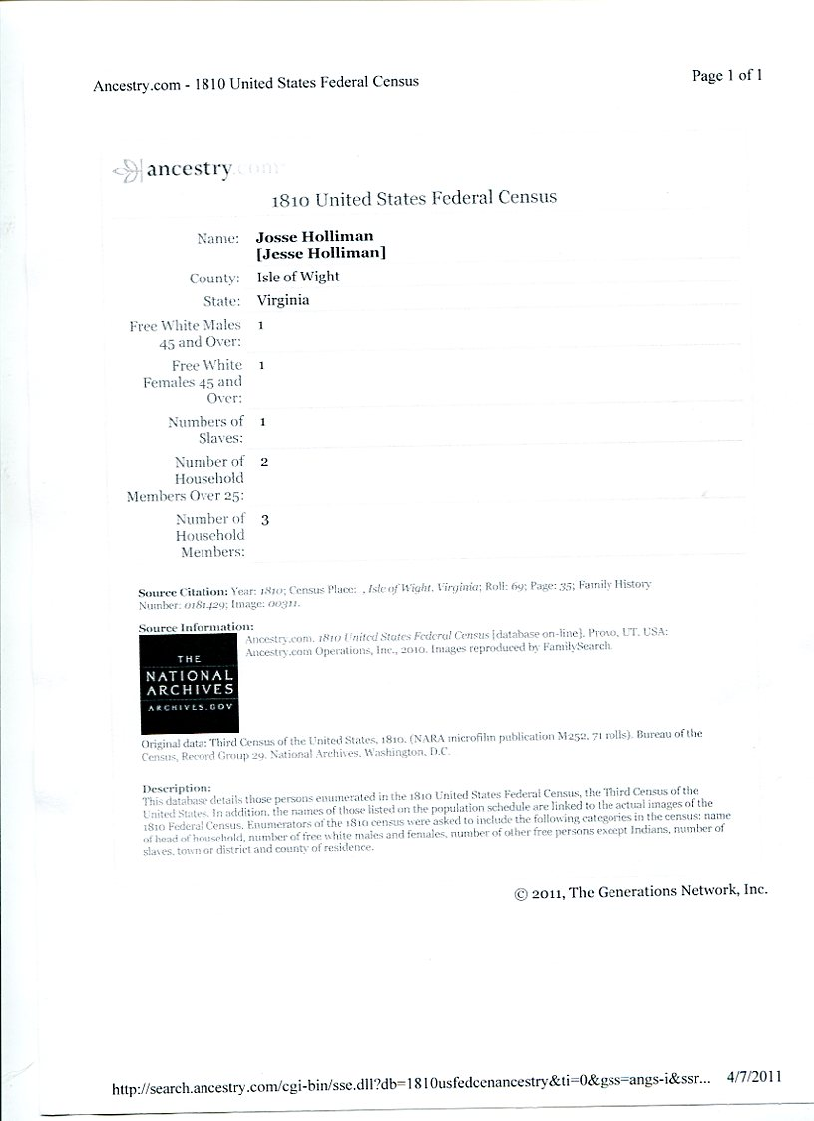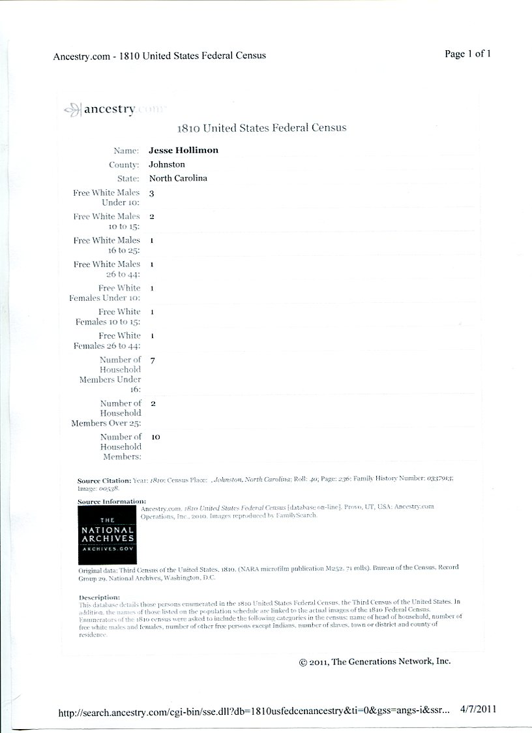
Glenn, I worked up a little time line on Jesse Holliman Sr. Of interest is that he was a minister at Mill Swamp Baptist Church. Here it is:
1737 Birth, Isle of Wight, VA
1753 Age 16, Marriage to Charity Frances Cofer, Isle of Wight, VA
1771 Age 34, Appraised John Jones Estate, IOW, VA
1779 Age 42, Replaces James Cofer as surveyor of IOW, VA
1783 Age 46, Executor for Thomas Cofer's Estate, IOW, VA
1790 Age 53, Residence, IOW, VA
1798-1801 Joint Minister with John Gwaltney of Mill Swamp Baptist Church
1801 Age 64, Became guardian of IOW orphan John Fones
1810 Age 73, Residence, IOW, VA
1816 Age 79, Marriage to Frances Stringfield, IOW, VA by John Gwaltney
Listed in the Ministers Returns of Marriage, IOW Co. Marriage Register
1819-1820 Age 82-83 Minister Mill Swamp Baptist Church
1829 Age 83, Residence IOW, VA
25 Sep 1824 Age 87, Will, IOW, VA, Will Bk Vol 17, pgs 101-102
Dec 1824, Age 87, Death, IOW, VA
Military: Revolutionary War Patriot, held a rather civil engineering position surveying roads, etc for the military. They had to have roads to move troops around, just like today.
Jeanette
Before, I have not weighed in on this discussion on the David Hollimans, but, have been itching to do so here in the last coupla weeks. Listed below is a lot of speculation, as most of you will be able to discern, but, some of it is in the record books.
To begin with, I do not agree that Jesse Holliman, son of John, is the father of James Grantson. Let's look at the dates, to begin with. Jesse, born abt 1737 married Charity Cofer, believed to be born at a later date, in 1753, as recorded in some county record books of those times. She would have been far too young to have born children at her tender age. Another county record book records Jesse and Charity's marriage date as 1783. A close look at this date will reveal that the "5" and the "3" numbers have often been transcribed wrong, due to the ancient script writing of some of the early Colonial aurthors' caracteristic handwriting. I am sure all of you have experience some of this from time to time. A look at the marriages of some of Jesse and Charity's children, revealed that they were getting married as early as 1780, and on up to over 1800, and some even after that. It is not unusual for some males to get married from age 17 to
well into their 50's, but, most females normally married from age 16 and up to age 30, in a normal marrying group. In looking at the dates of these children's marriages, it is easy to assume that the marriage date of Jesse & Charity in 1753, is not "just right", but, that a more plausible date of 1783 is also up for suspicion. Without having seen the marriage certificate, I would suggest that the marriage date was after 1753, but, before 1783, and recordings of these were, more or less, afterthoughts by the county clerks.
Another of my favor "thought" following of certain Hollimans' etc., is the number of "Davids" that are in that age group. I believe that Samuel Hollyman, son of Christopher, Jt., who married Elizabeth, and moved to Edgecombe Co., NC, also named one of his children Samuel, and he also had a son named David, along with Isham Holliman. The David Holliman, who died before July, 1783, and whose Will was administered by Isham Holiman, was the son of Samuel & Elizabeth Holliman of Edgecombe Co., NC. The David who died in 1783, had a number of minor children. David's wife was named Mary -not too sure who this Mary was. My belief that this David had a son also named "David" who married another Mary? after 1800. This David died about 1812, leaving in his family another "David" son. So many I lost track. Isham Holliman married in 1799, to a widow, and they had one child before Isham passed on around 1810.
Richard Hollyman, who married Margaret House before 1704, when she was called before the court to answer to who was the father of her child. Richard Hollyman was named, and, it appears that they were most likely married by that time, but, not sure - no proof. Richard had a son named Samuel, who married Jane McGlohon, and they had a son who was named Samuel, which this one married Christine. These Samuels mixed with the ones out of Edgecombe Co., NC, where they were in Wilkes Co., GA in the early years. Got'em all tangled up in there, I believe. I think you see the 'leaning" though. In around 1785, Samuel Hollyman, age 79, can be found on the tax rolls in NC. I believe this to be the son of Richard & Margaret.
My line of the Hollymans comes through two of the sons of Chris, Sr. Thomas and William are my line. My research on the other Hollimans, etc., is for curiosity, because of the name Hollyman, etc.
Joe Parker
April 29, 2010

