by Glenn N. Holliman

Continuing our Series of Wilson Photographs....
Cousin Shirley Sorrell has an important collection of photographs of her (our) ancestors who were born and for many, lived their lives in the North Fork of the New River in Ashe County, North Carolina. She has been gracious to share their pictures and stories. We continue the series with more on John Wilburn Wilson (1855-1928), a son of Isaac (1822-1864) and Caroline Greer Wilson's (1828-1911).
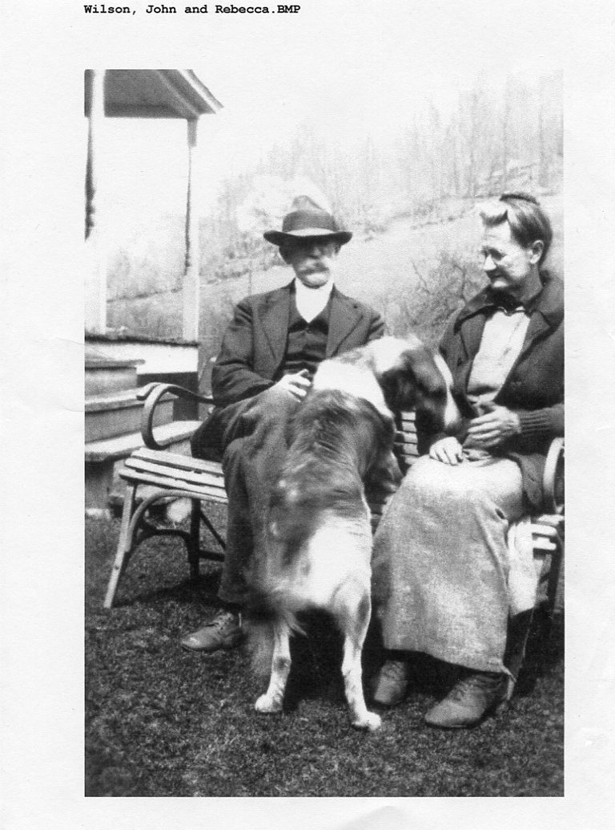
John and Rebecca Wilson Wilson (1862 - 1954) had ten children who lived to maturity, and while some descendants still reside in the Western North Carolina mountains, many have dispersed across the United States.

Shirley Sorrell writes "Thomas “Conley” Wilson was born Feb 18, 1882 and died Dec 9, 1957. He married Verde M. Barlow, (1880 - 1969). Their children are Marie Wilson (1908-2001), Conley Argus Wilson (October 3, 1909 - January 3, 1994) and Thomas “Earl” Wilson (October 22, 1913 - July 23, 1977). Earl married Neva Howard ( b. Aug 12, 1912).
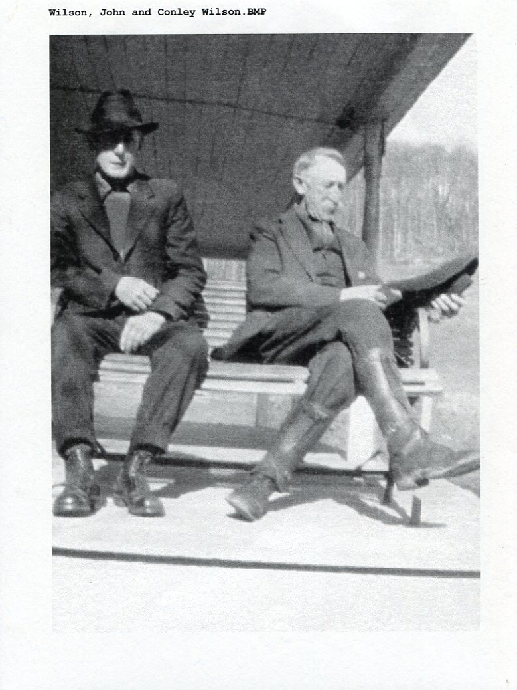
Conley lived all his life on a farm right down from the Issac Wilson home place. The house is on the right just before Wilson cemetery on Oscar Wilson Road. John and Rebecca, his parents, lived a little further up the road from him. He died of what appeared to be a heart failure in his barn. His son Argus found him."
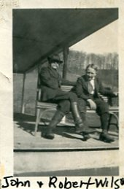

Again from the notes of Shirley Sorrell: "Robert was the last child of John and Rebecca, born June 4, 1906 and died May 18, 1987 and is buried in Guildford Memorial Park in Greensboro, NC. He went out West with his nephew, Earl Wilson (son of his brother Conley). Robert was a bachelor for a long time. He did marry Imogene (name unknown) from Galax, Virginia and had no children. They lived in High Point, North Carolina where he worked at Sears in Greensboro for years. Imogene worked at Pilot Life Insurance.

He loved horses but his wife did not want him spending money on them. So he would buy one and say it was his nephew's, Clyde Wilson. Clyde was the oldest son of Robert's sister, Bessie Wilson. He did have dogs and cats at home. Clyde Wilson, his wife Tincy and their daughter Kathryn lived in High Point also. Robert ‘s youngest sister, Ruth Wilson Hurt, lived in Greensboro within miles of Robert. Imogene and Ruth fought like cats and dogs!"

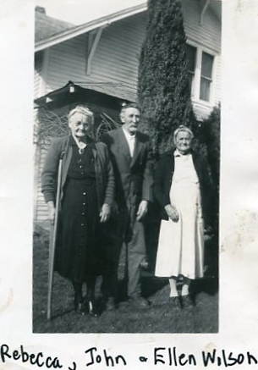

The above picture of Rebecca and John and Rebecca's sister, Ellen, the wife of Bob Wilson, may have been the last taken of John who died in 1928. This photograph was taken at the home of Shirley Sorrell's grandparents, Mayme Wilson and Thomas Edgar Donnelly, in Sutherland, North Carolina.

Below are the obituaries concerning John Wilburn Wilson and his death in 1928. This is has become a comprehensive treasure chest of family names and relations. Notice the reference to the bushwhacking in 1864 of Isaac Wilson by Leonard Columbus Wilson, a cousin by marriage.

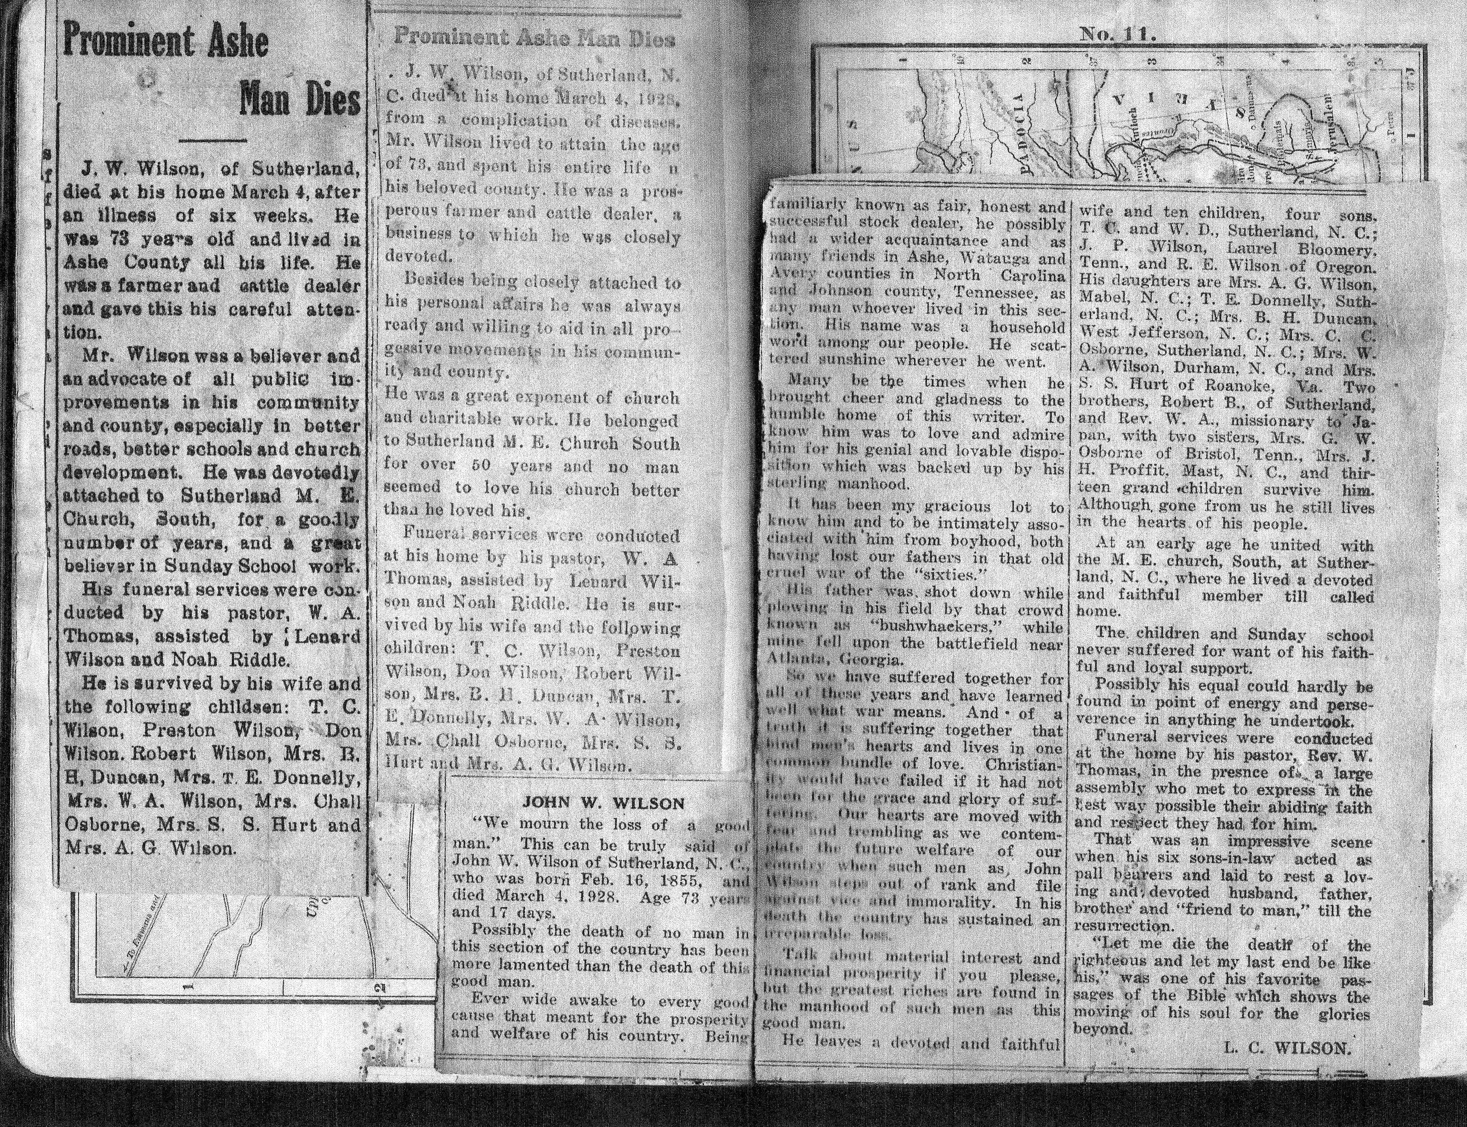

We invite you to rediscover your heritage at a Wilson, Greer, Wilcoxson, Osborne, Forrester, Adams and other families Forum, Saturday, 9 :30 am, July 19, 2014 in the community room of the Boone, North Carolina public library. Sunday, July 20th is also the annual Wilson Homecoming at Sutherland United Methodist Church in Ashe County. In addition, a detailed family tree of the above families is growing at a MyFamily.com site. For details and schedule on the above event and web site, watch this space and/or contact glennhistory@gmail.com. Isaac and Caroline Greer Wilson are great, great grandparents of this writer.

