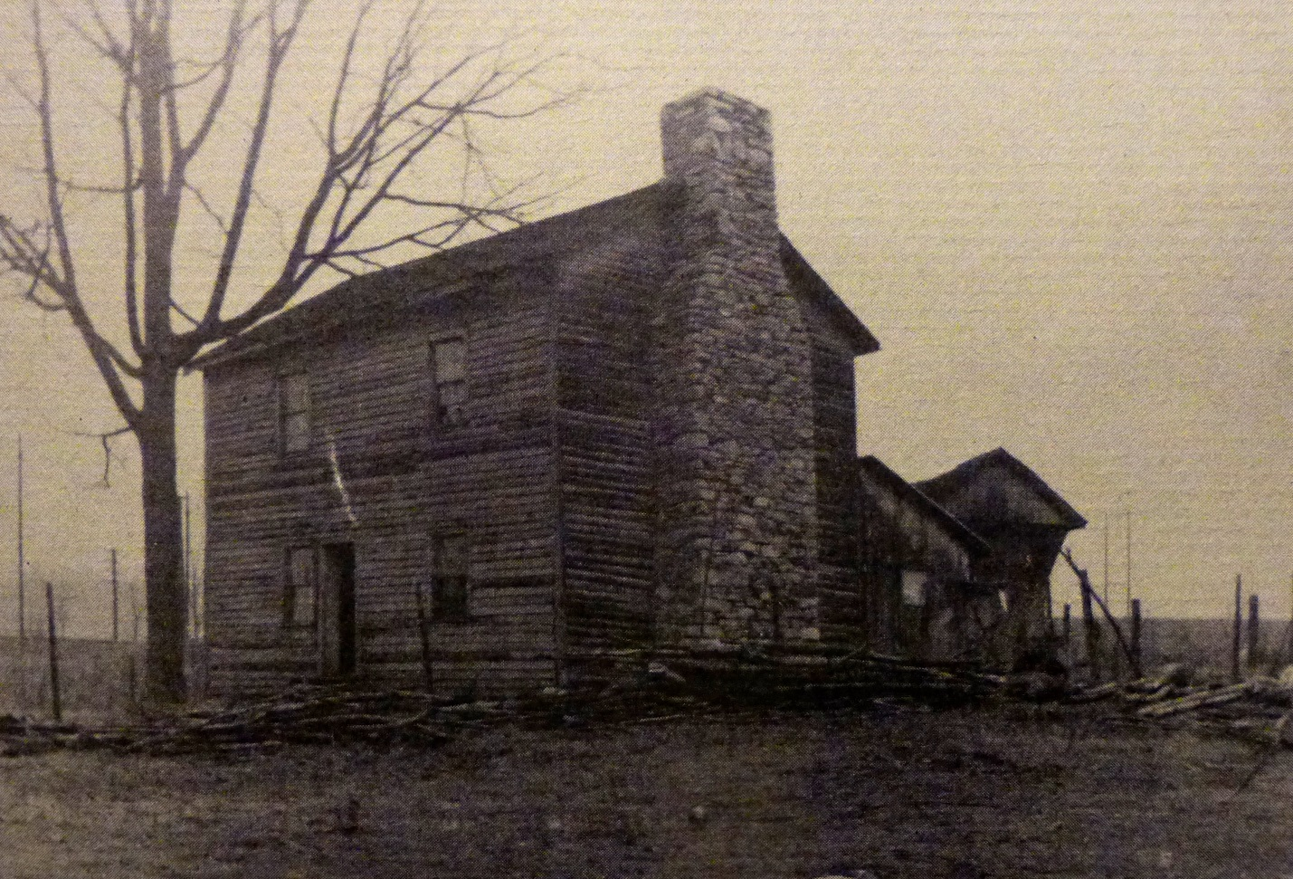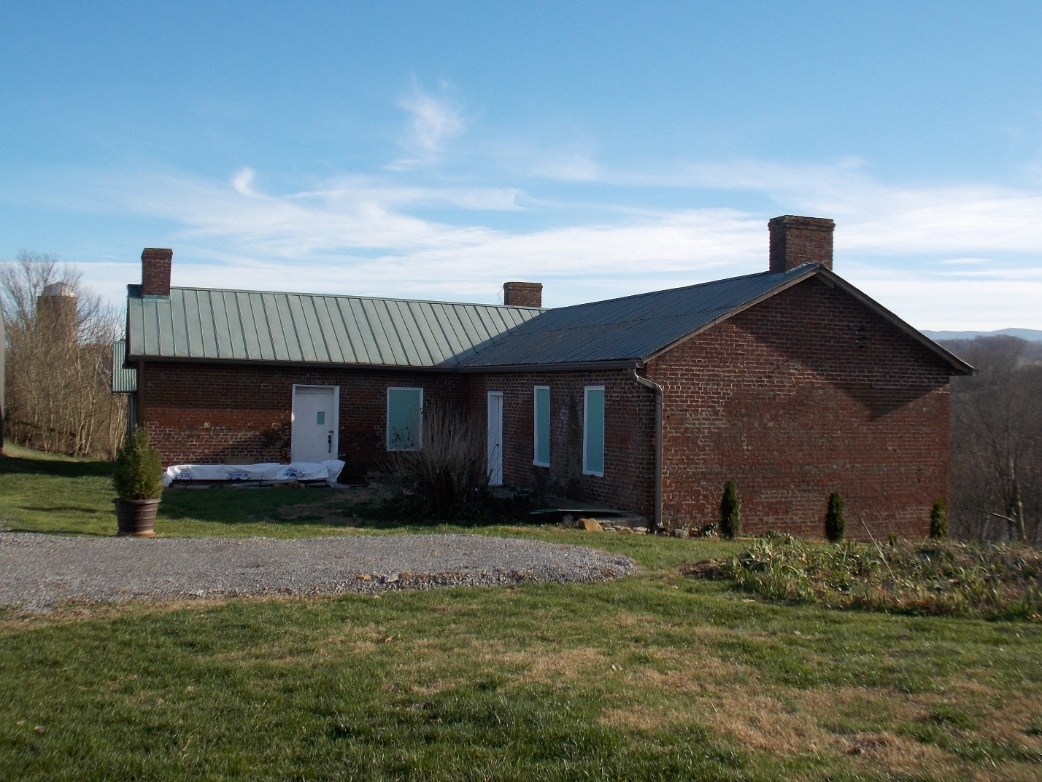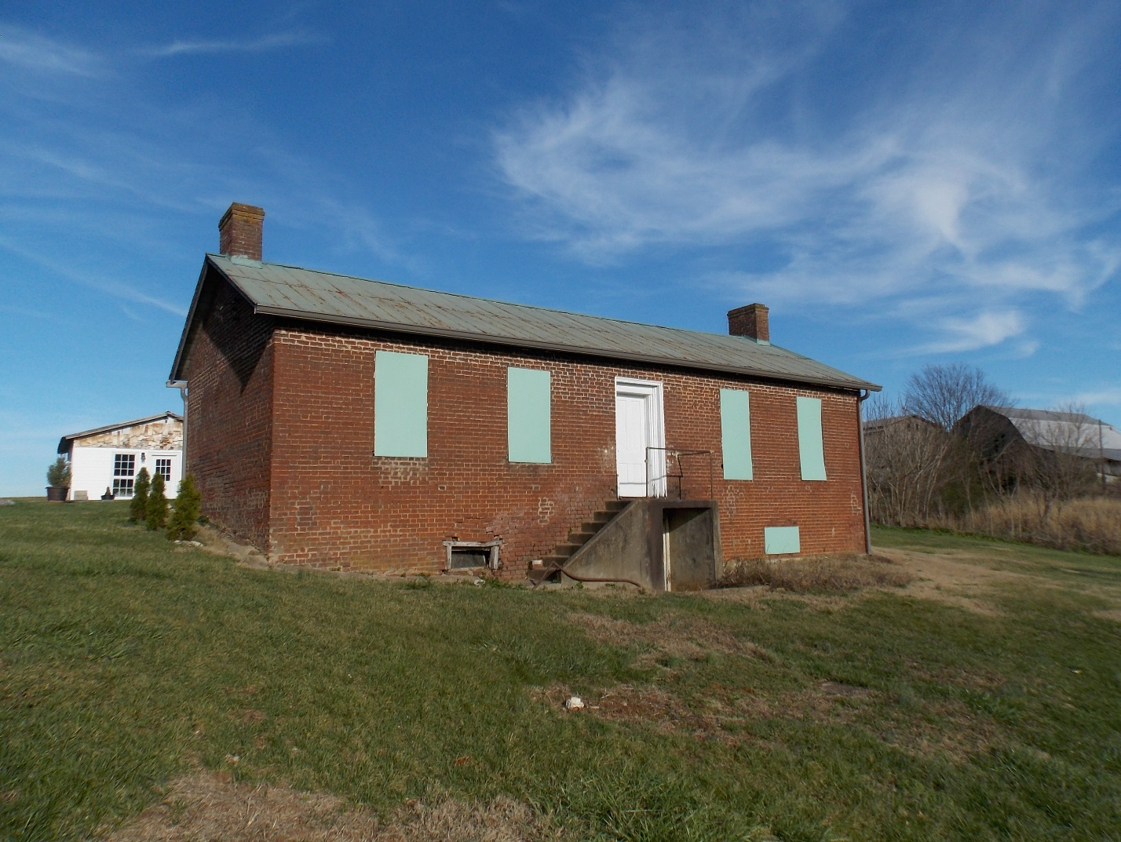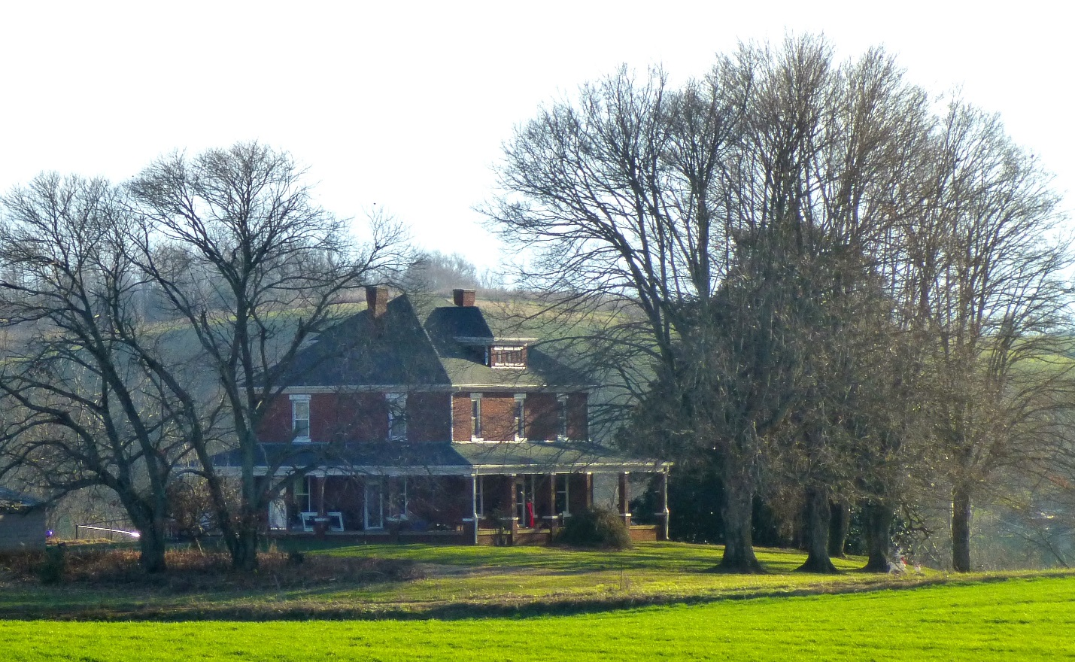
Mary-Bob-Will Noel <rvnrock@hotmail.com> | Feb 8 (3 days ago)
to me

I was looking online and found your page on McCray genealogy. I got interested again after an article in today's Johnson City paper regarding Limestone in the 1880's - it listed John D. McCray as one of the local farmers.

My husband and I moved to Limestone in late 2014 from Asheville, buying (and spending a lot of time fixing up) an historic house situated on the Nolichucky River. Our research has determined our house - a brick Foursquare - was built about 1910, but there is also an older house on the property that appears to have been a kitchen/servant's quarters for an older house that once stood where ours does today - probably built in the 1830's or 40's. We only own 3 acres - the rest of the originally 128-acre farm is owned by folks in Knoxville and still under cultivation around us by a local farmer.

Since we're both archaeologists, we have been researching deeds for the property. I also have been volunteering time with the Heritage Alliance in Jonesborough. Records show the farm was purchased by John D. and May Broyles McCray in July of 1865 from James and Sarah Beard Broyles - they referred to it as the Beard Estate. Assume this was an interfamily purchase (daughter and new husband?). The McCrays owned the property until 1907 when they sold it to the Shanks family, who tore down the older main structure and built our existing house. The older small house - not in livable condition right now but stabilized, would have been present and in use when the McCrays owned the property.

The first record I could find in the WA County Courthouse for the land dates from 1812 and shows a land grant to Isaac Wilson (maybe IW Jr by this point?). Other online links I've found show Isaac Wilson Sr acquiring this property (or something very close) in 1776 as a land grant from the British Crown. The Wilsons sold the property to Asa and Susan Broyles in 1837. Based in the architectural elements present, the small house was built by either the WIlsons or the Broyles. Some hand-written notes in pencil on a door jam were written by one of the Broyles.

I'd be interested in learning more about the WIlson/McCray families if your research has turned up some interesting stories. Not sure if you've been out here before or if you live close, but you're certainly welcome to come visit and we can show you the old homeplace.

You can reach me by phone at 423-257-3976.
glennhistory@gmail.com | Mrs. Noel, Wow, how intriguing to read and reread your email. McCray, Broyles... | Feb 8 (3 days ago)
Mary-Bob-Will Noel | Feb 8 (3 days ago)
to me

That would be fine. Safe travels.

I'll scan the article and email it.

