James Hollyman ca 1767 – 1853
James was born in Cuddington in 1767 and was baptised in the church of St Nicholas on 21 December 1767. He married Elizabeth Cook in the church of St Mary the Virgin in Long Crendon on 17 November 1791. They had 7 children (4 daughters and 3 sons), all of whom were born in Long Crendon. I suspect therefore that James moved from Cuddington to Long Crendon in 1791 when he married. Elizabeth died on 20 May 1807 and was buried in Long Crendon church. James then remarried six months later (no doubt to get help looking after all his many children!) on 30 November 1807 – to Elizabeth Wright. James and the second Elizabeth then had 4 children – 3 sons and 1 daughter. In the 1841 census (the earliest English census to have survived) James was an agricultural labourer and I suspect that he had been such all his life. His second wife died on 6 January 1851 and by the time of the 1851 census three months later James was living with his son Richard. James died in 1853 and was buried at Long Crendon on 14 September 1853.
James Hollyman 1797 – 1866
James was the fourth child of the marriage of James and the first Elizabeth. He was born in late 1797 and was christened at Long Crendon on 12 January 1798. He too was an agricultural labourer who lived all his life in Long Crendon at various addresses. James married Sarah Hendry in about 1821 and they had 5 children – Thomas, Ann, Jane, Charles and John. James died on 20 May 1866 and was buried at St Mary the Virgin church two days later. James had been a widower for about 6 years. His surname was Hollyman in earlier years but was, on occasions, Holliman.
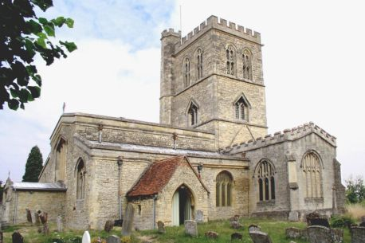
Church of St Mary the Virgin, Long Crendon.
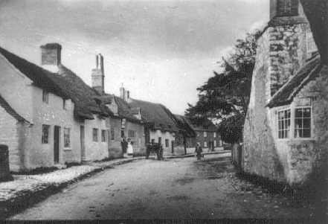
High Street, Long Crendon ca 1890 – this view will not be significantly different to that in the mod 1800s.
James had a half-brother, Richard, 1809-1854, who was imprisoned in 1837 for stealing potatoes. The following are extracts from the book of the letters of Thomas Hayton who was vicar of Long Crendon for several decades in the 1800s. They paint a pathetic picture

