In previous articles, Lindsay Holliman of England has been tracing his branch of the Holliman family from the time of Thomas Holyman, d 1588. Thomas was the common great grandfather of Lindsay and myself. One of Thomas' children stayed in Cuddington, Buckinghamshire, the ancestor of Lindsay. The story of his descendants continues including a 4th great half uncle whose story could have come from Charles Dickens.

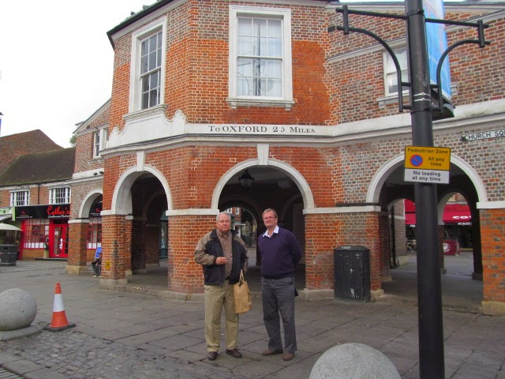

November 2014 Glenn, left, and Lindsay Holliman, right, stand in front of the medieval market place in High Wycombe, Buckinghamshire, England the home of a 14th Century Richard Holyman and another probable great grandfather!
Another son, Christopher, my 9th great grandfather, married into the Lee family and moved to Sherington, Buckinghamshire. One of Christopher's sons, Thomas moved to Bedfordshire from which one of his sons, Christopher Holyman migrated to Isle of Wight, Virginia and started most of the American Holliman (various spellings) families. In previous postings, Allen Holleman of North Carolina, has reported on his branch in the 19th Century. It is interesting to compare how the lives and fortunes of Old World and New World Hollimans unfolded. -GNH

The English Ancestors of Lindsay Holliman continued...by Lindsay Holliman
Prior to the 17th Century, early generations in my tree appear to have been both reasonably well off and educated. Later on, however, probably as a result of being younger children, my branch became more menial and less literate. As I have written in earlier articles, the short move from Cuddington, Buckinghamshire to Long Crendon took place in the latter part of the eighteenth century, possibly following the marriage of James Holyman (ca 1767 – 1853) to Elizabeth Cook who was from Long Crendon. Both villages are approximately 40 miles west of London.
During the 19th century many of the local women were lace makers working from home to provide supplementary income whilst being available for the children. My great great grandmother, Sarah Hendry, was a lace maker. She was the wife of John Holyman (1797-1866) who worked at the Manor.
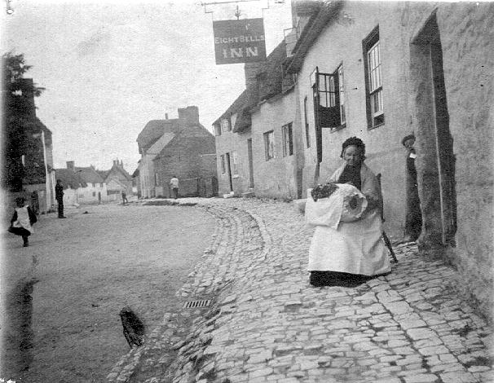
The above picture is of a Long Crendon lacemaker working outside her house in the late 1890s. It also shows Long Crendon High Street - a view which would have not changed much over the 19th century, and therefore familiar to everyone mentioned above in this email. Lace makers worked outdoors wherever possible because the light was much superior.
James had a half-brother, Richard (1809-1854), my half 4th great uncle, who was imprisoned in 1837 for stealing potatoes. The following are extracts of letters from Thomas Hayton, vicar of Long Crendon from 1821 to 1887. They paint a pathetic picture. (Minor editing of the letter for clarity -GNH)

Crendon, 26 May 1837
Gentlemen:
The following case I submit for your consideration, not, I hope for your approval. It is abstractly the case of the wives of labourers committed to jail on suspicion of petty thefts, whether they – the wives on application for relief - should be uniformly ordered into the workhouse.
Richard Holliman of this parish of Long Crendon is now confined in Aylesbury jail, waiting his trial for having some potatoes on his premises, supposed not to have been his own. He has a wife and three small children under 7 years of age: she, the wife, is a woman of good character, steady, industrious habits.
The Board of Guardians at Thame relieved her out of the workhouse two weeks, but a fortnight ago ordered her into the House, agreeably with a standing rule in reference to persons so situate. This rule, I, as guardian, never could approve being carried out rigorously into effect, inasmuch as it frequently bore unnecessarily harsh upon a poor female.
This woman alluded to has been undergoing the severest privations rather than fall in with an order, which I cannot but consider Unenglish and against the spirit of the Poor Law.
Starvation, however, is before her, if she does not enter the Workhouse. Doing this she must necessarily give up her Cottage, have her little goods scattered among alien hands, or sold, her garden planted with cabbages is pillaged. Should her husband be acquitted, they will be homeless, almost castaways. These are the obvious consequences of sending her into the workhouse.
I will not pretend to work upon your feelings by describing to you how agonizingly reluctant she is to be compelled to enter the “Prison House” as she calls it, for no fault of hers, and a supposed on of her husband’s …, I am sure you will not sanctions that which I consider to be cruel in the extreme."

Below an English Victorian Work House
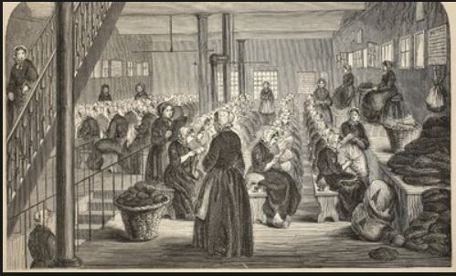
The Poor Law Commissioners did not accede to Thomas Hayton’s pleading and Richard was found guilty and sentenced to six months hard labour at the House of Correction, Aylesbury. The above illustrates the hardship under which the common man existed in times gone by. It is likely that Richard helped himself to the potatoes merely to provide food for his family. This is the same Richard who was looking after his father, James, in the 1851 census. -Lindsay Holliman
Next English posting...Lindsay's ancestors migrate to the city and begin to rise economically....

