Holliman Family History

Monday, August 4, 2014

The Hollimans of England
by Glenn N. Holliman
In June 2014, this American writer along with Lindsay Holliman, an Englishman with whom most Hollimans (various spellings) in the United States share the same 15th and 16th Century great grandparents, visited common ancestral sites in Long Crendon and Cuddington, Buckinghamshire, England. I asked Lindsay to write up biographies of his descendants, my distant cousins.
Where else would an Englishman take an American cousin to discuss family history? Why to the local pub! Glenn, left, and Lindsay right.
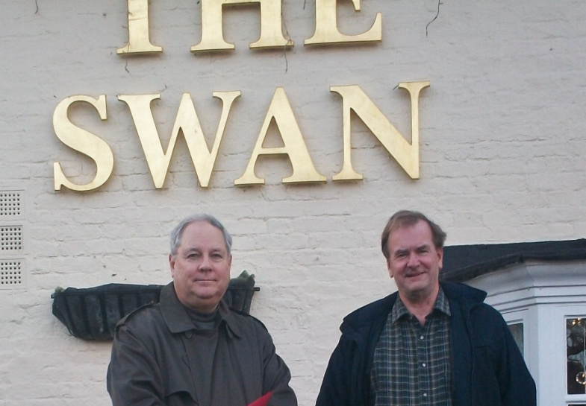
While my American ancestors were moving from Virginia and the Carolinas trekking ever westward and approaching the Civil War, Lindsay's great, great, great grandparents remained in England, striving to earn their daily bread and raise families. Land was not available as it was in the States. Until the Industrial Revolution quickened, many remained tied to their ancestral villages, often working for wealthy English landowners. GNH

First some maps - Long Crendon is located half way between Oxford and Aylesbury in Buckinghamshire.
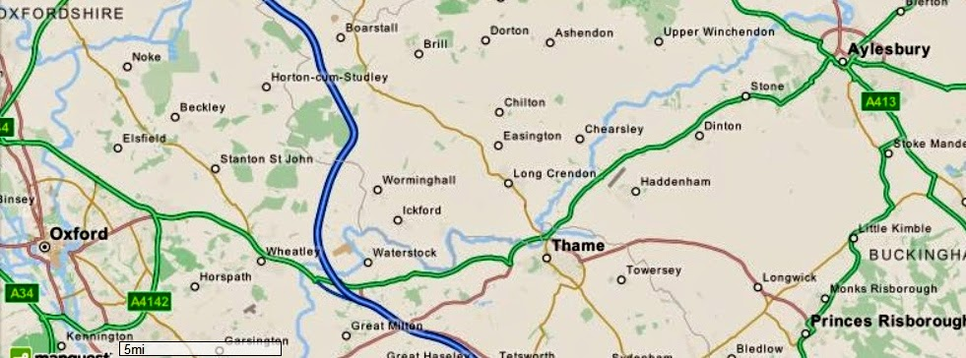
In map 2, notice how close Cuddington and Long Crendon are to each other. Holymans also lived in Haddenham and other villages in Buckinghamshire.
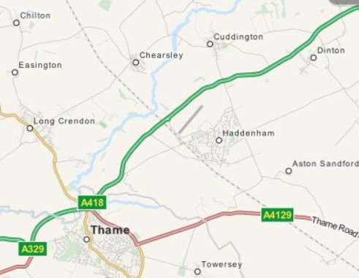
The 19th Century English Ancestors of Lindsay Holliman....by Lindsay Holliman
James Hollyman ,ca 1767 – 1853, my Great, Great, Great, Great Grandfather

James was born in Cuddington, Buckinghamshire in 1767 and baptized in the church of St Nicholas on 21 December 1767. He married Elizabeth Cook in the church of St Mary the Virgin in Long Crendon, a village three or so miles away, on 17 November 1791. They had 7 children (4 daughters and 3 sons), all of whom were born in Long Crendon.

I suspect therefore that James moved from Cuddington to Long Crendon in 1791 when he married. Elizabeth died on 20 May 1807 and was buried in Long Crendon church. James then remarried six months later (no doubt to get help looking after all his many children!) on 30 November 1807 – to Elizabeth Wright.
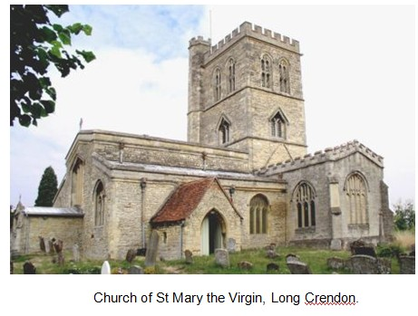
James and the second Elizabeth then had 4 children – 3 sons and 1 daughter. In the 1841 census (the earliest English census to have survived) James was an agricultural labourer and I suspect that he had been such all his life. His second wife died on 6 January 1851 and by the time of the 1851 census three months later James was living with his son Richard. James died in 1853 and was buried at Long Crendon on 14 September 1853.

James Hollyman ,1797 – 1866, my Great, Great, Great Grandfather

James was the fourth child of the marriage of James and the first Elizabeth. He was born in late 1797 and was christened at Long Crendon on 12 January 1798. He too was an agricultural labourer who lived all his life in Long Crendon at various addresses.

James married Sarah Hendry in about 1821 and they had 5 children – Thomas, Ann, Jane, Charles and John. James died on 20 May 1866 and was buried at St Mary the Virgin church two days later. James had been a widower for about 6 years. His surname was Hollyman in earlier years but was, on occasions, Holliman.
Below, Long Crendon in the 1890s...the thatched cottages survive into the 21st Century.
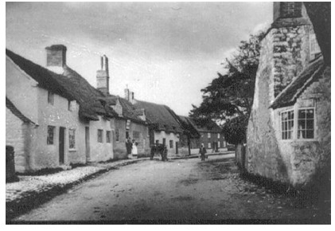
Next more on Lindsay's ancestors and their participation in the growing affluence of English life in the 19th and 20th Centuries....
Have questions about Holliman family history? You are invited to join the Hollyman Email List at Hollyman-Subscribe@yahoogroups.com and the Hollyman Family Facebook Page located on Facebook at "Hollyman Family". Post your questions and perhaps one of the dozens Holyman cousins on the list will have an answer. For more information contact Tina Peddie at desabla1@yahoo.com, the list and Facebook manager for Hollyman (and all our various spellings!).
There is also a massive Ancestry.com Holyman and Associated Families Tree available for review. For an invitation to this collection of over 18,000 individuals, please write glennhistory@gmail.com.

Posted by Glenn N. Holliman at 7:38 AM
Labels: Cuddington, Elizabeth Cook, James Hollyman, Lindsay Holliman, Long Crendon, Sarah Hendry

No comments:

Post a Comment
Home

clustrmap

Preview
Preview

