James Hollyman ca 1767 – 1853
James was born in Cuddington in 1767 and was baptised in the church of St Nicholas on 21 December 1767. He married Elizabeth Cook in the church of St Mary the Virgin in Long Crendon on 17 November 1791. They had 7 children (4 daughters and 3 sons), all of whom were born in Long Crendon. I suspect therefore that James moved from Cuddington to Long Crendon in 1791 when he married. Elizabeth died on 20 May 1807 and was buried in Long Crendon church. James then remarried six months later (no doubt to get help looking after all his many children!) on 30 November 1807 – to Elizabeth Wright. James and the second Elizabeth then had 4 children – 3 sons and 1 daughter. In the 1841 census (the earliest English census to have survived) James was an agricultural labourer and I suspect that he had been such all his life. His second wife died on 6 January 1851 and by the time of the 1851 census three months later James was living with his son Richard. James died in 1853 and was buried at Long Crendon on 14 September 1853.
James Hollyman 1797 – 1866
James was the fourth child of the marriage of James and the first Elizabeth. He was born in late 1797 and was christened at Long Crendon on 12 January 1798. He too was an agricultural labourer who lived all his life in Long Crendon at various addresses. James married Sarah Hendry in about 1821 and they had 5 children – Thomas, Ann, Jane, Charles and John. James died on 20 May 1866 and was buried at St Mary the Virgin church two days later. James had been a widower for about 6 years. His surname was Hollyman in earlier years but was, on occasions, Holliman.
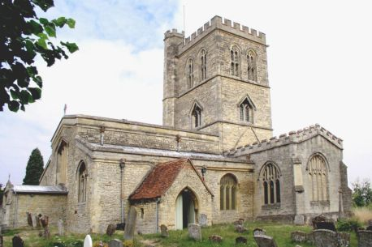
Church of St Mary the Virgin, Long Crendon.
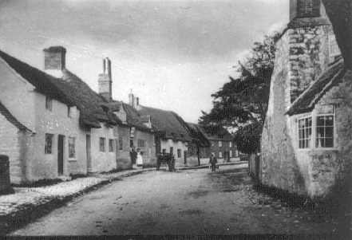
High Street, Long Crendon ca 1890 – this view will not be significantly different to that in the mod 1800s.
James had a half-brother, Richard, 1809-1854, who was imprisoned in 1837 for stealing potatoes. The following are extracts from the book of the letters of Thomas Hayton who was vicar of Long Crendon for several decades in the 1800s. They paint a pathetic picture
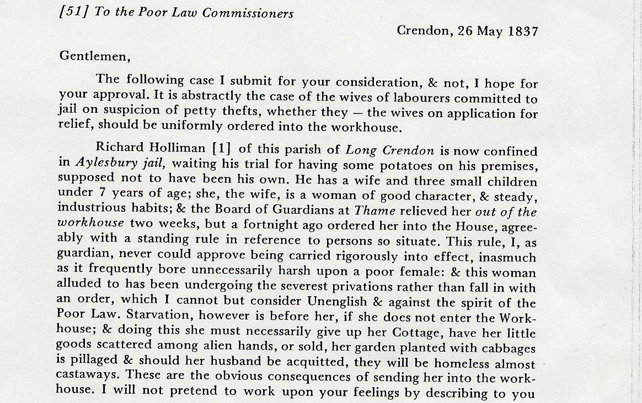
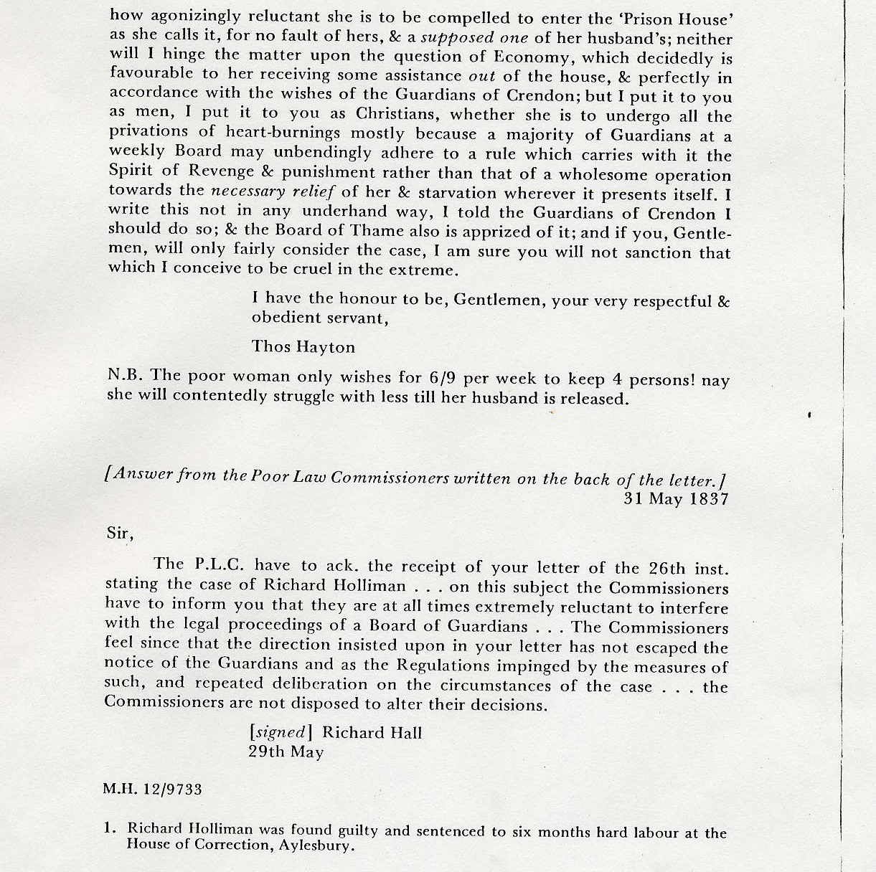
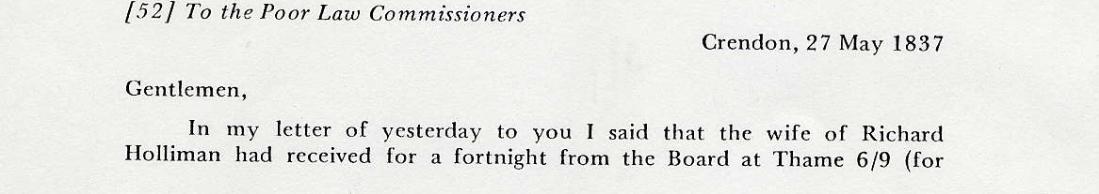
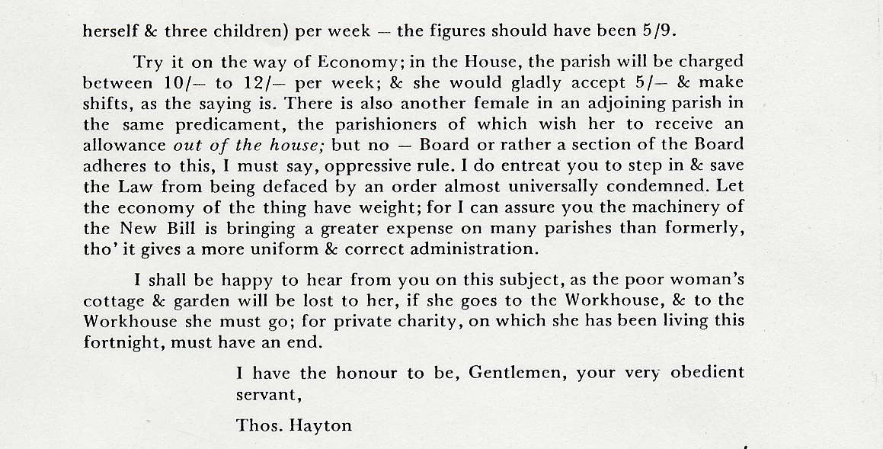
The above illustrated the hardship under which the common man existed in times gone by. It is likely that Richard helped himself to the potatoes merely to provide food for his family.

John Holliman 1831 – 1907
John was baptised at St Mary's Church, Long Crendon on 11 September 1831. He appeared in 5 census returns in Long Crendon (1841, 51, 61, 71 and 1901) and in all of these he was an agricultural labourer living in Frog Lane (now Frogmore Lane) in the shadow of Long Crendon Manor. In the 1851 census he was actually resident at the manor house. John married Zillah (Lillah) Sherriff at Long Crendon on 1 June 1855, both signing the marriage register with a X. John & Zillah had one son – James. Between 1871 and 1881 John and family moved to Chelsea in London presumably to seek a better life. In the 1871 census he was still a labourer but in 1891 he described himself as a furniture dealer. For some reason John had returned to Long Crendon by 1901 when he was back in Frog Lane as a labourer. Wife Zillah died in Long Crendon on 10 February 1902. John himself died on 1 May 1907 in Littleport, Cambridgeshire, having joined his son and family there, and was buried 5 days later. His occupation at death was shown as farmer.
James Holliman 1859 – 1932
James was baptised in Long Crendon on 17 April 1859. In 1871, aged 12 he was an agricultural labourer. He then moved to Chelsea, London with his parents and lived with them at the 1881 census. On 14 December 1885 he married Louisa Pettifer Atkins at St Luke’s Church, Chelsea. His profession at marriage was general dealer. In 1891 he was a fishmonger and he must then have 31 March decided to stay in London when his parents went back to Long Crendon. At the census on 31 March 1901 he was a greengrocer still living in Chelsea.
At some stage between 1901 and 1911 James and family moved to Littleport, Cambridge and they lived here when James’ father died in 1907. By 1911 however the family had moved to Cambridge and James classed himself as a hawker whilst his wife Louisa has started a servant’s registry office. John then became a hardware dealer from premises in Mill Road Cambridge and sometime between 1922 and 1925 this developed into a full house furnishing business in King Street - the middle of Cambridge. It appears fairly certain that Louisa was the driving force behind the development of the business. James died on 2 August 1932 and was buried on 5 August. Louisa had predeceased him on 20 July 1931. They are buried together in Mill Road Cemetery, Cambridge. James & Louisa were very active in the Cambridge Corps of the Salvation Army and it is believed that they became Salvationists at an early age.
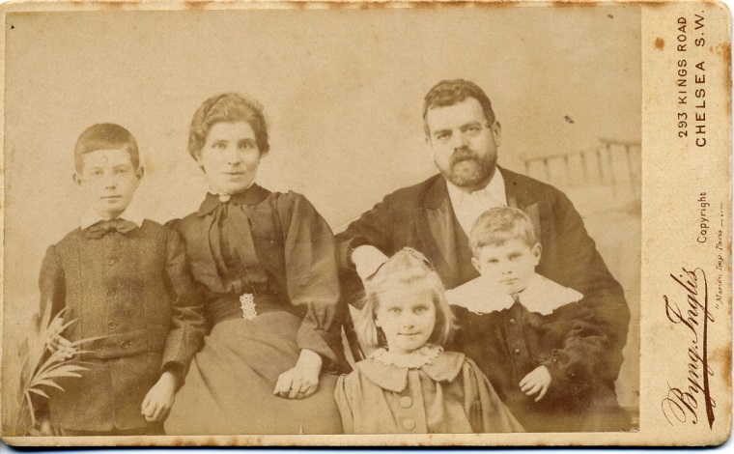
James & Louisa Holliman in about 1898 with children l to r George, Ada and William.
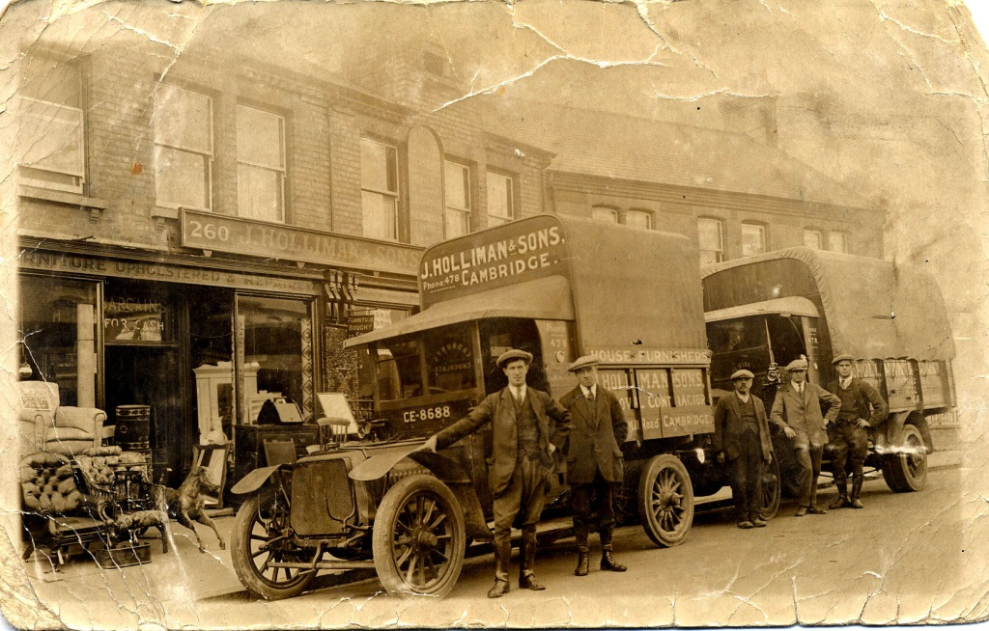
The family business in about 1924 – prior to moving to King Street, Cambridge. L to r: George James Holliman, Thomas Emmines (husband of Ada), James, William Thomas and John Alfred Holliman. The vehicles were likely army surplus ambulances.
George James Holliman 1889 – 1950
George was born in Chelsea on 2 March 1889 and was christened there on 31 March that year. He was the eldest of four children, the others being in order of age Ada Eleanor Mildred Holliman (1890), William Thomas Holliman (1894) and John Alfred Holliman (1900). On 28 October 1908 he married Florence Howlett in the Registry Office at Littleport, where the family were staying at the time. She was a native of Littleport. By the 1911 census George had the splendid job title “horsekeeper for jobmaster” – ie he looked after the horses for someone who hired out horse drawn carriages for domestic use. George was a cornet player in the Cambridge Salvation Army Band and by 1914 he had become bandmaster. However by 1916 George was in Bologne driving Salvation Army ambulances and he did this until his service was terminated on 28 January 1919 when he & his brothers helped their father James in the family hardware business as it was at the time. The brothers worked in the business all their working life and the business was eventually wound up in about 1970 when John Alfred retired. George died suddenly during the night of 3 December 1950 and was buried on 7th December. George & Florence had two children – Irene Mildred and Frederick George.
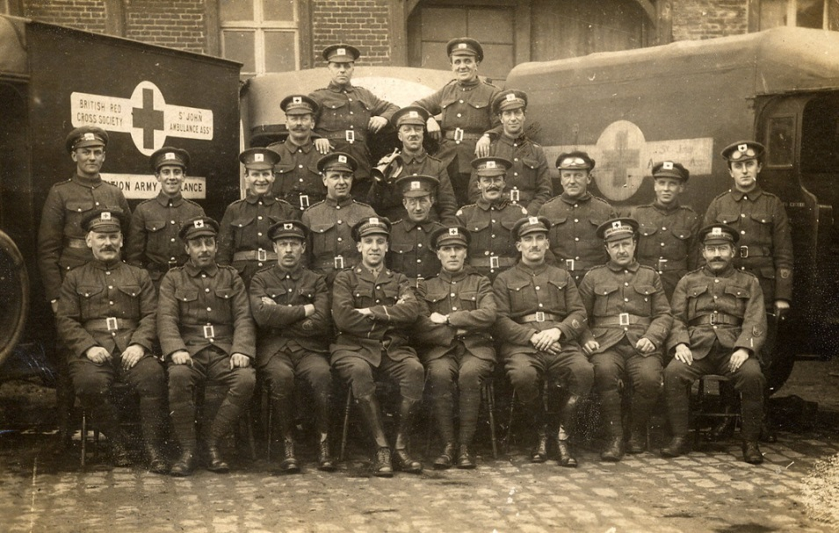
1915 WWI ambulance drivers. George James Holliman is on the right in the second back row.

Frederick George Holliman 1920 – 2001
He was born on 9 January 1920 and went to school and university there. A scholarship to Trinity College in 1938 launched him on his academic career and set its form. An attempt to join the Fleet Air Arm was deflected into wartime research that mixed unconventional and dangerous work on flames and poisons with a classical PhD in stereochemistry. He was elected to a fellowship at Trinity in 1943 and to a university demonstratorship in 1945. He married Dora Circuit at the Bedford Salvation Army Citadel on 12 July 1945. They had children Lindsay in 1946 and Philip in 1950. In 1947 he left to teach at the University of Cape Town (UCT) and was made professor of organic chemistry 1950, aged 30. He then became head of the chemistry department in 1955 and, a few years later, Dean of the Faculty of Science. During this time apartheid was being developed and Fred, along with others, were very active in trying to keep South African universities open to all. In 1962 the family returned to England, living in Harrogate in Yorkshire where Fred was a professor at Leeds University. He retired in the early 1980s and eventually lived in Market Harborough, Leicestershire where he died on 13 November 2001, two months after wife Dora.

Lindsay Ayrton Holliman 1946 –

Born in Cambridge on 3 June 1946 he went to South Africa with his parents in 1947 and, apart from two returns to the UK, in 1949 and 1952, when his father had sabbatical years, lived in the Cape until 1962. He finished schooling in Harrogate, Yorkshire before going to university in Manchester. He then worked with Formica in North Shields for three years during which he met and married Madeleine. First son Philip was born in North Shields but soon afterwards they moved to Longniddry, a small village in East Lothian in Scotland, and were there for 20 years. In 1993 they moved to Braybrooke near Market Harborough. Lindsay retired in 2002.

