Picture Pages

Lockport's
Potter's Field

It is Lockport's most simple cemetery. A huge expanse of level green growing out from encroachments of cement and asphalt along the northern limits of the Davison Road Niagara County Social Services complex. Before Niagara County's bureaucracy began to expand in the 1960's (at the very time its population began to decline) the Davison Road campus was the The County Poor House & Infirmary. It was where the old and infirm, without money or health to care for themselves were taken care by Niagara County taxpayers.
The buildings, most of which are still standing, were used to house the Poor House population, provide rest and relaxation areas for them, feeding, and even a small chapel. And when residents passed on, usually after a long stay in the infirmary, they often didn't go far. Those without families to take care of arrangements were buried in unmarked graves in a large Potter's Field just to the north of what was the County Infirmary Medical Center and is now the County Headquarters for Social Services (Welfare) operations. This Potter's Field is marked today by the single stone memorial framed below.

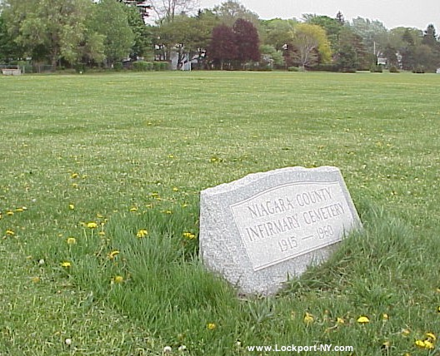
In the far background of the view above, along the northern border of the County's property with Carlisle Gardens, is where a Gypsy couple lived who took care of "burial arrangements." They dug the graves and did the necessary (and only necessary) "prep work." They lived in a sort of shack and were paid a modest amount by Niagara County along with room and board to care for the Potters Field.
Once in a while a child orphan in County care would die and would join the rest in this field of unmarked graves. Some time later the County's collective conscience called for placing a special acknowledgement of the small number of children buried here. The only other stone memorial or mark in the large field is the one shown below.
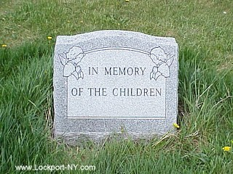

Historical Background
The following excerpt from the Gospel of St. Matthew (27:3-6) is probably the origin of the name Potter's Field. Even in pre-Biblical times, man felt the obligation to do justice and honor to the dead with proper burial.
When Judas, the traitor, learned that Jesus had been condemned, he repented and took back the thirty silver coins to the chief priests and the elders. "I have sinned by betraying an innocent man to death!" He said.
"What do we care about that?" they answered. "That is your business!"
Judas threw the coins down in the Temple and left; then he went off and hanged himself. The chief priests picked up the coins and said, "This is blood money, and it is against our Law to put it in the Temple treasury." After reaching an agreement about it, they used the money to buy Potter's Field, as a cemetery for foreigners.

News, Views, History, Links, References, Photos, & Information
The Lockport Home Page Is Today's...
PICTURE OF LOCKPORT
www.Lockport-NY.com

