A. Raphael Beck
Celebrated American Artist
Lockportian 1858 - 1947

Profiles In Lockport History And Pride From
www.Lockport-NY.com
Today...and Yesterday's
PICTURE OF LOCKPORT

Lockport Tourism Website Lockport Points Of Pride Lockport History Site Lockport Latest

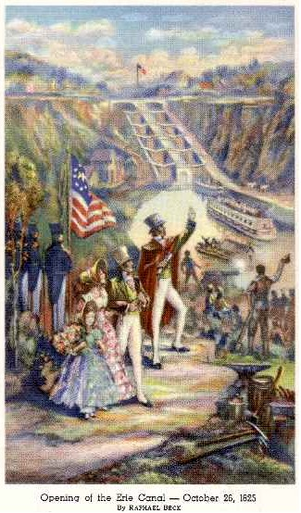
A. Raphael Beck was an internationally recognized American artist and resident of Lockport. He was the winner of three international expositions but is most famous, locally, for his famous mural entitled "The Opening Of The Erie Canal." The work was commissioned by the Lockport Exchange Bank and the famous mural was in the bank's impressive lobby and banking area in its building at Pine and Main Streets for many years.
Sometime after Manufacturer's and Traders Trust Company bought out the Lockport Exchange Bank. The bank's lobby became a victim of early corporate cost-cutting. It was a huge lobby and expensive to heat. The ceiling was lowered and the famous Beck mural was given to the Lockport School District for display in the High School auditorium where it remains today. It is not available for general public viewing although students see it when they attend events in the auditorium.
Manufacturer's and Trader's Trust Company became M&T Bank and further downsized their Lockport operation in the early 1990's. They sold the landmark bank building to developer David Ulrich who has had it as a restoration project for several years, returning the site to much of its original spendor. But, sadly, without the most famous Beck mural.
Reproduced on the left is the color print of the mural, produced for bank customers on a 1938 Christmas Card.

Thanks to Lockport Pager, Peter Buckholtz, for providing a copy of this historic Christmas Card.

Raphael Beck Lockport Home
The former home of Raphael Beck, at 478 Willow Street, across from Locust Park, is still occupied by family members. It is pictured below.
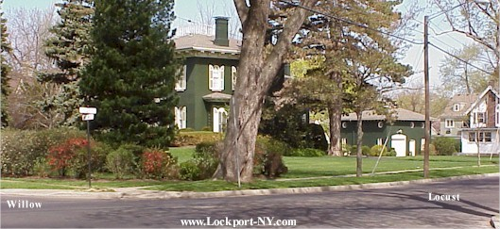
Beck maintained his studio in Buffalo for about 30 years, commuting daily from his home at 478 Willow Street. On his birthday each year he reportedly walked the 23 miles from his home to Buffalo.
Beck is famous for a sketch of former United States President, William McKinley. When McKinley spoke at the Pan American Exposition in Buffalo in 1901, Beck sketched him as he was speaking. Soon thereafter McKinley was shot by an assassin. The portrait was hung in the U.S. Senate in 1901 and later became property of the Buffalo and Erie County Historical Society where it is now on display.
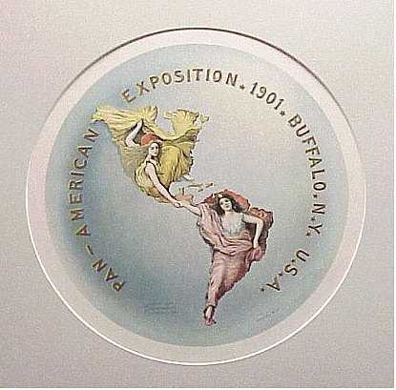
Beck is also responsible for the artwork on the Pan-Am Expo plaque shown in the photo at the left. The logo of two women in the shape of North and South America, holding hands through Central America came to be the most recognizable symbol of the Pan-Am. Beck's design was chosen as the official logo by the Pan-American Exposition Company. The artwork was reproduced on many souvenirs at the Exposition. Is still being reproduced today in connection with the 2001 100th anniversary of the Exposition at Buffalo.
He was born in Lancaster, PA. He was, in fact, named after the great artist, Raphael. Young Raphael Beck learned painting from his father who was a sculptor as well as a painter. Beck was the oldest of the eight children of Augustus Beck, an accomplished artist who designed the bas relief at the foot of the Washington Monument. At the age of 20 he went to Europe where he studied two years in Paris and Munich with other well-known artists of the era. Upon his return to the United States he chose Lockport to settle in and was a life resident here thereafter.
A. Raphael Beck, known as Lockport's greatest artist, is enrolled in the Lockport Walk of Fame (downtown off Main Street at Urban Park Plaza). He won first prize at the Pan American Exposition in Buffalo, the Louisiana Purchase Exposition in St. Louis, and the Clark Exposition in Portland, OR.
Beck also painted what would become President McKinley's last portrait. During McKinley's visit to Buffalo, Beck observed McKinley during his tour of the Exposition, including the President's speech to a crowd of 50,000 near the Triumphal Bridge. With the preliminary sketches for the portrait completed, Beck left Buffalo for a business trip to New York City. Beck was in New York when McKinley died and he went to work immediately to complete the portrait entitled "President McKinley Delivering His Last Great Speech at the Pan-American Exposition, Sept. 5, 1901."

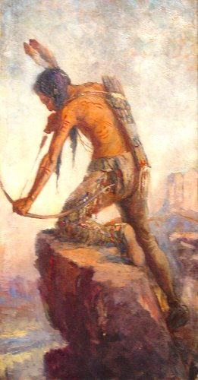
<<<Indian On Attack. The Niagara Frontier had many subjects as this one for Beck to paint. Interest in such pieces was substantial. It is from the VanDeMark & Beck family collection.
Beck maintained his studio in Buffalo for thirty years. He went on to design the logo for the 1905 Lewis and Clark Exposition in Portland, Oregon.
He was born on November 16, 1858 in Lancaster, Pennsylvania. Named after the famous painter, When Beck was 20, after studying with his father, he traveled to Europe for two years to study in Munich with the famous landscape artist, Paul Webber, and then at the Academie Julian in Paris.
After his return to the USA, Beck began his first major commissioned work, a series of murals for the capitol building in Harrisburg, Pennsylvania. It was around this time he selected Lockport as his home.
Beck produced a wide variety of artworks including stain glass windows, life size masks, etchings, oils, watercolors, and large murals, including mural of the opening of the Erie Canal and a portrait of General Lafayette among others. He is best known for his work related to the Pan-American Exposition.

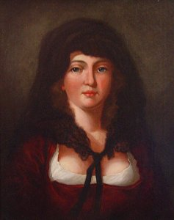
Mystery Woman>>>

Other than the obvious, we have no
information on this beauty painted by
Raphael Beck. From a local,
Lockport collection.

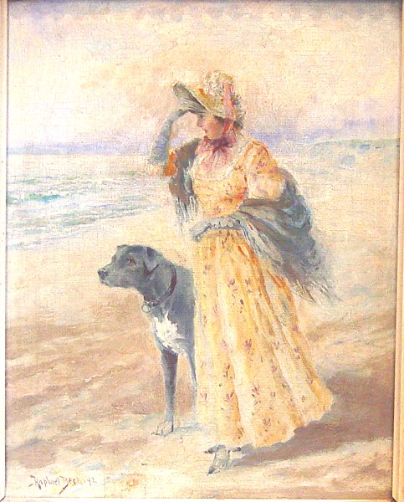

<<< A Lady & Her Companion

This masterpiece by Beck is also included
in a local, Lockport collection. The site
of the painting is unknown to those of us
at the Lockport Page. However, it hardly
seems as if it were composed, or even
inspired at Olcott Beach.

Final Resting Place
A. Raphael Beck is at rest in the Hall Family collection in the Lockport Glenwood Cemetery. Many of
the VanDeMark Family are also here. But this plot is actually that of the Hall family, bought by
Phyllis (Beck)VanDeMark's grandfather, Barnett Dewitt Hall. Allan VanDeMark
(of chemical company and political note) is buried with that branch of the
family. His forebears are buried elsewhere.

Comments From Our Readers
My name is Michael Huffman and I currently reside in Richmond, Virginia. I own several lithographs of Native American Indians passed to me by my great-grandfather, done by the famous resident of Lockport, A. Raphael Beck. I have been trying to document and collect as much information on Beck and his works as I can. I have read the history on him provided in your website and I am curious as to any other resources that might help in my research. I have a particular interest in his works on Native American Indians and any galleries or museums that would market or display his art. I appreciate your time and help.
Michael C. Huffman
E-Mail: Jta1288805@aol.com
5-29-00
Can anyone help Mr. Huffman? Please send copy of your e-mail to us here at the Lockport Page. ---Editor

I saw your article on A. Raphael Beck, and was very interested in the canal picture. I have a copy of it that was given out by the Lockport Exchange Bank in what must have had a calendar attached. It is approx. 5 x 7 and was made by Permanent Sign & Display Co., Reading, Pa. Do you know what year they gave out these calendars? I enjoy your site and have printed some of the pictures out to send along to other former Lockportians.
Mary Ellen Farley E-Mail: ldy63@email.msn.com
Clearwater, Fla 337611

Not Just Preserving Lockport History...
But Propagating It Worldwide!
The Lockport Home Page: www.Lockport-NY.com
For Lockportians Anywhere In The World...It's The Road Home

