by Glenn N. Holliman

More on Loudelle Holliman Ferrell, 1914 - 1998
the Fourth Child of Ulyss and Pearl Holliman

In 1917, Ulyss moved his family to E.F. Montgomery's planned subdivision on the hill overlooking the Southern and L & N railroad yards in Irondale, Alabama. The Hollimans first lived in a house on 2nd Avenue, just a few blocks from the center of town.

This picture was made in 1920 a few months after Bishop Holliman's birth. In the back are Vena and holding baby Bishop (b 1919) is Melton. The children in front are Euhal left, and partially obscured, Loudelle. Around this time, Ulyss realized he needed a bigger house for the five children, so he purchased a lot from the Bishop family at 2300 3rd Avenue.

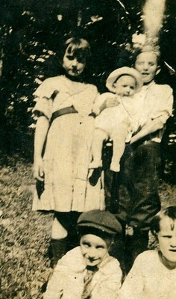

Below is a truly amazing photo from 1924 on the Cahawba River. Let's see, the youngster in the foreground is my father, Bishop. Behind his is Euhal, Loudelle, and Melton. In the right foreground is their father, Ulyss S. Holliman, my grandfather.
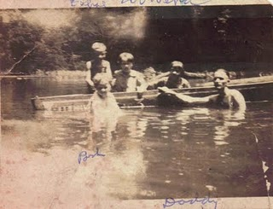

Note: The information and opinions expressed in these family biographies are those of the writer alone. Comments, corrections and additions are most welcome. The purpose of these articles is to capture a period and family in American history and to pass this legacy along to future generations who share the common bond of family. My thanks to Charles H. Ferrell for the loan of many of the pictures.

Next posting, more on Loudelle and the new house....

