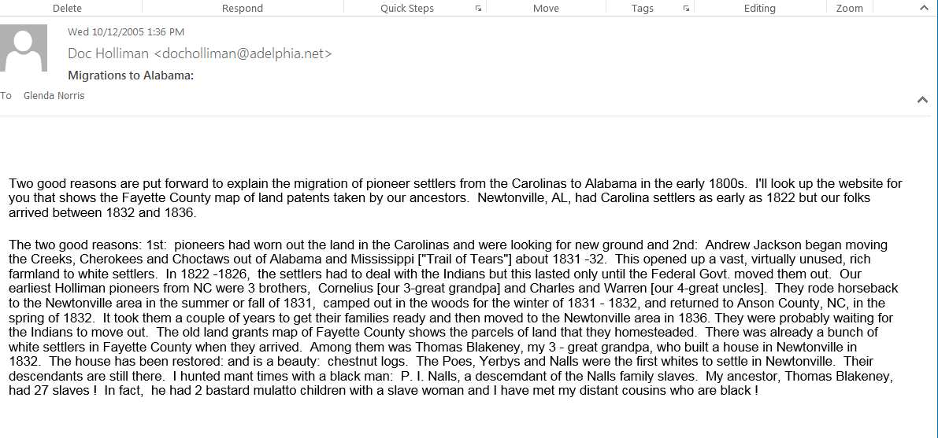-----Original Message-----  
**From:** Rhodes Holliman [<mailto:drrbh88@verizon.net>]   
**Sent:** Monday, March 10, 2008 2:34 PM  
**To:** Kay Blevins  
**Cc:** Ken Bowling; Joseph Lilly; James F Holliman; James Allen Holliman; Glenn Holliman (ECF); Bishop Holliman; Ron R. Holliman  
**Subject:** Fw: Start !

It never pays for a tired, old man with a failing memory to try to write something detailed on a late Sunday night after a hard day !!!  Just as I advised, there are **TOO  MANY  CORNELIUS  NAMES  IN  THE  HOLLIMAN  CLAN !!!** Let me make corrections if you haven't already caught my mistakes.  **START  AGAIN:**

The Cornelius Holliman, who was the father of John Jesse Holliman, was certainly killed in the trenches at Petersburg in 1864.  This Cornelius was the son of Charles Holliman and Barbara (Barberry) Walters Holliman.  Charles was one of the 3 brothers (Charles, Warren and Cornelius) that migrated from SC to Fayette County in 1835.  Charles died in Fayette County about 1841 and his grave nor Barbara's has ever been found.

Charles' son, Cornelius, was buried at night by his two brothers, Warren C. and Elijah and my great grandfather, John Thomas Holliman,  all in the same CSA unit,  41st Alabama Infantry Regt.  The night burial was done quietly in the Old Blandford Cemetery in Petersburg due to the fact that this site was open to Yankee sniper fire.  The Cornelius grave is in the "unknowns" section of  that cemetery that contains hundreds of CSA burials.

Now we can refer to my Father's notes on this Cornelius.  He married an unknown Bright and they had J.J.(1859) , ultimately known as "Cripple John".  She died and he married Malissa Kirkland with whom they produced 3 children: Jane, William and Sarah.  From this point I trust that I have corrected my mistakes and my Dad's notes are absolutely correct.

**SORRY  ABOUT  THAT !!  I'm just tired and can't pull it all back from memory.  Be advised that you may get this way !  You don't grow old "gracefully".  You grow old "painfully"!   Your philosophic companion in Christ,   Doc**

----- Original Message -----

**From:** [Rhodes Holliman](mailto:drrbh88@verizon.net)

**To:** [Kay Blevins](mailto:kjblevins@sbcglobal.net)

**Cc:** [Ken Bowling](mailto:kenbowling@hotmail.com) ; [Joseph Lilly](mailto:lillyjoseph680@aol.com) ; [James F Holliman](mailto:Jfholliman@aol.com) ; [James Allen Holliman](mailto:jim@hollimanlaw.com) ; [Glenn Holliman](mailto:glenn@episcopalfoundation.org) ; [Bishop Holliman](mailto:Ebskip@aol.com) ; [Ron R. Holliman](mailto:Ron@sanman.net)

**Sent:** Sunday, March 09, 2008 11:18 PM

**Subject:** Start !

Open the following:   [www.rootsweb.com/~alfayett/FayetteCem.htm](http://www.rootsweb.com/~alfayett/FayetteCem.htm)

Then scroll down to:  Chapel Hill Baptist Church Cemetery.  Click on it.  The scroll through the alphabet to J. J. Holliman.  This is the one you are looking for.  He was the only child of my 3-great grandfather (Cornelius) and his first wife.  He was John Jesse Holliman, known as "Crippled John".  This Cornelius was a veteran of the War of 1812 and migrated from SC to Fayette County in 1835 with two brothers:  Warren  (who went on to Arkansas in 1840) and Charles who died in Fayette County about 1841.  All this will be explained in the 5 attached pages that will follow this.

I have stepped over his grave marker many times but did not make a photo !  Probably the only Holliman grave I haven't photographed !  As you can see by the ROOTSWEB site above,  there are a bunch of Hollimans in Chapel Hill Cemetery.  I have been there many times.  It is a big Cemetery way out in the country but the church still has an active congregation.

You can have a lot of fun with this ROOTSWEB site.  Look at "Holliman" Cemetery for example.

More to follow.   Doc

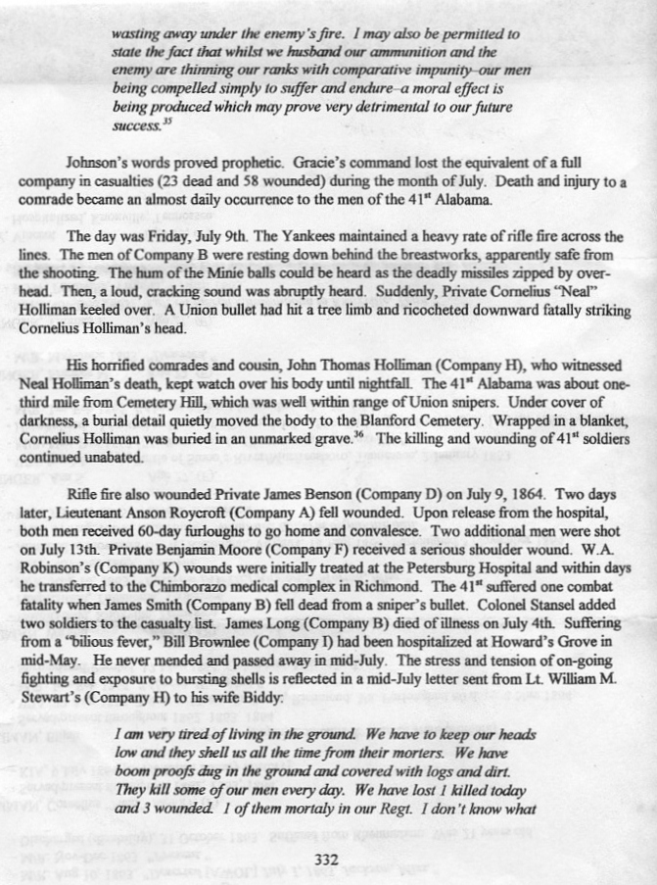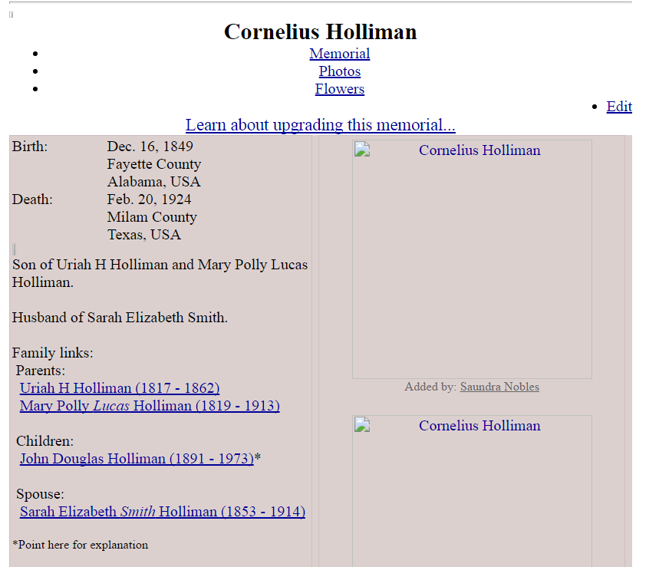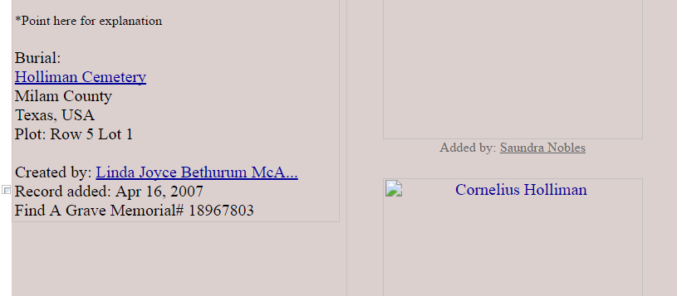

|  |  |  |
| --- | --- | --- |
| • *ID:* I16014  • *Name:* Cornelius Holliman M.D.  • *Surname:* Holliman  • *Given Name:* Cornelius  • *Suffix:* M.D.  • *Sex:* M  • *Birth:* 1792 in Anson Co., NC or Lancaster Co., SC  • *\_UID:* 334DD48707878B4EBA4D5BBD6427CCA45C72  • *Note:*  He may have been born in Anson County, North Carolina.  From rootsweb.com worldconnect by Debra Diane Moschetti:  He was a veteran of the War of 1812. He often spelled his name Cornelious Holiman. South Carolina Census of 1820 shows him residing in Lancaster Co. Census shows two sons under 10 and one adult female (his first wife). In 1830 Cornelius Holliman, along with Thomas Blakeney (son of Capt. James Blakeney) was named one of the trustees of Old Zoar Church and Campground in Chesterfield Co. South Carolina. Cornelius sold some land in Lancaster Co. South Carolina Nov. 14, 1824 to Martin Plyer and is listed in the 1830 Census of Anson County, N.C. with four sons and two daughters. In 1835 Cornelius and his two brothers Charles and Warren traveled back to Newtonville, Alabama, on horseback and spent the winter. Stories indicate they were on a hunting trip. In the spring of 1836 they rode back to N.C. and moved their families from Anson Co. N.C. to Fayette Co. Alabama. All three Holliman brothers purchased land at Newtonville, Cornelius bought 40 acres formerly known as the Yerby Place. After Cornelius' first wife died he remarried and moved to northwest Fayette Co.  [1](http://wc.rootsweb.ancestry.com/cgi-bin/igm.cgi?op=GET&db=2kwgkw&id=I16014#s1)  • *Change Date:* 18 Nov 2004 at 20:26:38  *Father:* [James Grantson Holliman](http://wc.rootsweb.ancestry.com/cgi-bin/igm.cgi?op=GET&db=2kwgkw&id=I15960) b: 25 May 1750 in Johnson County, North Carolina  *Mother:* [Elizabeth Bryant](http://wc.rootsweb.ancestry.com/cgi-bin/igm.cgi?op=GET&db=2kwgkw&id=I15961) b: 1753 in North Carolina  *Marriage* 1 [Mary Elizabeth Plyer](http://wc.rootsweb.ancestry.com/cgi-bin/igm.cgi?op=GET&db=2kwgkw&id=I16015) b: 1793 in Lancaster County, South Carolina   * *Married:* 1813 in Lancaster County, South Carolina   Children   1. [Elijah Alexander Holliman](http://wc.rootsweb.ancestry.com/cgi-bin/igm.cgi?op=GET&db=2kwgkw&id=I16039) b: 1816 in Lancaster County, South Carolina  1. [Uriah Holliman](http://wc.rootsweb.ancestry.com/cgi-bin/igm.cgi?op=GET&db=2kwgkw&id=I15930) b: 1818 in South Carolina  1. [Mary Holliman](http://wc.rootsweb.ancestry.com/cgi-bin/igm.cgi?op=GET&db=2kwgkw&id=I16042) b: 1819 in South Carolina  1. [Sarah Holliman](http://wc.rootsweb.ancestry.com/cgi-bin/igm.cgi?op=GET&db=2kwgkw&id=I16044) b: 1820 in South Carolina  1. [Dr. Joshua C. Holiman](http://wc.rootsweb.ancestry.com/cgi-bin/igm.cgi?op=GET&db=2kwgkw&id=I16038) b: 3 Feb 1823 in South Carolina   *Marriage* 2 [Elizabeth Lucas](http://wc.rootsweb.ancestry.com/cgi-bin/igm.cgi?op=GET&db=2kwgkw&id=I16041)   * *Married:* 23 Jun 1839 in Fayette County, Alabama   *Sources:*   1. Title: Rootsweb World Connect Note: http://worldconnect.rootsweb.com/cgi-bin/igm.cgi?op=GET&db=:879612&id=I426 | |  | | --- | |  | |

**Old Blooming Grove Cemetery Lamar County, Alabama**

**Number 77 on the 2002 Cemetery Map of Lamar County**

**Surveyed in 2005 by Rachel Virginia McReynolds and Kawatha “Kay” Chandler Koonce** [**kaykoon@bellsouth.net**](mailto:kaykoon@bellsouth.net)

**Cemetery Marker Donated by Descendants of Noah & Malinda Stone Morrison.**

**Grave with Cement Top (No Additional information)**

**Three Cement Block Markers (No additional Information)**

**Infant Daughters of Mr. & Mrs. Noah Morrison  (Appears to be two)**

**Grave Marked by Fieldstone (No Additional Information)**

**Cornelius Holliman, Sr. – Born Sept. 25, 1792 – Died Oct. 26, 1862, PVT  S. C. Militia War of 1812 ( This is a recent marker place there by Decemdants )**

**John Robertson – July 30, 1865 – Sept. 15, 1873**

**There are 7 Fieldstones that appear to be graves.**

[Return to Cemetery Index](http://www.fayette.net/carruth/Cemeteries.htm)

[Return to Ms B's Index](http://www.fayette.net/carruth/indexpage.htm)

This page owned by Barbara Woolbright Carruth, Sulligent, Alabama.  **All information** on these pages is furnished for the free use of those who are  researching their family history. Any commercial use, or other electronic posting of any files/pages without the consent of the MS B or donor of material is prohibited. [ [Home Page](file:///C:\users\n\o\b\Saundra-K-Nobles\index.html) | [First Page](file:///C:\users\n\o\b\Saundra-K-Nobles\GENE6-0001.html) | [Previous Page](file:///C:\users\n\o\b\Saundra-K-Nobles\GENE6-0006.html) | [Next Page](file:///C:\users\n\o\b\Saundra-K-Nobles\GENE6-0008.html) | [Last Page](file:///C:\users\n\o\b\Saundra-K-Nobles\GENE6-0014.html) ]

***Descendants of John Hollyman***

*Generation No. 7*

**12.** CORNELIUS7 HOLLIMAN*(JAMES GRANTSON*6*, JESSE*5*HOLLEMAN, JOHN*4*, CHRISTOPHER C.*3*HOLLIMAN, JR., CHRISTOPHER*2*HOLLYMAN, SR., JOHN*1*)* was born 1792 in Anson County, North Carolina, and died 1862 in Fayette County, Alabama. He married (1) MARY ELIZABETH PLYLER Abt. 1813 in Lancaster County, South Carolina, daughter of PAUL PLYLER and MARY UNKNOWN. He married (2) ELIZABETH LUCAS RAINWATER June 23, 1839 in Fayette Co., Alabama, daughter of CHARLES DANIEL LUCAS.   
  
Notes for CORNELIUS HOLLIMAN:  
He was a Veteran of the War of 1812. He often spelled his name Cornelious Holiman. South Carolina Census of 1820 shows him residing in Lancaster Co. Census shows two sons under 10 and one adult female (his first wife). In 1830, Cornelius Holliman, along with Thomas Blakeney (son of Capt. James Blakeney). was named as one of the trustees of Old Zoar Church and Campground in Chesterfield Co. South Carolina. Cornelius sold some land in Lancaster Co. South Carolina Nov. 14, 1824 to Martin Plyer and is listed in the 1830 Census of Anson County, N. C. with four sons and two daughters. In 1835 Cornelius and his two brothers Charles and Warren, traveled to Newtonville, Alabama, on horseback and spent the winter. Stories indicate they were on a hunting trip. In the spring of 1836 they rode back to North Carolina and moved their families from Anson Co. N. C. to Fayette Co., Alabama. All three Holliman brothers purchased land at Newtonville. Cornelius bought 40 Acres formerly known as the Yerby Place. After Cornelius' first wife died her remarried and moved to northwest Fayette Co.   
  
Notes for MARY ELIZABETH PLYLER:  
Mary b. 1793 in Lancaster Co., S. C. She is presumably the daughter of Paul Plyer. She married Cornelius in 1813 Lancaster, S. C. They moved to Alabama in the early 1830s, and received a land grant in 1836 near Newtonville, Fayette Co., Alabama. She died 1835 and is buried at Springhill Baptist Church Cemetery near Moore's bridge in north Tuscaloosa Co.   
  
Notes for ELIZABETH LUCAS RAINWATER:  
After marriage to Cornelius they lived in north Fayette Co., near the Lamar County line. They had 80 acreas in Fayette Co. and 10 acreas in Marion (Lamar) Co. in the Blooming Groce and Webster beat.   
         
Children of CORNELIUS HOLLIMAN and MARY PLYLER are: 

|  |  |  |  |
| --- | --- | --- | --- |
| [14.](file:///C:\users\n\o\b\Saundra-K-Nobles\GENE6-0008.html#CHILD14) | i. |  | ELIJAH A.8 HOLLIMAN, b. 1816, South Carolina; d. 1888, Weston, Texas. |

|  |  |  |  |
| --- | --- | --- | --- |
| [15.](file:///C:\users\n\o\b\Saundra-K-Nobles\GENE6-0008.html#CHILD15) | ii. |  | URIAH H. HOLLIMAN, b. 1818, South Carolina; d. May 1862, Okolowa, Mississippi. |

|  |  |  |  |
| --- | --- | --- | --- |
| [16.](file:///C:\users\n\o\b\Saundra-K-Nobles\GENE6-0008.html#CHILD16) | iii. |  | MARY HOLLIMAN, b. 1819. |

|  |  |  |  |
| --- | --- | --- | --- |
|  | iv. |  | SARAH HOLLIMAN, b. 1820. |

|  |  |  |  |
| --- | --- | --- | --- |
|  | v. |  | JOSHUA C. HOLLIMAN, b. 1823, South Carolina; d. 1902, Garland Co., Arkansas. |

|  |  |
| --- | --- |
|  | Notes for JOSHUA C. HOLLIMAN: Moved to Arkansas in 1867 and may have resided in Mississippi. Became a doctor, married twice and had 13 children. |

**13.** CHARLES7 HOLLIMAN*(JAMES GRANTSON*6*, JESSE*5*HOLLEMAN, JOHN*4*, CHRISTOPHER C.*3*HOLLIMAN, JR., CHRISTOPHER*2*HOLLYMAN, SR., JOHN*1*)* was born Abt. 1795 in Wake County, North Carolina, and died Bef. 1850 in Newtonville, Fayette County, Alabama. He married BARBARA (BARBARY) WALTERS 1818 in Anson County, North Carolina.   
         
Children of CHARLES HOLLIMAN and BARBARA WALTERS are: 

|  |  |  |  |
| --- | --- | --- | --- |
|  | i. |  | UNKNOWN8 HOLLIMAN. |

|  |  |  |  |
| --- | --- | --- | --- |
| [17.](file:///C:\users\n\o\b\Saundra-K-Nobles\GENE6-0008.html#CHILD17) | ii. |  | ASA HOLLIMAN, b. 1820, Anson County, North Carolina; d. Duck Hill, Montgomery County, Mississippi. |

|  |  |  |  |
| --- | --- | --- | --- |
|  | iii. |  | JOSHUA HOLLIMAN, b. 1821, North Carolina. |

|  |  |  |  |
| --- | --- | --- | --- |
|  | iv. |  | JOHN HOLLIMAN, b. 1823, North Carolina. |

|  |  |  |  |
| --- | --- | --- | --- |
|  | v. |  | MILLY ELIZABETH HOLLIMAN, b. 1825, North Carolina. |

|  |  |  |  |
| --- | --- | --- | --- |
|  | vi. |  | SOUSANNAH HOLLIMAN, b. 1827, North Carolina; d. Alabama. |

|  |  |  |  |
| --- | --- | --- | --- |
| [18.](file:///C:\users\n\o\b\Saundra-K-Nobles\GENE6-0008.html#CHILD18) | vii. |  | PETER HOLLIMAN, b. May 08, 1829, Anson County, North Carolina; d. December 18, 1878, Brownsboro, Henderson County, Texas. |

|  |  |  |  |
| --- | --- | --- | --- |
|  | viii. |  | JAMES JESSE HOLLIMAN, b. 1830. |

|  |  |  |  |
| --- | --- | --- | --- |
| [19.](file:///C:\users\n\o\b\Saundra-K-Nobles\GENE6-0008.html#CHILD19) | ix. |  | WARREN C. HOLLIMAN, b. February 07, 1833, Anson County, North Carolina; d. January 12, 1908, Chapel Hill, Fayette County, Alabama. |

|  |  |  |  |
| --- | --- | --- | --- |
| [20.](file:///C:\users\n\o\b\Saundra-K-Nobles\GENE6-0008.html#CHILD20) | x. |  | ELIGIAH HOLLIMAN, b. July 12, 1834, Millport, Lamar County, Alabama; d. August 06, 1938, Millport, Lamar County, Alabama. |

[ [Home Page](file:///C:\users\n\o\b\Saundra-K-Nobles\index.html) | [First Page](file:///C:\users\n\o\b\Saundra-K-Nobles\GENE6-0001.html) | [Previous Page](file:///C:\users\n\o\b\Saundra-K-Nobles\GENE6-0006.html) | [Next Page](file:///C:\users\n\o\b\Saundra-K-Nobles\GENE6-0008.html) | [Last Page](file:///C:\users\n\o\b\Saundra-K-Nobles\GENE6-0014.html) ]

[ [Internet FamilyFinder](file:///C:\iffintro.html) | [Internet FamilyFinder Agents](file:///C:\ifaintro.html) | [GRA Professional Research](file:///C:\graprfrs.html) | [GRA Record Lookups](file:///C:\gramain.html) ]   
[ [FamilyFinder Index](file:///C:\\ffitop.html" \t "_top) | [World Family Tree](file:///C:\wfttop.html) | [Classifieds](file:///C:\adsfront.html) | [Home Pages](file:///C:\users\index.html) | [Message Boards](file:///C:\_rnews_\index.html) | [Online University](file:///C:\university.html) ]   
[ [Home](file:///C:\index.html) | [Reference Library](file:///C:\00000088.html) | [Genealogy How-To](file:///C:\howtofnd.html) | [Genealogy Mall](file:///C:\mallfrnt.html) | [Guest Book](file:///C:\guestbk.html) | [Tech Support](file:///C:\supptop.html) | [Search](file:///C:\search.html) ]

© [Copyright](file:///C:\ftwcpyrt.html) 1996-98, Broderbund Software, Inc. All rights reserved.