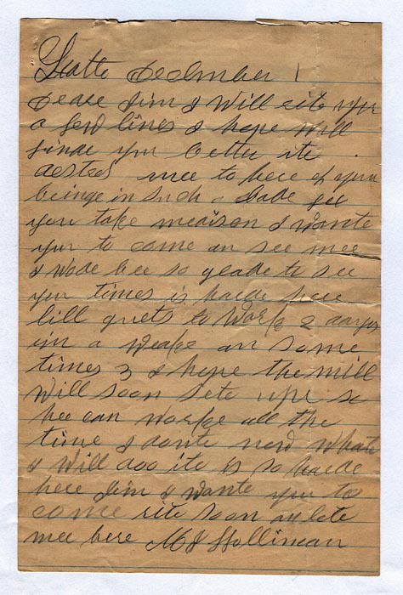C:\Users\Owner\AppData\Local\Microsoft\Windows\Temporary Internet Files\Content.Outlook\BWU4COH1\MJH 1-D+.jpgDear Glenda:

While I'm sitting here,  I'll mail the other 3 letters off to you (attached).  I think that this is all I have from MJH.  As this story unfolds,  you will find out why JTH and MJH were so poor.   Their decline coincided with the Great Depression and  the fact that John Thomas surrendered to the Yankees 141 years ago yesterday !!!

He was ostracized and ridiculed by his neighbors in Fayette for 65 years before he died in 1930 !!!   A very sad life.  It's too bad that he had to come back to such a small-minded community after the War.

I'll get stated scanning John Thomas' letters now.  Big job ahead !    Love,   Uncle Rhodes