Holliman cousin, Maxine Wright, recently sent me a booklet prepared several decades ago by the late Mavis Williams and Chester Bullock. Most of this 50 plus page manuscript highlights the life of Warren Holliman and his descendants in Arkansas. Ms. Williams was a great granddaugher of Warren Holliman ( ), one of the three Holliman brothers who left Lancaster County, South Carolina in 1836 to move their families to Alabama.

Warren was restless and after several years, left his brothers Charles and Cornelius in Alabama and moved his family and others to Arkansas in 1840. The brother, Charles Holliman, is Maxine's great great grandfather and brother Cornelius is this writer's great, great, great grandfather.

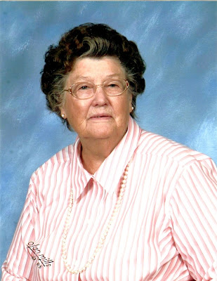

Maxine writes: "I started doing research back before computers, subscribed to genealogy magazines and wrote letters to different Hollimans. I posted queries in books and sent SASE along with family group sheets. Most always received a reply. There is a picture of Warren Holliman and his wife Barbara in a museum in Sheriden, Arkansas."

Thanks to Maxine this manuscript has now been scanned and with her permission is available by email to those who might be descendants of Warren Holliman or who wish to add to their family library.

Maxine is so kind to share of her collection of family history materials, and like the family of the late Walt O. Holliman, hopefuly their example will encourage others to share research and memorabilia via the Internet.

For a copy of the manuscript on the life and family of Warren Holliman, please write me at glennhistory@gmail.com. Since the last posting of this blog, many have requested manuscripts prepared by Walt O. Holliman, which I have been happy to oblige.

