----- Original Message -----

From: Doc. Holliman
To: Maxine Wright
Sent: Thursday, May 29, 2003 12:59 PM
Subject: Felix Holliman

Dear Maxine:

I have some wonderful photos of Felix Holliman that I will include in your package. He was born in 1902 and died in 1984. His wife, Mildred, is still living ! ! I think in Birmingham because Walt Holliman sees her occasionally. Felix was Walt's uncle. I'm in constant touch with Walt. He is a descendant of Warren C. Holliman, son of Charles and Barbara Walters, early pioneers from SC to Newtonville, AL. Warren C. is buried at Chapel Hill Cem. just west of Newtonville, lying between his 2 wives. Want a photo of Warren C. ? ?

Love, Doc
exact dates for.Her birth year estimated fronm 1850,1860 AL., Census.My grandmother Mary Elizabeth HOLLIMAN ,M.E.Shaw'sDaughter was about 5 years old when her mother died.She said that her younger brother was an infant at the time, and he was born June
1866.I went to AL. once looking for her Grave and was told that she had no headstone.This was at the end of Civil War and Elijah I suppose had no money.I often wonder why something wasn't done later But that did not happen.At that time I did visit with a cousin Felix Holliman who was grand son of Warren C.HOLLIMAN.
I have a picture of Mary Elizabeth Shaw HOLLIMAN 15x19 hanging in my bedroom.It came down to me from Grandma and then my mother.
I thought I sent you hard copies of these pictures and if I did not I'll have to do so.Looking forward to the pictures.I plan to take some time off and go over to TN and get photos of my grand parents headstone again .The picture I have of them GrandPa is sitting down.
All my research places Jesse HOLLIMAN and wife Charity in Isle of Wight Va.And no Cophers in NC at all.I have copies of land records placing Jesse HOLLIMAN always In VA.NOT in NC.His will was in Isle of Wight VA 1824.
I kept thinking that I could maybe bring Doug home but I can't handle him.He is wearing adult diapers now taks 2 people at times to pick him up.He has to have help to get up from bed and from chair and is in wheel chair most of the time.They get him to walk and he can only go a few steps at a time then he has to sit down.Dr has said he will only go down.
Again thank you Maxine

----- Original Message -----

From: Doc. Holliman
To: Maxine Wright
Sent: Wednesday, May 28, 2003 10:12 PM
Subject: Need help:

Dear Maxine:

I need a little help if you can work me in between chores. I am making labels for photos and I have been restoring the photo of Mary Elizabeth Shaw, first wife of Elijah Holliman.

I need to know: Her birth date, her death date, and where she is buried ? ? I'm staying up late at night after I get Phyllis comfortable to bed, and working on family photos of which you will get a batch.

Love, Doc

Here is a copy of a rare document signed by Holland M. Bell, Judge of Probate, Fayette County, on May 11th, 1892. It is an application for financial relief by Warren C. Holliman, Private, Company B, 41st Alabama Infantry Regt., who was wounded in the left arm by a Minie ball at Petersburg, Virginia, on August 17th, 1864. He was sent home to Newtonville to convalesce and the War ended before he was well enough to re-join his Unit. I don't know how he got to Newtonville from Petersburg because by August 17th, 1864, Petersburg was under seige from the east and the only escape route was west toward Appomattox Court House where the surrender took place on April 9th, 1865. I would guess he escaped in an ambulance wagon and caught a train when he got to Appomattox. It was a railroad town that the Yankees had not yet taken.

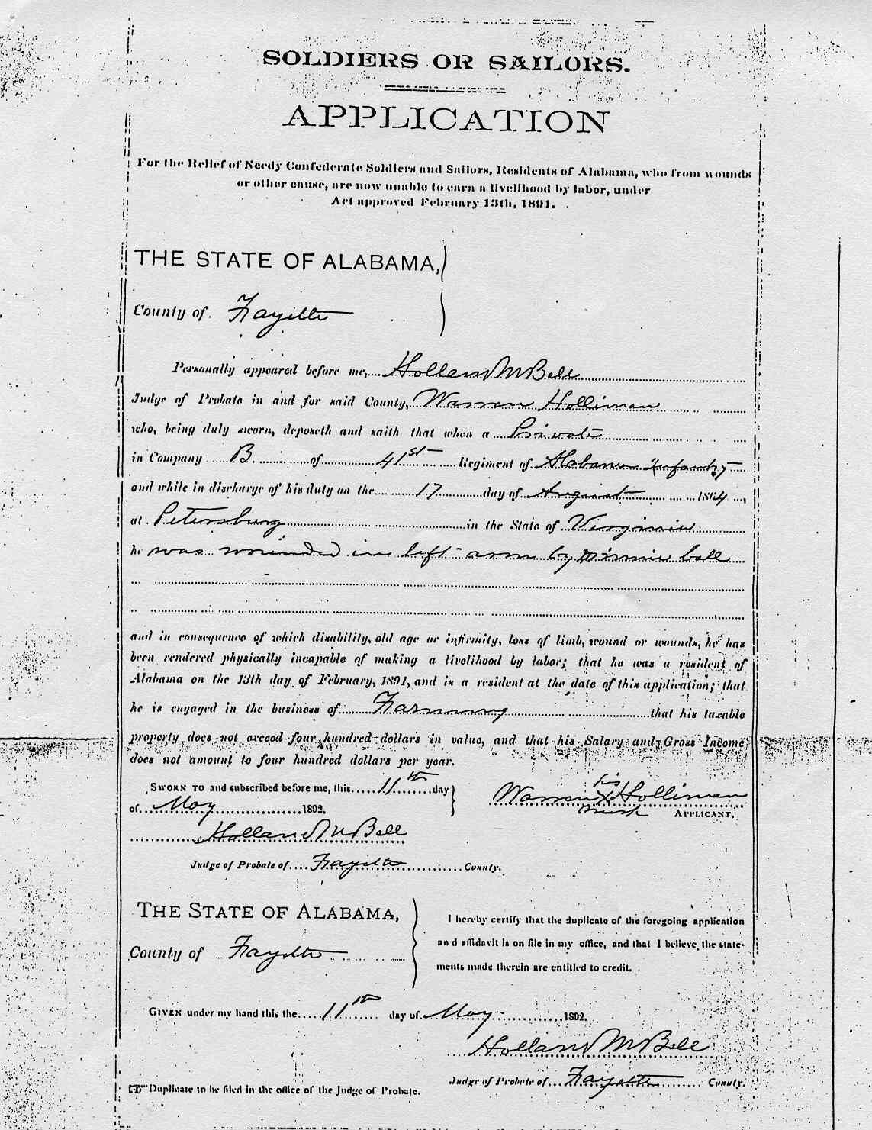Second page of Warren Holliman's relief application for wounds received in the Civil War. It was approved by the Board of Examiners.

