Ulyss and Pearl Caine Holliman and their Descendants
by Glenn N. Holliman
Melton Pierson Holliman (1908 - 1958),
the First Child of Ulyss and Pearl Caine Holliman
Below is pictured Melton in 1938, probably on the front steps of the home he and Ida Hughes Holliman, shared in Irondale, Alabama. Melton in his teens began working in Uncle Floyd Caine's drug store and learned how to prepare medicines. He was the first child out of the nest so to speak, being born in Fayette, Alabama, and moving to Irondale when he was nine years of age. In the 1920s, the requirements to be a pharmacist were more relaxed than in the 21st Century, and by 1940, Melton became a pharmaceutical salesman for Wyeth, eventually moving to Mobile, Alabama.
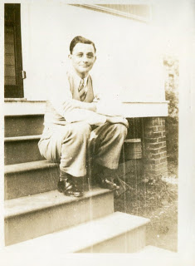
In 1932, he and Ida (1905 - 1995) were married, and in 1943 adopted a beautiful red headed daughter, Pati (Patsy to her father), who grew up with a vivacious personality. Scarcely had they become a family of three before Melton was drafted into the U.S. in August 1943 at the height of World War II. He trained in camps in Georgia and Texas, and for months moved from replacement station to replacement station (Pennsylvania, New York and England) before arriving in France in late July 1944. There he served as a medic in a battalion that was trained to treat chemical warfare casualties.
Thankfully, there was no chemical warfare in Europe during this war, and so he served a medic in a medical receiving station in France. In November 1944, age 36, he was diagnosed with high blood pressure and evacuated first to England, then back to the States, stopping at a hospital in Long Island, and finally at a facility in Jackson, Mississippi. In March 1945, he was discharged, and returned to work as a pharmaceutical salesman.
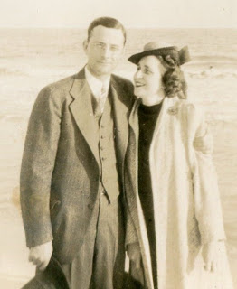
Melton and Ida Holliman, 1935
His genial, kindly manner, honesty and knowledge of the trade made him immensely successful. The family built a modern home in Mobile, and were active in the Baptist Church. He served on the Mayor's Advisory Council for the local hospital and was a frequent lecturer to the medical community. However, there were shadows over this happiness. Ida suffered from ill health time to time, and in 1955 Melton, a sometime smoker, experienced a heart attack. Treatment in that decade was complete rest. After several months, Melton went back to work, but after a game of golf in 1958, he died suddenly of a massive heart attack. Ida passed away in 1995, the rest of her long life a widow.
Their legacy lives on through the life of Pati, her three daughters and now grandchildren, whom she shares with her husband of decades, George Hairston. Pictured above in late November 2010, are left to right Holly Hairston, Pati's oldest daughter, Pati Holliman Hairston and Melton's brother, Bishop Holliman. Holly owns a lovely cafe near Trussville, Alabama.
Note: The information and opinions expressed in these family biographies are those of the writer alone. Comments, corrections and additions are most welcome. The purpose of these articles is to capture a period and family in American history and to pass this legacy along to future generations who share the common bond of family.

